Contents
Supplementary Table S1: Protein counts and presence across samples per dataset of all the proteins found across all datasets, considering the percentage of samples where they were found. 4
Supplementary Figure S1: Line plot showing the protein counts and the presence across samples per dataset for all proteins found across all datasets. 5
Supplementary Figure S2: Upset plots for counts of genes seen significantly associated in multiple datasets for age and sex in either direction (where “Sex Up” is higher in males than females) 7
Supplementary Figure S3: comBat correction of imputed iBAQ values A) clusters correlated with study identifier (PXD), B) clusters correlated with Age, C) clusters correlated with Sex, D) clusters correlated with BMI, E) bar chart of % variance explained by each principal component (PC) and F) heatmap showing loadings of metadata for each PC. 8
Supplementary Figure S4: limma correction of imputed iBAQ values A) clusters correlated with study identifier (PXD), B) clusters correlated with Age, C) clusters correlated with Sex, D) clusters correlated with BMI, E) bar chart of % variance explained by each principal component (PC) and F) heatmap showing loadings of metadata for each PC. 9
Supplementary Figure S5: Imputed ranked values with no further batch correction A) clusters correlated with study identifier (PXD), B) clusters correlated with Age, C) clusters correlated with Sex, D) clusters correlated with BMI, E) bar chart of % variance explained by each principal component (PC) and F) heatmap showing loadings of metadata for each PC. 10
Supplementary Figure S6: Combat correction of imputed ranked values A) clusters correlated with study identifier (PXD), B) clusters correlated with Age, C) clusters correlated with Sex, D) clusters correlated with BMI, E) bar chart of % variance explained by each principal component (PC) and F) heatmap showing loadings of metadata for each PC. 11
Supplementary Figure S7: Limma correction of imputed ranked values A) clusters correlated with study identifier (PXD), B) clusters correlated with Age, C) clusters correlated with Sex, D) clusters correlated with BMI, E) bar chart of % variance explained by each principal component (PC) and F) heatmap showing loadings of metadata for each PC. 12
Supplementary Figure S8: Imputed ppb values with no further correction A) clusters correlated with study identifier (PXD), B) clusters correlated with Age, C) clusters correlated with Sex, D) clusters correlated with BMI, E) bar chart of % variance explained by each principal component (PC) and F) heatmap showing loadings of metadata for each PC. 13
Supplementary Figure S9: ComBat correction of imputed ppb values A) clusters correlated with study identifier (PXD), B) clusters correlated with Age, C) clusters correlated with Sex, D) clusters correlated with BMI, E) bar chart of % variance explained by each principal component (PC) and F) heatmap showing loadings of metadata for each PC. 14
Supplementary Figure S10: Bar charts to show A) false positive counts separated in to “Plausible true positives”, ambiguous positives and false positives, as well as “predicted true positives”, calculated from the probability of genes being seen in the same direction across multiple datasets due to chance and B) false negative counts, with ambiguous negatives shown. Ambiguous are those only seen significant in one dataset when considering the native iBAQ intensities. 16
Supplementary Figure S11: Distribution of intensities with age for ranked normalised combined dataset for protein IGFBP3, categorised as false negative. β denotes GLM test statistic, p GLM p-value and R² from intensity values. Linear fit shown in grey. 17
Supplementary Figure S12: Distribution of intensities with age for ranked normalised combined dataset for protein QSOX1, categorised as true negative. β denotes GLM test statistic, p GLM p-value and R² from intensity values. Linear fit shown in grey. 18
Supplementary Figure S13: Distribution of intensities with age for ComBat corrected iBAQ values combined dataset for protein IGFBP3, categorised as true positive. β denotes GLM test statistic, p GLM p-value and R² from intensity values. Linear fit shown in grey. 19
Supplementary Figure S14: Distribution of intensities with age for ComBat corrected iBAQ values combined dataset for protein QSOX1, categorised as false positive. β denotes GLM test statistic, p GLM p-value and R² from intensity values. Linear fit shown in grey. 20
Supplementary Figure S15: Cross-validation error distribution with number of features selected for the random forest model using batch corrected data. 21
Supplementary Table S2: Summary of the reanalysis counts of the 55 public datasets originally identified 22
Supplementary Table S3: Overview of DIA-NN searches for each of the 11 datasets used for downstream analysis 24

Supplementary Table S1: Protein counts and presence across samples per dataset of all the proteins found across all datasets, considering the percentage of samples where they were found.
Dataset | 100% | 90% | 80% | 70% | 60% | 50% | 40% | 30% | 20% | 10% | 0%
PXD001064 | 169 | 236 | 259 | 284 | 324 | 352 | 374 | 401 | 437 | 471 | 519
PXD004998 | 82 | 146 | 176 | 203 | 223 | 245 | 272 | 306 | 347 | 393 | 505
PXD007944 | 255 | 347 | 393 | 431 | 469 | 491 | 523 | 542 | 564 | 581 | 599
PXD015422 | 190 | 289 | 335 | 375 | 402 | 437 | 478 | 527 | 582 | 701 | 1046
PXD020563 | 106 | 199 | 229 | 250 | 272 | 298 | 334 | 362 | 393 | 431 | 575
PXD021713 | 127 | 228 | 255 | 289 | 327 | 364 | 407 | 440 | 483 | 546 | 820
PXD029009 | 151 | 246 | 273 | 304 | 320 | 349 | 373 | 397 | 429 | 467 | 573
PXD030598 | 137 | 277 | 353 | 395 | 442 | 494 | 546 | 606 | 698 | 807 | 1061
PXD036074 | 288 | 356 | 393 | 424 | 459 | 482 | 500 | 531 | 560 | 607 | 652
PXD036609 | 384 | 463 | 558 | 649 | 697 | 789 | 871 | 949 | 1073 | 1241 | 1385
PXD036718 | 233 | 348 | 389 | 425 | 457 | 477 | 501 | 539 | 595 | 642 | 918

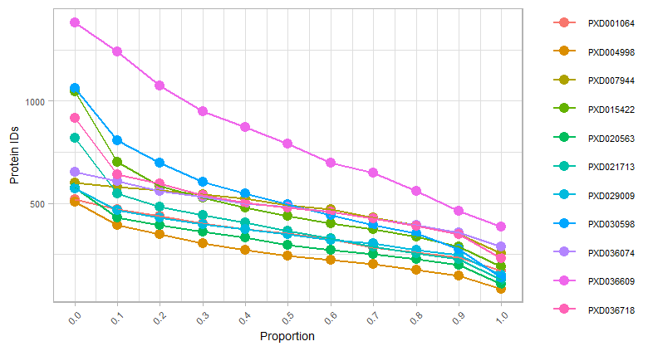

Supplementary Figure S1: Line plot showing the protein counts and the presence across samples per dataset for all proteins found across all datasets.

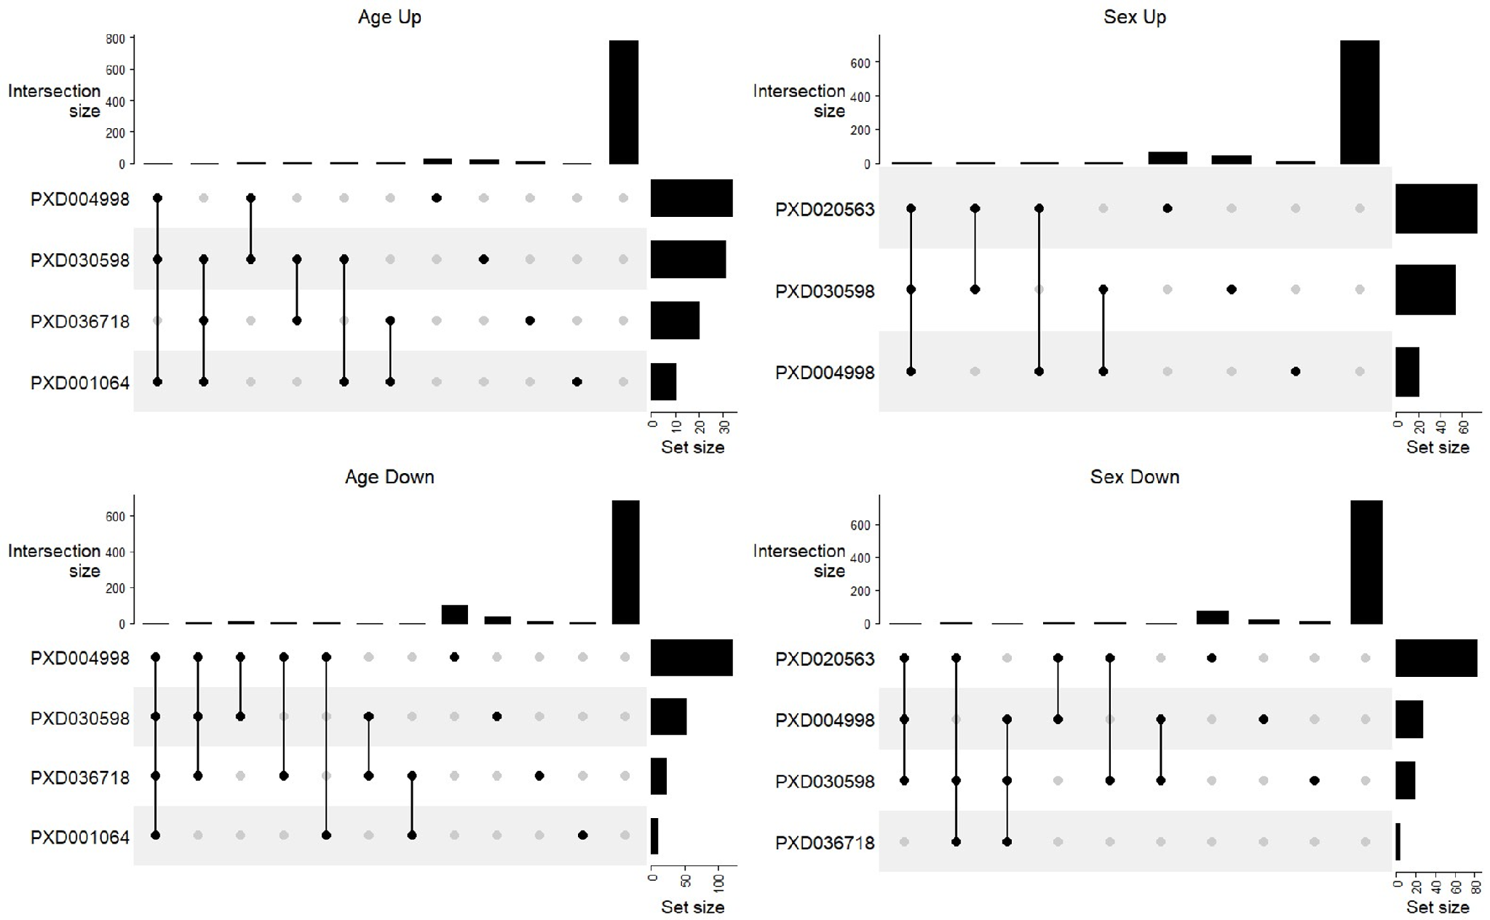

Supplementary Figure S2: Upset plots for counts of genes seen significantly associated in multiple datasets for age and sex in either direction (where “Sex Up” is higher in males than females)

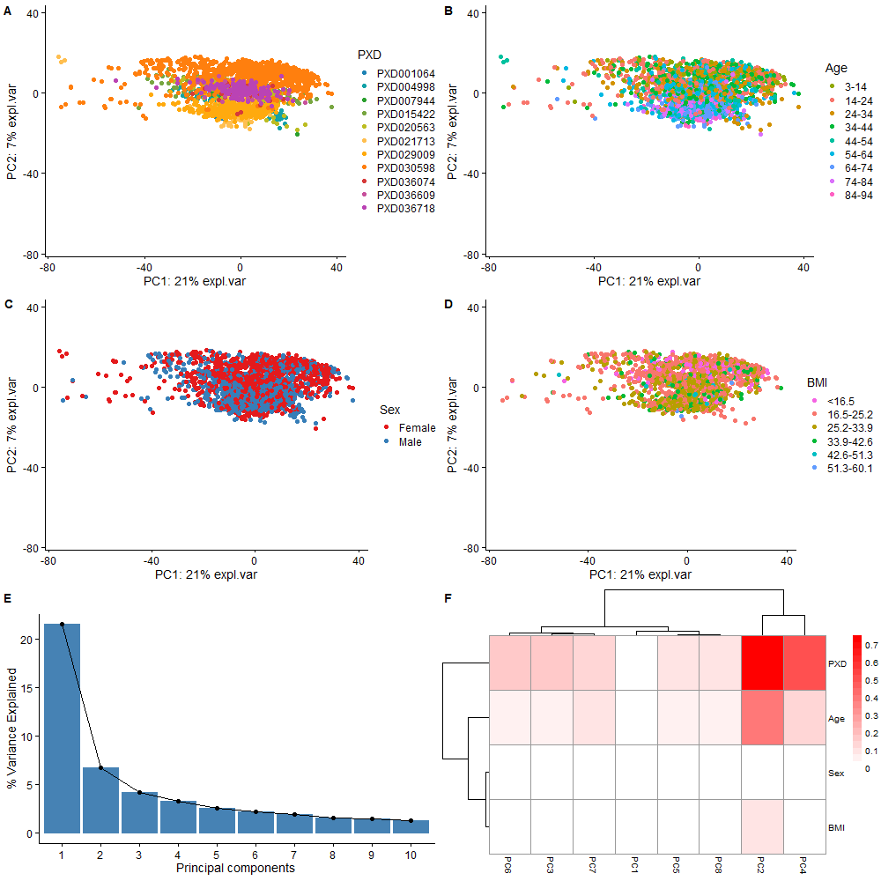

Supplementary Figure S3: comBat correction of imputed iBAQ values A) clusters correlated with study identifier (PXD), B) clusters correlated with Age, C) clusters correlated with Sex, D) clusters correlated with BMI, E) bar chart of % variance explained by each principal component (PC) and F) heatmap showing loadings of metadata for each PC.

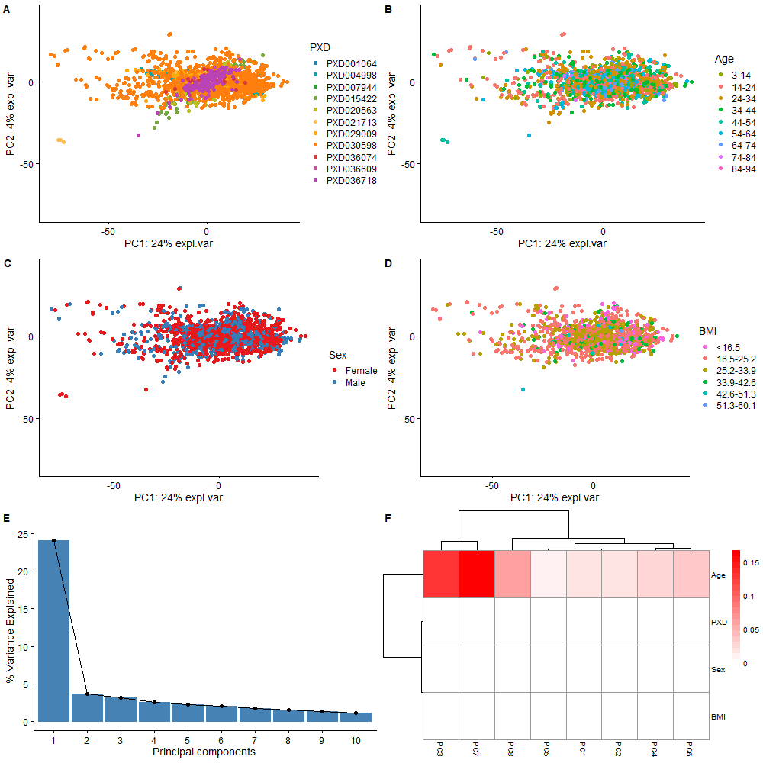 Supplementary Figure S4: limma correction of imputed iBAQ values A) clusters correlated with study identifier (PXD), B) clusters correlated with Age, C) clusters correlated with Sex, D) clusters correlated with BMI, E) bar chart of % variance explained by each principal component (PC) and F) heatmap showing loadings of metadata for each PC.

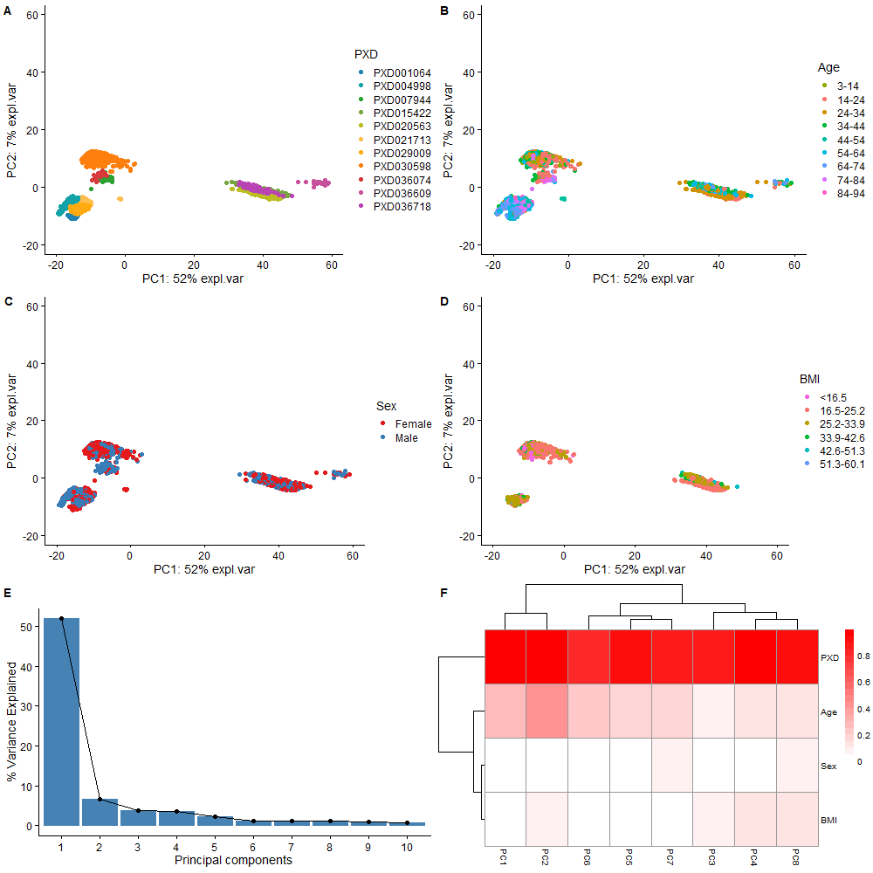

Supplementary Figure S5: Imputed ranked values with no further batch correction A) clusters correlated with study identifier (PXD), B) clusters correlated with Age, C) clusters correlated with Sex, D) clusters correlated with BMI, E) bar chart of % variance explained by each principal component (PC) and F) heatmap showing loadings of metadata for each PC.

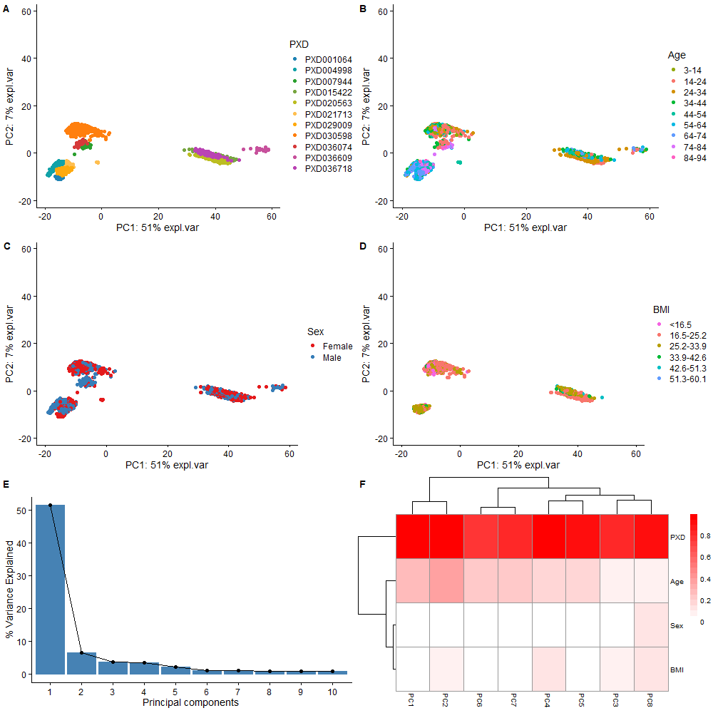

Supplementary Figure S6: Combat correction of imputed ranked values A) clusters correlated with study identifier (PXD), B) clusters correlated with Age, C) clusters correlated with Sex, D) clusters correlated with BMI, E) bar chart of % variance explained by each principal component (PC) and F) heatmap showing loadings of metadata for each PC.

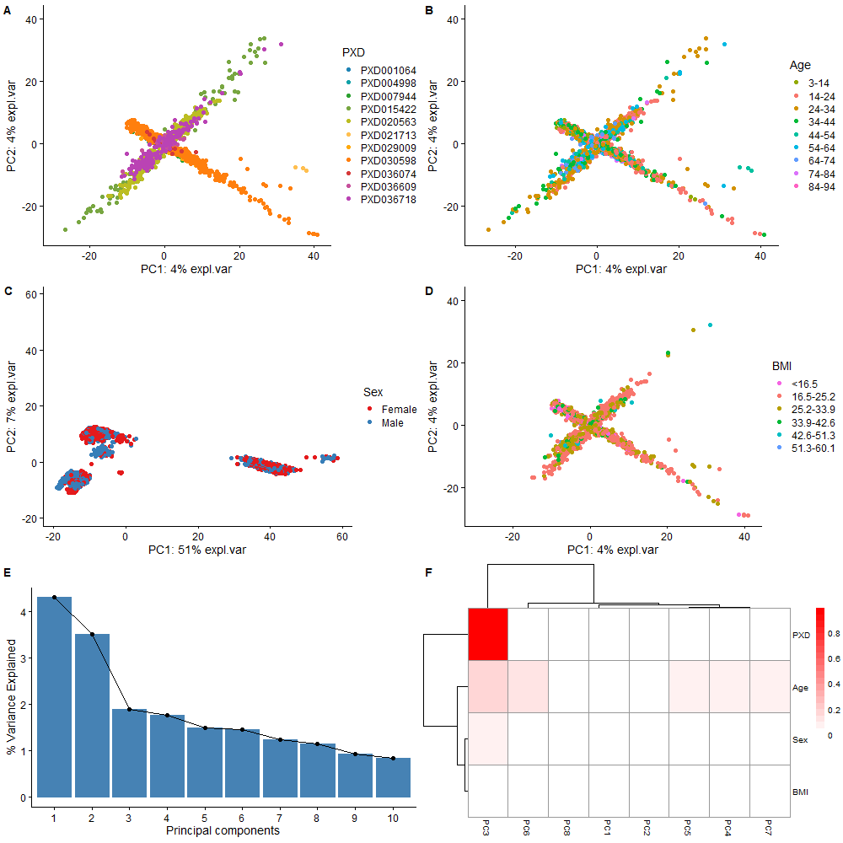

Supplementary Figure S7: Limma correction of imputed ranked values A) clusters correlated with study identifier (PXD), B) clusters correlated with Age, C) clusters correlated with Sex, D) clusters correlated with BMI, E) bar chart of % variance explained by each principal component (PC) and F) heatmap showing loadings of metadata for each PC.

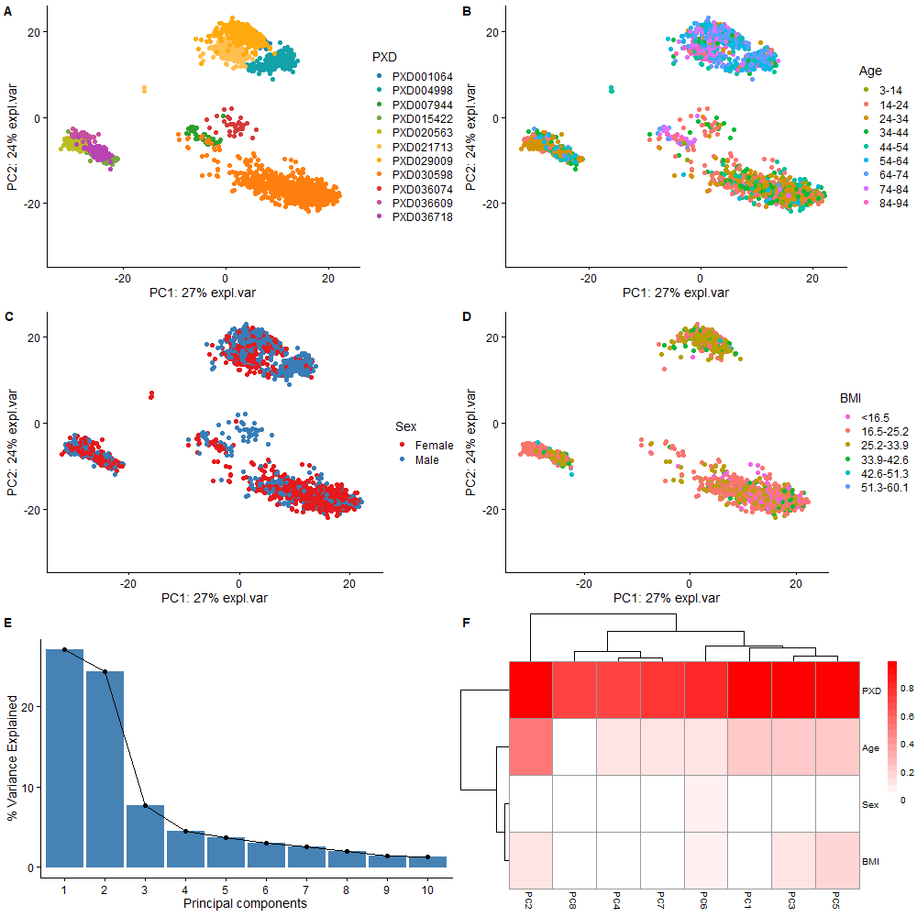

Supplementary Figure S8: Imputed ppb values with no further correction A) clusters correlated with study identifier (PXD), B) clusters correlated with Age, C) clusters correlated with Sex, D) clusters correlated with BMI, E) bar chart of % variance explained by each principal component (PC) and F) heatmap showing loadings of metadata for each PC.

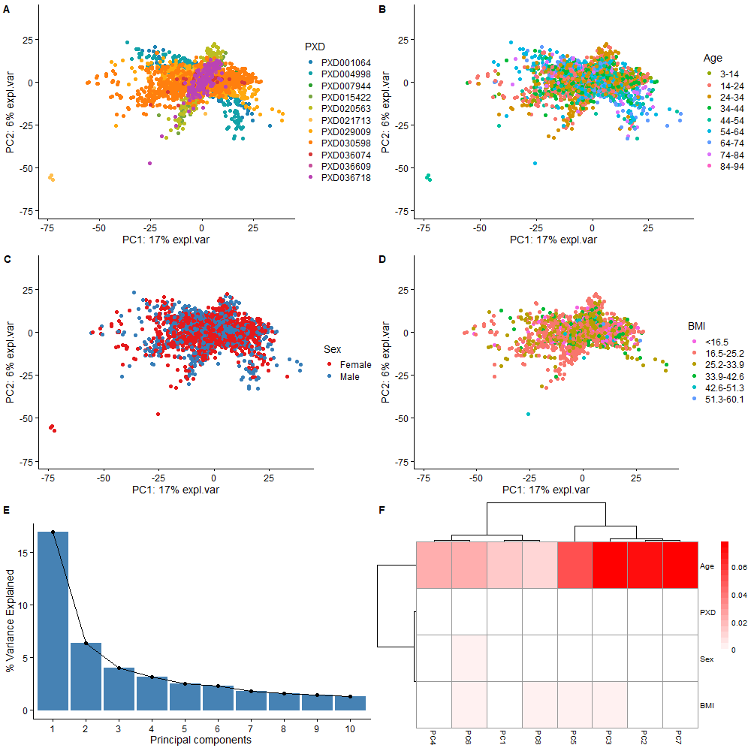

Supplementary Figure S9: ComBat correction of imputed ppb values A) clusters correlated with study identifier (PXD), B) clusters correlated with Age, C) clusters correlated with Sex, D) clusters correlated with BMI, E) bar chart of % variance explained by each principal component (PC) and F) heatmap showing loadings of metadata for each PC.

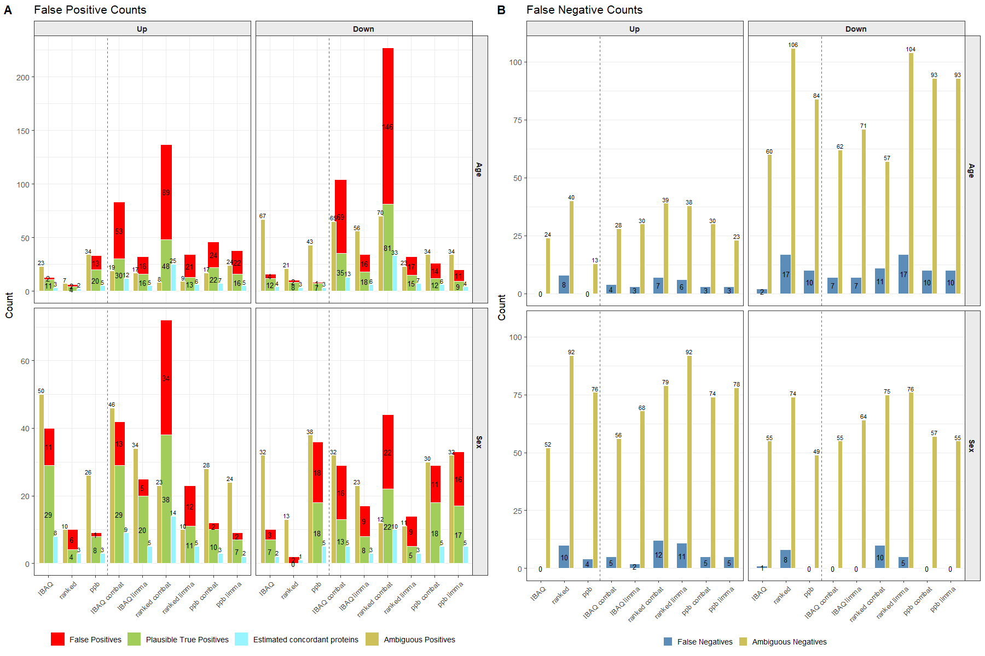

Supplementary Figure S10: Bar charts to show A) false positive counts separated in to “Plausible true positives”, ambiguous positives and false positives, as well as “predicted true positives”, calculated from the probability of genes being seen in the same direction across multiple datasets due to chance and B) false negative counts, with ambiguous negatives shown. Ambiguous are those only seen significant in one dataset when considering the native iBAQ intensities.

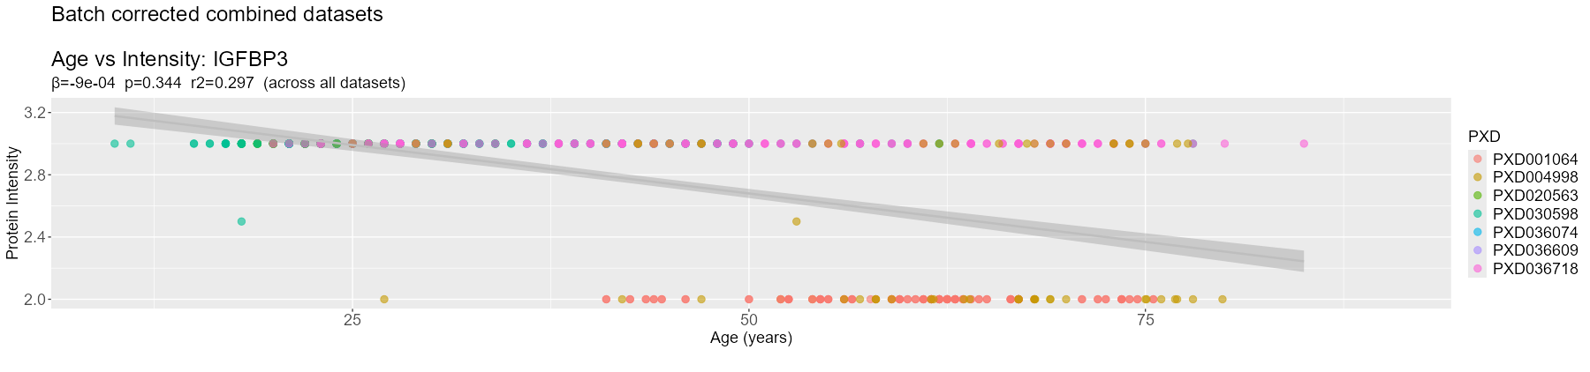

Supplementary Figure S11: Distribution of intensities with age for ranked normalised combined dataset for protein IGFBP3, categorised as false negative. β denotes GLM test statistic, p GLM p-value and R² from intensity values. Linear fit shown in grey.

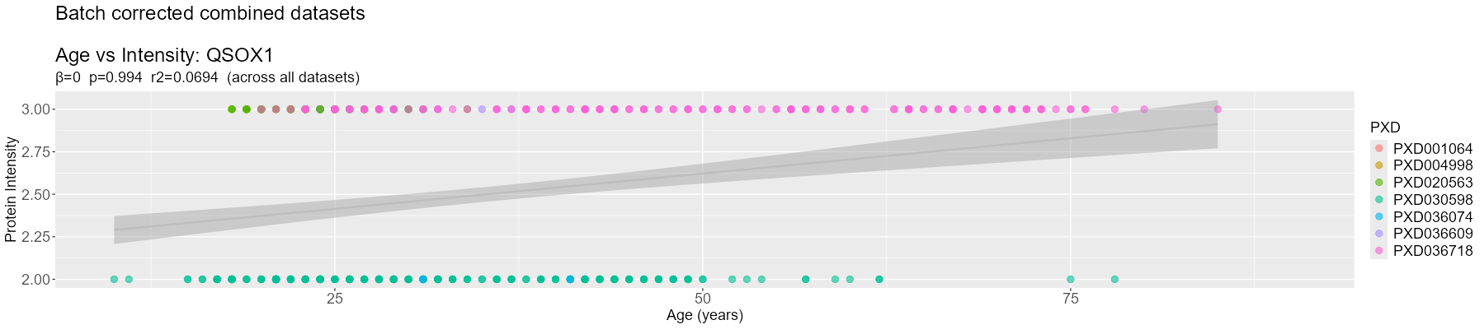

Supplementary Figure S12: Distribution of intensities with age for ranked normalised combined dataset for protein QSOX1, categorised as true negative. β denotes GLM test statistic, p GLM p-value and R² from intensity values. Linear fit shown in grey.

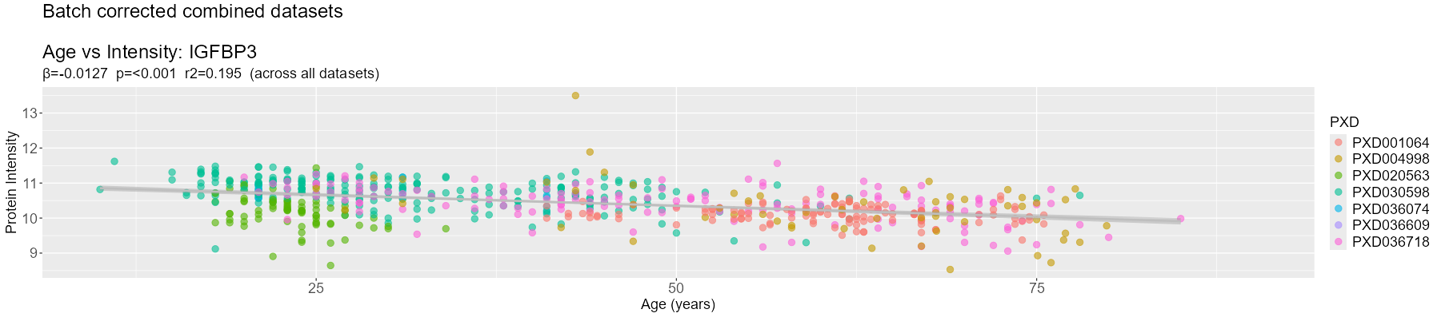

Supplementary Figure S13: Distribution of intensities with age for ComBat corrected iBAQ values combined dataset for protein IGFBP3, categorised as true positive. β denotes GLM test statistic, p GLM p-value and R² from intensity values. Linear fit shown in grey.

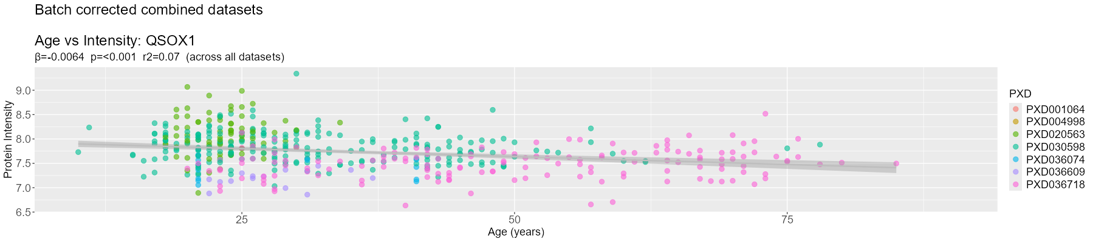

Supplementary Figure S14: Distribution of intensities with age for ComBat corrected iBAQ values combined dataset for protein QSOX1, categorised as false positive. β denotes GLM test statistic, p GLM p-value and R² from intensity values. Linear fit shown in grey.

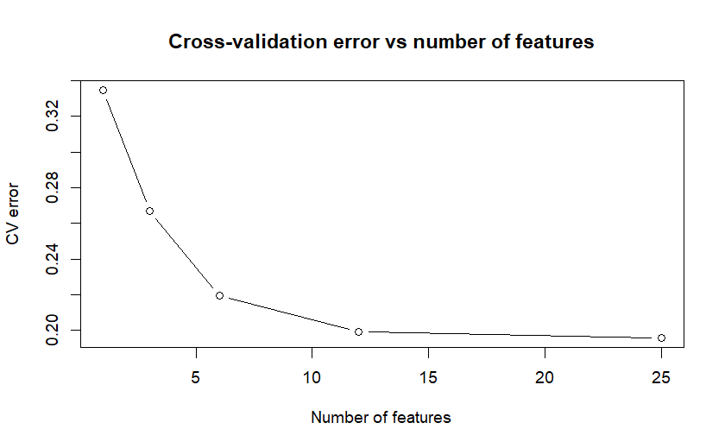

Supplementary Figure S15: Cross-validation error distribution with number of features selected for the random forest model using batch corrected data.

Supplementary Table S2: Summary of the reanalysis counts of the 55 public datasets originally identified
Identifier | Proteins | Protein Groups | Samples
PXD001064 | 503 | 519 | 240
PXD004998 | 499 | 505 | 290
PXD006441 | 381 | 388 | 100
PXD006704 | 534 | 545 | 48
PXD007944 | 584 | 599 | 45
PXD008234 | 430 | 437 | 35
PXD008927 | 498 | 509 | 141
PXD010382 | 945 | 970 | 12
PXD011063 | 810 | 829 | 12
PXD015422 | 1027 | 1059 | 142
PXD016622 | 870 | 899 | 100
PXD017210 | 1102 | 1129 | 168
PXD017227 | 754 | 774 | 48
PXD020261 | 637 | 653 | 180
PXD020437 | 524 | 536 | 22
PXD020563 | 563 | 575 | 328
PXD021144 | 792 | 805 | 24
PXD021197 | 1025 | 1057 | 42
PXD021713 | 805 | 820 | 244
PXD023553 | 765 | 788 | 159
PXD024549 | 376 | 383 | 45
PXD024674 | 1941 | 1998 | 160
PXD025125 | 449 | 457 | 41
PXD025224 | 457 | 467 | 9
PXD025453 | 577 | 587 | 58
PXD025462 | 899 | 928 | 117
PXD025484 | 667 | 691 | 272
PXD025752 | 364 | 376 | 307
PXD026907 | 851 | 881 | 79
PXD027091 | 846 | 872 | 66
PXD027535 | 752 | 762 | 86
PXD028310 | 497 | 515 | 113
PXD029009 | 558 | 576 | 1189
PXD029437 | 858 | 872 | 130
PXD029473 | 1118 | 1148 | 38
PXD029877 | 551 | 557 | 127
PXD030598 | 1015 | 1061 | 870
PXD030936 | 711 | 716 | 80
PXD030947 | 623 | 640 | 61
PXD031908 | 589 | 604 | 39
PXD031969 | 467 | 478 | 56
PXD032137 | 656 | 676 | 46
PXD032917 | 555 | 566 | 76
PXD033169 | 998 | 1033 | 50
PXD034184 | 924 | 944 | 51
PXD034391 | 1134 | 1148 | 76
PXD034978 | 602 | 608 | 16
PXD034996 | 1006 | 1033 | 63
PXD036074 | 636 | 652 | 31
PXD036609 | 1348 | 1385 | 27
PXD036718 | 921 | 946 | 224
PXD037341 | 447 | 459 | 36
PXD037682 | 522 | 532 | 71
PXD038526 | 485 | 499 | 63
PXD039023 | 444 | 462 | 879

Supplementary Table S3: Overview of DIA-NN searches for each of the 11 datasets used for downstream analysis
Dataset | MS1 tolerance (Da) | MS2 tolerance (Da) | Scan Window (Da)
PXD029009 | 14.2051 | 22.4346 | 6
PXD030598 | 12.5262 | 27.9431 | 10
PXD020563 | 2.34259 | 15.2912 | 9
PXD004998 | 19.211 | 26.312 | 11
PXD021713 | 17.702 | 27.8386 | 11
PXD001064 | 18.889 | 29.1707 | 9
PXD036718 | 8.03567 | 10.7202 | 8
PXD015422 | 3.51264 | 5.52299 | 7
PXD007944 | 15.0362 | 22.5916 | 17
PXD036074 | 12.4934 | 14.2297 | 7
PXD036609 | 3.19748 | 3.17849 | 8

