Supporting Information
Synergistic dual-modification of polyurethane sponge with MIL-53(Al) and dimethylsilicone oil for efficient oil–water separation of oily sludge thermal washing wastewater
Junjie Pan ª, Chunyu Wang ^{b}, Xiaoting Hong ^{a,*}, Xuegang Zhang ª, Huanyang Liu ª, Junye Guo ª, Yanghao Huang ª, Chengyue Wang ª

ª School of chemistry and chemical engineering, Zhejiang Sci-Tech University, Hangzhou 310018, P.R. China
^{b} School of mechanical engineering, Zhejiang Sci-Tech University, Hangzhou 310018, P.R. China

*Corresponding author. Tel.: +86 (0571) 86843228, Fax +86 (0571) 86843228.
E-mail address: hanren.xiaoting@gmail.com (X.T. Hong).

Contents
Fig. S1 Synthesis of MIL-53(Al).
Supplemental description I
Fig. S2 Custom-built oil-water separation setup.
Fig. S3 The XRD pattern of MIL-53(Al).
Fig. S4 FT-IR spectra of MIL-53(Al) and PU sponge before and after modification.
Fig. S5 The TG curve of modified MIL-53(Al).
Fig. S6 The Elemental mapping of modified MIL-53(Al).
Fig. S7 Acid and alkali resistance test of M/Si-6@PU.
Fig. S8 The appearance of the oil washing waste liquid before and after treatment.
Fig. S9 FT-IR spectra of the oil washing waste liquid before and after treatment.
Table S1 The specific surface area and average pore size of MIL-53(Al-x) and MIL-53(Al-1.3) modified by DMS.

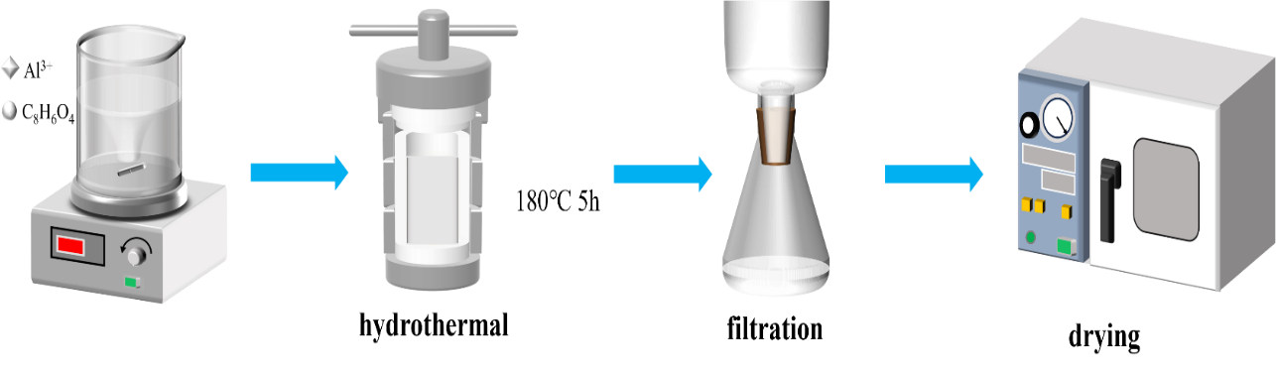
Fig. S1 Synthesis of MIL-53(Al)
Supplemental description I
The preparation process of MIL-53(Al) is illustrated in Fig. S1. First, 1.87 g of Al(NO₃)₃·9H₂O was dissolved in 18 mL of methanol to form solution A. Meanwhile, a series of terephthalic acid (TPA) solutions (solution B) with gradient molar ratios of Al(NO₃)₃·9H₂O to TPA ranging from 1:1 to 1:1.5 were prepared by dissolving the corresponding amounts of TPA in 18 mL of methanol. Each solution was stirred for 15 min to ensure uniform dispersion. Subsequently, solution B was slowly poured into solution A under vigorous stirring. The resulting precursor mixture was transferred into a 150 mL Teflon-lined stainless steel autoclave and heated at 180 °C for 5 h. After natural cooling to room temperature, the suspension was centrifuged at 4000 rpm, and the precipitate was thoroughly washed sequentially with DMF and ethanol for 30 min each to remove any unreacted residues. Finally, the precipitate was dried overnight in an oven at 100 °C to obtain a white powder.
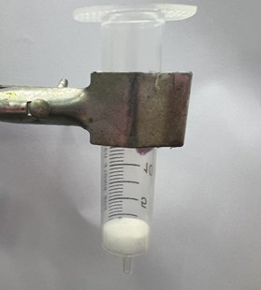
Fig. S2 Custom-built oil-water separation setup

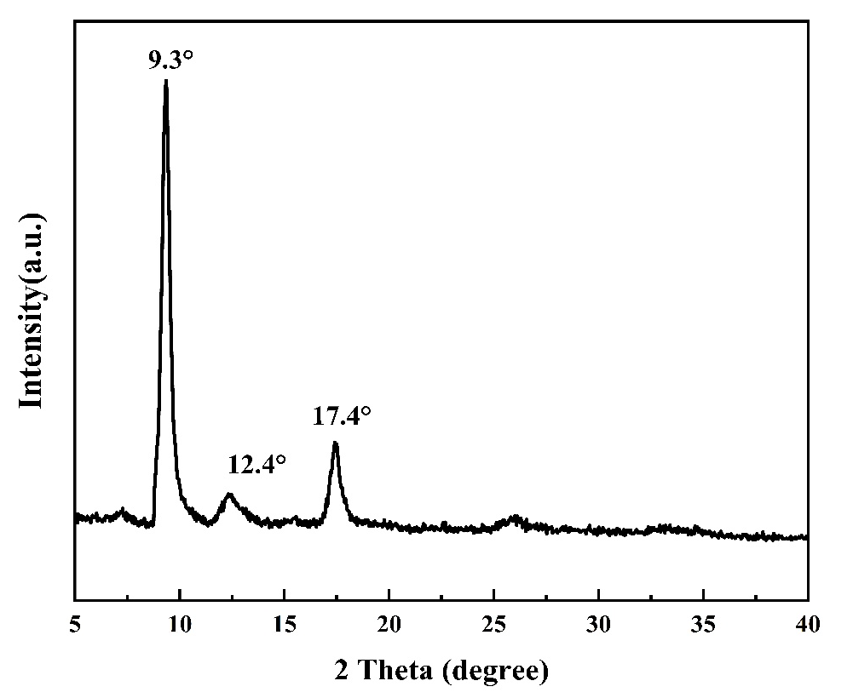
Fig. S3 The XRD pattern of MIL-53(Al)

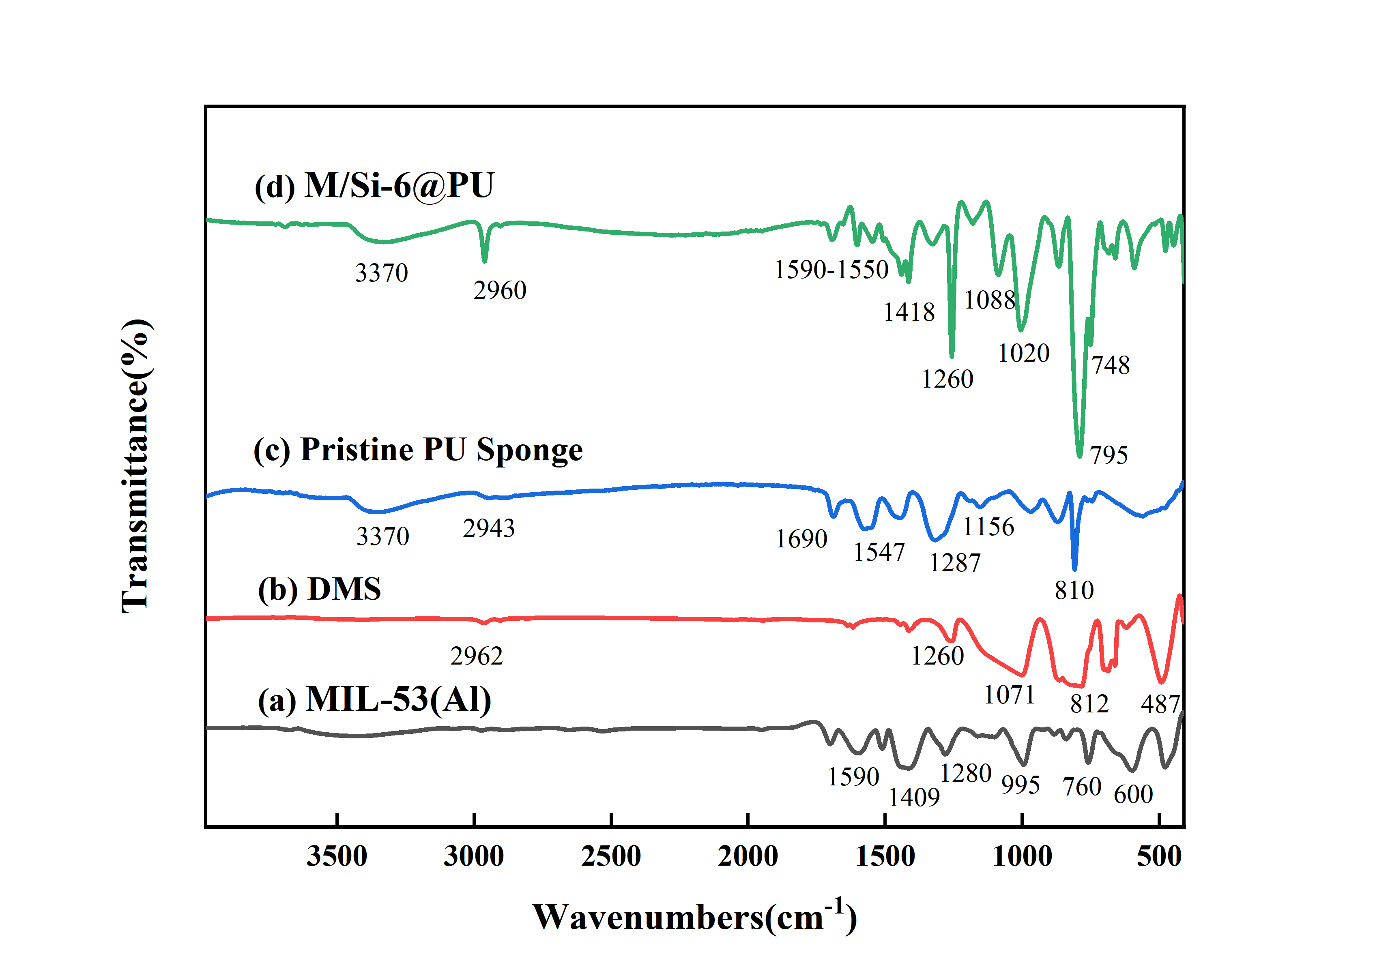

Fig. S4 FT-IR spectra of MIL-53(Al) and PU sponge before and after modification
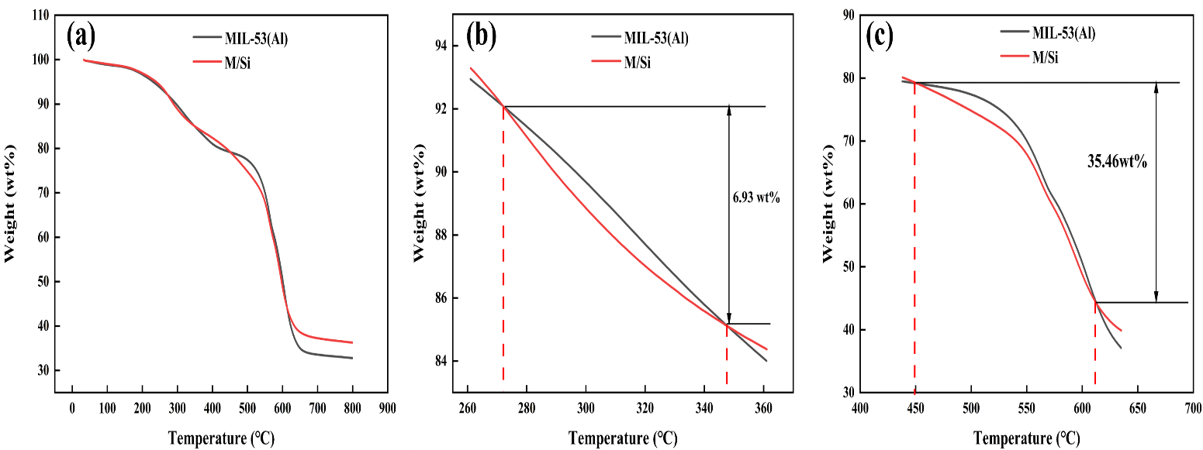

Fig. S5 The TG curve of modified MIL-53(Al)

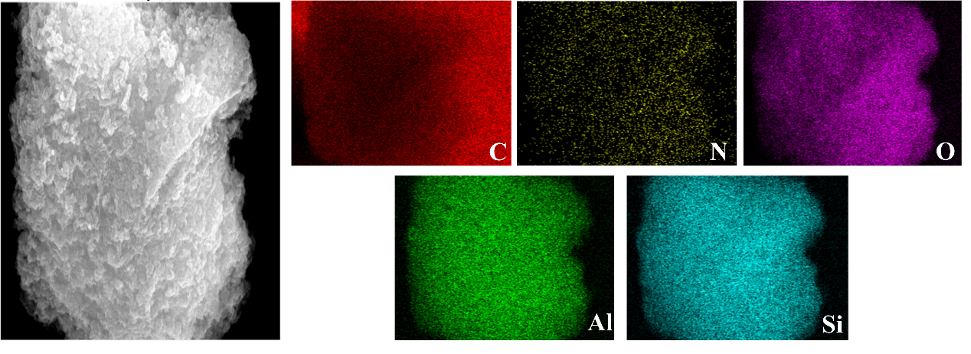
Fig. S6 The Elemental mapping of modified MIL-53(Al)

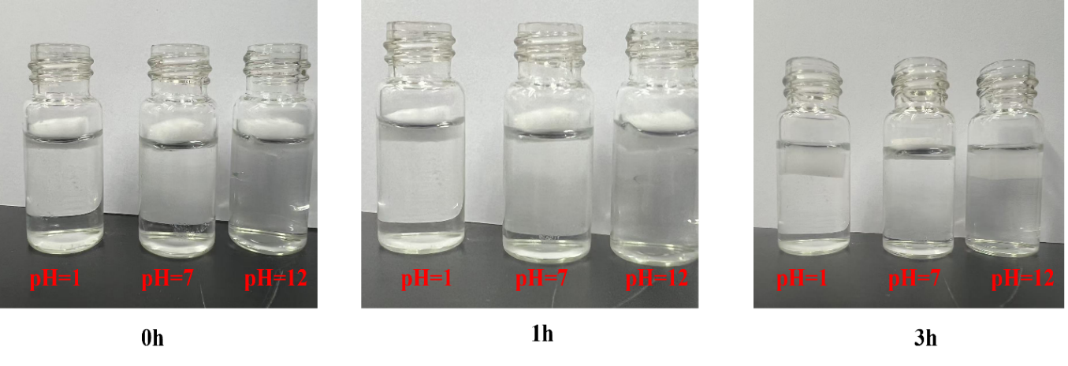
Fig. S7 Acid and alkali resistance test of M/Si-6@PU

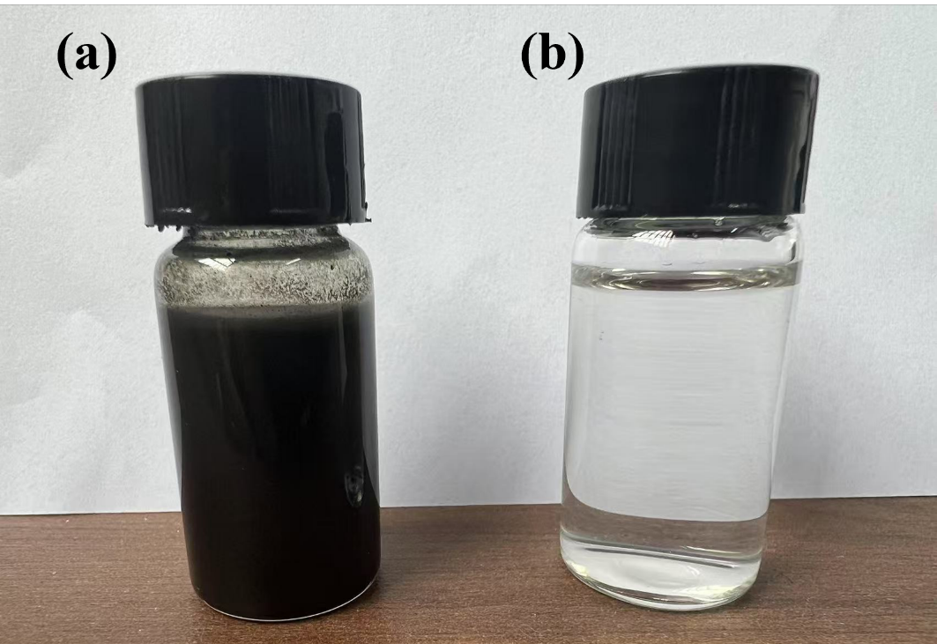
Fig. S8 The appearance of the oil washing waste liquid before and after treatment
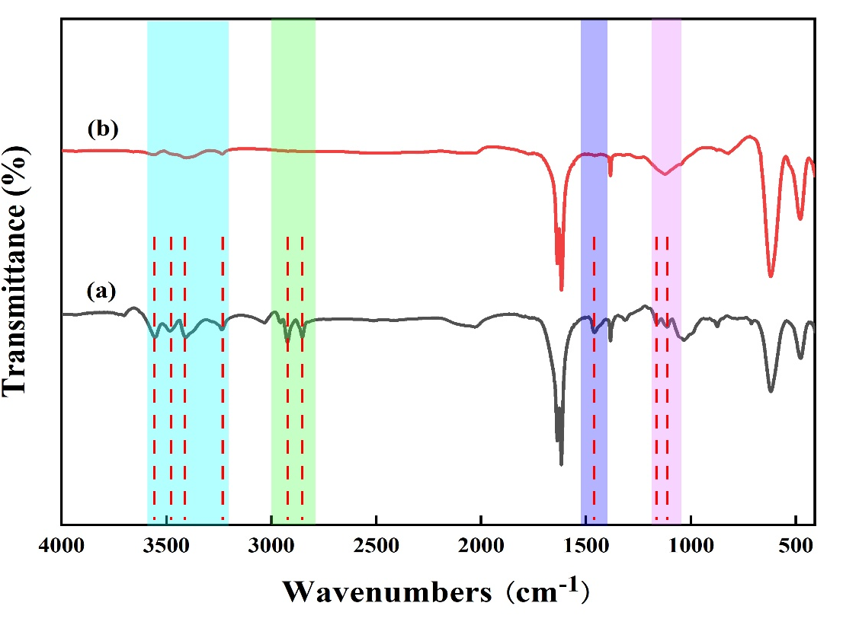
Fig. S9 FT-IR spectra of (a) the oily sludge thermal washing wastewater before separation, (b) the oily sludge thermal washing wastewater after separation

Table S1 The specific surface area and average pore size of MIL-53(Al-x) and MIL-53(Al-1.3) modified by DMS

 | MIL-53(Al-1.0) | MIL- 53(Al-1.1) | MIL-53(Al-1.2) | MIL-53(Al-1.3) | MIL-53(Al-1.4) | MIL-53(Al-1.5) | MIL-53(Al-1.3) modified by DMS
BET surface area (m²/g) | 890 | 945 | 1098 | 1199 | 704 | 523 | 1025
average pore diameter (nm) | 10.8 | 12.3 | 17.3 | 17.5 | 18 | 16.2 | 15.2

