Supplementary Material for

LncRNA NR_030777/DRP1 negatively regulates intercellular mitochondrial transfer in cobalt nanoparticles-induced neuronal damage

Yilong Chen ^{a,b,1}, Xiangyu Chang ^{a,b,1}, Jiamei Li ^{a,b,1}, Yilin Zhang ^{a,b}, Xinpei Lin ^{a,b}, Shangrong Jiang ^{a,b}, Cheng Chen ^{a,b}, Shengsong Lin ^{a,b}, Ling Lin ^{c},Junjing Lin ^{c}, Zhenkun Guo ^{a,b}, Jinfu Zhou ^{d}, Hong Hu ^{a,b}, Guangxia Yu ^{a,b}, Wenya Shao ^{a,b}, Siying Wu ^{a, e}, Huangyuan Li ^{a,b}, Fuli Zheng ^{a,b,*}

ª Department of Preventive Medicine, School of Public Health, Fujian Medical University, Fuzhou 350122, China
^{b} The Key Laboratory of Environment and Health, School of Public Health, Fujian Medical University, Fuzhou 350122, China
^{c} Public Technology Service Center, Fujian Medical University, Fuzhou 350122, China
^{d} Medical Genetic Diagnosis and Therapy Center, Fujian Maternity and Child Health Hospital College of Clinical Medicine for Obstetrics & Gynecology and Pediatrics, Fujian Medical University, Fuzhou 350001, China
^{e} Department of Epidemiology and Health Statistics, School of Public Health, Fujian Medical University, Fuzhou 350122, China
¹ Theses authors contributed equally to the work.
* Corresponding author: Fuli Zheng, f.zheng@fjmu.edu.cn.

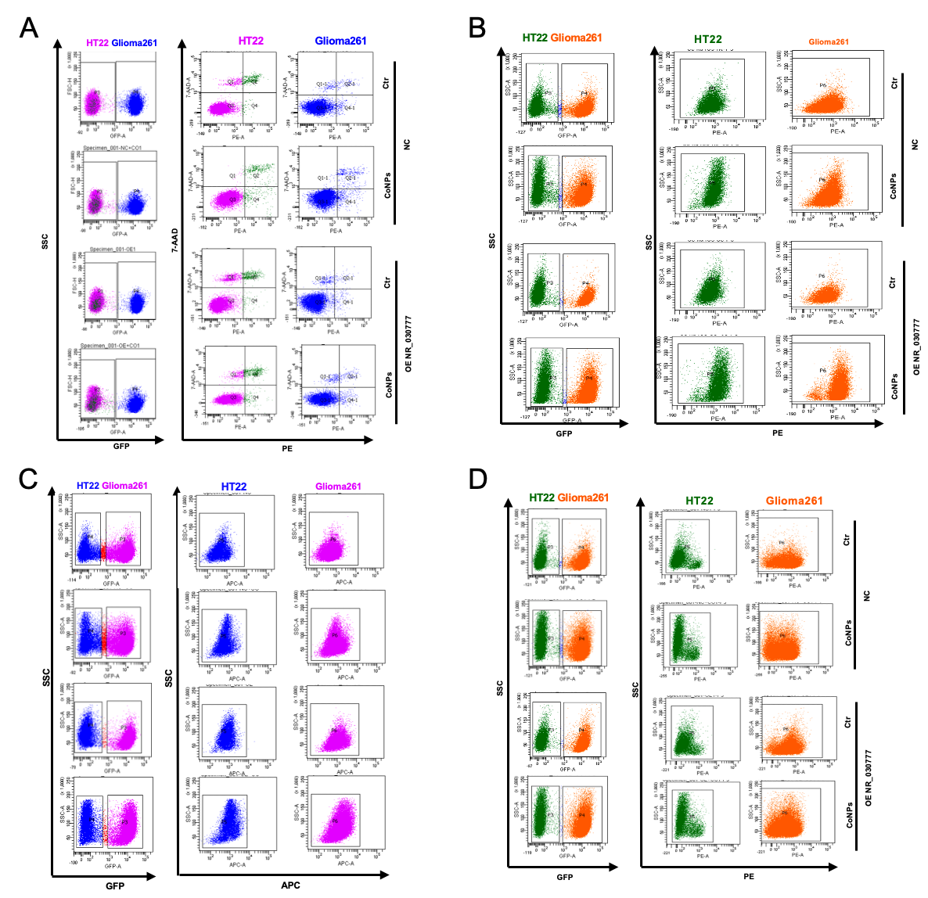
Figure S1. Flow cytometry dot plots of apoptosis, intracellular O₂⁻, mtROS, and MMP in NR_030777-overexpressing Glioma261 and HT22 cells after co-culture and CoNPs treatment. (A) Apoptosis dot plots. (B) Intracellular O₂⁻ dot plots. (C) mtROS dot plots. (D) MMP dot plots. All measurements were taken after 24 h of co-culture with CoNPs treatment.

Figure S2. Flow cytometry dot plots of apoptosis, intracellular O₂⁻, mtROS, and MMP in NR_030777-KD Glioma261 and HT22 cells after co-culture and CoNPs treatment. (A) Apoptosis dot plots. (B) Intracellular O₂⁻ dot plots. (C) mtROS dot plots. (D) MMP dot plots. All measurements were taken after 24 h of co-culture with CoNPs treatment.

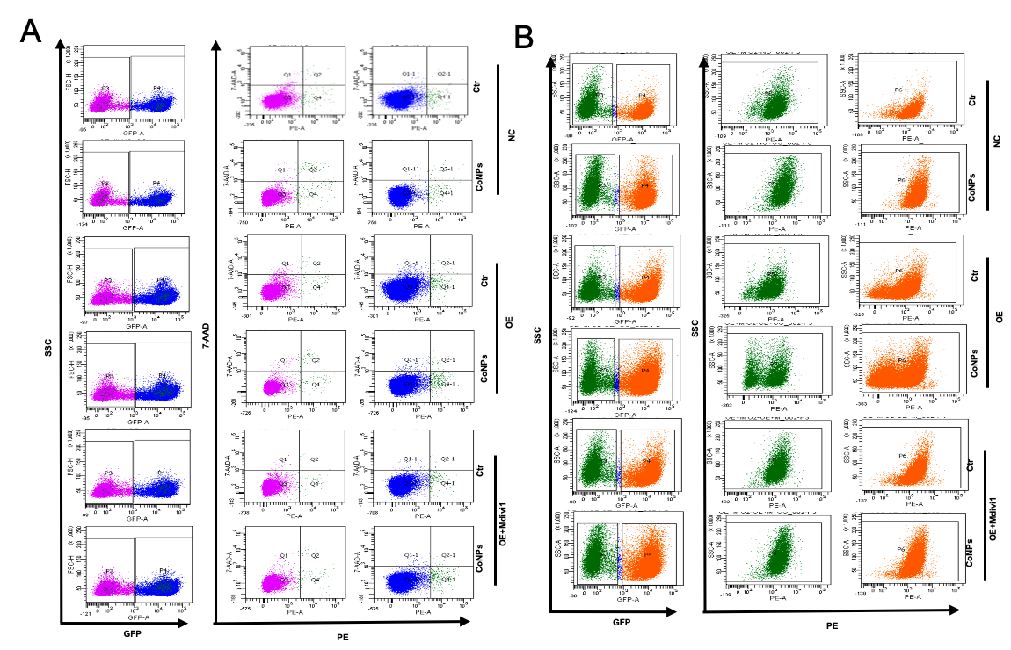
Figure S3. Flow cytometry dot plots of apoptosis and intracellular O₂⁻ in NR_030777-overexpressing and DRP1-inhibited Glioma261 and HT22 cells after co-culture and CoNPs treatment. (A) Apoptosis dot plots. (B) Intracellular O₂⁻ dot plots. All measurements were performed after 24 h of co-culture and CoNPs treatment.
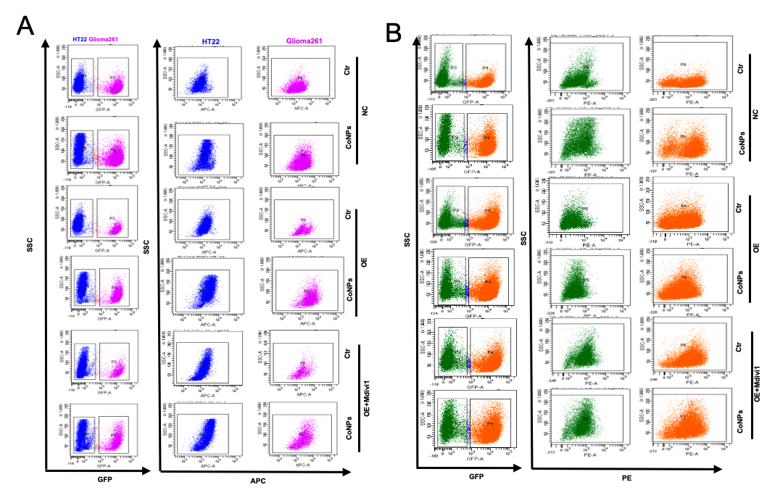
Figure S4. Flow cytometry dot plots of mtROS and MMP in NR_030777-overexpressing and DRP1-inhibited Glioma261 and HT22 cells after co-culture and CoNPs treatment. (A) mtROS dot plots. (B) MMP dot plots. All measurements were performed after 24 h of co-culture and CoNPs treatment.

