SUPPLEMENTARY FIGURES AND TABLES
Age- and sex-specific modifiable risk factor profiles of dementia: evidence from the UK Biobank

Figure S1. Participant inclusion flowchart
Figure S2. Non-linear association between alcohol intake and dementia
Figure S3. Population attributable fractions of individual risk factors and risk factor categories in overall population
Table S1. Hazard ratios (HRs) and 95% confidence intervals (CIs) for associations between modifiable risk factors and dementia by age and sex
Table S2. Hazard ratios (HRs) and 95% confidence intervals (CIs) of incident dementia associated with each 1-point increment in risk scores (RSs) by age and sex
Table S3. Hazard ratios (HRs) and 95% confidence intervals (CIs) for associations between modifiable risk factors and dementia by age and sex (further adjusted for APOE genotype)
Table S4. Hazard ratios (HRs) and 95% confidence intervals (CIs) for associations between modifiable risk factors and dementia by age and sex (excluding participants being censored or developed dementia within the first 2 years)
Table S5. Hazard ratios (HRs) and 95% confidence intervals (CIs) for associations between modifiable risk factors and dementia by age and sex (excluding participants with stroke history)
Table S6. Hazard ratios (HRs) and 95% confidence intervals (CIs) for associations between modifiable risk factors and dementia by age and sex (treating mortality of other-cause as competing risk)
Table S7. Population-attributable fractions (PAFs) for incident dementia associated with individual risk factors by sex and age
Table S8. Population-attributable fractions for incident dementia associated with categories of risk factors by age and sex

Figure S1. Participant inclusion flowchart
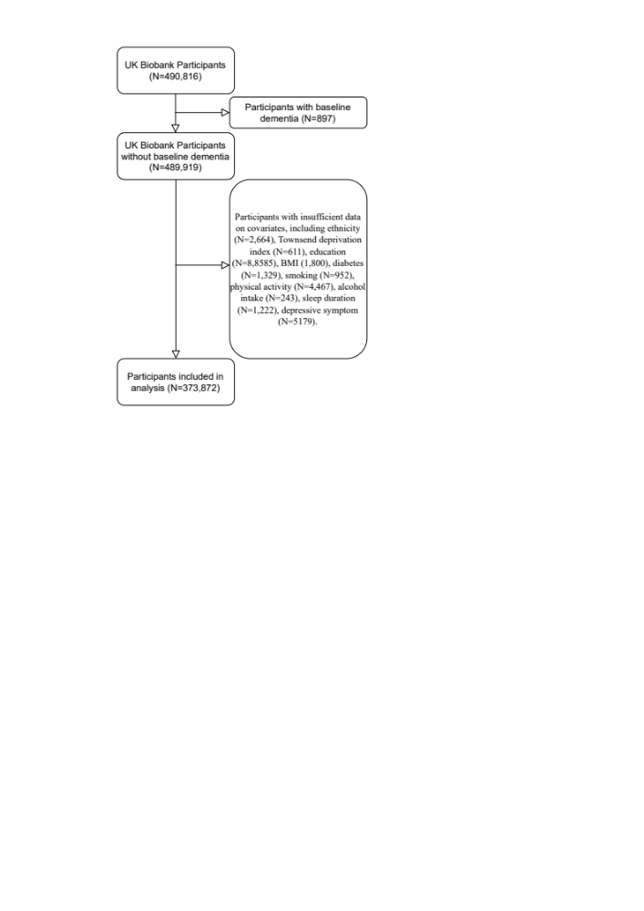

Figure S2. Non-linear association between alcohol intake and dementia
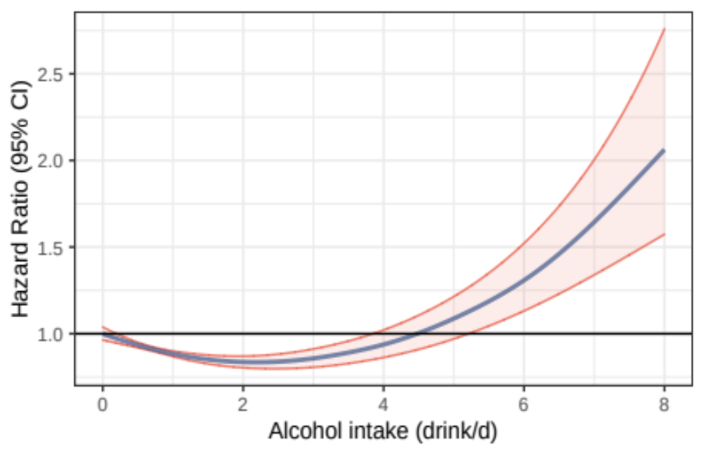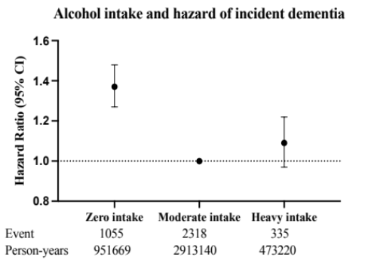
Model adjusted for age, sex, body mass index, education, Townsend deprivation index, smoking status, diet quality, physical exercise, sleep duration, hypertension, diabetes, cardiovascular diseases, and depressive symptom.

Figure S3. Population attributable fractions of individual risk factors and risk factor categories in overall population

Table S1. Hazard ratios (HRs) and 95% confidence intervals (CIs) for associations between modifiable risk factors and dementia by age and sex
 | Overall | Age |  |  |  |  |  | Sex
 | Overall | 40-<50 y | 50-<55 y | 55-<60 y | 60-<65 y | >=65 y | P-interaction | Female | Male | P-interaction
Events | 3708 | 113 | 146 | 360 | 1087 | 2002 |  | 1674 | 2034
Person-years | 4338030 | 1181219 | 721430 | 811949 | 972162 | 651268 |  | 2364974 | 1973055
Socioeconomic risk factors
High deprivation | 1.13 [1.06, 1.21] | 1.63 [1.07, 2.50] | 1.23 [0.88, 1.73] | 1.13 [0.91, 1.39] | 1.11 [0.98, 1.25] | 1.11 [1.02, 1.21] | 0.458 | 1.14 [1.03, 1.25] | 1.12 [1.02, 1.22] | 0.849
Below High School | 1.14 [1.07, 1.23] | 1.82 [1.16, 2.85] | 1.17 [0.83, 1.65] | 1.18 [0.95, 1.47] | 1.11 [0.97, 1.26] | 1.12 [1.02, 1.23] | 0.282 | 1.13 [1.02, 1.26] | 1.15 [1.05, 1.27] | 0.970
Lifestyle risk factors
Current smoking | 1.31 [1.17, 1.46] | 1.65 [1.07, 2.54] | 1.12 [0.69, 1.81] | 1.48 [1.09, 2.02] | 1.36 [1.11, 1.66] | 1.17 [0.98, 1.39] | 0.422 | 1.33 [1.11, 1.60] | 1.29 [1.12, 1.48] | 0.967
Insufficient physical activity | 1.13 [1.06, 1.22] | 1.42 [0.96, 2.10] | 1.28 [0.91, 1.81] | 1.12 [0.90, 1.40] | 1.12 [0.98, 1.27] | 1.12 [1.02, 1.23] | 0.760 | 1.11 [1.01, 1.23] | 1.15 [1.05, 1.27] | 0.678
Suboptimal diet | 0.97 [0.90, 1.04] | 1.86 [1.26, 2.74] | 1.22 [0.87, 1.72] | 0.88 [0.70, 1.10] | 0.91 [0.79, 1.04] | 0.96 [0.86, 1.06] | 0.006 | 0.96 [0.85, 1.08] | 0.97 [0.89, 1.07] | 0.722
Non-moderate alcohol intake | 1.29 [1.20, 1.39] | 1.28 [0.86, 1.89] | 1.90 [1.35, 2.68] | 1.11 [0.88, 1.40] | 1.41 [1.24, 1.61] | 1.22 [1.11, 1.35] | 0.049 | 1.28 [1.16, 1.41] | 1.30 [1.17, 1.44] | 0.991
Sleep <=6 or >=8 hrs | 1.16 [1.08, 1.24] | 1.56 [1.03, 2.36] | 1.25 [0.89, 1.76] | 1.26 [1.01, 1.56] | 1.09 [0.96, 1.23] | 1.15 [1.05, 1.27] | 0.425 | 1.16 [1.05, 1.29] | 1.16 [1.06, 1.27] | 0.836
Health condition risk factors
Hypertension | 1.16 [1.08, 1.25] | 1.52 [0.96, 2.42] | 1.38 [0.94, 2.02] | 1.57 [1.25, 1.96] | 1.14 [1.00, 1.30] | 1.08 [0.99, 1.19] | 0.025 | 1.18 [1.06, 1.31] | 1.14 [1.04, 1.26] | 0.288
Cardiovascular diseases | 1.81 [1.65, 1.99] | 4.20 [2.15, 8.22] | 2.23 [1.22, 4.08] | 1.76 [1.23, 2.53] | 2.24 [1.89, 2.66] | 1.64 [1.45, 1.85] | 0.008 | 1.95 [1.65, 2.30] | 1.77 [1.58, 1.99] | 0.190
Diabetes | 1.93 [1.74, 2.14] | 3.09 [1.60, 6.00] | 3.06 [1.79, 5.23] | 1.61 [1.11, 2.33] | 2.33 [1.94, 2.80] | 1.73 [1.51, 2.00] | 0.021 | 2.15 [1.80, 2.57] | 1.83 [1.61, 2.08] | 0.132
Depressive Symptom | 1.99 [1.73, 2.28] | 2.74 [1.71, 4.39] | 1.58 [0.93, 2.70] | 2.47 [1.76, 3.46] | 1.60 [1.22, 2.11] | 1.89 [1.53, 2.35] | 0.167 | 1.95 [1.61, 2.36] | 2.01 [1.65, 2.46] | 0.662
Models were adjusted for age (not in the age-stratified models), sex (not in the sex-stratified models), and mutually adjusted for individual risk factors. P-interaction was calculated as the significance of the multiplication term of individual risk factors and sex or age in the overall population.

Table S2. Hazard ratios (HRs) and 95% confidence intervals (CIs) of incident dementia associated with each 1-point increment in risk scores (RSs) by age and sex
 | Socioeconomic RS | P interaction | Lifestyle RS | P interaction | Health condition RS | P interaction
Overall | 1.14 [1.09, 1.20] |  | 1.15 [1.11, 1.19] |  | 1.50 [1.44, 1.56]
By sex |  | 0.943 |  | >0.999 |  | 0.891
Female | 1.14 [1.06, 1.23] |  | 1.15 [1.10, 1.20] |  | 1.52 [1.43, 1.63]
Male | 1.14 [1.07, 1.21] |  | 1.15 [1.10, 1.20] |  | 1.49 [1.41, 1.57]
By age |  | 0.003 |  | 0.001 |  | <0.001
40-<50 | 1.74 [1.28, 2.35] |  | 1.56 [1.33, 1.84] |  | 2.36 [1.90, 2.95]
50-<55 | 1.19 [0.94, 1.51] |  | 1.34 [1.16, 1.55] |  | 1.80 [1.47, 2.20]
55-<60 | 1.16 [1.00, 1.35] |  | 1.13 [1.02, 1.25] |  | 1.72 [1.51, 1.95]
60-<65 | 1.12 [1.03, 1.22] |  | 1.14 [1.07, 1.21] |  | 1.60 [1.49, 1.73]
>=65 | 1.11 [1.04, 1.19] |  | 1.11 [1.07, 1.16] |  | 1.37 [1.29, 1.45]
Socioeconomic risk factors included education below high school and high Townsend deprivation index, with the risk score ranging from 0 to 2. Lifestyle risk factors included non-moderate alcohol intake, current smoking behaviour, suboptimal diet, non-regular physical exercise, and sleep duration <=6 or >=8 hrs/d, with the risk score ranging from 0 to 5. Health condition risk factors included hypertension, diabetes, cardiovascular diseases, and depressive symptom, with the risk score ranging from 0 to 4. Models were adjusted for age (not in the age-stratified models), sex (not in the sex-stratified models), and mutually adjusted for risk scores of other categories.

Table S3. Hazard ratios (HRs) and 95% confidence intervals (CIs) for associations between modifiable risk factors and dementia by age and sex (further adjusted for APOE genotype)
 | Overall | Age |  |  |  |  | Sex
 | Overall | 40-<50 y | 50-<55 y | 55-<60 y | 60-<65 y | >=65 y | Female | Male
Events | 3056 | 94 | 123 | 284 | 898 | 1657 | 1410 | 1646
Person-years | 3614302.031 | 991009.988 | 601305.7 | 674547.803 | 806713.32 | 540725.221 | 1979755.29 | 1634546.75
Socioeconomic risk factors
High deprivation | 1.12 [1.04, 1.21] | 2.00 [1.24, 3.24] | 1.21 [0.84, 1.75] | 1.17 [0.92, 1.49] | 1.06 [0.93, 1.21] | 1.11 [1.00, 1.22] | 1.17 [1.05, 1.30] | 1.08 [0.98, 1.20]
Below High School | 1.12 [1.04, 1.21] | 1.60 [1.00, 2.57] | 1.15 [0.79, 1.67] | 1.21 [0.95, 1.55] | 1.04 [0.90, 1.19] | 1.12 [1.01, 1.24] | 1.14 [1.01, 1.28] | 1.10 [1.00, 1.22]
Lifestyle risk factors
Current smoking | 1.30 [1.15, 1.48] | 1.57 [0.96, 2.57] | 1.57 [0.96, 2.57] | 1.48 [1.04, 2.11] | 1.36 [1.08, 1.71] | 1.12 [0.92, 1.36] | 1.36 [1.10, 1.67] | 1.27 [1.09, 1.49]
Insufficient physical activity | 1.16 [1.08, 1.25] | 1.35 [0.88, 2.07] | 1.33 [0.92, 1.93] | 1.17 [0.91, 1.49] | 1.13 [0.98, 1.30] | 1.16 [1.04, 1.28] | 1.16 [1.03, 1.29] | 1.17 [1.05, 1.30]
Suboptimal diet | 1.00 [0.92, 1.08] | 2.07 [1.35, 3.18] | 1.27 [0.88, 1.84] | 0.91 [0.70, 1.17] | 0.94 [0.81, 1.09] | 0.98 [0.88, 1.10] | 1.01 [0.89, 1.16] | 0.99 [0.90, 1.10]
Non-moderate alcohol intake | 1.29 [1.20, 1.40] | 1.43 [0.93, 2.19] | 1.73 [1.19, 2.53] | 1.22 [0.94, 1.58] | 1.37 [1.19, 1.58] | 1.22 [1.10, 1.36] | 1.26 [1.13, 1.40] | 1.32 [1.18, 1.48]
Sleep <=6 or >=8 hrs | 1.18 [1.10, 1.28] | 1.74 [1.09, 2.76] | 1.34 [0.92, 1.96] | 1.34 [1.04, 1.71] | 1.11 [0.96, 1.27] | 1.16 [1.05, 1.29] | 1.21 [1.08, 1.35] | 1.16 [1.05, 1.29]
Health condition risk factors
Hypertension | 1.16 [1.07, 1.25] | 1.40 [0.84, 2.36] | 1.39 [0.91, 2.10] | 1.62 [1.26, 2.09] | 1.13 [0.98, 1.30] | 1.08 [0.98, 1.20] | 1.19 [1.07, 1.34] | 1.12 [1.01, 1.24]
Cardiovascular diseases | 1.78 [1.60, 1.97] | 4.57 [2.18, 9.59] | 1.51 [0.71, 3.22] | 1.56 [1.01, 2.39] | 2.17 [1.79, 2.63] | 1.64 [1.43, 1.87] | 1.98 [1.65, 2.38] | 1.72 [1.51, 1.95]
Diabetes | 1.91 [1.70, 2.15] | 3.21 [1.54, 6.68] | 3.89 [2.22, 6.82] | 1.55 [1.01, 2.38] | 2.48 [2.02, 3.03] | 1.62 [1.38, 1.90] | 2.05 [1.68, 2.50] | 1.86 [1.61, 2.15]
Depressive Symptom | 2.01 [1.73, 2.34] | 2.82 [1.68, 4.71] | 1.49 [0.82, 2.69] | 2.41 [1.65, 3.52] | 1.64 [1.22, 2.22] | 1.97 [1.56, 2.49] | 1.90 [1.54, 2.34] | 2.13 [1.71, 2.64]
Models were adjusted for age (not in the age-stratified models), sex (not in the sex-stratified models), and mutually adjusted for individual risk factors. P-interaction was calculated as the significance of the multiplication term of individual risk factors and sex or age in the overall population.

Table S4. Hazard ratios (HRs) and 95% confidence intervals (CIs) for associations between modifiable risk factors and dementia by age and sex (excluding participants being censored or developed dementia within the first 2 years)
 | Overall | Age |  |  |  |  | Sex
 | Overall | 40-<50 y | 50-<55 y | 55-<60 y | 60-<65 y | >=65 y | Female | Male
Events | 3576 | 102 | 138 | 340 | 1052 | 1944 | 1624 | 1952
Person-years | 4336210.349 | 1181030.78 | 721221.073 | 811640.274 | 971627.02 | 650691.203 | 2364265.35 | 1971945
Socioeconomic risk factors
High deprivation | 1.13 [1.06, 1.21] | 1.60 [1.03, 2.48] | 1.26 [0.89, 1.78] | 1.11 [0.89, 1.38] | 1.10 [0.97, 1.24] | 1.12 [1.02, 1.22] | 1.14 [1.03, 1.26] | 1.12 [1.02, 1.22]
Below High School | 1.14 [1.06, 1.23] | 1.79 [1.12, 2.85] | 1.18 [0.83, 1.68] | 1.16 [0.93, 1.46] | 1.10 [0.97, 1.26] | 1.12 [1.02, 1.24] | 1.14 [1.02, 1.26] | 1.15 [1.05, 1.26]
Lifestyle risk factors
Current smoking | 1.31 [1.17, 1.47] | 1.68 [1.06, 2.65] | 1.13 [0.69, 1.85] | 1.53 [1.12, 2.09] | 1.34 [1.10, 1.65] | 1.18 [0.99, 1.41] | 1.31 [1.09, 1.58] | 1.31 [1.13, 1.51]
Insufficient physical activity | 1.15 [1.07, 1.23] | 1.37 [0.91, 2.07] | 1.36 [0.96, 1.94] | 1.17 [0.93, 1.47] | 1.12 [0.98, 1.27] | 1.13 [1.03, 1.24] | 1.12 [1.00, 1.24] | 1.17 [1.07, 1.29]
Suboptimal diet | 0.95 [0.88, 1.02] | 1.81 [1.20, 2.73] | 1.18 [0.83, 1.68] | 0.86 [0.68, 1.09] | 0.91 [0.79, 1.04] | 0.92 [0.83, 1.03] | 0.93 [0.82, 1.05] | 0.95 [0.87, 1.05]
Non-moderate alcohol intake | 1.28 [1.20, 1.38] | 1.30 [0.86, 1.97] | 1.86 [1.31, 2.65] | 1.10 [0.87, 1.40] | 1.40 [1.23, 1.59] | 1.22 [1.10, 1.34] | 1.27 [1.15, 1.40] | 1.29 [1.17, 1.43]
Sleep <=6 or >=8 hrs | 1.15 [1.07, 1.23] | 1.44 [0.94, 2.21] | 1.21 [0.85, 1.72] | 1.21 [0.97, 1.51] | 1.07 [0.94, 1.22] | 1.16 [1.05, 1.27] | 1.14 [1.03, 1.26] | 1.16 [1.05, 1.27]
Health condition risk factors
Hypertension | 1.15 [1.07, 1.24] | 1.41 [0.86, 2.32] | 1.27 [0.86, 1.89] | 1.56 [1.24, 1.97] | 1.14 [1.00, 1.30] | 1.08 [0.98, 1.18] | 1.17 [1.05, 1.30] | 1.13 [1.03, 1.25]
Cardiovascular diseases | 1.80 [1.64, 1.98] | 3.52 [1.63, 7.58] | 2.16 [1.15, 4.04] | 1.65 [1.13, 2.42] | 2.25 [1.88, 2.68] | 1.64 [1.45, 1.86] | 1.95 [1.64, 2.31] | 1.76 [1.57, 1.97]
Diabetes | 1.91 [1.72, 2.12] | 2.67 [1.27, 5.63] | 3.04 [1.75, 5.27] | 1.64 [1.12, 2.39] | 2.29 [1.90, 2.77] | 1.73 [1.50, 2.00] | 2.09 [1.74, 2.51] | 1.84 [1.61, 2.10]
Depressive Symptom | 1.95 [1.69, 2.25] | 2.80 [1.70, 4.62] | 1.69 [0.99, 2.89] | 2.58 [1.83, 3.63] | 1.54 [1.15, 2.05] | 1.84 [1.47, 2.30] | 1.94 [1.60, 2.36] | 1.95 [1.59, 2.40]
Models were adjusted for age (not in the age-stratified models), sex (not in the sex-stratified models), and mutually adjusted for individual risk factors. P-interaction was calculated as the significance of the multiplication term of individual risk factors and sex or age in the overall population.

Table S5. Hazard ratios (HRs) and 95% confidence intervals (CIs) for associations between modifiable risk factors and dementia by age and sex (excluding participants with stroke history)
 | Overall | Age |  |  |  |  | Sex
 | Overall | 40-<50 y | 50-<55 y | 55-<60 y | 60-<65 y | >=65 y | Female | Male
Events | 3520 | 106 | 140 | 338 | 1033 | 1903 | 1613 | 1907
Person-years | 4289300.257 | 1176275.99 | 715915.573 | 803351.743 | 958003.236 | 635753.711 | 2344886.66 | 1944413.59
Socioeconomic risk factors
High deprivation | 1.13 [1.06, 1.21] | 1.61 [1.04, 2.48] | 1.20 [0.85, 1.69] | 1.12 [0.90, 1.39] | 1.12 [0.99, 1.26] | 1.12 [1.02, 1.23] | 1.14 [1.03, 1.26] | 1.12 [1.03, 1.23]
Below High School | 1.16 [1.08, 1.24] | 1.70 [1.08, 2.67] | 1.11 [0.78, 1.57] | 1.20 [0.96, 1.51] | 1.14 [1.00, 1.30] | 1.12 [1.02, 1.24] | 1.13 [1.02, 1.26] | 1.17 [1.07, 1.29]
Lifestyle risk factors
Current smoking | 1.28 [1.14, 1.44] | 1.71 [1.10, 2.68] | 1.16 [0.71, 1.90] | 1.40 [1.01, 1.93] | 1.32 [1.07, 1.62] | 1.18 [0.98, 1.40] | 1.31 [1.08, 1.58] | 1.27 [1.10, 1.47]
Insufficient physical activity | 1.12 [1.04, 1.20] | 1.40 [0.94, 2.10] | 1.20 [0.84, 1.71] | 1.16 [0.92, 1.46] | 1.08 [0.95, 1.24] | 1.12 [1.01, 1.23] | 1.11 [1.00, 1.24] | 1.13 [1.02, 1.25]
Suboptimal diet | 0.98 [0.91, 1.05] | 1.87 [1.25, 2.80] | 1.23 [0.87, 1.74] | 0.87 [0.68, 1.10] | 0.92 [0.80, 1.06] | 0.97 [0.87, 1.07] | 0.97 [0.86, 1.09] | 0.98 [0.89, 1.08]
Non-moderate alcohol intake | 1.28 [1.19, 1.38] | 1.30 [0.87, 1.95] | 1.96 [1.38, 2.78] | 1.15 [0.91, 1.46] | 1.42 [1.24, 1.62] | 1.19 [1.08, 1.31] | 1.26 [1.14, 1.39] | 1.30 [1.17, 1.44]
Sleep <=6 or >=8 hrs | 1.15 [1.07, 1.24] | 1.53 [1.00, 2.34] | 1.19 [0.84, 1.68] | 1.20 [0.96, 1.51] | 1.08 [0.95, 1.23] | 1.16 [1.05, 1.28] | 1.14 [1.03, 1.26] | 1.17 [1.06, 1.28]
Health condition risk factors
Hypertension | 1.17 [1.09, 1.25] | 1.39 [0.85, 2.28] | 1.43 [0.97, 2.11] | 1.51 [1.19, 1.90] | 1.16 [1.01, 1.32] | 1.10 [1.00, 1.21] | 1.19 [1.07, 1.32] | 1.14 [1.04, 1.26]
Cardiovascular diseases | 1.57 [1.41, 1.76] | 2.46 [0.87, 6.91] | 1.70 [0.77, 3.75] | 0.94 [0.54, 1.62] | 1.98 [1.61, 2.42] | 1.51 [1.31, 1.74] | 1.72 [1.40, 2.12] | 1.54 [1.35, 1.75]
Diabetes | 1.92 [1.72, 2.14] | 2.88 [1.38, 6.01] | 3.07 [1.75, 5.37] | 1.65 [1.12, 2.44] | 2.29 [1.88, 2.78] | 1.75 [1.51, 2.02] | 2.13 [1.77, 2.56] | 1.83 [1.60, 2.09]
Depressive Symptom | 1.95 [1.69, 2.25] | 3.07 [1.90, 4.97] | 1.67 [0.96, 2.89] | 2.52 [1.77, 3.59] | 1.54 [1.15, 2.07] | 1.82 [1.45, 2.29] | 1.89 [1.55, 2.31] | 2.00 [1.62, 2.47]
Models were adjusted for age (not in the age-stratified models), sex (not in the sex-stratified models), and mutually adjusted for individual risk factors. P-interaction was calculated as the significance of the multiplication term of individual risk factors and sex or age in the overall population.

Table S6. Hazard ratios (HRs) and 95% confidence intervals (CIs) for associations between modifiable risk factors and dementia by age and sex (treating mortality of other-cause as competing risk)
 | Overall | Age |  |  |  |  | Sex
 | Overall | 40-<50 y | 50-<55 y | 55-<60 y | 60-<65 y | >=65 y | Female | Male
Events | 3576 | 102 | 138 | 340 | 1052 | 1944 | 1624 | 1952
Person-years | 4336210.349 | 1181030.779 | 721221.0732 | 811640.2738 | 971627.0198 | 650691.2033 | 2364265.35 | 1971945
Socioeconomic risk factors
High deprivation | 1.13 [1.06, 1.22] | 1.62 [1.07, 2.46] | 1.19 [0.85, 1.66] | 1.12 [0.91, 1.39] | 1.12 [0.99, 1.26] | 1.10 [1.00, 1.20] | 1.13 [1.03, 1.25] | 1.11 [1.02, 1.21]
Below High School | 1.14 [1.07, 1.22] | 1.83 [1.17, 2.85] | 1.19 [0.85, 1.67] | 1.17 [0.94, 1.45] | 1.08 [0.95, 1.22] | 1.11 [1.01, 1.23] | 1.13 [1.02, 1.26] | 1.14 [1.04, 1.25]
Lifestyle risk factors
Current smoking | 1.27 [1.14, 1.42] | 1.67 [1.10, 2.55] | 1.08 [0.67, 1.75] | 1.44 [1.06, 1.95] | 1.30 [1.07, 1.59] | 1.12 [0.94, 1.33] | 1.30 [1.08, 1.56] | 1.23 [1.07, 1.42]
Insufficient physical activity | 1.11 [1.04, 1.19] | 1.40 [0.95, 2.09] | 1.29 [0.91, 1.82] | 1.11 [0.90, 1.39] | 1.10 [0.97, 1.25] | 1.09 [0.99, 1.20] | 1.10 [0.99, 1.22] | 1.12 [1.02, 1.23]
Suboptimal diet | 0.97 [0.90, 1.04] | 1.89 [1.28, 2.78] | 1.23 [0.89, 1.72] | 0.88 [0.70, 1.11] | 0.91 [0.79, 1.04] | 0.95 [0.85, 1.05] | 0.96 [0.85, 1.08] | 0.97 [0.89, 1.06]
Non-moderate alcohol intake | 1.29 [1.20, 1.38] | 1.27 [0.86, 1.86] | 1.81 [1.31, 2.51] | 1.13 [0.89, 1.42] | 1.41 [1.24, 1.60] | 1.19 [1.08, 1.31] | 1.27 [1.15, 1.40] | 1.27 [1.15, 1.41]
Sleep <=6 or >=8 hrs | 1.15 [1.07, 1.23] | 1.54 [1.02, 2.34] | 1.24 [0.88, 1.74] | 1.24 [1.00, 1.53] | 1.07 [0.95, 1.22] | 1.14 [1.04, 1.25] | 1.16 [1.04, 1.28] | 1.14 [1.04, 1.25]
Health condition risk factors
Hypertension | 1.15 [1.07, 1.24] | 1.41 [0.89, 2.23] | 1.35 [0.93, 1.97] | 1.52 [1.22, 1.88] | 1.11 [0.97, 1.27] | 1.06 [0.97, 1.17] | 1.15 [1.03, 1.28] | 1.12 [1.02, 1.23]
Cardiovascular diseases | 1.73 [1.57, 1.90] | 3.83 [1.89, 7.74] | 2.16 [1.19, 3.92] | 1.67 [1.17, 2.39] | 2.08 [1.75, 2.47] | 1.52 [1.35, 1.72] | 1.86 [1.57, 2.20] | 1.65 [1.47, 1.85]
Diabetes | 1.89 [1.71, 2.10] | 2.80 [1.38, 5.68] | 2.80 [1.62, 4.84] | 1.58 [1.11, 2.26] | 2.23 [1.85, 2.69] | 1.63 [1.41, 1.88] | 2.06 [1.73, 2.46] | 1.73 [1.52, 1.97]
Depressive Symptom | 2.01 [1.76, 2.31] | 2.68 [1.63, 4.40] | 1.51 [0.89, 2.56] | 2.53 [1.81, 3.55] | 1.64 [1.25, 2.17] | 1.88 [1.51, 2.33] | 1.97 [1.63, 2.38] | 1.99 [1.63, 2.44]
Models were adjusted for age (not in the age-stratified models), sex (not in the sex-stratified models), and mutually adjusted for individual risk factors. P-interaction was calculated as the significance of the multiplication term of individual risk factors and sex or age in the overall population.

Table S7. Population-attributable fractions (PAFs) for incident dementia associated with individual risk factors by sex and age
 | Age |  |  |  |  | Sex
 | 40-<50 y | 50-<55 y | 55-<60 y | 60-<65 y | >=65 y | Female | Male
Socioeconomic risk factors
High deprivation | 28.25% [6.54%, 49.97%] | 11.40% [0.00%, 29.11%] | 6.17% [0.00%, 17.06%] | 4.88% [0.00%, 10.65%] | 4.74% [0.69%, 8.78%] | 6.19% [1.50%, 10.89%] | 5.28% [1.17%, 9.38%]
Below High School | 34.67% [11.95%, 57.38%] | 9.49% [0.00%, 29.65%] | 9.72% [0.00%, 22.08%] | 6.32% [0.00%, 14.23%] | 7.11% [1.06%, 13.17%] | 8.03% [1.17%, 14.89%] | 8.67% [3.19%, 14.15%]
Lifestyle risk factors
Current smoking | 10.51% [0.49%, 20.52%] | 1.50% [0.00%, 8.09%] | 4.75% [0.59%, 8.91%] | 2.83% [0.77%, 4.89%] | 1.09% [0.00%, 2.38%] | 1.98% [0.57%, 3.38%] | 2.57% [1.01%, 4.14%]
Insufficient physical activity | 11.90% [0.00%, 25.62%] | 8.31% [0.00%, 20.22%] | 3.80% [0.00%, 11.11%] | 3.51% [0.00%, 7.65%] | 3.42% [0.46%, 6.38%] | 3.45% [0.09%, 6.80%] | 4.35% [1.40%, 7.31%]
Suboptimal diet | 27.80% [11.26%, 44.35%] | 7.64% [0.00%, 20.36%] | 0.00% [0.00%, 3.31%] | 0.00% [0.00%, 1.08%] | 0.00% [0.00%, 1.54%] | 0.00% [0.00%, 1.57%] | 0.00% [0.00%, 2.41%]
Non-moderate alcohol intake | 9.96% [0.00%, 25.95%] | 22.92% [10.88%, 34.97%] | 3.48% [0.00%, 11.34%] | 11.31% [6.98%, 15.65%] | 6.59% [3.34%, 9.83%] | 11.14% [6.69%, 15.59%] | 6.19% [3.65%, 8.72%]
Sleep <=6 or >=8 hrs | 25.77% [3.66%, 47.87%] | 12.98% [0.00%, 32.23%] | 13.21% [1.10%, 25.31%] | 5.09% [0.00%, 12.74%] | 8.97% [3.22%, 14.71%] | 9.25% [3.07%, 15.43%] | 9.13% [3.59%, 14.67%]
Health condition risk factors
Hypertension | 9.01% [0.00%, 19.56%] | 8.79% [0.00%, 19.55%] | 14.59% [7.30%, 21.88%] | 4.92% [0.02%, 9.81%] | 3.20% [0.00%, 6.96%] | 5.50% [1.86%, 9.13%] | 5.47% [1.67%, 9.28%]
Heart Diseases | 7.83% [1.71%, 13.95%] | 5.13% [0.09%, 10.17%] | 4.53% [1.06%, 8.00%] | 8.89% [6.46%, 11.33%] | 6.90% [4.95%, 8.86%] | 4.79% [3.24%, 6.34%] | 9.12% [7.01%, 11.22%]
Diabetes | 7.56% [1.05%, 14.07%] | 9.23% [3.14%, 15.32%] | 3.99% [0.50%, 7.48%] | 8.41% [6.04%, 10.79%] | 5.63% [3.91%, 7.35%] | 5.06% [3.54%, 6.58%] | 7.52% [5.61%, 9.42%]
Depressive Symptom | 13.87% [5.10%, 22.64%] | 4.20% [0.00%, 9.90%] | 6.85% [3.29%, 10.41%] | 1.97% [0.56%, 3.37%] | 2.16% [1.19%, 3.13%] | 3.47% [2.17%, 4.76%] | 2.73% [1.67%, 3.78%]
PAFs were calculated using adjusted hazard ratios (HRs) of each individual risk factors. Risk factors with a PAF below 0 were truncated at 0.

Table S8. Population-attributable fractions for incident dementia associated with categories of risk factors by age and sex
 | Sociodemographic risk factors | Lifestyle risk factors | Health condition risk factors
40-<50 | 52.56% [22.98%, 82.15%] | 46.57% [8.08%, 85.06%] | 35.42% [24.09%, 46.75%]
50-<55 | 13.71% [0.00%, 44.63%] | 54.67% [25.92%, 83.42%] | 20.90% [9.71%, 32.09%]
55-<60 | 24.46% [6.81%, 42.12%] | 17.21% [0.00%, 40.85%] | 20.79% [13.03%, 28.56%]
60-<65 | 7.80% [0.00%, 19.21%] | 21.24% [7.79%, 34.69%] | 19.51% [14.65%, 24.36%]
>=65 | 12.29% [3.82%, 20.75%] | 13.01% [2.53%, 23.49%] | 15.85% [11.81%, 19.90%]
Male | 16.38% [6.62%, 26.14%] | 21.67% [10.27%, 33.07%] | 15.72% [11.96%, 19.49%]
Female | 11.41% [3.60%, 19.21%] | 16.32% [6.50%, 26.13%] | 21.63% [17.63%, 25.63%]
PAFs were calculated using adjusted hazard ratios (HRs) of each categories of risk factors. Risk factor categories with a PAF below 0 were truncated at 0.

