Supplementary Materials
Experimental alloy
The Mg–1.8Zn–0.2Ca alloys were prepared from high-purity Mg, Zn, and Ca by induction melting in a steel mold crucible under a gas mixture of 99.5% CO2 and 0.5% SF6 atmosphere. The billet was homogenized at 673 K and subsequently extruded at 653 K with an extrusion ratio of 25:1 to produce a plate with a cross-sectional area of 40 × 5 mm².
Fig. S1 IPF map and pole figure of initial microstructure. Scale bar = 200 μm.
Supplementary for processing steps
M denotes the parent matrix with Euler angles of (88°, 79°, 31°). During the first deformation step, the T₁ twin variant, with Euler angles of (19°, 12°, 36°), is activated in M and is identified as the ($\text{01}\overline{\text{1}}\text{2}$) variant with respect to the parent matrix. A secondary twin, denoted as T₁₂, subsequently forms within T₁. T₁₂ has Euler angles of (150°, 83°, 26°) and corresponds to the ($\overline{\text{1}}\text{012}$) variant with T₁ serving as its parent orientation. During the subsequent change in strain path, another twin variant, T₃, is activated directly from M and is identified as the ($\overline{\text{1}}\text{102}$) variant relative to the parent matrix. The sequential formation of T₁, T₁₂ and T₃ illustrates strain-path-dependent twin-variant selection during multidirectional cyclic deformation and provides the crystallographic basis for interactions and reactions among different twin variants.
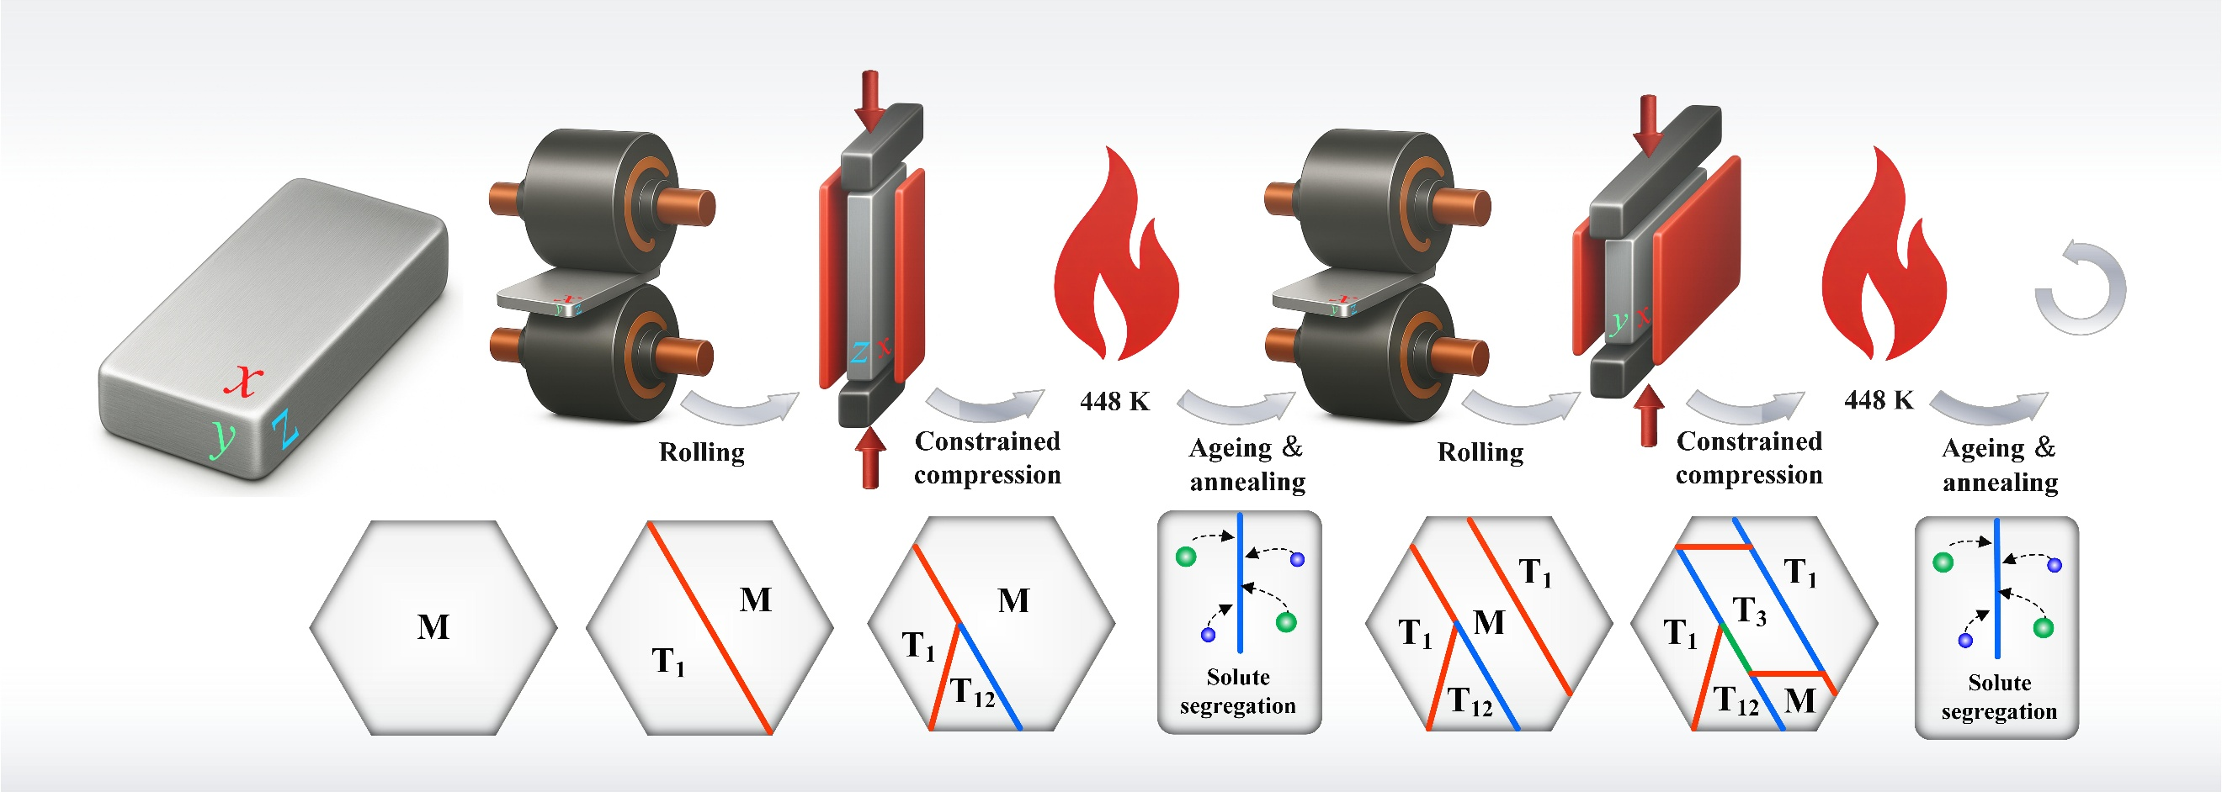
Fig. S2 Schematic drawing of the mechanical and thermal process, corresponding multi-directional strain induced twin-twin reaction and ageing induced solute segregation.
Fine-grained (FG) microstructure obtained via accumulative roll-bonding
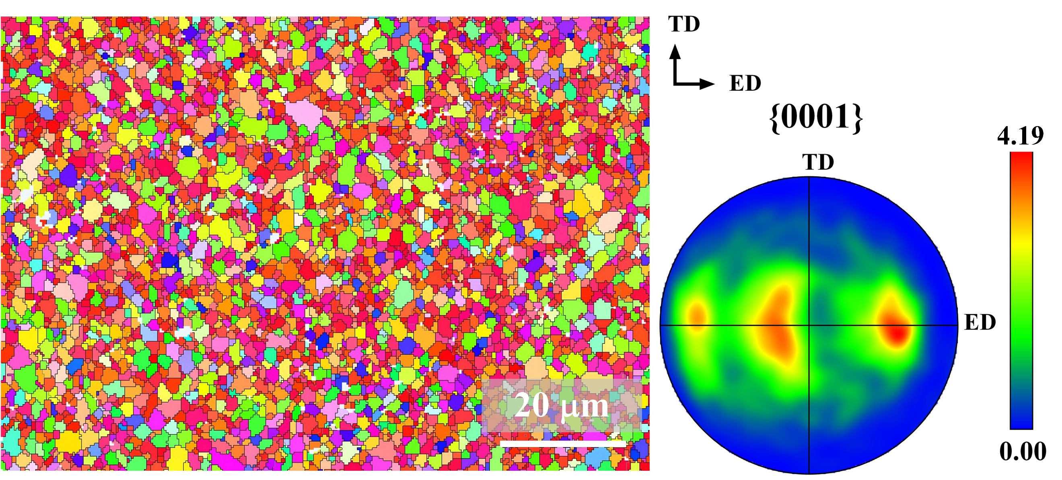
Fig. S3 IPF map and pole figure of FG microstructure via accumulative roll-bonding.
Supplementary for performance comparison
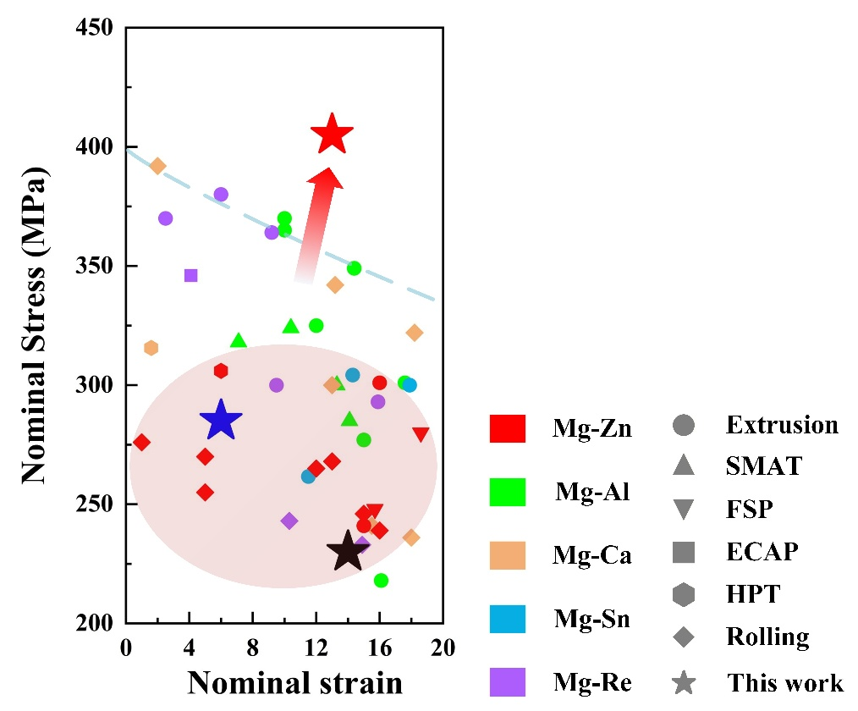
Fig. S4 Comparison of the ultimate tensile strengths and uniform elongations between UBN structure in this work and typical wrought Mg alloys.
The citation of Fig 2c is as follows:
Mg–Zn¹⁻⁷, Mg–Al⁸⁻¹¹, Mg–Ca¹²⁻¹⁴, Mg–Sn^{15,16}, Mg–Re¹⁷⁻²¹.
FIB-prepared lamellae for HAADF-STEM
Under HAADF-STEM imaging conditions, obtaining atomic-resolution contrast on both sides of the special boundary requires precise alignment to the [$\text{1}\overline{\text{1}}\text{0}\text{0}$] zone axis. To this end, TEM lamellae were prepared from the UBN by combining FIB milling and EBSD-assisted orientation control. The resulting specimens were subsequently characterised by TKD, as shown in Fig. S5.
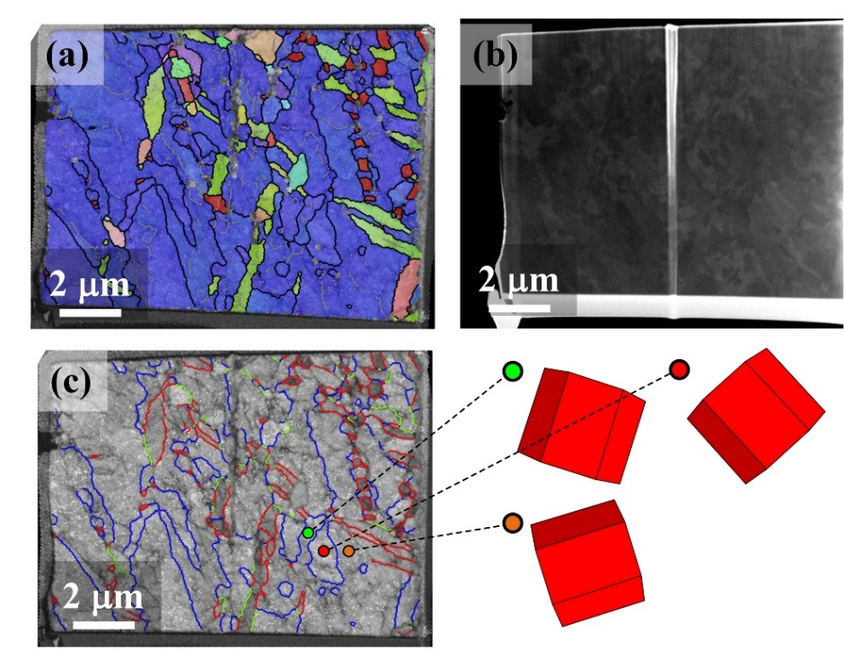
Fig. S5 TKD map of the FIB-prepared TEM sample. a IPF map. b Morphology map of the lamella. c Boundary misorientation map. The blue lines represent SCCBs. The red lines represent {$\text{10}\overline{\text{1}}\text{2}$} twin boundaries.
The diffraction information of SCCBs
The diffraction information for the two coherent symmetric boundaries shown in Fig. 3 is provided in Fig. S6.
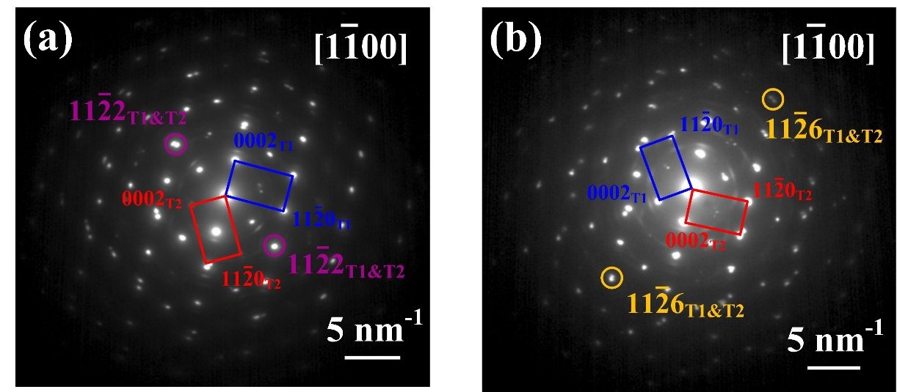
Fig. S6 Diffraction information corresponding to Fig. 3 of the main text.
Atomic-resolution EDS data
For lightweight alloys such as Mg, Al, and Ti, direct identification of atomic segregation remains particularly challenging, as segregated solute species are highly susceptible to electron-beam damage—especially the Zn and Ca examined in this work. By acquiring atomic-resolution EDS data at 120 kV (i.e. below the more commonly employed 300 kV), this issue was mitigated as far as practicable. For the {$\text{11}\overline{\text{2}}\text{6}$} special boundaries, the EDS maps of Zn and Ca (Fig. S7b) show that the signals of both elements coincide with the high-intensity atomic sites. In the main text, the corresponding Zn and Ca occupancy sites are further assigned on the basis of DFT calculations.
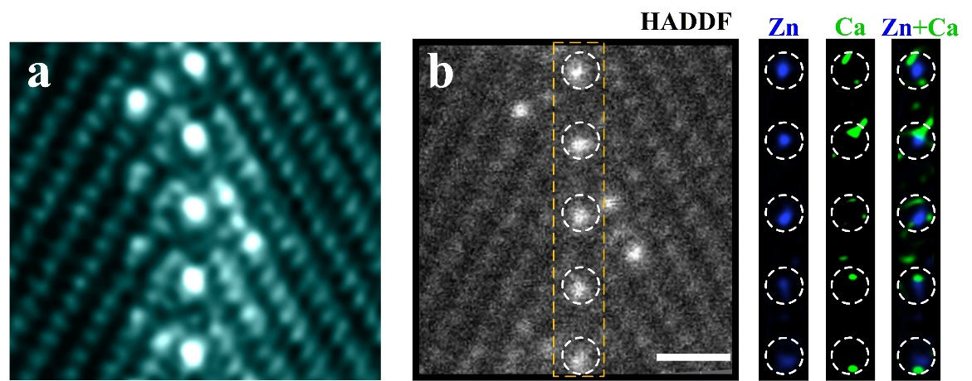
Fig. S7 The distribution of Zn and Ca atoms in the {$\text{11}\overline{\text{2}}\text{6}$} special boundary. a Atomic-resolution HAADF-STEM image. b Atomic-resolution EDS maps. Scale bar = 500 pm
For the superstructure of the {$\text{11}\overline{\text{2}}\text{2}$} special boundary, clear elemental contrast was observed only for the atomic columns at the boundaries. As shown in Fig. S8b, one column exhibits a pronounced Ca signal, whereas the other shows a pronounced Zn signal, with no indication of signal overlap as observed for the {$\text{11}\overline{\text{2}}\text{6}$} special boundaries. On the basis of the EDS data, a structure search for the atomic configuration of the superstructure was carried out in the main text via DFT calculation.
Fig. S8 The distribution of Zn and Ca atoms in boundary superstructure of the {$\text{11}\overline{\text{2}}\text{2}$} SCCBs. a Atomic-resolution HAADF-STEM image. b Atomic-resolution EDS maps.
Crystallographic calculation of special reaction boundaries
The special boundaries with [$\text{1}\overline{\text{1}}\text{00}$] ~60° misorientation can be generated through an impingement reaction between two ​non- co-zone {$\text{10}\overline{\text{1}}\text{2}$} twins. Following the deformation path graph proposed by Gao et al., a {$\text{10}\overline{\text{1}}\text{2}$} twin can be treated as the outcome of a single-step pathway. By using the lattice parameter of Mg, i.e., a = 3.209 Å and c = 5.211 Å, the deformation gradient matrix along this primary twinning path can be determined.
$${\text{F}}_{\text{H}\text{1}}\text{=}\left[\begin{matrix}\begin{matrix}\text{1} & \text{0} & \text{0} \\ \text{0} & \text{0} & \text{1.0666} \\ \text{0} & \text{-0.9375} & \text{0}\end{matrix}\end{matrix}\right]$$
The deformation gradient matrix along this secondary path can be determined.
$${\text{F}}_{\text{H}\text{4}}\text{=}\left[\begin{matrix}\begin{matrix}\text{0.5} & \text{0} & \text{0.9237} \\ \text{0} & \text{-1} & \text{0} \\ \text{0.8119} & \text{0} & \text{-0.5}\end{matrix}\end{matrix}\right]$$
From these deformation-gradient matrices, two conjugated solutions can be obtained. One solution suggests a plane of {$\text{11}\overline{\text{2}}\text{6}$} with a misorientation of 56.9° about [$\text{1}\overline{\text{1}}\text{00}$]. The other solution suggests a plane of {$\text{11}\overline{\text{2}}\text{2}$} with a misorientation of 63.3° about [$\text{1}\overline{\text{1}}\text{00}$].
FIB-prepared samples for APT
To ensure accurate acquisition of APT data from the special boundary and the {$\text{10}\overline{\text{1}}\text{2}$} twin boundaries, region targeting was carried out by combining FIB preparation with EBSD data. The symmetry-related orientation relationship across each boundary was confirmed from the pole figures corresponding to the respective symmetry planes, as shown in Fig. S9.
Fig. S9 Schematic diagram of FIB sampling for APT data. IPF maps for special boundaries and pole figures of the orientations on both sides of the special boundaries. Scale bar = 0.5 μm.
Analysis of the local stress state of atoms at the special boundaries
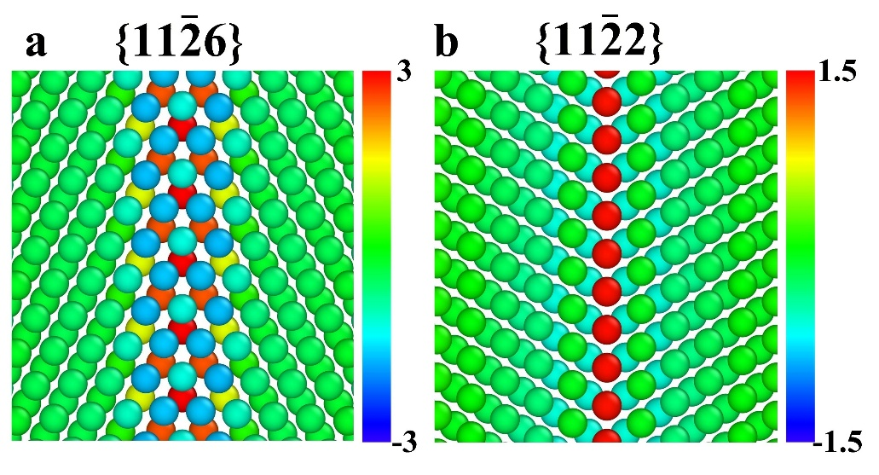
Fig. S10 Local Atomic Stress State at the special boundaries. a {$\text{11}\overline{\text{2}}\text{6}$} special boundaries. b {$\text{11}\overline{\text{2}}\text{2}$} special boundaries.
APT data of {$\text{10}\overline{\text{1}}\text{2}$} twin boundaries
Fig. S11 APT data of {$\text{10}\overline{\text{1}}\text{2}$} twin boundary. a APT reconstruction of Mg, Zn and Ca atoms. b The distribution of Zn and Ca atoms in a. c Solute concentration near boundary. Scale bar = 10 μm.
Microstructure of Mg-1.8Zn alloy under same cyclic process
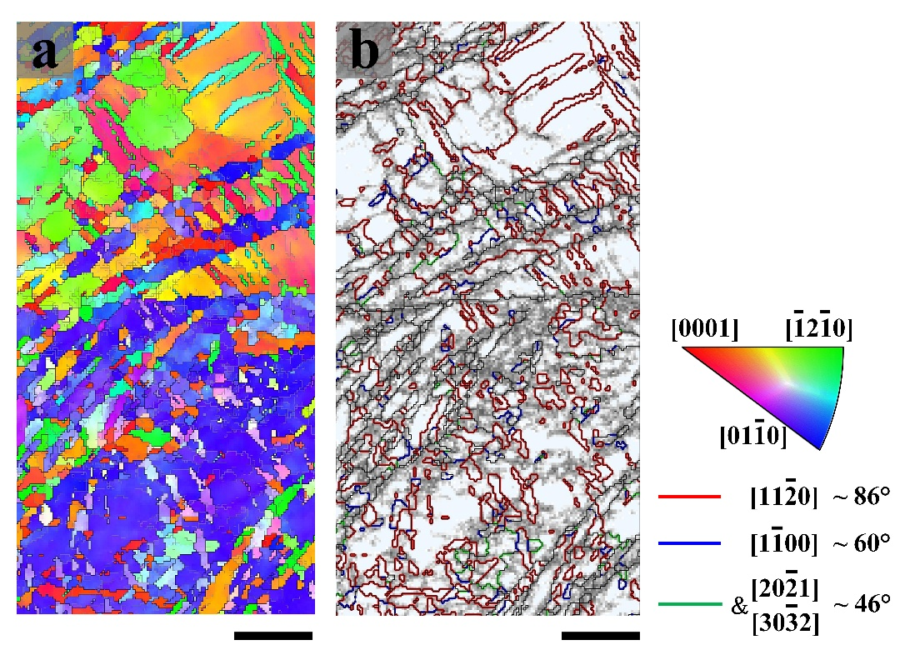
Fig. S12 a IPF map. b Boundary misorientation map. Scale bar = 5 μm.
Reference
1 Liu, X. Q. et al. Role of extrusion rate on the microstructure and tensile properties evolution of ultrahigh-strength low-alloy Mg-1.0Al-1.0Ca-0.4Mn (wt.%) alloy. Journal of Magnesium and Alloys 11, 553-561 (2023). https://doi.org/10.1016/j.jma.2021.05.010
2 Xu, Y., Li, J., Qi, M., Liao, L. & Gao, Z. Enhanced mechanical properties of Mg-Zn-Y-Zr alloy by low-speed indirect extrusion. Journal of Materials Research and Technology 9, 9856-9867 (2020). https://doi.org/10.1016/j.jmrt.2020.06.029
3 Li, Z., Xu, M., Cao, Y. & Zhao, Y. Current progress in strengthening, plastic deformation and thermal stability of Mg alloys. Journal of Alloys and Compounds 1018, 179151 (2025). https://doi.org/10.1016/j.jallcom.2025.179151
4 Vargas, M. et al. Microstructure, crystallographic texture and mechanical behaviour of friction stir processed Mg-Zn-Ca-Zr alloy ZKX50. Materials Science and Engineering: A 685, 253-264 (2017). https://doi.org/10.1016/j.msea.2016.12.125
5 Ojdanic, A. et al. The Effects of Severe Plastic Deformation and/or Thermal Treatment on the Mechanical Properties of Biodegradable Mg-Alloys. Metals 10, 1064 (2020).
6 Victoria-Hernández, J., Yi, S., Klaumünzer, D. & Letzig, D. Recrystallization behavior and its relationship with deformation mechanisms of a hot rolled Mg-Zn-Ca-Zr alloy. Materials Science and Engineering: A 761, 138054 (2019). https://doi.org/10.1016/j.msea.2019.138054
7 Li, S. et al. The role of Ca-induced Al2Ca and Ca2Mg6Zn3 phases in regulating the extrusion formability and mechanical properties of Mg-Al and Mg-Zn alloys. Journal of Alloys and Compounds 1057, 186815 (2026). https://doi.org/10.1016/j.jallcom.2026.186815
8 Zeng, Z. R. et al. Achieving exceptionally high strength in Mg3Al1Zn-0.3Mn extrusions via suppressing intergranular deformation. Acta Materialia 160, 97-108 (2018). https://doi.org/10.1016/j.actamat.2018.08.045
9 Zeng, Z. R. et al. Effects of Calcium on Strength and Microstructural Evolution of Extruded Alloys Based on Mg-3Al-1Zn-0.3Mn. Metallurgical and Materials Transactions A 50, 4344-4363 (2019). https://doi.org/10.1007/s11661-019-05318-6
10 Yan, X. et al. Mechanical behaviour of AZ31 magnesium alloy with the laminate and gradient structure. Philosophical Magazine 99, 3059-3077 (2019). https://doi.org/10.1080/14786435.2019.1660009
11 Duan, M., Luo, L. & Liu, Y. Microstructural evolution of AZ31 Mg alloy with surface mechanical attrition treatment: Grain and texture gradient. Journal of Alloys and Compounds 823, 153691 (2020). https://doi.org/10.1016/j.jallcom.2020.153691
12 She, J. et al. Improvement of strength-ductility balance by Mn addition in Mg–Ca extruded alloy. Materials Science and Engineering: A 772, 138796 (2020). https://doi.org/10.1016/j.msea.2019.138796
13 Pan, H. et al. Ultra-fine grain size and exceptionally high strength in dilute Mg–Ca alloys achieved by conventional one-step extrusion. Materials Letters 237, 65-68 (2019). https://doi.org/10.1016/j.matlet.2018.11.080
14 Kasaeian-Naeini, M., Sedighi, M. & Hashemi, R. Severe plastic deformation (SPD) of biodegradable magnesium alloys and composites: A review of developments and prospects. Journal of Magnesium and Alloys 10, 938-955 (2022). https://doi.org/10.1016/j.jma.2021.11.006
15 Han, D. et al. Achieving strength-ductility-biodegradation synergy in a low-alloyed Mg-Sn-Li-Ca alloy via multi-polarization of texture and second phases. Journal of Magnesium and Alloys, 102000 (2026). https://doi.org/10.1016/j.jma.2026.102000
16 Chai, Y. et al. Improvement of mechanical properties and reduction of yield asymmetry of extruded Mg-Sn-Zn alloy through Ca addition. Journal of Alloys and Compounds 782, 1076-1086 (2019). https://doi.org/10.1016/j.jallcom.2018.12.109
17 Pan, H. et al. Development of novel lightweight and cost-effective Mg–Ce–Al wrought alloy with high strength. Materials Research Letters 9, 329-335 (2021). https://doi.org/10.1080/21663831.2021.1918776
18 Yang, Y. et al. On the micromechanism of superior strength and ductility synergy in a heterostructured Mg-2.77Y alloy. Journal of Magnesium and Alloys 12, 2793-2811 (2024). https://doi.org/10.1016/j.jma.2022.10.027
19 Peng, P. et al. Significant improvement in yield stress of Mg-Gd-Mn alloy by forming bimodal grain structure. Materials Science and Engineering: A 803, 140569 (2021). https://doi.org/10.1016/j.msea.2020.140569
20 Peng, P. et al. Bimodal grained Mg–0.5Gd–xMn alloys with high strength and low-cost fabricated by low-temperature extrusion. Journal of Alloys and Compounds 935, 168008 (2023). https://doi.org/10.1016/j.jallcom.2022.168008
21 Bryła, K., Morgiel, J., Faryna, M., Edalati, K. & Horita, Z. Effect of high-pressure torsion on grain refinement, strength enhancement and uniform ductility of EZ magnesium alloy. Materials Letters 212, 323-326 (2018). https://doi.org/10.1016/j.matlet.2017.10.113

