Supplementary Information
A finite pool of agency, not of worry: health burden, deprivation and the vulnerability–voice gap in European climate opinion
European Social Survey Round 11, edition 4.2 (doi:10.21338/ess11e04_2) — 30 countries, N = 50,116. Contents: Supplementary Methods; Tables S1–S16; Figures S1–S6.

Supplementary Methods

1. Estimation and pooling
Two-step design. Step 1: within each country we estimate weighted least squares (post-stratification weights pspwght) with heteroskedasticity-robust (HC1) standard errors, regressing each climate outcome on the standardized focal burden measure plus demographic controls: age (z), age² (z), gender, education (ES-ISCED, z), urban residence, and current unemployment. Predictors are standardized on the pooled estimation sample; outcomes remain on their native scales (worry 1–5; responsibility 0–10; attribution 1–5) so pooled coefficients read as outcome points per 1 s.d. of burden. Step 2: the k = 30 country coefficients are pooled by DerSimonian–Laird (DL) random-effects meta-analysis; inference uses the Knapp–Hartung (KH) adjustment with t(k−1) reference distribution. We report τ², I², the country sign split, and 95% KH confidence intervals. Countries enter only if the country-specific complete-case sample is ≥250 (all 30 countries qualify in every model reported). One-step validation: linear mixed models (REML) with random intercepts and random slopes for the focal predictor reproduce every pooled estimate (Table S13, panel c).

2. Weights
Within-country regressions use pspwght; pooled descriptive quantities (Table 1, Fig. 1) use anweight = pspwght × pweight, following ESS weighting guidance. Confidence intervals for weighted shares in Fig. 1 use the Kish effective sample size. All headline models were re-estimated unweighted with virtually identical results (Table S13, panel b).

3. Measures and coding
All variables are taken from the ESS11 integrated file, edition 4.2, and were verified item-by-item against the edition codebook. Chronic conditions are the eleven CARD-54 items experienced in the last 12 months (heart or circulation problem; high blood pressure; breathing problems; allergies; back or neck pain; muscular or joint pain in hand or arm; muscular or joint pain in foot or leg; stomach or digestion related; skin condition related; severe headaches; diabetes), summed 0–11; batteries flagged refusal/don't know/no answer, or with no item marked including 'none of these', are set missing. Current cancer (hltprca = 1, CARD 55) is a robustness addition. Pre-specified climate-sensitivity classification — sensitive: heart/circulation, high blood pressure, breathing problems, allergies, diabetes (heat- and air-quality-linked morbidity per the Lancet Countdown Europe indicators); other: back/neck, hand/arm, foot/leg, stomach/digestion, skin, severe headaches. Unmet medical need is medtrun = 1 (unable to get a medical consultation or treatment in the last 12 months); reasons could-not-pay (medtrnp), waiting list (medtrwl) and no appointments (medtrnaa) define the affordability vs system split (waiting list OR no appointments). Housing problems are the eight CARD-57 accommodation items (mould/rot; damp/leaks; no indoor flushing toilet; neither bath nor shower; overcrowding; extreme heat or cold; noise; insects or rodents), summed 0–8. Financial strain is hincfel (1 living comfortably … 4 very difficult); objective income is the household decile hinctnta (valid n = 39,688). CES-D-8 sums fltdpr, flteeff, slprl, fltlnl, fltsd, cldgng and reversed wrhpp, enjlf to 0–24, prorated when exactly one item is missing. Perceived control reverses ctrlife (0–10). Childhood adversity: fnsdfml and cnfpplh, reversed. Denial is ccnthum = 55; because the responsibility item is filtered on not volunteering denial, responsibility gradients are conservative for any burden that raises denial.

4. Composite vulnerability and cumulative burden
The composite vulnerability index is the mean of four standardized domain scores — physical health (mean of z-scored poor self-rated health, hampered, condition count), unmet need, housing-problem count, financial strain — computed when at least three domains are observed, then re-standardized. Cumulative burden counts the domains (of four) in which the respondent falls above the pooled 75th percentile of the domain distribution; because unmet need (17.2% weighted) and any housing problem (22.7%) are minority states, their top quartile coincides with reporting the state at all, which rows 9–11 of Table 1 make explicit.

5. Outcome-contrast bootstrap (H3)
To compare associations across outcomes measured on different scales, we compute, within each country and on the same complete-case sample, the WLS slope of standardized worry and standardized responsibility (both divided by their pooled s.d.: 0.965 and 2.688) on the focal burden, and take the difference (responsibility minus worry). The within-country standard error of the difference comes from a nonparametric bootstrap (B = 500 row resamples, weights retained); country differences are then pooled by DL/KH exactly as in Methods 1. This respects the within-person covariance of the two outcomes that a naive comparison of separately estimated slopes would ignore.

6. Equivalence testing
For null concern effects we report two one-sided tests (TOST) against pre-specified bounds of ±0.05 outcome points per 1 s.d. of burden — about 5% of a worry s.d., i.e., smaller than every robustly detected positive effect in the study — using the KH standard error and t(k−1) distribution. P_TOST is the larger of the two one-sided P values.

7. Macro moderators (H4)
Log GDP per capita (PPP, current international $, 2023; World Bank) is carried over from the companion project's verified moderator file. Health-system strain (country unmet-need rate) and aggregate deprivation (country mean financial strain) are computed from ESS11 itself with pspwght. Meta-regressions are DL/KH with standardized moderators; R²meta is the proportional reduction in τ² relative to the intercept-only model (floored at 0). One-step validation adds the cross-level interaction to the mixed model of Methods 1.

8. Software and reproducibility
Python 3.11; pandas, numpy, statsmodels, scipy, matplotlib. The deposited pipeline (01_prepare … 13_figures_pub plus lib_meta) regenerates every number and figure in the paper and this SI from the public ESS11 file. ESS microdata are freely available from Sikt and are not redistributed.

9. Specificity outcomes and the worried subsample
Generic political participation is the count of five non-electoral acts in the last 12 months (sgnptit, bctprd, pbldmna, contplt, pstplonl; each 1 = yes, 2 = no), computed when at least four items are valid (s.d. = 1.10); voting is vote = 1 vs 2, with the not-eligible set missing (s.d. = 0.475). Both are modelled exactly as in Methods 1. The responsibility-vs-participation contrast uses the Methods 5 bootstrap on the same within-country complete-case sample, standardizing each outcome by its pooled s.d. The worried subsample comprises respondents with worry ≥ 4 (very or extremely worried; n = 17,726); weighted shares use anweight with Kish effective-n confidence intervals, and the within-subsample strain model repeats the Methods 1 specification with a 150-case country minimum.

10. Analysis flags and deviations
(i) One one-step model (attribution on self-rated health) and one one-step interaction model (responsibility on self-rated health × log GDP) did not converge; their two-step counterparts, which carry the reported inference, are unaffected. (ii) Hungary is a significant positive outlier for the strain–responsibility slope (+0.448); leave-one-out ranges are reported in Table S13 and the pooled estimate strengthens without it. (iii) Two marginal moderation signals (P ≈ .05–.06) are mutually incoherent across estimators and are treated as exploratory, not confirmatory. (iv) The bootstrap uses a fixed seed; B = 500.

Supplementary Tables
Table S1 | Per-country samples and weighted key rates.
Country | N | N model | Worry (1–5) | Resp. (0–10) | Unmet need % | Any housing problem % | Income difficult % | Bad/very bad SRH %
AT | 2,354 | 2,308 | 3.379 | 6.316 | 10.3 | 11.7 | 12.6 | 4.4
BE | 1,594 | 1,556 | 3.224 | 6.145 | 16.6 | 30.1 | 19.8 | 6.2
BG | 2,239 | 2,021 | 2.766 | 4.402 | 10.7 | 18.2 | 49.7 | 6.5
CH | 1,384 | 1,361 | 3.288 | 7.015 | 8.6 | 20 | 10.5 | 2.5
CY | 685 | 619 | 3.218 | 6.013 | 11 | 36 | 30.8 | 5.6
DE | 2,420 | 2,386 | 3.466 | 6.338 | 18.9 | 26.4 | 9.8 | 11.4
EE | 1,293 | 1,265 | 2.75 | 5.109 | 20.6 | 32.7 | 16.8 | 7.4
ES | 1,844 | 1,796 | 3.39 | 6.392 | 22.5 | 29 | 17.8 | 9.4
FI | 1,563 | 1,554 | 3.188 | 6.702 | 22.1 | 17.3 | 13.5 | 5.3
FR | 1,771 | 1,747 | 3.257 | 7.158 | 19 | 28.4 | 14.4 | 8.8
GB | 1,684 | 1,565 | 3.184 | 6.529 | 26.2 | 26.1 | 16.8 | 8.3
GR | 2,757 | 2,623 | 3.221 | 5.438 | 7.6 | 8.1 | 44.8 | 3
HR | 1,563 | 1,524 | 3.316 | 4.767 | 13.6 | 15.1 | 16.6 | 10.9
HU | 2,118 | 2,040 | 3.302 | 5.544 | 10.3 | 14.3 | 25.4 | 8
IE | 2,017 | 1,932 | 3.081 | 6.484 | 13.5 | 18.3 | 17.7 | 2.7
IL | 906 | 780 | 2.84 | 4.653 | 14.7 | 24.5 | 23 | 7.2
IS | 842 | 829 | 2.957 | 6.053 | 26.8 | 28.8 | 11 | 6.3
IT | 2,865 | 2,722 | 3.268 | 5.734 | 10.8 | 14.7 | 21.3 | 6.2
LT | 1,365 | 1,292 | 2.923 | 5.497 | 19.3 | 15.9 | 16.8 | 7.2
LV | 1,252 | 1,167 | 2.87 | 4.271 | 18.1 | 25.4 | 38.3 | 12.5
ME | 1,609 | 1,438 | 2.972 | 4.292 | 17.5 | 20.6 | 49.9 | 6.2
NL | 1,695 | 1,670 | 3.155 | 6.361 | 7.6 | 23.3 | 6.9 | 4.6
NO | 1,337 | 1,331 | 3.123 | 6.635 | 22.5 | 21.5 | 8.1 | 6.6
PL | 1,442 | 1,383 | 3.008 | 6.357 | 20.5 | 12.7 | 12.2 | 6.4
PT | 1,373 | 1,359 | 3.535 | 6.591 | 19 | 28.3 | 33.2 | 8.7
RS | 1,563 | 1,467 | 3.204 | 4.12 | 23.8 | 17.4 | 15.2 | 10.3
SE | 1,230 | 1,205 | 3.045 | 6.754 | 16.5 | 23.2 | 5.5 | 5.6
SI | 1,248 | 1,225 | 3.374 | 6.22 | 13.3 | 15.5 | 9.5 | 7.4
SK | 1,442 | 1,349 | 3.081 | 4.377 | 8.3 | 16.6 | 28.4 | 7.5
UA | 2,661 | 2,502 | 3.276 | 4.604 | 8.7 | 22.4 | 65.9 | 14.2
N model = complete cases for the worry–vulnerability model. Rates weighted by pspwght.
Table S2 | Item coverage (valid N of 50,116).
Measure | Valid N | % of sample
Climate worry (wrclmch) | 49,131 | 98
Felt responsibility (ccrdprs) | 48,430 | 96.6
Human attribution (ccnthum) | 48,237 | 96.3
Denial indicator | 48,836 | 97.4
Self-rated health | 50,040 | 99.8
Hampered by illness | 49,936 | 99.6
Chronic-condition count | 49,289 | 98.3
Current cancer | 49,354 | 98.5
Unmet medical need | 49,715 | 99.2
Housing-problem count | 49,134 | 98
Financial strain (hincfel) | 49,411 | 98.6
Income decile (hinctnta) | 39,688 | 79.2
CES-D-8 | 49,654 | 99.1
Perceived control (ctrlife) | 49,831 | 99.4
Childhood financial hardship | 49,322 | 98.4
Composite vulnerability | 49,620 | 99
Age | 49,723 | 99.2
Gender | 50,116 | 100
Education (eisced) | 49,734 | 99.2
Urbanicity | 50,012 | 99.8
Left-right scale (lrscale) | 42,627 | 85.1
Denial indicator is defined for all respondents answering the attribution item (including volunteered denial).

Table S3 | Weighted pairwise correlations (anweight), pooled sample.
 | Worry | Responsib. | Attrib. | Poor SRH | N cond. | Unmet | Housing | Fin. strain | CES-D-8 | Low control
Responsib. | 0.48
Attrib. | 0.37 | 0.29
Poor SRH | -0.01 | -0.10 | -0.06
N cond. | 0.08 | 0.04 | 0.02 | 0.43
Unmet | 0.04 | 0.05 | 0.03 | 0.12 | 0.22
Housing | 0.02 | 0.00 | 0.03 | 0.11 | 0.18 | 0.14
Fin. strain | -0.04 | -0.16 | -0.07 | 0.26 | 0.06 | 0.06 | 0.17
CES-D-8 | 0.03 | -0.10 | 0.00 | 0.44 | 0.31 | 0.17 | 0.18 | 0.33
Low control | -0.04 | -0.12 | -0.01 | 0.20 | 0.10 | 0.07 | 0.11 | 0.21 | 0.33
Vulnerab. | 0.02 | -0.06 | -0.01 | 0.53 | 0.51 | 0.59 | 0.62 | 0.57 | 0.46 | 0.24
Point-biserial for the binary unmet-need indicator.
Table S4 | Full domain-wise estimates (M1): outcome per 1 s.d. of burden, demographic controls.
Outcome: worry
Burden | b | KH s.e. | 95% CI | P | τ² | I²% | neg/pos | N
Financial strain | -0.004 | 0.011 | [-0.025, 0.018] | 0.720 | 0.0018 | 60 | 17/13 | 47,812
Poor self-rated health | -0.002 | 0.007 | [-0.017, 0.013] | 0.796 | 0.0006 | 37 | 17/13 | 48,327
Hampered | 0.023 | 0.007 | [0.010, 0.037] | 0.001 | 0.0004 | 30 | 8/22 | 48,242
N conditions | 0.065 | 0.007 | [0.050, 0.080] | 1.1e-9 | 0.0007 | 43 | 0/30 | 47,681
Unmet need | 0.025 | 0.008 | [0.009, 0.041] | 0.003 | 0.0008 | 53 | 5/25 | 48,053
Housing problems | 0.017 | 0.008 | [-0.000, 0.033] | 0.056 | 0.0010 | 54 | 11/19 | 47,560
CES-D-8 | 0.036 | 0.010 | [0.016, 0.057] | 9.6e-4 | 0.0016 | 63 | 9/21 | 48,019
Low control | -0.014 | 0.013 | [-0.040, 0.012] | 0.278 | 0.0029 | 75 | 18/12 | 48,150
Composite vulnerability | 0.034 | 0.009 | [0.016, 0.052] | 5.1e-4 | 0.0011 | 55 | 8/22 | 48,016
Outcome: responsibility
Burden | b | KH s.e. | 95% CI | P | τ² | I²% | neg/pos | N
Financial strain | -0.159 | 0.035 | [-0.232, -0.087] | 1.1e-4 | 0.0233 | 74 | 25/5 | 47,164
Poor self-rated health | -0.182 | 0.029 | [-0.242, -0.123] | 7.3e-7 | 0.0175 | 70 | 27/3 | 47,656
Hampered | -0.067 | 0.018 | [-0.103, -0.031] | 7.5e-4 | 0.0025 | 28 | 24/6 | 47,576
N conditions | 0.029 | 0.032 | [-0.035, 0.094] | 0.362 | 0.0159 | 71 | 12/18 | 47,042
Unmet need | 0.036 | 0.017 | [0.001, 0.071] | 0.044 | 0.0029 | 35 | 12/18 | 47,386
Housing problems | 0.002 | 0.021 | [-0.041, 0.045] | 0.910 | 0.0047 | 46 | 13/17 | 46,933
CES-D-8 | -0.116 | 0.031 | [-0.179, -0.054] | 6.9e-4 | 0.0189 | 73 | 27/3 | 47,385
Low control | -0.230 | 0.035 | [-0.302, -0.159] | 3.1e-7 | 0.0287 | 80 | 26/4 | 47,516
Composite vulnerability | -0.068 | 0.026 | [-0.122, -0.014] | 0.016 | 0.0117 | 64 | 20/10 | 47,365
Outcome: attribution
Burden | b | KH s.e. | 95% CI | P | τ² | I²% | neg/pos | N
Financial strain | -0.002 | 0.011 | [-0.024, 0.020] | 0.845 | 0.0024 | 72 | 14/16 | 46,992
Poor self-rated health | 0.005 | 0.010 | [-0.015, 0.025] | 0.604 | 0.0018 | 67 | 18/12 | 47,482
Hampered | 0.013 | 0.007 | [-0.002, 0.027] | 0.096 | 0.0006 | 45 | 13/17 | 47,398
N conditions | 0.034 | 0.008 | [0.017, 0.050] | 2.7e-4 | 0.0009 | 56 | 5/25 | 46,866
Unmet need | 0.009 | 0.009 | [-0.008, 0.027] | 0.282 | 0.0011 | 66 | 13/17 | 47,213
Housing problems | 0.011 | 0.007 | [-0.002, 0.025] | 0.099 | 0.0006 | 48 | 11/19 | 46,745
CES-D-8 | 0.019 | 0.008 | [0.001, 0.036] | 0.035 | 0.0010 | 58 | 7/23 | 47,203
Low control | 0.002 | 0.009 | [-0.016, 0.019] | 0.859 | 0.0012 | 62 | 15/15 | 47,340
Composite vulnerability | 0.017 | 0.009 | [-0.001, 0.035] | 0.068 | 0.0013 | 64 | 9/21 | 47,186
k = 30 countries in every row. DL random effects, KH t-inference.

Table S5 | Mutual adjustment (M2): five burden domains entered simultaneously.
Outcome: worry
Burden | b | KH s.e. | 95% CI | P
Poor self-rated health | -0.034 | 0.007 | [-0.049, -0.019] | 7.3e-5
N conditions | 0.072 | 0.009 | [0.054, 0.089] | 3.0e-9
Unmet need | 0.017 | 0.008 | [0.001, 0.033] | 0.033
Housing problems | 0.009 | 0.008 | [-0.009, 0.026] | 0.318
Financial strain | -0.010 | 0.011 | [-0.031, 0.012] | 0.362
Outcome: responsibility
Burden | b | KH s.e. | 95% CI | P
Poor self-rated health | -0.217 | 0.027 | [-0.273, -0.161] | 9.9e-9
N conditions | 0.105 | 0.030 | [0.044, 0.165] | 0.001
Unmet need | 0.053 | 0.017 | [0.018, 0.088] | 0.005
Housing problems | 0.018 | 0.020 | [-0.024, 0.059] | 0.390
Financial strain | -0.134 | 0.036 | [-0.208, -0.060] | 8.5e-4
Outcome: attribution
Burden | b | KH s.e. | 95% CI | P
Poor self-rated health | -0.008 | 0.010 | [-0.029, 0.013] | 0.437
N conditions | 0.035 | 0.008 | [0.019, 0.052] | 1.5e-4
Unmet need | 0.004 | 0.007 | [-0.011, 0.018] | 0.623
Housing problems | 0.008 | 0.007 | [-0.005, 0.022] | 0.224
Financial strain | -0.008 | 0.011 | [-0.030, 0.014] | 0.463
Table S6 | Extended mutual adjustment: seven burden measures simultaneously.
Outcome: worry
Burden | b | KH s.e. | 95% CI | P
Poor self-rated health | -0.041 | 0.008 | [-0.058, -0.024] | 3.3e-5
N conditions | 0.066 | 0.008 | [0.048, 0.083] | 1.4e-8
Unmet need | 0.014 | 0.007 | [-0.001, 0.030] | 0.062
Housing problems | 0.009 | 0.008 | [-0.008, 0.025] | 0.306
Financial strain | -0.013 | 0.010 | [-0.033, 0.007] | 0.199
CES-D-8 | 0.038 | 0.010 | [0.018, 0.059] | 6.4e-4
Low control | -0.025 | 0.011 | [-0.048, -0.002] | 0.036
Outcome: responsibility
Burden | b | KH s.e. | 95% CI | P
Poor self-rated health | -0.174 | 0.025 | [-0.225, -0.123] | 1.2e-7
N conditions | 0.112 | 0.029 | [0.053, 0.171] | 5.8e-4
Unmet need | 0.058 | 0.018 | [0.022, 0.095] | 0.003
Housing problems | 0.028 | 0.020 | [-0.013, 0.068] | 0.171
Financial strain | -0.101 | 0.034 | [-0.170, -0.032] | 0.005
CES-D-8 | -0.022 | 0.030 | [-0.083, 0.038] | 0.455
Low control | -0.192 | 0.033 | [-0.260, -0.125] | 2.7e-6
CES-D-8 loses distinct predictive power for responsibility once perceived control and self-rated health are held constant — the bandwidth markers overlap, as expected.

Table S7 | H1 formal tests: cumulative burden, equivalence, and bandwidth ordering.
a. Multiply-burdened categorical models
Contrast (ref: 0 domains) | Outcome | b | 95% CI | P
1 domain | worry | 0.029 | [0.000, 0.057] | 0.046
2+ domains | worry | 0.074 | [0.032, 0.116] | 0.001
1 domain | responsibility | -0.030 | [-0.099, 0.040] | 0.388
2+ domains | responsibility | -0.130 | [-0.222, -0.038] | 0.007
1 domain | attribution | 0.011 | [-0.015, 0.037] | 0.385
2+ domains | attribution | 0.050 | [0.004, 0.096] | 0.035
b. Equivalence tests (TOST)
Null effect | b | KH s.e. | TOST bound | P_TOST | Equivalent?
worry~finstrain | -0.004 | 0.011 | ±0.05 | 7.5e-5 | yes
worry~srh_poor | -0.002 | 0.007 | ±0.05 | 2.7e-7 | yes
worry~control_low | -0.014 | 0.013 | ±0.05 | 0.004 | yes
attribution~finstrain | -0.002 | 0.011 | ±0.05 | 5.4e-5 | yes
attribution~srh_poor | 0.005 | 0.010 | ±0.05 | 4.1e-5 | yes
worry~finstrain (strict) | -0.004 | 0.011 | ±0.03 | 0.010 | yes
worry~srh_poor (strict) | -0.002 | 0.007 | ±0.03 | 4.1e-4 | yes
worry~control_low (strict) | -0.014 | 0.013 | ±0.03 | 0.106 | no
c. Bandwidth ordering (both predictors in the same model)
Within-model coefficient difference | Outcome | d | 95% CI | P
Financial strain − N conditions | worry | -0.082 | [-0.109, -0.055] | 8.5e-7
Financial strain − N conditions | responsibility | -0.207 | [-0.311, -0.103] | 3.3e-4
CES-D-8 − N conditions | worry | -0.041 | [-0.070, -0.013] | 0.006

Table S8 | H2 formal tests: climate-sensitive vs other conditions.
a. Pooled within-model differences
Difference (sensitive − other) | d | 95% CI | P | neg/pos countries
Worry | -0.056 | [-0.077, -0.034] | 1.3e-5 | 25/5
Worry (CES-D-adjusted) | -0.052 | [-0.073, -0.030] | 2.8e-5 | 24/6
Responsibility | -0.083 | [-0.161, -0.005] | 0.039 | 21/9
Attribution | -0.034 | [-0.053, -0.015] | 9.0e-4 | 24/6
Worry (allergies reclassified to other) | -0.072 | [-0.095, -0.049] | 4.4e-7 | 25/5
b. Condition-specific effects (each adjusted for count of other conditions + controls)
Condition | Class | Worry b | 95% CI | P | Resp. b | 95% CI | P
Heart/circulation | sensitive | -0.026 | [-0.074, 0.021] | 0.269 | -0.117 | [-0.222, -0.012] | 0.030
High blood pressure | sensitive | -0.005 | [-0.037, 0.026] | 0.722 | -0.074 | [-0.173, 0.024] | 0.133
Breathing problems | sensitive | 0.016 | [-0.037, 0.069] | 0.547 | -0.051 | [-0.193, 0.090] | 0.462
Allergies | sensitive | 0.068 | [0.030, 0.105] | 8.7e-4 | 0.150 | [0.056, 0.245] | 0.003
Diabetes | sensitive | -0.028 | [-0.083, 0.026] | 0.299 | -0.115 | [-0.257, 0.027] | 0.108
Back/neck pain | other | 0.040 | [0.009, 0.070] | 0.012 | 0.027 | [-0.060, 0.114] | 0.530
Hand/arm pain | other | 0.062 | [0.034, 0.090] | 1.1e-4 | 0.058 | [-0.037, 0.152] | 0.220
Foot/leg pain | other | 0.057 | [0.028, 0.085] | 3.5e-4 | 0.006 | [-0.073, 0.086] | 0.873
Stomach/digestion | other | 0.069 | [0.031, 0.108] | 9.7e-4 | 0.040 | [-0.029, 0.109] | 0.248
Skin condition | other | 0.079 | [0.038, 0.121] | 4.9e-4 | 0.171 | [0.071, 0.272] | 0.002
Severe headaches | other | 0.056 | [0.021, 0.090] | 0.003 | 0.124 | [-0.025, 0.274] | 0.100
Cancer (current) | other | -0.019 | [-0.082, 0.043] | 0.531 | -0.063 | [-0.199, 0.074] | 0.357

Table S9 | H3 formal tests: outcome contrasts, attenuation, subjective vs objective.
a. Standardized outcome contrasts (cluster bootstrap, DL/KH)
Burden | Contrast d (resp. − worry, s.d. units) | 95% CI | P | neg/pos
Financial strain | -0.054 | [-0.077, -0.031] | 4.0e-5 | 25/5
Poor self-rated health | -0.068 | [-0.092, -0.043] | 4.5e-6 | 27/3
Low control | -0.067 | [-0.089, -0.045] | 1.3e-6 | 26/4
CES-D-8 | -0.080 | [-0.105, -0.055] | 5.0e-7 | 26/4
N conditions | -0.054 | [-0.070, -0.038] | 1.6e-7 | 29/1
Composite vulnerability | -0.059 | [-0.077, -0.040] | 5.5e-7 | 26/4
b. Bandwidth attenuation
Path (→ responsibility) | Base b | Adjusted b (+CES-D, control) | Attenuation % | P (adjusted)
Financial strain | -0.159 | -0.106 | 33.6 | 0.004
Poor self-rated health | -0.182 | -0.134 | 26.6 | 2.5e-5
c. Subjective vs objective (same model): b(poor SRH) − b(N conditions) on responsibility = -0.343 [-0.442, -0.244], P = 8.0e-8, negative in 27/30 countries.
Table S10 | Denial (ccnthum = 55): pooled weighted logit, country fixed effects, country-clustered s.e.
Predictor (per 1 s.d.) | OR | 95% CI | P | N
Composite vulnerability | 1.371 | [1.044, 1.8] | 0.023 | 47,763
Financial strain | 1.456 | [1.107, 1.915] | 0.007 | 47,560
Poor self-rated health | 1.049 | [0.902, 1.221] | 0.534 | 48,066

Table S11 | H4: meta-regression of country slopes on macro moderators, and one-step validation.
a. DL/KH meta-regressions (k = 30)
Slope set | Moderator | γ per 1 s.d. | KH s.e. | P | R²meta %
responsibility~finstrain | loggdp | 0.033 | 0.037 | 0.388 | 2.4
responsibility~finstrain | unmet_rate | -0.004 | 0.039 | 0.923 | 0
responsibility~finstrain | mean_finstrain | -0.005 | 0.039 | 0.904 | 0
responsibility~srh_poor | loggdp | 0.019 | 0.029 | 0.518 | 0
responsibility~srh_poor | unmet_rate | -0.003 | 0.029 | 0.929 | 0
responsibility~srh_poor | mean_finstrain | -0.004 | 0.029 | 0.882 | 0
responsibility~vuln_index | loggdp | 0.036 | 0.026 | 0.190 | 7.7
responsibility~vuln_index | unmet_rate | 0.003 | 0.028 | 0.919 | 0
responsibility~vuln_index | mean_finstrain | -0.027 | 0.028 | 0.327 | 3.3
worry~n_conditions | loggdp | 0.001 | 0.007 | 0.906 | 0
worry~n_conditions | unmet_rate | -0.007 | 0.007 | 0.323 | 5.6
worry~n_conditions | mean_finstrain | -0.000 | 0.007 | 0.973 | 0
worry~vuln_index | loggdp | 0.009 | 0.009 | 0.314 | 1.9
worry~vuln_index | unmet_rate | 0.002 | 0.009 | 0.810 | 0
worry~vuln_index | mean_finstrain | -0.016 | 0.008 | 0.056 | 19.5
worry~finstrain | loggdp | -0.002 | 0.011 | 0.879 | 0
worry~finstrain | unmet_rate | -0.006 | 0.011 | 0.623 | 1.4
worry~finstrain | mean_finstrain | 0.002 | 0.011 | 0.885 | 0
b. One-step mixed-model interactions
Cross-level interaction | b | s.e. | P | Converged
responsibility~finstrainxloggdp | 0.0263 | 0.1364 | 0.847 | yes
responsibility~finstrainxunmet_rate | -0.0214 | 0.0319 | 0.502 | yes
responsibility~finstrainxmean_finstrain | 0.0053 | 0.0316 | 0.867 | yes
worry~n_conditionsxloggdp | -0.0086 | 0.0119 | 0.470 | yes
worry~n_conditionsxunmet_rate | -0.0085 | 0.0084 | 0.311 | yes
worry~n_conditionsxmean_finstrain | 0.0037 | 0.0084 | 0.658 | yes
responsibility~srh_poorxloggdp | 0.0498 | 0.1382 | 0.719 | no
responsibility~vuln_indexxloggdp | 0.0502 | 0.1396 | 0.719 | yes
worry~vuln_indexxloggdp | -0.0065 | 0.0087 | 0.456 | yes
worry~vuln_indexxmean_finstrain | -0.0061 | 0.0089 | 0.492 | yes
worry~finstrainxloggdp | -0.0195 | 0.0101 | 0.054 | yes
The single marginal one-step interaction (worry~finstrain × log GDP, P = .054) is contradicted by its two-step counterpart (γ = −0.002, P = .88) and is treated as exploratory.

Table S12 | Regional and demographic heterogeneity.
a. East/West subgroup pooling
Slope | Post-communist b | Rest of Europe b | Difference | P (diff)
responsibility~finstrain | -0.247 (k=12) | -0.105 (k=18) | -0.142 | 0.068
responsibility~srh_poor | -0.234 (k=12) | -0.150 (k=18) | -0.084 | 0.150
worry~n_conditions | 0.059 (k=12) | 0.068 (k=18) | -0.009 | 0.551
worry~finstrain | -0.013 (k=12) | 0.002 (k=18) | -0.015 | 0.522
b. Gender and age moderation
Interaction (one-step) | b | s.e. | P
responsibility~finstrainxfemale | -0.068 | 0.0234 | 0.004
responsibility~finstrainxage_z | -0.0684 | 0.012 | 1.3e-8
responsibility~srh_poorxfemale | -0.0725 | 0.0231 | 0.002
worry~n_conditionsxfemale | -0.0052 | 0.0087 | 0.548
worry~n_conditionsxage_z | -0.0139 | 0.0045 | 0.002
Post-communist: BG, EE, HR, HU, LT, LV, ME, PL, RS, SI, SK, UA. Subgroup difference tested with a normal approximation on the pooled estimates.
Table S13 | Robustness battery.
a. Pre-registered battery (two-step unless noted)
Check | b / OR | 95% CI or range | P
R1 Objective low income → worry | -0.028 | [-0.052, -0.004] | 0.022
R1 Objective low income → responsibility | -0.166 | [-0.219, -0.113] | 4.8e-7
R2 Strain → worry, ideology-adjusted | -0.002 | [-0.023, 0.019] | 0.823
R2 Strain → responsibility, ideology-adjusted | -0.141 | [-0.210, -0.072] | 2.5e-4
R2 Poor SRH → responsibility, ideology-adjusted | -0.167 | [-0.227, -0.107] | 3.9e-6
R3 Unmet need (could not pay) → worry | 0.005 | [-0.008, 0.018] | 0.444
R3 Unmet need (waiting/appointments) → worry | 0.023 | [0.009, 0.038] | 0.003
R3 Unmet (could not pay) → responsibility | -0.010 | [-0.051, 0.031] | 0.618
R3 Unmet (waiting/appts) → responsibility | 0.031 | [-0.006, 0.067] | 0.095
R4 Conditions incl. cancer → worry | 0.064 | [0.050, 0.079] | 4.2e-10
R5 Permanent disability → worry | 0.004 | [-0.009, 0.017] | 0.563
R5 Permanent disability → responsibility | -0.040 | [-0.068, -0.012] | 0.006
R5 Informal caregiver → worry | 0.037 | [0.019, 0.054] | 1.7e-4
R5 Informal caregiver → responsibility | 0.099 | [0.044, 0.154] | 0.001
R6 Childhood hardship → worry | 0.005 | [-0.017, 0.026] | 0.662
R6 Childhood hardship → responsibility | -0.062 | [-0.126, 0.001] | 0.054
R9 Adults only (18+): strain → responsibility | -0.152 | [-0.223, -0.082] | 1.3e-4
R9 Adults only (18+): conditions → worry | 0.065 | [0.049, 0.080] | 1.4e-9
R7 Leave-one-out: strain → responsibility | -0.159 | [-0.1768, -0.1463] (max infl.: HU) | —
R7 Leave-one-out: conditions → worry | 0.065 | [0.0609, 0.0677] (max infl.: HR) | —
R8 Ordered logit: conditions → worry (OR) | 1.137 | n = 47,681 | 5.4e-43
b. Weights sensitivity
Model | Weighted b | Unweighted b | P (unweighted)
responsibility~finstrain | -0.159 | -0.150 | 4.2e-5
responsibility~srh_poor | -0.182 | -0.194 | 5.3e-8
worry~n_conditions | 0.065 | 0.060 | 2.8e-9
worry~finstrain | -0.004 | -0.002 | 0.859
c. One-step mixed-model replication of headline models
One-step model (random slope) | b | s.e. | P | Converged
worry~vuln_index | 0.0368 | 0.0123 | 0.003 | yes
worry~finstrain | 0.0033 | 0.011 | 0.766 | yes
worry~srh_poor | -0.0007 | 0.0104 | 0.944 | yes
responsibility~vuln_index | -0.0989 | 0.0245 | 5.5e-5 | yes
responsibility~finstrain | -0.1666 | 0.0312 | 9.7e-8 | yes
responsibility~srh_poor | -0.2184 | 0.0289 | 4.2e-14 | yes
attribution~vuln_index | 0.0219 | 0.0469 | 0.641 | yes
attribution~finstrain | 0.0006 | 0.0467 | 0.990 | yes
attribution~srh_poor | 0.004 | 0.0469 | 0.932 | no
d. Adjusted categorical contrasts
Adjusted category contrast | b | 95% CI | P
Responsibility: difficult vs comfortable | -0.332 | [-0.565, -0.098] | 0.007
Responsibility: very difficult vs comfortable | -0.516 | [-0.874, -0.158] | 0.006
Worry: difficult vs comfortable | -0.031 | [-0.098, 0.036] | 0.348
Worry: very difficult vs comfortable | 0.033 | [-0.075, 0.142] | 0.535
Responsibility: bad/very bad vs good SRH | -0.553 | [-0.686, -0.420] | 2.2e-9
Worry: bad/very bad vs good SRH | 0.023 | [-0.028, 0.074] | 0.365

Table S14 | Country-specific adjusted slopes for the two headline models.
Country | Strain → responsibility b | s.e. | n | Conditions → worry b | s.e. | n
AT | -0.238 | 0.095 | 2,282 | 0.077 | 0.025 | 2,282
BE | 0.185 | 0.091 | 1,546 | 0.092 | 0.030 | 1,556
BG | -0.194 | 0.076 | 1,974 | 0.017 | 0.033 | 2,007
CH | -0.092 | 0.074 | 1,343 | 0.077 | 0.025 | 1,356
CY | -0.127 | 0.133 | 595 | 0.086 | 0.053 | 615
DE | -0.261 | 0.111 | 2,380 | 0.066 | 0.033 | 2,373
EE | -0.391 | 0.108 | 1,251 | 0.046 | 0.031 | 1,259
ES | 0.011 | 0.076 | 1,771 | 0.036 | 0.024 | 1,786
FI | -0.193 | 0.086 | 1,536 | 0.035 | 0.022 | 1,553
FR | -0.289 | 0.079 | 1,722 | 0.075 | 0.027 | 1,738
GB | -0.046 | 0.073 | 1,539 | 0.062 | 0.031 | 1,550
GR | -0.004 | 0.067 | 2,589 | 0.170 | 0.035 | 2,605
HR | -0.433 | 0.096 | 1,503 | 0.171 | 0.030 | 1,517
HU | 0.448 | 0.109 | 2,029 | 0.004 | 0.032 | 2,032
IE | -0.024 | 0.073 | 1,939 | 0.112 | 0.031 | 1,897
IL | -0.145 | 0.114 | 750 | 0.099 | 0.050 | 769
IS | 0.131 | 0.125 | 818 | 0.110 | 0.043 | 828
IT | -0.200 | 0.061 | 2,625 | 0.005 | 0.025 | 2,688
LT | -0.369 | 0.116 | 1,272 | 0.037 | 0.033 | 1,273
LV | -0.570 | 0.112 | 1,145 | 0.038 | 0.031 | 1,162
ME | -0.127 | 0.077 | 1,377 | 0.099 | 0.049 | 1,447
NL | -0.189 | 0.080 | 1,650 | 0.062 | 0.025 | 1,665
NO | -0.256 | 0.113 | 1,328 | 0.015 | 0.032 | 1,330
PL | -0.235 | 0.115 | 1,357 | 0.034 | 0.026 | 1,364
PT | 0.003 | 0.106 | 1,316 | 0.082 | 0.028 | 1,355
RS | -0.229 | 0.110 | 1,426 | 0.057 | 0.039 | 1,438
SE | -0.168 | 0.110 | 1,199 | 0.063 | 0.031 | 1,207
SI | -0.326 | 0.115 | 1,197 | 0.096 | 0.027 | 1,218
SK | -0.351 | 0.123 | 1,313 | 0.030 | 0.040 | 1,334
UA | -0.220 | 0.079 | 2,392 | 0.075 | 0.021 | 2,477
WLS with pspwght and HC1 errors; demographic controls; per 1 s.d. of predictor.

Table S15 | Specificity: burden and non-climate civic outcomes.
a. Two-step estimates (per 1 s.d. of burden; demographic controls)
Model | b (native) | b (outcome s.d.) | 95% CI (native) | P | neg/pos
Participation (0–5) ~ Financial strain | 0.004 | 0.004 | [-0.019, 0.027] | 0.721 | 13/17
Voted ~ Financial strain | -0.025 | -0.060 | [-0.035, -0.015] | 9.2e-6 | 25/5
Participation (0–5) ~ Poor self-rated health | 0.028 | 0.025 | [0.004, 0.052] | 0.024 | 9/21
Voted ~ Poor self-rated health | -0.022 | -0.052 | [-0.033, -0.010] | 7.4e-4 | 25/5
Participation (0–5) ~ Composite vulnerability | 0.121 | 0.110 | [0.097, 0.144] | 2.8e-11 | 1/29
Voted ~ Composite vulnerability | -0.020 | -0.048 | [-0.029, -0.010] | 2.5e-4 | 25/5
Participation (0–5) ~ Unmet medical need | 0.104 | — | [0.083, 0.125] | 3.0e-11 | 0/30
Participation (0–5) ~ Housing problems | 0.065 | — | [0.048, 0.082] | 1.7e-8 | 3/27
b. Formal outcome contrasts (cluster bootstrap + DL/KH)
Contrast (std. responsibility slope − std. participation slope) | d | 95% CI | P | neg/pos
Financial strain | -0.069 | [-0.097, -0.041] | 1.9e-5 | 27/3
Poor self-rated health | -0.097 | [-0.120, -0.073] | 2.7e-9 | 27/3
Participation: five non-electoral acts, last 12 months. Voting excludes the ineligible. Composite vulnerability raises participation (+0.121 per s.d.) while lowering climate responsibility — burden redirects voice, it does not silence it.
Table S16 | The worried-but-powerless margin (respondents very or extremely worried; n = 17,726).
a. Weighted shares (anweight, Kish CIs). Very difficult vs comfortable ratio = 4.78.
Group (weighted) | Low responsibility (0–3), % | 95% CI ± | Mean responsibility
Living comfortably | 4.1 | 0.9 | 7.66
Coping | 6.3 | 1 | 7.33
Difficult | 10.9 | 2.1 | 6.87
Very difficult | 19.6 | 3.7 | 6.1
Very good self-rated health | 5.2 | 1.1 | —
Bad/very bad self-rated health | 11.8 | 2.9 | —
b. Adjusted models within the worried subsample (two-step, 150-case country minimum)
Model (within the worried) | b | 95% CI | P | neg/pos
Responsibility ~ financial strain (per 1 s.d.) | -0.123 | [-0.207, -0.039] | 0.005 | 23/7
Responsibility: very difficult vs comfortable | -0.387 | [-0.823, 0.049] | 0.080 | 18/12

Supplementary Figures
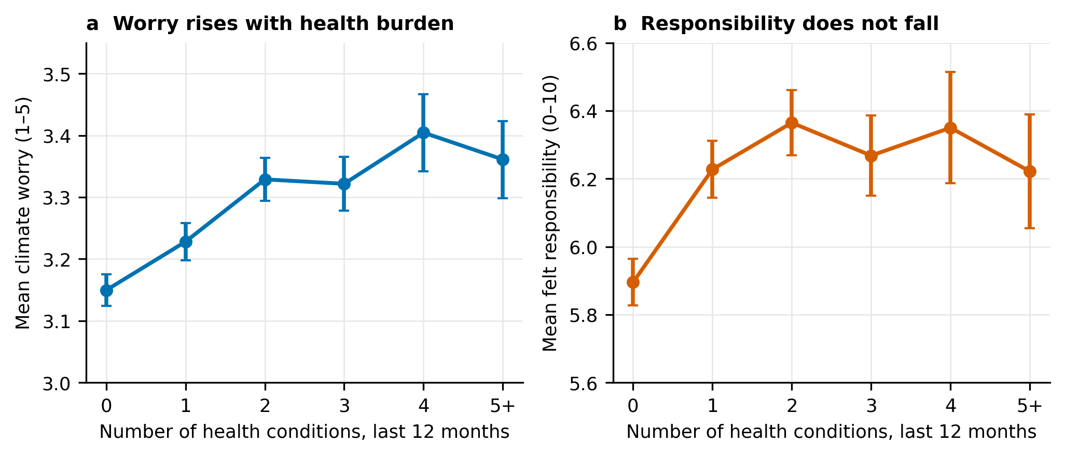
Figure S1 | Dose-response. Weighted mean worry (a) and felt responsibility (b) by number of chronic conditions in the last 12 months (0–5+; anweight, 95% CIs). Worry rises with burden; responsibility does not fall.
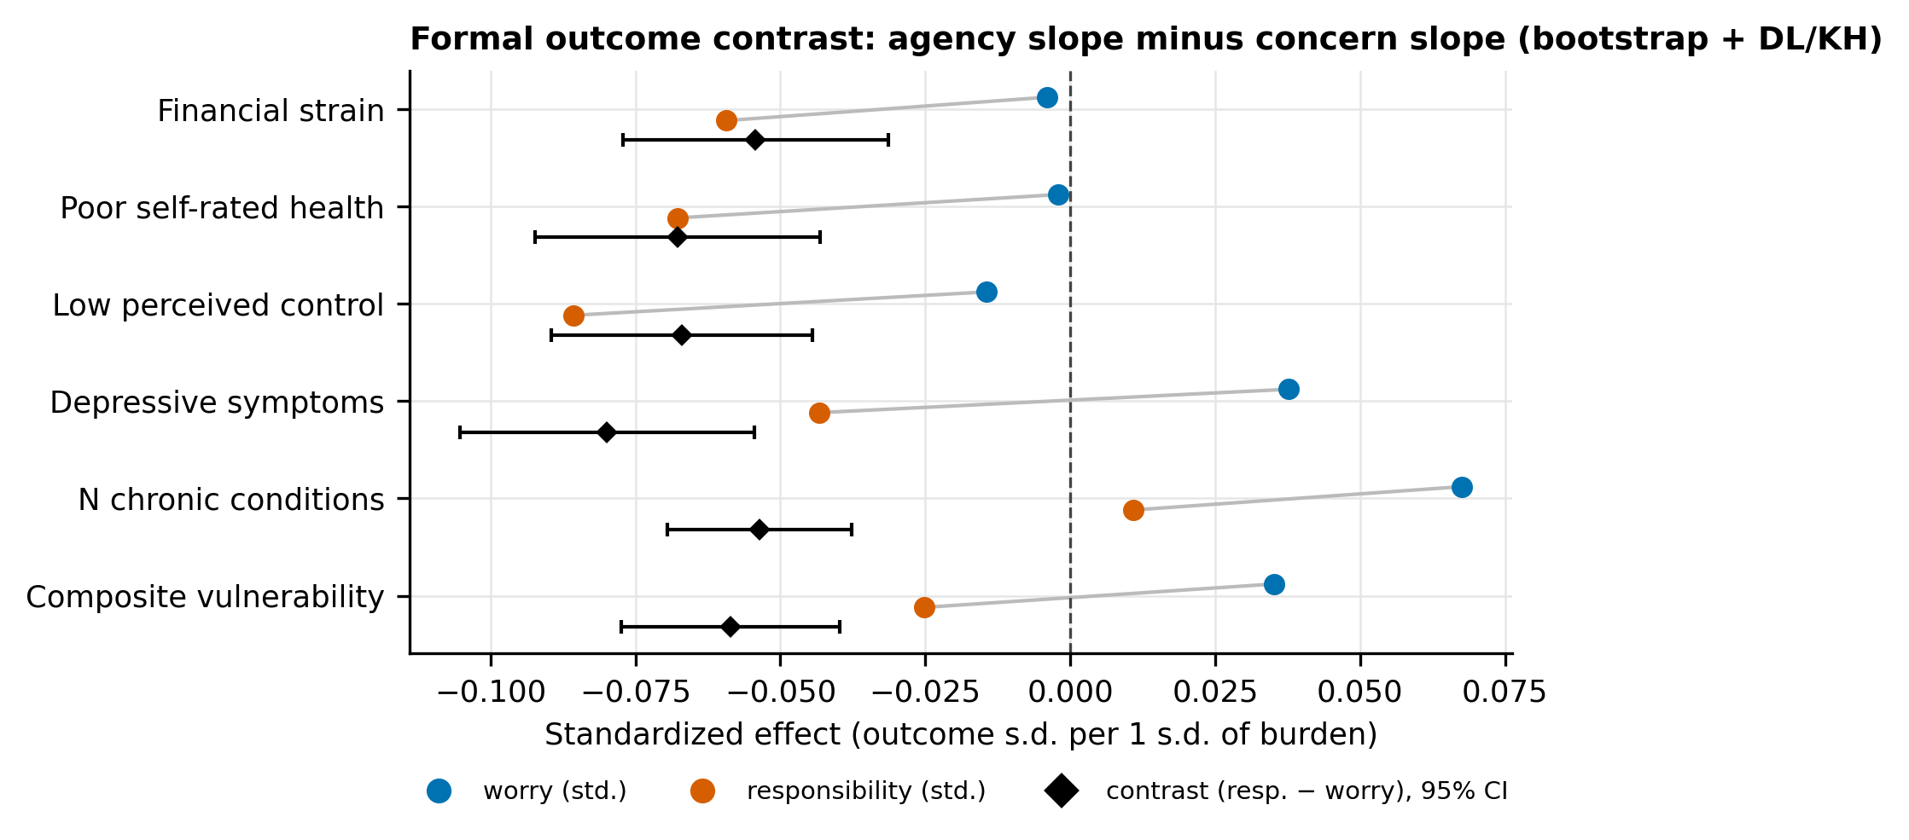
Figure S2 | Formal outcome contrasts (H3). Standardized worry slope (blue) and responsibility slope (orange) per 1 s.d. of each burden, with the pooled within-country contrast (diamond; responsibility − worry; cluster bootstrap + DL/KH 95% CI). All six contrasts are negative (P ≤ 4.0 × 10⁻⁵).
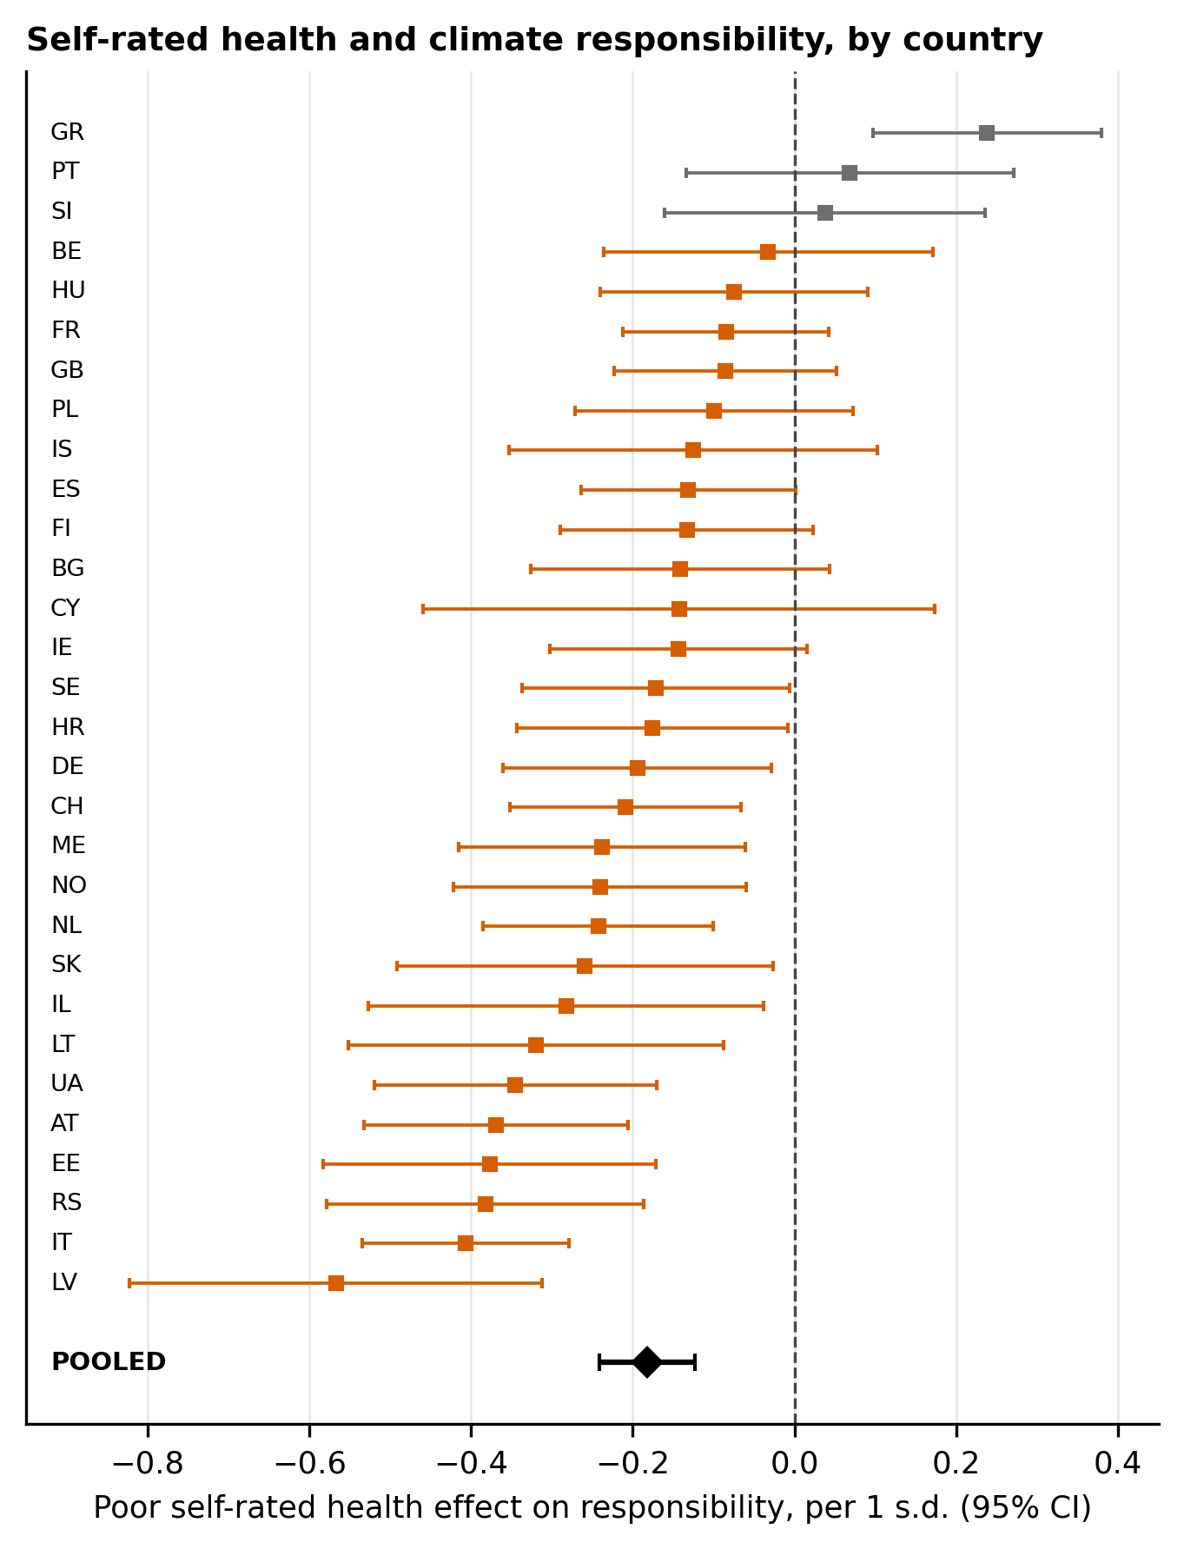
Figure S3 | Poor self-rated health and felt responsibility, by country (per 1 s.d.; WLS with demographic controls; 95% CIs), with DL pooled estimate (diamond; KH 95% CI). Negative in 27 of 30 countries.
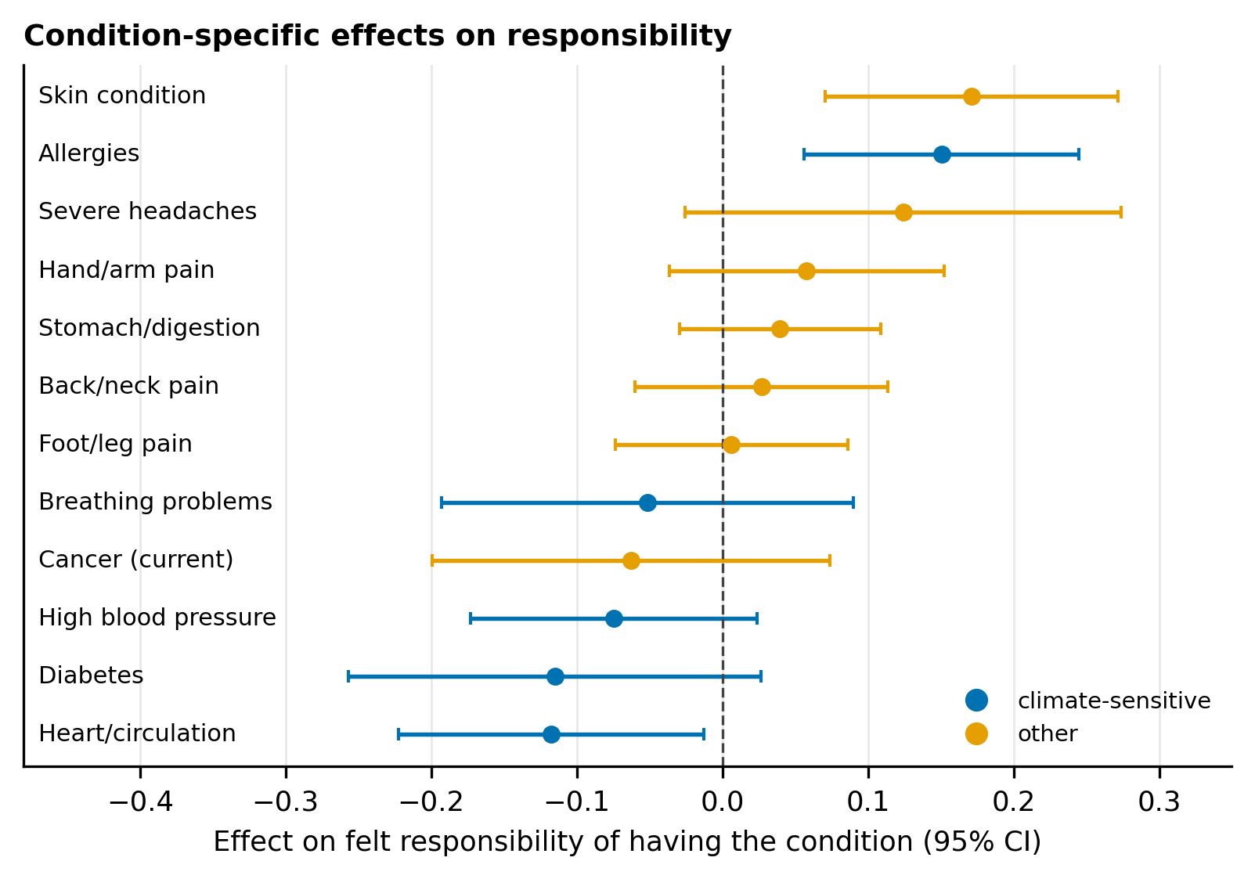
Figure S4 | Condition-specific effects on felt responsibility (each condition adjusted for the count of other conditions and demographic controls; DL/KH 95% CIs). No condition class reduces responsibility — the agency deficit tracks subjective burden, not diagnoses.
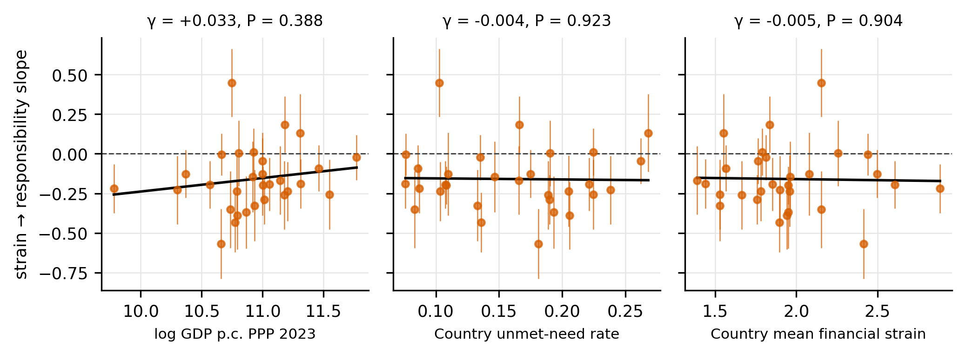
Figure S5 | Meta-regression of the strain → responsibility slope on the three macro moderators (DL-weighted fit lines; KH inference). All null.
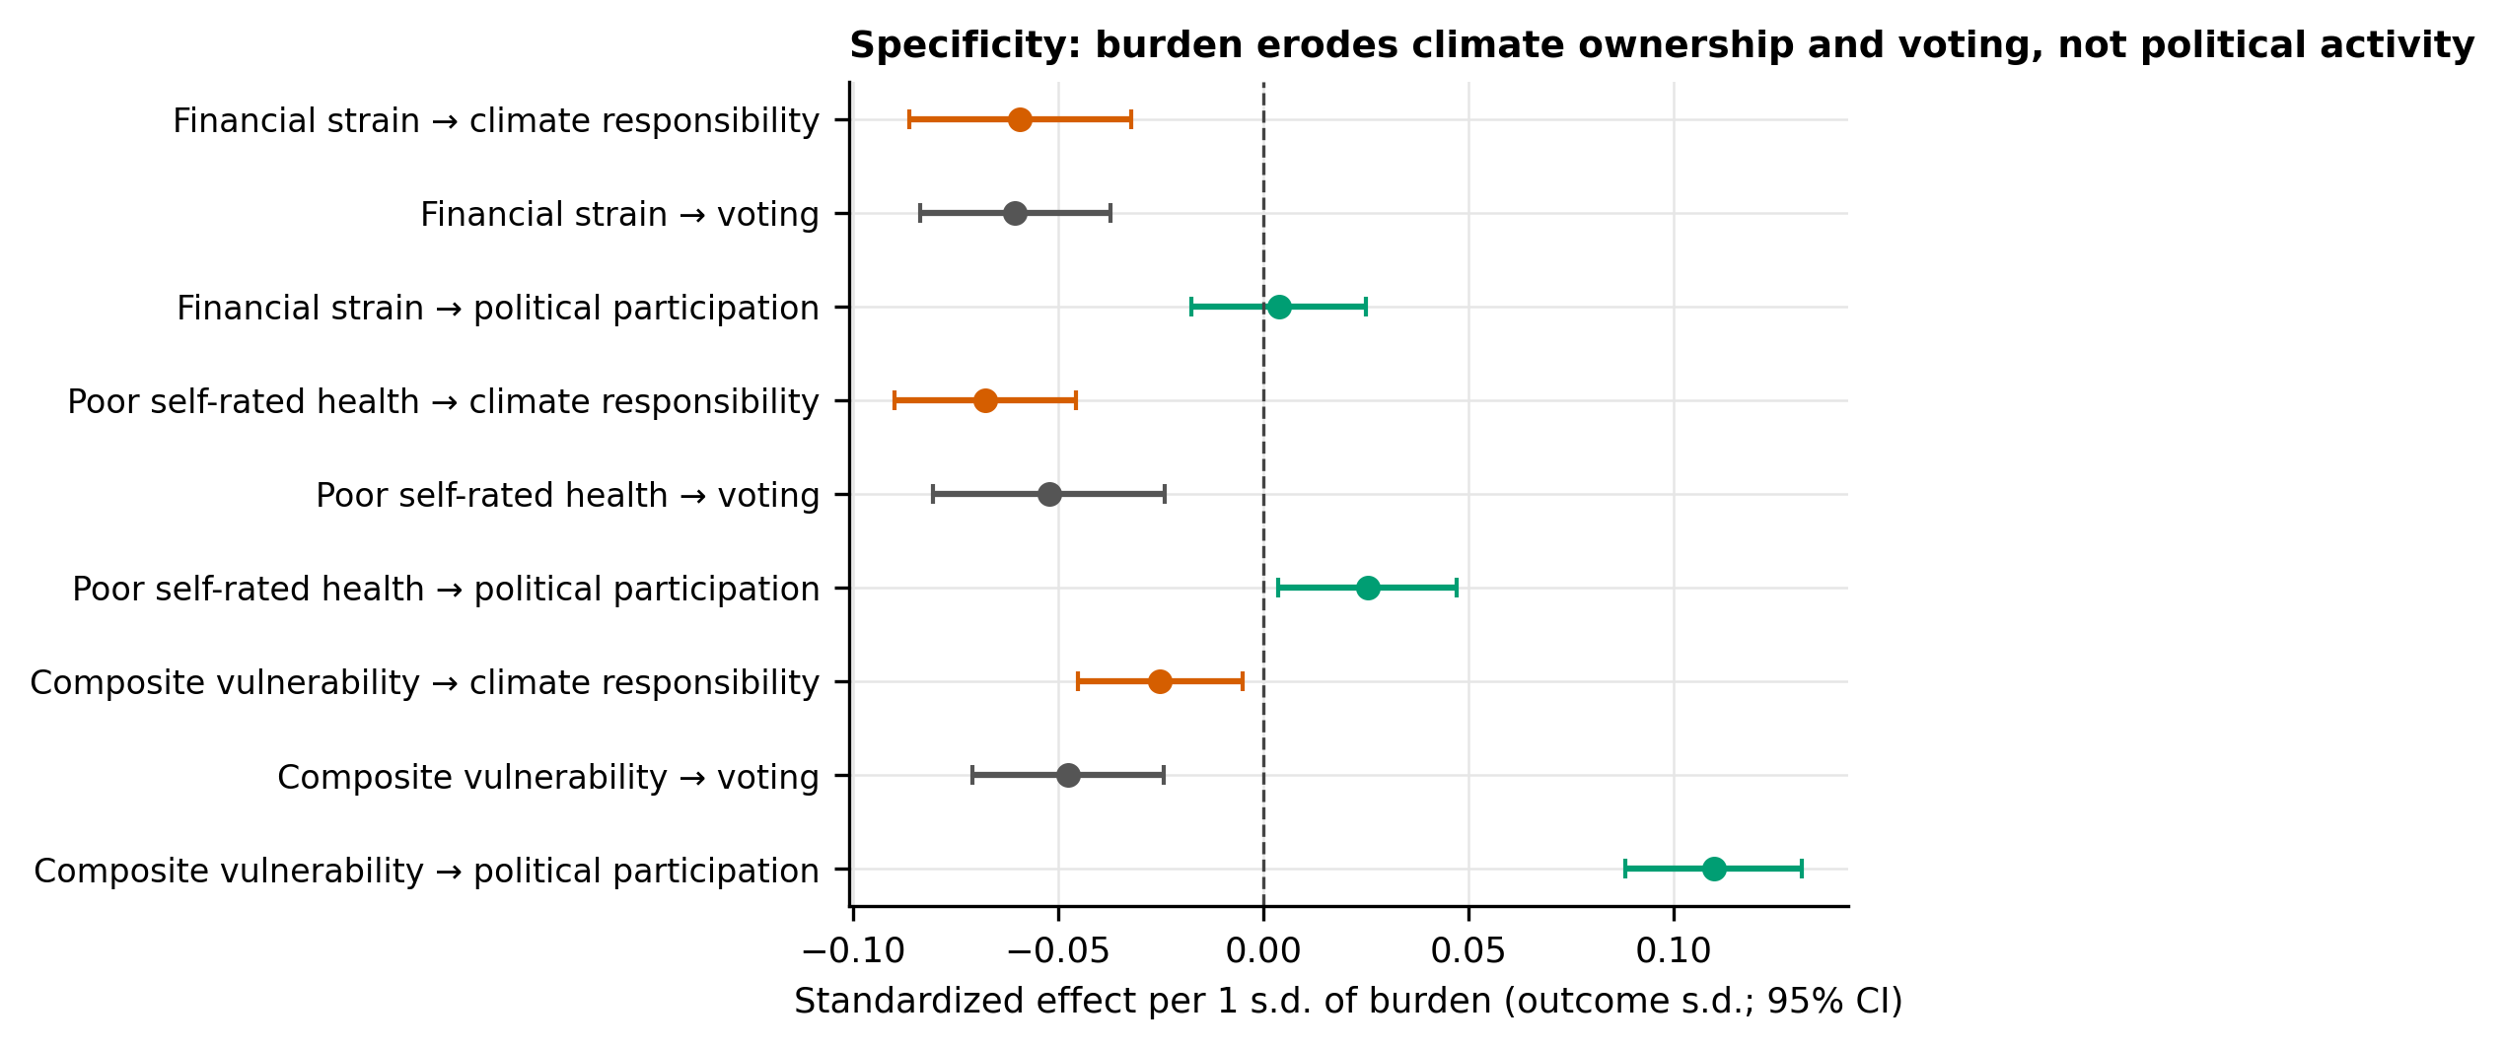
Figure S6 | Specificity of the agency deficit. Standardized adjusted effects (per 1 s.d. of burden; DL/KH 95% CIs) on climate responsibility (orange), voting (grey) and the five-act participation count (green). Burden erodes the duty-flavoured outcomes — climate ownership and voting — while leaving non-electoral participation intact or higher.

