Supplementary materials
The datasets generated and analyzed during this study are publicly available in the associated GitHub repository at https://github.com/FarahbodHeidari/BIPBR-Shading-Dataset/releases/tag/v1.0.0. The archived release, Version 1.0.0, contains six CSV files comprising ROI-based illuminant features and sparse 3D point-cloud features extracted from three laboratory-scale photobioreactor cases. The dataset is distributed under the Creative Commons Attribution 4.0 International License (CC BY 4.0), which permits sharing and adaptation provided that appropriate credit is given to the original authors, a link to the license is provided, and any changes are indicated.
- CSV 1: Illuminant features extracted by ROIs (Case 1)
- CSV 2: Illuminant features extracted by ROIs (Case 2)
- CSV 3: Illuminant features extracted by ROIs (Case 3)
- CSV 4: Sparse 3D point-cloud features extracted by ROIs (Case 1)
- CSV 5: Sparse 3D point-cloud features extracted by ROIs (Case 2)
- CSV 6: Sparse 3D point-cloud features extracted by ROIs (Case 3)
Fig.1 3D printing process of the scaffold in the AI-supported adaptive PBR panel.
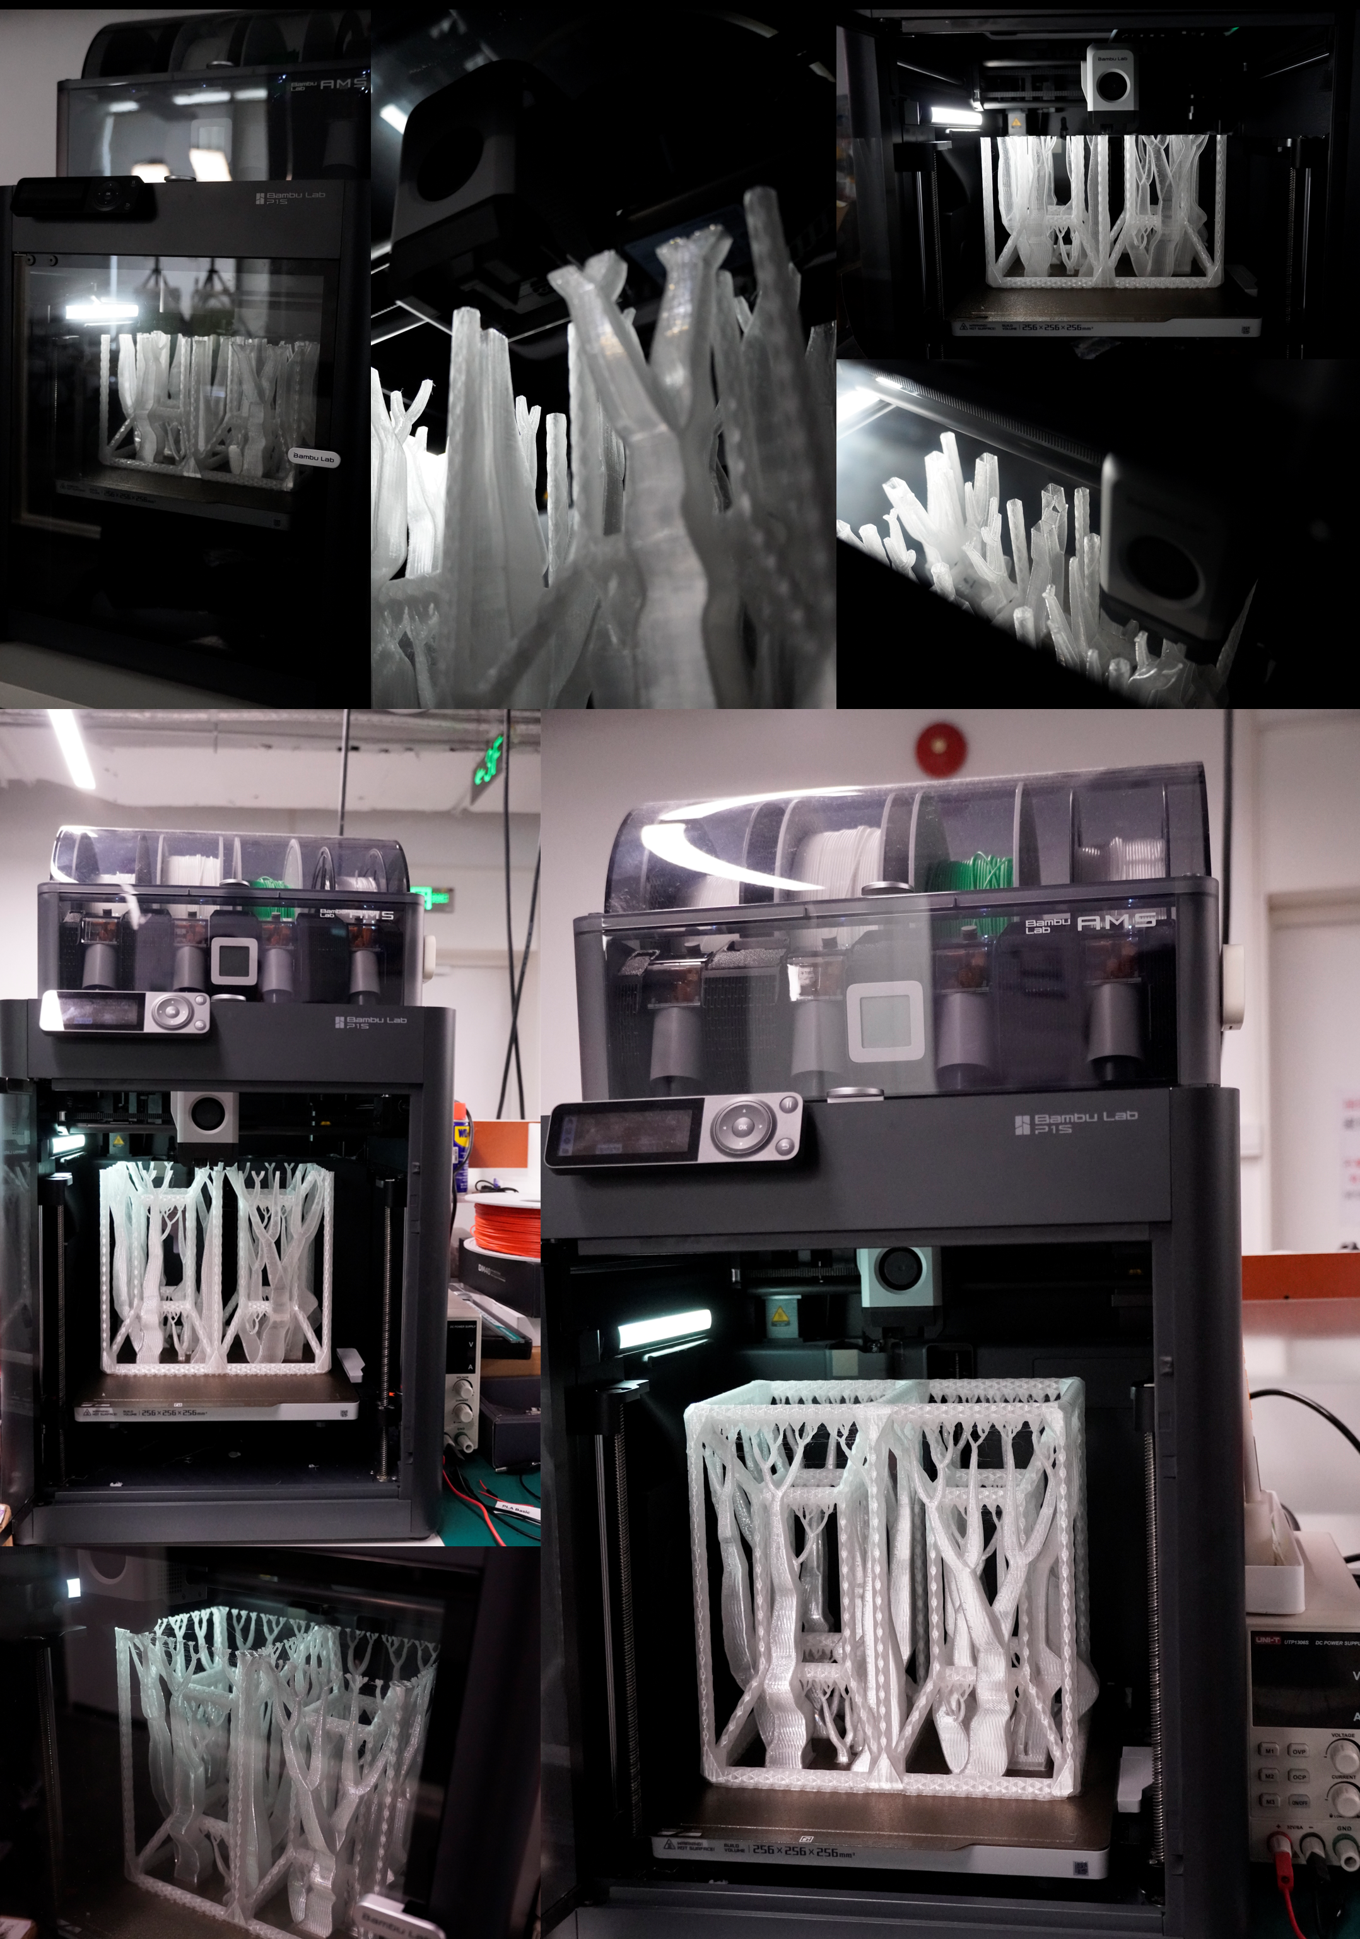
Fig.2 Nutrients and composition of PBR panels medium culture.
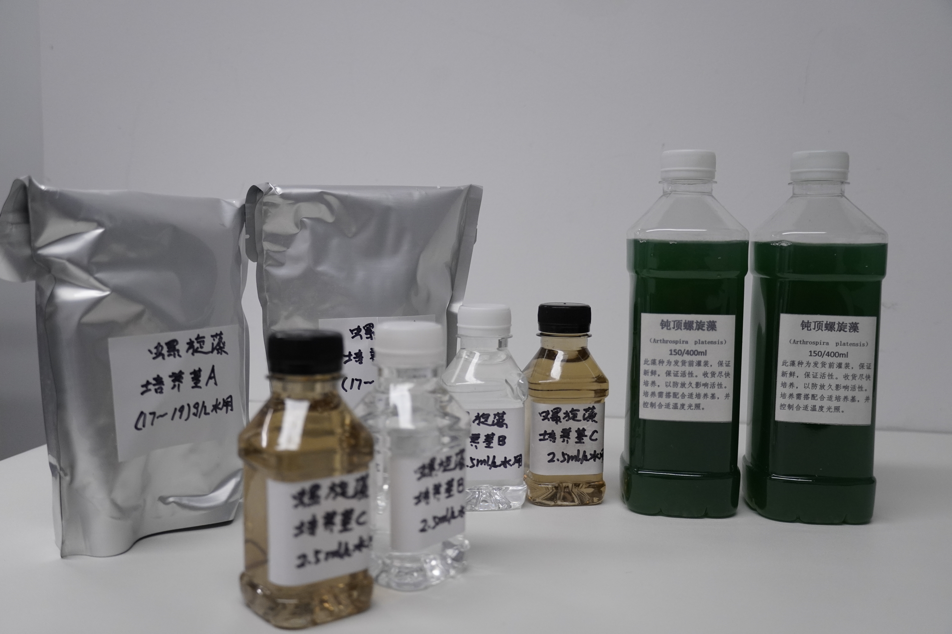
Fig.3 Starting point of system installation and first testing.
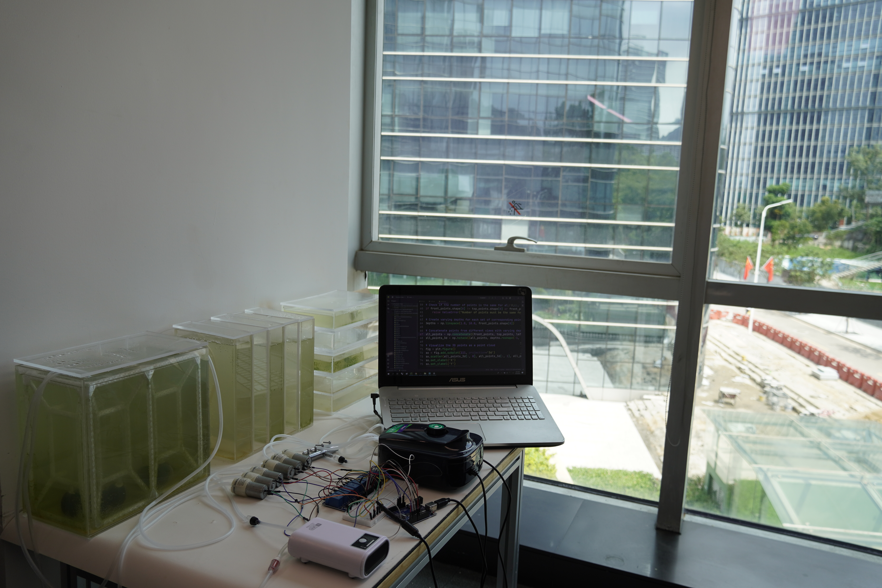
Fig.4 1D Architecture of proposed base hybrid CNN learner for few-shot meta-learning phase
(The CNN designed by authors and visualized via NN-SVG, and one of the output heads is visualized at the end of the network).
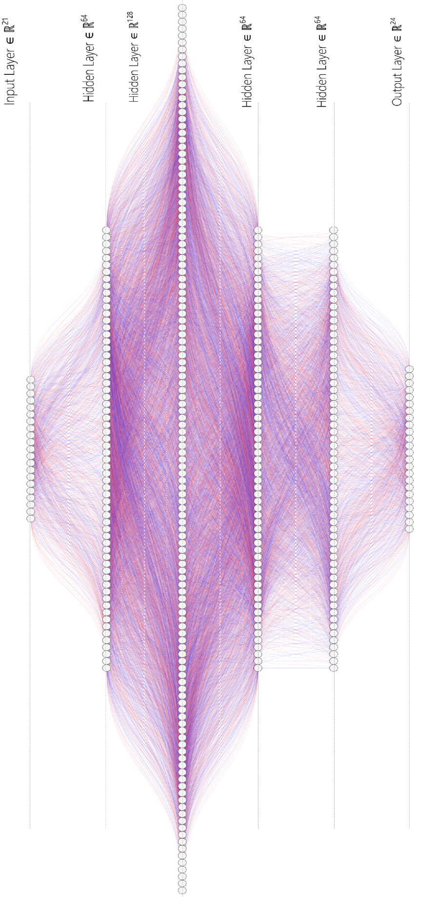
Fig.5 Glare metrics (GA, DGP) simulation lines for visual comfort evaluation (direct glare-120cm, indirect glare-75cm).
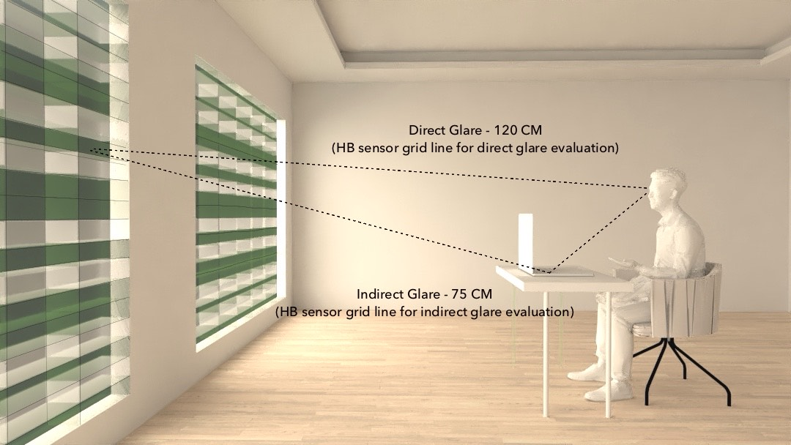
Fig.6 3D printed hyper cube internal scaffold for physical environment guiding of air flow in the AI-supported PBR panel.
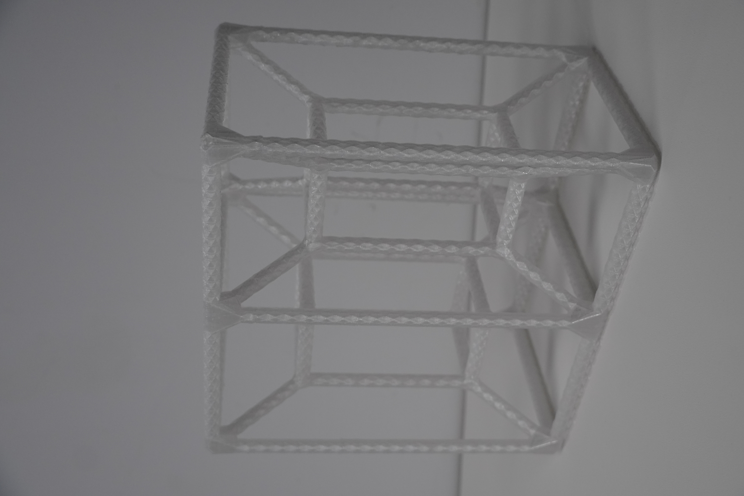
Fig.7 Vertical pathways in AI-supported PBR panel.
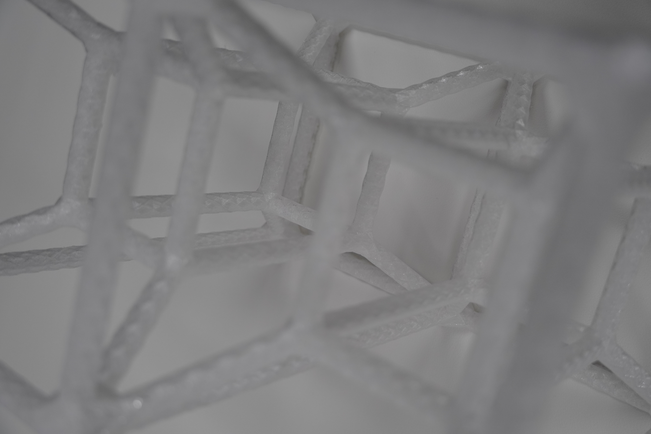

Fig.8 Initial proliferation procedure of PBR panels without AI-supported control system.
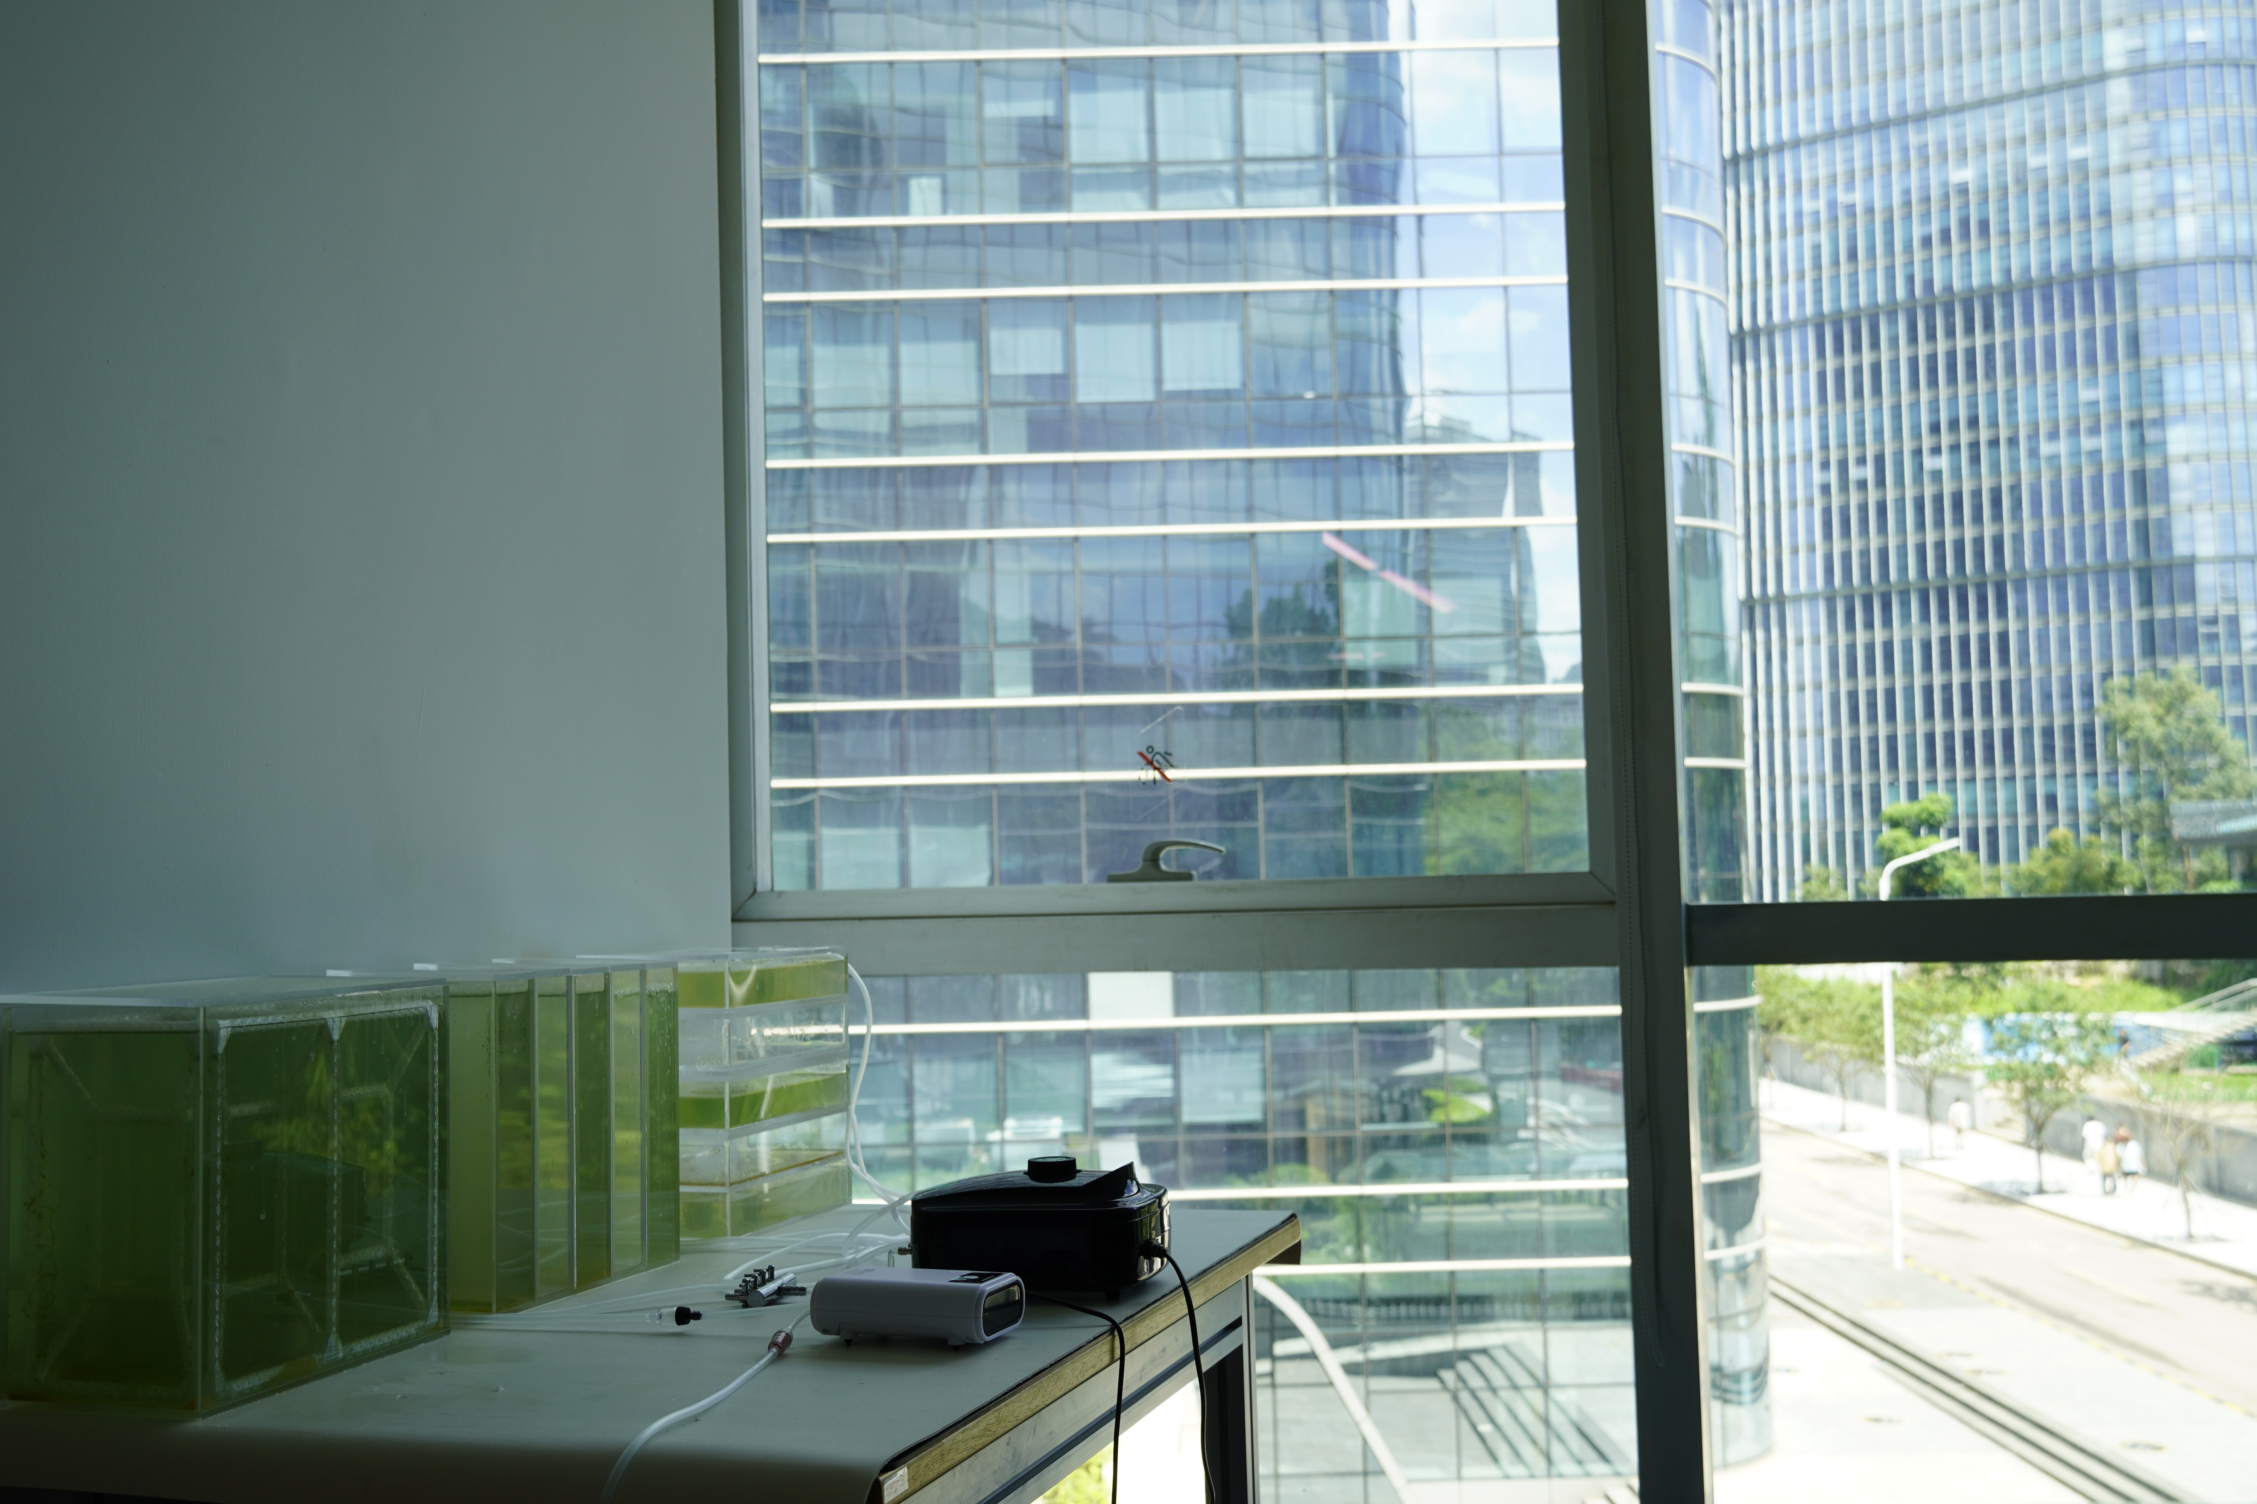
Fig.9 Post-processing and maintenance of the control system after the research experiment.
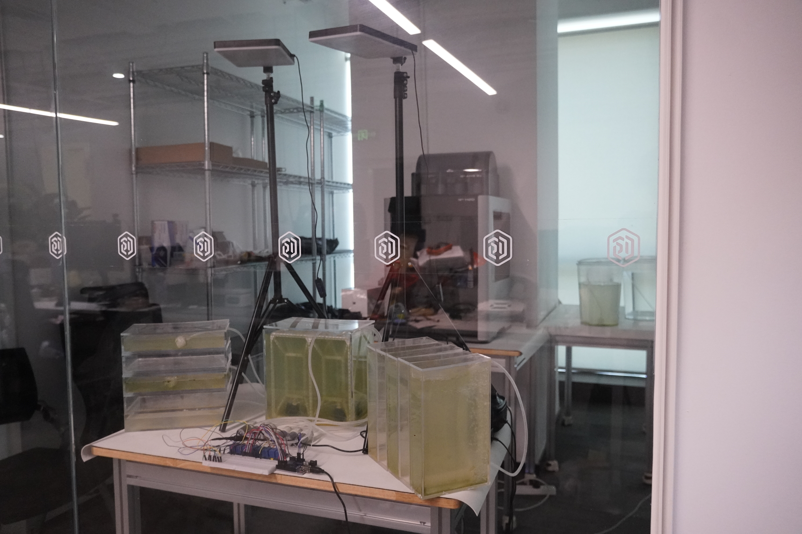
Fig.10 Cyanobacteria clusters and diffusion pattern in the AI-supported adaptive PBR panel.
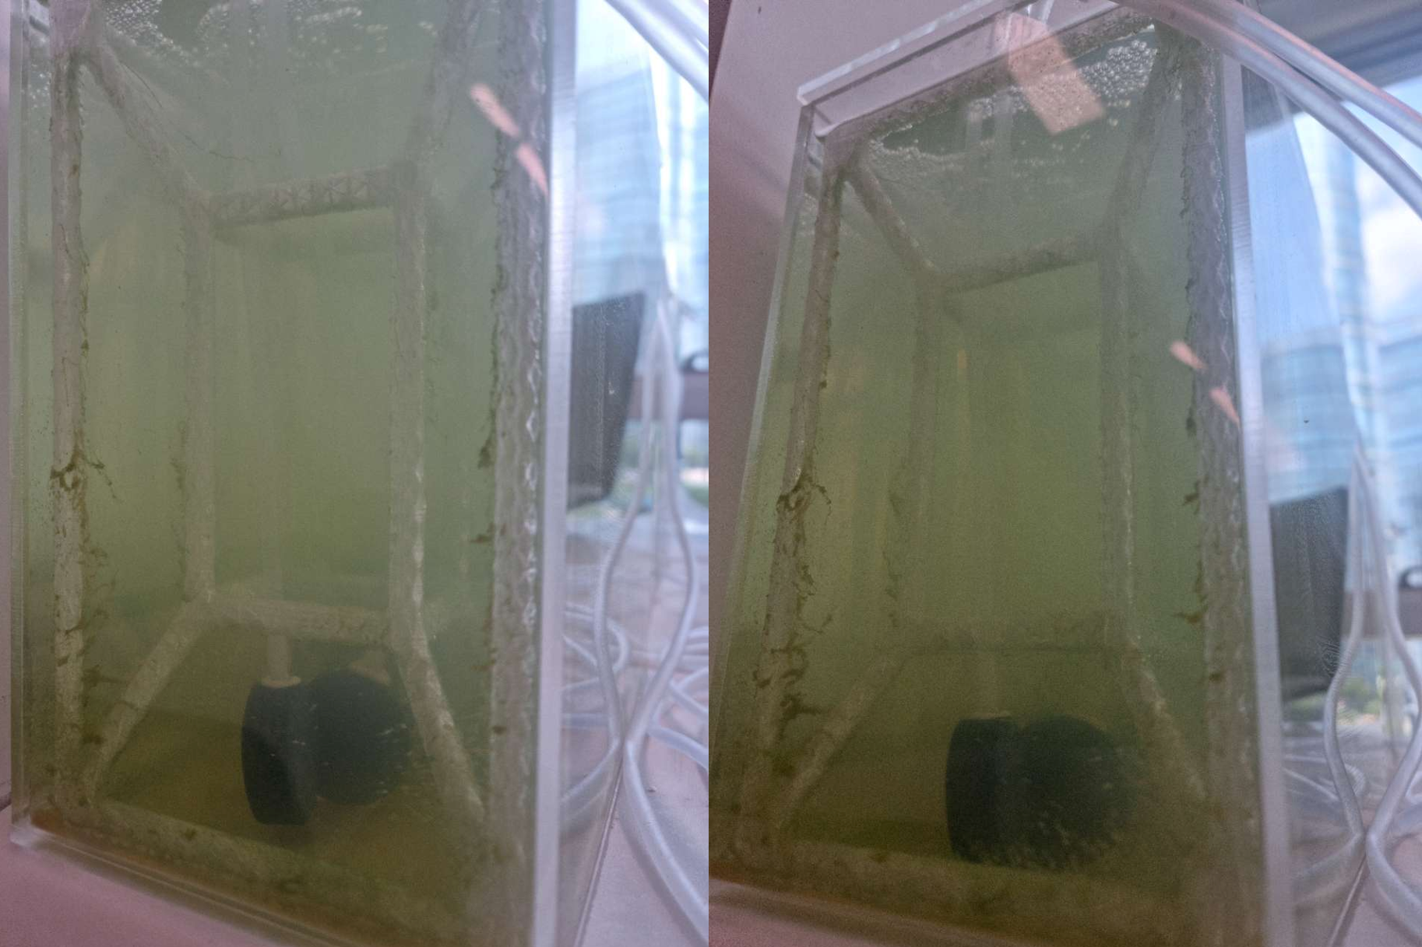
Fig.11 Assembly process of PBR panels.
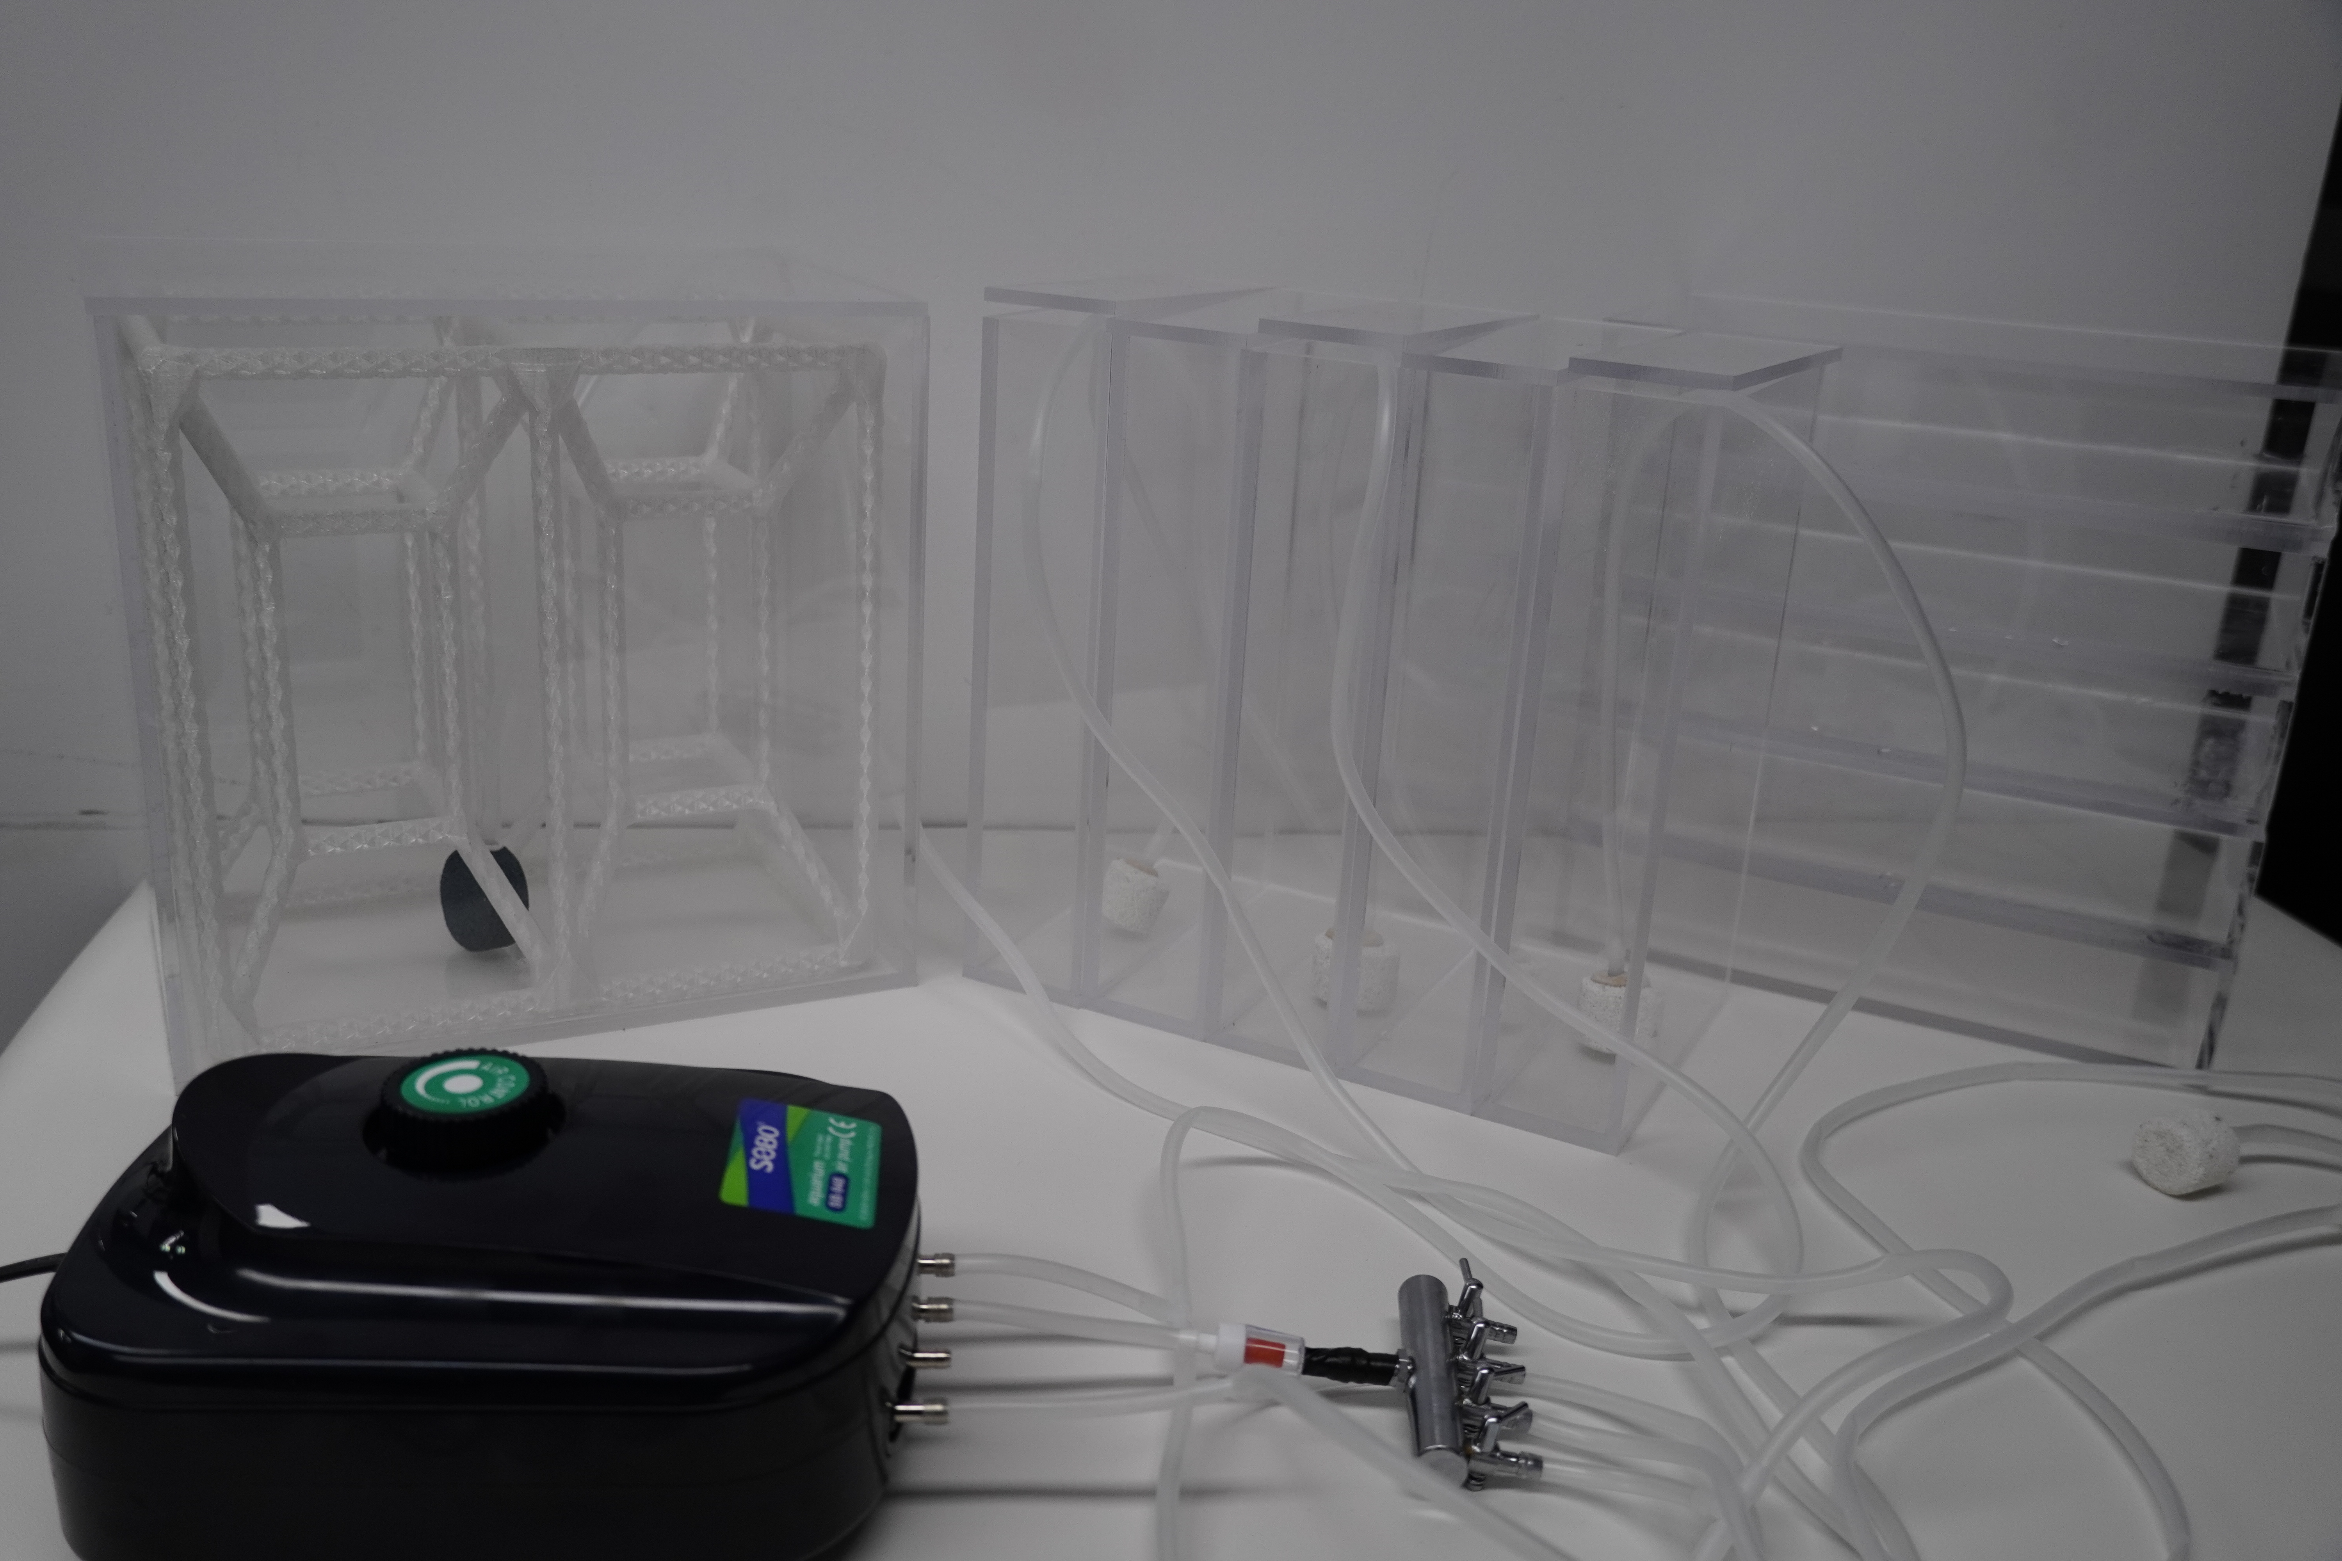
Fig.12 A sample of front-view images (case 1).
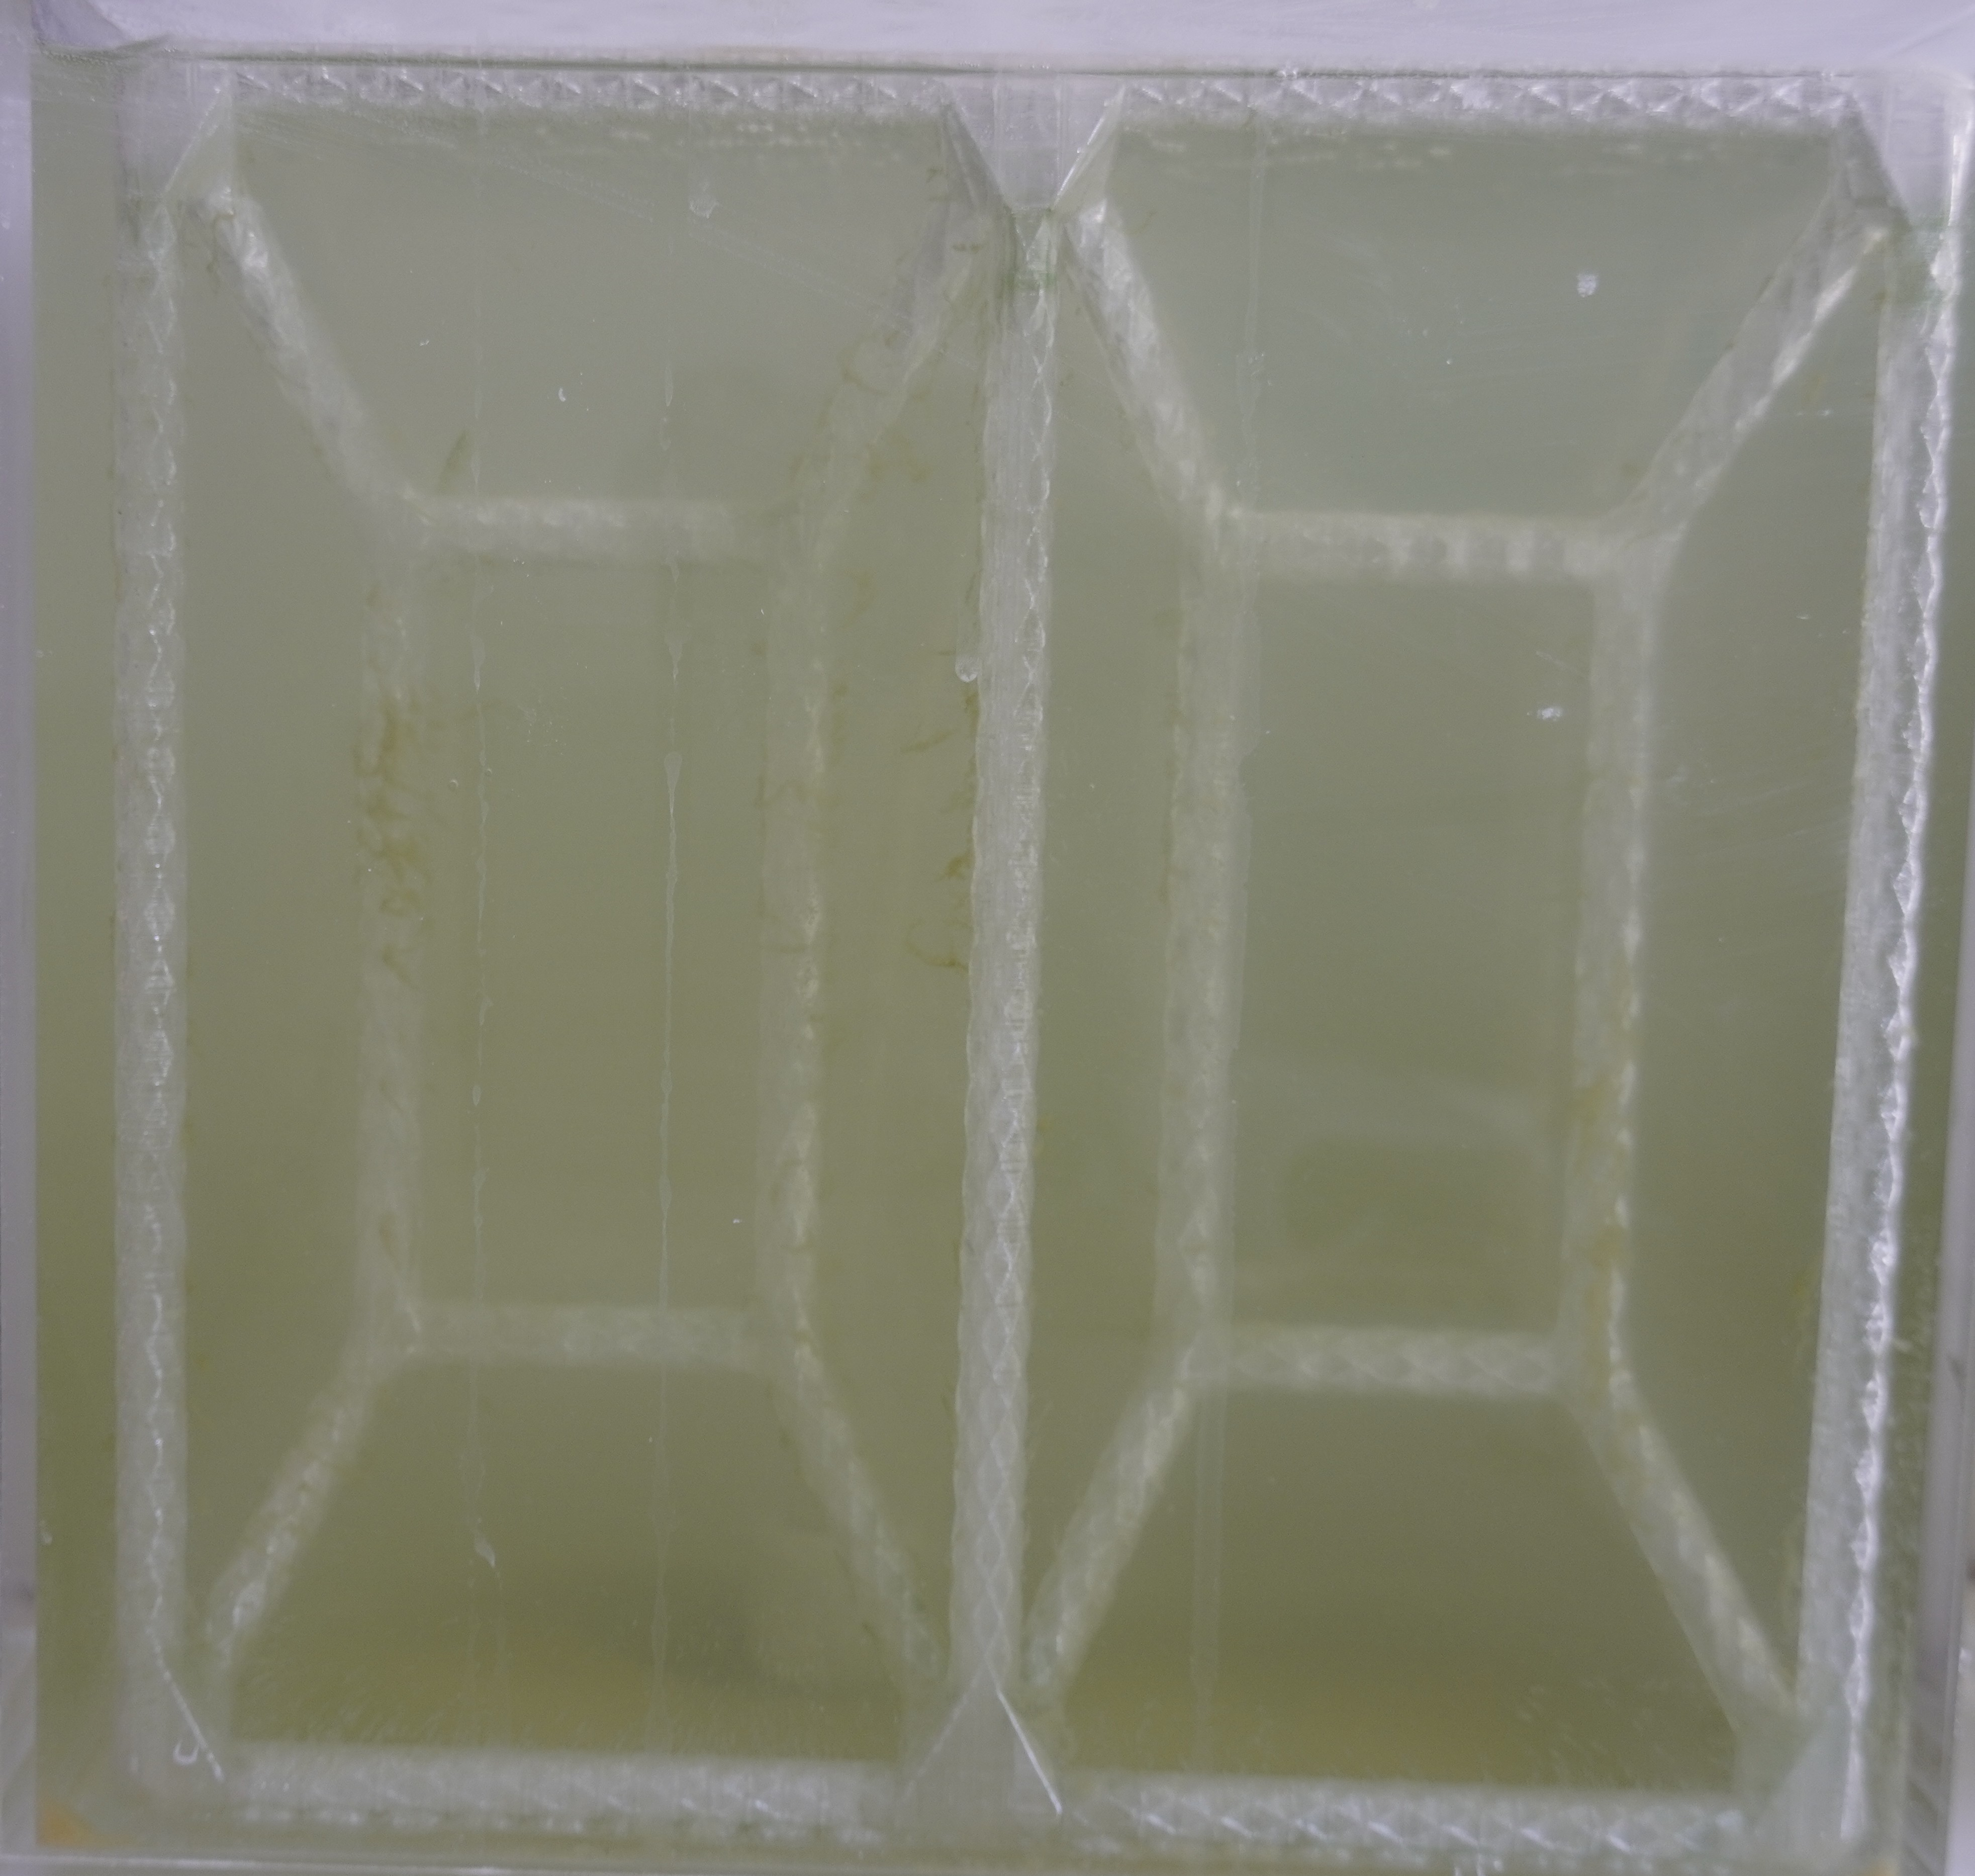

Fig.13 A sample of right/left-view images (case 1).
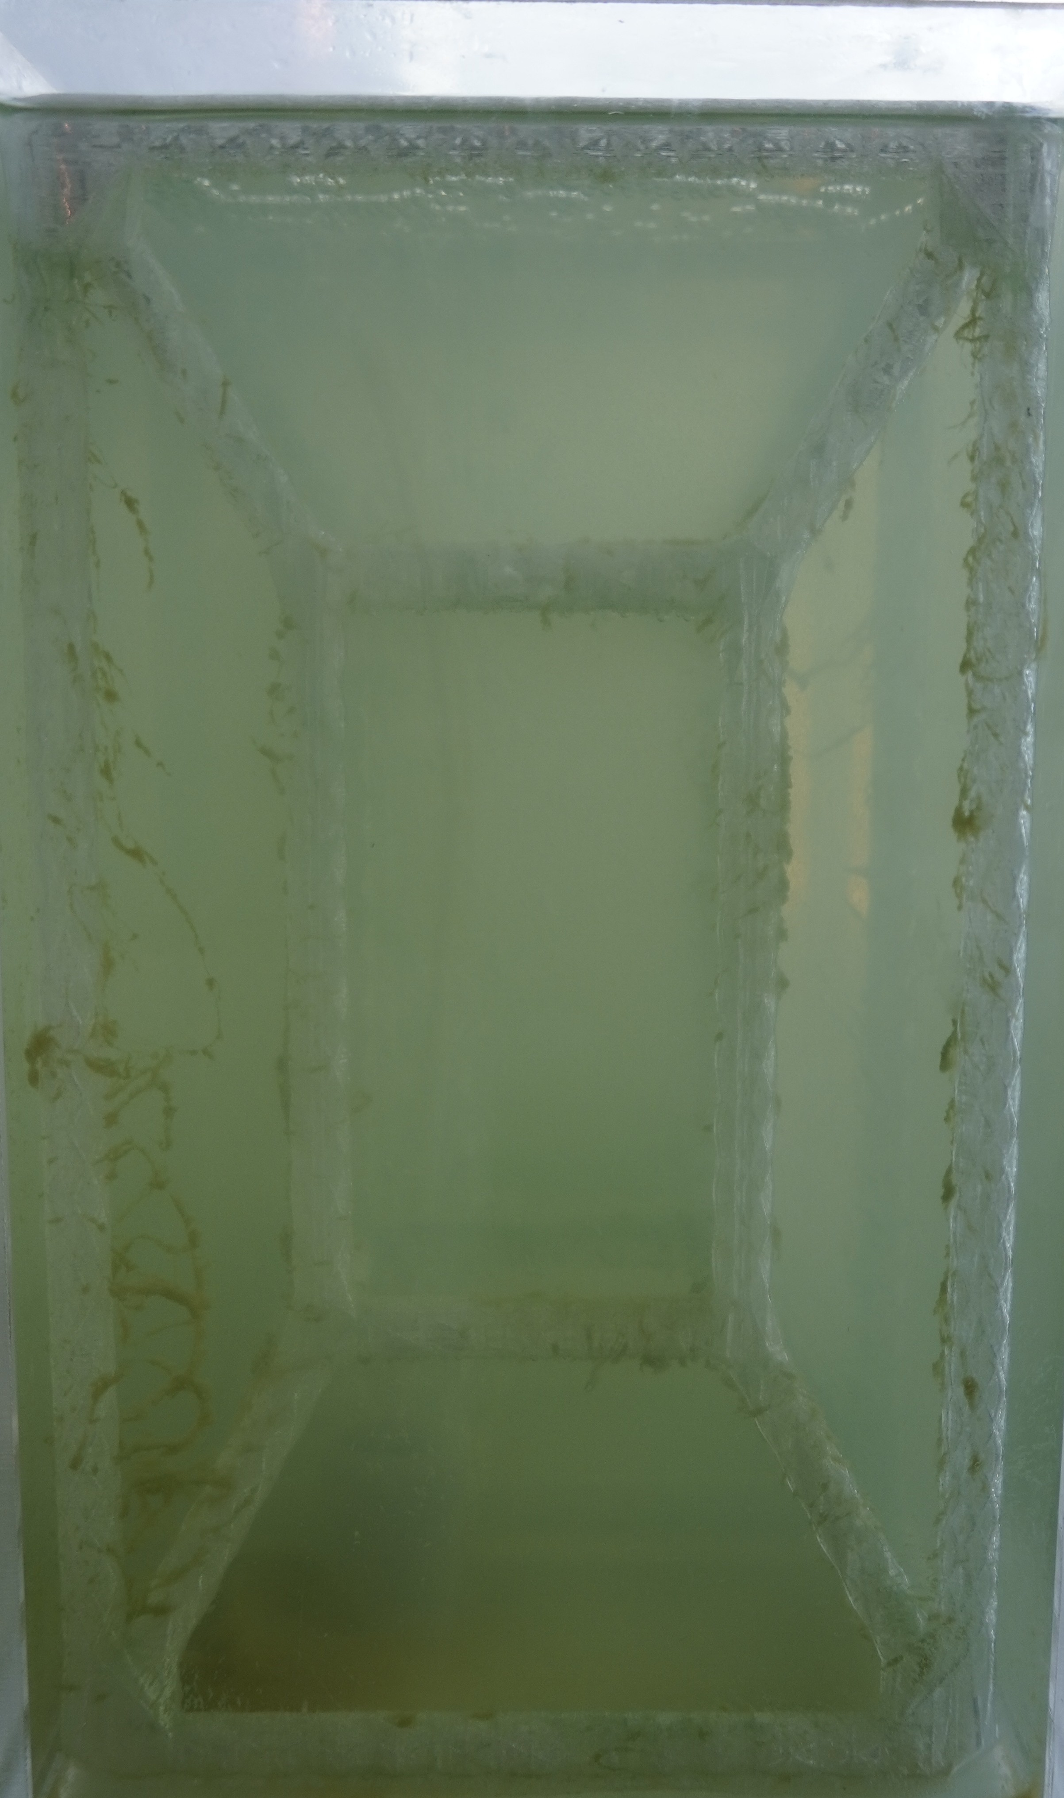
Fig.14 A sample of top-view images (case 1).
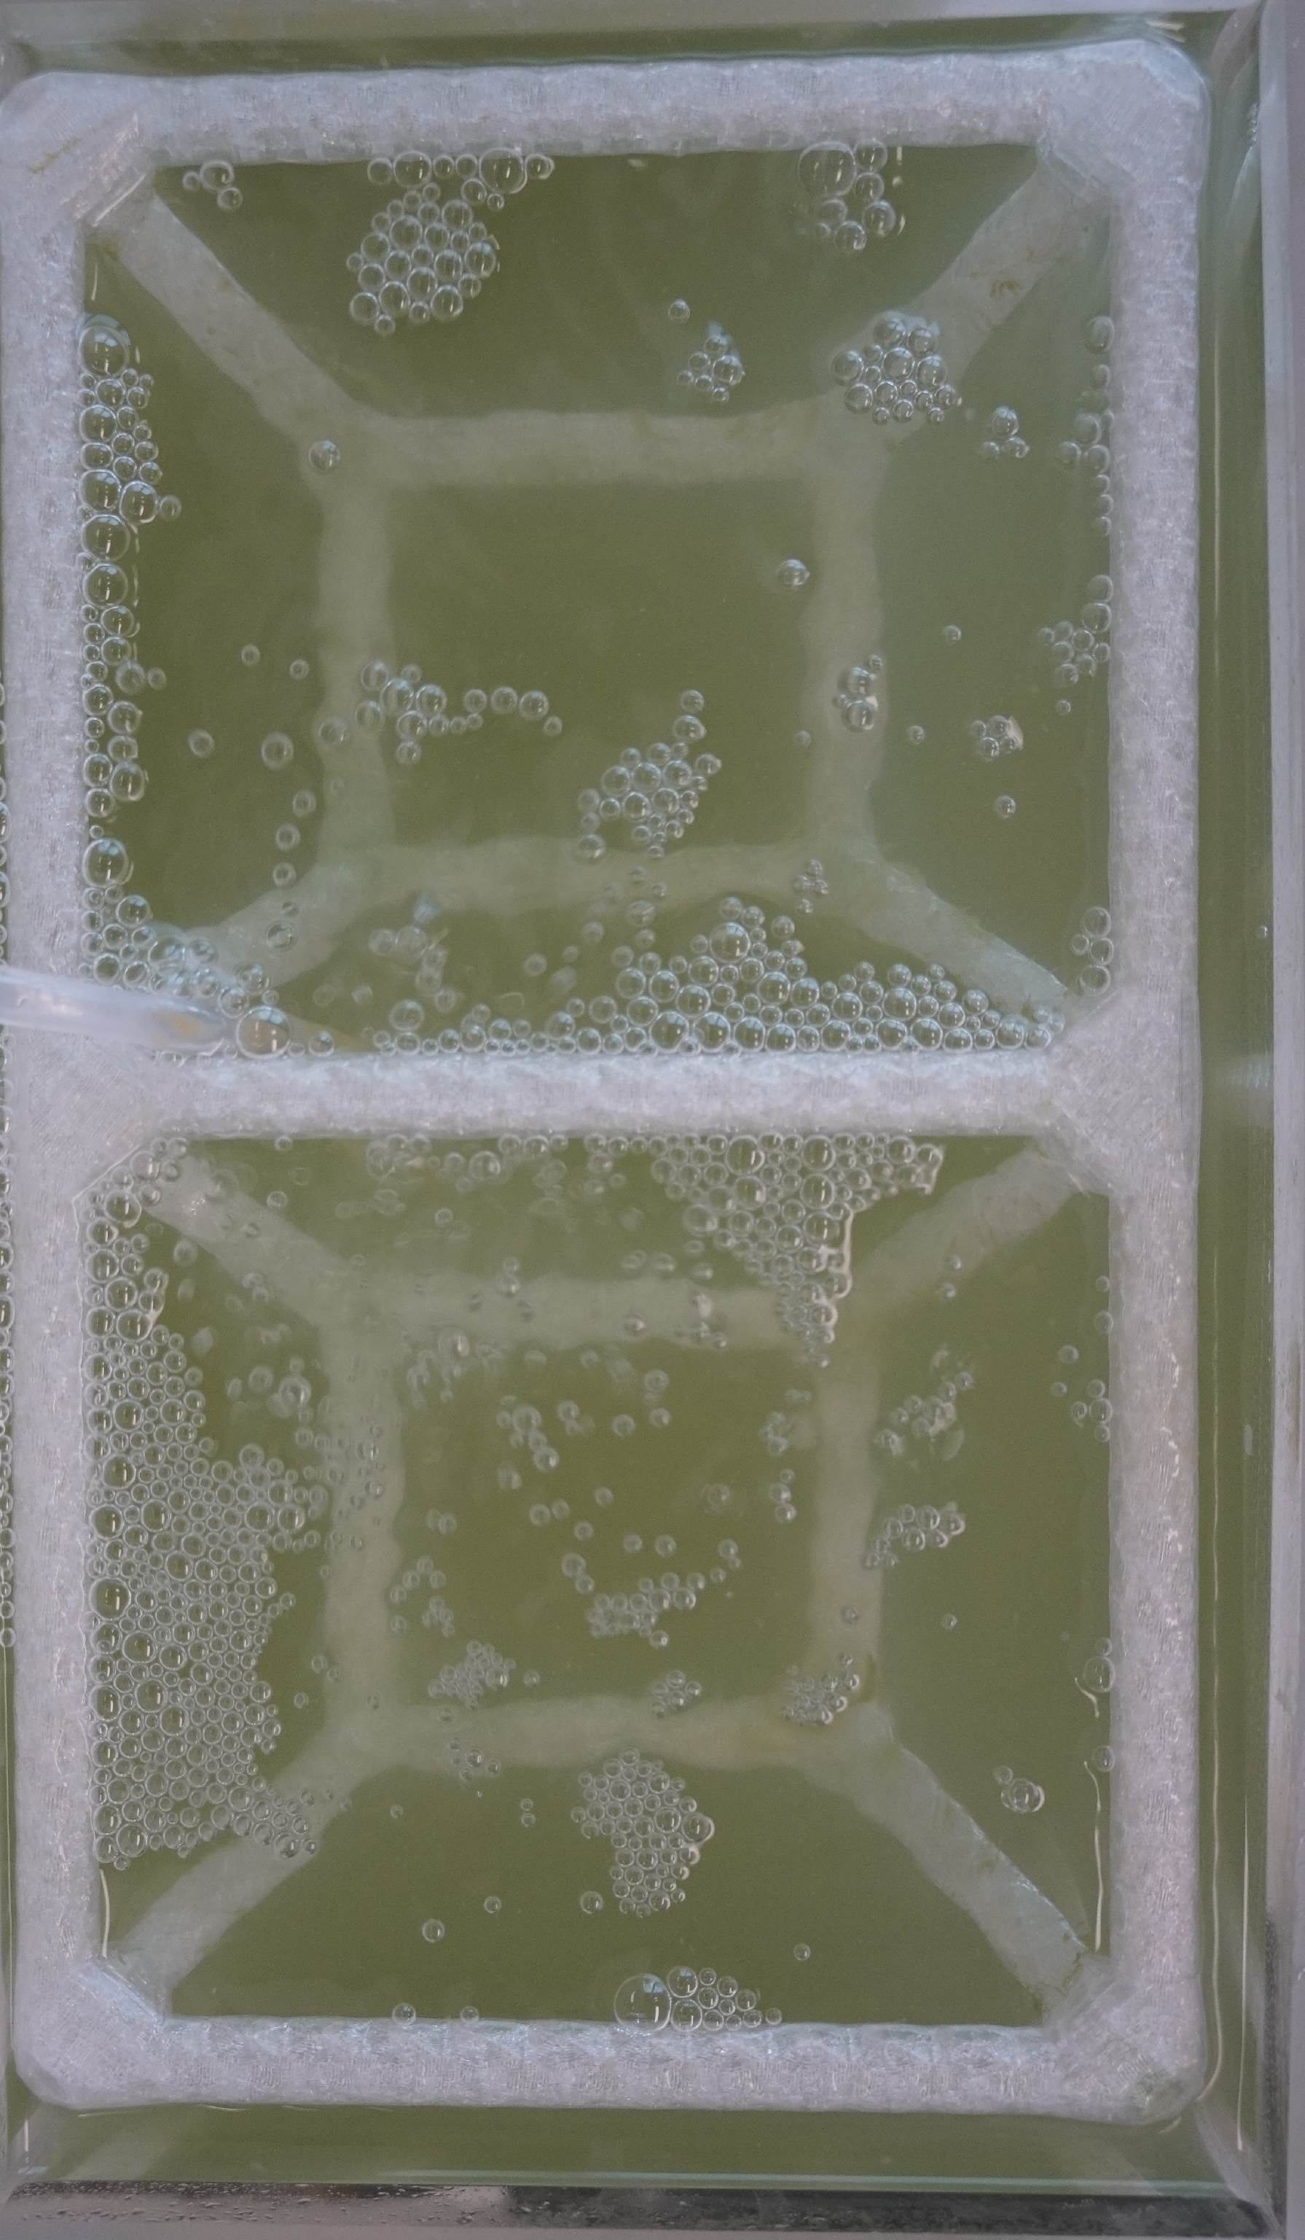

Fig.15 A sample of front-view images (case 2).
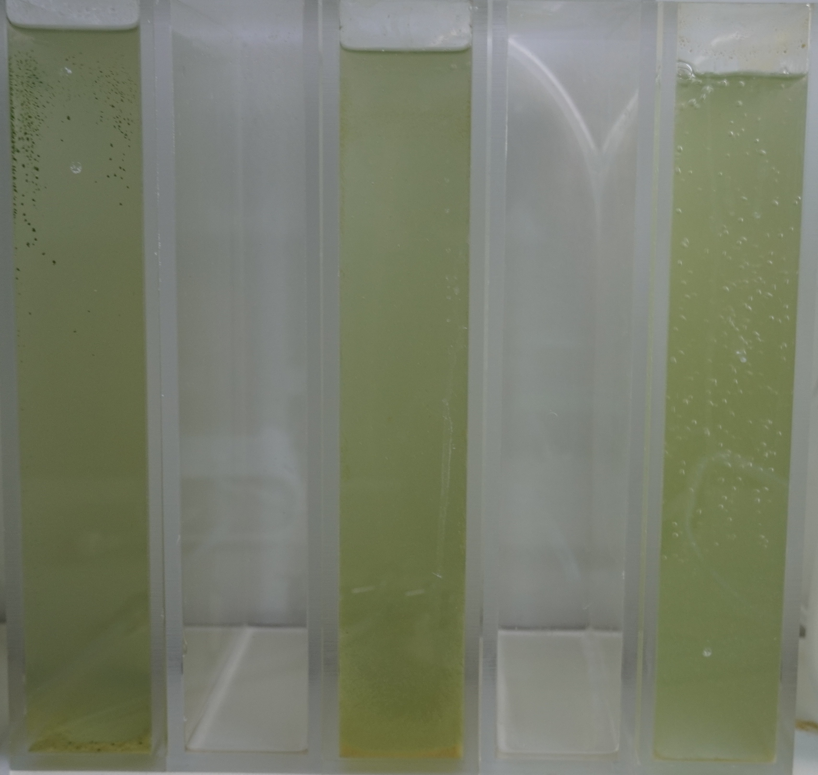

Fig.16 A sample of right/left-view images (case 2).
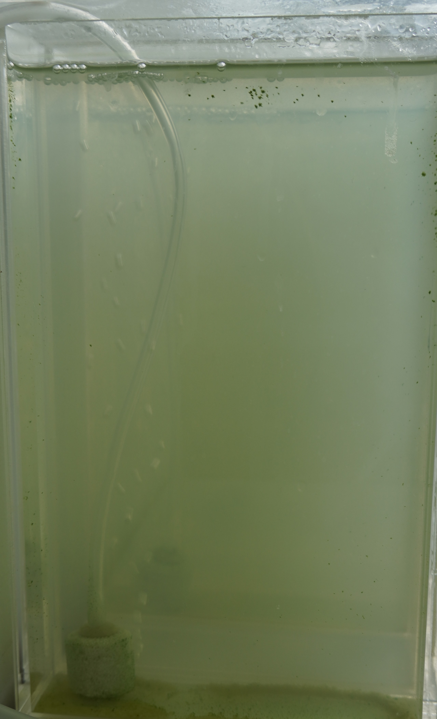
Fig.17 A sample of top-view images (case 2).
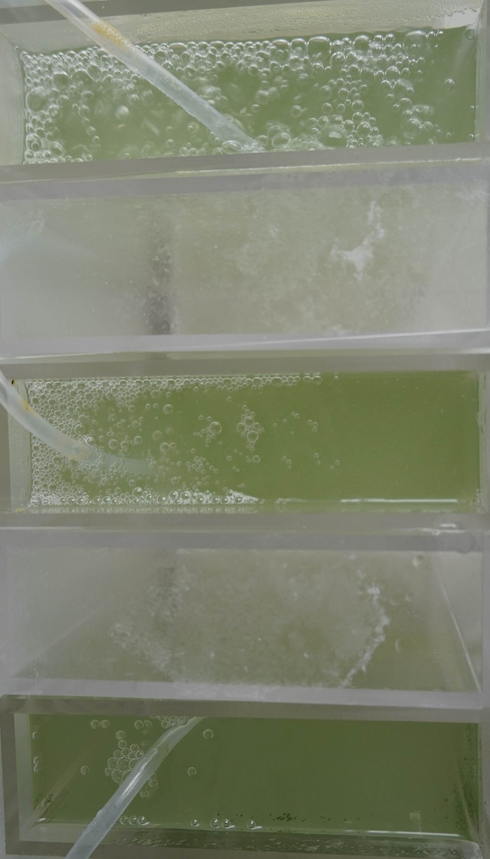

Fig.18 A sample of front-view images (case 3).
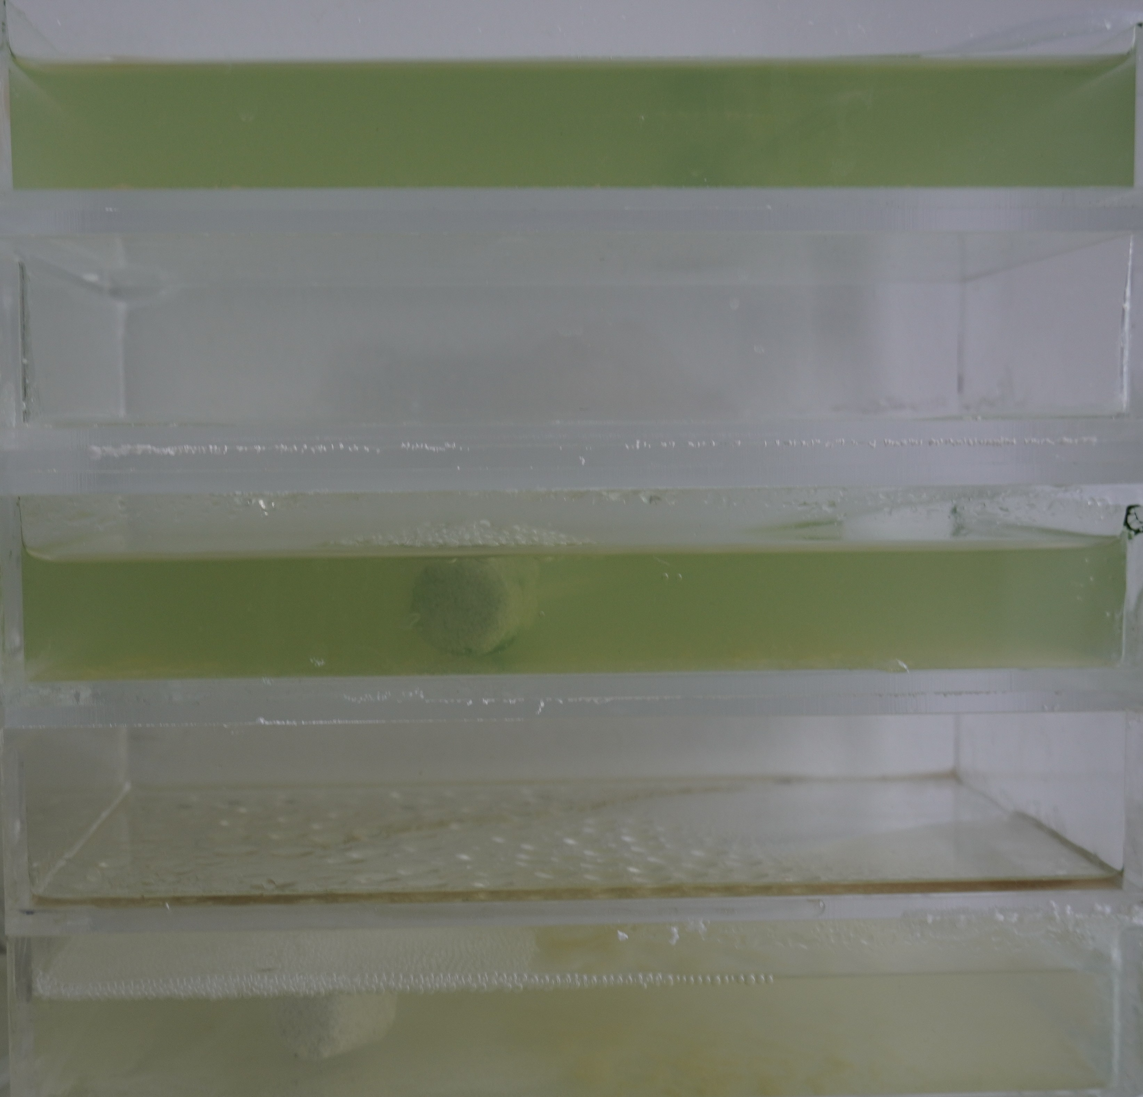

Fig.19 A sample of right/left-view images (case 3).
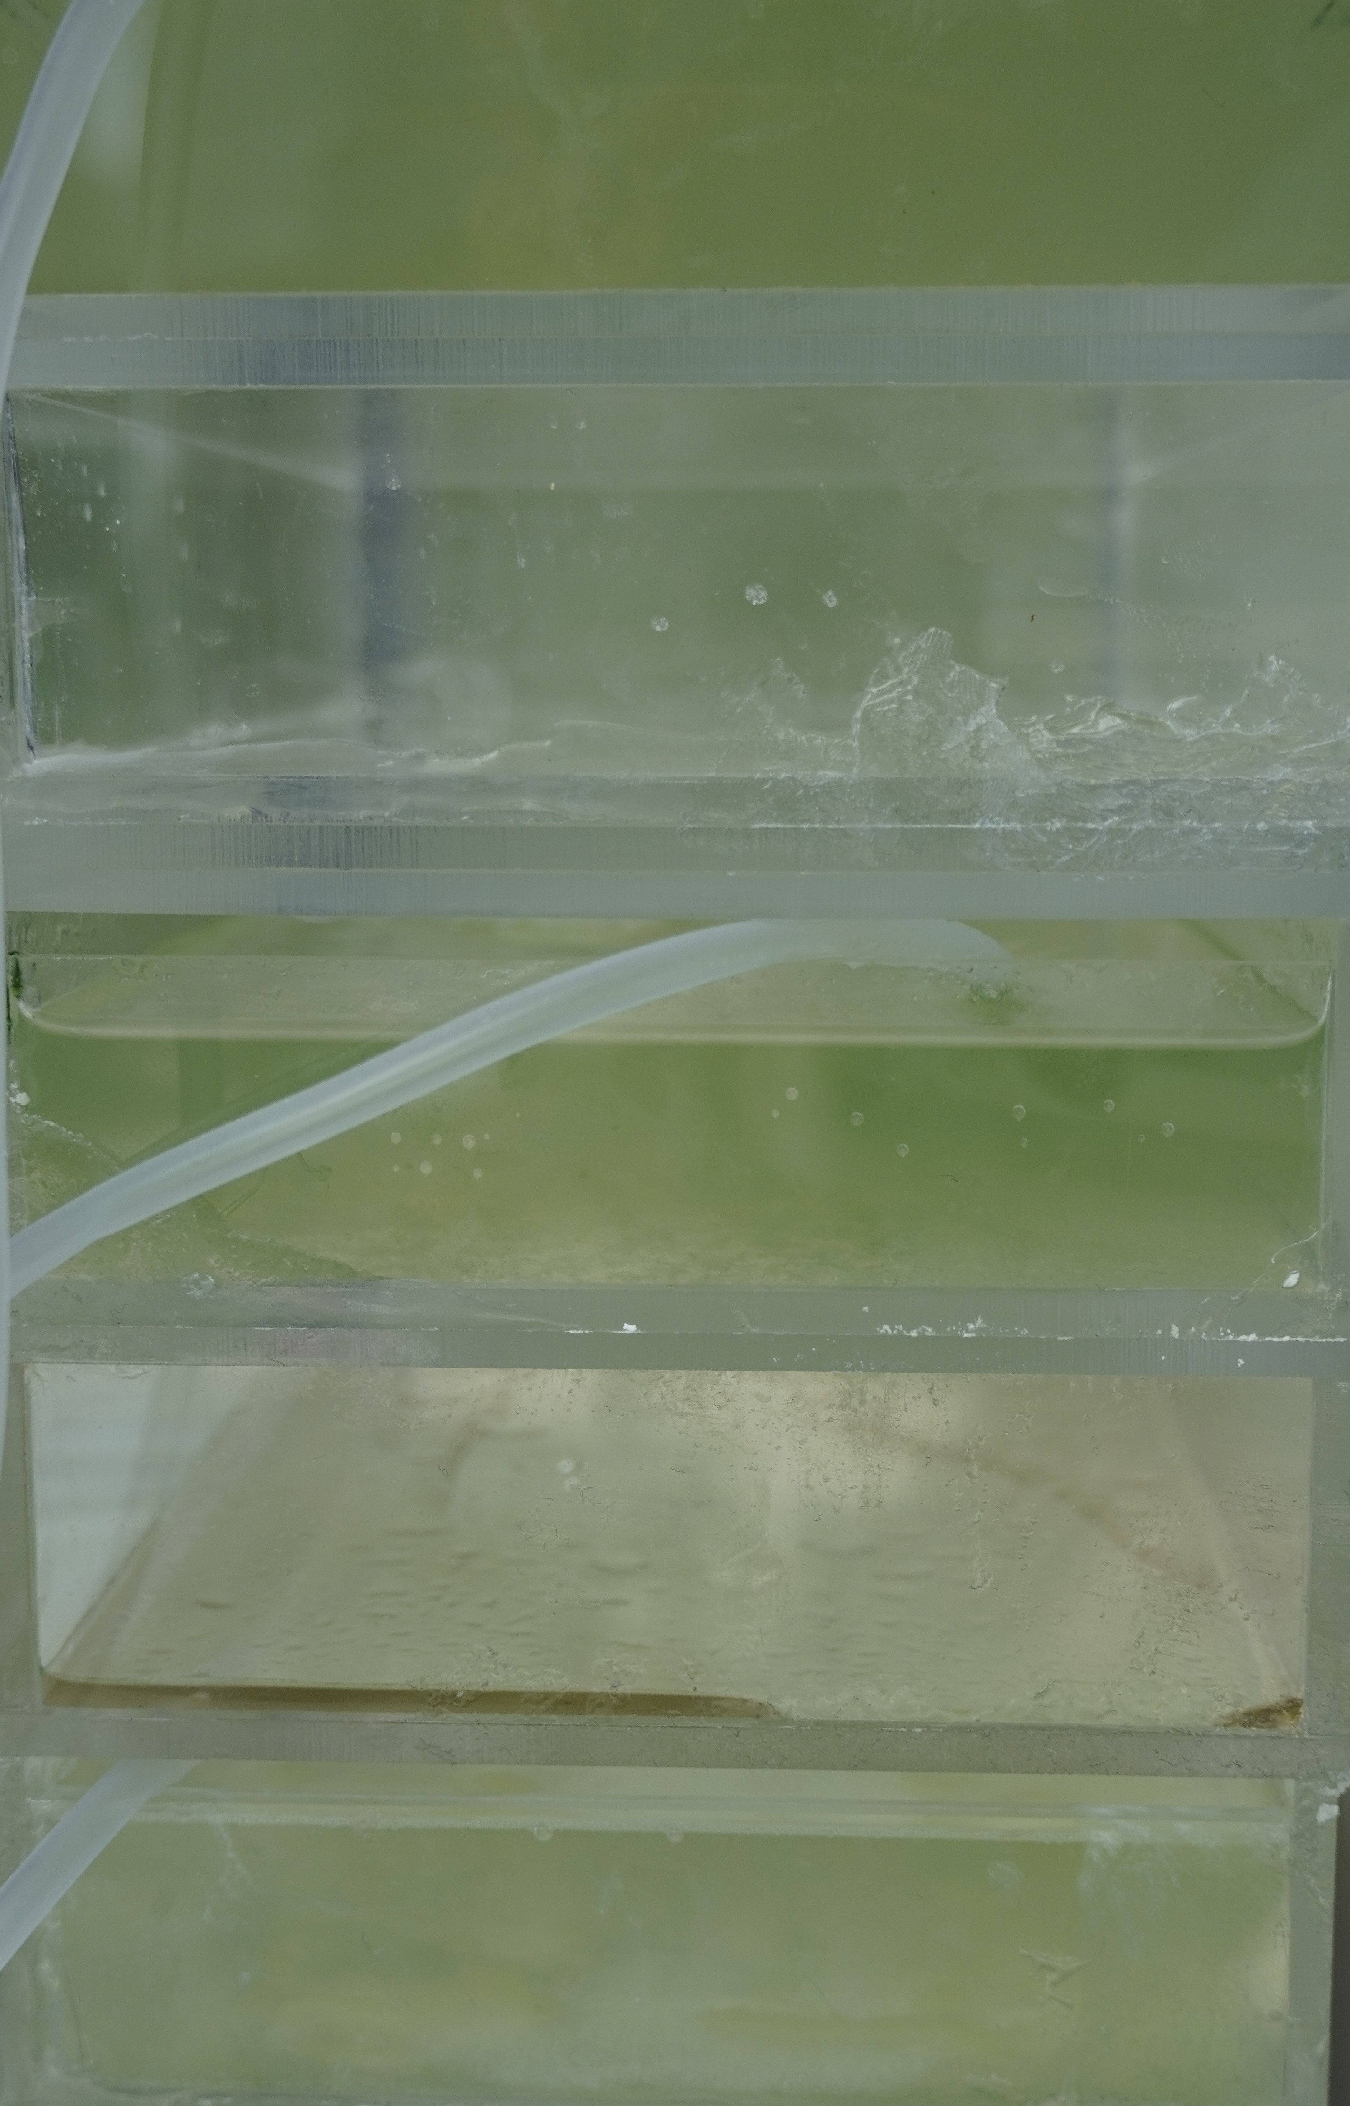
Fig.20 A sample of top-view images (case 3).
