Supplementary Materials
Table S1: sociodemographic characteristics

Variable |  | N | Mean |  | SD
Age |  | 1660 | 52.18 | 5.10
 |  |  | %
Menopause group | Perimenopause | 711 | 42.83
Menopause group | Natural menopause | 660 | 39.75
Menopause group | Medically induced menopause | 289 | 17.41
Country | Australia | 209 | 12.59
Country | Canada | 224 | 13.49
Country | New Zealand | 265 | 15.96
Country | UK | 473 | 28.49
Country | USA | 489 | 29.46
Gender | Female | 1636 | 98.55
Gender | Male | 3 | 0.18
Gender | Non-binary | 12 | 0.72
Gender | Other | 3 | 0.18
Gender | Prefer not to say | 6 | 0.36
Ethnicity | White/Caucasian | 1515 | 91.26
Ethnicity | Asian | 19 | 1.14
Ethnicity | Black/Caribbean/ African | 9 | 0.54
Ethnicity | Arab/Middle  Eastern/ North African descent | 2 | 0.12
Ethnicity | Hispanic/Latinx | 27 | 1.63
Ethnicity | Mixed/multiple | 68 | 4.10
Ethnicity | Other | 12 | 7.23
Ethnicity | I am not sure | 1 | 0.06
Ethnicity | Prefer not to answer | 7 | 0.42
Education | ≤ Primary (up to 11 years) | 9 | 0.54
Education | Lower secondary (up to 16 years) | 116 | 6.99
Education | Upper secondary (up to 18 years) | 205 | 12.35
Education | Undergraduate/college degree (i.e., Bachelors) | 677 | 40.78
Education | Postgraduate degree (e.g., Masters, PhD) | 572 | 34.46
Education | Other | 67 | 4.04
Education | Prefer not to answer | 14 | 0.84
Employment | Full-time | 849 | 51.14
Employment | Part-time | 320 | 19.28
Employment | Self-employed | 220 | 13.25
Employment | Parental leave/caring responsibilities | 27 | 1.63
Employment | Homemaker | 126 | 7.59
Employment | Student | 25 | 1.51
Employment | Voluntary work | 50 | 3.01
Employment | Retired | 111 | 6.69
Employment | Unemployed | 55 | 3.31
Employment | Prefer not to answer | 25 | 1.51
Note: HCPs = Healthcare professionals. Percentages (%) are representative of the survey sample (N =1660). For employment, participants could select multiple options dependent on what best represented their current circumstances.

Table S2: descriptive statistics of key study variables
Variable | N | Mean | SD
Total number of vasomotor symptoms | 1660 | 2.81 | 0.47
Total number of psychosocial symptoms | 1660 | 4.94 | 1.95
Total number of physical symptoms | 1660 | 5.89 | 3.95
Total number of sexual symptoms | 1660 | 1.16 | 0.99
Total number of symptoms | 1660 | 12.38 | 6.63
 |  | N | %
Total number of HCPs seen prior to treatment | 1 HCP | 552 | 33.25
Total number of HCPs seen prior to treatment | 2 to 3 HCPs | 772 | 46.51
Total number of HCPs seen prior to treatment | 3 to 4 HCPs | 182 | 10.96
Total number of HCPs seen prior to treatment | 4 to 5 HCPs | 115 | 6.93
Total number of HCPs seen prior to treatment | More than 5 HCPs | 100 | 6.02
Involvement in discussions | Not at all | 314 | 18.92
 | To a small extent | 471 | 28.37
 | To some extent | 516 | 31.08
 | To a moderate extent | 525 | 31.63
 | To a large extent | 848 | 51.08
Satisfaction with treatment in the last 4 weeks | Extremely dissatisfied | 109 | 6.57
Satisfaction with treatment in the last 4 weeks | Dissatisfied | 307 | 18.49
Satisfaction with treatment in the last 4 weeks | Neutral | 1124 | 67.71
Satisfaction with treatment in the last 4 weeks | Satisfied | 1183 | 71.27
Satisfaction with treatment in the last 4 weeks | Extremely Satisfied | 887 | 53.43
Note: HCPs = Healthcare professionals. Percentages (%) are representative the survey sample who reported currently taking treatment (N=1660). HCP number, involvement in discussions, and satisfaction were asked per treatment option.

Table S3: bivariate correlations between study variables.
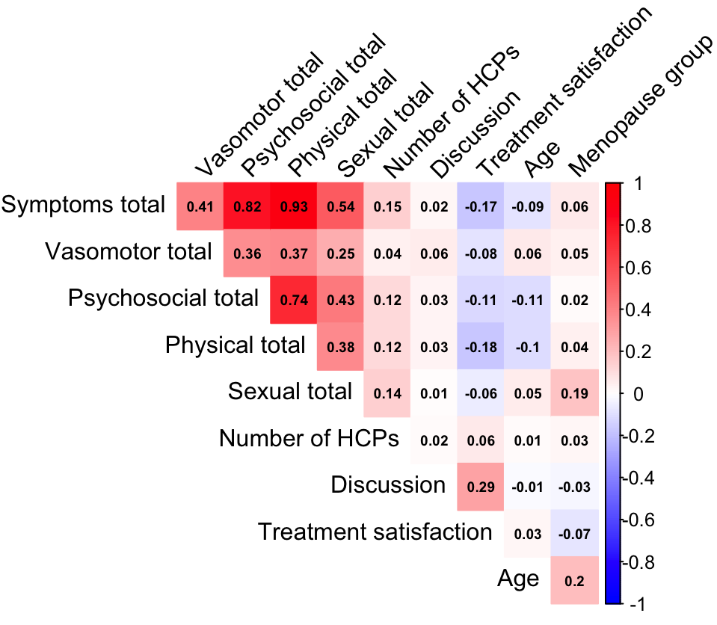

Note: HCPs = Healthcare professionals

