Figure 1
Fig 1 E
Flag
GFP
GFP
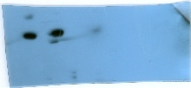
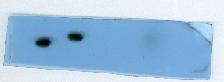
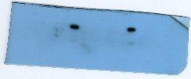
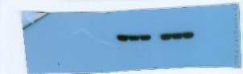
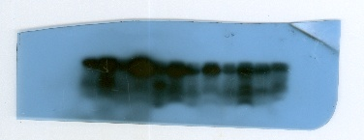
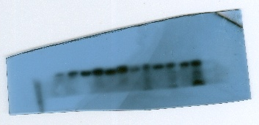
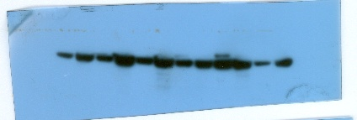
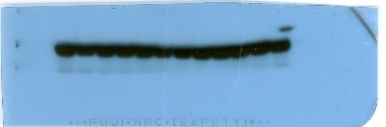
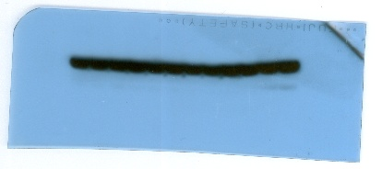
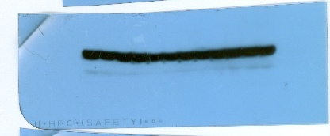
Fig 1 G
β-actin
β-actin
β-actin
TCEA1-45aa
TCEA1-45aa
TCEA1-45aa
β-actin
TCEA1-45aa
β-actin
Flag

Figure 3
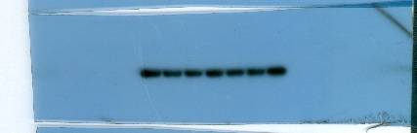


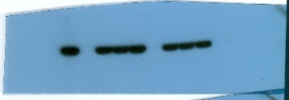
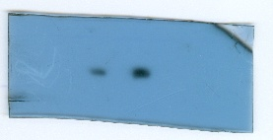
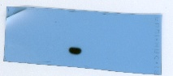
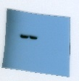
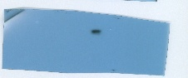
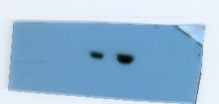
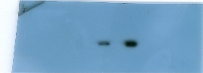
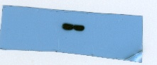
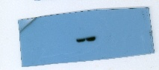
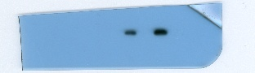
β-actin
flag
ENO1
ENO1
flag
GST
His
Fig 3 C GST-PULL DOWN
β-actin
HA
flag
HA
flag
co-ip HUH7-right
flag
HA
flag
HA
β-actin
flag
ENO1
β-actin
flag
ENO1
co-ip PLC-left
co-ip HUH7-right
flag
ENO1
β-actin
flag
ENO1
Fig 3 B co-ip HUH7-left

Figure 4
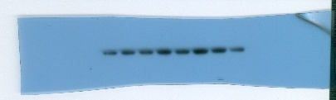
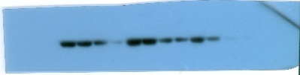
TCEA1-45aa
β-actin
ENO1
Fig 4 B
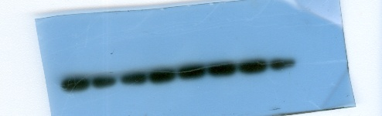
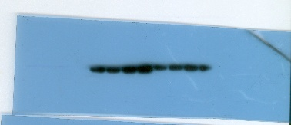
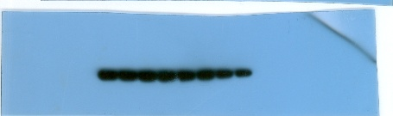

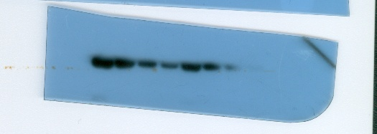
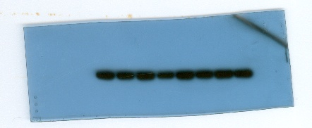
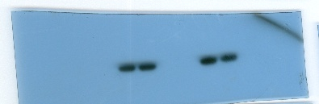
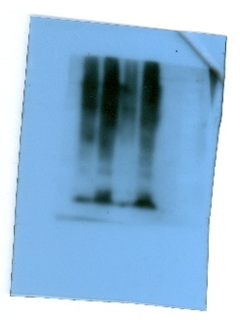
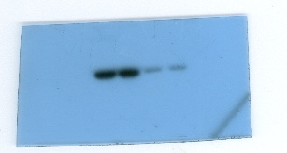
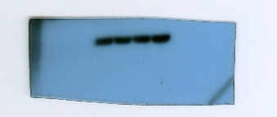
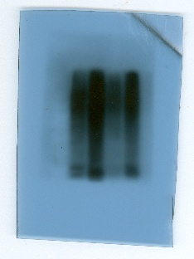
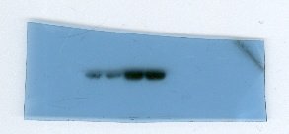
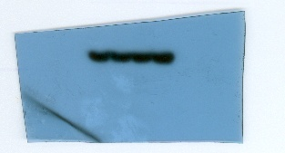
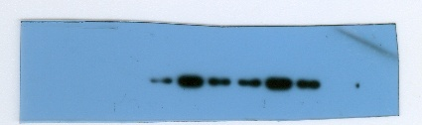
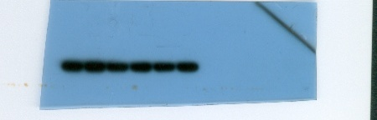
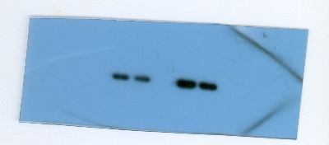
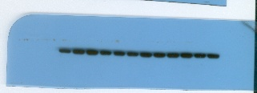
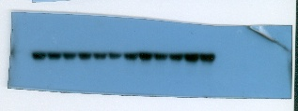
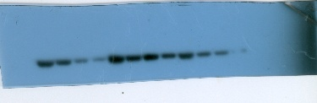
β-actin
β-actin
TCEA1-45aa
ENO1
ENO1
Fig 4 E
Fig 4 D
Fig 4 C
β-actin
Flag
ENO1
ub
ENO1
Flag
β-actin
ub
ENO1
Flag
β-actin
Fig 4 A
ENO1
β-actin
Flag

Fig 4 E
ENO1
ENO1
TCEA1-45aa
β-actin
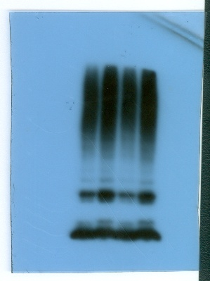
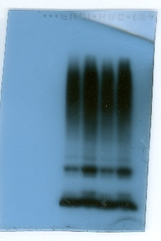
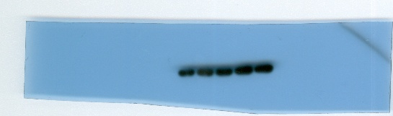
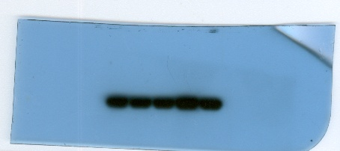
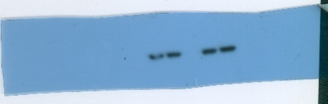
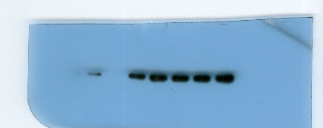
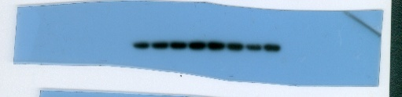
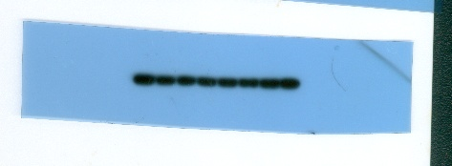
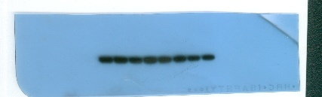
ub
ub
β-actin
HA
Flag
FBXW7
Fig 4 I
β-actin
Fig 4 F
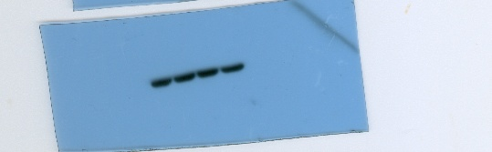
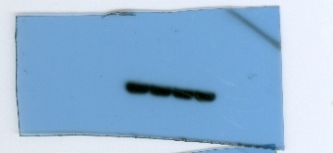
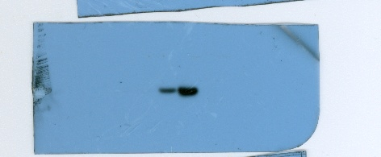
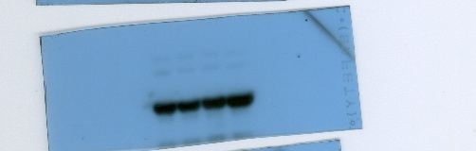
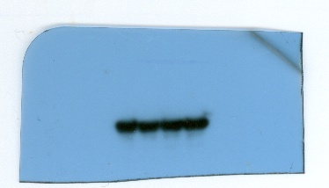
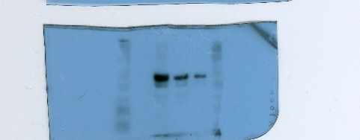
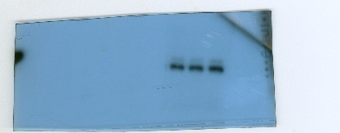
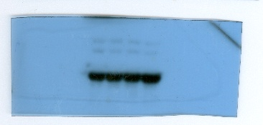
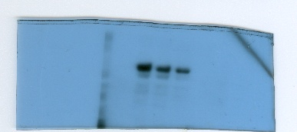
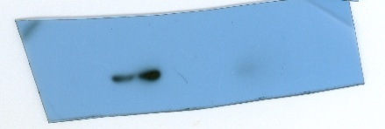
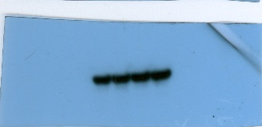
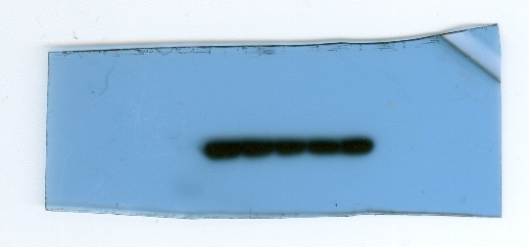
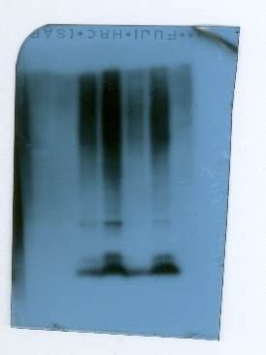
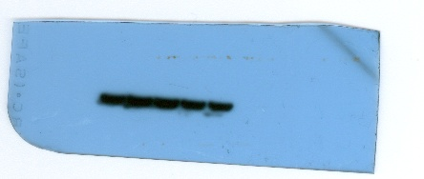
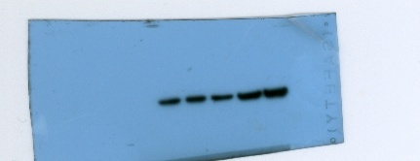
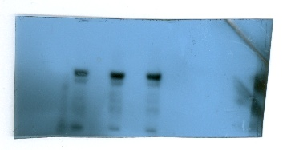
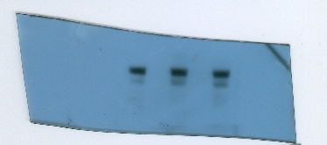
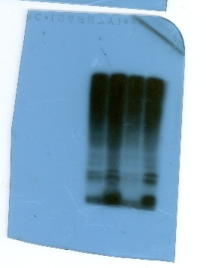
Flag
MYC
HA
HA
MYC
Flag
Flag
MYC
HA
β-actin
β-actin
HA
Flag
TCEA1-45aa

Flag
MYC
β-actin
HA
Fig 4 G
ub
ub
β-actin
HA
Flag
TCEA1-45aa

Flag
Flag
Fig 4 H
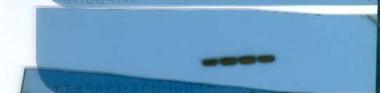
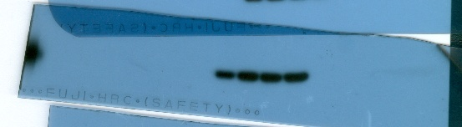
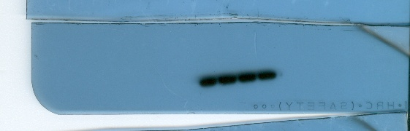
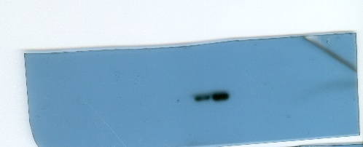
β-actin
β-actin
HA
HA
HA
HA
Myc
Myc
Myc
Myc
Flag
Flag
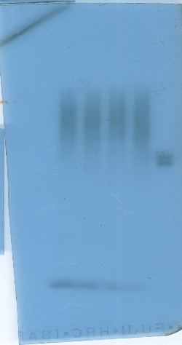
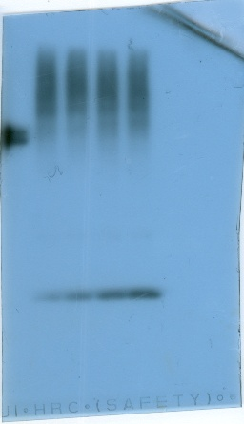

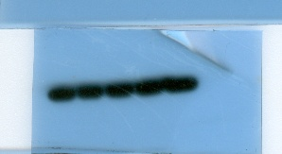
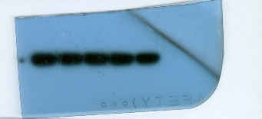
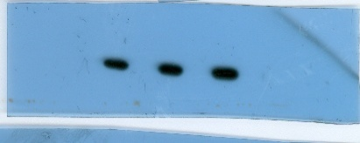
Ub
Ub
β-actin

β-actin

HA

HA

TCEA1-45aa

TCEA1-45aa

Flag
Flag
Fig 4 J
Figure 5
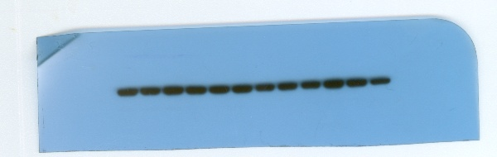
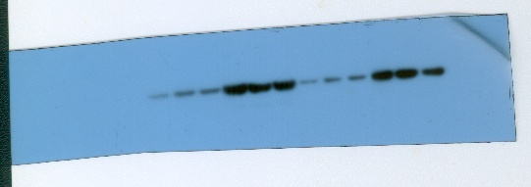
β-actin
ENO1
TCEA1-45aa
Fig 5O
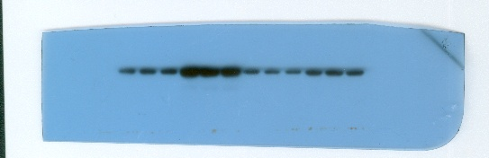
Figure 6
Fig 6M
TCEA1-45aa

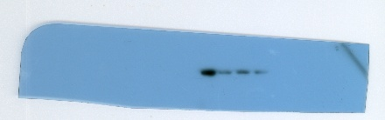
TCEA1-45aa

TCEA1-45aa

Fig 6H
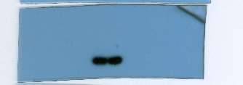
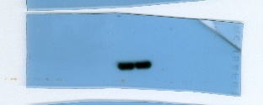
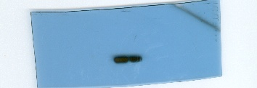
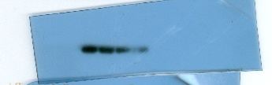
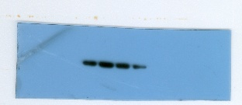
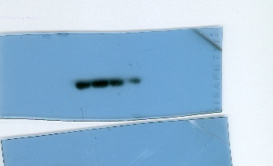
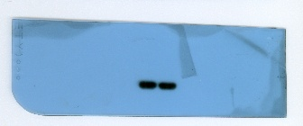
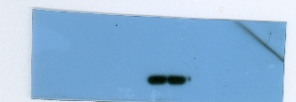
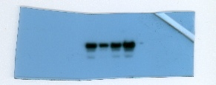
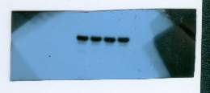
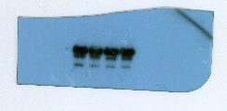
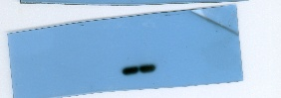
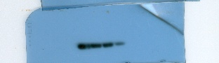
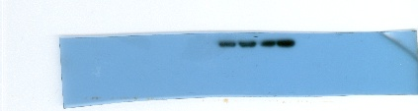
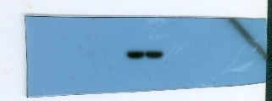
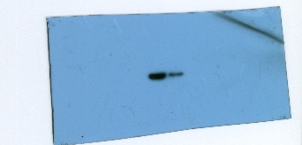
β-actin
YTHDF3
EIF3A
β-actin
YTHDF3
EIF3A
Fig 6P MUT
Fig 6P WT
β-actin
β-actin
YTHDF3
YTHDF3
EIF3A
EIF3A
EIF3A
EIF3A
EIF3A
Fig 6N
β-actin
β-actin
TCEA1-45aa

β-actin
β-actin
β-actin
β-actin
Figure 7
Fig 7L
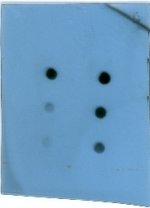
m⁶A
MB
m⁶A
MB
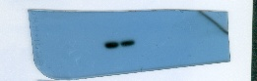

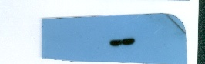
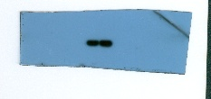
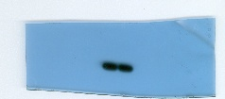

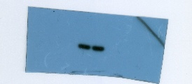
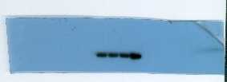
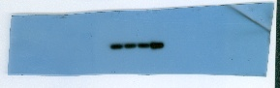
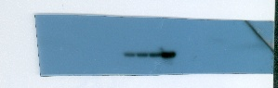
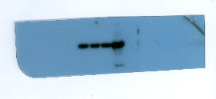
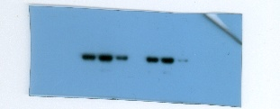
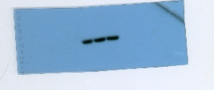
YTHDF3
YTHDF3
YTHDF3
YTHDF3
EIF3A
EIF3A
Fig 7S WT
β-actin
β-actin
YTHDF3
YTHDF3
EIF3A
EIF3A
Fig 7S WT
TCEA1-45aa
β-actin
β-actin
Fig 7R
EIF3A
EIF3A
β-actin
Fig 7Q
Figure 8
β-actin
TCEA1-45aa
Fig 8 A
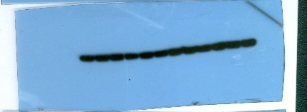
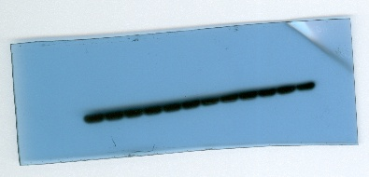
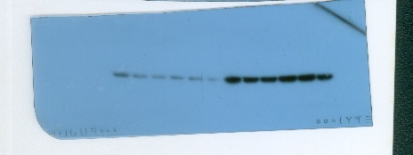
β-actin
ENO1
TCEA1-45aa
Fig 8 F
Figure S4
Fig S4 A
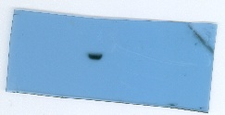
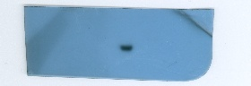
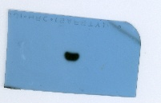
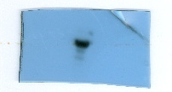
β-actin
Flag
HA
Flag
HA
Flag
ENO1
ENO1
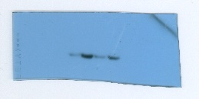
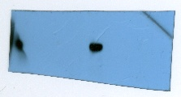
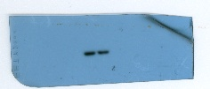
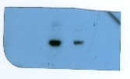
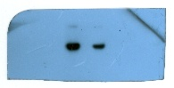
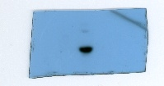
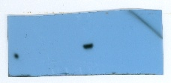
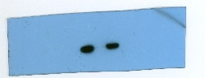
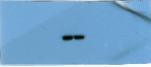
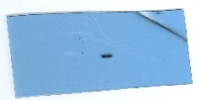
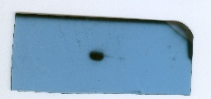
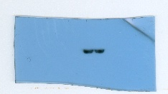
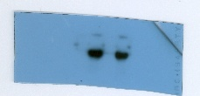
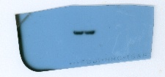
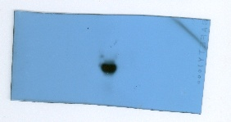
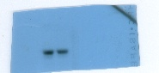
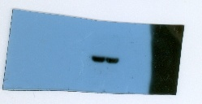
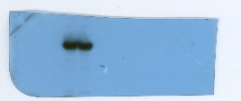
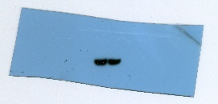
TCEA1-45aa

β-actin
Fig S4 E
β-actin
Flag
HA
Flag
HA
HA
Flag
HA
Flag
β-actin
HA
Flag
HA
Flag
β-actin
β-actin
HA
Flag
HA
Flag
Fig S4 B
β-actin
Flag
HA
HA
β-actin
Flag
ENO1
Flag
Flag
ENO1
Flag
β-actin

