Electronic supplementary material
Lake-catchment system responses to mercury and lead pollution from industrial activities in Mediterranean environments: legacy controls and current recovery dynamics in Lake Estanya (NE Spain)

Isabel Rodriguez-Veiga^{1,2}, Jorge Pey³, Antonio Garralón¹, Virginia Peyres^{4,} Thomas Schmid¹, Mario Morellón^{5,6}, Blas L. Valero-Garcés³, Marcel-Saïd Galofré Penacho⁷, Bastien Duval⁸, David Amouroux⁹, Rocío Millán¹, Juan Pablo Corella¹⁰
¹Department of Environment (DMA), Centro de Investigaciones Energéticas, Medioambientales y Tecnológicas (CIEMAT), 28040, Madrid, Spain
²Department of Systems and Natural Resources, School of Forest Engineering and Natural Resources, Universidad Politécnica de Madrid (UPM), 28040, Madrid, Spain
³Pyrenean Institute of Ecology (IPE-CSIC), 50059, Saragossa, Spain
⁴CIEMAT, Metrology of Ionizing Radiation, 28040, Madrid, Spain
⁵Department of Geodynamics, Stratigraphy, and Paleontology, Complutense University of Madrid, Madrid, 28040, Spain
⁶Institute of Geosciences (IGEO, CSIC-UCM), 28040, Madrid, Spain
⁷Andalusian Earth Sciences Institute (IACT-CSIC), 18100, Armilla, Spain
⁸CEA Cadarache, DES, IRESNE, DEC, LARC Saint-Paul-Lez-Durance, 13108, France
⁹Universite de Pau et des Pays de l’Adour UPPA, CNRS, Institut des Sciences Analytiques et de Physico-Chimie pour l’Environnement et les Materiaux, UMR5254, 64053 Pau, France
¹⁰Department of Geology, National Museum of Natural Sciences (MNCN), Spanish Scientific Research Council (CSIC), José Gutiérrez Abascal 2, Madrid, Spain.

*Corresponding authors:
Isabel Rodríguez Veiga: isabel.rodriguez@ciemat.es
Juan Pablo Corella: pablo.corella@mncn.csic.es
Appendix A. Supplementary methods
Atmospheric deposition fluxes matrix factorization
Positive Matrix Factorization (PMF 5.0, U.S. EPA) was used to identify and quantify potential sources contributing to the measured variables (Paatero and Tapper 1994). The analysis followed the good practices recommended in the European Guide on Air Pollution Source Apportionment with Receptor Models (Belis et al. 2019). The dataset consisted of 28 samples and 35 variables. Given the limited dataset size, this work is intended as an exploratory evaluation of potential sources rather than a statistically robust source apportionment analysis. Among the selected variables, K, Li, Cu, Se, Cd and Sn were treated as weak species. Several model runs were performed testing different numbers of factors (from 4 to 9) in order to evaluate model stability and interpretability. The optimal solution was obtained with eight factors, based on the examination of Q values (Qtrue and Qexpected), residual distributions, and the physical interpretability of factor profiles. Model diagnostics, including scaled residuals and bootstrap uncertainty analysis, confirmed the robustness of the eight-factor solution.
Uncertainties were estimated following the approach proposed by Amato et al. (2009), combining analytical uncertainties with a percentage of the measured concentrations to account for instrumental and methodological variability. In addition, an extra 5% uncertainty was added to all variables to better reflect potential measurement and sampling biases. These uncertainty estimates were used to weight the data matrix, and variables with low signal-to-noise ratios were down-weighted accordingly. Bootstrap and displacement tests further confirmed the robustness and stability of the eight-factor solution.
Appendix B. Supplementary tables
Table S1. Inter-elemental Pearson correlations (Hg, Pb, Al, Zn, TIC, and TOC) for the periods pre-1950 (lower matrix) and post-1950 (upper matrix)
 | Hg | Pb | Al | Zn | TOC | TIC
Hg | 1
Pb | -0,387* | 1
Al | -0,594*** | 0,260 | 1
Zn | -0,108 | 0,160 | 0,271 | 1
TOC | 0,250 | -0,217 | -0,549*** | 0,094 | 1
TIC | 0,365* | -0,343* | -0,854*** | -0,412** | 0,287 | 1
Hg | 1
Pb | 0,719*** | 1
Al | -0,621*** | -0,357* | 1
Zn | 0,625*** | 0,696*** | -0,074 | 1
TOC | 0,858*** | 0,662*** | -0,835*** | 0,491*** | 1
TIC | -0,073 | -0,353* | -0,488*** | -0,560*** | 0,012 | 1
*** Correlation is significant at P < 0.001 level (two-tailed).
** Correlation is significant at P < 0.01 level (two-tailed).
* Correlation is significant at P < 0.05 level (two-tailed).

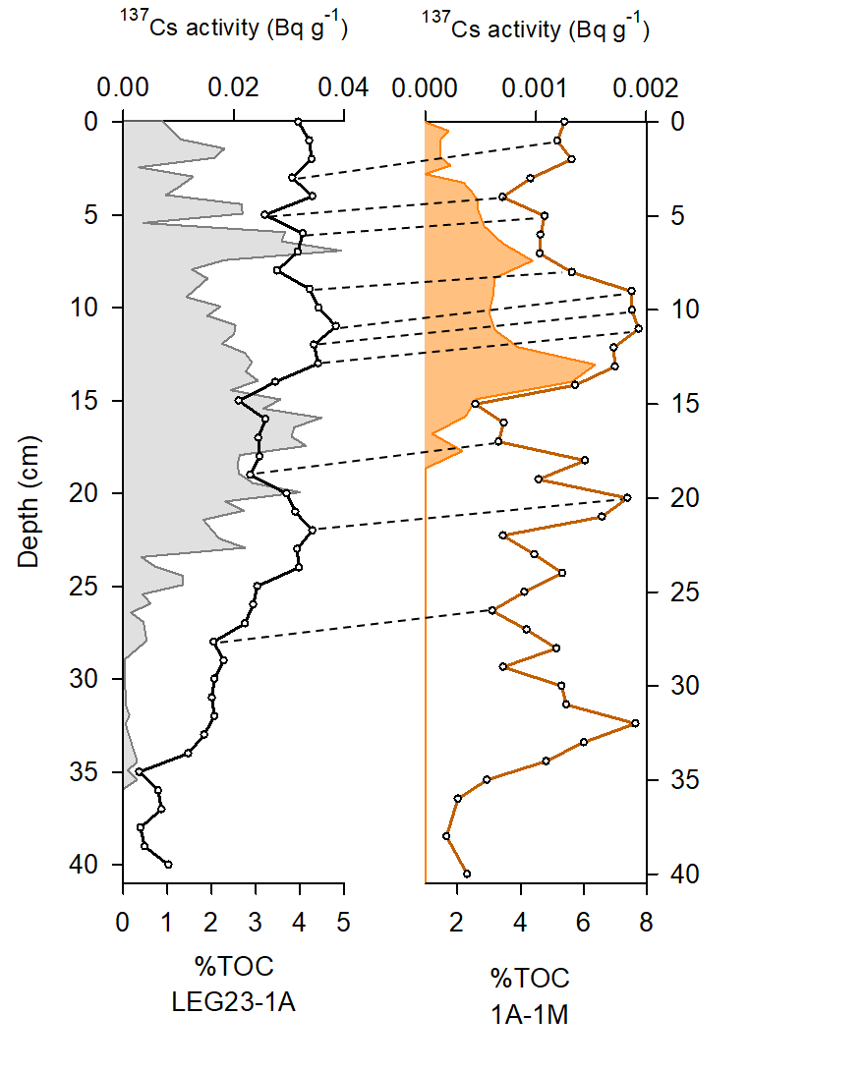
Appendix C. Supplementary figures
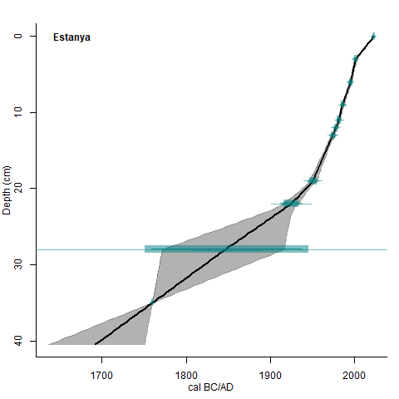
Fig. S1. Sedimentological correlation of cores LEG23-1A and 1A-1M (Morellón et al. 2011). TOC profiles represented as percentage (concentration) are included as means of correlation between the cores. The ¹³⁷Cs profiles of both cores (shaded areas) have been cross-referenced to validate the correlation

Fig. S2. Age-depth model for the last ~330 years of Lake Estanya. The age-depth model was generated by linear interpolation between tie-points correlated with the previously dated 1A-1M core (Morellón et al. 2011), using the R package 'clam' (Blaauw 2010) integrating 137Cs measurements in LEG23-1A sediment core
References

Amato F, Pandolfi M, Escrig A, Querol X, Alastuey A, Pey J et al Hopke PK (2009) Quantifying road dust resuspension in urban environment by Multilinear Engine: A comparison with PMF2. Atmos Environ 43: 2770-2780. https://doi.org/10.1016/j.atmosenv.2009.02.039
Belis C, Favez O, Mircea M, Diapouli E, Manousakas M, Vratolis S et al Paatero P (2019) European guide on air pollution source apportionment with receptor models. Publications Office of the European Union, Luxembourg. https://doi.org/10.2760/439106
Blaauw M (2010) Methods and code for ‘classical’ age-modelling of radiocarbon sequences. Quat Geochronol 5: 512-518. https://doi.org/10.1016/j.quageo.2010.01.002
Morellón M, Valero-Garcés B, González-Sampériz P, Vegas-Vilarrúbia T, Rubio E, Rieradevall M et al Soto J (2011) Climate changes and human activities recorded in the sediments of Lake Estanya (NE Spain) during the Medieval Warm Period and Little Ice Age. J Paleolimnol 46: 423-452. https://doi.org/10.1007/s10933-009-9346-3
Paatero P, Tapper U (1994) Positive matrix factorization: A non-negative factor model with optimal utilization of error estimates of data values. Environmetrics 5: 111-126. https://doi.org/10.1002/env.3170050203
U.S. EPA (2014) EPA Positive Matrix Factorization (PMF) 5.0 Fundamentals and User Guide. EPA/600/R-14/108. Washington, DC.

