Supplementary Information (SI)
Filling a gap in the peopling of Mainland Southeast Asia: 100 000-year-old lithic evidence from Laang Spean Cave (Cambodia)

METHODS

SI-1. Dating analysis (U-Th; OSL)

  - U-series dating
Several calcite samples were collected during different excavation campaigns. Samples analysed by uranium-series dating at the Geochronology Laboratory of the Musée de l'Homme (Paris, France) were taken from a large stalagmite located at the base of the sedimentary sequence and resting directly on the Permian limestone bedrock (extended Data Fig. 1). Two younger samples from a stalagmitic floor underlying Layer 11 were also taken (extended Data Fig. 2) and analysed at the Laboratory for Climate and Environmental Sciences (LSCE, Gif-sur-Yvette, France).
The samples were cut and cleaned using a rotary tool fitted with a diamond cutting disc and subsequently cleaned with a diamond burr.
For each analysed sample, a known amount of the ²²⁹Th–²³³U–²³⁶U mixed spike was weighed and evaporated to dryness in a Teflon beaker. The samples were then weighed (100–1200 mg, depending on the sample and the laboratory) and dissolved in 7M HNO₃ (at HNHP) or in diluted HCl (at LSCE). A few drops of H₂O₂ were added to remove organic matter. An iron hydroxide co-precipitation step was performed to remove most of the carbonate matrix and thereby pre-concentrate uranium and thorium. Uranium and thorium isotopes were subsequently separated and purified using a single Eichrom® UTEVA ion-exchange resin (Horwitz et al., 1992) following Douville et al. (2010). The resin columns were conditioned and rinsed with ultrapure hydrochloric and nitric acids of various molarities according to the established analytical protocol. The purified U and Th fractions were evaporated to dryness and before final dilution for isotopic analysis. Each analytical batch included a lab reference material (HU-1, Harwell uraninite) for quality control, together with a total procedural blank, which was measured and quantified.
At the Musée de l’Homme, isotopic measurements were performed using a Thermo Electron iCAP-RQ ICP-Q-MS coupled to a Teledyne CETAC Aridus 3 desolvation system and a Teledyne CETAC ASX-112FR autosampler. The interface was configured for high sensitivity (high-sensitivity insert and skimmer cone), and the instrument was tuned using ²³⁸U and ²³⁵U. Signal intensities for ²²⁹Th, ²³⁰Th, ²³³U, ²³⁴U, ²³⁵U and ²³⁶U were measured on the secondary electron multiplier (SEM) operating in pulse-counting mode. Because the calcite samples were exceptionally pure, ²³²Th was also measured in pulse-counting mode rather than in analogue mode, thus eliminating the need for a cross-calibration factor. To maximise sensitivity for ²³⁰Th, the helium collision mode (CCTS) of the QCell was used to optimise ion focusing. Instrumental mass fractionation was corrected using the exponential law of Russell et al. (1978) by comparing the measured ²³³U/²³⁶U spike ratio with its certified value. The ²³⁴U/²³⁸U ratio was calculated from the measured ²³⁴U/²³⁵U ratio using the natural ²³⁸U/²³⁵U ratio (Hiess et al., 2012). Following data reduction, the measured atomic isotope ratios were converted into activity ratios. A spiked HU-1 uraninite standard, assumed to be in secular radioactive equilibrium, was analysed at the beginning and end of each analytical sequence to monitor instrumental performance.
At the LSCE, after pre-analysis of a diluted fraction of the samples, U and Th were recombined in order to reach no more than 10V for ²³⁸U and less than 1 V on mass ²³²Th. The recombined fraction (usually the totality of the Th fraction and part of the U fraction) were analysed on a multicollector inductively coupled plasma mass spectrometer (MC-ICPMS, Thermo Neptune Plus), fitted with a jet interface and an Aridus II desolvating system. ²³⁸U, ²³⁵U, ²³⁶U and ²²⁹Th were measured on Faraday cups, and ²³⁰Th and ²³⁴U on ion counting following Pons‐Branchu et al. (2022).
Total procedural blanks were required to remain as low as possible, and the corrected values obtained for the internal reference material had to agree with the certified values in order to validate the analytical results and the calculated ages.
U-series ages were calculated using half-lives of 75,584 years for ²³⁰Th and 245,620 years for ²³⁴U (Cheng et al., 2013). Age uncertainties were propagated from all analytical sources of uncertainty and are reported with a factor k = 2 (extended Data Tabs. 1 and 2).
For the analyses conducted at the Musée de l’Homme (extended Data Tab. 1), uranium concentrations range from 140 to 510 ppb. The isotopic ratios are highly reproducible, with ²³⁴U/²³⁸U activity ratios very close to secular equilibrium. No significant detrital thorium contamination was detected, and therefore no correction for initial ²³⁰Th was required. The ages obtained for the basal stalagmite are older than 250 ka, suggesting that this speleothem is not stratigraphically related to the archaeological infilling. Nevertheless, these results demonstrate that karst development and speleothem formation at the site began well before the deposition of the archaeological sequence.
The corrected ages obtained at the LSCE (extended Data Tab. 2) allow framing the lower and upper part of the younger speleothem to 63.930 ± 5.120 ka (PS1-1) and 10.440 ± 0.800 ka (PS3) respectively. Unlike the samples from the basal speleothem, these samples have significant contamination in detritic Th, as shown by the ²³⁰Th/²³²Th isotopic ratios of 7.61 ± 0.01 (PS1-1) and 11.09 ± 0.02 (PS3). Uncorrected ages of 11.980 ± 0.050 ka and 73.970 ± 0.360 were thus corrected using a ²³⁰Th/²³²Th initial value of 1.5 ± 50%.

  - OSL dating

During the fieldwork in May 2024, five sediment samples were collected in the test-pit. The samples were collected by scraping the stratigraphic section under controlled lighting conditions; in each case the sediment collected by scraping the external surface 2 centimetres of the stratigraphic section – a zone that has been exposed to natural light since the test pit was excavated – was set aside for radioactivity measurements; the internal part of the sediment collected (beyond the surface 2 cm) has been packed in opaque black bags for transport. In situ measurements using portable gamma spectrometer were also carried out during the campaign, at the exact sampling point for each of the samples collected.

Dating methods based on natural crystal luminescence exploit the ability of certain natural crystals (primarily sedimentary quartz and feldspars) to act as natural dosimeters. They emit a signal linked to the effects of the natural radioactivity surrounding them, a signal that can be measured in the laboratory. This signal is reset to zero by exposure to light or heat, and increases with the radiation dose received, and thus with the passage of time. Luminescence methods require the evaluation of two quantities: the dose equivalent to the total radiation dose received since the last reset (D_{e}), on the one hand, and the dose rate of radiation received over time (D_{r}), quantities appearing respectively in the numerator and denominator of the age equation (age = D_{e}/D_{r}) (Aitken, 1985; 1998).

Measuring the luminescence of the crystals one by one (single-grain mode, or SG) makes it possible to detect any anomalies in the D_{e} distributions (variations beyond normal statistical dispersion), which appears to be the case for the three previously dated samples (Sophady et al., 2016). We therefore prioritised the preparation of crystals suitable for this approach for the five samples collected in 2024.

Samples for D_{e} measurements have been treated mechanically and chemically to extract the 100-140μm quartz fraction, according to commonly used protocols (Wintle, 1997; 2008). The samples have been wet sieved, and chemically treated (HCl 10% 60min; H₂O₂, 30% during 5 to 8 days, renewed once). The quartz fraction has then been isolated by flotation in Lithium Heteropolytungstate aqueous solution. It was then etched (HF 40% 40 minutes), rinsed, HCl 10% treated and rinsed again. At the same time, the external sample fractions collected have been dried, crushed, and packed in sealed standard-size plastic containers and stored for one month before gamma spectrometry measurements for D_{r} determination.

Luminescence measurements have been conducted using a blue light emitting diodes (470 nm) Risø TL/OSL DA-20 reader coupled with 7.5 mm Hoya U-340 detection filters and with a green laser (532 nm) used with a 7.5 mm Hoya U-340 detection filter. The SAR protocol (single-aliquot regenerative dose protocol, Wintle and Murray 2000) has been tested and adopted. The D_{e} measurements were preceded by a preheat plateau test on multi-grain aliquots that did not show any significant variations in the D_{e} values, and a dose recovery test, that led to a satisfactory recovery rate of 0.89±0.03. The total dispersion (0.29±0.04) of this measurement has then been considered as representative of the intrinsic dispersion (σ_m) of all five samples when applying the Average Dose Mode (ADM; Guérin et al., 2017). Detailed results of the D_{e} measurements are provided in Extended data Tab. 2; neither the extrinsic overdispersion values (ranging from 0.26 to 0.58) nor the abanico-plots (Extended data Fig. 3) suggest the existence of an incomplete bleaching phenomenon. Moreover, less than 4% of the grains that passed all tests are saturated. We therefore adopted the ADM values for ages determination.
Radioelement contents measured on the sediments have been obtained by high purity low background gamma spectrometry using a Mirion Technologies gamma spectrometer (Guibert and Schvoerer, 1991) (Extended data Tab. 3); beta and gamma contributions to the dose rate have been derived from these data, using the U(²²⁶Ra) contents for U series, and the cosmic dose-rates were assessed considering the location of the site and the burial-depth (Prescott and Hutton, 1988) (Extended data Tab. 3).

Ages of the quartz last exposure to the sunlight are given in Extended data Tab. 2. They are ranging from ca. 21±1 ka for the sample collected in US12 to ca. 175±10 ka for the sample collected in US22. Furthermore, the base of the sequence is dated (Terminus post Quem) by the formation of the stalagmitic flow at 253+35/-25 ka. The two ages (up and down) obtained for the speleothem collected in B25 square constitute a Terminus Post Quem for the Hoabinhian occupation. The age of 10.4 ±0.8 ka obtained for the upper part is coherent with the chronostratigraphy established in the test-pit and complements it well.

All five new OSL samples are stratigraphically in good agreement with one another, and are coherent with both the U-Th results and with previous OSL minimum ages presented in Sophady et al., 2016). The chronostratigraphy thus established indicates an approximative sedimentation rate ranging between 2.5 and 4.5 cm/ka between US 22 and US12 in the test pit.

The chronostratigraphy established by combining the results of previous and new OSL ages, radiocarbon ages in the top of the sequence, U-Th ages of the stalagmitic flow at the base of the sequence in the test-pit and U-Th ages of a speleothem unearthed in B25 square make it possible to date the formation of the layer containing the lithic assemblage of SU18 of Laang Spean Cave to around 100,000 years ago.

EXTENDED DATA

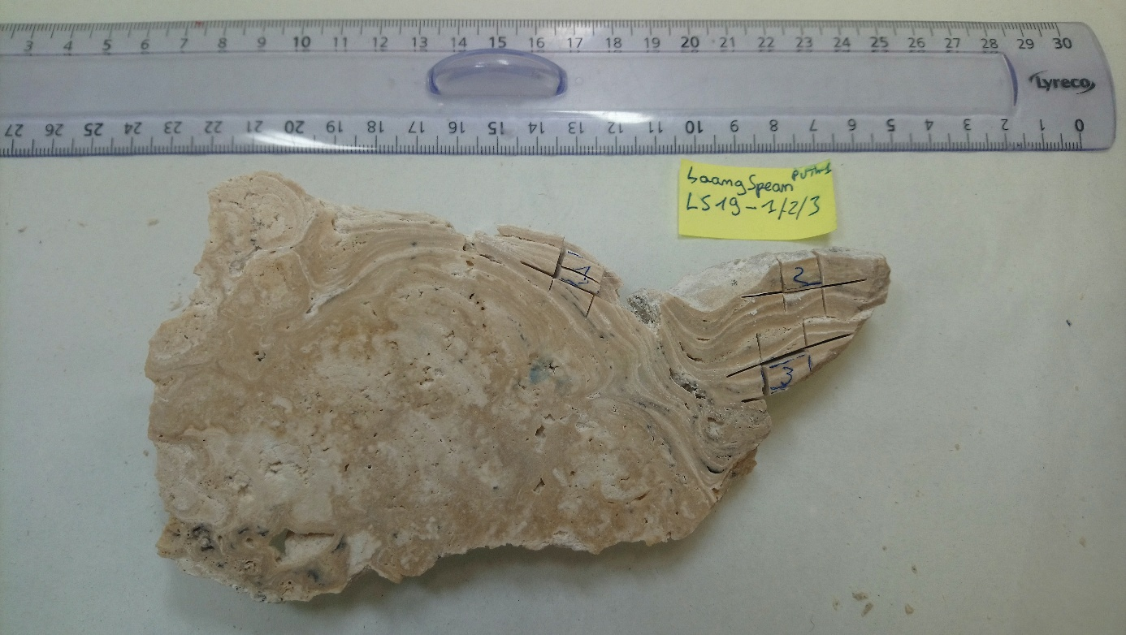
Extended Data Fig. 1: Laang Spean flowstone from the base of the sedimentary sequence.

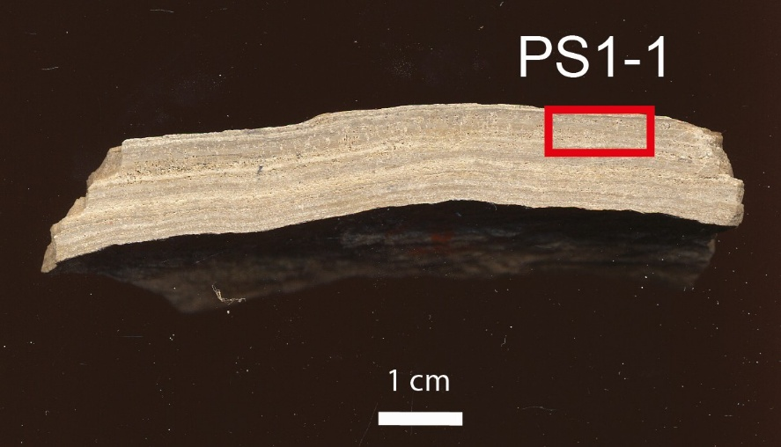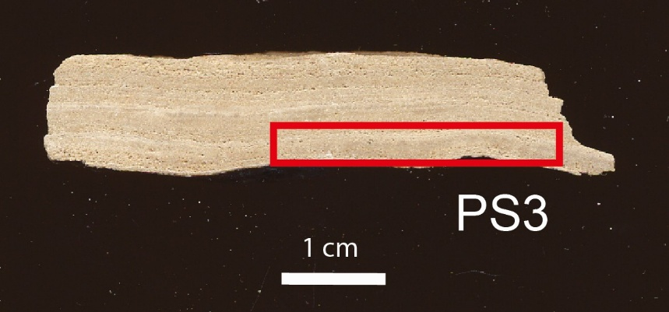
Extended Data Fig. 2: Laang Spean flowstone samples PS 1 (upper part) and PS3 (lower part).

Sample | ²³⁸U (ppm) | ²³²Th (ppb) | δ²³⁴U_{M}  (‰) | (²³⁰Th/²³⁸U) | (²³⁰Th/²³²Th) | Age (ka) | δ²³⁴U_{T}  (‰) | Corrected age (ka b2k)
LS17* | 0.51 ± 0.01 | 1.75 ± 0.02 | 33.0 ± 8.3 | 0.9968 ± 0.0114 | 891 ± 15 | 338 +38 -28 | 85.5 ± 23.1
LS19-1* | 0.44 ± 0.01 | 0.89 ± 0.02 | 9.0 ± 22.2 | 0.9111 ± 0.0212 | 1360 ± 16 | 253 + 35 - 25 | 18.4±45
LS19-2* | 0.15 ± 0.01 | 0.45 ± 0.01 | -3.0 ± 20.9 | 0.9641 ± 0.229 | 974 ± 11 | 378 + inf-72 | -8.7 ± 61.1
LS19-3* | 0.14 ± 0.01 | 0.50 ± 0.01 | 2.0 ± 21.0 | 0.9880 ± 0.0261 | 825 ± 11 | 460 +inf / -126 | 7.3 ± 77.1
LS PS3** | 1.35 ± 0.01 | 40.23 ± 0.04 | 41.5 ± 1.5 | 0.1083 ± 0.0002 | 11.09 ± 0.02 | 11.980 ± 0.050 | 42.96 ± 1.51 | 10.440 ± 0.800
LS PS1-1** | 0.48 ± 0.01 | 99.19 ± 0.06 | 49.3 ± 1.4 | 0.5182 ± 0.0010 | 7.61 ± 0.01 | 73.970 ± 0.360 | 60.79 ± 1.69 | 63.930 ± 5.120

Extended Data Tab. 2: U and Th content, isotopic ratios and ages for samples PS1-1 and PS3. *were measured at the Musée de l’Homme using ICP-Q-MS, and ** were measured at LSCE using MC-ICPMS. Ages with non-negligible amount of ²³²Th were corrected for inherited ²³⁰Th assuming a (²³⁰Th/²³²Th) of the detrital fraction of 15± 0.75. These corrected ages are expressed as ka b2k (before the year 2000). δ²³⁴U = (²³⁴U/²³⁸U)_{measured}/(²³⁴U/²³⁸U)_{equilibrium} – 1) × 1000, with ²³⁴U/²³⁸U_{equilibrium} = 54.89×10⁻⁶ (molar ratio, Cheng et al., 2013).

Sample | US | σ_d | Passed all tests/measured | In saturation (%) | D_{e} ADM (Gy) | OSL age (ka)
LSP24-05 | 12 | 0.29±0.02 | 518/2400 | 0.96 | 19±1 | 21±1
LSP24-04 | 13 | 0.26±0.02 | 520/2400 | 2.13 | 38±1 | 47±2
LSP24-03 | 15 | 0.58±0.05 | 548/2400 | 2.42 | 66±2 | 60±3
LSP24-02 | 18 | 0.26±0.03 | 499/2400 | 3.88 | 105±2 | 100±5
LSP24-01 | 22 | 0.42±0.05 | 216/2400 | 0.08 | 191±7 | 175±10

Extended Data Tab. 2: OSL equivalent doses and extrinsic dispersion ( σ_d ) using the Average Dose Model (Guérin et al., 2017) and ages.

Extended Data Fig. 3: abanico-plots of the natural D_{e} distributions for the five sediment samples collected in the test-pit in 2024.

Sample | K (%) | U(²³⁸U) (ppm) | U(²²⁶Ra) (ppm) | Th232 (ppm) | External dose rate (gamma+cosmic)  (Gy ka⁻¹) | Total dose rate  (Gy ka⁻¹)
LSP24-05 | 0.14±0.01 | 1.26±0.04 | 2.08±0.01 | 2.61±0.02 | 0.53±0.05 | 0.93±0.03
LSP24-04 | 0.11±0.01 | 1.29±0.04 | 1.77±0.01 | 2.44±0.02 | 0.47±0.05 | 0.81±0.03
LSP24-03 | 0.12±0.01 | 2.45±0.06 | 2.64±0.02 | 3.89±0.03 | 0.62±0.06 | 1.10±0.05
LSP24-02 | 0.17±0.01 | 2.03±0.05 | 2.56±0.02 | 3.17±0.03 | 0.57±0.06 | 1.06±0.03
LSP24-01 | 0.11±0.01 | 2.56±0.07 | 2.95±0.02 | 3.61±0.04 | 0.59±0.06 | 1.09±0.06

Extended Data Tab. 3: Dose-rate data for the five sediment samples collected in 2024. K, U and Th concentrations were measured by high-resolution gamma spectrometry.

References
Aitken, M.J. (1985). Thermoluminescence Dating. London: Academic Press, 359 p.
Aitken, M.J. (1998). An introduction to optical dating: The dating of quaternary sediments by the use of photon-stimulated luminescence. Oxford University Press, 266 p.
Cheng H., Edward R. L., Shen C.-C., Polyak V. J., Asmerom Y., Woodhead J., Hellstrom J., Wang Y., Kong X., Spötl C., Wang X., Alexander E.C.Jr. (2013) - Improvements in 230Th dating, 230Th and 234U half-life values, and U–Th isotopic measurements by multi-collector inductively coupled plasma mass spectrometry. Earth and Planetary Science Letters, Volumes 371–372, 82-91.
Douville E., Sallé E., Frank N., Eisele M., Pons-Branchu E., Ayrault S. (2010) - Rapid and accurate U–Th dating of ancient carbonates using inductively coupled plasma-quadrupole mass spectrometry. Chemical Geology 272, 1-11.
Guerin, G., Christophe, C., Philippe, A., Murray, A.S., Thomsen, K.J., Tribolo, C., Urbanova, P., Jain, M., Guibert, P., Mercier, N., Kreutzer, S., Lahaye, C., 2017. Absorbed dose, equivalent dose, measured dose rates, and implications for OSL age estimates: Introducing the Average Dose Model. Quat. Geochronol. 41, 163–173.
Guibert, P., & Schvoerer, M. (1991). TL dating: low background gamma spectrometry as a tool for the determination of the annual dose. Nuclear Tracks and Radiation Measurements, 18, 231–238.
Hiess J., Condon D., McLean N., Noble S. R. (2012) - 238U/235U Systematics in Terrestrial Uranium-Bearing Minerals. Science 335, 1610.
Horwitz E.P., Dietz M. L., C. Renato, D. Herbert (1992) - Separation and preconcentration of uranium from acidic media by extraction chromatography. Analytica Chimica Acta, Volume 266, Issue 1, Pages 25-37
Pons-Branchu E., Barbarand J., Caffy I. Dapoigny A., Drugat L., Dumoulin J.P., Medina Alcaide M.A., Nouet J., Sanchidrián Torti J.L., Tisnerat-Laborde N., Jiménez de Cisneros, Valladas H (2022). U-series and radiocarbon cross dating of speleothems from Nerja Cave (Spain): evidence of open system behavior. Implication for the Spanish rock Art chronology. Quaternary Sciences Review. 290. 107634.
Prescott, J.R., & Hutton, J.T. (1988). Cosmic ray and gamma ray dosimetry for TL and ESR. Nuclear Tracks and Radiation Measurements, 14, 223-227.
Russell W.A., Papanastassiou D.A., Tombrello T.A. (1978) - Ca isotope fractionation on the Earth and other solar system materials. Geochimica et Cosmochimica Acta Volume 42, Issue 8, 1075-1090
Sophady, H., Forestier, H., Zeitoun, V., Puaud, S., Frère, S., Celiberti, V., Westaway, K., Mourer, R., Mourer-Chauviré, C., Than, H., Billault, L., Tech, S., 2016. Laang Spean cave (Battambang province): A tale of occupation in Cambodia from the Late Upper Pleistocene to Holocene, Quaternary International, 162-176.
Wintle, A.G. (1997). Luminescence dating: laboratory procedures and protocols. Radiation Measurements, 27, 769-817.
Wintle, A.G. (2008). Fifty years of luminescence dating. Archaeometry, 50 (2), 276-312.
Wintle, A.G. & Murray, A.S. (2006). A review of quartz optically stimulated luminescence characteristics and their relevance in single-aliquot regeneration dating protocols. Radiation Measurements, 41, 369-391

