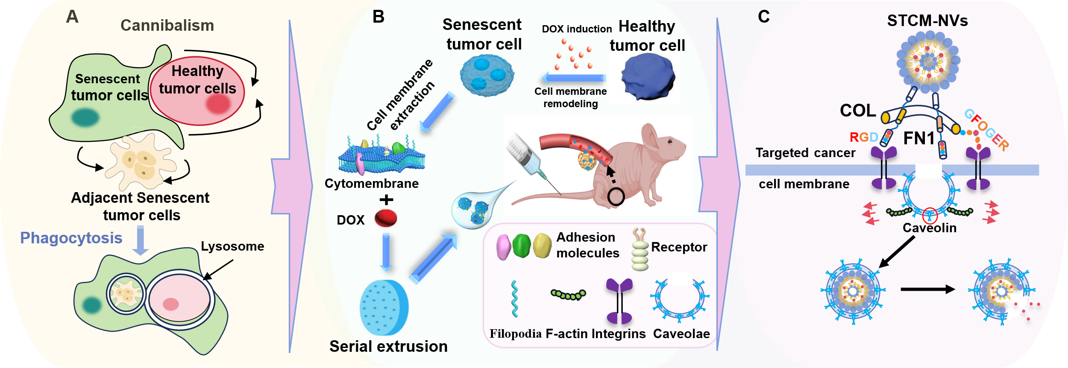
Scheme 1. Schematic illustration of the design strategy, therapeutic regimen, and targeting mechanism of senescent tumor cell membrane nanovesicles (STCM-NVs). A: The diagram of cannibalism in senescent tumor cells. The senescent tumor cells actively and precisely localized to the adjacent tumor cells and engulf them at a remarkable frequency. B: The fabrication process of STCM-NVs and their administration route. We utilized senescence-induced cell membrane remodeling strategy to amplify native targeting capacity. C: Molecular mechanisms of tumor targeting and internalization of STCM‑NVs. Fibronectin-1 and Collagens serve as the core targeting molecule and internalization mediators, respectively, which promote efficient caveolae-dependent cellular uptake through F-actin reorganization.

