Supporting Information
Cannibalism-inspired biomimetic nanovesicles achieve boosted tumor targeting capacity via senescence-induced membrane remodeling

Liyuan Zheng^{1, *}, Shuxian Duan¹, Yingying Li¹, Hui Che¹, Yuran Liang¹, Xingding Zhang², Bihua Lin¹, Caihong Li¹, Junjie Deng³, Xianxiu Qiu¹, Qunzhou Zhang⁴, Lin Qi⁵, Jincheng Zeng^{1, *}

Supplementary Materials for this manuscript include the following: Figures. S1 to S13
Table S1

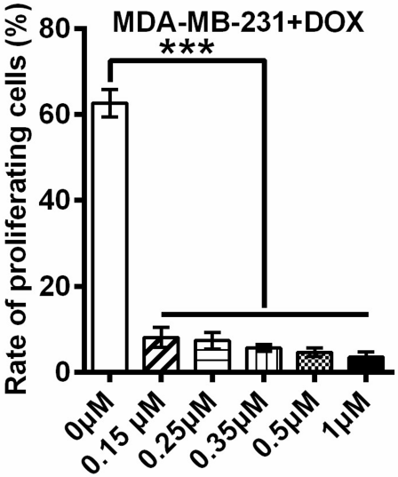
Figure S1. Statistical graph of the EdU assay in Figure 1 B.

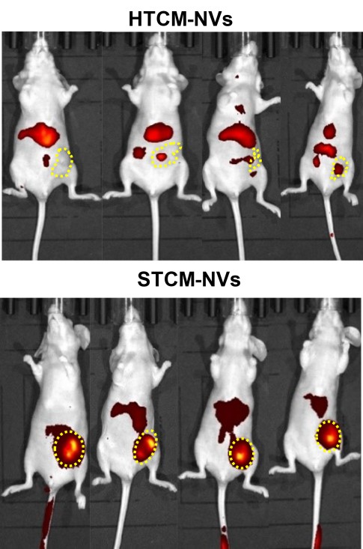
Figure S2. In vivo fluorescence images of mice bearing MDA-MB-231 tumors 48 h post-injection with STCM-NVs or HTCM-NVs.

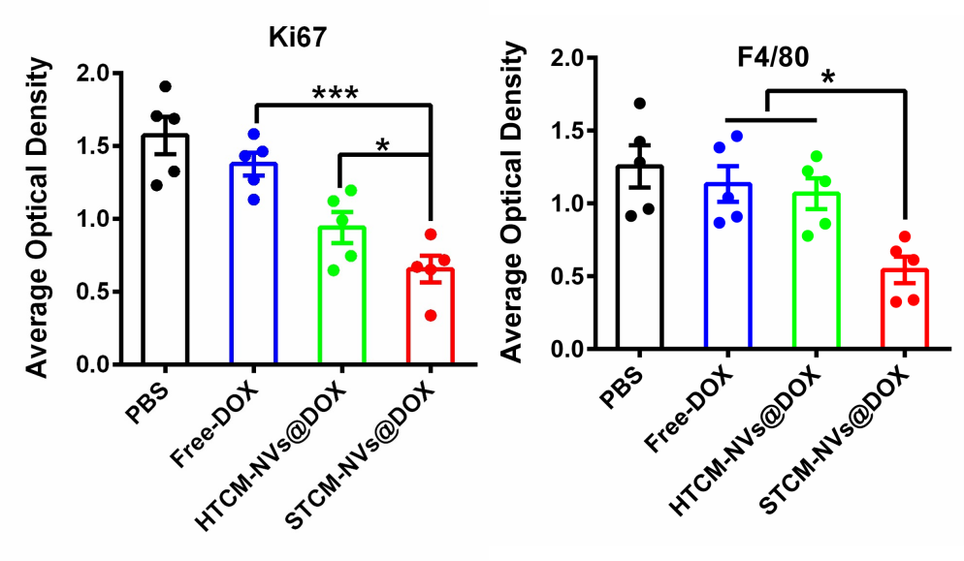
Figure S3. The IHC score of (A) Ki67 and (B) F4/80.

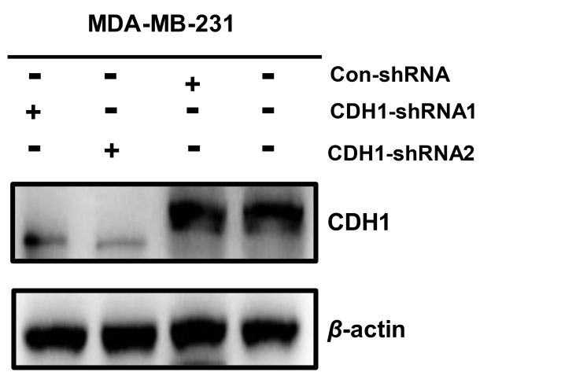

Figure S4. Knock down efficiency of CDH1-shRNAs was analyzed by western.

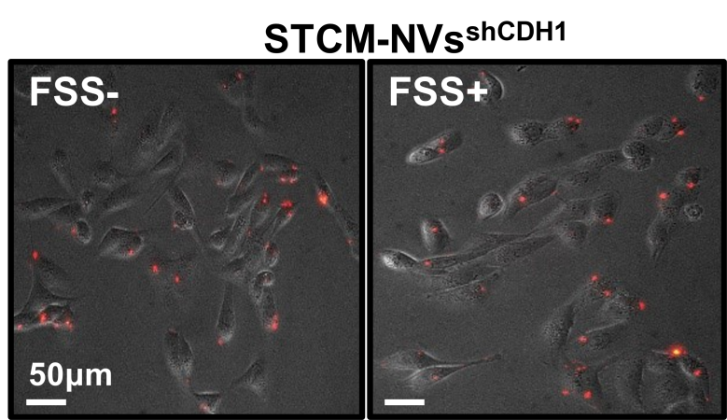
STCM-NVs^{shCDH1}
Figure S5. The homotypic adhesion of HTCM-NVs^{shCDH1} was measured with or
without flow shear stress treatment.

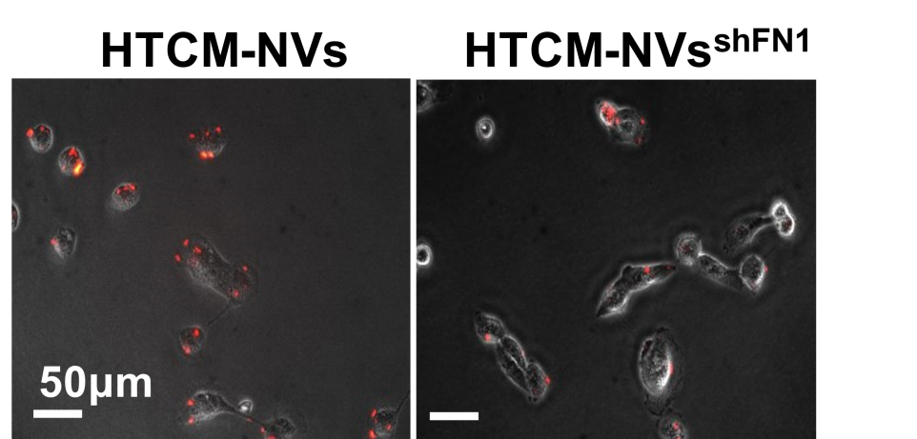
HTCM-NVs
HTCM-NVs^{shFN1}
Figure S6. Dil labeled HTCM-NVs and HTCM-NVs^{shFN1} bound to the MDA-MB-231 cells after incubation for 2 h.

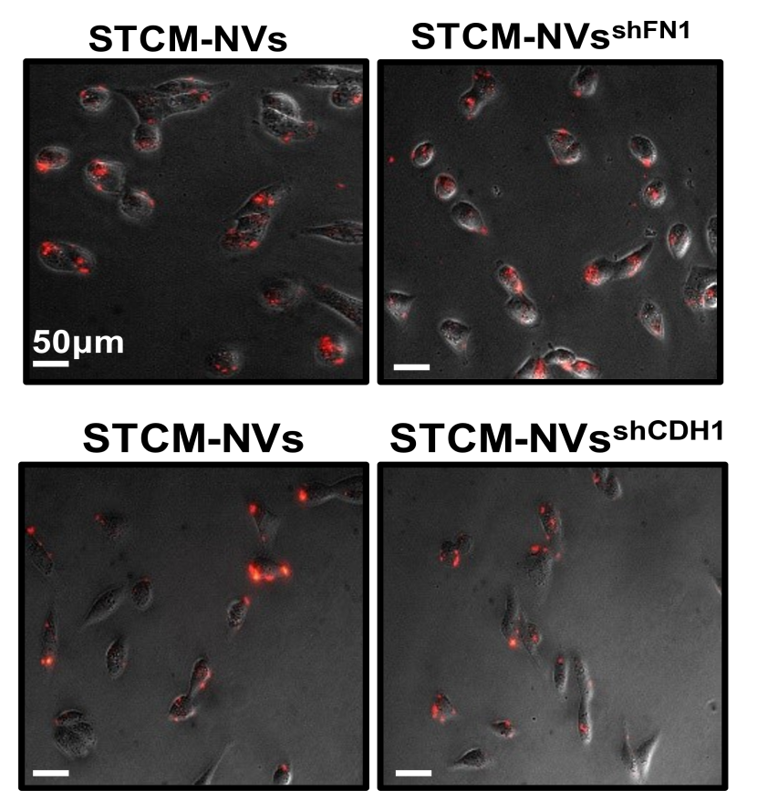
STCM-NVs
STCM-NVs^{shFN1}
STCM-NVs^{shCDH1}
STCM-NVs
Figure S7. Cellular uptake of STCM-NVs^{shFN1} and STCM-NVs^{shCDH1} after co-incubation with homotypic cancer cells (MDA-MB-231) for 12 h at 37 ºC.

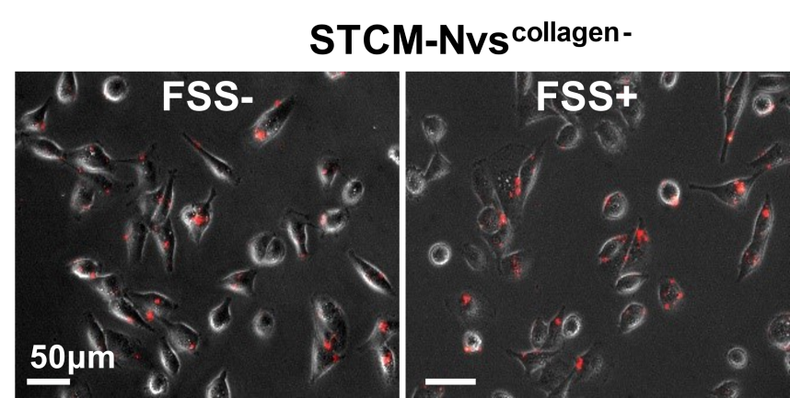
Figure S8. The homotypic adhesion of HTCM-NVs^{collagen-} was measured with or without flow shear stress treatment.

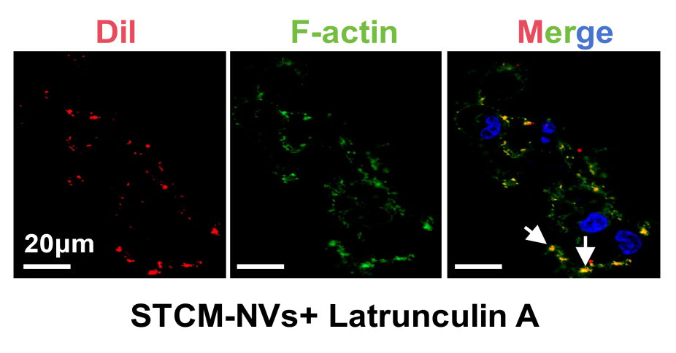
Figure S9. The uptake efficiency of STCM-NVs after the target cancer cell pretreated with actin polymerization inhibitor (Latrunculin A).

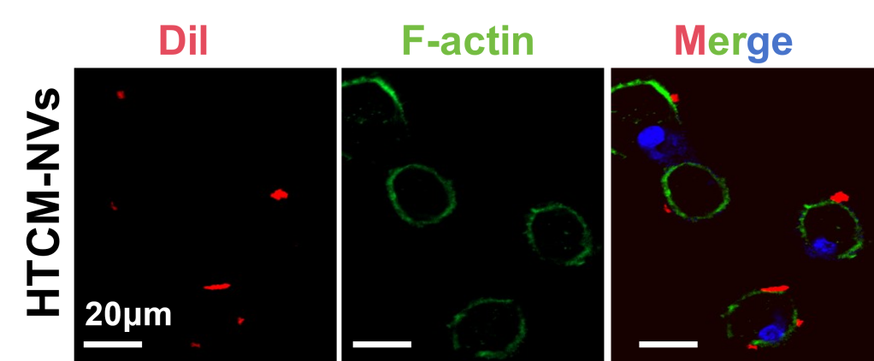
Figure S10. Confocal imaging shown F-actin localization in targetd cell during the early stage of engulfing HTCM-NVs .

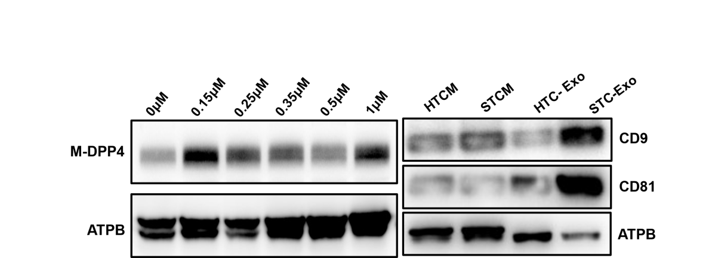
Figure S11. Western blot analysis of the levels of DPP4 on the surface of MDA-MB-231 cell membrane after treated with DOX at different concentration. Validation of CD9 and CD81 differential expression level on exosomes and cells membrane surface.

Figure S12. Cellular uptake of HTCM-NVs by MDA-MB-231 (pretreated with CPZ, EIPA or MβCD) was visualized using laser confocal microscopy.

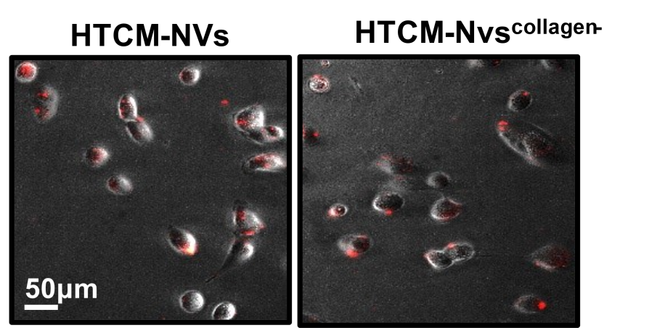
Figure S13. The uptake of HTCM-NVs^{collagen-} by healthy MDA-MB-231 cells.

Materials and Methods
Cell line maintenance: The human breast carcinoma cells MDA-MB-231 and MCF-7, the breast epithelial cell MCF-10A, as well as human monocyte cell THP-1 were obtained from American Type Culture Collection (ATCC). MDA-MB-231, MCF-7 and MCF-10A cells were cultured in DMEM (high glucose, C11995500BT, Gibco) supplemented with 10% FBS (10437028, Thermo Fisher scientific), 100 U/mL penicillin, and 100 μg/mL streptomycin (15140-163, invitrogen). THP-1 cells were cultured in RPMI-1640 medium (C11875500BT, Gibco) supplemented with 10% FBS (A5256701, Gibco), 0.05 mM 2-mercaptoethanol (M6250, Merck), 100 U/mL penicillin, and 100 μg/ mL streptomycin (15140122, Gibco). All cells were incubated at 37°C in a humidified atmosphere with 5% CO₂.
SA-β-gal staining: MDA-MB-231 cells or MCF-7cells were seeded in 10 cm culture dishes at a density of 5×10⁶ cells and cultured overnight. When the cells reached approximately 60% confluence, they were treated with various concentrations of doxorubicin (DOX) (0.15, 0.25, 0.35, 0.5, and 1 μM) for 6 or 7 days to induce senescence. The cells were then fixed with 4% PFA (HY-DY3003, MedChemExpress) for 15 min at room temperature. The cells were then washed with PBS and incubated with SA-β-gal staining solution (#9860, Cell Signaling Technology) overnight at 37°C in the dark. Blue-stained cells were observed and imaged using an inverted microscope.
EdU Incorporation Assay: MDA-MB-231cells or MCF-7 cells (3×10³ per well) were seeded in 96-well plates and cultured overnight, then treated with 0.15 μM DOX for 6 or 7 days. Subsequently, EdU working solution (11669915001, Roche) was added to the wells for an additional 2 h of incubation. After the removal of the EdU solution, cells were fixed, permeabilized, and incubated with Click reaction solution for 45 min at room temperature in the dark. Nuclei were counterstained with Hoechst 33342 solution (40730ES03, Yesen) for 10 minutes. Images were captured under a ﬂuorescence microscope.
Western blot analysis. The senescent cells induced by DOX were lysed in RIPA lysis buffer (89901, Thermo Fisher scientific), followed by ultrasonicated and incubated at 4°C for 1 h. The lysates were centrifuged at 12,000 g for 15 min, and the protein concentration was determined using BCA protein assay kit (P006C, Beyotime). 50 μg of proteins from each sample was separated by 10% SDS-PAGE and electrotransferred onto 0.2 μm PVDF membranes (IPFL00010, Merck). The membranes were blocked using 5% nonfat milk (115363, Sigma) in TBST buffer for 1 h at room temperature, followed by overnight incubation at 4 °C with primary antibodies against P53 (ab308609, Abcam), P21 (#2947, Cell Signaling Technology), BCL-2 (ab238042, Abcam), IL-6 (ab233706, Abcam), MMP9 (#3852, Cell Signaling Technology), IL-1β (ab283818, Abcam), DPP4 (ab28340, Abcam), FN1 (ab2413, Abcam), CDH1 (#24E10, Cell Signaling Technology), and Col-1(#72026, Cell Signaling Technology), Col-2 (ab34712, Abcam) and Col-3 (ab23445, Abcam). The Anti-mouse IgG, HRP-linked Antibody (#7076, Cell Signaling Technology). All the after washing three times with TBST buffer, the membranes were incubated with horseradish peroxidase-conjugated secondary antibody for 1 h at room temperature. Protein bands were visualized using enhanced chemiluminescence (ECL) (32109, Thermo Fisher Scientific) detection and scanned with an Amersham Imager 680.

RT-qPCR: Total RNA was extracted from senescent cells induced by DOX using TRIzol reagent (15596018CN, Invitrogen), and RNA concentration were determined with Nanodrop 2000. Reverse transcription was performed using 1 μg of RNA with a high-capacity cDNA reverse transcription kit (AG11705, Accurate Biology) in a BIO-RAD thermal cycler. Quantitative polymerase chain reaction (qPCR) was carried out in CFX96 Real-Time PCR System using SYBR Green Master Mix (AG11762, Accurate Biology). β-actin was used as an internal control, and the primer sequences are listed in Supplementary Table 1. Relative gene expression was performed using the 2^{-ΔΔCT} method.
Stability of different kinds of cell membrane-based NVs: To evaluate the stability of the nanovesicles carrier, 2 μg of freshly prepared cell membrane-based NVs (STCM-NVs, HTCM-NVs, HTCM-NVs@DOX, and STCM-NVs@DOX) were resuspended in 2 mL of PBS and stored at 4°C. The particle size of nanovesicle carrier was monitored continuously over a 72 h period (at 0, 6, 12, 24, 48, and 72 h) using a nanoparticle size analyzer.
Macrophage recognition and phagocytosis assay: THP-1 cells (7×10⁴ cells) were seeded into confocal culture dishes and treated with 200 ng/mL phorbol 12-myristate 13-acetate (HY-18739, MedChemExpress) for 48 h to allow them to attach and differentiate into macrophages (4). Subsequently, the culture medium was replaced with fresh RPMI-1640 medium, and the cells were co-incubated for 6 h with 3 μg of Dil- labeled STCM-NVs and HTCM-NVs. Following co-incubation, the supernatant was removed, and the cells were gently washed twice with PBS. Macrophage phagocytosis of the STCM-NVs or HTCM-NVs was then analyzed using confocal laser microscopy and flow cytometry.
Hemolysis experiments: Whole blood was collected from healthy BALB/c Nude mice via eyeball removal and centrifuged at 3,000 rpm for 5 min at 4 °C. After removal of serum, the remaining red blood cells were washed twice with saline and then diluted with saline to 5% (v/v) erythrocyte suspension. The 500 μL of the red blood cell suspension was mixed with 0.5 mL distilled water (positive control), 100 μL of PBS and 400 μL of DOX solution dissolved in saline (negative control), and 400 μL of saline and 100 μL of nanovesicle carrier solution dissolved in PBS. The mixtures were incubated at 37℃ for 3 h, followed by centrifugation at 2,000 rpm for 5 min at 4℃. 100 μL of supernatants were then transferred to a 96-well plate, and absorbance was measured at 570 nm using a microplate reader. The hemolysis rate was calculated according to the following formula (1): Hemolysis rate (%) = (Asample-Anegative)/(APositive-Anegative) × 100.
In vitro cytotoxicity assay: The cytotoxicity assay of STCM-NVs was performed with MCF-10A cells by CCK-8 assay. MCF-10A cells were seeded into 96-well plates (3,000 cells per well). The next day, the culture medium was replaced with fresh medium containing different concentrations of STCM-NVs (10, 25, 50, 75, and 100 μg/mL) for 48 h. After treatment, 10 µL of CCK-8 solution (40203ES60, Yesen) was added to each well, followed by incubation for 2 h according to the manufacturer’s instructions. Absorbance was then measured at 450 nm using a microplate reader.
Measurement of encapsulation efficiency: 200 μL of STCM-NVs@DOX or HTCM-NVs@DOX suspension was mixed with an equal volume of lysis buffer and incubated on ice for 1 h. Subsequently, 100 μL of the lysed suspension was transferred to a 96-well plate, and absorbance was measured at 480 nm using a microplate reader. The released DOX content was calculated based on the standard curve established for the DOX solution. The maximum drug entrapment efficiency (EE%) can be calculated as follows (28):
Equation S1 EE%=$\frac{Drug added−Free untrapped drug}{Drug added}∗1$00
In vitro drug release: As prepared STCM-NVs@DOX and HTCM-NVs@DOX solution 1 mL in PBS with 0.1% Triton-X100 was dialyzed against PBS buffer (3 mL). The buffer tube was immersed in a water bath (37 ◦C) with gentle shaking (200 rpm). At the indicated time points, the outer buffer was withdrawn and replaced with the same volume of fresh buffer solution. The cumulative amounts of DOX released from STCM-NVs@DOX or HTCM-NVs@DOX were determined by calculation the fluorescence intensity at 560 nm, using an experimental obtained standard calibration curve.
In vivo circulation analysis: Mice were cared for and performed according to the instruction and approval of the institutional animal care and use committee of Guangdong medical University. DID labeled STCM-NVs and HTCM-NVs were washed with PBS for 3 times. The mice (n=3) were injected intravenously with 200 μL STCM-NVs and HTCM-NVs solution respectively. At various time points after the injection (0.05, 0.5, 1, 2, 4, 12, 24, and 48 h). Blood samples were then collected retroorbitally from the right eye and read on the microplate reader, and the sample fluorescence was normalized.
Mass spectrometry-based proteomics of senescent MDA-MB-231 cell membrane: The membrane proteins were isolated from MDA-MB-231 cells that were proliferating or rendered senescent by exposure DOX. Mass spectrometry processing was performed by liquid chromatography coupled tandem MS (LS-MS/MS) using a Orbitrap Astral mass spectrometer (Thermo Fisher Scientific). Raw data files acquired from each sample were searched against the human UniprotKB database using the Proteome Discoverer (v1.4) based on the SEQUEST algorithm (Thermo Fisher Scientific). The mass spectrometry proteomics data have been deposited to iProX database with project ID IPX0016960000.
Disruption of collagen structure: Senescent MDA-MB-231 cells were treated with 1 mg/mL type I collagenase (17018029, Thermo Fisher Scientific) in DMEM at 37 °C for 1 h, followed by 0.2 mg/mL type III collagenase (10269638001, Roche) in Opti-MEM serum-free medium (57985091, Gibco) at 37 °C for 45 min. After incubation, the collagenase solution was removed, and the senescent cells were collected using a cell scraper to prepare nanovesicles for subsequent endocytosis and adhesion assays. The degradation efficiency of collagen was verified by western blot.
Lentivirus-mediated stable transfection: To generate MDA-MB-231 cells with stable FN1 and CDH1 knockdown, shRNAs targeting FN1 and CDH1 were used as previously reported (2-3). Oligos were cloned into the pLKO.1-puromycin transfer plasmid (ATCC #8453). Lentivirus were produced using 293T cells co-transfected with psPAX2 packaging plasmid and pMD2.G envelope plasmid. 48 h after transfection, viral supernatants were collected, filtered, and used to infect 5 ×10⁵ MDA-MB-231 cells in the presence of 4 μg/mL polybrene ( TR-1003, Sigma Aldrich)，24 h after viral infection, MDA-MB-231 cells were selected with 2.5 μg/mL puromycin (A1113802, InvivoGen). FN1 and CDH1 knockdown efficiency were evaluated at protein levels.
Animals: Female BALB/C-Nude mice (8 weeks old) were purchased from Guangdong Medical Laboratory Animal Center (Foshan, China). All animal experiments were performed in accordance with the guidelines of the Institutional Animal Care and Use Committee of Guangdong medical University (Approved number GDMU-2024-000101). The study followed a randomized, prospective, and controlled animal model design, adhering to the ARRIVE guidelines. Mice were housed in polycarbonate cages within a controlled environment (23°C ± 2°C; 40-65% humidity; 12-h light/dark cycle). The animals were acclimatized for at least one week prior to the experiment, provided alfalfa-free diet (AIN-76A, Harlan Teklad), and allowed ad libitum access to drinking water.Orthotopic mammary tumor models: Before tumor implantation, mice underwent general anesthesia and were kept on a heating pad. A total of 5 × 10⁶ MDA-MB-231 cells were suspended in 100 μL of Matrigel matrix gel (Corning, Cat# 354234) and were injected into the fourth mammary fat pad. Tumor growth was monitored every 2 or 3 days by measuring tumor dimensions with a caliper. Tumor volume was calculated using the formula (length x width²) / 2.
Histology and immunohistochemical analysis. Mammary tumor tissues and major organs were collected and ﬁxed in 4% PFA. For histological analysis, parafﬁn-embedded slides were stained with H&E. For immunohistochemical analysis, parafﬁn-embedded slides (3 μm) were deparafﬁnized in xylene, rehydrated through graded ethanol, and heated in 10 mmol/L sodium citrate buffer (pH 6.0) for antigen retrieval. After blocking with 5% goat serum in PBS, the slides were incubated overnight at 4 °C with primary antibodies against F4/80 (#19233, Cell Signaling Technology) and Ki67 (9449s, Cell Signaling Technology), then detected using an HRP-conjugated secondary antibody (#7076, Cell Signaling Technology) and DAB (D7304, Sigma Aldrich) substrate. All the slides were counterstained with hematoxylin. Images were photographed using a light microscope.
Enzyme-Linked Immunosorbent assay (ELISA): The ELISA kit (575609, 575809, BioLegent) were used to detect mouse IL-4 and IL-10 levels according to the manufacturer’s protocol. The serum samples were diluted and incubated with anti-IL4 or IL-10 antibody in a 96-well plate. A microplate reader was used to detect the OD value of IL-4 and IL-10 expression.
Liver and kidney function tests: The important indexes concerning liver and kidney function, including alanine transaminase (ALT), aspartate transaminase (AST), albumin/globulin (A/G) ratio, and creatine (CRE), were measured by a blood biochemistry analyzer.
SEM observation of senescent cancer cell filopodial structures: After sterilization, glass coverslips were placed in 24 well plates and MDA-MB-231cells were seeded at 3 × 10⁴ cells per well. After 12 h of adhesion, 400 µL of 0.15 μM DOX-containing medium was added to induce stimulation for 6 days. The cells were then washed with PBS and fixed with 2.5% glutaraldehyde at 4°C for 12 h, followed by secondary fixation with 1% osmium tetroxide at 4°C for 1.5 h. Samples were then processed through ethanol gradients, rapid liquid nitrogen freezing, and vacuum drying. Coverslips were mounted on conductive adhesive, sputter-coated with gold, and examined by scanning electron microscopy.
Table S1.
qPCR primer sequences
Gene name |  |  | sequence
MMP9 |  | Forward | TCTATGGTCCTCGCCCTGAA
MMP9 |  | Reverse | TCGCCAGTACTTCCCATCCT
MMP1 |  | Forward | AGAGCAGATGTGGACCATGC
MMP1 |  | Reverse | TTGTCCCGATGATCTCCCCT
CXCL8 |  | Forward | GAAGTTTTTGAAGAGGGCTGAGA
CXCL8 |  | Reverse | TGCTTGAAGTTTCACTGGCATC
IL6 |  | Forward | CCACCGGGAACGAAAGAGAA
IL6 |  | Reverse | GGACCGAAGGCGCTTGT
IL1B |  | Forward | CCAAACCTCTTCGAGGCACA
IL1B |  | Reverse | GCTGCTTCAGACACTTGAGC
IL1A |  | Forward | GCGTTTGAGTCAGCAAAGAAAGT
IL1A |  | Reverse | CAGAGACAGATGATCAATGGAGGA
GAPDH |  | Forward | CTGGGCTACACTGAGCACC
GAPDH |  | Reverse | AAGTGGTCGTTGAGGGCAATG

SI References
- Fang TL, Li BQ, Li M, Zhang YL, Jing ZY, Li Y, et al. Engineered cell membrane vesicles expressing CD40 alleviate system lupus nephritis by intervening B cell activation. Small Methods 2023;7:e2200925.
- Wang JT, Deng L, Huang JP, Cai R, Zhu XJ, Liu FQ, et al. High expression of fibronectin 1 suppresses apoptosis through the NF-κB pathway and is associated with migration in nasopharyngeal carcinoma. Am J Transl Res 2017;9:4502-4511.
- Ghosh B, Loube J, Thapa S, Ryan H, Capodanno E, Chen D, et al. Loss of E-cadherin is causal to pathologic changes in chronic lung disease, Commun Biol 2022;5:1149.
- Shen WH, Huang YY, Yang XP, Zhang YT, Pan YY, Xiao Y, et al. Senescent macrophages in tumor: phenotypes, roles, and interventions. Cell Death Dis. 2025;16:677.

