Novel heterogeneous catalyst obtained from Citrus macroptera peel ash (CMPA) for plastic waste recycling and biodiesel production
Vanlalngaihawma Khiangte,^{a,b} ZT Laldinpuii,ª Samson Lalhmangaihzuala,ª Khiangte Vanlaldinpuiaª
ª Department of Chemistry, Pachhunga University College, Mizoram University, Aizawl, Mizoram, India – 796001
^{b} Department of Chemistry, Mizoram University, Aizawl, Mizoram, India – 796001
Keywords: Plastic waste, recycling, biodiesel production, soybean oil, heterogeneous catalyst.

Table S1: SEM-EDX result of CMPA
Element | Weight % | Atomic % | Net Int. | Error % | K ratio | Z | R | A | F
C K | 4.16 | 8.20 | 40.33 | 12.82 | 0.02 | 1.13 | 0.93 | 0.41 | 1
O K | 37.60 | 55.58 | 230.55 | 11.35 | 0.05 | 1.08 | 0.95 | 0.11 | 1
MgK | 2.61 | 2.54 | 110.61 | 10.62 | 0.01 | 1 | 0.99 | 0.46 | 1.01
P K | 1.44 | 1.10 | 86.41 | 10.97 | 0.01 | 0.95 | 1.01 | 0.82 | 1.04
S K | 0.31 | 0.23 | 20.53 | 43.08 | 0.00 | 0.97 | 1.01 | 0.89 | 1.06
ClK | 0.18 | 0.12 | 11.47 | 56.81 | 0.00 | 0.92 | 1.02 | 0.93 | 1.11
K K | 37.09 | 22.44 | 1,904.9 | 1.81 | 0.35 | 0.92 | 1.03 | 0.99 | 1.03
CaK | 16.60 | 9.80 | 596.50 | 4.24 | 0.13 | 0.94 | 1.04 | 0.84 | 1

Table S2: SEM-EDX analysis of the reused CMPA catalyst in biodiesel synthesis
Element | Weight % | Atomic % | Net Int. | Error % | K ratio | Z | R | A | F
C K | 12.84 | 21.60 | 217.96 | 8.79 | 0.06 | 1.1 | 0.94 | 0.42 | 1
O K | 43.48 | 54.92 | 535.39 | 10.66 | 0.06 | 1.05 | 0.97 | 0.13 | 1
MgK | 2.78 | 2.31 | 205.20 | 9.71 | 0.01 | 0.98 | 1 | 0.47 | 1.01
P K | 1.31 | 0.85 | 134.79 | 9.71 | 0.01 | 0.92 | 1.02 | 0.83 | 1.03
S K | 0.19 | 0.12 | 21.55 | 56.13 | 0.00 | 0.94 | 1.03 | 0.89 | 1.05
ClK | 0.14 | 0.08 | 14.70 | 55.82 | 0.00 | 0.9 | 1.03 | 0.94 | 1.08
K K | 25.19 | 13.02 | 2,231.66 | 1.76 | 0.23 | 0.89 | 1.04 | 0.99 | 1.03
CaK | 14.07 | 7.10 | 916.90 | 3.61 | 0.11 | 0.91 | 1.05 | 0.89 | 1

Table S3: Comparative data of HPA catalyst with other reported catalysts
Sl.  No. | Types of Catalyst | Starting Material | Calcination condition | Reaction condition | Yield %  Or  Conversion % | Reusability | Ref.
1 | Banana and Egg shell blend | Soybean | Banana (700 ℃ for 4 h)  Egg shell (900 ℃ for 3 h) | 7ª, 1:9^{b}, 65 ℃ and 2 h | 76.87% | - | [1]
2 | Musa paradisiaca var. sapientum | Palm oil | 600 ℃ for 2 h | 7ª, 1:15^{b}, RT and 30 min. | 97.7% | 7% at 5th | [2]
3 | Marble powder | Pongamia pinnata oil | 800 ℃ for 2 h | 3.5ª, 1:9^{b}, 65 ℃ and 2.5 h | 94% | 73% at 5th | [3]
4^{c} | Musa spp Nendran banana peduncle | C. pentandra oil | 700 ℃ for 4 h | 2ª, 1:10^{b}, 30-56 ℃ and 45 min. | 94.62% | - | [4]
5 | Periwinkle shell, melon seed-husk, and locust bean pod-husk composite | Palm kernel oil | 800 ℃ for 4 h | 7^{b}, 1:12^{b}, 65 ℃ and 40 min. | 90.21% | 82% at 4th | [5]
6 | Snail shell | Rapeseed oil | 850 ℃ for 5 h | 6.06ª, 1:7.51^{b}, 64 ℃ and 8 h | 98.15% | - | [6]
7 | Nipah fruit skin | WCO^{e} | 500 ℃ for 5 h | 3ª, 1:23^{b}, 60 ℃ and 2 h | 93.36% | - | [7]
8 | Durian Shell | Palm oil | 350 ℃ | 8ª, 1:8^{b}, RT and 4 h | 94.8% | 70% at 5th | [8]
9 | Durian Shell | Palm oil | - | 8ª, 1:8^{b}, RT and 4 h | ~13% | - | [8]
10^{d} | BP‑SO₃H | Oleic acid | - | 8ª, 1:20^{b}, 80 ℃ and 55 min | 97.9% | 82.2 at 5th | [9]
11 | Zn-CaO nanocatalyst | WCO^{e} | 800 ℃ for 3 h | 5ª, 1:14^{b}, 57.5 ℃ and 2 h | 96.5% | - | [10]
12 | Tragacanth gum -CeO₂ | D. sophia L. seed oil | 500 ℃ for 3 h | 0.3ª, 1:8^{b}, 90 ℃ and 2 h | 98% | ~50% at 5th | [11]
13 | CaO-MgFe₂O₄ @K₂CO₃ | WCO^{e} | - | 4ª, 1:18^{b}, 70 ℃ and 5 h | 96.53% | >90% at 4th | [12]
14 | CaO–SiO₂ | WCO^{e} | 500 ℃ for 4 h | 3.11ª, 1:14.83^{b}, 55 ℃ and 2.38 h | 92.34% | - | [13]
15^{c} | Walnut shell/sawdust | WCO^{e} | 600 ℃ for 2 h | 9.76ª, 1:10,31^{b}, 56.58 ℃ and 30.14 min | 92.25% | 80.19% at 5th | [14]
16 | Bi₂O₃ | Cannabis sativa seed  Oil | 500 ℃ for 3 h | 1.5ª, 1:12^{b}, 92 ℃ and 3.5 hrs | 92% | 67.28% at 6th | [15]
17 | CMPA peel | Soybean oil | - | 8ª, 1:12^{b}, RT and 7 h | 98.64% | - | This paper
18 | CMPA peel | Soybean oil | - | 8ª, 1:12^{b}, 65 ℃ and 45 min | 99.94% | 76% at 5th | This paper

ª – Catalyst Loading; ^{b} – oil to methanol molar ratio; ^{c} – Reaction done using Ultrasonication; ^{d} – Reaction performed under Microwave; ^{e} - Waste cooking Oil (WCO)

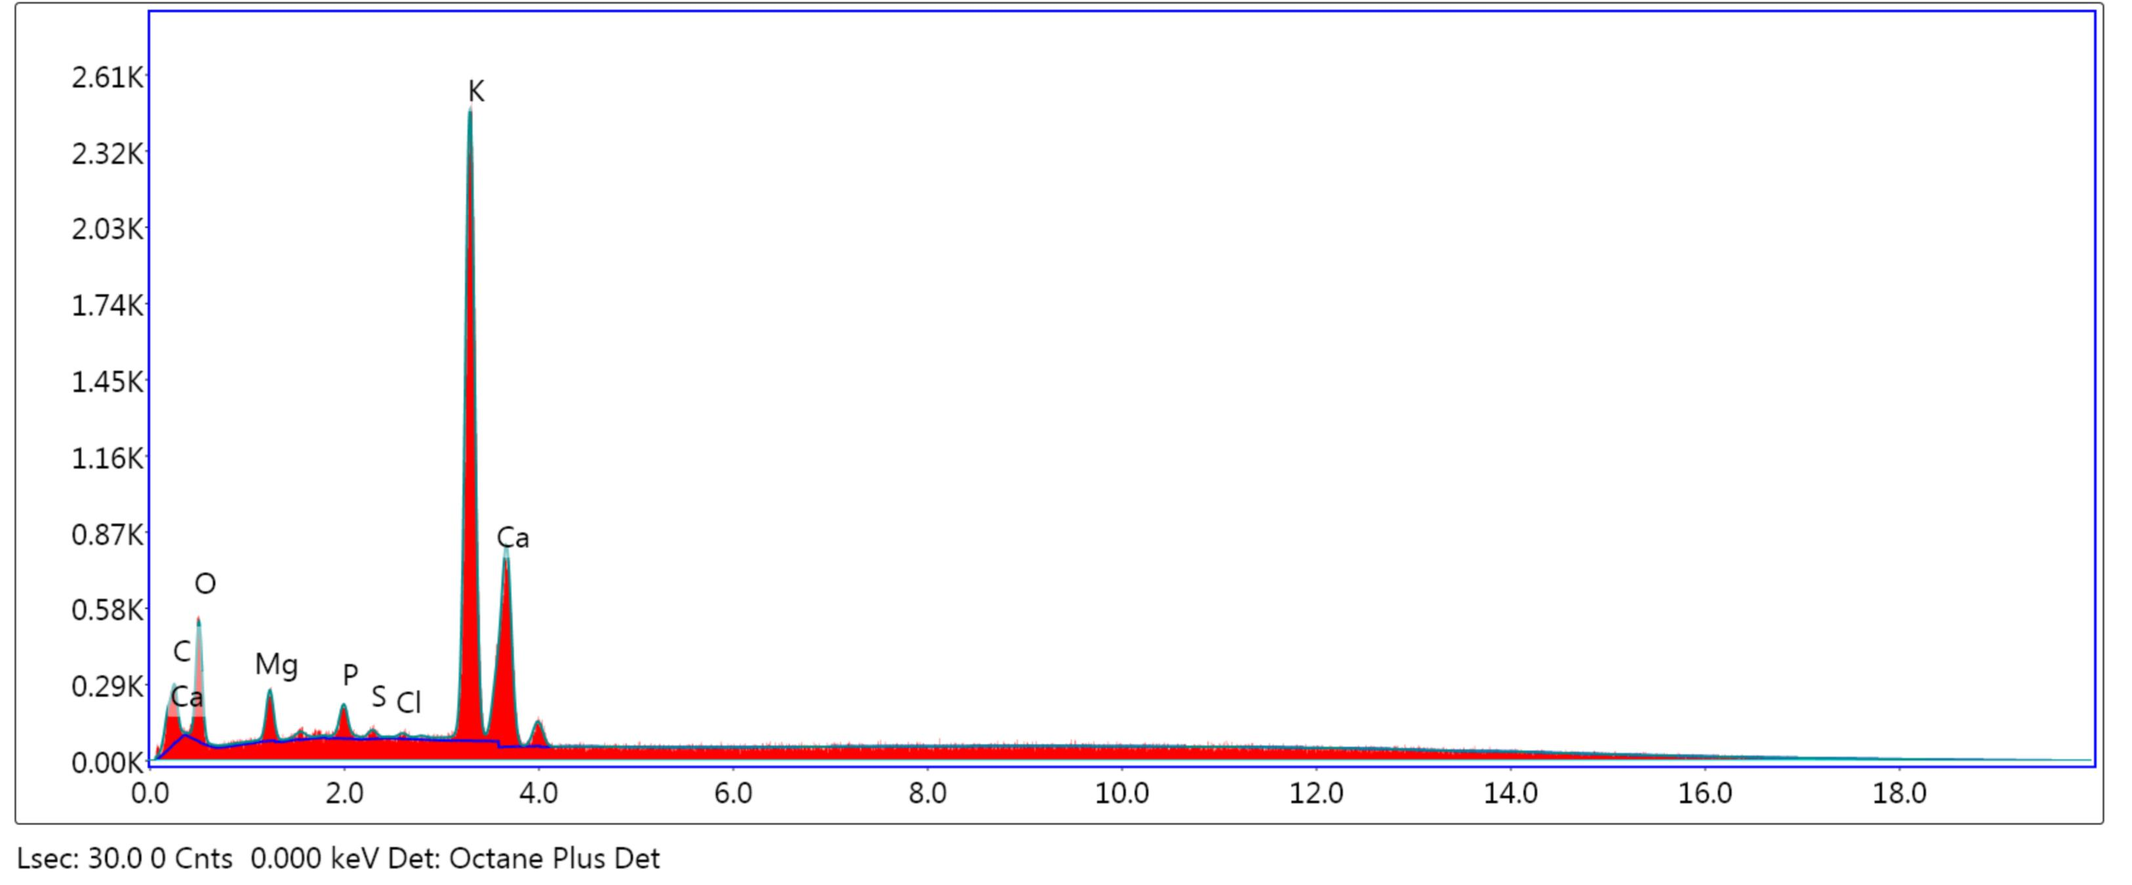
Figure S1: SEM-EDX spectrum of CMPA
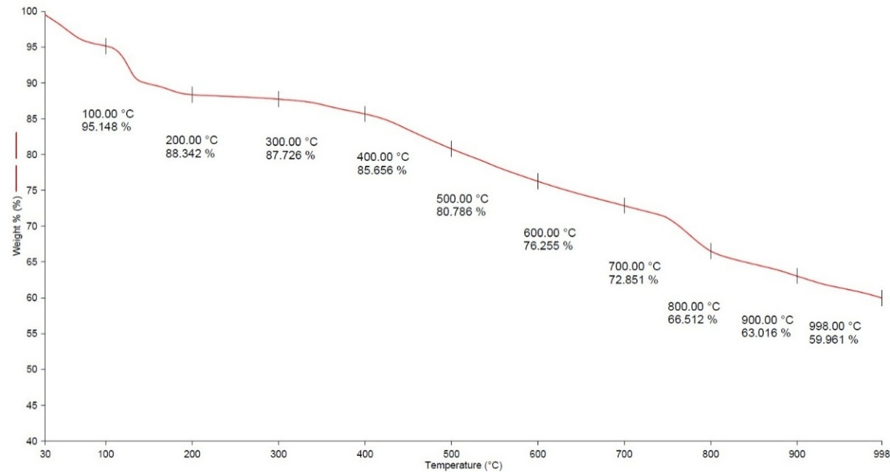
Figure S2: Thermogravimetric analysis of CMPA
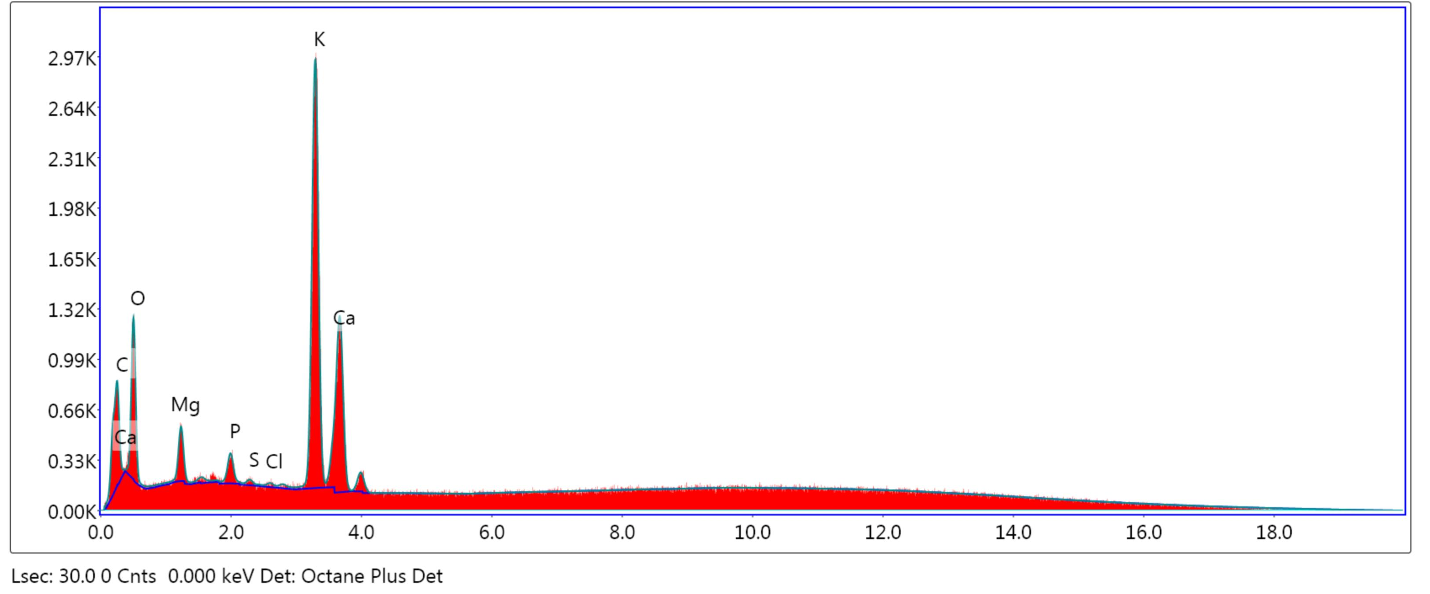
Figure S3: SEM-EDX spectra of the reused CMPA catalyst in biodiesel synthesis

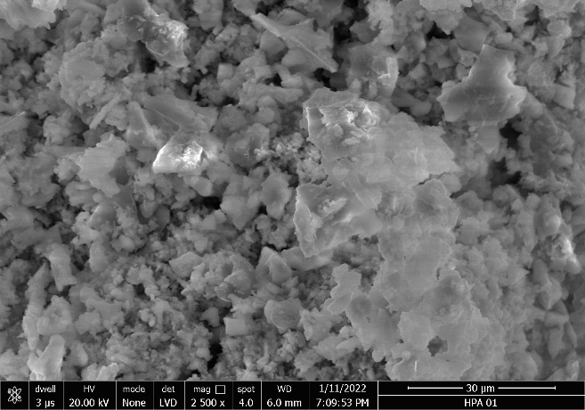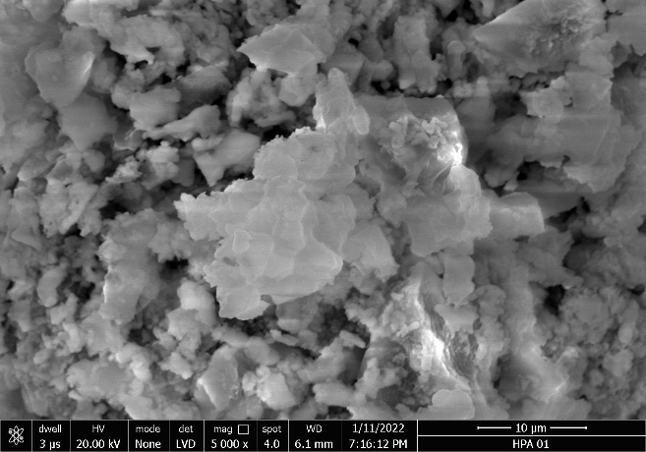
(a)

(b)
Figure S4: (a & b) SEM images of reused CMPA catalyst in biodiesel synthesis
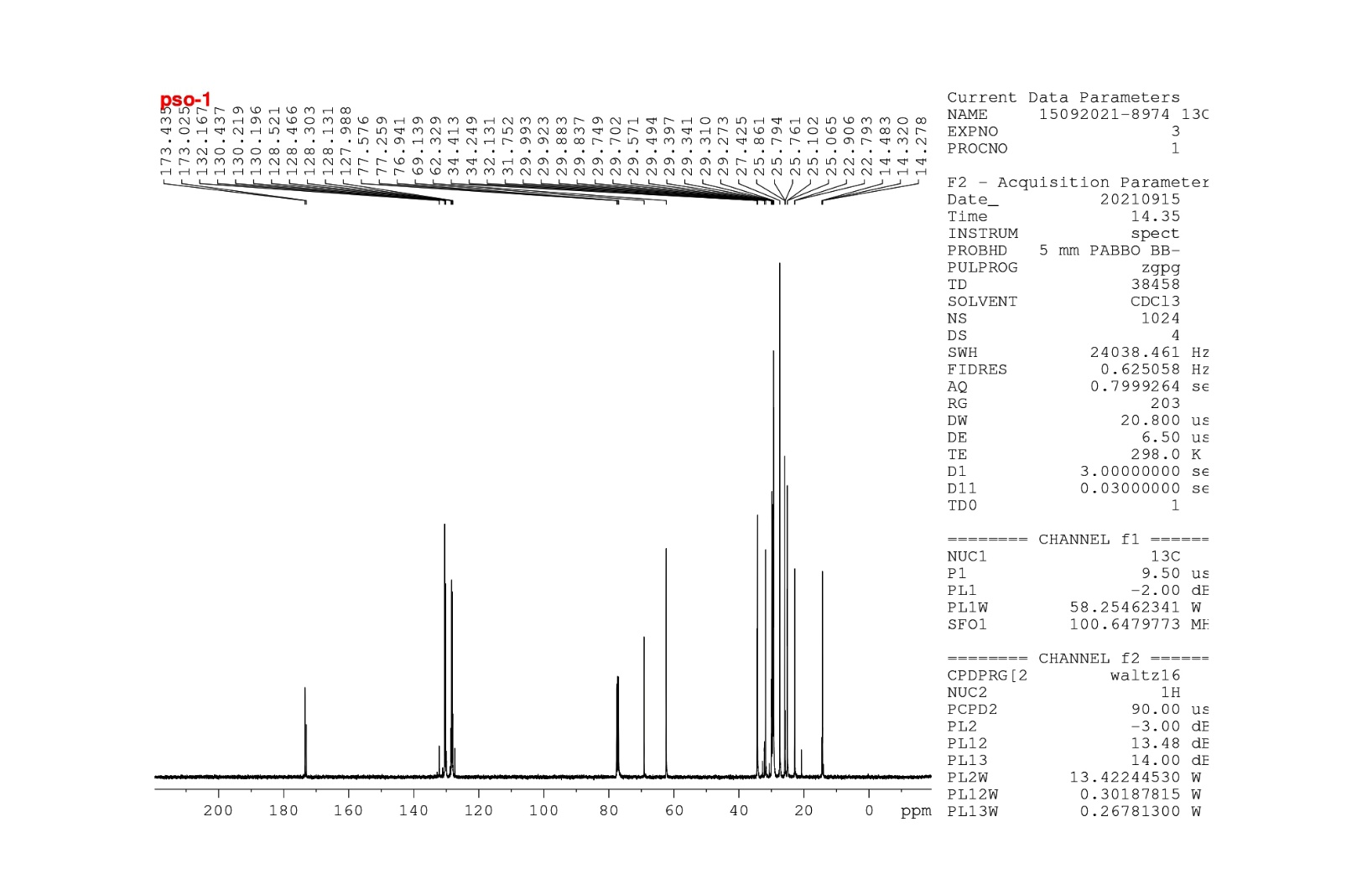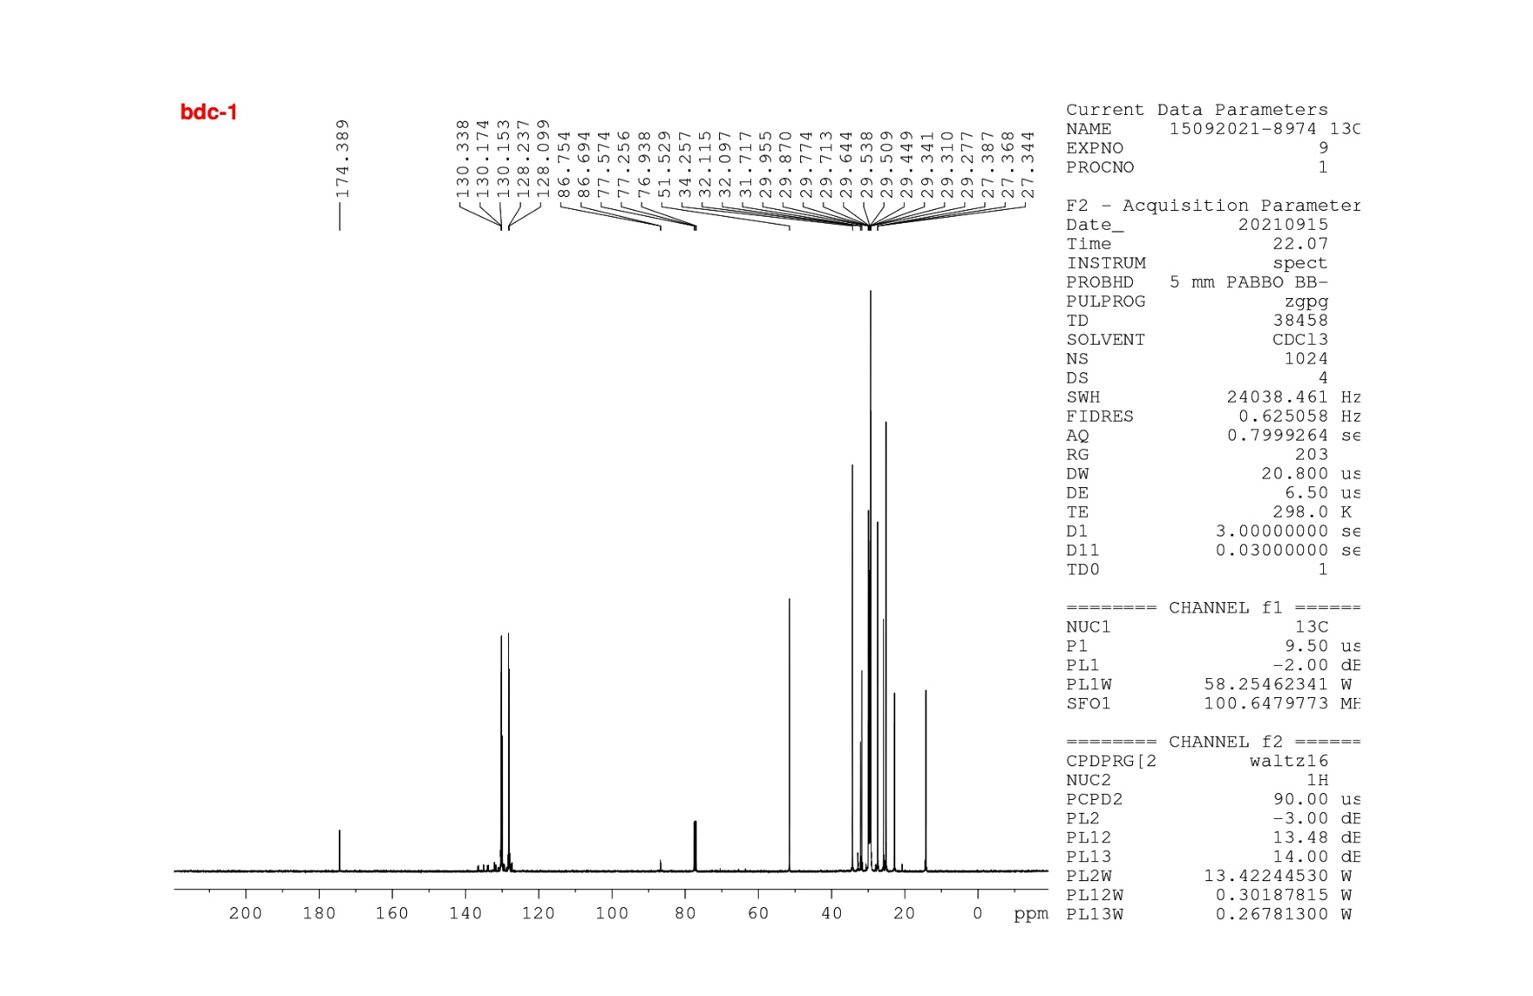
(a)
(b)
Figure S5: ¹³C NMR spectra of soybean oil (a) and biodiesel (b) synthesized using CMPA

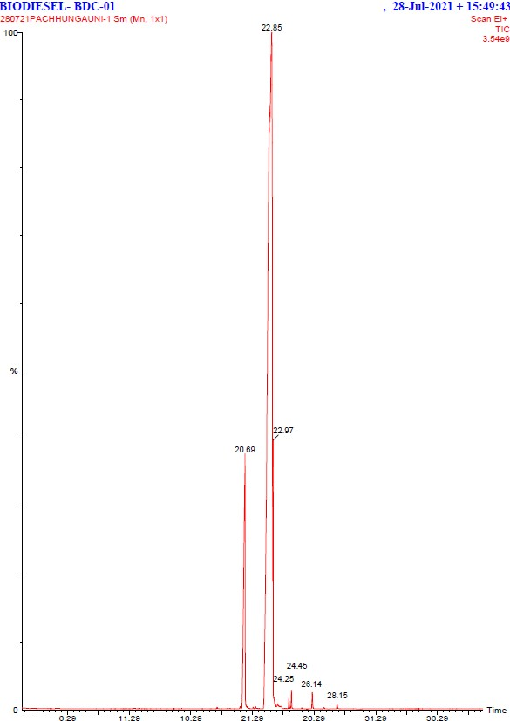
28.15
26.14
24.45
24.25
Figure S6: GC-MS chromatogram of biodiesel synthesized using CMPA.
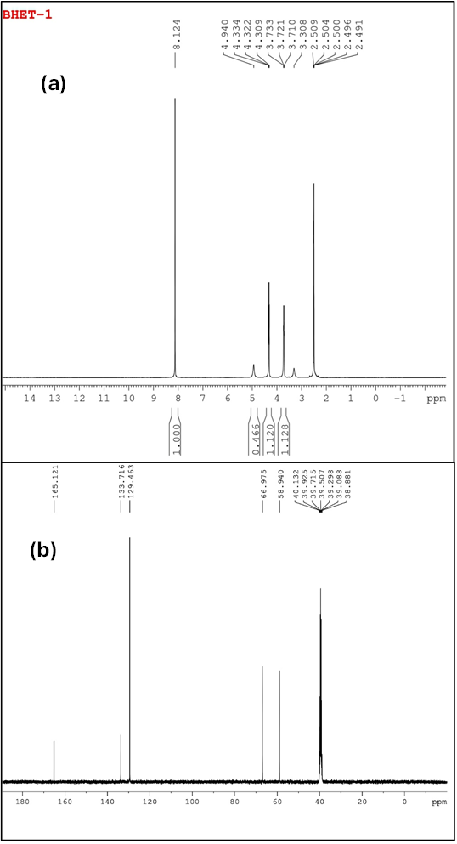
Figure S7: ¹H (a) and ¹³C (b) NMR spectrum of BHET synthesized using CMPA.
Table S4: Reusability data of CMPA in glycolysis of PET
No. of cycle | 1 | 2 | 3 | 4 | 5
Reaction Time (h) | 2.06 | 3.25 | 4.75 | 6.25 | 9
BHET Yield (%) | 87.76 | 84.58 | 82.15 | 79.35 | 76.78

Table S5: SEM-EDX analytical result of reused CMPA in PET glycolysis
Element | Weight % | Atomic % | Net Int. | Error % | Kratio | Z | R | A | F
C K | 18.17 | 28.50 | 288.84 | 9.68 | 0.06 | 1.14 | 0.92 | 0.43 | 1
O K | 33.81 | 48.85 | 553.85 | 10.48 | 0.04 | 1.1 | 0.94 | 0.12 | 1
MgK | 1.89 | 1.80 | 204.05 | 8.94 | 0.01 | 1.02 | 0.98 | 0.47 | 1.01
SrL | 0.23 | 0.06 | 19.57 | 51.94 | 0.00 | 0.77 | 1.17 | 0.99 | 1.06
P K | 0.82 | 0.61 | 123.10 | 9.06 | 0.01 | 0.96 | 1 | 0.82 | 1.03
S K | 0.17 | 0.12 | 27.47 | 34.41 | 0.00 | 0.98 | 1.01 | 0.88 | 1.04
ClK | 0.17 | 0.11 | 25.04 | 43.90 | 0.00 | 0.94 | 1.01 | 0.88 | 1.07
K K | 26.71 | 12.93 | 4,114.33 | 1.91 | 0.30 | 0.93 | 1.02 | 0.94 | 1.02
CaK | 10.71 | 6.18 | 950.28 | 3.96 | 0.08 | 0.95 | 1.03 | 0.82 | 1
TlL | 7.31 | 0.83 | 36.94 | 53.83 | 0.04 | 0.55 | 1.11 | 1.03 | 0.99

Table S6: Glycolysis of coloured PET using CMPA
PET Bottles | Catalyst (mg) | Ethylene glycol (mL) | Reaction time (h) | Reaction Temperature ℃ | BHET yield (%)
Green | 19.29 | 2.8 | 2.06 | 194 | 83.25±0.54
Light-Yellow | 19.29 | 2.8 | 2.06 | 194 | 82.65±0.62
Red | 19.29 | 2.8 | 2.06 | 194 | 84.53±0.81
Blue | 19.29 | 2.8 | 2.06 | 194 | 82.87±0.73

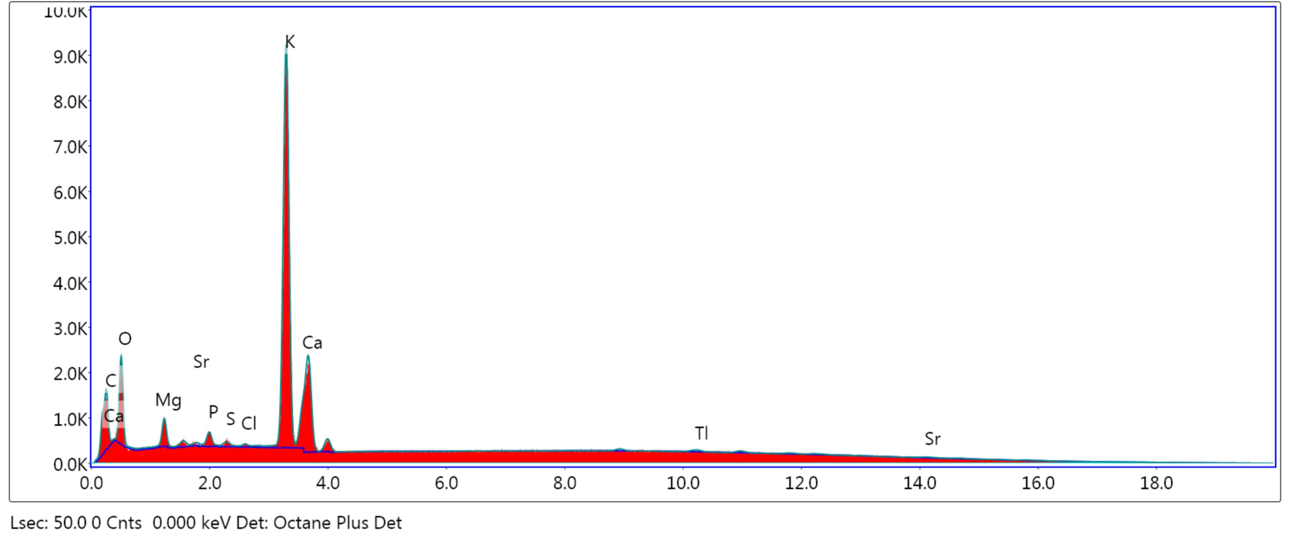
Figure S8: SEM-EDX spectrum of reused CMPA catalyst
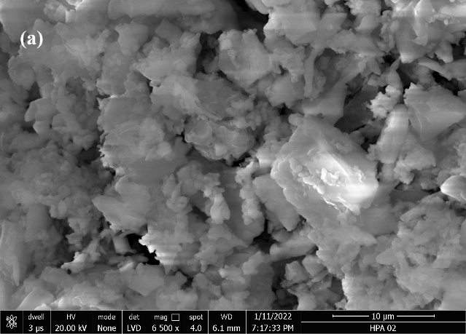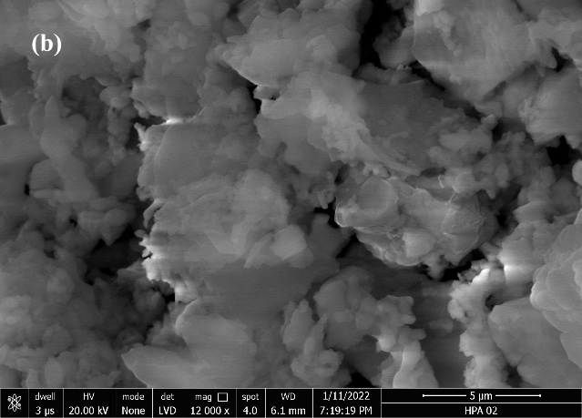
Figure S9: SEM images of CMPA after reused in glycolysis
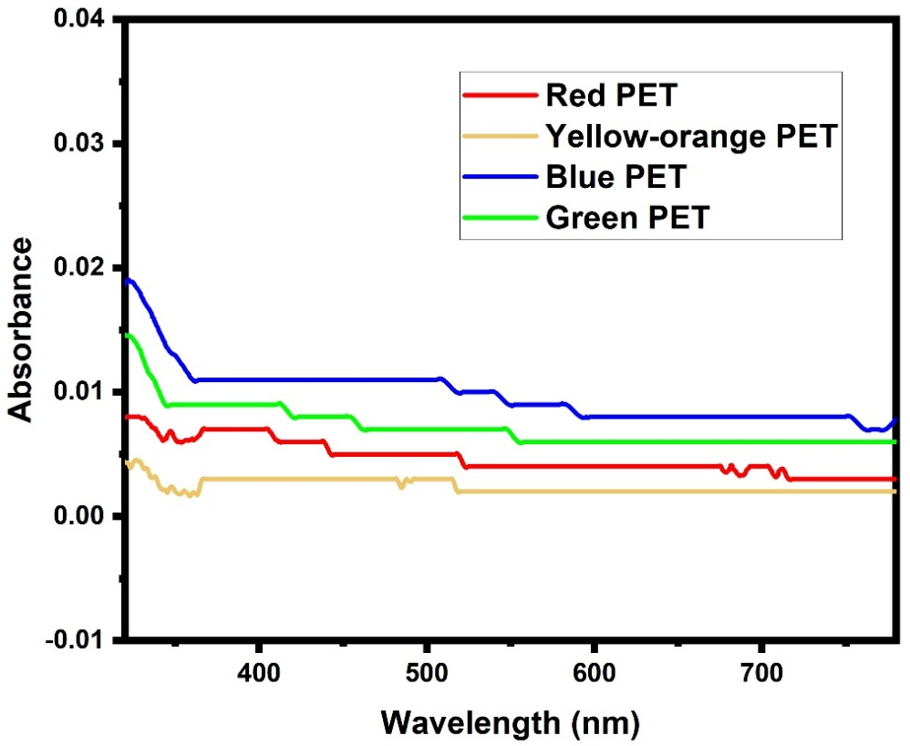
Figure S10: UV-VIS spectrum of recrystallized BHET synthesized from colour PET
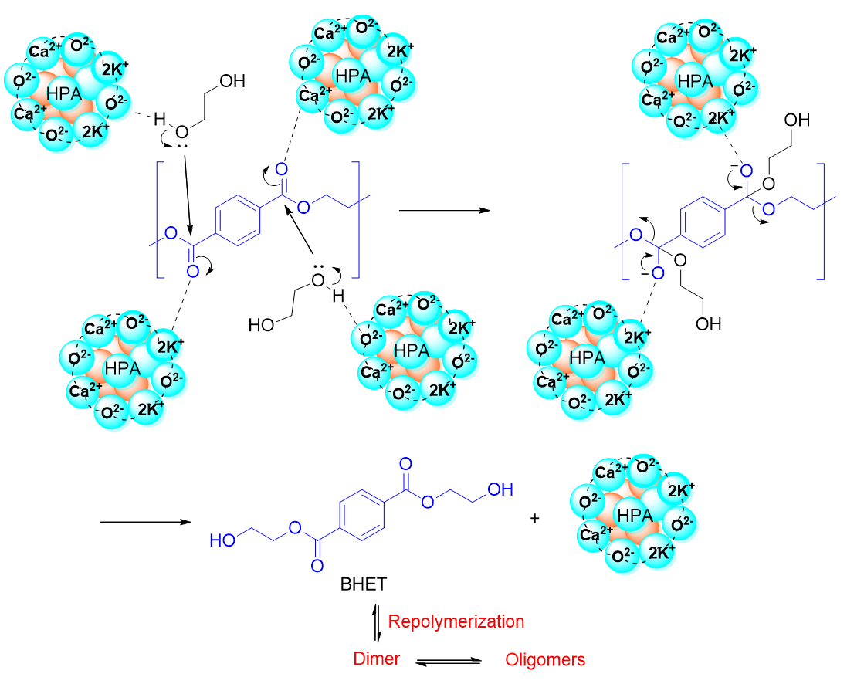
Figure S11: Proposed reaction mechanism of glycolysis of PET using CMPA
References:
1. Ma’arof NANB, Hindryawati N, Khazaai SNM, Bhuyar P, Rahim MHA, Maniam GP. Exploitation of cost-effective renewable heterogeneous base catalyst from banana (Musa paradisiaca) peel for effective methyl ester production from soybean oil. Applied Nanoscience (Switzerland). 2021;13(1):871–82. https://doi.org/10.1007/S13204-021-01926-0/METRICS
2. Tarigan JB, Perangin-Angin S, Simanungkalit SR, Zega NP, Sitepu EK. Utilization of waste banana peels as heterogeneous catalysts in room-temperature biodiesel production using a homogenizer. RSC Adv. 2023;13(9):6217–24. https://doi.org/10.1039/D3RA00016H
3. JHARNA G, Madhu A. Cost-Effective Biodiesel Synthesis from Waste Marble Powder as A Green Heterogeneous Catalyst Using Pongamia Pinnata Oil. Catalysis Research 2023, Vol 3, 013. 2023;3(1):1–11. https://doi.org/10.21926/CR.2301013
4. Balajii M, Niju S. Ultrasound-assisted biodiesel production from Ceiba pentandra oil using Musa spp Nendran banana peduncle derived heterogeneous catalyst. Bioresour Technol Rep. 2023;21:101310. https://doi.org/10.1016/J.BITEB.2022.101310
5. Oloyede CT, Jekayinfa SO, Alade AO, Ogunkunle O, Laseinde OT, Adebayo AO, et al. Synthesis of Biobased Composite Heterogeneous Catalyst for Biodiesel Production Using Simplex Lattice Design Mixture: Optimization Process by Taguchi Method. Energies 2023, Vol 16, Page 2197. 2023;16(5):2197. https://doi.org/10.3390/EN16052197
6. Gaide I, Makareviciene V, Sendzikiene E, Kazancev K. Snail Shells as a Heterogeneous Catalyst for Biodiesel Fuel Production. Processes 2023, Vol 11, Page 260. 2023;11(1):260. https://doi.org/10.3390/PR11010260
7. Ginting Z, Mulyawan R, Tirani T, Mughni Anisa Haryono L. Indonesian Journal of Fundamental and Applied Chemistry Characteristic Study of Biodiesel from Waste Cooking Oil using Nipah Skin Ash as a Heterogeneous Catalyst. https://doi.org/10.24845/ijfac.v8.i1.34
8. Zhao C, Chen H, Wu X, Shan R. Exploiting the Waste Biomass of Durian Shell as a Heterogeneous Catalyst for Biodiesel Production at Room Temperature. International Journal of Environmental Research and Public Health 2023, Vol 20, Page 1760. 2023;20(3):1760. https://doi.org/10.3390/IJERPH20031760
9. Devasan R, Ruatpuia JVL, Gouda SP, Kodgire P, Basumatary S, Halder G, et al. Microwave-assisted biodiesel production using bio-waste catalyst and process optimization using response surface methodology and kinetic study. Scientific Reports 2023 13:1. 2023;13(1):1–17. https://doi.org/10.1038/s41598-023-29883-4
10. Weldeslase MG, Benti NE, Desta MA, Mekonnen YS. Maximizing biodiesel production from waste cooking oil with lime-based zinc-doped CaO using response surface methodology. Scientific Reports 2023 13:1. 2023;13(1):1–14. https://doi.org/10.1038/s41598-023-30961-w
11. Akhtar MT, Ahmad M, Ramadan MF, Makhkamov T, Yuldashev A, Mamarakhimov O, et al. Sustainable Production of Biodiesel from Novel Non-Edible Oil Seeds (Descurainia sophia L.) via Green Nano CeO2 Catalyst. Energies 2023, Vol 16, Page 1534. 2023;16(3):1534. https://doi.org/10.3390/EN16031534
12. Xie Y, Wang D, Almojil SF, Almohana AI, Alali AF, Zhou Y, et al. CaO-MgFe2O4@K2CO3 as a novel and retrievable nanocatalyst for two-step transesterification of used frying oils to biodiesel. Process Safety and Environmental Protection. 2023;172:195–210. https://doi.org/10.1016/J.PSEP.2023.02.005
13. Asaad SM, Inayat A, Jamil F, Ghenai C, Shanableh A. Optimization of Biodiesel Production from Waste Cooking Oil Using a Green Catalyst Prepared from Glass Waste and Animal Bones. Energies 2023, Vol 16, Page 2322. 2023;16(5):2322. https://doi.org/10.3390/EN16052322
14. Maleki B, Singh B, Eamaeili H, Venkatesh YK, Talesh SSA, Seetharaman S. Transesterification of waste cooking oil to biodiesel by walnut shell/sawdust as a novel, low-cost and green heterogeneous catalyst: Optimization via RSM and ANN. Ind Crops Prod. 2023;193:116261. https://doi.org/10.1016/J.INDCROP.2023.116261
15. Sawaira, Alsaiari M, Ahmad M, Munir M, Zafar M, Sultana S, et al. Efficient application of newly synthesized green Bi2O3 nanoparticles for sustainable biodiesel production via membrane reactor. Chemosphere. 2023;310:136838. https://doi.org/10.1016/J.CHEMOSPHERE.2022.136838

