Novel ultrasonic system for investigating cell behaviour on titanium surfaces in vitro to advance orthopaedic and dental therapeutics.

Olga Yevlashevskaya¹, Xuan Li², Aleksander Marek², Margaret Lucas³, Fabrice Pierron^{2,4}, Ben A. Scheven¹, A. Damien Walmsley¹, Richard M. Shelton¹

University of Birmingham¹, University of Southampton², University of Glasgow³, MatchID NV⁴

Supplementary materials

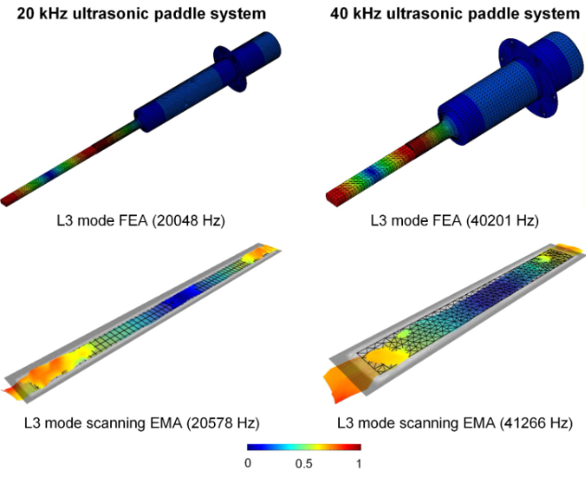
Figure S1. The top row shows FEA simulated vibration mode shapes of the 20 and 40 kHz ultrasonic paddle systems at their third longitudinal mode (L3). The bottom row shows the measured in-plane vibration mode of the paddle surface. The colour transition from warm (red) to cool (blue) represents antinodes to nodes.

