A durable membrane-free platform for green hydrogen and high-purity ammonium recovery powered by human urine remediation
Duc Anh Nguyen^{1,#}, Kim Anh Nguyen Thi¹, Taehun Kim¹, Hongrae Im¹, Am Jang^{1,}*

¹Department of Global Smart City, Sungkyunkwan University (SKKU), 2066, Seobu-ro, Jangan-gu, Suwon, Gyeonggi-do, 16419, Republic of Korea.

*Corresponding author’s e-mail: amjang@skku.edu; ORCID no. 0000-0003-2400-7664

Authors’ information:
Duc Anh Nguyen (D.A.N): nguyenducanh@g.skku.edu; ORCID no. 0000-0002-6005-4305,
Kim Anh Nguyen Thi (K.A.N): toikimanh@gmail.com; ORCID no. 0000-0002-4322-5280,
Taehun Kim (T.K): kimth9510@naver.com; ORCID no. 009-007-6874-2835,
Hongrae Im (H.I): ky421100@naver.com; ORCID no. 0000-0002-9724-3089.
Table of Supplementary Figures
Supplementary Fig. 1. PePurease synthesis scheme. Three-step bead synthesis: in-situ copolymerisation, phase inversion, and EDC/NHS urease grafting. 8
Supplementary Fig. 2. Wetting and dispersion of the beads in urine. Photographs of raw urine after contact with carbon black, Pe, PeP and PePurease beads. 9
Supplementary Fig. 3. Bead integrity after 100 reuse cycles. Optical micrographs and contact angles of PePurease beads imaged every 10 cycles. 10
Supplementary Fig. 4. Surface composition of beads after 100 reuse cycles. SEM and EDS of PePurease beads every 10 cycles. 11
Supplementary Fig. 5. Photographs of the nine as-synthesised PBA powders. 12
Supplementary Fig. 6. Particle-size distribution of KCoHCF. 13
Supplementary Fig. 7. Morphology and elemental distribution of KCoHCF. (A) SEM images and (B) EDS elemental maps of KCoHCF. 14
Supplementary Fig. 8. Capacity-retention screening in 1 M NaCl. Per-cycle capacity retention of all nine analogues over 100 cycles, with the electrolyte colour change after cycling. 15
Supplementary Fig. 9. Capacity-retention screening in 1 M KCl. 16
Supplementary Fig. 10. Capacity-retention screening in 1 M NH₄Cl. 17
Supplementary Fig. 11. Capacity-retention screening in 0.5 M KHCO₃. 18
Supplementary Fig. 12. Capacity-retention screening in synthetic urine. 19
Supplementary Fig. 13. Capacity-retention screening in human urine pH 7. 20
Supplementary Fig. 14. Capacity-retention screening in human urine pH 9. 21
Supplementary Fig. 15. Linear sweep voltammetry of Ti mesh. 22
Supplementary Fig. 16. Faradaic efficiency of ion intercalation and deintercalation. 23
Supplementary Fig. 17. Cyclic voltammetry of KCoHCF in synthetic and real urine. 24
Supplementary Fig. 18. RUL prediction to 80% on the reaching trajectories. 25
Supplementary Fig. 19. Capacity racking to 80% on the reaching trajectories. 26
Supplementary Fig. 20. Forward projection of 3 replicates of KCoHCF capacity to 80% on a linear axis. 27
Supplementary Fig. 21. Forward projection of 3 replicates of Pepurease bead relative activity to 80% on a linear axis. 28
Supplementary Fig. 22. Capacity tracking across all 56 screening trajectories. 29
Supplementary Fig. 23. Triplicate capacity retention tracking for the KCoHCF electrode. 30
Supplementary Fig. 24. Triplicate activity tracking for the PePurease bead. 31
Supplementary Fig. 25. Absolute RUL error versus observed fraction (averaged). 32
Supplementary Fig. 26. Per-trajectory Gaussian-mutation effect on PPC acceptance for 56 trajectories. 33
Supplementary Fig. 27. Per-trajectory Gaussian-mutation effect on the PPC acceptance for 10 trajectories to 80% threshold. 34
Supplementary Fig. 28. Per-replicate Gaussian-mutation effect on the PPC acceptance for KCoHCF electrode (90% and 87% thresholds). 35
Supplementary Fig. 29. Per-replicate Gaussian-mutation effect on the PPC acceptance for PePurease beads (90% and 86% thresholds). 36
Supplementary Fig. 30. Soft versus strict Gaussian mutation performance. 37
Supplementary Fig. 31. Conformal calibration reliability (averaged across all tasks). 38
Supplementary Fig. 32. Zeta potential of KCoHCF. 39
Supplementary Fig. 33. Mass of 100 beads at each fabrication stage. Photographs and weights of 100 Pe, PeP and PePurease beads (0.2175, 0.6361 and 0.6444 g). 40
Supplementary Fig. 34. Synthesis of KCoHCF in a Y-microchannel. Visualisation of the continuous Y-microchannel route that mixes the cobalt nitrate and potassium ferricyanide precursors to give size- and composition-homogeneous KCoHCF nanoparticles. 41
Supplementary Fig. 35. Electrode casting. Photographs of KCoHCF electrodes after one, two and three casting passes to a loading of 212.8 mg cm⁻². 42
Supplementary Fig. 36. Electrode microstructure. 43
Supplementary Fig. 37. Hydrophilicity of the cast electrode. Water contact angle of (A) Super P, (B) KCoHCF and (C) the cast electrode of KCoHCF, Super P and PVDF. 44
Supplementary Fig. 38. Composition of raw and hydrolysed human urine. Cation and anion concentrations and bulk water-quality parameters before and after hydrolysis. 45
Supplementary Fig. 39. Standard calibration for (A) TOC, (B) TN, (C) TIC, (C) Urea. 46
Supplementary Fig. 40. Standard calibration for (A) Urease, (B) Co, (C) Ni, (D) Fe, (E) Mn, (F) Cu, (G) Na, (H) K quantification. 47
Supplementary Fig. 41. Standard calibration for (A) Cl⁻, (B) NO₂⁻, (C) NO₃⁻, (D) PO₄³⁻, (E) SO₄²⁻ quantification. 48
Supplementary Fig. 42. Rate capability of KCoHCF. 49
Supplementary Fig. 43. Capacitive and diffusive current fractions. Deconvolution for (A) KCoHCF, (B) NaNiHCF, (C) KNiHCF, (D) NaCoHCF, (E) KMnHCF, (F) NaMnHCF, (G) KFeHCF, (H) NaFeHCF and (I) KCuHCF in human urine pH 9. 50
Supplementary Fig. 44. Scan-rate analysis and b-values. (A) CV profiles of (1) KCoHCF, (2) NaNiHCF, (3) KNiHCF, (4) NaCoHCF, (5) KMnHCF, (6) NaMnHCF, (7) KFeHCF, (8) NaFeHCF and (9) KCuHCF at varying scan rates and (B) their b-value fits at the peak potential. 51
Supplementary Fig. 45. Gas collection: O₂ in synthetic urine. Water-displacement set-up and collected O₂ volumes over the five-cycle synthetic-urine recovery, the raw images underlying the Faradaic-efficiency quantification of Extended Data Fig. 3 and Supplementary Video 1. Panel A is before operation. Panels B1-5 represent the gas volumes of O₂ from cycle 1 to 5. 52
Supplementary Fig. 46. Gas collection: H₂ in synthetic urine (three-electrode). Collected H₂ volumes for the three-electrode synthetic-urine recovery in Li₂SO₄ 0.1M, pH 1, underlying Extended Data Fig. 3 and Supplementary Video 2. Panel A is before operation. Panels B1-5 represent the gas volumes of H₂ from cycle 1 to 5. 53
Supplementary Fig. 47. Gas collection: H₂ in real urine with Li₂SO₄ (three-electrode). Collected H₂ volumes for real-urine release into Li₂SO₄, underlying Extended Data Fig. 3B and Supplementary Video 4. Panel A is before operation. Panels B represents the gas volumes of H₂ after operation. 54
Supplementary Fig. 48. Gas collection: H₂ in real urine with (NH₄)₂SO₄ (three-electrode). Collected H₂ volumes for real-urine release into (NH₄)₂SO₄ 0.1M, pH 1, underlying Extended Data Fig. 3C. Panel A is before operation. Panels B represents the gas volumes of H₂ after operation. 55
Supplementary Fig. 49. Gas collection: H₂ in real urine with (NH₄)₂SO₄ (two-electrode). Collected H₂ volumes for real-urine release into (NH₄)₂SO₄ 0.1M, pH 1, underlying Extended Data Fig. 3D and Supplementary Video 5. Panel A is before operation. Panels B represents the gas volumes of H₂ after 1 cycle operation. 56

Table of Supplementary Tables
Supplementary Table 1. BET surface area, BJH pore volumes, and diameters of Pe, PeP, and PePurease beads. 57
Supplementary Table 2. BET surface area, BJH pore volumes, and diameters of 9 PBA materials. 58
Supplementary Table 3. Chemical formula of the PBA materials. 59
Supplementary Table 4. Concentrations of NH₄⁺, Na⁺, and K⁺ in typical wastewaters. 60
Supplementary Table 5. Ammonium recovery rate comparison 61
Supplementary Table 6. Energy consumption for ammonium production/recovery technologies comparison. 63
Supplementary Table 7. Mean RUL accuracy measured by MAE (cycle) of all tasks and baselines. 65
Supplementary Table 8. Mean capacity retention tracking accuracy measured by RMSE (%) of all tasks and baselines. 66
Supplementary Table 9. Forward projection to 80% (per replicate). 67
Supplementary Table 10. Basis and preprocessing hyperparameters (per materials) 68
Supplementary Table 11. Definition of variables in Eq. (S2). 71
Supplementary Table 12. Conditions and derivations of Eq. (S7). 73
Supplementary Table 13. Selectivity zone of NH₄⁺ and M⁺ 73
Supplementary Table 14. Operating parameters 76
Supplementary Table 15. On-site population estimation of Sungkyunkwan University (SKKU) ⁵⁵ 78
Supplementary Table 16. Urine production volume estimation of Sungkyunkwan University (SKKU) 79
Supplementary Table 17. Annual product output 80
Supplementary Table 18. OPEX estimations of SKKU 81
Supplementary Table 19. KCoHCF electrode lifetime performance estimation 82
Supplementary Table 20. Pt-coated Ti electrode lifetime performance estimation (10-year service life ⁶¹) 82
Supplementary Table 21. PePurease bead lifetime performance estimation. 83
Supplementary Table 22. OPEX estimation for SKKU (per NH₄⁺-N, USD). 83
Supplementary Table 23. On-site population estimation of Univerisity of Delhi (DU) ⁶⁵ 85
Supplementary Table 24. Urine production volume estimation of Univerisity of Delhi (DU) ⁶⁵ 86
Supplementary Table 25. Comparison OPEX estimations between SKKU and DU 87
Supplementary Table 26. DU annual product output 88
Supplementary Table 27. OPEX estimation for DU (per NH₄⁺-N, USD). 89

Table of Supplementary Notes

Supplementary Notes 69
Supplementary Note 1. Materials, reagents and urease quantification 69
Supplementary Note 2. Ionic selectivity by Nikolsky–Eisenman framework 71
Supplementary Note 3. Quantification of Coulombic efficiency and Faradaic efficiency 74
Supplementary Note 4. Techno-economic, energy balance and specific energy consumption 76
SKKU plant-scale and throughput 78
DU plant-scale and throughput 85
Supplementary Note 5. Remaining life-cycle prediction system detailed methodology 91
Proposed models and estimated parameters: 91
Proposed constrained Bayesian update based on posterior predictive checking: 95
Data preprocessing, forgetting factor, and walk-forward updating: 100
Historical-lives constraint band: 101
Calibrated prediction interval: 102
Baseline methods for comparison: 103
Implementation of the proposed framework: 110
Computational implementation. 112
Supplementary Note 6. Synthesis of the Prussian Blue Analogues materials 112
Synthesis of Potassium Cobalt Hexacyanoferrate nanoparticles (KCoHCF) 113
Synthesis of Sodium Cobalt Hexacyanoferrate (NaCoHCF) 113
Synthesis of Potassium Nickel Hexacyanoferrate (KNiHCF) 114
Synthesis of Sodium Nickel Hexacyanoferrate (NaNiHCF) 114
Synthesis of Potassium Iron Hexacyanoferrate (KFeHCF) 114
Synthesis of Sodium Iron Hexacyanoferrate (NaFeHCF) 115
Synthesis of Potassium Copper Hexacyanoferrate (KCuHCF) 115
Synthesis of Potassium Manganese Hexacyanoferrate (KMnHCF) 115
Synthesis of Sodium Manganese Hexacyanoferrate (NaMnHCF) 116
Reference 116

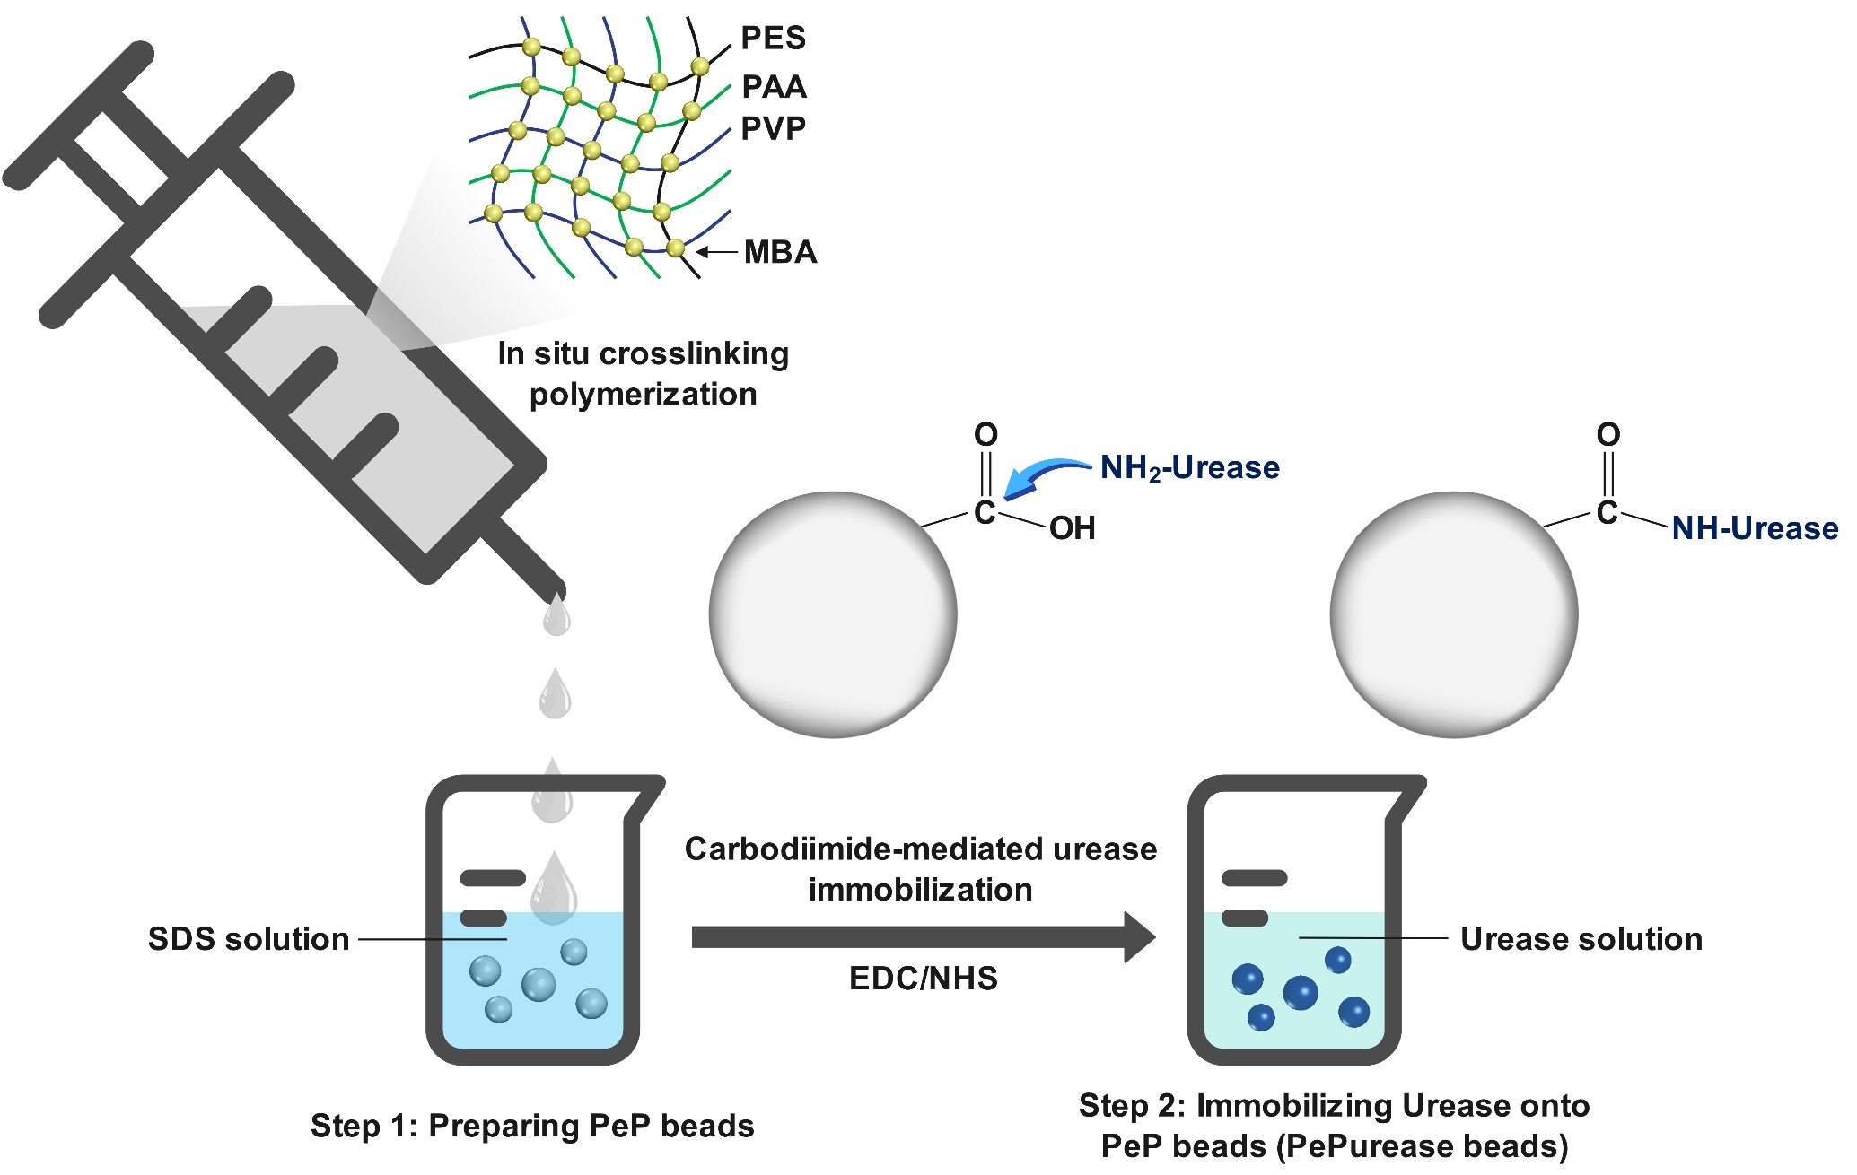
Supplementary Fig. 1. PePurease synthesis scheme. Three-step bead synthesis: in-situ copolymerisation, phase inversion, and EDC/NHS urease grafting.
The scheme traces how a hydrophobic polyethersulfone matrix is functionalised with carboxyl groups and then covalently loaded with urease, the route whose product is characterised in Fig. 2 and Extended Data Fig. 1.

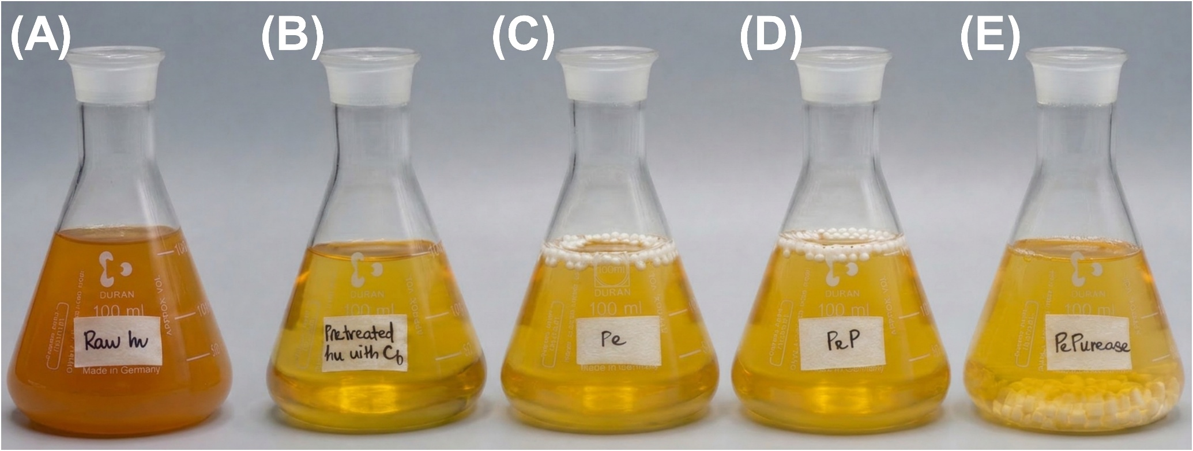
Supplementary Fig. 2. Wetting and dispersion of the beads in urine. Photographs of raw urine after contact with carbon black, Pe, PeP and PePurease beads.
Pe and PeP float and resist wetting, whereas PePurease sinks and disperses through the bulk, the macroscopic consequence of the contact-angle drop in Fig. 2B and the physical reason the immobilised enzyme reaches substrate efficiently.

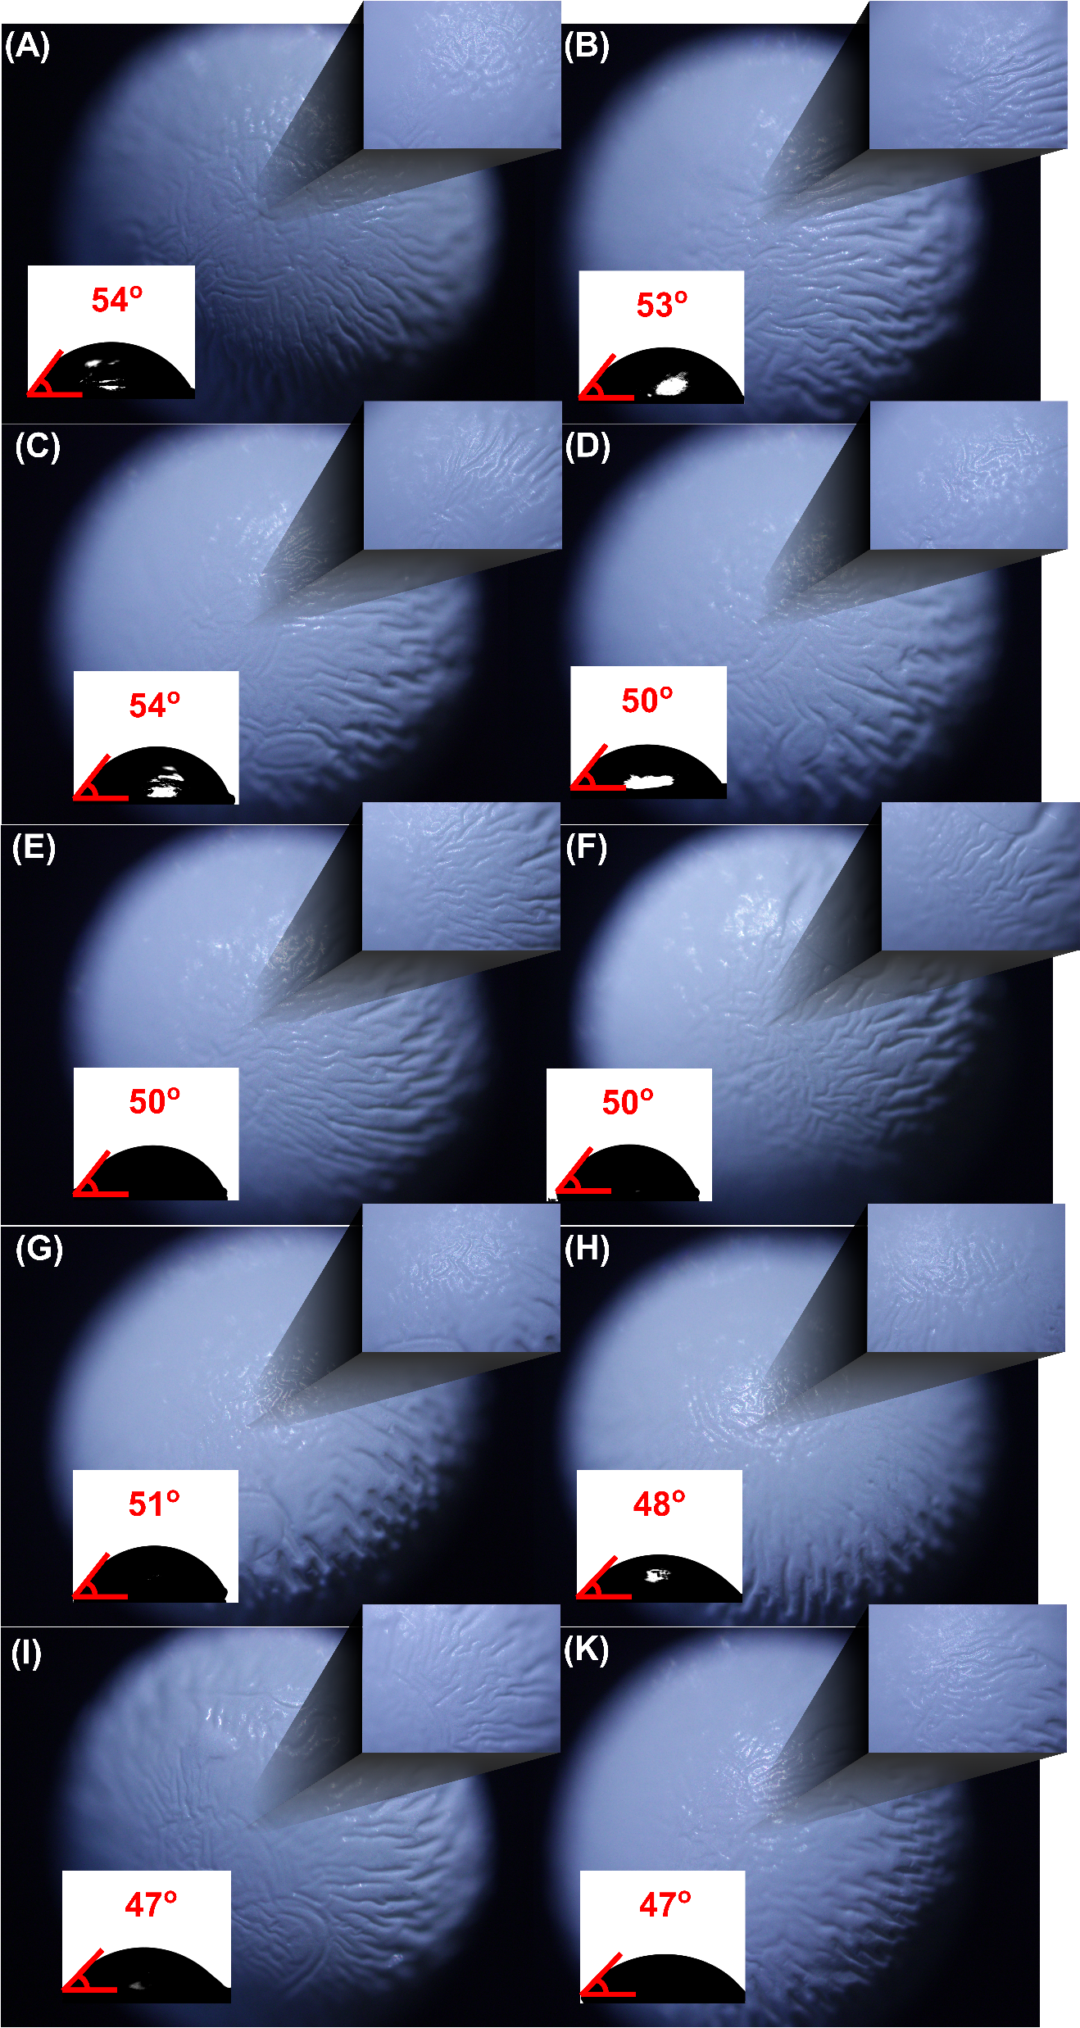
Supplementary Fig. 3. Bead integrity after 100 reuse cycles. Optical micrographs and contact angles of PePurease beads imaged every 10 cycles.
Morphology and wettability are unchanged through 100 cycles, with no visible fouling, supporting the activity retention plotted in Fig. 2F.

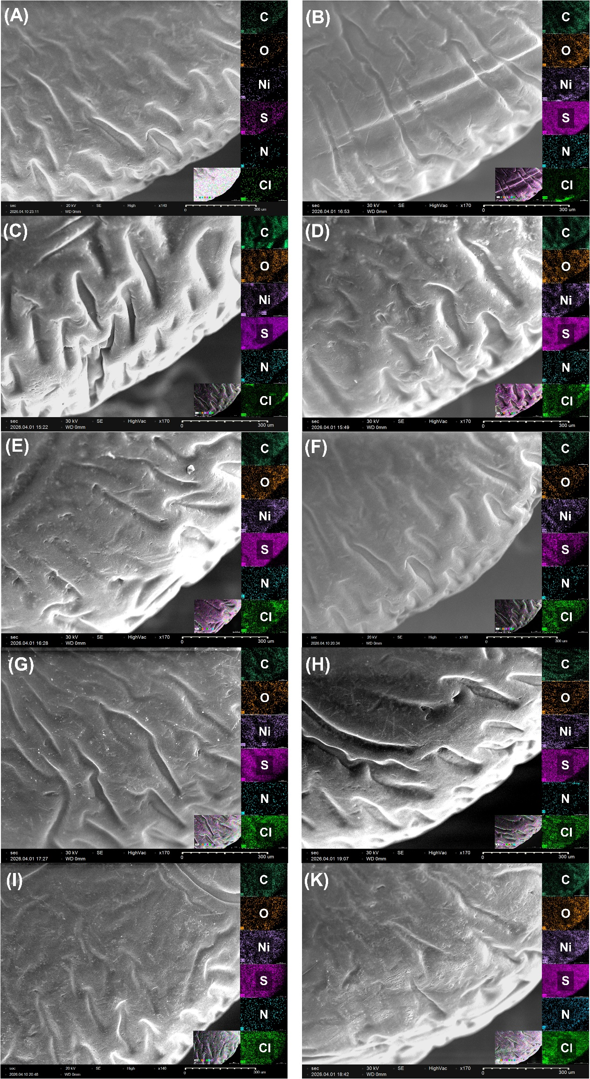
Supplementary Fig. 4. Surface composition of beads after 100 reuse cycles. SEM and EDS of PePurease beads every 10 cycles.
The surface morphology and elemental distribution are preserved, confirming that the 21 % activity loss in Fig. 2F reflects gradual enzyme deactivation rather than mechanical or compositional degradation of the scaffold.

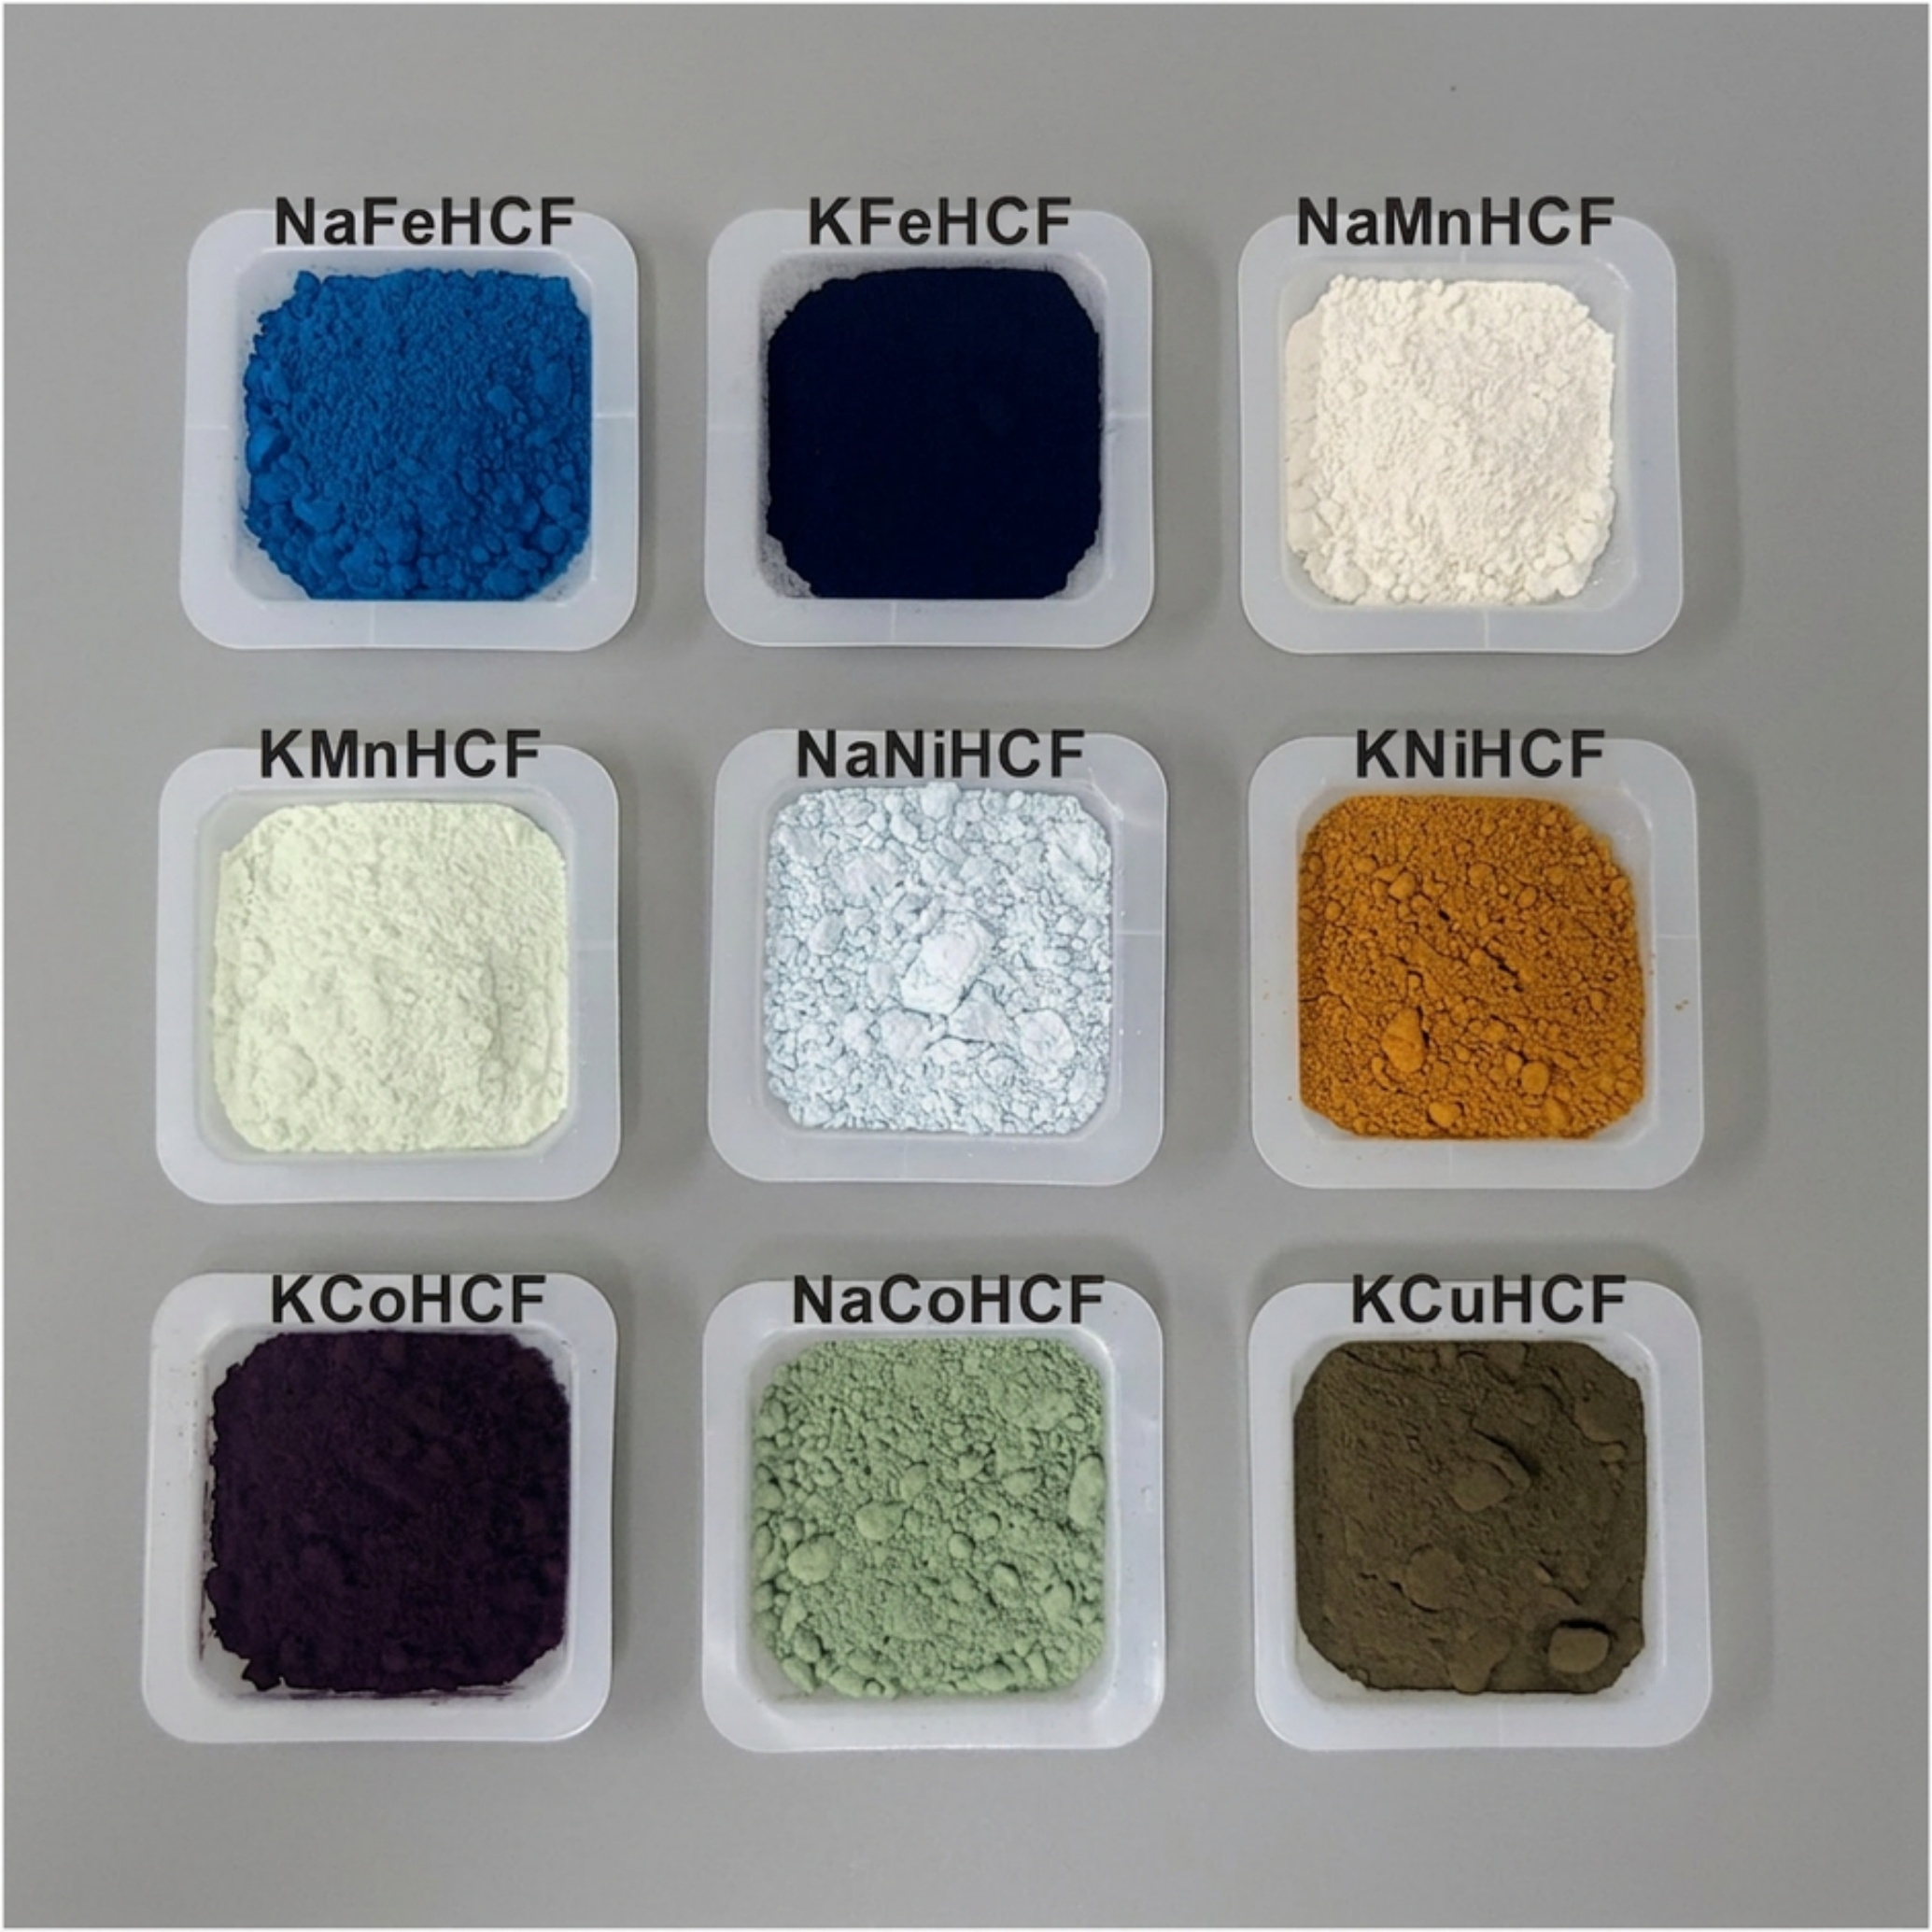
Supplementary Fig. 5. Photographs of the nine as-synthesised PBA powders.
The colour of each analogue (NaFeHCF, KFeHCF, NaMnHCF, KMnHCF, NaNiHCF, KNiHCF, KCoHCF, NaCoHCF, KCuHCF) is a first, qualitative fingerprint of phase and oxidation state, complementing the XRD of Fig. 3A and the chemical formulas of Supplementary Table 2.

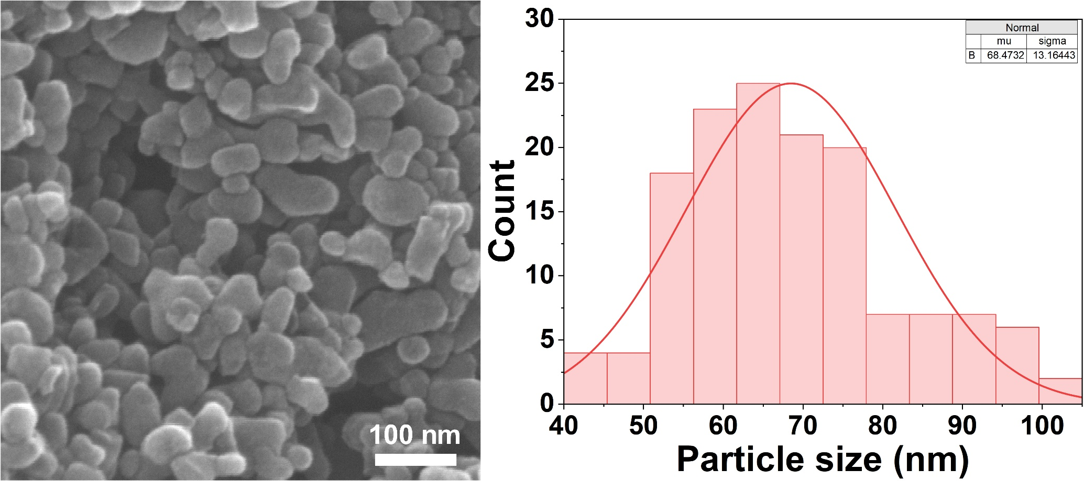
Supplementary Fig. 6. Particle-size distribution of KCoHCF.
Distribution measured from SEM images, giving the 68 ± 13 nm mean primary-particle diameter.
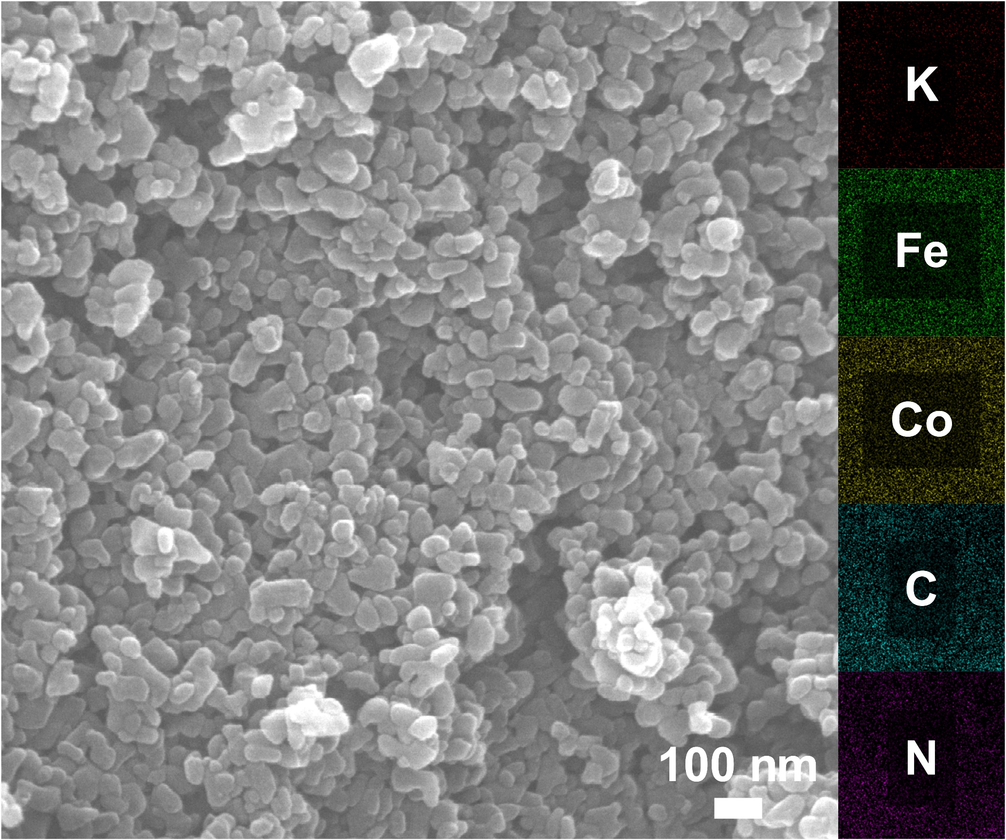
Supplementary Fig. 7. Morphology and elemental distribution of KCoHCF. (A) SEM images and (B) EDS elemental maps of KCoHCF.
The uniform spatial distribution of K, Fe, Co, C and N across the nanoparticle clusters confirms a chemically homogeneous framework with no phase segregation, the basis for the assignment in Fig. 3E.

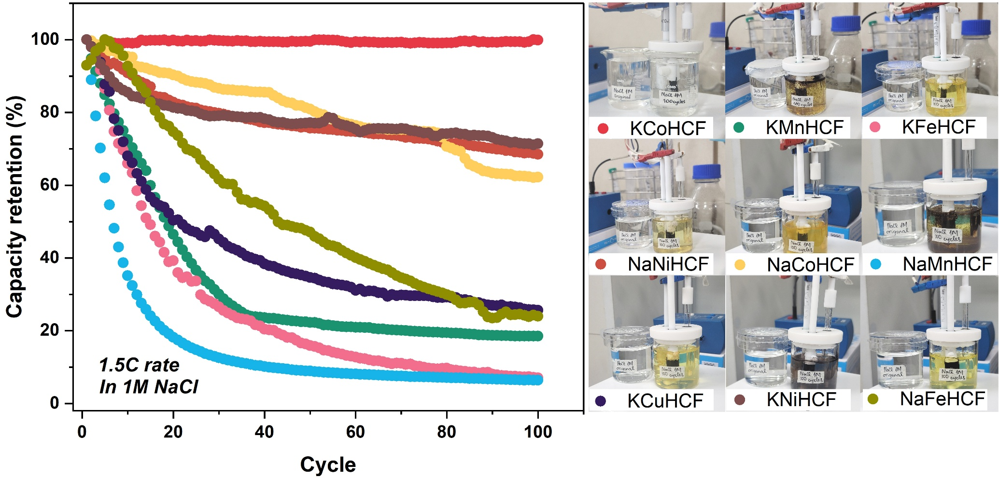
Supplementary Fig. 8. Capacity-retention screening in 1 M NaCl. Per-cycle capacity retention of all nine analogues over 100 cycles, with the electrolyte colour change after cycling.
Except for KCoHCF, NaFeHCF, KCuHCF, KMnHCF, KFeHCF and NaMnHCF decay sharply within a few cycles, several discolouring the electrolyte as the framework dissolves.

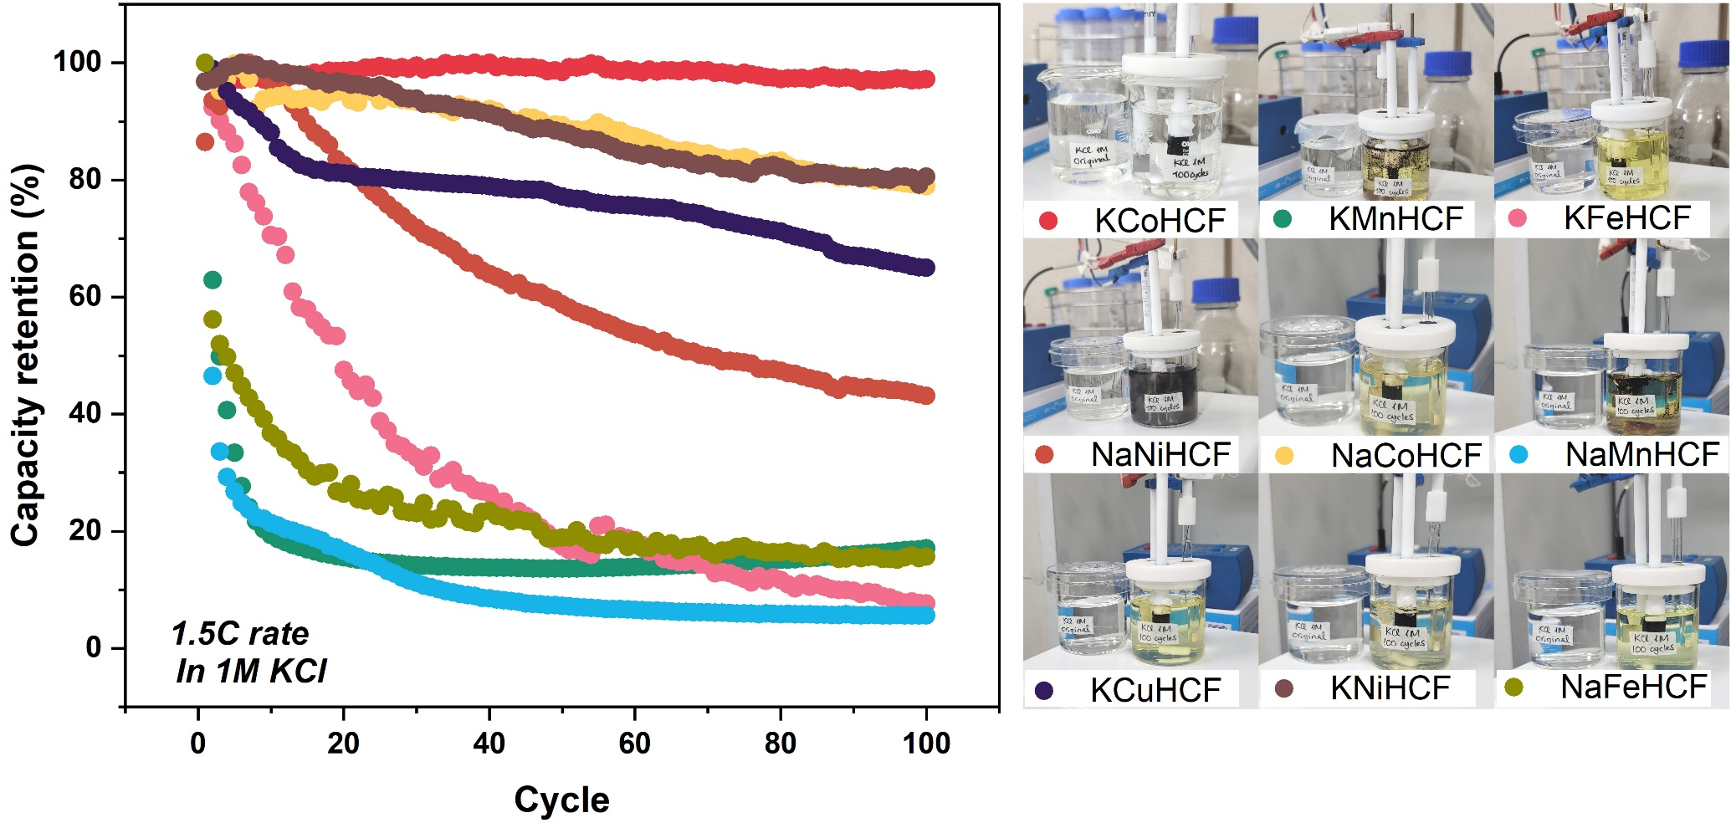
Supplementary Fig. 9. Capacity-retention screening in 1 M KCl.
As in Supplementary Fig. 8 but in 1 M KCl. KCoHCF, NaCoHCF and KNiHCF are relatively stable; KFeHCF, NaFeHCF, KMnHCF and NaMnHCF decay quickly, with the manganese analogues discolouring most.

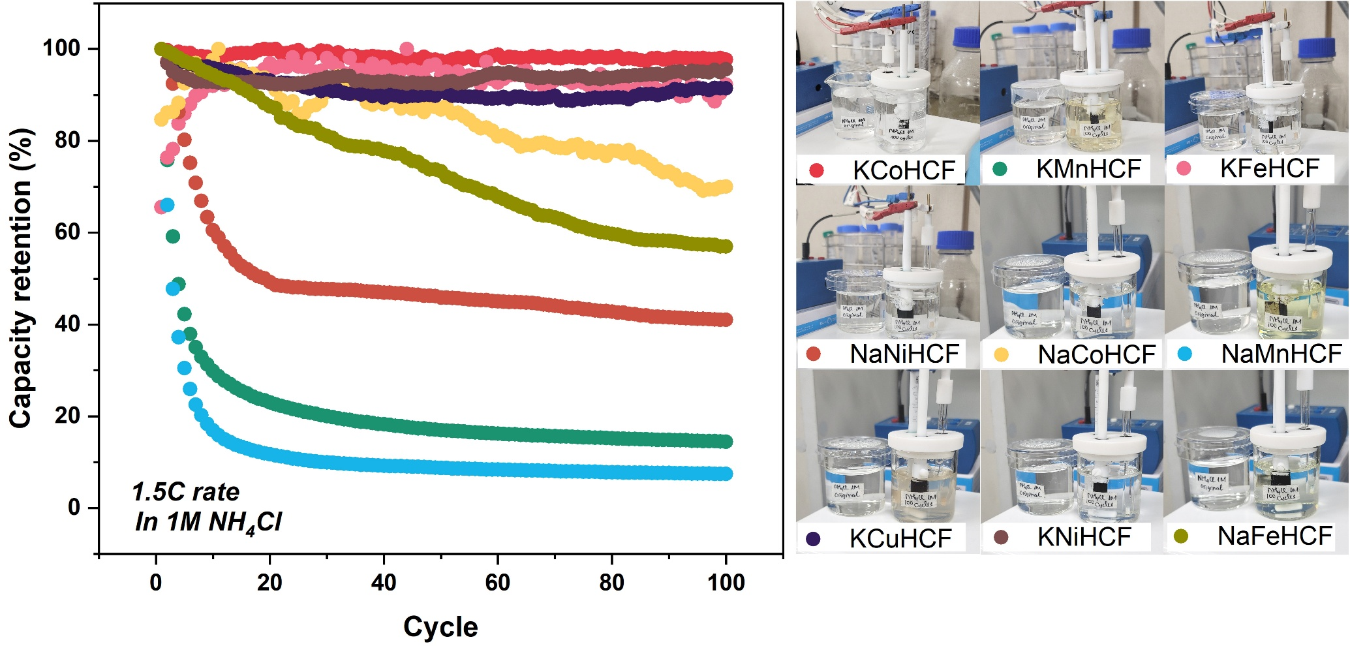
Supplementary Fig. 10. Capacity-retention screening in 1 M NH₄Cl.
In the target cation's own electrolyte, KCoHCF, KFeHCF, KCuHCF and KNiHCF hold capacity while NaNiHCF, KMnHCF and NaMnHCF fade, confirming that stability is matrix-dependent and not guaranteed even in NH₄⁺.

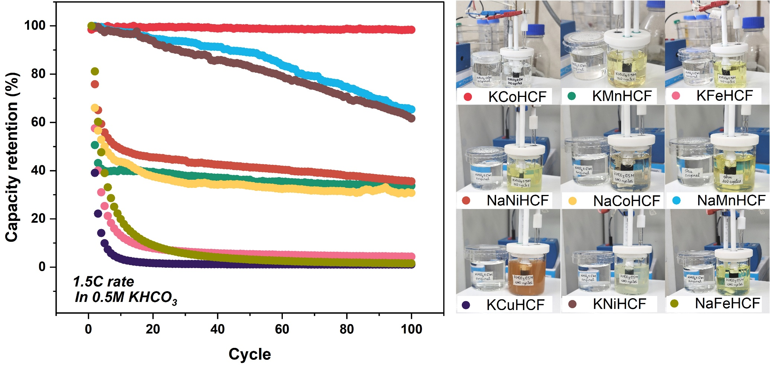
Supplementary Fig. 11. Capacity-retention screening in 0.5 M KHCO₃.
Only KCoHCF is stable; NaNiHCF, KMnHCF, NaCoHCF, KFeHCF, NaFeHCF and KCuHCF decay, several strongly discolouring the carbonate electrolyte.

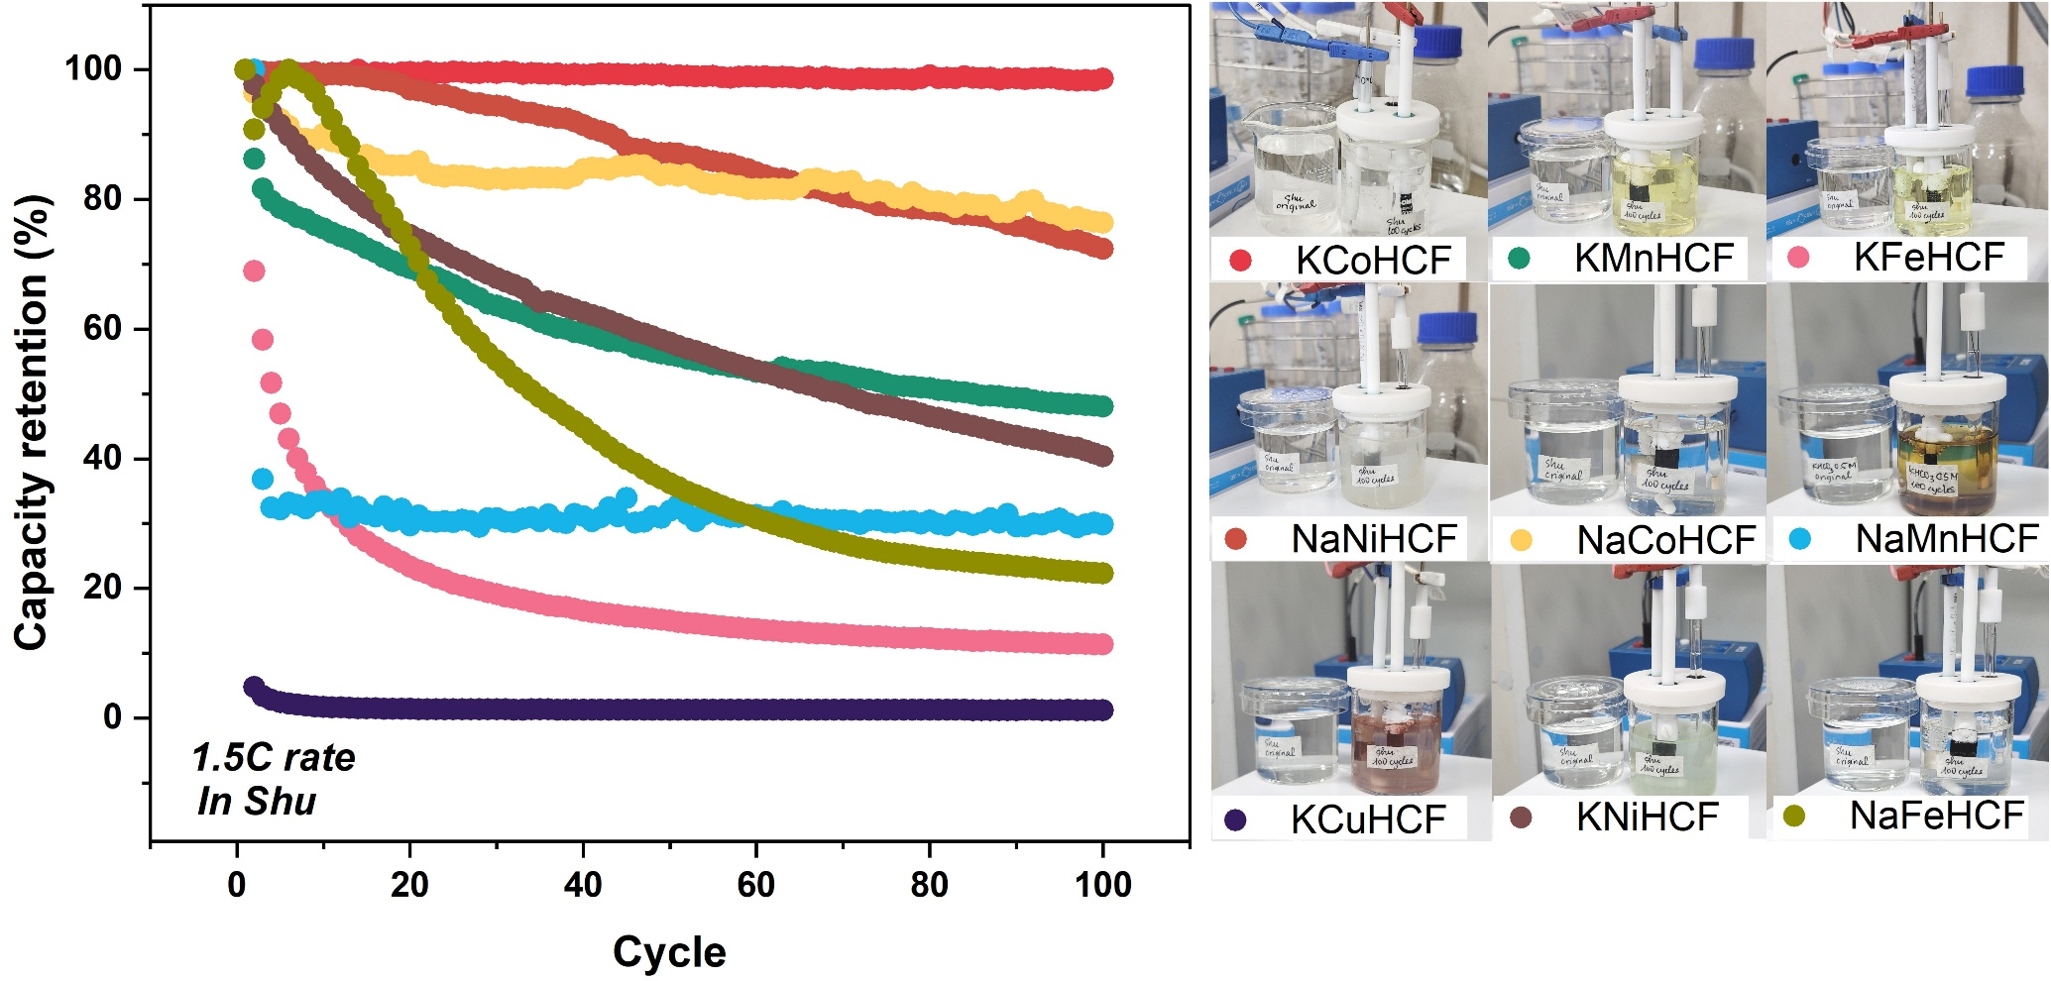
Supplementary Fig. 12. Capacity-retention screening in synthetic urine.
KCoHCF, NaNiHCF and NaCoHCF retain capacity; KMnHCF, KNiHCF, NaMnHCF, KFeHCF and KCuHCF decay, with the manganese and copper analogues discolouring most.
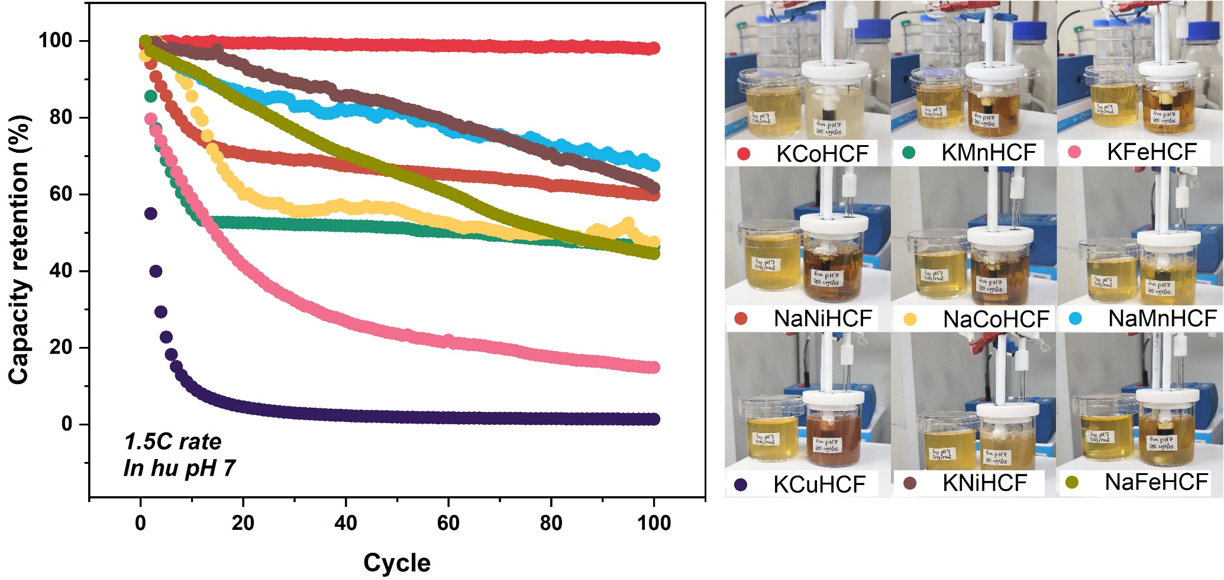
Supplementary Fig. 13. Capacity-retention screening in human urine pH 7.
Only KCoHCF is stable; NaNiHCF, NaCoHCF, KMnHCF, KFeHCF and KCuHCF decay in the pH-neutral real matrix.

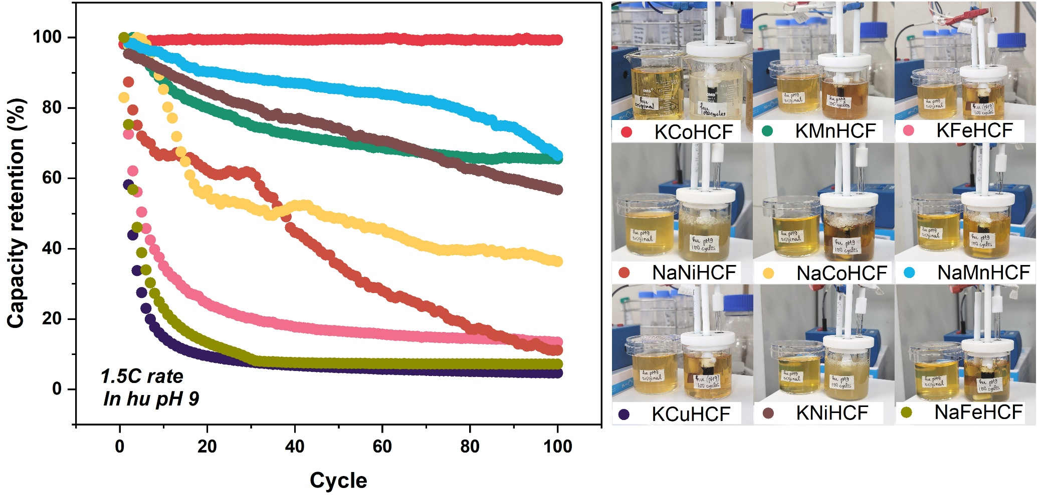
Supplementary Fig. 14. Capacity-retention screening in human urine pH 9.
The operating matrix of the platform. KCoHCF (and marginally NaMnHCF) hold capacity while KNiHCF, KMnHCF, NaCoHCF, NaNiHCF, KFeHCF, NaFeHCF and KCuHCF decay at 0.5–1.1 % per cycle, the hundredfold spread summarised against KCoHCF's 1,000-cycle stability in Fig. 4A.

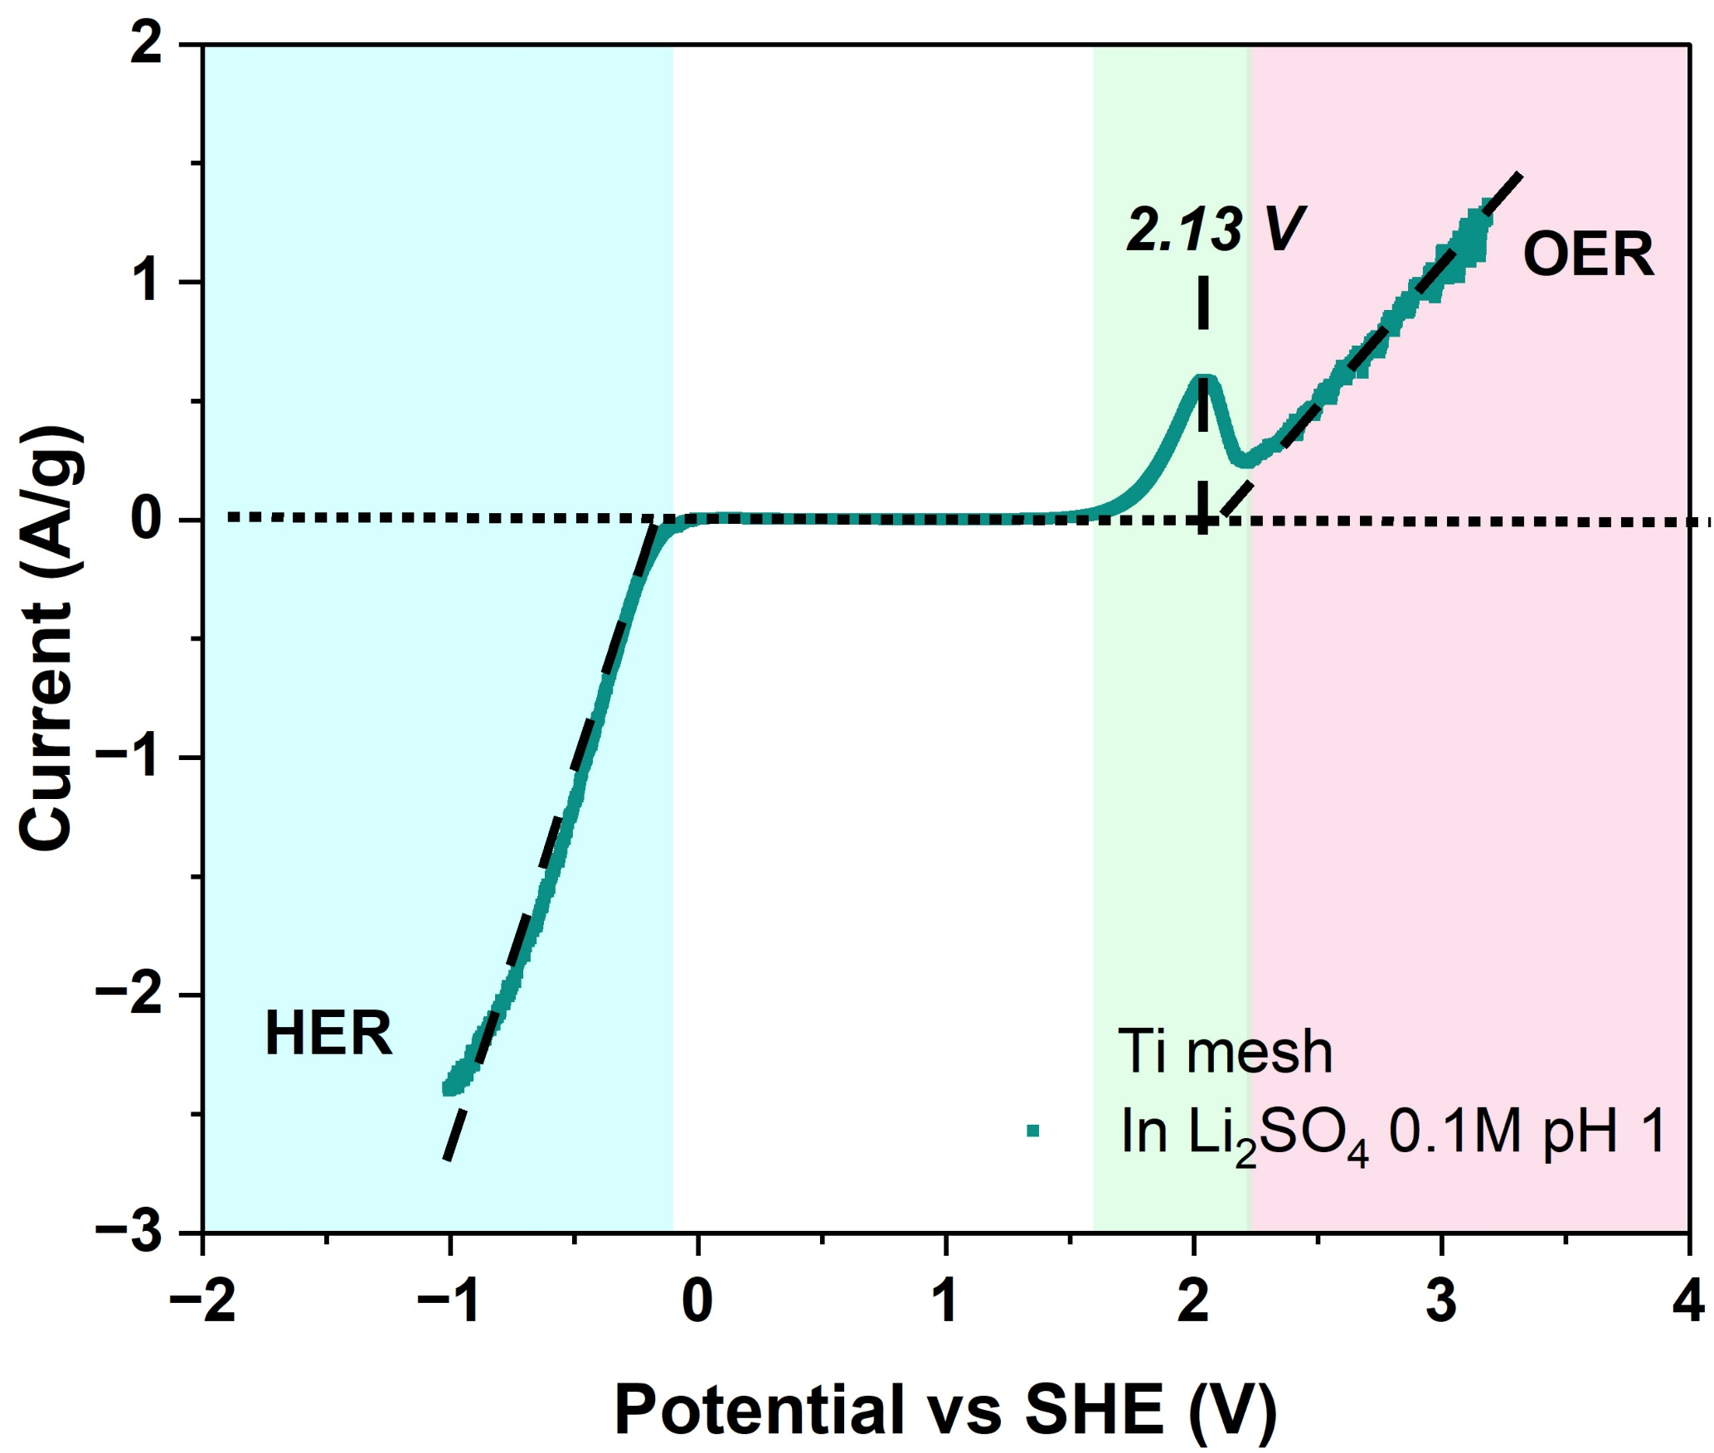
Supplementary Fig. 15. Linear sweep voltammetry of Ti mesh.
The OER, HER and intrinsic Ti oxidation lie outside the 0.1–1.1 V vs SHE operating window, so the oxidation peaks observed on Ti mesh in real urine pH 9 arise from urinary organics, the same fingerprint seen on Pt in Fig. 4F.

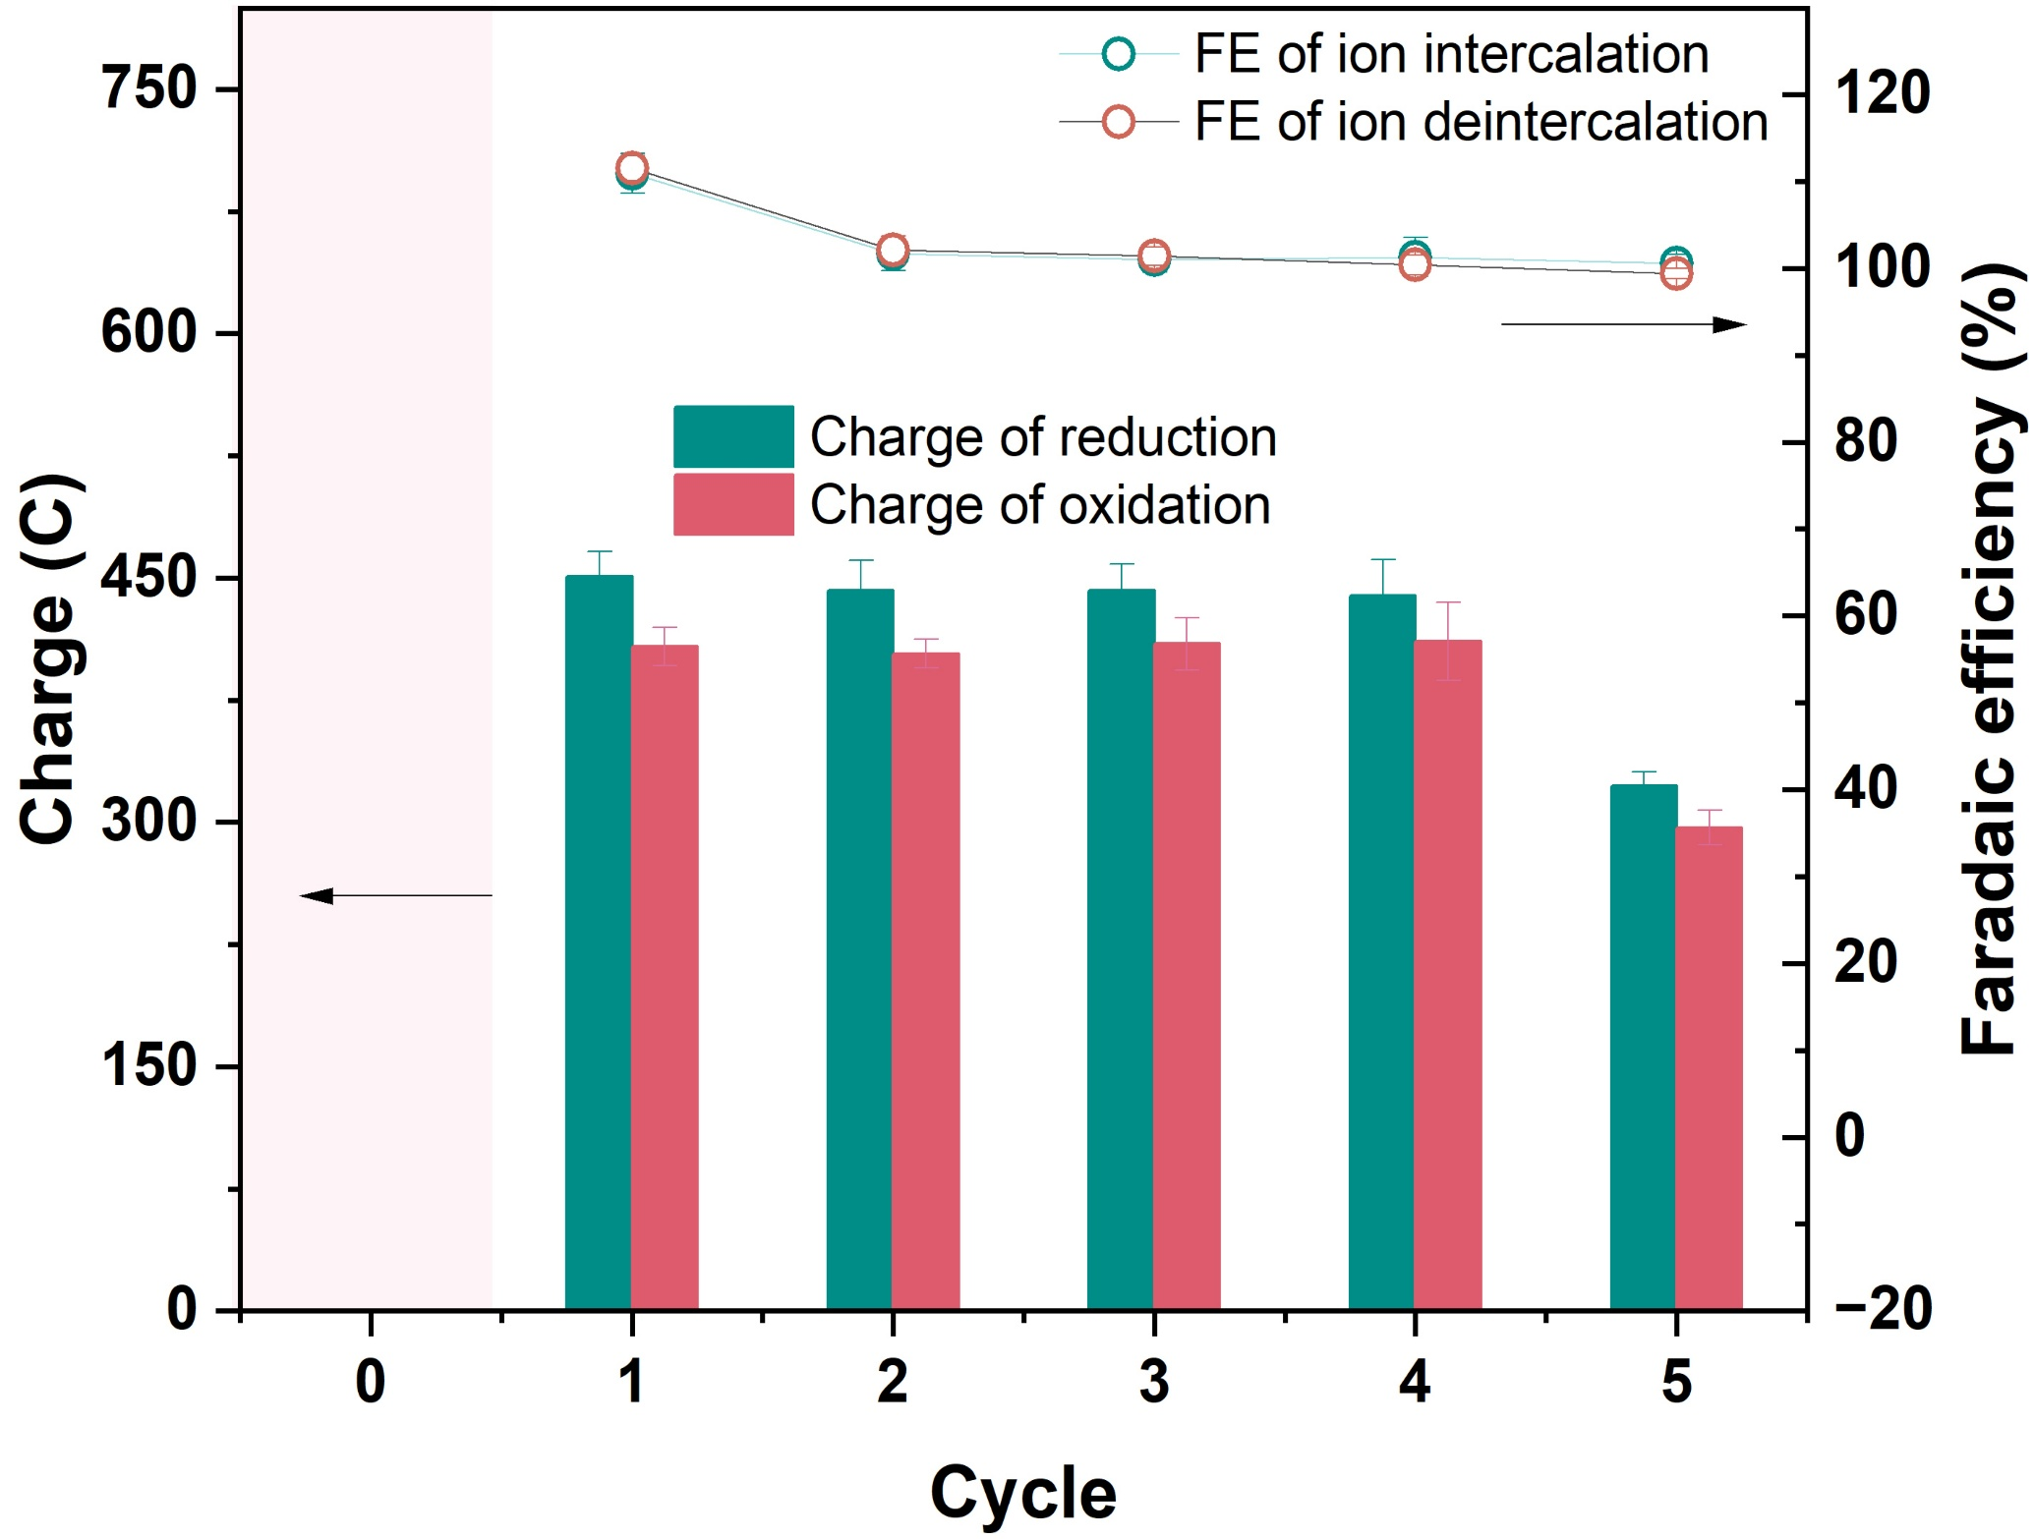
Supplementary Fig. 16. Faradaic efficiency of ion intercalation and deintercalation.
Where the Faradaic efficiency is 100 %, charge is used entirely for ion recovery. In some cycles, especially the first, it exceeds 100 % because KCoHCF naturally adsorbs ammonium physically, a process previously reported for NaCoHCF¹. A portion of the apparent mass loss can also be attributed to this intrinsic adsorption capacity, which involves complex binding mechanisms that are not easily reversed by oxidizing the electrode. This same behaviour explains the residual N_{1s} signal of NH₄⁺ observed in the XPS spectra of oxidized KCoHCF (Fig. 6H3). The surplus is under 10% and becomes negligible from the second cycle onward, which explains the higher NH₄⁺ removal in the first cycle and the relatively similar NH₄⁺ removal observed in cycles 2–4 in Fig. 5B2.

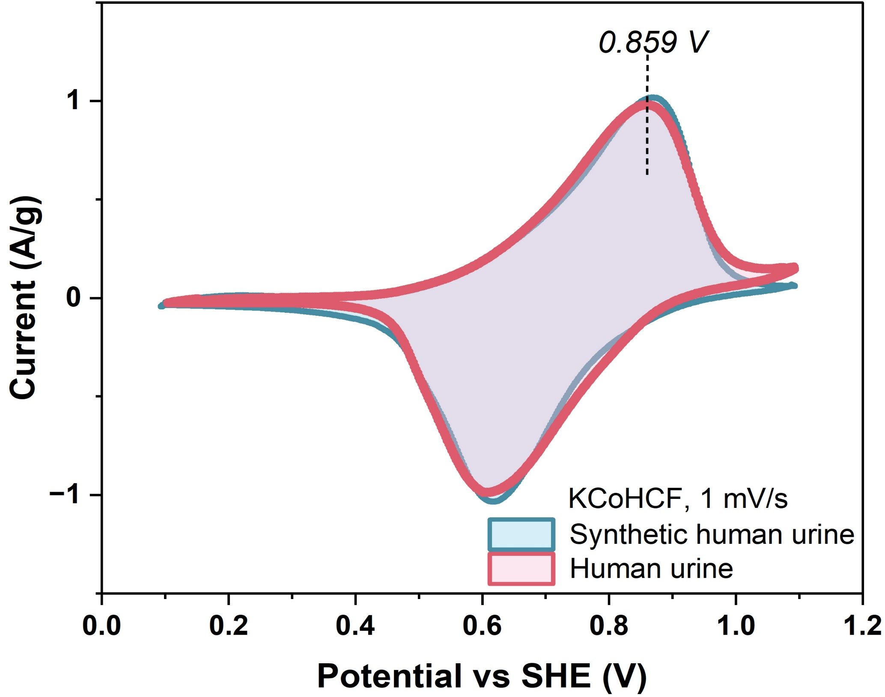
Supplementary Fig. 17. Cyclic voltammetry of KCoHCF in synthetic and real urine.
The CV in synthetic and real urine at pH 9 differs only in the organic oxidation features, isolating the dissolved organics as the sole chemical difference between the two matrices and underpinning the spontaneous-capture mechanism of Fig. 6A and 6H3.

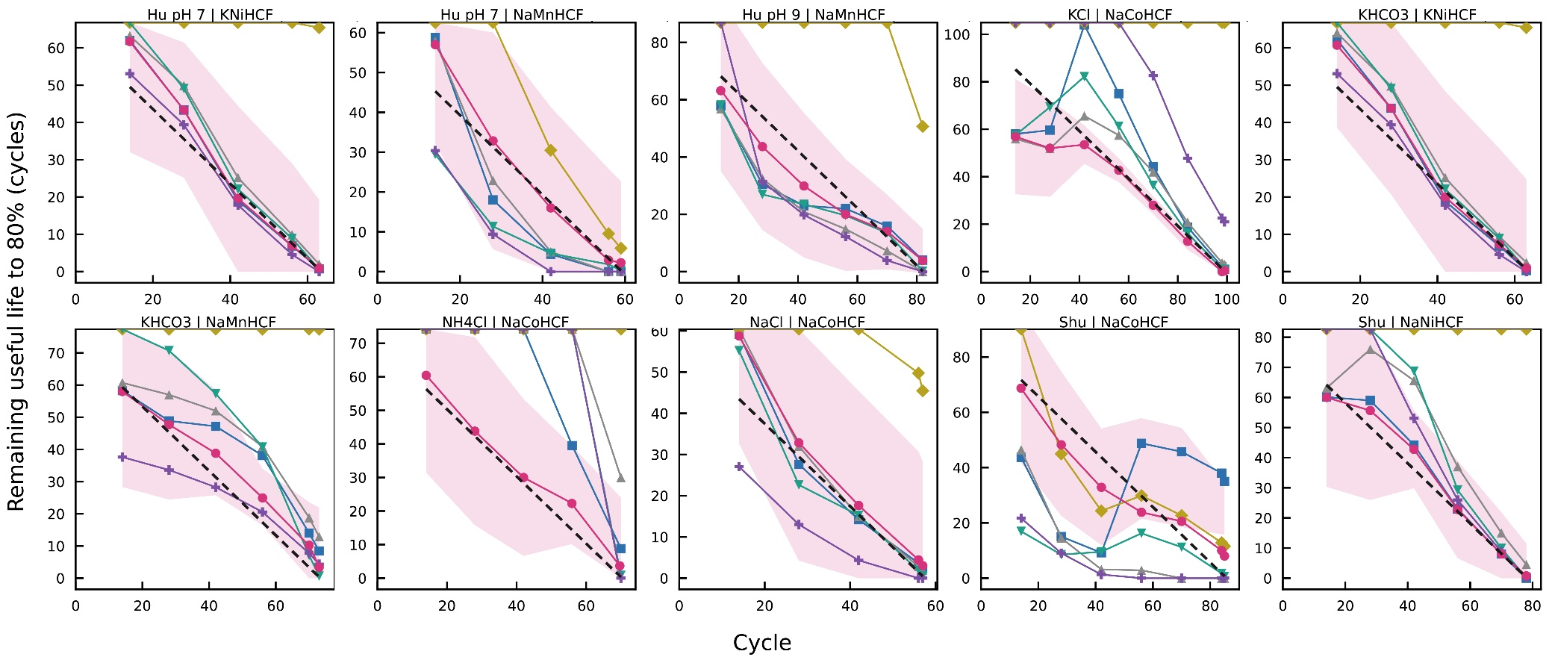
Supplementary Fig. 18. RUL prediction to 80% on the reaching trajectories.
This figure evaluates RUL prediction to a fixed, operationally meaningful target, the 80% threshold, on the 10 trajectories that actually fade that far. SPI+CBU predicts the remaining life to a MAE of 5.1 cycles with a mean 90% interval coverage of 93%, against 23.8, 19.2, 31.3, 53.1 and 72.7 cycles for the unconstrained Bayesian, linear, naive-log, Wiener and Weibull methods respectively. The advantage is therefore several-fold over the best alternative, and it is achieved together with near-nominal calibration rather than at the expense of it. The representative NaCoHCF-in-NH₄Cl trajectory highlighted in the main text is the clearest single illustration, where SPI+CBU reaches 5.3 cycles against an average of 152 cycles for the compared methods, because the unconstrained methods extrapolate the most recent local slope and run away while the constrained update holds the prediction inside the plausible operating range. The difference between methods has a consistent explanation. The TBU tracks the data well but has nothing to stop it projecting an implausible life when the recent slope flattens; the linear model cannot represent the curvature of the fade; and the classical reliability baselines, which assume a constant-drift (Wiener) or a power-law degradation path (Weibull), are mis-specified for a logarithmic fade and over- or under-shoot accordingly. Coverage meets or exceeds the nominal 90% on almost all panels. The two that sit slightly below are the single longest-lived trajectory, which lies at the very edge of the historical band where the prior is least informative, and one trajectory whose fade accelerates rather than decelerates, a shape that any single parametric family will find demanding; both are intrinsic edge cases rather than failures of calibration, and neither affects the conclusion that across the operationally relevant set SPI+CBU is simultaneously the most accurate and the best-calibrated predictor.
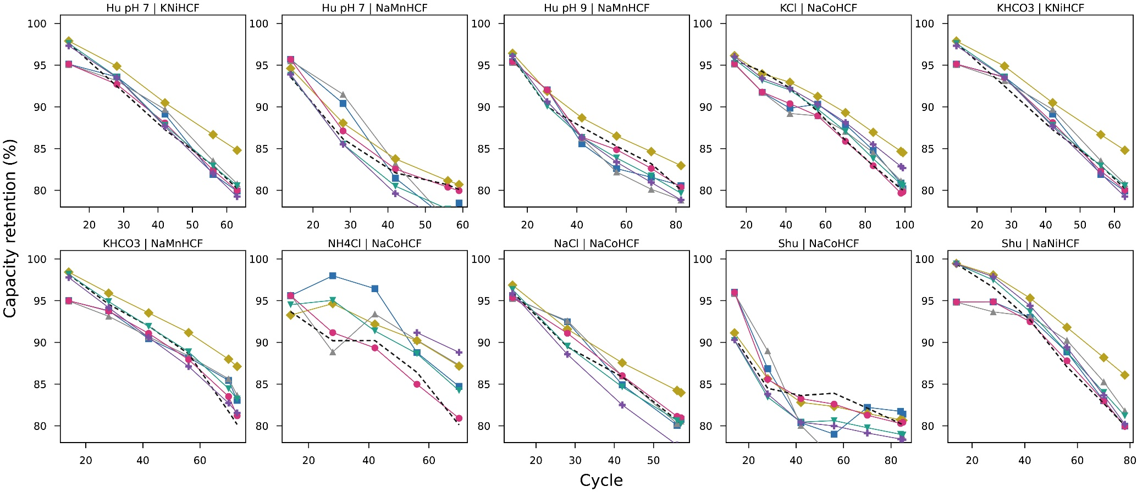
Supplementary Fig. 19. Capacity racking to 80% on the reaching trajectories.
This figure reports the capacity tracking that underlies the life predictions of Supplementary Fig. 18, On the same 10 trajectories up to the 80% crossing. SPI+CBU attains the tightest tracking, with an RMSE of 1.4%, ahead of the linear, SPI+TBU, Log-Bayes and Weibull methods at 2.9%, 2.6%, 3.0% and 2.3%. The importance of this figure is that it rules out a benign but unwanted explanation for the life accuracy, namely that a poorly fitting model might still predict the threshold crossing by chance through cancelling errors. Because SPI+CBU also produces the most faithful capacity fit, its life accuracy rests on getting the underlying degradation right rather than on a fortuitous cancellation, and the constrained update is shown to improve the fit and the forecast at the same time. The close agreement between fitted and measured capacity all the way to the threshold is what gives confidence that the same model, run forward, yields a meaningful projection beyond the measured window.
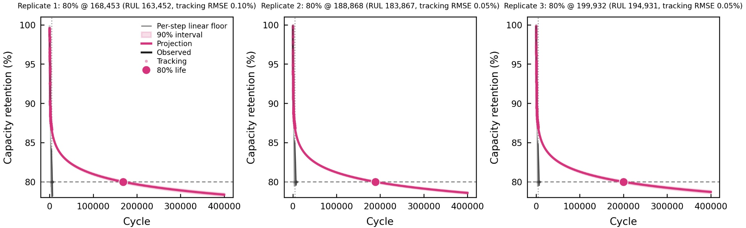
Supplementary Fig. 20. Forward projection of 3 replicates of KCoHCF capacity to 80% on a linear axis.
This figure presents the forward projection that supplies the electrode lifetime, for the three KCoHCF replicates, on a linear cycle axis. Each panel shows the near-term tracking points, the projected mean (pink), its 90% interval, and the conservative linear floor (orange); the linear axis is used so the extrapolation distance is shown directly, without the visual compression of a logarithmic scale. The near-term tracking from which the projection is launched is essentially exact, with sub-tenth-of-a-percent error, so the starting point of the extrapolation is well determined. Because the KCoHCF electrode is exceptionally durable and does not reach the 80% threshold within the measured window, its 80% life is reported as a bounded estimate rather than a single number: a central projection on the order of 1.7-2.0 × 10⁵ cycles, bracketed by a calibrated interval and supported by a conservative linear floor on the order of 7 × 10³ cycles. This bounded presentation is the appropriate way to report an exceptional-durability result: the central value conveys the remarkable longevity the decelerating fade implies, while the floor provides a deliberately cautious lower bound that does not rely on the extrapolation continuing smoothly, so a maintenance schedule can be set against a value that remains safe under conservative assumptions. The two together turn an extrapolated quantity into an actionable interval and make the basis for the electrode replacement interval used in the TEA fully explicit.
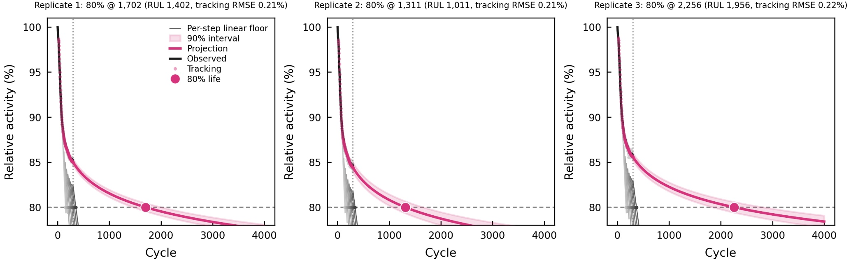
Supplementary Fig. 21. Forward projection of 3 replicates of Pepurease bead relative activity to 80% on a linear axis.
These figures are the biocatalyst counterpart, showing the projection for the three PePurease-bead replicates on a linear axis with the same elements: tracking, projected mean, 90% interval and conservative floor. In contrast to the electrode, the bead projection is a short and well-constrained extrapolation, because the beads reach the threshold region much sooner, so the projected 80% life and its interval are tight and the near-term tracking that launches the projection is essentially exact. The result is a directly usable biocatalyst-replacement interval, with a central 80% life on the order of 1.3-2.3 × 10³ cycles and a conservative floor of a few hundred cycles. Taken with Supplementary Fig. 20, this shows that the same projection methodology applies cleanly at two very different timescales, a very-long-lived electrode and a moderately-lived biocatalyst, which is what allows a single framework to set replacement intervals for both parts of the device.

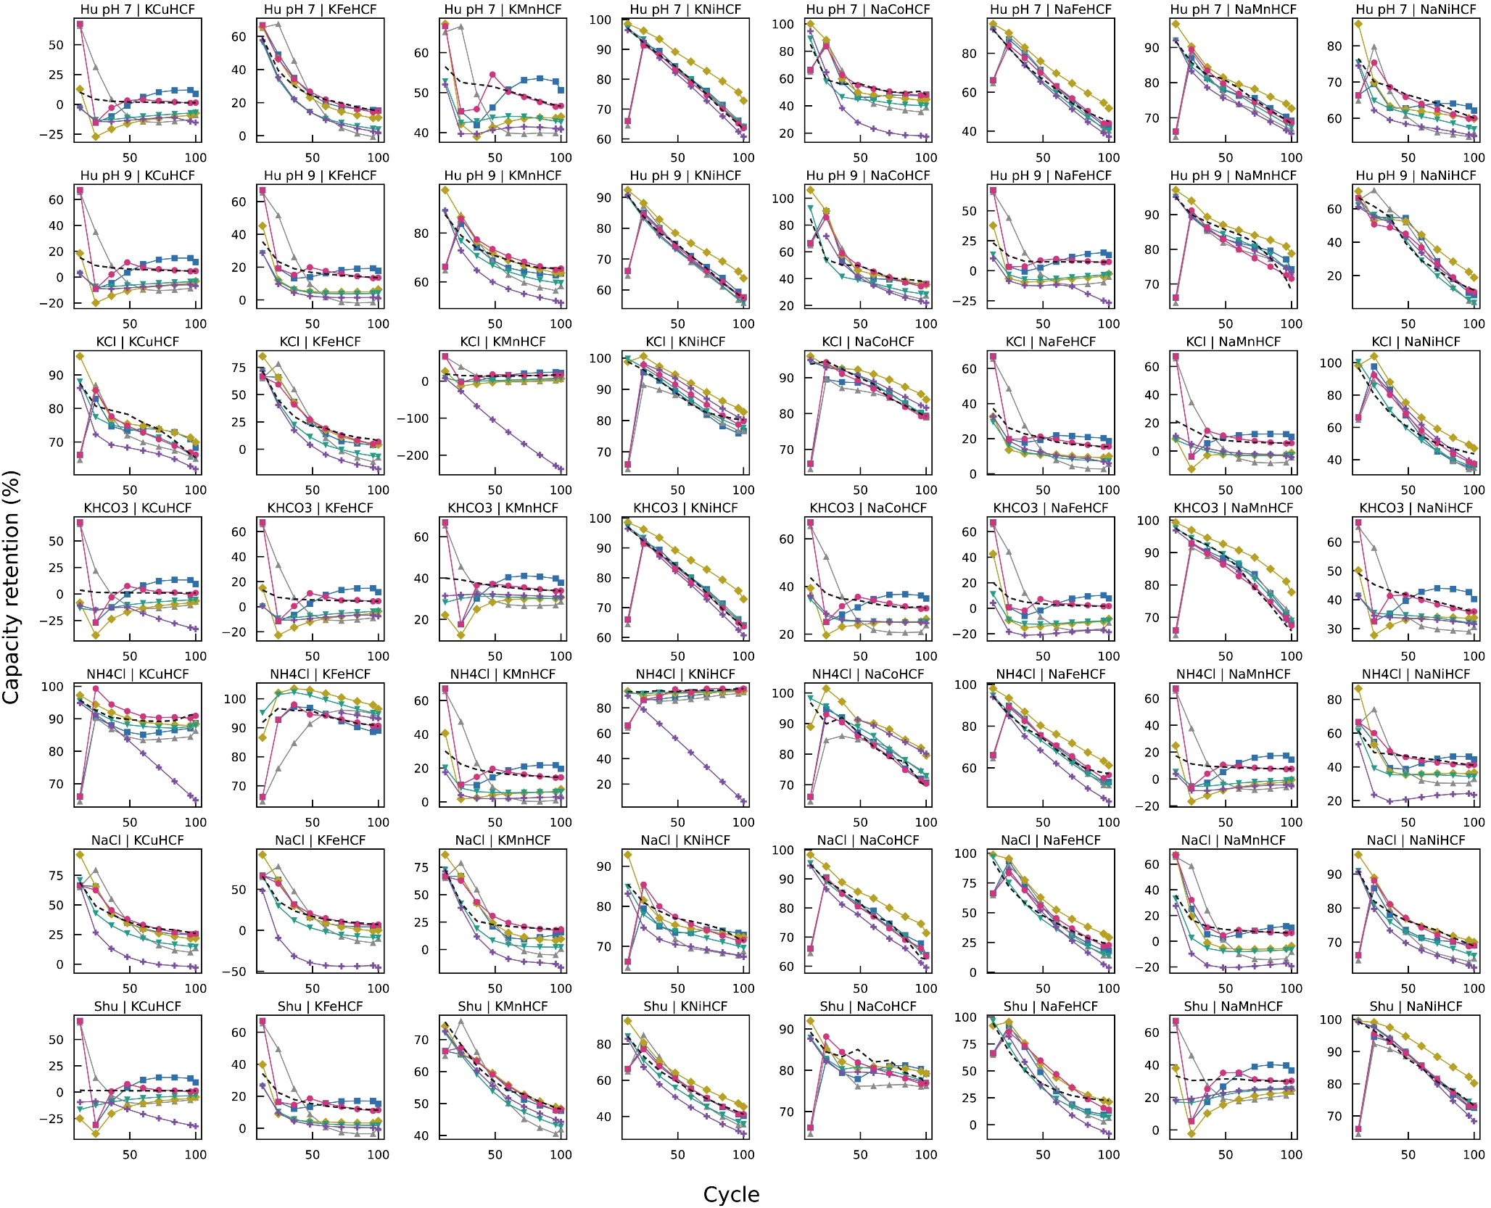
Supplementary Fig. 22. Capacity tracking across all 56 screening trajectories.
This figure shows the capacity-model fit underlying the screening RUL results: for all 56 trajectories, the measured retention (black dashed) is overlaid with each method's fitted retention. A RUL estimate can only be as good as the capacity model it is read from, and this figure shows that SPI+CBU reproduces the characteristic decelerating fade closely across the entire screen, which is the direct reason its life predictions are accurate. The log-linear basis captures the two features that dominate these curves, a rapid early loss described by the logarithmic term and any slow residual drift described by the linear term, and the constrained update keeps the fit anchored as new cycles arrive. The linear baseline, by contrast, can only draw a straight line through a curved trajectory, so it departs from any panel that bends; this systematic mis-fit at the capacity level is the mechanistic origin of its much larger life error, because a small slope error near the threshold translates into a large error in the projected crossing cycle. Presenting all 56 panels rather than an average keeps the small number of atypically shaped curves visible instead of hiding them in a mean, and shows that the close SPI+CBU tracking is a general property of the screen rather than a selection effect.
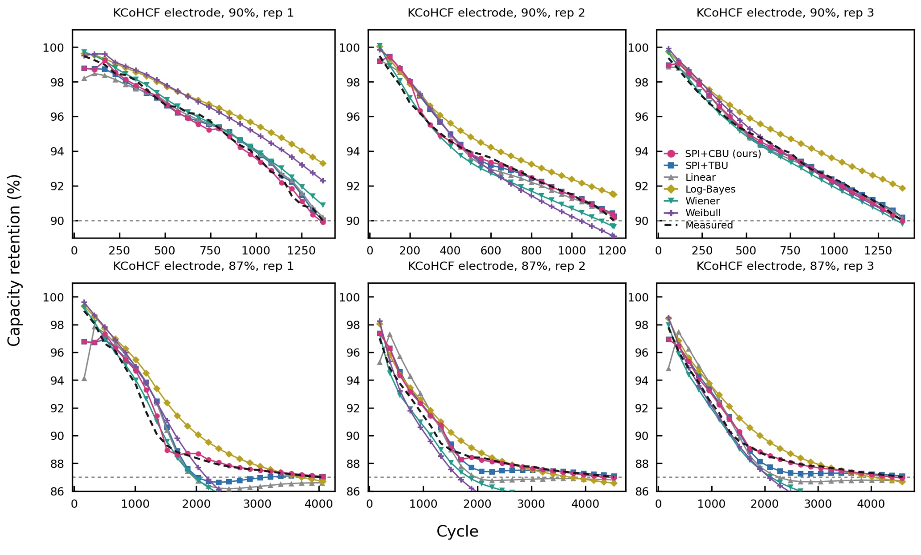
Supplementary Fig. 23. Triplicate capacity retention tracking for the KCoHCF electrode.
These figures illustrate how different predictive models track degradation behavior for KCoHCF capacity retention across multiple replicates and threshold conditions. In specific, the SPI+CBU and SPI+TBU closely follow the measured black‑dashed curves, maintaining tight alignment throughout cycling and across replicates. This consistency highlights their robustness and generalizability for the electrochemical system. The linear model performs moderately well but tends to miss curvature at mid‑life, while log‑Bayes, Wiener, and Weibull show visible divergence, particularly the log‑Bayes model, which systematically overestimates retention or activity as degradation deepens. The Wiener and Weibull baselines also undershoot by noticeable margins, reflecting their lack of historical‑band constraints. Overall, SPI‑based approaches yield the most stable and accurate tracking of gradual performance decline, effectively capturing both the smooth early‑cycle decay and the sharper late‑cycle transitions observed in the measured data.
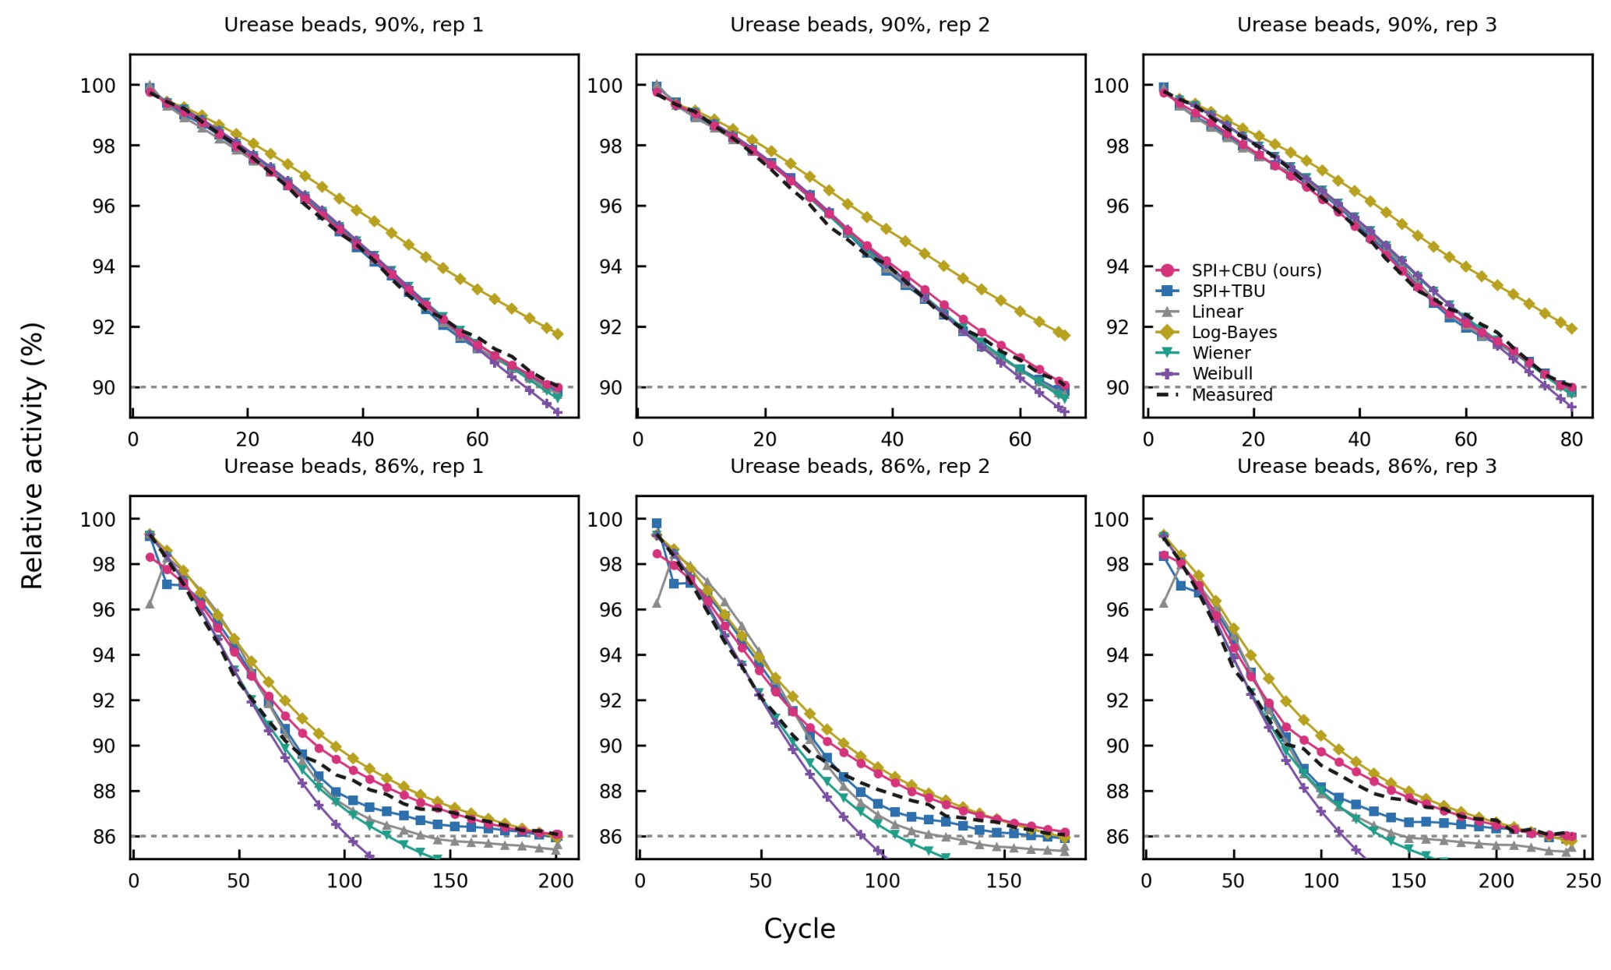
Supplementary Fig. 24. Triplicate activity tracking for the PePurease bead.
These figures illustrate how different predictive models track degradation behavior for PePurease bead activity retention across multiple replicates and threshold conditions. As with KCoHCF capacity‑retention tracking, the SPI+CBU and SPI+TBU models closely follow the measured black‑dashed curves, maintaining tight alignment throughout cycling and across replicates. The linear model performs moderately well but tends to miss curvature at mid‑life, while the log‑Bayes, Wiener, and Weibull baselines show visible divergence—particularly the log‑Bayes model, which systematically overestimates retention as degradation deepens. The Wiener and Weibull models also undershoot by noticeable margins, reflecting their lack of historical‑band constraints.

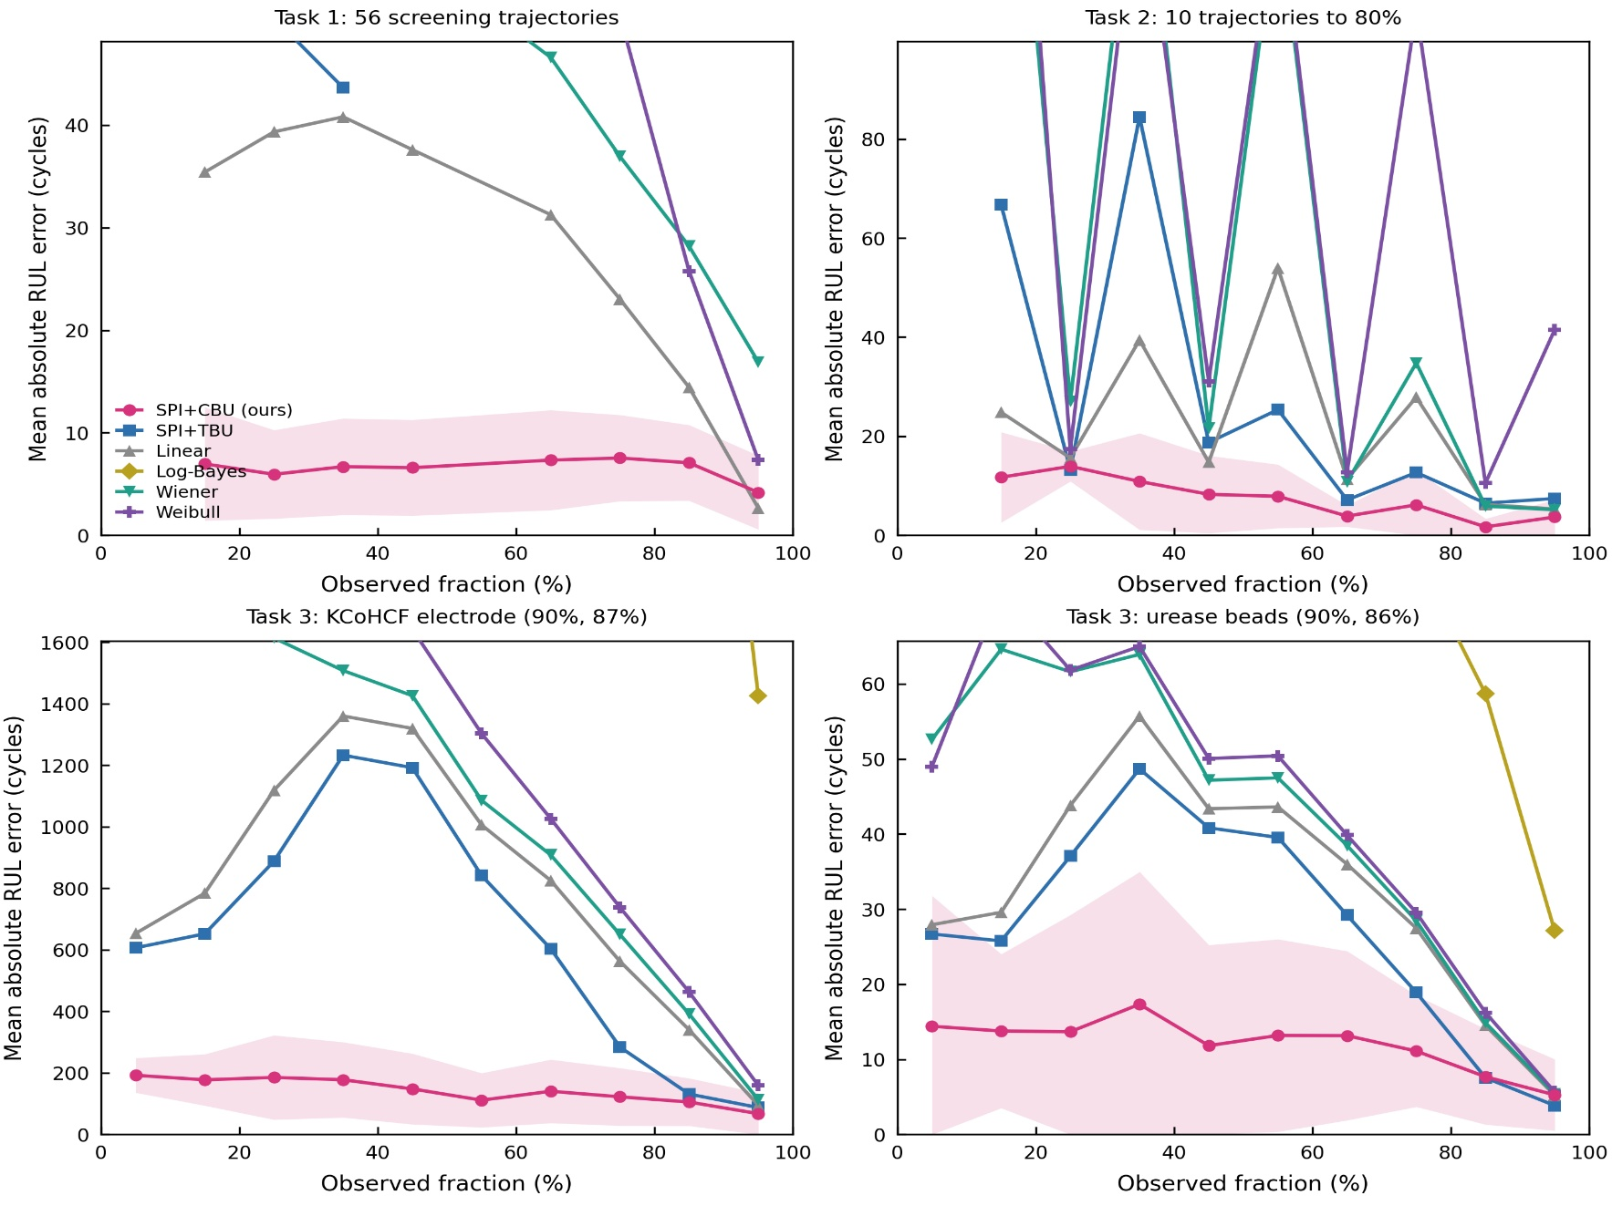
Supplementary Fig. 25. Absolute RUL error versus observed fraction (averaged).
This figure summarises the central practical claim of the prognostic on one set of axes. For each task, the mean absolute RUL error is plotted against the observed fraction of life, which places trajectories of very different absolute length on a common footing and lets the methods be compared at matched stages of degradation. SPI+CBU holds the lowest error at every stage of life, and the margin is widest in the first 10-20% of the trajectory. This early regime is the most valuable operationally and the hardest statistically: few cycles have been observed, the unconstrained posterior is broad, and a useful forecast must come largely from prior information about plausible lives, exactly what the constraint supplies. As more of the trajectory is observed the data increasingly pin the trend for every method, so the curves converge, and the competing methods approach SPI+CBU only in the final fraction of life, when the remaining life is small enough that any reasonable method is adequate and the prediction is of little operational consequence. Because the horizontal axis is a fraction rather than an absolute cycle count, the sustained advantage cannot be attributed to a single long trajectory dominating the average, and because the same ordering holds on the screening set and on both deployed materials, it is not specific to one chemistry. The figure thus expresses the whole prognostic argument compactly: the constrained update delivers an early, large and durable accuracy advantage exactly where an honest forecast is most needed.
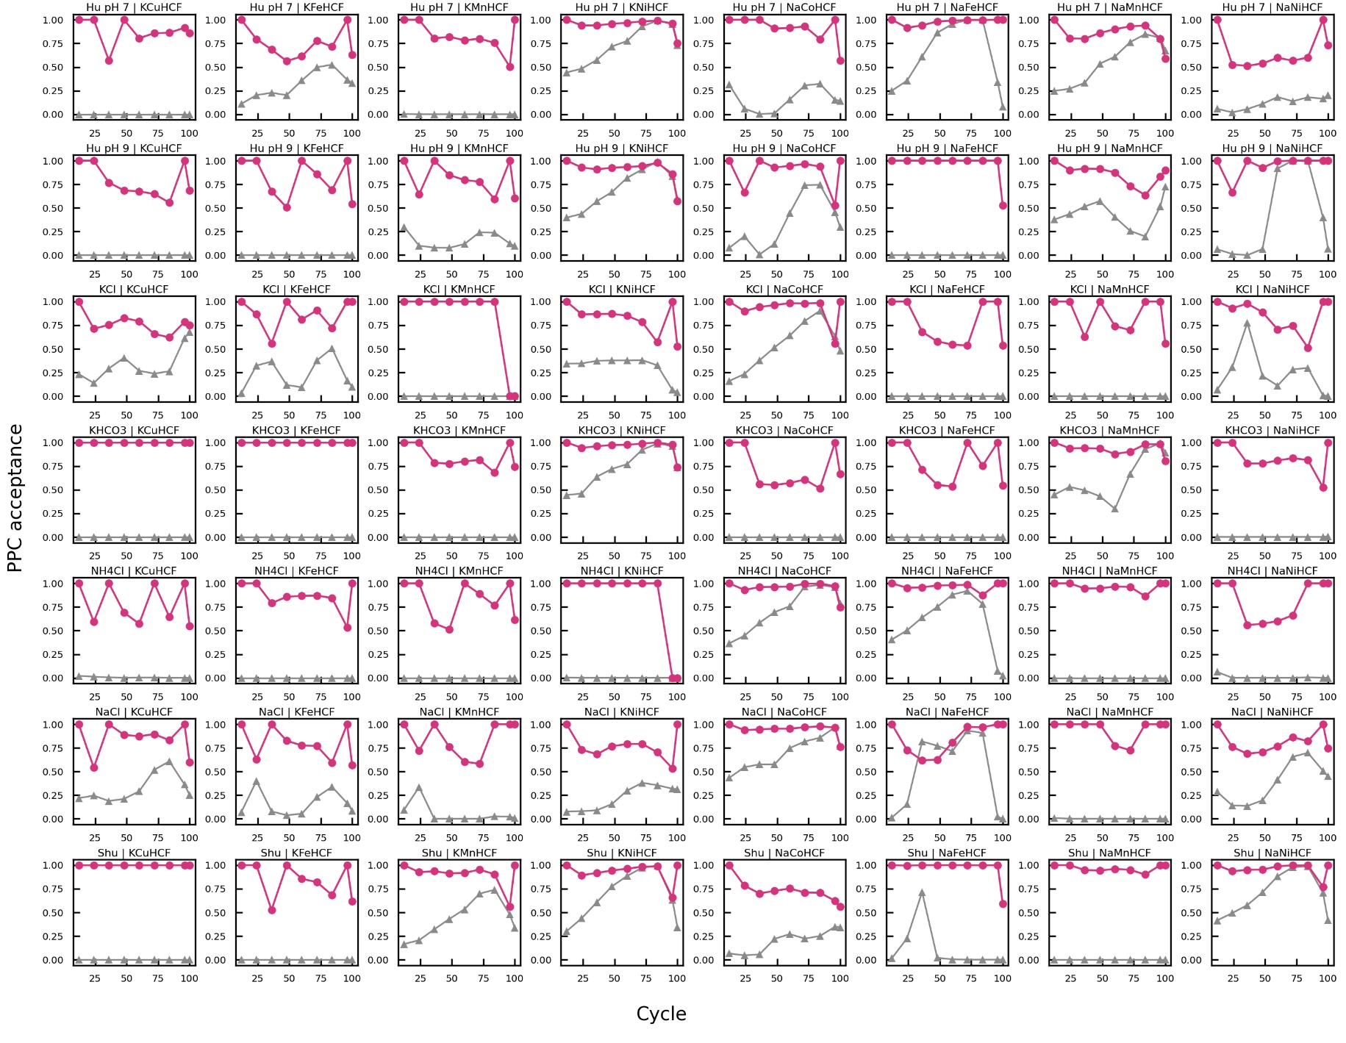
Supplementary Fig. 26. Per-trajectory Gaussian-mutation effect on PPC acceptance for 56 trajectories.
This figure compares posterior-predictive-check (PPC) acceptance with and without Gaussian mutation for each of the 56 screening trajectories (pink, with mutation; grey, without). Without mutation, a large fraction of the sampled fade trajectories fall outside the historical-lives band and acceptance is low, particularly early in life when only a few cycles have been observed. With mutation, the violating particles are relocated into the plausible region and acceptance rises to a high, stable level across all 56 panels. The recovery is uniform whether a trajectory is short- or long-lived, gentle or steep, which shows that it is a population-level property of the constraint rather than a feature of a few favourable cases. The trajectories that start from the lowest acceptance are the longest-lived and the few with atypical fade shapes, and mutation restores these as well. This consistency identifies the constraint, enforced by mutation, as the origin of the reliability of SPI+CBU rather than the curve fitting alone.
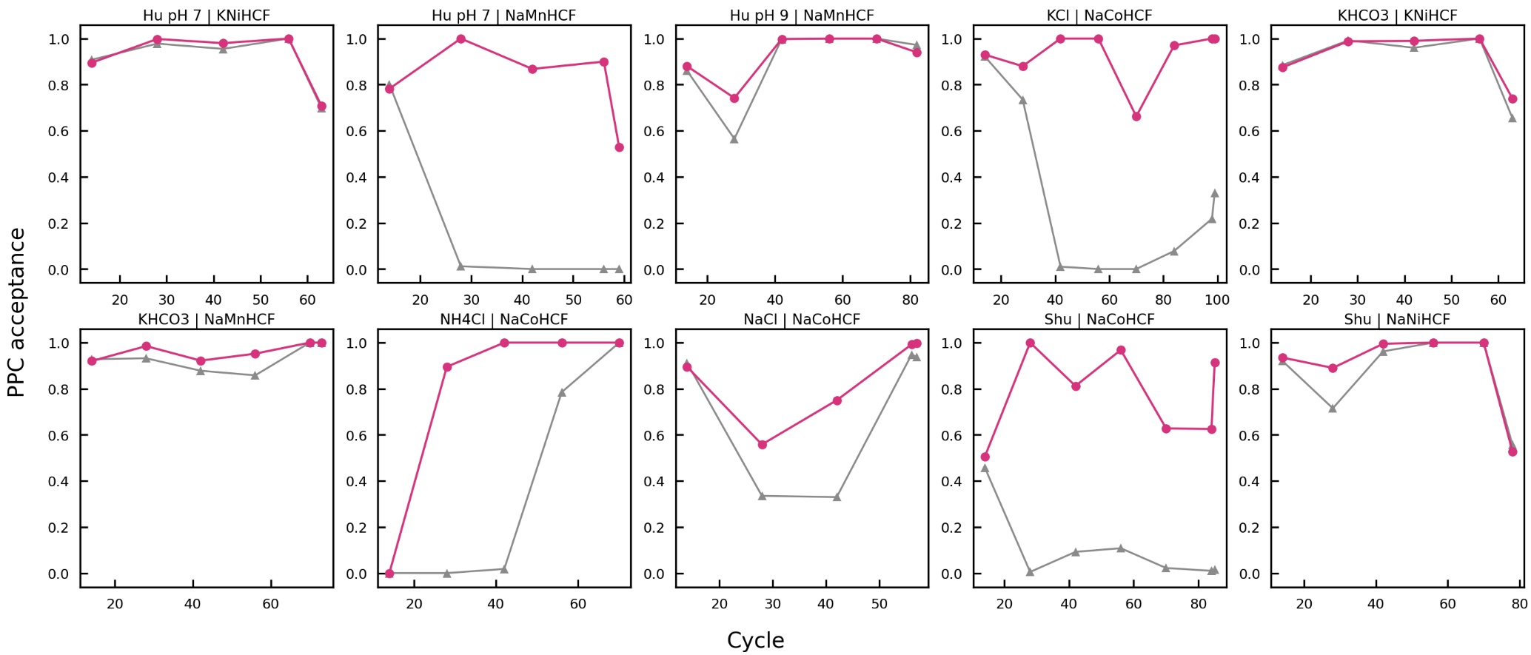
Supplementary Fig. 27. Per-trajectory Gaussian-mutation effect on the PPC acceptance for 10 trajectories to 80% threshold.
This figure presents the same comparison at full resolution, one trajectory per panel and split across sheets so that every axis and legend is legible. Examined individually, each panel tells the same story as the aggregate: the with-mutation acceptance (pink) climbs quickly and then sits at or near its maximum for the rest of the observation window, while the without-mutation acceptance (grey) remains depressed and fluctuates irregularly as the unconstrained posterior wanders in and out of the plausible range. The panel-level view confirms that the recovery is not produced by averaging over a few dominant trajectories; it holds trajectory by trajectory, including on the panels where the uncorrected acceptance is lowest. Two points follow. First, the method requires no per-trajectory tuning: a single trigger threshold and a single mutation scale ($λ$ = 3) are applied uniformly and restore acceptance across the whole spread of fade shapes and lifetimes in the screen. Second, this is exactly the behaviour an online, deployable prognostic must show, because in practice each new cell is unseen and cannot be individually calibrated; the same fixed configuration generalises across the screening population without adjustment.

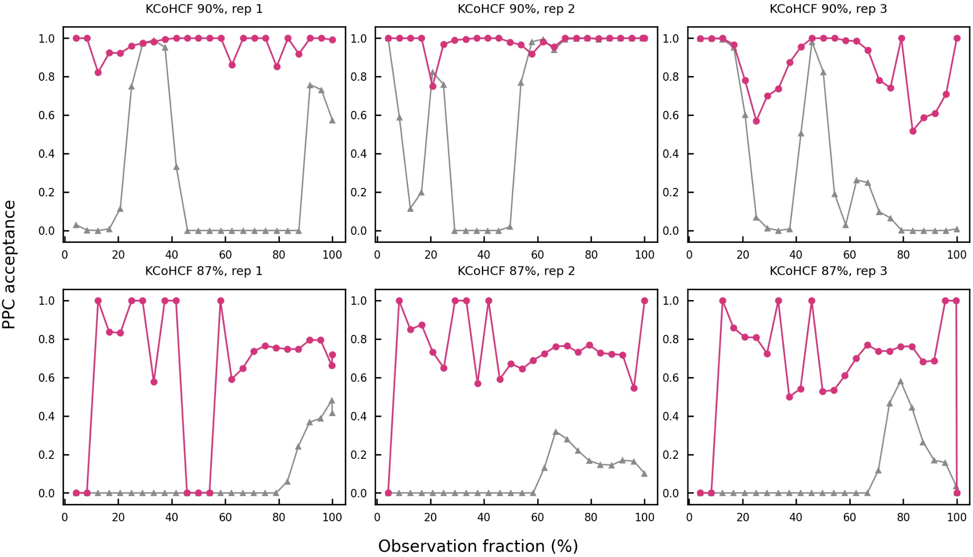
Supplementary Fig. 28. Per-replicate Gaussian-mutation effect on the PPC acceptance for KCoHCF electrode (90% and 87% thresholds).
This figure moves from the screening population to the deployed electrode and examines the mechanism where it matters for the device, across three independent KCoHCF replicates and at both the 90% and the deeper 87% capacity thresholds. In every replicate and at both thresholds, mutation lifts acceptance from a low, unstable baseline to a high and steady level. The two thresholds probe different parts of the fade: reaching 90% is a short extrapolation, whereas reaching 87% requires projecting further along the decelerating tail, where the gap between a constrained and an unconstrained posterior is widest. Mutation restores acceptance at both, so the constraint continues to operate precisely where the prediction is hardest, at the deeper threshold that defines a realistic EoL for the electrode. That the recovery repeats across all three replicates is important for a materials-level claim: it indicates a reproducible property of the KCoHCF system together with the method rather than an outcome that depends on a single favourable cell, and it is the per-replicate basis on which the electrode lifetime used in the TEA is built. The behaviour is also smooth and monotone once mutation is active, consistent with a well-posed constraint that nudges the posterior rather than forcing it abruptly.
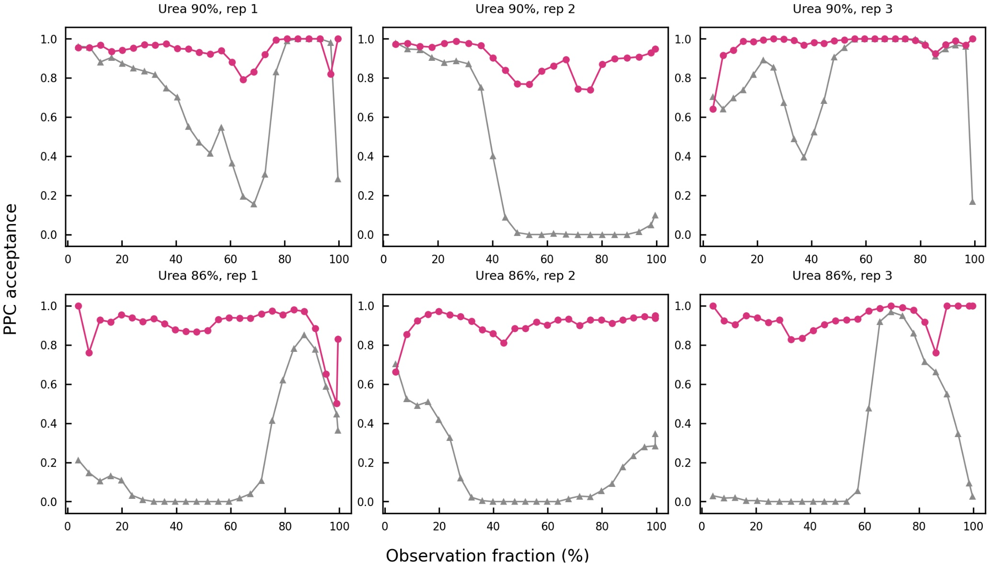
Supplementary Fig. 29. Per-replicate Gaussian-mutation effect on the PPC acceptance for PePurease beads (90% and 86% thresholds).
This figure is the biocatalyst counterpart, across three PePurease-bead replicates at the 90% and 86% activity thresholds. The pattern matches the electrode: triggered mutation raises acceptance from a low, fluctuating baseline to a high and consistent level in every replicate and at both thresholds. The significance here is the transfer of the mechanism between two physically different degradation processes. The constraint and the mutation were formulated on an electrochemical capacity signal, yet they apply without any modification to an enzymatic-activity signal whose decay is governed by entirely different chemistry. Because the constraint acts on the distribution of plausible lives rather than on any material-specific feature of the fade, it is agnostic to the underlying degradation physics, and the figure demonstrates this empirically on the two components that constitute the platform. A single prognostic layer therefore covers both the electrode and the biocatalyst, which is what a device-level predictive-maintenance scheme requires.
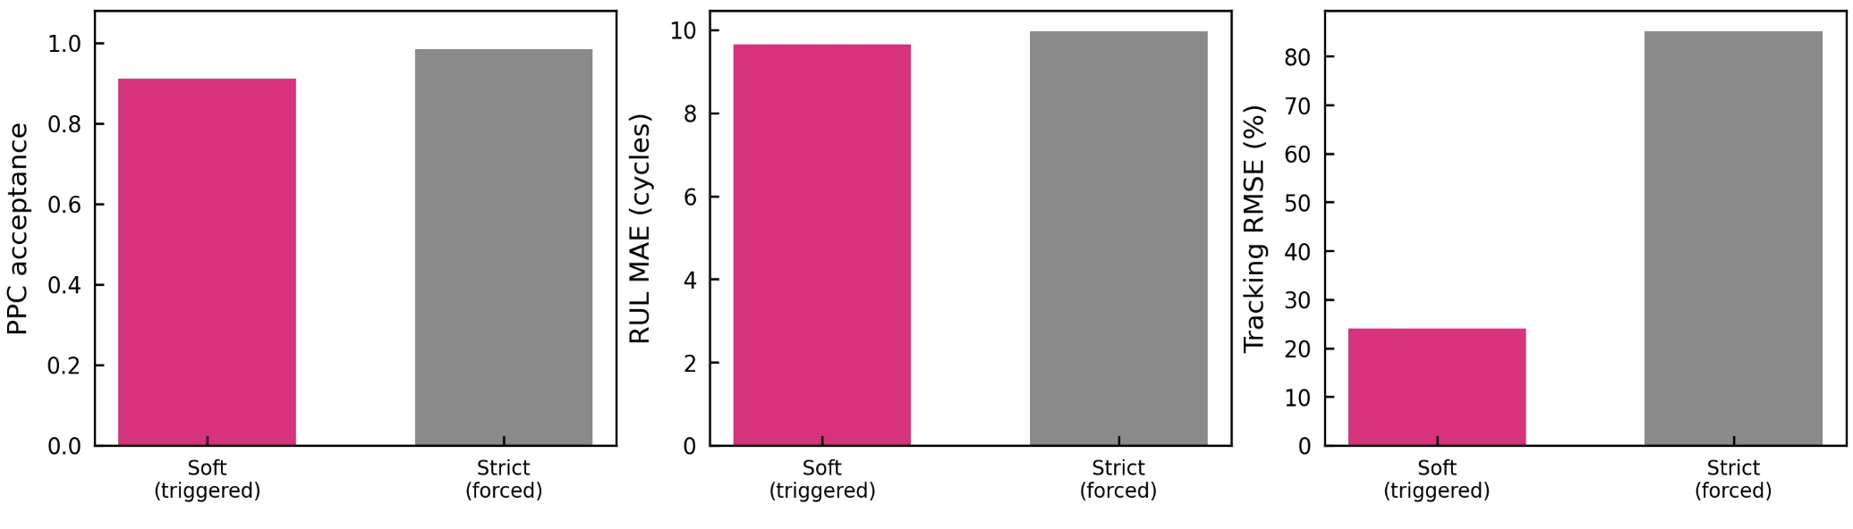
Supplementary Fig. 30. Soft versus strict Gaussian mutation performance.
This figure justifies applying mutation softly, only when reliability falls below the trigger, rather than enforcing the constraint at every step. The three bars compare the triggered (soft) rule used throughout with a strict rule that drives PPC acceptance to one at every update. The strict rule raises constraint satisfaction only marginally above the already-high level the soft rule reaches, but it does so by overriding the measured data: forcing every particle into the historical band pulls the fitted trajectory away from the observed points and inflates the capacity-tracking error substantially, roughly threefold to fourfold, while the point RUL MAE is essentially unchanged (it moves only at the level of a fraction of a cycle). The interpretation is that the constraint contributes almost all of its accuracy benefit as soon as it is applied where it is needed, and that pushing it further buys no additional accuracy while degrading the fit. The soft, triggered rule therefore occupies the right operating point: it keeps the full accuracy and calibration benefit of the constraint and preserves a faithful description of the measured fade, the trajectory the forward projection is launched from. This is why the triggered formulation is the default, and the comparison makes the trade-off explicit, resolved in favour of data fidelity rather than set arbitrarily.
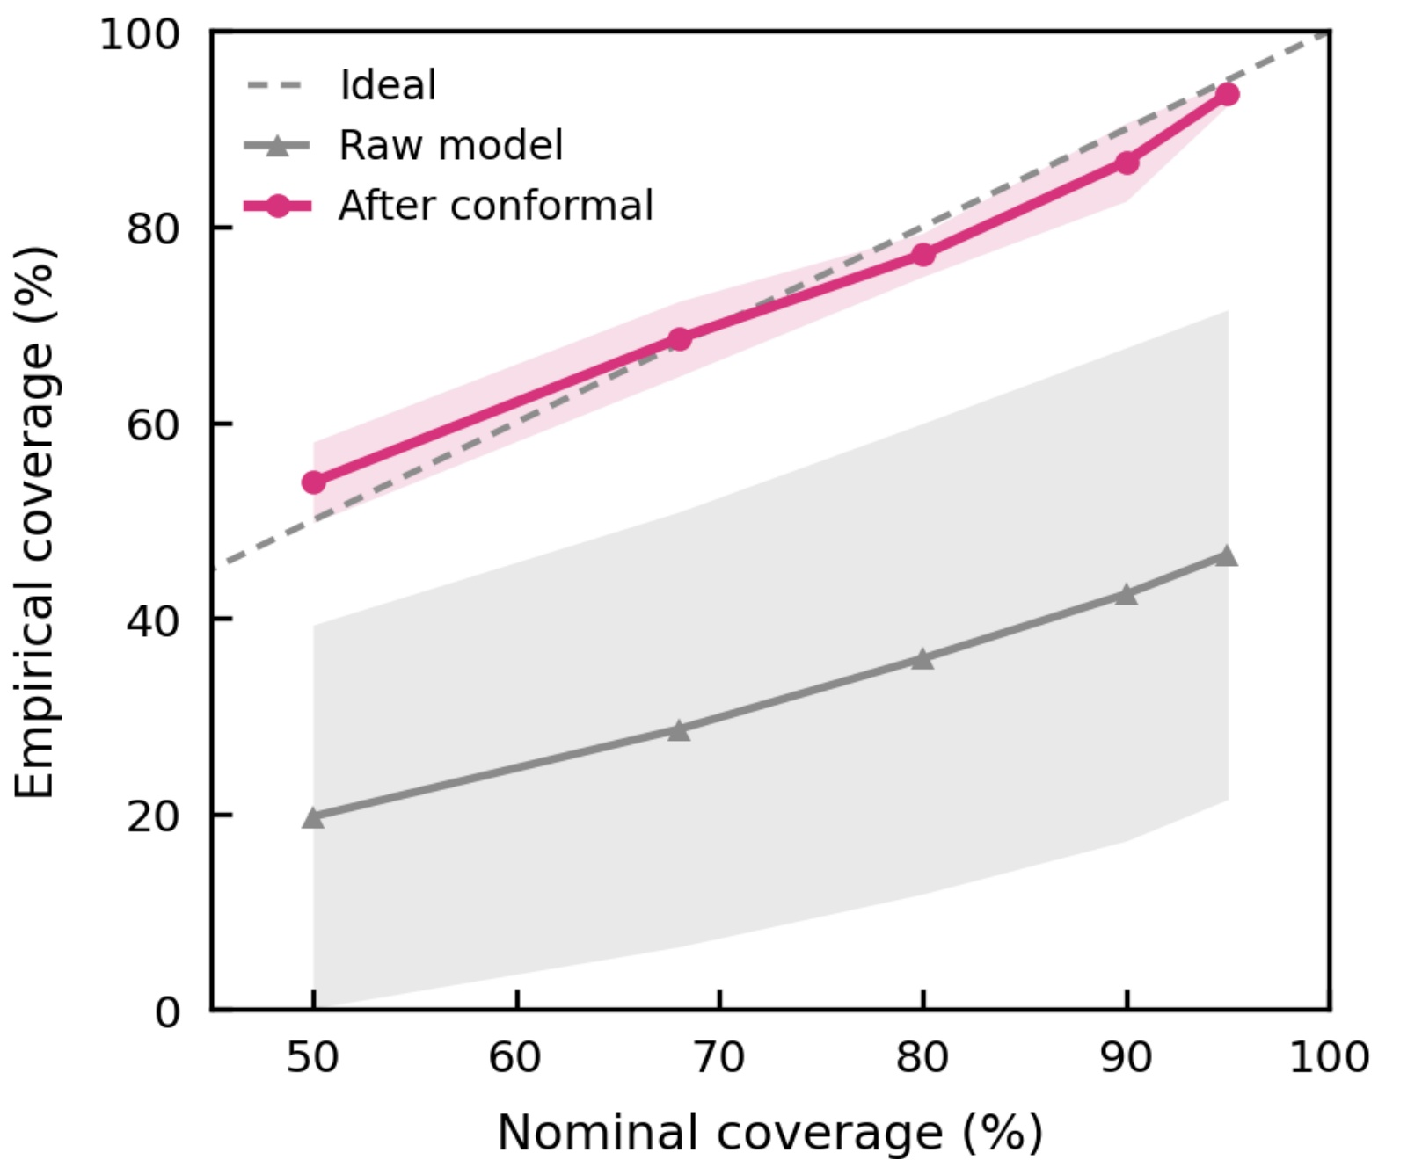
Supplementary Fig. 31. Conformal calibration reliability (averaged across all tasks).
This figure establishes that the reported uncertainty is trustworthy. It plots empirical coverage against the nominal level on average, before (grey) and after (pink) split-conformal recalibration, with the mean ± s.d. across trajectories or replicates shaded. The dash grey line (the diagonal) is the ideal‑calibration line, where the model is stated confidence level matches the actual, observed confidence level. Before calibration the curve lies below the diagonal at every nominal level, meaning the raw intervals are too narrow and a stated 90% interval would in practice contain the true remaining life somewhat less than 90% of the time; this under-coverage is the expected consequence of reading uncertainty directly from a particle spread that does not account for model misspecification. After a single split-conformal step, empirical coverage is brought onto the diagonal across the full range of nominal levels, so the stated and achieved coverage agree. The procedure is distribution-free and finite-sample: it rescales the interval by a factor estimated from the empirical distribution of normalised errors on the reference trajectories, adding no parameters and no structural assumptions. Two consequences follow: every calibrated 90% interval quoted in the manuscript is backed by this check rather than asserted, and because the interval now means what it says, an operator planning to the lower edge of the 90% band is making a quantified, near-nominal-risk choice rather than relying on an optimistic raw estimate.
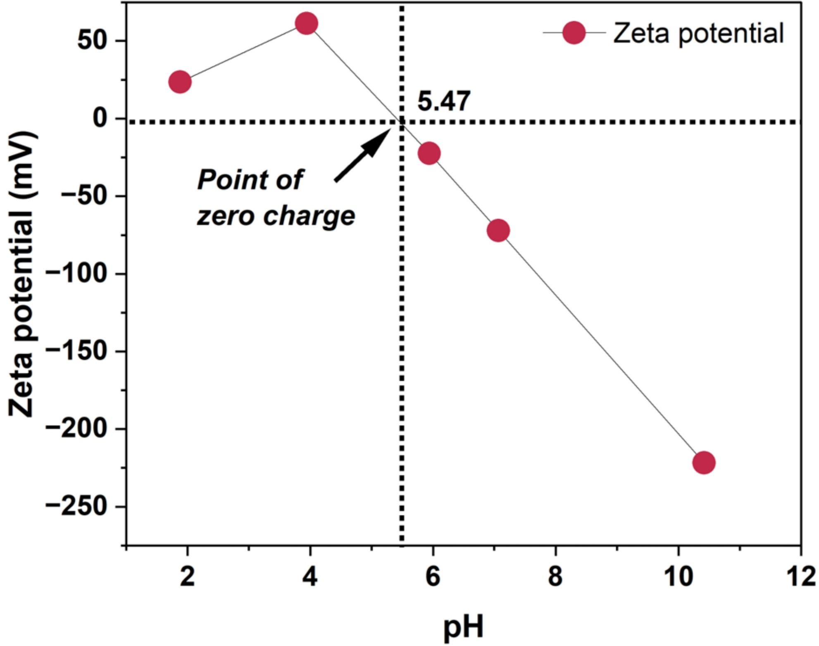
Supplementary Fig. 32. Zeta potential of KCoHCF.
The point of zero charge is 5.47, so KCoHCF protonates below and deprotonates above this pH, naturally buffering the wastewater toward neutrality and driving the late‑stage CO₂ degassing observed during capture in Supplementary Video 3. These spontaneous oxidizing and degassing processes result in final pH, TOC, TIC, and turbidity values of approximately 5.67, 283.31, 0.32 mg L⁻¹, and 0.23 NTU, respectively. Importantly, under IPCC guidelines, the released CO₂ is classified as biogenic and therefore carbon‑neutral, as it originates entirely from the spontaneous breakdown of organic matter. In other words, this carbon release belongs to the balanced carbon cycle rather than contributing to net emissions.
This buffering‑driven CO₂ degassing also plays a practical role: it removes most of the carbonate and bicarbonate from the potassium‑ and phosphorus‑containing liquid fertilizer produced by the system. By preventing the accumulation of these hardness‑forming species, the resulting fertilizer is less likely to contribute to soil compaction or hardening over repeated watering cycles.
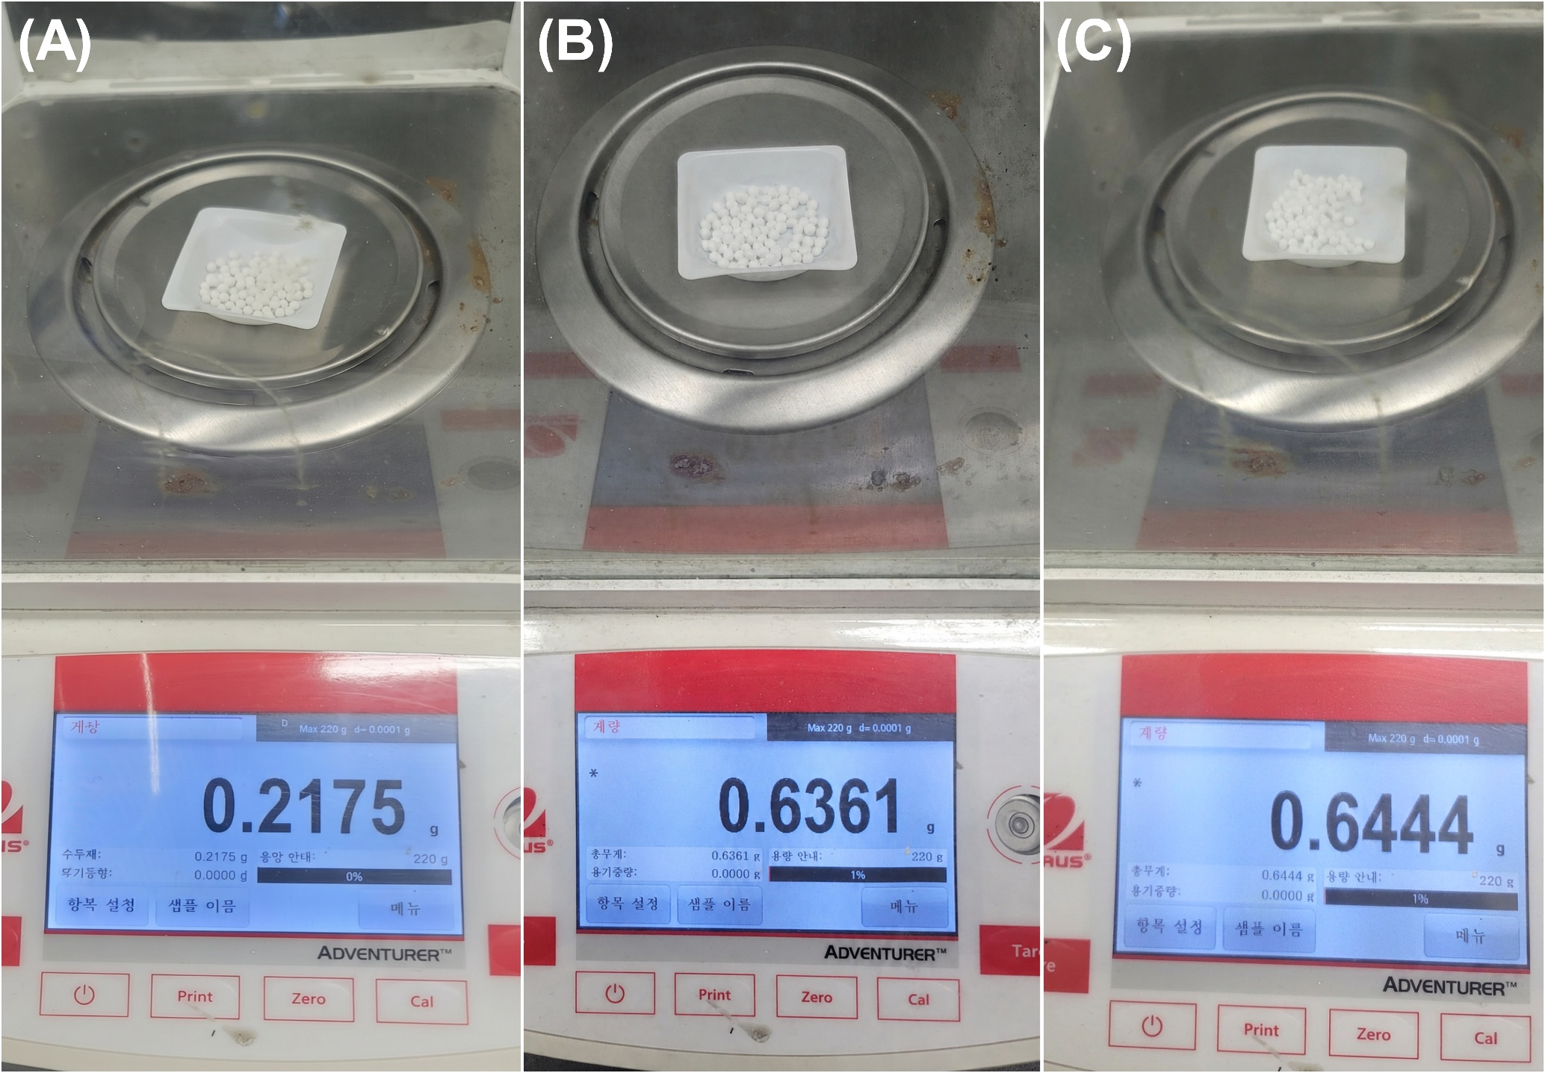
Supplementary Fig. 33. Mass of 100 beads at each fabrication stage. Photographs and weights of 100 Pe, PeP and PePurease beads (0.2175, 0.6361 and 0.6444 g).
The mass gained at each step quantifies polymer incorporation and enzyme loading and provides the per-bead basis used to convert bead dose to enzyme mass.

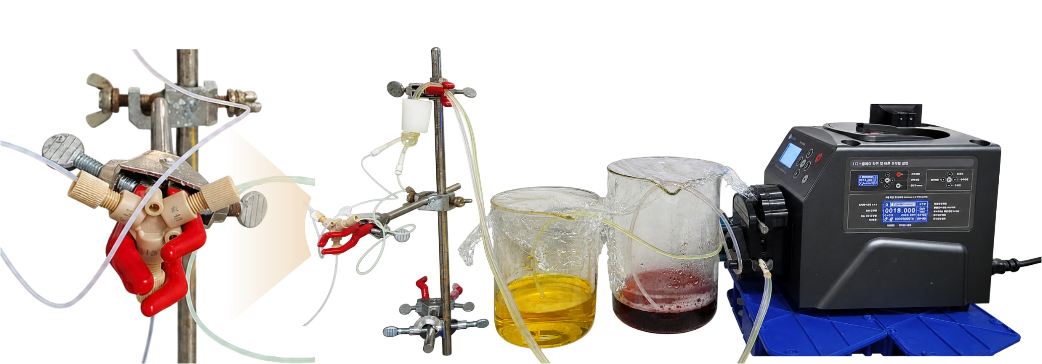
Supplementary Fig. 34. Synthesis of KCoHCF in a Y-microchannel. Visualisation of the continuous Y-microchannel route that mixes the cobalt nitrate and potassium ferricyanide precursors to give size- and composition-homogeneous KCoHCF nanoparticles.
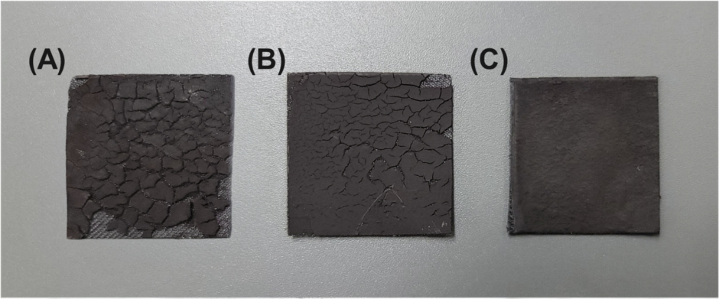
Supplementary Fig. 35. Electrode casting. Photographs of KCoHCF electrodes after one, two and three casting passes to a loading of 212.8 mg cm⁻².
Repeated casting builds high mass loading without surface cracking, the practical route to the 212.8 mg cm⁻² electrodes used in real-urine recovery.
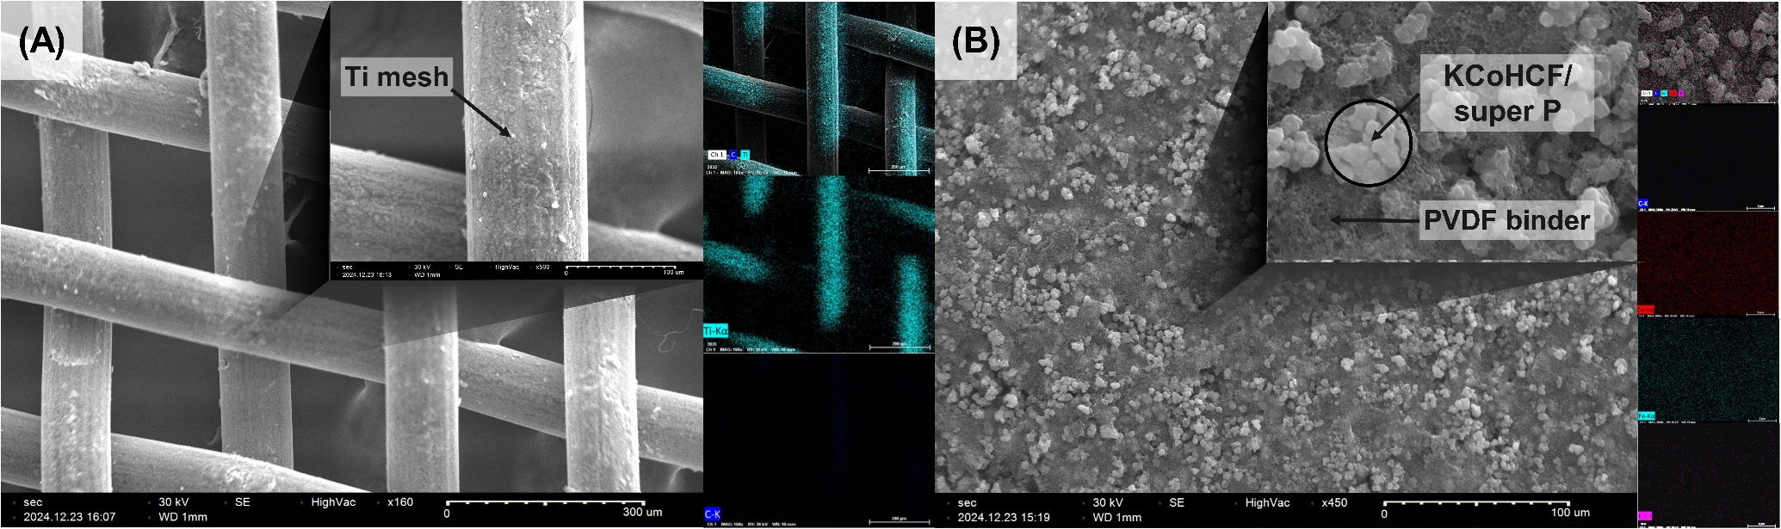
Supplementary Fig. 36. Electrode microstructure.
SEM of the acid-cleaned Ti mesh and of the homogeneous Super P/KCoHCF coating, confirming uniform active-material distribution on the current collector.

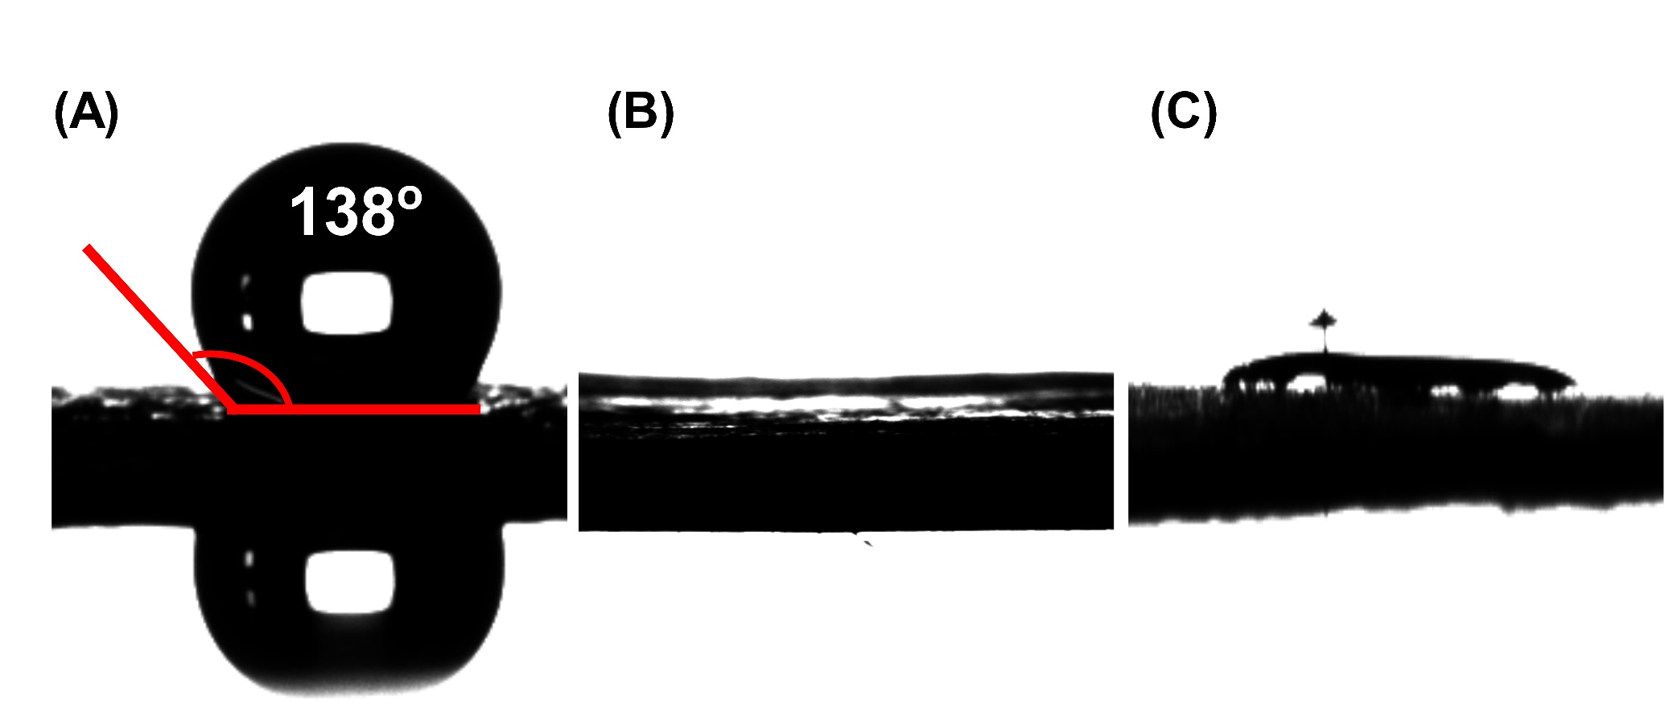
Supplementary Fig. 37. Hydrophilicity of the cast electrode. Water contact angle of (A) Super P, (B) KCoHCF and (C) the cast electrode of KCoHCF, Super P and PVDF.
The composite retains the superhydrophilic character of the active phase despite the hydrophobic carbon additive, so the urine electrolyte wets the full internal surface.

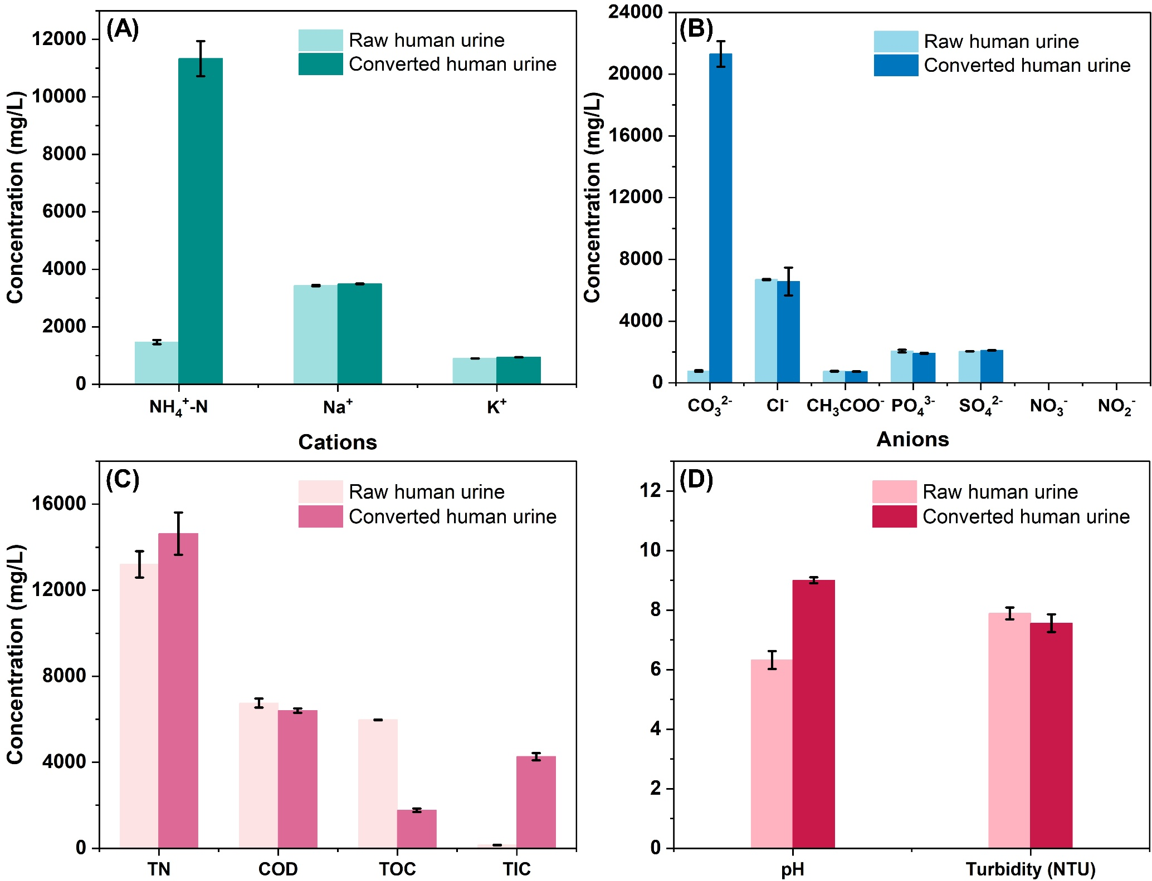
Supplementary Fig. 38. Composition of raw and hydrolysed human urine. Cation and anion concentrations and bulk water-quality parameters before and after hydrolysis.
Hydrolysis raises NH₄⁺-N to the 11,300 mg L⁻¹ that enters the recovery cell while the K⁺ and Na⁺ background the electrode must reject stays fixed; this is the reference matrix against which the synthetic urine of the Methods was formulated.

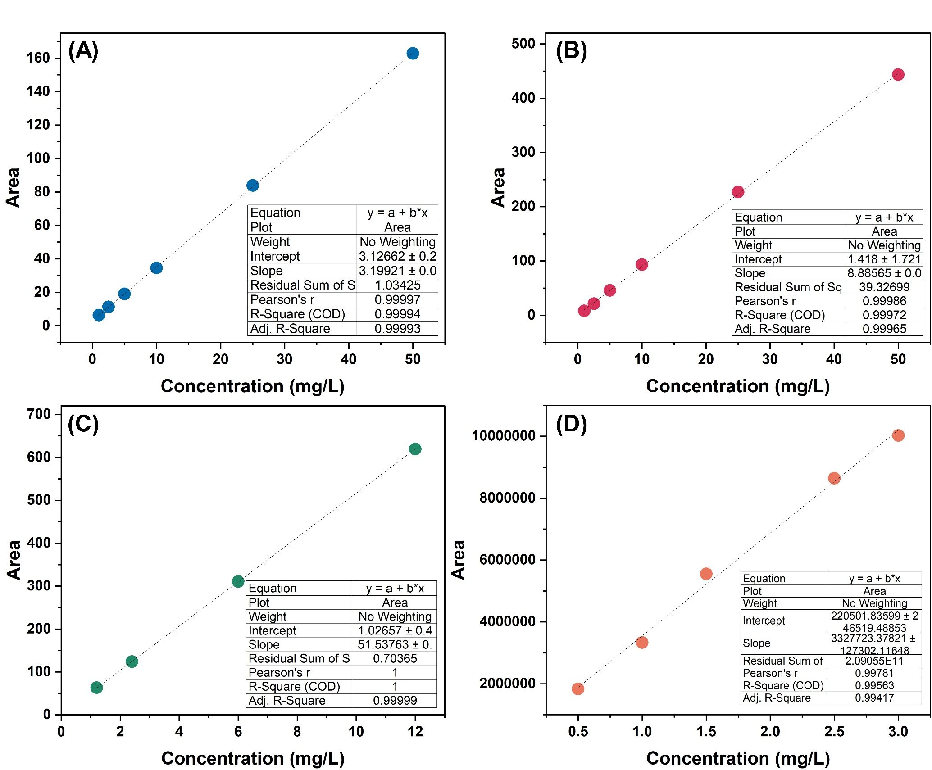
Supplementary Fig. 39. Standard calibration for (A) TOC, (B) TN, (C) TIC, (D) Urea.

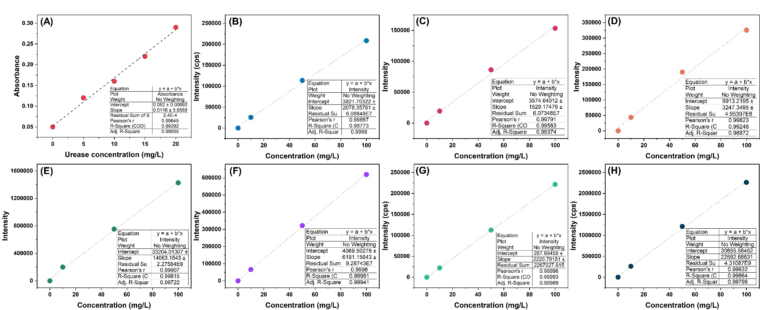
Supplementary Fig. 40. Standard calibration for (A) Urease, (B) Co, (C) Ni, (D) Fe, (E) Mn, (F) Cu, (G) Na, (H) K quantification.
For Urease quantification by BCA, the relationship between urease concentration and absorbance at 562 nm from the Micro BCA assay is linear; therefore, it’s used to convert the measured absorbance into the immobilised-urease loading (Supplementary Note 1). In this study, the grafted beads gave a loading of 13 mg g⁻¹. Pristine Pe and carboxylated PeP beads gave negligible absorbance at 562 nm, confirming that protein is retained only when both the carboxyl handle and the carbodiimide coupling are present, the signal therefore arises from grafted enzyme rather than nonspecific adsorption. As a direct covalency control, a PeP + urease sample prepared without EDC/NHS and washed identically retained negligible mg g⁻¹, far below the coupled value, confirming that attachment proceeds, through amide-bond formation rather than physisorption.

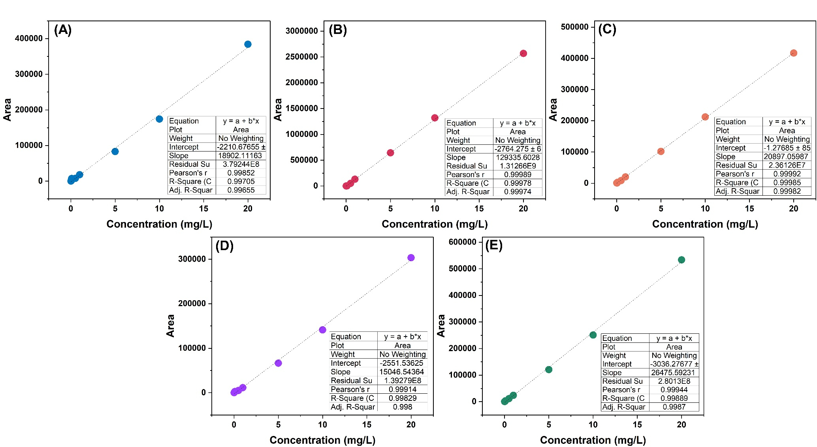
Supplementary Fig. 41. Standard calibration for (A) Cl⁻, (B) NO₂⁻, (C) NO₃⁻, (D) PO₄³⁻, (E) SO₄²⁻ quantification.

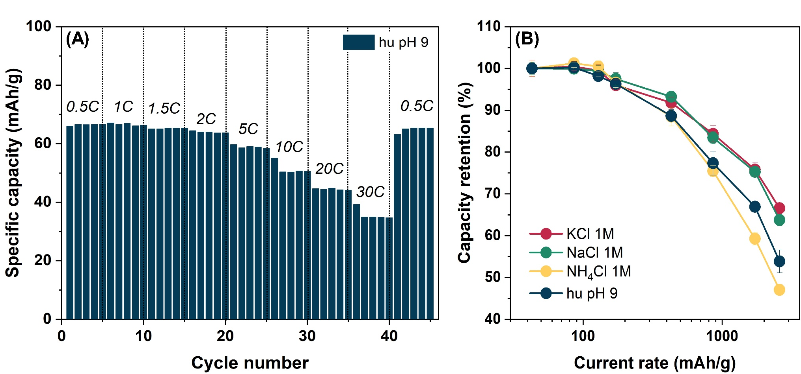
Supplementary Fig. 42. Rate capability of KCoHCF.
Capacity from 0.5 C to 30 C (1C = 86.79 mAh/g), retaining 48 % at 30 C in real urine pH 9. Because solid-state ammonium diffusion sets the high-rate ceiling, all recovery experiments were run at maximum 1.5 C to keep the electrode in its high-utilisation regime.

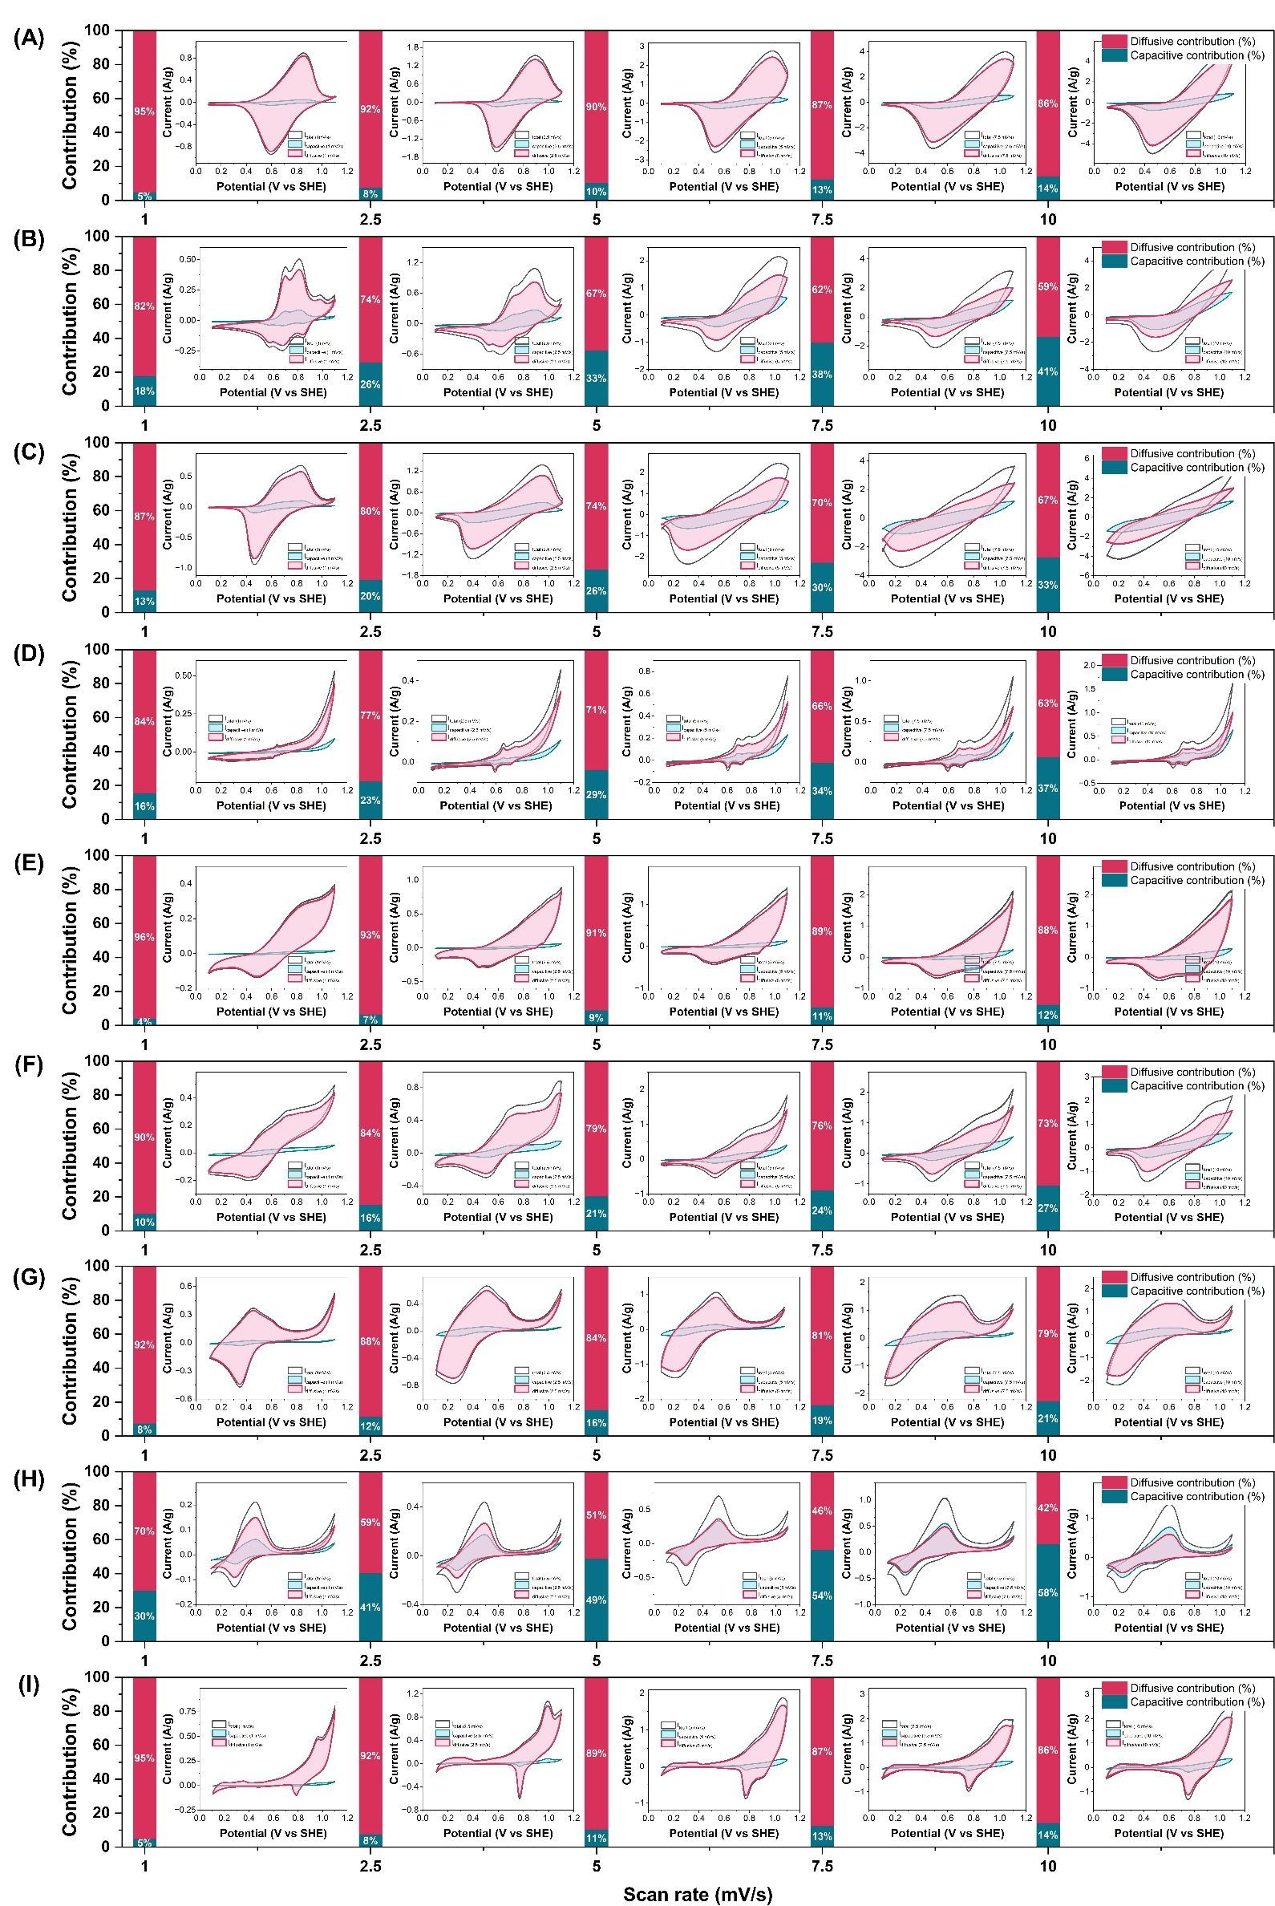
Supplementary Fig. 43. Capacitive and diffusive current fractions. Deconvolution for (A) KCoHCF, (B) NaNiHCF, (C) KNiHCF, (D) NaCoHCF, (E) KMnHCF, (F) NaMnHCF, (G) KFeHCF, (H) NaFeHCF and (I) KCuHCF in human urine pH 9.
Except for NaFeHCF, all are diffusion-dominated, confirming bulk intercalation rather than surface adsorption.

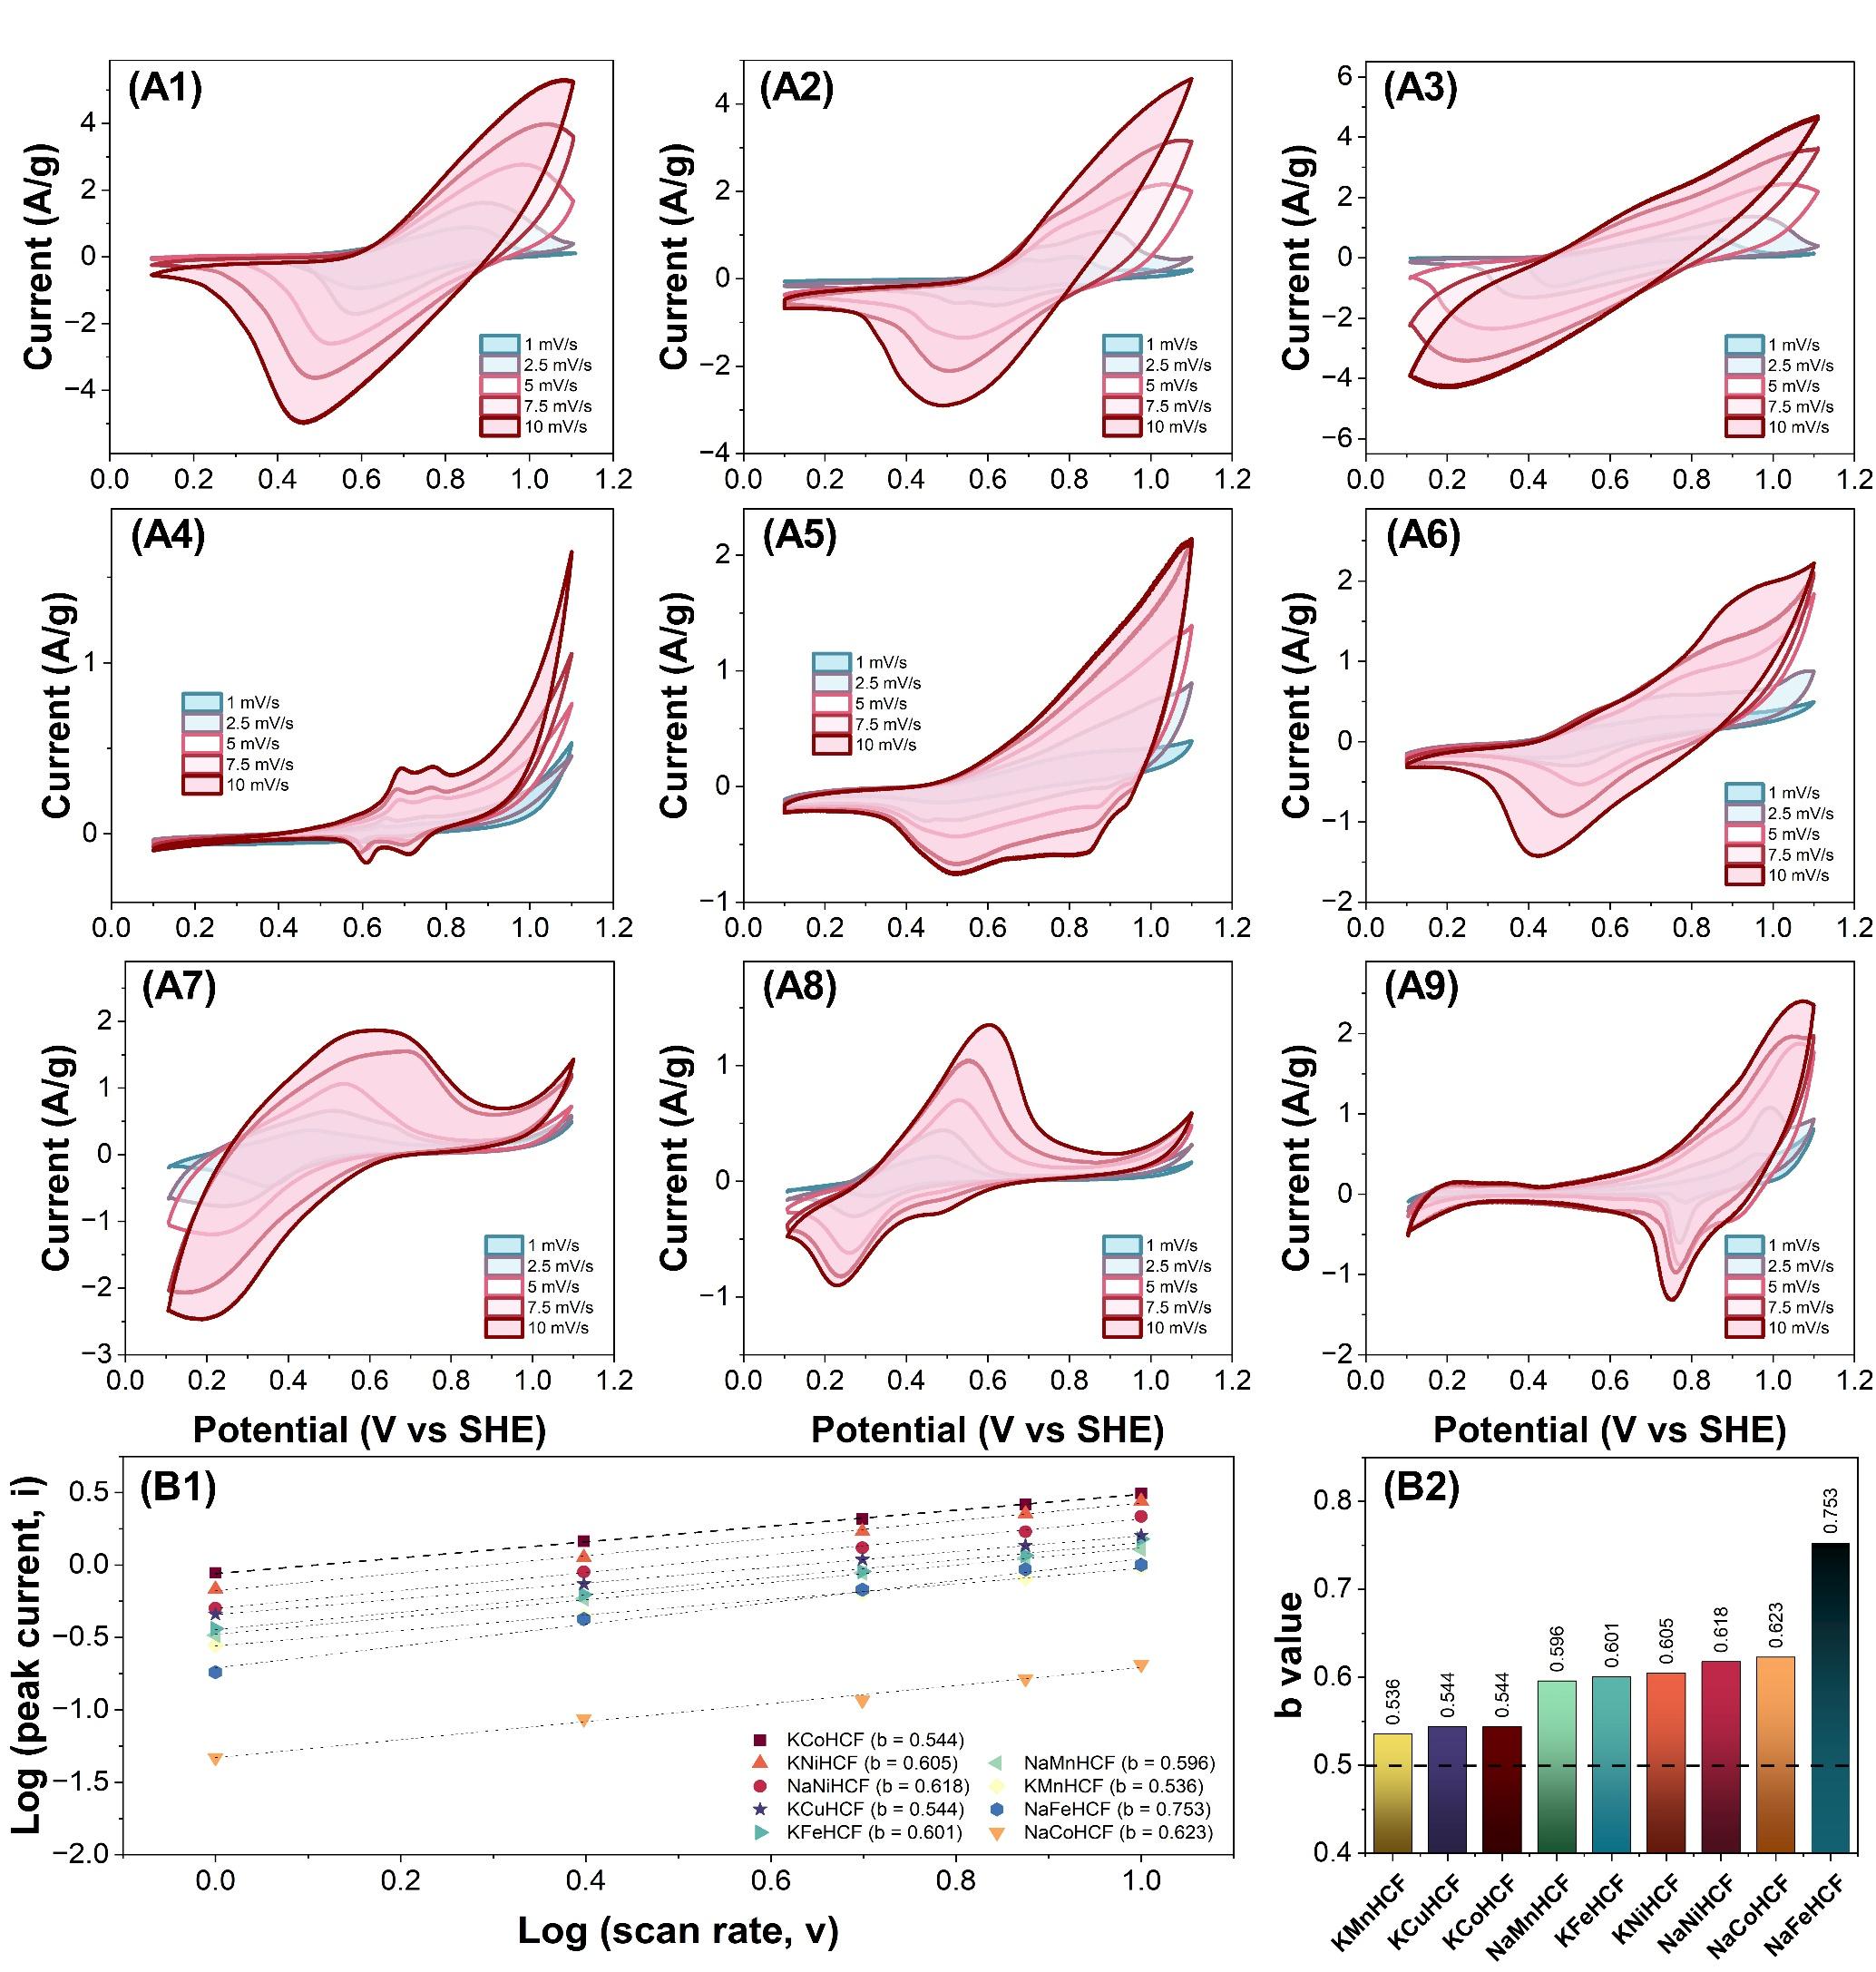
Supplementary Fig. 44. Scan-rate analysis and b-values. (A) CV profiles of (1) KCoHCF, (2) NaNiHCF, (3) KNiHCF, (4) NaCoHCF, (5) KMnHCF, (6) NaMnHCF, (7) KFeHCF, (8) NaFeHCF and (9) KCuHCF at varying scan rates and (B) their b-value fits at the peak potential.
KCoHCF gives b = 0.544, firmly in the battery type and diffusive regime.

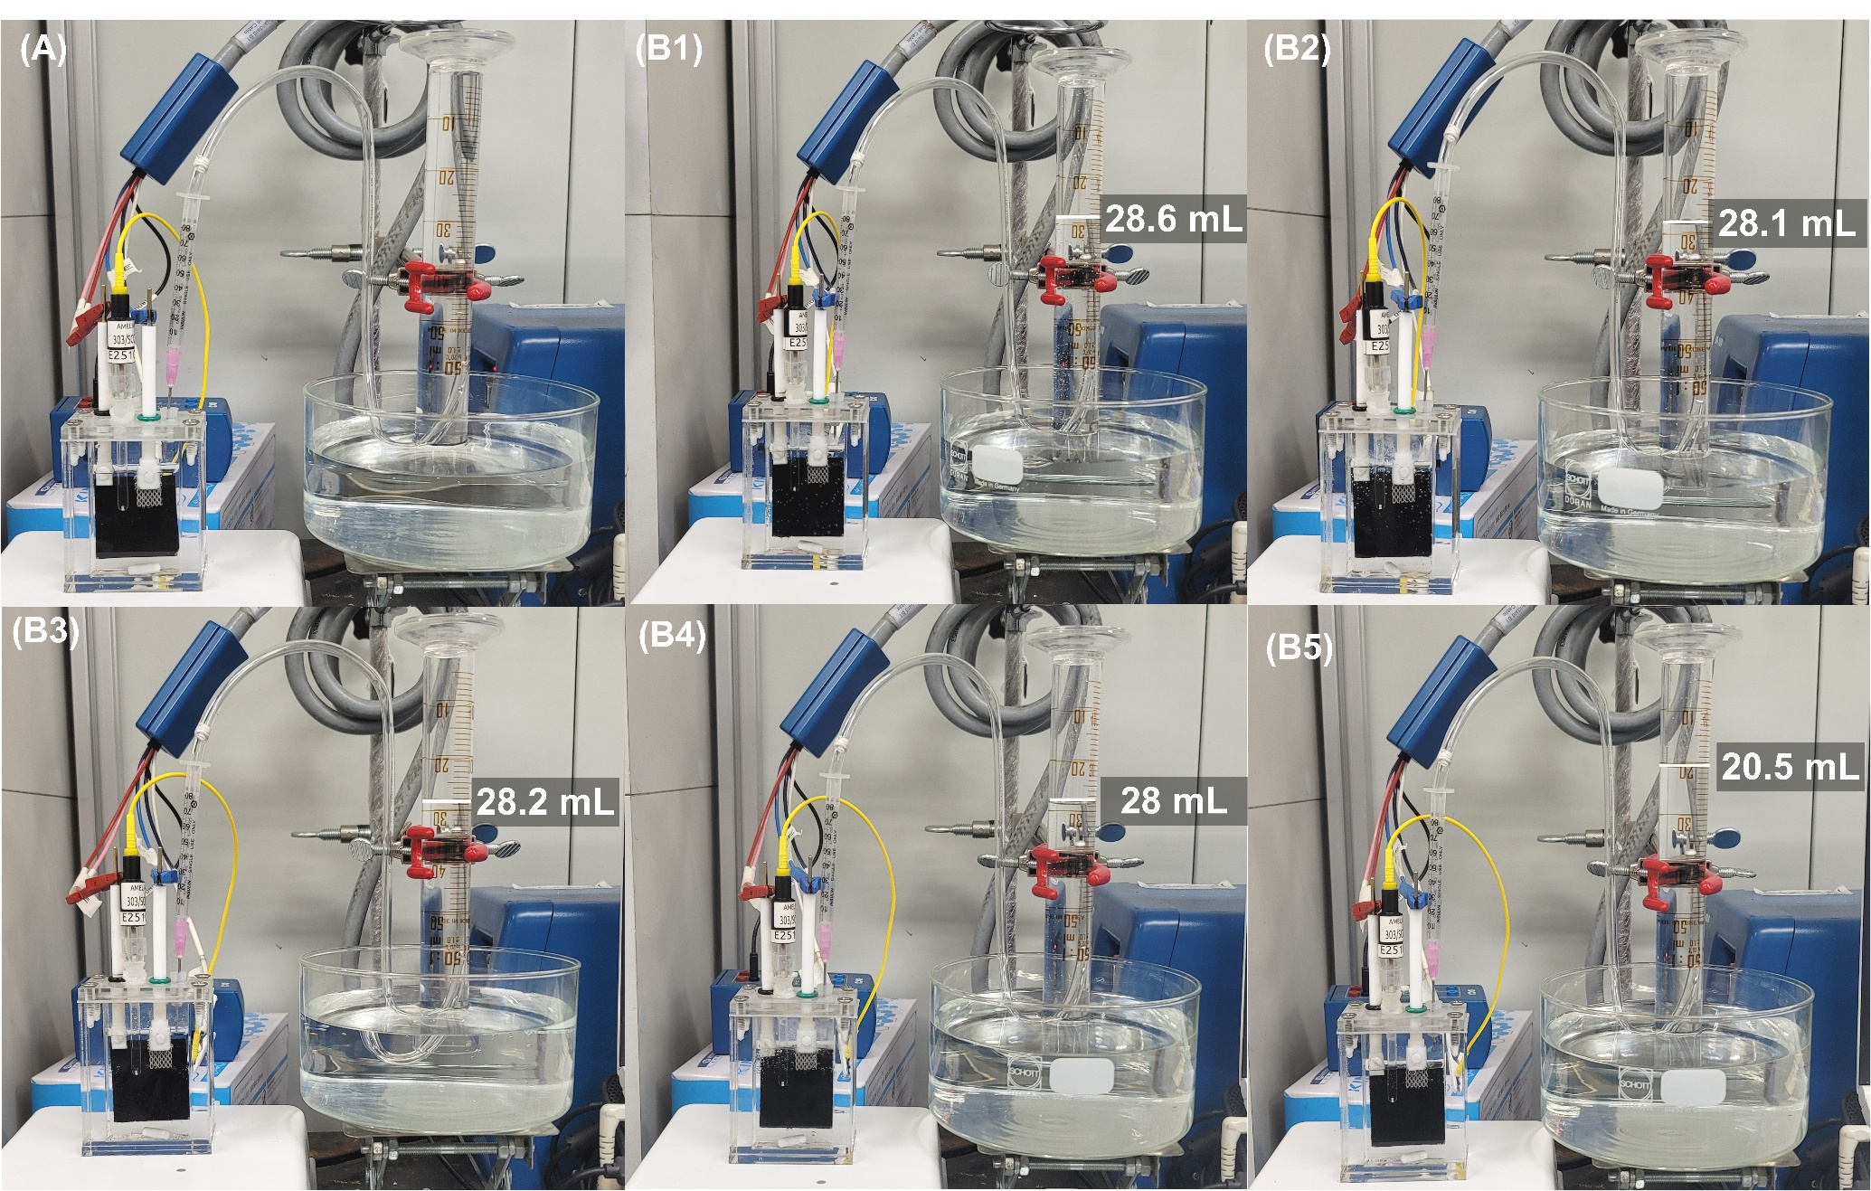
Supplementary Fig. 45. Gas collection: O₂ co-production in synthetic urine (three-electrode). Water-displacement set-up and collected O₂ volumes over the five-cycle synthetic-urine recovery, the raw images underlying the Faradaic-efficiency quantification of Extended Data Fig. 3 and Supplementary Video 1. Panel A is before operation. Panels B1-5 represent the gas volumes of O₂ from cycle 1 to 5.
The synthetic‑urine electrolyte remained colourless and unchanged throughout the five‑cycle operation. O₂ evolved cleanly on the Pt–Ti mesh at a consistent rate with ~100% Faradaic efficiency. Together with ICP‑OES showing negligible Fe or Co in solution, these observations indicate that the KCoHCF electrode remains stable and does not release measurable metal during synthetic‑urine cycling.

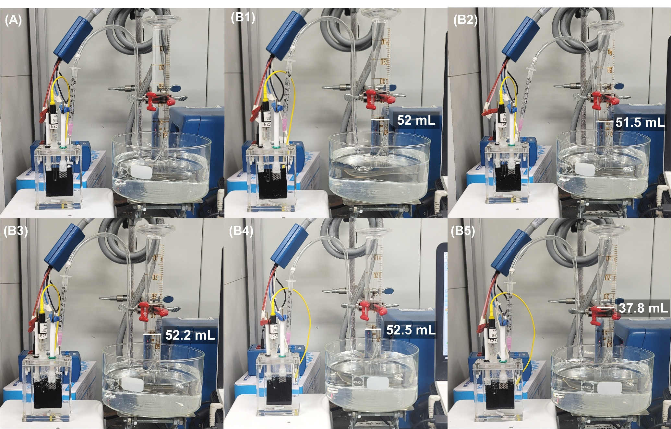
Supplementary Fig. 46. Gas collection: H₂ co-production in Li₂SO₄ following synthetic urine recovery (three-electrode). Collected H₂ volumes for the three-electrode synthetic-urine recovery in Li₂SO₄ 0.1M, pH 1, underlying Extended Data Fig. 3 and Supplementary Video 2. Panel A is before operation. Panels B1-5 represent the gas volumes of H₂ from cycle 1 to 5.
Similar to Supplementary Fig. 45, the Li₂SO₄ electrolyte showed no colour change before or after operation. H₂ was generated steadily on the Pt–Ti mesh with ~100% Faradaic efficiency. ICP‑OES confirms that Fe and Co remain below detection, supporting the conclusion that the KCoHCF electrode is chemically stable and does not shed metal under these conditions.

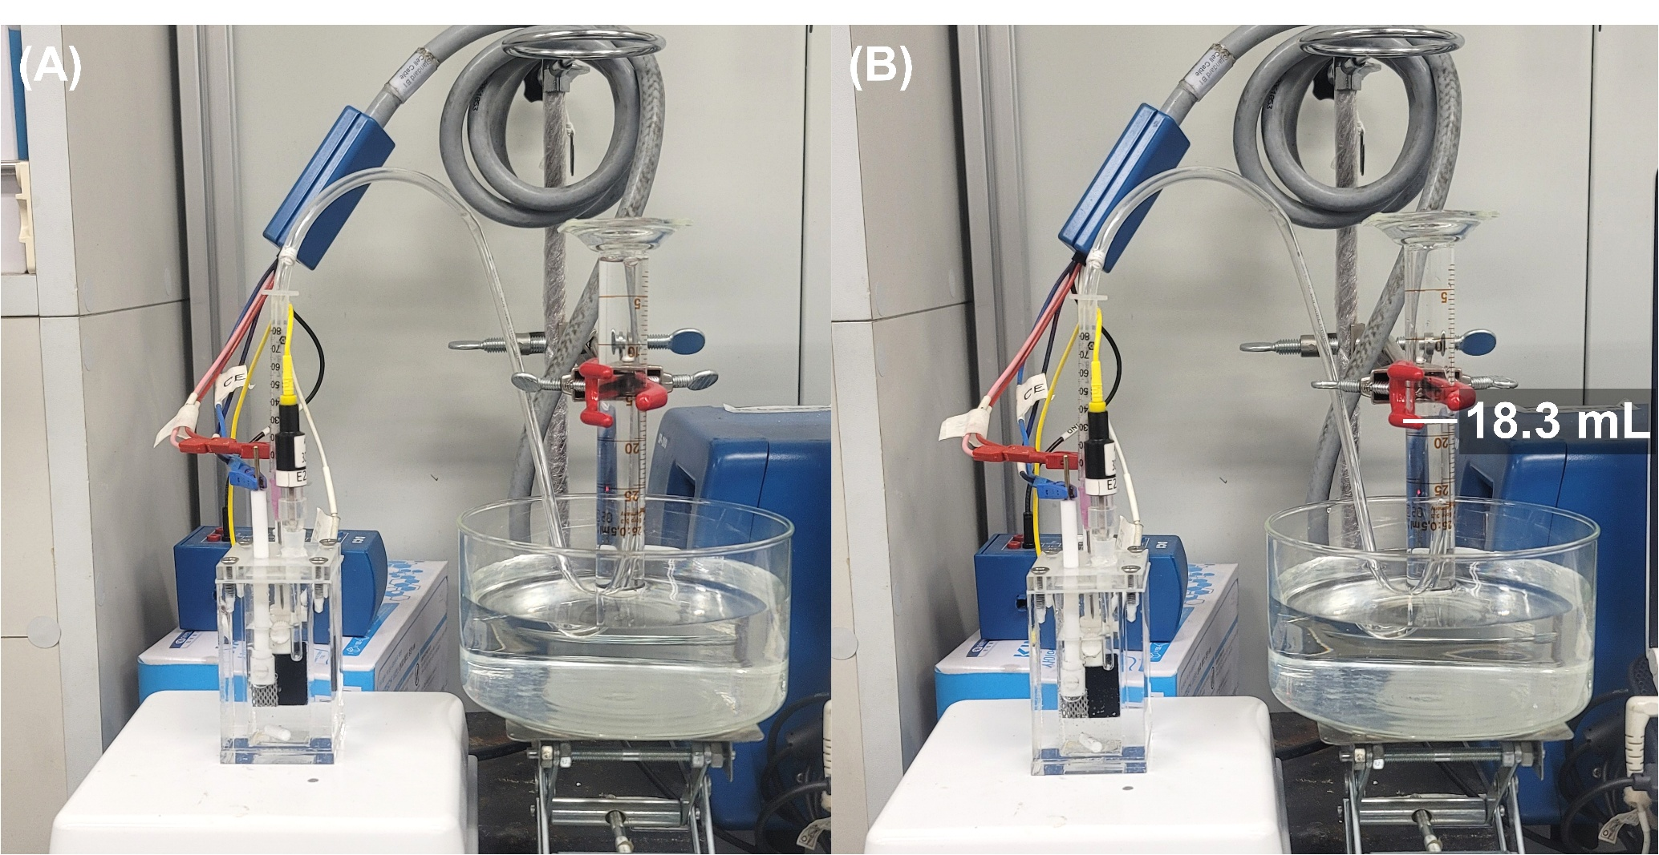
Supplementary Fig. 47. Gas collection: H₂ co-production in Li₂SO₄ following real urine recovery (three-electrode). Collected H₂ volumes for real-urine release into Li₂SO₄ 0.1M, pH 1, underlying Extended Data Fig. 3B and Supplementary Video 4. Panel A is before operation. Panels B represents the gas volumes of H₂ after operation.
The Li₂SO₄ electrolyte remained visually unchanged, with no darkening or precipitate formation. H₂ evolution on the Pt–Ti mesh proceeded at a stable rate and with near‑quantitative Faradaic efficiency. ICP‑OES analysis again detected negligible Fe or Co, demonstrating that the KCoHCF electrode maintains structural integrity in real‑urine conditions.

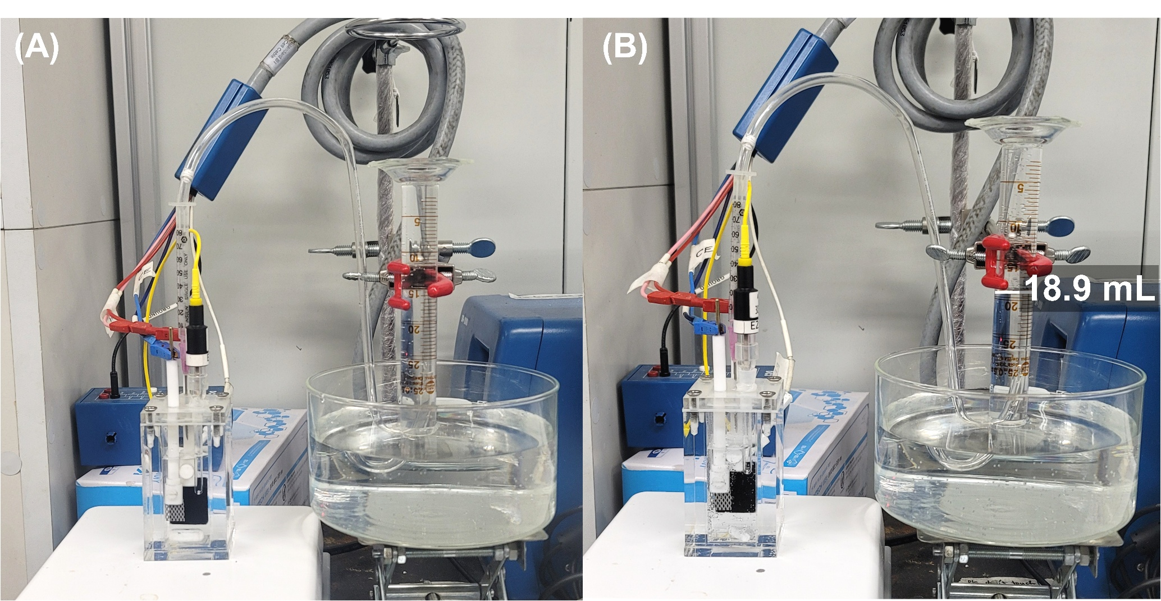
Supplementary Fig. 48. Gas collection: H₂ co-production in (NH₄)₂SO₄ following real urine recovery (three-electrode). Collected H₂ volumes for real-urine release into (NH₄)₂SO₄ 0.1M, pH 1, underlying Extended Data Fig. 3C. Panel A is before operation. Panels B represents the gas volumes of H₂ after operation.
Similar to Supplementary Fig. 47, the electrolyte remained colourless and unchanged before and after operation. H₂ was produced consistently on the Pt–Ti mesh with ~100% Faradaic efficiency. ICP‑OES confirms that Fe and Co remain at negligible levels, indicating that the KCoHCF electrode does not leach or redeposit metal during real‑urine cycling.

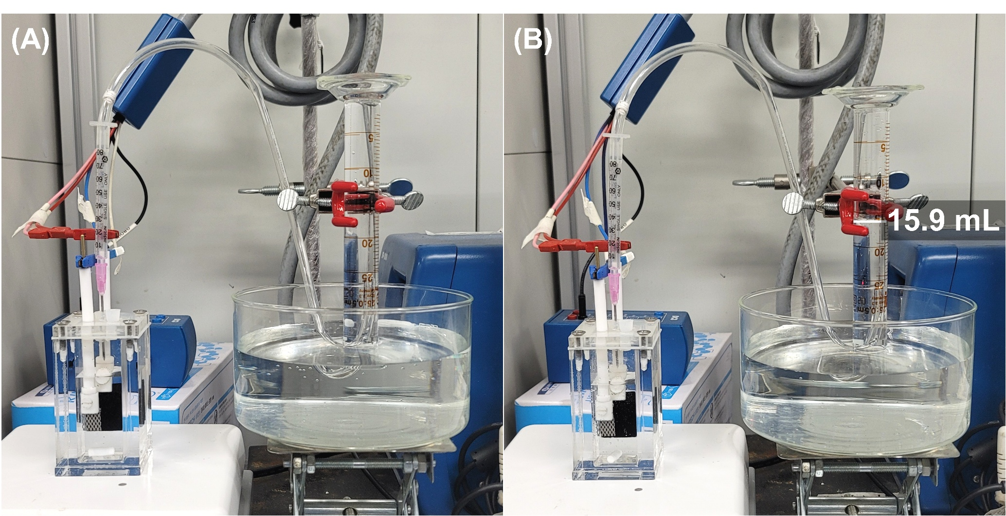
Supplementary Fig. 49. Gas collection: H₂ co-production in (NH₄)₂SO₄ at cycle 100 during 100-cycle real urine recovery (two-electrode). Collected H₂ volumes for real-urine release into (NH₄)₂SO₄ 0.1M, pH 1, underlying Extended Data Fig. 3D and Supplementary Video 5. Panel A is before operation. Panels B represents the gas volumes of H₂ after 1 cycle operation.
Similar to Supplementary Fig. 48, the (NH₄)₂SO₄ electrolyte showed no colour change across the 100-cycle experiment. H₂ evolution on the Pt–Ti mesh was steady and quantitatively Faradaic. ICP‑OES again shows negligible Fe or Co in solution or on the mesh, supporting the conclusion that the KCoHCF electrode is robust and chemically stable under two‑electrode real‑urine operation.

Supplementary Table 1. BET surface area, BJH pore volumes, and diameters of Pe, PeP, and PePurease beads.
Sample | BET SA  (m²/g) | BJH pore vol  (cm³/g) | Mean pore width  (nm)
Pe beads | 38.837 | 17.505 $×$ 10⁻³ | 4.274
PeP beads | 39.618 | 9.318$×$ 10⁻³ | 2.664
PePurease beads | 17.254 | 4.366 $×$ 10⁻³ | 3.578

Surface area and pore volume both decrease after grafting, consistent with enzyme molecules partly occupying the surface, in agreement with the FTIR result in Extended Data Fig. 1.

Supplementary Table 2. BET surface area, BJH pore volumes, and diameters of 9 PBA materials.
Sample | Metal 1 | Metal 2 | BET SA  (m²/g) | Pore vol (cm³/g) | Micropore vol  (cm³/g) | Mesorepore vol  (cm³/g) | BJH ads pore (nm) | BJH des pore (nm)
KCoHCF | K | Co | 628.7 | 0.532 | 0.181 | 0.351 | 3.49 | 19.17
KFeHCF | K | Fe | 110.1 | 0.394 | 0.005 | 0.389 | 16.3 | 13.58
KNiHCF | K | Ni | 93.2 | 0.373 | 0.002 | 0.371 | 15.4 | 18.69
KMnHCF | K | Mn | 63.2 | 0.312 | 0.007 | 0.305 | 20.5 | 16.77
KCuHCF | K | Cu | 19.8 | 0.154 | 0.001 | 0.153 | 36.5 | 26.54
NaCoHCF | Na | Co | 29.5 | 0.118 | 0.003 | 0.115 | 26.5 | 16.51
NaMnHCF | Na | Mn | 28.1 | 0.166 | 0.002 | 0.164 | 31.1 | 29.15
NaNiHCF | Na | Ni | 8.8 | 0.019 | 0.0005 | 0.0185 | 10.2 | 7.92
NaFeHCF | Na | Fe | 1.8 | 0.006 | 0.001 | 0.005 | 47.8 | 40.43

KCoHCF stands apart on two axes at once: the highest surface area by six-fold and the only material with substantial micropore volume, the textural origin of its size-selective, high-throughput capture (Fig. 3B, C).

Supplementary Table 3. Chemical formula of the PBA materials.
Material | Ni/Co/Mn/Cu/Fe | K/Na | [Fe(CN)₆] | H₂O | Theoritical capacity (mAh/g) | Chemical formular
KCoHCF | 1.026 | 0.075 | 1 | 1.868 | 86.793 | K_{0.075}Co_{1.026}[Fe(CN)₆].1.868H₂O
NaCoHCF | 2.818 | 0.012 | 1 | 3.759 | 60.159 | Na_{0.012}Co_{2.818}[Fe(CN)₆].3.759H₂O
KNiHCF | 1.409 | 0.129 | 1 | 8.328 | 59.598 | K_{0.129}Ni_{1.409}[Fe(CN)₆].8.328H₂O
NaNiHCF | 0.935 | 4.211 | 1 | 2.930 | 55.346 | Na_{4.211}Ni_{0.935}[Fe(CN)₆].2.930H₂O
KMnHCF | 1.086 | 2.054 | 1 | 0.468 | 74.369 | K_{2.054}Mn_{1.086}[Fe(CN)₆].0.468H₂O
NaMnHCF | 1.052 | 1.663 | 1 | 1.378 | 80.530 | Na_{1.663}Mn_{1.052}[Fe(CN)₆].1.378H₂O
KFeHCF | 1.220 | 1.219 | 1 | 3.499 | 68.594 | K_{1.219}Fe_{1.220}[Fe(CN)₆].3.499H₂O
NaFeHCF | 1.219 | 1.719 | 1 | 2.714 | 72.742 | Na_{1.719}Fe_{1.026}[Fe(CN)₆].2.714H₂O
KCuHCF | 1.388 | 0.986 | 1 | 11.356 | 49.333 | K_{0.986}Cu_{1.388}[Fe(CN)₆].11.356H₂O
Elemental composition analysis was done by annealing PBA samples in air at 600 °C and dissolving them in 5% HNO₃ at 80 °C overnight. The metal concentrations were analysed by ICP/OES.
For KFeHCF and NaFeHCF, C and N wt% were measured additionally with elemental analysis. For KFeHCF, the wt% of C and N are 18.42% and 26.21%, respectively. For NaFeHCF, the wt% of C and N are 19.54% and 28.63%, respectively.
The K-deficient, low-water KCoHCF formula leaves the cubic cages largely vacant and accessible for incoming ammonium, in contrast to the water-crowded KCuHCF and KNiHCF, the structural basis for the capacity and selectivity differences in Fig. 4.

Supplementary Table 4. Concentrations of NH₄⁺, Na⁺, and K⁺ in typical wastewaters.
Wastewater | pH | NH₄⁺ (mM) | Na⁺ (mM) | K⁺ (mM) | [NH₄⁺]/[K⁺] | ΔE_{Nik-Eis} vs K⁺ | [NH₄⁺]/[Na⁺] | ΔE_{Nik-Eis} vs Na⁺ | Ref
Manure wastewater | 9.0 | 497.0 | 146.0 | 183.0 | 2.7 | 1.0 | 3.4 | 0.0 | ²
Treated manure wastewater | 9.0 | 188.9 | 69.6 | 35.8 | 5.3 | 0.5 | 2.7 | 0.0 | ²
Livestock wastewater | 4.2 | 158.3 | 28.3 | 40.4 | 3.9 | 0.7 | 5.6 | 0.0 | ³
Wastewater centrate from WWTP | 8.4 | 47.1 | 18.5 | 5.8 | 8.1 | 0.3 | 2.5 | 0.0 | ⁴
Wastewater centrate from WWTP | 7.6 | 84.9 | 12.0 | 2.6 | 32.7 | 0.1 | 7.1 | 0.0 | ⁵
Landfill leachate | 7.9 | 324.3 | 145.3 | 33.2 | 9.8 | 0.3 | 2.2 | 0.0 | ⁶
Anaerobic digestate | 8.4 | 162.3 | 39.7 | 18.1 | 9.0 | 0.3 | 4.1 | 0.0 | ⁷
Treated anaerobic digestate | 7.6 | 8.2 | 37.7 | 3.8 | 2.2 | 1.3 | 0.2 | 0.1 | ⁷
Human urine | 9.2 | 392.1 | 107.4 | 58.6 | 6.7 | 0.4 | 3.7 | 0.0 | ⁸
Human urine | 6.9 | 289.3 | 80.4 | 38.1 | 7.6 | 0.4 | 3.6 | 0.0 | ⁹
Human urine from this work | 6.3 | 67.2 | 149.3 | 23.1 | 2.9 | 0.9 | 0.5 | 0.0 | This work
Converted human urine from this work | 9.0 | 809.5 | 152.0 | 24.2 | 33.5 | 0.1 | 5.3 | 0.0 | This work
*The calculation of ΔE_{Nik-Eis} vs K⁺ and ΔE_{Nik-Eis} vs Na⁺ refers to Supplmentary Note 2.
Almost every stream falls inside the ammonium-selective window, so the same electrode should deliver a fertilizer-grade product across most nitrogen-bearing wastewaters, the basis for the generality claimed in the Fig. 4 discussion.

Supplementary Table 5. Ammonium recovery rate comparison
Technology | Nitrogen recovery rate (g-N m⁻² d⁻¹) | Reference
Microbial fuel cell | 15.10 | ¹⁰
Microbial fuel cell | 3.31–9.58 | ¹¹
Microbial fuel cell | 0.91 | ¹²
Microbial fuel cell | 6.79–12.70 | ¹³
Microbial fuel cell | 6.79 | ¹⁴
Microbial fuel cell | 6.91 | ¹⁵
Microbial fuel cell | 2.71 | ¹⁶
Microbial fuel cell | 25.51 | ¹⁷
Microbial fuel cell | 27.36 | ¹⁸
Microbial electrochemical cell | 45.91 | ¹⁹
Microbial electrochemical cell | 9.60 | ¹⁴
Microbial electrochemical cell | 24.00 | ¹⁷
Microbial electrochemical cell | 120.00 | ²⁰
Microbial electrochemical cell | 10.20 | ²¹
Microbial electrochemical cell | 16.80–66.00 | ²²
Microbial electrochemical cell | 1.39–7.10 | ²³
Microbial electrochemical cell | 10.38 | ²⁴
Microbial electrochemical cell | 6.72 | ²⁵
Microbial electrochemical cell | 36.19 | ²⁶
Microbial electrochemical cell | 70.01 | ²⁷
Microbial electrochemical cell | 3.29 | ¹⁸
Microbial desalination cell | 79.99–85.99 | ²⁸
Microbial desalination cell | 0.41 | ²⁹
Microbial desalination cell | 11.50 | ³⁰
Bioelectroconcentration cell | 5.11 | ³¹
Bioelectroconcentration cell | 430.01 | ³²
Bioelectroconcentration cell | 1.39 | ³³
Bioelectroconcentration cell | 23.99 | ³⁴
Electrostripping | 334.99 | ²
Electrostripping | 889.99 | ³⁵
Membrane distillation | 1704.00 | ³⁶
Membrane distillation | 48.00 | ³⁶
Membrane distillation | 213.36-343.20 | ³⁷
Membrane distillation | 148.80 | ³⁸
Membrane distillation | 144.00 | ³⁹
Membrane contactor | 40.08 | ³⁶
Membrane contactor | 1.20 | ³⁶
Membrane contactor | 145.20 | ⁴⁰
This study | 1,087 ± 68

Supplementary Table 6. Energy consumption for ammonium production/recovery technologies comparison.
Technology | Energy consumption (kWh kg⁻¹-N) | Reference
Air stripping | 3.9 | ⁴¹
Air stripping | 8.65 | ⁴²
Air stripping | 28.2 | ⁴³
Membrane contactor | 3.66 | ⁴⁴
Membrane contactor | 4.53 | ⁴⁴
Membrane contactor | 5.28 | ⁴⁴
Membrane contactor | 7 | ⁴⁴
Membrane contactor | 7.06 | ⁴⁴
Membrane contactor | 7.1 | ⁴⁴
Membrane contactor | 8.65 | ⁴⁴
Membrane contactor | 11.68 | ⁴⁴
Membrane contactor | 20 | ⁴⁴
Membrane contactor | 20.45 | ⁴⁴
Membrane contactor | 25 | ⁴¹
Electrodialysis | 3.47 | ⁴⁵
Electrodialysis | 3.5 | ⁴⁶
Electrodialysis | 6 | ⁴⁶
Electrodialysis | 7.17 | ⁴⁵
Electrodialysis | 31 | ⁴⁷
Electrodialysis | 127 | ⁴⁵
Membrane distillation | 7.1 | ⁴⁴
Membrane distillation | 16.5 | ⁴⁸
Membrane distillation | 27.2 | ⁴⁹
Membrane distillation | 46.4 | ⁴⁹
Haber-Bosch | 8.9 | ⁵⁰
Haber-Bosch | 9.11 | ⁵¹
Haber-Bosch | 9.23 | ⁴⁸
Haber-Bosch | 10.69 | ⁴⁸
Haber-Bosch | 11.78 | ⁵²
Haber-Bosch | 11.97 | ⁵²
Haber-Bosch | 12.87 | ⁵²
Haber-Bosch | 13.36 | ⁵¹
Haber-Bosch | 14.09 | ⁵²
Green ammonia | 10.93 | ⁵²
Green ammonia | 11.9 | ⁵²
Green ammonia | 13.36 | ⁵²
Green ammonia | 14.57 | ⁵²
Green ammonia | 18.21 | ⁵¹
Green ammonia | 23.07 | ⁵²
Green ammonia | 26.72 | ⁵²
Electrochemical nitrogen reduction  (e-NRR) | 21.59 | ⁵³
Electrochemical nitrogen reduction  (e-NRR) | 1409.84 | ⁵⁴
This study | 1.96 ± 0.04 (Gross energy consumption)  -0.47 ± -0.004 (Net energy consumption)

Supplementary Table 7. Mean RUL accuracy measured by MAE (cycle) of all tasks and baselines.
Task | SPI+CBU | SPI+TBU | Lin | log-Bayes | Wiener | Weibull
56 panels | 6.3 | 29.5 | 25.2 | 169 | 57.7 | 64.2
10 panels at 80% | 5.1 | 23.8 | 19.2 | 313 | 53.1 | 72.7
KCoHCF 90% | 67 | 129 | 160 | 15,603 | 2,062 | 4,490
KCoHCF 87% | 209 | 1118 | 1,392 | 16,242 | 2,763 | 3,713
PePurease 90% | 4.3 | 5.2 | 4.5 | 770 | 8.3 | 8.3
PePurease 86% | 19 | 48 | 58.1 | 858 | 70.6 | 73.8
MAE was used for this task because remaining useful life is an extrapolated scalar, and its error distribution is heavy-tailed: early in life and on the hard/edge trajectories the prediction can be off by a lot (the unconstrained baselines run to thousands of cycles; even SPI+CBU has larger errors at low observed fraction). RMSE squares those few large errors, so a handful of extrapolation points would dominate the number and hide typical performance. MAE is robust to that as it reports the typical miss in cycles, which is also exactly what a maintenance schedule cares about. In specific, MAE is both the more representative central measure for a skewed distribution and the more directly interpretable one for the decision RUL feeds. With the use of MAE, five baselines are included in every comparison figure: TBU, Lin, log-Bayes (naive log refit), the Wiener process (drift first-passage), and Weibull degradation (Weibull-path extrapolation). None is competitive: SPI+CBU has the lowest RUL MAE in every task and case (full table below), and the gap is large. log-Bayes diverges catastrophically (it is axis-capped in the figures); the Wiener and Weibull baselines, which lack the historical-band constraint, over- or under-shoot through mid-life by roughly an order of magnitude on the deep-threshold cases.
Supplementary Table 8. Mean capacity retention tracking accuracy measured by RMSE (%) of all tasks and baselines.
Task | SPI+CBU | SPI+TBU | Lin | log-Bayes | Wiener | Weibull
56 panels | 5.61 | 7.21 | 11.07 | 10.69 | 8.17 | 27.59
10 panels at 80% | 1.47 | 2.57 | 2.57 | 3.00 | 1.53 | 2.27
KCoHCF 90% | 0.32 | 0.37 | 0.43 | 1.23 | 0.47 | 0.86
KCoHCF 87% | 0.53 | 0.76 | 1.27 | 1.01 | 1.73 | 2.55
PePurease 90% | 0.17 | 0.21 | 0.23 | 1.28 | 0.22 | 0.36
PePurease 86% | 0.57 | 0.68 | 1.20 | 0.95 | 1.64 | 3.14
Tracking is a dense fit of a smooth, bounded signal (retention 100% to threshold). The residuals are small, roughly symmetric, and have no heavy tail, so RMSE is well-behaved here. It's also the natural goodness-of-fit metric: the models are fit by (weighted) least squares, so RMSE in the same L2 sense the fit optimizes, and it's the convention for state-of-health/curve-tracking in the degradation and battery literature, which makes the numbers comparable to other studies. RMSE's extra penalty on larger deviations is desirable for tracking. Across all six capacity‑retention tracking tasks, the SPI‑based models, especially SPI+CBU, consistently achieve the lowest RMSE, indicating that the state‑progress constraints keep predictions tightly aligned with the true degradation trajectory, even when thresholds deepen or mid‑life curvature becomes more pronounced. In contrast, the linear model struggles whenever the trajectory bends, log‑Bayes repeatedly exhibits instability and inflated errors, and the Wiener/Weibull models tend to over‑ or under‑shoot by large factors in deeper‑threshold cases where their parametric forms cannot enforce consistency with earlier historical behavior. While all models perform reasonably on shallow‑threshold datasets (e.g., KCoHCF 90%, PePurease 90%), the baselines degrade substantially as the threshold moves deeper, whereas SPI‑based methods remain stable and accurate across all scenarios.

Supplementary Table 9. Forward projection to 80% (per replicate).
Material | Cycle at 80% (rep 1/2/3) | Linear floor | Tracking RMSE*
KCoHCF | 168×10³ / 189×10³ / 200×10³ | 6.7-7.9×10³ | 0.05-0.10%
PePurease | 1,702 / 1,312 / 2,256 | 340-370 | 0.21%
*Tracking RMSE was calculated upto the last point of the existing data.
Legend states the projection method (recent-window log fit) and that the floor is the per-step linear lower bound. The forward projection asks how far each deployed material is from its 80% end‑of‑life point using only the data measured so far, which currently reaches approximately 87% capacity for the electrode and 86% activity for the PePurease beads. Two numbers bracket the answer. The central projection extrapolates a recent‑window logarithmic fit, the same decelerating basis that tracks the measured fade to within 0.05–0.10% RMSE for the electrode and 0.21% for the beads. On that fit, the KCoHCF electrode reaches 80% between 168×10³ and 200×10³ cycles across the three replicates, and the PePurease beads between 1,300 and 2,300 cycles. The linear floor replaces this continuation with the steepest straight line consistent with the present rate; under a decelerating fade it must cross the threshold earlier than the material itself (Eqs. S70–S73), placing hard lower bounds of 6.7–7.9×10³ cycles for the electrode and 340–370 cycles for the beads. The gap between the two columns is the signature of the decelerating fade: because degradation slows, a straight‑line extrapolation reaches 80% far sooner than reality, making the floor deliberately conservative. For that reason, the TEA uses the floor rather than the central value, anchoring economics to a life the material is guaranteed to exceed. The near‑zero tracking RMSE shows the projected shape is not an overfitting artifact, and replicate spread remains tight for the electrode (20% of the median) and wider for the beads at a factor of roughly 1.7, consistent with enzyme‑preparation variability and with the min–max band used in the online constraint.
Supplementary Table 10. Basis and preprocessing hyperparameters (per materials)
Item | Screening panels | KCoHCF electrode | PePurease beads
Basis | log-linear | log-linear | log-linear
Smoothing window ($w$) | 5 (56 trajectory)  13 (10 trajectory) | 11 | 9
Forgetting factor ($λ_{f}$) | 1.0 | 0.75 | 0.8
PPC threshold ($ψ$) / GM ($λ$) | 0.5 / 3 | 0.5 / 3 | 0.5 / 3
Constraint band (historical lives) | [Q₁₀, Q₉₀] (56 trajectories);  [T_{min,} T_{max}] of 10 panels (10 trajectories) | [T_{min,} T_{max}] of 3 replicates;  [T_{min} only] for the future projection | [T_{min,} T_{max}] of 3 replicates;  [T_{min} only] for the future projection
EoL threshold(s) | curve endpoint / 80% | 90%, 87%; 80% (future projection) | 90%, 86%; 80% (future projection)
State the basis and causal smoothing window for each dataset, that smoothing uses only past samples with no look‑ahead, and that end‑of‑life is the first cycle where the smoothed curve crosses the threshold. All datasets use the same log‑linear basis $\{1, log(1+t), t\}$ (Eqs. S17–S18), since capacity and activity fade quickly then level off, a shape the logarithmic term captures with minimal parameters. Fault‑index series are denoised with a causal trailing moving‑average of window $w$ (Eq. S48), which uses only samples up to cycle $k$. The window is the only preprocessing knob and scales with record length or noise (w = 5 for the 56‑trajectory screen, 13 for the 10‑trajectory set, 11 for the electrode, 9 for the beads). End‑of‑life is defined by first passage (Eq. S38): the earliest cycle where the smoothed curve crosses the threshold, 80% for the screen and 90%, 87%/86%, and 80% for the deployed materials. The remaining rows govern the online update. The forgetting factor $λ_{f}$ (Eq. S49) is 1.0 for the stationary screen and 0.75/0.8 for the deployed materials so the posterior tracks recent dynamics. The posterior‑predictive threshold $ψ$= 0.5 and mutation factor $λ$ = 3 (Eq. S43) are identical across datasets, ensuring the constraint mechanism is never tuned to a specific material. The constraint band derives from historical run‑to‑failure lives (Eqs. S39, S40, S50): the 56‑trajectory screen uses the 10th–90th band [Q₁₀, Q₉₀], while smaller sets use the full [T_{min}, T_{max}] span. For forward projection, only T_{min} is retained, since extrapolation deliberately runs beyond all reference lives; an upper bound would clip genuinely long‑lived trajectories, while the lower bound still rejects implausibly short predictions.

Supplementary Notes

Supplementary Note 1. Materials, reagents and urease quantification
Reagents. All chemicals were used as received without further purification. The following reagents were obtained from the listed suppliers.
Polymer matrix and bead synthesis. Polyethersulfone (PES, Ultrason E6020P, BASF), acrylic acid (AA, contains 180 ppm MEHQ inhibitor; Sigma-Aldrich), N-vinyl-2-pyrrolidone (VP, contains 100 ppm NaOH; Sigma-Aldrich), N,N′-methylenebisacrylamide (MBA; Sigma-Aldrich), 2,2′-azobis(2-methylpropionitrile) (AIBN; Sigma-Aldrich), N,N-dimethylacetamide (DMAc, 99%; Sigma-Aldrich), and sodium dodecyl sulfate (SDS; Sigma-Aldrich).
Urease conjugation. Jack-bean urease (≥10,000 U g⁻¹ dry weight; Xi’an Jenifer Technology Co., China), 1-[3-(dimethylamino)propyl]-3-ethylcarbodiimide hydrochloride (EDC; Sigma-Aldrich), N-hydroxysuccinimide (NHS; Sigma-Aldrich), and 2-(N-morpholino)ethanesulfonic acid (MES; Sigma-Aldrich).
Prussian-blue analogue (PBA) precursors. Cobalt(II) nitrate hexahydrate (Co(NO₃)₂.6H₂O), potassium hexacyanoferrate(III) (K₃Fe(CN)₆), potassium hexacyanoferrate(II) trihydrate (K₄Fe(CN)₆·3H₂O), sodium hexacyanoferrate(II) decahydrate (Na₄Fe(CN)₆.10H₂O), iron(II) chloride tetrahydrate (FeCl₂.4H₂O), iron(II) sulfate heptahydrate (FeSO₄.7H₂O), copper(II) nitrate trihydrate (Cu(NO₃)₂.3H₂O), manganese(II) nitrate solution (50 wt%), manganese(II) chloride tetrahydrate (MnCl₂.4H₂O), and Sigma Aldrich for nickel(II) nitrate hexahydrate (Ni(NO₃)₂.6H₂O) and nickel(II) chloride hexahydrate (NiCl₂.6H₂O). Sodium citrate dihydrate (American Chemical Society reagent grade, ICN Biomedicals) was used as a complexing agent. The above PBA-precursor reagents were purchased from Sigma-Aldrich.
Electrode formulation. Carbon black (Super P Conductive, 99.0+%; MTI Korea); carbon black (acetylene, 99.9+%; MTI Korea); TUBALL BATT NMP 0.4%, a dispersion containing 0.4 wt% single-wall carbon nanotubes, 2 wt% polyvinylidene fluoride (PVDF), and >96.7 wt% N-methyl-2-pyrrolidone (OCSiAl); titanium mesh (150–200 mesh, aperture 0.4 mm, wire diameter 0.2 mm; Hebei Aegis Metal Materials Co., via Alibaba); and Pt-deposited Ti mesh (Titanium grade: GR1, working current: <20,000 A m⁻², Platinum content: >15 g m⁻², Platinum coating thickness: 760 - 1500 nm, mesh hole size: 3 mm x 2 mm, mesh thickness: 0.5 mm, redoxme AB, Sweden).
Electrolyte salts and pH adjustment. Potassium chloride (KCl, Sigma-Aldrich), sodium chloride (NaCl, Sigma-Aldrich), ammonium chloride (NH₄Cl, Sigma-Aldrich); ammonium sulfate ((NH₄)₂SO₄, Sigma-Aldrich), lithium sulfate (Li₂SO₄, Sigma-Aldrich), potassium bicarbonate (KHCO₃, Sigma-Aldrich), sodium bicarbonate (NaHCO₃, Sigma-Aldrich), sodium hydroxide (NaOH, Samchun Chemical), hydrochloric acid (HCl, Samchun Chemical), nitric acid (HNO₃, Samchun Chemical), sodium nitrate (NaNO₃, Sigma-Aldrich), sulfuric acid (H₂SO₄, 98%, Samchun Chemical), and ethanol (anhydrous, Samchun Chemical).
Bead storage and biochemistry. Phosphate-buffered saline (PBS, Sigma-Aldrich) and physiological saline (0.9 wt% NaCl). Bicinchoninic acid (BCA) assay reagent (Thermo Scientific) for urease quantification.
Analytical reagents. Methanol (HPLC grade, Samchun Chemical), formic acid (LC-MS grade, Samchun Chemical), TNTplus vial tests for ammonia and total nitrogen (TNT830 / TNT832; Hach), and Hach high-range COD test kits, Digestion Vials (20–1500 mg L⁻¹) and TNTplus TNT822 (20–1500 mg L⁻¹). Water deionized nanopure water (18.2 MΩ cm) were used throughout the process.
Urease quantification: In order to estimate the amount of urease immobilized on the modified CM beads and immobilization efficiency, modified Pierce BCA protein assay kit (ThermoFisher Scientific) was employed for quantitative measurement of urease protein concentration within initial urease solution and supernatant solution. The immobilized urease amount (mg/g) and immobilization efficiency were calculated by Eq. (S1):
$Immobilized urease ammount \left(\frac{mg}{g}\right)= \frac{m_{u}}{W}$ (S1)
where m_{u} are the amounts of urease protein quantified by Supplementary Fig. 40. W is the weight of the beads.

Supplementary Note 2. Ionic selectivity by Nikolsky–Eisenman framework
In real mixed solutions, interfering ions M⁺ (K⁺, Na⁺) contribute to the measured electrode potential. The Nikolsky–Eisenman equation account for this:
$E_{app}=E_{{NH}_{4}^{+}}^{o}+S.log⁡(a_{{NH}_{4}^{+}}+K_{{NH}_{4}^{+},M^{+}}^{pot}.a_{M^{+}})$ (S2)
Where,
Supplementary Table 11. Definition of variables in Eq. (S2).
Symbol | Definition
$$E_{app}$$ | Apparent (measured) electrode potential in the mixed solution (V)
$$E_{{NH}_{4}^{+}}^{o}$$ | Standard potential for NH₄⁺ = 0.845 V vs SHE for KCoHCF measured in NH₄Cl 1M by Figure 7C
$$a_{{NH}_{4}^{+}}$$ | Activity of NH₄⁺ = $γ×C_{{NH}_{4}^{+}}$ (activity-corrected), $γ$ is the activity coefficient (dimensionless, $0<γ≤1$)
$$K_{{NH}_{4}^{+},M^{+}}^{pot}$$ | Potentiometric selectivity coefficient (dimensionless). Controls how strongly M⁺ mimics NH₄⁺.
$$a_{M^{+}}$$ | Activity of interfering ion M⁺ = $γ×C_{M^{+}}$
S | The theoretical sensitivity of any Nernst-responding electrode:  (R.T.ln10) / (z.F) = (8.314 × 298.15 × 2.3026) / (1 × 96485) = 0.05916 V/decade
For $K_{N_{4}^{+},M^{+}}^{pot}$, it can be derived from the Nernst standard potentials
For NH₄⁺ alone: $E_{{NH}_{4}^{+}}=E_{{NH}_{4}^{+}}^{o}+S.log⁡(a_{{NH}_{4}^{+}})$ (S3)
For M⁺ alone: $E_{M^{+}}=E_{M^{+}}^{o}+S.log⁡(a_{M^{+}})$ (S4)
Subtracting S3 from S2, $∆E=E_{{NH}_{4}^{+}}-E_{M^{+}}=E_{{NH}_{4}^{+}}^{o}-E_{M^{+}}^{o}+S.\log\left(\frac{a_{{NH}_{4}^{+}}}{a_{M^{+}}}\right)$ (S5)
At the matched-potential condition where M⁺ produces the same potential response as NH₄⁺,
$E_{M^{+}}^{o}-E_{{NH}_{4}^{+}}^{o}=S.\log\left(K_{{NH}_{4}^{+},M^{+}}^{pot}\right)$ (S6)
Or
$K_{{NH}_{4}^{+},M^{+}}^{pot}=\frac{{10}^{[E_{M^{+}}^{o}-E_{{NH}_{4}^{+}}^{o}]}}{S}$ (S7)
For KCoHCF, $E_{K^{+}}^{o}=0.788 V, E_{{Na}^{+}}^{o}=0.646 V$(observed in Figure 7C)
Vs K⁺: $K_{{NH}_{4}^{+},K^{+}}^{pot}=\frac{{10}^{[E_{K^{+}}^{o}-E_{{NH}_{4}^{+}}^{o}]}}{S}=\frac{{10}^{0.788-0.845}}{0.05916}=0.1088$
Vs Na⁺: $K_{{NH}_{4}^{+},{Na}^{+}}^{pot}=\frac{{10}^{[E_{{Na}^{+}}^{o}-E_{{NH}_{4}^{+}}^{o}]}}{S}=\frac{{10}^{0.646-0.845}}{0.05916}=0.000433$
The interference error $∆E_{Nik-Eis}$ is
$$∆E_{Nik-Eis}=E_{app}-E_{ideal ({NH}_{4}^{+}alone)} =E_{{NH}_{4}^{+}}^{o}+S.\log\left(a_{{NH}_{4}^{+}}+K_{{NH}_{4}^{+},M^{+}}^{pot}.a_{M^{+}}\right)-{(E}_{{NH}_{4}^{+}}^{o}+S.log⁡(a_{{NH}_{4}^{+}}))$$
$∆E_{Nik-Eis}=S.\log\left(1+\frac{K_{{NH}_{4}^{+},M^{+}}^{pot}}{\frac{a_{{NH}_{4}^{+}}}{a_{M^{+}}}}\right)=S.\log\left(1+\frac{K_{{NH}_{4}^{+},M^{+}}^{pot}}{\frac{C_{{NH}_{4}^{+}}}{C_{M^{+}}}}\right)$ (S8)
Based on Eq. S7,
Supplementary Table 12. Conditions and derivations of Eq. (S7).
Condition | Result and meaning
$\frac{C_{{NH}_{4}^{+}}}{C_{M^{+}}} → ∞$ ($C_{{NH}_{4}^{+}}$ ≫ $C_{M^{+}}$) | $∆E_{Nik-Eis}$ → 0 V : no interference; pure NH₄⁺ signal
$\frac{C_{{NH}_{4}^{+}}}{C_{M^{+}}}$ = $K_{{NH}_{4}^{+},M^{+}}^{pot}$ | $∆E_{Nik-Eis}= S.log(2) ≈ 17.8 mV$: equal-contribution boundary: M⁺ and NH₄⁺ contribute equally
$\frac{C_{{NH}_{4}^{+}}}{C_{M^{+}}}$ → 0 ($C_{M^{+}}$≫ $C_{{NH}_{4}^{+}}$) | $∆E_{Nik-Eis}$ grows without bound : M⁺ dominates; electrode is no longer selective for NH₄⁺
In other words,
Supplementary Table 13. Selectivity zone of NH₄⁺ and M⁺
Zone | Condition
NH₄⁺ selective zone | $\frac{C_{{NH}_{4}^{+}}}{C_{M^{+}}}$ > $K_{{NH}_{4}^{+},M^{+}}^{pot}$ (0.1088 for K⁺ and 0.000433 for Na⁺)  → $∆E_{Nik-Eis}$ < 17.8 mV → NH₄⁺ dominates intercalation
M⁺ interference zone | $\frac{C_{{NH}_{4}^{+}}}{C_{M^{+}}}$ > $K_{{NH}_{4}^{+},M^{+}}^{pot}$→ $∆E_{Nik-Eis}$ > 17.8 mV → M⁺ dominates intercalation

Supplementary Note 3. Quantification of Coulombic efficiency and Faradaic efficiency
In this note, the adapted physical constants are Faraday constant F = 96,485 C mol⁻¹ gas constant R = 8.314 J mol⁻¹ K⁻¹; temperature T = 298.15 K; Nernstian slope S = 0.05916 V decade⁻¹ for a monovalent ion (z = 1). Charge passed in any step is the time-integral of the current, $Q = \int{Idt(C)}.$ Molar amounts transferred are obtained from ICP-OES and NH₃-N test kit concentrations as $Δn = V.ΔC$, with V the electrolyte volume (L) and ΔC the concentration change (mol L⁻¹); when a concentration is in mg L⁻¹ it is divided by the molar mass M (g mol⁻¹).
Faradaic efficiency (FE):
Faradaic efficiency is the fraction of the charge passed that is used for the intended Faradaic conversion (ion intercalation or gas evolution), i.e. the measured product expressed as charge divided by the charge actually supplied.
FE of ion recovery (ion intercalation / de-intercalation):
${FE}_{ion recovery}=\frac{z.F.∆n_{{NH}_{4}^{+} + K^{+}+{ Na}^{+} }}{Q}×100\%$ (S9)
Where $∆n_{{NH}_{4}^{+} + K^{+}+{ Na}^{+} }$is the moles of ions removed from the feed (capture) or delivered to the release electrolyte, from ICP/OES and NH₃-N test kit. z is the electrons per intercalated = 1 (one Fe³⁺ $→$ Fe²⁺ per inserted monovalent cation). Q is the charge passed during the capture (or release) step ($Q=\int{Idt}$). V, $ΔC$, M are the electrolyte volume (L), ion concentration change, and ion molar mass.
FE of hydrogen evolution:
${FE}_{H_{2}}=\frac{2.F.n_{H_{2}}}{Q}×100\%$ (S10)
Where $n_{H_{2}}$ is the moles of H₂ collected by water displacement (ideal-gas conversion of the measured volume $V_{H_{2}}$at lab P, T ($n_{H_{2}}=\frac{P.V_{H_{2}}}{R.T}$). 2 is the electrons per H₂ molecule (2H⁺ + 2e⁻ $→$ H₂). Q is the charge passed in the same step ($Q=\int{Idt}$).
FE of oxygen evolution:
${FE}_{O_{2}}=\frac{4.F.n_{O_{2}}}{Q}×100\%$ (S11)
Where $n_{O_{2}}$ is the moles of O₂ collected by water displacement (ideal-gas conversion of the measured volume $V_{H_{2}}$at lab P, T ($n_{H_{2}}=\frac{P.V_{O_{2}}}{R.T}$). 4 is the electrons per O₂ molecule (2H₂O $→$ O₂ + 4H⁺ + 4e⁻). Q is the charge passed in the same step ($Q=\int{Idt}$).
Coulombic efficiency (CE):
Galvanostatic cycling CE of the electrode:
${CE}_{GCD}=\frac{Q_{out}}{Q_{in}}×100\%=\frac{t_{release}}{t_{capture}}×100\% (at constant current)$ (S12)
Where Q_{in} is the charge stored during intercalation (capture/charge half-cycle, $Q_{in}=\int{Idt}$). Q_{out} is the charge recovered during the deintercalation (release/discharge half cycle). t_{capture} and t_{release} are the half-cycle durations; the ratio equals Q_{out}/Q_{in} because $\left|I\right|$ is held constant.
CE of COD removal:
${CE}_{GCD}=\frac{4.F.V.∆COD}{M_{O_{2}}.Q}×100\%$ (S13)
Where $∆COD$ is the chemical oxygen demand removed (gO₂ L⁻¹) by definition expressed as the mass of O₂ equivalent to the organics oxidized. $M_{O_{2}}$is the molar mass of O₂ = 32 g mol⁻¹. 4 is the electrons transferred per O₂-equivalent (O₂ + 4H⁺ + 4e⁻ 2H₂O $⇌$ 2H₂O). V is the treated volume (L); Q is charge passed ($Q=\int{Idt}$).
Ion selectivity:
Per cycle: $S_{cycle}^{{NH}_{4}^{+}}=\frac{∆n_{{NH}_{4}^{+} }}{(∆n_{{NH}_{4}^{+} }+ ∆n_{K^{+}}+ ∆n_{{Na}^{+}})}×100\%$ (S14)
Sum over cycles: $S_{sum}^{{NH}_{4}^{+}}=\frac{\sum{∆n_{{NH}_{4}^{+} }}}{\sum{(∆n_{{NH}_{4}^{+} }+ ∆n_{K^{+}}+ ∆n_{{Na}^{+}})}}×100\%$ (S15)
Where $∆n_{X^{+}}$is the moles of cation X⁺ (NH₄⁺, K⁺, Na⁺) released by the electrode in the release cell in a cycle ($∆=V.∆C$). S_{cycle} is the mole fraction of release cations that are NH₄⁺ in a single cycle (product purity that cycle). S_{sum} is the cumulative NH₄⁺ fraction of all cations released across all the run.

Supplementary Note 4. Techno-economic, energy balance and specific energy consumption
Supplementary Table 14. Operating parameters
Symbol | Quantity | Value
V_{cell} | Time-averaged full-cell voltage in 100-cycle 2-electrode operation | 1.025 V (= E_{WE} − E_{CE} = (0.6 + 1.3)/2 − (−0.075);  E_{WE}: +0.6 to +1.3 V vs SHE; E_{CE}: −0.075 V vs SHE constant)
I | Galvanostatic current | 34 mA = 0.034 A
t_{release} | Per-cycle release duration | 60 min = 3,600 s (mean over 100-cycle test = ~61.2 min so Q_{avg} = 0.034 × 3,672 = 124.85 C ≈ 124.76 C per cycle)
t_{capture} | Per-cycle spontaneous capture duration | 9 h (zero electrical input)
Q | Per-cycle charge | 124.76 C (mean over 100 cycles)
m_{N} | Mass of NH₄⁺-N recovered per release cycle | 18.15 mg
$$V_{H_{2}}$$ | Per-cycle H₂ volume (Pt-Ti cathode, water displacement at STP 25 °C) | 15.98 mL (mean over 100 cycles)

Per-cycle electrical-energy input:
W_{in} = V_{cell} × Q = 1.025 V × 124.76 C = 127.879 J = 127.879 J × (1 kWh / 3.6 × 10⁶ J) = 3.552 × 10⁻⁵ kWh per cycle.
Per-cycle H₂ mass and chemical-energy output (LHV):
$m_{H_{2}}$= $V_{H_{2}}$× (1 mol / 24.46 L at 25 °C) × 2.016 g mol⁻¹ = 15.98 × 10⁻³ L × (1 / 24.46) × 2.016 = 1.317 mg per cycle.
$W_{H_{2}}$= $m_{H_{2}}$ × ${LHV}_{H_{2}}$= 1.317 × 10⁻³ g × 33.32 × 10⁻³ kWh g⁻¹ = 4.387 × 10⁻⁵ kWh per cycle.
Per-cycle net electrical input:
W_{net} = W_{in} − $W_{H_{2}}$ = 3.552 × 10⁻⁵ − 4.387 × 10⁻⁵ = −8.35 × 10⁻⁶ kWh per cycle (≈ −8.4 J output per cycle)
The H₂ chemical-energy output exceeds the electrical input by
($W_{H_{2}}$ − W_{in}) / W_{in} = (4.387 − 3.552) / 3.552 = 24 %
This result renders the platform net energy-positive on a cycle-averaged basis.
Specific energy consumption per kg of recovered NH₄⁺-N
SEC_{gross} = W_{in} / m_{N} = 3.552 × 10⁻⁵ kWh / 18.15 × 10⁻⁶ kg = 1.96 kWh.kg⁻¹ NH₄⁺-N
SEC_{net} = W_{net} / m_{N} = −8.35 × 10⁻⁶ kWh / 18.15 × 10⁻⁶ kg = −0.47 kWh.kg⁻¹ NH₄⁺-N

SKKU plant-scale and throughput
Supplementary Table 15. On-site population estimation of Sungkyunkwan University (SKKU) ⁵⁵
Calendar phase | Period  (days) | Daytime count (peak hours) | Daily male count (dorms/labs) | Daily female count (dorms/labs) | Daytime men count | Daytime women count | Total daily attendance
Peak semester weekdays  (midterms & finals) | 20 | 22,000 | 2,555 | 1,230 | 12,295 | 5,920 | 22,000
Regular semester weekdays  (standard lecture weeks) | 120 | 17,000 | 2,555 | 1,235 | 8,920 | 4,290 | 17,000
Semester weekends  (saturdays & sundays) | 56 | 6,000 | 2,362 | 1,138 | 1,688 | 812 | 6,000
Vacation days  (summer & winter breaks) | 169 | 4,000 | 810 | 390 | 1,890 | 910 | 4,000

Supplementary Table 16. Urine production volume estimation of Sungkyunkwan University (SKKU)
Calendar phase (days) | Total daily volume (L) | Daily male shareª(L) | Daily female shareª (L) | Daytime male share^{b}(L) | Daytime female share^{b} (L) | Cumulative phase total (L)
Peak semester weekdays  (20 days) | 15,950.00 | 4,088 | 1,599 | 7,377 | 2,886 | 319,000
Regular semester weekdays | 13,136.88 | 4,088 | 1,605.5 | 5,352 | 2,091.375 | 1,576,425
(120 days)
Semester weekends  (56 days) | 6,667.25 | 3,779 | 1,479.4 | 1,012.8 | 395.85 | 373,366
Vacation days  (169 days) | 3,380.63 | 1,296 | 507 | 1,134 | 443.625 | 571,325.625
Total annual output (L) |  |  |  |  |  | 2,840,116.625
ªTotal daily volume of urine produced by men and women on average are 1.6 and 1.4 L, correspondingly⁵⁶
^{b}Total daytime volume of urine produced by men and women on average are 0.6 and 0.5 L, correspondingly⁵⁶
Daily plant N processing capacity (at 80 % recovery, capacity of plant is 13,137 L.day⁻¹, deigned based on total daily urine volume of regular semester weekdays):
13,137 L × 11,300 mg.L⁻¹ × 0.80 = 119.1 kg-N.day⁻¹
Required working electrode area:
119.1 × 10⁶ mg.day⁻¹ ÷ (0.48 mg-N.cm⁻².h⁻¹ × 24 h.day⁻¹) = 1,034 m² of KCoHCF working electrode (259 standard 2 m × 2 m panels)
Pt-Ti mesh area (baseline = 1/235 of WE area, calculated by the maximum current density of electrode (20,000 A.m⁻²)) = 4.4 m²
Total KCoHCF active mass in plant:
1,034 m² × (0.68 g / 4 cm²) = 1,034 × 10⁴ × 0.17 g.cm⁻² = 1,758 kg of KCoHCF
Annual N processing input (sum across all four phases, peak weekday throughput of 15,950 L.day⁻¹ briefly exceeds 13,137 L.day⁻¹ plant capacity by 21 %; assumed to be buffered by storage tanks):
2,840,117 L × 11,300 mg.L⁻¹ × 80 % = 25.75 t-N.year⁻¹
Supplementary Table 17. Annual product output
Product | Annual amount | Calculation
(NH₄)₂SO₄ dried salt | 121.5 t.year⁻¹ | 25.75 t-N × 4.72 kg salt / kg-N
Green H₂ | 1.87 t.year⁻¹  (22,720 m³ at 25 °C STP) | 25.75 t-N × 0.0726 kg H₂ / kg-N
K + PO₄-rich fertigation effluent | 2,260 m³.year⁻¹ | annual volume after retaining 20 % as recovery electrolyte

Reagent and product prices
Supplementary Table 18. OPEX estimations of SKKU
Item | Low (bulk POª) | High (small PO) | Reference
Electricity | $0.011 kWh⁻¹ | $0.012 kWh⁻¹ | ⁵⁷
KCoHCF | $0.00210 g⁻¹ | $0.01035 g⁻¹ | ^{58,59}
PePurease bead (bundled) | $0.0007 g⁻¹ | $0.0009 g⁻¹ | ⁶⁰
Pt-deposited Ti mesh | $0.008 cm⁻² | $0.045 cm⁻² | ⁶¹
H₂SO₄ (industrial) | $0.060 kg⁻¹ | $0.075 kg⁻¹ | ⁶²
(NH₄)₂SO₄ market price | $0.157 kg⁻¹ | $0.890 kg⁻¹ | ⁶³
Green H₂ market price | $2.50 kg⁻¹ | $5.00 kg⁻¹ | ⁶⁴
K fertilizer | $0.565 kg⁻¹ K | $0.851 kg⁻¹ K | ⁶³
PO₄ fertilizer | $0.890 kg⁻¹ PO₄ | $1.27 kg⁻¹ PO₄ | ⁶³
ªPO stands for purchase order.

Component amortization per kg NH₄⁺-N normalization factors
Supplementary Table 19. KCoHCF electrode lifetime performance estimation
Parameter | Value
Active mass per 4 cm² electrode | 0.682 g
Cycle lifetime | 168,425 – 200,117 cycles (estimated at 80 % retention threshold)
N per cycle (mass-balance basis) | 18.15 mg
N per electrode lifetime | Life time × 0.01815 =3056,91 – 3632.12 g-N
Cost per kg-N | $/g KCoHCF × 0.682 g × 1,000 / g-N per lifetime = $0.00047 – $0.0019
Supplementary Table 20. Pt-coated Ti electrode lifetime performance estimation (10-year service life ⁶¹)
Parameter | Value
Pt-Ti area per 4 cm² WE | 0.017 cm² (1/235 of WE; calculated by the maximum current density of electrode (20,000 A.m⁻²) ⁶¹)
Cycle lifetime | 8,760 cycles (10 years × 365 days × 2.4 cycles/day at full-capacity continuous operation)
N per Pt-Ti area lifetime | 8,760 × 0.01815 = 158.99 g-N
Cost per kg N (baseline 1/235 area | $/cm² × 0.017 cm² × 1,000 / 158.99 g-N = $/cm² × 0.1069 = $0.0008 - $0.00256
Supplementary Table 21. PePurease bead lifetime performance estimation.
Parameter | Value
Bead dose | 200 g.L⁻¹ urine
Cycle lifetime | 1311 – 2256 cycles (estimated at 20 % activity loss)
N per cycle per L of urine | 11.33 g-N.L⁻¹
N per 200 g bead lifetime | 200 g × Lifetime cycle × (11.33 g N / 1 L urine × 1 L per 200 g bead dose) = 100 × 11.33 = 14,853 – 25,560 g-N per 200 g bead
Cost per kg N | $/g bead × 200 g × 1,000 / g N per 200 g bead lifetime = $0.0094 - $0.0070

Full OPEX estimation for SKKU
Supplementary Table 22. OPEX estimation for SKKU (per NH₄⁺-N, USD).
Cost item | Formula | Low | High
Electricity (gross) | SEC_{gross} × $/kWh | $0.02 | $0.02
H₂ electrical-equivalent credit | SEC_{net} × $/kWh | $−0.0052 | $−0.0056
H₂SO₄ for pH readjustment | 0.15 mol/kg N × 98 × $/kg × 10⁻³ | $0.00088 | $0.0011
Pt-deposited Ti mesh amortisation (0.017 cm² at 1/235 of WE, 8,760 cycles = 10 years) | $/cm² × 0.1069 | $0.0008 | $0.0026
KCoHCF amortisation (0.682 g, 168,425 – 200,117 cycles) | $/g KCoHCF × 0.682 g × 1,000 / g-N per lifetime | $0.00047 | $0.00194
PePurease bead amortisation (200 g/L, 1,311 – 2,256 cycles, bundled) | $/g bead × 200 g × 1,000 / g N per 200 g bead lifetime | $0.00942 | $0.00704
Subtotal OPEX (gross) |  | $0.02638 | $0.02705
(NH₄)₂SO₄ revenue | 4.72 kg salt × $/kg | $−0.741 | $−4.20
H₂ revenue | 0.0726 kg × $/kg | $−0.182 | $−0.363
K fertilizer revenue | 0.104 kg-K (944 mg.L⁻¹ × 110 L.kg⁻¹-N) × $/kg | $−0.059 | $−0.089
PO₄ fertilizer revenue | 0.212 kg-PO₄ (1,923 mg.L⁻¹ × 110 L.kg⁻¹-N) × $/kg | $−0.189 | $−0.270
Subtotal revenue |  | $−1.171 | $−4.92
Net per kg-N in the worst case | Rev_{low} − OPEX_{high} | $−1.144 (net revenue)
Net per kg-N in the best case | Rev_{high} − OPEX_{low} |  | $−4.896 (net revenue)
Annual SKKU plant economics of worst case (lowest revenue × highest OPEX):
25,750 kg-N × $1.143 = $29,457 year⁻¹ net operating profit
Annual SKKU plant economics of best case (highest revenue × lowest OPEX)
25,750 kg N × $4.896 = $126,062 year⁻¹ net operating profit
For SKKU, Suwon Natural Science Campus, a small to medium campus, this platform is operationally profitable across the entire realistic procurement-and-market envelope. This is a stronger claim than coupled low/high pairs because it captures the worst plausible market scenario as the lower bound.

DU plant-scale and throughput
Supplementary Table 23. On-site population estimation of Univerisity of Delhi (DU) ⁶⁵
Calendar phase | Period  (days) | Daytime count (peak hours) | Daily male count (dorms/labs) | Daily female count (dorms/labs) | Daytime men count | Daytime women count | Total daily attendance
Active semester weekdays | 180 days | 265,000 | 117,660 | 147,340 | 108,780 | 136,220 | 265,000
Semester weekends | 76 days | 45,000 | 19,980 | 25,020 | 11,100 | 13,900 | 45,000
Vacation days & holidays | 109 days | 25,000 | 11,100 | 13,900 | 8,880 | 11,120 | 25,000

Supplementary Table 24. Urine production volume estimation of Univerisity of Delhi (DU) ⁶⁵
Calendar phase (days) | Total daily volume (L) | Daily male shareª(L) | Daily female shareª (L) | Daytime male share^{b}(L) | Daytime female share^{b} (L) | Cumulative phase total (L)
Active semester weekdays  (180 days) | 160,339.3 | 14,208 | 14,456 | 65,268 | 66,407.3 | 28,861,065
Semester weekends  (76 days) | 34,636.5 | 14,208 | 14,456 | 2,960.4 | 3,012.1 | 2,632,374
Vacation days & holidays  (109 days) | 11,944 | 3,552 | 3,614 | 2,368.3 | 2,409.7 | 1,301,896
Total annual output (L) |  |  |  |  |  | 32,795,335
ªTotal daily volume of urine produced by men and women on average are 1.6 and 1.4 L, correspondingly⁵⁶
^{b}Total daytime volume of urine produced by men and women on average are 0.6 and 0.5 L, correspondingly⁵⁶

Reagent and product prices
Supplementary Table 25. Comparison OPEX estimations between SKKU and DU
Item | SKKU (Korea) | DU (India) | Note
Electricity | $0.011 - $0.012 kWh⁻¹ | $0.067 - $0.103 kWh⁻¹ ⁶⁶ | 7× higher
H₂SO₄ | $0.060 - $0.075 kg⁻¹ | $0.12 - $0.15 kg⁻¹ ⁶⁷ | 2× higher (Low) / (High)
KCoHCF | $0.00210 - $0.01035 g⁻¹ | $0.00210 - $0.01035 g⁻¹ ^{58,59} | Unchanged (Manufacturing)
PePurease bead | $0.0007 - $0.0009 g⁻¹ | $0.0007 - $0.0009 g⁻¹ ⁶⁰ | Unchanged (Manufacturing)
Pt-deposited Ti mesh | $0.008 - $0.045 cm⁻² | $0.008 - $0.045 cm⁻² | Unchanged (Importing from China market)
All four revenue streams | Domestic - global prices | Domestic - global prices | Domestic sale or export-deployment assumption

Annual urine throughput averaged across the year:
32,795,335 L / 365 = 89,850 L.day⁻¹
Plant design capacity (Plant capacity is sized to 60 % utilization, matching the SKKU sizing convention):
89,850 / 0.60 = 150,000 L.day⁻¹
Daily plant N processing capacity (at 80 % recovery, 150,000 L day⁻¹ design capacity)
150,000 × 11,300 × 0.80 = 1,360 kg-N.day⁻¹
Required electrode area
1,360 × 10⁶ mg.day⁻¹ ÷ (0.48 mg.cm⁻².h⁻¹ × 24 h.day⁻¹) = 11,810 m² of KCoHCF working electrode (2,950 standard 2 m × 2 m panels)
Pt-Ti mesh area (1/235 of WE, experimentally validated in section 3.3.2): 50.2 m²
Total KCoHCF active mass in plant:
11,810 × 10⁴ × 0.1705 g.cm⁻² = 20,100 kg of KCoHCF
DU annual N processing input:
32,795,335 L × 11,300 mg.L⁻¹ = 371.7 t-N.year⁻¹ recovered at 80% = 297.3 t-N.year⁻¹
Supplementary Table 26. DU annual product output
Product | Annual amount | Calculation
(NH₄)₂SO₄ dried salt | 1,403 t.year⁻¹ | 297.3 t × 4.72 kg salt / kg-N
Green H₂ | 21.59 t.year⁻¹ (261,930 m³ at 25 °C STP) | 297.3 t × 0.0726
K + PO₄-rich fertigation effluent | 26,200 m³.year⁻¹ | proportional to throughput

Full OPEX estimation for University of Delhi (DU)
Supplementary Table 27. OPEX estimation for DU (per NH₄⁺-N, USD).
Cost item | Formula | Low | High
Electricity (gross) | SEC_{gross} × $/kWh | $0.137 | $0.202
H₂ electrical-equivalent credit | SEC_{net} × $/kWh | $−0.033 | $−0.048
H₂SO₄ for pH readjustment | 0.15 mol/kg N × 98 × $/kg × 10⁻³ | $0.0018 | $0.0022
Pt-deposited Ti mesh amortisation (0.017 cm² at 1/235 of WE, 8,760 cycles = 10 years) | $/cm² × 0.1069 | $0.0008 | $0.00256
KCoHCF amortisation (0.682 g, 168,425 – 200,117 cycles) | $/g KCoHCF × 0.682 g × 1,000 / g-N per lifetime | $0.00047 | $0.00194
PePurease bead amortisation (200 g/L,1,311 – 2,256 cycles, bundled) | $/g bead × 200 g × 1,000 / g N per 200 g bead lifetime | $0.00943 | $0.00704
Subtotal OPEX (gross) |  | $0.11488 | $0.16775
(NH₄)₂SO₄ revenue | 4.72 kg salt × $/kg | $−0.741 | $−4.20
H₂ revenue | 0.0726 kg × $/kg | $−0.182 | $−0.363
K fertilizer revenue | 0.104 kg-K (944 mg.L⁻¹ × 110 L.kg⁻¹-N) × $/kg | $−0.059 | $−0.089
PO₄ fertilizer revenue | 0.212 kg-PO₄ (1,923 mg.L⁻¹ × 110 L.kg⁻¹-N) × $/kg | $−0.189 | $−0.270
Subtotal revenue |  | $−1.171 | $−4.920
Net per kg-N in the worst case | Rev_{low} − OPEX_{high} | $−1.003 (net revenue)
Net per kg-N in the best case | Rev_{high} − OPEX_{low} |  | $−4.805 (net revenue)
DU annual plant economics:
Worst case (lowest revenue × highest OPEX)
297,340 kg N × $1.003 = $298,305 year⁻¹ net operating profit
Best case (highest revenue × lowest OPEX)
297,340 kg N × $4.805 = $1,428,755 year⁻¹ net operating profit
For DU, a campus with relatively large population, this platform is operationally significantly profitable across the entire realistic procurement-and-market envelope.

Supplementary Note 5. Remaining life-cycle prediction system detailed methodology

Proposed models and estimated parameters:
The process of a system is modeled as:
$\begin{matrix} & Z(t)=g(t,ω)+ξ(t) & & \end{matrix}$(S16)
Where $Z(t)$ denotes the fault index of the system at time $t$, taken as capacity retention for the KCoHCF electrode and as relative enzymatic activity for the PePurease beads; both are normalised to 100% at t = 0 and decline monotonically toward the end-of-life threshold. $g(t,ω)$ denotes the non-linear function parameterized by $ω$, and $ξ(t)$ denotes the noise process following a Gaussian distribution $ξ∼N(0,σ^{2})$. Because the system’s trend typically follows a non-linear process, the function $g(t,ω)$ must be sufficiently expressive to capture such non-linear process. An accurate approximation of $g(t,ω)$ is therefore critical for reliable RUL prediction, as it directly affects both prediction accuracy and long-term stability of the proposed framework.
To address the remaining limitations of the existing methods (i.e., machine learning methods, empirical models, and combination-based approaches), this study proposes an SPI model that approximates the non-linear degradation trend using a minimal number of physically motivated basis functions and is suitable for practical implementation in real-world systems. The capacity of the electrode and the activity of the biocatalyst decay rapidly at first and then decelerate, a behaviour well captured by a logarithmic term; over a finite time interval [0, t_{fail}], the degradation process is represented by a compact log-linear basis comprising a constant, a logarithmic term log(1+t), and a linear term t. This monotone basis motivates a sparse combination of basis functions for modeling degradation processes in RUL prediction.
To promote sparsity and prevent overfitting, especially in scenarios with limited training data, the Spare Parametric Identification (SPI) model's parameters are estimated using Spare Bayesian learning (SBL). The SPI+SBL thus provides an efficient approximation method for non-linear modeling, as detailed in the following subsection.

Sparse Parametric Identification for non-linear modeling:
The SPI model approximates $g(t,ω)$ as a linear combination of logarithmic and linear basis functions, expressed as:
$\begin{matrix} & g(t,ω)=\sum_{i=0}^{n}{ω_{i}}θ_{i}(t) & & \end{matrix}$(S17)
where $ω=[ω_{0},ω_{1},…,ω_{n}]$ is the sparse coefficient vector of the SPI model, $θ_{i}(t)$ are the basis functions, and $n$ is the highest basis index, so the library contains $n+1$ candidate terms; sparse Bayesian learning may shrink any inactive coefficient to zero. For the decelerating fade studied here it is instantiated with a compact log-linear library (a constant, a logarithmic term and a linear term) rather than a pure power series, because a logarithmic term captures the fast-then-slow decay with the fewest parameters, with $n=2$ and $θ(t)=[1, \text{log}(1+t),t]$, giving $g(t;ω)=ω_{0}+ω_{1}\text{log}(1+t)+ω_{2}t$. Accordingly, the basis library $θ(t)$ is constructed from a constant, a logarithmic term, and a linear term as:
$\begin{matrix} & θ(t)=[1, \text{log}(1+t), t ]^{⊤} & & \end{matrix}$(S18)
If there is no maintenance or replacement, the degradation trend is monotonic. The logarithmic term log(1+t) reproduces the characteristic decelerating fade observed for the electrode capacity and the biocatalyst activity, that is, a rapid initial loss that progressively slows, while the linear term t captures any steady residual drift and the constant term acts as a bias that sets the initial level. For materials whose later-stage fade is essentially logarithmic, a reduced log sub-model that retains only the constant and the logarithmic term is used as a second ensemble component. This compact log-linear form represents the observed trends with very few parameters and is well suited to sparse estimation and real-time updating.

Estimate parameter using Sparse Bayesian Learning:
To estimate the parameter vector $ω$in $g(t,ω)$, historical trend data are collected and arranged as:
$\begin{matrix} & Z=[Z(t_{1}),Z(t_{2}),...,Z(t_{m})]^{T} & & \end{matrix}$(S19)
Where $m$ denotes the number of samples. Based on the basis function library $θ(t)$, the corresponding design matrix $∅∈R^{m×(n+1)}$ is constructed as:
$\begin{matrix} & ∅=[θ(t_{1})θ(t_{2})...θ(t_{m})]^{T} & & \end{matrix}$(S20)
According to the model in (S16), the likelihood of observing the trendy data $Z$ given the parameter vector $ω$and noise variance $σ^{2}$ is expressed as:
$\begin{matrix} & p(Z∣ω,σ^{2})=(2πσ^{2})^{-\frac{m}{2}}exp⁡(-\frac{{∥Z-∅ω∥}^{2}}{2σ^{2}}) & & \end{matrix}$(S21)
To promote sparsity and prevent overfitting, a zero-mean Gaussian prior is imposed on each element of $ω$ with an individual hyperparameter, defined as:
$\begin{matrix} & p(ω∣α)=\prod_{i=0}^{n}{N(}ω_{i}∣0,α_{i}^{-1}) & & \end{matrix}$(S22)
where $α=[α_{0},α_{1},...,α_{n}]^{T}$ controls the sparsity of the model parameters. Combining the likelihood and the prior yields the posterior distribution of $ω$, which follows a multivariate Gaussian distribution.
$p\left(ω ∣ Z,α,σ^{2}\right)∝p\left(Z ∣ ω,σ^{2}\right).p\left(ω ∣ α\right)={(2π)}^{-\frac{n+1}{2}}∣Σ∣^{-\frac{1}{2}}exp⁡\{-0.5(ω-μ)^{T}Σ^{-1}(ω-μ)\}$ (S23)
The posterior covariance and mean of $ω$given by:
$\begin{matrix} & Σ=(σ^{-2}∅^{T}∅+A)^{-1} & & \end{matrix}$(S24)
$\begin{matrix} & μ=σ^{-2}Σ∅^{T}Z & & \end{matrix}$(S25)
Where $A=\text{diag}(α_{0},α_{1},...,α_{n})$. The hyperparameters $α$ and noise variance $σ^{2}$ are estimated by maximizing the marginal likelihood of the data:
$p\left(Z ∣ α,σ^{2}\right)=∫p\left(Z ∣ ω,σ^{2}\right)p\left(ω ∣ α\right)dω={(2π)}^{-\frac{m}{2}}∣C∣^{-\frac{1}{2}}exp⁡\{-0.5Z^{T}C^{-1}Z\}$ (S26)
Where $C=σ^{2}I+∅A^{-1}∅^{T}$. Since closed-form solutions for $α$and $σ^{2}$are not available, an iterative re-estimation procedure is adopted. The update rule for $α_{i}$ is given by:
$\begin{matrix} & α_{i}^{new}=\frac{γ_{i}}{μ_{i}^{2}} & & \end{matrix}$(S27)
where $μ_{i}$ denotes the $i$^{th} element of the posterior mean vector, and $γ_{i}$ is defined as:
$\begin{matrix} & γ_{i}=1-α_{i}Σ_{ii} & & \end{matrix}$(S28)
The noise variance $σ^{2}$ is updated as:
$\begin{matrix} & σ_{new}^{2}=\frac{{∥Z-∅μ∥}^{2}}{m-\sum_{i}{γ_{i}}} & & \end{matrix}$(S29)
The above steps are repeated until the change in the log marginal likelihood $L=log p(Z∣α,σ^{2})$ falls below a convergence threshold $κ$.
$\begin{matrix} & ∣L^{r}-L^{r-1}∣ <κ & & \end{matrix}$(S30)
After convergence, the estimate parameter is sparse, retaining the most essential basis functions.
For a training set $Z_{tr}=\{Z_{1},Z_{2},...,Z_{N_{d}}\}$ consisting of $N_{d}$ run-to-failure datasets, SBL yields a posterior mean $μ_{j}$ and covariance $Σ_{j}$ for each dataset $Z_{j}$. The aggregated mean and variance of $ω$ for online updating are computed as:
$\begin{matrix} & μ_{tr}=\frac{1}{N_{d}}\sum_{j=1}^{N_{d}}{μ_{j}} & & \end{matrix}$(S31)
$\begin{matrix} & Σ_{tr}=\frac{1}{N_{d}}\sum_{j=1}^{N_{d}}{{[Σ}_{j} +(μ_{j}-μ_{tr})(μ_{j}-μ_{tr})^{T}]} & & \end{matrix}$(S32)
When new trend data becomes available at an initial prediction time $t_{0}$, the parameter distribution is initialized using $μ_{tr}$ and $Σ_{tr}$, which serve as the prior for subsequent online updating and RUL prediction.

Proposed constrained Bayesian update based on posterior predictive checking:
After the SPI model is trained in advance on the historical run-to-failure datasets, before deployment, a subset of essential basis functions is identified to represent the process. The corresponding posterior means $μ_{tr}$ and covariance $Σ_{tr}$ of the model parameters are used to define the prior distribution for subsequent online updating and RUL prediction. When new trend data becomes available, the model parameters are updated using the proposed CBU method, which integrates PPC and GM to ensure stable and reliable RUL prediction. Specifically, PPC is employed to assess whether the posterior predictive RUL distribution remains consistent with historical RUL information, thereby providing an explicit reliability criterion for online model updating. If the PPC index falls below a predefined threshold, indicating degraded predictive reliability, the GM method is activated to remove low-weight particles from regions that satisfy the predictive consistency constraint. The detailed formulation of each component is presented in the following subsections.

Traditional Bayesian update:
The TBU method updates the prior distribution of the model parameters using newly obtained fault index measurements $Z_{k}=[Z(t_{1}),Z(t_{2}),...,Z(t_{k})]^{T}$. The Bayesian updating process consists of two components: the likelihood function of the observed data given the parameter vector, and the prior distribution of the parameter vector. Given $ω$, the fault index measurements are assumed to follow a Gaussian distribution with mean $μ$ and variance $σ^{2}$. The prior distribution of the parameter vector is assumed to be multivariate Gaussian, $ω∼N(μ,Σ)$. According to Bayes' theorem, the posterior distribution is given by:
$\begin{matrix} & p(ω∣Z_{t_{1}},… ,Z_{t_{k}})∝p(Z_{t_{1}},… ,Z_{t_{k}}∣ω)p(ω) & & \end{matrix}$(S33)
Under the Gaussian assumptions, the posterior distribution of $ω$ is also Gaussian.
$\begin{matrix} & p(ω)=(2{π)}^{-\frac{n+1}{2}}{∣Σ∣}^{-\frac{1}{2}}exp⁡\{-0.5(ω-μ)^{T}Σ^{-1}(ω-μ)\} & & \end{matrix}$(S34)
The updated mean and covariance of the parameter vector $ω$ at time $t_{k}$ are computed:
$\begin{matrix} & Σ_{post}=(σ^{-2}∅^{T}∅+Σ^{-1})^{-1} & & \end{matrix}$(S35)
$\begin{matrix} & μ_{post}=Σ_{post}(σ^{-2}∅^{T}Z+Σ^{-1}μ) & & \end{matrix}$(S36)
where $∅_{k}$ denotes the design matrix constructed from the sampling times ${\{t}_{1},…,t_{k}\}$. The updated SPI model obtained via TBU closely fits the observed trend data and is subsequently used to predict the future fault index and the RUL, defined as the time at which the fault index reaches a predefined failure threshold. However, the TBU method focuses solely on maximizing data likelihood during parameter updates and does not assess the reliability of the updated model for long-term RUL prediction.

Applying constraints using posterior predictive checking:
To address the limitations of TBU, where the updated SPI model may fit historical data well but fail to provide reliable long-term predictions, this study proposes a CBU method based on PPC and enhanced by a GM method. The proposed CBU method introduces an explicit reliability constraint by evaluating whether the posterior predictive RUL distribution remains consistent with historical RUL information.
To implement PPC, the posterior distribution of the parameter vector $ω$obtained from TBU is approximated using a Monte Carlo approach with $L$ simulated particles. At time $t_{k}$, particles $ω_{s}$, $s=1,2,...,L$, are sampled from the posterior distribution $N(μ_{post},Σ_{post})$. For each particle $ω_{s}$, the future fault index at time $t_{k}+t$ is predicted as:
$\begin{matrix} & Z(t_{k}+t)=ω_{s}θ(t_{k}+t)+ξ(t) & & \end{matrix}$(S37)
The RUL corresponding to each particle, denoted by $T_{s}$, is obtained by solving:
$\begin{matrix} & Z(t_{k}+t)=D & & \end{matrix}$(S38)
where $D$ is the predefined failure threshold and $t$ represents the time to failure measured from $t_{k}$.
To evaluate predictive reliability, the predicted RUL values $T_{s}$ are compared with a historical RUL interval $[T_{min},T_{max}]$, defined as
$\begin{matrix} & T_{min}=max⁡\{0,(T_{min}^{his}-t_{k})(1-δ)\} & & \end{matrix}$(S39)
$\begin{matrix} & T_{max}=(T_{max}^{his}-t_{k})(1+δ) & & \end{matrix}$(S40)
where $T_{min}^{his}$ and $T_{max}^{his}$ denote the minimum and maximum RUL values observed in historical devices. A tolerance parameter $δ$ can be introduced to adjust the strictness of this interval when necessary. In this study, $δ=0$ is used to preserve the full historical RUL range and avoid rejecting potentially informative predictions. A weight $p_{s}$ is assigned to each particle as:
$\begin{matrix} & p_{s} =I(T_{min}<T_{s}<T_{max}) & & \end{matrix}$(S41)
which indicates whether the predicted RUL of particle $ω_{s}$ satisfies the PPC constraint. The PPC index at time $t_{k}$ is then defined as:
$\begin{matrix} & PPC_{k}=\frac{1}{L}\sum_{s=1}^{L}{p_{s}} & & \end{matrix}$(S42)
PPC index represents the proportion of posterior samples whose predicted RUL values are consistent with historical RUL information. If $PPC_{k}<ψ$, where $ψ$ is a predefined reliability threshold, the updated model is regarded as unreliable for RUL prediction. In this case, a GM method is activated to enhance particle diversity by relocating low-reliability particles toward regions that satisfy the predictive consistency constraint, as detailed below.

Gaussian Mutation method for enhanced particle diversity:
Since the PPC index is computed directly from the posterior particle set, improving predictive reliability requires modifying the particle-based posterior representation when inconsistencies are detected. The GM method is activated when the PPC index falls below a predefined threshold, indicating degraded reliability of RUL prediction. The procedure consists of the following steps.
Regarding particle classification, let ${\{ω_{s},p_{s}\}}_{s=1}^{L}$ denote the posterior particle set and the corresponding PPC indicators defined in (S41). The particles are divided into a high-consistency group: the high-weight group $G_{H}$, comprising particles with $p_{s}=1$, and the low-weight group $G_{L}$, comprising particles with $p_{s}=0$. Where, $L_{h}$ and $L_{l}$ denote the number of particles in $G_{H}$ and $G_{L}$, respectively, with $L_{h}+L_{l}=L$.
For mutation of low-weight particles, for each low-weight simulated particle $ω_{s}∈G_{L}$, a new particle is generated as:
$\begin{matrix} & ω_{s}^{+} \sim N(ω_{h},\frac{cov(ω_{h},ω_{s})}{λ^{2}}) & & \end{matrix}$(S43)
where $N(μ,Σ)$ is the multivariate Gaussian distribution, $(μ,Σ)$ are the mean and covariance, respectively. $\text{Cov}(.)$ is the covariance matrix of 2 vectors. $ω_{h}$ is a randomly selected particle from $G_{H}$. $λ$ is the covariance correction factor controlling the mutation region, with larger values resulting in more localized exploration around $ω_{h}$. In this study, $λ = 3$ is selected according to the 3-sigma rule.
For RUL evaluation, for each mutated particle $ω_{s}^{+}$, the corresponding RUL $T_{s}^{+}$ is computed by solving:
$\begin{matrix} & ω_{s}^{+}θ(t_{k}+T_{s}^{+})=D & & \end{matrix}$(S44)
For weight update, update the weight $p_{s}^{+}$ according to $p_{s}^{+}=1$ if $T_{s}^{+}∈[T_{min},T_{max}]$, and $p_{s}^{+}=0$ otherwise.
For iterative check, If $p_{s}^{+}=0$, repeat steps 2, 3 and 4 by generating a new $ω_{s}^{+}$ until $p_{s}^{+}=1$.
After applying the GM method to all particles in $G_{L}$, the updated posterior particle set is used to re-estimate the parameter statistics. The mean and covariance of the mutated particle set are computed as:
$\begin{matrix} & μ_{k}=\frac{1}{L}\sum_{s=1}^{L}{ω_{s}} & & \end{matrix}$(S45)
$\begin{matrix} & Σ_{k}=\frac{1}{L-1}\sum_{s=1}^{L}{(}ω_{s}-μ_{k})(ω_{s}-μ_{k})^{T} & & \end{matrix}$(S46)
Finally, the RUL (${\hat{R}}_{k}$) at time $t_{k}$ is computed as:
$\begin{matrix} & {\hat{R}}_{k}=\frac{1}{L}\sum_{s=1}^{L}{T_{s}} & & \end{matrix}$(S47)

Data preprocessing, forgetting factor, and walk-forward updating:
All fault-index trends are first denoised with a causal (trailing) moving-average filter of window $w$, which uses only past samples so that no future information leaks into any online prediction:
$\tilde{z}(t_{k})=\frac{1}{\text{min}(k,w)}\sum_{j=k-\text{min}(k,w)+1}^{k}{z}(t_{j})$ (S48)
where $z(t_{j})$ is the raw fault index at sampling time $t_{j}$ and $w$ is the smoothing window ($w=5$ and $13$ for the two screening protocols, $11$ for the KCoHCF electrode, and $9$ for the urease beads). Predictions are produced prequentially in a walk-forward manner: starting from an initial observation time $t_{n_{0}}$, the posterior is updated on all data observed up to $t_{k}$, a remaining useful life (RUL) is predicted, the next measurement is then appended, and the procedure repeats; no prediction uses samples beyond $t_{k}$. To let the online posterior track the most recent dynamics, a forgetting factor $0<λ_{f}≤1$ inflates the prior covariance before each Bayesian update:
${\tilde{Σ}}_{k-1}=\frac{Σ_{k-1}}{λ_{f}}$ (S49)
where $Σ_{k-1}$ is the posterior covariance from the previous step and $λ_{f}$ is the forgetting factor ($λ_{f}=1$ for the screening set, $0.75$ for the KCoHCF electrode, and $0.8$ for the urease beads). The inflated covariance ${\tilde{Σ}}_{k-1}$ then replaces $Σ_{k-1}$ in the update equations (S35) and (S36); a value $λ_{f}<1$ increases the influence of recent observations.

Historical-lives constraint band:
The historical RUL interval in (S39) and (S40) is constructed from a reference set of run-to-failure lives. In this study the reference set is material-specific: the lives of the other electrolyte/electrode trajectories for the screening tasks, and the lives of the remaining replicates for the two deployed materials. The plausible RUL interval at time t_{k} is obtained by shifting the empirical-percentile band of these reference lives to the current cycle:
$[ T_{\text{min}}(t_{k}), T_{\text{max}}(t_{k}) ]=[ Q_{10}-t_{k}, Q_{90}-t_{k} ]_{+}$ (S50)
where $Q_{p}$ is the $p$^{th} percentile of the reference-life set $\{T_{m}^{his}\}$, $[ . ]_{+}$ denotes truncation at zero, and $t_{k}$ is the current cycle. For the 56 screening trajectories the 10th–90th percentile band is used: these percentiles, rather than the full range, are taken because the screen contains a few extreme outliers (cells that fail almost immediately and cells that barely fade), so trimming the extreme 10% at each end gives a robust plausible-life range that still rejects runaway predictions. For the two deployed materials only three replicates are available, where percentiles are not meaningful, so the band uses the full min–max span of the three replicate lives (i.e. $Q_{10}​→​\text{min}$, $Q_{90}​→​\text{max}$); Each posterior particle is then tested against $[ T_{\text{min}}(t_{k}), T_{\text{max}}(t_{k}) ]$ in the posterior predictive check. This reproduces (S39) and (S40) with the tolerance parameter β replaced by the percentile choice.

Calibrated prediction interval:
The point RUL of (S47) is accompanied by a raw 90% predictive interval of half-width $h_{k}$ obtained from the posterior particle spread. Because the nominal coverage of this raw interval can deviate from 90%, it is recalibrated by split-conformal prediction. On a calibration set of reference trajectories, the nonconformity score of each prediction is the absolute error normalized by the raw half-width:
$s^{j}=\frac{|R_{\text{true}}^{j}-{\hat{R}}^{j}|}{h^{j}}$ (S51)
where $R_{\text{true}}^{j}$ is the ground-truth RUL, ${\hat{R}}^{j}$ the point prediction and $h^{j}$ the raw half-width of calibration sample $j$. The conformal scaling factor $q$ is the 0.90 empirical quantile of these scores:
$q={\text{Quantile}}_{0.90}(\{ s^{j} \}_{j=1}^{N_{c}})$ (S52)
with $N_{c}$ the number of calibration samples. The calibrated 90% interval at time $t_{k}$ is then
$[ {\hat{R}}_{k}-q h_{k}, {\hat{R}}_{k}+q h_{k} ]$ (S53)
which restores the empirical coverage to the nominal 90% level; the reported coverage is the fraction of walk-forward steps whose true RUL falls inside this interval.

Baseline methods for comparison:
To benchmark the proposed SPI+CBU method, five alternative predictors are evaluated under the identical walk-forward protocol, smoothing, and failure threshold. SPI+TBU is the unconstrained variant of the proposed method: the parameters are updated by (S35) and (S36) and the RUL is obtained from (S37) and (S38) without the PPC/GM reliability constraint, isolating the contribution of the constraint.
The Linear Bayesian model fits the fault index with a first-order basis under the same Bayesian update,
$g_{\text{lin}}(t;ω)=ω_{0}+ω_{1}t$ (S54)
where $ω_{0}$ and $ω_{1}$ are the intercept and slope; the RUL is obtained by solving $g_{\text{lin}}(t_{k}+t)=D$ for t.
Log-Bayes (naive log refit) performs, at each step, an ordinary least-squares fit of the smoothed trend on a logarithmic basis over the observed window,
$\left(\hat{a},\hat{b}\right)=\text{arg}{\text{ min}}_{a,b}\sum_{j=1}^{k}{(}\tilde{z}\left(t_{j}\right)-a-b\text{log}(1+t_{j}))^{2}$ (S55)
from which the RUL follows by extrapolating the fit to the failure threshold $D$,
${\hat{R}}_{k}=\text{exp}​(\frac{D-\hat{a}}{\hat{b}})-1-t_{k}$ (S56)
This refit uses neither a prior nor a constraint, so it extrapolates unstably when only a few samples are available.
The Wiener process models the degradation as Brownian motion with drift,
$X(t)=X(t_{k})+μ_{w} (t-t_{k})+σ_{w}(B(t)-B(t_{k}))$ (S57)
where $μ_{w}$ is the drift, $σ_{w}$ the diffusion coefficient, and $B(t)$ standard Brownian motion. With the drift $μ_{w}$ estimated online from the observed increments, the RUL is the mean first-passage time of the level to the threshold,
${\hat{R}}_{k}=\frac{\hat{z}(t_{k})-D}{|{\hat{μ}}_{w}|}$ (S58)
The Weibull degradation model represents the normalized degradation fraction by a Weibull-shaped path,
$u(t)=\frac{y_{0}-\tilde{z}(t)}{y_{0}-D}=(\frac{t}{η})^{β}$ (S59)
where $y_{0}$ is the reference (peak) level, $β$ the shape parameter and $η$ the characteristic life; $β$ and $η$ are estimated by log-log regression of the observed $u(t)$, and the RUL is $η-t_{k}$. A Gaussian-process regression baseline was additionally tested as a final-point estimator but, like the other baselines, diverges under long extrapolation and is therefore not carried in the per-cycle comparison.
Theoretical guarantees of the constrained update and the forward projection:
This subsection completes the methodological description by establishing three guarantees of the proposed predictor: that the Gaussian-mutation step of (S43) terminates, that the constrained posterior of (S45) and (S46) stays bounded so the online predictor is stable, and that the life reported by the forward projection together with its conservative floor is a provable lower bound on the true time to the threshold. The development builds on particle-based prognostics and their convergence^{68–70}, PPC⁷¹, SBL⁷², and the first-passage definition of RUL⁷³; the calibrated intervals of (S51)-(S53) follow split-conformal prediction^{74,75}
The coefficient vector ω lies in the (n+1) (dimensional space), here with n = 2 (a constant, a logarithmic and a linear term), and the traditional Bayesian update of (S34)-(S36) gives the Gaussian posterior $N(μ_{post}, Σ_{post})$ at cycle $t_{k}$ . The RUL functional T(ω) is the first-passage time obtained by solving (S38), the point at which the predicted index of (S37) reaches the failure threshold D⁷³. The posterior is represented by L Monte-Carlo particles $ω_{s}$ drawn as in (S37), in the manner standard for particle-filter prognostics^{68,70}; each carries the indicator p_{s} of (S41), one when its predicted life lies in the plausible band [T_{min}, T_{max}] of (S39) and (S40) and zero otherwise, and the average of these indicators is the posterior-predictive index PPC_{k} of (S42), which plays the role of a PPC⁷¹. The constraint is triggered when PPC_{k} falls below the reliability threshold $ψ$. At a triggered cycle the particles split into the consistent set G_{H} of size L_{h}, with p_{s} = 1, and the inconsistent set G_{L} of size L_{l}, with p_{s} = 0, where L_{h} + L_{l} = L. With these symbols the plausible region of the coefficient space and the Gaussian-mutation kernel of (S43) are, compactly,
$A_{k} = \{ω ∈ R^{n+1} : T(ω)∈[T_{min}(t_{k}), T_{max}(t_{k})]\}$ (S60)
$ω_{s}^{+} | ω_{h} \sim N( ω_{h}, λ^{-2}Σ_{g} ), ω_{h} \sim Unif(G_{H}), Σ_{g} = cov(ω_{h}, ω_{s}), λ = 3$ (S61)
Here A_{k} is the set of coefficient vectors whose predicted life lies in the band; ω_{h} is an anchor drawn uniformly from the consistent set G_{H}; Σ_{g} is the pair covariance that shapes the mutation in (S43), regularised by a small positive-definite floor so that the kernel has full support; and λ is the covariance-correction factor fixed by the three-sigma rule to λ = 3, so that λ⁻² equals one ninth. A mutated coefficient ω_{new} is accepted, its weight set to one in the iterative check that follows (S44), if and only if it lands in A_{k}. Three properties of the model are used, each holding for the monotone log-linear basis of (S18): the life functional T is continuous because the basis is continuous and the index crosses the threshold transversally, so A_{k} has non-empty interior whenever T_{max} exceeds T_{min}; the consistent set is non-empty at any triggered cycle, which is guaranteed because the band of (S50) is built from the reference run-to-failure lives so that the population prediction lies inside it; and A_{k} is convex in ω, since the predicted index is linear in ω and monotone in t, so the band is the intersection of two half-spaces.
For a fixed anchor the probability that a single draw from the kernel is accepted, ρ(ω_{h}), is the Gaussian mass that the kernel places on the plausible region,
$ρ(ω_{h}) = \int_{A_{k}}{N(ω;ω_{h}, λ^{-2}Σ_{g}) dω} = Pr[ω_{new}∈A_{k}|ω_{h}]$ (S62)
Because A_{k} has non-empty interior it contains a ball of radius r_{h} > 0 about the band-centre anchor, on which the regularised kernel places strictly positive mass; the smallest such value over the anchors used, ρ_{min}, is therefore a positive uniform lower bound,
$ρ(ω_{h})≥Pr[|ω_{s}^{+}-ω_{h}|≤r_{h}]=Pr[‖N(0, λ^{-2}Σ_{g})‖≤r_{h}]=ρ_{min}>0$ (S63)
Each redraw is independent given the anchor, so the number of redraws M needed to accept a low-weight particle is geometric with finite mean⁷⁶,
$Pr[M=m]={(1-ρ)}^{m-1}ρ, E[M]=\frac{1}{ρ}≤\frac{1}{ρ_{min}}<∞$ (S64)
and the probability that acceptance has not occurred after m draws is (1 − ρ) raised to the power m, which tends to zero; the iterative check following (S44) therefore terminates almost surely and the sweep over the low-weight set finishes in finite expected time,
$Pr[M<∞]=1, E[\sum_{s ∈ G_{L}}{M_{s}}]≤\frac{L_{l}}{ρ_{min}}$ (S65)
Once the sweep is complete every retained particle satisfies the band constraint, so all weights equal one and the posterior-predictive index of (S42) reaches its maximum,
${PPC}_{k}^{+} = \frac{1}{L} \sum_{s=1}^{L}{p_{s}^{+}}=1≥ψ$ (S66)
Bounded in the interval from zero to one and raised to its upper value in a single sweep, the index admits no oscillatory or divergent behaviour and the trigger is cleared at every mutated cycle⁶⁹.
The mutated particle set then lies entirely in A_{k}, so every retained life satisfies $T({ω_{s}}^{+})$ within the band from T_{min} to T_{max}. The point life of (S47), here written ${\hat{R}}_{k}$, and its spread are bounded for every cycle by the historical band alone,
$T_{min}(t_{k})≤{\hat{R}}_{k}=\frac{1}{L}\sum_{s=1}^{L}{T_{s}^{+}}≤T_{max}(t_{k})$ (S67)
$\begin{aligned}Var[ T^{+}(t_{k}) ] ≤ \frac{1}{4}{( T_{max}(t_{k}) - T_{min}(t_{k}) )}^{2} \\ \sup_{k} Var[ T^{+}(t_{k}) ] ≤ \frac{1}{4}\max_{k}{( T_{max} - T_{min} )}^{2} < ∞\end{aligned}$ (S68)
the second inequality being Popoviciu's bound for a variable supported on an interval⁷⁷. Because the band of (S50) is built from a fixed, finite reference-life set, its width is uniformly bounded over the horizon, so the predicted life is confined to a fixed bounded tube and cannot diverge however long the prequential run continues.
For the ensemble, writing the mutated coefficient as ω_{new} = ω_{h} + ε with ε the acceptance-truncated mutation noise, the law of total covariance together with the convexity of the band gives a two-sided bound, in the Loewner ordering of symmetric matrices, on the mutated covariance of (S46),
$νI ≤ Σ_{k} ≤ ( 1 + λ^{-2} ) Σ_{post} , λ = 3 ⇒ 1 + λ^{-2} = \frac{10}{9}$ (S69)
The upper bound follows because conditioning a Gaussian on the convex band does not increase its covariance^{78,79}, so Σ_{k} is no larger than Σ_{post}, while the floored kernel adds at most λ⁻² of it; the lower bound $νI$ is the small diversity floor that keeps the ensemble non-degenerate so the posterior never collapses to a point. With λ = 3 the mutation inflates the consistent-set covariance by at most a factor of ten ninths and shrinks it by no more than the floor, so it is contractive rather than expansive. Across the walk-forward recursion the prior at each cycle is the previous posterior covariance inflated by the fixed forgetting factor λ_{f} of (S49), the update of (S35) and (S36) is covariance-non-increasing, and every triggered cycle re-confines the predicted life to the bounded band; the composition of a fixed-gain inflation, a contraction, and a projection onto a fixed bounded set is bounded-input bounded-state, so the parameter posterior and the predicted life remain within a compact set for all cycles. The constrained Gaussian-mutation update is therefore globally stable, consistent with the measured posterior-predictive acceptance, which rises from about 0.22 without the constraint to about 0.90 with it and then holds steady (Supplementary Fig. 30 and Extended Data Fig. 10).
Lower-bound guarantee for the forward projection
When a deployed material does not reach the operational threshold within the measured window, its life is obtained by forward projection rather than interpolation, and the value carried into the techno-economic analysis is a conservative floor rather than the central projection. We show this floor is a guaranteed lower bound on the true time to the threshold under the single property that the fade is decelerating, that is, that the magnitude of its rate does not increase over the projection horizon. This is the behaviour captured by the logarithmic basis term of (S18) and observed for both the electrode capacity and the biocatalyst activity, and it is consistent with the cycling of PBA electrodes^{80,81} and with the reported limits of data-driven battery-life extrapolation⁸². Let $\hat{z}(t)$ be the smoothed fault index of (S48), D the failure threshold, and t_{obs} the last observed cycle; the true remaining life is the first-passage time
$T^{*}=inf \{t≥t_{obs} :z(t)≤D\}$ (S70)
The projection augments the central log extrapolation with a linear floor that leaves the last observation at a fade rate of magnitude s-hat estimated from the recent window,
$l(t)=z(t_{obs})-\hat{s}(t-t_{obs}), \hat{s}≥|z'(t)| for all t≥t_{obs}$ (S71)
where $\hat{z}'(t)$ is the instantaneous fade rate and $\hat{s}$ is taken at least as large in magnitude as every future rate. Under the decelerating-fade property the magnitude of $\hat{z}'$ is non-increasing beyond t_{obs}, so taking $\hat{s}$equal to the present rate magnitude satisfies the condition for the whole horizon. Writing $h(t)=\hat{z}(t)-l(t)$ gives h(t_{obs}) = 0 and $h'(t)=\hat{z}'(t)+\hat{s}$ ≥ 0, because the future rate is no more negative than −$\hat{s}$; hence h is non-decreasing and $\hat{z}(t)$ ≥ ℓ(t) for all t beyond t_{obs}, so the straight line never lies above the true fade. The line reaches the threshold at the floor life
$T_{floor} = t_{obs} + \frac{( \hat{z}(t_{obs}) - D )}{\hat{s}}$ (S72)
and since $\hat{z}(T_{floor})$ ≥ ℓ(T_{floor}) = D the fade has not yet crossed the threshold, so the true life is at least as large, that is T_{floor} ≤ T*. Taking the earliest crossing over the snapshots used in the projection makes the bound robust to the choice of window and yields the reported conservative life,
$T_{floor}^{cons} = \min_{j} [ t_{obs} + \frac{( \hat{z}(t_{obs}) - D )}{{\hat{s}}_{j}} ] ≤ T^{*}$ (S73)
a guaranteed lower bound that needs no assumption that the decelerating extrapolation continues smoothly; the central log projection, being decelerating, lies above this line and predicts a longer life. The floor that enters the maintenance and techno-economic analysis is therefore safe in the sense that, under the same conservative assumptions, it cannot overstate the achievable life, while the calibrated 90% interval of (S51)-(S53) quantifies the residual uncertainty about the central projection^{74,75}.

Implementation of the proposed framework:
This study proposes an integrated framework combining SPI and a CBU method to enable reliable online prediction of remaining useful life. The SPI model is designed to capture non-linear trend dynamics using a sparse set of logarithmic and linear basis functions. SBL is employed in advance, before deployment, to automatically select essential basis functions and estimate the parameter vector based on historical run-to-failure data. The prior SPI training procedure is summarized in Algorithm 1.
After this prior training, the resulting SPI model and its parameter statistics serve as prior information for online prediction. As new trend data becomes available, the model parameters are updated using the proposed CBU method, which combines PPC and a GM method to ensure reliable, stable long-term RUL prediction. The online parameter updating and RUL prediction process using the proposed CBU method is summarized in Algorithm 2.
Algorithm 1: Training SPI model using SBL
Input: $Z_{tr};θ(t)$; $κ$; $ϵ$; small value $τ$
foreach $Z_{j}∈Z_{tr}$ do
$∅_{j}←$Construct ($θ(t_{i})$) ▷Construct design matrix
$α←τ$; $σ^{2}←$ Var ($Z_{j}$) ▷Initialize
repeat
▷Update parameters
$(μ_{j},Σ_{j})←$ Calculate Posterior ($μ_{j},Σ_{j},Z_{j},α,σ^{2}$)
$\left(γ,α,σ^{2}\right)←$Update ($Z_{j},γ,α,σ^{2}$) ▷Using (S27), (S28), (S29)
until $∣L^{r}-L^{r-1}∣<κ$;
if $∣μ_{tr,k}∣<ϵ$ then
Remove $t^{p_{k}}$ to $θ(t)$ ▷Weight pruning
$μ_{tr},Σ_{tr}←$Reduce ($μ_{tr},Σ_{tr}$)
Compute ${(μ}_{tr},Σ_{tr})$ ▷Using (S31), (S32)
return Optimal $μ_{tr},Σ_{tr},θ(t)$
Algorithm 2: Online update and RUL prediction using CBU with PPC and GM
Input: $μ_{tr},Σ_{tr}$; new observed data Z{t₁:t_{k}}; D; $\left[T_{min}^{his} , T_{max}^{his}\right]$; PPC threshold $ψ$
foreach $t_{k}=1,2,3,...$do
▷Update posterior distribution of parameters
Update $Σ_{post},μ_{post}$ ▷Using (S35), (S36) with forgetting factor (S49)
Sample $ω_{s}∼N(μ_{post},Σ_{post})$
Calculate $T_{min},T_{max}$ ▷Using (S39), (S40)
foreach $ω^{s}$ do
▷Estimate RUL by solving: $ω_{s}θ(t_{k}+T_{s})=D$;
Set $p_{s}←I[T_{min}≤T_{s}≤T_{max}]$;
if $p_{s}=1$ then
$G_{H}←G_{H}∪\{ω_{s}\}$;
else
$G_{L}←G_{L}∪\{ω_{s}\}$;
Compute $PPC_{k}$ ▷Using (S42)
if $PPC_{k}<ψ$ then
foreach $ω_{s}∈G_{L}$do
repeat
$ω_{h}←$Random ($G_{H}$)
▷Obtain new particles
$$ω_{s}^{+}∼N(ω_{h},\text{cov}(ω_{h},ω_{s})/9)$$
Recalculate $T_{s}$ and update weight $p_{s}$;
Re-estimate $(μ,Σ)$ using (S45), (S46);
until $p_{s}=1$;
$RUL←T_{s}$ ▷Using (S47)
Calibrate 90% prediction interval ▷Using (S51), (S53)
return RUL

Computational implementation.
All analyses conducted in Python 3.10 using NumPy 1.24.3, pandas 2.0.3, scikit-learn 1.3.0, TensorFlow 2.13.0, SciPy 1.11.1, matplotlib 3.7.2, seaborn 0.12.2. Training performed on a PC with CPU AMD Ryzen 7 5700X3D 8-core processor, 32 GB of RAM, and a GPU NVIDIA Geforce RTX 3060Ti.

Supplementary Note 6. Synthesis of the Prussian Blue Analogues materials

Synthesis of Potassium Cobalt Hexacyanoferrate nanoparticles (KCoHCF)
KCoHCF were synthesized using a Y-shaped microchannel flow reactor (NY03-28-K (0.8), Nanjing Runze Fluid Control Equipment Co.,) with an inner diameter of 800 µm to ensure homogeneity of particle size and chemical composition. Two precursor solutions were prepared: solution A containing Co(NO₃)₂.6H₂O (11.64 g/L, 40 mM) and solution B containing K₃Fe(CN)₆ (6.59 g/L, 20 mM). For a typical synthesis, 50 mL of solution A and 50 mL of solution B were delivered from syringe pumps and mixed within the Y-shaped microchannel connected by silicon tubes with inner diameters of 800 µm (Supplementary Fig. 34). Flow rates were set at 10 mL/min. The particle dispersion was added into 100 mL of deionized water cylinder under vigorous stirring at room temperature for 15 min. The precipitate was collected by centrifugation, washed with deionized water five times, and dried under vacuum at 70°C for 48 h.

Synthesis of Sodium Cobalt Hexacyanoferrate (NaCoHCF)
NaCoHCF was synthesized using a Y-shaped microchannel flow reactor with an inner diameter of 500 µm (NT Science MFDTC-YC3W16PK). Two precursor solutions were prepared: solution A containing Na₄Fe(CN)₆.10H₂O (193.7 g/L, 400 mM) and solution B containing Co(NO₃)₂.6H₂O (116.4 g/L, 400 mM). The solutions were delivered from syringe pumps (CETONI NEM-B101-03A) and mixed within the Y-shaped microchannel connected by silicon tubes with inner diameters of 500 µm. Flow rates were set at 10 mL/min. The particle dispersion was added into 100 mL of deionized water cylinder under vigorous stirring at room temperature for 15 min. The resulting particle dispersion was collected, washed five times via centrifugation with deionized water, and dried under vacuum at 70°C for 48 h to obtain the NaCoHCF nanoparticles.

Synthesis of Potassium Nickel Hexacyanoferrate (KNiHCF)
KNiHCF was synthesized using a modified co-precipitation method⁸³. Two precursor solutions were prepared: solution A containing Ni(NO₃)₂.6H₂O (11.64 g/L, 40 mM) and solution B containing K₃Fe(CN)₆ (6.59 g/L, 20 mM). For a typical synthesis, 80 mL of solution A and 80 mL of solution B were added dropwise into 40 mL of deionized water under vigorous stirring at room temperature. The mixed solution was then stirred for 6 h at 70°C to yield a dark-orange precipitate. The precipitate was collected by centrifugation, washed with deionized water multiple times, and dried in a vacuum oven at 60°C overnight.

Synthesis of Sodium Nickel Hexacyanoferrate (NaNiHCF)
NaNiHCF was synthesized using a co-precipitation method with sodium citrate as a complexing agent⁸³. Solution A was prepared by dissolving NiCl₂.6H₂O (23.77 g/L, 100 mM) and sodium citrate dihydrate (294.1 g/L, 1000 mM) in deionized water to achieve a Ni²⁺ to citrate molar ratio of 1:10. Solution B was prepared by dissolving Na₄Fe(CN)₆.10H₂O (48.43 g/L, 100 mM) in deionized water. For a typical synthesis, 80 mL of solution A and 80 mL of solution B were added dropwise into 40 mL of deionized water under vigorous stirring at room temperature. The mixed solution was then stirred for 24 h at 80°C to yield a light-green precipitate. The precipitate was collected by centrifugation, washed with deionized water multiple times, and dried in a vacuum oven at 60°C overnight.

Synthesis of Potassium Iron Hexacyanoferrate (KFeHCF)
KFeHCF nanoparticles were synthesized via a co-precipitation method⁸⁴. Two precursor solutions were prepared: solution A containing K₃Fe(CN)₆ (21.95 g/L, 66.67 mM) and solution B containing FeCl₂.4H₂O (13.25 g/L, 66.67 mM). For a typical synthesis, 80 mL of solution A and 80 mL of solution B were mixed under magnetic stirring in a cylinder with 40 mL DI water and heated at 80°C for 12 h. The precipitate was collected by centrifugation, washed with deionized water and ethanol five times, and dried at 60°C overnight under vacuum.

Synthesis of Sodium Iron Hexacyanoferrate (NaFeHCF)
NaFeHCF was synthesized using a co-precipitation method with sodium citrate as a complexing agent⁸⁵. Solution A was prepared by dissolving Na₄Fe(CN)₆.10H₂O (9.70 g/L, 20 mM) in deionized water. Solution B was prepared by dissolving FeSO₄.7H₂O (8.34 g/L, 30 mM) and sodium citrate dihydrate (75 g/L, 255 mM) in deionized water under continuous stirring for 2 h. For a typical synthesis, 80 mL of solution A was mixed with 80 mL of solution B were added dropwise into 40 mL of deionized water under vigorous stirring, and the mixed solution was aged for 6 h at room temperature. The precipitate was collected by centrifugation, washed with deionized water and ethanol five times, and dried at 160°C in a vacuum oven for 12 h.

Synthesis of Potassium Copper Hexacyanoferrate (KCuHCF)
KCuHCF nanopowder was synthesized by co-precipitatio⁸⁶. Two precursor solutions were prepared: solution A containing Cu(NO₃)₂.3H₂O (24.17 g/L, 100 mM) and solution B containing K₃Fe(CN)₆ (16.46 g/L, 50 mM). For a typical synthesis, 80 mL of solution A and 80 mL of solution B were simultaneously added dropwise into 40 mL of deionized water under constant stirring at room temperature. A tawny brown precipitate formed immediately. After sonicating for 20 min, the suspension was allowed to age for 6 h. The precipitate was then filtered, washed with deionized water five times, and dried under vacuum at 70ºC overnight.

Synthesis of Potassium Manganese Hexacyanoferrate (KMnHCF)
KMnHCF was prepared by a precipitation method⁸⁷. Solution A was prepared by dissolving Mn(NO₃)₂ (46 g/L, 129 mM) in deionized water. Solution B was prepared by dissolving K₄Fe(CN)₆.3H₂O (12.7 g/L, 30 mM) and KCl (178 g/L, 2387 mM) in deionized water. For a typical synthesis, 50 mL of solution A was added dropwise into 100 mL of solution B under magnetic stirring at room temperature. The suspension was aged for 2 h before filtration. The precipitate was washed with deionized water several times and dried at 70°C overnight.

Synthesis of Sodium Manganese Hexacyanoferrate (NaMnHCF)
NaMnHCF was synthesized using a modified co-precipitation method⁸⁸. Solution A was prepared by dissolving Na₄Fe(CN)₆.10H₂O (14.5 g/L, 30 mM) and NaCl (140 g/L, 2400 mM) in deionized water. Solution B was prepared by dissolving MnCl₂.4H₂O (23.8 g/L, 120 mM) and sodium citrate dihydrate (51.6 g/L, 175 mM) in deionized water. For a typical synthesis, 50 mL of solution B was slowly dropped into 100 mL of solution A using a peristaltic pump with vigorous stirring at room temperature. The dropping process lasted 90 min, followed by 1 h of aging. The product was collected by centrifugation and washed with deionized water five times to remove unreacted reagents. The obtained white precipitate was dried under vacuum at 120°C for 24 h and stored in a desiccator.

Reference
1. Jiang, Y. et al. High-capacity and selective ammonium removal from water using sodium cobalt hexacyanoferrate. RSC Adv. 8, 34573 (2018).
2. Kuntke, P. et al. Hydrogen Gas Recycling for Energy Efficient Ammonia Recovery in Electrochemical Systems. Environ. Sci. Technol. 51, 3110–3116 (2017).
3. Lee, G., Kim, K., Chung, J. & Han, J. I. Electrochemical ammonia accumulation and recovery from ammonia-rich livestock wastewater. Chemosphere 270, (2021).
4. Ward, A. J., Arola, K., Thompson Brewster, E., Mehta, C. M. & Batstone, D. J. Nutrient recovery from wastewater through pilot scale electrodialysis. Water Res. 135, 57–65 (2018).
5. Guo, H., Yuan, P., Pavlovic, V., Barber, J. & Kim, Y. Ammonium sulfate production from wastewater and low-grade sulfuric acid using bipolar- and cation-exchange membranes. J. Clean. Prod. 285, 124888 (2021).
6. Iskander, S. M., Novak, J. T., Brazil, B. & He, Z. Simultaneous energy generation and UV quencher removal from landfill leachate using a microbial fuel cell. Environmental Science and Pollution Research 24, 26040–26048 (2017).
7. Leca, M. A. et al. Treating liquid anaerobic digestate using natural zeolite and Arthrospira platensis cyanobacteria: From laboratory to pilot-scale. Chemical Engineering Journal Advances 20, 100660 (2024).
8. Christiaens, M. E. R. et al. Electrochemical Ammonia Recovery from Source-Separated Urine for Microbial Protein Production. Environ. Sci. Technol. 51, 13143–13150 (2017).
9. Kuntke, P. et al. Ammonium recovery and energy production from urine by a microbial fuel cell. Water Res. 46, 2627–2636 (2012).
10. Zang, G. L. et al. Nutrient removal and energy production in a urine treatment process using magnesium ammonium phosphate precipitation and a microbial fuel cell technique. Physical Chemistry Chemical Physics 14, 1978–1984 (2012).
11. Kuntke, P., Sleutels, T. H. J. A., Saakes, M. & Buisman, C. J. N. Hydrogen production and ammonium recovery from urine by a Microbial Electrolysis Cell. Int. J. Hydrogen Energy 39, 4771–4778 (2014).
12. Ye, Y. et al. Microbial fuel cell for nutrient recovery and electricity generation from municipal wastewater under different ammonium concentrations. Bioresour. Technol. 292, 121992 (2019).
13. Yang, Z. et al. Bio-electrochemically extracted nitrogen from residual resources for microbial protein production. Bioresour. Technol. 337, 125353 (2021).
14. Losantos, D. et al. Development and optimization of a bioelectrochemical system for ammonium recovery from wastewater as fertilizer. Clean. Eng. Technol. 4, 100142 (2021).
15. Zhang, D. X. et al. A tartrate-EDTA-Fe complex mediates electron transfer and enhances ammonia recovery in a bioelectrochemical-stripping system. Environmental Science and Ecotechnology 11, 100186 (2022).
16. Han, C. et al. Simultaneous recovery of nutrients and power generation from source-separated urine based on bioelectrical coupling with the hydrophobic gas permeable tube system. Science of The Total Environment 824, 153788 (2022).
17. Sotres, A., Cerrillo, M., Viñas, M. & Bonmatí, A. Nitrogen recovery from pig slurry in a two-chambered bioelectrochemical system. Bioresour. Technol. 194, 373–382 (2015).
18. Yan, T. et al. A critical review on membrane hybrid system for nutrient recovery from wastewater. Chemical Engineering Journal 348, 143–156 (2018).
19. Wu, X. & Modin, O. Ammonium recovery from reject water combined with hydrogen production in a bioelectrochemical reactor. Bioresour. Technol. 146, 530–536 (2013).
20. Desloover, J., Abate Woldeyohannis, A., Verstraete, W., Boon, N. & Rabaey, K. Electrochemical Resource Recovery from Digestate to Prevent Ammonia Toxicity during Anaerobic Digestion. Environ. Sci. Technol. 46, 12209–12216 (2012).
21. Liu, Y., Qin, M., Luo, S., He, Z. & Qiao, R. Understanding Ammonium Transport in Bioelectrochemical Systems towards its Recovery. Sci. Rep. 6, 22547 (2016).
22. Cerrillo, M. et al. Hydrophobic membranes for ammonia recovery from digestates in microbial electrolysis cells: Assessment of different configurations. J. Environ. Chem. Eng. 9, 105289 (2021).
23. Qin, M., White, C., Zou, S. & He, Z. Passive separation of recovered ammonia from catholyte for reduced energy consumption in microbial electrolysis cells. Chemical Engineering Journal 334, 2303–2307 (2018).
24. Cristiani, L., Zeppilli, M., Porcu, C. & Majone, M. Ammonium Recovery and Biogas Upgrading in a Tubular Micro-Pilot Microbial Electrolysis Cell (MEC). Molecules 25, 2723 (2020).
25. Cerrillo, M., Burgos, L. & Bonmatí, A. Biogas Upgrading and Ammonia Recovery from Livestock Manure Digestates in a Combined Electromethanogenic Biocathode—Hydrophobic Membrane System. Energies 2021, Vol. 14, Page 503 14, 503 (2021).
26. Hou, D. et al. Nickel-Based Membrane Electrodes Enable High-Rate Electrochemical Ammonia Recovery. Environ. Sci. Technol. 52, 8930–8938 (2018).
27. Carucci, A. et al. Ammonium recovery from agro-industrial digestate using bioelectrochemical systems. Water Science and Technology 85, 2432–2441 (2022).
28. Zhang, Y. & Angelidaki, I. Counteracting ammonia inhibition during anaerobic digestion by recovery using submersible microbial desalination cell. Biotechnol. Bioeng. 112, 1478–1482 (2015).
29. Iskander, S. M., Novak, J. T. & He, Z. Enhancing forward osmosis water recovery from landfill leachate by desalinating brine and recovering ammonia in a microbial desalination cell. Bioresour. Technol. 255, 76–82 (2018).
30. Yang, F., Zhang, K., Zhang, D., Zhang, L. & Huang, Y. Treatment and nutrient recovery of synthetic flowback water from shale gas extraction by air-cathode (PMo/CB) microbial desalination cells. Journal of Chemical Technology and Biotechnology 96, 262–272 (2021).
31. Zhang, Y. & Angelidaki, I. Submersible microbial desalination cell for simultaneous ammonia recovery and electricity production from anaerobic reactors containing high levels of ammonia. Bioresour. Technol. 177, 233–239 (2015).
32. Ledezma, P., Jermakka, J., Keller, J. & Freguia, S. Recovering Nitrogen as a Solid without Chemical Dosing: Bio-Electroconcentration for Recovery of Nutrients from Urine. Environ. Sci. Technol. Lett. 4, 119–124 (2017).
33. Monetti, J., Ledezma, P., Virdis, B. & Freguia, S. Nutrient Recovery by Bio-Electroconcentration is Limited by Wastewater Conductivity. ACS Omega 4, 2152–2159 (2019).
34. Koskue, V., Rinta-Kanto, J. M., Freguia, S., Ledezma, P. & Kokko, M. Optimising nitrogen recovery from reject water in a 3-chamber bioelectroconcentration cell. Sep. Purif. Technol. 264, 118428 (2021).
35. Lee, G., Kim, D. Y. & Han, J. I. Gas-diffusion-electrode based direct electro-stripping system for gaseous ammonia recovery from livestock wastewater. Water Res. 196, 117012 (2021).
36. Zhu, Y. et al. Review of ammonia recovery and removal from wastewater using hydrophobic membrane distillation and membrane contactor. Sep. Purif. Technol. 328, 125094 (2024).
37. Duong, T., Xie, Z., Ng, D. & Hoang, M. Ammonia removal from aqueous solution by membrane distillation. Water and Environment Journal 27, 425–434 (2013).
38. Zhu, Z., Hao, Z., Shen, Z. & Chen, J. Modified modeling of the effect of pH and viscosity on the mass transfer in hydrophobic hollow fiber membrane contactors. J. Memb. Sci. 250, 269–276 (2005).
39. Lu, J., Li, B., Wang, L., Wang, Y. & Wang, S. Utilization of ammonia-containing wastewater by combining membrane absorption and vacuum membrane distillation. Journal of Chemical Technology and Biotechnology 89, 312–321 (2014).
40. Agrahari, G. K., Shukla, S. K., Verma, N. & Bhattacharya, P. K. Model prediction and experimental studies on the removal of dissolved NH3 from water applying hollow fiber membrane contactor. J. Memb. Sci. 390–391, 164–174 (2012).
41. Zhang, C., Ma, J., Song, J., He, C. & Waite, T. D. Continuous Ammonia Recovery from Wastewaters Using an Integrated Capacitive Flow Electrode Membrane Stripping System. Environ. Sci. Technol. 52, 14275–14285 (2018).
42. Rivera, F. et al. Optimizing Ammonia Separation from Thermophilic Digestate: The Combined Effect of pH and Thermal Gradients in Direct Contact Membrane Distillation. Membranes 2025, Vol. 15, Page 348 15, 348 (2025).
43. Antonini, S., Paris, S., Eichert, T. & Clemens, J. Nitrogen and Phosphorus Recovery from Human Urine by Struvite Precipitation and Air Stripping in Vietnam. Clean (Weinh). 39, 1099–1104 (2011).
44. Iddya, A. et al. Efficient ammonia recovery from wastewater using electrically conducting gas stripping membranes. Environ. Sci. Nano 7, 1759–1771 (2020).
45. Li, Y. et al. Bipolar Membrane Electrodialysis for Ammonia Recovery from Synthetic Urine: Experiments, Modeling, and Performance Analysis. Environ. Sci. Technol. 55, 14886–14896 (2021).
46. Zhu, M. et al. Recovery of ammonia nitrogen from simulated reject water by bipolar membrane electrodialysis. Environ. Technol. 46, 1147–1159 (2025).
47. Kim, J. K., Kim, H. G., Kwac, L. K., Jeong, N. & Hwang, K. S. Improving ammonia nitrogen removal and recovery by BMED stack optimization: The effect of ion exchange membrane thickness. Chem. Eng. Sci. 296, 120203 (2024).
48. Guillen-Burrieza, E., Moritz, E., Hobisch, M. & Muster-Slawitsch, B. Recovery of ammonia from centrate water in urban waste water treatment plants via direct contact membrane distillation: Process performance in long-term pilot-scale operation. J. Memb. Sci. 667, 121161 (2023).
49. McCartney, S. N., Williams, N. A., Boo, C., Chen, X. & Yip, N. Y. Novel Isothermal Membrane Distillation with Acidic Collector for Selective and Energy-Efficient Recovery of Ammonia from Urine. ACS Sustain. Chem. Eng. 8, 7324–7334 (2020).
50. Erisman, J. W., Sutton, M. A., Galloway, J., Klimont, Z. & Winiwarter, W. How a century of ammonia synthesis changed the world. Nature Geoscience 2008 1:10 1, 636–639 (2008).
51. Allen, J., Panquet, S. & Bastiani, A. Electrochemical Ammonia: Power to Ammonia Ratio and Balance of Plant Requirements for Two Different Electrolysis Approaches. Frontiers in Chemical Engineering 3, 765457 (2021).
52. de la Hera, G., Ruiz-Gutiérrez, G., Viguri, J. R. & Galán, B. Flexible Green Ammonia Production Plants: Small-Scale Simulations Based on Energy Aspects. Environments 2024, Vol. 11, Page 71 11, 71 (2024).
53. Wen, Z. et al. Ammonia as a renewable energy carrier from synthesis to utilization. Nature Reviews Clean Technology 2025 1:11 1, 755–770 (2025).
54. Huang, Z. et al. Recent progress in electrocatalytic nitrogen reduction to ammonia (NRR). Coord. Chem. Rev. 478, 214981 (2023).
55. Sungkyunkwan University | University Information | University Status | Status. https://www.skku.edu/skku/about/status/univ_info.do (2025).
56. Song, Y. et al. Analysis on fluid intake and urination behaviors among the elderly in five cities in China: a cross-sectional study. Front. Nutr. 10, 1280098 (2024).
57. Jung, H. Energy Price Headwinds Set to Weigh. https://rdata.kbsec.com/pdf_data/20260415093710510E.pdf (2026).
58. Büchele, S. et al. Sodium Manganese Hexacyanoferrate: Characterization as Sodium-Ion Battery Cathode Material, Full Cell Cycling with Hard Carbon and Post-Mortem Analyses. Batter. Supercaps 8, e202500015 (2025).
59. Hurlbutt, K., Wheeler, S., Capone, I. & Pasta, M. Prussian Blue Analogs as Battery Materials. Joule 2, 1950–1960 (2018).
60. Xi’an Jenifer Technology Co., Ltd. https://www.jeniferbio.cn/ (2026).
61. Hebei Kangshuo Wire Mesh Manufacturing Co., Ltd. https://kangshuowiremesh.en.alibaba.com/ (2026).
62. ICIS. Trusted market intelligence for global chemical. energy, and fertilizer industries. https://web.archive.org/web/20111216144726/http:/www.icis.com:80/chemicals/channel-info-chemicals-a-z/ (2026).
63. United States Department of Agriculture. Farm Production Cost Report 2026. https://www.ams.usda.gov/mnreports/ams_3657.pdf (2026).
64. Energy Solution Intelligence. Green Hydrogen Costs. https://energy-solutions.co/articles/sub/green-hydrogen-production-costs (2026).
65. Delhi University. Annual Reports. https://www.du.ac.in/index.php?page=Annual-Reports (2025).
66. Global Petrol Prices. India electricity prices. https://www.globalpetrolprices.com/India/electricity_prices/ (2026).
67. Price-watch. Sulphuric Acid Price Trends, Forecast, Chart, Market & Pricing. https://www.price-watch.ai/sulphuric-acid-prices/ (2025).
68. Arulampalam, M. S., Maskell, S., Gordon, N. & Clapp, T. A tutorial on particle filters for online nonlinear/non-Gaussian Bayesian tracking. IEEE Transactions on Signal Processing 50, 174–188 (2002).
69. Crisan, D. & Doucet, A. A survey of convergence results on particle filtering methods for practitioners. IEEE Transactions on Signal Processing 50, 736–746 (2002).
70. An, D., Choi, J. H. & Kim, N. H. Prognostics 101: A tutorial for particle filter-based prognostics algorithm using Matlab. Reliab. Eng. Syst. Saf. 115, 161–169 (2013).
71. Gelman, A., Meng, X.-L. & Stern, H. POSTERIOR PREDICTIVE ASSESSMENT OF MODEL FITNESS VIA REALIZED DISCREPANCIES. Stat. Sin. 6, 733–807 (1996).
72. Tipping, M. E. Sparse Bayesian Learning and the Relevance Vector Machine. Journal of Machine Learning Research 1, 211–244 (2001).
73. Si, X. S., Wang, W., Hu, C. H. & Zhou, D. H. Remaining useful life estimation – A review on the statistical data driven approaches. Eur. J. Oper. Res. 213, 1–14 (2011).
74. Vovk, V., Gammerman, A. & Shafer, G. Algorithmic learning in a random world. Algorithmic Learning in a Random World 1–324 (2005) doi:10.1007/B106715/SAVE-RESEARCH.
75. Lei, J., G’Sell, M., Rinaldo, A., Tibshirani, R. J. & Wasserman, L. Distribution-Free Predictive Inference for Regression. J. Am. Stat. Assoc. 113, 1094–1111 (2018).
76. Robert, C. P. & Casella, G. Monte Carlo Statistical Methods. https://doi.org/10.1007/978-1-4757-4145-2 (2004) doi:10.1007/978-1-4757-4145-2.
77. Bodewig. Sur la méthode de LAGUERRE pour l’approximation des racines de certaines équations algébriques et sur la critique d’HERMINE. (1946).
78. Brascamp, H. J. & Lieb, E. H. On extensions of the Brunn-Minkowski and Prékopa-Leindler theorems, including inequalities for log concave functions, and with an application to the diffusion equation. J. Funct. Anal. 22, 366–389 (1976).
79. Hargé, G. A convex/log-concave correlation inequality for Gaussian measure and an application to abstract Wiener spaces. Probability Theory and Related Fields 2004 130:3 130, 415–440 (2004).
80. Chen, L. et al. How Prussian Blue Analogues Can Be Stable in Concentrated Aqueous Electrolytes. ACS Energy Lett. 7, 1672–1678 (2022).
81. Peng, J. et al. Structural Engineering of Prussian Blue Analogues Enabling All-Climate and Ultralong Cycling Sodium-Ion Batteries. ACS Nano https://doi.org/10.1021/ACSNANO.4C07021/SUPPL_FILE/NN4C07021_SI_002.MP4 (2024) doi:10.1021/ACSNANO.4C07021/SUPPL_FILE/NN4C07021_SI_002.MP4.
82. Attia, P. M., Weng, A. & Chueh, W. C. Limits of electrochemical data for predicting battery lifetime and failure. Joule 10, 102423 (2026).
83. Wang, R. et al. Electrochemical ammonia recovery and co-production of chemicals from manure wastewater. Nature Sustainability 2023 7:2 7, 179–190 (2023).
84. Chong, S. et al. Potassium ferrous ferricyanide nanoparticles as a high capacity and ultralong life cathode material for nonaqueous potassium-ion batteries. J. Mater. Chem. A Mater. 5, 22465–22471 (2017).
85. Wang, Z. et al. Sodium storage and capacity retention behavior derived from high-spin/low-spin Fe redox reaction in monoclinic Prussian blue based on operando Mössbauer characterization. Nano Energy 109, 108256 (2023).
86. Wessells, C. D., Huggins, R. A. & Cui, Y. Copper hexacyanoferrate battery electrodes with long cycle life and high power. Nat. Commun. 2, 1–5 (2011).
87. Xue, L. et al. Low-Cost High-Energy Potassium Cathode. J. Am. Chem. Soc. 139, 2164–2167 (2017).
88. Bie, X., Kubota, K., Hosaka, T., Chihara, K. & Komaba, S. Synthesis and electrochemical properties of Na-rich Prussian blue analogues containing Mn, Fe, Co, and Fe for Na-ion batteries. J. Power Sources 378, 322–330 (2018).

