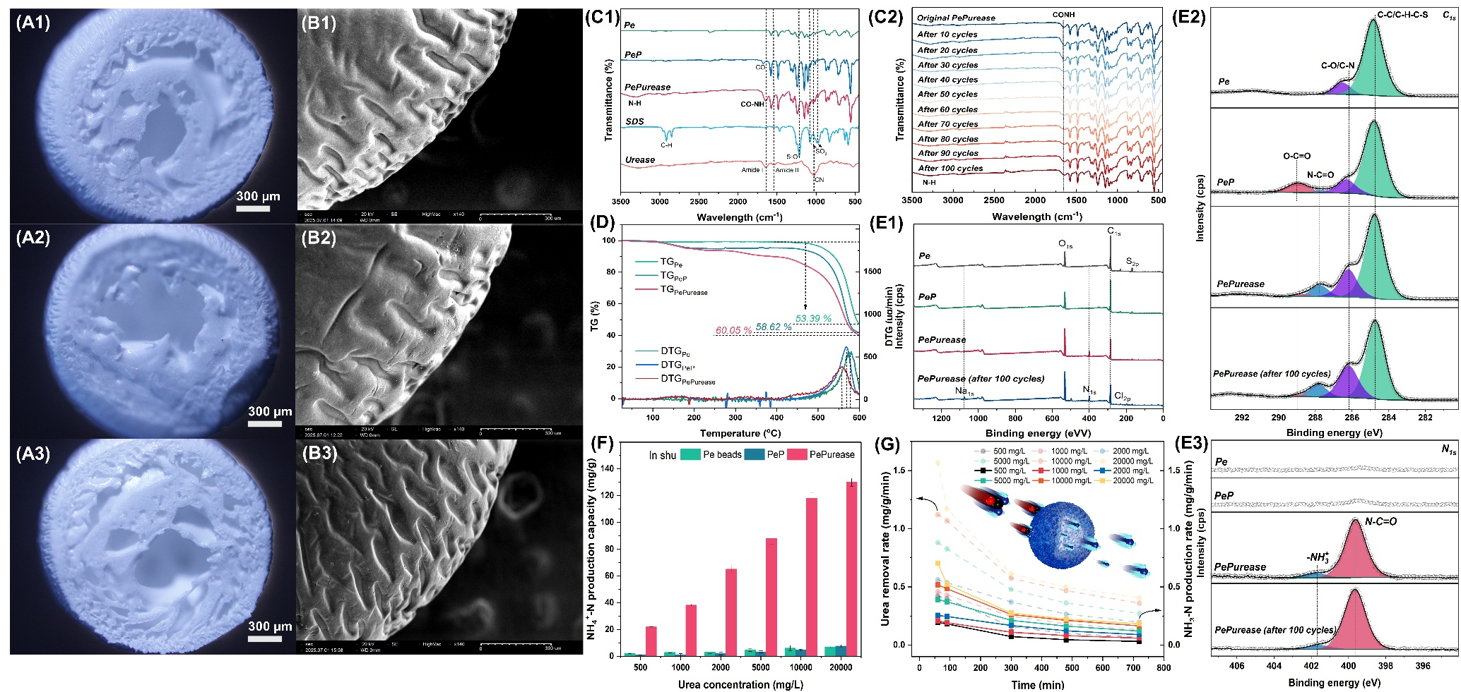
Extended Data Fig. 1. Physicochemical characterization of the PePurease beads. (A) Optical micrographs and (B) surface SEM of (1) Pe, (2) PeP and (3) PePurease beads. (C) FTIR spectra before and after 100 cycles of use. (D) TGA and DTG curves. (E) XPS full spectrum, C_{1s}, and N_{1s} spectra. (F) Ammonia produced by Pe, PeP and PePurease after 720 min in synthetic urine, isolating enzymatic activity. (G) Urea-removal and ammonia-production rates in synthetic urine. The 3 fabrication stages each leave a signature across every probe. Optical microscopy shows uniform 2.0-mm spheres at every stage, so grafting does not deform the bead, while surface SEM roughens visibly after urease coupling, consistent with protein deposited on the skin layer. FTIR and XPS agree on the chemistry: the carboxyl handle appears at PeP (1,720 cm⁻¹; O–C=O at 289.1 eV, approximately10% of the C_{1s}, sulfone falling 5.0 to 3.9 at%) and is consumed on grafting into an amide (PePurease: amide bands at 3,350/1,670 cm⁻¹; carboxyl 9.9 to 1.7%, N–C=O at 287.9 eV, surface N up to 8.3 at% with N_{1s} 92% amide, sulfone 2.0 at%), the carboxyl-to-amide conversion that marks covalent immobilisation, echoed by the C–O/C–N envelope drifting to lower binding energy (286.6 to 286.3 eV) as C–N replaces the ether C–O. TGA matches, PePurease being the least thermally stable owing to the protein, and the bond is durable: after 100 cycles the amide nitrogen is fully retained (8.8 at%, 92% amide) with the FTIR amide bands approximately unchanged. However, Na and Cl peaks also appear on PePurease surface, indicating gradual adsorption that likely contributes to its declining activity, consistent with its reduced performance after 14 to 30 days of storage in 0.9% NaCl. Panels F and G confirm function, neither Pe nor PeP makes ammonia or removes urea, so all the hydrolytic activity in Fig. 2C–D belongs to the immobilised enzyme.
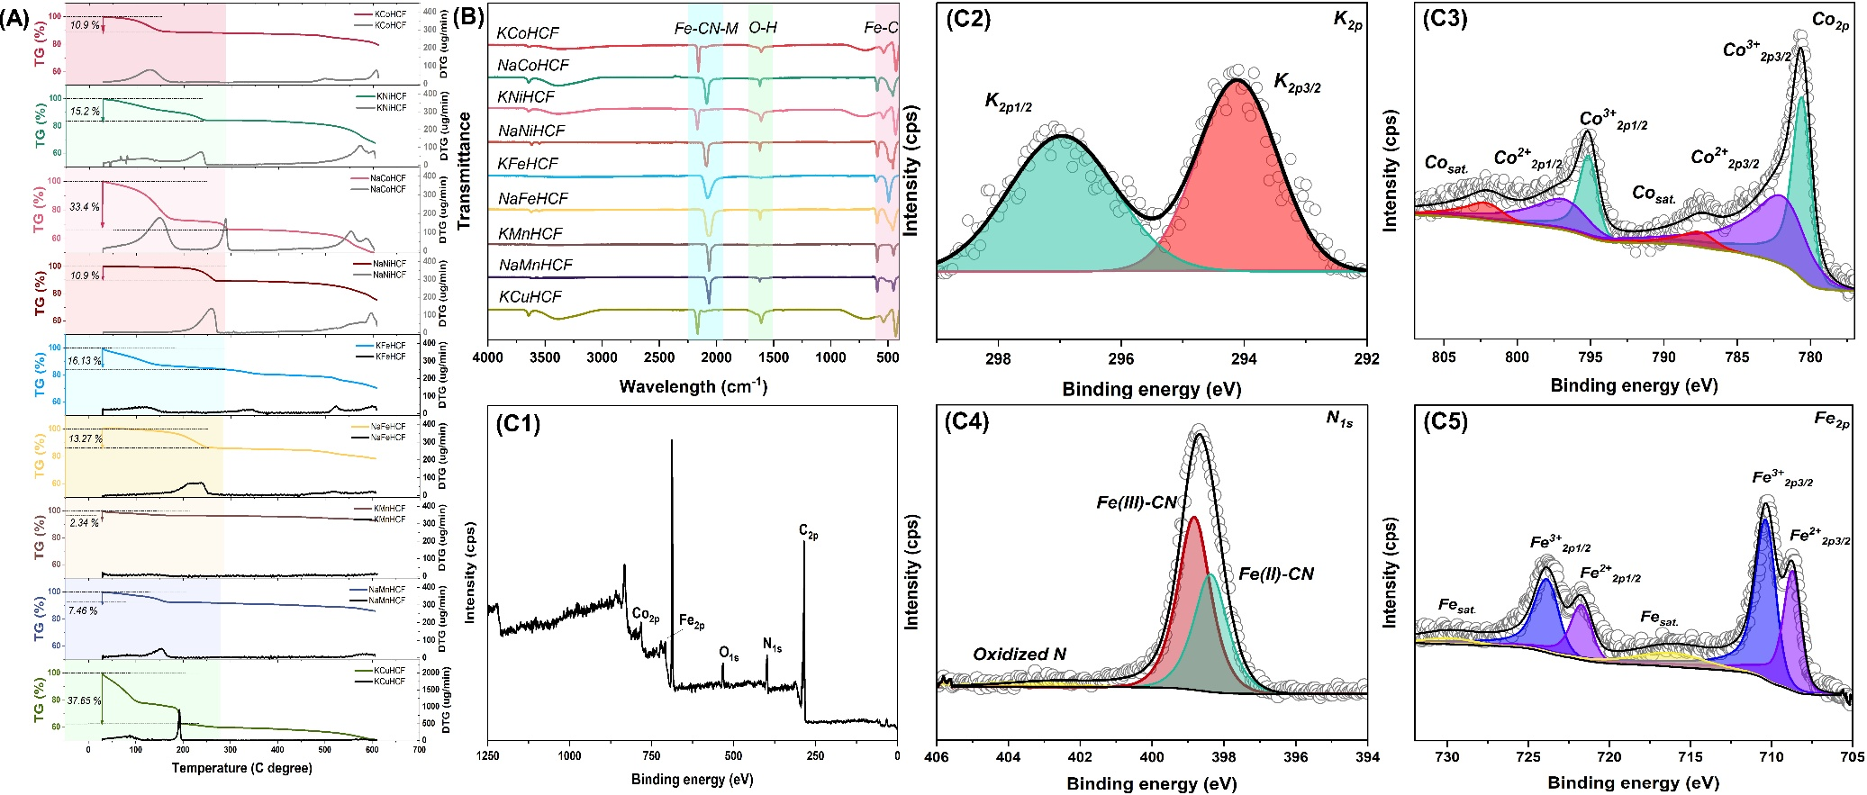
Extended Data Fig. 2. Chemical characterization of the nine Prussian-blue analogues. (A) TGA/DTG of all nine analogues. (B) FTIR spectra. (C) High-resolution XPS of KCoHCF: (1) full survey, (2) K_{2p}, (3) Co_{2p}, (4) N_{1s}, (5) Fe_{2p}. The C≡N stretch near 2,100 cm⁻¹ confirms formation of the Fe–CN–M framework in every analogue, with position shifts that report the second metal and its oxidation state. TGA quantifies the coordinated and zeolitic water used to assign the formulas in Supplementary Table 2, and shows why the water-crowded KCuHCF and KNiHCF have partly blocked cages while KCoHCF stays open. The KCoHCF XPS resolves the mixed-valence Fe^{2+/3+} and Co^{2+/3+} couples, places K⁺ in the interstitial cages, and assigns the N_{1s} components to Fe(II)–CN and Fe(III)–CN, the redox picture used in Fig. 3F and Fig. 6H.

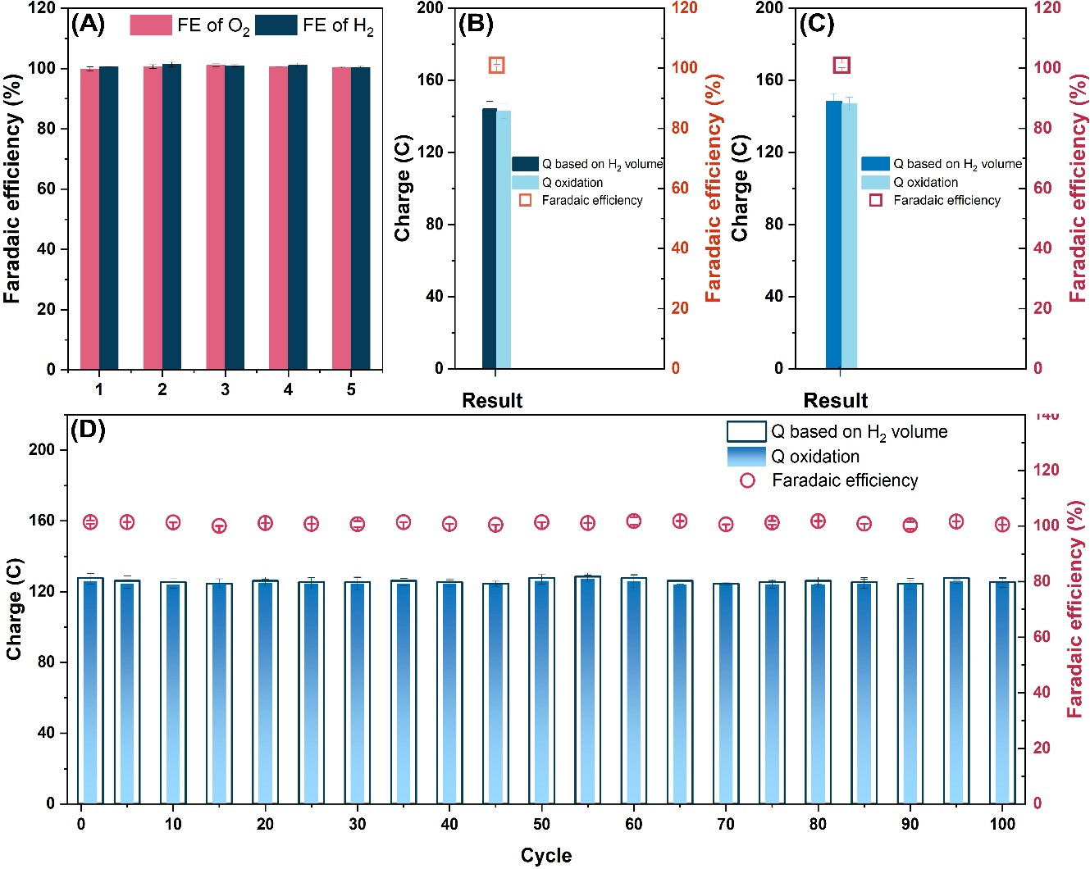
Extended Data Fig. 3. Faradaic efficiency of O₂ and H₂ evolution. (A) Faradaic efficiency of O₂ and H₂ in Li₂SO₄ cell over five synthetic-urine cycles. (B) H₂ Faradaic efficiency in the three-electrode Li₂SO₄ cell after real urine treatment. (C) H₂ Faradaic efficiency in the three-electrode (NH₄)₂SO₄ cell after real urine treatment. (D) H₂ Faradaic efficiency in the two-electrode (NH₄)₂SO₄ cell after real urine treatment. Gas was measured by water displacement and compared with the charge passed. In every configuration the Faradaic efficiency sits at essentially 100% (Supplementary Note 3), including the ammonium-depleted fifth cycle, which means no parasitic reaction competes with the intended chemistry on either electrode. This is the experimental foundation of the energy balance in Supplementary Note 4: the hydrogen credited at its heating value is real, stoichiometric hydrogen, so the net energy-positive claim rests on measured gas rather than assumed efficiency.

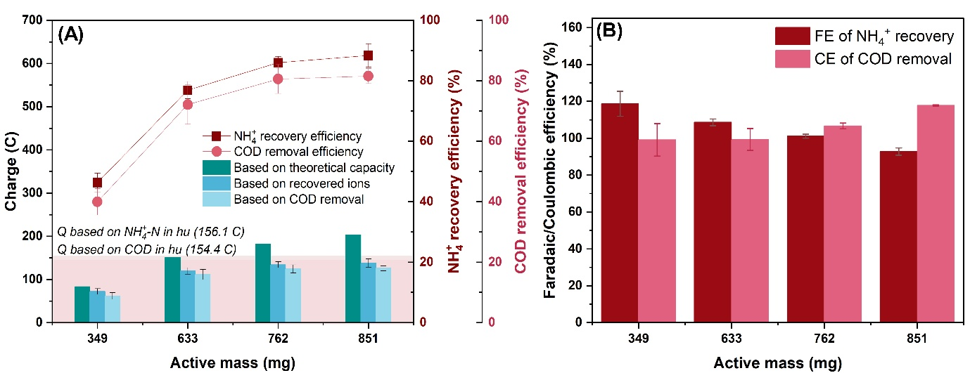
Extended Data Fig. 4. Active-mass-loading optimization of the KCoHCF electrode. (A) NH₄⁺ recovery and COD removal versus active mass (349, 633, 762, 851 mg). (B) Faradaic efficiency for NH₄⁺ recovery and Coulombic efficiency for COD removal. Loading was matched to the charge demand of the 2 mL capture cell. Recovery rises steeply from 46.3% at 349 mg to 85.9% at 633 mg and 88.3% at 762 mg and then plateaus, placing 633–762 mg at the knee of the curve. Panel B shows why pushing beyond this point is counterproductive: from 633 to 762 mg, the Faradaic efficiency for ammonium remains high (108.6–101.1%) and the Coulombic efficiency for COD stays near unity (99.3–106.7%). At 851 mg, however, the Coulombic efficiency increases to 117.8%, indicating that the additional charge is consumed by side reactions. Therefore, the maximum recovery achievable before energy efficiency begins to degrade lies within the 633–762 mg range, which was used throughout Fig. 6.

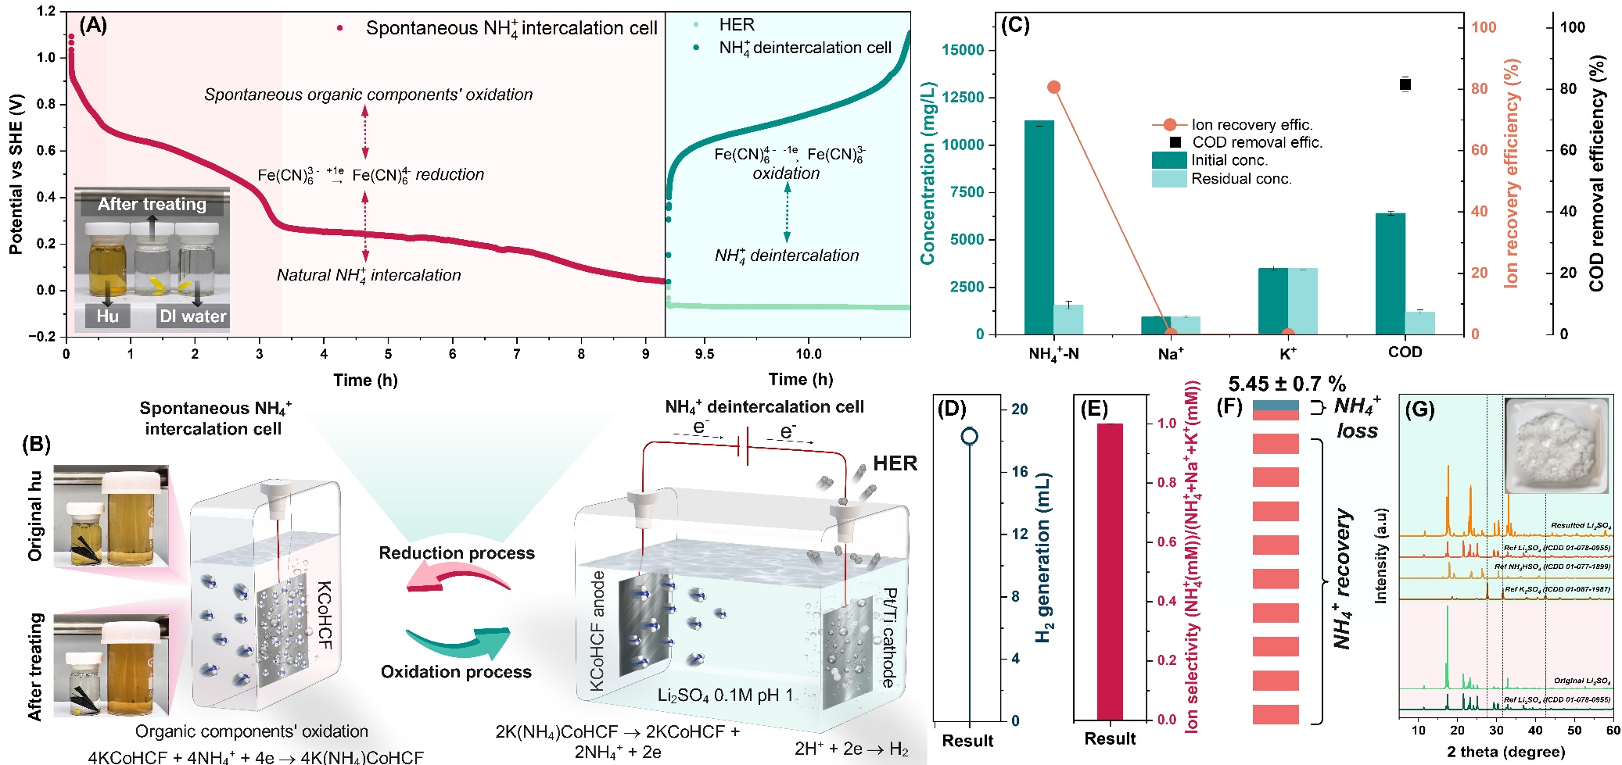
Extended Data Fig. 5. Real-urine recovery with an analytical (Li₂SO₄) release electrolyte. (A) Chronopotentiometry of NH₄⁺ capture and release in Li₂SO₄ 0.1M pH 1. (B) Decolorisation of urine after capture. (C) Ion concentrations and COD removal. (D) Hydrogen evolution (Supplementary Video 5). (E) Per-cycle selectivity. (F) Nitrogen mass balance. (G) XRD of the dried Li₂SO₄ electrolyte after operation. Li₂SO₄ is the analytical control: because it contains none of the measured cations, the K⁺, Na⁺ and NH₄⁺ that appear in it can only have come from the electrode, and the dried-electrolyte XRD (panel G) shows pure Li₂SO₄ with negligible potassium or sodium sulfate, a diffraction-level confirmation of the ICP-OES selectivity. The single-cycle figures, 80.1% ammonium recovery and 81.5% COD removal, are the values referenced in Fig. 6, here resolved ion by ion and stage by stage.

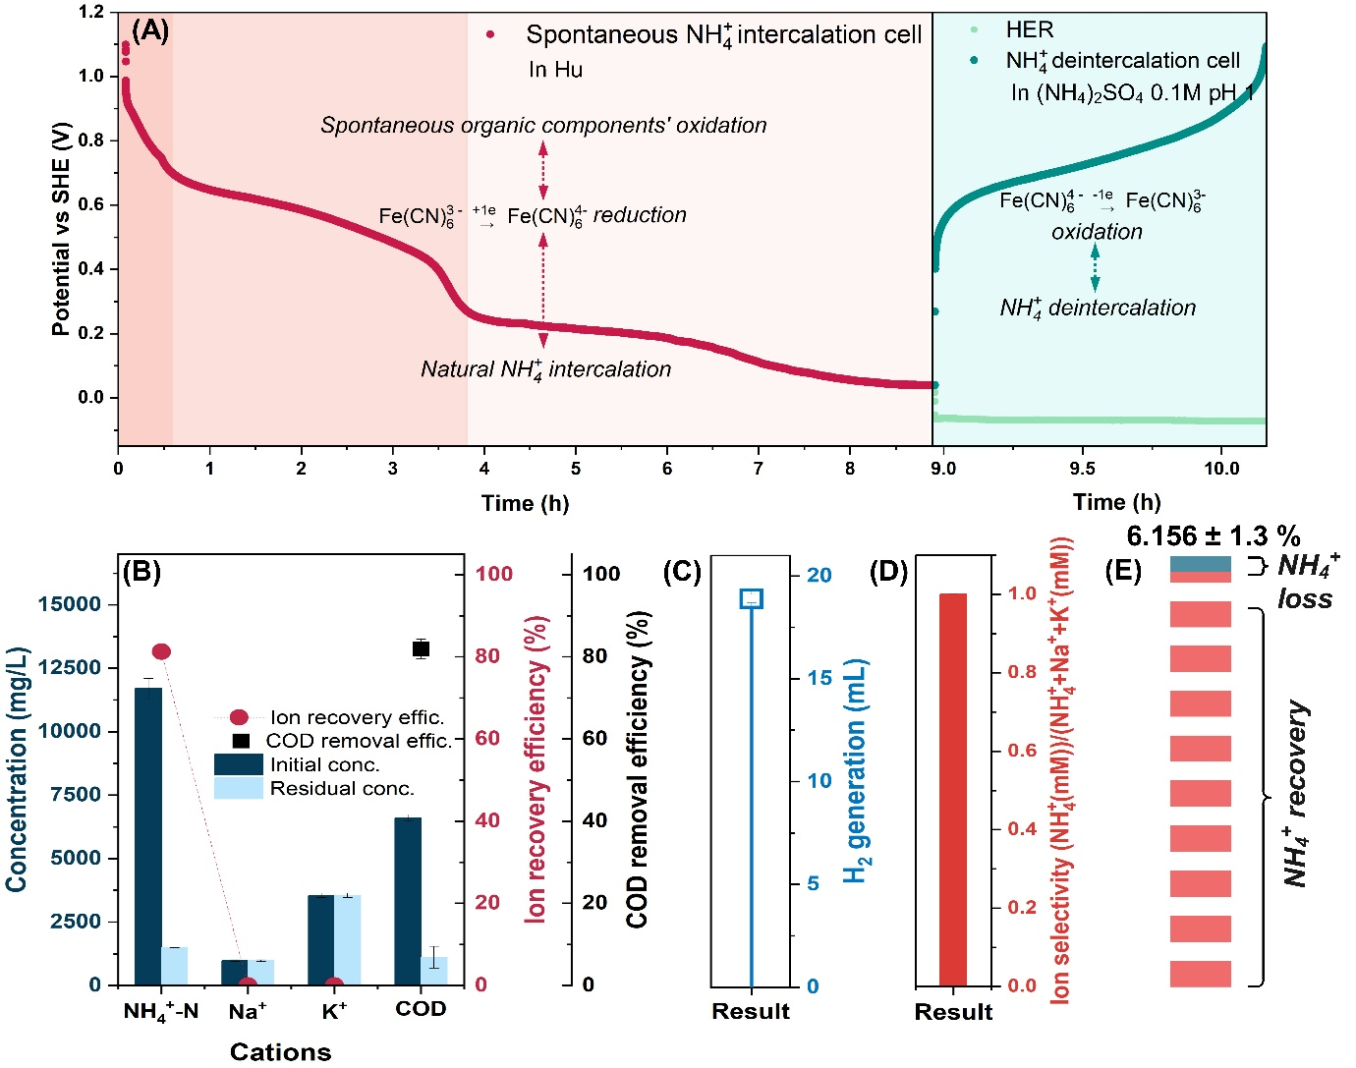
Extended Data Fig. 6. Real-urine recovery with a fertilizer ((NH₄)₂SO₄) release electrolyte. (A) Chronopotentiometry of NH₄⁺ capture and release in (NH₄)₂SO₄ 0.1M pH 1. (B) Ion concentrations and COD removal. (C) Hydrogen evolution. (D) Per-cycle selectivity. (E) Nitrogen mass balance. Switching the release electrolyte to fertilizer-grade (NH₄)₂SO₄ lets the recovered ammonium accumulate directly into a usable product. Performance matches the Li₂SO₄ case to within two percentage points (81.3% recovery, 81.9% COD removal, 99.9% per-cycle selectivity), so the choice of release electrolyte does not alter the recovery chemistry; Li₂SO₄ is preferred for clean analysis, (NH₄)₂SO₄ for direct product accumulation as in the 100-cycle run of Fig. 6D.

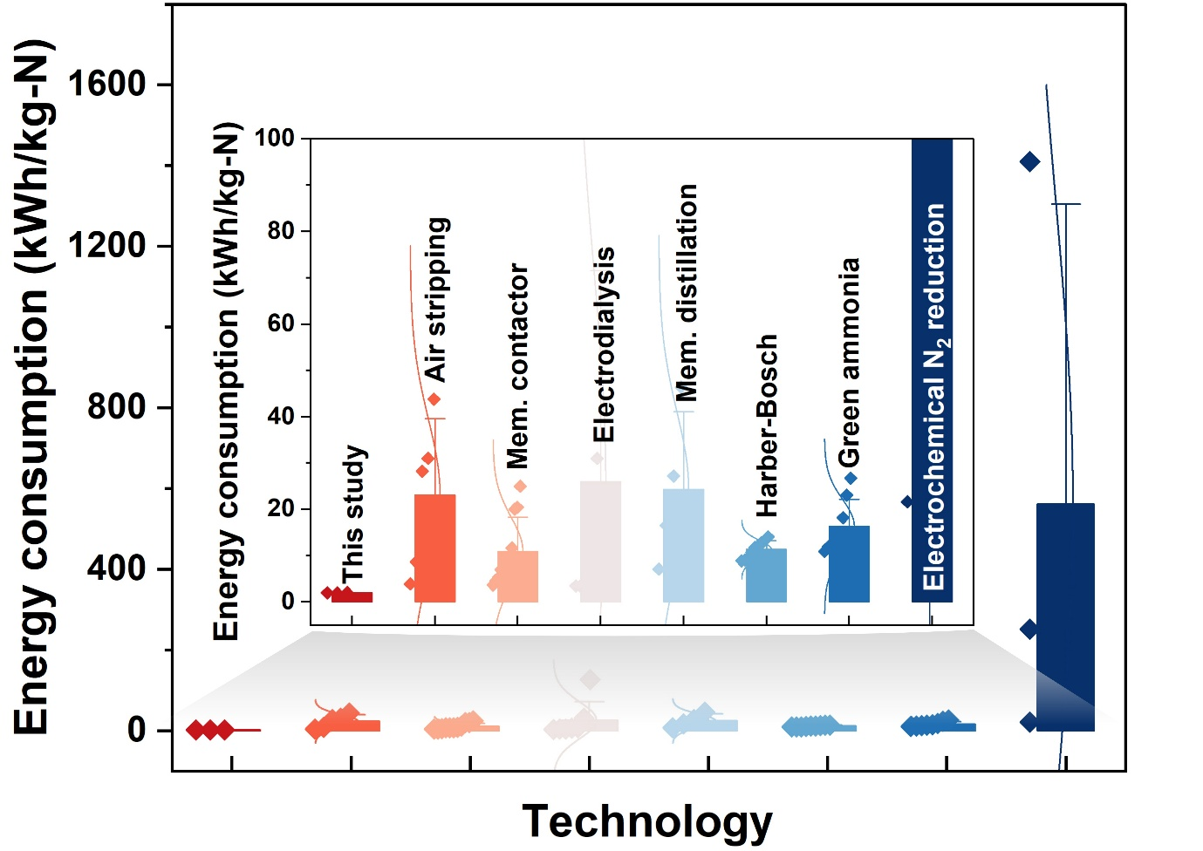
Extended Data Fig. 7. Energy-consumption benchmarking against existing NH₃/NH₄⁺ recovery and synthesis routes. Specific energy consumption of this platform compared with microbial fuel cells, microbial electrolysis cells, electrochemical stripping, membrane distillation, membrane contactors and Haber–Bosch in Supplementary Table 6. Placed against the surveyed field, this platform sits at the low-energy extreme, and uniquely below zero once the hydrogen co-product is credited. The gross 1.96 kWh kg⁻¹ N already undercuts the alternatives, and the net −0.47 kWh kg⁻¹ N has no counterpart among them, because no other route recovers a saleable fuel at the regeneration cathode. This figure is the external benchmark for the energy accounting of Supplementary Note 4.

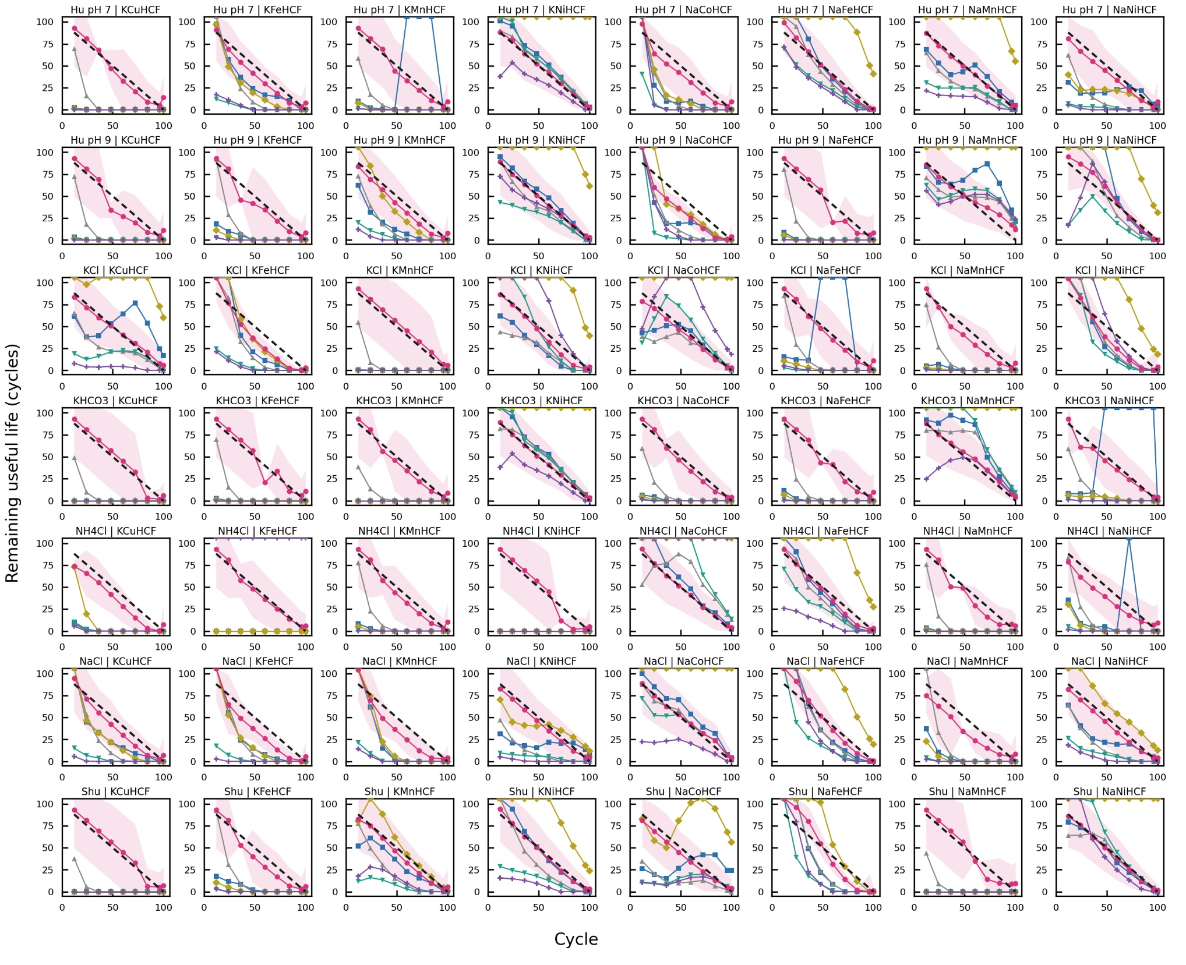
Extended Data Fig. 8. Walk-forward RUL across all 56 screening trajectories. Each small panel is one electrode/electrolyte pair (8 electrodes across, 7 electrolytes down) on equal axes, so the ground-truth RUL (black dashed) is a clean diagonal falling to zero at end-of-life. Solid pink is SPI+CBU, solid blue SPI+TBU, solid grey the linear baseline; pink shading is the calibrated 90% interval. Pooled across the screen, SPI+CBU predicts life to 6.3 cycles MAE, against 29.5 (unconstrained Bayesian update), 25.2 (linear), 169 (naive log fit), 57.7 (Wiener), and 64.2 (Weibull). The panels show why: where the fade is gentle the methods agree, because the data pin the trend. The baselines diverge only where a trajectory bends, while SPI+CBU stays locked to the truth because the constraint band keeps every prediction inside the historical operating range. With n = 56 trajectories this is a population result, not an anecdote, the strongest evidence that the constraint, not the fitting, delivers the accuracy.
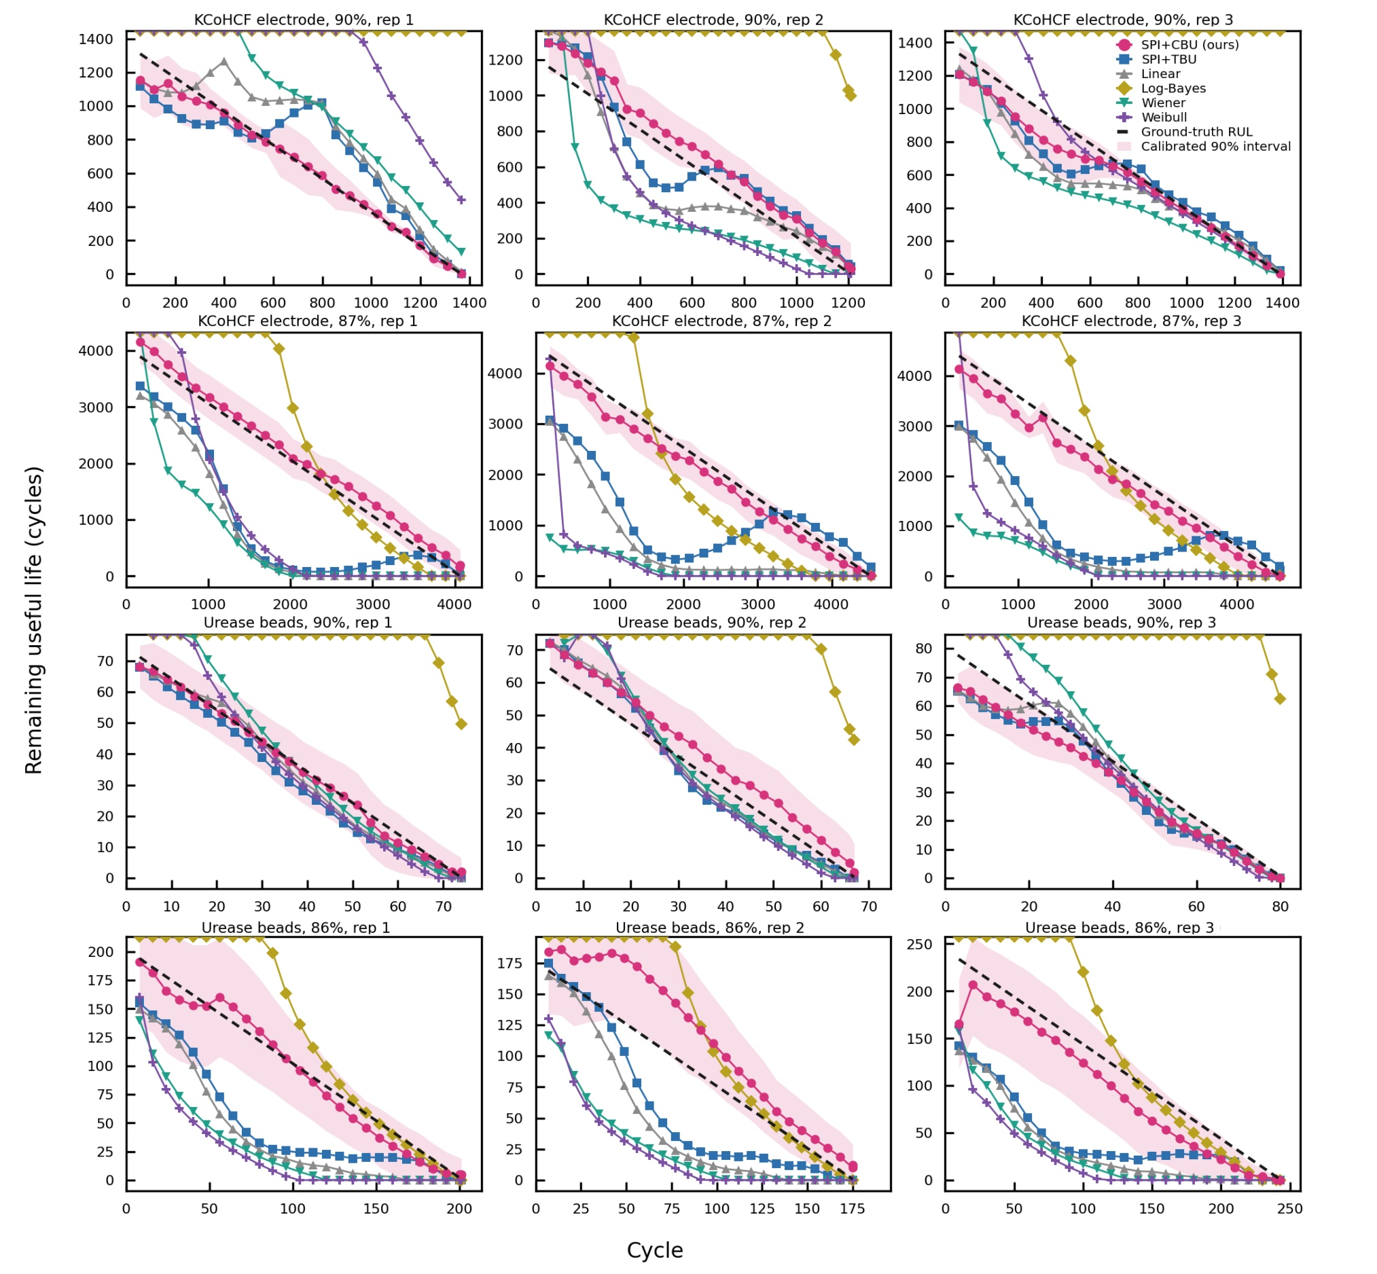
Extended Data Fig. 9. Triplicate RUL for the deployed materials (KCoHCF and PePurease) at different thresholds. The 2 materials that go into the device, validated the way they would be used: 3 independent replicates, 2 thresholds each, equal axes, calibrated 90% interval shaded and coverage printed per panel. Rows 1-2 are the KCoHCF electrode at 90% and 87% capacity; rows 3-4 the PePurease beads at 90% and 86% activity. The deeper thresholds (87% and 86%) are the demanding tests, where SPI+CBU separates hardest: predicting further into the decelerating tail is a longer extrapolation, and the unconstrained baselines blow up to over 1100 cycles of error while SPI+CBU holds near 200, because the constraint, built from the min-max span of the 3 replicates, refuses to leave the plausible range. At the shallow thresholds, all methods are close, which is not over-claimed here. Coverage across 12 panels is near 90%, and tracking RMSE is 0.12-0.73%, so the capacity/activity underlying each RUL curve is essentially exact. This is what licenses the material lifetimes in the techno-economic analysis.
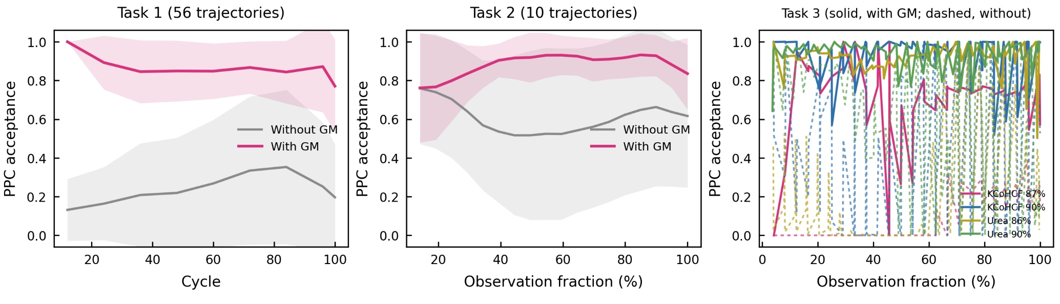
Extended Data Fig. 10. Gaussian-mutation ablation, averaged across tasks. This figure condenses the mechanism shown trajectory by trajectory in Supplementary Figs. 26-29 into a single population-level comparison, plotting mean PPC acceptance with and without mutation, together with its spread, for the screening set and the two deployed materials. Without mutation the average acceptance is low, around a quarter on the screening set, and on the most demanding deployed case it falls to a small fraction, near one in ten; with mutation it recovers to a high and consistent level, roughly 0.87 to 0.94 across all tasks. The averaged view makes the causal point compactly: the historical-lives constraint is effectively inert unless the mutation step enforces it, and once enforced it produces reliable acceptance everywhere, on both the broad screen and the specific materials that go into the device. Read alongside the per-trajectory and per-replicate panels, this completes the ablation argument: the accuracy and calibration advantages of SPI+CBU coincide exactly with the regime in which acceptance is high, and that regime exists only when mutation is active. The constraint with its mutation enforcement is therefore the decisive component of the method, separable from and additional to the choice of a log-linear basis.

