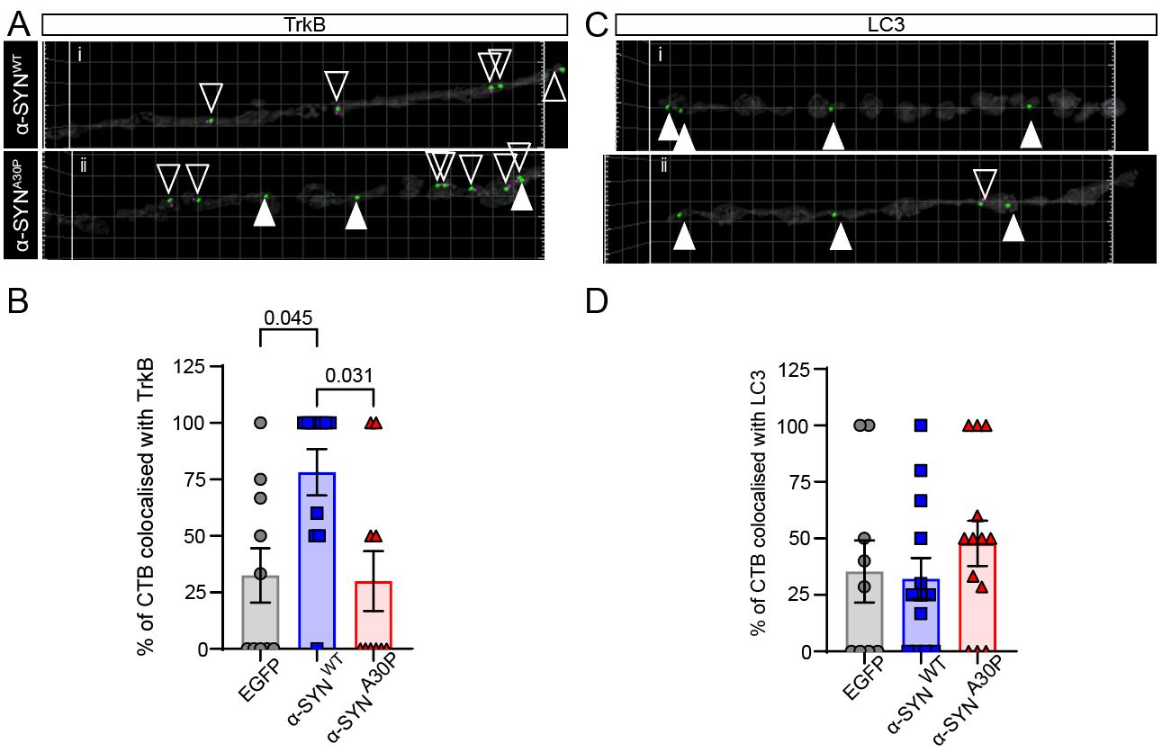

Supplementary Figure 1. Conditioned medium from hippocampal neurons expressing α-synWT-GFP increases colocalisation of axonal CTB with TrkB, but not LC3, in recipient neurons. Recipient hippocampal neurons were exposed to conditioned medium collected from donor hippocampal neurons expressing EGFP, α-syn^{WT}-GFP or α-syn^{A30P}-GFP. Axonal CTB puncta were then analysed for colocalisation with TrkB or LC3. (A) Representative axonal segments showing CTB and TrkB staining in recipient neurons exposed to α-syn^{WT}-GFP or α-syn^{A30P}-GFP conditioned medium. (B) Quantification of the percentage of axonal CTB puncta colocalised with TrkB. α-syn^{WT}-GFP conditioned medium significantly increased CTB-TrkB colocalisation compared with EGFP control and α-syn^{A30P}-GFP conditioned medium. (C) Representative axonal segments showing CTB and LC3 staining. Open arrowheads indicate CTB-positive puncta colocalised with LC3, whereas filled white arrowheads indicate CTB-positive puncta without detectable LC3 colocalisation. (D) Quantification of the percentage of axonal CTB puncta colocalised with LC3, showing no significant difference between groups. Individual points represent independent measurements, and bars show mean ± SEM. P values are shown above brackets. Open arrowheads = colocalised CTB puncta and filled arrowheads = non-colocalised CTB puncta.

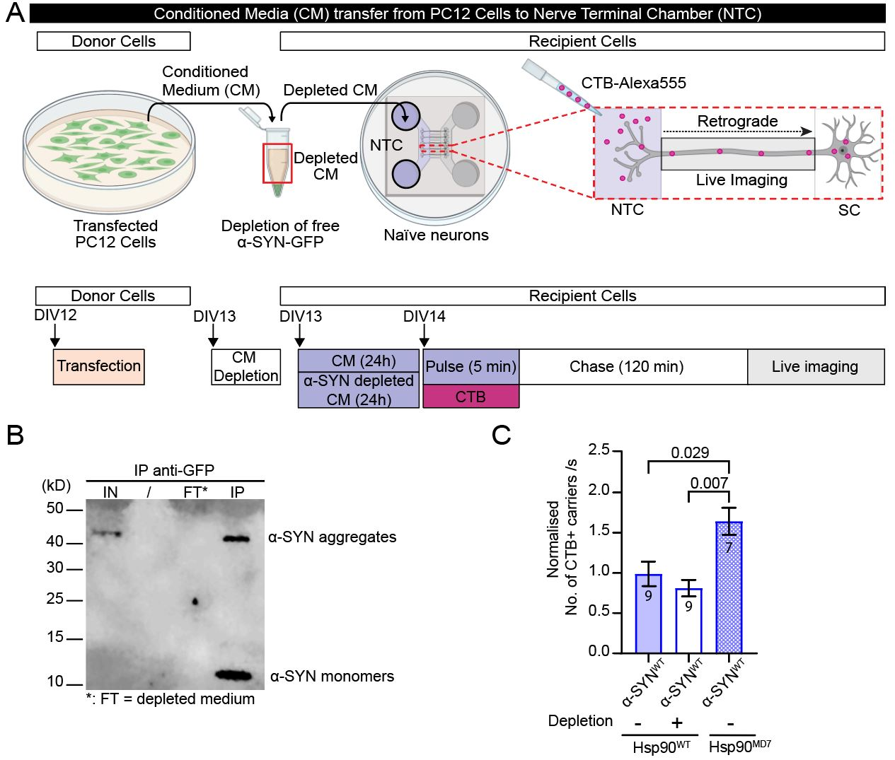
Supplementary Figure 2: The downregulating effect of the conditioned medium in recipient cells is not mediated by free secreted α-syn. A. Schematic of the experimental paradigm: PC12 cells were co-transfected with either α-syn^{WT}-GFP and Hsp90^{WT}-mCherry, or α-syn^{WT}-GFP and Hsp90^{MD7}-mCherry (donor device; DIV 12). After 24 h, part of the conditioned medium from PC12 cells co-transfected with α-syn^{WT}-GFP and Hsp90^{WT}-mCherry was immunodepleted of α-syn-GFP, using anti-GFP magnetic beads. Subsequently, each conditioned medium (α-syn^{WT}-GFP/Hsp90^{WT} with and without immunodepletion and α-syn^{WT}-GFP/Hsp90^{MD7} with and without immunodepletion) was added to the nerve terminal chamber (NTC) (70:30 vol/vol ratio) of a microfluidic device containing untransfected naïve neurons. The following day a 5-minute pulse of cholera toxin B subunit Alexa Fluor™ 555 (CTB-Af555; 50 ng/mL) diluted in high potassium (high K⁺) buffer was conducted followed by 3 washes with low potassium (LK⁺) buffer to remove excess CTB. Afterwards, devices were incubated with the conditioned media for 2 h before imaging CTB-positive carriers undergoing retrograde transport in axons of the recipient neurons. B. Western Blot of the conditioned media from PC12 cells co-transfected with α-syn^{WT}-GFP and Hsp90^{WT}-mCherry before and after immunodepletion to confirm the efficient removal of α-syn. IN = input corresponding to the loading of the original conditioned medium, FT = flow-through corresponding to the loading of the α-syn depleted fraction, IP = immunoprecipitation corresponding to the loading of the fraction containing α-syn-GFP bound to magnetic beads. C. Quantification of the frequency of CTB+ carriers (number of carriers per second). Timelapse confocal imaging was performed on the Discovery spinning disk at a 3 Hz imaging rate. Data from 1 independent experiment, n=7-9 channels, Kruskal-Wallis test followed by Dunn’s comparison test, mean ± SEM.

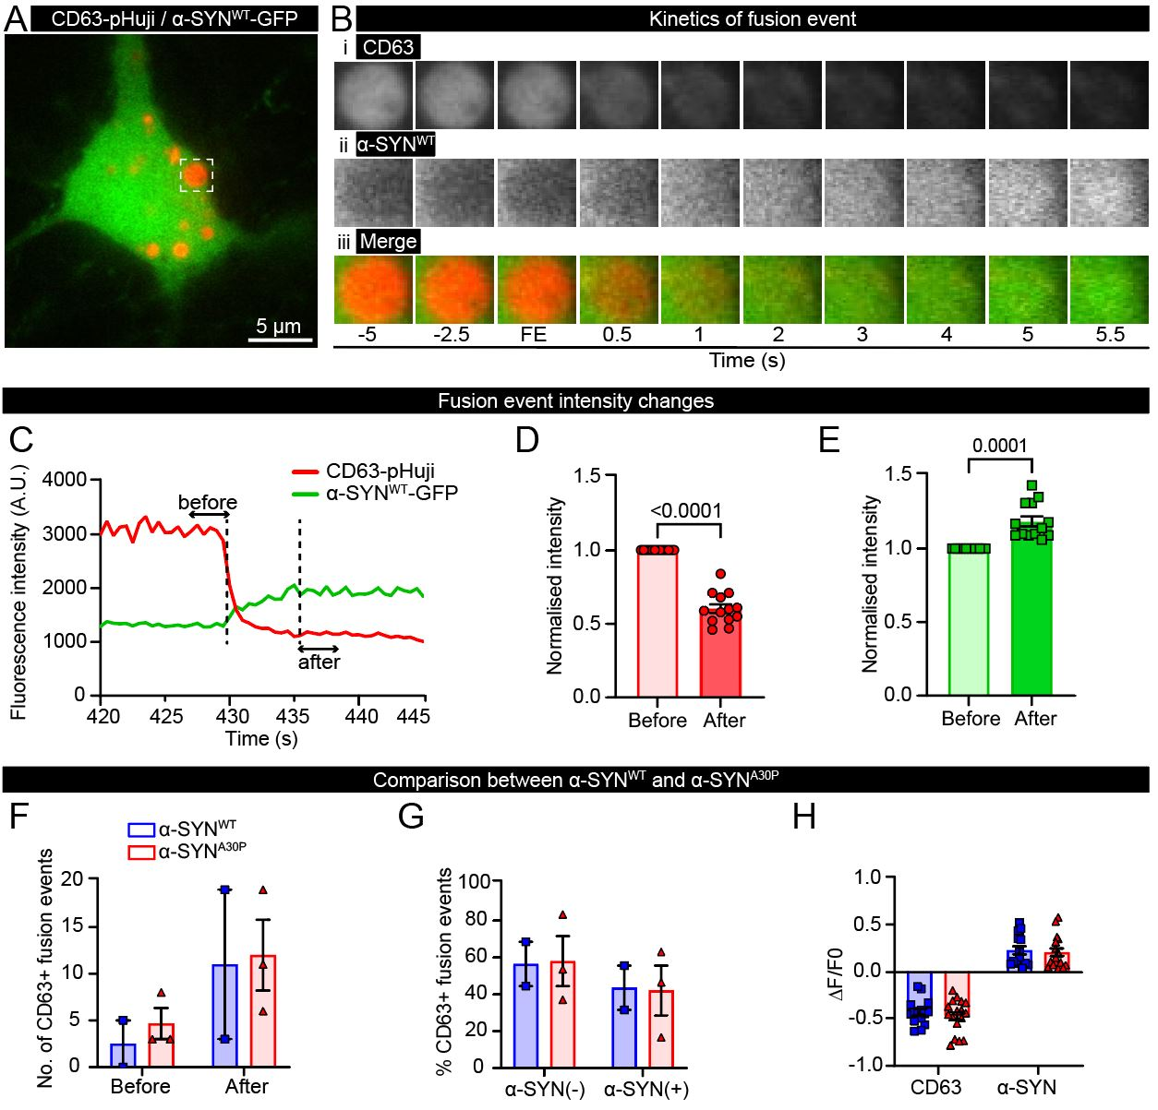

Supplementary Figure 3: Live imaging of α-syn exosomal release in hippocampal neurons does not reveal any differences between WT and A30P mutant. Scheme of the experiment: Glass-bottom dishes seeded with hippocampal neurons extracted from the brains of E16 mouse embryos were co-transfected with exosomal marker CD63-pHuji and α-syn^{WT}-GFP at DIV 18. At DIV 20, neurons were washed in low potassium buffer, and TIRF live-cell dual imaging was performed for 10 min during which stimulation was applied after 5 minutes using high potassium buffer. CD63-pHuji is quenched in the acidic environment of the multivesicular body (MVB). Upon fusion of a MVB with the plasma membrane, CD63-pHuji becomes exposed to the neutral extracellular environment and is unquenched, enabling visualisation of CD63-pHuji proximal to the membrane via TIRF. Then, exosomal α-syn-GFP is released, reflected by a sharp decrease in the red channel fluorescence (CD63-pHuji) and an increase in the green channel (α-syn-GFP). A. TIRF fluorescent image of a hippocampal neuron expressing α-syn-GFP (green) and CD63-pHuji (red) with one MVB outlined with dashed white line, scale bar: 5 µm. B-E. Characterisation of the fusion of the MVB outlined in (A) with the plasma membrane. B. Timelapse scheme of the exocytic event, time in seconds, FE = fusion event. i. Representative images showing the change in fluorescence intensity in the red channel over time (CD63-pHuji); ii. Representative images showing the change in fluorescence intensity in the green channel (α-syn^{WT}-GFP); iii. Representative images showing the change in fluorescence intensity in the merged red and green channels. C. Graph illustrating the method used to characterise changes in fluorescence intensities during a fusion event. For each fusion event, the mean fluorescence intensity prior to the beginning of the fusion event was determined over 10 frames, as well as the mean intensity over 10 frames at the end of the fusion event, corresponding to the maximum value in the green channel (α-syn^{WT}-GFP), and the minimum value in the red channel (CD63-pHuji). D. Graph of normalised intensities in the red channel before and after the exocytic event. Fluorescent intensities were normalised to the intensity at the beginning of the exocytic event. E. Same as (D) but in the green channel. F. Graph comparing the number of fusion events in the red channel before and after stimulation for α-syn^{WT}-GFP and α-syn^{A30P}-GFP. G. Graph representing the percentage of exocytic events that contained α-syn and ones that did not. H. Graph representing the amplitude of the change in fluorescence before and after each exocytic event. Values were normalised to the intensity measured at the beginning of an exocytic event.

