Supplementary Information File

Bioplastic Food Packaging and the Young Women’s Exposome: Body Burden of Bisphenols in a Randomized Intervention Trial

Figure S1: Flow chart of the study. n indicates the number of participants and s the number of urine samples.

Figure S2: Regression estimates of the models assessing the effectiveness of intervention on the urinary bisphenol levels. Predictors included the participant age, educational level, overweight status, employment status, log cortisol level, creatinine level, period (intervention) and time since start of the period. An interaction term between study period and time since the beginning of the study period was initially considered and retained only when was statistically significant (p < 0.05). Red colour indicates significant estimates.

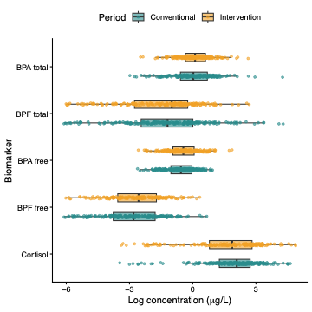
Figure S3: Urinary concentrations of biomarkers adjusted by creatinine during conventional and intervention periods. Boxplots show the distribution of log-transformed urinary concentrations of total BPA, total BPF, free BPA, free BPF, and cortisol according to study period.

Figure S4: Regression estimates of the models assessing the effectiveness of intervention on the urinary bisphenol levels using creatinine-adjusted bisphenols. Predictors included the participant age, educational level, overweight status, employment status, log cortisol level, period (intervention) and time since start of the period. An interaction term between study period and time since the beginning of the study period was initially considered and retained only when was statistically significant (p < 0.05). Red colour indicates significant estimates.

Figure S5: Exposome-wide association analyses. Volcano plot showing the associations between study period (intervention vs conventional periods) and 30 exposome variables estimated using generalised linear mixed-effects models. Logistic mixed-effects models were fitted for binary variables, and a Gaussian mixed-effects model was used for handwashing frequency. Models were adjusted for age, educational level, overweight status, and employment status, with participant included as a random intercept to account for repeated measurements. The x-axis shows the estimated effect of the intervention (odds ratio for binary variables and regression coefficient for handwashing frequency), and the y-axis shows the p-value. The dashed horizontal line denotes the significance threshold of p=0.05. For clarity, one association with p-value < 0.0001 (food stored in plastic containers) is not displayed.

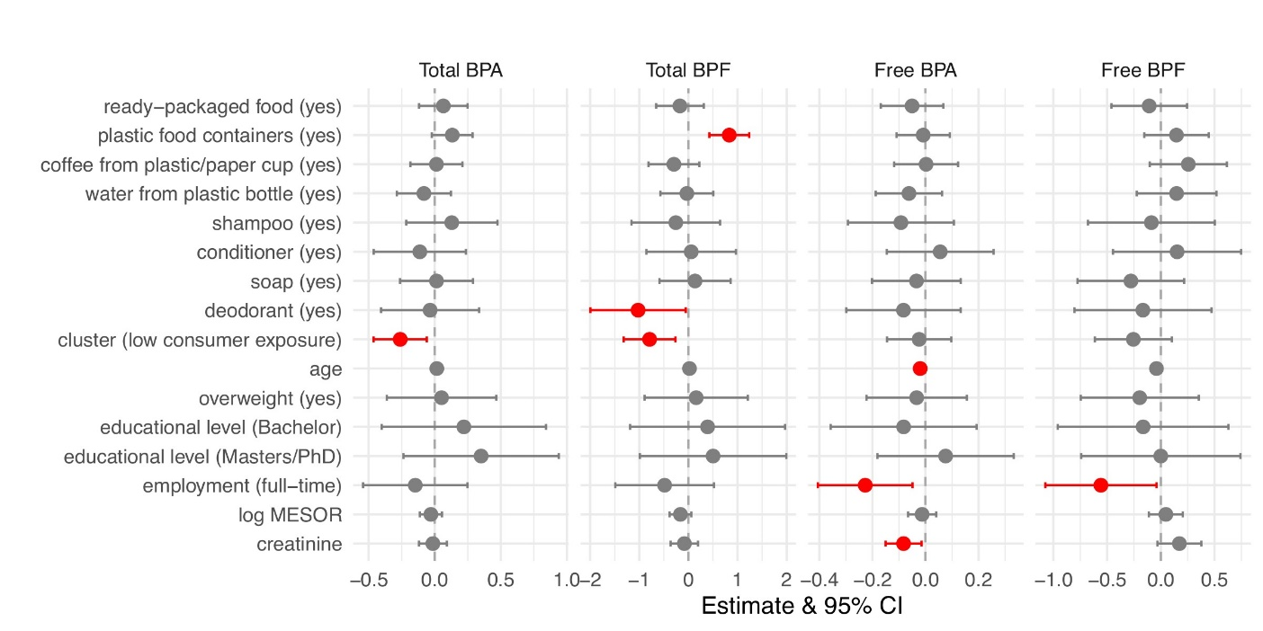
Figure S6: Regression estimates of the final linear mixed effect models with all potential predictors of urinary bisphenol levels, including the circadian clock system marker of MESOR. Predictors included all significant estimates identified by ExWAS and LASSO analyses, and the cluster variable defined by the Latent Class Analysis. The models adjusted for participant age, educational level, overweight status, and employment status, log MESOR, creatinine level, period (intervention) and time since start of the period. Red colour indicates significant estimates.

Figure S7: Regression estimates of the final models with all potential predictors of urinary bisphenol levels, including the amplitude marker of circadian clock system. Predictors included all significant estimates identified by ExWAS and LASSO analyses, and the cluster variable defined by the Latent Class Analysis. The models adjusted for participant age, educational level, overweight status, and employment status, log amplitude, creatinine level, period (intervention) and time since start of the period. Red colour indicates significant estimates.

Figure S8: Regression estimates of the final models with all potential predictors of urinary bisphenol levels, including acrophase, the circadian clock system marker. Predictors included all significant estimates identified by ExWAS and LASSO analyses, and the cluster variable defined by the Latent Class Analysis. The models adjusted for participant age, educational level, overweight status, and employment status, acrophase, creatinine level, period (intervention) and time since start of the period. Red colour indicates significant estimates.

Supplementary Text
Model formulae for the exposomics intervention treatment effectiveness pipeline:
Below you may find the generalized model formula for each stage of the detailed exposomics pipeline to evaluate intervention treatment effectiveness in a non-pharmacological health intervention trial. The below formulae are offered at a minimum, because one may choose to incorporate further advanced bioanalytical algorithms, such as, multi-omics platforms and/or one may also choose to consider other high dimensionality or feature selection algorithms tackling highly correlated variables, nonlinear patterns, and repeated measures. At a minimum, the below specific model formulae represent Stages I, III and IV. No formulae are presented for Stage II since no omics platforms were used. Neither formulae are presented for Stages V and VI.
- Primary linear mixed-effects models (one model per bisphenol outcome) (Stage I)
$$Y_{it}=β_{0}+β_{1}{Period}_{it}+β_{2}{Time}_{it}+β_{3}\left({Period}_{it} × {Time}_{it}\right)+\sum_{k=1}^{K}{β_{k}C_{ik}}+b_{i}+ε_{it}$$

where:
$Y_{it}$ is the bisphenol concentration for participant $i$ at time $t$ (primary outcome here)
${Period}_{it}$ is the binary indicator of the intervention vs conventional period
${Time}_{it}$ indicates the time since the start of the intervention
$C_{ik}$ is the set of covariates (age, overweight, education, employment, cortisol, creatinine)
$b_{i}$ is the random intercept per participant
$ε_{it}$ is the residual error

- Exposome-wide association study (ExWAS) (one model per exposure)
$$E_{it}=β_{0}+β_{1}{Period}_{it}+\sum_{k=1}^{K}{β_{k}C_{ik}}+b_{i}+ε_{it}$$
where:
$E_{it}$ is an exposomic signature variable (one of the 30)
${Period}_{it}$ is the binary indicator of the intervention vs conventional period
$C_{ik}$ is the set of covariates (age, overweight, education, employment)
$b_{i}$ is the random intercept per participant
$ε_{it}$ is the residual error

- LASSO penalized mixed-effect regression (a single model for all exposures)
$${Period}_{it}=β_{0}+\sum_{n=1}^{N}{β_{n}E_{itn}}+\sum_{k=1}^{K}{β_{k}C_{ik}}+b_{i}+ε_{it}$$
where:
${Period}_{it}$ is the binary indicator of the intervention vs conventional period
$E_{itn}$ is the set of all 30 exposomic signatures
$C_{ik}$ is the set of covariates (age, overweight, education, employment)
$b_{i}$ is the random intercept per participant
$ε_{it}$ is the residual error

- Final linear mixed-effects models (one model per bisphenol outcome) (Stage 4)
$$Y_{it}=β_{0}+β_{1}Cl_{it}+\sum_{m=1}^{M}{β_{m}E_{itm}}+\sum_{k=1}^{K}{β_{k}C_{ik}}+b_{i}+ε_{it}$$
where:
$Y_{it}$ is the bisphenol concentration for participant $i$ at time $t$ (primary outcome here)
${Cl}_{it}$ is the binary indicator of the low-plastics exposomic profile (cluster) vs high multi-domain plastics exposomic profile as derived from Latent Class Analysis
$E_{itm}$ is the set of the 8 statistically significant exposures identified by ExWAS and LASSO
$C_{ik}$ is the set of covariates (age, overweight, education, employment, cortisol, creatinine)
$b_{i}$ is the random intercept per participant
$ε_{it}$ is the residual error

