Supplementary Table and figure
Supplementary Table 1. Prokka annotation-depth metrics for the three genomes.
Genome | CDS with gene symbol | Gene-symbol CDS (%) | CDS with EC number | EC-annotated CDS (%) | CDS with COG entry | COG-annotated CDS (%) | Hypothetical proteins | Hypothetical CDS (%) | Non-hypothetical CDS (%)
R. binae | 3,593 | 45.57 | 2,239 | 28.40 | 2,304 | 29.22 | 4,007 | 50.82 | 49.18
R. bangladeshenes | 3,534 | 48.50 | 2,182 | 29.94 | 2,183 | 29.96 | 3,543 | 48.62 | 51.38
R. lentis | 3,172 | 40.68 | 2,031 | 26.05 | 2,009 | 25.77 | 4,404 | 56.48 | 43.52

Supplementary Table 2. Pairwise ANI and coverage values calculated from dRep output.
Pairwise comparison | Mean ANI (%) | Alignment coverage range (%) | Reference coverage range (%) | Query coverage range (%)
R. binae vs R. lentis | 88.80 | 69.86-69.87 | 61.17-69.87 | 61.18-69.86
R. lentis vs R. bangladeshines | 89.84 | 76.96-77.05 | 73.23-77.05 | 73.33-76.96
R. binae vs R. bangladeshines | 88.47 | 72.21-72.26 | 66.45-72.26 | 66.49-72.21

Supplementary Table 3. Roary gene-cluster distribution by presence pattern.
Presence pattern | Gene clusters | Percentage of pan-genome (%)
R. binae | 5,626 | 30.17
R. lentis | 5,405 | 28.99
R. bangladeshenes | 4,629 | 24.83
R. binae + R. lentis | 328 | 1.76
R. binae + R. bangladeshenes | 594 | 3.19
R. lentis + R. bangladeshenes | 728 | 3.90
All three genomes | 1,336 | 7.17

Supplementary Table 4. Functional category counts.
Genome | Transport | Regulation | Redox enzymes | Biosynthetic enzymes | Motility | Cell envelope | Nitrogen functions
R. binae | 575 | 543 | 499 | 596 | 43 | 26 | 27
R. bangladeshenes | 573 | 524 | 504 | 579 | 41 | 28 | 26
R. lentis | 527 | 432 | 479 | 544 | 48 | 28 | 17

Supplementary Table 5. Counts of selected symbiosis-associated gene families.
Genome | nod/nol/noe | nif | fix/cco | exo/pss/rkp/ndv/chv | dct | ccm | gln/ntr | motility/chemotaxis
R. binae | 10 | 9 | 10 | 9 | 9 | 7 | 33 | 37
R. bangladeshenes | 9 | 11 | 8 | 11 | 10 | 4 | 27 | 34
R. lentis | 4 | 5 | 12 | 11 | 7 | 6 | 23 | 39

Supplementary Table 6. Comparative of trait associated CDS annotation hits.
Functional category | R. binae | R. bangladeshenes | R. lentis
Heavy-metal tolerance and homeostasis | 24 | 32 | 28
Phytohormone-related traits | 5 | 4 | 8
Antimicrobial and biocontrol potential | 5 | 5 | 4
Iron acquisition and siderophore-associated traits | 9 | 19 | 13
Phosphate acquisition and utilization | 20 | 12 | 12
Quorum sensing and rhizosphere colonization | 17 | 20 | 15
Antimicrobial-resistance and multidrug-efflux systems | 51 | 47 | 47
Total category-assigned hits | 131 | 139 | 127

Supplementary Table 7. Comparative distribution of genes associated with heavy-metal tolerance, plant-growth promotion, biocontrol, colonization, and antimicrobial resistance.
Functional category | Rhizobium binae | Rhizobium bangladeshines | Rhizobium lentis
Heavy-metal tolerance and homeostasis | 24: arsC1-3, czcA, czcD, zntA, zntB, zntR, actP1-6, copA1-2, cusR1-2, cutC, mmcO1-2, atm1, merA, silP | 32: arsB, arsC1-3, arsH, cnrB1-2, czcA, czcD, zntA, zntB, zntR, chrB1-1-2, srpC, actP1-4, copA1-4, cueR, cusA1-2, cusB, cusR, cutC, atm1-1-2, silP | 28: arsB, arsC 1-2, cadA1, cadA3, cnrB, czcD, zntA, zntB, chrA, chrB1, actP 1-2, copA1-3, ctpV, cusA1-4, cusB, cusR, cutC, mmcO1-2, pacS, atm1
Phytohormone-related traits | 5: aldA; nitrilase CDS x2; nhhA; nitrile-hydratase beta-subunit CDS | 4: ipdC; nitrilase CDS; nhhA; nthB | 8: ipdC; acdS1-3; LOG-like cytokinin-activating enzyme CDS; nitrilase CDS; nhhA; nthB
Antimicrobial and biocontrol potential | 5: cvpA, cex, egl, phzF1-2 | 5: cvpA, celY, egl, phzF1-2 | 4: celY, egl, phzF1-2
Iron acquisition and siderophore-associated traits | 9: iucB, iucD, mbtH, exbD, fhuA, fhuB, fhuC, fhuD, fhuF | 19: dhbF, iucD, mbtH, exbD, fhuA1-3, fhuB1-3, fhuC, fhuD1-2, fhuF, yfhA, yfiY, yfiZ1-3 | 13: iucD, mbtH, exbD, fecE, fhuA1-4, fhuB, fhuC, yfhA, yfiZ 1-2
Phosphate acquisition and utilization | 20: gcd, gpm2, phoU, pstA1-2, pstB1-2, pstC, pstS, phnG, phnH, phnI, phnJ, phnK, phnL, phnM1-2, phnO1-2, phnT | 12: gcd, phoB, phoU, pstB, phnG, phnH, phnI, phnK, phnL, phnM1-2, phnO | 12: gcd1-2, phoB, phoR, phoU, pstB, phnI, phnJ, phnL, phnM1-2, phnT
Quorum sensing and rhizosphere colonization | 17: lasI, luxR, rpaR1-3, traR, vjbR1-2, chvE, exoI, ndvA, ndvB1-3, pssM, pssY, rkpK | 20: lasI, luxR 1-2, rpaR1-3, traR, vjbR1-2, chvE, exoI1-2, ndvA, ndvB1-5, pssM, rkpK | 15: lasR, rpaR1-2, vjbR, chvE, exoI, ndvA, ndvB1-6, pssY, rkpK
Antimicrobial-resistance and multidrug-efflux systems | 51: abaQ, bcr1-3, bmr3, ehpR1-2, emrA2-4, emrB1-4, emrD, fsr, lnrL, mdtA1-12, mdtB1-5, mdtC1-6, mdtD1-2, mdtE1-3, mdtL, norM, sbmA, tetA1-2, tetM | 47: abaQ, bcr1-2, ble, bmr3, ehpR, emrA1-3, emrB, emrY, fsr1-2, lnrL, mdtA1-5, mdtB1-4, mdtC1-6, mdtD1-5, mdtE1-2, mdtL1-3, mexB1-2, norM, sbmA, tetA1-2, tetO1-2 | 47: abaQ, arnA1-2, bcr1-3, ble, bmr3, ehpR, emrB1-2, lnrL, mdtA1-5, mdtB1-8, mdtC1-5, mdtD1-2, mdtE1-2, mdtG1-2, mdtK1-2, mdtL1-3, mexA, mexB, norM, tetA1-3

Supplementary Table 8. Exact structural metrics for local and accession-verified external genomes.
Country | Genome/strain | Appropriate NCBI assembly accession | Length (bp) | GC (%) | Sequences | Assembly organization
Bangladesh | Rhizobium bangladeshense BLR175 | GCF_017357245.1 (GCA_017357245.1) | 6,262,937 | 60.9105 | 254 | Draft; N50 = 47,700 bp
Bangladesh | Rhizobium binae BLR195 | GCF_017357225.1 (GCA_017357225.1) | 6,806,285 | 61.1156 | 444 | Draft; N50 = 40,022 bp
Bangladesh | Rhizobium lentis BLR27 | GCF_017352135.1 (GCA_017352135.1) | 5,959,984 | 61.1477 | 1,566 | Draft; N50 = 5,067 bp
India | Rhizobium leguminosarum I10 | GCA_051904995.1 | 7,598,161 | 60.5 | 7 | Draft; 7 contigs
Canada | Rhizobium favelukesii T136 | GCF_021044665.1 (GCA_021044665.1) | 7,738,336 | 59.5 | 5 | Complete; 5 replicons
South Africa | Rhizobium tropici SARCC-755 | GCF_008370325.1 | 6,300,547 | 59.9 | 36 | Draft; 36 contigs
Mexico | Rhizobium etli CFN42 | GCF_000092045.1 (GCA_000092045.1) | 6,530,228 | 61.5 | 7 | Complete; 7 replicons

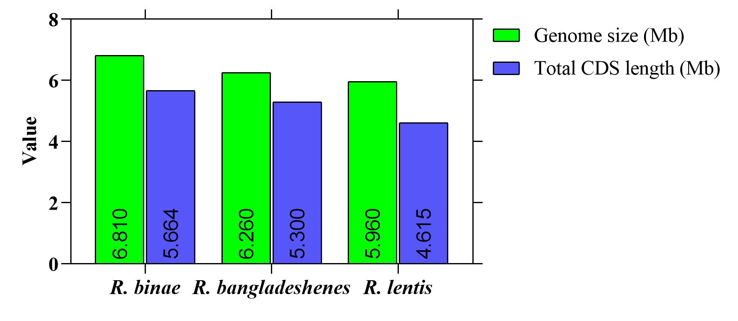
Supplementary Figure 1. Genome size and CDS counts from annotated genome of three strains.
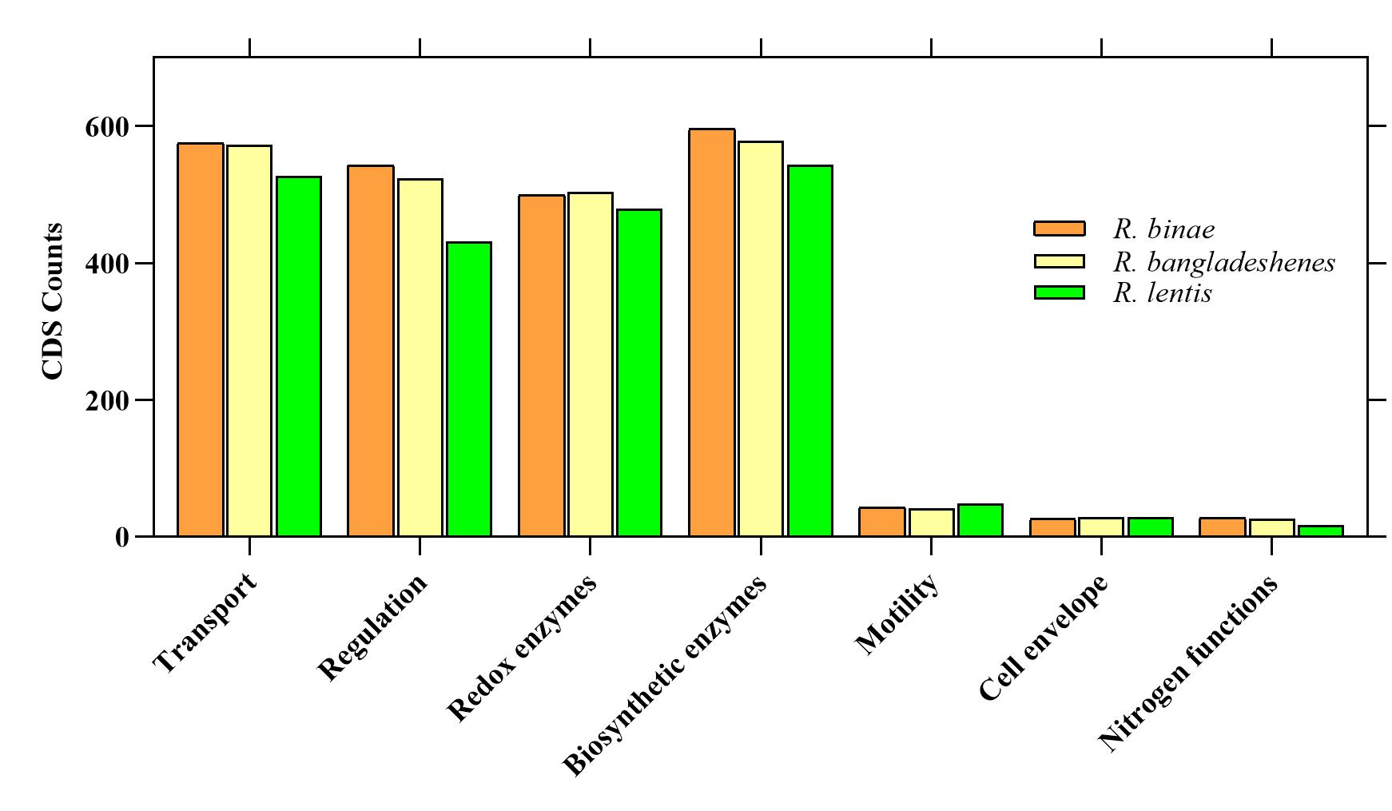
Supplementary Figure 2. Functional categories of annotated genes.

