Supporting Information
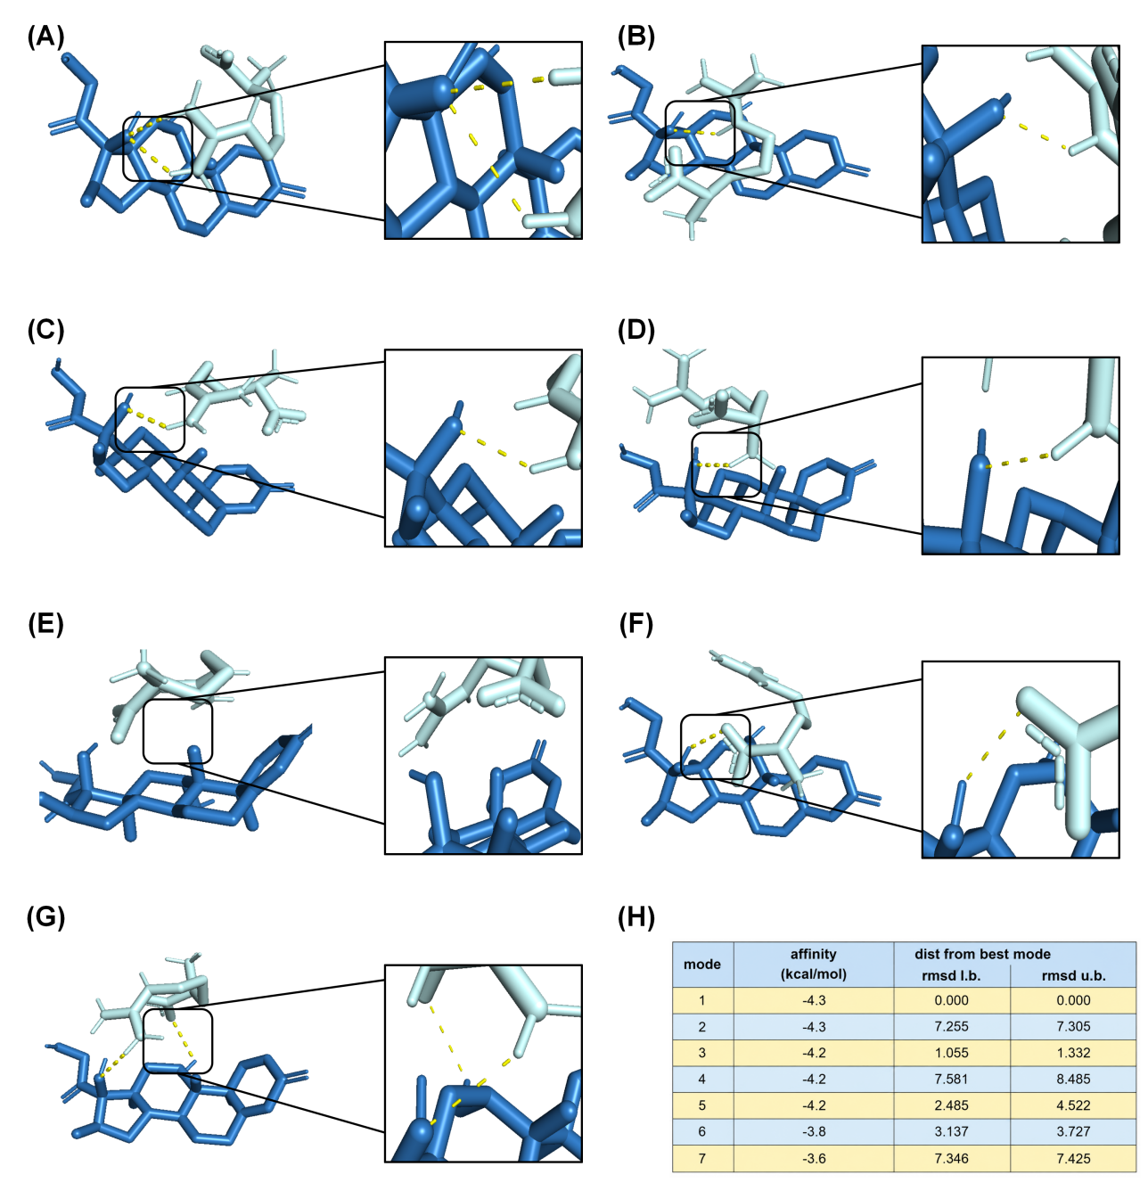
Figure S1. Molecular docking analysis of the interactions between arginine and dexamethasone. (A–G) Representative binding conformations of arginine and dexamethasone predicted by molecular docking. The enlarged panels highlight the intermolecular hydrogen-bonding interactions (yellow dashed lines) formed between the two molecules in different docking poses. Arginine and dexamethasone are displayed as stick models in different colors for visual distinction. (H) Docking scores of the seven predicted binding modes, including binding affinity (kcal mol⁻¹), root-mean-square deviation (RMSD) from the best-scoring pose, and upper-bound RMSD values. The lowest-energy docking conformation exhibited a binding affinity of −4.3 kcal mol⁻¹, suggesting that hydrogen bonding contributes to the intermolecular interaction between arginine and dexamethasone and may facilitate their self-assembly.

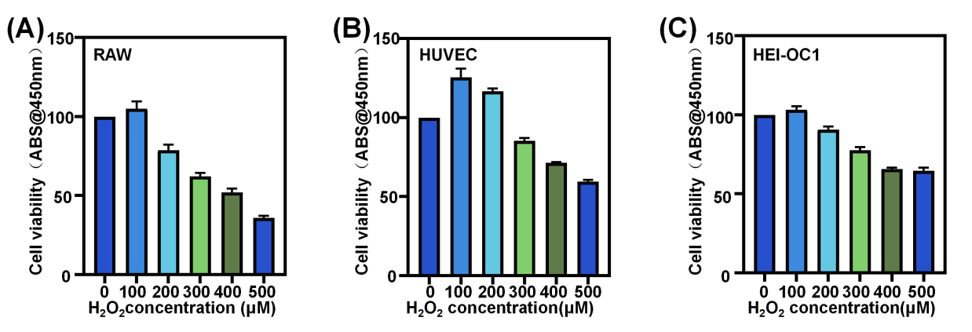
Figure S2. Optimization of H₂O₂ concentration for establishing oxidative stress models in different cell types.(A–C) Cell viability of (A) RAW264.7 macrophages, (B) HUVECs, and (C) HEI-OC1 cells after exposure to increasing concentrations of H₂O₂ (0–500 μM) for 24 h, as determined by the CCK-8 assay. The results were used to determine the optimal H₂O₂ concentration for subsequent in vitro oxidative stress experiments. Data are presented as mean ± SD (n = 3).

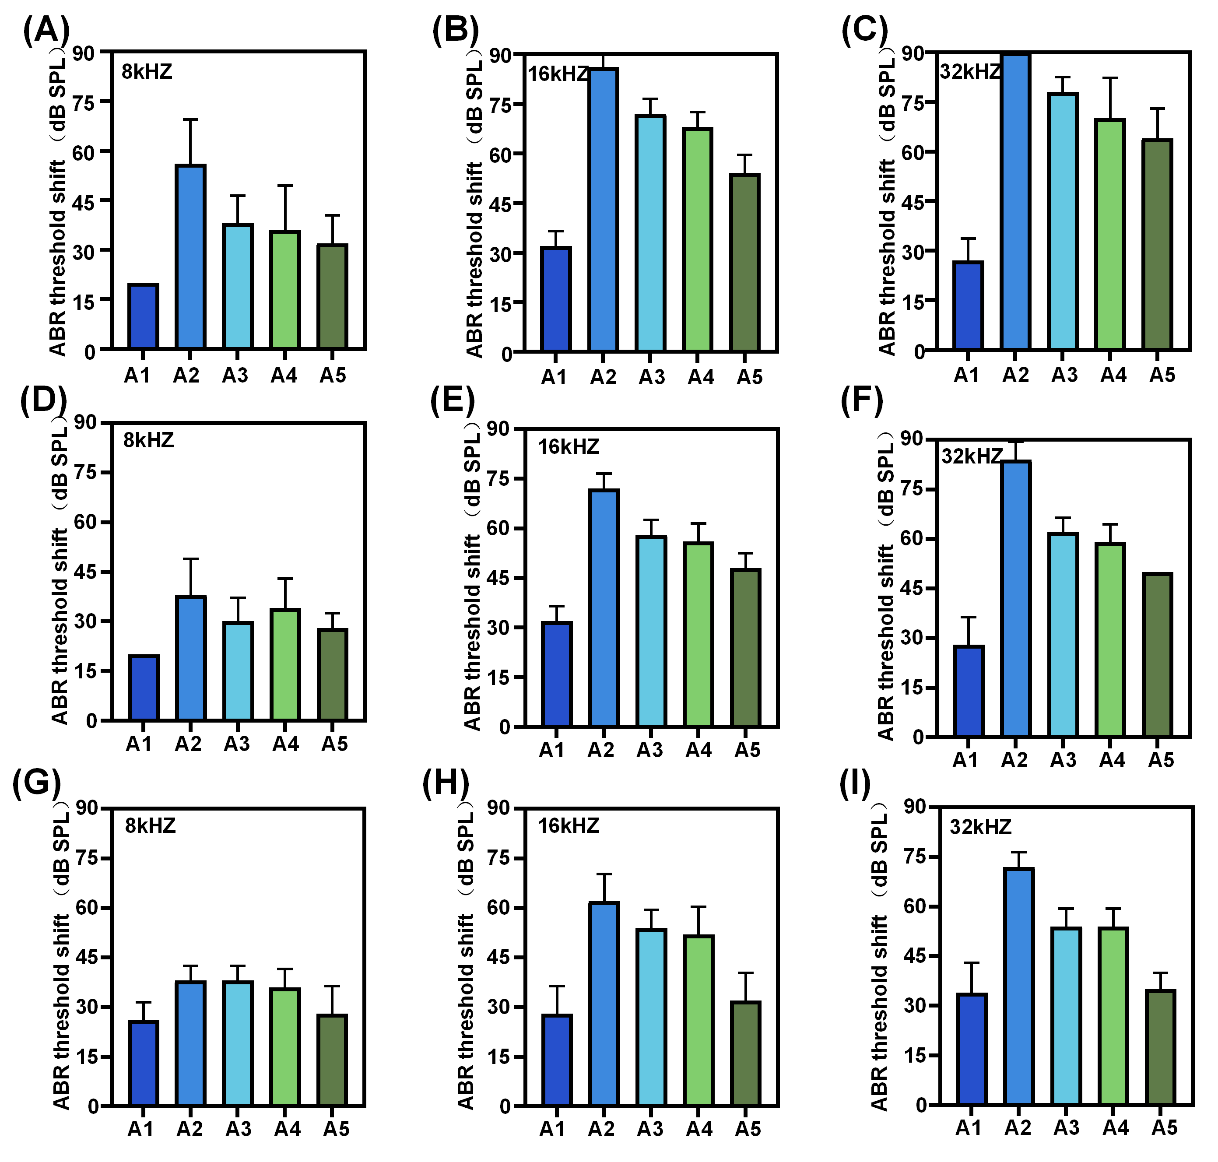
Figure S3. Quantitative analysis of ABR threshold shifts in noise-exposed mice at different time points after treatment. (A–C) ABR threshold shifts at 8, 16, and 32 kHz, respectively, on day 3 after noise exposure. (D–F) ABR threshold shifts at 8, 16, and 32 kHz, respectively, on day 7. (G–I) ABR threshold shifts at 8, 16, and 32 kHz, respectively, on day 14. Threshold shifts were calculated relative to pre-noise baseline hearing thresholds. Data are presented as mean ± SD (n = 5 mice per group). Statistical analyses were performed using one-way ANOVA followed by Tukey's multiple comparisons test.

