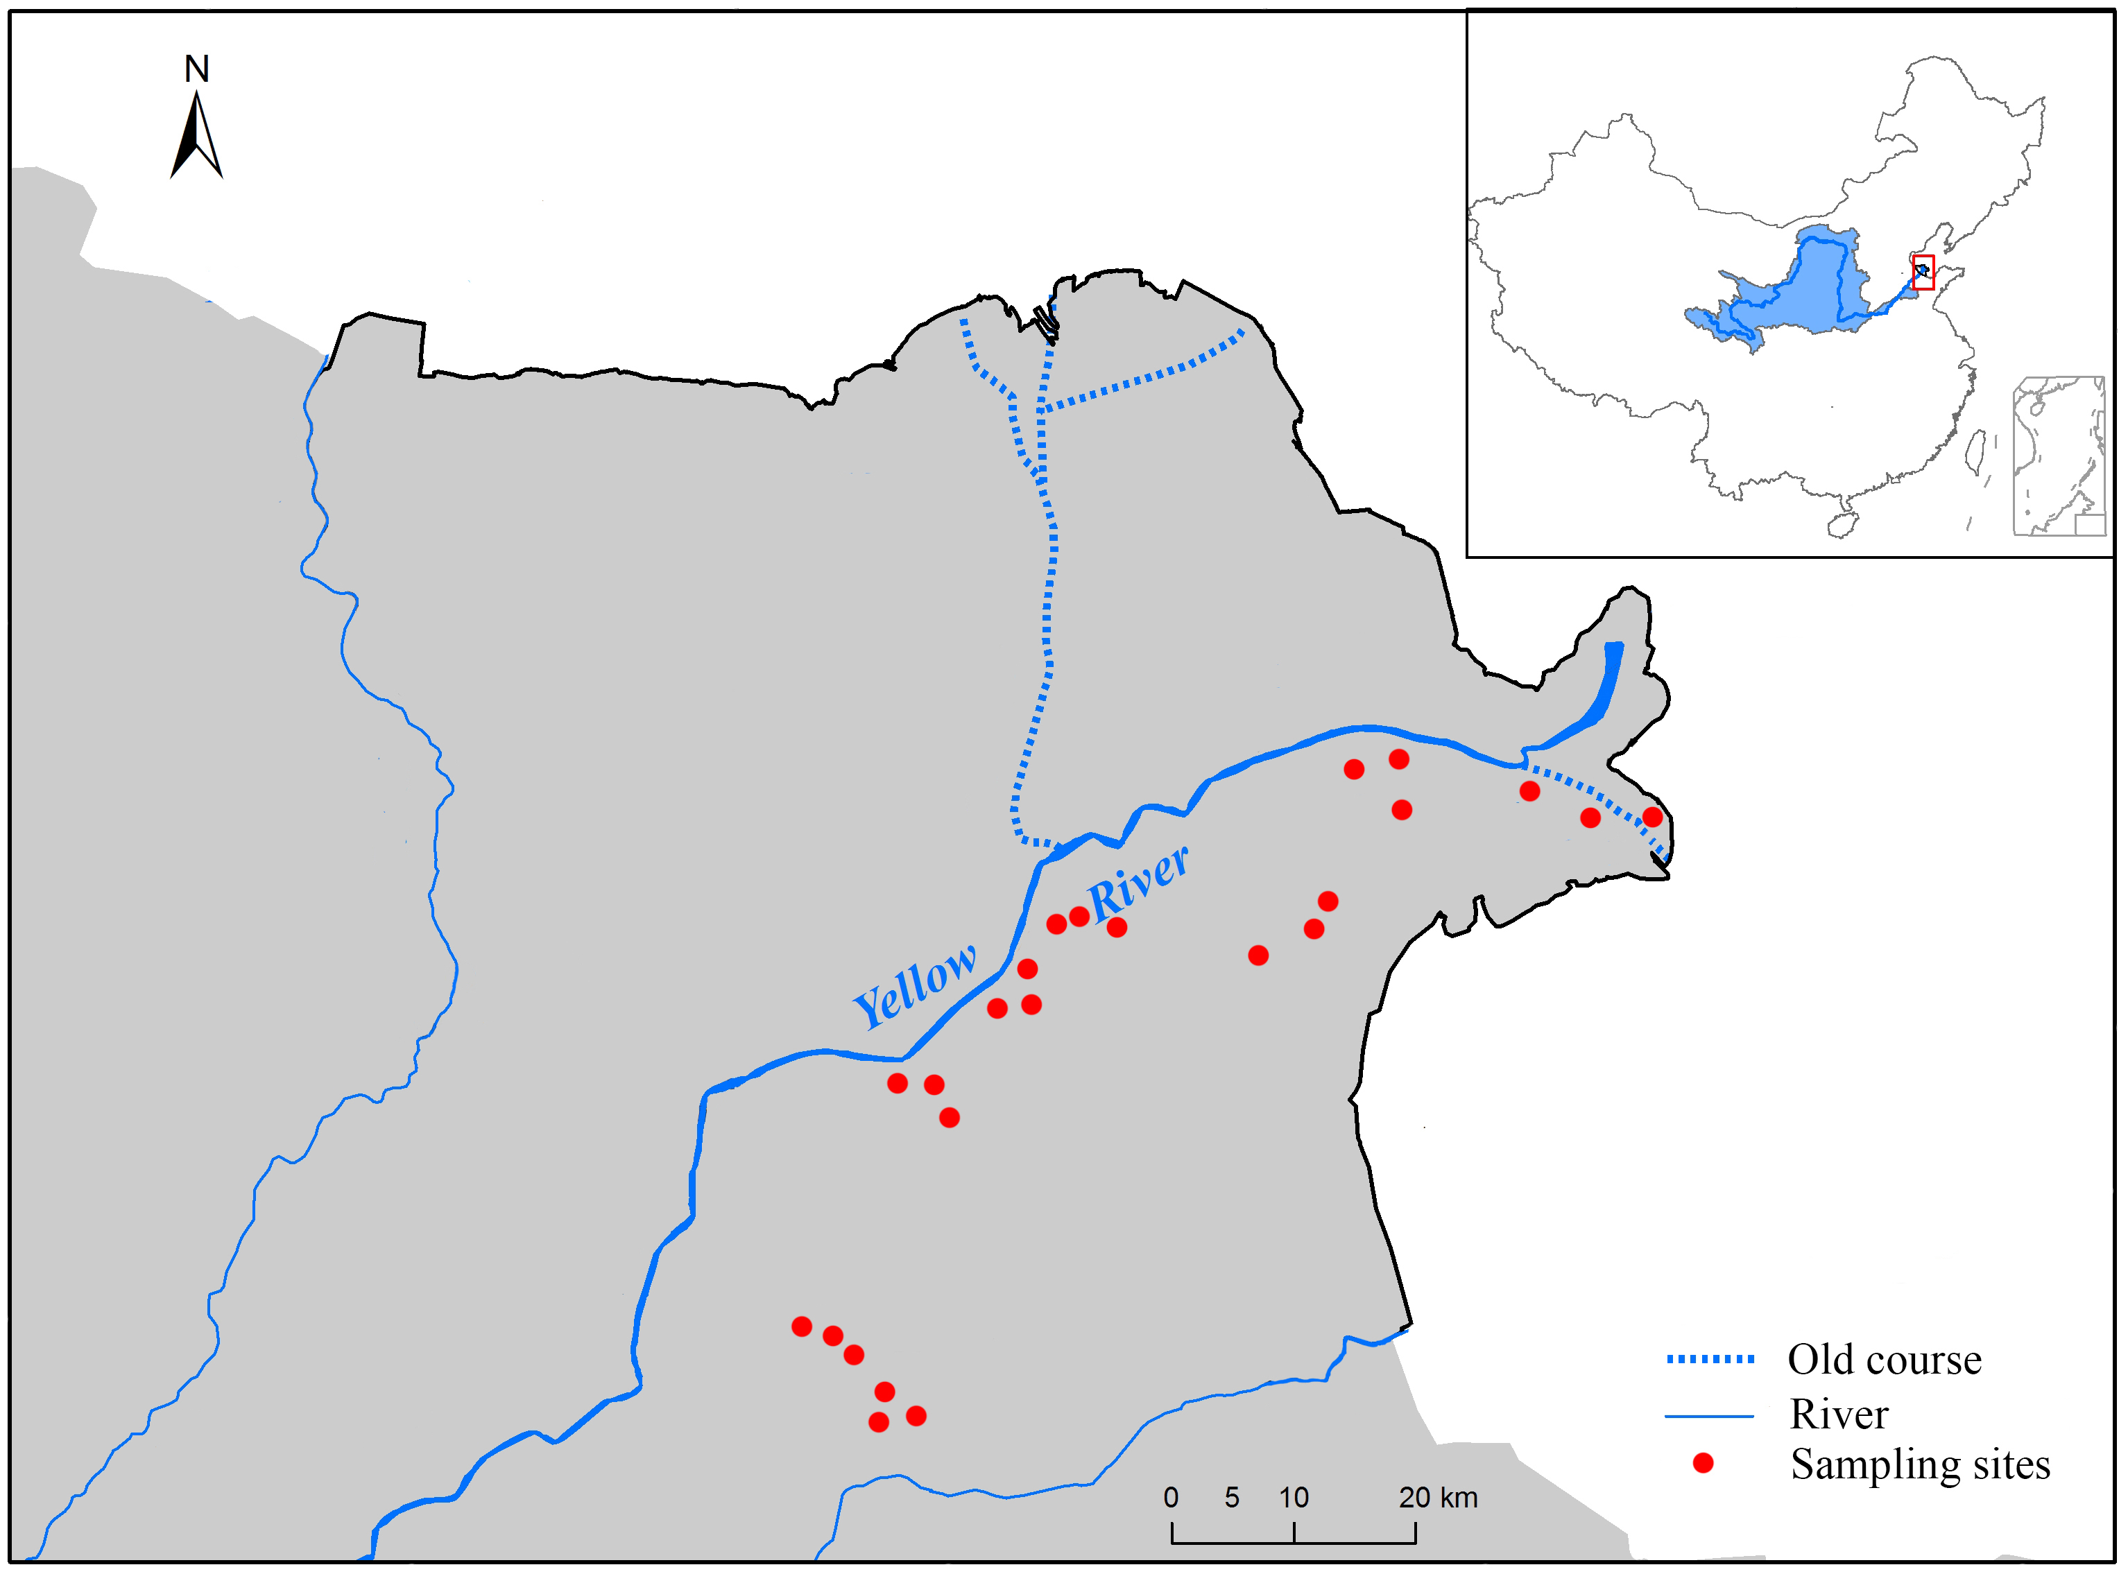
Figure S1. Sites of Melilotus officinalis populations sampled in the Yellow River Delta, China.

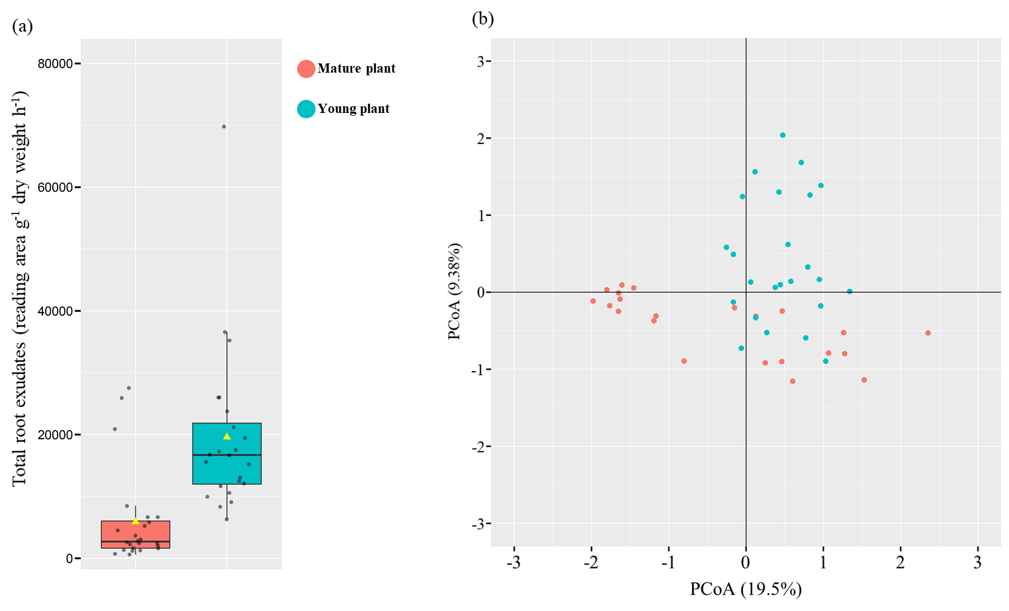
Figure S2. (a) Total quantity and (b) the composition of root exudates of mature and young plants of Melilotus officinalis collected from 24 sites.

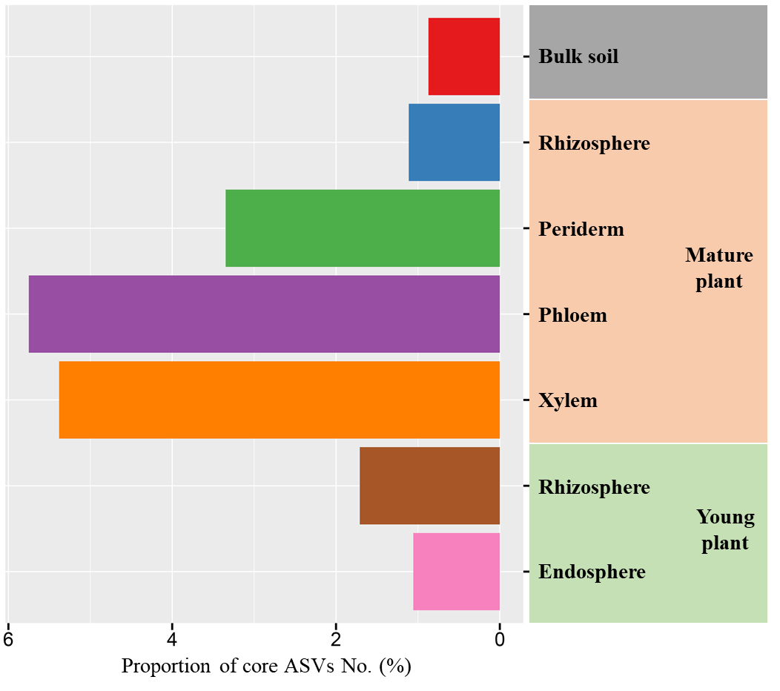
Figure S3. Proportion of unique core ASVs as a percentage of the total number of detected ASVs for bulk soil, and root-associated microhabitats of mature plants (rhizosphere, periderm, phloem and xylem) and young plants (rhizosphere and endosphere).

Table S1. Sampling locations and properties of soils from which Melilotus officinalis plants were collected. Data of soil properties are presented as mean ± standard error.
Site ID | Longitude (º) | Latitude (º) | Total N (%) | Organic C (%) | Total P (%) | Total K (%) | pH | EC (mS/m) | Sand (%)
Site01 | 118.647 | 37.299 | 0.0830±0.00102 | 2.02±0.052 | 0.189±0.0052 | 4.09±0.042 | 7.35±0.154 | 26.1±1.07 | 70.7±1.59
Site02 | 118.645 | 37.298 | 0.0825±0.00127 | 1.85±0.107 | 0.157±0.0059 | 3.67±0.102 | 7.22±0.230 | 25.0±0.89 | 74.1±3.42
Site03 | 118.6477 | 37.301 | 0.0822±0.00155 | 2.16±0.056 | 0.230±0.0069 | 4.59±0.063 | 7.37±0.155 | 25.8±0.38 | 70.2±2.07
Site04 | 118.6399 | 37.343 | 0.0400±0.00104 | 1.33±0.069 | 0.101±0.0012 | 1.38±0.018 | 8.01±0.183 | 49.2±1.16 | 79.1±2.24
Site05 | 118.632 | 37.343 | 0.0351±0.000405 | 1.34±0.036 | 0.113±0.0020 | 1.14±0.026 | 8.03±0.249 | 50.3±1.12 | 74.5±2.54
Site06 | 118.635 | 37.350 | 0.0443±0.00123 | 1.59±0.037 | 0.101±0.0015 | 1.43±0.015 | 8.03±0.324 | 49.7±2.60 | 73.4±3.59
Site07 | 118.873 | 37.620 | 0.0229±0.000466 | 1.27±0.027 | 0.131±0.0060 | 1.76±0.076 | 8.19±0.212 | 72.0±2.81 | 68.1±3.75
Site08 | 118.881 | 37.621 | 0.0263±0.000642 | 1.45±0.036 | 0.154±0.0049 | 1.95±0.084 | 7.51±0.172 | 79.6±2.15 | 67.6±1.74
Site09 | 118.869 | 37.625 | 0.022±0.000191 | 1.50±0.015 | 0.136±0.0066 | 1.82±0.050 | 8.11±0.262 | 74.6±2.38 | 67.4±1.00
Site10 | 118.598 | 37.527 | 0.0500±0.000748 | 1.36±0.040 | 0.0391±0.00110 | 1.66±0.072 | 8.09±0.206 | 203±9.5 | 66.6±1.92
Site11 | 118.600 | 37.535 | 0.0496±0.000847 | 1.44±0.022 | 0.0354±0.00087 | 1.36±0.008 | 7.60±0.222 | 210±5.8 | 58.9±1.82
Site12 | 118.602 | 37.542 | 0.0454±0.000662 | 1.24±0.029 | 0.0316±0.00077 | 1.51±0.079 | 7.86±0.083 | 208±4.1 | 65.1±1.27
Site13 | 118.893 | 37.744 | 0.0757±0.00148 | 2.00±0.058 | 0.0905±0.00195 | 1.70±0.098 | 7.93±0.104 | 97.1±2.41 | 69.0±1.65
Site14 | 118.913 | 37.757 | 0.0809±0.00174 | 1.65±0.029 | 0.101±0.0026 | 1.72±0.066 | 7.66±0.158 | 97.7±3.10 | 70.8±0.64
Site15 | 118.873 | 37.765 | 0.0761±0.00399 | 2.09±0.033 | 0.0788±0.00308 | 1.34±0.018 | 7.49±0.259 | 100±3.6 | 70.8±1.28
Site16 | 118.702 | 37.686 | 0.0435±0.00150 | 1.40±0.017 | 0.0782±0.00390 | 1.76±0.042 | 7.75±0.406 | 97±1.8 | 76.1±2.03
Site17 | 118.704 | 37.681 | 0.0522±0.000301 | 1.37±0.009 | 0.0806±0.00233 | 1.74±0.086 | 7.75±0.379 | 99.9±1.49 | 76.4±2.12
Site18 | 118.708 | 37.690 | 0.0462±0.00129 | 1.12±0.040 | 0.0825±0.00142 | 1.83±0.055 | 7.72±0.289 | 99.6±3.89 | 76.6±3.62
Site19 | 119.063281 | 37.76338 | 0.0436±0.00103 | 1.28±0.029 | 0.0758±0.00242 | 1.56±0.076 | 7.61±0.186 | 143±2.4 | 70.4±1.42
Site20 | 119.051640 | 37.76688 | 0.0362±0.00106 | 1.21±0.024 | 0.088±0.00336 | 1.75±0.086 | 8.57±0.256 | 136±3.9 | 72.5±1.62
Site21 | 119.069429 | 37.76905 | 0.0424±0.00103 | 1.29±0.045 | 0.0828±0.00174 | 1.81±0.031 | 8.25±0.109 | 141±3.3 | 72.8±1.42
Site22 | 118.621433 | 37.62785 | 0.0493±0.00103 | 1.35±0.056 | 0.0759±0.00152 | 1.55±0.052 | 7.47±0.198 | 123±2.2 | 64.0±1.34
Site23 | 118.615800 | 37.63257 | 0.0446±0.00120 | 1.24±0.031 | 0.0670±0.00091 | 1.23±0.030 | 8.10±0.164 | 118±3.6 | 63.3±1.72
Site24 | 118.629126 | 37.62646 | 0.0639±0.00166 | 1.31±0.031 | 0.0664±0.00115 | 1.42±0.035 | 7.79±0.160 | 121±5.9 | 67.7±2.18

Table S2. Similarity percentage analysis (SIMPER) on Bray-Curtis distance to identify the contribution of each ASV to the dissimilarity of microbiome composition between two neighbouring niches in the root of mature plant, including (a) Bulk soil vs Rhizosphere, (b) Rhizosphere vs Periderm, (c) Periderm vs Phloem, and (d) Phloem vs Xylem. Only the top five contributors in two pairwise comparisons were present.

(a) Bulk soil vs Rhizosphere
Top 5  contributor | Contribution % | Mean abundance % |  | Change from  the outer to  inner niche | Taxon
Top 5  contributor | Contribution % | Bulk soil | Rhizosphere | Change from  the outer to  inner niche | Taxon
ASV0 | 1.12 | 0.09 | 2.51 | Increase | Ensifer spp. (Proteobacteria)
ASV8 | 1.08 | 0.89 | 2.21 | Increase | Pantoea spp. (Proteobacteria)
ASV37 | 0.95 | 2.30 | 1.61 | Decrease | Isoptericola spp. (Actinobacteria)
ASV134 | 0.95 | 1.73 | 1.23 | Decrease | unclassified Vicinamibacterales (Acidobacteriota)
ASV1 | 0.73 | 0.89 | 1.30 | Increase | Arthrobacter spp. (Actinobacteria)
(b) Rhizosphere vs Periderm
Top 5  contributor | Contribution % | Mean abundance % |  | Change from  the outer to  inner niche | Taxon
Top 5  contributor | Contribution % | Rhizosphere | Periderm | Change from  the outer to  inner niche | Taxon
ASV0 | 5.72 | 2.51 | 15.69 | Increase | Ensifer spp. (Proteobacteria)
ASV3 | 5.46 | 1.21 | 14.23 | Increase | Kineosporia spp. (Actinobacteria)
ASV10 | 4.22 | 0.42 | 10.49 | Increase | Azohydromonas spp. (Proteobacteria)
ASV6 | 1.55 | 1.11 | 5.05 | Increase | Allorhizobium-Neorhizobium-Pararhizobium-Rhizobium spp. (Proteobacteria)
ASV8 | 1.24 | 2.21 | 0.13 | Decrease | Pantoea spp. (Proteobacteria)
(c) Periderm vs Phloem
Top 5  contributor | Contribution % | Mean abundance % |  | Change from  the outer to  inner niche | Taxon
Top 5  contributor | Contribution % | Periderm | Phloem | Change from  the outer to  inner niche | Taxon
ASV0 | 15.53 | 15.69 | 0.80 | Decrease | Ensifer spp. (Proteobacteria)
ASV3 | 13.97 | 14.23 | 12.06 | Decrease | Kineosporia spp. (Actinobacteria)
ASV10 | 10.38 | 10.49 | <0.01 | Decrease | Azohydromonas spp. (Proteobacteria)
ASV6 | 4.98 | 5.05 | 1.63 | Decrease | Allorhizobium-Neorhizobium-Pararhizobium-Rhizobium spp. (Proteobacteria)
ASV7 | 3.76 | 3.82 | 1.96 | Decrease | Streptomyces spp. (Actinobacteria)
(d) Phloem vs Xylem
Top 5  contributor | Contribution % | Mean abundance % |  | Change from  the outer to  inner niche | Taxon
Top 5  contributor | Contribution % | Phloem | Xylem | Change from  the outer to  inner niche | Taxon
ASV3 | 6.18 | 12.06 | 2.41 | Decrease | Kineosporia spp. (Actinobacteria)
ASV6852 | 2.58 | 4.34 | <0.01 | Decrease | unclassified Comamonadaceae (Proteobacteria)
ASV0 | 2.06 | 0.80 | 6.21 | Increase | Ensifer spp. (Proteobacteria)
ASV465 | 1.86 | 3.14 | <0.01 | Decrease | unclassified Actinomycetaceae (Actinobacteria)
ASV1207 | 1.68 | 0.21 | 4.37 | Increase | hgcI clade (Actinobacteriota)

Table S3. Similarity percentage analysis (SIMPER) on Bray-Curtis distance to identify the contribution of each ASV to the dissimilarity of microbiome composition between two neighbouring niches in the root of young plant, including (a) Bulk soil vs Rhizosphere, and (b) Rhizosphere vs endosphere. Only the top five contributors in two pairwise comparisons were present.

(a) Bulk soil vs Rhizosphere
Top 5  contributor | Contribution % | Mean abundance % |  | Change from the outer to inner niche | Taxon
Top 5  contributor | Contribution % | Bulk soil | Rhizosphere | Change from the outer to inner niche | Taxon
ASV134 | 1.08 | 1.73 | 1.87 | Increase | unclassified Vicinamibacterales (Acidobacteriota)
ASV37 | 0.94 | 2.30 | 1.94 | Decrease | Isoptericola spp. (Actinobacteria)
ASV42 | 0.60 | 1.28 | 1.18 | Decrease | unclassified Vicinamibacteraceae (Acidobacteriota)
ASV7 | 0.59 | 0.99 | 0.85 | Decrease | Streptomyces spp. (Actinobacteria)
ASV47 | 0.51 | 0.81 | 0.61 | Decrease | RB41 spp. (Acidobacteriota)
(b) Rhizosphere vs Endosphere
Top 5  contributor | Contribution % | Mean abundance % |  | Change from the outer to inner niche | Taxon
Top 5  contributor | Contribution % | Rhizosphere | Endosphere | Change from the outer to inner niche | Taxon
ASV0 | 3.85 | 0.10 | 30.79 | Increase | Ensifer spp. (Proteobacteria)
ASV37 | 1.69 | 1.94 | <0.01 | Decrease | Isoptericola spp. (Actinobacteria)
ASV134 | 1.63 | 1.87 | <0.01 | Decrease | unclassified Vicinamibacterales (Acidobacteriota)
ASV42 | 1.03 | 1.18 | <0.01 | Decrease | unclassified Vicinamibacteraceae (Acidobacteriota)
ASV3 | 0.93 | 0.02 | 6.95 | Increase | Kineosporia spp. (Actinobacteria)

Table S4. Chemical analysis of cell wall components in root compartments of Melilotus officinalis collected from 24 sites. Data are presented as mean ± standard error. n.d. means not detected
 | Total cell wall (%) |  |  |  | Lignin (%) |  |  |  | Cellulose (%)
 | Mature plant |  |  | Young plant | Mature plant |  |  | Young plant | Mature plant |  |  | Young plant
Site ID | Periderm | Phloem | Xylem | Root | Periderm | Phloem | Xylem | Root | Periderm | Phloem | Xylem | Root
Site01 | 45.1±6.8 | 55.0±6.2 | 70.7±5.9 | 20.9±3.3 | 5.57±0.37 | 11.58±1.16 | 22.1±1.8 | 0.38±0.057 | 13.5±1.3 | 15.3±1.2 | 21.8±1.0 | 8.1±0.5
Site02 | 44.8±0.5 | 54.9±7.4 | 68.5±5.0 | 47.4±4.4 | 3.44±0.32 | 12.32±0.43 | 20.5±1.9 | 0.08±0.011 | 15.4±1.4 | 16.1±2.2 | 20.3±2.5 | 12.4±1.5
Site03 | 48.8±5.7 | 56.6±10.2 | 74.8±4.5 | 34.5±4.0 | 6.34±0.60 | 8.25±1.16 | 21.8±3.0 | 0.20±0.019 | 16.3±2.0 | 19.5±2.0 | 24.0±2.2 | 13.6±0.8
Site04 | 42.8±4.7 | 53.3±5.4 | 74.1±10.9 | 20.6±1.8 | 3.48±0.36 | 8.71±0.35 | 23.0±0.5 | 0.11±0.012 | 12.9±0.7 | 18.0±2.0 | 21.5±2.1 | 10.7±0.5
Site05 | 46.9±3.3 | 59.5±1.0 | 71.1±4.8 | 34.9±3.5 | 6.72±0.73 | 13.93±0.82 | 20.6±1.6 | 0.49±0.026 | 13.4±1.3 | 17.4±1.2 | 21.7±4.0 | 11.4±1.1
Site06 | 42.7±6.6 | 55.3±5.8 | 70.6±5.7 | 48.3±6.6 | 4.05±0.44 | 8.36±0.78 | 19.8±2.4 | 0.36±0.040 | 13.5±0.9 | 19.6±2.4 | 24.6±2.3 | 10.0±0.9
Site07 | 48.3±1.7 | 59.7±6.0 | 76.0±2.3 | 36.1±1.9 | 6.57±0.82 | 13.01±1.59 | 28.1±4.5 | 0.05±0.0054 | 15.8±0.8 | 19.2±1.8 | 21.9±1.8 | 9.6±1.0
Site08 | 47.2±5.2 | 55.4±5.3 | 75.5±5.0 | 44.8±7.8 | 6.06±0.61 | 9.33±0.56 | 26.3±2.6 | 0.68±0.014 | 13.9±1.5 | 18.7±2.0 | 20.4±4.0 | 14.0±2.1
Site09 | 44.9±4.5 | 54.0±4.4 | 75±4.6 | 36.2±4.5 | 4.77±0.42 | 9.89±0.91 | 26.8±3.9 | 0.24±0.026 | 14.3±2.0 | 16.0±2.9 | 23.0±2.3 | 8.5±0.8
Site10 | 42.9±3.7 | 54.6±7.8 | 71.6±12.6 | 37.1±4.3 | 3.41±0.23 | 10.27±1.11 | 22.6±1.2 | 0.70±0.057 | 15.1±1.5 | 16.9±1.7 | 23.7±2.3 | 9.3±0.7
Site11 | 47.3±6.4 | 59.1±2.0 | 70.1±6.7 | 22.5±4.1 | 6.15±0.40 | 12.00±0.66 | 19.3±1.9 | 0.05±0.0032 | 13.6±0.9 | 19.2±1.3 | 23.4±4.2 | 8.7±0.8
Site12 | 45.0±1.4 | 57.1±0.7 | 72.5±9.0 | 47.3±1.9 | 5.44±0.84 | 13.51±1.51 | 24.4±2.1 | 0.66±0.098 | 13.8±1.2 | 15.4±1.3 | 19.9±2.0 | 12.3±1.1
Site13 | 45.3±5.6 | 53.5±3.3 | 73.1±4.7 | 48.2±7.0 | 4.15±0.51 | 9.60±0.99 | 25.5±0.8 | 0.04±0.0042 | 14.6±1.5 | 17.8±2.6 | 20.1±1.4 | 7.8±0.5
Site14 | 46.8±4.2 | 53.2±7.1 | 73.6±7.0 | 44.8±4.5 | 6.42±0.65 | 8.08±0.78 | 25.3±1.7 | 0.57±0.050 | 14.2±1.1 | 17.0±1.3 | 24.4±1.6 | 14.0±1.4
Site15 | 45.3±3.3 | 54.1±4.7 | 72±5.8.2 | 35.8±3.1 | 4.70±0.22 | 8.90±0.89 | 21.3±3.3 | 0.55±0.056 | 15.4±0.5 | 16.8±1.7 | 24.4±2.1 | 8.5±0.5
Site16 | 46.4±5.1 | 57.0±6.1 | 72.4±8.1 | 29.5±1.4 | 4.58±0.37 | 13.58±1.60 | 24.8±2.1 | 0.31±0.026 | 16.6±1.4 | 17.1±1.9 | 20.8±3.0 | 14.9±2.5
Site17 | 44.7±7.0 | 54.9±8.4 | 75.0±5.3 | 46.3±2.3 | 5.22±0.51 | 9.32±1.12 | 22.9±2.5 | 0.41±0.047 | 15.3±2.8 | 18.3±1.8 | 24.1±2.3 | 9.9±1.1
Site18 | 45.6±8.4 | 56.3±6.2 | 75.5±0.8 | 35.7±5.6 | 3.79±0.38 | 9.04±0.54 | 22.9±1.9 | 0.20±0.019 | 16.7±1.5 | 19.4±1.8 | 23.6±1.4 | 9.8±1.1
Site19 | 43.5±3.7 | 55.5±4.8 | 73.1±6.9 | 30.1±6.0 | 3.23±0.22 | 11.80±0.18 | 25.5±2.8 | 0.28±0.023 | 13±0.3.0 | 16.7±2.9 | 20.1±2.2 | 7.6±0.5
Site20 | 50.1±4.8 | 52.7±7.9 | 77.4±6.5 | 44.7±4.3 | 5.02±0.43 | 9.83±0.49 | 28.3±1.7 | 0.43±0.024 | 16.6±0.7 | 15.7±0.2 | 21.7±2.2 | 12.6±0.9
Site21 | 44.5±3.0 | 56.7±4.6 | 72.6±5.5 | 49.6±3.2 | 4.87±0.27 | 12.53±1.19 | 22.8±1.6 | 0.14±0.0086 | 13.2±1.8 | 16.1±2.1 | 22.3±2.1 | 10.0±0.8
Site22 | 43.0±1.4 | 53.1±3.2 | 72.1±10.9 | 48±3.6.0 | 3.20±0.10 | 8.09±0.96 | 21.7±0.5 | 0.27±0.0087 | 13.2±0.3 | 16.9±2.6 | 24.1±3.1 | 13.0±2.0
Site23 | 46.2±2.6 | 60.1±6.2 | 70.2±9.7 | 27.8±3.9 | 6.28±0.82 | 12.26±2.33 | 22.9±0.8 | 0.56±0.11 | 13.2±0.5 | 19.2±2.4 | 21.0±1.4 | 11.6±1.1
Site24 | 42.4±4.4 | 56.0±6.3 | 72.2±5.8 | 34.8±2.9 | 4.65±0.34 | 9.09±0.91 | 19.6±0.7 | n.d. | 14.3±0.9 | 18.4±0.5 | 24.3±1.8 | 10.0±0.9
Mean | 45.4 | 55.7 | 72.9 | 37.7 | 4.92 | 10.6 | 23.3 | 0.32 | 14.5 | 17.5 | 22.4 | 10.8

