SUPPLEMENTARY MATERIAL

First community mental health contact after youth justice supervision among adolescents in New South Wales, Australia: timing, setting, and association with reincarceration in a population-based data-linkage study

Contents
Supplementary Methods
Supplementary Figure 1. Cohort flow from the linked cohort to the complete-case analytic samples
Supplementary Table 1. Linked data sources and record types
Supplementary Table 2. Operational definitions of key study variables
Supplementary Table 3. Classification of mental health disorders with ICD-10-AM and ICD-9 codes
Supplementary Figure 2. Directed acyclic graph informing covariate selection for the time-to-contact analyses
Supplementary Figure 3. Directed acyclic graph informing covariate selection for the reincarceration analyses
Supplementary Table 4. Missing data in the full cohort and the cohort with a history of mental health disorder
Supplementary Table 5. Complete-case analytic sample compared with excluded adolescents with a history of mental health disorder
Supplementary Table 6. Proportional-hazards diagnostics from Cox model scaled Schoenfeld residual tests
Supplementary Table 7. Flexible parametric model selection: alternative time-varying-effect specifications
Supplementary Table 8. Sensitivity analysis excluding source of ascertainment: time-fixed and time-varying associations
Supplementary Table 9. Spline sensitivity for age and prior offence count
Supplementary Table 10. Post-baseline justice outcomes, by history of mental health disorder
Supplementary Table 11. Post-baseline justice outcomes among adolescents with a history of mental health disorder, by hierarchical custody status
Supplementary Table 12. Construction of the custody-release landmark analytic samples among adolescents with a history of mental health disorder
Supplementary Table 13. Landmark models of early mental health contact and reincarceration among adolescents released from custody: full specification detail
Supplementary Table 14. Cumulative mental health contact within 14 custody-free days to 24 custody-free months after baseline, by history of mental health disorder and supervision status
Supplementary Table 15. Follow-up for adolescents without a history of mental health disorder at baseline
Supplementary Table 16. Time to first community mental health contact among adolescents without a history of mental health disorder at baseline
Supplementary Table 17. Proportional-hazards diagnostics for the no-disorder time-to-contact model
Supplementary Table 18. Baseline spline selection for the no-disorder time-to-contact model
Supplementary Table 19. Continuity-of-care cascade after baseline or release, by history of mental health disorder

SUPPLEMENTARY METHODS
Data sources and linkage
The cohort was assembled from four total-population surveys of justice-involved young people in New South Wales and linked to routinely collected health, justice, opioid agonist treatment (OAT), and mortality records. Linkage was performed by the Centre for Health Record Linkage using probabilistic methods, with an estimated false-positive linkage rate below 0.5%. Data sources and availability windows are listed in Supplementary Table 1.
Mental health diagnoses and contacts were identified from ICD-10-AM codes recorded in admitted-patient, ambulatory mental health, and emergency collections, with equivalent ICD-9 codes applied to earlier records. Emergency department presentations recorded using SNOMED-CT were mapped to ICD-10-AM classifications using the standard crosswalk maintained by the data custodian. Diagnostic code groupings are provided in Supplementary Table 3.
Cohort and baseline
The linked cohort comprised 1,589 young people. Baseline was the survey date for young people surveyed in the community and the release date for young people surveyed in custody. History of mental health disorder was defined by a mental health diagnosis recorded at or before baseline, a self-reported mental health condition at survey, or both. Source of ascertainment was classified as health-record diagnosis only, self-report only, or both health-record diagnosis and self-report.
Continuity-of-care cascade
The cascade was measured separately for adolescents with and without a history of mental health disorder. Indicators included mental health contact within 7, 14, 30, and 90 days of baseline, any contact by 12 and 24 months, no recorded contact by 24 months, first-contact setting within 24 months, and contact with more than one service type within 24 months.
Cascade percentages used the relevant cohort denominator. First-contact setting was mutually exclusive and was assigned from the earliest qualifying record within 24 months. Service-source indicators were not mutually exclusive, so a young person could contribute to more than one service type. Psychiatric hospital admission included both voluntary and involuntary admissions. Operational definitions are provided in Supplementary Table 2.
Time-to-contact model
Among adolescents with a history of mental health disorder, time to first community mental health contact was modelled over 24 months. Time at risk accrued only while the young person was in the community. Periods spent in custody after baseline were removed from follow-up time, and follow-up resumed at release. Adolescents without a community contact were censored at 730 custody-free days or at death. Mental health contacts recorded during custody were excluded from this model.
Cox proportional-hazards diagnostics showed evidence against proportional hazards (Supplementary Table 6). Royston-Parmar flexible parametric survival models were therefore fitted on the log cumulative-hazard scale. Candidate models varied the baseline spline and time-varying effects and were compared using the Akaike information criterion, the Bayesian information criterion, and likelihood-ratio tests (Supplementary Table 7). The primary model retained time-varying effects for baseline supervision status, sex, and behavioural disorder. Full model estimates are reported in the main text. Sensitivity analyses excluded source of ascertainment and modelled age and prior offence count using restricted cubic splines (Supplementary Tables 8 and 9).
Landmark analyses of early contact and reincarceration
Landmark analyses examined whether early mental health contact after release from custody was associated with later reincarceration among adolescents with a history of mental health disorder. The analyses were restricted to adolescents entering follow-up from custody because early contact was rare among those under community supervision. Landmarks were set at 7, 14, 21, and 28 days after release. At each landmark, young people were classified according to whether they had any qualifying mental health contact before that day. Young people reincarcerated before the landmark were excluded from that landmark analysis (Supplementary Table 12).
The outcome was reincarceration after the landmark and within 24 months of release. Relative risks were estimated using modified Poisson regression with robust standard errors, and adjusted risks and risk differences were estimated from the same adjusted models. Models adjusted for age, sex, Aboriginal and/or Torres Strait Islander status, SEIFA quartile, prior offence count, prior violent offence, baseline mental health disorder categories, self-harm history, and source of disorder ascertainment. Complete-case numbers were 373, 353, 341, and 335 across the 7-, 14-, 21-, and 28-day landmarks, respectively. Post-baseline justice outcomes are described in Supplementary Tables 10 and 11.

Supplementary Figure 1. Cohort flow from the linked cohort to the complete-case analytic samples
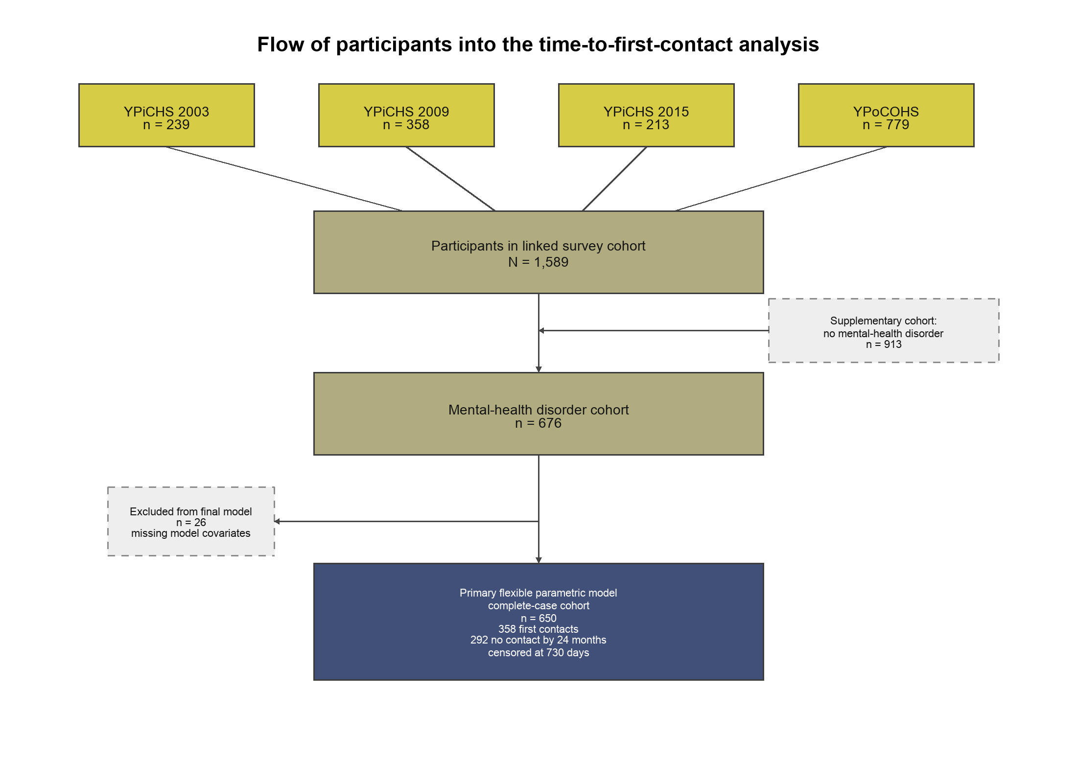

Supplementary Table 1. Linked data sources and record types
Data collection | Content used | Availability window
Young People on Community Orders Health Survey; Young People in Custody Health Surveys (2003, 2009, 2015) | Survey-based ascertainment of self-reported mental-health need/history and baseline characteristics | 2003-2005 (community); 2003, 2009, 2015 (custody)
NSW Bureau of Crime Statistics and Research Reoffending Database | Offence, court, custody, and community-order records | 1 Jan 1994-31 Dec 2024
NSW Bureau of Crime Statistics and Research custody records | Custody intervals used to compute custody-free follow-up and reincarceration | 1 Jan 1994-31 Dec 2024
NSW Admitted Patient Data Collection | Hospital mental-health contacts, psychiatric admissions, and same-day hospital episodes | 1 Jul 2001-30 Jun 2024
NSW Mental Health Ambulatory Data Collection | Community and outpatient mental-health contacts | 1 Jan 2001-31 Mar 2025
NSW Emergency Department Data Collection | Emergency mental-health presentations | 1 Jan 2005-30 Jun 2024
NSW Controlled Drugs Data Collection (CDDC) | Opioid agonist treatment contacts | 1 Jan 1999-28 Feb 2025
NSW Registry of Births, Deaths and Marriages | Death for censoring | 1 Jan 1985-31 Mar 2025
Windows are the availability periods used in the analytic data dictionary and linked-cohort documentation. Linkage was performed by the Centre for Health Record Linkage using probabilistic matching with an estimated false-positive linkage rate below 0.5%. Baseline diagnoses and covariates were ascertained from the earliest available record to baseline, with no fixed look-back restriction (lifetime to baseline), using the APDC, MH-AMB, EDDC, offence, custody, and survey records.

Supplementary Table 2. Operational definitions of key study variables
Variable | Definition
Baseline (time origin) | Survey date for young people surveyed in the community; release date for young people surveyed in custody.
History of mental health disorder | Mental-health diagnosis in linked records at or before baseline, self-reported mental-health condition at survey, or both.
Source of ascertainment | Health-record diagnosis only; self-report only; or health-record diagnosis and self-report.
Mental health contact | Earliest outpatient/community mental-health contact (MH-AMB), emergency mental-health presentation (EDDC), hospital mental-health contact including psychiatric admission or same-day hospital episode (APDC), or opioid agonist treatment contact from the NSW Controlled Drugs Data Collection (CDDC). Contacts were ascertained from ICD-10-AM codes; SNOMED-CT emergency codes were mapped to ICD-10-AM. Opioid agonist treatment was counted as a mental-health-relevant service contact for this population.
First-contact setting | The setting of the earliest linked contact within 24 months: outpatient mental-health contact; emergency presentation; same-day hospital episode; psychiatric hospital admission (voluntary or involuntary); or opioid agonist treatment. Categories are mutually exclusive and sum to the proportion with any contact. Voluntary and involuntary admission status is taken from the Mental Health Act legal-status field recorded in APDC.
Overlapping service-source use | Any contact within 24 months in each outpatient, emergency, hospital mental-health, and opioid agonist treatment source. A young person may contribute to more than one source.
Time-to-contact outcome | Custody-free community days from baseline to first community mental-health contact within 24 months; days spent in custody after baseline were removed from time at risk, and young people without a community contact were censored at 730 custody-free days or death.
Baseline custody/community status | Custody survey participants (baseline = release) compared with community-order survey participants (baseline = survey date).
Hierarchical custody status (landmark analyses) | Community order with no previous custody; community order with previous custody; custody at baseline/release.
Reincarceration | First return to custody after baseline (descriptive tables) or after the landmark (landmark models), ascertained from custody records.
Baseline mental-health indicators | Mood, anxiety, psychosis, behavioural, alcohol/substance, and trauma/stress disorders, plus self-harm history, ascertained at or before baseline.
Contact within 7, 14, 30, or 90 days | Mental health contact within 7, 14, 30, or 90 days of baseline/release, each threshold reported separately.
Longer-term mental health contact | Any mental health contact by 12 months and by 24 months after baseline/release.

Supplementary Table 3. Classification of mental health disorders with ICD-10-AM and ICD-9 codes
Disorder group | ICD-10-AM codes | ICD-9 codes
Disruptive / behavioural disorders (ADHD, conduct, mixed conduct-emotion) | F90, F91, F92 | 312.xx, 314.xx
Mood disorders | F32.0-.2, .8, .9; F33.0, .1, .4, .8, .9; F34 | 296.2x-296.5x, 300.4, 311
Anxiety disorders | F40, F41, F42 | 300.0, 300.2, 300.3
Trauma- and stress-related disorders | F43 | 308.x, 309.x
Psychosis | F20, F22-F25, F28, F29, F30.2, F31.2, F31.5, F32.3, F33.3, and substance-induced psychotic codes (F1x.5) | 295.x, 297.x, 298.x
Alcohol and substance use disorders | F10-F19 (.0-.4, .6-.9 by substance) | 291.x, 292.x, 303.x-305.x
Self-harm history | X60-X84, Y10-Y34, Y87.0 | E950-E959, E980-E989

Supplementary Figure 2. Directed acyclic graph informing covariate selection for the time-to-contact analyses
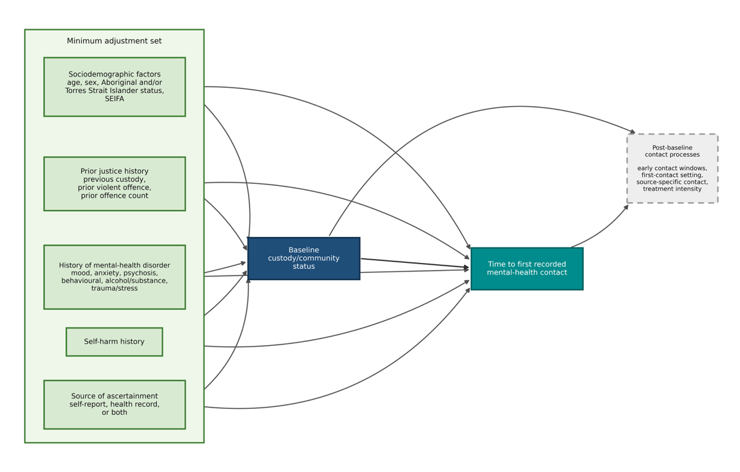
Exposure was baseline custody/community status, and the outcome was time to first recorded mental health contact within 24 months. Post-baseline service-contact variables were treated as outcomes or post-baseline consequences of baseline custody/community status and were not adjusted for. The minimal sufficient adjustment set comprised age, sex, Aboriginal and/or Torres Strait Islander status, SEIFA quartile, previous custody, prior violent offence, prior offence count, baseline mental health disorder indicators, self-harm history, and source of disorder ascertainment.

Supplementary Figure 3. Directed acyclic graph informing covariate selection for the reincarceration analyses
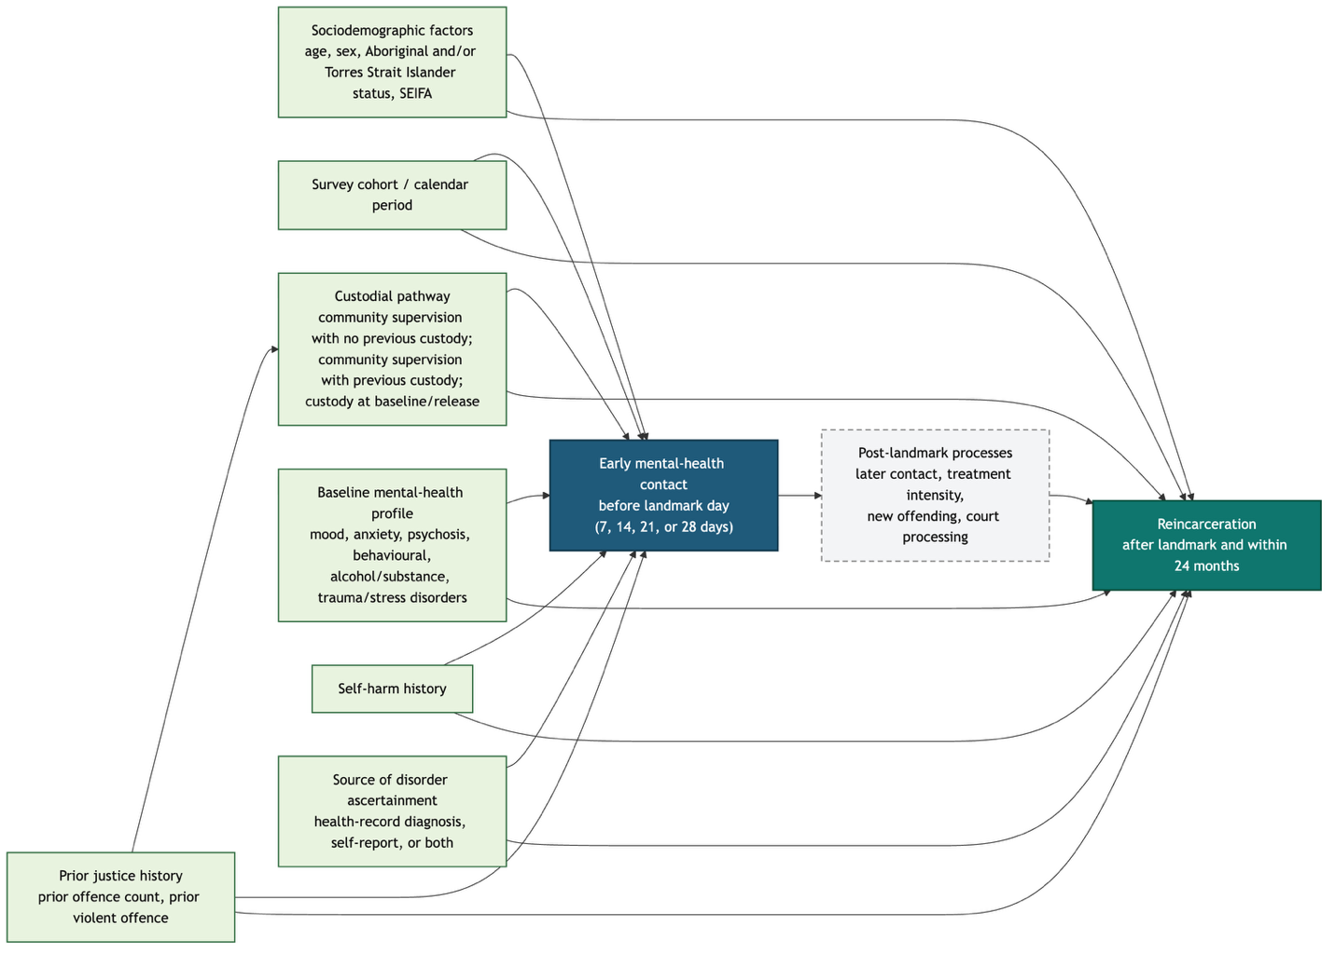
The contrast of interest was early mental health contact before each landmark day, and the outcome was reincarceration after the landmark and within 24 months. The adjustment set comprised age, sex, Aboriginal and/or Torres Strait Islander status, SEIFA, survey cohort/calendar period, prior offence count, prior violent offence, hierarchical custodial pathway, baseline mental health disorder categories, self-harm history, and source of disorder ascertainment. Post-landmark contact, treatment intensity, new offending, and court processing were treated as downstream processes and were not adjusted for.

Supplementary Table 4. Missing data in the full cohort and the cohort with a history of mental health disorder
Variable | Missing n (full) | % (full) | Missing n (676) | % (676)
Age | 10 | 0.6 | 3 | 0.4
Sex | 0 | 0.0 | 0 | 0.0
Aboriginal and/or Torres Strait Islander | 30 | 1.9 | 7 | 1.0
SEIFA quartile | 39 | 2.5 | 17 | 2.5
Survey year | 0 | 0.0 | 0 | 0.0
Baseline custody/community status | 0 | 0.0 | 0 | 0.0
Previous custody | 0 | 0.0 | 0 | 0.0
Prior violent offence | 0 | 0.0 | 0 | 0.0
Prior offence count | 0 | 0.0 | 0 | 0.0
Source of ascertainment | 0 | 0.0 | 0 | 0.0
Outcome (time and event) | 0 | 0.0 | 0 | 0.0
The primary time-to-contact model used complete cases (N=649); 27 adolescents with a history of mental health disorder were excluded, chiefly for missing SEIFA quartile or Aboriginal and/or Torres Strait Islander status (Supplementary Table 5).

Supplementary Table 5. Complete-case analytic sample compared with excluded adolescents with a history of mental health disorder
Characteristic | Complete case (N=649) | Excluded (N=27)
Age, mean (SD) | 16.6 (1.5) | 17.3 (1.4)
Female, n (%) | 92 (14.2) | 4 (14.8)
Aboriginal and/or Torres Strait Islander, missing n (%) | 0 (0.0) | 7 (25.9)
SEIFA quartile, missing n (%) | 0 (0.0) | 17 (63.0)
No custody-free follow-up, n (%) | 0 (0.0) | 3 (11.1)
Baseline custody, n (%) | 381 (58.7) | 18 (66.7)
Previous custody, yes n (%) | 569 (87.7) | 22 (81.5)
Prior offence count, median (IQR) | 4.0 (2.0, 7.0) | 1.0 (1.0, 3.5)
Source: health-record diagnosis only, n (%) | 354 (54.5) | 23 (85.2)
Source: self-report only, n (%) | 211 (32.5) | 3 (11.1)
Source: health-record diagnosis and self-report, n (%) | 84 (12.9) | 1 (3.7)
Excluded participants mainly had missing SEIFA quartile or Aboriginal and/or Torres Strait Islander status and had a lower prior offence count. Complete-case estimates are unbiased when missingness is independent of the outcome conditional on the covariates in the model; residual selection remains possible.

Supplementary Table 6. Proportional-hazards diagnostics from Cox model scaled Schoenfeld residual tests
Covariate | Chi-square | df | p
Custody/community status | 41.81 | 1 | <0.001
Source of ascertainment | 32.23 | 2 | <0.001
Behavioural disorder | 14.73 | 1 | <0.001
Mood disorder | 8.01 | 1 | 0.005
Psychosis | 6.51 | 1 | 0.011
Alcohol/substance disorder | 0.81 | 1 | 0.367
Sex | 5.05 | 1 | 0.025
Age | 0.48 | 1 | 0.490
Aboriginal and/or Torres Strait Islander | 1.60 | 1 | 0.206
SEIFA quartile | 5.07 | 3 | 0.167
Previous custody | 1.02 | 1 | 0.311
Prior violent offence | 1.60 | 1 | 0.206
Prior offence count | 1.42 | 1 | 0.233
Anxiety disorder | 1.40 | 1 | 0.236
Trauma/stress disorder | 1.07 | 1 | 0.301
Self-harm history | 0.08 | 1 | 0.773
GLOBAL | 89.80 | 19 | <0.001
Each chi-square is the scaled Schoenfeld residual test statistic on the stated degrees of freedom (df), and a small p-value indicates evidence against the proportional-hazards assumption. Custody/community status, sex, and behavioural disorder were retained with time-varying effects in the primary flexible parametric model. Additional non-proportional covariates were evaluated in model-selection and sensitivity analyses (Supplementary Tables 7 and 8).

Supplementary Table 7. Flexible parametric model selection: alternative time-varying-effect specifications
Model | Parameters | AIC | BIC | LRT p vs primary
Primary: custody, sex, behavioural TVC | 30 | 4652.5 | 4786.8 | -
+ source of ascertainment TVC (df=2) | 32 | 4655.2 | 4798.4 | 0.519
+ source of ascertainment TVC (df=3) | 33 | 4657.3 | 4805.0 | 0.749
+ mood disorder TVC (df=2) | 32 | 4653.3 | 4796.5 | 0.201
+ psychosis TVC (df=2) | 32 | 4648.1 | 4791.3 | 0.015
+ alcohol/substance TVC (df=2) | 32 | 4655.6 | 4798.8 | 0.628
+ mood + psychosis + alcohol/substance TVC | 36 | 4651.6 | 4812.7 | 0.045
+ source + mood + psychosis + alcohol/substance TVC | 38 | 4655.1 | 4825.1 | 0.098
AIC, Akaike information criterion; BIC, Bayesian information criterion; LRT, likelihood-ratio test; TVC, time-varying covariate. Lower AIC and BIC values indicate better fit. The psychosis and combined specifications improved AIC but worsened BIC. The primary specification was retained as the most parsimonious specification not outperformed on BIC.

Supplementary Table 8. Sensitivity analysis excluding source of ascertainment: time-fixed and time-varying associations
Covariate / contrast | HR (95% CI) | p
Age (per year) | 0.92 (0.85, 0.99) | 0.031
Aboriginal and/or Torres Strait Islander (yes vs no) | 0.74 (0.58, 0.94) | 0.015
SEIFA Q4 vs Q1 | 1.40 (0.95, 2.06) | 0.085
Previous custody (yes vs no) | 1.48 (0.95, 2.33) | 0.086
Mood disorder (yes vs no) | 1.83 (1.40, 2.40) | <0.001
Psychosis (yes vs no) | 1.46 (1.07, 1.99) | 0.017
Alcohol/substance disorder (yes vs no) | 1.49 (1.18, 1.87) | <0.001
Self-harm history (yes vs no) | 1.10 (0.77, 1.58) | 0.592
Custody vs community order at 6 months | 1.00 (0.73, 1.38) | 0.992
Custody vs community order at 12 months | 0.72 (0.49, 1.02) | 0.074
Custody vs community order at 18 months | 0.56 (0.38, 0.83) | 0.006
Custody vs community order at 24 months | 0.48 (0.30, 0.72) | 0.002
Excluding source of ascertainment preserved the direction and magnitude of the main associations, including the time-varying custody/community pattern.

Supplementary Table 9. Spline sensitivity for age and prior offence count
Specification | Parameters | AIC | BIC | LRT p
Linear age, linear prior offences (reference) | 28 | 4657.6 | 4782.9 | -
Restricted cubic spline age (df=3) | 30 | 4659.8 | 4794.1 | 0.417
Restricted cubic spline age (df=4) | 31 | 4661.4 | 4800.1 | 0.534
Restricted cubic spline prior offences (df=3) | 30 | 4659.9 | 4794.1 | 0.432
Restricted cubic spline prior offences (df=4) | 31 | 4660.9 | 4799.6 | 0.442
Spline age (df=3) + spline prior offences (df=3) | 32 | 4662.5 | 4805.7 | 0.553
Spline age (df=4) + spline prior offences (df=4) | 34 | 4665.1 | 4817.2 | 0.611
Restricted cubic splines for age and prior offence count gave little evidence of improvement over linear terms. The functional-form check was conducted in the source-of-ascertainment-excluded specification, giving different absolute AIC and BIC values from Supplementary Table 7.

Supplementary Table 10. Post-baseline justice outcomes, by history of mental health disorder
Characteristic | Full cohort (N=1,589) | History of mental health disorder (n=676) | No history of mental health disorder (n=913)
Reincarceration within 12 months, n (%) | 755 (47.5) | 354 (52.4) | 401 (43.9)
Reincarceration within 24 months, n (%) | 954 (60.0) | 448 (66.3) | 506 (55.4)
Days in custody, 12-month follow-up, median (IQR); mean (SD) | 1.0 (0.0-99.0); 61.9 (99.6) | 3.5 (0.0-142.0); 73.6 (105.5) | 0.0 (0.0-64.0); 53.2 (94.1)
Days in custody, 24-month follow-up, median (IQR); mean (SD) | 16.0 (0.0-240.0); 138.7 (195.8) | 56.5 (0.0-278.2); 161.2 (205.2) | 3.0 (0.0-199.0); 121.9 (187.0)
Custody-free days, 12-month follow-up, median (IQR); mean (SD) | 364.0 (266.0-365.0); 303.1 (99.6) | 361.5 (223.0-365.0); 291.4 (105.5) | 365.0 (301.0-365.0); 311.8 (94.1)
Custody-free days, 24-month follow-up, median (IQR); mean (SD) | 714.0 (490.0-730.0); 591.3 (195.8) | 673.5 (451.8-730.0); 568.8 (205.2) | 727.0 (531.0-730.0); 608.1 (187.0)
IQR, interquartile range; SD, standard deviation. Reincarceration is the first return to custody after baseline, ascertained from custody records.

Supplementary Table 11. Post-baseline justice outcomes among adolescents with a history of mental health disorder, by hierarchical custody status
Characteristic | Custody at baseline/release (n=399) | Community order, previous custody (n=192) | Community order, no previous custody (n=85)
Reincarceration within 12 months, n (%) | 249 (62.4) | 90 (46.9) | 15 (17.6)
Reincarceration within 24 months, n (%) | 295 (73.9) | 128 (66.7) | 25 (29.4)
Days in custody, 12-month follow-up, median (IQR); mean (SD) | 65.0 (0.0-184.5); 106.5 (115.7) | 0.0 (0.0-18.5); 36.8 (74.1) | 0.0 (0.0-0.0); 1.9 (7.8)
Days in custody, 24-month follow-up, median (IQR); mean (SD) | 177.0 (5.0-378.5); 225.8 (219.3) | 7.0 (0.0-124.0); 93.1 (156.2) | 0.0 (0.0-2.0); 12.1 (43.0)
Custody-free days, 12-month follow-up, median (IQR); mean (SD) | 300.0 (180.5-365.0); 258.5 (115.7) | 365.0 (346.5-365.0); 328.2 (74.1) | 365.0 (365.0-365.0); 363.1 (7.8)
Custody-free days, 24-month follow-up, median (IQR); mean (SD) | 553.0 (351.5-725.0); 504.2 (219.3) | 723.0 (606.0-730.0); 636.9 (156.2) | 730.0 (728.0-730.0); 717.9 (43.0)
IQR, interquartile range; SD, standard deviation. Group sizes derive from the cohort with a history of mental health disorder (n=676): custody at baseline/release 399, community order with previous custody 192, community order with no previous custody 85.

Supplementary Table 12. Construction of the custody-release landmark analytic samples among adolescents with a history of mental health disorder
Landmark | Custody-release cohort N | Contact by landmark before exclusions, n | Reincarcerated before landmark excluded, n | Analytic N | Contact by landmark in analytic sample, n | No contact by landmark in analytic sample, n | Complete-case N
7 days | 399 | 87 | 9 | 390 | 87 | 303 | 373
14 days | 399 | 103 | 29 | 370 | 94 | 276 | 353
21 days | 399 | 110 | 41 | 358 | 99 | 259 | 341
28 days | 399 | 116 | 48 | 351 | 104 | 247 | 335
The custody-release cohort comprised 399 adolescents with a history of mental health disorder who entered follow-up from custody. Contact counts before exclusions describe contact by each landmark in the full custody-release cohort. Analytic-sample contact and no-contact counts are after excluding adolescents reincarcerated on or before the landmark and sum to the analytic N.

Supplementary Table 13. Landmark models of early mental health contact and reincarceration among adolescents released from custody: full specification detail
Landmark | Outcome window | Excluded pre-landmark reincarceration | Analytic N | Complete-case N | Contact by landmark, n | No contact by landmark, n | Adjusted risk: contact | Adjusted risk: no contact | Adjusted RD | Adjusted RR (95% CI)
7 days | Landmark to 24 months | 9 | 390 | 373 | 87 | 303 | 65.0 (53.5, 74.2) | 77.5 (72.0, 81.0) | -12.5 (-24.8, -0.6) | 0.84 (0.68, 0.99)
14 days | Landmark to 24 months | 29 | 370 | 353 | 94 | 276 | 62.7 (52.3, 71.5) | 76.9 (71.5, 80.6) | -14.1 (-25.3, -2.6) | 0.82 (0.68, 0.96)
21 days | Landmark to 24 months | 41 | 358 | 341 | 99 | 259 | 62.2 (52.1, 70.6) | 76.3 (70.6, 80.2) | -14.0 (-24.6, -2.9) | 0.82 (0.68, 0.96)
28 days | Landmark to 24 months | 48 | 351 | 335 | 104 | 247 | 63.0 (53.7, 71.3) | 75.7 (69.4, 79.8) | -12.7 (-23.2, -1.2) | 0.83 (0.70, 0.98)
RD, risk difference in percentage points; RR, relative risk; CI, confidence interval. Contact by landmark is any qualifying mental health contact before the stated landmark among adolescents released from custody. The outcome is reincarceration after the landmark and within 24 months of release. Adjusted models included age, sex, Aboriginal and/or Torres Strait Islander status, SEIFA quartile, prior offence count, prior violent offence, baseline mental health disorder categories, self-harm history, and source of disorder ascertainment, and used complete cases. Complete-case N is the number of adolescents with no missing model covariates.

Supplementary Table 14. Cumulative mental health contact within 14 custody-free days to 24 custody-free months after baseline, by history of mental health disorder and supervision status
Mental health status | Supervision status | N | 14 custody-free days | 1 custody-free month | 3 custody-free months | 6 custody-free months | 12 custody-free months | 24 custody-free months
Total cohort | Overall | 1,589 | 134 (8.4) | 167 (10.5) | 237 (14.9) | 313 (19.7) | 426 (26.8) | 587 (36.9)
Total cohort | Community supervision | 779 | 12 (1.5) | 22 (2.8) | 48 (6.2) | 81 (10.4) | 134 (17.2) | 215 (27.6)
Total cohort | Custody | 810 | 122 (15.1) | 145 (17.9) | 189 (23.3) | 232 (28.6) | 292 (36.0) | 372 (45.9)
Mental health disorder | Overall | 676 | 101 (14.9) | 120 (17.8) | 151 (22.3) | 203 (30.0) | 273 (40.4) | 349 (51.6)
Mental health disorder | Community supervision | 277 | 5 (1.8) | 11 (4.0) | 23 (8.3) | 46 (16.6) | 81 (29.2) | 123 (44.4)
Mental health disorder | Custody | 399 | 96 (24.1) | 109 (27.3) | 128 (32.1) | 157 (39.3) | 192 (48.1) | 226 (56.6)
No mental health disorder | Overall | 913 | 33 (3.6) | 47 (5.1) | 86 (9.4) | 110 (12.0) | 153 (16.8) | 238 (26.1)
No mental health disorder | Community supervision | 502 | 7 (1.4) | 11 (2.2) | 25 (5.0) | 35 (7.0) | 53 (10.6) | 92 (18.3)
No mental health disorder | Custody | 411 | 26 (6.3) | 36 (8.8) | 61 (14.8) | 75 (18.2) | 100 (24.3) | 146 (35.5)
Cell values are the cumulative number (percentage) of the row group with any mental health contact by each time point after baseline/release; percentages use the row N as the denominator. Time points are cumulative and not mutually exclusive. Supervision status contrasts community-order participants (baseline = survey date) with custody participants (baseline = release). Within each mental-health-status group, community supervision and custody sum to the overall N (community 779 + custody 810 = 1,589; 277 + 399 = 676; 502 + 411 = 913).

Supplementary Table 15. Follow-up for adolescents without a history of mental health disorder at baseline
Characteristic | Value
Analytic cohort | 913
First community mental-health contact | 238
Censored without contact | 675
Person-years | 1516.0
Median follow-up, days (IQR) | 730 (653-730)
Complete-case analytic cohort | 863
Complete-case events | 233
Complete-case censored | 630
Complete-case person-years | 1428.8
Complete-case median follow-up, days (IQR) | 730 (625.5-730)
The analysis included adolescents with no history of mental health disorder ascertained before or at baseline. The outcome was first community mental health contact within 730 community-follow-up days. Time spent in custody did not contribute to community follow-up.

Supplementary Table 16. Time to first community mental health contact among adolescents without a history of mental health disorder at baseline
Characteristic | Level / contrast | n | Events / person-years | Univariable HR (95% CI) | Univariable p | Adjusted HR (95% CI) | Adjusted p
Custody/community status | Community order | 472 | 89/842.7 | Reference |  | Reference
 | Custody | 391 | 144/586.1 | 2.27 (1.74, 2.95) | <0.001 | 1.74 (1.27, 2.38) | <0.001
Age | per year |  |  | 0.89 (0.81, 0.97) | 0.013 | 0.89 (0.81, 0.98) | 0.020
Sex | Male | 768 | 207/1270.5 | Reference |  | Reference
 | Female | 95 | 26/158.3 | 1.02 (0.68, 1.53) | 0.941 | 1.15 (0.75, 1.76) | 0.520
Aboriginal and/or Torres Strait Islander | No | 391 | 137/601.0 | Reference |  | Reference
 | Yes | 472 | 96/827.8 | 0.52 (0.40, 0.67) | <0.001 | 0.86 (0.64, 1.16) | 0.331
SEIFA quartile | Q1 | 363 | 90/612.4 | Reference |  | Reference
 | Q2 | 192 | 61/307.7 | 1.33 (0.96, 1.85) | 0.082 | 1.50 (1.07, 2.09) | 0.018
 | Q3 | 221 | 55/370.7 | 1.01 (0.72, 1.41) | 0.971 | 1.07 (0.76, 1.50) | 0.706
 | Q4 | 87 | 27/138.0 | 1.31 (0.85, 2.02) | 0.213 | 1.63 (1.05, 2.54) | 0.030
Previous custody | No | 163 | 24/302.1 | Reference |  | Reference
 | Yes | 700 | 209/1126.7 | 2.28 (1.50, 3.48) | <0.001 | 1.18 (0.73, 1.91) | 0.494
Prior violent offence | No | 253 | 75/407.3 | Reference |  | Reference
 | Yes | 610 | 158/1021.5 | 0.85 (0.64, 1.11) | 0.233 | 0.79 (0.59, 1.05) | 0.107
Prior offence count | per offence |  |  | 1.14 (1.10, 1.17) | <0.001 | 1.12 (1.08, 1.16) | <0.001
Self-harm history | No | 857 | 229/1420.4 | Reference |  | Reference
 | Yes | 6 | 4/8.4 | 2.84 (1.06, 7.64) | 0.038 | 1.68 (0.61, 4.60) | 0.312
The flexible parametric survival model used a Royston-Parmar specification with baseline spline df=3. The adjusted model included baseline supervision status, age, sex, Aboriginal and/or Torres Strait Islander status, SEIFA quartile, previous custody, prior violent offence, prior offence count, and self-harm history. HR, hazard ratio; CI, confidence interval; SEIFA, Socio-Economic Indexes for Areas.

Supplementary Table 17. Proportional-hazards diagnostics for the no-disorder time-to-contact model
Covariate | Chi-square | df | p
Custody/community status | 2.831 | 1 | 0.092
Age | 0.546 | 1 | 0.460
Sex | 0.179 | 1 | 0.672
Aboriginal and/or Torres Strait Islander | 1.637 | 1 | 0.201
SEIFA quartile | 0.321 | 3 | 0.956
Previous custody | 3.004 | 1 | 0.083
Prior violent offence | 0.730 | 1 | 0.393
Prior offence count | 0.187 | 1 | 0.665
Self-harm history | 1.545 | 1 | 0.214
GLOBAL | 8.816 | 11 | 0.639
Each chi-square is the scaled Schoenfeld residual test statistic on the stated degrees of freedom (df). The global test did not indicate evidence against proportional hazards (p=0.639), so no time-varying effects were included.

Supplementary Table 18. Baseline spline selection for the no-disorder time-to-contact model
Model | AIC | BIC
Baseline spline df=3 | 3908.8 | 3980.2
Baseline spline df=4 | 3911.9 | 3988.1
Baseline spline df=5 | 3910.5 | 3991.4
The model with baseline spline df=3 had the lowest AIC and BIC and was retained. AIC, Akaike information criterion; BIC, Bayesian information criterion.

Supplementary Table 19. Continuity-of-care cascade after baseline or release, by history of mental health disorder
Cascade measure, n (%) | Mental health disorder (N=676) | No mental health disorder (N=913)
Source of ascertainment
Health-record diagnosis only | 377 (55.8) | –
Self-report only | 214 (31.7) | –
Health-record diagnosis and self-report | 85 (12.6) | –
Early mental health contact after baseline or release
Within 7 days | 84 (12.4) | 22 (2.4)
Within 14 days | 101 (14.9) | 33 (3.6)
Within 30 days | 120 (17.8) | 47 (5.1)
Within 90 days | 151 (22.3) | 86 (9.4)
Any mental health contact
By 12 months | 273 (40.4) | 153 (16.8)
By 24 months | 349 (51.6) | 238 (26.1)
No contact by 24 months | 327 (48.4) | 675 (73.9)
First-contact setting within 24 months (mutually exclusive)
Outpatient mental health contact | 225 (33.3) | 122 (13.4)
Emergency presentation | 34 (5.0) | 22 (2.4)
Same-day hospital episode | 41 (6.1) | 40 (4.4)
Psychiatric hospital admission | 27 (4.0) | 25 (2.7)
Opioid agonist treatment | 22 (3.3) | 29 (3.2)
Overlapping service-source use within 24 months (not mutually exclusive)
Outpatient mental health contact | 277 (41.0) | 149 (16.3)
Emergency presentation | 112 (16.6) | 53 (5.8)
Hospital mental health contact/admission | 124 (18.3) | 93 (10.2)
Opioid agonist treatment | 49 (7.2) | 49 (5.4)
Percentages use the cohort denominator (676 for history of mental health disorder, 913 without). First-contact-setting categories are mutually exclusive and sum to the proportion with any contact within 24 months. Overlapping service-source indicators are not mutually exclusive. Psychiatric hospital admission combines voluntary and involuntary admissions.

