Online Supplementary Data

Quantitative Systems Pharmacology Analysis of Amyloid Aggregation and Hippocampal Atrophy Trajectories in Alzheimer’s Disease by APOE4 Genotype and Valiltramiprosate/ALZ-801 Treatment

John A. Hey¹, Hugo Geerts², Jean F. Schaefer¹, Shaina M. Short², Piet van der Graaf², Susan Abushakra¹, Aidan Power¹, Martin Tolar¹ and Jeremy Y. Yu¹

Corresponding author: Dr. John A. Hey, Alzheon, Inc., 111 Speen Street, Suite 306, Framingham,

MA 01701, USA. Email: john.hey@alzheon.com

Affiliations: ¹Alzheon, Inc., Framingham, MA, USA; ²Certara, Radnor, PA, USA

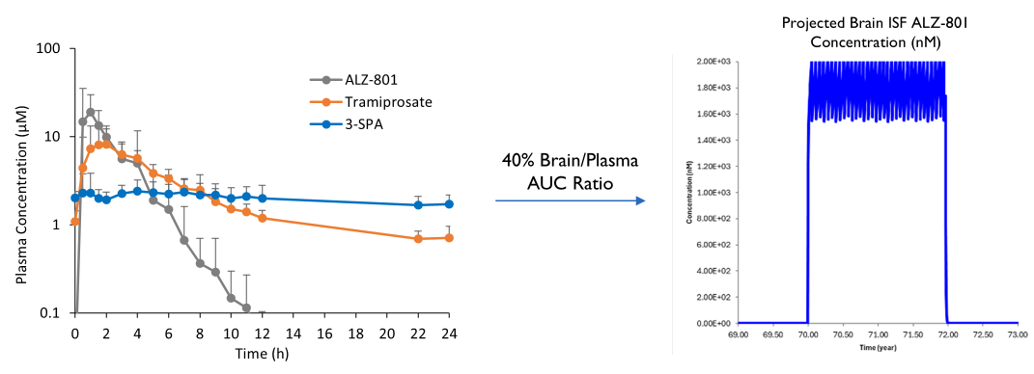
Figure S1. Brain interstitial fluid drug concentration projection based on the dose regimen used in the valiltramiprosate clinical trials. Left: Steady state plasma pharmacokinetic profile of valiltramiprosate (ALZ-801), tramiprosate and 3-SPA following oral valiltramiprosate tablet 265 mg BID for 2 weeks in APOE4 carrier AD subjects (Hey et al., 2025). Right: Simulated brain interstitial fluid drug levels (Cmax ~2 µM, average 1.7 µM) for a 2-year trial (valiltramiprosate 265 mg BID), based on a conservative 40% brain/plasma AUC ratio of combined tramiprosate and 3-SPA (active molecules). AD, Alzheimer’s disease; APOE, apolipoprotein E; AUC, area under the curve.

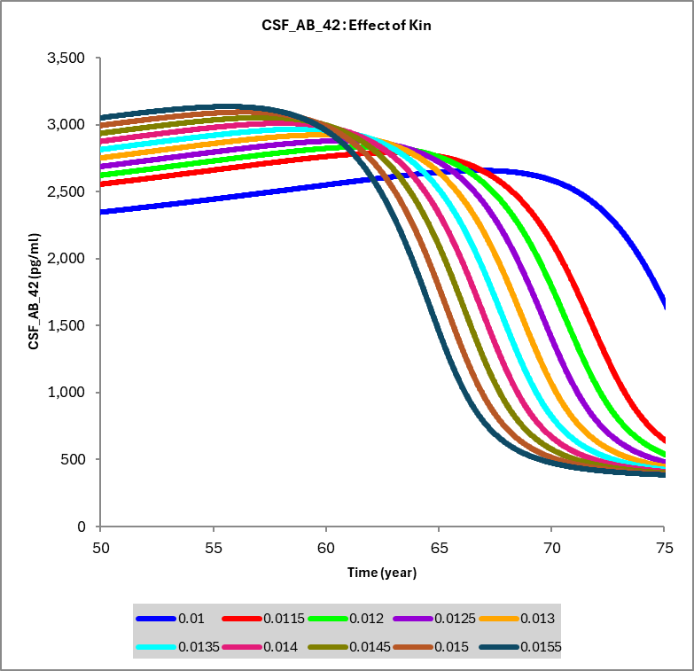
K_{in} (1/hr) | Age at 50% threshold (years)
0.005 | 85.56
0.01 | 76.00
0.0115 | 72.09
0.012 | 70.97
0.0125 | 69.20
0.013 | 68.95
0.0135 | 68.03
0.014 | 67.16
0.0145 | 66.35
0.015 | 65.54

Figure S2. Sensitivity analysis of the effect of different values of Aβ synthesis (K_{in}) on the longitudinal trajectory of CSF Aβ42 in AD. For this range of values, midpoint of CSF Aβ42 falls between 64 and 85 years. Table shows age at which CSF Aβ42 reaches 50% of its value in subjects on the trajectory for becoming amyloid positive as a function of K_{in}.

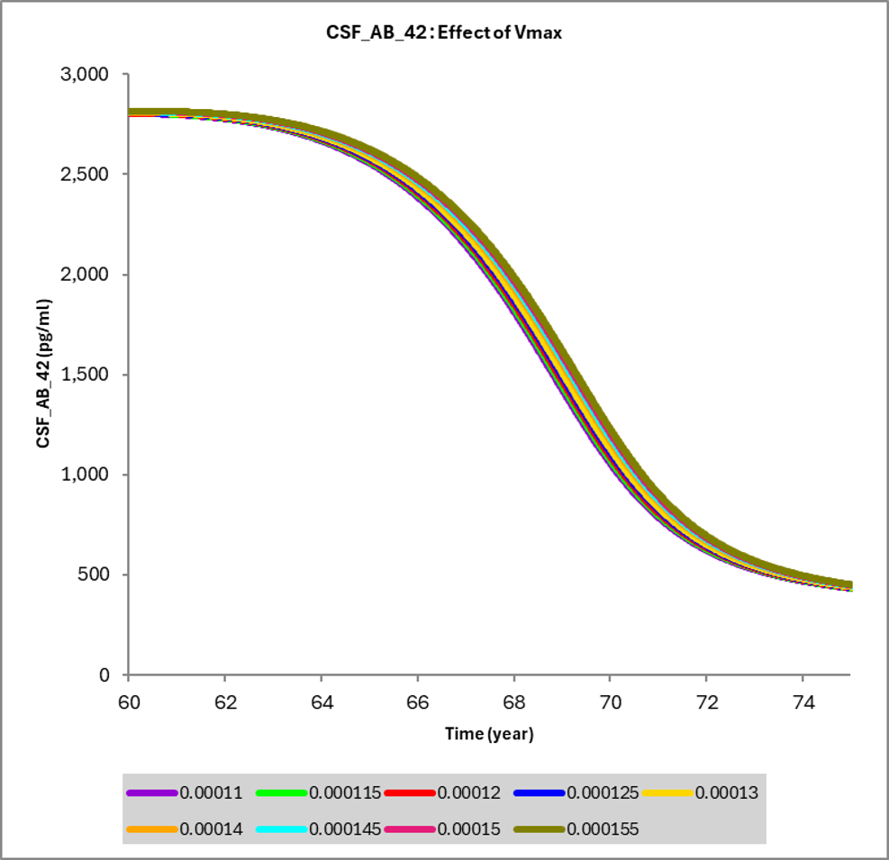
V_{max} (nM/hr) | Age at 50% threshold (years)
0.00011 | 69.06
0.000115 | 69.11
0.00012 | 69.17
0.000125 | 69.20
0.00013 | 69.27
0.00014 | 69.37
0.000145 | 69.43
0.00015 | 69.48
0.000155 | 69.53

Figure S3. Sensitivity analysis of the effect of different values of microglia V_{max} for Aβ clearance on the longitudinal trajectory of CSF Aβ42 in AD. For this range of values (50% increase from baseline), midpoint of CSF Aβ42 falls between 68 and 70 years, suggesting that this parameter has a somewhat smaller effect on the natural trajectory. Table shows age at which CSF Aβ42 reaches 50% of its value in subjects on the trajectory for becoming amyloid positive as a function of microglia V_{max}.

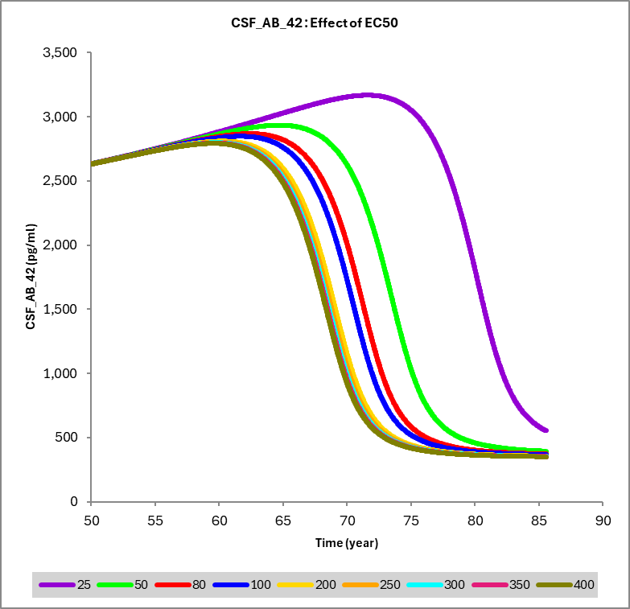
EC₅₀ (nM) | Age at 50% threshold (years)
25 | 80.52
50 | 73.79
80 | 71.50
100 | 70.76
200 | 69.20
250 | 69.04
300 | 68.86
350 | 68.72
400 | 68.62

Figure S4. Sensitivity analysis of the effect of different values of microglia EC₅₀ for Aβ clearance on the longitudinal trajectory of CSF Aβ42 in AD. For this range of values, midpoint of CSF Aβ42 falls between 68 and 80 years. Table shows age at which CSF Aβ42 reaches 50% of its value in subjects on the trajectory to become amyloid positive as a function of microglia EC₅₀.

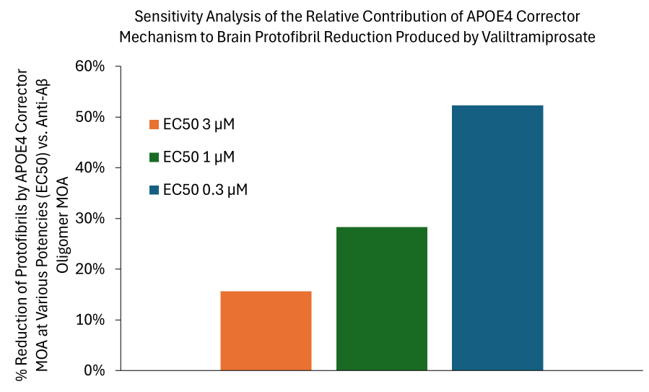
Figure S5. QSP predicted contribution of APOE4 structure corrector mechanism of action (MOA) vs. anti-Aβ oligomer MOA to brain protofibril reduction following valiltramiprosate 265 mg BID treatment for 2 years in APOE4/4 AD subjects. Illustrated are the normalized additional reductions of protofibril levels for a 2-year valiltramiprosate trial starting at 70 years of age when introducing the APOE4 structure corrector MOA at various potencies (EC₅₀) relative to the anti-Aβ aggregation mechanism alone (set at a fixed EC₅₀ of 3 µM). AD, Alzheimer’s disease; APOE, apolipoprotein E; QSP, quantitative systems pharmacology.

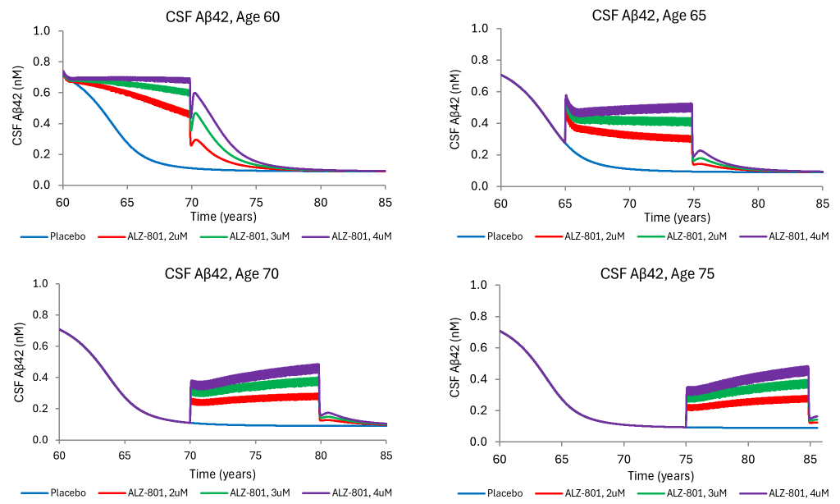Figure S6. QSP predicted long-term valiltramiprosate effect on CSF Aβ42 following 10-year 265 mg BID treatment in APOE4/4 AD patients. Illustrated are the effects on CSF Aβ42 when the treatment is initiated at 60, 65, 70 and 75 years of age, with a steady state brain interstitial fluid drug exposure ranging from 2-4 µM. Valiltramiprosate substantially increases CSF Aβ42 levels in an age- and exposure-dependent manner. The earliest age of treatment initiation shows the greatest benefit, indicating that the long-term treatment efficacy is dependent on the stage of disease and the predose baseline amyloid pathology load. Aβ, β-amyloid; AD, Alzheimer’s disease; APOE, apolipoprotein E; QSP, quantitative systems pharmacology.

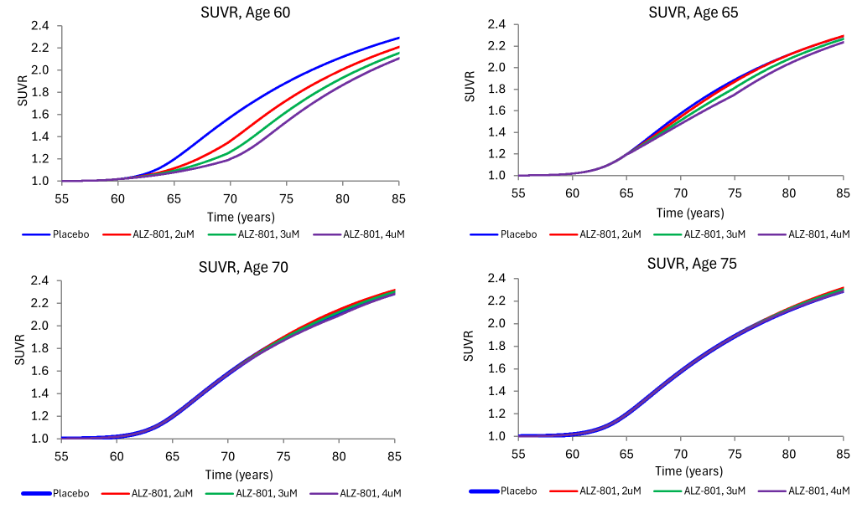
Figure S7. QSP predicted long-term valiltramiprosate effect on SUVR following 10-year 265 mg BID treatment in APOE4/4 AD patients. Illustrated are the effects on brain amyloid SUVR when the treatment is initiated at 60, 65, 70 and 75 years of age, with a steady state brain interstitial fluid drug exposure ranging from 2-4 µM. Valiltramiprosate decreases SUVR in an age- and exposure-dependent manner, with the earliest age of treatment initiation showing the greatest benefit. Over 65 years of age, the effect is smaller and only observed over long-term treatment (>5 years). AD, Alzheimer’s disease; APOE, apolipoprotein E; QSP, quantitative systems pharmacology; SUVR, standardized uptake value ratio.

