Supporting Information
Effect of Interfacial Properties on Viscoelastic Behavior of High-Temperature Multi-Phase System

Kento Nakanishi ^{1*}, Takehiro Sumita¹, and Noritaka Saito¹
¹Department of Materials, Kyushu University, 744 Motooka, Nishi-ku, Fukuoka, 819-0395, Japan.

*Corresponding author: nakanishi.kento.830@s.kyushu-u.ac.jp

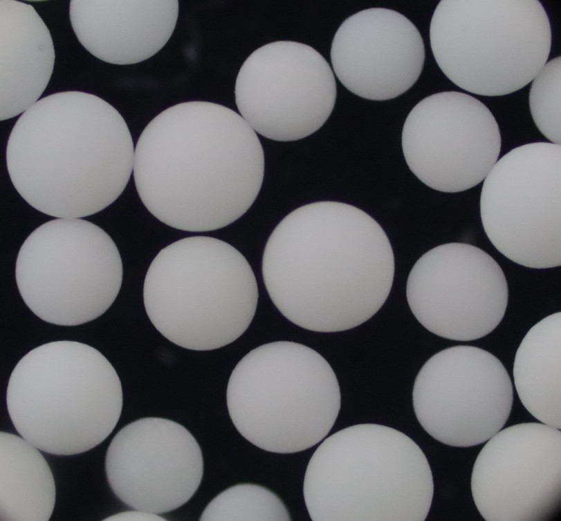
S.1 Sample preparation and material characterization
S.2 Alignment mechanism of the measuring rod assembly
S.3 Calibration of the torque-to-stress conversion
Fig. S1 Picture of Al₂O₃ beads (diameter: 0.5 mm) used in this study, confirming their nearly spherical shape
200μm
Fig. S2 Schematic illustration of the alignment fixture used for assembling the rod.
To minimize eccentricity of the rod, the Al₂O₃ tube, stainless-steel tube, and torque sensor accessory were precisely aligned and fixed using the custom-made fixture. An alumina plate with a central circular opening was placed on an aluminum base plate. The alumina plate was clamped from the top and bottom using screws. The rod was inserted through the central opening of the alumina plate and mechanically constrained to maintain a straight, coaxial configuration, after which the Al₂O₃ tube and stainless-steel tube were bonded using a ceramic adhesive
The raw output of the present measurement system is the torque generated on the rod, $M$ [mN·m]. To convert this quantity into shear stress, $σ$ [Pa], a calibration curve was established. Specifically, 20 mL of silicone oil standards with known viscosities $η$ [Pa·s] were loaded into the crucible and subjected to seven shear rates, $\dot{γ}$ (0.01, 0.05, 0.1, 0.5, 1, 5, and 10 $s^{-1}$). Under each condition, the torque was measured 20 times. Since the shear stress of a Newtonian fluid is strictly given by $σ=η\dot{γ},$ this procedure enabled calibration over a wide stress range. Although torque and stress are theoretically proportional, an intercept was included in the calibration equation to account for the instrumental detection limit and offset:
$$M=aσ+b, \text{(S.}\text{3.1}\text{)}$$
where $a$ and $b$ are constants.
Fig. S3 shows the relationship between stress and torque. Because the scatter in torque increased at higher stress levels, a weighted linear regression was performed using the standard deviation obtained from each calibration condition. The stress values were treated as exact, while the standard deviation of torque was calculated from the 20 repeated measurements ($n=20$). The weighting factors, regression coefficients, and weighted centroids were determined according to the conventional weighted least-squares method[1].The weighting factor $w_{i}$ was defined as
$$w_{i}=\frac{s_{i}^{-2}}{\sum_{i}{s_{i}^{-2}}/n}. \text{(S.}\text{3.2}\text{)}$$
Using these weights, the weighted slope $a$ and intercept $b$ were determined as
$$a=\frac{\sum{w_{i}}σ_{i}M_{i}-n{\hat{σ}}_{w}{\hat{M}}_{w}}{\sum{w_{i}}σ_{i}^{2}-n{\hat{σ}}_{w}^{2}}, \text{(S.}\text{3.3}\text{)}$$
$$b={\hat{M}}_{w}-a{\hat{σ}}_{w}, \text{(S.}\text{3.4}\text{)}$$
where ${\hat{σ}}_{w}$ and ${\hat{M}}_{w}$ are the weighted centroids defined by
$${\hat{σ}}_{w}=\frac{\sum{w_{i}}σ_{i}}{n}, \text{(S.}\text{3.5}\text{)}$$
$${\hat{M}}_{w}=\frac{\sum{w_{i}}M_{i}}{n}. \text{(S.}\text{3.6}\text{)}$$
As a result of the calibration, the following conversion equation was obtained:
$$σ \left[Pa\right]=121.05 M \left[mN⋅m\right]+2.70×{10}^{-3}. \text{(S.}\text{3.7}\text{)}$$

Fig. S3 Calibration results obtained at room temperature using silicone oil measured by the rotational method
R² = 0.0998
S.4 Uncertainty propagation to the dynamic moduli
A sinusoidal strain,
$$γ\left(t\right)=γ_{0}sin⁡\left(ωt\right), \text{(S.}\text{4.1}\text{)}$$
was applied to the sample. The storage modulus $G^{'}$ and loss modulus $G^{''}$ were theoretically calculated from the stress response as follows[2].
$$G^{'}=\frac{2}{γ_{0}T}\int_{0}^{T}{σ}\left(t\right)sin⁡\left(ωt\right) dt, \text{(S.}\text{4.}\text{2}\text{a}\text{)}$$
$$G^{''}=\frac{2}{γ_{0}T}\int_{0}^{T}{σ}\left(t\right)cos⁡\left(ωt\right) dt, \text{(S.}\text{4.}\text{2b}\text{)}$$where $T$ is the oscillation period. In practice, stress data were recorded at $N$ equally spaced time points $t_{k}$ ($k=0,1,…,N-1$) with a sampling interval $Δt=T/N$. Therefore, Eqs. (S.4.2a) and (S.4.2b) can be approximated by
$$G^{'}≈\frac{2}{γ_{0}T}\sum_{k=0}^{N-1}{σ}\left(t_{k}\right)sin⁡\left(ωt_{k}\right)Δt, \text{(S.}\text{4.}\text{3a}\text{)}$$
$$G^{''}≈\frac{2}{γ_{0}T}\sum_{k=0}^{N-1}{σ}\left(t_{k}\right)cos⁡\left(ωt_{k}\right)Δt. \text{(S.}\text{4.}\text{3b}\text{)}$$
Since Eqs. (S.4.3a) and (S.4.3b) represent linear combinations of $σ_{k}$, the standard uncertainties of $G^{'}$ and $G^{''}$ were evaluated using the law of propagation of uncertainty [1] and are given by

$$u_{G^{'}}=\frac{2}{γ_{0}T}\sqrt{\sum_{k=0}^{N-1}{{\left[u_{σ}\left(t_{k}\right)sin⁡\left(ωt_{k}\right)Δt\right]}^{2}}}, \text{(S.}\text{4.}\text{4a}\text{)}$$
$$u_{G^{''}}=\frac{2}{γ_{0}T}\sqrt{\sum_{k=0}^{N-1}{{\left[u_{σ}\left(t_{k}\right)cos⁡\left(ωt_{k}\right)Δt\right]}^{2}}}, \text{(S.}\text{4.}\text{4b}\text{)}$$
where $u_{σ}\left(t_{k}\right)$ denotes the uncertainty of the stress measurement. Using $Δt=T/N$, Eqs. (S.4.4a) and (S.4.4b) become
$$u_{G^{'}}=\frac{2}{γ_{0}N}\sqrt{\sum_{k=0}^{N-1}{{\left[u_{σ}\left(t_{k}\right)sin⁡\left(ωt_{k}\right)\right]}^{2}}}, \text{(S.}\text{4.}\text{5}\text{a}\text{)}$$
$$u_{G^{''}}=\frac{2}{γ_{0}N}\sqrt{\sum_{k=0}^{N-1}{{\left[u_{σ}\left(t_{k}\right)cos⁡\left(ωt_{k}\right)\right]}^{2}}}. \text{(S.}\text{4.}\text{5}\text{b}\text{)}$$
Assuming that $u_{σ}\left(t_{k}\right)$ is independent of time,
$$u_{G^{'}}=\frac{2u_{σ}}{γ_{0}N}\sqrt{\sum_{k=0}^{N-1}{\sin^{2}}\left(ωt_{k}\right)}, \text{(S.}\text{4.}\text{6}\text{a}\text{)}$$
$$u_{G^{''}}=\frac{2u_{σ}}{γ_{0}N}\sqrt{\sum_{k=0}^{N-1}{\cos^{2}}\left(ωt_{k}\right)}. \text{(S.}\text{4.}\text{6}\text{b}\text{)}$$
The uncertainty in stress calculated from an arbitrary measured torque $M$ is given by
$$u_{σ}\left(M_{k}\right)=\frac{s{\left(y/x\right)}_{w}}{a}\sqrt{1+\frac{1}{n}+\frac{{\left(M-{\hat{M}}_{w}\right)}^{2}}{a^{2}\left(\sum_{i}{w_{i}}σ_{i}^{2}-n{\hat{σ}}_{w}^{2}\right)}}, \text{(S.}\text{4.}\text{7}\text{)}$$
where
$$s{\left(y/x\right)}_{w}={\left[\frac{\sum_{i}{w_{i}}{\left(M_{i}-{\hat{M}}_{i}\right)}^{2}}{n-2}\right]}^{1/2}, \text{(S.}\text{4.}\text{8)}$$
and ${\hat{M}}_{i}=aσ_{i}+b$ is the torque predicted by the regression equation. Using the trigonometric identities $\sin^{2}θ=\left(1-\cos{2}θ\right)/2$ and $\cos^{2}θ=\left(1+\cos{2}θ\right)/2$, the summation of $\sin^{2}\left(ωt_{k}\right)$ over one oscillation cycle can be written as
$$\sum_{k=0}^{N-1}{\sin^{2}}\left(ωt_{k}\right)=\sum_{k=0}^{N-1}{\frac{1-cos⁡\left(2ωt_{k}\right)}{2}}=\sum_{k=0}^{N-1}{\frac{1}{2}}-\sum_{k=0}^{N-1}{\frac{1}{2}}cos⁡\left(2ωt_{k}\right). \text{(S.}\text{4.}\text{9)}$$
Since the sampling points are equally spaced over one complete oscillation cycle, the summation of the cosine term becomes zero. Therefore,
$$\sum_{k=0}^{N-1}{\sin^{2}}\left(ωt_{k}\right)=\frac{N}{2}. \text{(S.}\text{4.}\text{10)}$$
Similarly,
$$\sum_{k=0}^{N-1}{\cos^{2}}\left(ωt_{k}\right)=\frac{N}{2}. \text{(S.}\text{4.}\text{11)}$$Substituting these results into Eqs. (S.5a) and (S.5b) yields
$$u_{G^{'}}=u_{G^{''}}=\frac{\sqrt{2} u_{σ}}{\sqrt{N}γ_{0}}. \text{(S.}\text{4.}\text{12)}$$

S.5 Stress Responses under Oscillatory Shear

S.6 Correlation between Storage Modulus and Candidate Interfacial Deformation Mechanisms
(a) Molten Sn + Al₂O₃ beads at 973 K
(b) Molten Sn + Al₂O₃ beads at 773 K
(c) Molten Sn + Al₂O₃ beads at 611 K
Shear strain, γ/-
10⁻⁴
10⁻³
10⁻²
10⁻¹
1.3 %
1.5 %
0.9 %
1.4 %
29.3 %
5.5 %
6.5 %
13.5 %
16.8 %
2.2 %
4.3 %
16.7 %
Fig. S4 Stress responses of the samples—(a) Sn/Al₂O₃ at 973 K, (b) Sn/Al₂O₃ at 773 K, and (c) Sn/Al₂O₃ at 611 K, —under applied sinusoidal strains. For each sample, the stress response corresponding to each imposed strain amplitude is shown. The contribution of the third harmonic component (%) obtained from Fourier analysis is indicated in each panel

Fig. S5 Relationships between the storage modulus G′ and the effective spring constants derived from (a) lateral capillary interactions and (b) interfacial capillary forces. The solid lines represent the linear regression fits (G’∝ ${\left(k\right)}^{α}$) for each strain condition. For the lateral capillary interaction (a), the coefficients of determination (R²) for strain amplitudes of 10⁻⁵, 10⁻⁴, and 10⁻³ are 0.82, 0.86, and 0.77, respectively. For the interfacial capillary force (b), the corresponding R² values are 0.79, 0.79, and 0.71, respectively.

(a)
(b)
Reference
1. Miller, J.N., Miller, J.C.: Statistics and chemometrics for analytical chemistry. Prentice Hall (2000)
2. Hyun, K., Wilhelm, M., Klein, C.O., Cho, K.S., Nam, J.G., Ahn, K.H., Lee, S.J., Ewoldt, R.H., McKinley, G.H.: A review of nonlinear oscillatory shear tests: Analysis and application of large amplitude oscillatory shear (LAOS). Prog. Polym. Sci. 36, 1697–1753 (2011). https://doi.org/10.1016/j.progpolymsci.2011.02.002

