Suuplamentary material for
Large cooperativity in strongly coupled chip-scale photonic-atomic integrated system
Alex Naiman, Yoel Sebbag, Eliran Talker, Yefim Barash, Liron Stern, and Uriel Levy*
Department of Applied Physics, The Benin School of Engineering and Computer Science, The Center for Nanoscience and Nanotechnology, The
Hebrew University of Jerusalem, Jerusalem, 91904, Israel
*ulevy@mail.huji.ac.il

Theoretical model
The challenge in adequately describing the coupled Rb-nanophotonic system resides mostly in the nonlinearity of the Rb vapor due to the effect of saturation, as well as in its nonlocal properties in the momentum space (broadening effects depend on the photon momentum, which in turn depends on the mode properties). Below we describe the model which takes into account these effects. Our model consists of two sections. First, we consider Rb as a simplified two level atomic system and solve the Bloch’s equation, from which we obtain the intensity dependent susceptibility $χ(I)$ as was described by Gea-Banacloche¹ et.al :

$χ^{'}=-\frac{8\sqrt{\ln\left(2\right)π}d^{2}N}{ℏVε_{0}Δω_{D} }Im\left[e^{z^{2}}\left(1-\operatorname{erf}\left(z\right)\right)\right] (1)$
$χ$’’=$\frac{2d^{2}N\sqrt{ln⁡(2)π}}{ℏVε_{0}Δω_{D} }\frac{1}{\sqrt{1+I/I_{0}}}Im\left[e^{z^{2}}\left(1-erf⁡\left(z\right)\right)\right] (2)$
With
$$z=\frac{2\sqrt{ln⁡(2)}}{Δω_{D}}\left[\frac{γ_{a}}{2}\sqrt{1+\frac{I}{I_{0}}}+iΔ\right] (3)$$
Where d is the dipole moment matrix element for the transition and $γ_{a}$ is the decay rate of the upper level. The latter is given by $γ_{a}=γ_{n}+Γ_{tt}$, where $γ_{n}$ is the natural decay rate of the Rb and $Γ_{tt}$ is the transit time related decay rate, which we utilize as a fit parameter in our model. By fitting, we obtain $Γ_{tt}/2π=143 \left[MHz\right]$ which is well within the limits discussed earlier. V is the mode volume where the interaction between the atoms the photons takes place. In our case it is the 100nmX1500nm cross sectional area above the disc edge as can be seen by the grey box in Figure 3 of the main paper, multiplied by the disc circumference which is $2π⋅80\left[μm\right]$, resulting in mode volume of $V≅75 \left[μm^{3}\right]$. N is the number of atoms within the mode volume. It can be extracted by multiplying the mode volume by the atom density at the temperature of 383K ( $n=9⋅{10}^{12}\left[cm^{-3}\right]$ ) resulting in N=675 atoms in the cavity at any given time. $ℏ$ is the reduced plank constant, $ε_{0}$ is the vacuum permittivity, $\frac{I}{I_{0}}=\frac{2d^{2}E^{2}}{ℏ^{2}γ_{a}^{2}}$ where I/I₀ is the electric field intensity divided by the saturation intensity and E is the amplitude of the electric field. $Δ$ is the detuning from the atomic resonance. Finally, erf is the complex error function. While a rigorous treatment of this model needs to account for all the hyperfine transitions and sum their contributions to the susceptibility, the extensive broadening mechanisms would eventually overshadow any benefit one can get from such a detailed treatment. Thus, we can treat each of the two D2 transitions (corresponding to the two ground states F=1,2) as an independent two-level system with resonance frequency separated by the ground state separation of 6.84GHz. Our model allows one to extract the susceptibility of the Rb vapor as it is sensed by the cavity mode.
Having the susceptibility as a function of power in hand, we move on to describe the photonic section of the model, in which the propagation of light in the cavity is iteratively calculated, taking into account the nonlinear nature of the susceptibility term. We start with a fullwave electromagnetic simulation using a finite element method (FEM) solver in cylindrical coordinates to find the cavity mode and obtain the effective refractive index (n_{eff}) for the empty cavity (no Rb). The obtained mode profile is shown in Figure 3 of the main paper. From the mode profile we estimate the fraction of the mode that is in interaction with the Rb vapor^{2–4}:
$$α_{Rb,field}=\frac{\iint_{A_{interaction}}{{\left|E\right|}^{2}dxdy}}{Z_{0}\iint_{-∞}^{∞}{\left|S_{z}\right|dxdy}} (4)$$
Where $S_{z}$ is the Poynting vector in the direction of propagation. Afterwards, the power dependent effective refractive index is calculated by:
$$n_{eff}\left(I\right)=n_{eff}^{empty}+α_{Rb,field}\left(n_{Rb}\left(I\right)-1\right) (5)$$
Where $n_{eff}^{empty}$ is the effective refractive index of the cavity without the Rb vapor, and $n_{Rb}(I)$ is the power dependent refractive index of the Rb vapor which is related to the susceptibility as: $n=\sqrt{\frac{1+3χ(I)}{3-χ(I)}}$ . This approach is based on a first order perturbation theory where the susceptibility of the Rb is treated as a small perturbation to the cavity mode. Since the intensity is proportional to the electric field squared, the effective index with electric field dependency can be rewritten as $n_{eff}(\left|E\right|)$. Once the effective refractive index of the mode is incorporated with the effect of the Rb, coupled mode theory^{5,6} (CMT) is applied for the analysis of light propagation within the optical cavity. The CMT model is based on the following assumptions: single polarization, single mode in the cavity for the spectral region of the simulation, and no loss or phase accumulation due to the coupling between the waveguide and the resonator. With these assumptions in hand, the propagation of light can be initiated. We start by considering the straight waveguide section located just before the microdisk (step 1 in Figure S1.a). This short segment is already exposed to the Rb vapor, (see schematics in Figure S1.b), mostly due to fabrication tolerances. In principle it can be avoided e.g. by altering the fabrication process or by changing the coupling scheme to vertical coupling⁷. The optical power at the origin of the exposed waveguide section, $P_{in}$ , is determined by measuring the power coming out of the lensed fiber and subtracting the coupling loss from the fiber to the chip and the propagation loss of waveguide section delivering the light from the facet of the chip into the region which is exposed to Rb. substitute it with the average electric field in the interaction area:
$$E_{0}=\sqrt{\frac{2P_{interaction}}{A_{interaction}ε_{0}c}} (6)$$
Where $P_{interaction}=α_{Rb,power}⋅P_{in}$ , c is the speed of light in vacuum, and $α_{Rb,power}$ is the fraction of the electromagnetic power in the interaction region which is calculated as follows:
$$α_{Rb,power}=\frac{\iint_{A_{interaction}}{\left|S_{z}\right|dxdy}}{\iint_{-∞}^{∞}{\left|S_{z}\right|dxdy}} (7)$$

The electric field obtained in Eq (6) neglects the spatial distribution of the evanescent electric field of the WGM which in fact decays exponentially outside of the waveguide core. This simplification is prone to underestimation of the transit time broadening effect since it does not favor the photon-atom interaction to occur closer to the surface where it is most likely for the interaction to take place due to intense electric fields resulting in shorter time spent in the cavity mode. This can be accounted for by using a smaller effective area. After the average electric field is obtained both for the waveguide and for the cavity mode, the light is allowed to propagate over the length of the exposed waveguide section $L_{WG}$ which is 100 microns in our device as can be seen in Figure S1.b., taking into account the effective index of the waveguide section $n_{eff,WG}$ which is ~1.65 for the TE-like mode. One needs to account also for the fact that the waveguide mode is smaller in size and leaks more to its surrounding compared to the cavity mode due to the small waveguide core cross section of 500nm width by 250nm height. This in turn sets the average electric field of the waveguide to be about 3 times higher than in the cavity. After propagation through the waveguide, the optical field (step 1 in Figure S1.b.) is expressed as:
$$E_{in}=E_{0}exp\left(i\frac{ω}{c}n_{eff,WG}\left({|E}_{0}|\right)L_{WG}\right) (8)$$
$E_{in}$ serves as the input field for the cavity model which related between the fields prior to the coupling region and the fields following the coupling region using the following coupling matrix:
$$\left(\begin{matrix}E_{out} \\ E_{C}\end{matrix}\right)=\left(\begin{matrix}t & κ \\ -κ^{*} & t^{*}\end{matrix}\right)\left(\begin{matrix}E_{in} \\ E_{RT}\end{matrix}\right) (9)$$
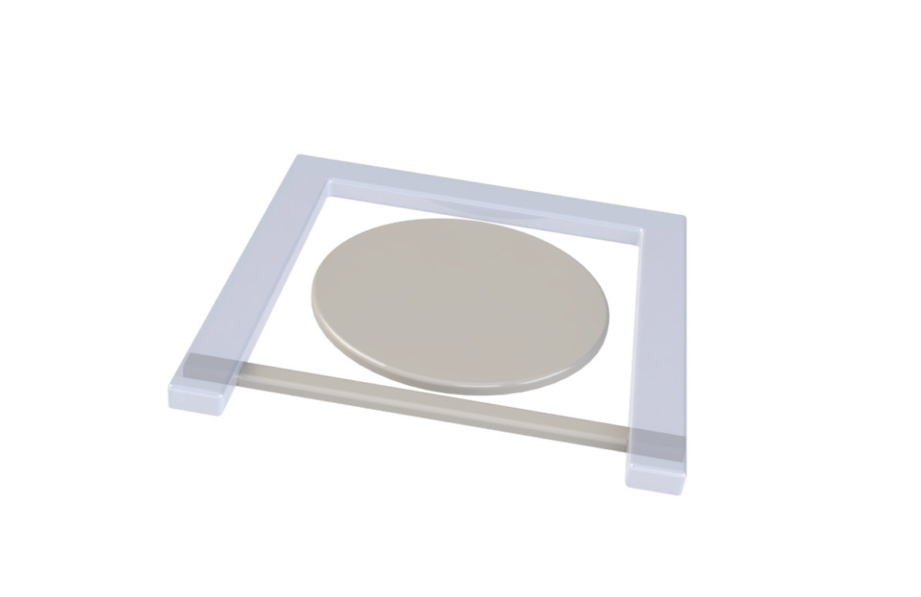
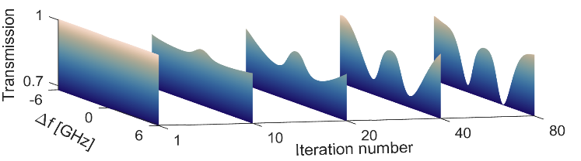
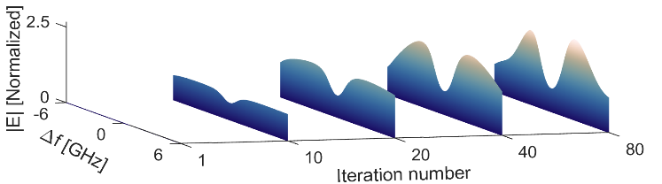
Where E_{C} is the complex amplitude of the field coupled to the resonator (step 2 in Figure S1.a.), E_{RT} is the complex amplitude of the electric field after propagating one roundtrip in the cavity (step 3 in Figure S1.a.), E_{out} is the complex amplitude of the field emitted from the cavity (step 5 in Figure S1.a.) into the output waveguide. κ and t are the cross and through coupling coefficients from the waveguide to the cavity, respectively. For a lossless coupler, the coupling coefficients satisfy:
Figure S1 – a) The iteration steps of the simulation model describing the waveguide and resonator where: $E_{0}$ is the amplitude of the electric field at the beginning of the exposed waveguide section, E_{in} is the complex amplitude of the incoming electric field after propagating distance $L_{WG}$ in the exposed waveguide section leading to the resonator (also written as $E_{WG}$ for clarification) , E_{C} is the complex amplitude of the field coupled to the resonator, E_{RT} is the complex amplitude of E_{C} after propagation of one roundtrip in the cavity, E_{out} is the complex amplitude of the field that is coupled from the cavity to the output waveguide, $E_{final}$ is the complex amplitude of the electric field after propagating distance $L_{WG}$, κ is the coupling coefficient from the waveguide to the cavity, and t is the self-coupling coefficient. b) schematics of the disc resonator and waveguide coupling section. c) Transmission function of the hybrid Rb-cavity system as function of iteration number. d) Normalized electric field within the cavity for the hybrid Rb-cavity system as a function of iteration number.
$$E_{WG}=E_{0}exp\left(i\frac{ω}{c}n_{eff,WG}\left({|E}_{0}|\right)L_{WG}\right)=E_{in}$$
$$E_{C}^{(m)}=- κ^{*}E_{in}+tE_{RT}^{\left(m-1\right)} , E_{RT}^{\left(0\right)}=0$$
$$E_{RT}^{(m)}=exp\left(i\frac{ω}{c}n_{eff,disc}\left(\left|E_{C}^{(m)}\right|\right)2πR\right)E_{C}^{(m)}$$
$$E_{out}=t^{*}E_{in}+κE_{RT}^{(N)}$$
$$E_{final}=E_{out}exp\left(i\frac{ω}{c}n_{eff,WG}\left({|E}_{out}|\right)L_{WG}\right)$$
$$\frac{\left|E_{RT}^{\left(m\right)}\right|}{\left|E_{in}\right|}-\frac{\left|E_{RT}^{\left(m-1\right)}\right|}{\left|E_{in}\right|}<CV$$
Has the
convergence condition met?
Yes
No
a)
ӿ m=0,1,2,…N
ӿ ӿ N=m, when the convergence
criteria is met
1
2
3
4
5
6
c)
d)
b)
$$E_{in}$$
$$E_{C}$$
-$κ^{*}$
$$κ$$
$$t$$
$$E_{out}$$
$$E_{0}$$
$$E_{final}$$
$$L_{WG}$$
$$L_{WG}$$
$$t^{*}$$
$$E_{RT}$$
$$\left|κ^{2}\right|+\left|t^{2}\right|=1 (10)$$

The simulation in hand is iterative in nature because the effective refractive index depends on the field. We start with iteration number m=0 where the light is coupled to the cavity and the electric field in the cavity after the coupling region is given by: $E_{C}^{(0)}=-κ^{*}E_{in}+tE_{RT}^{\left(0\right)}$ (step 2 in Figure S1.a.), where $E_{RT}^{(0)}=0$ since there is no light circulating within the cavity at the first iteration step. The field is then propagated by a single roundtrip to obtain: $E_{RT}^{\left(1\right)}=exp\left(i\frac{ω}{c}n_{eff}\left(\left|E_{C}^{(0)}\right|\right)2πR\right)E_{C}^{(0)}$ (step 3 in Figure S1.a.). A crucial point to be made is that during the propagation step the power dependent effective refractive index needs to be calculated based on the amplitude of the electric field that resides within the cavity during this iteration step ($E_{C}^{(0)})$. At the next iteration there will be more power within the cavity and $n_{eff}(\left|E\right|)$ is subjected to changes due to power-based effects of the Rb vapor such as power broadening and saturation. As a result, in each iteration we need to consider the light already circulating within the cavity and add its contribution to the light coming from the waveguide as follows: $E_{C}^{(1)}=-κ^{*}E_{in}+tE_{RT}^{\left(1\right)}$. These iteration steps are repeated until the fields are converging to a stable solution. The stability is verified by:
$$\frac{\left|E_{RT}^{(m)}\right|}{\left|E_{in}\right|}-\frac{\left|E_{RT}^{\left(m-1\right)}\right|}{\left|E_{in}\right|}<CV (11)$$
Where m is the iteration number, $E_{RT}^{(m)}$ is the complex amplitude of the electric field for iteration number m, and CV is a Convergence Value that is typically set to be below 1% between consecutive iterations for all the frequencies involved (step 4 in Figure S1.a.). The gradual convergence process is shown in Figure S1.c and Figure S1.d demonstrating the evolution of the transmission spectrum and the field within the cavity as a function of iteration number.
Once a steady state solution has been reached, the field that is coupled out of the microdisk is calculated as:
$$E_{out}=t^{*}E_{in}+κE_{RT} (12)$$
This field propagates along another exposed segment of the waveguide (step 6 in Figure S1.a.), and thus the final field is calculated as:
$E_{final}=E_{out}exp\left(i\frac{ω}{c}n_{eff,WG}\left({|E}_{out}|\right)L_{WG}\right) (13)$

REFERENCES
1. Gea-Banacloche, J., Wu, H. & Xiao, M. Transmission spectrum of Doppler-broadened two-level atoms in a cavity in the strong-coupling regime. Phys. Rev. A 78, 23828 (2008).
2. Robinson, J. T., Preston, K., Painter, O. & Lipson, M. First-principle derivation of gain in high-index-contrast waveguides. Opt. Express 16, 16659–16669 (2008).
3. Robinson, J. T., Chen, L. & Lipson, M. On-chip gas detection in silicon optical microcavities. Opt. Express 16, 4296–4301 (2008).
4. Dell’Olio, F. & Passaro, V. M. N. Optical sensing by optimized silicon slot waveguides. Opt. Express 15, 4977–4993 (2007).
5. Liu, Y., Chang, T. & Craig, A. E. Coupled mode theory for modeling microring resonators. Opt. Eng. 44, 84601 (2005).
6. Yariv, A. Coupled-mode theory for guided-wave optics. IEEE J. Quantum Electron. 9, 919–933 (1973).
7. Li, Q. et al. Vertical integration of high-Q silicon nitride microresonators into silicon-on-insulator platform. Opt. Express 21, 18236–18248 (2013).

