Supplemental Material

Workshop 1 Schedule
Activity | Description
Arrival (30 minutes)

Welcome and Introductions (30 minutes) | Researchers presented an overview of the aims of the workshop, setting ground rules, and an ice breaker (building the tallest tower with Legos)
Current System (15 minutes) | Findings from previous research carried out by the research team were presented back to the participants, many of whom took part in the semi-structured interviews and survey that informed the co-design workshop day.
Small Group Activity 1 (30 minutes) – What are the most important barriers to overcome to weight maintenance? | Participants were presented with a deck of cards with barriers to keeping weight off that stakeholders have told us about in interviews (cite Lorraine et al., 2025) and were asked to discuss which barriers are the most important to address (Photo 1). The barriers fell under three categories: Accessing the programme, being in the weight management programme, and support after the programme. Participants were able to add more barriers by writing barriers on blank cards provided.
Small Group Activity 2 (30 minutes) – What has helped people keep the weight off? | The research team presented enablers to weight maintenance printed out on white card stock paper where they could either place them on a large red or green coloured paper (Photo 2). Enablers placed on the red paper were deemed not helpful or realistic to implement. Enablers placed on the green paper were deemed helpful and realistic. Participants were then asked to look through a list of barriers and pick out the ones that were the most important to address. Enablers and barriers were from previously published research and from the findings of the semi-structured interviews and survey results (cite Lorraine et al, 2025). Participants were invited to write any enablers or barriers not already included and to write directly on the paper any thoughts or reflections.
Break for Tea and Coffee

Group Discussion of Activity 1 and 2 (30 minutes) | Researchers asked the participants to prioritise the enablers and barriers that could be realistically addressed in this workshop and in practice. Also, participants were asked what helped people keep the weight off.
Lunch (1 hour and 15 minutes)

Presentation to Entire Group (30 minutes) | The research team presented findings from the semi-structured interviews and survey results on what the participants said weight management services should look like to facilitate weight maintenance.
Small Group Activity 3 (1 hour) – What are the solutions? | Each table was presented with one suggestion for creating a better weight management service and pathway and were invited to provide comments, feedback, and suggestions for how it would look implemented into a real-life setting (Photos 3 & 4). This also included potential barriers and roadblocks for implementing said suggestion. After 10-15 minutes the large paper with the suggestion was passed to the next table for continued comments, feedback, and suggestions while seeing what has been previously said.
Break for Tea and Coffee

Group Discussion of Activity 3 (30 minutes) | The participants discussed as a group their proposed solutions
End of Day (30 minutes) | Researchers outlined the next steps of the research and intended dissemination of the findings. Participants then filled out an anonymous questionnaire about the facilitation and delivery of the workshop. Participants received their vouchers (£100) for their time before leaving the venue.

Workshop 1 – Small Group Activity 1 Artefacts
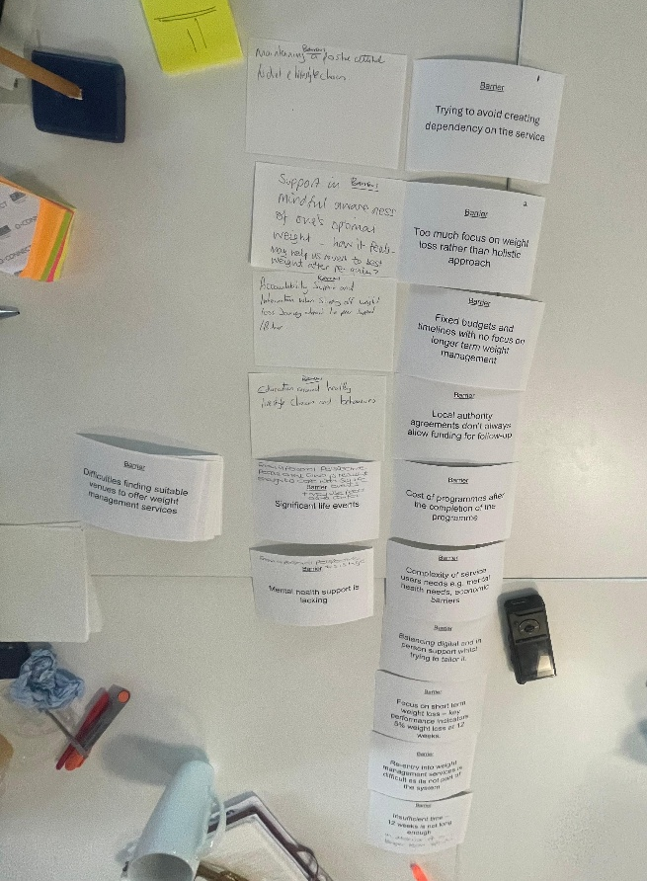

Workshop 1 – Small Group Activity 2 Artefacts

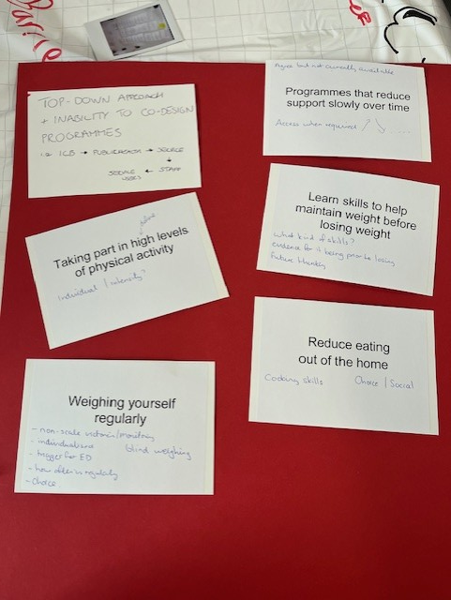
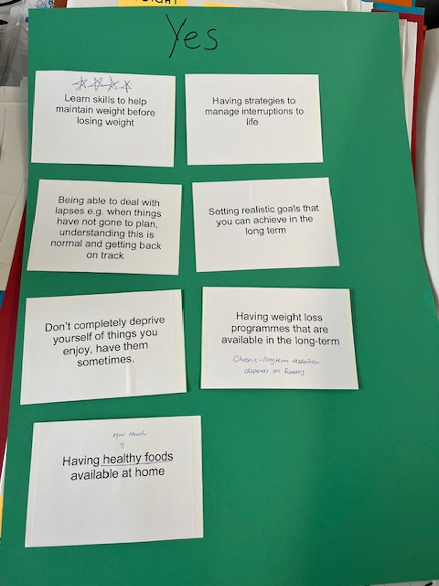

Workshop 1 – Small Group Activity 3 Artefacts
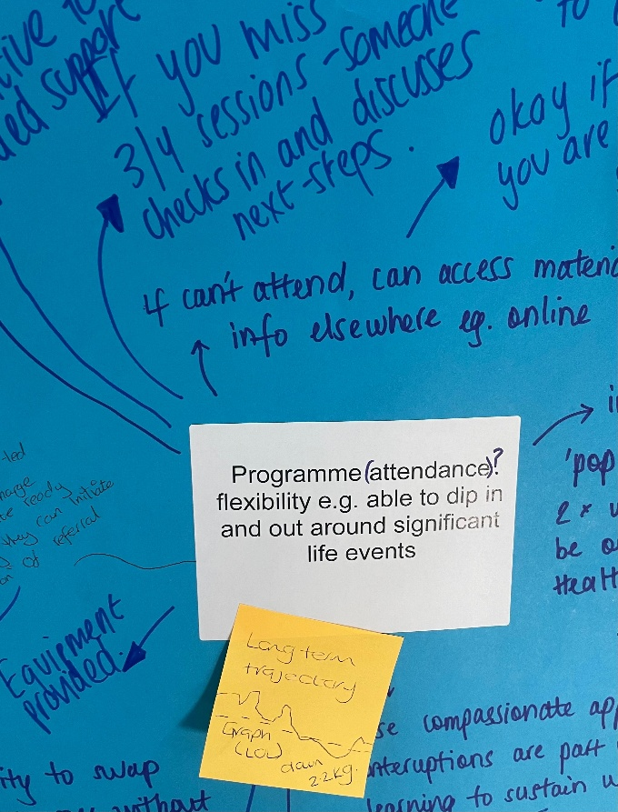
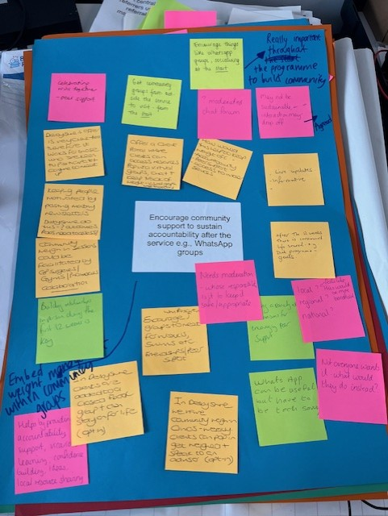

Online Engagement – Padlet Artefacts
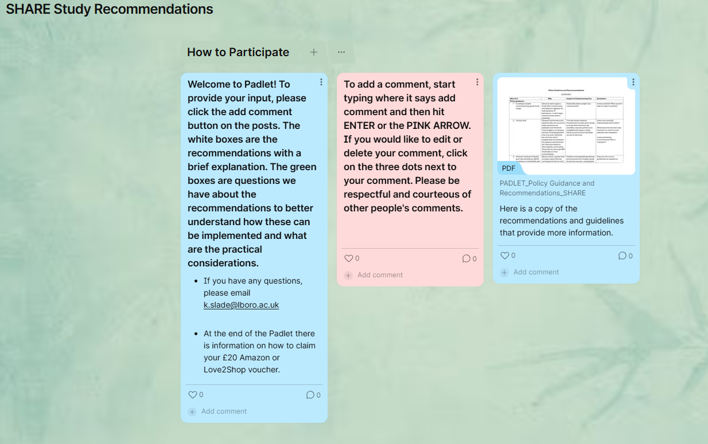

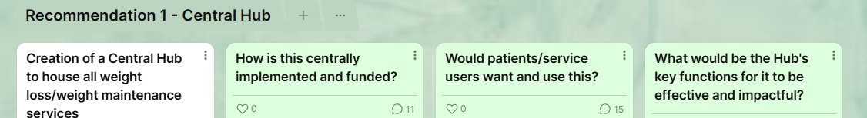

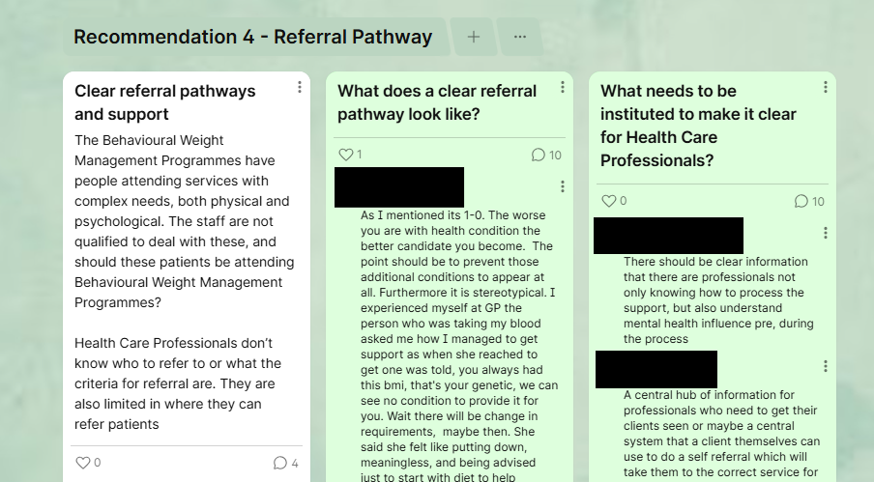

Workshop 2 – Schedule

Activity | Description
Arrival (30 minutes)

Welcome and Introductions (30 minutes) | Researchers presented the NICE guidance from January 2025, and participants were asked to give feedback by writing down thoughts and putting them in a cube. Participants were presented with the NICE guidance (see below)
Presentation of Activity 1 (15 minutes) | Findings from previous workshops and aims of Activity 1 were presented to the participants.
Small Group Activity 1 (1 hour and 15 minutes) – What should the Central Hub, tapering of support, and KPIs look like? | Participants were presented with large, coloured paper with either the Central Hub, Tapering of Support, and KPIs listed on them. Feedback from Workshop 1 and Workshop 2 indicated these three-policy guidance was the most important to people, however there were lingering questions about how they would be implemented, etc. Participants were asked to write down what the Central Hub, tapering of support, and KPIs should look like. The three large, coloured pieces of paper were passed around from table to table.  Participants were presented with the proposed Central Hub and a list of KPIs that participants had indicated they think should be measured in Workshop 1 and Workshop 2, and from NICE guidance and feedback from commissioning (see below).
Feedback from Group Activity 1 (30 minutes) | Each table shared their thoughts and perspectives of the three policy guidance recommendations.
Lunch (1 hour and 15 minutes) | During lunch, the research team rearranged the seating arrangements for the participants per the feedback from Workshop 1.
Presentation to Entire Group 15 minutes) – Who should be attending behavioural weight management programmes? | From the previous workshops, there was a lot of discussion around WHO should be attending behavioural weight management groups. For example, should individuals with mental health challenges and those just below the BMI threshold attend the BWMP or if not, where do they go? Researchers presented what had been previously said by participants in Workshop 1 and Workshop 2.
Small Group Activity 2 (1 hour) – Who should be attending behavioural weight management programmes? What support is available or should be available for those not able to attend BWMPs? | Each table was asked three key questions:  - Who can attend behavioural weight management programmes  - Are there any service users that should be referred to other services to help them with long term weight management  - How do we identify these people?
Break for Tea and Coffee

Group Discussion of Activity 3 (30 minutes) | The participants discussed as a group their proposed solutions
End of Day (30 minutes) | Researchers outlined the next steps of the research and intended dissemination of the findings. Participants then filled out an anonymous questionnaire about the facilitation and delivery of the workshop. Participants received their vouchers (£100) for their time before leaving the venue.

Workshop 2 – Small Group Activity 1 Materials and Artefacts
KPI’s presented to small groups on large-coloured paper with room to write. X’s indicate which group (NICE guidance, Commissioning guidance, Suggestions from Workshop 2 – Padlet) said they should be measured.
Key Performance indicators | NICE | Commissioning guidance for tier 2 services | Padlet suggestions
Anthropometric measures such as BMI or waist-to-height ratio | x | x | x
Indicators of dietary intake (for example intake of fruit and vegetables or sugar-sweetened drinks | x |  | x
Physical activity (for example time spent in moderately vigorous activities such as brisk walking) or sedentary behaviour (for example leisure-based screen time or car use) | x |  | x
Prevalence of obesity-related diseases | x
Wider health outcomes such as indicators of mental health and wellbeing, improvements in self-esteem and quality of life | x |  | x
Prevalence of obesity-related diseases | x
Wider health outcomes such as indicators of mental health and wellbeing, improvements in self-esteem and quality of life | x
Changes in dietary habits, physical activity and sedentary behaviour | x
Changes in self-esteem, depression or anxiety | x
Indicators of structural changes (such as changes to procurement contracts | x
Process outcomes such as service use, engagement of groups subject to health inequalities groups, establishment or expansion of community groups | x
Change in health outcomes, such as blood pressure, HbA1c | x |  | x
75% of participants will have lost weight at the end of the active intervention |  | x
30% of all participants will lose a minimum of 5% of their (baseline) initial body weight, at the end of the active intervention. Additional (optional) indicator: ii) 50% of completers will lose a minimum of 5% of their (baseline) initial body weight, at the end of the active |  | x
35% of completers provide a weight measure at 6 months |  | x
20% of completers provide a weight measure at 12 months |  | x
XX% of completers at 12 months have a body weight that is lower than their (baseline) initial body weight (please insert locally defined figure). |  | x
Percentage of services users completing follow-up appts at 6, 9, and 12 months |  |  | x
Percentage of service users that have maintained their weight |  |  | x
Health deficiencies of macros, hormones, etc. (???) |  |  | x
Muscle and skin conditions |  |  | x
Mental management during and after programme |  |  | x
Long term goals/indicators such as non-progression to pre-diabetes/diabetes, non-progression to hypertension, improved mood, etc |  |  | x
percentage of service users that have lost additional weight since the programme |  |  | x
Sleep quality |  |  | x
Stress levels |  |  | x

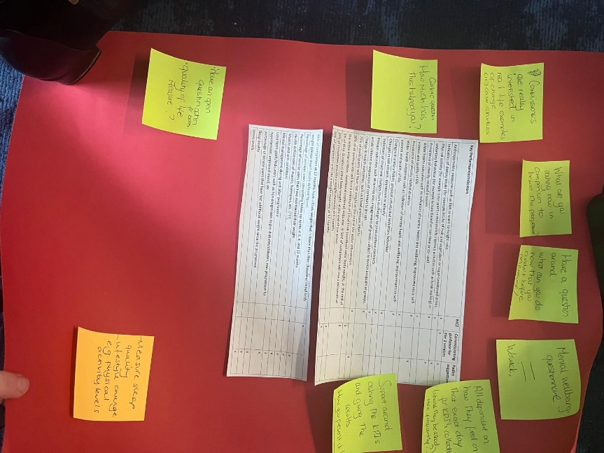
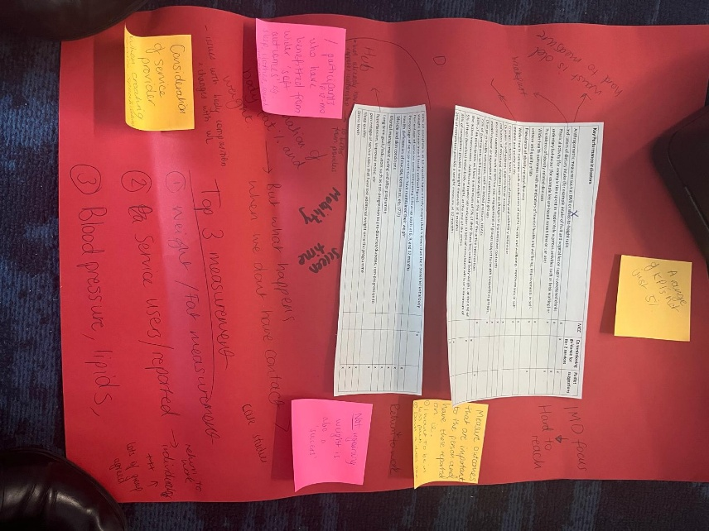

Proposed Central Hub
Participants were presented with the proposed central Hub idea and were asked to provide their feedback, comments, and considerations for the implementation of the Hub.
Digital Hub
Aim:
To provide coordinated, evidence-based approaches to help individuals achieve and maintain a healthy weight, improve wellbeing, and reduce health risks associated with overweight and obesity.

Objectives:
- To identify and offer appropriate weight management support that is available.
- To ensure continuity of care for patients by having follow-up support and records of weight management activity.
- Encourage sustainable weight loss and long-term maintenance through ongoing follow-up and support.
- Collect and analyse data on patient outcomes, satisfaction, and service delivery.
- To offer further intervention or re-referral if weight is regained.
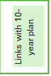
Responsibilities
- Nationally funded digital hub with allowance for phone support (to avoid digital exclusion). Either through the NHS app or the Neighbourhood health services.
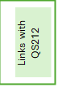
- Service providers (including health promotion services, primary care, behavioural overweight and obesity management services) ensure they provide details of their service to relevant local authorities and health commissioning organisations. They make them aware when these details are updated or are no longer relevant.
- Commissioners ensure that they coordinate, maintain and make accessible up-to-date information on available local and national interventions and services that are accessible within the areas they commission.

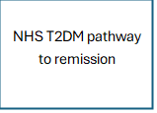
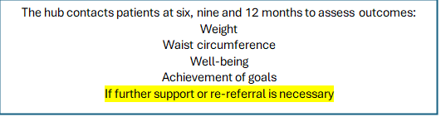
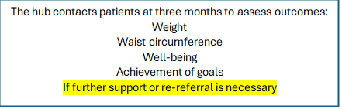
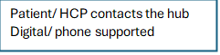
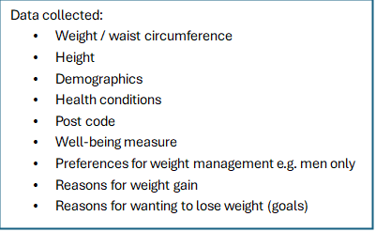

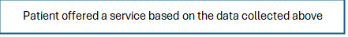


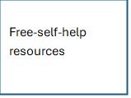
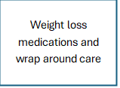

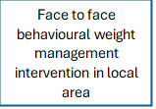

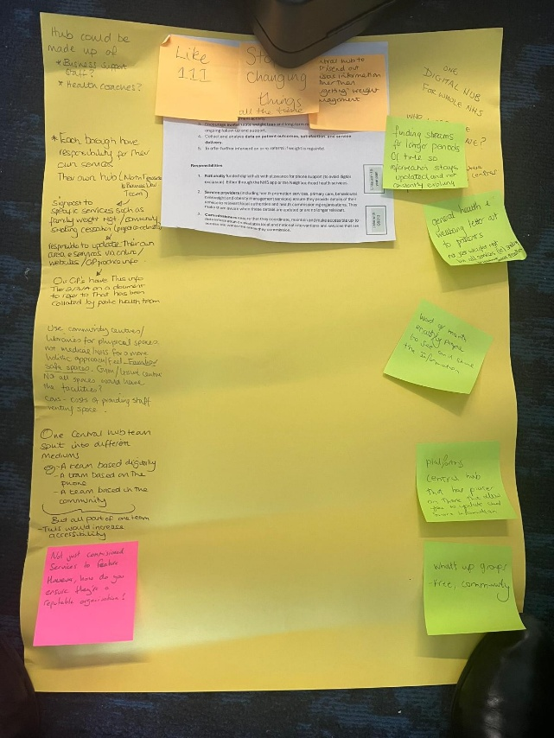
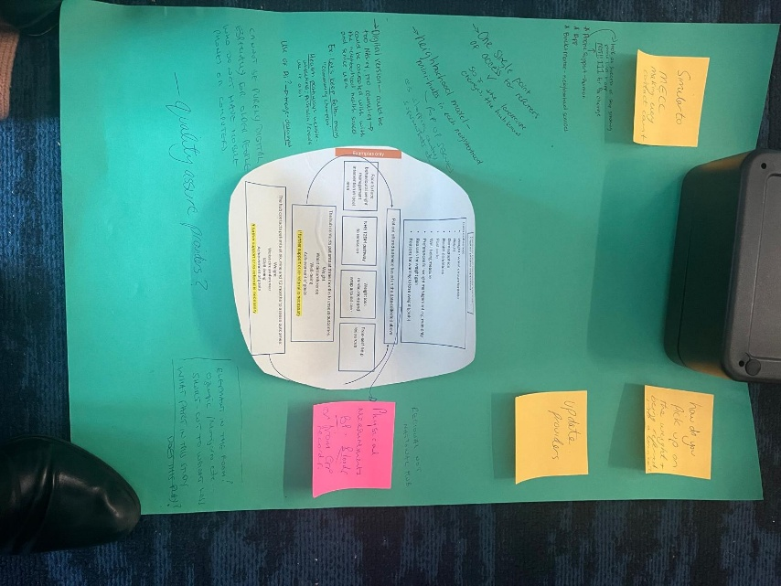

Tapering of Support
Participants were asked to discuss what tapering of support would look like in practice.
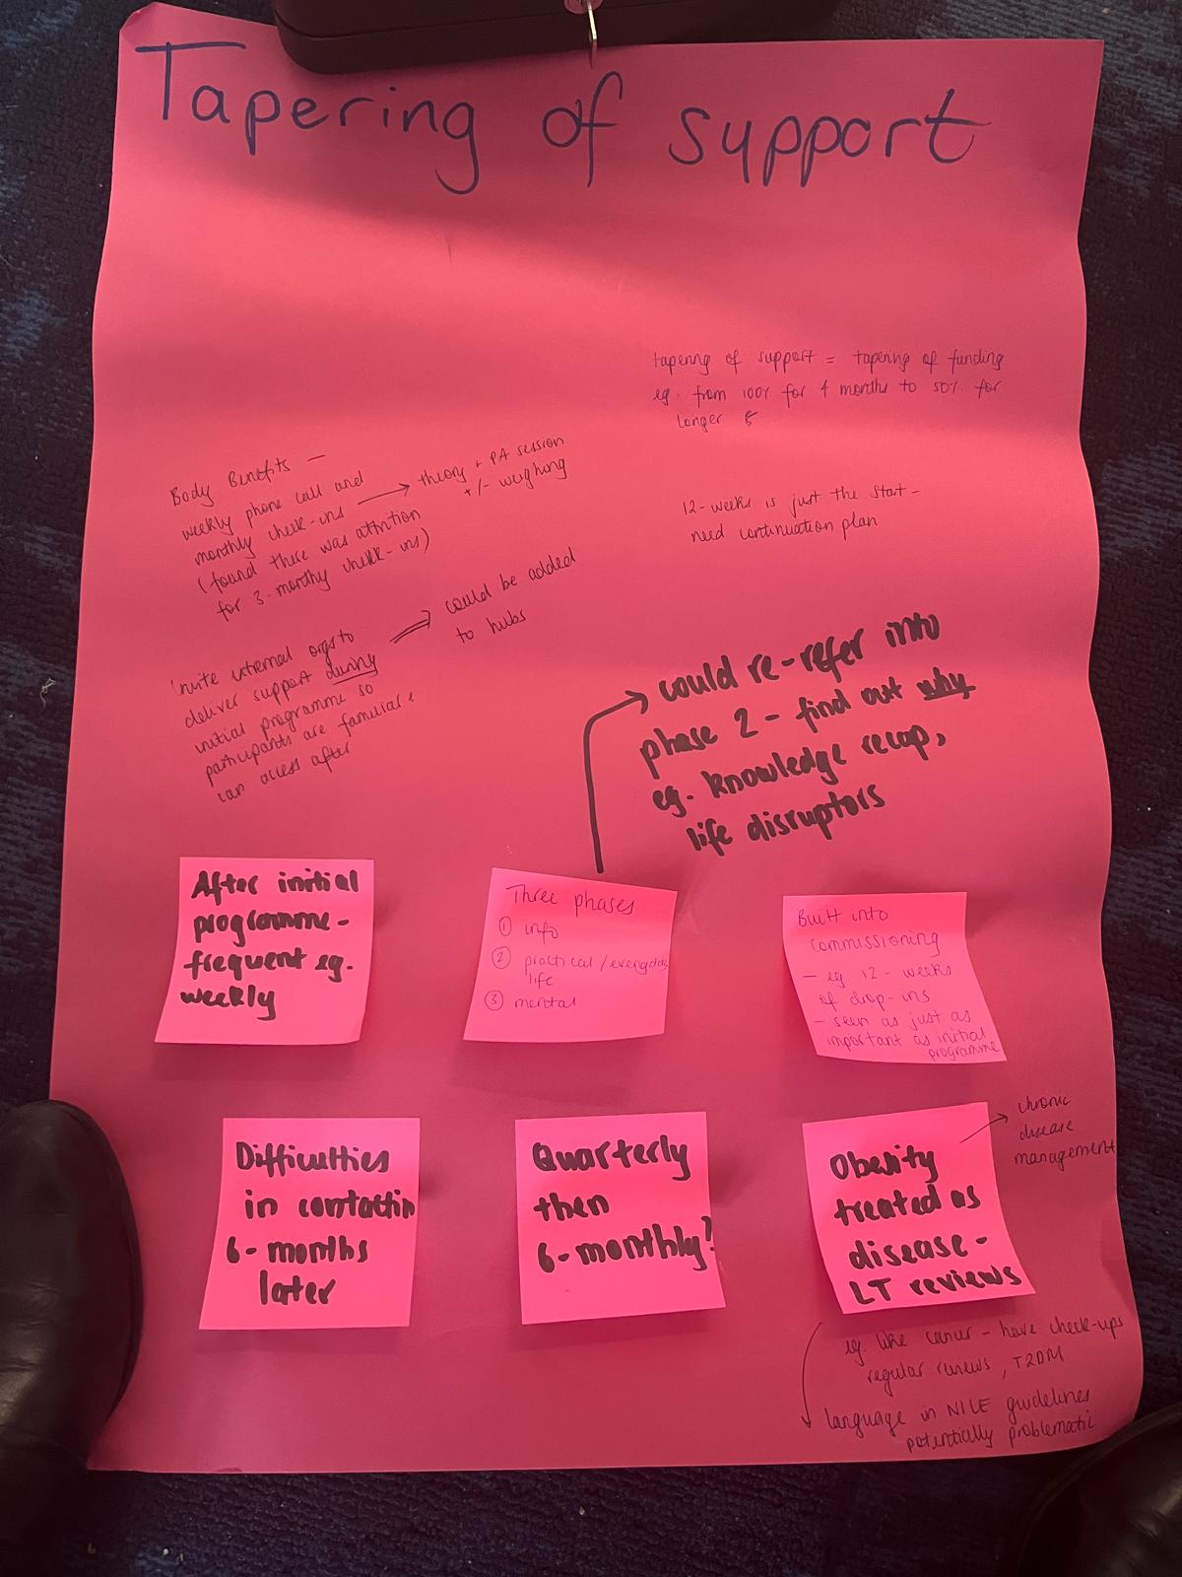

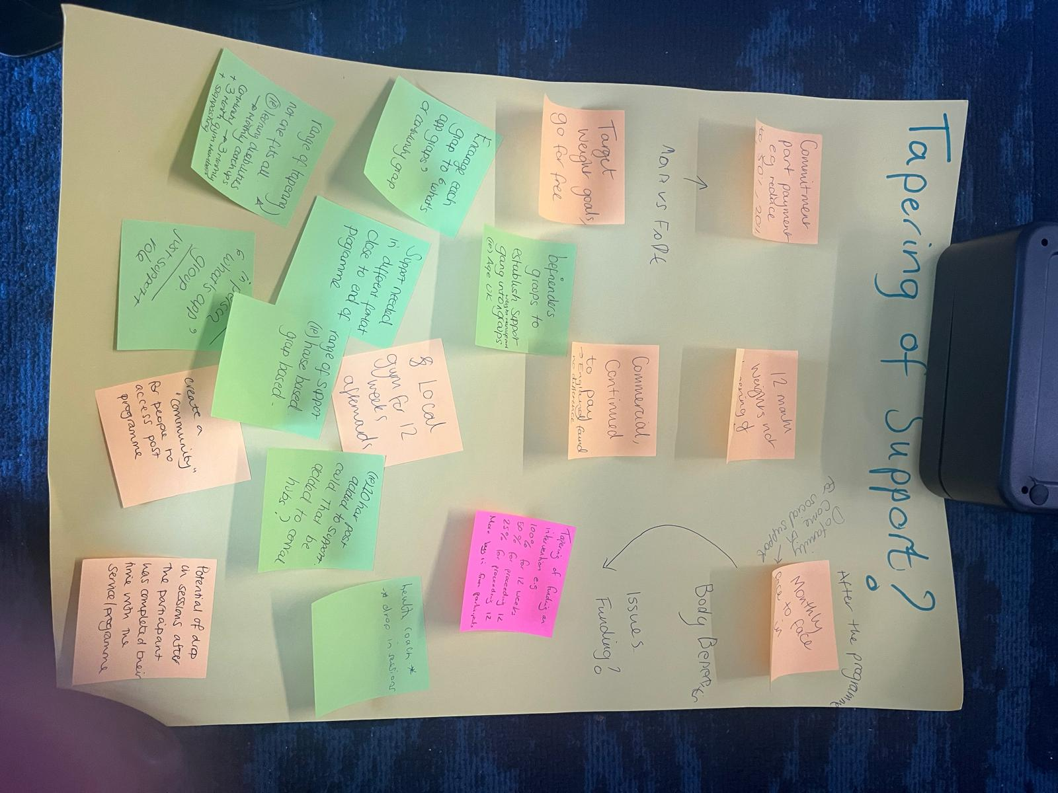

Workshop Feedback Form
The SHARE study Feedback form
1. Overall Experience
How would you rate your overall experience of the workshop?
☐ Excellent
☐ Good
☐ Fair
☐ Poor
2. Workshop Content
How satisfied were you with the following aspects?
Aspect | Very Satisfied | Satisfied | Neutral | Unsatisfied | Very Unsatisfied
Workshop objectives were clear | ☐ | ☐ | ☐ | ☐ | ☐
Relevance of topics | ☐ | ☐ | ☐ | ☐ | ☐
Balance of discussion/ activities | ☐ | ☐ | ☐ | ☐ | ☐

3. Facilitation
Please rate the following:
Aspect | Excellent | Good | Fair | Poor
Facilitator’s communication | ☐ | ☐ | ☐ | ☐
Encouragement of participation | ☐ | ☐ | ☐ | ☐
Time management | ☐ | ☐ | ☐ | ☐
Comments:

4. Participation
Aspect | True | False | Somewhat
I felt encouraged to share my ideas | ☐ | ☐ | ☐
I felt my contributions were valued | ☐ | ☐ | ☐
There was a good balance of voices in the room | ☐ | ☐ | ☐

Comments:

5. What worked well in this workshop?
6. What could be improved for future workshops?
7. Any other comments or suggestions?

Thank you for your feedback!

Example of Data Collection and Transcription of Artefacts – Workshop 1 Activity 3

- Space sessions out
- Need time – months – to develop and co-design – but can’t take time out of service to do à build relationships with community groups – earlier for in-house vs. commercial à community groups come to programme and talk about what’s available à do throughout programme from the start
- Develop pathway to maintain weight management: call/recall 6-montly – bloods, weight
- ‘Add’ health check and holistic care in care plan for every visit
- Closing the feedback loop to referrer for ongoing referrals
- Database/directory of services available à ?sustainability ? resource à not good for those who aren’t tech savvy
- Signpost to self-referral à you need to know what services are there for you to do this, not everyone does à also encourage patients to know how to find this info for themselves
- Formalised/structures referral system
- Start planning the end pathway from the beginning

A central hub that refers users to manage referrals to weight management services
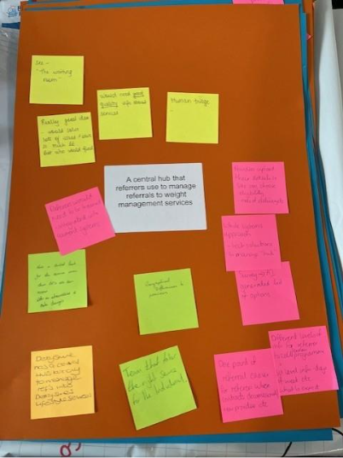
- See “the waiting room”
- Really good idea – would solve lots of issues and save so much £££. But who would fund?
- Would not good quality info about services
- Human triage
- Referrers would need to be trained – integrated into current systems
- Providers upload their details so service users can choose eligibility
- Survey → AI generates list of options
- Tech solutions to manage hub
- One point of referral easier for referrers when contracts decommissioned/new provider etc.
- Different levels of info for referrers to explain programme – SU level info – days of week, what to expect etc.
- Team that finds the right service for the individual
- Doncaster has a central hub already to manage refs into Doncaster’s lifestyle services
- Have a digital hub for the service area that they can then access. Like an alternative to Data Lounge.

Encourage community support to sustain accountability after the service e.g., Whatsapp groups

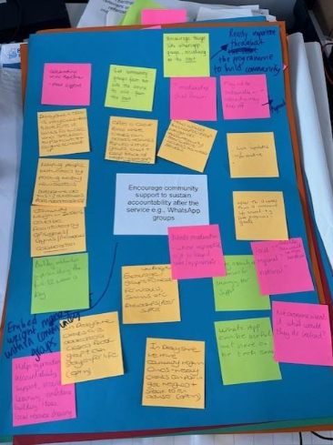
- Pink Notes
- "Weekly support group meetings for those who have signed up."
- "Easily integrate WhatsApp groups into the program."
- "Provide resources and tools to build community."
- "WhatsApp groups can help maintain engagement post-service."
- "Use social media platforms for wider reach."
- Green Notes
- "Encourage them to share their experiences and feedback."
- "Embed motivational videos within WhatsApp groups."
- "Share tips on maintaining progress."
- Yellow Notes
- "Create a buddy system for mutual support and motivation."
- "Provide training on how to use WhatsApp effectively."
- "Facilitate discussions on common challenges and solutions."
- "Incorporate gamification elements like challenges & rewards."
- "Create a sense of belonging through group activities."
- Orange Notes
- "Share success stories and testimonials."
- "Organize regular check-ins and follow-ups."
- "Regularly update content shared in the group."

Key performance indicators should include long term weight maintenance
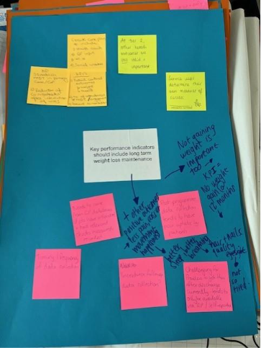
- Yellow Notes
- "Are there other health benefits that should be considered?"
- "What are the long-term effects of weight loss maintenance?"
- "How can we measure the success of weight loss programs?"

- Green Note
- *"Some ways to measure success:
- BMI
- Waist circumference
- Blood pressure"*

- Pink Notes
- *"What is the best way to track progress over time?
- Regular check-ins
- Self-monitoring tools"*
- "Not seeing weight loss results can be discouraging for patients."
- *"Challenges in maintaining weight loss:
- Lifestyle changes
- Support systems"*
- "What role do genetics play in weight loss maintenance?"
- "Differences between short-term and long-term strategies for weight management"

- Blue Notes (with arrows)
- "Weight regain is common"
- "Need for ongoing support"
- "Importance of realistic goals"
- "Psychological factors play a role in success"

Services should focus on health and wellbeing not just weight loss

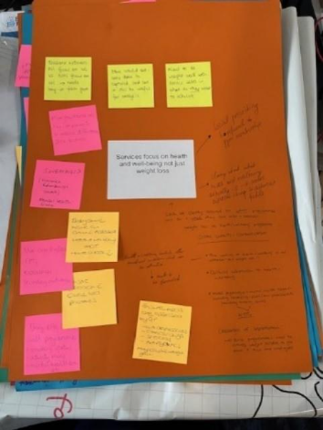
- Pink Notes
- "Remove culture of shame around food and body size"
- "Encourage self-acceptance and body positivity"
- "Educate about nutrition in a way that is inclusive and non-judgmental"

- Yellow Notes
- "Give people access to healthy food that is affordable"
- "Promote mental health support for those struggling with body image issues"
- "Create supportive communities where people can share their experiences without fear of judgment"

- Green Notes
- "Focus on the benefits of exercise beyond weight loss"

Example of Facilitator Notes – Workshop 3
SHARE Stakeholder workshop
4th November 2025 – Birmingham
Break out activity notes
Activity one: What should a hub look like?
- Digital
- A digital hub could be more convenient for service users
- More cost effective
- Similar template or part of the NHS digital app
- Downsides, needs to be kept regularly updated, goes out of date quickly – who is responsible for updating?
- Public health team or Branch coordinators could be responsible for updates
- Info to be shared with GPs etc. and in local newspapers/magazines
- In-person
- Where could services tap into? Community centres/settings/libraries/leisure centres etc. (safe, familiar places where people are) could have the option to be in more than one space but would have to make sure they are connected/communicate
- Costs and funding could be an issue
- Wide advertising would be needed (local, free newspapers etc.) But do not just focus on one aspect i.e. WMS but provide information about all aspects of health/wellbeing services/activities available locally
- Badge the hub as a general wellbeing space to include all aspects of health such as smoking cessation, wellbeing checks etc.
- Empower people to share information/stories
- Lengths of commissioning times should be standardised
Activity two: tapering of support
- Keep service users engaged with a personal phone call/email/text every few weeks
- Build a peer support community/network at the beginning of the programme (have a designated support person role)
- Provide drop-in sessions
- Peer support is a good model but requires participants to be proactive and confident
- Can someone in the ‘hubs’ help to maintain engagement?
- Link in with other services such as Age UK, befrienders, social prescribers and other services/specialisms to support people to engage in healthy behaviours, attend gyms etc. Grow support…
- Not every area has other support services to signpost to
- Have the flexibility to adapt support to individual needs
Activity three: KPIs
- Ask ‘what can you do now that you couldn’t before?’
- How do you measure things like sleep quality/ being able to walk upstairs etc?
- Have open-ended questions for service users and providers (what is important for them?)
- It is important to feedback what service users are getting out of the service
- Have some basic questions with a sliding scale (how has this service helped you? – not very much, somewhat etc…)
- Produce case studies
- Some questionnaires such as the Warwick Scale, have questions that are very difficult to answer, especially comparison at baseline and end if no significant changes/progression has been made
- Provide weekly catchups to go over personal goals not just at baseline and programme end (appreciated that there may not be capacity to do this)

Who should be allowed to attend a behaviour WMS?
- Anyone who is ready to make a change – regardless of weight.
- Motivation to change is more important than BMI
- It may be to improve diet, gain more exercise for overall health and not just a focus on weight
- Services should be available for adults and family groups
- Providers should make sure effort/resource is made to engage service users from the beginning to lessen barriers/anxieties
- Service users who are using obesity reducing drugs should have access to wrap around support
- Removal of the tier systems may be of benefit as people can be referred to where they need to be
What does a holistic approach mean?
- Enables a conversation between a provider and service user to be able to signpost and recognise what a person’s needs are and having the resources to refer them on to
- Single point of access/triage
- Not focusing just on weight but health and wellbeing
- Approaches should be personalised with appropriate support and signposting (wraparound support)
- Service users should have opportunities and support for accountability
- Could be issues to provide at scale
- The way in which services are commissioned can impact the ability to provide a holistic approach

