Additional file 1
Supplementary Methods, Tables, and Figures
Trends and Disparities in Mortality Involving Co-Documented Sepsis and Obesity Among US Adults Aged 25 Years or Older, 1999-2024: A Serial Cross-Sectional Study
Maham Afzal, MBBS¹; Maryam Raza, MBBS²; Shiza Talib Butt, MBBS³
¹Fatima Jinnah Medical University, Lahore, Pakistan; ²Lahore Medical and Dental College, Lahore, Pakistan; ³Dow University of Health Sciences, Karachi, Pakistan
Corresponding author: Maham Afzal, MBBS; Fatima Jinnah Medical University, Lahore, Pakistan; Email: mahamafzaltarar@gmail.com; ORCID: 0009-0003-8541-6864

Contents
- Supplementary Methods 1. Data source, study population, and case definition
- Supplementary Methods 2. Mortality measures and Joinpoint analysis
- Supplementary Methods 3. Sensitivity analyses
- Supplementary Methods 4. Race and Hispanic-origin classification
- Supplementary Methods 5. Race data quality and analysis framework
- Supplementary Tables S1-S28
- Supplementary Figures S1-S10
- Supplementary References

Supplementary Methods 1. Data source, population, and case definition
This retrospective serial cross-sectional study used the CDC WONDER Multiple Cause of Death databases for US resident decedents aged 25 years or older. The historical database covered 1999-2020 [1], and the Single Race database covered 2021-2024 for the primary non-race series and 2018-2024 for the contemporary race analysis [2]. Eligible deaths had at least one prespecified septicemia code and at least one obesity code recorded anywhere on the same death certificate. The underlying cause of death was not restricted.
Septicemia codes were A02.1, A20.7, A22.7, A26.7, A32.7, A39.4, A40.0-A40.3, A40.8-A40.9, A41.0-A41.5, A41.8-A41.9, A42.7, and B37.7. Obesity codes were E66.0, E66.1, E66.2, E66.8, and E66.9. Codes within each set were joined by OR, and the two code sets were joined by AND. Counts of 1-9 deaths suppressed by CDC WONDER were retained as missing and were not imputed.

Supplementary Methods 2. Mortality measures and Joinpoint analysis
The primary measure was the age-adjusted mortality rate (AAMR) per 100000 population, standardized by the direct method to the 2000 US standard population. Annual deaths, population denominators, AAMRs, 95% confidence intervals, and standard errors were retained when available. Trend analyses included the overall population, sex, Hispanic origin, Census region, historical race, contemporary race and ethnicity, urbanization for 1999-2020, and the A40-A41 sensitivity definition.
Joinpoint regression analyses used Joinpoint Regression Program version 6.1.0 [3]. Log-linear models incorporated annual AAMR standard errors under the heteroscedastic-errors option. Model selection used Weighted Bayesian Information Criterion, and Empirical Quantile 95% confidence intervals used 5001 resamples. Up to four joinpoints were permitted for long series; contemporary seven-group models permitted one joinpoint. No breakpoint was forced at 2020. APCs and AAPCs were significant when their 95% confidence intervals excluded zero. Numerical subgroup differences were not treated as statistically different without formal comparison.
Urbanization-specific AAMRs and Joinpoint models used the 2013 NCHS urban-rural classification for 1999-2020. For 2021-2024, the age-restricted grouped query returned death counts without population denominators or rate measures; these counts were reported descriptively and were not interpreted as mortality-rate comparisons. State AAMRs were pooled separately for 1999-2020 and 2021-2024. Tables S10-S11 and Figures S9-S10 present the corresponding period-specific state estimates.

Supplementary Methods 3. Sensitivity analyses
The sensitivity analysis restricted the septicemia definition to A40-A41 while retaining the same obesity codes, population, years, and multiple-cause AND logic. Annual AAMRs and standard errors for the restricted definition were analyzed using the same Joinpoint settings. Separately, the descriptive COVID-19 analysis identified deaths in the expanded-code cohort with U07.1 as the underlying cause during 2020-2024. These deaths were subtracted from annual counts and their percentage contribution was calculated. Post-exclusion AAMRs were not derived because age-specific suppressed cells prevented valid direct standardization and age-adjusted rates are not additive. The analysis did not identify deaths in which U07.1 was recorded only as a contributing cause.

Supplementary Methods 4. Race and Hispanic-origin classification
Race and Hispanic origin were analyzed as distinct characteristics. Historical race analyses used the 1999-2020 bridged-race system, in which multiple-race records were reassigned to White, Black or African American, American Indian or Alaska Native, or Asian or Pacific Islander categories [4]. Contemporary analyses used the 2018-2024 Single Race database, which separately reports Asian, Native Hawaiian or Other Pacific Islander, and more-than-one-race populations [2]. Long-term Hispanic-origin trends compared Hispanic or Latino and non-Hispanic or Latino decedents from 1999 through 2024.
The historical and contemporary race classifications were not concatenated into a single 1999-2024 time series. Contemporary comparisons used mutually exclusive categories: six non-Hispanic single-race groups and Hispanic or Latino persons of any race. Pooled 2021-2024 AAMRs were the principal contemporary disparity estimates, with non-Hispanic White decedents as the reference group. Annual 2018-2024 race Joinpoint analyses were considered secondary and exploratory because each group contributed only seven observations.

Supplementary Methods 5. Race data quality and analysis framework
Historical rates based on fewer than 20 deaths were designated unreliable. Contemporary rates followed the CDC WONDER reliability criterion based on relative confidence-interval width. Hispanic-origin records categorized as Not Stated were retained for counts-only quality control because valid population denominators and AAMRs are not applicable. Historical Joinpoint modeling was restricted to non-Hispanic Black and non-Hispanic White groups, the only groups with complete reliable annual AAMRs and standard errors for all 22 years. Model inputs and reported APCs, AAPCs, and figures were checked for consistency. Because race and Hispanic origin can be misclassified on death certificates, group comparisons were interpreted as surveillance estimates rather than biological differences [5]. Reporting followed STROBE [6] and RECORD [7]; the checklist is provided in Supplementary Table S28.

Supplementary Table S1. Reproducible query and analysis criteria
Item | Specification
Study design | Retrospective serial cross-sectional multiple-cause-of-death analysis
Population | US resident decedents aged 25 years or older
Historical database | CDC WONDER Multiple Cause of Death, 1999-2020
Contemporary database | CDC WONDER Multiple Cause of Death, 2018-2024, Single Race
Underlying cause | Unrestricted (all causes)
Case definition | At least one selected septicemia code AND at least one selected obesity code anywhere on the same death certificate
Septicemia ICD-10 codes | A02.1; A20.7; A22.7; A26.7; A32.7; A39.4; A40.0-A40.3; A40.8-A40.9; A41.0-A41.5; A41.8-A41.9; A42.7; B37.7
Obesity ICD-10 codes | E66.0; E66.1; E66.2; E66.8; E66.9
Measures | Deaths; population; crude rate; AAMR; 95% CI; standard error, where available
Rate scale | Per 100000 population
Standard population | 2000 US standard population; direct age standardization
Trend-analysis domains | Overall; sex; Hispanic origin; Census region; historical race; contemporary race and ethnicity; urbanization (1999-2020); A40-A41 sensitivity
State summaries | Separate pooled tables for 1999-2020 and 2021-2024
Urbanization 2021-2024 | Counts only; not appended to 1999-2020 AAMRs
Joinpoint software | Joinpoint Regression Program version 6.1.0
Error model | Heteroscedastic errors using annual AAMR standard errors
Model selection | Weighted BIC
Confidence intervals | Empirical Quantile, 5001 resamples
Suppression | Counts of 1-9 suppressed; suppressed estimates retained as missing; no imputation

Supplementary Table S2. Annual percent-change segments
Domain | Group | Segment | APC (%) | 95% CI | P value | Significant
Overall | Overall | 1999-2018 | 4.35 | 2.7832 to 5.7144 | 0.0008 | Yes
Overall | Overall | 2018-2021 | 33.6037 | 18.9 to 40.5052 | <0.000001 | Yes
Overall | Overall | 2021-2024 | -20.591 | -28.298 to -14.6245 | <0.000001 | Yes
Sex | Female | 1999-2018 | 3.6203 | 2.0172 to 4.934 | 0.002 | Yes
Sex | Female | 2018-2021 | 30.579 | 15.8884 to 37.6529 | <0.000001 | Yes
Sex | Female | 2021-2024 | -18.4593 | -26.4764 to -12.2464 | <0.000001 | Yes
Sex | Male | 1999-2018 | 5.5726 | 4.1494 to 6.9395 | <0.000001 | Yes
Sex | Male | 2018-2021 | 35.9044 | 23.9412 to 42.6229 | <0.000001 | Yes
Sex | Male | 2021-2024 | -22.5848 | -28.9466 to -17.235 | <0.000001 | Yes
Hispanic origin | Hispanic | 1999-2018 | 4.3811 | 1.3316 to 7.1603 | 0.013197 | Yes
Hispanic origin | Hispanic | 2018-2021 | 50.6053 | 28.9302 to 64.6757 | <0.000001 | Yes
Hispanic origin | Hispanic | 2021-2024 | -33.952 | -42.6936 to -26.3458 | <0.000001 | Yes
Hispanic origin | Non-Hispanic | 1999-2018 | 4.4188 | 2.9272 to 5.6724 | 0.0004 | Yes
Hispanic origin | Non-Hispanic | 2018-2021 | 30.8957 | 16.7759 to 37.3426 | <0.000001 | Yes
Hispanic origin | Non-Hispanic | 2021-2024 | -18.3 | -25.9075 to -12.4427 | <0.000001 | Yes
Census region | Midwest | 1999-2005 | 10.2132 | 5.6137 to 31.6298 | <0.000001 | Yes
Census region | Midwest | 2005-2018 | 3.3171 | -4.413 to 4.3145 | 0.110778 | No
Census region | Midwest | 2018-2021 | 26.6136 | 18.4543 to 32.0259 | <0.000001 | Yes
Census region | Midwest | 2021-2024 | -19.9733 | -24.8886 to -15.6672 | <0.000001 | Yes
Census region | Northeast | 1999-2015 | 5.0929 | 4.299 to 10.1404 | 0.0016 | Yes
Census region | Northeast | 2015-2018 | -5.4606 | -11.4056 to 2.9205 | 0.185963 | No
Census region | Northeast | 2018-2021 | 26.5037 | 14.5113 to 35.2849 | <0.000001 | Yes
Census region | Northeast | 2021-2024 | -17.0684 | -24.1709 to -11.9608 | <0.000001 | Yes
Census region | South | 1999-2018 | 4.4073 | 2.8609 to 5.8715 | <0.000001 | Yes
Census region | South | 2018-2021 | 41.6488 | 27.4314 to 49.66 | <0.000001 | Yes
Census region | South | 2021-2024 | -20.6106 | -27.2887 to -14.8367 | <0.000001 | Yes
Census region | West | 1999-2018 | 4.1902 | 2.4001 to 5.7119 | 0.002 | Yes
Census region | West | 2018-2021 | 34.5548 | 18.492 to 42.0894 | <0.000001 | Yes
Census region | West | 2021-2024 | -23.6405 | -31.9861 to -17.3322 | <0.000001 | Yes
Historical race | Non-Hispanic Black | 1999-2018 | 2.3724 | -0.107 to 3.8608 | 0.055189 | No
Historical race | Non-Hispanic Black | 2018-2020 | 33.0251 | 7.66 to 45.6902 | <0.000001 | Yes
Historical race | Non-Hispanic White | 1999-2003 | 13.1187 | 5.6102 to 47.6901 | 0.002 | Yes
Historical race | Non-Hispanic White | 2003-2018 | 4.3126 | -5.3564 to 5.1634 | 0.294741 | No
Historical race | Non-Hispanic White | 2018-2020 | 21.4628 | 7.2132 to 32.1974 | <0.000001 | Yes
Contemporary race/ethnicity | Non-Hispanic American Indian or Alaska Native | 2018-2021 | 51.8193 | 24.9468 to 120.3992 | <0.000001 | Yes
Contemporary race/ethnicity | Non-Hispanic American Indian or Alaska Native | 2021-2024 | -26.1374 | -46.4506 to -11.5822 | <0.000001 | Yes
Contemporary race/ethnicity | Non-Hispanic Asian | 2018-2021 | 77.5177 | 60.8583 to 108.403 | <0.000001 | Yes
Contemporary race/ethnicity | Non-Hispanic Asian | 2021-2024 | -37.6194 | -44.8488 to -31.889 | <0.000001 | Yes
Contemporary race/ethnicity | Non-Hispanic Black | 2018-2021 | 38.2607 | 20.1908 to 81.6278 | <0.000001 | Yes
Contemporary race/ethnicity | Non-Hispanic Black | 2021-2024 | -18.7755 | -35.643 to -7.1571 | <0.000001 | Yes
Contemporary race/ethnicity | Non-Hispanic Native Hawaiian or Other Pacific Islander | 2018-2021 | 69.3608 | 24.2645 to 558.3848 | 0.006399 | Yes
Contemporary race/ethnicity | Non-Hispanic Native Hawaiian or Other Pacific Islander | 2021-2024 | -35.0355 | -80.0181 to -11.4047 | 0.010798 | Yes
Contemporary race/ethnicity | Non-Hispanic White | 2018-2021 | 37.1008 | 19.313 to 72.0592 | <0.000001 | Yes
Contemporary race/ethnicity | Non-Hispanic White | 2021-2024 | -17.9067 | -32.1702 to -6.4713 | <0.000001 | Yes
Contemporary race/ethnicity | Non-Hispanic More than one race | 2018-2021 | 50.732 | 25.185 to 121.9743 | <0.000001 | Yes
Contemporary race/ethnicity | Non-Hispanic More than one race | 2021-2024 | -19.417 | -37.8853 to -4.521 | 0.007998 | Yes
Contemporary race/ethnicity | Hispanic or Latino, any race | 2018-2021 | 58.9113 | 24.7439 to 209.437 | <0.000001 | Yes
Contemporary race/ethnicity | Hispanic or Latino, any race | 2021-2024 | -34.518 | -60.5435 to -16.2811 | <0.000001 | Yes
Urbanization | Large Central Metro | 1999-2015 | 4.689 | 3.7764 to 31.8238 | 0.009998 | Yes
Urbanization | Large Central Metro | 2015-2018 | -4.3157 | -11.7875 to 3.5286 | 0.337932 | No
Urbanization | Large Central Metro | 2018-2020 | 34.452 | 16.1278 to 51.2994 | <0.000001 | Yes
Urbanization | Large Fringe Metro | 1999-2018 | 3.3571 | 1.5896 to 4.6319 | 0.016397 | Yes
Urbanization | Large Fringe Metro | 2018-2020 | 27.8095 | 8.4415 to 37.708 | <0.000001 | Yes
Urbanization | Medium Metro | 1999-2018 | 4.8469 | 2.0683 to 6.4585 | 0.019596 | Yes
Urbanization | Medium Metro | 2018-2020 | 31.0359 | 8.0776 to 41.8132 | <0.000001 | Yes
Urbanization | Micropolitan (Nonmetro) | 1999-2018 | 5.8881 | 0.9863 to 8.8474 | 0.035993 | Yes
Urbanization | Micropolitan (Nonmetro) | 2018-2020 | 27.2758 | 7.1567 to 39.4873 | <0.000001 | Yes
Urbanization | NonCore (Nonmetro) | 1999-2018 | 5.8772 | 0.847 to 7.9056 | 0.043591 | Yes
Urbanization | NonCore (Nonmetro) | 2018-2020 | 27.6882 | 7.2712 to 41.1125 | <0.000001 | Yes
Urbanization | Small Metro | 1999-2018 | 5.3703 | 3.176 to 6.7665 | 0.011598 | Yes
Urbanization | Small Metro | 2018-2020 | 27.7065 | 9.0141 to 38.1333 | <0.000001 | Yes
A40-A41 sensitivity | Overall | 1999-2018 | 4.1814 | 2.4762 to 5.7177 | 0.002 | Yes
A40-A41 sensitivity | Overall | 2018-2021 | 33.1682 | 16.974 to 40.0291 | <0.000001 | Yes
A40-A41 sensitivity | Overall | 2021-2024 | -19.5798 | -27.5346 to -13.7892 | <0.000001 | Yes
Note: APC indicates annual percentage change. Significance is based on the 95% confidence interval excluding zero.

Supplementary Table S3. Prespecified full-period average annual percent changes
Domain | Group | Interval | AAPC (%) | 95% CI | P value | Significant
Overall | Overall | 1999-2024 | 4.0248 | 3.0088 to 4.9571 | <0.000001 | Yes
Sex | Female | 1999-2024 | 3.5161 | 2.4923 to 4.4095 | <0.000001 | Yes
Sex | Male | 1999-2024 | 4.8446 | 3.9407 to 5.7769 | <0.000001 | Yes
Hispanic origin | Hispanic | 1999-2024 | 3.2468 | 1.5951 to 5.1237 | 0.0008 | Yes
Hispanic origin | Non-Hispanic | 1999-2024 | 4.1764 | 3.188 to 5.0283 | <0.000001 | Yes
Census region | Midwest | 1999-2024 | 4.2777 | 3.4937 to 5.7003 | <0.000001 | Yes
Census region | Northeast | 1999-2024 | 3.1286 | 2.3393 to 4.2416 | <0.000001 | Yes
Census region | South | 1999-2024 | 4.7979 | 3.8692 to 5.8091 | <0.000001 | Yes
Census region | West | 1999-2024 | 3.5047 | 2.3385 to 4.5449 | <0.000001 | Yes
Historical race | Non-Hispanic Black | 1999-2020 | 4.9582 | 3.2446 to 6.1544 | <0.000001 | Yes
Historical race | Non-Hispanic White | 1999-2020 | 7.4823 | 6.2016 to 9.7101 | <0.000001 | Yes
Contemporary race/ethnicity | Non-Hispanic American Indian or Alaska Native | 2018-2024 | 5.8951 | -4.7606 to 18.9584 | 0.306339 | No
Contemporary race/ethnicity | Non-Hispanic Asian | 2018-2024 | 5.2315 | -0.6423 to 13.1114 | 0.082783 | No
Contemporary race/ethnicity | Non-Hispanic Black | 2018-2024 | 5.9724 | -1.3778 to 15.0339 | 0.118376 | No
Contemporary race/ethnicity | Non-Hispanic Native Hawaiian or Other Pacific Islander | 2018-2024 | 4.8925 | -22.1902 to 54.7917 | 0.624275 | No
Contemporary race/ethnicity | Non-Hispanic White | 2018-2024 | 6.0899 | -1.186 to 15.2374 | 0.080384 | No
Contemporary race/ethnicity | Non-Hispanic More than one race | 2018-2024 | 10.2109 | 0.5009 to 23.9395 | 0.039192 | Yes
Contemporary race/ethnicity | Hispanic or Latino, any race | 2018-2024 | 2.009 | -14.2243 to 27.4257 | 0.70066 | No
Urbanization | Large Central Metro | 1999-2020 | 5.8449 | 4.8134 to 7.9046 | <0.000001 | Yes
Urbanization | Large Fringe Metro | 1999-2020 | 5.4687 | 4.1572 to 6.4834 | <0.000001 | Yes
Urbanization | Medium Metro | 1999-2020 | 7.0971 | 5.3964 to 8.3971 | <0.000001 | Yes
Urbanization | Micropolitan (Nonmetro) | 1999-2020 | 7.7597 | 5.8652 to 9.2864 | <0.000001 | Yes
Urbanization | NonCore (Nonmetro) | 1999-2020 | 7.7829 | 5.8444 to 9.2632 | <0.000001 | Yes
Urbanization | Small Metro | 1999-2020 | 7.3174 | 5.8965 to 8.4489 | <0.000001 | Yes
A40-A41 sensitivity | Overall | 1999-2024 | 4.0141 | 3.0125 to 5.0565 | <0.000001 | Yes
Note: AAPC indicates average annual percent change. Only the prespecified full-period AAPCs are shown.

Supplementary Table S4. Annual overall mortality, 1999-2024
Year | Deaths | Population | AAMR | 95% CI | SE
1999 | 734 | 180408769 | 0.4061 | 0.3767 to 0.4355 | 0.0150
2000 | 828 | 181984640 | 0.4620 | 0.4305 to 0.4935 | 0.0161
2001 | 901 | 184305128 | 0.4850 | 0.4533 to 0.5167 | 0.0162
2002 | 1056 | 186208028 | 0.5453 | 0.5123 to 0.5783 | 0.0168
2003 | 1231 | 188090429 | 0.6334 | 0.5979 to 0.6688 | 0.0181
2004 | 1250 | 190205384 | 0.6484 | 0.6122 to 0.6845 | 0.0185
2005 | 1403 | 192551384 | 0.6917 | 0.6553 to 0.7282 | 0.0186
2006 | 1486 | 195019359 | 0.7335 | 0.6961 to 0.7709 | 0.0191
2007 | 1573 | 197403777 | 0.7481 | 0.7108 to 0.7854 | 0.0190
2008 | 1576 | 199795090 | 0.7478 | 0.7105 to 0.7850 | 0.0190
2009 | 1725 | 202107016 | 0.7855 | 0.7480 to 0.8230 | 0.0191
2010 | 1857 | 203891983 | 0.8659 | 0.8260 to 0.9058 | 0.0204
2011 | 2053 | 206592936 | 0.9301 | 0.8892 to 0.9710 | 0.0209
2012 | 2010 | 208826037 | 0.8735 | 0.8346 to 0.9125 | 0.0199
2013 | 2230 | 211085314 | 0.9536 | 0.9134 to 0.9938 | 0.0205
2014 | 2416 | 213809280 | 1.0121 | 0.9711 to 1.0531 | 0.0209
2015 | 2538 | 216553817 | 1.0678 | 1.0250 to 1.1105 | 0.0218
2016 | 2709 | 218641417 | 1.1132 | 1.0701 to 1.1562 | 0.0220
2017 | 2669 | 221447331 | 1.0781 | 1.0362 to 1.1199 | 0.0214
2018 | 2836 | 223311190 | 1.1273 | 1.0848 to 1.1698 | 0.0217
2019 | 2807 | 224981167 | 1.0892 | 1.0476 to 1.1307 | 0.0212
2020 | 5228 | 226635013 | 2.0312 | 1.9747 to 2.0877 | 0.0288
2021 | 7460 | 228238412 | 2.9500 | 2.8814 to 3.0200 | 0.0352
2022 | 5345 | 229508599 | 2.0587 | 2.0028 to 2.1161 | 0.0288
2023 | 4253 | 231529762 | 1.6080 | 1.5592 to 1.6582 | 0.0251
2024 | 3989 | 235615087 | 1.4631 | 1.4165 to 1.5109 | 0.0240
Note: AAMR per 100000 population.

Supplementary Table S5. Annual sex-specific mortality, 1999-2024
Sex | Year | Deaths | Population | AAMR | 95% CI | SE
Female | 1999 | 469 | 94123092 | 0.4906 | 0.4460 to 0.5352 | 0.0228
Female | 2000 | 534 | 94864102 | 0.5567 | 0.5093 to 0.6041 | 0.0242
Female | 2001 | 569 | 95984408 | 0.5654 | 0.5189 to 0.6119 | 0.0237
Female | 2002 | 665 | 96927703 | 0.6494 | 0.5999 to 0.6988 | 0.0252
Female | 2003 | 801 | 97893297 | 0.7583 | 0.7057 to 0.8109 | 0.0268
Female | 2004 | 842 | 98921524 | 0.8184 | 0.7626 to 0.8742 | 0.0285
Female | 2005 | 916 | 100097839 | 0.8788 | 0.8217 to 0.9360 | 0.0292
Female | 2006 | 911 | 101328442 | 0.8497 | 0.7939 to 0.9055 | 0.0285
Female | 2007 | 978 | 102513830 | 0.8702 | 0.8152 to 0.9252 | 0.0281
Female | 2008 | 960 | 103688156 | 0.8378 | 0.7845 to 0.8911 | 0.0272
Female | 2009 | 1035 | 104834186 | 0.9109 | 0.8547 to 0.9671 | 0.0287
Female | 2010 | 1087 | 105717426 | 0.9360 | 0.8796 to 0.9924 | 0.0288
Female | 2011 | 1281 | 107004480 | 1.0799 | 1.0199 to 1.1399 | 0.0306
Female | 2012 | 1195 | 108088829 | 0.9887 | 0.9315 to 1.0459 | 0.0292
Female | 2013 | 1329 | 109172782 | 1.0848 | 1.0251 to 1.1446 | 0.0305
Female | 2014 | 1429 | 110581619 | 1.1413 | 1.0805 to 1.2022 | 0.0310
Female | 2015 | 1472 | 111947362 | 1.1355 | 1.0760 to 1.1951 | 0.0304
Female | 2016 | 1606 | 112990913 | 1.2479 | 1.1849 to 1.3108 | 0.0321
Female | 2017 | 1533 | 114358026 | 1.1390 | 1.0808 to 1.1973 | 0.0297
Female | 2018 | 1611 | 115265998 | 1.2134 | 1.1521 to 1.2746 | 0.0312
Female | 2019 | 1587 | 116084432 | 1.1490 | 1.0910 to 1.2069 | 0.0296
Female | 2020 | 2887 | 116909132 | 2.0802 | 2.0020 to 2.1583 | 0.0399
Female | 2021 | 3994 | 116838617 | 2.9649 | 2.8700 to 3.0624 | 0.0488
Female | 2022 | 3016 | 117317971 | 2.1724 | 2.0932 to 2.2542 | 0.0408
Female | 2023 | 2429 | 118635845 | 1.7152 | 1.6461 to 1.7868 | 0.0356
Female | 2024 | 2298 | 120712622 | 1.5738 | 1.5080 to 1.6423 | 0.0340
Male | 1999 | 265 | 86285677 | 0.3146 | 0.2763 to 0.3529 | 0.0195
Male | 2000 | 294 | 87120538 | 0.3388 | 0.2997 to 0.3779 | 0.0199
Male | 2001 | 332 | 88320720 | 0.3894 | 0.3471 to 0.4316 | 0.0216
Male | 2002 | 391 | 89280325 | 0.4482 | 0.4034 to 0.4930 | 0.0229
Male | 2003 | 430 | 90197132 | 0.4862 | 0.4398 to 0.5325 | 0.0236
Male | 2004 | 408 | 91283860 | 0.4281 | 0.3860 to 0.4702 | 0.0215
Male | 2005 | 487 | 92453545 | 0.5287 | 0.4812 to 0.5762 | 0.0242
Male | 2006 | 575 | 93690917 | 0.5775 | 0.5296 to 0.6254 | 0.0244
Male | 2007 | 595 | 94889947 | 0.6090 | 0.5594 to 0.6586 | 0.0253
Male | 2008 | 616 | 96106934 | 0.6046 | 0.5563 to 0.6529 | 0.0246
Male | 2009 | 690 | 97272830 | 0.7128 | 0.6585 to 0.7671 | 0.0277
Male | 2010 | 770 | 98174557 | 0.7529 | 0.6989 to 0.8069 | 0.0275
Male | 2011 | 772 | 99588456 | 0.7348 | 0.6816 to 0.7879 | 0.0271
Male | 2012 | 815 | 100737208 | 0.7664 | 0.7127 to 0.8200 | 0.0274
Male | 2013 | 901 | 101912532 | 0.8187 | 0.7641 to 0.8733 | 0.0279
Male | 2014 | 987 | 103227661 | 0.9213 | 0.8625 to 0.9801 | 0.0300
Male | 2015 | 1066 | 104606455 | 0.9624 | 0.9032 to 1.0215 | 0.0302
Male | 2016 | 1103 | 105650504 | 0.9667 | 0.9082 to 1.0253 | 0.0299
Male | 2017 | 1136 | 107089305 | 0.9738 | 0.9161 to 1.0315 | 0.0294
Male | 2018 | 1225 | 108045192 | 1.0511 | 0.9909 to 1.1113 | 0.0307
Male | 2019 | 1220 | 108896735 | 1.0647 | 1.0032 to 1.1262 | 0.0314
Male | 2020 | 2341 | 109725881 | 1.9654 | 1.8837 to 2.0471 | 0.0417
Male | 2021 | 3466 | 111399795 | 2.8747 | 2.7762 to 2.9760 | 0.0507
Male | 2022 | 2329 | 112190628 | 1.8795 | 1.8011 to 1.9608 | 0.0404
Male | 2023 | 1824 | 112893917 | 1.4695 | 1.4014 to 1.5404 | 0.0352
Male | 2024 | 1691 | 114902465 | 1.3468 | 1.2819 to 1.4143 | 0.0335
Note: AAMR per 100000 population. Total rows from the grouped CDC export are not duplicated here.

Supplementary Table S6. Annual mortality by Hispanic origin, 1999-2024
Hispanic origin | Year | Deaths | Population | AAMR | 95% CI | SE
Hispanic | 1999 | 41 | 17503631 | 0.2605 | 0.1793 to 0.3659 | 0.0451
Hispanic | 2000 | 56 | 18219679 | 0.3943 | 0.2897 to 0.5244 | 0.0578
Hispanic | 2001 | 59 | 19290018 | 0.4236 | 0.3182 to 0.5527 | 0.0576
Hispanic | 2002 | 62 | 20159630 | 0.4065 | 0.3071 to 0.5279 | 0.0543
Hispanic | 2003 | 92 | 21011656 | 0.5823 | 0.4651 to 0.7200 | 0.0631
Hispanic | 2004 | 94 | 21877214 | 0.5754 | 0.4596 to 0.7114 | 0.0622
Hispanic | 2005 | 82 | 22804023 | 0.4963 | 0.3876 to 0.6260 | 0.0588
Hispanic | 2006 | 109 | 23743864 | 0.5987 | 0.4803 to 0.7170 | 0.0604
Hispanic | 2007 | 119 | 24673919 | 0.6059 | 0.4900 to 0.7218 | 0.0591
Hispanic | 2008 | 146 | 25602850 | 0.7108 | 0.5875 to 0.8340 | 0.0629
Hispanic | 2009 | 156 | 26504021 | 0.7297 | 0.6076 to 0.8518 | 0.0623
Hispanic | 2010 | 158 | 27192663 | 0.7587 | 0.6332 to 0.8841 | 0.0640
Hispanic | 2011 | 164 | 28255675 | 0.6878 | 0.5774 to 0.7982 | 0.0563
Hispanic | 2012 | 188 | 28988437 | 0.8087 | 0.6861 to 0.9313 | 0.0625
Hispanic | 2013 | 215 | 29784174 | 0.8950 | 0.7691 to 1.0208 | 0.0642
Hispanic | 2014 | 220 | 30809714 | 0.8535 | 0.7372 to 0.9699 | 0.0594
Hispanic | 2015 | 246 | 31761872 | 0.8933 | 0.7760 to 1.0106 | 0.0598
Hispanic | 2016 | 263 | 32438262 | 1.0065 | 0.8806 to 1.1323 | 0.0642
Hispanic | 2017 | 243 | 33594503 | 0.8519 | 0.7402 to 0.9636 | 0.0570
Hispanic | 2018 | 256 | 34350362 | 0.8763 | 0.7649 to 0.9877 | 0.0568
Hispanic | 2019 | 248 | 35025850 | 0.8235 | 0.7170 to 0.9301 | 0.0544
Hispanic | 2020 | 891 | 35758193 | 2.7409 | 2.5560 to 2.9259 | 0.0944
Hispanic | 2021 | 1158 | 36687942 | 3.3822 | 3.1839 to 3.5918 | 0.1027
Hispanic | 2022 | 613 | 37391420 | 1.8223 | 1.6779 to 1.9776 | 0.0752
Hispanic | 2023 | 467 | 38599156 | 1.3620 | 1.2380 to 1.4967 | 0.0648
Hispanic | 2024 | 402 | 40491544 | 1.1174 | 1.0095 to 1.2351 | 0.0564
Non-Hispanic | 1999 | 691 | 162905138 | 0.4196 | 0.3882 to 0.4509 | 0.0160
Non-Hispanic | 2000 | 767 | 163764961 | 0.4620 | 0.4292 to 0.4948 | 0.0167
Non-Hispanic | 2001 | 841 | 165015110 | 0.4850 | 0.4522 to 0.5178 | 0.0167
Non-Hispanic | 2002 | 992 | 166048398 | 0.5612 | 0.5262 to 0.5961 | 0.0178
Non-Hispanic | 2003 | 1136 | 167078773 | 0.6325 | 0.5956 to 0.6694 | 0.0188
Non-Hispanic | 2004 | 1153 | 168328170 | 0.6553 | 0.6172 to 0.6934 | 0.0194
Non-Hispanic | 2005 | 1320 | 169747361 | 0.7061 | 0.6679 to 0.7443 | 0.0195
Non-Hispanic | 2006 | 1374 | 171275495 | 0.7587 | 0.7182 to 0.7992 | 0.0207
Non-Hispanic | 2007 | 1450 | 172729858 | 0.7481 | 0.7092 to 0.7870 | 0.0198
Non-Hispanic | 2008 | 1428 | 174192240 | 0.7244 | 0.6866 to 0.7622 | 0.0193
Non-Hispanic | 2009 | 1562 | 175602995 | 0.7855 | 0.7461 to 0.8249 | 0.0201
Non-Hispanic | 2010 | 1696 | 176699320 | 0.8692 | 0.8270 to 0.9113 | 0.0215
Non-Hispanic | 2011 | 1886 | 178337261 | 0.9607 | 0.9165 to 1.0050 | 0.0226
Non-Hispanic | 2012 | 1818 | 179837600 | 0.8948 | 0.8528 to 0.9368 | 0.0214
Non-Hispanic | 2013 | 2000 | 181301140 | 0.9467 | 0.9045 to 0.9889 | 0.0215
Non-Hispanic | 2014 | 2188 | 182999566 | 1.0214 | 0.9776 to 1.0652 | 0.0223
Non-Hispanic | 2015 | 2277 | 184791945 | 1.0678 | 1.0224 to 1.1132 | 0.0232
Non-Hispanic | 2016 | 2435 | 186203155 | 1.1197 | 1.0739 to 1.1656 | 0.0234
Non-Hispanic | 2017 | 2413 | 187852828 | 1.1134 | 1.0671 to 1.1597 | 0.0236
Non-Hispanic | 2018 | 2573 | 188960828 | 1.1650 | 1.1182 to 1.2119 | 0.0239
Non-Hispanic | 2019 | 2554 | 189955317 | 1.1129 | 1.0681 to 1.1577 | 0.0229
Non-Hispanic | 2020 | 4324 | 190876820 | 1.9193 | 1.8595 to 1.9791 | 0.0305
Non-Hispanic | 2021 | 6288 | 191550470 | 2.8316 | 2.7585 to 2.9063 | 0.0375
Non-Hispanic | 2022 | 4719 | 192117179 | 2.0851 | 2.0240 to 2.1478 | 0.0314
Non-Hispanic | 2023 | 3765 | 192930606 | 1.6181 | 1.5647 to 1.6732 | 0.0275
Non-Hispanic | 2024 | 3576 | 195123543 | 1.5072 | 1.4556 to 1.5604 | 0.0265
Note: Not Stated records were excluded from rate-based comparisons and are reported separately in the race data-quality assessment.

Supplementary Table S7. Annual mortality by Census region, 1999-2024
Census region | Year | Deaths | Population | AAMR | 95% CI | SE
Midwest | 1999 | 170 | 41293967 | 0.4232 | 0.3591 to 0.4873 | 0.0327
Midwest | 2000 | 171 | 41504992 | 0.4256 | 0.3612 to 0.4900 | 0.0329
Midwest | 2001 | 207 | 41762990 | 0.4614 | 0.3978 to 0.5250 | 0.0324
Midwest | 2002 | 252 | 41970731 | 0.5979 | 0.5239 to 0.6719 | 0.0378
Midwest | 2003 | 279 | 42200881 | 0.6310 | 0.5568 to 0.7053 | 0.0379
Midwest | 2004 | 286 | 42455980 | 0.6575 | 0.5807 to 0.7343 | 0.0392
Midwest | 2005 | 319 | 42748579 | 0.7292 | 0.6487 to 0.8097 | 0.0411
Midwest | 2006 | 327 | 43084311 | 0.7358 | 0.6549 to 0.8166 | 0.0413
Midwest | 2007 | 361 | 43424366 | 0.7984 | 0.7153 to 0.8815 | 0.0424
Midwest | 2008 | 381 | 43718509 | 0.8156 | 0.7330 to 0.8982 | 0.0421
Midwest | 2009 | 383 | 44010460 | 0.7826 | 0.7033 to 0.8618 | 0.0404
Midwest | 2010 | 400 | 44248465 | 0.8355 | 0.7525 to 0.9186 | 0.0424
Midwest | 2011 | 464 | 44584105 | 0.9472 | 0.8594 to 1.0349 | 0.0448
Midwest | 2012 | 441 | 44817227 | 0.8769 | 0.7929 to 0.9610 | 0.0429
Midwest | 2013 | 466 | 45090597 | 0.9436 | 0.8562 to 1.0311 | 0.0446
Midwest | 2014 | 538 | 45360409 | 1.0532 | 0.9624 to 1.1440 | 0.0463
Midwest | 2015 | 566 | 45628315 | 1.0923 | 0.9998 to 1.1848 | 0.0472
Midwest | 2016 | 583 | 45802491 | 1.1010 | 1.0094 to 1.1926 | 0.0467
Midwest | 2017 | 569 | 46143783 | 1.0709 | 0.9801 to 1.1617 | 0.0463
Midwest | 2018 | 623 | 46405110 | 1.1536 | 1.0603 to 1.2469 | 0.0476
Midwest | 2019 | 634 | 46589364 | 1.1736 | 1.0788 to 1.2684 | 0.0484
Midwest | 2020 | 1029 | 46721679 | 1.8644 | 1.7469 to 1.9820 | 0.0600
Midwest | 2021 | 1296 | 47032092 | 2.3782 | 2.2446 to 2.5186 | 0.0691
Midwest | 2022 | 977 | 47087294 | 1.7379 | 1.6258 to 1.8567 | 0.0582
Midwest | 2023 | 791 | 47312396 | 1.4376 | 1.3362 to 1.5456 | 0.0527
Midwest | 2024 | 697 | 47893529 | 1.2112 | 1.1196 to 1.3094 | 0.0477
Northeast | 1999 | 125 | 35633134 | 0.3558 | 0.2926 to 0.4191 | 0.0323
Northeast | 2000 | 149 | 35788687 | 0.4266 | 0.3577 to 0.4954 | 0.0351
Northeast | 2001 | 162 | 36006250 | 0.4108 | 0.3472 to 0.4744 | 0.0324
Northeast | 2002 | 170 | 36185082 | 0.4547 | 0.3860 to 0.5233 | 0.0350
Northeast | 2003 | 180 | 36346948 | 0.4922 | 0.4190 to 0.5655 | 0.0374
Northeast | 2004 | 229 | 36462699 | 0.5947 | 0.5172 to 0.6722 | 0.0395
Northeast | 2005 | 228 | 36559788 | 0.5765 | 0.5010 to 0.6521 | 0.0385
Northeast | 2006 | 230 | 36682176 | 0.5714 | 0.4971 to 0.6458 | 0.0379
Northeast | 2007 | 251 | 36846338 | 0.6414 | 0.5606 to 0.7223 | 0.0413
Northeast | 2008 | 253 | 37084149 | 0.6372 | 0.5574 to 0.7170 | 0.0407
Northeast | 2009 | 254 | 37339597 | 0.6340 | 0.5545 to 0.7134 | 0.0405
Northeast | 2010 | 319 | 37543347 | 0.7832 | 0.6960 to 0.8705 | 0.0445
Northeast | 2011 | 302 | 37864117 | 0.7414 | 0.6565 to 0.8262 | 0.0433
Northeast | 2012 | 303 | 38158527 | 0.7083 | 0.6275 to 0.7890 | 0.0412
Northeast | 2013 | 348 | 38437194 | 0.8055 | 0.7200 to 0.8910 | 0.0436
Northeast | 2014 | 369 | 38710627 | 0.8444 | 0.7563 to 0.9325 | 0.0449
Northeast | 2015 | 373 | 38965872 | 0.8182 | 0.7331 to 0.9034 | 0.0434
Northeast | 2016 | 403 | 39040202 | 0.9155 | 0.8231 to 1.0079 | 0.0471
Northeast | 2017 | 401 | 39417175 | 0.8801 | 0.7908 to 0.9693 | 0.0455
Northeast | 2018 | 364 | 39321978 | 0.8001 | 0.7161 to 0.8841 | 0.0428
Northeast | 2019 | 342 | 39381333 | 0.7343 | 0.6529 to 0.8157 | 0.0415
Northeast | 2020 | 582 | 39418559 | 1.2631 | 1.1567 to 1.3696 | 0.0543
Northeast | 2021 | 722 | 40339548 | 1.5457 | 1.4309 to 1.6685 | 0.0597
Northeast | 2022 | 628 | 40289184 | 1.3301 | 1.2247 to 1.4434 | 0.0549
Northeast | 2023 | 487 | 40402747 | 1.0295 | 0.9375 to 1.1294 | 0.0480
Northeast | 2024 | 437 | 41034160 | 0.8790 | 0.7948 to 0.9711 | 0.0441
South | 1999 | 262 | 64108630 | 0.4097 | 0.3600 to 0.4594 | 0.0254
South | 2000 | 298 | 64843390 | 0.4791 | 0.4247 to 0.5336 | 0.0278
South | 2001 | 327 | 65874012 | 0.4715 | 0.4202 to 0.5228 | 0.0262
South | 2002 | 397 | 66758178 | 0.5796 | 0.5225 to 0.6368 | 0.0292
South | 2003 | 475 | 67639133 | 0.7003 | 0.6371 to 0.7634 | 0.0322
South | 2004 | 448 | 68718205 | 0.6285 | 0.5701 to 0.6869 | 0.0298
South | 2005 | 570 | 69951038 | 0.7698 | 0.7064 to 0.8331 | 0.0323
South | 2006 | 582 | 71198336 | 0.7502 | 0.6889 to 0.8115 | 0.0313
South | 2007 | 596 | 72387467 | 0.7609 | 0.6994 to 0.8223 | 0.0313
South | 2008 | 557 | 73529724 | 0.7364 | 0.6747 to 0.7981 | 0.0315
South | 2009 | 668 | 74596130 | 0.8488 | 0.7837 to 0.9139 | 0.0332
South | 2010 | 676 | 75419767 | 0.8382 | 0.7740 to 0.9023 | 0.0327
South | 2011 | 748 | 76650163 | 0.9027 | 0.8372 to 0.9683 | 0.0334
South | 2012 | 781 | 77681893 | 0.9208 | 0.8553 to 0.9863 | 0.0334
South | 2013 | 894 | 78693557 | 1.0367 | 0.9675 to 1.1058 | 0.0353
South | 2014 | 934 | 79945474 | 1.0834 | 1.0122 to 1.1546 | 0.0363
South | 2015 | 951 | 81260812 | 1.0754 | 1.0057 to 1.1451 | 0.0356
South | 2016 | 1035 | 82405493 | 1.1530 | 1.0809 to 1.2251 | 0.0368
South | 2017 | 1022 | 83659214 | 1.0810 | 1.0134 to 1.1486 | 0.0345
South | 2018 | 1161 | 84717024 | 1.2411 | 1.1676 to 1.3146 | 0.0375
South | 2019 | 1171 | 85606773 | 1.2169 | 1.1451 to 1.2888 | 0.0366
South | 2020 | 2316 | 86611804 | 2.3771 | 2.2774 to 2.4769 | 0.0509
South | 2021 | 3564 | 86926028 | 3.7300 | 3.6054 to 3.8581 | 0.0641
South | 2022 | 2409 | 87978320 | 2.4213 | 2.3232 to 2.5230 | 0.0506
South | 2023 | 1988 | 89219544 | 1.9339 | 1.8478 to 2.0235 | 0.0444
South | 2024 | 1964 | 91136871 | 1.8768 | 1.7928 to 1.9642 | 0.0433
West | 1999 | 177 | 39373038 | 0.4868 | 0.4150 to 0.5586 | 0.0366
West | 2000 | 210 | 39847571 | 0.5647 | 0.4882 to 0.6413 | 0.0391
West | 2001 | 205 | 40661876 | 0.5200 | 0.4485 to 0.5915 | 0.0365
West | 2002 | 237 | 41294037 | 0.6085 | 0.5309 to 0.6862 | 0.0396
West | 2003 | 297 | 41903467 | 0.7045 | 0.6241 to 0.7850 | 0.0411
West | 2004 | 287 | 42568500 | 0.6659 | 0.5885 to 0.7432 | 0.0394
West | 2005 | 286 | 43291979 | 0.6566 | 0.5802 to 0.7330 | 0.0390
West | 2006 | 347 | 44054536 | 0.8025 | 0.7175 to 0.8874 | 0.0433
West | 2007 | 365 | 44745606 | 0.7845 | 0.7033 to 0.8657 | 0.0414
West | 2008 | 385 | 45462708 | 0.8249 | 0.7419 to 0.9080 | 0.0424
West | 2009 | 420 | 46160829 | 0.9103 | 0.8221 to 0.9985 | 0.0450
West | 2010 | 462 | 46680404 | 0.9787 | 0.8881 to 1.0693 | 0.0462
West | 2011 | 539 | 47494551 | 1.0697 | 0.9780 to 1.1614 | 0.0468
West | 2012 | 485 | 48168390 | 0.9423 | 0.8573 to 1.0273 | 0.0434
West | 2013 | 522 | 48863966 | 1.0024 | 0.9150 to 1.0898 | 0.0446
West | 2014 | 575 | 49792770 | 1.0743 | 0.9851 to 1.1636 | 0.0455
West | 2015 | 648 | 50698818 | 1.2054 | 1.1106 to 1.3002 | 0.0484
West | 2016 | 688 | 51393231 | 1.2140 | 1.1218 to 1.3061 | 0.0470
West | 2017 | 677 | 52227159 | 1.1710 | 1.0809 to 1.2612 | 0.0460
West | 2018 | 688 | 52867078 | 1.2043 | 1.1127 to 1.2960 | 0.0467
West | 2019 | 660 | 53403697 | 1.1377 | 1.0488 to 1.2266 | 0.0454
West | 2020 | 1301 | 53882971 | 2.2299 | 2.1059 to 2.3539 | 0.0633
West | 2021 | 1878 | 53940744 | 3.2440 | 3.0955 to 3.3984 | 0.0767
West | 2022 | 1331 | 54153801 | 2.2058 | 2.0848 to 2.3325 | 0.0626
West | 2023 | 987 | 54595075 | 1.6073 | 1.5058 to 1.7145 | 0.0526
West | 2024 | 891 | 55550527 | 1.4519 | 1.3553 to 1.5541 | 0.0501
Note: AAMR per 100000 population. Regional slopes were not formally compared with one another.

Supplementary Table S8. Annual mortality by urbanization, 1999-2020
Urbanization | Year | Deaths | Population | AAMR | 95% CI | SE
Large Central Metro | 1999 | 235 | 55158210 | 0.4404 | 0.3835 to 0.4974 | 0.0291
Large Central Metro | 2000 | 270 | 55591115 | 0.4950 | 0.4354 to 0.5547 | 0.0304
Large Central Metro | 2001 | 269 | 56328966 | 0.5101 | 0.4490 to 0.5712 | 0.0312
Large Central Metro | 2002 | 304 | 56817793 | 0.5682 | 0.5042 to 0.6322 | 0.0326
Large Central Metro | 2003 | 339 | 57256612 | 0.6174 | 0.5515 to 0.6832 | 0.0336
Large Central Metro | 2004 | 364 | 57705739 | 0.6670 | 0.5982 to 0.7359 | 0.0351
Large Central Metro | 2005 | 402 | 58229392 | 0.7093 | 0.6394 to 0.7792 | 0.0357
Large Central Metro | 2006 | 439 | 58668221 | 0.7587 | 0.6873 to 0.8300 | 0.0364
Large Central Metro | 2007 | 425 | 59267664 | 0.7386 | 0.6678 to 0.8094 | 0.0361
Large Central Metro | 2008 | 464 | 59967549 | 0.7847 | 0.7126 to 0.8567 | 0.0368
Large Central Metro | 2009 | 491 | 60752217 | 0.8038 | 0.7317 to 0.8759 | 0.0368
Large Central Metro | 2010 | 518 | 61313153 | 0.8504 | 0.7764 to 0.9243 | 0.0377
Large Central Metro | 2011 | 549 | 62459599 | 0.8973 | 0.8211 to 0.9736 | 0.0389
Large Central Metro | 2012 | 570 | 63452027 | 0.8849 | 0.8115 to 0.9583 | 0.0374
Large Central Metro | 2013 | 582 | 64526705 | 0.9087 | 0.8339 to 0.9835 | 0.0382
Large Central Metro | 2014 | 660 | 65705514 | 0.9892 | 0.9125 to 1.0658 | 0.0391
Large Central Metro | 2015 | 688 | 66832493 | 1.0124 | 0.9353 to 1.0895 | 0.0393
Large Central Metro | 2016 | 714 | 67507468 | 1.0004 | 0.9259 to 1.0750 | 0.0380
Large Central Metro | 2017 | 696 | 68657865 | 0.9890 | 0.9138 to 1.0642 | 0.0384
Large Central Metro | 2018 | 736 | 69113529 | 1.0183 | 0.9435 to 1.0930 | 0.0381
Large Central Metro | 2019 | 699 | 69547234 | 0.9524 | 0.8805 to 1.0243 | 0.0367
Large Central Metro | 2020 | 1302 | 69923712 | 1.7786 | 1.6802 to 1.8771 | 0.0502
Large Fringe Metro | 1999 | 148 | 43153790 | 0.3612 | 0.3028 to 0.4195 | 0.0298
Large Fringe Metro | 2000 | 182 | 43700200 | 0.4392 | 0.3751 to 0.5033 | 0.0327
Large Fringe Metro | 2001 | 157 | 44588342 | 0.3787 | 0.3192 to 0.4383 | 0.0304
Large Fringe Metro | 2002 | 223 | 45270335 | 0.4928 | 0.4279 to 0.5577 | 0.0331
Large Fringe Metro | 2003 | 261 | 45928816 | 0.5610 | 0.4925 to 0.6294 | 0.0349
Large Fringe Metro | 2004 | 257 | 46609071 | 0.5554 | 0.4865 to 0.6244 | 0.0352
Large Fringe Metro | 2005 | 271 | 47328668 | 0.5849 | 0.5147 to 0.6551 | 0.0358
Large Fringe Metro | 2006 | 285 | 48062418 | 0.5966 | 0.5261 to 0.6670 | 0.0359
Large Fringe Metro | 2007 | 323 | 48754831 | 0.6229 | 0.5537 to 0.6921 | 0.0353
Large Fringe Metro | 2008 | 311 | 49453044 | 0.5862 | 0.5204 to 0.6521 | 0.0336
Large Fringe Metro | 2009 | 334 | 50097697 | 0.6160 | 0.5493 to 0.6827 | 0.0340
Large Fringe Metro | 2010 | 393 | 50596730 | 0.7208 | 0.6486 to 0.7930 | 0.0368
Large Fringe Metro | 2011 | 413 | 51368773 | 0.7575 | 0.6833 to 0.8317 | 0.0379
Large Fringe Metro | 2012 | 411 | 51987706 | 0.7152 | 0.6453 to 0.7852 | 0.0357
Large Fringe Metro | 2013 | 422 | 52560168 | 0.7357 | 0.6639 to 0.8075 | 0.0366
Large Fringe Metro | 2014 | 480 | 53330012 | 0.8231 | 0.7476 to 0.8986 | 0.0385
Large Fringe Metro | 2015 | 452 | 54086892 | 0.7600 | 0.6881 to 0.8318 | 0.0367
Large Fringe Metro | 2016 | 501 | 54715238 | 0.8093 | 0.7371 to 0.8816 | 0.0369
Large Fringe Metro | 2017 | 502 | 55537375 | 0.7769 | 0.7074 to 0.8463 | 0.0354
Large Fringe Metro | 2018 | 540 | 56142470 | 0.8372 | 0.7653 to 0.9092 | 0.0367
Large Fringe Metro | 2019 | 557 | 56732013 | 0.8337 | 0.7628 to 0.9046 | 0.0362
Large Fringe Metro | 2020 | 992 | 57349831 | 1.4998 | 1.4037 to 1.5959 | 0.0491
Medium Metro | 1999 | 155 | 36511530 | 0.4389 | 0.3690 to 0.5087 | 0.0356
Medium Metro | 2000 | 161 | 36828914 | 0.4537 | 0.3828 to 0.5245 | 0.0362
Medium Metro | 2001 | 191 | 37302887 | 0.5119 | 0.4390 to 0.5848 | 0.0372
Medium Metro | 2002 | 222 | 37735689 | 0.5656 | 0.4909 to 0.6404 | 0.0382
Medium Metro | 2003 | 236 | 38173809 | 0.5926 | 0.5167 to 0.6685 | 0.0387
Medium Metro | 2004 | 279 | 38719799 | 0.6695 | 0.5907 to 0.7483 | 0.0402
Medium Metro | 2005 | 291 | 39326078 | 0.6970 | 0.6165 to 0.7774 | 0.0411
Medium Metro | 2006 | 321 | 40000794 | 0.7524 | 0.6697 to 0.8352 | 0.0422
Medium Metro | 2007 | 330 | 40585861 | 0.7968 | 0.7096 to 0.8839 | 0.0445
Medium Metro | 2008 | 335 | 41130558 | 0.7484 | 0.6677 to 0.8291 | 0.0412
Medium Metro | 2009 | 371 | 41632719 | 0.8408 | 0.7535 to 0.9281 | 0.0445
Medium Metro | 2010 | 373 | 42039409 | 0.8366 | 0.7500 to 0.9231 | 0.0441
Medium Metro | 2011 | 404 | 42571652 | 0.8428 | 0.7594 to 0.9263 | 0.0426
Medium Metro | 2012 | 439 | 43020837 | 0.9200 | 0.8319 to 1.0081 | 0.0450
Medium Metro | 2013 | 531 | 43441445 | 1.0985 | 1.0032 to 1.1938 | 0.0486
Medium Metro | 2014 | 548 | 43973917 | 1.1093 | 1.0143 to 1.2043 | 0.0485
Medium Metro | 2015 | 569 | 44553648 | 1.1451 | 1.0481 to 1.2421 | 0.0495
Medium Metro | 2016 | 605 | 45085099 | 1.1825 | 1.0859 to 1.2791 | 0.0493
Medium Metro | 2017 | 606 | 45649578 | 1.1561 | 1.0611 to 1.2510 | 0.0484
Medium Metro | 2018 | 627 | 46138793 | 1.1887 | 1.0925 to 1.2849 | 0.0491
Medium Metro | 2019 | 634 | 46578418 | 1.1751 | 1.0807 to 1.2695 | 0.0482
Medium Metro | 2020 | 1246 | 47034942 | 2.3114 | 2.1783 to 2.4445 | 0.0679
Micropolitan (Nonmetro) | 1999 | 68 | 16659611 | 0.4061 | 0.3141 to 0.5166 | 0.0501
Micropolitan (Nonmetro) | 2000 | 75 | 16757127 | 0.4196 | 0.3289 to 0.5275 | 0.0490
Micropolitan (Nonmetro) | 2001 | 112 | 16823690 | 0.6373 | 0.5179 to 0.7567 | 0.0609
Micropolitan (Nonmetro) | 2002 | 108 | 16916100 | 0.6213 | 0.5028 to 0.7399 | 0.0605
Micropolitan (Nonmetro) | 2003 | 150 | 17026544 | 0.8209 | 0.6890 to 0.9528 | 0.0673
Micropolitan (Nonmetro) | 2004 | 137 | 17165188 | 0.7266 | 0.6042 to 0.8489 | 0.0624
Micropolitan (Nonmetro) | 2005 | 154 | 17326444 | 0.8261 | 0.6942 to 0.9581 | 0.0673
Micropolitan (Nonmetro) | 2006 | 157 | 17533143 | 0.7979 | 0.6714 to 0.9244 | 0.0645
Micropolitan (Nonmetro) | 2007 | 196 | 17704020 | 0.9624 | 0.8267 to 1.0981 | 0.0692
Micropolitan (Nonmetro) | 2008 | 178 | 17853202 | 0.8859 | 0.7530 to 1.0188 | 0.0678
Micropolitan (Nonmetro) | 2009 | 211 | 17976546 | 1.0622 | 0.9172 to 1.2073 | 0.0740
Micropolitan (Nonmetro) | 2010 | 230 | 18082101 | 1.1322 | 0.9827 to 1.2817 | 0.0763
Micropolitan (Nonmetro) | 2011 | 258 | 18158559 | 1.2215 | 1.0690 to 1.3741 | 0.0778
Micropolitan (Nonmetro) | 2012 | 209 | 18201116 | 1.0039 | 0.8626 to 1.1451 | 0.0721
Micropolitan (Nonmetro) | 2013 | 276 | 18250046 | 1.2902 | 1.1329 to 1.4475 | 0.0802
Micropolitan (Nonmetro) | 2014 | 282 | 18313971 | 1.2939 | 1.1384 to 1.4495 | 0.0794
Micropolitan (Nonmetro) | 2015 | 320 | 18394558 | 1.5084 | 1.3354 to 1.6813 | 0.0883
Micropolitan (Nonmetro) | 2016 | 316 | 18467561 | 1.4663 | 1.2971 to 1.6355 | 0.0863
Micropolitan (Nonmetro) | 2017 | 338 | 18539269 | 1.5734 | 1.3975 to 1.7494 | 0.0898
Micropolitan (Nonmetro) | 2018 | 364 | 18628411 | 1.6588 | 1.4815 to 1.8361 | 0.0904
Micropolitan (Nonmetro) | 2019 | 345 | 18695730 | 1.4911 | 1.3262 to 1.6560 | 0.0842
Micropolitan (Nonmetro) | 2020 | 647 | 18750942 | 2.9229 | 2.6853 to 3.1605 | 0.1212
NonCore (Nonmetro) | 1999 | 60 | 12503816 | 0.3973 | 0.3024 to 0.5124 | 0.0518
NonCore (Nonmetro) | 2000 | 64 | 12568814 | 0.4400 | 0.3374 to 0.5641 | 0.0557
NonCore (Nonmetro) | 2001 | 87 | 12585180 | 0.6221 | 0.4969 to 0.7692 | 0.0675
NonCore (Nonmetro) | 2002 | 94 | 12632877 | 0.7052 | 0.5678 to 0.8659 | 0.0740
NonCore (Nonmetro) | 2003 | 114 | 12696170 | 0.7848 | 0.6388 to 0.9309 | 0.0745
NonCore (Nonmetro) | 2004 | 95 | 12768099 | 0.6323 | 0.5109 to 0.7738 | 0.0653
NonCore (Nonmetro) | 2005 | 142 | 12853114 | 0.9801 | 0.8162 to 1.1440 | 0.0836
NonCore (Nonmetro) | 2006 | 118 | 12962827 | 0.7567 | 0.6186 to 0.8947 | 0.0704
NonCore (Nonmetro) | 2007 | 138 | 13048871 | 0.8544 | 0.7102 to 0.9986 | 0.0736
NonCore (Nonmetro) | 2008 | 126 | 13115861 | 0.8086 | 0.6649 to 0.9523 | 0.0733
NonCore (Nonmetro) | 2009 | 139 | 13164896 | 0.9340 | 0.7734 to 1.0946 | 0.0820
NonCore (Nonmetro) | 2010 | 158 | 13218777 | 1.0159 | 0.8520 to 1.1798 | 0.0836
NonCore (Nonmetro) | 2011 | 190 | 13229845 | 1.2062 | 1.0302 to 1.3822 | 0.0898
NonCore (Nonmetro) | 2012 | 170 | 13201245 | 1.0536 | 0.8904 to 1.2168 | 0.0833
NonCore (Nonmetro) | 2013 | 201 | 13200819 | 1.2810 | 1.0956 to 1.4664 | 0.0946
NonCore (Nonmetro) | 2014 | 201 | 13191293 | 1.2708 | 1.0872 to 1.4545 | 0.0937
NonCore (Nonmetro) | 2015 | 216 | 13199953 | 1.3591 | 1.1682 to 1.5501 | 0.0974
NonCore (Nonmetro) | 2016 | 276 | 13210666 | 1.7169 | 1.5004 to 1.9333 | 0.1104
NonCore (Nonmetro) | 2017 | 232 | 13233000 | 1.4092 | 1.2157 to 1.6027 | 0.0987
NonCore (Nonmetro) | 2018 | 242 | 13267755 | 1.5530 | 1.3435 to 1.7626 | 0.1069
NonCore (Nonmetro) | 2019 | 243 | 13278949 | 1.4694 | 1.2699 to 1.6688 | 0.1017
NonCore (Nonmetro) | 2020 | 464 | 13277463 | 2.8451 | 2.5673 to 3.1230 | 0.1418
Small Metro | 1999 | 68 | 16421812 | 0.4015 | 0.3118 to 0.5091 | 0.0488
Small Metro | 2000 | 76 | 16538470 | 0.4368 | 0.3436 to 0.5475 | 0.0504
Small Metro | 2001 | 85 | 16676063 | 0.4782 | 0.3819 to 0.5913 | 0.0519
Small Metro | 2002 | 105 | 16835234 | 0.5819 | 0.4703 to 0.6935 | 0.0569
Small Metro | 2003 | 131 | 17008478 | 0.7314 | 0.6055 to 0.8573 | 0.0642
Small Metro | 2004 | 118 | 17237488 | 0.6334 | 0.5180 to 0.7487 | 0.0588
Small Metro | 2005 | 143 | 17487688 | 0.7629 | 0.6368 to 0.8891 | 0.0644
Small Metro | 2006 | 166 | 17791956 | 0.8644 | 0.7313 to 0.9974 | 0.0679
Small Metro | 2007 | 161 | 18042530 | 0.7921 | 0.6686 to 0.9157 | 0.0630
Small Metro | 2008 | 162 | 18274876 | 0.8106 | 0.6837 to 0.9375 | 0.0647
Small Metro | 2009 | 179 | 18482941 | 0.9122 | 0.7754 to 1.0490 | 0.0698
Small Metro | 2010 | 185 | 18641813 | 0.9112 | 0.7766 to 1.0458 | 0.0687
Small Metro | 2011 | 239 | 18804508 | 1.1397 | 0.9913 to 1.2882 | 0.0757
Small Metro | 2012 | 211 | 18963106 | 0.9782 | 0.8429 to 1.1135 | 0.0690
Small Metro | 2013 | 218 | 19106131 | 0.9899 | 0.8553 to 1.1245 | 0.0687
Small Metro | 2014 | 245 | 19294573 | 1.1190 | 0.9746 to 1.2634 | 0.0737
Small Metro | 2015 | 293 | 19486273 | 1.2970 | 1.1432 to 1.4508 | 0.0785
Small Metro | 2016 | 297 | 19655385 | 1.3020 | 1.1491 to 1.4549 | 0.0780
Small Metro | 2017 | 295 | 19830244 | 1.2699 | 1.1193 to 1.4204 | 0.0768
Small Metro | 2018 | 327 | 20020232 | 1.3728 | 1.2182 to 1.5274 | 0.0789
Small Metro | 2019 | 329 | 20148823 | 1.3812 | 1.2259 to 1.5365 | 0.0793
Small Metro | 2020 | 577 | 20291625 | 2.4371 | 2.2284 to 2.6458 | 0.1065
Note: Uses the 2013 NCHS urban-rural classification. AAMR per 100000 population.

Supplementary Table S9. Urbanization-specific death counts, 2021-2024
Urbanization | Year | Deaths
Large Central Metro | 2021 | 1815
Large Central Metro | 2022 | 1216
Large Central Metro | 2023 | 981
Large Central Metro | 2024 | 850
Large Fringe Metro | 2021 | 1389
Large Fringe Metro | 2022 | 1022
Large Fringe Metro | 2023 | 863
Large Fringe Metro | 2024 | 866
Medium Metro | 2021 | 1750
Medium Metro | 2022 | 1240
Medium Metro | 2023 | 1036
Medium Metro | 2024 | 956
Micropolitan (Nonmetro) | 2021 | 962
Micropolitan (Nonmetro) | 2022 | 705
Micropolitan (Nonmetro) | 2023 | 503
Micropolitan (Nonmetro) | 2024 | 500
NonCore (Nonmetro) | 2021 | 685
NonCore (Nonmetro) | 2022 | 507
NonCore (Nonmetro) | 2023 | 369
NonCore (Nonmetro) | 2024 | 354
Small Metro | 2021 | 859
Small Metro | 2022 | 655
Small Metro | 2023 | 501
Small Metro | 2024 | 463
Note: Population denominators and rates were not available for this age-restricted grouped query; counts are not interpreted as mortality-rate comparisons.

Supplementary Table S10. State-level pooled mortality, 1999-2020
State | Deaths | Population | AAMR | 95% CI | SE
Alabama | 587 | 68915349 | 0.8 | 0.7 to 0.8 | 0
Alaska | 66 | 9623822 | 0.8 | 0.6 to 1 | 0.1
Arizona | 765 | 90089006 | 0.8 | 0.7 to 0.9 | 0
Arkansas | 448 | 41711420 | 1 | 0.9 to 1.1 | 0
California | 5675 | 530625638 | 1.1 | 1 to 1.1 | 0
Colorado | 730 | 73189174 | 1 | 0.9 to 1.1 | 0
Connecticut | 310 | 53012824 | 0.5 | 0.5 to 0.6 | 0
Delaware | 115 | 13210778 | 0.8 | 0.6 to 0.9 | 0.1
District of Columbia | 110 | 9448827 | 1.3 | 1 to 1.5 | 0.1
Florida | 2000 | 289701852 | 0.6 | 0.6 to 0.6 | 0
Georgia | 1012 | 135415629 | 0.7 | 0.7 to 0.8 | 0
Hawaii | 139 | 20066183 | 0.6 | 0.5 to 0.7 | 0.1
Idaho | 237 | 21392071 | 1 | 0.9 to 1.2 | 0.1
Illinois | 1451 | 184489320 | 0.7 | 0.7 to 0.8 | 0
Indiana | 1140 | 92386904 | 1.1 | 1 to 1.2 | 0
Iowa | 510 | 44030204 | 1 | 0.9 to 1.1 | 0
Kansas | 363 | 39931570 | 0.9 | 0.8 to 0.9 | 0
Kentucky | 800 | 63061451 | 1.2 | 1.1 to 1.3 | 0
Louisiana | 558 | 64895449 | 0.8 | 0.7 to 0.9 | 0
Maine | 163 | 20521512 | 0.7 | 0.6 to 0.8 | 0.1
Maryland | 809 | 84902583 | 0.9 | 0.8 to 1 | 0
Massachusetts | 564 | 99096796 | 0.5 | 0.5 to 0.6 | 0
Michigan | 1405 | 145550610 | 0.9 | 0.8 to 0.9 | 0
Minnesota | 661 | 77002440 | 0.8 | 0.7 to 0.8 | 0
Mississippi | 481 | 41496865 | 1.1 | 1 to 1.2 | 0.1
Missouri | 790 | 86518061 | 0.8 | 0.8 to 0.9 | 0
Montana | 143 | 14577633 | 0.9 | 0.7 to 1 | 0.1
Nebraska | 236 | 25869503 | 0.9 | 0.7 to 1 | 0.1
Nevada | 251 | 38580189 | 0.6 | 0.5 to 0.7 | 0
New Hampshire | 155 | 19856602 | 0.7 | 0.6 to 0.8 | 0.1
New Jersey | 1205 | 130947870 | 0.8 | 0.8 to 0.9 | 0
New Mexico | 339 | 28568524 | 1.1 | 1 to 1.2 | 0.1
New York | 1927 | 288624005 | 0.6 | 0.6 to 0.7 | 0
North Carolina | 1465 | 137233223 | 1 | 0.9 to 1.1 | 0
North Dakota | 92 | 9822062 | 0.9 | 0.7 to 1 | 0.1
Ohio | 1928 | 169651360 | 1 | 1 to 1.1 | 0
Oklahoma | 1154 | 53110132 | 2 | 1.9 to 2.1 | 0.1
Oregon | 599 | 57214641 | 0.9 | 0.8 to 1 | 0
Pennsylvania | 1683 | 189975429 | 0.8 | 0.7 to 0.8 | 0
Rhode Island | 169 | 15765032 | 1 | 0.8 to 1.1 | 0.1
South Carolina | 846 | 67227226 | 1.1 | 1 to 1.2 | 0
South Dakota | 115 | 11603220 | 0.9 | 0.7 to 1 | 0.1
Tennessee | 1040 | 92689763 | 1 | 1 to 1.1 | 0
Texas | 4346 | 344632461 | 1.3 | 1.2 to 1.3 | 0
Utah | 284 | 34057911 | 0.9 | 0.8 to 1 | 0.1
Vermont | 161 | 9393709 | 1.5 | 1.3 to 1.7 | 0.1
Virginia | 658 | 116579933 | 0.5 | 0.5 to 0.6 | 0
Washington | 1159 | 98931323 | 1.1 | 1 to 1.2 | 0
West Virginia | 440 | 28023276 | 1.4 | 1.2 to 1.5 | 0.1
Wisconsin | 758 | 82712057 | 0.8 | 0.8 to 0.9 | 0
Wyoming | 74 | 7921067 | 0.9 | 0.7 to 1.1 | 0.1
Note: Pooled AAMRs are specific to 1999-2020; estimates for 2021-2024 are reported separately in Supplementary Table S11.

Supplementary Table S11. State-level pooled mortality, 2021-2024
State | Deaths | Population | AAMR | 95% CI | SE
Alabama | 282 | 13963845 | 1.7 | 1.5 to 2 | 0.1
Alaska | 28 | 1964276 | 1.4 | 0.9 to 2.1 | 0.3
Arizona | 416 | 20437980 | 1.8 | 1.6 to 2 | 0.1
Arkansas | 235 | 8276882 | 2.5 | 2.2 to 2.9 | 0.2
California | 2451 | 108078425 | 2.1 | 2 to 2.2 | 0
Colorado | 373 | 16426592 | 2.1 | 1.9 to 2.4 | 0.1
Connecticut | 75 | 10237860 | 0.6 | 0.5 to 0.8 | 0.1
Delaware | 177 | 2914977 | 4.6 | 3.9 to 5.4 | 0.4
District of Columbia | 40 | 1944893 | 2.3 | 1.6 to 3.2 | 0.4
Florida | 1266 | 65250332 | 1.6 | 1.6 to 1.7 | 0
Georgia | 1007 | 29606615 | 3.1 | 2.9 to 3.3 | 0.1
Hawaii | 42 | 4103106 | 1 | 0.7 to 1.4 | 0.2
Idaho | 142 | 5175822 | 2.4 | 2 to 2.9 | 0.2
Illinois | 408 | 34962163 | 1 | 0.9 to 1.1 | 0.1
Indiana | 472 | 18425187 | 2.2 | 2 to 2.4 | 0.1
Iowa | 212 | 8629428 | 2.1 | 1.8 to 2.4 | 0.1
Kansas | 210 | 7794499 | 2.3 | 2 to 2.7 | 0.2
Kentucky | 491 | 12415000 | 3.5 | 3.2 to 3.8 | 0.2
Louisiana | 279 | 12423808 | 2 | 1.8 to 2.2 | 0.1
Maine | 22 | 4121243 | 0.5 | 0.3 to 0.7 | 0.1
Maryland | 433 | 17212265 | 2.2 | 2 to 2.4 | 0.1
Massachusetts | 188 | 19932250 | 0.8 | 0.7 to 0.9 | 0.1
Michigan | 523 | 28033783 | 1.6 | 1.5 to 1.7 | 0.1
Minnesota | 359 | 15707041 | 1.9 | 1.7 to 2.2 | 0.1
Mississippi | 311 | 7908003 | 3.6 | 3.2 to 4 | 0.2
Missouri | 283 | 17018943 | 1.4 | 1.3 to 1.6 | 0.1
Montana | 121 | 3150541 | 3.2 | 2.6 to 3.8 | 0.3
Nebraska | 150 | 5205669 | 2.5 | 2.1 to 3 | 0.2
Nevada | 205 | 8987962 | 2 | 1.8 to 2.4 | 0.1
New Hampshire | 68 | 4101276 | 1.4 | 1.1 to 1.8 | 0.2
New Jersey | 339 | 26103101 | 1.2 | 1 to 1.3 | 0.1
New Mexico | 183 | 5833476 | 2.9 | 2.5 to 3.4 | 0.2
New York | 599 | 55830967 | 0.9 | 0.8 to 1 | 0
North Carolina | 571 | 29736736 | 1.7 | 1.5 to 1.8 | 0.1
North Dakota | 51 | 2045066 | 2.4 | 1.7 to 3.2 | 0.3
Ohio | 596 | 32661108 | 1.6 | 1.4 to 1.7 | 0.1
Oklahoma | 801 | 10715573 | 6.6 | 6.2 to 7.1 | 0.2
Oregon | 289 | 12182381 | 2 | 1.8 to 2.3 | 0.1
Pennsylvania | 789 | 36734918 | 1.8 | 1.7 to 2 | 0.1
Rhode Island | 139 | 3133646 | 3.5 | 2.9 to 4.2 | 0.3
South Carolina | 1095 | 14849093 | 6.1 | 5.7 to 6.5 | 0.2
South Dakota | 80 | 2424847 | 2.9 | 2.3 to 3.6 | 0.3
Tennessee | 491 | 19605929 | 2.3 | 2.1 to 2.5 | 0.1
Texas | 1953 | 79278217 | 2.3 | 2.2 to 2.4 | 0.1
Utah | 189 | 8293679 | 2.3 | 1.9 to 2.6 | 0.2
Vermont | 55 | 1870378 | 2.3 | 1.7 to 3.1 | 0.3
Virginia | 335 | 24096602 | 1.3 | 1.1 to 1.4 | 0.1
Washington | 595 | 22008763 | 2.5 | 2.3 to 2.7 | 0.1
West Virginia | 158 | 5061993 | 2.7 | 2.3 to 3.2 | 0.2
Wisconsin | 417 | 16417577 | 2 | 1.8 to 2.3 | 0.1
Wyoming | 53 | 1597144 | 2.8 | 2 to 3.7 | 0.4
Note: Pooled AAMRs are specific to 2021-2024; estimates for 1999-2020 are reported separately in Supplementary Table S10.

Supplementary Table S12. Annual A40-A41 sensitivity analysis, 1999-2024
Year | Deaths | Population | AAMR | 95% CI | SE
1999 | 730 | 180408769 | 0.41 | 0.38 to 0.44 | 0.02
2000 | 824 | 181984640 | 0.46 | 0.43 to 0.49 | 0.02
2001 | 896 | 184305128 | 0.48 | 0.45 to 0.52 | 0.02
2002 | 1051 | 186208028 | 0.55 | 0.51 to 0.58 | 0.02
2003 | 1228 | 188090429 | 0.63 | 0.60 to 0.67 | 0.02
2004 | 1246 | 190205384 | 0.65 | 0.61 to 0.68 | 0.02
2005 | 1399 | 192551384 | 0.68 | 0.65 to 0.72 | 0.02
2006 | 1478 | 195019359 | 0.72 | 0.68 to 0.76 | 0.02
2007 | 1569 | 197403777 | 0.75 | 0.71 to 0.78 | 0.02
2008 | 1572 | 199795090 | 0.75 | 0.71 to 0.79 | 0.02
2009 | 1720 | 202107016 | 0.79 | 0.75 to 0.82 | 0.02
2010 | 1855 | 203891983 | 0.87 | 0.83 to 0.91 | 0.02
2011 | 2049 | 206592936 | 0.93 | 0.89 to 0.97 | 0.02
2012 | 2004 | 208826037 | 0.87 | 0.83 to 0.91 | 0.02
2013 | 2226 | 211085314 | 0.95 | 0.91 to 0.99 | 0.02
2014 | 2412 | 213809280 | 1.01 | 0.97 to 1.05 | 0.02
2015 | 2531 | 216553817 | 1.07 | 1.02 to 1.11 | 0.02
2016 | 2707 | 218641417 | 1.11 | 1.07 to 1.16 | 0.02
2017 | 2668 | 221447331 | 1.08 | 1.04 to 1.12 | 0.02
2018 | 2832 | 223311190 | 1.13 | 1.08 to 1.17 | 0.02
2019 | 2801 | 224981167 | 1.09 | 1.05 to 1.13 | 0.02
2020 | 5220 | 226635013 | 2.03 | 1.97 to 2.09 | 0.03
2021 | 7442 | 228238412 | 2.95 | 2.88 to 3.02 | 0.04
2022 | 5333 | 229508599 | 2.06 | 2.00 to 2.12 | 0.03
2023 | 4248 | 231529762 | 1.57 | 1.52 to 1.62 | 0.03
2024 | 3979 | 235615087 | 1.46 | 1.42 to 1.51 | 0.02
Note: The septicemia definition was restricted to ICD-10 A40-A41; all other eligibility criteria were unchanged.

Supplementary Table S13. COVID-19 underlying-cause descriptive analysis, 2020-2024
Year | Full eligible cohort | U07.1 underlying cause | Remaining after exclusion | U07.1 contribution (%)
2020 | 5228 | 1431 | 3797 | 27.4
2021 | 7460 | 3003 | 4457 | 40.3
2022 | 5345 | 845 | 4500 | 15.8
2023 | 4253 | 135 | 4118 | 3.2
2024 | 3989 | 78 | 3911 | 2.0
Total | 26275 | 5492 | 20783 | 20.9
Note: The exclusion applies only when U07.1 was the underlying cause. Remaining deaths equal full-cohort deaths minus the U07.1-underlying subset. Age-adjusted rates were not subtracted.

Supplementary Table S14. Reproducible race and Hispanic-origin query criteria
Item | Specification
Study design | Retrospective serial cross-sectional multiple-cause-of-death analysis
Population | US resident decedents aged 25 years or older
Historical database | CDC WONDER Multiple Cause of Death, 1999-2020
Contemporary database | CDC WONDER Multiple Cause of Death, 2018-2024, Single Race
Case definition | Both a prespecified septicemia code and an obesity code recorded anywhere on the same death certificate; neither condition required as the underlying cause
Septicemia ICD-10 codes | A02.1; A20.7; A22.7; A26.7; A32.7; A39.4; A40.0-A40.3; A40.8-A40.9; A41.0-A41.5; A41.8-A41.9; A42.7; B37.7
Obesity ICD-10 codes | E66.0; E66.1; E66.2; E66.8; E66.9
Logical relationship | Septicemia code group AND obesity code group
Historical race categories | White; Black or African American; American Indian or Alaska Native; Asian or Pacific Islander; each cross-classified by Hispanic origin
Contemporary race categories | American Indian or Alaska Native; Asian; Black or African American; Native Hawaiian or Other Pacific Islander; White; more than one race; each cross-classified by Hispanic origin
Mutually exclusive contemporary comparison | Six non-Hispanic single-race groups plus Hispanic or Latino of any race
Measures | Deaths, population, crude rate, AAMR, 95% CI, and AAMR standard error where provided
Standard population | 2000 US standard population; direct age standardization
Historical trend interval | 1999-2020
Contemporary annual interval | 2018-2024
Contemporary pooled interval | 2021-2024
Suppression handling | Suppressed estimates retained as missing; no imputation
Not Stated Hispanic origin | Counts only; no rates or Joinpoint modeling because population denominators are not applicable
Query date | July 22, 2026
Historical grouping | Year; Race; Hispanic Origin
Contemporary grouping | Year; Single Race 6; Hispanic Origin
Query display options | Totals disabled; zero values shown; suppressed values shown
Historical trend groups | Non-Hispanic Black and non-Hispanic White
Contemporary trend groups | Six non-Hispanic race groups and Hispanic or Latino adults of any race
Trend model | Log-linear Joinpoint regression using annual AAMR standard errors

Supplementary Table S15. Historical bridged-race completeness and Joinpoint eligibility
Non-Hispanic group | Reliable annual AAMRs | Suppressed years | Unreliable years | Eligible for 1999-2020 Joinpoint | Pooled deaths | Pooled AAMR (95% CI)
Non-Hispanic American Indian or Alaska Native | 12 | 2 | 8 | No | 591 | 1.8263 (1.6747-1.9780)
Non-Hispanic Asian or Pacific Islander | 10 | 5 | 7 | No | 413 | 0.1947 (0.1757-0.2138)
Non-Hispanic Black or African American | 22 | 0 | 0 | Yes | 6909 | 1.3903 (1.3569-1.4236)
Non-Hispanic White | 22 | 0 | 0 | Yes | 30965 | 0.8391 (0.8296-0.8485)

Supplementary Table S16. Annual historical bridged-race estimates, 1999-2020
Group | Year | Deaths | Population | AAMR | Lower 95% CI | Upper 95% CI | SE | Status
Non-Hispanic American Indian or Alaska Native | 1999 | Suppressed | 1243850 | Suppressed | Suppressed | Suppressed | Suppressed | Suppressed
Non-Hispanic American Indian or Alaska Native | 2000 | 11 | 1293461 | Unreliable | 0.5473 | 2.0989 | 0.3623 | Unreliable
Non-Hispanic American Indian or Alaska Native | 2001 | 12 | 1307212 | Unreliable | 0.4438 | 1.5004 | 0.2491 | Unreliable
Non-Hispanic American Indian or Alaska Native | 2002 | 13 | 1325864 | Unreliable | 0.5474 | 1.8505 | 0.3077 | Unreliable
Non-Hispanic American Indian or Alaska Native | 2003 | 14 | 1343849 | Unreliable | 0.6017 | 2.0340 | 0.3333 | Unreliable
Non-Hispanic American Indian or Alaska Native | 2004 | Suppressed | 1364416 | Suppressed | Suppressed | Suppressed | Suppressed | Suppressed
Non-Hispanic American Indian or Alaska Native | 2005 | 18 | 1387305 | Unreliable | 0.7026 | 1.8737 | 0.2822 | Unreliable
Non-Hispanic American Indian or Alaska Native | 2006 | 14 | 1410814 | Unreliable | 0.6136 | 2.0745 | 0.3387 | Unreliable
Non-Hispanic American Indian or Alaska Native | 2007 | 20 | 1434577 | 1.4818 | 0.8782 | 2.3419 | 0.3479 | Reliable
Non-Hispanic American Indian or Alaska Native | 2008 | 13 | 1460440 | Unreliable | 0.4556 | 1.5402 | 0.2494 | Unreliable
Non-Hispanic American Indian or Alaska Native | 2009 | 16 | 1485009 | Unreliable | 0.6304 | 1.7911 | 0.2778 | Unreliable
Non-Hispanic American Indian or Alaska Native | 2010 | 26 | 1503624 | 1.6165 | 1.0461 | 2.3863 | 0.3216 | Reliable
Non-Hispanic American Indian or Alaska Native | 2011 | 28 | 1533376 | 1.9427 | 1.2690 | 2.8464 | 0.3827 | Reliable
Non-Hispanic American Indian or Alaska Native | 2012 | 30 | 1556684 | 1.9367 | 1.2869 | 2.7991 | 0.3690 | Reliable
Non-Hispanic American Indian or Alaska Native | 2013 | 25 | 1581241 | 1.6079 | 1.0193 | 2.4126 | 0.3375 | Reliable
Non-Hispanic American Indian or Alaska Native | 2014 | 29 | 1608821 | 1.9722 | 1.3105 | 2.8503 | 0.3760 | Reliable
Non-Hispanic American Indian or Alaska Native | 2015 | 47 | 1637629 | 2.7641 | 2.0084 | 3.7106 | 0.4151 | Reliable
Non-Hispanic American Indian or Alaska Native | 2016 | 42 | 1667114 | 2.6441 | 1.8802 | 3.6146 | 0.4211 | Reliable
Non-Hispanic American Indian or Alaska Native | 2017 | 35 | 1695440 | 1.9329 | 1.3305 | 2.7145 | 0.3358 | Reliable
Non-Hispanic American Indian or Alaska Native | 2018 | 45 | 1722458 | 2.6347 | 1.9068 | 3.5490 | 0.4026 | Reliable
Non-Hispanic American Indian or Alaska Native | 2019 | 36 | 1746677 | 2.0001 | 1.3851 | 2.7950 | 0.3415 | Reliable
Non-Hispanic American Indian or Alaska Native | 2020 | 103 | 1771292 | 5.6122 | 4.5003 | 6.7240 | 0.5673 | Reliable
Non-Hispanic Asian or Pacific Islander | 1999 | Suppressed | 6917321 | Suppressed | Suppressed | Suppressed | Suppressed | Suppressed
Non-Hispanic Asian or Pacific Islander | 2000 | Suppressed | 7210256 | Suppressed | Suppressed | Suppressed | Suppressed | Suppressed
Non-Hispanic Asian or Pacific Islander | 2001 | Suppressed | 7651274 | Suppressed | Suppressed | Suppressed | Suppressed | Suppressed
Non-Hispanic Asian or Pacific Islander | 2002 | Suppressed | 7999855 | Suppressed | Suppressed | Suppressed | Suppressed | Suppressed
Non-Hispanic Asian or Pacific Islander | 2003 | 10 | 8336941 | Unreliable | 0.0531 | 0.2206 | 0.0388 | Unreliable
Non-Hispanic Asian or Pacific Islander | 2004 | Suppressed | 8679634 | Suppressed | Suppressed | Suppressed | Suppressed | Suppressed
Non-Hispanic Asian or Pacific Islander | 2005 | 12 | 9041913 | Unreliable | 0.0785 | 0.3012 | 0.0508 | Unreliable
Non-Hispanic Asian or Pacific Islander | 2006 | 13 | 9409587 | Unreliable | 0.0669 | 0.2398 | 0.0400 | Unreliable
Non-Hispanic Asian or Pacific Islander | 2007 | 13 | 9760888 | Unreliable | 0.0614 | 0.2201 | 0.0374 | Unreliable
Non-Hispanic Asian or Pacific Islander | 2008 | 14 | 10102040 | Unreliable | 0.0844 | 0.2591 | 0.0417 | Unreliable
Non-Hispanic Asian or Pacific Islander | 2009 | 24 | 10429408 | 0.2559 | 0.1604 | 0.3874 | 0.0543 | Reliable
Non-Hispanic Asian or Pacific Islander | 2010 | 13 | 10670562 | Unreliable | 0.0665 | 0.2135 | 0.0352 | Unreliable
Non-Hispanic Asian or Pacific Islander | 2011 | 22 | 11055808 | 0.2107 | 0.1305 | 0.3221 | 0.0462 | Reliable
Non-Hispanic Asian or Pacific Islander | 2012 | 20 | 11510641 | 0.1733 | 0.1027 | 0.2738 | 0.0403 | Reliable
Non-Hispanic Asian or Pacific Islander | 2013 | 18 | 11931284 | Unreliable | 0.0924 | 0.2626 | 0.0399 | Unreliable
Non-Hispanic Asian or Pacific Islander | 2014 | 26 | 12503895 | 0.2409 | 0.1559 | 0.3557 | 0.0477 | Reliable
Non-Hispanic Asian or Pacific Islander | 2015 | 27 | 13054155 | 0.2122 | 0.1386 | 0.3109 | 0.0415 | Reliable
Non-Hispanic Asian or Pacific Islander | 2016 | 26 | 13344756 | 0.1851 | 0.1186 | 0.2755 | 0.0380 | Reliable
Non-Hispanic Asian or Pacific Islander | 2017 | 21 | 13938546 | 0.1596 | 0.0946 | 0.2522 | 0.0371 | Reliable
Non-Hispanic Asian or Pacific Islander | 2018 | 25 | 14258765 | 0.1862 | 0.1180 | 0.2793 | 0.0386 | Reliable
Non-Hispanic Asian or Pacific Islander | 2019 | 34 | 14536839 | 0.2333 | 0.1606 | 0.3276 | 0.0407 | Reliable
Non-Hispanic Asian or Pacific Islander | 2020 | 73 | 14798344 | 0.4807 | 0.3754 | 0.6063 | 0.0569 | Reliable
Non-Hispanic Black or African American | 1999 | 149 | 19808077 | 0.8522 | 0.7125 | 0.9920 | 0.0713 | Reliable
Non-Hispanic Black or African American | 2000 | 166 | 20058273 | 0.9345 | 0.7898 | 1.0791 | 0.0738 | Reliable
Non-Hispanic Black or African American | 2001 | 160 | 20404945 | 0.8668 | 0.7307 | 1.0029 | 0.0694 | Reliable
Non-Hispanic Black or African American | 2002 | 193 | 20695836 | 1.0076 | 0.8629 | 1.1523 | 0.0738 | Reliable
Non-Hispanic Black or African American | 2003 | 223 | 20982115 | 1.1320 | 0.9804 | 1.2835 | 0.0773 | Reliable
Non-Hispanic Black or African American | 2004 | 237 | 21327519 | 1.2195 | 1.0609 | 1.3780 | 0.0809 | Reliable
Non-Hispanic Black or African American | 2005 | 249 | 21703691 | 1.2088 | 1.0554 | 1.3622 | 0.0783 | Reliable
Non-Hispanic Black or African American | 2006 | 262 | 22092072 | 1.2330 | 1.0804 | 1.3855 | 0.0778 | Reliable
Non-Hispanic Black or African American | 2007 | 260 | 22474128 | 1.2029 | 1.0536 | 1.3523 | 0.0762 | Reliable
Non-Hispanic Black or African American | 2008 | 266 | 22857307 | 1.2402 | 1.0873 | 1.3931 | 0.0780 | Reliable
Non-Hispanic Black or African American | 2009 | 298 | 23236715 | 1.3647 | 1.2060 | 1.5234 | 0.0810 | Reliable
Non-Hispanic Black or African American | 2010 | 305 | 23537629 | 1.3365 | 1.1825 | 1.4904 | 0.0785 | Reliable
Non-Hispanic Black or African American | 2011 | 320 | 23958352 | 1.3931 | 1.2365 | 1.5497 | 0.0799 | Reliable
Non-Hispanic Black or African American | 2012 | 324 | 24345607 | 1.3793 | 1.2249 | 1.5338 | 0.0788 | Reliable
Non-Hispanic Black or African American | 2013 | 307 | 24743381 | 1.2660 | 1.1209 | 1.4111 | 0.0740 | Reliable
Non-Hispanic Black or African American | 2014 | 358 | 25244585 | 1.4802 | 1.3224 | 1.6380 | 0.0805 | Reliable
Non-Hispanic Black or African American | 2015 | 389 | 25752287 | 1.5390 | 1.3818 | 1.6961 | 0.0802 | Reliable
Non-Hispanic Black or African American | 2016 | 389 | 26212105 | 1.4820 | 1.3312 | 1.6328 | 0.0769 | Reliable
Non-Hispanic Black or African American | 2017 | 367 | 26762620 | 1.3929 | 1.2466 | 1.5392 | 0.0746 | Reliable
Non-Hispanic Black or African American | 2018 | 448 | 27178229 | 1.6582 | 1.5009 | 1.8155 | 0.0802 | Reliable
Non-Hispanic Black or African American | 2019 | 402 | 27592123 | 1.4272 | 1.2836 | 1.5707 | 0.0733 | Reliable
Non-Hispanic Black or African American | 2020 | 837 | 27969928 | 2.9865 | 2.7794 | 3.1937 | 0.1057 | Reliable
Non-Hispanic White | 1999 | 530 | 134935890 | 0.3959 | 0.3617 | 0.4300 | 0.0174 | Reliable
Non-Hispanic White | 2000 | 588 | 135202971 | 0.4080 | 0.3746 | 0.4414 | 0.0171 | Reliable
Non-Hispanic White | 2001 | 667 | 135651679 | 0.4572 | 0.4223 | 0.4921 | 0.0178 | Reliable
Non-Hispanic White | 2002 | 778 | 136026843 | 0.5384 | 0.5003 | 0.5764 | 0.0194 | Reliable
Non-Hispanic White | 2003 | 889 | 136415868 | 0.6199 | 0.5788 | 0.6609 | 0.0210 | Reliable
Non-Hispanic White | 2004 | 904 | 136956601 | 0.6000 | 0.5607 | 0.6392 | 0.0200 | Reliable
Non-Hispanic White | 2005 | 1041 | 137614452 | 0.6829 | 0.6409 | 0.7248 | 0.0214 | Reliable
Non-Hispanic White | 2006 | 1085 | 138363022 | 0.7001 | 0.6581 | 0.7420 | 0.0214 | Reliable
Non-Hispanic White | 2007 | 1157 | 139060265 | 0.7206 | 0.6787 | 0.7624 | 0.0214 | Reliable
Non-Hispanic White | 2008 | 1135 | 139772453 | 0.7175 | 0.6752 | 0.7597 | 0.0216 | Reliable
Non-Hispanic White | 2009 | 1224 | 140451863 | 0.7636 | 0.7198 | 0.8073 | 0.0223 | Reliable
Non-Hispanic White | 2010 | 1352 | 140987505 | 0.8434 | 0.7972 | 0.8896 | 0.0236 | Reliable
Non-Hispanic White | 2011 | 1516 | 141789725 | 0.8975 | 0.8515 | 0.9435 | 0.0235 | Reliable
Non-Hispanic White | 2012 | 1444 | 142424668 | 0.8708 | 0.8242 | 0.9174 | 0.0238 | Reliable
Non-Hispanic White | 2013 | 1650 | 143045234 | 0.9671 | 0.9190 | 1.0152 | 0.0245 | Reliable
Non-Hispanic White | 2014 | 1775 | 143642265 | 1.0316 | 0.9814 | 1.0818 | 0.0256 | Reliable
Non-Hispanic White | 2015 | 1814 | 144347874 | 1.0110 | 0.9631 | 1.0590 | 0.0245 | Reliable
Non-Hispanic White | 2016 | 1978 | 144979180 | 1.1345 | 1.0820 | 1.1869 | 0.0268 | Reliable
Non-Hispanic White | 2017 | 1990 | 145456222 | 1.1054 | 1.0545 | 1.1564 | 0.0260 | Reliable
Non-Hispanic White | 2018 | 2055 | 145801376 | 1.1420 | 1.0901 | 1.1940 | 0.0265 | Reliable
Non-Hispanic White | 2019 | 2082 | 146079678 | 1.1378 | 1.0862 | 1.1895 | 0.0264 | Reliable
Non-Hispanic White | 2020 | 3311 | 146337256 | 1.8132 | 1.7479 | 1.8785 | 0.0333 | Reliable
Note: Suppressed estimates remain blank and were not treated as zero or imputed.

Supplementary Table S17. Pooled historical non-Hispanic race estimates, 1999-2020
Group | Deaths | Pooled AAMR | Lower 95% CI | Upper 95% CI | SE
Non-Hispanic American Indian or Alaska Native | 591 | 1.8263 | 1.6747 | 1.9780 | 0.0774
Non-Hispanic Asian or Pacific Islander | 413 | 0.1947 | 0.1757 | 0.2138 | 0.0097
Non-Hispanic Black or African American | 6909 | 1.3903 | 1.3569 | 1.4236 | 0.0170
Non-Hispanic White | 30965 | 0.8391 | 0.8296 | 0.8485 | 0.0048

Supplementary Table S18. Annual contemporary mutually exclusive race/ethnicity estimates, 2018-2024
Group | Year | Deaths | Population | AAMR | Lower 95% CI | Upper 95% CI | SE | Status
Non-Hispanic American Indian or Alaska Native | 2018 | 42 | 1543663 | 2.6916 | 1.9191 | 3.7054 | 0.4279 | Reliable
Non-Hispanic American Indian or Alaska Native | 2019 | 35 | 1564568 | 2.1349 | 1.4726 | 3.0290 | 0.3697 | Reliable
Non-Hispanic American Indian or Alaska Native | 2020 | 97 | 1585625 | 5.8720 | 4.7333 | 7.2260 | 0.6124 | Reliable
Non-Hispanic American Indian or Alaska Native | 2021 | 134 | 1604632 | 7.9466 | 6.6233 | 9.4833 | 0.7059 | Reliable
Non-Hispanic American Indian or Alaska Native | 2022 | 102 | 1599267 | 6.1158 | 4.9599 | 7.4816 | 0.6207 | Reliable
Non-Hispanic American Indian or Alaska Native | 2023 | 53 | 1625106 | 3.0966 | 2.2988 | 4.1038 | 0.4377 | Reliable
Non-Hispanic American Indian or Alaska Native | 2024 | 61 | 1646944 | 3.7565 | 2.8567 | 4.8663 | 0.4908 | Reliable
Non-Hispanic Asian | 2018 | 13 | 13260032 | 0.0924 | 0.0448 | 0.1708 | 0.0288 | Reliable
Non-Hispanic Asian | 2019 | 17 | 13507402 | 0.1222 | 0.0687 | 0.2037 | 0.0314 | Reliable
Non-Hispanic Asian | 2020 | 40 | 13739721 | 0.2838 | 0.2010 | 0.3918 | 0.0459 | Reliable
Non-Hispanic Asian | 2021 | 69 | 14017253 | 0.4770 | 0.3664 | 0.6125 | 0.0602 | Reliable
Non-Hispanic Asian | 2022 | 39 | 14461473 | 0.2562 | 0.1796 | 0.3561 | 0.0426 | Reliable
Non-Hispanic Asian | 2023 | 29 | 14843075 | 0.2012 | 0.1367 | 0.2874 | 0.0361 | Reliable
Non-Hispanic Asian | 2024 | 19 | 15844208 | 0.1103 | 0.0642 | 0.1777 | 0.0268 | Reliable
Non-Hispanic Black or African American | 2018 | 446 | 26495846 | 1.6890 | 1.5328 | 1.8583 | 0.0816 | Reliable
Non-Hispanic Black or African American | 2019 | 401 | 26874108 | 1.4615 | 1.3175 | 1.6183 | 0.0754 | Reliable
Non-Hispanic Black or African American | 2020 | 828 | 27213418 | 3.0061 | 2.8016 | 3.2228 | 0.1062 | Reliable
Non-Hispanic Black or African American | 2021 | 1158 | 27538737 | 4.1520 | 3.9103 | 4.4061 | 0.1252 | Reliable
Non-Hispanic Black or African American | 2022 | 777 | 27685911 | 2.7785 | 2.5826 | 2.9864 | 0.1018 | Reliable
Non-Hispanic Black or African American | 2023 | 676 | 28042483 | 2.3587 | 2.1800 | 2.5495 | 0.0930 | Reliable
Non-Hispanic Black or African American | 2024 | 676 | 28588970 | 2.2822 | 2.1107 | 2.4651 | 0.0892 | Reliable
Non-Hispanic Native Hawaiian or Other Pacific Islander | 2018 | 10 | 378625 | 2.9789 | 1.4059 | 5.8333 | 0.9592 | Reliable
Non-Hispanic Native Hawaiian or Other Pacific Islander | 2019 | 12 | 389100 | 3.0380 | 1.5573 | 5.6594 | 0.8861 | Reliable
Non-Hispanic Native Hawaiian or Other Pacific Islander | 2020 | 25 | 398507 | 6.2416 | 4.0040 | 9.5011 | 1.2709 | Reliable
Non-Hispanic Native Hawaiian or Other Pacific Islander | 2021 | 53 | 408353 | 13.1083 | 9.7986 | 17.3762 | 1.8126 | Reliable
Non-Hispanic Native Hawaiian or Other Pacific Islander | 2022 | 17 | 415854 | 4.3257 | 2.5025 | 7.1063 | 1.0609 | Reliable
Non-Hispanic Native Hawaiian or Other Pacific Islander | 2023 | 19 | 426814 | 4.4189 | 2.6357 | 7.1107 | 1.0303 | Reliable
Non-Hispanic Native Hawaiian or Other Pacific Islander | 2024 | 16 | 442751 | 3.9023 | 2.2165 | 6.4639 | 0.9852 | Reliable
Non-Hispanic White | 2018 | 2049 | 144298563 | 1.1420 | 1.0903 | 1.1960 | 0.0267 | Reliable
Non-Hispanic White | 2019 | 2077 | 144527776 | 1.1513 | 1.1001 | 1.2048 | 0.0264 | Reliable
Non-Hispanic White | 2020 | 3296 | 144732061 | 1.8132 | 1.7483 | 1.8803 | 0.0334 | Reliable
Non-Hispanic White | 2021 | 4828 | 144655323 | 2.7290 | 2.6475 | 2.8128 | 0.0419 | Reliable
Non-Hispanic White | 2022 | 3745 | 144499701 | 2.0790 | 2.0095 | 2.1507 | 0.0357 | Reliable
Non-Hispanic White | 2023 | 2959 | 144415042 | 1.6329 | 1.5723 | 1.6957 | 0.0312 | Reliable
Non-Hispanic White | 2024 | 2776 | 144849472 | 1.4937 | 1.4350 | 1.5546 | 0.0302 | Reliable
Non-Hispanic more than one race | 2018 | 13 | 2984099 | 0.5156 | 0.2726 | 0.9258 | 0.1444 | Reliable
Non-Hispanic more than one race | 2019 | 12 | 3092363 | 0.4565 | 0.2360 | 0.8347 | 0.1316 | Reliable
Non-Hispanic more than one race | 2020 | 38 | 3207488 | 1.3791 | 0.9639 | 1.9372 | 0.2311 | Reliable
Non-Hispanic more than one race | 2021 | 46 | 3326172 | 1.5218 | 1.1011 | 2.0757 | 0.2322 | Reliable
Non-Hispanic more than one race | 2022 | 39 | 3454973 | 1.3375 | 0.9479 | 1.8515 | 0.2161 | Reliable
Non-Hispanic more than one race | 2023 | 29 | 3578086 | 0.9972 | 0.6648 | 1.4511 | 0.1870 | Reliable
Non-Hispanic more than one race | 2024 | 28 | 3751198 | 0.8965 | 0.5976 | 1.3064 | 0.1682 | Reliable
Hispanic or Latino, any race | 2018 | 256 | 34350362 | 0.8763 | 0.7693 | 0.9963 | 0.0563 | Reliable
Hispanic or Latino, any race | 2019 | 248 | 35025850 | 0.8235 | 0.7206 | 0.9391 | 0.0543 | Reliable
Hispanic or Latino, any race | 2020 | 891 | 35758193 | 2.7409 | 2.5584 | 2.9350 | 0.0947 | Reliable
Hispanic or Latino, any race | 2021 | 1158 | 36687942 | 3.3822 | 3.1839 | 3.5918 | 0.1027 | Reliable
Hispanic or Latino, any race | 2022 | 613 | 37391420 | 1.8223 | 1.6779 | 1.9776 | 0.0752 | Reliable
Hispanic or Latino, any race | 2023 | 467 | 38599156 | 1.3620 | 1.2380 | 1.4967 | 0.0648 | Reliable
Hispanic or Latino, any race | 2024 | 402 | 40491544 | 1.1174 | 1.0095 | 1.2351 | 0.0564 | Reliable
Note: The seven contemporary groups are mutually exclusive: six non-Hispanic race groups plus Hispanic or Latino persons of any race.

Supplementary Table S19. Pooled contemporary race/ethnicity disparities, 2021-2024
Mutually exclusive group | Deaths | Population | Pooled AAMR (95% CI) | Difference vs NH White (95% CI) | Ratio vs NH White (95% CI)
Non-Hispanic American Indian or Alaska Native | 350 | 6475949 | 5.2043 (4.6585-5.8009) | 3.21 (2.64 to 3.77) | 2.60 (2.33 to 2.90)
Non-Hispanic Asian | 156 | 59166009 | 0.2488 (0.2094-0.2938) | -1.75 (-1.80 to -1.70) | 0.12 (0.11 to 0.15)
Non-Hispanic Black or African American | 3287 | 111856101 | 2.8802 (2.7804-2.9830) | 0.88 (0.77 to 0.99) | 1.44 (1.39 to 1.50)
Non-Hispanic Native Hawaiian or Other Pacific Islander | 105 | 1693772 | 6.3877 (5.2135-7.7779) | 4.39 (3.15 to 5.62) | 3.20 (2.63 to 3.88)
Non-Hispanic White | 14308 | 578419538 | 1.9990 (1.9648-2.0338) | Reference | Reference
Non-Hispanic more than one race | 142 | 14110429 | 1.1569 (0.9688-1.3745) | -0.84 (-1.04 to -0.64) | 0.58 (0.49 to 0.69)
Hispanic or Latino, any race | 2640 | 153170062 | 1.8606 (1.7874-1.9363) | -0.14 (-0.22 to -0.06) | 0.93 (0.89 to 0.97)
Note: Non-Hispanic White is the reference group for the difference and ratio columns.

Supplementary Table S20. Bridged-versus-single-race overlap assessment, 2018-2020
Group | Year | Bridged-race AAMR | Single-race AAMR | Absolute difference | Relative difference
Non-Hispanic American Indian or Alaska Native | 2018 | 2.6347 | 2.6916 | 0.0569 | 2.16%
Non-Hispanic American Indian or Alaska Native | 2019 | 2.0001 | 2.1349 | 0.1348 | 6.74%
Non-Hispanic American Indian or Alaska Native | 2020 | 5.6122 | 5.8720 | 0.2598 | 4.63%
Non-Hispanic Black or African American | 2018 | 1.6582 | 1.6890 | 0.0308 | 1.86%
Non-Hispanic Black or African American | 2019 | 1.4272 | 1.4615 | 0.0343 | 2.40%
Non-Hispanic Black or African American | 2020 | 2.9865 | 3.0061 | 0.0196 | 0.66%
Non-Hispanic White | 2018 | 1.1420 | 1.1420 | 0.0000 | 0.00%
Non-Hispanic White | 2019 | 1.1378 | 1.1513 | 0.0135 | 1.19%
Non-Hispanic White | 2020 | 1.8132 | 1.8132 | 0.0000 | 0.00%

Supplementary Table S21. Race Joinpoint model specifications
Analysis | Input interval | Groups | Status | Reported output
Historical bridged-race trend | 1999-2020 | Non-Hispanic Black; non-Hispanic White | Completed | One joinpoint for Black; two joinpoints for White; full APC/AAPC outputs in Tables S22-S23
Contemporary single-race/ethnicity trend | 2018-2024 | Six non-Hispanic race groups; Hispanic any race | Completed; exploratory | One 2021 joinpoint in each group; full APC/AAPC outputs in Tables S24-S25
Note: Historical and contemporary analyses were modeled separately and were not concatenated.

Supplementary Table S22. Historical race APC results
Group | Segment | Lower endpoint | Upper endpoint | APC | Lower 95% CI | Upper 95% CI | P value
Non-Hispanic Black | 1 | 1999 | 2018 | 2.3724 | -0.107 | 3.8608 | 0.055189
Non-Hispanic Black | 2 | 2018 | 2020 | 33.0251 | 7.66 | 45.6902 | <0.000001
Non-Hispanic White | 1 | 1999 | 2003 | 13.1187 | 5.6102 | 47.6901 | 0.002
Non-Hispanic White | 2 | 2003 | 2018 | 4.3126 | -5.3564 | 5.1634 | 0.294741
Non-Hispanic White | 3 | 2018 | 2020 | 21.4628 | 7.2132 | 32.1974 | <0.000001
Note: Historical models used complete reliable non-Hispanic Black and non-Hispanic White annual series.

Supplementary Table S23. Historical race full-period AAPCs
Group | Interval | AAPC | Lower 95% CI | Upper 95% CI | P value
Non-Hispanic Black | 1999-2020 | 4.9582 | 3.2446 | 6.1544 | <0.000001
Non-Hispanic White | 1999-2020 | 7.4823 | 6.2016 | 9.7101 | <0.000001
Note: Historical models used complete reliable non-Hispanic Black and non-Hispanic White annual series.

Supplementary Table S24. Contemporary race and ethnicity APC results
Group | Segment | Lower endpoint | Upper endpoint | APC | Lower 95% CI | Upper 95% CI | P value
Non-Hispanic American Indian or Alaska Native | 1 | 2018 | 2021 | 51.8193 | 24.9468 | 120.3992 | <0.000001
Non-Hispanic American Indian or Alaska Native | 2 | 2021 | 2024 | -26.1374 | -46.4506 | -11.5822 | <0.000001
Non-Hispanic Asian | 1 | 2018 | 2021 | 77.5177 | 60.8583 | 108.403 | <0.000001
Non-Hispanic Asian | 2 | 2021 | 2024 | -37.6194 | -44.8488 | -31.889 | <0.000001
Non-Hispanic Black | 1 | 2018 | 2021 | 38.2607 | 20.1908 | 81.6278 | <0.000001
Non-Hispanic Black | 2 | 2021 | 2024 | -18.7755 | -35.643 | -7.1571 | <0.000001
Non-Hispanic Native Hawaiian or Other Pacific Islander | 1 | 2018 | 2021 | 69.3608 | 24.2645 | 558.3848 | 0.006399
Non-Hispanic Native Hawaiian or Other Pacific Islander | 2 | 2021 | 2024 | -35.0355 | -80.0181 | -11.4047 | 0.010798
Non-Hispanic White | 1 | 2018 | 2021 | 37.1008 | 19.313 | 72.0592 | <0.000001
Non-Hispanic White | 2 | 2021 | 2024 | -17.9067 | -32.1702 | -6.4713 | <0.000001
Non-Hispanic More than one race | 1 | 2018 | 2021 | 50.732 | 25.185 | 121.9743 | <0.000001
Non-Hispanic More than one race | 2 | 2021 | 2024 | -19.417 | -37.8853 | -4.521 | 0.007998
Hispanic or Latino, any race | 1 | 2018 | 2021 | 58.9113 | 24.7439 | 209.437 | <0.000001
Hispanic or Latino, any race | 2 | 2021 | 2024 | -34.518 | -60.5435 | -16.2811 | <0.000001
Note: These seven-observation models were exploratory and permitted one joinpoint.

Supplementary Table S25. Contemporary race and ethnicity full-period AAPCs
Group | Interval | AAPC | Lower 95% CI | Upper 95% CI | P value
Non-Hispanic American Indian or Alaska Native | 2018-2024 | 5.8951 | -4.7606 | 18.9584 | 0.306339
Non-Hispanic Asian | 2018-2024 | 5.2315 | -0.6423 | 13.1114 | 0.082783
Non-Hispanic Black | 2018-2024 | 5.9724 | -1.3778 | 15.0339 | 0.118376
Non-Hispanic Native Hawaiian or Other Pacific Islander | 2018-2024 | 4.8925 | -22.1902 | 54.7917 | 0.624275
Non-Hispanic White | 2018-2024 | 6.0899 | -1.186 | 15.2374 | 0.080384
Non-Hispanic More than one race | 2018-2024 | 10.2109 | 0.5009 | 23.9395 | 0.039192
Hispanic or Latino, any race | 2018-2024 | 2.009 | -14.2243 | 27.4257 | 0.70066
Note: These seven-observation models were exploratory and permitted one joinpoint.

Supplementary Table S26. Hispanic-origin Not Stated data-quality assessment
Database era | Year | Deaths with Hispanic origin Not Stated | Population/rate | Analytic handling
Bridged-race database | 1999 | Suppressed | Not applicable | Counts only
Bridged-race database | 2000 | Suppressed | Not applicable | Counts only
Bridged-race database | 2001 | Suppressed | Not applicable | Counts only
Bridged-race database | 2002 | Suppressed | Not applicable | Counts only
Bridged-race database | 2003 | Suppressed | Not applicable | Counts only
Bridged-race database | 2004 | Suppressed | Not applicable | Counts only
Bridged-race database | 2005 | Suppressed | Not applicable | Counts only
Bridged-race database | 2006 | Suppressed | Not applicable | Counts only
Bridged-race database | 2007 | Suppressed | Not applicable | Counts only
Bridged-race database | 2008 | Suppressed | Not applicable | Counts only
Bridged-race database | 2009 | Suppressed | Not applicable | Counts only
Bridged-race database | 2010 | Suppressed | Not applicable | Counts only
Bridged-race database | 2011 | Suppressed | Not applicable | Counts only
Bridged-race database | 2012 | Suppressed | Not applicable | Counts only
Bridged-race database | 2013 | 15 | Not applicable | Counts only
Bridged-race database | 2014 | Suppressed | Not applicable | Counts only
Bridged-race database | 2015 | 15 | Not applicable | Counts only
Bridged-race database | 2016 | 11 | Not applicable | Counts only
Bridged-race database | 2017 | 13 | Not applicable | Counts only
Bridged-race database | 2018 | Suppressed | Not applicable | Counts only
Bridged-race database | 2019 | Suppressed | Not applicable | Counts only
Bridged-race database | 2020 | 13 | Not applicable | Counts only
Single-race database | 2018 | Suppressed | Not applicable | Counts only
Single-race database | 2019 | Suppressed | Not applicable | Counts only
Single-race database | 2020 | 13 | Not applicable | Counts only
Single-race database | 2021 | 14 | Not applicable | Counts only
Single-race database | 2022 | 13 | Not applicable | Counts only
Single-race database | 2023 | 21 | Not applicable | Counts only
Single-race database | 2024 | 11 | Not applicable | Counts only

Supplementary Table S27. Race-by-Hispanic-origin Not Stated counts assessment
Database era | Race category | Deaths
1999-2020 bridged race | American Indian or Alaska Native | Suppressed
1999-2020 bridged race | Asian or Pacific Islander | Suppressed
1999-2020 bridged race | Black or African American | 25
1999-2020 bridged race | White | 101
2021-2024 single race | American Indian or Alaska Native | 0
2021-2024 single race | Asian | Suppressed
2021-2024 single race | Black or African American | Suppressed
2021-2024 single race | Native Hawaiian or Other Pacific Islander | 0
2021-2024 single race | White | 50
2021-2024 single race | More than one race | 0

Supplementary Table S28. STROBE and RECORD reporting checklist
Checklist item | Reporting requirement | Location in manuscript or supplement
STROBE 1 | Identify design and provide an informative summary | Title and structured abstract
STROBE 2 | Explain scientific background and rationale | Background, paragraphs 1-3
STROBE 3 | State prespecified objectives | End of Background
STROBE 4 | Present key design elements early | Methods: Study design and data source
STROBE 5 | Describe setting, locations, and dates | Methods: Study design and data source
STROBE 6 | State eligibility and selection criteria | Methods: Study population and case definition
STROBE 7 | Define outcomes, exposures, and covariates | Methods: Study population and case definition; Mortality measures and subgroup variables
STROBE 8 | Describe data sources and measurement | Methods and Supplementary Tables S1, S4-S20
STROBE 9 | Describe efforts to address bias | Separate database eras; A40-A41 sensitivity analysis; suppression handling
STROBE 10 | Explain study size | All eligible national records; Results
STROBE 11 | Explain handling of quantitative variables | AAMRs, standardization, APC/AAPC definitions
STROBE 12 | Describe statistical methods and additional analyses | Methods: Joinpoint trend analysis; Sensitivity analyses; Supplementary Tables S2-S3
STROBE 13 | Report numbers at each study stage | Results and Supplementary annual/pooled tables
STROBE 14 | Provide descriptive data | Results; Table 1; Supplementary Tables S4-S20
STROBE 15 | Report outcome data | Results; Tables 1-2; Supplementary Tables S2-S25
STROBE 16 | Report main estimates with precision | Results; Table 2; Supplementary Tables S2-S25
STROBE 17 | Report other analyses | A40-A41 sensitivity analysis; COVID-19 descriptive analysis; race-era comparability
STROBE 18 | Summarize key results against objectives | Discussion: Principal findings
STROBE 19 | Discuss limitations and likely direction | Discussion: Strengths and limitations
STROBE 20 | Provide cautious overall interpretation | Discussion and Conclusions
STROBE 21 | Discuss generalizability | Discussion: Strengths and limitations; Implications
STROBE 22 | State funding | Declarations: Funding
RECORD 1.1 | Name the routinely collected data source | Title, abstract, and Methods
RECORD 6.1 | Describe codes and algorithms used to identify the population | Methods; Supplementary Table S1
RECORD 6.2 | Describe validation or note its absence | Limitations: no clinical Sepsis-3 validation
RECORD 7.1 | Provide complete code lists | Methods and Supplementary Table S1
RECORD 12.1 | Describe data access, cleaning, and preparation | Methods; Supplementary Methods 1-5
RECORD 12.2 | Describe linkage methods | Not applicable; no record linkage
RECORD 13.1 | Describe selection from source population | All eligible US resident deaths; Methods and Results
RECORD 13.2 | Report linkage flow | Not applicable; no linkage
RECORD 13.3 | Report data quality and availability | Suppression, Not Stated categories, rate reliability, and non-comparable classification eras
RECORD 19.1 | Discuss limitations of routinely collected data | Discussion: Strengths and limitations
RECORD 22.1 | State access to code lists and algorithms | Full ICD-10 definitions in article and Additional file 1

Supplementary Figures

Supplementary Figure S1. Overall age-adjusted mortality trends, 1999-2024
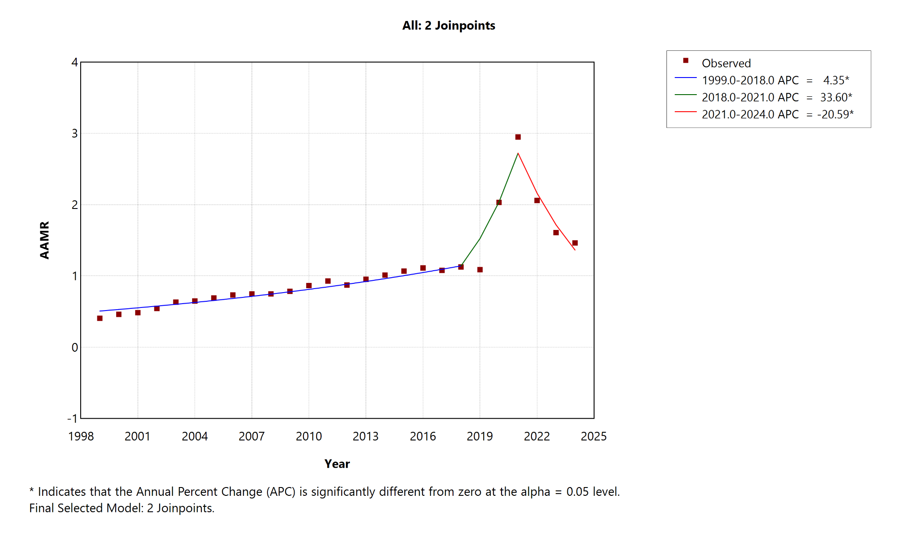
Observed AAMRs and fitted Joinpoint segments for the overall population. APC labels and significance indicators were generated by the Joinpoint Regression Program. AAMRs are deaths per 100000 population.

Supplementary Figure S2. Sex-specific age-adjusted mortality trends, 1999-2024
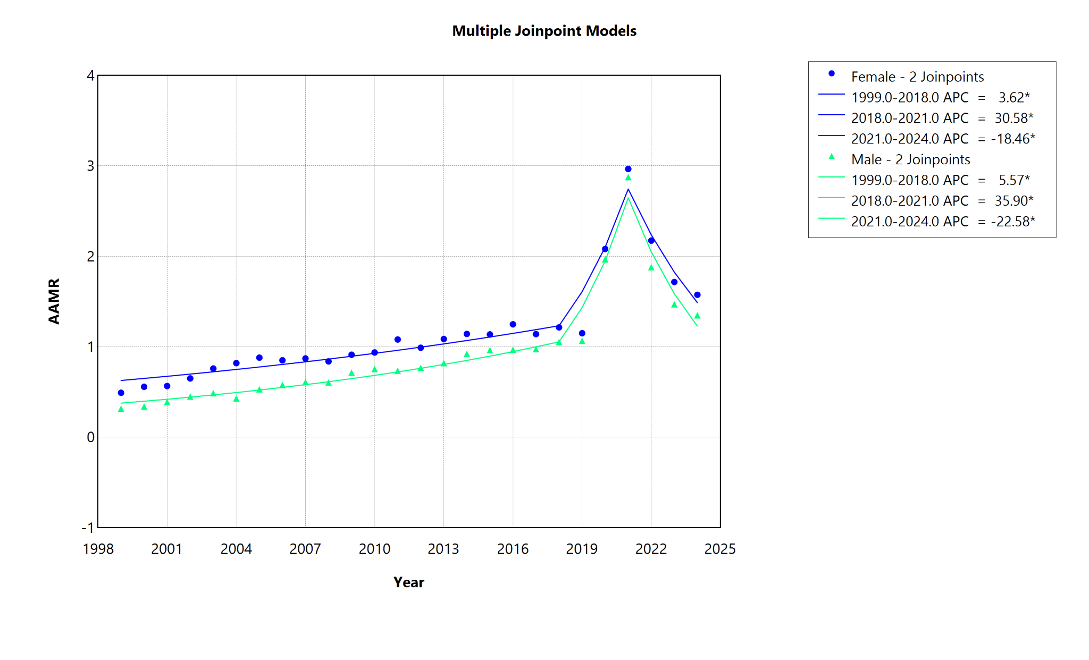
Observed AAMRs and fitted Joinpoint segments for female and male decedents. APC labels and significance indicators were generated by the Joinpoint Regression Program. AAMRs are deaths per 100000 population.

Supplementary Figure S3. Hispanic-origin mortality trends, 1999-2024
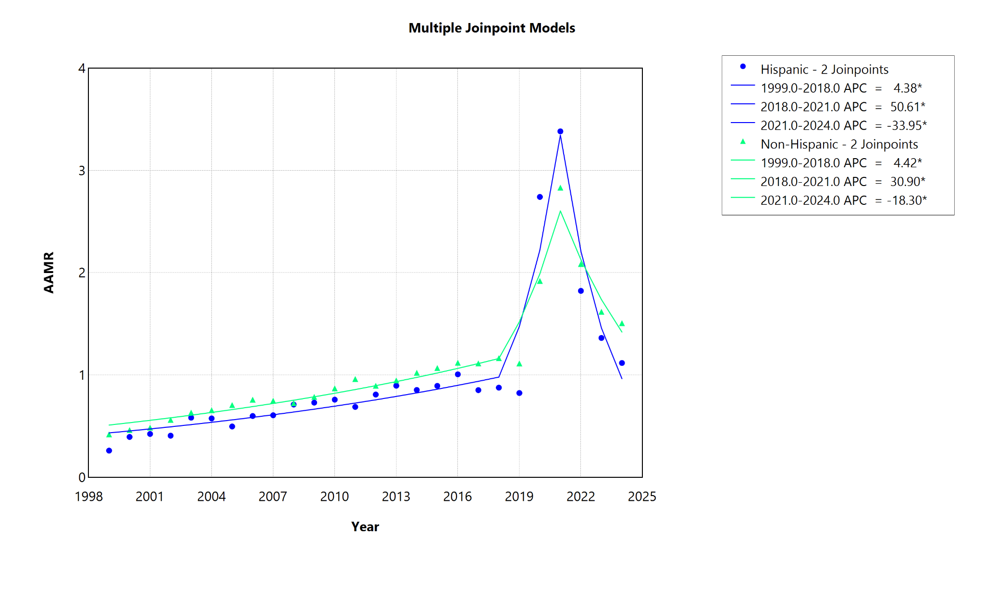
Observed AAMRs and fitted Joinpoint segments for Hispanic and non-Hispanic decedents. APC labels and significance indicators were generated by the Joinpoint Regression Program. AAMRs are deaths per 100000 population.

Supplementary Figure S4. Census-region mortality trends, 1999-2024
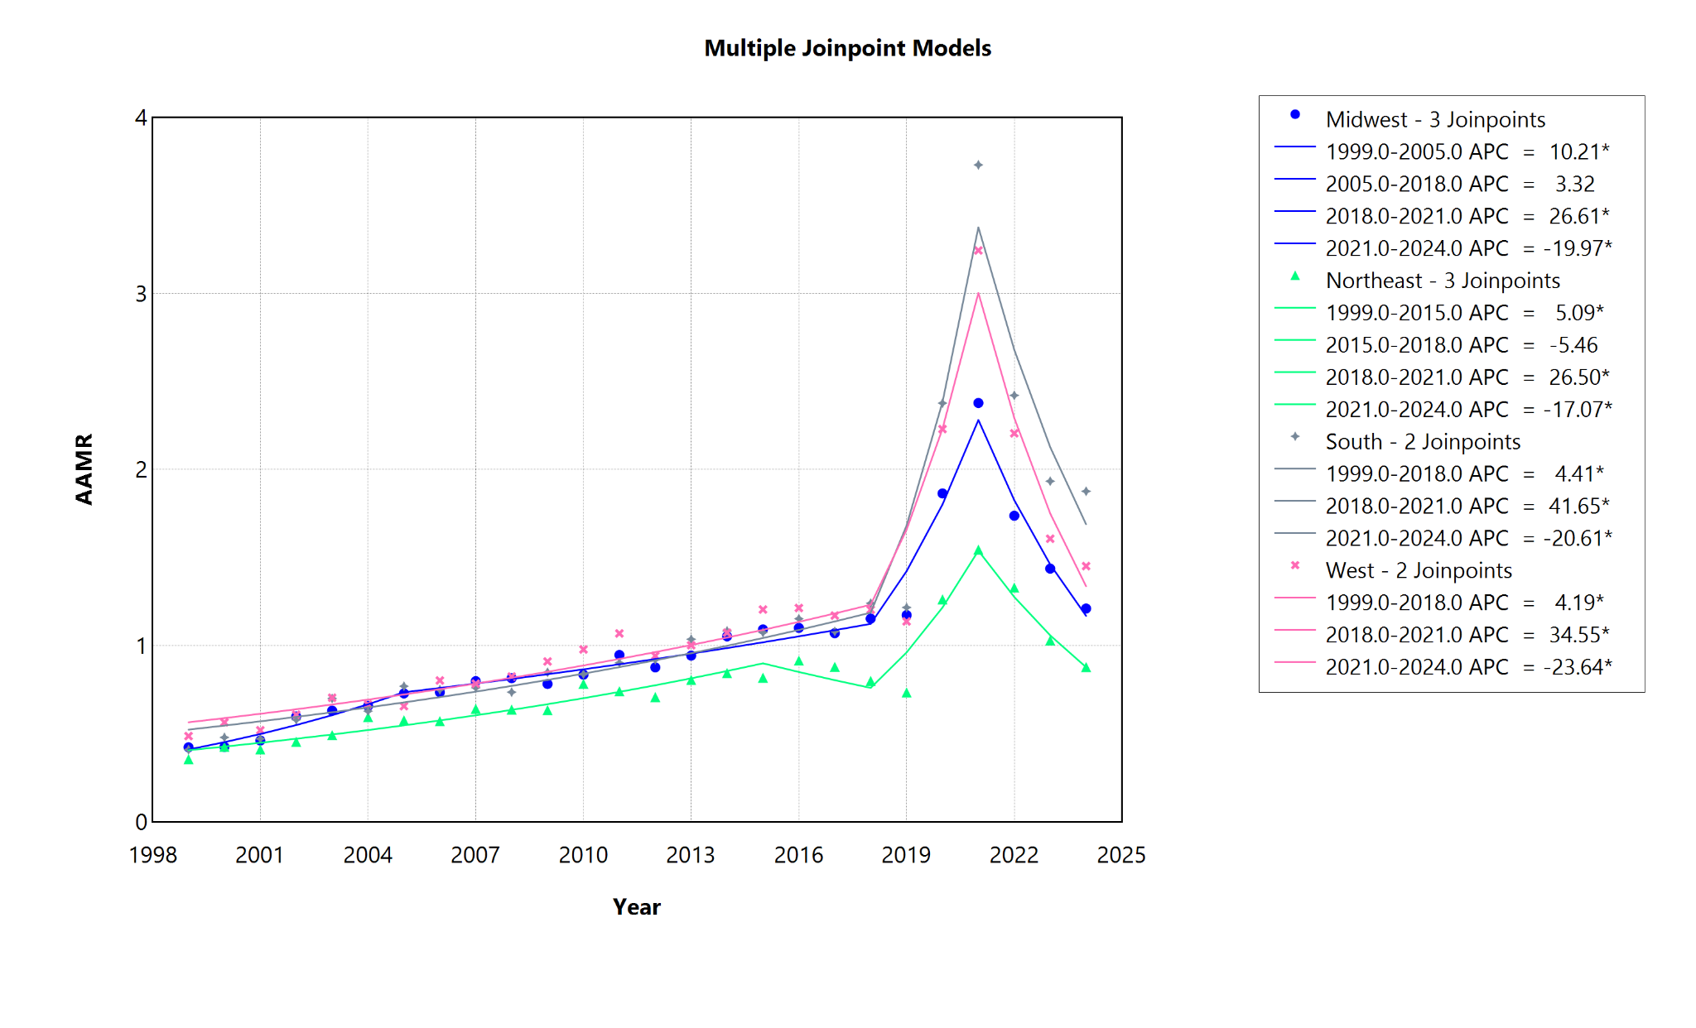
Observed AAMRs and fitted Joinpoint segments for the Northeast, Midwest, South, and West. APC labels and significance indicators were generated by the Joinpoint Regression Program. AAMRs are deaths per 100000 population.

Supplementary Figure S5. Urbanization-specific mortality trends, 1999-2020
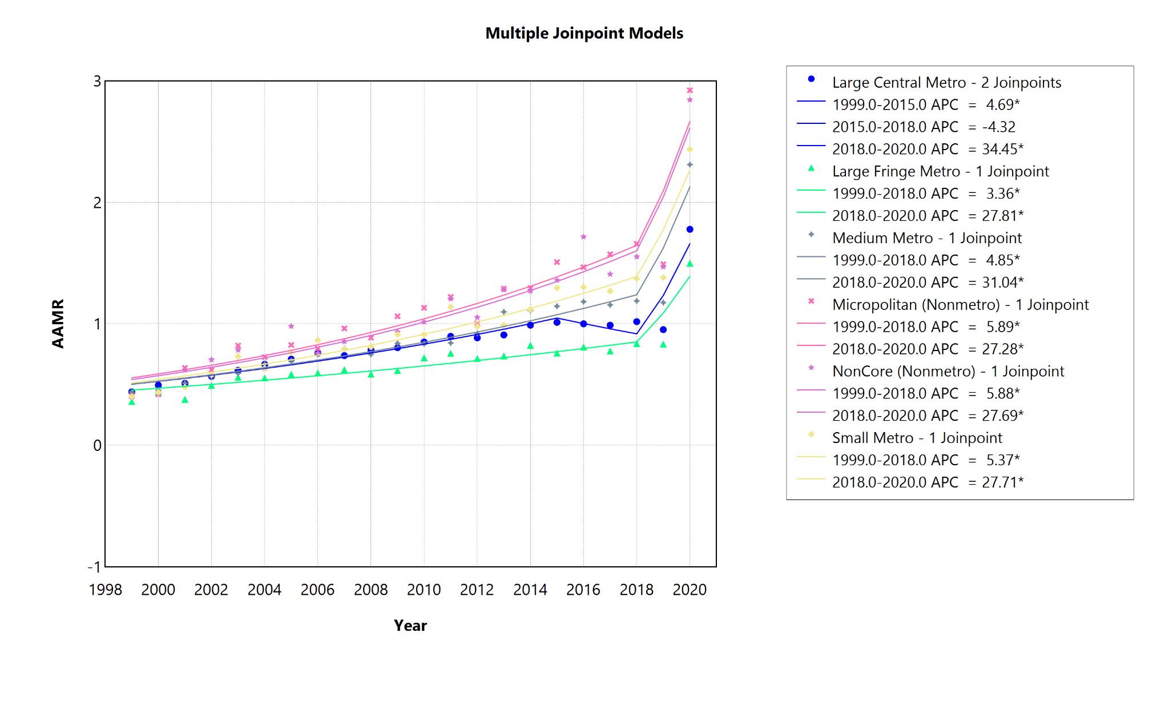
Observed AAMRs and fitted Joinpoint segments across six NCHS urban-rural categories. APC labels and significance indicators were generated by the Joinpoint Regression Program. AAMRs are deaths per 100000 population.

Supplementary Figure S6. A40-A41 sensitivity mortality trends, 1999-2024
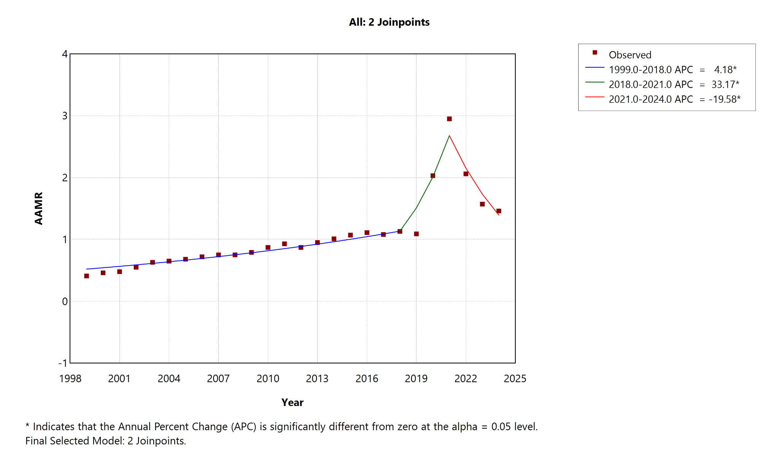
Observed AAMRs and fitted Joinpoint segments after restricting the septicemia definition to ICD-10 A40-A41. APC labels and significance indicators were generated by the Joinpoint Regression Program. AAMRs are deaths per 100000 population.

Supplementary Figure S7. Historical race mortality trends, 1999-2020
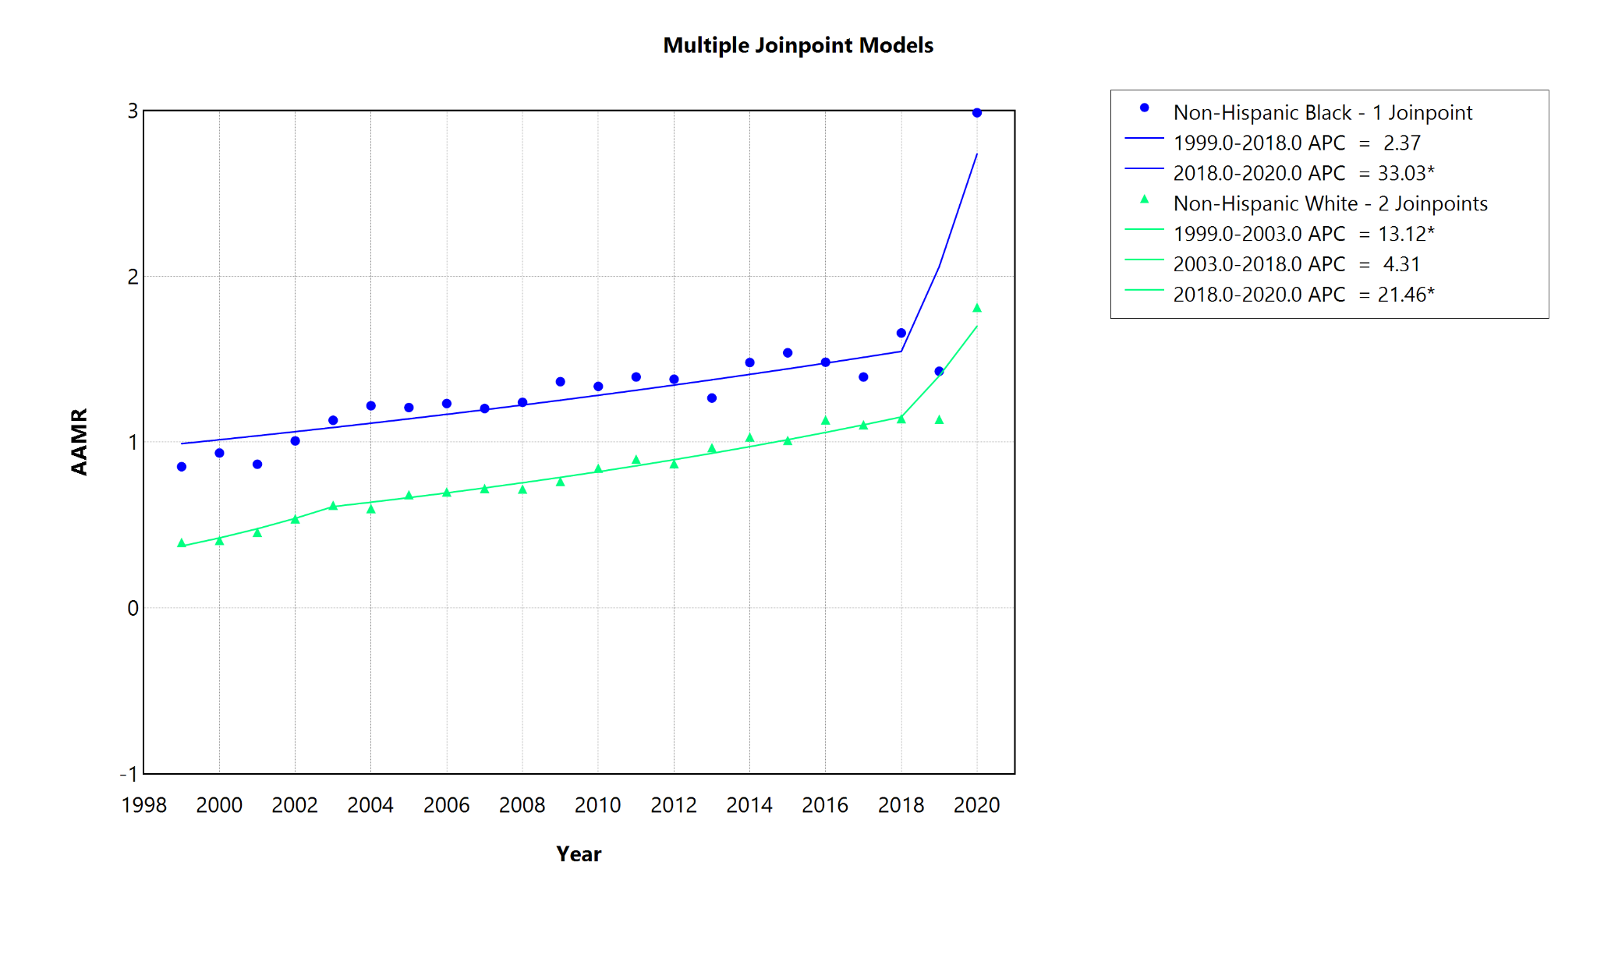
Observed AAMRs and fitted Joinpoint segments for non-Hispanic Black and non-Hispanic White decedents. APC labels and significance indicators were generated by the Joinpoint Regression Program. AAMRs are deaths per 100000 population.

Supplementary Figure S8. Contemporary race/ethnicity trends, 2018-2024
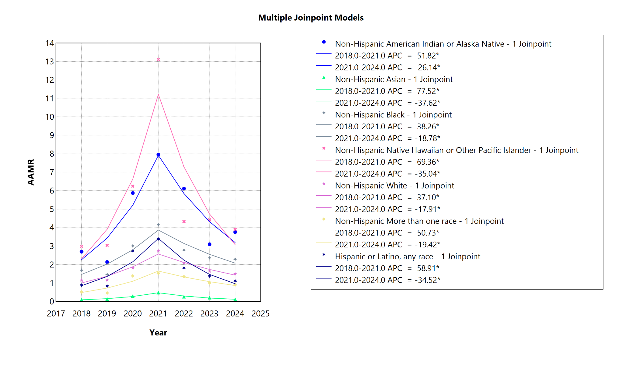
Observed AAMRs and fitted Joinpoint segments for six non-Hispanic race groups and Hispanic or Latino decedents of any race. APC labels and significance indicators were generated by the Joinpoint Regression Program. AAMRs are deaths per 100000 population.
Supplementary Figure S9. State-level pooled AAMRs, 1999-2020
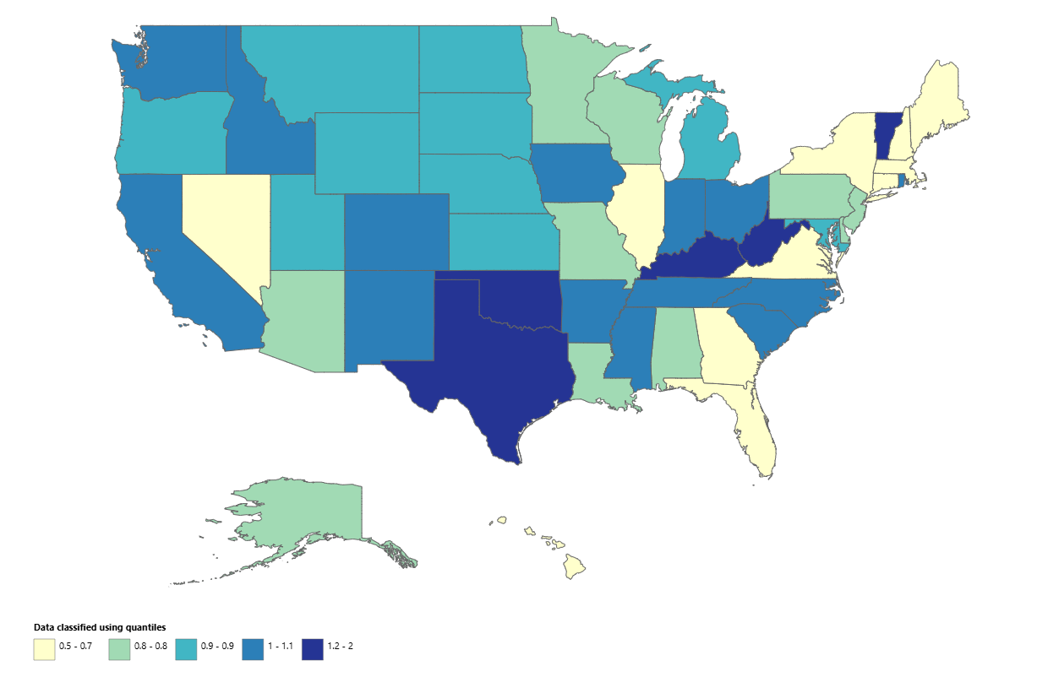
Pooled state AAMRs per 100000 adults aged 25 years or older during 1999-2020, classified using the displayed intervals. Numerical estimates are reported in Supplementary Table S10. Period-specific estimates were not formally compared. States are classified into quantile-based intervals; because the highest interval (1.2-2.0) spans a wide absolute range, states within it may differ substantially in AAMR (e.g., Oklahoma, 2.0, versus Kentucky, 1.2). Exact values and 95% confidence intervals for every state are reported in Supplementary Table S10 and should be used for state-to-state comparisons.
Supplementary Figure S10. State-level pooled AAMRs, 2021-2024
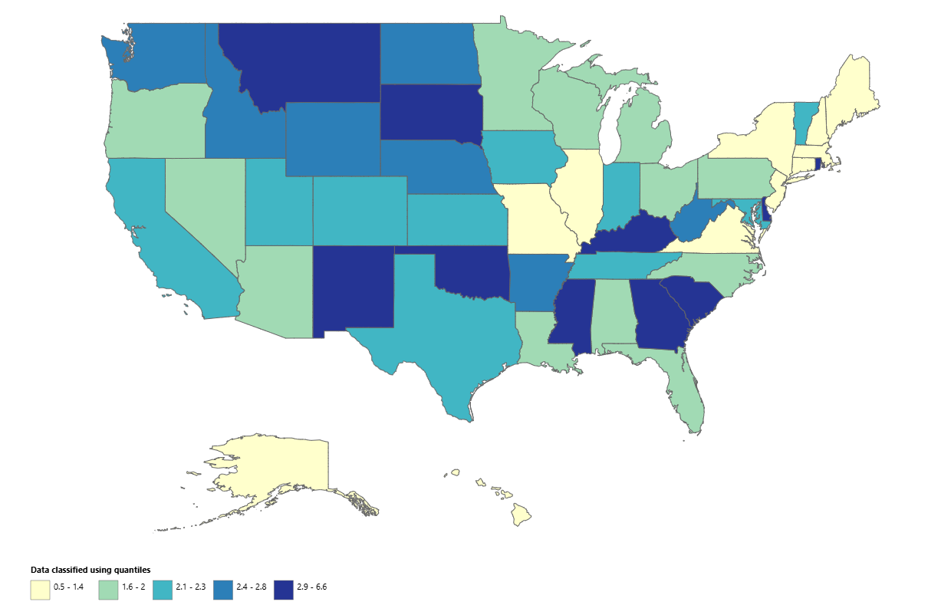
Pooled state AAMRs per 100000 adults aged 25 years or older during 2021-2024, classified using the displayed intervals. Numerical estimates are reported in Supplementary Table S11. Period-specific estimates were not formally compared. States are classified into quantile-based intervals; because the highest interval (2.9-6.6) spans a wide absolute range, states within it may differ substantially in AAMR (e.g., Oklahoma, 6.6, versus Montana, 3.2). Exact values and 95% confidence intervals for every state are reported in Supplementary Table S11 and should be used for state-to-state comparisons.

Supplementary References
- Centers for Disease Control and Prevention, National Center for Health Statistics. Multiple Cause of Death, 1999-2020: CDC WONDER documentation. https://wonder.cdc.gov/wonder/help/mcd.html. Accessed 23 July 2026.
- Centers for Disease Control and Prevention, National Center for Health Statistics. Multiple Cause of Death, 2018-2024, Single Race: CDC WONDER documentation. https://wonder.cdc.gov/wonder/help/mcd-expanded.html. Accessed 23 July 2026.
- National Cancer Institute. Joinpoint Regression Program. https://surveillance.cancer.gov/joinpoint/. Accessed 23 July 2026.
- Heron M. Comparability of race-specific mortality data based on 1977 versus 1997 reporting standards. Natl Vital Stat Rep. 2021;70(3):1-31. doi:10.15620/cdc:103476.
- Arias E, Heron M, Hakes J. The validity of race and Hispanic-origin reporting on death certificates in the United States: an update. Vital Health Stat 2. 2016;(172):1-21.
- von Elm E, Altman DG, Egger M, Pocock SJ, Gøtzsche PC, Vandenbroucke JP, et al. The Strengthening the Reporting of Observational Studies in Epidemiology (STROBE) Statement: guidelines for reporting observational studies. PLoS Med. 2007;4(10):e296. doi:10.1371/journal.pmed.0040296.
- Benchimol EI, Smeeth L, Guttmann A, et al. The REporting of studies Conducted using Observational Routinely-collected health Data (RECORD) statement. PLoS Med. 2015;12:e1001885. doi:10.1371/journal.pmed.1001885.

