Supplementary Material

Methods

DMG cells

DMG cells (SF-8628 cells; Sigma-Aldrich), a human glioma cell line derived from a surgical biopsy of a pediatric H3.3K27M DMG patient, were cultured in the same medium and environmental conditions as GBM cells.

Human astrocytes

Primary cultures of human astrocytes isolated from the human brain (cerebral cortex; ScienCell, Catalogue no.1800) were maintained on T-75 poly-L-lysine coated flasks (2 μg/cm2) in astrocyte basal medium (ScienCell, Cat. No. 1801) with 2% FBS (ScienCell, Cat. No. 0010), 1% astrocyte growth supplement (AGS; ScienCell, Cat. No. 1852) and 1% P/S solution (ScienCell, Cat. No. 0503).

cDNA synthesis

Human brain reference RNA (QS0611; Thermo Fisher Scientific) was used as a control. GBM, DMG and human reference brain cDNA were synthesised from RNA using SuperScript IV VILO (Thermo Fisher Scientific). Thermocycler conditions for cDNA synthesis are detailed in Table S1. All samples were plated and placed in a QuantStudio™ 3 Real-Time PCR System (Thermo Fisher Scientific) following the thermocycler conditions for cDNA synthesis as in Table S1. cDNA was diluted 1:10 to 0.1 µg/µL after addition of 180 µL water. Human oligodendrocyte precursor cell (OPC) cDNA was used (ScienCell, Cat. No. SC-1604).

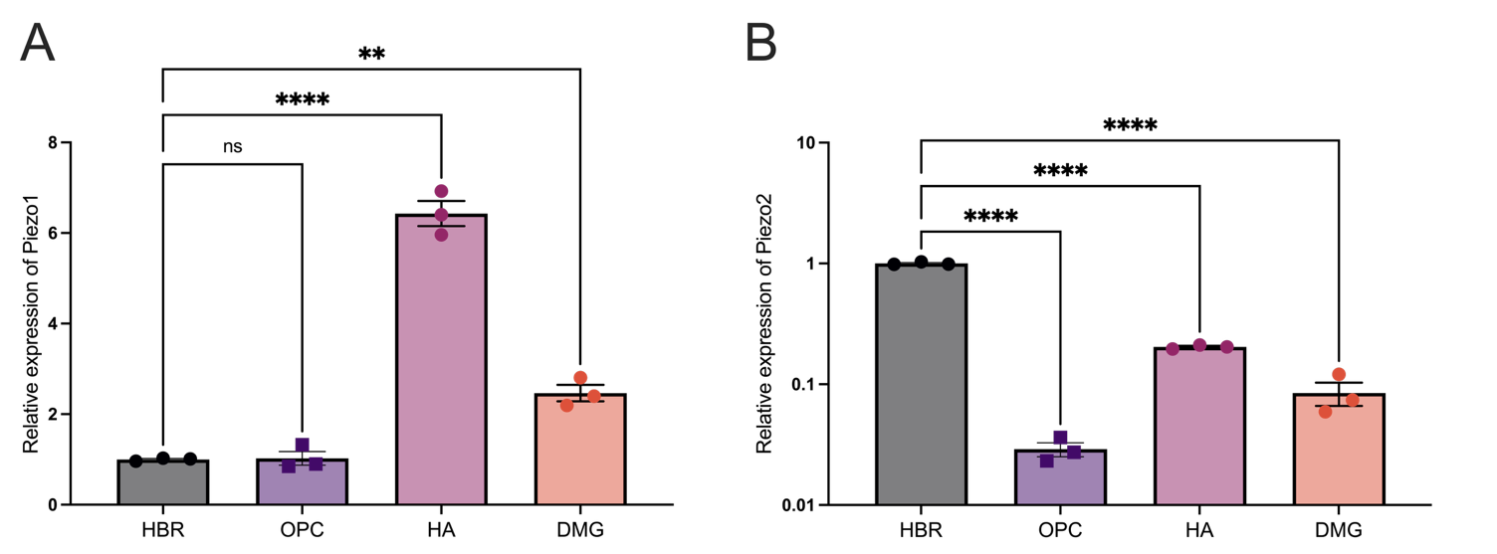

Figure S1. Expression of mechanosensitive ion channels in different cell types. A) Piezo1 and B) Piezo2. RT-qPCR comparing total RNA levels of Piezo1 and Piezo2 in human brain reference RNA (HBR) samples, oligodendrocyte precursor cells (OPCs), human astrocytes (HA), and diffuse midline glioma cells (DMG). Significance was determined using one-way analysis of variance (ANOVA) with Dunnett's multiple comparisons test. Normalized expression of Piezo1 is shown. Data is shown as mean ± standard error of the mean (SEM) from four biological experiments, each with three technical replicates. Significance was set at p < 0.05. ns: not significant; **: p < 0.01; ****: p < 0.0001.
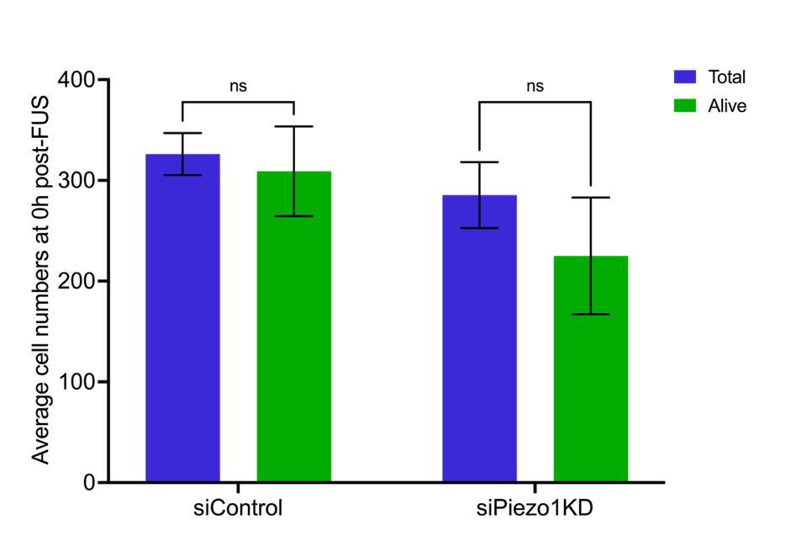
Figure S2. Focused ultrasound with microbubbles does not affect glioblastoma cell viability immediately after treatment in siControl or Piezo1KD groups. Total cells (blue; Hoechst 33342-stained nuclei) and live cells (green; Calcein AM) were quantified at 0 h post-sonication in siControl and Piezo1KD cells. Data is shown as mean ± standard error of the mean (SEM) from three biological experiments, each with three technical replicates per biological. Statistical analysis was conducted using an unpaired t-test. Significance was set at p<0.05. ns, not significant.
Supplementary Table 1. Thermal Cycle information used for cDNA synthesis

 | cDNA synthesis
Number of cycles | Temperature (°C) | Time per cycle
1 | 25 | 10 minutes
1 | 50 | 10 minutes
1 | 85 | 5 minutes

Supplementary Table 2. Gene primers used in qPCR

Gene name | Primer direction | Oligo Sequence (5’ to 3’) | Length | Tm (°C)
GAPDH | Forward | CTCCTGCACCACCAACTGCT | 20 | 67.8
GAPDH | Reverse | GGGCCATCCACAGTCTTCTG | 20 | 67
Piezo1 | Forward | TTCCTGCTGTACCAGTACCT | 20 | 58.8
Piezo1 | Reverse | AGGTACAGCCACTTGATGAG | 20 | 59.4

Supplementary Table 3. Thermal Cycle Information used for qPCR
qPCR
No. of cycles | Temperature (°C) | Time per cycle
1 | 50 | 2 minutes
1 | 95 | 2 minutes
45 | 95 | 15 seconds
45 | 60 | 1 minute
1 | 50 | 50 seconds
1 | 55 | 1 minute
1 | 95 | 1 minute

