Supplementary Information
Genome-guided prioritization of rifabutin MIC testing among rifampicin high-MIC Mycobacterium tuberculosis isolates: a retrospective development and internal evaluation study

Contents
Supplementary Methods; Supplementary Figures S1–S11; Supplementary Tables S1–S16.

Supplementary Methods

Data harmonisation and cohort construction
Phenotypic records were reconstructed from CRyPTIC Release 3.4.0 DST_SAMPLES, DST_MEASUREMENTS, UKMYC_PHENOTYPES, UKMYC_PLATES and PLATE_LAYOUT tables. Joins used available isolate, plate and layout identifiers rather than row order. The workflow rejected non-identical duplicates, conflicting official binary phenotypes, conflicting MICs, discrepancies between MIC-derived and official ECOFF categories and ambiguous plate joins. The primary analysis retained only high-quality phenotypes. A separate high-plus-medium-quality resource was generated for sensitivity work; the high-quality cohort defined the primary endpoint.
The membership table records the inclusion stratum for every linked isolate. The harmonised flow contained 11,939 locally matched isolates, of which 11,936 had official consensus and 10,497 entered the high-quality set. Paired analysis required both rifampicin and rifabutin phenotypes. The conditional analysis then retained paired isolates with rifampicin MIC above 0.5 mg/L. Rifabutin MIC at or below 0.12 mg/L defined the positive low-MIC outcome. These values are CRyPTIC research ECOFFs rather than treatment breakpoints. Missing endpoints were not imputed. The conditional cohort contained 3466 isolates from 3397 subjects; 42 subjects contributed more than one isolate and the maximum was five. Because eligibility required a measured rifampicin MIC, this cohort is narrower than RR-TB populations defined only by Xpert, targeted sequencing or WGS.

Mutation-event inputs
Each isolate was represented by an unordered collection of mutation events. Event fields comprised gene, annotation, event type, genomic-position bin, reference allele and alternate allele. Events were deterministically ordered by genomic coordinate only to make batching reproducible. Neural sequences were truncated to 128 events under a fixed priority that did not use WHO catalogue confidence. Logistic regression used complete sparse binary mutation-token indicators without the neural event cap. WHO confidence was excluded from discovery-eligible models and retained only for comparator analyses.
Categorical fields were mapped through fixed vocabularies with unknown tokens. The clean baseline used learned categorical embeddings. Alternative fixed gene-level representations were ESM-2 and ESMC embeddings. Because those vectors described the reference gene rather than the amino-acid change, they were evaluated as optional representations and not as mutation-level mechanistic features.

Candidate model family and training
The candidate family used a drug-conditioned mutation-event encoder. Categorical fields were embedded into 96-dimensional vectors. Prespecified configurations varied additive versus residual fusion, attention-based event contextualisation, drug-conditioned pooling, lineage modulation and an auxiliary MIC objective. The attention encoder contained two layers and four heads.
The primary classification loss was class-balanced binary cross-entropy computed in paired rifampicin high-MIC training isolates. Within each training fold, the class weight for class c was N/(2N_c), capped at 12. Auxiliary phenotype and MIC objectives had a combined weight of 0.10. MIC values were standardised separately by drug using training-fold parameters. Three development seeds (1, 7 and 42) and five final seeds (1, 7, 13, 21 and 42) were locked in the computational protocol.

Nested selection and calibration
The subject-grouped profile used five outer and five inner folds. Records sharing SUBJID were assigned to one group. Within each outer-development set, the inner procedure controlled preprocessing, class weights, configuration selection, epoch selection, calibration and threshold definition. The primary inner metric was AUPRC for rifabutin low MIC among rifampicin high-MIC isolates. For each candidate configuration and inner fold, predictions from development seeds 1, 7 and 42 were averaged before metric calculation. The one-standard-error rule chose the least complex configuration whose mean inner AUPRC was within one standard error of the maximum. The fixed epoch for the selected outer-fold model was the rounded median of its inner-fold best epochs.
The five outer folds retained fold-specific model and epoch selections. Table S2 provides the configuration, epoch, Platt coefficients and two operating thresholds learned independently from each outer-development partition.
Supplementary Table S2 | Outer-fold-specific locked model, epoch, calibration and threshold selections
Outer fold | Selected configuration | Epoch | Platt intercept | Platt slope | Threshold targeting specificity | Threshold targeting sensitivity
1 | C1_clean_categorical | 9 | −1.979966 | 0.629371 | 0.250629 | 0.125758
2 | M1_clean_baseline | 9 | −1.959109 | 0.670171 | 0.278840 | 0.104677
3 | M1_clean_baseline | 7 | −2.031922 | 0.648526 | 0.265922 | 0.138359
4 | C1_clean_categorical | 5 | −2.008305 | 0.649882 | 0.266819 | 0.090336
5 | M1_clean_baseline | 6 | −2.079522 | 0.622350 | 0.314825 | 0.143284
Every row was learned from the corresponding outer-development partition; no outer-test observation contributed to selection, calibration or threshold definition.
For each outer fold, the validation procedure was:
- Hold out every isolate assigned to the outer test fold.
- Fit vocabularies, MIC scaling and class weights using the outer-development partition only.
- Run subject-grouped inner cross-validation for every eligible configuration and development seed.
- Average seed predictions within each inner validation fold and calculate inner AUPRC.
- Apply the one-standard-error rule, then derive the selected fixed epoch from inner training histories.
- Concatenate selected inner out-of-fold predictions; fit Platt calibration and derive the two operating thresholds from those predictions only.
- Fit the selected configuration for the locked epoch on the full outer-development partition for seeds 1, 7 and 42.
- Average the three outer-test predictions, apply the fold-specific calibrator and evaluate the untouched outer test fold once.
- Retain the fold identifier, selected configuration, epoch, calibration parameters and thresholds with every OOF prediction.
Platt scaling was fitted to inner out-of-fold predictions from the outer-development data and applied once to the outer-test predictions. A non-positive fitted slope triggered a prespecified identity fallback rather than reversal of rank. Raw scores were used for discrimination; calibrated probabilities were used for Brier, calibration and threshold analyses. Performance reporting used only predictions from untouched outer-test folds.

Blocked and holdout validation
The final blocked sensitivity formed connected components on a bipartite graph linking SUBJID to the supplied source-sublineage label. Every isolate belonging to a connected subject–sublineage component was assigned to one group. The map contained 10,497 isolates, 10,189 subjects, 253 source sublineages and 224 connected components; 41 subjects (110 isolates) linked more than one source sublineage. The largest component contained 5939 isolates (56.6%), so three outer and three inner folds were the largest feasible nested profile with events in every held-out fold. Actual joint-blocked outer test folds contained 750/41, 2085/128 and 631/41 isolates/events. No subject, source sublineage or connected component crossed an outer fold.
Every outer fold retained separate neural-procedure selection and calibration. Raw scores assessed discrimination, and testing-budget ranking was performed within each outer test fold before counts were aggregated. We report both pooled OOF and macro mean-fold AUPRC because the event prevalence and fold sizes were heterogeneous. The connected-component definition was used consistently for the neural procedure, XGBoost, a separate fixed-C all-token logistic comparator and five nested-C rpoB simplification variants. The fixed-C comparator used scikit-learn's C=1.0 after outer-development vectorisation. Each rpoB variant instead selected C inside the corresponding joint outer-development partition.
For joint-blocked budgets, fold-specific recall is reported alongside the aggregate estimate. At 10%, aggregate recall was 68.8% for the neural procedure, 69.7% for XGBoost and 67.1% for the selected carrier≥10 procedure. The carrier≥10 procedure's outer-fold recall ranged from 61.4% to 74.7%. Every point is the exact uniform expectation within the fold-specific boundary tie. Connected components were highly imbalanced across only three outer folds, including one component of 2076 isolates; component-bootstrap intervals are therefore interpreted as conditional robustness intervals for this locked split.
Leave-one-lineage-out and leave-one-site-out analyses were restricted to groups with at least 10 positive and 10 negative isolates for the conditional endpoint. Five training seeds were used for the neural analysis. All-token logistic regression, XGBoost and the carrier≥10 rpoB logistic procedure were fitted on each complementary training partition, and results were reported for every eligible held-out group rather than only as group means. Outputs include held-out sample size, event count, prevalence, AUROC, AUPRC and fold-local 10%-budget recall, PPV and tests per low-MIC isolate detected. Subject-cluster percentile intervals used 1000 replicates within each held-out group for the original model set; the carrier≥10 procedure is reported with original-sample group estimates.

Targeted concentration and phenotype-quality analyses
The endpoint concentration analysis counted events by site and lineage before model fitting. Three subject-grouped five-fold analyses then removed PER|05, Lineage 4 or both and refitted logistic regression, XGBoost and the selected carrier≥10 procedure within the retained cohort. Fold-local budgets were applied after exclusion, and estimates were calculated only among retained isolates. These analyses quantify dependence on dominant groups.
The primary configuration required high-quality phenotypes (`high_quality_only=true`). A separate sensitivity analysis admitted high- and medium-quality paired phenotypes (`high_quality_only=false`) and regenerated subject-grouped five-fold assignments. This expanded the conditional cohort to 4266 isolates with 258 RFB-lowMIC events; the neural, XGBoost, all-token logistic and selected carrier≥10 procedures were refitted, while the high-quality cohort remained primary.

Event-cap sensitivity, logistic simplification and full-cohort refit
The neural rank sensitivity analysis repeated the subject-grouped five-fold fit with maximum sequence lengths of 64, 128 and 256 events. Of 3466 primary isolates, 45 (1.30%) exceeded 64 events, two (0.058%) exceeded 128 and one (0.029%) exceeded 256; the maximum was 486 events. The 64-, 128- and 256-event settings discarded 784, 418 and 230 events in total, respectively. These runs emitted uncalibrated neural scores (`probability=raw score`); interpretation was therefore restricted to AUPRC, AUROC and fold-local budget ranking.
The logistic sensitivity used scikit-learn `LogisticRegression` with liblinear optimisation, L2 penalty, balanced class weights and maximum 5000 iterations. Within each outer-development partition, C was selected from 0.0001, 0.001, 0.01, 0.1, 1, 10 and 100. Initial variants used the complete mutation-token matrix, minimum development-carrier filters or unrestricted rpoB tokens. The classical-closure analysis then compared five rpoB variants: unrestricted mutation tokens, token carrier thresholds of 5 and 10, and protein-change carrier thresholds of 5 and 10. Every carrier filter and C selection was fitted inside the relevant outer-development partition.
A post-comparison parsimony rule retained variants whose pooled OOF AUPRC was within 0.02 of the best primary and 0.03 of the best joint result and whose 10%-budget recall was within 0.05 of the best result in both profiles. Eligible variants were ordered by median feature count and then by joint and primary pooled AUPRC. The carrier≥10 mutation-token variant and the carrier≥5 protein-change variant met all four criteria; the former was selected because its outer-fold models used a median of 33.5 versus 60.0 features. Confidence intervals reported for this selected procedure are conditional descriptive intervals and do not adjust for the selection step.
The selected variant was refitted on all 3466 primary isolates. The frozen model uses 37 recurrent rpoB mutation tokens, C=0.1 and a fixed intercept of 0.7838316512; its model SHA-256 is `7fa515b381935d9186ed17d937013052f0e3357859f9c4f5d7c74dfd0e4f629c`. Unknown tokens are ignored, and an isolate without a recognised token receives the intercept-only score. The supplied specification, coefficient table, carrier table and prediction function reproduce the serialised scikit-learn model. Performance estimates come from cross-validated OOF predictions, not this full-cohort refit.
The class-weighted output is interpreted as a relative prioritisation score. It is not an absolute RFB-lowMIC probability and should not be used with a fixed probability threshold without local calibration.

Comparators and operating policies
Comparators were a WHO-catalogue rule, class-balanced logistic regression, class-balanced XGBoost and a transparent four-variant rule prioritising rpoB D435V, D435Y, H445L or L430P. Trainable comparators used only outer-development data and identical fold assignments. Categorical, ESM-2 and ESMC representation comparisons also used the same endpoint and folds.
Testing-budget policies selected the highest-ranked 5%, 10%, 15% or 20% separately inside each held-out outer test fold. The number selected in a fold was the ceiling of the fold size multiplied by the nominal budget. Confusion counts were summed across outer folds before calculating event recall, PPV, NPV, specificity and tests per low-MIC isolate detected. The primary analysis ranked isolates within each outer test fold because scores produced by different fitted models and calibrators are not guaranteed to be directly comparable. Global top-k ranking of pooled OOF scores was examined only as a sensitivity analysis. The endpoint and AUPRC model-selection rule were protocol defined; the 10% emphasis and parsimony envelope were post-comparison operational choices used to define an exploratory candidate for future evaluation.
The WHO-catalogue and four-variant comparators generate large tied score groups, and learned-model scores may also be quantised at a budget boundary. The operating-policy procedure retained all scores strictly above the boundary and assigned the remaining slots uniformly within the boundary tie group. Final point estimates use the exact expected event count under this policy, so identifiers and input-row order cannot influence the result. At a 10% budget, expected recall was 71.9% for the nested procedure, 74.5% for full all-token logistic regression, 71.5% for the cross-validated carrier≥10 procedure, 75.9% for XGBoost, 46.2% for the four-rpoB rule and 11.8% for the WHO comparator.
Two fold-locked thresholds targeted approximately 95% specificity and 80% sensitivity using inner calibrated predictions. They were then applied without modification to the corresponding outer-test fold.

Statistical analysis
AUPRC was the primary metric because the positive class was uncommon and its no-information value equals event prevalence. Secondary measures were AUROC, Brier score, Brier skill against a constant-prevalence prediction, calibration intercept and slope, log loss, sensitivity, specificity, PPV, NPV and tests per low-MIC isolate detected. Primary discrimination, calibration and paired differences used 2000 subject-cluster bootstrap replicates. Joint carrier≥10-procedure discrimination and paired differences used 2000 resamples of the locked subject–sublineage connected components. Point estimates were calculated on the original held-out sample, and a paired comparison was considered resolved only when its 95% confidence interval excluded zero.
Logistic-regression and XGBoost comparator values were raw class-weighted scores rather than probabilities passed through fold-specific Platt calibration. Their AUPRC and AUROC support ranking comparisons, while Brier skill and reliability summaries are raw-score diagnostics. They were displayed separately from the calibrated nested-procedure curve.
For budget analyses, the resampling unit was SUBJID. Subjects were sampled with replacement separately within each outer test fold, and all isolates from each selected subject were retained. Fold-local top-k selection and exact uniform boundary-tie expectations were recalculated in each of 2000 bootstrap samples. Confusion counts were aggregated across folds, and percentile intervals were reported for recall, PPV, tests per low-MIC isolate detected, detected events, missed events and paired model differences. This procedure captures within-subject correlation while preserving the fitted outer-fold structure.
The endpoint sensitivity excluded 134 isolates at the nominal 0.12-mg/L dilution, identified as numeric values within ±0.0005 mg/L of 0.12 (the source representation was 0.119908014916). This left 3332 isolates from 3263 subjects and 76 low-MIC events. Archived OOF ranking scores were retained without refitting. Discrimination and fold-local budget metrics were recomputed with 2000 SUBJID-cluster bootstrap replicates within the locked outer folds. This fixed-score analysis tests ranking behaviour after removal of the ECOFF-boundary dilution rather than estimating a newly trained grey-zone model.
Mutation associations were evaluated in the paired rifampicin high-MIC cohort. The workflow calculated carrier counts, low-MIC proportions and 95% binomial intervals, Fisher exact tests with Benjamini–Hochberg correction and Firth bias-reduced logistic regression. Adjustment variables were lineage, site, country and burden of other nonsynonymous rpoB events when estimable. Single-rpoB and compound-rpoB contexts were examined where sample sizes permitted.
Cross-fitted direction stability was evaluated across outer folds. Token-deletion effects were calculated only for isolates not used to train the corresponding model. Tokens with identical carrier sets were collapsed to one deterministic representative. Prespecified candidate gates covered carrier count, Firth evidence, effect interval, cross-fit stability, subgroup consistency, harmonised MIC evidence, token-deletion support, independent external replication and experimental support. Only candidates passing every required gate could be labelled validation-ready.

Software and reproducibility
Analyses used Python 3.10.20, NumPy 2.2.6, pandas 2.3.3, SciPy 1.15.3, scikit-learn 1.7.2, statsmodels 0.14.6, PyTorch 2.6.0 with CUDA 12.4, XGBoost 3.2.0, pyarrow 22.0.0 and matplotlib 3.10.9. The reproducibility package retains cohort membership, folds, model selections, calibration, operating-policy outputs and file hashes; the accompanying reproducibility archive is provided as Additional file 2.
Supplementary Figure S1
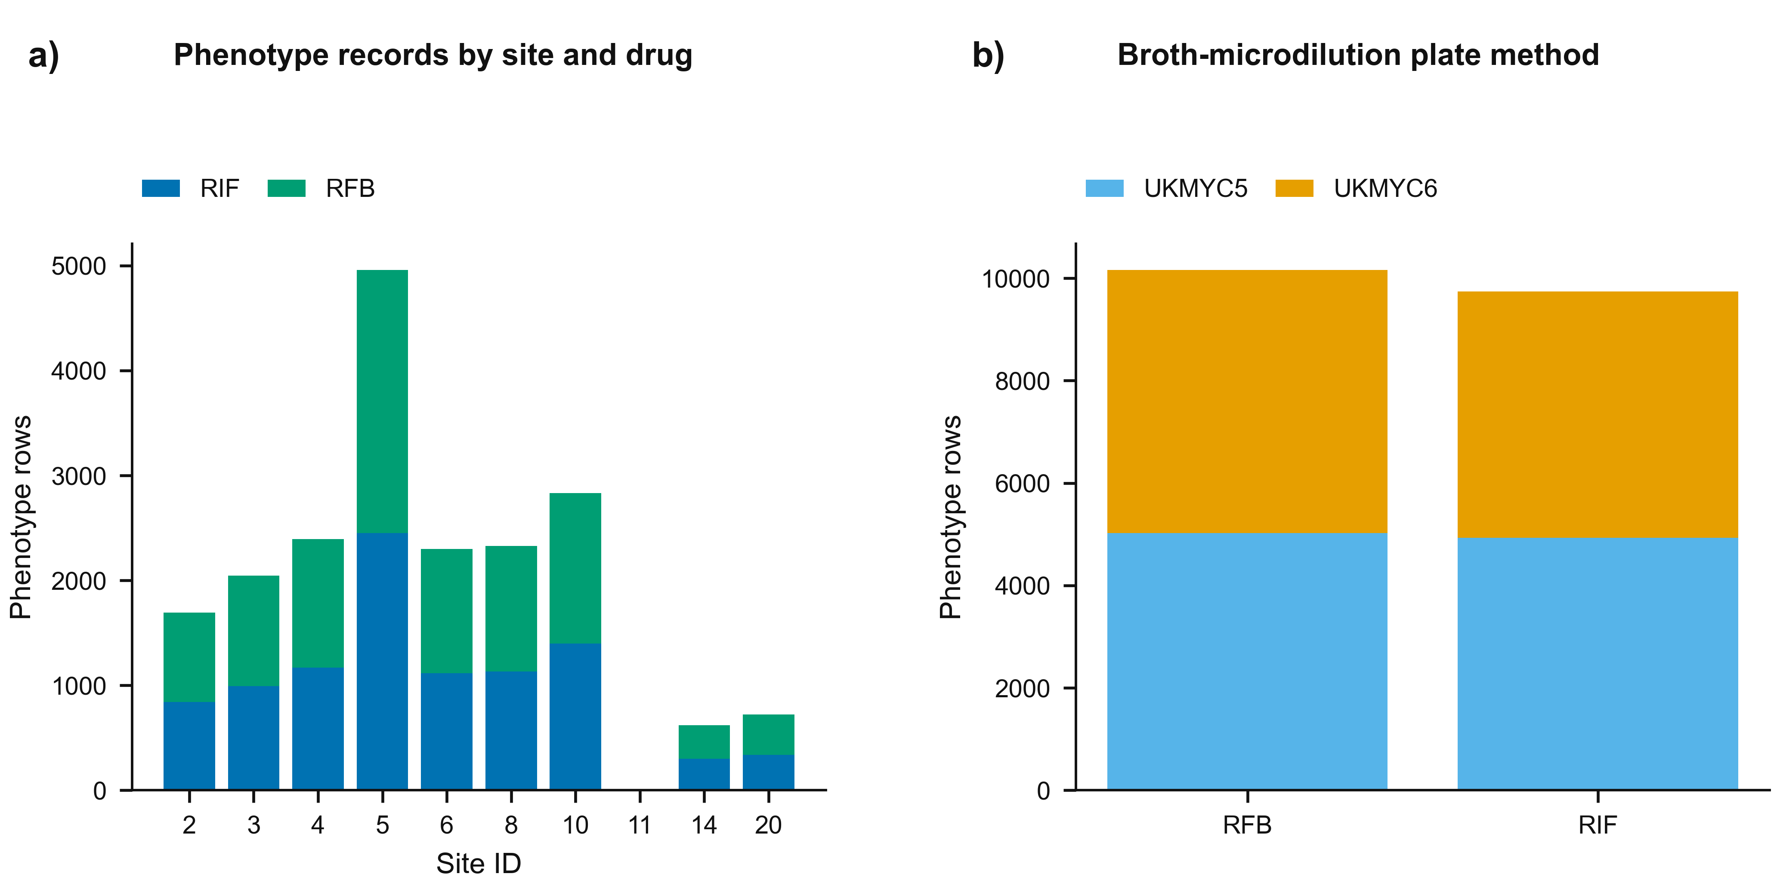
Supplementary Figure S1 | Phenotype harmonization summary. Phenotype record distributions by site, drug, and broth-microdilution plate method.
Supplementary Figure S2
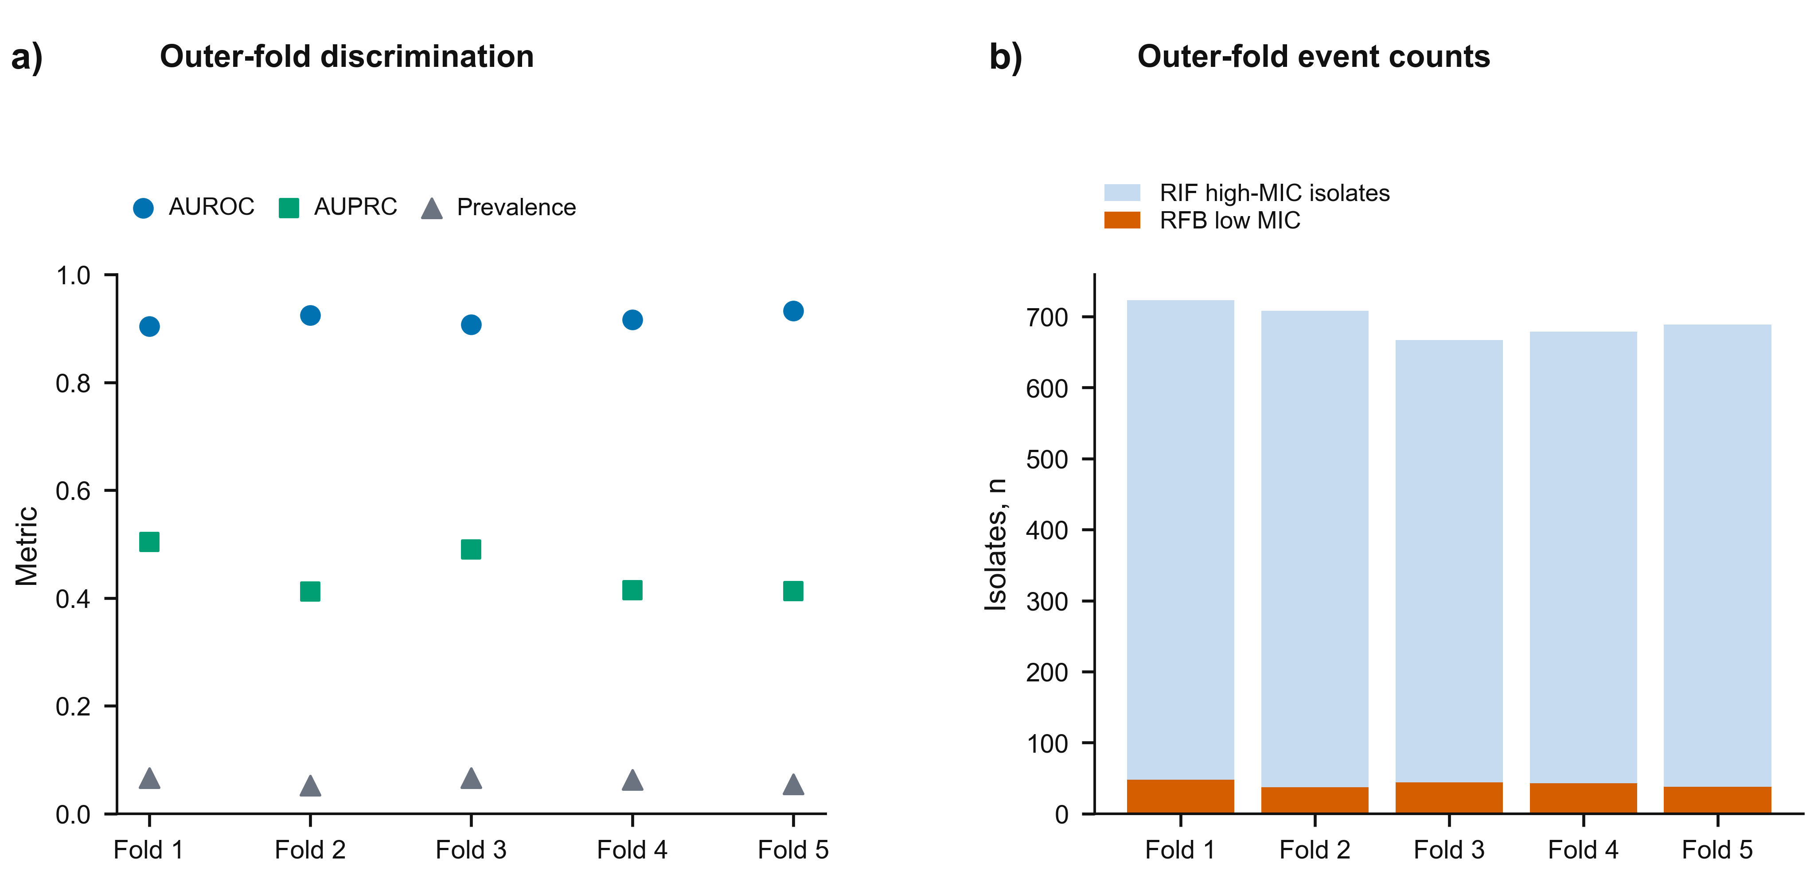
Supplementary Figure S2 | Subject-grouped outer-fold heterogeneity. Independent points show fold-specific discrimination and prevalence; bars show fold-specific cohort and event counts. Fold numbers are arbitrary labels and are not connected as a sequence.
Supplementary Figure S3
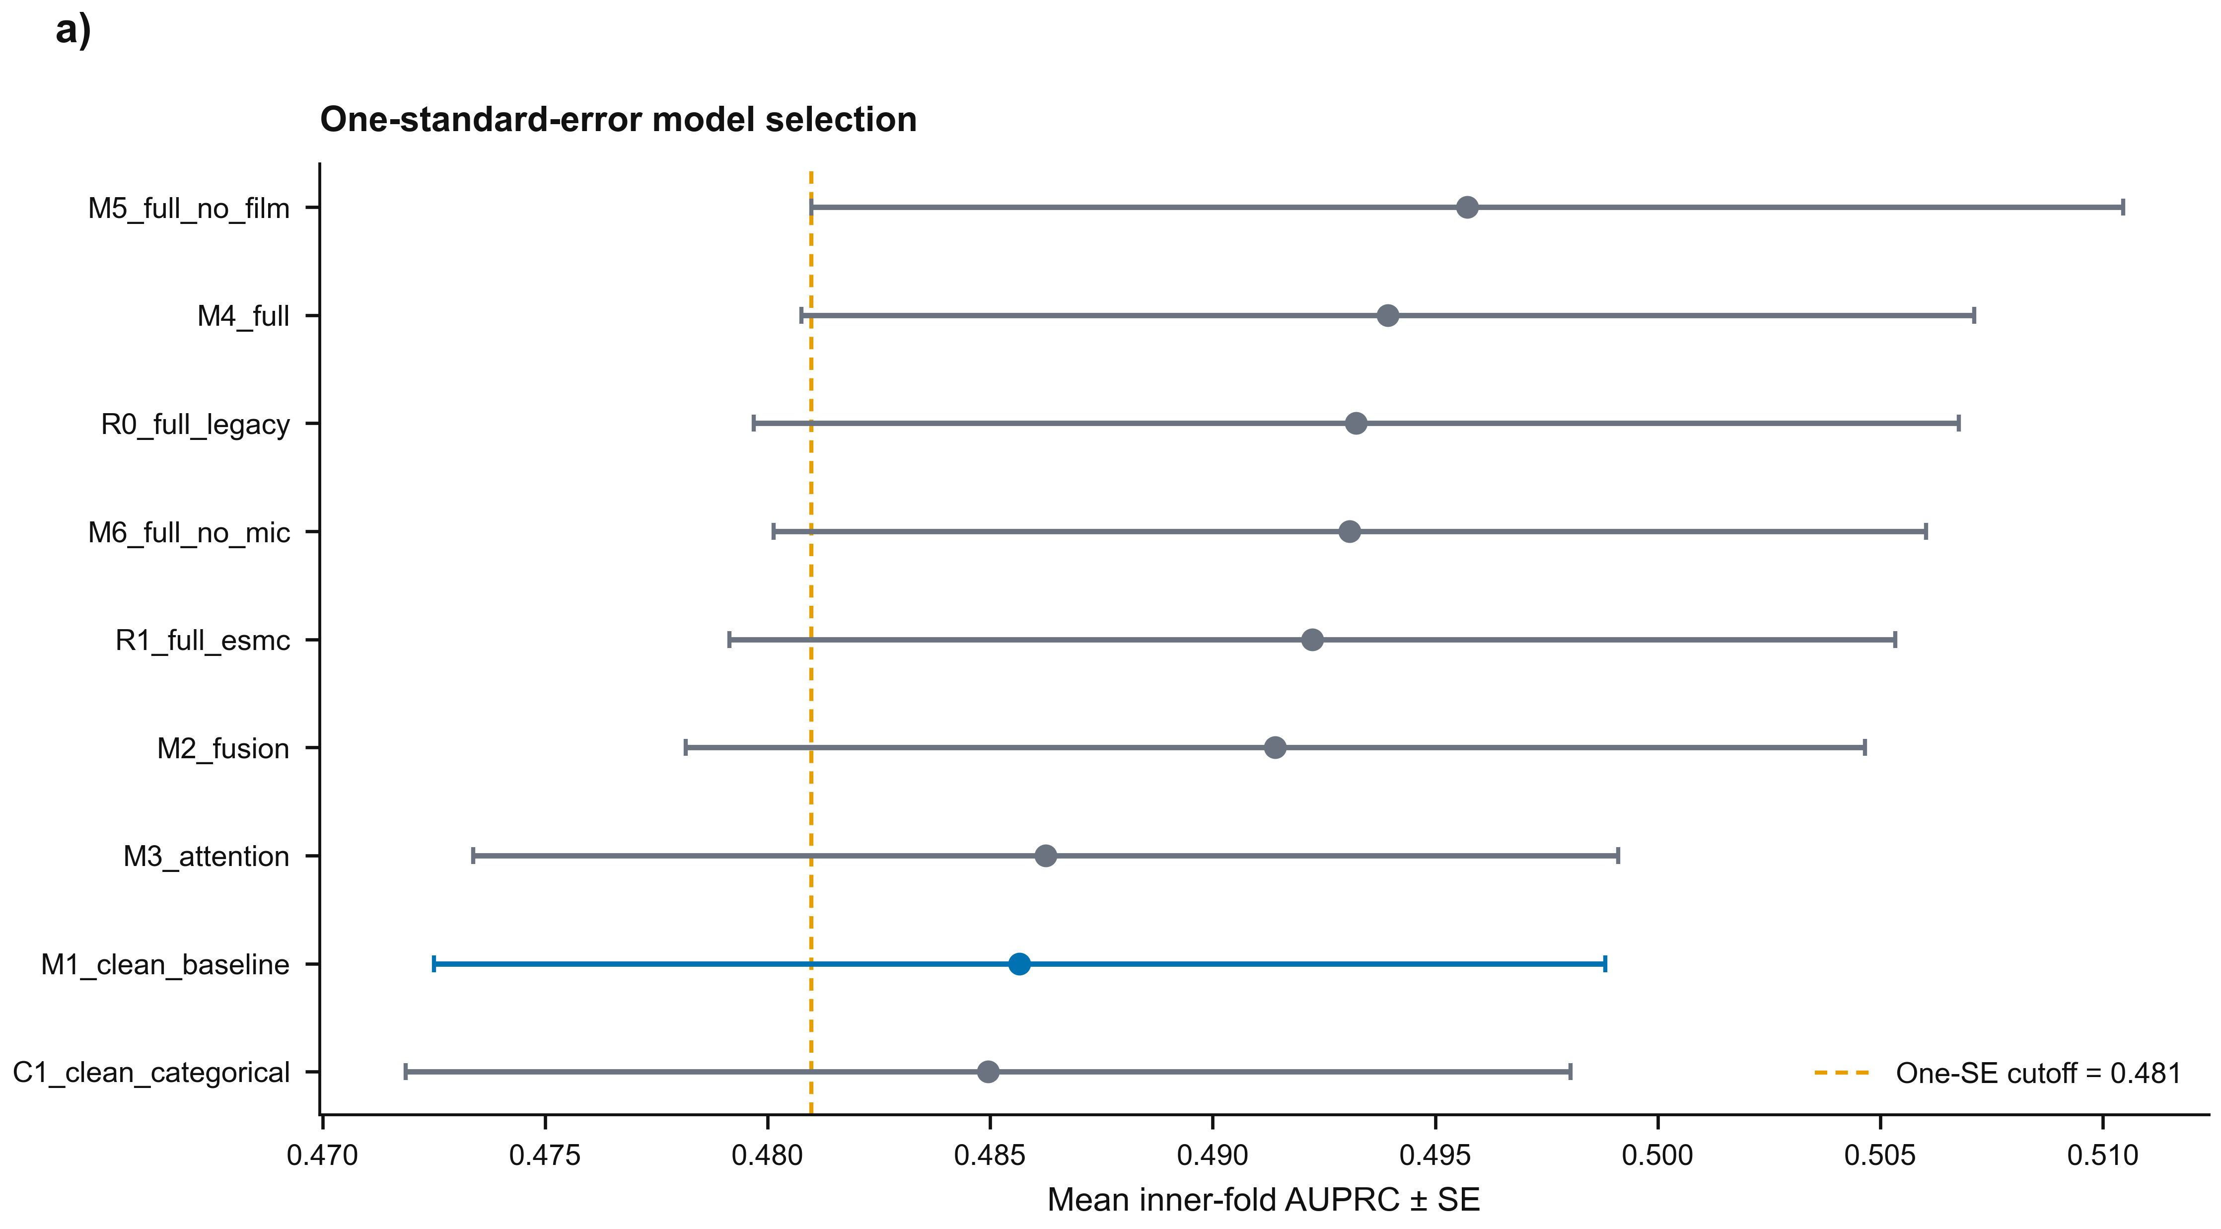
Supplementary Figure S3 | One-standard-error model selection. Inner-fold AUPRC means and standard errors; the minimum-complexity eligible model is highlighted.
Supplementary Figure S4
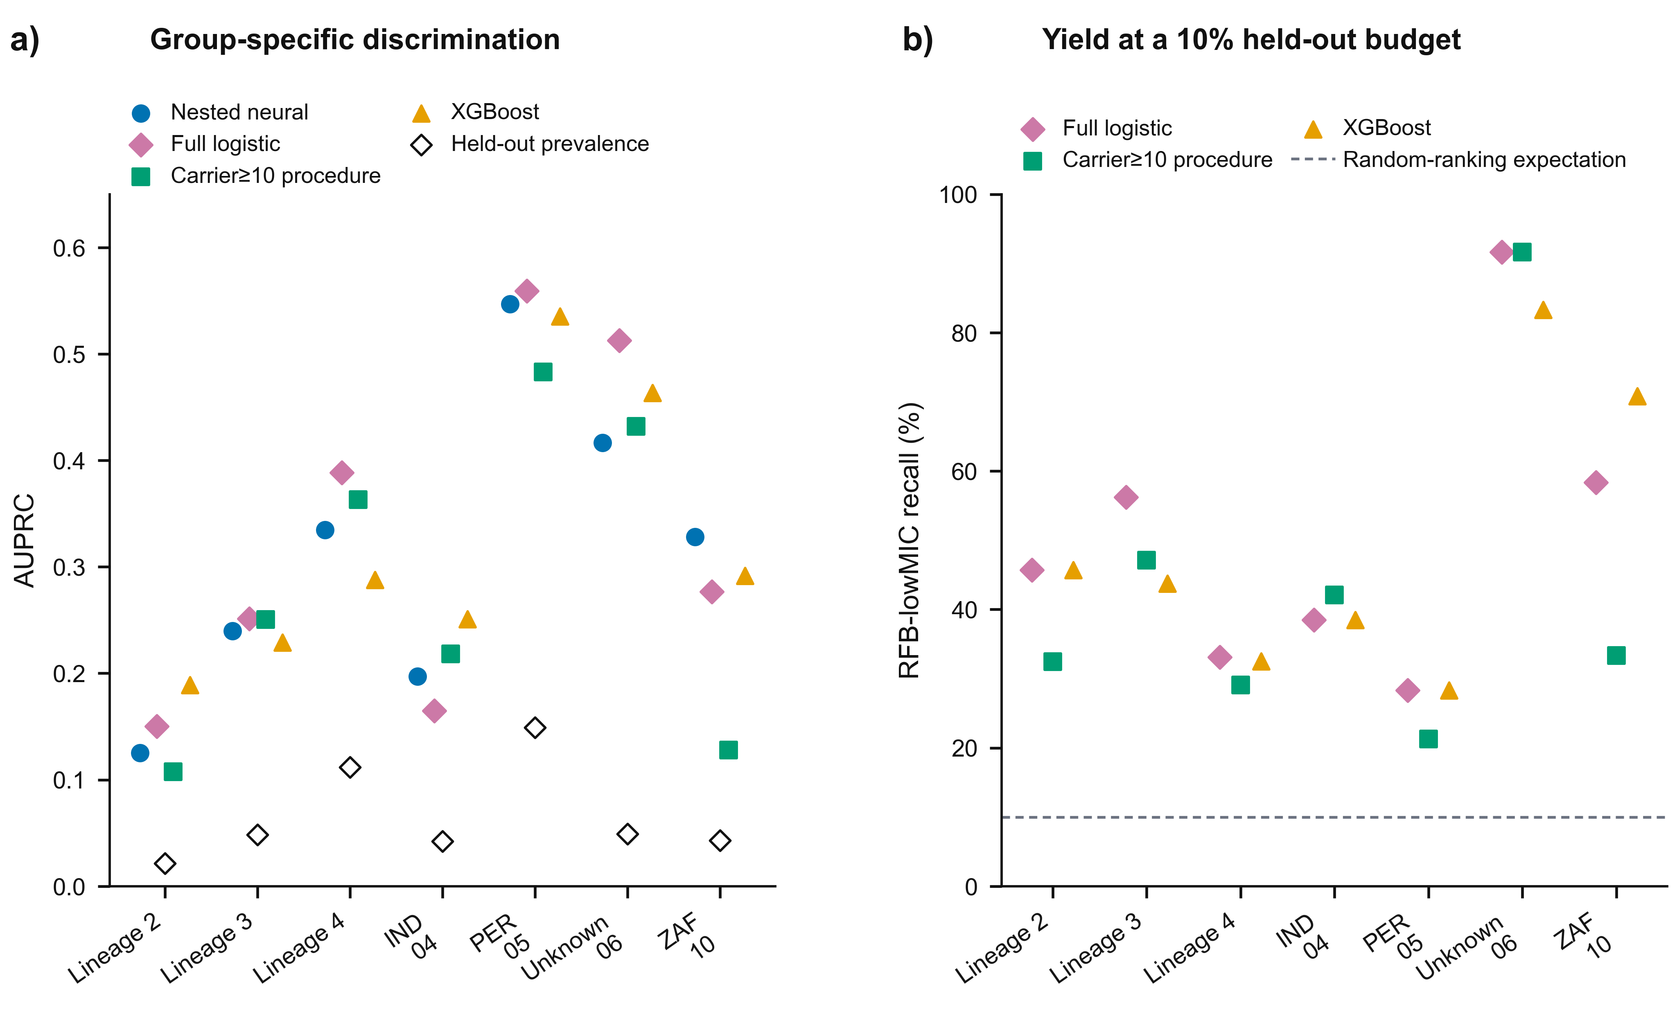
Supplementary Figure S4 | Group-specific lineage and site holdouts. Panel a shows AUPRC for every eligible holdout under the nested procedure, full logistic regression, carrier≥10 rpoB logistic procedure and XGBoost, with held-out prevalence as open diamonds. Panel b shows fold-local 10%-budget recall for the classical procedures; the dashed line is random-ranking expectation.
Supplementary Figure S5
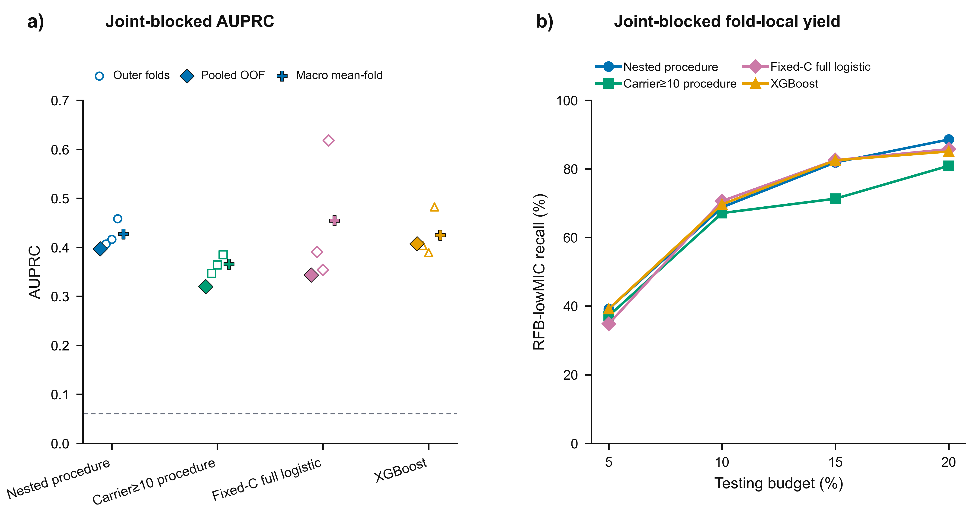
Supplementary Figure S5 | Joint subject-plus-sublineage connected-component sensitivity. Panel a shows fold-specific, pooled OOF and macro mean-fold AUPRC for the nested procedure, carrier≥10 rpoB logistic procedure, fixed-C full logistic comparator and XGBoost; panel b shows fold-local recall using exact uniform boundary-tie expectations. No subject, source sublineage or connected component crossed outer folds.
Supplementary Figure S6
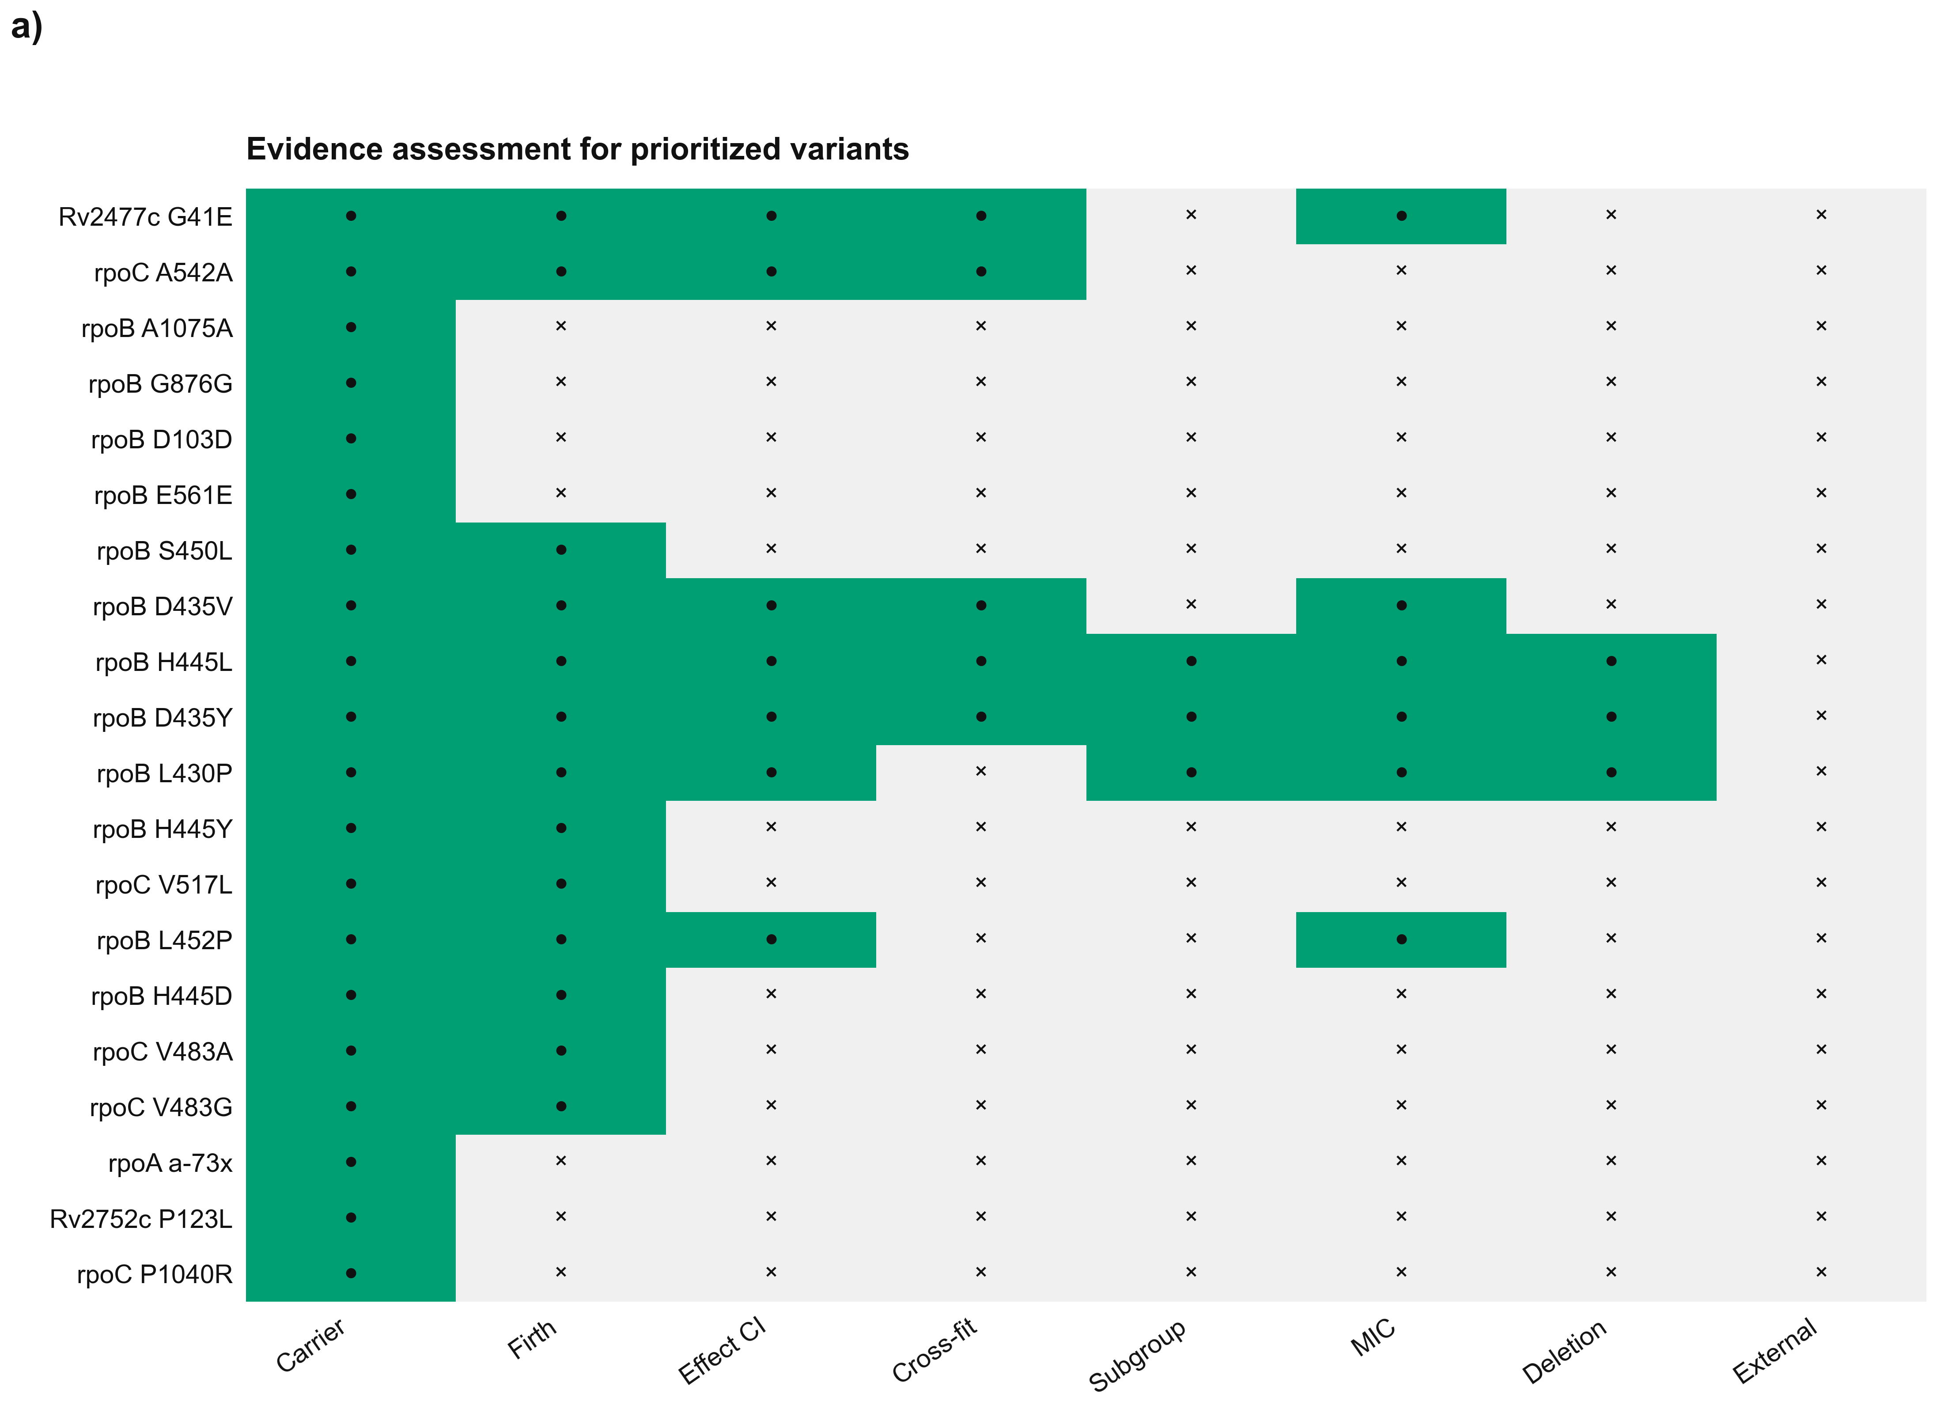
Supplementary Figure S6 | Candidate evidence assessment. Gate outcomes for the first 20 prioritized variants.
Supplementary Figure S7
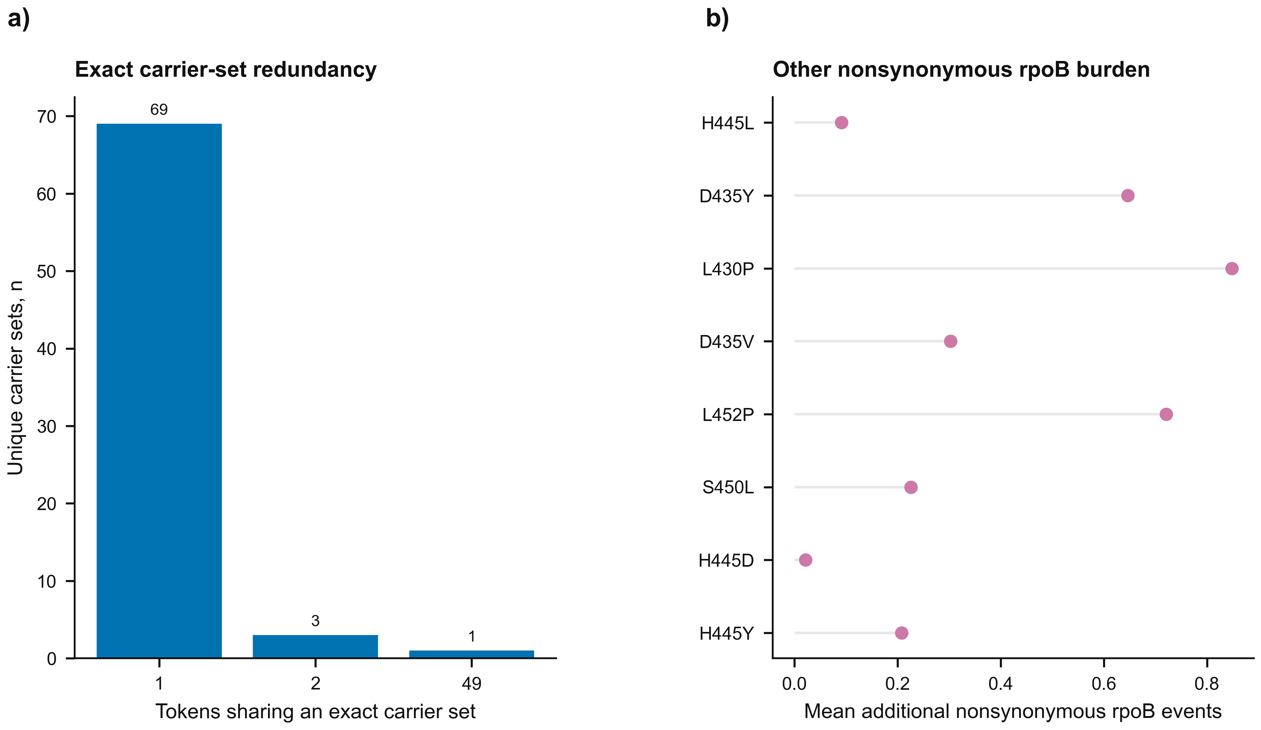
Supplementary Figure S7 | Carrier-set redundancy and rpoB context. Exact carrier-set multiplicity and additional nonsynonymous-rpoB burden.
Supplementary Figure S8
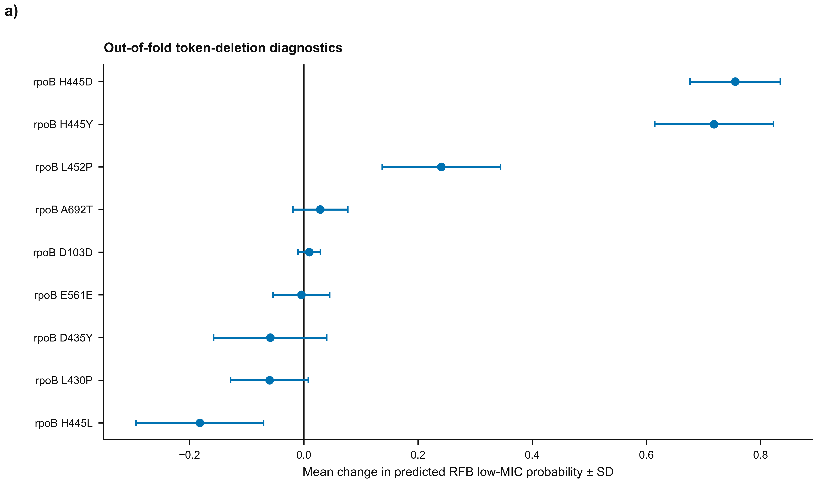
Supplementary Figure S8 | Token-deletion diagnostics. Out-of-fold mean changes in predicted RFB low-MIC probability with between-run standard deviations.
Supplementary Figure S9
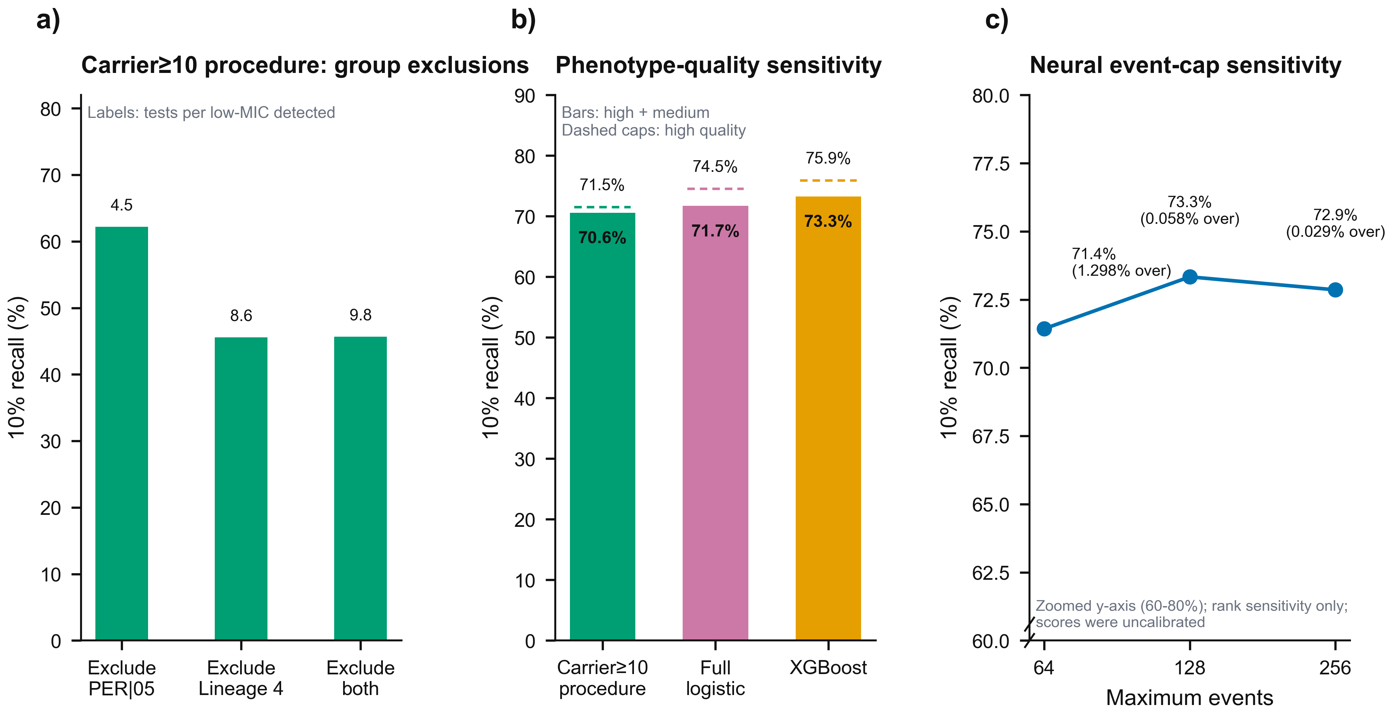
Supplementary Figure S9 | Targeted concentration, phenotype-quality and event-cap sensitivities. Panel a shows fold-local 10%-budget recall for the carrier≥10 rpoB logistic procedure after excluding PER|05, Lineage 4 or both; labels above bars are tests per low-MIC isolate detected. Panel b compares high-plus-medium-quality and high-quality primary recalls. Panel c shows neural rank sensitivity at 64-, 128- and 256-event caps on an explicitly zoomed 60-80% y-axis; truncation-run scores were uncalibrated.
Supplementary Figure S10
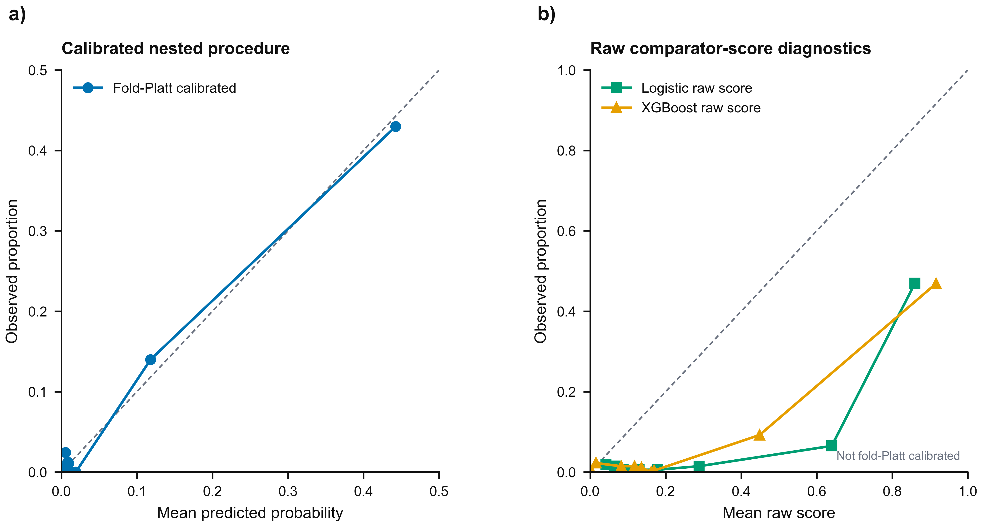
Supplementary Figure S10 | Reliability diagnostics. Panel a shows the fold-Platt-calibrated nested procedure. Panel b displays logistic-regression and XGBoost relative-score patterns as shape diagnostics.
Supplementary Figure S11
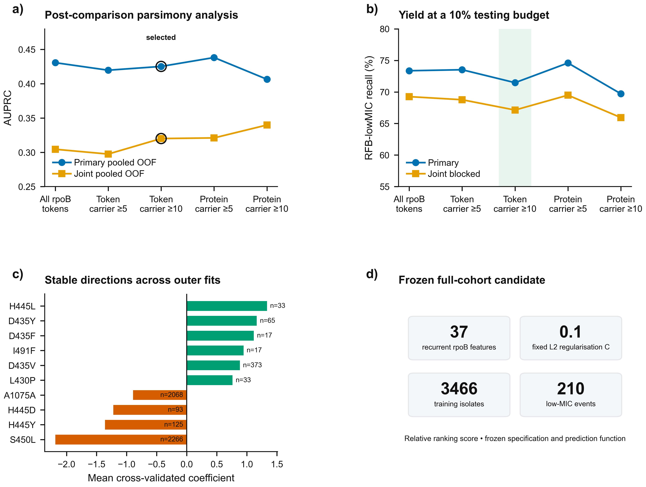
Supplementary Figure S11 | Selection of a carrier-filtered procedure and characterisation of its separate full-cohort refit. Panel a shows primary and joint pooled OOF AUPRC across five post-comparison rpoB simplification variants; panel b shows 10%-budget recall; panel c shows the ten largest mean absolute coefficients across outer fits with carrier counts; panel d summarises the frozen 37-feature full-cohort specification.

Supplementary Tables
Supplementary Table S1 | Drug-specific cohort summary
Drug | Rows | Isolates | Resistant | MIC missing
RFB | 10,165 | 10,165 | 3,428 | 0
RIF | 9,741 | 9,741 | 3,650 | 0

Supplementary Table S3 | One-standard-error model-selection summary
Configuration | Mean AUPRC | SE | One-SE cutoff | Eligible | Selected
M5_full_no_film | 0.496 | 0.015 | 0.481 | True | False
M4_full | 0.494 | 0.013 | 0.481 | True | False
R0_full_legacy | 0.493 | 0.014 | 0.481 | True | False
M6_full_no_mic | 0.493 | 0.013 | 0.481 | True | False
R1_full_esmc | 0.492 | 0.013 | 0.481 | True | False
M2_fusion | 0.491 | 0.013 | 0.481 | True | False
M3_attention | 0.486 | 0.013 | 0.481 | True | False
M1_clean_baseline | 0.486 | 0.013 | 0.481 | True | True
C1_clean_categorical | 0.485 | 0.013 | 0.481 | True | False

Supplementary Table S4 | Fold-local testing-budget performance under both validation profiles
Validation | Budget | Selected | Detected | Recall | PPV | Tests/detected
Subject-grouped 5×5 | 5% | 176 | 90.9/210 | 43.3% (38.1–48.9) | 51.7% (44.8–58.1) | 1.94 (1.72–2.23)
Subject-grouped 5×5 | 10% | 348 | 151.0/210 | 71.9% (65.2–77.2) | 43.4% (37.1–48.7) | 2.30 (2.05–2.70)
Subject-grouped 5×5 | 15% | 523 | 179.0/210 | 85.2% (79.3–89.5) | 34.2% (29.5–38.5) | 2.92 (2.60–3.39)
Subject-grouped 5×5 | 20% | 695 | 188.1/210 | 89.6% (85.3–93.6) | 27.1% (23.4–30.8) | 3.70 (3.24–4.28)
Joint subject–sublineage 3×3 | 5% | 175 | 82.3/210 | 39.2% | 47.0% | 2.13
Joint subject–sublineage 3×3 | 10% | 348 | 144.5/210 | 68.8% | 41.5% | 2.41
Joint subject–sublineage 3×3 | 15% | 521 | 172.0/210 | 81.9% | 33.0% | 3.03
Joint subject–sublineage 3×3 | 20% | 694 | 186.0/210 | 88.6% | 26.8% | 3.73
Tests/detected denotes tests per low-MIC isolate detected. Subject-grouped point estimates use exact uniform boundary-tie expectations; parentheses are 95% CIs from 2000 subject-cluster bootstrap replicates conditional on fixed folds and fitted models. Joint-blocked rows are point estimates without budget intervals; no subject, source sublineage or connected component crossed those outer folds.
Supplementary Table S5 | Group-specific lineage and site holdouts
Model | Held-out group | n | Events | Prevalence | AUPRC | AUROC | Brier skill | 10% recall
Nested neural | Lineage 2 | 1,637 | 35 | 2.1% | 0.125 | 0.724 | -1.400 | —
Full logistic | Lineage 2 | 1,637 | 35 | 2.1% | 0.150 | 0.707 | -0.010 | 45.7%
Carrier≥10 rpoB procedure | Lineage 2 | 1,637 | 35 | 2.1% | 0.107 | 0.714 | — | 32.5%
XGBoost | Lineage 2 | 1,637 | 35 | 2.1% | 0.189 | 0.717 | 0.083 | 45.7%
Nested neural | Lineage 3 | 331 | 16 | 4.8% | 0.240 | 0.841 | -1.082 | —
Full logistic | Lineage 3 | 331 | 16 | 4.8% | 0.251 | 0.822 | 0.113 | 56.3%
Carrier≥10 rpoB procedure | Lineage 3 | 331 | 16 | 4.8% | 0.251 | 0.848 | — | 47.1%
XGBoost | Lineage 3 | 331 | 16 | 4.8% | 0.229 | 0.836 | -0.053 | 43.8%
Nested neural | Lineage 4 | 1,405 | 157 | 11.2% | 0.335 | 0.722 | -0.188 | —
Full logistic | Lineage 4 | 1,405 | 157 | 11.2% | 0.389 | 0.826 | -0.040 | 33.1%
Carrier≥10 rpoB procedure | Lineage 4 | 1,405 | 157 | 11.2% | 0.363 | 0.850 | — | 29.1%
XGBoost | Lineage 4 | 1,405 | 157 | 11.2% | 0.288 | 0.576 | -0.050 | 32.5%
Nested neural | IND|04 | 617 | 26 | 4.2% | 0.197 | 0.683 | -0.247 | —
Full logistic | IND|04 | 617 | 26 | 4.2% | 0.165 | 0.639 | 0.005 | 38.5%
Carrier≥10 rpoB procedure | IND|04 | 617 | 26 | 4.2% | 0.218 | 0.696 | — | 42.1%
XGBoost | IND|04 | 617 | 26 | 4.2% | 0.251 | 0.653 | 0.073 | 38.5%
Nested neural | PER|05 | 759 | 113 | 14.9% | 0.547 | 0.899 | 0.095 | —
Full logistic | PER|05 | 759 | 113 | 14.9% | 0.559 | 0.905 | 0.088 | 28.3%
Carrier≥10 rpoB procedure | PER|05 | 759 | 113 | 14.9% | 0.483 | 0.857 | — | 21.3%
XGBoost | PER|05 | 759 | 113 | 14.9% | 0.536 | 0.900 | 0.050 | 28.3%
Nested neural | Unknown|06 | 245 | 12 | 4.9% | 0.417 | 0.951 | -0.194 | —
Full logistic | Unknown|06 | 245 | 12 | 4.9% | 0.513 | 0.968 | 0.256 | 91.7%
Carrier≥10 rpoB procedure | Unknown|06 | 245 | 12 | 4.9% | 0.432 | 0.963 | — | 91.7%
XGBoost | Unknown|06 | 245 | 12 | 4.9% | 0.463 | 0.960 | 0.178 | 83.3%
Nested neural | ZAF|10 | 557 | 24 | 4.3% | 0.328 | 0.901 | -1.622 | —
Full logistic | ZAF|10 | 557 | 24 | 4.3% | 0.277 | 0.922 | 0.083 | 58.3%
Carrier≥10 rpoB procedure | ZAF|10 | 557 | 24 | 4.3% | 0.128 | 0.770 | — | 33.3%
XGBoost | ZAF|10 | 557 | 24 | 4.3% | 0.292 | 0.940 | 0.118 | 70.8%
Every row is an internal group holdout. The carrier≥10 class-weighted logistic procedure was refitted in each development partition and yields a relative ranking score; Brier skill is therefore not reported for that row set.
Supplementary Table S6 | Evidence-gate pass counts among 50 prioritized variants
Gate | Passed | Reviewed | Pass proportion
Catalogue | 39 | 50 | 78.0%
Carrier | 50 | 50 | 100.0%
Firth | 13 | 50 | 26.0%
Effect CI | 7 | 50 | 14.0%
Cross-fit | 5 | 50 | 10.0%
Subgroup | 3 | 50 | 6.0%
MIC | 6 | 50 | 12.0%
Deletion | 3 | 50 | 6.0%
External | 0 | 50 | 0.0%
Complete definition | 0 | 50 | 0.0%

Supplementary Table S7 | Primary original-sample estimates with subject-cluster percentile intervals
Model | AUPRC (95% CI) | AUROC (95% CI) | Brier skill (95% CI) | Calibration intercept | Calibration slope | Score status
Nested procedure | 0.438 (0.376–0.511) | 0.908 (0.881–0.932) | 0.301 (0.242–0.354) | −0.075 (−0.298–0.149) | 0.943 (0.858–1.043) | Fold-Platt calibrated
Carrier≥10 rpoB procedure | 0.425 (0.361–0.496) | 0.892 (0.863–0.921) | Not interpreted | Ranking score only | Ranking score only | Nested-C relative score
All-token logistic | 0.447 (0.380–0.519) | 0.903 (0.873–0.929) | Not interpreted | Ranking score only | Ranking score only | Nested-C relative score
XGBoost | 0.409 (0.350–0.475) | 0.905 (0.881–0.928) | Not interpreted | Ranking score only | Ranking score only | Relative score
Intervals use 2000 subject-cluster bootstrap replicates. Point estimates were calculated on the original held-out sample. Brier and calibration are interpreted only for the fold-Platt-calibrated nested procedure.
Supplementary Table S8 | Targeted 10%-budget sensitivity analyses
Analysis | Model | Detected/events | Recall | PPV | Tests/detected
High-quality primary | Carrier≥10 rpoB procedure | 150.1/210 | 71.5% | 43.1% | 2.32
High-quality primary | Nested procedure | 151.0/210 | 71.9% | 43.4% | 2.30
High-quality primary | Full logistic | 156.4/210 | 74.5% | 44.9% | 2.22
High-quality primary | XGBoost | 159.4/210 | 75.9% | 45.8% | 2.18
Joint subject–sublineage 3×3 | Carrier≥10 rpoB procedure | 141.0/210 | 67.1% | 40.5% | 2.47
Joint subject–sublineage 3×3 | Nested procedure | 144.5/210 | 68.8% | 41.5% | 2.41
Joint subject–sublineage 3×3 | Fixed-C full logistic | 148.4/210 | 70.6% | 42.6% | 2.35
Joint subject–sublineage 3×3 | XGBoost | 146.3/210 | 69.7% | 42.0% | 2.38
High + medium quality | Carrier≥10 rpoB procedure | 182.1/258.0 | 70.6% | 42.5% | 2.35
High + medium quality | Full logistic | 185/258 | 71.7% | 43.2% | 2.31
High + medium quality | XGBoost | 189/258 | 73.3% | 44.2% | 2.26
exclude PER 05 | Carrier≥10 rpoB procedure | 60.3/97.0 | 62.2% | 22.1% | 4.52
exclude Lineage 4 | Carrier≥10 rpoB procedure | 24.2/53.0 | 45.6% | 11.7% | 8.57
exclude PER 05 and Lineage 4 | Carrier≥10 rpoB procedure | 20.6/45.0 | 45.7% | 10.2% | 9.83
Tests/detected denotes tests per low-MIC isolate detected. Counts are aggregated after ranking within held-out folds. The carrier≥10 procedure, including its development-fold feature filter and C selection, was refitted inside each reported validation analysis.
Supplementary Table S9 | Neural event-cap and rank sensitivity
Maximum events | Isolates over cap | Events discarded | Mean-fold AUPRC | Mean-fold AUROC | 10% recall | 10% PPV
64 | 45/3466 (1.298%) | 784 | 0.446 | 0.918 | 71.4% | 43.1%
128 | 2/3466 (0.058%) | 418 | 0.453 | 0.922 | 73.3% | 44.3%
256 | 1/3466 (0.029%) | 230 | 0.445 | 0.918 | 72.9% | 44.0%
Rank sensitivity is reported from uncalibrated truncation-run scores; Brier and calibration measures are omitted.
Supplementary Table S10 | Top features across carrier≥10 outer-fold fits
Mutation token | Folds | Sign consistency | Mean coefficient | Carriers | Positive carriers
rpoB S450L | 5 | 1.00 | -2.187 | 2,266 | 17
rpoB H445Y | 5 | 1.00 | -1.360 | 125 | 0
rpoB H445L | 5 | 1.00 | 1.334 | 33 | 19
rpoB H445D | 5 | 1.00 | -1.222 | 93 | 0
rpoB D435Y | 5 | 1.00 | 1.164 | 65 | 24
rpoB D435F | 5 | 1.00 | 1.115 | 17 | 9
rpoB I491F | 5 | 1.00 | 0.945 | 17 | 10
rpoB A1075A | 5 | 1.00 | -0.893 | 2,068 | 54
rpoB D435V | 5 | 1.00 | 0.883 | 373 | 88
rpoB L430P | 5 | 1.00 | 0.762 | 33 | 8
rpoB S450F | 5 | 1.00 | -0.607 | 33 | 0
rpoB H445R | 5 | 1.00 | -0.499 | 29 | 0
rpoB S450W | 5 | 1.00 | -0.478 | 48 | 1
rpoB V170F | 5 | 1.00 | -0.423 | 21 | 0
rpoB D103D | 5 | 1.00 | -0.382 | 163 | 9
rpoB D435G | 5 | 1.00 | -0.379 | 38 | 1
rpoB 1288_indel | 5 | 1.00 | -0.324 | 16 | 0
rpoB Q432P | 3 | 1.00 | -0.321 | 12 | 0
rpoB L452P | 5 | 1.00 | 0.308 | 43 | 7
rpoB A692T | 5 | 1.00 | -0.293 | 37 | 0
Rows are ordered by mean absolute cross-validated coefficient. Coefficients are penalised and correlated; carrier counts and fold stability do not establish causality. The separate 37-feature full-cohort refit is supplied in Supplementary Table S15.
Supplementary Table S11 | Joint subject–sublineage discrimination and yield
Model | Pooled OOF AUPRC (95% CI) | Macro AUPRC (95% CI) | Outer-fold AUPRCs | 10% recall (fold range) | Detected/events
Nested procedure | 0.397 (0.339–0.467) | 0.427 (0.366–0.508) | 0.407; 0.416; 0.458 | 68.8% (63.4%–71.2%) | 144.5/210
Carrier≥10 rpoB procedure | 0.320 (0.306–0.346) | 0.366 (0.275–0.477) | 0.347; 0.365; 0.385 | 67.1% (61.4%–74.7%) | 141.0/210
Fixed-C all-token logistic | 0.344 (0.290–0.409) | 0.455 (0.388–0.534) | 0.391; 0.355; 0.618 | 70.6% (67.2%–83.6%) | 148.4/210
XGBoost | 0.408 (0.349–0.480) | 0.425 (0.367–0.510) | 0.404; 0.389; 0.482 | 69.7% (67.8%–74.1%) | 146.3/210
Budget values are exact uniform boundary-tie expectations after fold-local ranking; parentheses give the range across the three outer folds. Actual test folds contained 750/41, 2085/128 and 631/41 isolates/events. The carrier≥10 procedure selected its feature set and C in each development partition; the fixed-C row remains a separate full-token sensitivity comparator.
Supplementary Table S12 | Post-comparison parsimony envelope for an exploratory rpoB procedure
Variant | Primary AUPRC | Primary 10% recall | Joint AUPRC | Joint 10% recall | Median features | Envelope
All rpoB tokens | 0.431 | 73.4% | 0.304 | 69.3% | 477.5 | No
Token carrier ≥5 | 0.420 | 73.5% | 0.297 | 68.8% | 62.5 | No
Token carrier ≥10 | 0.425 | 71.5% | 0.320 | 67.1% | 33.5 | Eligible; selected
Protein carrier ≥5 | 0.438 | 74.6% | 0.321 | 69.5% | 60.0 | Eligible
Protein carrier ≥10 | 0.406 | 69.7% | 0.340 | 65.9% | 31.5 | No
After the principal model comparison, eligibility required primary pooled AUPRC within 0.02 of the best variant, primary 10%-budget recall within 0.05, joint pooled AUPRC within 0.03 and joint recall within 0.05. The minimum median feature count was the first tie-breaker. Intervals for the selected procedure are conditional descriptive intervals and do not adjust for this selection step.
Supplementary Table S13 | Nested regularisation selections for the carrier≥10 procedure
Outer fold | Selected C | Features | Development n | Development events | Selection scope
1 | 0.1 | 31 | 2,743 | 162 | Inner-development selection
2 | 0.1 | 36 | 2,758 | 173 | Inner-development selection
3 | 0.1 | 33 | 2,799 | 166 | Inner-development selection
4 | 0.1 | 34 | 2,787 | 167 | Inner-development selection
5 | 0.1 | 34 | 2,777 | 172 | Inner-development selection
The carrier filter and C were fitted independently inside each outer-development partition. Feature counts are fold-specific and are not the 37 features in the separate full-cohort refit. C was selected from 0.0001, 0.001, 0.01, 0.1, 1, 10 and 100 without using the outer-test fold.
Supplementary Table S14 | Fixed-score endpoint sensitivity excluding the nominal rifabutin 0.12-mg/L dilution
Model | AUPRC (95% CI) | 10% recall (95% CI) | 10% PPV (95% CI) | Tests/detected (95% CI)
Carrier≥10 rpoB procedure | 0.246 (0.173–0.350) | 71.4% (61.1%–81.3%) | 16.2% (12.3%–20.2%) | 6.19 (4.94–8.12)
The analysis retained archived OOF scores and excluded 134 isolates whose numeric MIC was within ±0.0005 mg/L of 0.12, leaving 3332 isolates from 3263 subjects and 76 low-MIC events; no model was refitted. Intervals use 2000 SUBJID-cluster bootstrap replicates within locked outer folds.
Supplementary Table S15 | Frozen 37-feature coefficient and carrier specification
Mutation token | Coefficient | Carriers | Positive carriers | Positive folds | Sign consistency
rpoB S450L | -2.2274 | 2,266 | 17 | 0/5 | 1.00
rpoB H445Y | -1.5255 | 125 | 0 | 0/5 | 1.00
rpoB H445L | 1.4471 | 33 | 19 | 5/5 | 1.00
rpoB H445D | -1.3858 | 93 | 0 | 0/5 | 1.00
rpoB D435Y | 1.2377 | 65 | 24 | 5/5 | 1.00
rpoB D435F | 1.2318 | 17 | 9 | 5/5 | 1.00
rpoB I491F | 1.0391 | 17 | 10 | 5/5 | 1.00
rpoB A1075A | -0.9140 | 2,068 | 54 | 0/5 | 1.00
rpoB D435V | 0.8784 | 373 | 88 | 5/5 | 1.00
rpoB L430P | 0.8390 | 33 | 8 | 5/5 | 1.00
rpoB S450F | -0.7236 | 33 | 0 | 0/5 | 1.00
rpoB H445R | -0.5927 | 29 | 0 | 0/5 | 1.00
rpoB S450W | -0.5485 | 48 | 1 | 0/5 | 1.00
rpoB V170F | -0.5085 | 21 | 0 | 0/5 | 1.00
rpoB D435G | -0.4309 | 38 | 1 | 0/5 | 1.00
rpoB D103D | -0.4171 | 163 | 9 | 0/5 | 1.00
rpoB 1288_indel | -0.3914 | 16 | 0 | 0/5 | 1.00
rpoB Q432P | -0.3675 | 12 | 0 | 0/3 | 1.00
rpoB A692T | -0.3492 | 37 | 0 | 0/5 | 1.00
rpoB L452P | 0.3390 | 43 | 7 | 5/5 | 1.00
rpoB I491L | -0.3118 | 17 | 0 | 0/5 | 1.00
rpoB E561E | 0.2810 | 49 | 3 | 5/5 | 1.00
rpoB L731P | -0.1693 | 24 | 0 | 0/5 | 1.00
rpoB G876G | 0.1685 | 329 | 16 | 5/5 | 1.00
rpoB Q409R | -0.1525 | 17 | 0 | 0/4 | 1.00
rpoB R552L | -0.1329 | 15 | 0 | 0/3 | 1.00
rpoB R827C | -0.1318 | 15 | 0 | 0/5 | 1.00
rpoB S874Y | -0.1255 | 17 | 0 | 0/5 | 1.00
rpoB Q975H | -0.1232 | 27 | 0 | 0/5 | 1.00
rpoB c-61t | 0.1051 | 318 | 15 | 3/5 | 0.60
rpoB P45S | -0.1049 | 18 | 0 | 0/5 | 1.00
rpoB P45L | -0.0912 | 12 | 0 | 0/3 | 1.00
rpoB V695L | 0.0726 | 38 | 6 | 4/5 | 0.80
rpoB A286V | -0.0713 | 15 | 0 | 0/5 | 1.00
rpoB L554P | -0.0484 | 11 | 0 | 0/1 | 1.00
rpoB V228V | 0.0439 | 12 | 1 | 3/3 | 1.00
rpoB H445N | -0.0381 | 11 | 1 | 0/1 | 1.00
Coefficients and intercept define the full-cohort frozen score. Cross-validated stability fields come from the five primary outer fits; coefficient magnitude does not establish causality.
Supplementary Table S16 | Frozen full-cohort score specification
Field | Locked value
Model type | class_weighted_L2_logistic_relative_ranking_score
Feature rule | rpoB mutation token; full-cohort carrier count ≥10
Feature count | 37
Regularisation C | 0.1
Intercept | 0.7838316512
Training isolates/events | 3,466/210
Unknown-token policy | ignore
No-recognised-event policy | all-zero feature vector
Output | relative ranking score; not an absolute RFB-lowMIC probability
Serialized model SHA-256 | 7fa515b381935d9186ed17d937013052f0e3357859f9c4f5d7c74dfd0e4f629c

