Supplementary Information for

The role of chalcogen vacancies for atomic defect emission in MoS₂
Elmar Mitterreiter^{1,2}, Bruno Schuler^{3,4}, Katja Barthelmi^{1,2}, Katherine A. Cochrane³, Jonas Kiemle^{1,2}, Florian Sigger^{1,2}, Julian Klein^{1,5}, Edward Wong³, Edward S. Barnard³, Sivan Refaely-Abramson⁶, Diana Y. Qiu⁷, Michael Lorke^{8,9}, Frank Jahnke⁹, Kenji Watanabe¹⁰, Takashi Taniguchi¹¹, Johnathan J. Finley^{1,2}, Adam M. Schwartzberg³, Alexander W. Holleitner^{1,2*}, Alexander Weber-Bargioni^{3§}, Christoph Kastl^{1,2#}

1 – Walter Schottky Institut and Physics Department, Technical University of Munich, Am Coulombwall 4a, 85748 Garching, Germany
2 – Munich Center for Quantum Science and Technology (MCQST), Schellingstrasse 4, 80799 München, Germany
3 – Molecular Foundry, Lawrence Berkeley National Laboratory, 1 Cyclotron Road, Berkeley, CA 94720, United States
4 – nanotech@surfaces Laboratory, Empa – Swiss Federal Laboratories for Materials Science and Technology, 8600 Dübendorf, Switzerland
5 – Department of Materials Science and Engineering, Massachusetts Institute of Technology, Cambridge, MA 02139, United States
6 – Department of Materials and Interfaces, Weizmann Institute of Science, Rehovot, Israel
7 – Department of Mechanical Engineering and Materials Science, Yale University, New Haven, CT, USA
8 – Bremen Center for Computational Materials Science, University of Bremen, Am Fallturm 1, 28359 Bremen, Germany
9 – Bremen Institute for Theoretical Physics, University of Bremen, Otto-Hahn-Allee 1, 28359 Bremen, Germany
10 – Research Center for Functional Materials, National Institute for Materials Science, 1-1 Namiki, Tsukuba 305-0044, Japan
11 – International Center for Materials Nanoarchitectonics, National Institute for Materials Science, 1-1 Namiki, Tsukuba 305-0044, Japan

*holleitner@wsi.tum.de
§ afweber-bargioni@lbl.gov
#christoph.kastl@wsi.tum.de

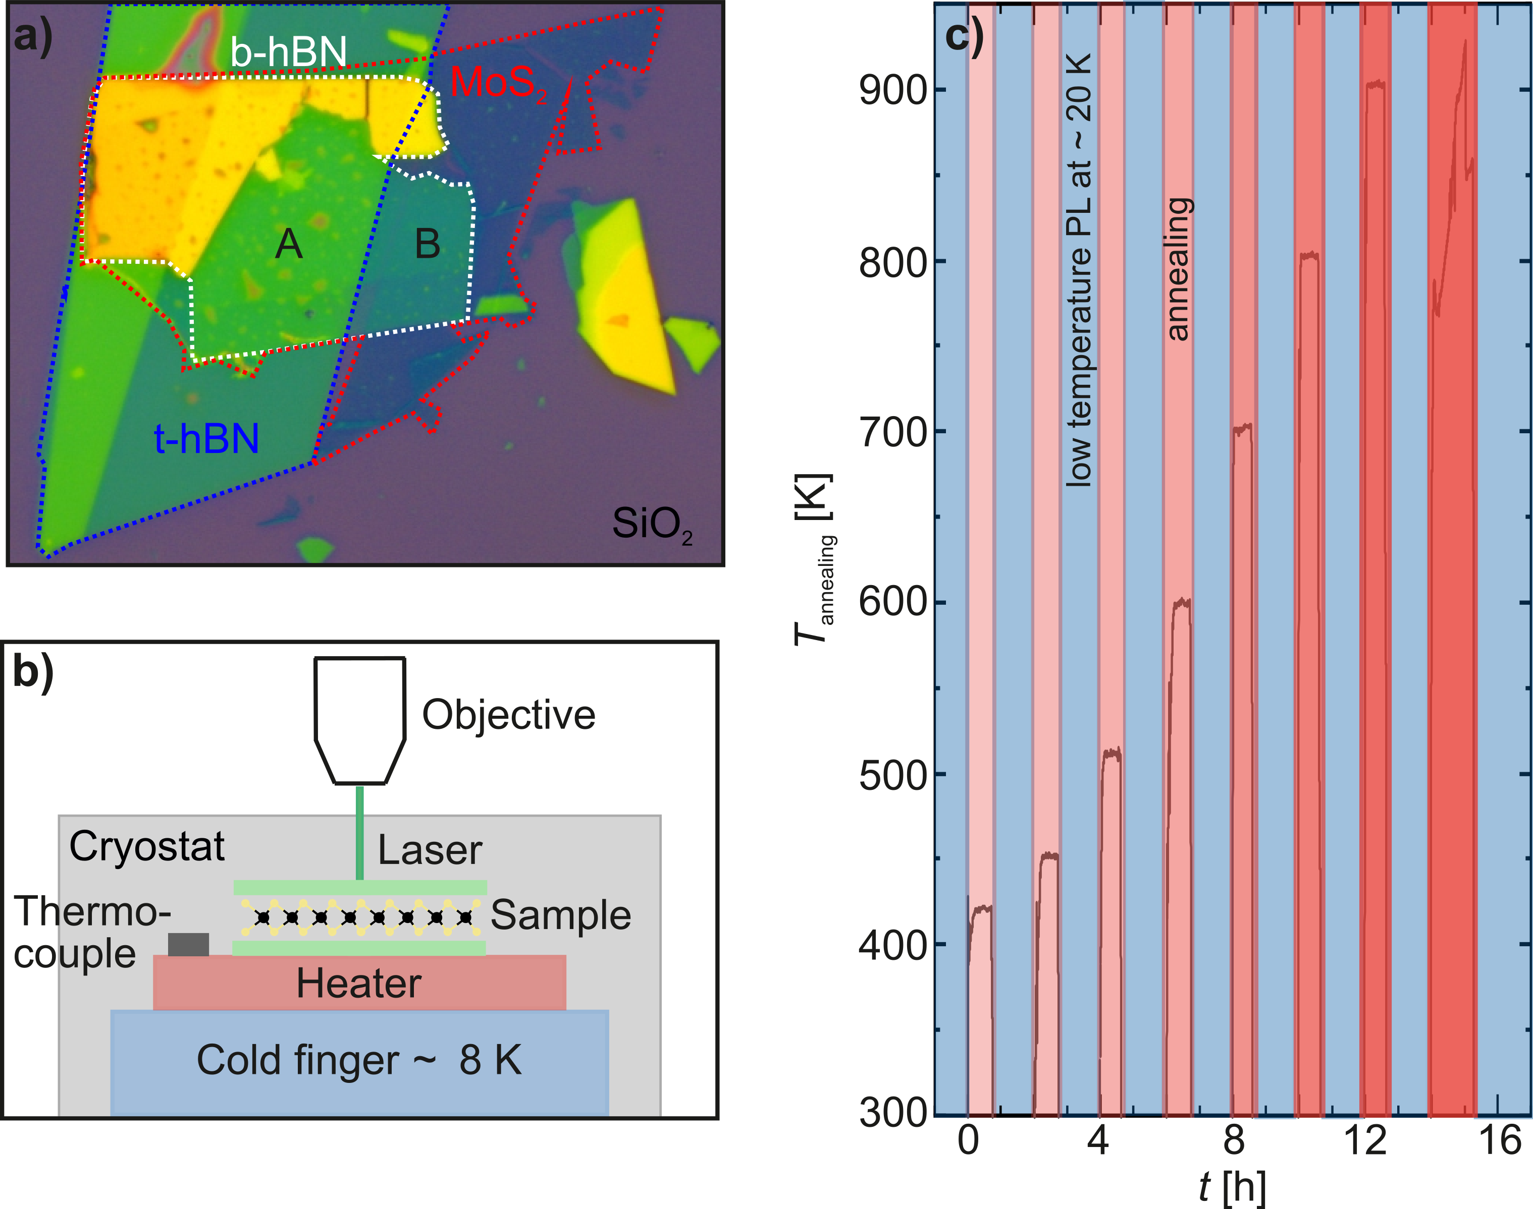
S1: Schematic of in-vacuo annealing. a) Microscope image of a sample consisting of bottom hBN (b-hBN), MoS₂ , and top hBN (t-hBN) on SiO₂. A and B represent the resulting fully, and half-encapsulated MoS₂ heterostructure, respectively. b) Schematic measurement setup showing a modified optical cryostat with integrated heater enabling in-vacuo high-temperature annealing (up to T_{annealing} ∼ 900 K) and successive low-temperature PL measurements (T_{sample} ∼ 20 K). c) Temperature profile of the entire PL study. The red-shaded areas highlight the temperature profile during the annealing processes. Upon reaching the desired annealing temperature, the latter was maintained constant for 30 minutes. The blue-shaded areas represent the low-temperature PL measurements.

S2: Annealing temperature dependent evolution of low-temperature PL spectra. a) PL spectra of fully encapsulated pristine MoS₂, and after annealing to 420 K, 450 K, 510 K, 600 K, 700 K, 800 K, 900 K, and again 900 K. Pristine MoS₂ exhibits a broad emission peak, which is strongly reduced after mild annealing. A single emission peak appears and its intensity increases with rising annealing temperature. The intensity of the single emission peak decreases after annealing to 900 K and the PL disappears after a subsequent annealing step to 900 K (gray). b) PL spectra of pristine MoS₂ on h-BN, and after annealing to 420 K, 450 K, 510 K, 600 K, 700 K, and 800 K. A similar behavior to fully encapsulated MoS₂ occurs. However, lower annealing temperatures of about 700 K already reduce the intensity of single emission line before it vanishes at 800 K.
S3: Laser power dependent PL of fully encapsulated MoS₂ after annealing to 800 K. a) Power dependent PL spectra. Curves are offset for clarity. b) Power dependent integrated intensity of the neutral exciton (X^{A}) (red) and the single emission line X_{L} (blue). We do not observe a laser power dependent saturation for the emission of the exciton. However, the defect emission line exhibits a saturating behavior, which we can be fitted by $I ∝ \frac{P}{P + P_{Sat}}$. The turnover for saturation where P = P_{sat} occurs at approximately 50 µW.

S4: STM overview image of single layer MoS₂ on graphene/SiC after mild annealing. Within our experimental statistics, the only observed defects are oxygen passivated sulfur top and bottom vacancies. The bright spots correspond to adsorbed molecules on the MoS₂ surface.

S5: Low-temperature PL spectrum of homogeneously He-ion irradiated single-layer MoS₂ on graphene/SiC. The He-ion dose was 5·10¹⁴ cm⁻². The defect emission is absent due to quenching from the underlying graphene substrate.

S6: Details of DFT calculations for defect orbitals in MoS₂ with sulfur vacancies
DFT calculations were performed using the Vienna Ab initio Simulation Package, Vasp 5.4.4^{1,2}, using the projector augmented wave method and treating the semi-core d-states as part of the valence shell in the PBE variant of the generalized gradient approximation³. For defect calculations, 9x9 supercells, consisting of 243 atoms were used with the experimental lattice constant, applying the G-point approximation. The defect geometries were fully relaxed. A 450eV (900eV) cutoff was applied for the expansion of the wave functions (charge density).

S7: Details of GW-BSE calculations for absorbance spectra of MoS₂ with sulfur vacancies
We first performed density functional theory (DFT) calculations within the local density approximation (LDA) using the Quantum-ESPRESSO code⁴. The calculations were done on a 5×5 supercell arrangement of a MoS₂ monolayer with one S vacancy, following prior work⁵. We used a plane-wave basis and norm-conserving pseudopotentials with a 125 Ry plane-wave cutoff. We included the Mo semi-core 4d, 4p, 4s, 5s and 5p states as valence states in our pseudopotential. The distance between repeated supercells in the out-of-plane direction was 15 Å. We relaxed the geometry within DFT and used DFT charge density as a starting point for our GW and Bethe Salpeter equation (GW-BSE) calculations. Our GW calculations are performed with the BerkeleyGW code⁶ using the generalized plasmon-pole model⁷, an energy cutoff of 25 Ry for the planewave components of the dielectric matrix, and a nonuniform k-point sampling corresponding to a 30×30 uniform k-grid. We included 4,000 unoccupied states in the sum over empty states in the self-energy and polarizability and tested the convergence with respect to unoccupied states by comparing to a calculation using up to 20,000 effective states obtained by averaging high-energy states within a small energy window. We find that these parameters converge the relative quasiparticle energies for the defect and pristine states at the K point to within 100 meV. The BSE was also solved with the BerkeleyGW code^{6,8}. We diagonalize the BSE Hamiltonian within the Tamm-Dancoff approximation with 10 valence and 10 conduction bands. The clustered sampling interpolation (CSI) scheme⁹ was used to interpolate a nonuniform k point sampling to a uniform k-grid of 18×18×1 k points. A 5 Ry cutoff was used for the planewave components of the dielectric matrix used in the BSE. Spin orbit coupling was added as a perturbation. We find that these parameters converge the calculated exciton excitation energies up to 200 meV.

Supplemental References
1. Kresse, G. & Furthmüller, J. Efficiency of ab-initio total energy calculations for metals and semiconductors using a plane-wave basis set. Comput. Mater. Sci. 6, 15–50 (1996).
2. Kresse, G. & Furthmüller, J. Efficient iterative schemes for ab initio total-energy calculations using a plane-wave basis set. Phys. Rev. B 54, 11169–11186 (1996).
3. Perdew, J. P., Burke, K. & Ernzerhof, M. Generalized Gradient Approximation Made Simple. Phys. Rev. Lett. 78, 1396–1396 (1997).
4. Giannozzi, P. et al. QUANTUM ESPRESSO: a modular and open-source software project for quantum simulations of materials. J. Phys. Condens. Matter 21, 395502 (2009).
5. Refaely-Abramson, S., Qiu, D. Y., Louie, S. G. & Neaton, J. B. Defect-Induced Modification of Low-Lying Excitons and Valley Selectivity in Monolayer Transition Metal Dichalcogenides. Phys. Rev. Lett. 121, 167402 (2018).
6. Deslippe, J. et al. BerkeleyGW: A massively parallel computer package for the calculation of the quasiparticle and optical properties of materials and nanostructures. Comput. Phys. Commun. 183, 1269–1289 (2012).
7. Hybertsen, M. S. & Louie, S. G. Electron correlation in semiconductors and insulators: Band gaps and quasiparticle energies. Phys. Rev. B 34, 5390–5413 (1986).
8. Rohlfing, M. & Louie, S. G. Electron-Hole Excitations in Semiconductors and Insulators. Phys. Rev. Lett. 81, 2312–2315 (1998).
9. da Jornada, F. H., Qiu, D. Y. & Louie, S. G. Nonuniform sampling schemes of the Brillouin zone for many-electron perturbation-theory calculations in reduced dimensionality. Phys. Rev. B 95, 035109 (2017).

