Supplementary figure 1 Screening of polymorphic molecular markers between parents and F₁ individuals within the preliminary mapping interval.Notes: R: resistant parent; S: susceptible parent; F₁: F₁ plant.
Based on the primer markers published on the Gramene database, 20 pairs of SSR markers located between 22887903 bp and 23002998 bp on the long arm of rice chromosome 11, together with 9 SNP markers previously obtained via the SLAF-seq BSA approach, were selected. Polymorphic primer screening was first performed using F₁ plants, and finally five polymorphic molecular markers were identified, including three CAPS markers and two SSR markers. CAPS markers: Marker2-2R (polymorphic site at 22890615 bp, C/T; restriction endonuclease: AccII or GlaI), Marker5-2F (polymorphic site at 22954596 bp, A/C; restriction endonuclease: BseDI), Marker9-1F (polymorphic site at 23002815 bp, G/T; restriction endonuclease: SgeI). SSR markers: RM27051 (interval: 22765788–22765823 bp), RM27054 (interval: 22836460–22836571 bp).

A
R S 1 2 3 4 5 6 7 8 9 10 11 12 13 14 15 16 17 18 19 20 21 22 23
B
R S 1 2 3 4 5 6 7 8 9 10 11 12 13 14 15 16 17 18 19 20 21 22

C
R S 1 2 3 4 5 6 7 8 9 10 11 12 13 14 15 16 17 18 19 20 21 22

Supplementary figure 2 Detection results of marker RM27051, RM27054,and results of Marker9-1F digested with SgeI in F₂ individual plants of the population.Notes: R: resistant parent; S: susceptible parent; the rest are F₂ individuals.
(A)Genotyping results of RM27051 in F₂ individuals;(B)Genotyping results of RM27054 in F₂ individuals;(C)Results of Marker9-1F digested with SgeI in F₂ individual plants of the population

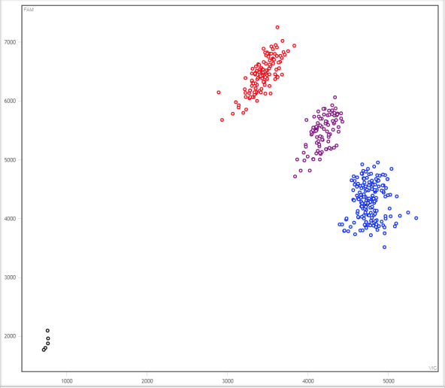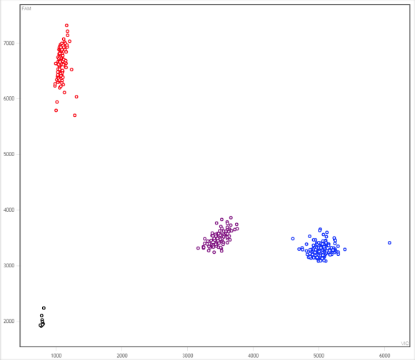
A
B
KASP Marker -28849494 KASP Marker -28934599

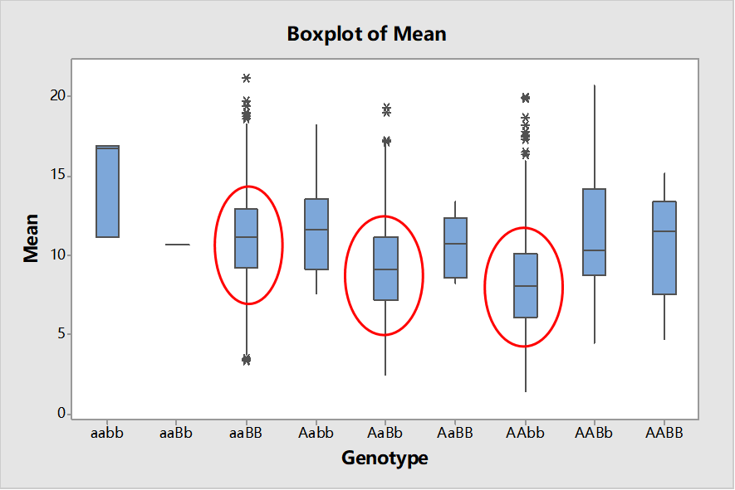
C

Supplementary figure 3 Genotyping plot of KASP preliminary-screen markers (fluorescence scanning) , significant correlation between each genotype and lesion length among 2191 F₃ population individuals.(A)Genotyping plot of KASP preliminary-screen markers 28849494 in 2191 population individuals.(B)Genotyping plot of KASP preliminary-screen markers 28934599 in 2191 population individuals.
Note:Each dot indicates one individual plant. Red: HNY genotype; Purple: heterozygous genotype; Blue: JG30 genotype. The lower-left corner shows the blank control.(C)significant correlation between each genotype and lesion length among 2191 population individuals.
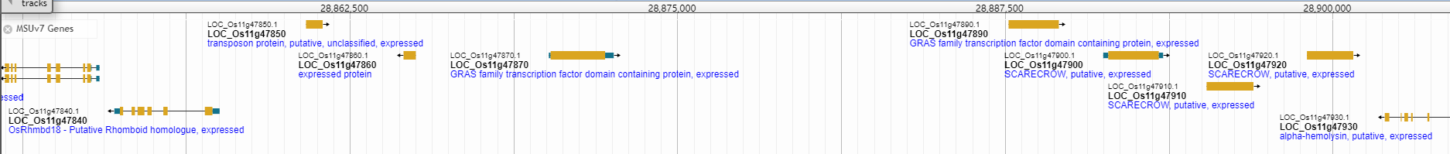
1
2
5
4
3
Supplementary figure 4 The target interval was narrowed to 28863864-28894443bp on Chr. 11 (41.5 kb)

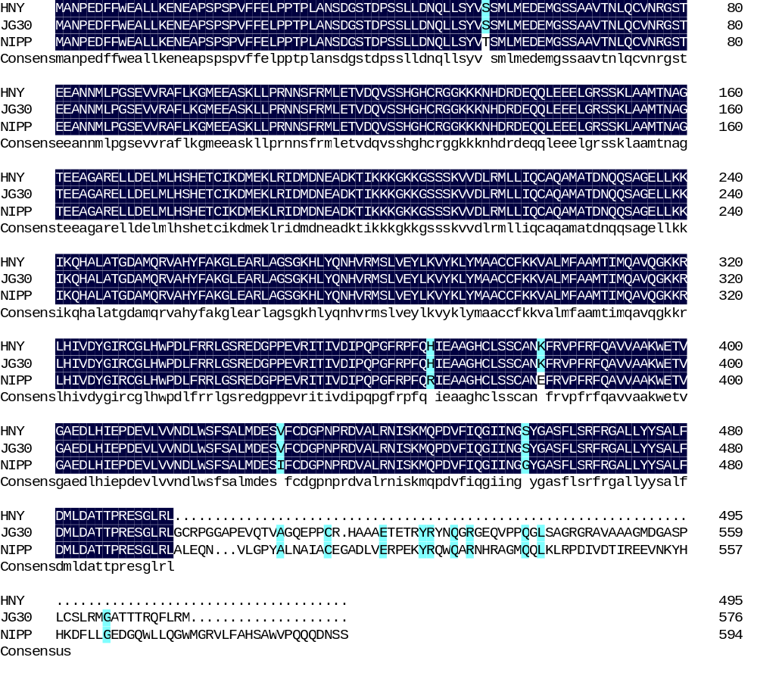
Supplementary figure 5. Sequence differences of candidate gene Xa51(t) in HNY, JG30 and Nipponbare
The sequence in HNY has a terminator at 1485bp compared with JG30. The total length of the nucleotide sequence of G5 gene in HNY is 1488 bp,the length of the translated amino acid sequence is 495 aa, the total length of G5 gene in JG30 is 1738bp, the length of the translated amino acid sequence is 576aa, the amino acid sequence encoded by G5 (in HNY) is amino acids less than that encoded by G5 (in JG30), and the missing amino acids were GCRPGGAPEVQTVAGQEPPCRHAAAETETRYRYN
QGRGEQVPPQGLSAGRGRAVAAAGMDGASPLCSLRMGATTTRQFLRM. Through SMART software analysis, it was found that these base mutations and deletions encoded by G5 (in HNY) led to changes in the protein functional domain.

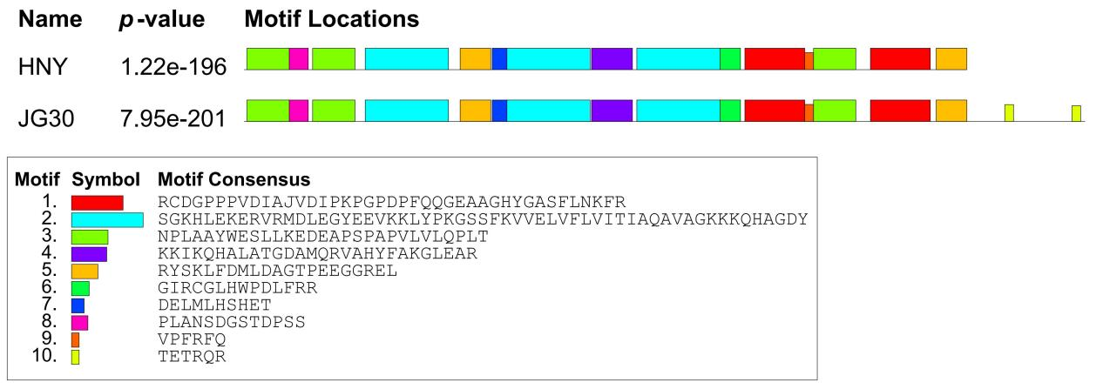
Supplementary figure 6. Motif prediction and analysis of the Xa51(t) in HNY and JG30

