Uncropped gels for Western Blots in Figure 4
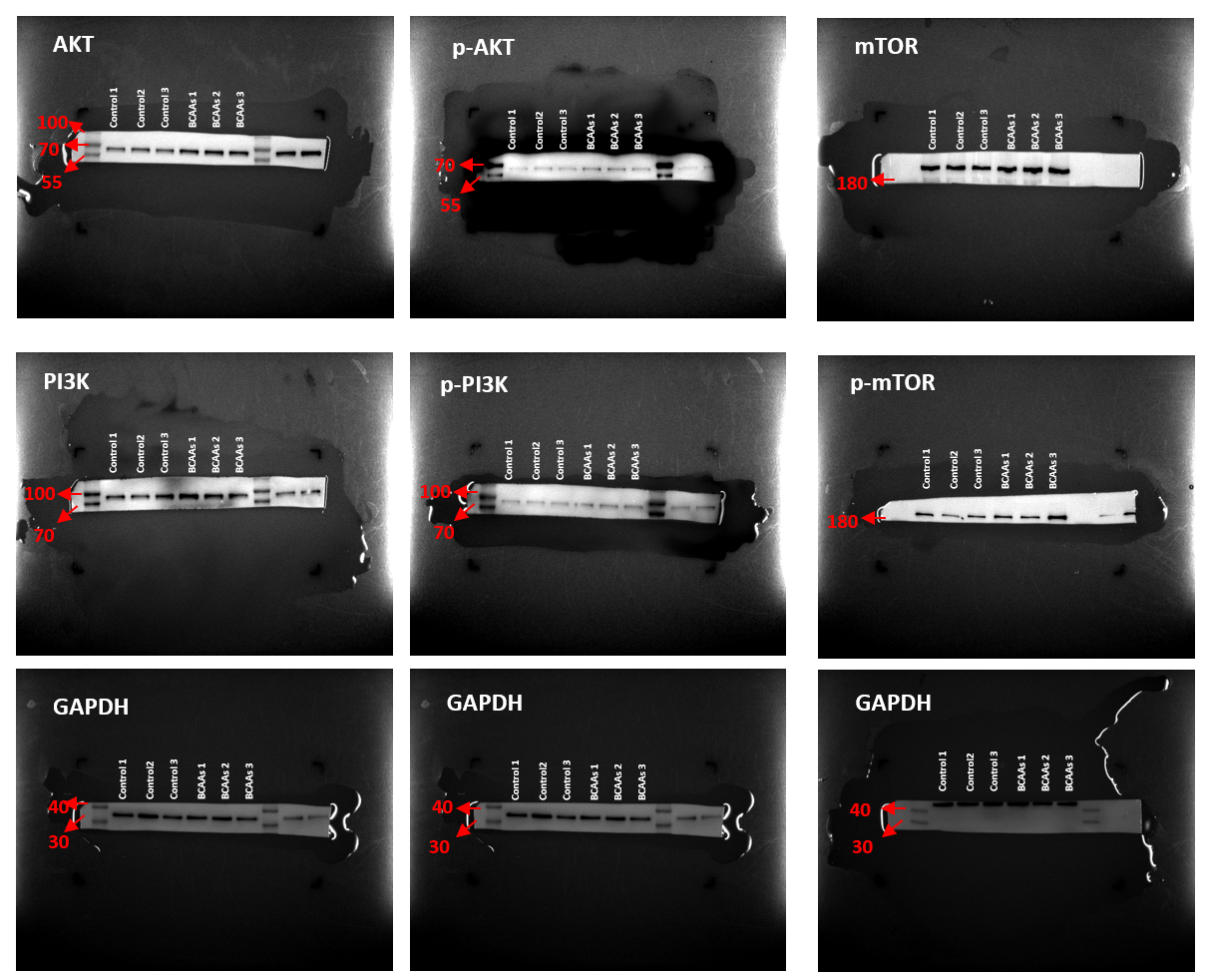

Uncropped gels for Western Blots in Figure 5
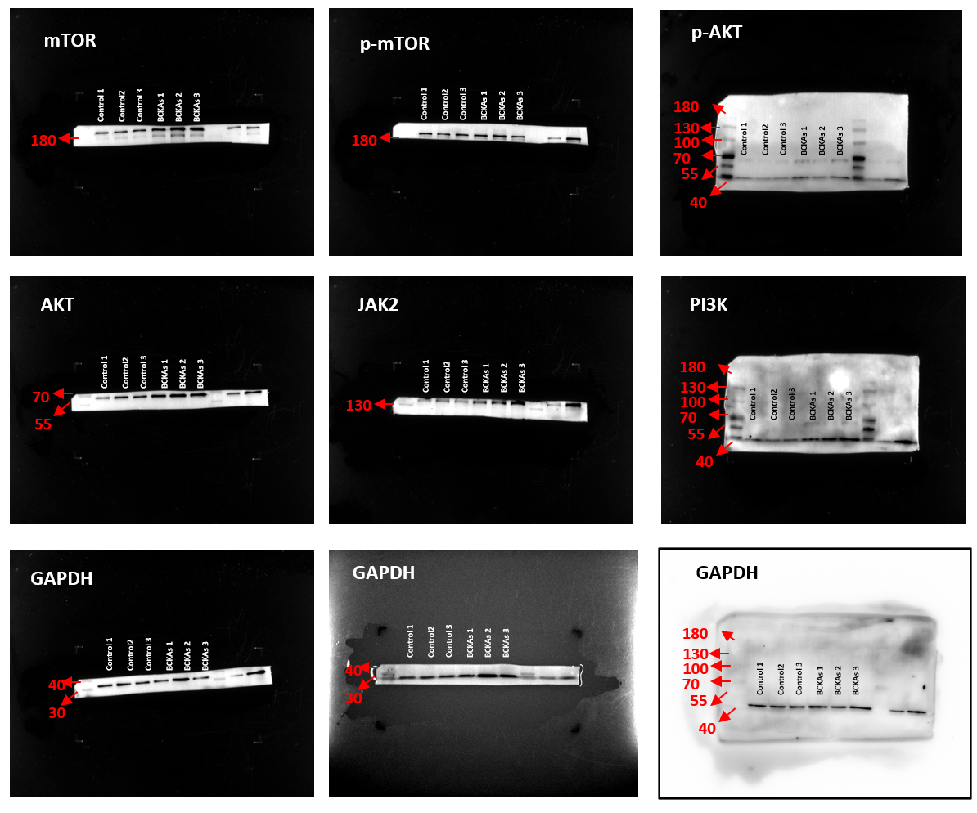

Uncropped gels for Western Blots in Figure 6
