Theoretical and experimental study of new dihydroorotate dehydrogenase and tryparedoxin peroxidase inhibitors: one more step in the study of leishmaniasis infection

Roger Espinosa-Saez¹, Sara M. Robledo², Tatiana Pineda², Javier Murillo², Gilmar Santafé Patiño³, César Zúñiga⁴, Osvaldo Yañez ^{5,6,7,}, Plinio Cantero-López^{8,9*}, and Camilo Guzmán-Teran^{1*}
¹ IDEFARMA, Facultad de Ciencias de la Salud, Universidad de Córdoba, Montería, Colombia.
² PECET-Facultad de Medicina, Universidad de Antioquia, Medellín, Colombia
³ Química de los Productos Naturales, Departamento de Química, Universidad de Córdoba, Montería, Colombia.
⁴ Instituto de Ciencias Naturales, Facultad de Medicina Veterinaria y Agronomía, Universidad de Las Américas, Sede Providencia, Santiago, Chile.
⁵ Computational and Theoretical Chemistry Group, Departamento de Ciencias Químicas, Facultad de Ciencias Exactas, Universidad Andrés Bello, Santiago, Chile
⁶ Center of New Drugs for Hypertension (CENDHY), Santiago, Chile.
⁷ Department of Pharmaceutical Science and Technology, School of Chemical and Pharmaceutical Sciences, Universidad de Chile, Santiago, Chile.
⁸ Center of Applied Nanoscience (CANS), Facultad de Ciencias Exactas, Universidad Andres Bello, Santiago, Chile;
⁹ Relativistic Molecular Physics Group (ReMoPh), PhD program in Molecular Physical Chemistry, Facultad de Ciencias Exactas, Universidad Andres Bello, Santiago, Chile.

* Correspondence: cantonioguzman@correo.unicordoba.edu.co; pliniocantero@gmail.com

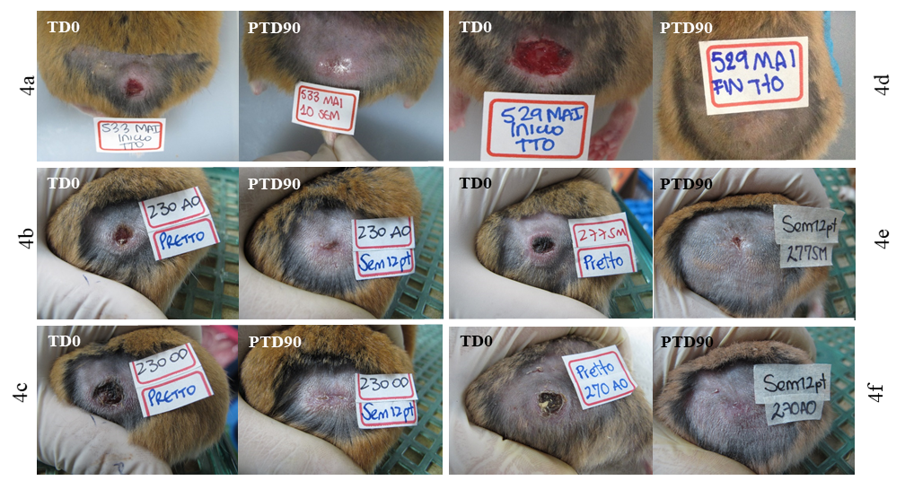
Figure S1. Treatment progress of cutaneous leishmaniasis (CL) caused by L. panamensis in hamsters treated with compounds 4a–f, before treatment (TD0) and on day 90 after the end of treatment (PTD90). Observe the decrease in the size of the lesion at three months after treatment, with respect to that at the beginning of the treatment

Figure S2. Changes in the weight of hamsters infected with L. (V) panamensis after treatment with 1% 4a–f cream formulation. The x-axis corresponds to the time points of study, while the y-axis shows the weight average of hamsters from before treatment until the end of the study. Data represent median of weight ± standard deviation. TD0: before treatment; TD20: last day of treatment; PTD30: day 30 after the end of treatment; PTD60: day 60 after treatment ended; PTD90: day 90 after the end of treatment.

Table S1. Molecular docking results for 4a–f in the LmDHODH. The interacting residues within a radius of 3Å and the most relevant hydrogen bonds in the complexes are shown.
LmDHODH
Compound | H-bonds interaction | Residue interaction
4a | - | asn128, asn54, asn68, gly101, gly71, leu102, leu72, met70, ser100, ser103, ser130, ser69, val140
4b | - | asn128, asn195, asn68, gly101, gly71, leu102, leu129, leu72, lys44, met70, ser100, ser130, ser196, val140
4c | asn68 | asn128, asn195, asn68, gln139, gly101, gly220, leu102, leu72, lys44, met70, ser100, ser130, ser196, val140
4d | asn68 | asn128, asn68, gln139, gly101, gly220, leu102, leu129, leu72, lys44, met70, ser100, ser130, ser196, ser69, val140
4e | fmn | asn107, asn128, asn68, gln139, gly101, gly220, leu102, leu129, leu72, ser100, ser130, ser196, val140, fmn
4f | - | asn107, asn128, asn195, asn68, cys150, gly101, gly220, gly71, leu102, leu129, leu72, lys44, met70, ser100, ser103, ser130, ser196, ser69, val140

Table S2. Molecular docking results for 4a–f in the LmTXNPx. The interacting residues within a radius of 3Å and the most relevant hydrogen bonds in the complexes are shown.
LmTXNPx
Compound | H-bonds interaction | Residue interaction
4a | val172, leu46, met147, phe50 | arg128, arg140, cys52, glu167, leu46, met147, phe50, pro148, pro186, pro45, thr49, val166, val172, val51
4b | val172, leu46, met147, phe50 | arg128, arg140, cys52, leu46, met147, phe50, pro148, pro186, pro45, thr49, val166, val172, val51
4c | pro148, thr49 | arg128, arg140, asn9, asp146, leu46, met147, phe50, pro148, pro45, thr49, tyr127, val125, val166, val172, val51
4d | val172 | arg128, asn9, asp146, cys52, leu46, met147, phe50, pro148, pro186, pro45, thr49, val172, val51
4e | pro148, val125, phe50, met147 | arg128, cys52, glu171, gly170, leu46, met147, phe50, pro148, pro186, pro45, thr49, val125, val166, val172, val51
4f | met147, phe50 | arg128, asn9, cys52, gln123, glu120, leu46, met147, phe50, pro148, pro186, pro45, ser122, thr49, val125, val172, val51

Figure S3. Docking analysis for ligands (A–F) 4a–4f bound to LmDHODH. The surrounding amino acid residues in the binding pocket of LmDHODH within 3Å.

Figure S4. Analysis of six physicochemical properties (lipophilicity, size, polarity, solubility, flexibility, and saturation) using bioavailability radar plot representations. The shaded area represents the range of properties to be considered drug-like. The black line represents the properties of the test molecules.
Figure S5. Predictive human intestinal absorption (HIA) model and blood–brain barrier permeation (BBB) method (boiled-egg plot) of the six considered compounds (4a–f).

Figure S6. Last snapshot (taken at 70 ns) of molecular dynamics simulations of LmDHODH in complex with FMN molecule and compounds 4a–f at BP1 site. LmDHODH is represented in white, FMN is coloured cyan, and 4a–f are coloured grey.

Figure S7. Distance (as a function of simulation time) between the centre of mass of the LmDHODH protein and centre of mass compounds 4a–f. BP1 and BP2 correspond to LmDHODH binding sites one and two, respectively.

Figure S8. Percentage rate of interaction between LmDHODH residues and compounds 4a–f.

