Supplementary Data

Section 1
The nucleotide sequences of the antibody heavy and light chain genes obtained in this study are included in the Supplementary Information files accompanying this article

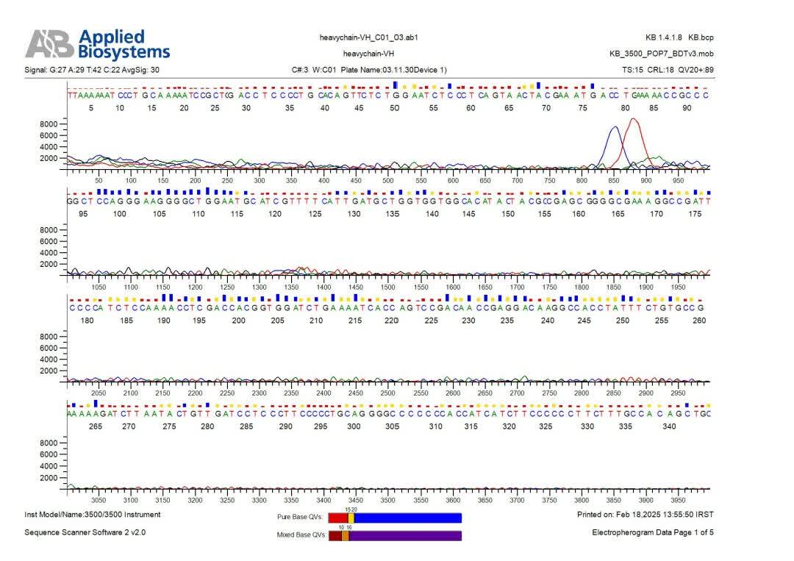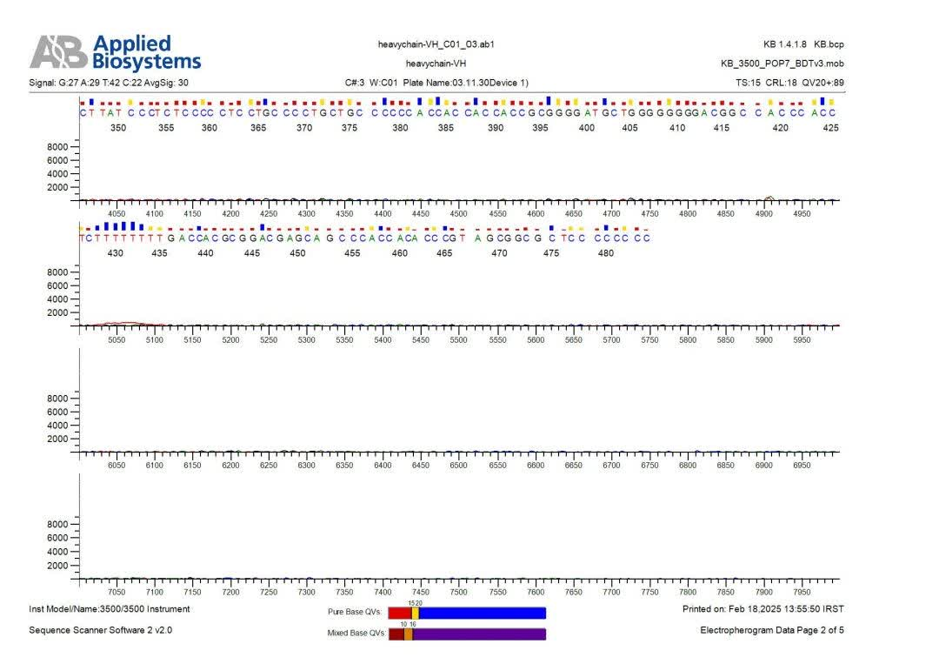
Figure S1: The sequence for the Fab heavy chain (Fd fragment) with forward primer

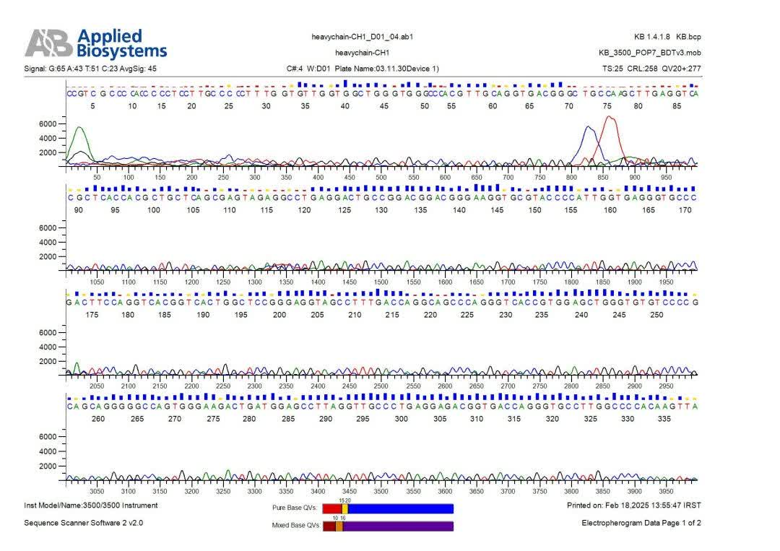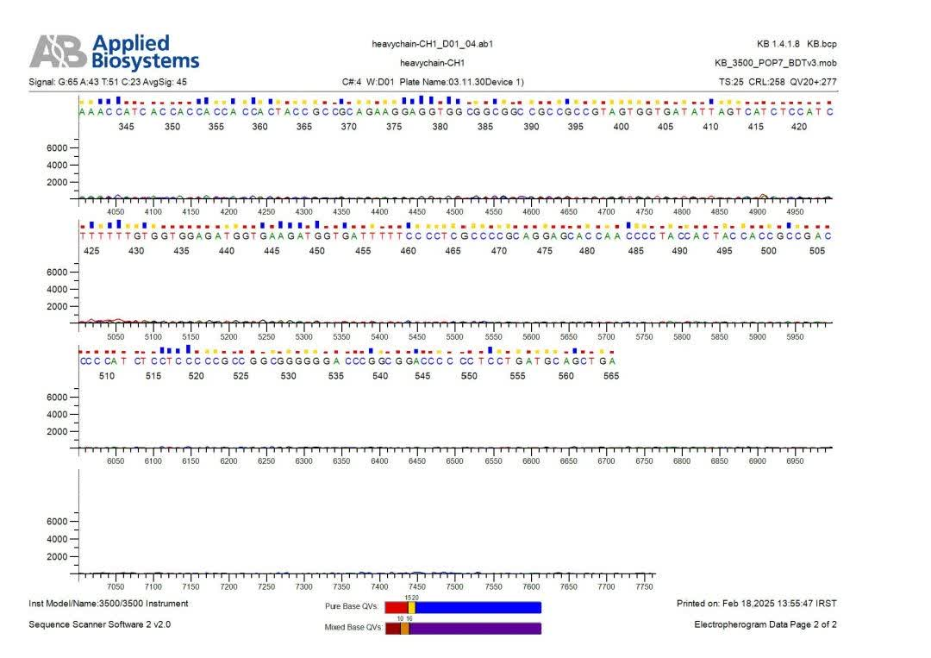
Figure S2: The sequence for the Fab heavy chain (Fd fragment) with reverse primer

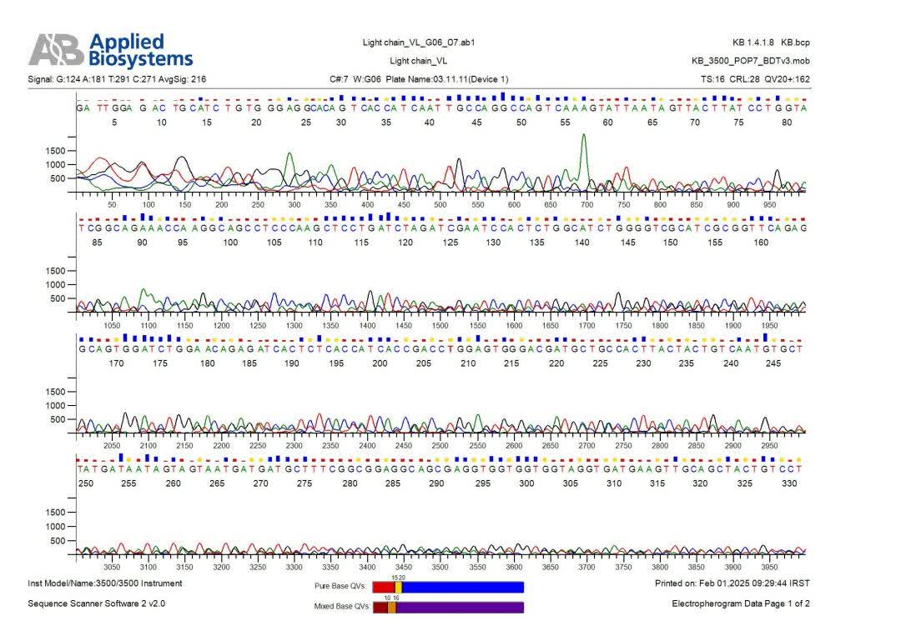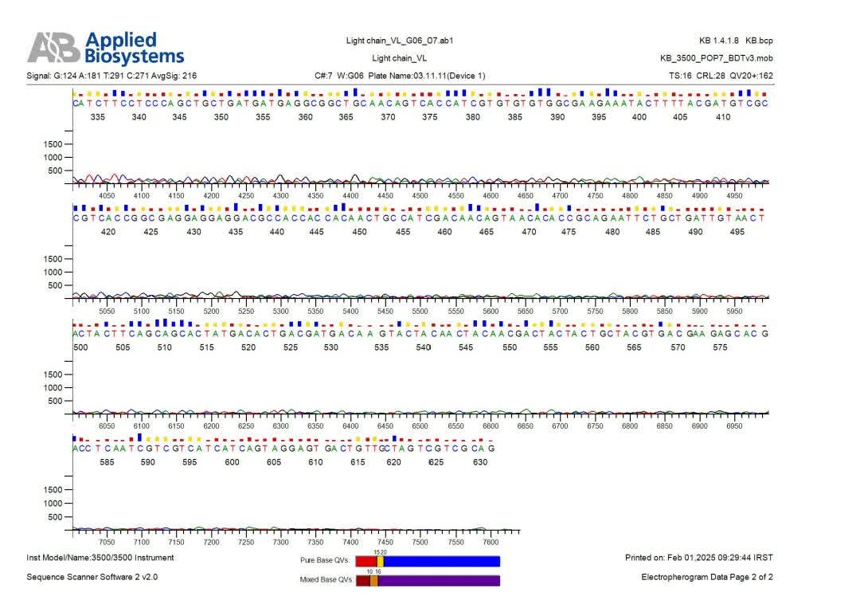
Figure S3: The sequence for the Fab light chain with forward primer

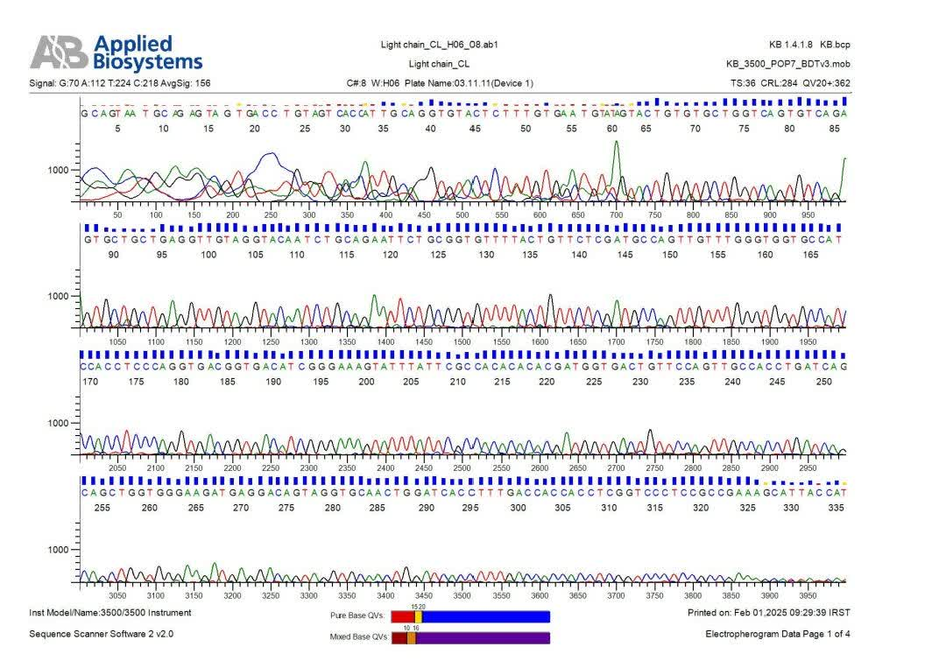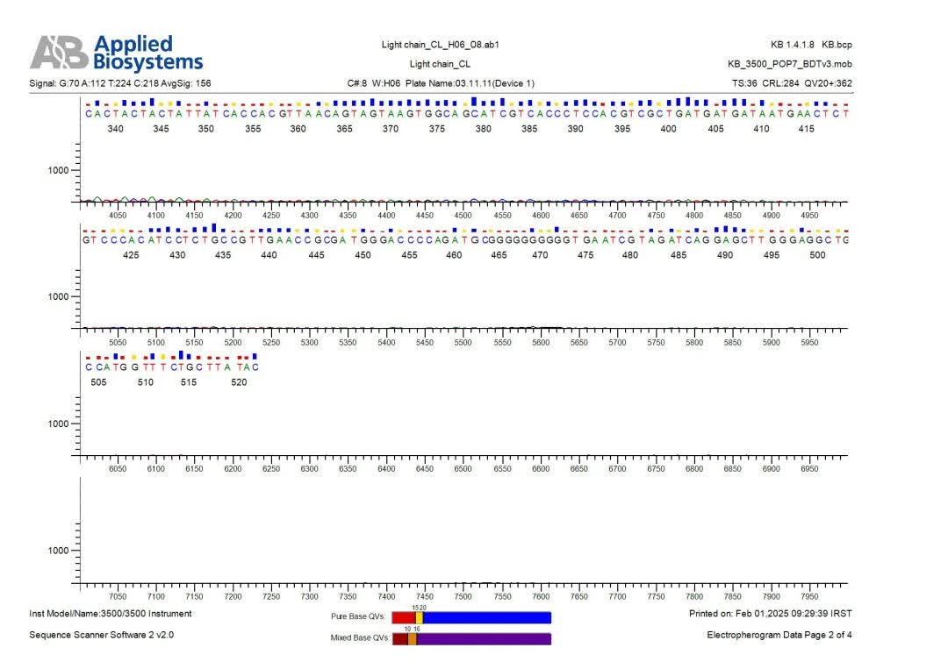
Figure S4: The sequence for the Fab light chain with reverse primer

Section 2
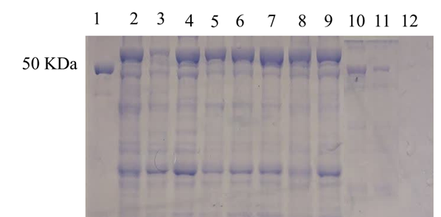
Figure S5: Effect of temperature on Fab expression. SDS-PAGE analysis of Fab expression at 20 °C, 28 °C, and 37 °C. Optimal expression was observed at 28°C temperatures. Lane 1: protein with a molecular weight of 50 KDa, lane 11: 20°C, lane 10: 28°C, lane 12: 37°C

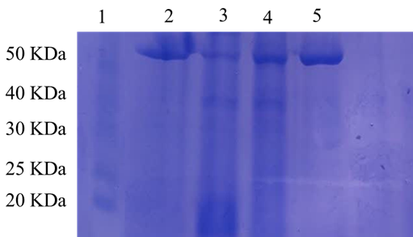

Figure S6: Effect of incubation time on Fab expression in Rosetta-Gami 2 strain. SDS-PAGE showing Fab expression after 4 h, 8 h, and 16 h induction. Protein yield increased with prolonged incubation. Lane 1: ladder marker, lane 3: 4 h, lane 4: 8 h, lane 5: 16 h.

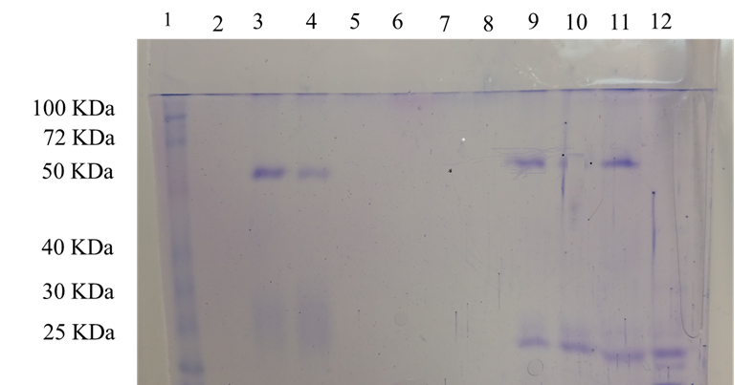

Figure S7: Expression of Fab in different E. coli strains. SDS-PAGE comparing expression in Top10, HB2151, and Rosetta-gami 2. Only Rosetta-gami 2 produced intact Fab with disulfide bond formation. Lane 1: ladder marker, lane 10: Top10, lane 12: HB2151, lane 3: Rosetta-Gami 2.

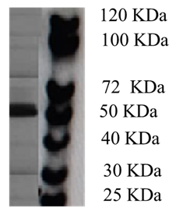
Figure S8: The complete Western blot image.

Section 3
Clinical Results
Dairy Cow Validation
The diagnostic performance of the Fab anti-PIF assay was further evaluated in dairy cows. Serum samples were collected at 10–15 days, 16–20 days, and 30 days post-insemination, with non-inseminated cows (n=75) serving as negative controls. Pregnancy status was confirmed by ultrasonography on day 30. The Fab-based ELISA detected pregnancy with >98% accuracy as early as 10–15 days post-insemination, and results showed 100% agreement with ultrasonography at day 30. Only a few early positive samples (2 at 10–15 days, 1 at 16–20 days) were later confirmed non-pregnant, likely due to early embryonic loss.
Time Post-Insemination | Sensitivity (%) | Specificity (%) | Accuracy (%)
10-15 days | 100 | 97.5 | 98.5
16-20 days | 100 | 98.6 | 99.2
30 days | 100 | 100 | 100

Summary
The Fab anti-PIF–based competitive ELISA demonstrated high sensitivity and specificity for detecting early pregnancy in livestock. In dairy cows, detection was possible 10–20 days after insemination with almost perfect accuracy. These results highlight the assay’s potential as a universal, non-invasive, and early diagnostic tool for pregnancy detection across species.

