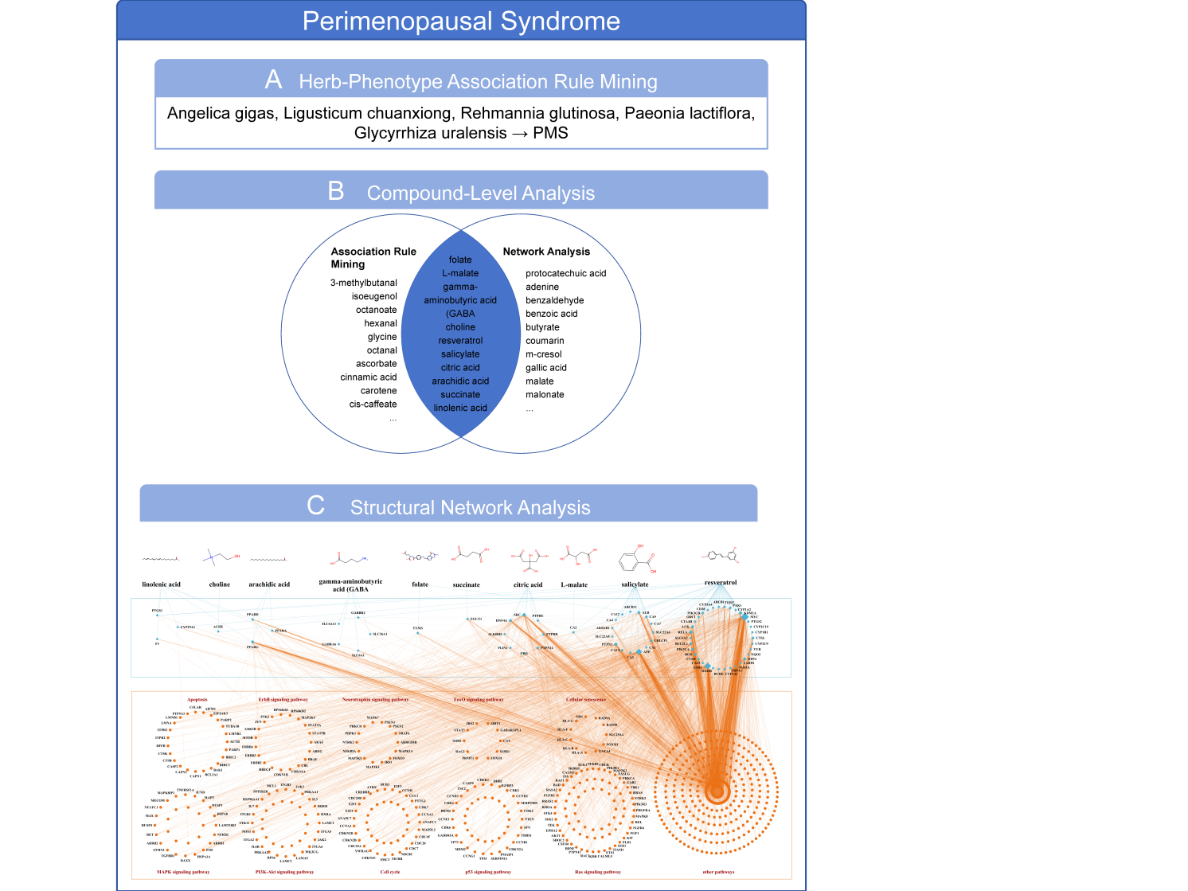
Fig S1 Results of PMS herbal combination and compound-level analysis. A Herbal-level analysis extracted the herbal combination. B Compound-phenotype association network analysis (ARM) and compound-phenotype network analysis extracted 10 common compounds. C Structural network analysis: Nodes were divided into compound targets (upper layer) and phenotype-related genes (lower layer). Compound targets were represented by diamond-shaped nodes, and phenotype-related genes were represented by circular nodes. The lines between the upper and lower boxes represent the interactions between compound targets and phenotype-related genes. Phenotype-related genes were classified into more than ten categories according to the biological pathways they belong to.
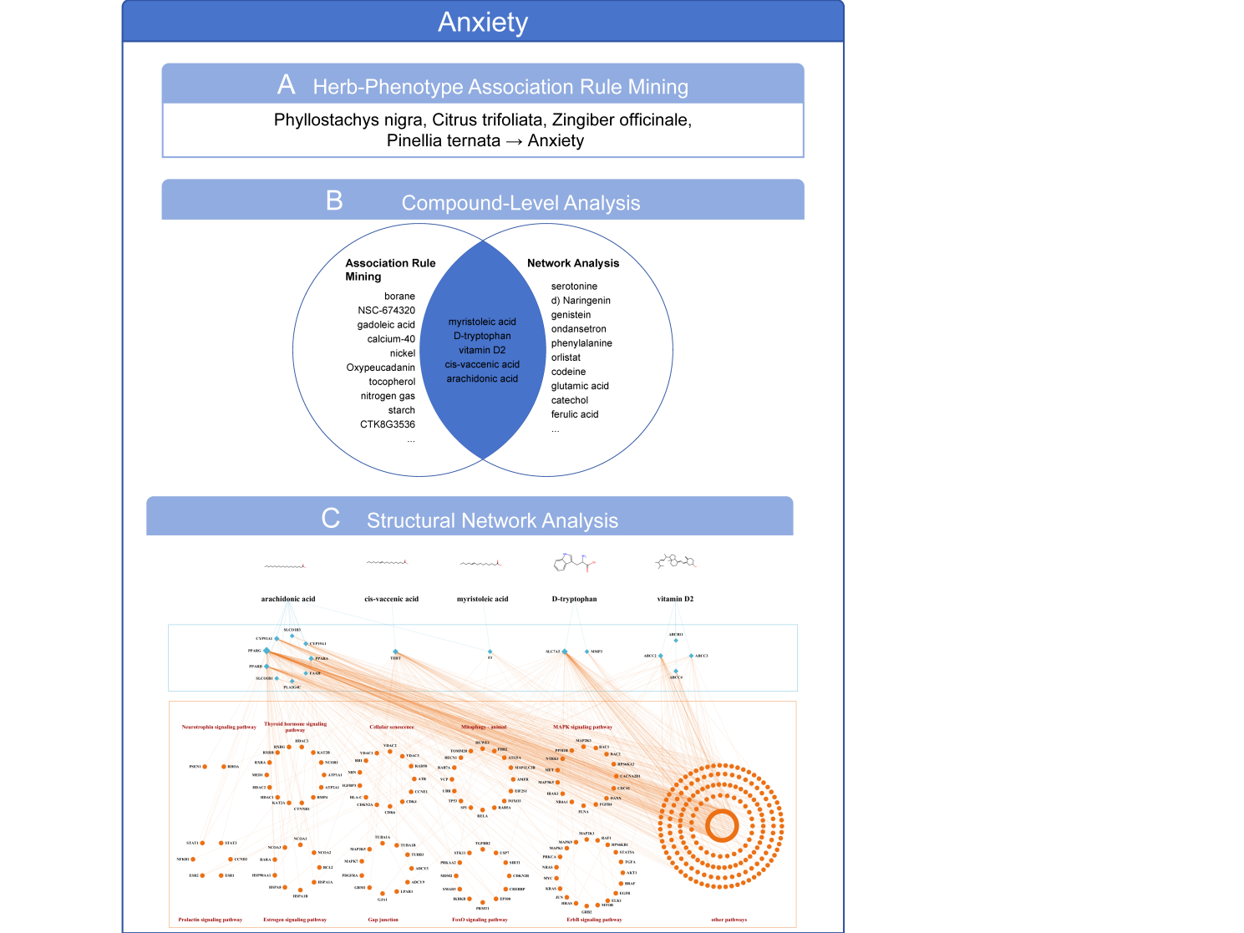
Figure S2 Results of the analysis of the Anxiety herbal combination and compounds. A Herbal level analysis extracted the herbal combination. B Compound-phenotype association network analysis (ARM) and compound-phenotype network analysis identified five common compounds. C Structural network analysis: Nodes were divided into compound targets (upper layer) and phenotype-related genes (lower layer). Compound targets were represented by diamond-shaped nodes, and phenotype-related genes were represented by circular nodes. The lines between the upper and lower boxes represent the interactions between compound targets and phenotype-related genes. Phenotype-related genes were classified into more than ten categories according to the biological pathways they belong to.
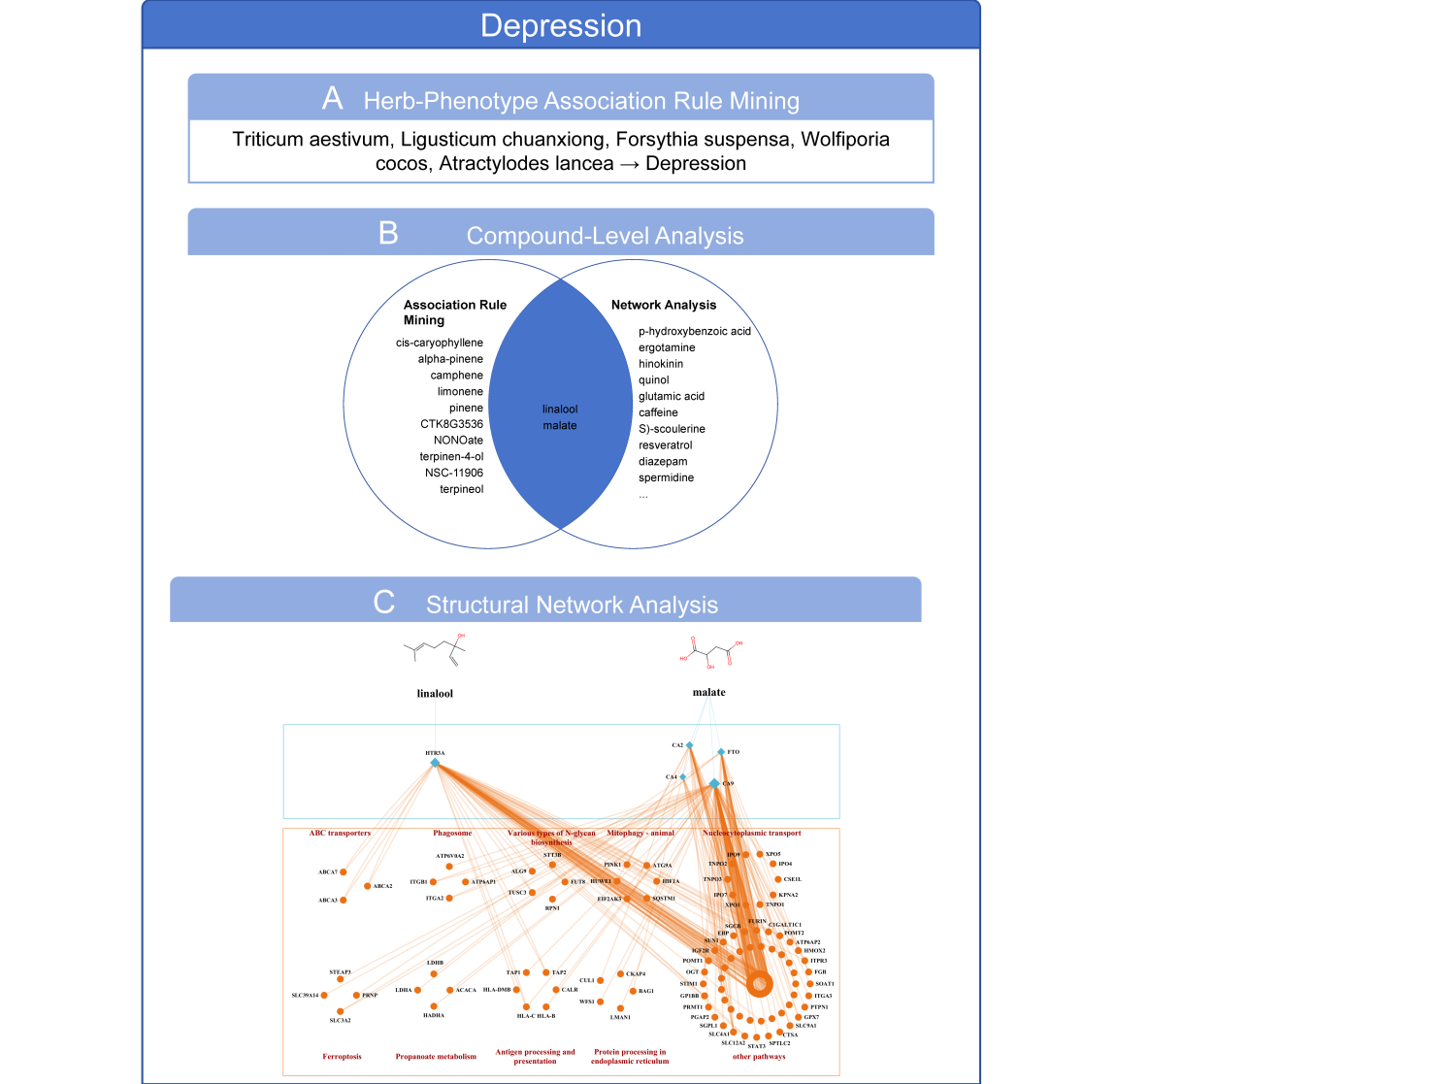
Fig S3 Results of depression herbal combination and compound-level analysis. A Herbal-level analysis extracted the herbal combination. B Compound-phenotype association network analysis (ARM) and compound-phenotype network analysis identified two common compounds. C Structural network analysis: Nodes were divided into compound targets (upper layer) and phenotype-related genes (lower layer). Compound targets were represented by diamond-shaped nodes, and phenotype-related genes were represented by circular nodes. The lines between the upper and lower boxes represent the interactions between compound targets and phenotype-related genes. Phenotype-related genes were classified into more than ten categories based on their biological pathways.
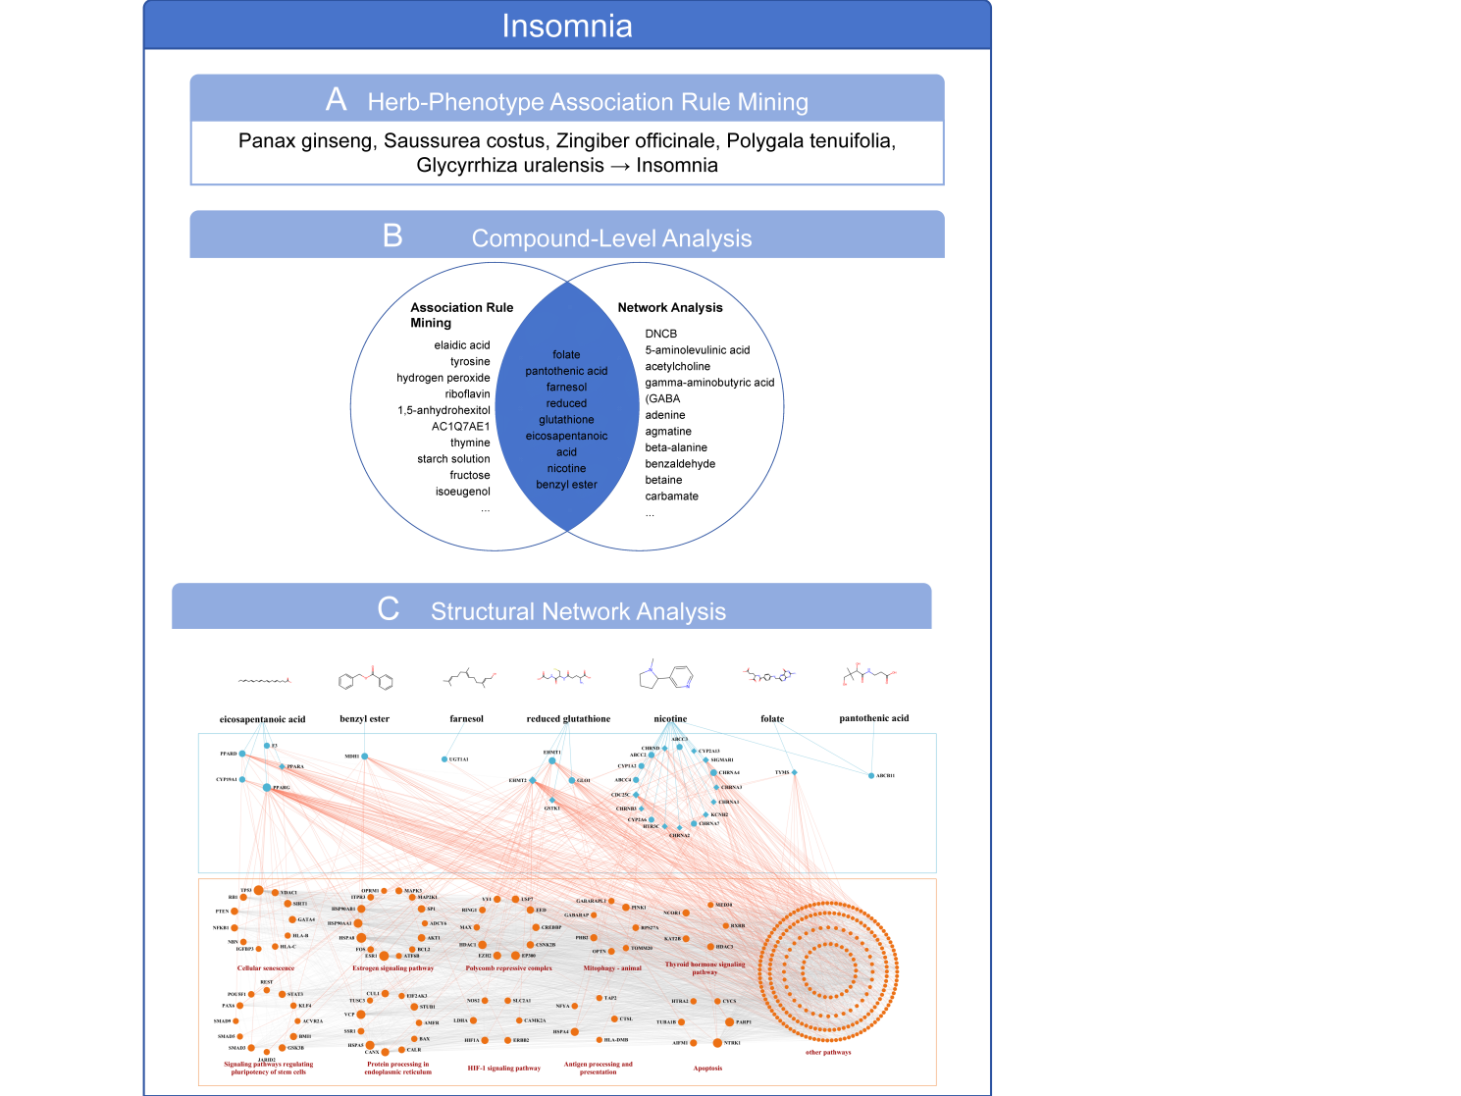
Fig S4 Results of insomnia herbal combination and compound level analysis. A Herbal level analysis extracted the herbal combination. B Compound-phenotype association network analysis (ARM) and compound-phenotype network analysis extracted 7 common compounds from both. C Structural network analysis: Nodes were divided into compound targets (upper layer) and phenotype-related genes (lower layer). Compound targets were represented by rhombus nodes, and phenotype-related genes were represented by circular nodes. The connections between the upper and lower boxes represent the interactions between compound targets and phenotype-related genes. Phenotype-related genes were classified into more than ten categories based on the biological pathways they belonged to.
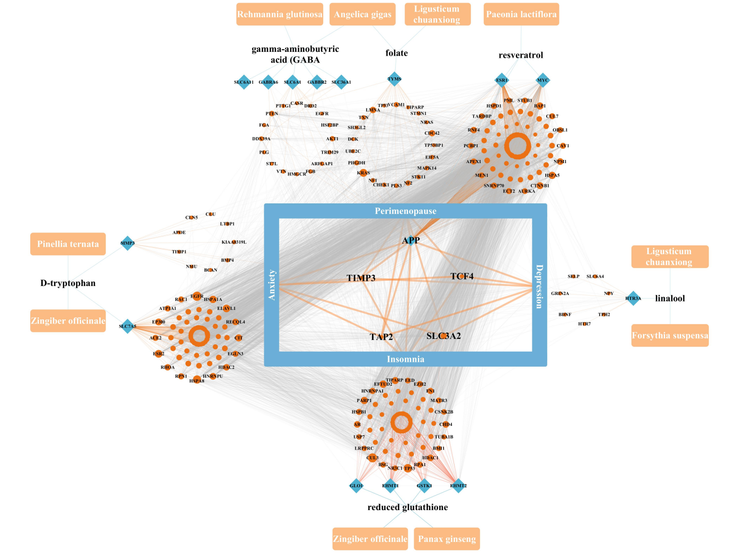
Fig S5 Herbal Medicine - Core Compounds - Disease Core Genes. The outer orange-background white-letter rectangle represents traditional Chinese medicine, the ones connected to it are compounds, the blue rhombus represents drug targets, the orange circle represents disease targets, the blue-background white-letter rectangle represents diseases, and the innermost circle shows the 4 common disease targets shared by all diseases (APP is also a drug target).
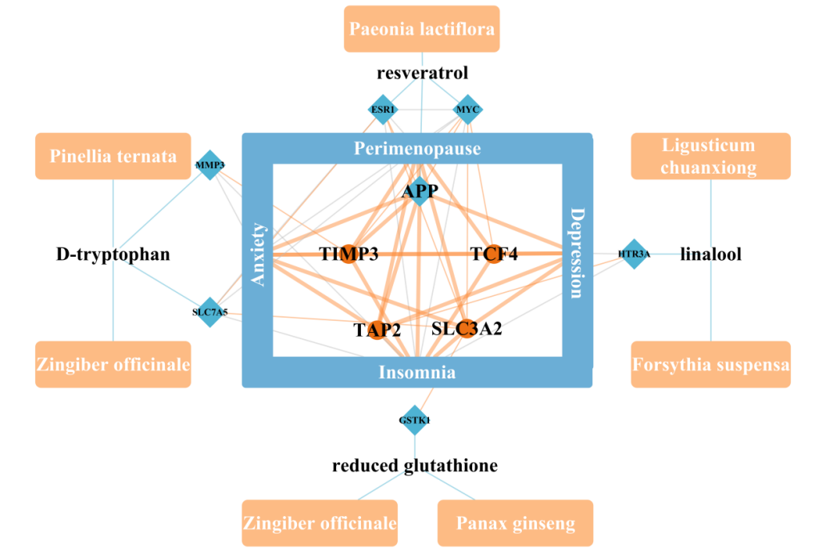
Fig S6 Herbal medicine - Core compounds - Disease core disease target genes. The outer circle with orange background and white text is for traditional Chinese medicine, the part connected to traditional Chinese medicine is for compounds, the blue rhombus is for drug targets, the orange circle is for disease targets, the blue background with white text rectangle is for diseases, and the innermost circle shows the 4 common disease targets shared by all diseases (APP is also a drug target).
Tab S1 Molecular Docking Binding Energy
compound | gene | Energy(kcal/mol) | Cavities_volume
folate | TYMS | -9.1 | 1019
resveratrol | ESR1 | -7.8 | 543
D-tryptophan | MMP3 | -7.7 | 1197
reduced_glutathione | EHMT2 | -6.8 | 2664
linalool | HTR3A | -6.1 | 633
gamma-aminobutyric_acid_(GABA | SLC6A11 | -4.3 | 3104

