SUPPLEMENTARY INFORMATION
Targeting the Stress-Driven Loop in Glioma with Exosomes Co-loaded with BDNF Antibody and Propranolol
Supplementary Figures
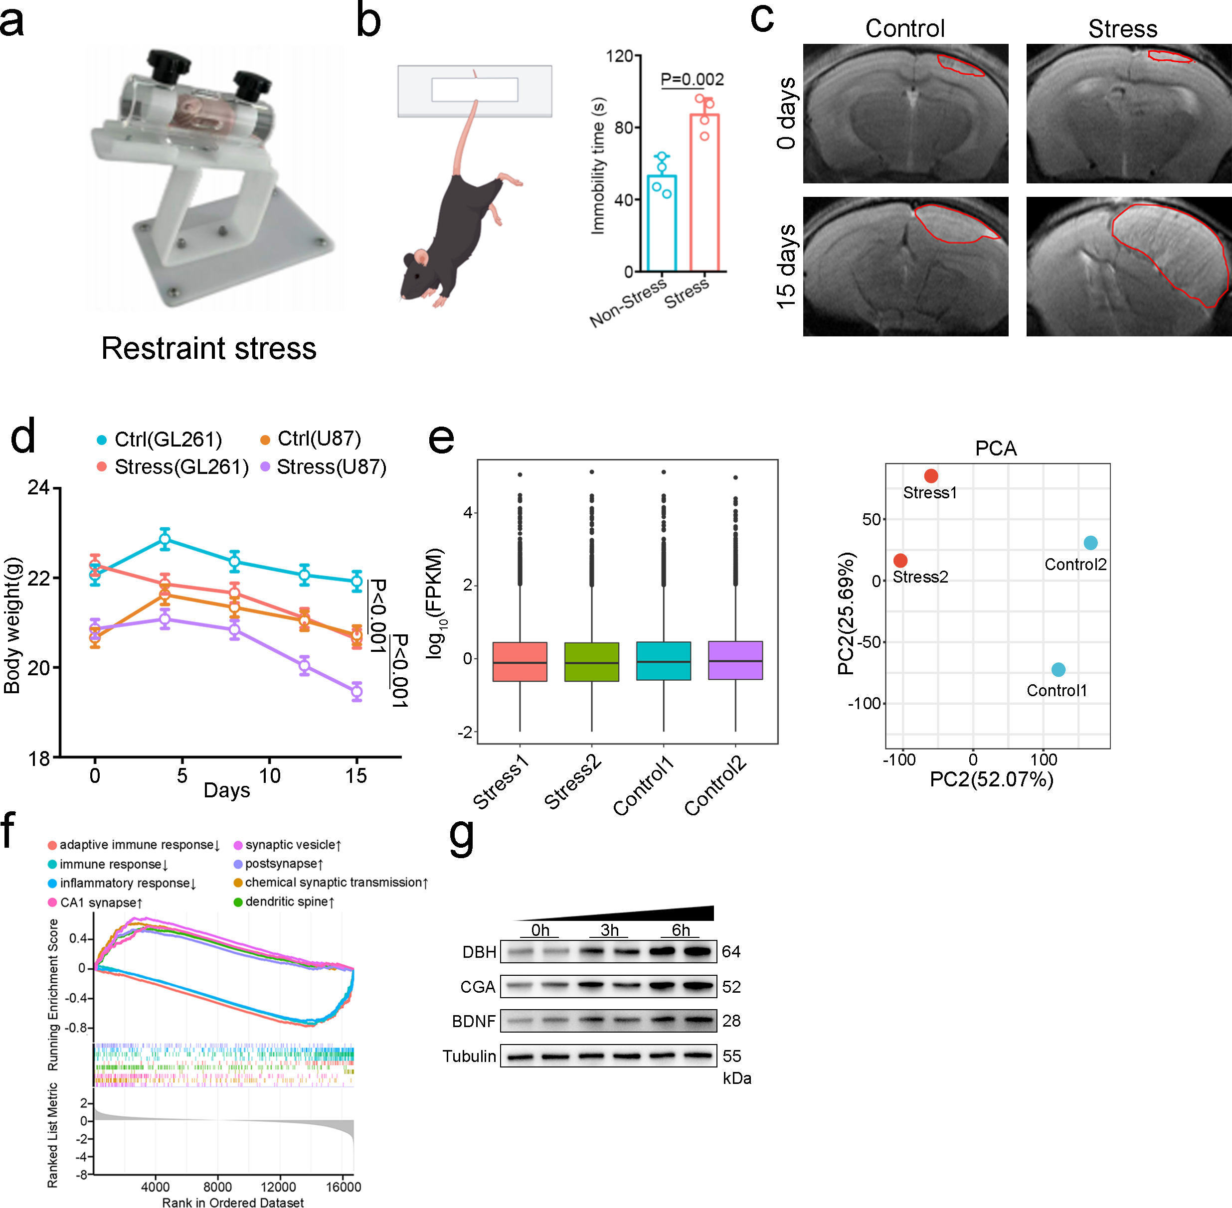
Supplementary Fig. 1. a, Photograph of the customized restraint stress device used for CRS model establishment. b,Tail suspension test confirms depression-like behavior in chronically stressed mice. Representative images of the tail suspension test. Immobility time was significantly prolonged in stressed mice compared to non-stressed controls. c, Representative MRI images of glioma-bearing mouse brains at 0 and 15 days post-inoculation (n=5). Red outlines indicate tumor regions. d, Body weight changes of glioma-bearing mice over 15 days. Chronic stress induced significant body weight loss compared to control, with GL261-bearing mice demonstrating greater vulnerability(n=5). e, Box plot of log₁₀(FPKM) gene expression in control and stressed glioma tissues (n=2 biological replicates per group). PCA plot of glioma transcriptomes. Control (blue) and stress (red) groups are distinctly separated (PC1: 52.07%, PC2: 25.69%), confirming stress-induced transcriptomic changes and good intra-group reproducibility. f, GSEA plot of glioma transcriptomes under chronic stress. Immune pathways are downregulated (negative enrichment), while synaptic/neuronal pathways are upregulated (positive enrichment), confirming stress-induced immune suppression and neuronal activation. g, Western blot analysis of DBH, CGA, and BDNF expression in tumor tissues from U251MG glioma-bearing mice in the Non-stress and Stress groups. Data are mean ± SEM. Statistical significance by unpaired t-test; exact P values shown.

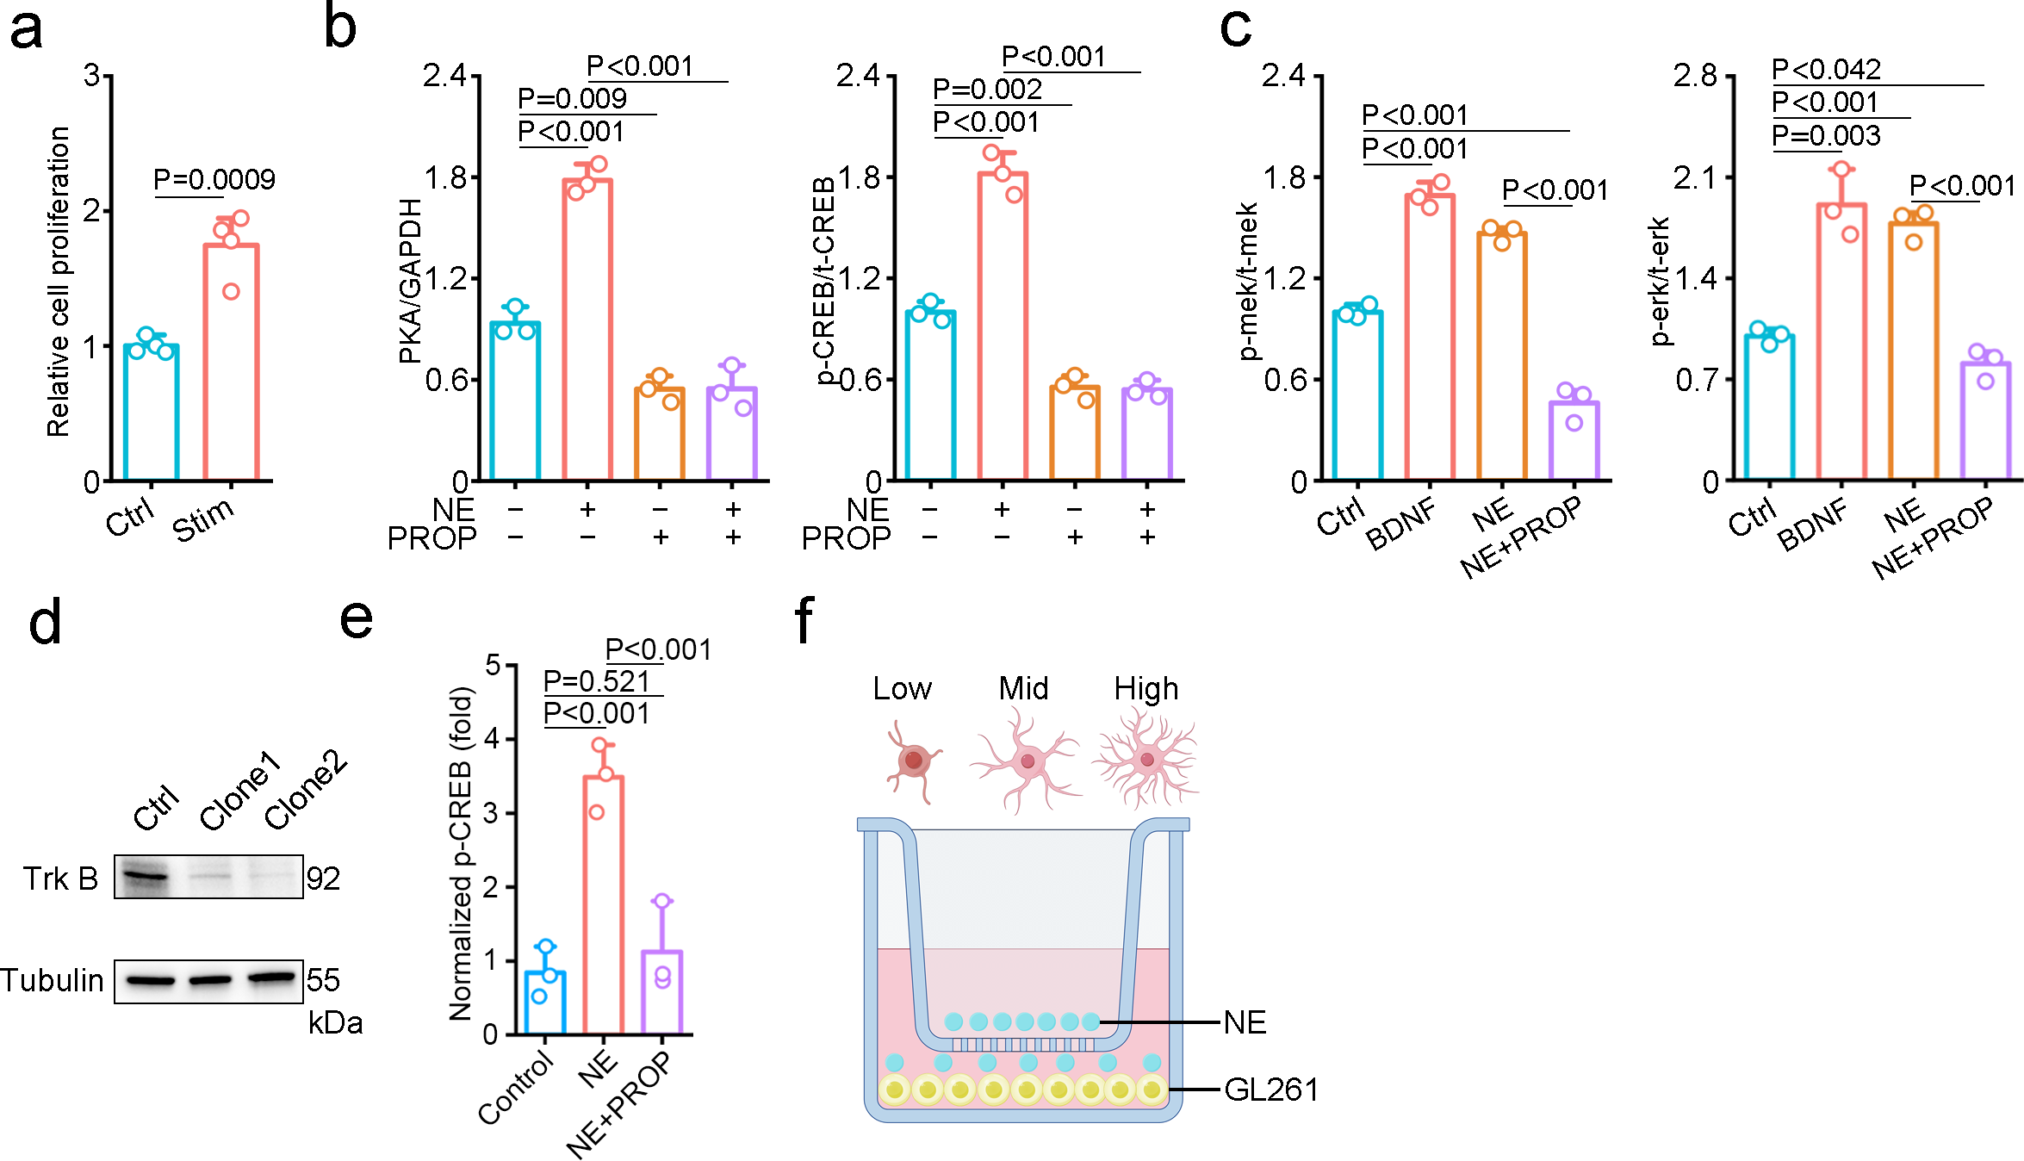
Supplementary Fig. 2. a, Relative glioma cell proliferation under control (Ctrl) and stimulated (Stim) conditions (n=4). b, PKA expression and CREB phosphorylation in astrocytes treated with NE ± PROP. NE activates PKA/CREB signaling via β-adrenergic receptors, and PROP blocks this effect (n=3). c, MEK and ERK phosphorylation in cells treated with Ctrl, BDNF, NE, or NE+PROP. NE activates MEK/ERK via β-adrenergic receptors, and PROP blocks this effect. d, Western blot validation of Trk B knockdown in glioma cells (Ctrl vs. Clone 1/2). Tubulin serves as loading control. Trk B expression is significantly reduced in knockdown clones. e, ChIP-qPCR analysis of p-CREB enrichment at the Bdnf promoter in C8-D1A astrocytes treated with Control, NE, or NE plus PROP for the indicated time. f, Schematic of Transwell co-culture: neurons (Low/Mid/High differentiation) in upper chamber, GL261 glioma cells in lower chamber. Neuronal-secreted NE mediates paracrine signaling to glioma cells. Data are mean ± SEM. Statistical significance by unpaired t-test; exact P values shown.

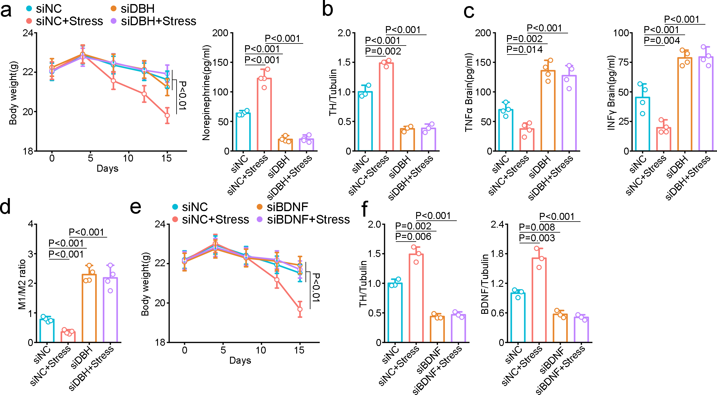
Supplementary Fig. 3. a, Body weight changes (left) and norepinephrine (NE) levels (right) in glioma-bearing mice. DBH knockdown alleviates stress-induced weight loss and blocks stress-induced NE elevation. b, TH protein expression in glioma tissues (siNC/siDBH ± Stress). Stress upregulates TH in siNC mice, and DBH knockdown suppresses TH expression. c, TNFα and IFNγ concentrations in mouse brain tissues. Stress suppresses pro-inflammatory cytokines in siNC mice, and DBH knockdown restores their expression (n=4). d, M1/M2 macrophage ratio in glioma tissues. Stress suppresses the M1/M2 ratio, and DBH knockdown reverses this effect (n=4). e, Body weight changes in glioma-bearing mice (siNC/siBDNF ± Stress). BDNF knockdown alleviates stress-induced body weight loss (n=5). f, TH and BDNF protein expression in glioma tissues. Stress upregulates both factors in siNC mice, and BDNF knockdown suppresses their induction(n=3). Data are mean ± SEM. Statistical significance by unpaired t-test; exact P values shown.

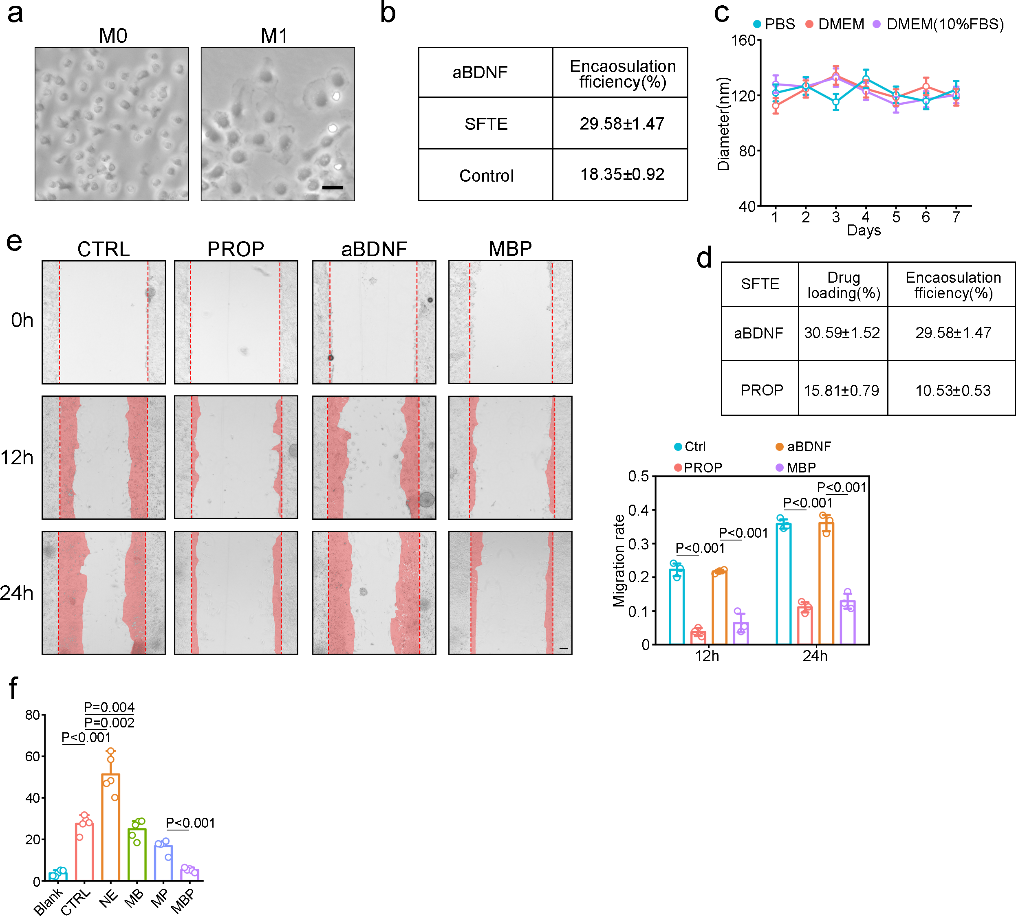
Supplementary Fig. 4. a, Morphological comparison of M0 (unpolarized) and M1 (pro-inflammatory) macrophages. M1 cells display enlarged, amoeboid morphology (scale bar = 5 μm). b, Encapsulation efficiency of aBDNF via SFTE vs. control. SFTE significantly enhances encapsulation efficiency. c, Colloidal stability of iRA2-MBP in biological media. Hydrodynamic diameter of iRA2-MBP incubated in PBS, DMEM, and DMEM containing 10% FBS over 7 days, measured by DLS daily. d, Drug loading efficiency and encapsulation efficiency of anti-BDNF antibody (aBDNF) and propranolol (PROP) into nanoparticles/exosomes using the SFTE method. The SFTE method achieves a significantly higher drug loading (30.59±1.52%) and encapsulation efficiency (29.58±1.47%) for aBDNF, compared to 15.81±0.79% (drug loading) and 10.53±0.53% (encapsulation efficiency) for PROP. e, Wound healing assay images (left) and migration rate quantification (right) of cells under CTRL, PROP, aBDNF, and MBP treatments. CTRL/aBDNF significantly promote cell migration compared to PROP/MBP. f, Relative cell activity under Blank, CTRL, NE, MB, MP, and MBP treatments. NE significantly promotes, while MBP suppresses, cell activity. Data are mean ± SEM. Statistical significance by unpaired t-test; exact P values shown.

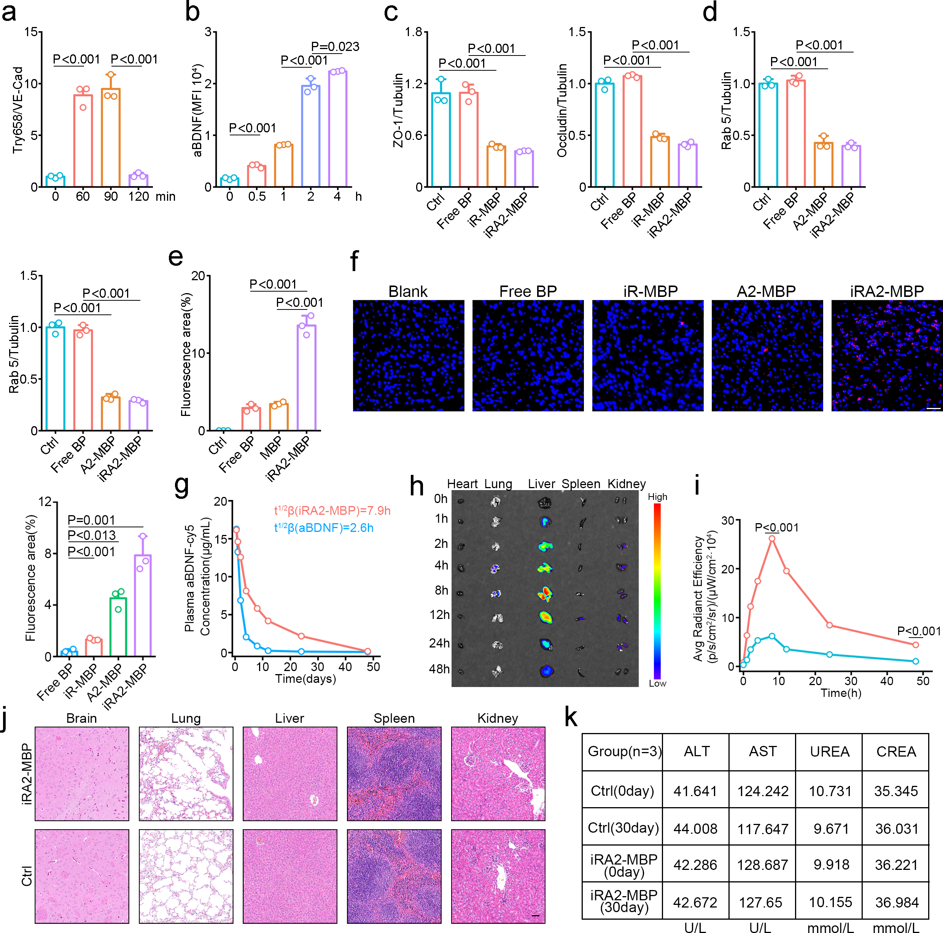Supplementary Fig. 5. a, Quantification of Try658-phosphorylated VE-cadherin levels in cells at 0, 60, 90, and 120 minutes post-treatment. The expression of Try658/VE-Cad is significantly upregulated at 60 and 90 minutes compared to the 0-minute baseline, followed by a marked reduction at 120 minutes (n=3). b, Time-course of aBDNF MFI. aBDNF levels increase significantly over time (n=3). c, ZO-1 and Occludin expression under Ctrl, Free BP, iR-MBP, and iRA2-MBP treatments. Ctrl/Free BP show significantly higher tight junction protein levels than iR-MBP/iRA2-MBP (n=3). d, Rab 7 and Rab5 expression (normalized to Tubulin) under Ctrl, Free BP, A2-MBP, and iRA2-MBP treatments. Ctrl/Free BP show significantly higher Rab 7 and Rab5 levels than A2-MBP/iRA2-MBP (n=3). e, Fluorescence area under Ctrl, Free BP, MBP, and iRA2-MBP treatments. iRA2-MBP shows significantly higher fluorescence area than other groups (n=3).f, Representative fluorescence cryosection images and quantification of brain tumor tissues from GL261 tumor-bearing mice at 12 h after intravenous injection of CY5-labeled formulations(n=3). g, Plasma concentration–time curves of aBDNF following intravenous administration of free aBDNF or iRA2-MBP in GL261 tumor-bearing mice(n=3). k-l, Ex vivo fluorescence imaging of major organs (heart, liver, spleen, lung, kidney) harvested from GL261 tumor-bearing mice at 1, 2, 4, 8, 12, 24, and 48 h after intravenous injection of CY5-labeled iRA2-MBP (n = 3). j, Histopathological evaluation after repeated iRA2-MBP dosing. Representative H&E staining of brain, lung, liver, spleen, and kidney from GL261 tumor-bearing mice on day 30 post-implantation. iRA2-MBP was given on days 5, 8, 12, 16, 20, 24, and 28. Scale bar, 25 μm. k, Serum biochemistry evaluation following repeated iRA2-MBP dosing. Serum ALT, AST, UREA, and CREA levels in GL261 tumor-bearing mice at day 0 and day 30. iRA2-MBP was administered on days 5, 8, 12, 16, 20, 24, and 28 post-implantation. Data are mean ± SEM. Statistical significance by unpaired t-test; exact P values shown.

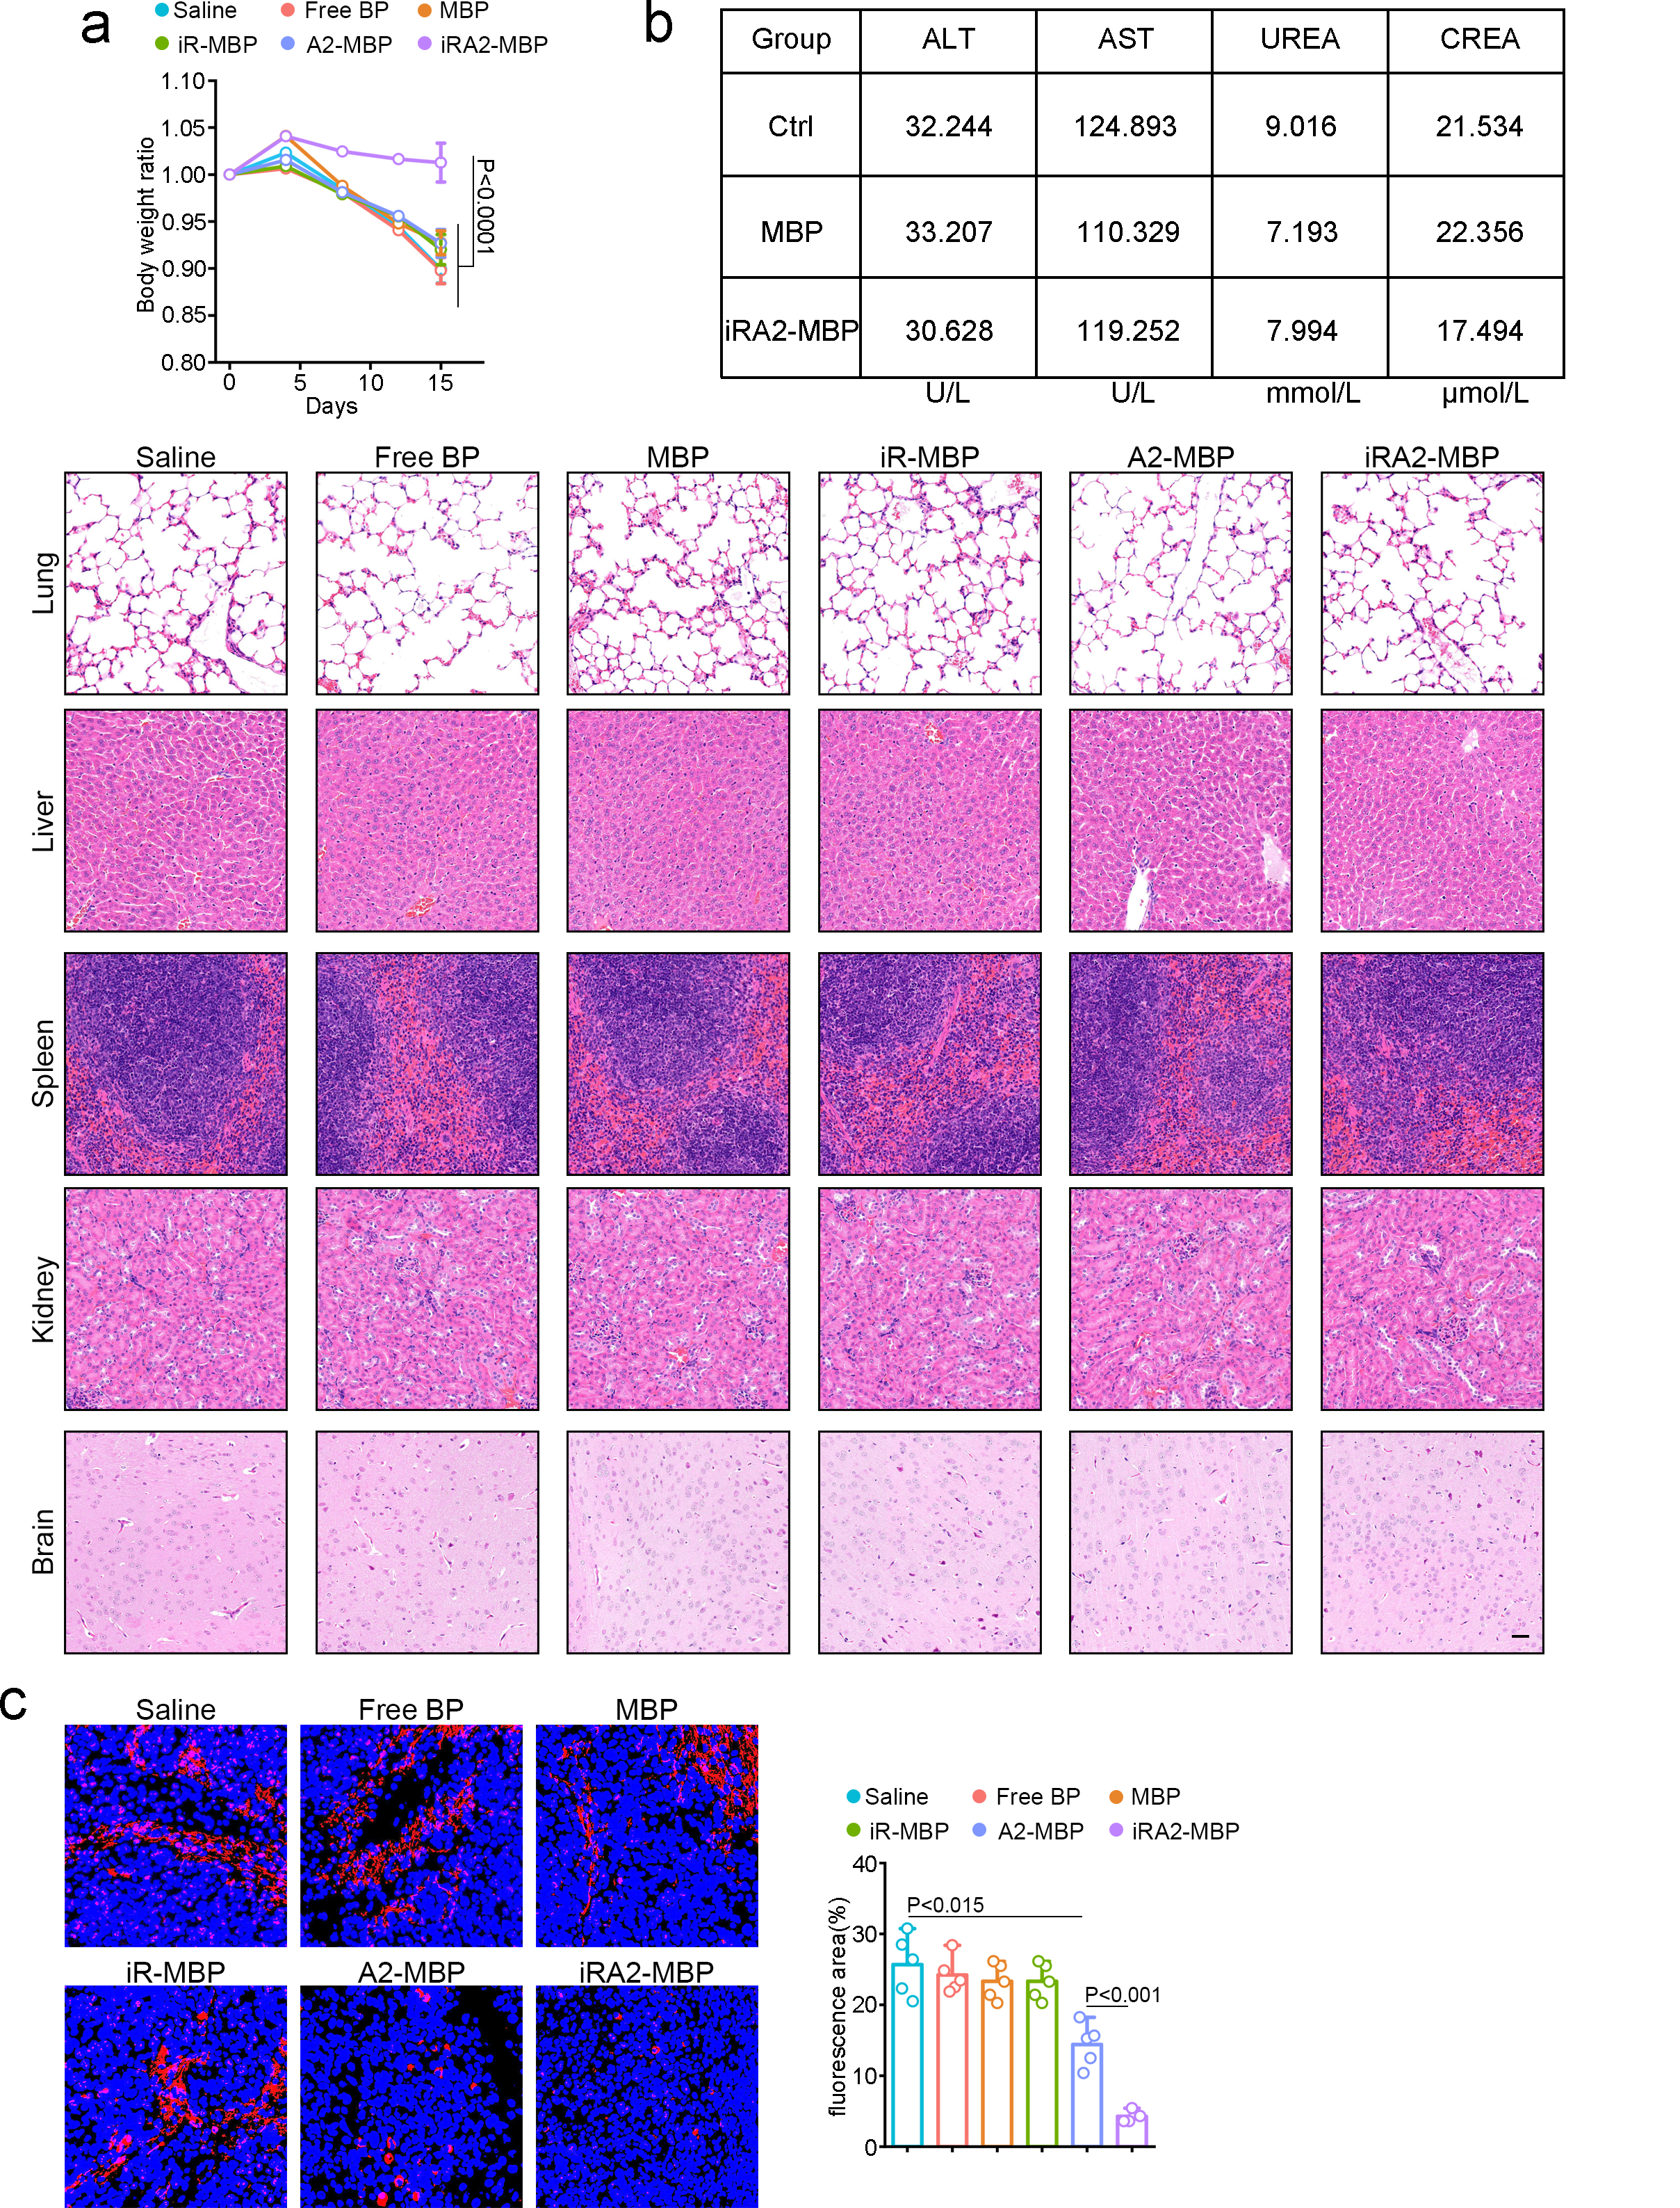
Supplementary Fig. 6. a, Body weight changes in tumor-bearing mice over 15 days (Saline/FreeBP/MBP/iR-MBP/A2-MBP/iRA2-MBP). iRA2-MBP preserves body weight, while other groups show significant loss (n=5). b, Serum biochemical parameters reflecting liver and kidney function in mice treated with control (Ctrl), MBP, or iRA2-MBP. Liver function markers: alanine aminotransferase (ALT, U/L) and aspartate aminotransferase (AST, U/L); kidney function markers: urea (UREA, mmol/L) and creatinine (CREA, μmol/L). No significant differences in these parameters are observed between treatment groups (MBP/iRA2-MBP) and the Ctrl group, indicating favorable biocompatibility and biosafety of the MBP-based formulations (n=5). HE staining of major organs (Lung/Liver/Spleen/Kidney/Brain) in mice under Saline/FreeBP/MBP/iR-MBP/A2-MBP/iRA2-MBP treatments. No histopathological abnormalities are observed in any group, indicating good in vivo biocompatibility. Scale bar: 20 μm (n=5). c, TH⁺ Immunofluorescence images (left) and fluorescence area quantification (right) in mouse tissues under Saline/Free BP/MBP/iR-MBP/A2-MBP/iRA2-MBP treatments. iRA2-MBP shows the lowest, while Saline shows the highest fluorescence area(n=5). Data are mean ± SEM. Statistical significance by unpaired t-test; exact P values shown.
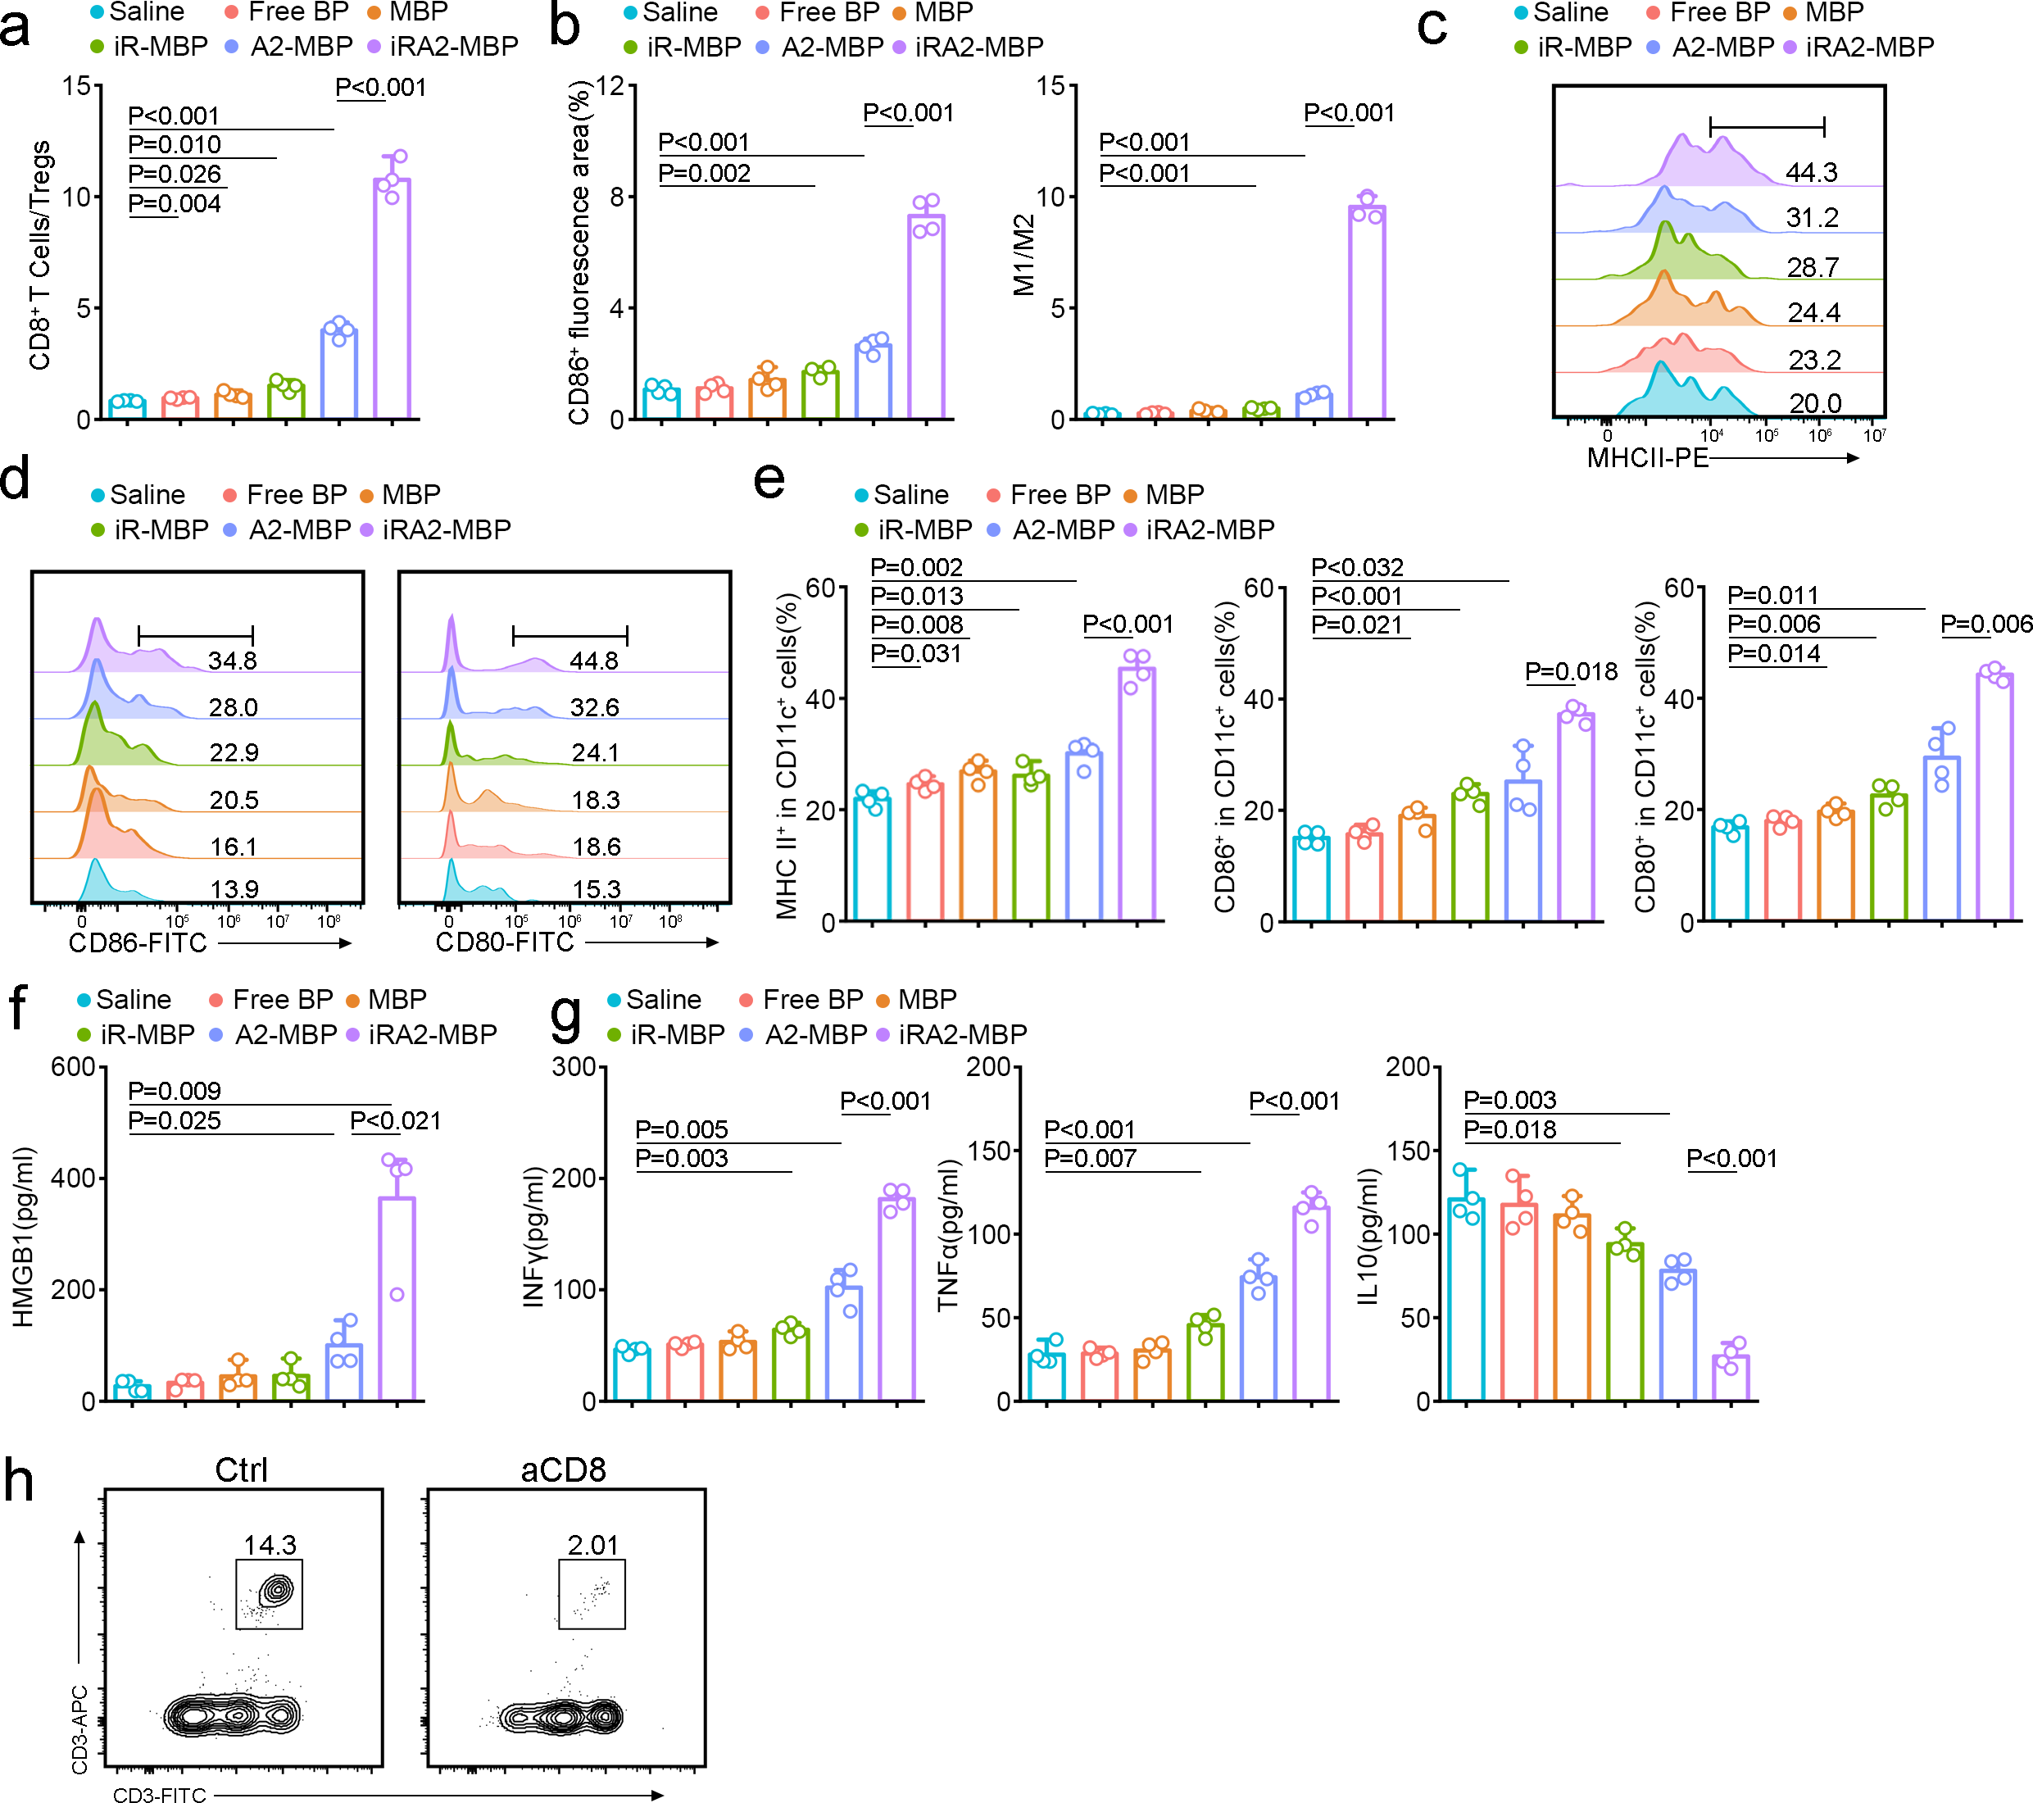
Supplementary Fig. 7. a, CD8+ T Cells/Tregs ratio in tumor tissues under Saline/FreeBP/MBP/iR-MBP/A2-MBP/iRA2-MBP treatments. iRA2-MBP shows the highest ratio, indicating enhanced anti-tumor immunity (n=4). b, CD86⁺ fluorescence area and M1/M2 ratio in tumor tissues under Saline/Free BP/MBP/iR-MBP/A2-MBP/iRA2-MBP treatments. iRA2-MBP shows the highest levels , indicating enhanced M1 macrophage polarization (n=4). c, Flow cytometry analysis of MHCII expression (MFI) in APCs under Saline/Free BP/MBP/iR-MBP/A2-MBP/iRA2-MBP treatments. iRA2-MBP shows the highest MHCII, indicating enhanced antigen presentation (n=4). d, Flow cytometry analysis of CD86 (left) and CD80 (right) expression in APCs under Saline/Free BP/MBP/iR-MBP/A2-MBP/iRA2-MBP treatments. iRA2-MBP shows the highest, indicating enhanced APC activation (n=4). e, Percentage of MHCII⁺/CD86⁺/CD80⁺ cells in CD11c⁺ mDCs under Saline/Free BP/MBP/iR-MBP/A2-MBP/iRA2-MBP treatments. iRA2-MBP shows the highest DC activation, indicating enhanced anti-tumor immunity (n=4). f, HMGB1 levels (pg/ml) under Saline/Free BP/MBP/iR-MBP/A2-MBP/iRA2-MBP treatments. iRA2-MBP shows the highest HMGB1 level, indicating enhanced immunogenic cell death (n=4). g, Cytokine levels (IFN-γ/TNF-α/IL-10, pg/ml) in tumor tissues under Saline/FreeBP/MBP/iR-MBP/A2-MBP/iRA2-MBP treatments. iRA2-MBP shows highest pro-inflammatory cytokines and lowest immunosuppressive IL-10, indicating enhanced anti-tumor immunity (n=4). h, Flow cytometry contour plot analysis of CD8⁺ cytotoxic T cell proportion within the CD3⁺ T cell population in tumor tissues from mice treated with control or aCD8 (n=3). Data are mean ± SEM. Statistical significance by unpaired t-test; exact P values shown.

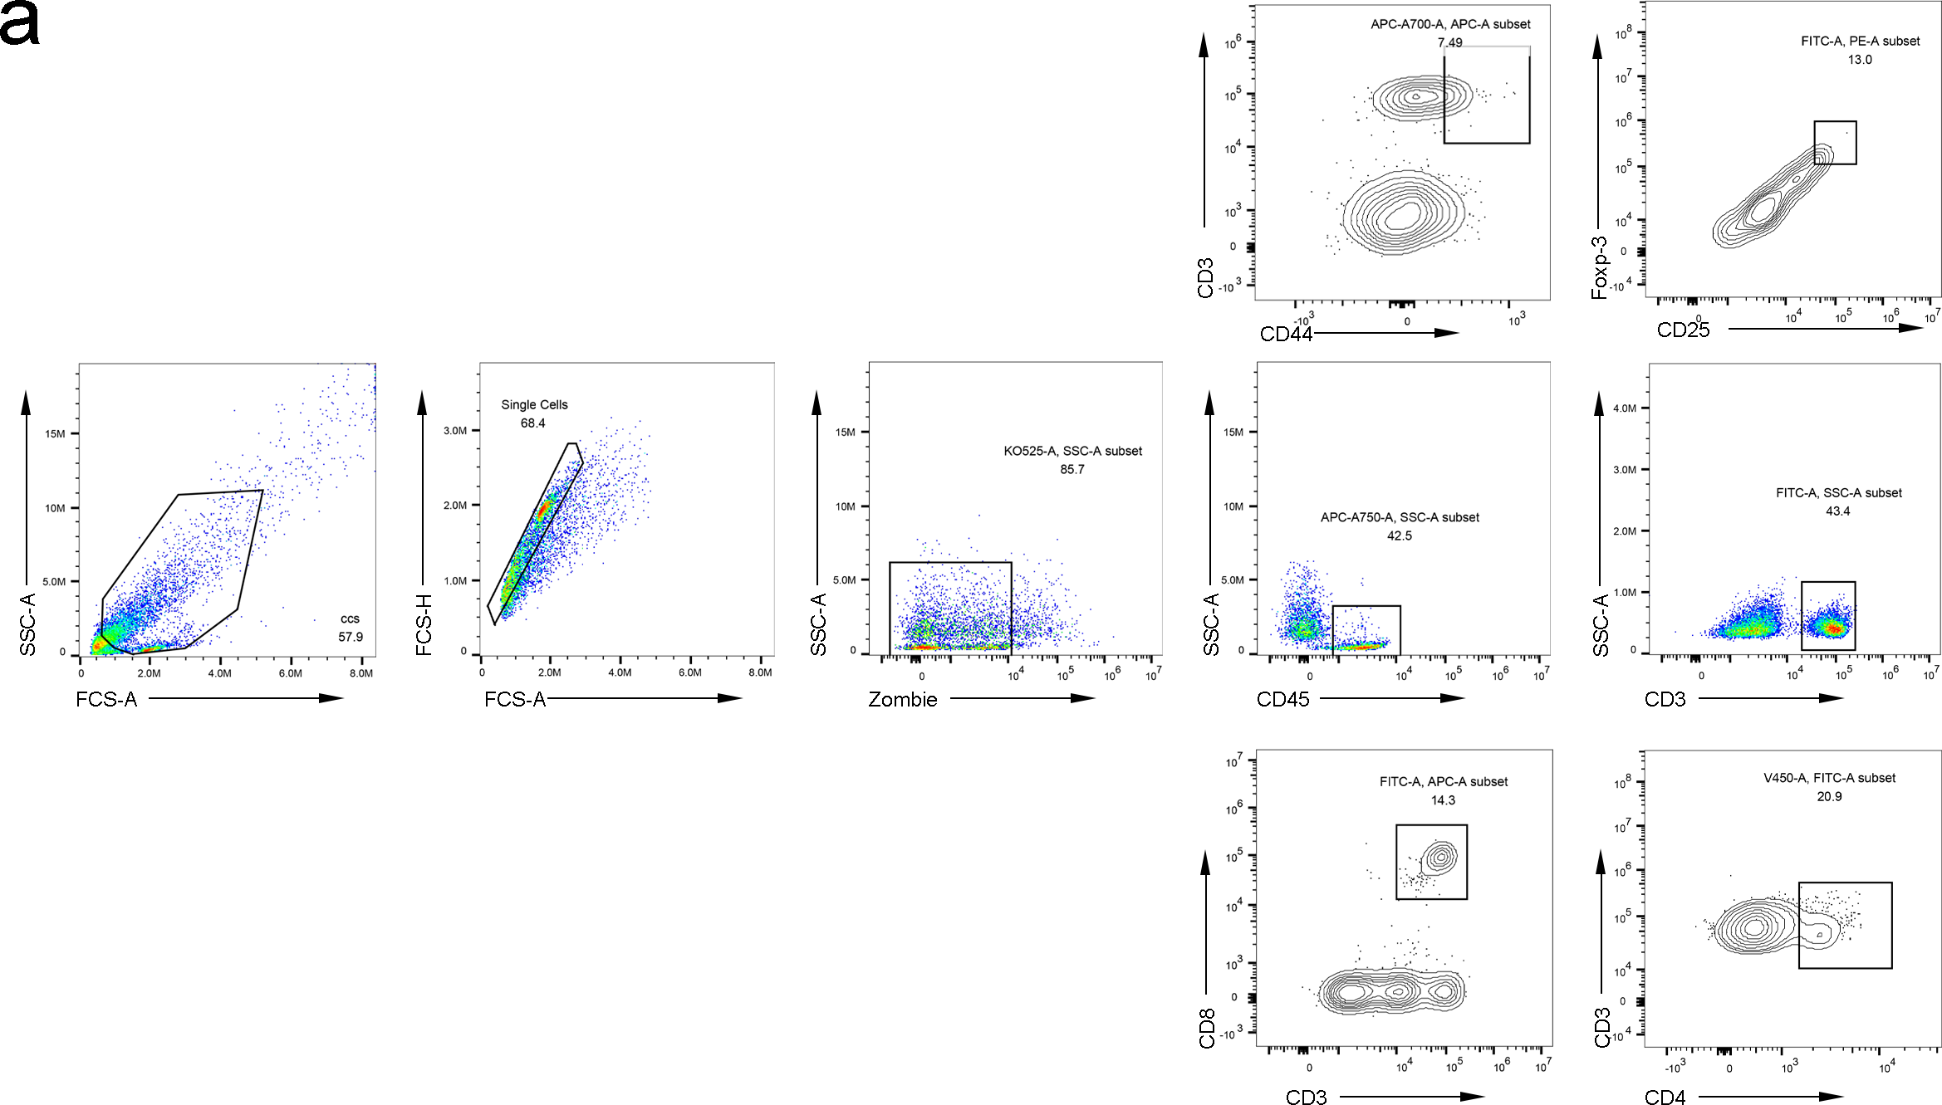
Supplementary Fig. 8. a, Graphical account for flow cytometry gating strategies of CD8⁺ T cells, CD4⁺ T cells, Tregs and T memory cells. Gating strategy to sort CD8⁺ T cells and CD4⁺ T cells in tumor tissues gating on Live⁺ CD45⁺ CD3⁺ cells and Treg cells in tumor tissues gating on Live⁺ CD45⁺ CD3⁺ CD4⁺ Foxp3⁺ cells.
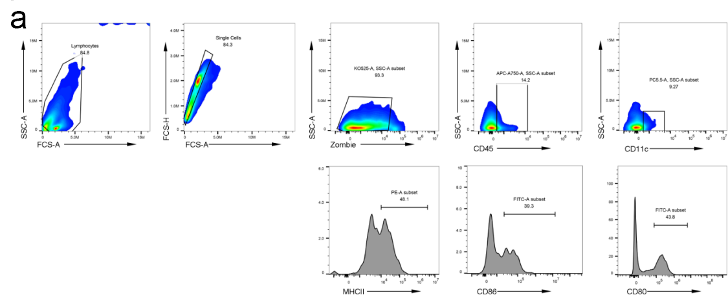Supplementary Fig. 9. a, Graphical account for flow cytometry gating strategies of DCs. Gating strategy to access the level of mDC (MHCII⁺,CD80⁺ and CD86⁺) in tumor tissues gating on Live⁺ CD11c⁺ cells.

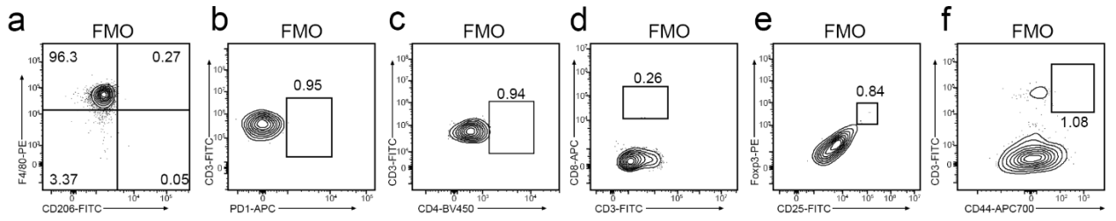
Supplementary Fig. 10. Fluorescence minus one (FMO) controls for multicolour flow cytometry. a, FMO control for M2 macrophages (CD206⁺): stained panel omitting CD206-FITC. b, FMO control for PD-1 expression on immune cells (CD45⁺): stained panel omitting PD-1 antibody. c, FMO control for CD4⁺ T cells within the CD3⁺ gate: stained panel omitting CD4 antibody. d, FMO control for CD8⁺ T cells: stained panel omitting CD8 antibody. e, FMO control for memory Treg cells: stained panel omitting the defining marker for this population. f, FMO control for memory T cells: stained panel used as a compensation control to define the CD44-APC700 positive boundary. The values shown reflect the background staining levels used to set positive gates for the respective markers throughout the study. All FMO controls were prepared and acquired in parallel with the corresponding full-stained samples. Data are representative of at least three independent experiments.

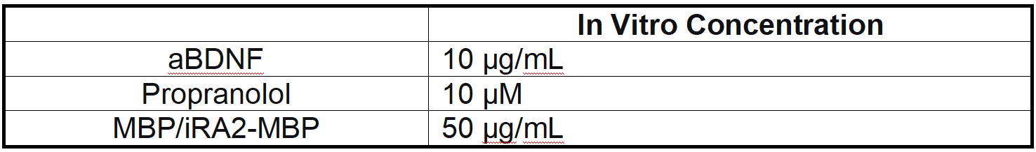
Supplementary Table S1. In vitro dosing summary for iRA2-MBP and its components.

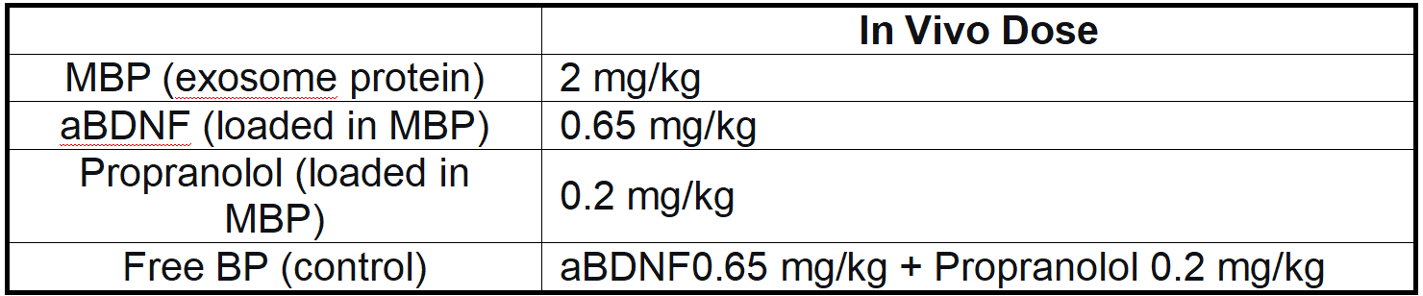
Supplementary Table S2. In vivo dosing summary for iRA2-MBP and its components.

Resource Type | Resource Name | Vendor/Source | RRID
Cell lines | GL261 | DSMZ | CVCL_Y003
 | U87 MG | ATCC | CVCL_0022
 | U251MG | ATCC | CVCL_0021
 | C8-D1A | ATCC | CVCL_6379
 | bEnd.3 | ATCC | CVCL_0170
 | PC12 | CLS | CVCL_0481
 | HEK293T | ATCC | CVCL_0063
Antibodies | Anti-BDNF | Proteintech | AB_2818960
 | Anti-DBH | Proteintech | AB_2092084
 | Anti-TH | Proteintech | AB_2881623
 | Anti-CGA | Proteintech | AB_2879213
 | Anti-TrkB | Proteintech | AB_2877871
 | Anti-PKA | CST | AB_2170170
 | Anti-phospho-PKA | HuaBio | AB_3072974
 | Anti-ERK | Proteintech | AB_2878077
 | Anti-phospho-ERK | CST | AB_331772
 | Anti-MEK | Proteintech | AB_2877635
 | Anti-phospho-MEK | CST | AB_2138017
 | Anti-CREB | Proteintech | AB_2877803
 | Anti-phospho-CREB (Ser133) | Cell Signaling Technology | AB_2561044
 | Anti-HMGB1 | Proteintech | AB_2877527
 | Anti-CD86 | Proteintech | AB_2880721
 | Anti-CD206 | Proteintech | AB_3746481
 | Anti-CD80 | Proteintech | AB_3746566
 | Anti-PD-1 | Proteintech | AB_2881611
 | Anti-LAG-3 | Proteintech | AB_2881958
 | Anti-TSG101 | Proteintech | AB_2881055
 | Anti-Calnexin | CST | AB_2882231
 | Anti-Histone H3 | Proteintech | AB_2878411
 | Anti-Rab5 | CST | AB_2269388
 | Anti-Rab7 | Proteintech | AB_2881337
 | Anti-ZO-1 | Proteintech | AB_2881626
 | Anti-Occludin | CST | AB_2880820
 | Anti-VE-cadherin | Proteintech | AB_2881630
 | Anti-phospho-VE-cadherin | CST | AB_10839118
 | Anti-β-actin | Proteintech | AB_2687938
 | Anti-GAPDH | CST | AB_561053
 | Anti-CD206 | CST | AB_2800175
 | Anti-Ki67 | CST | AB_2756525
 | Anti-CD8α (clone 2.43) | Proteintech | AB_3746647
 | Anti-CD4 | Proteintech | AB_3746487
 | Anti-Foxp3 | Proteintech | AB_2918392
 | Anti-CD44 | Proteintech | AB_3746636
 | Anti-F4/80 | Proteintech | AB_3746604
 | Anti-CD11b | Proteintech | AB_3746461
 | Anti-CD11c | Proteintech | AB_3084901
 | Anti-CD3 | Proteintech | AB_1939430
 | Anti-CD45 | Proteintech | AB_2881404
 | Anti-CD25 | Proteintech | AB_3746623
 | Anti-MHC II | Proteintech | AB_3746457
 | Normal Rabbit IgG (ChIP) | Proteintech | AB_2819035
 | Anti-H3K27ac (ChIP) | Active Motif | AB_2561016
Animal models | C57BL/6 mice | Jiangsu Huachuang Xinnuo | IMSR_JAX:000664
 | Balb/c mice | Jiangsu Huachuang Xinnuo | IMSR_JAX:000651
ELISA kits | BDNF ELISA kit | Jiangsu Meimian | MM-48234M2
 | NE ELISA kit | Jiangsu Meimian | MM-0876M2
 | TNF-α ELISA kit | Jiangsu Meimian | MM-47831M2
 | IFN-γ ELISA kit | Jiangsu Meimian | MM-0182M2
 | IL-10 ELISA kit | Jiangsu Meimian | MM-0176M1
Software | GraphPad Prism 9.0 | GraphPad Software | SCR_002798
 | FlowJo | TreeStar | SCR_008520
 | ImageJ | NIH | SCR_003070
 | Seurat (v4.1.0) | R package | SCR_016341
Supplementary Table S3. Key resources table with Research Resource Identifiers.

