Supplementary Table 1: Baseline Characteristics of the Study Population (N = 2638)

Variables | Value
Demographic features
Male sex | 1615 (61.2)
Age, years  <45 years, n(%)  45–55 years, n(%)  56–65 years, n(%)  >65 years, n(%) | 55.6 ± 13.0  537 (20.4)  669 (25.4)  822 (31.2)  610 (23.1)
Metabolic features
BMI, kg/m²  <25 kg/m², n(%)  25–30 kg/m², n(%)  ≥30 kg/m², n(%) | 30.7 ± 5.3  351 (13.3)  936 (35.5)  1351 (51.2)
Waist circumference, cm*  80/94 cm women/men, n(%) | 105.3 ± 12.5  2345 (88.9)
Hypertension, n(%) | 1417 (53.7)
Dyslipidemia, n(%) | 1730 (65.6)
Total cholesterol, mg/dL | 182 ± 44
HDL cholesterol, mg/dL | 48.6 ± 12.8
Triglycerides, mg/dL | 117 (89–168)
LDL cholesterol, mg/dL | 106 ± 38
Diabetes mellitus, n(%) | 715 (27.1)
Glycated hemoglobin, mmol/mol | 42 ± 11
HOMA-IR  ≥2.5, n(%) | 2.8 (1.9–4.1)  1567 (59.4)
eGFR, mL/min/1.73m²  <60 mL/min/1.73m², n(%) | 93.4 ± 17.4  119 (4.5)
Hepatic features
AST, U/L  Increased AST, n(%) | 34.9 ± 21.0  675 (25.6)
ALT, U/L  Increased ALT, n(%) | 46.3 ± 34.0  1131 (42.9)
Elevated transaminases, n(%) | 1202 (45.6)
GGT, U/L  Increased GGT, n(%) | 35 (23–65)  902 (34.2)
Platelets, ×10⁹/L | 238 ± 66
Severe ultrasound steatosis, n(%) | 673 (25.5)
FIB-4  ≥1.3/2.0, n(%)  ≥2.67, n(%) | 1.16 (0.83–1.65)  823 (31.2)  217 (8.2)
LSM, kPa  ≥8 kPa, n(%)  ≥19 kPa, n(%)  ≥15 kPa, n(%) | 5.5 (4.4–7.5)  579 (21.9)  370 (14.0)  193 (7.3)
Abbreviations: ALT, alanine aminotransferase; AST, aspartate aminotransferase; BMI, body mass index; eGFR, estimated glomerular filtration rate; FIB-4, Fibrosis-4 index; GGT, gamma-glutamyl transferase; HDL, high-density lipoprotein; HOMA-IR, homeostatic model assessment of insulin resistance; LDL, low-density lipoprotein; LSM, liver stiffness measurement.

Supplementary Table 2. Baseline characteristics by centre (N=2638)

Variables |  | Overall | Milan | Bologna | Verona | Rome | Foggia | Humanitas | Modena | Palermo | Salerno | P value
Patients |  | 2638 | 562 | 140 | 409 | 638 | 158 | 186 | 268 | 145 | 132
Demographics | <45 ya, n(%) | 537 (20.4) | 175 (31.1) | 23 (16.4) | 106 (25.9) | 109 (17.1) | 18 (11.4) | 29 (15.6) | 32 (11.9) | 32 (22.1) | 13 (9.8) | <0.001
 | 45–55 ya, n(%) | 669 (25.4) | 194 (34.5) | 30 (21.4) | 99 (24.2) | 173 (27.1) | 32 (20.3) | 36 (19.4) | 43 (16.0) | 28 (19.3) | 34 (25.8)
 | 56–65 ya, n(%) | 822 (31.2) | 152 (27.0) | 40 (28.6) | 116 (28.4) | 215 (33.7) | 61 (38.6) | 59 (31.7) | 87 (32.5) | 46 (31.7) | 46 (34.8)
 | ≥65 ys, n(%) | 610 (23.1) | 41 (7.3) | 47 (33.6) | 88 (21.5) | 141 (22.1) | 47 (29.7) | 62 (33.3) | 106 (39.6) | 39 (26.9) | 39 (29.5)
 | Male sex, n(%) | 1615 (61.2) | 354 (62.9) | 75(53.6) | 252(61.6) | 403(63.2) | 92(58.2) | 115(61.8) | 158(59) | 88(60.7) | 78(59.1) | 0.422
Anthropometry | BMI <25, n(%) | 351 (13.3) | 120 (21.3) | 18 (12.9) | 79 (19.3) | 27 (4.2) | 20 (12.7) | 33 (17.7) | 42 (15.7) | 12 (8.3) | 0 (0.0) | <0.001
 | BMI≥30, n(%) | 1351 (51.2) | 195 (34.7) | 74 (52.9) | 178 (43.5) | 453 (71.0) | 76 (48.1) | 82 (44.1) | 111 (41.4) | 87 (59.9) | 95 (72.1) | <0.001
Metabolic | Hypertension, n(%) | 1417 (53.7) | 202 (35.9) | 95 (67.9) | 223 (54.5) | 401 (62.8) | 74 (46.8) | 89 (47.8) | 141 (52.6) | 93 (64.1) | 99 (75.0) | <0.001
 | T2DM, n(%) | 715 (27.1) | 64 (11.4) | 50 (35.7) | 110 (26.9) | 184 (28.8) | 90 (57.0) | 54 (29.0) | 52 (19.4) | 69 (47.6) | 42 (31.8) | <0.001
 | Dyslipidemia, n(%) | 1730 (65.6) | 374 (66.5) | 108 (77.1) | 223 (54.5) | 446 (69.9) | 113 (71.5) | 127 (68.3) | 160 (59.7) | 77 (53.1) | 102 (77.3) | <0.001
Liver enzymes | Increased AST, n(%) | 675 (25.6) | 70 (12.5) | 45 (32.1) | 137 (33.5) | 169 (26.5) | 35 (22.2) | 58 (31.2) | 58 (21.6) | 63 (43.4) | 40 (30.3) | <0.001
 | Increased ALT, n(%) | 1131 (42.9) | 174 (31.0) | 61 (43.6) | 216 (52.8) | 356 (55.8) | 45 (28.5) | 71 (38.2) | 72 (26.9) | 83 (57.2) | 53 (40.2) | <0.001
Fibrosis | FIB-4 ≥1.3, n(%) | 823 (31.2) | 92 (16.4) | 52 (37.1) | 122 (29.8) | 185 (29.0) | 73 (46.2) | 51 (27.4) | 105 (39.2) | 77 (53.1) | 66 (50.0) | <0.001
 | LSM ≥8 kPa, n(%) | 579 (21.9) | 42 (7.5) | 49 (35.0) | 100 (24.4) | 102 (16.0) | 48 (30.4) | 44 (23.7) | 42 (15.7) | 107 (73.8) | 45 (34.1) | <0.001
 | LSM>15kPa, n(%) | 193 (7.3) | 7 (1.2) | 11 (7.9) | 24 (5.9) | 24 (3.8) | 22 (13.9) | 14 (7.5) | 10 (3.7) | 55 (37.9) | 26 (19.7) | <0.001
Abbreviations: ALT, alanine aminotransferase; AST, aspartate aminotransferase; BMI, body mass index; FIB-4, Fibrosis-4 index; LSM, liver stiffness measurement; T2DM, type 2 diabetes mellitus.

Supplementary Table 3. Diagnostic accuracy of FIB-4 and optimal thresholds across clinically relevant subgroups
Subgroup | AUROC (95% CI) | Cut-off for 80% sensitivity | Cut-off for 95% specificity
Age categories
Age <45 years | 0.59 (0.51–0.66) | 0.47 | 1.30
Age 45–55 years | 0.65 (0.59–0.72) | 0.79 | 1.68
Age 56–65 years | 0.72 (0.68–0.76) | 1.17 | 2.29
Age ≥65 years | 0.77 (0.73–0.81) | 1.75 | 3.34
BMI categories
Lean | 0.82 (0.74–0.91) | 1.38 | 2.34
Overweight | 0.73 (0.68–0.78) | 1.04 | 2.34
Obese | 0.71 (0.67–0.74) | 0.94 | 2.30
Renal function categories
GFR ≥60 mL/min | 0.71 (0.67–0.73) | 0.93 | 2.26
GFR <60 mL/min | 0.83 (0.74–0.91) | 1.56 | 2.54
Transaminases categories
Normal transaminases | 0.68 (0.63–0.72) | 0.93 | 2.24
Increased transaminases | 0.75 (0.72–0.78) | 1.04 | 2.65
Steatosis categories
No severe steatosis | 0.76 (0.73–0.80) | 1.09 | 2.34
Severe steatosis | 0.64 (0.58–0.69) | 0.77 | 2.24

Supplementary Figure 1: Diagnostic performance of FIB-4 for predicting LSM >10 kPa (A) and LSM >15 kPa (B)
in the overall cohort

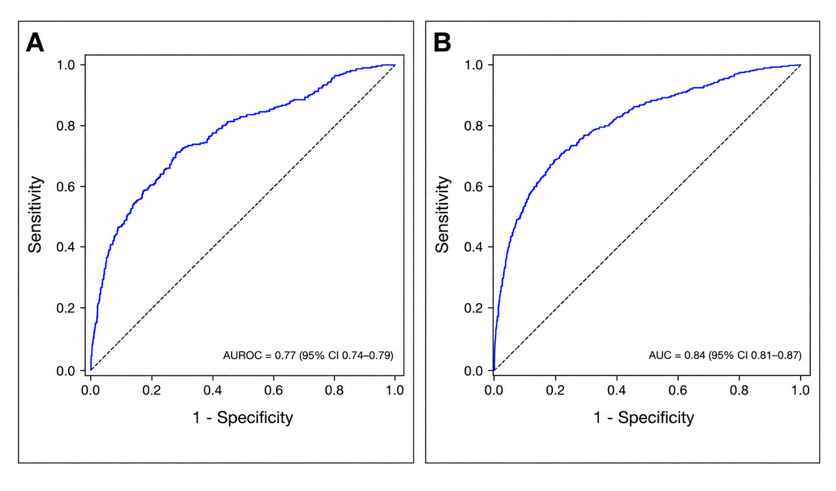

Supplementary figure 2: Diagnostic performance of FIB-4 for predicting LSM >8 kPa in the whole cohort according to transaminases status (A) and the presence of severe steatosis at ultrasound (B).

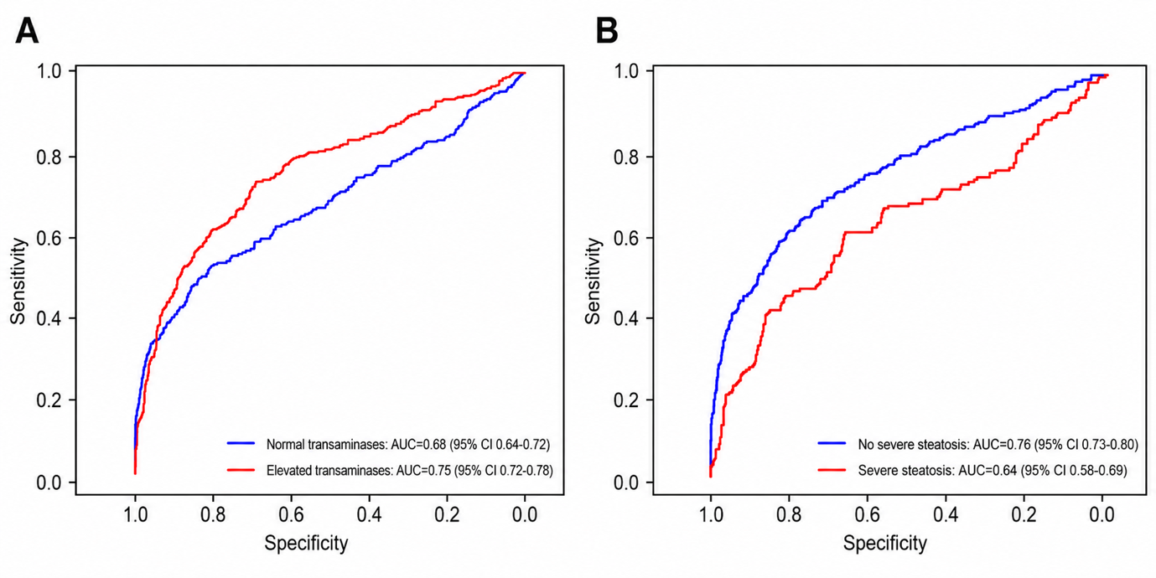
Abbreviations: AUC, area under the receiver operating characteristic curve; CI, confidence interval; FIB-4, Fibrosis-4 index; LSM, liver stiffness measurement; ROC, receiver operating characteristic.

