Supplementary data:
Host genetic determinants of rotavirus disease and immunity in African children.
Agoti CN, et al

Supplementary Tables
Supplementary Table 1. Variation in serum anti-RV IgA levels in Ugandan children by age at sampling, sex and the number of doctor-diagnosed episodes of diarrhoea in the first year of life.
 |  | Serum anti-RV IgA levels |  | Serostatus
 |  | median IU/ml (range) | p-value | Seronegative (n, %) | Seropositive (n, %) | p-value
 | Overall | 104 (0-2,100) |  | 145 (24%) | 471 (76%)
Age | 2 years | 82 (0-2,100) | 0.049 | 94 (28%) | 236 (72%) | 0.0026
Age | 3 years | 117 (0-2,100) | 0.049 | 51 (18%) | 235 (82%) | 0.0026
Sex | Female | 124 (0-2,100) | 0.014 | 72 (24% | 224 (76%) | 0.73
Sex | Male | 82 (0-2,100) | 0.014 | 73 (23%) | 247 (77%) | 0.73
Episodes diarrhoea | 0 | 92 (0-2,100) | 0.003 | 42 (23%) | 139 (77%) | 0.14
Episodes diarrhoea | 1 | 85 (0-2,100) | 0.003 | 51 (26%) | 146 (74%) | 0.14
Episodes diarrhoea | 2 | 94 (0-2,100) | 0.003 | 33 (26%) | 93 (74%) | 0.14
Episodes diarrhoea | 3 | 157 (0-2,100) | 0.003 | 13 (19%) | 54 (81%) | 0.14
Episodes diarrhoea | 4 | 146 (0-2,100) | 0.003 | 6 (21%) | 23 (79%) | 0.14
Episodes diarrhoea | 5 | 216 (0-2,100) | 0.003 | 0 (0%) | 11 (100%) | 0.14
Episodes diarrhoea | 6 | 138 (60-534) | 0.003 | 0 (0%) | 5 (100%) | 0.14
Effects of age and sex on serostatus are calculated with χ² tests, and effects on serum anti-RV IgA levels using Wilcoxon rank sum tests. The association between serum anti-RV IgA and the number of diarrhoeal episodes is calculated by ordinal regression, and the association between serostatus and the number of diarrhoeal episodes by χ² trend tests.

Supplementary Table 2. Demographics, clinical features, outcome and RV genotype among hospitalised Kenyan children with rotavirus gastroenteritis.

 |  | Cases (n=554) | Controls (n=1,556)
Age; months (range) |  | 10 (0-133) | *
Sex; female |  | 225 (41%) | 761 (49%)
Self-reported ethnicity
 | Giriama | 261 (47%) | 670 (47%)
 | Chonyi | 109 (20%) | 625 (40%)
 | Kauma | 44 (8%) | 175 (11%)
Clinical presentation
 | Diarrhoea | 514 (97%)
 | Vomiting | 463 (87%)
 | Fever | 408 (77%)
 | Shock | 135 (25%)
Inpatient stay; days (range) |  | 4 (0-40)
Inpatient mortality |  | 8 (1%)
Rotavirus genotype**
 | G1P[8] | 208 (46%)
 | G2P[4] | 18 (4%)
 | G8P[4] | 49 (11%)
 | G8P[6] | 23 (5%)
 | G9P[8] | 62 (14%)
 | other | 47 (10%)
 | mixed | 41 (9%)

Demographics of Kenyan control samples are presented for comparison.
*Control participants were recruited between the ages of 3 and 12 months.
**448 cases with complete G and P genotype data

Supplementary Table 3. Variation in clinical presentation and course by age, sex and RV genotype.
 |  |  | Age |  | Sex |  |  | Genotype
Clinical presentation |  | Total | OR/β | pval | Female | Male | pval | P[4] | P[6] | P[8] | pval
 | Diarrhoea | 514/554 (97%) | 0.41 | 6.9x10⁻⁴ | 208/217 (96%) | 306/314 (97%) | 0.44 | 92/92 (100%) | 47/47 (100%) | 322/332 (97%) | 0.12
 | Vomiting | 463/554 (87%) | 1.21 | 0.14 | 192/217 (88%) | 271/314 (86%) | 0.54 | 83/92 (90%) | 39/47 (83%) | 290/332 (87%) | 0.47
 | Fever | 408/554 (77%) | 0.98 | 0.85 | 167/217 (77%) | 241/314 (77%) | 1 | 74/92 (80%) | 31/47 (66%) | 255/332 (77%) | 0.15
 | Shock | 135/554 (25%) | 1.11 | 0.32 | 53/217 (24%) | 82/314 (26%) | 0.74 | 14/92 (15%) | 14/47 (30%) | 90/332 (27%) | 0.05
Inpatient stay; days (range) |  | 4 (0-40) | -0.06 | 0.19 | 4 (0-40) | 4 (0-23) | 0.1 | 4 (1-22) | 4 (1-9) | 4 (0-40) | 0.43
Inpatient mortality |  | 8/554 (1%) | 1.5 | 0.26 | 2/217 (1%) | 6/314 (2%) | 0.57 | 0/92 (0%) | 1/47 (2%) | 7/332 (2%) | 0.37
Effects of age and sex are calculated by logistic regression (binary outcomes; clinical presentation and inpatient mortality) or linear regression (inpatient stay). RV genotype effects were calculated by χ² tests (binary outcomes; clinical presentation and inpatient mortality) or ANOVA (inpatient stay). Continuous variables were quantile normalised prior to analysis.

Supplementary Table 4. Imputation of ABO blood group using phased genotype data.
 |  | rs8176719 genotype
 |  | T|T | T|TC | TC|T | TC|TC
rs8176747 genotype | C|C | O | A | A | A
rs8176747 genotype | C|G | O | B | A | AB
rs8176747 genotype | G|C | O | A | B | AB
rs8176747 genotype | G|G | O | B | B | B

Supplementary Table 5. Exonic FUT3 SNPs and their effect on Lewis antigen expression.
Chr | BP | SNP | rsid | VEP annotation | Protein Consequence | Polyphen | SIFT | Enzymatic activity | Reference
19 | 5843784 | 19:5843784:A:T | rs3894326 | missense_variant | p.Ile356Lys | possibly_damaging | deleterious | reduced activity | PMID: 7961897
19 | 5843844 | 19:5843844:T:G | rs151218854 | missense_variant | p.Asp336Ala | benign | tolerated | unclear | NA
19 | 5843871 | 19:5843871:C:T | rs28381970 | missense_variant | p.Arg327Gln | benign | tolerated | unclear | NA
19 | 5843877 | 19:5843877:G:A | rs28381969 | missense_variant | p.Thr325Met | benign | tolerated | unclear | NA
19 | 5843993 | 19:5843993:T:C | rs139326855 | synonymous_variant | p.Pro286Pro | NA | NA | NA | NA
19 | 5844043 | 19:5844043:C:T | rs28381968 | missense_variant | p.Val270Met | possibly_damaging | deleterious | reduced activity | PMID: 9703429
19 | 5844184 | 19:5844184:C:T | rs28362466 | missense_variant | p.Gly223Arg | probably_damaging | deleterious | reduced activity | PMID: 9703429
19 | 5844343 | 19:5844343:C:T | rs3745635 | missense_variant | p.Gly170Ser | possibly_damaging | deleterious | inactive | PMID: 8219240
19 | 5844367 | 19:5844367:C:T | rs28362463 | missense_variant | p.Asp162Asn | probably_damaging | deleterious | reduced activity | PMID: 9703429
19 | 5844537 | 19:5844537:A:G | rs778986 | missense_variant | p.Met105Thr | benign | deleterious | active | PMID: 9268337
19 | 5844649 | 19:5844649:G:A | rs812936 | missense_variant | p.Arg68Trp | benign | tolerated | inactive | PMID: 9268337
19 | 5844779 | 19:5844779:C:G | rs28362461 | synonymous_variant | p.Leu24Leu | NA | NA | NA | NA
19 | 5844790 | 19:5844790:G:A | rs28362460 | synonymous_variant | p.Leu21Leu | NA | NA | NA | NA
19 | 5844792 | 19:5844792:A:C | rs28362459 | missense_variant | p.Leu20Arg | probably_damaging | deleterious | reduced activity | PMID: 8063716
19 | 5844804 | 19:5844804:C:G | rs145362171 | missense_variant | p.Cys16Ser | possibly_damaging | tolerated | inactive | PMID: 15383031
19 | 5844838 | 19:5844838:C:T | rs28362458 | missense_variant | p.Gly5Ser | benign | tolerated | inactive | PMID: 14674375

Supplementary Table 6: Evidence for colocalization between the anti-RV IgA-associated chromosome 2 locus, lead SNP rs59241810, and regulatory determinants of EDAR expression in T cells, leukocytes and blood.
eQTL study |  |  |  | Posterior probability model 0: PP0 | Posterior probability model 1: PP1 | Posterior probability model 2: PP2 | Posterior probability model 3: PP3 | Posterior probability model 4: PP4 | Lead QTL association |  |  | GWAS lead SNP in QTL study
Dataset | Tissue type | Molecular QTL | Ancestry | No evidence of association in either study | Evidence of association in QTL study alone. | Evidence of association in RV IgA GWAS alone. | Both associated, but different causal variants | Both associated with the same causal variant | SNP | p-value | beta | SNP | p-value | beta
BLUEPRINT. Chen, et al. PMID: 27863251 | CD4+ T cells | RNA | European | 0.00 | 0.00 | 0.75 | 0.17 | 0.08 | rs116809988 | 2.0x10⁻⁴ | -0.66 | rs59241810 | 0.25 | 0.45
CEDAR  Momozawa, et al.  PMID: 29930244 | CD4+ T cells | RNA | European | 0.34 | 0.05 | 0.51 | 0.07 | 0.03 | rs6723274 | 1.0x10⁻³ | 0.24 | rs11123703* | 0.72 | 0.02
CEDAR  Momozawa, et al.  PMID: 29930244 | CD8+ T cells | RNA | European | 0.30 | 0.07 | 0.45 | 0.11 | 0.07 | rs11123722 | 1.8x10⁻⁴ | -0.21 | rs56711588* | 4.4x10⁻³ | 0.15
GENCORD. Gutierrez-Arcelus, et al. PMID: 23755361 | T cells | RNA | European | 0.00 | 0.00 | 0.73 | 0.17 | 0.10 | rs11123722 | 3.7x10⁻⁴ | 0.31 | rs59241810 | 0.05 | -0.53
Kasela, et al. PMID: 28248954 | CD4+ T cells | RNA | European | 0.33 | 0.06 | 0.49 | 0.09 | 0.03 | rs66987393 | 1.3x10⁻³ | 0.37 | rs11123703* | 0.50 | -0.05
Kasela, et al. PMID: 28248954 | CD8+ T cells | RNA | European | 0.35 | 0.04 | 0.52 | 0.06 | 0.03 | rs74899024 | 7.8x10⁻³ | 0.78 | rs11123703* | 0.63 | 0.03
SABR. Castel, et al. PMID: 40500424 | Whole Blood | RNA | African | 0.00 | 0.00 | 0.60 | 0.35 | 0.04 | rs10184198 | 7.2x10⁻⁵ | -0.17 | rs59241810 | 0.14 | -0.06
JHS. Wen, et al. PMID: 39056362 | PBMCs | RNA | African | 0.00 | 0.00 | 0.82 | 0.15 | 0.03 | rs875228 | 6.4x10⁻⁴ | -0.11 | rs59241810 | 0.32 | 0.03
UKB. Sun, et al. PMID: 37794186 | Plasma | Protein | African | 0.00 | 1.32 E-4 | 0.14 | 0.57 | 0.29 | rs201212955 | 9.2x10⁻⁹ | -0.72 | rs59241810 | 2.2x10⁻³ | -0.26

*where rs59241810 is not included in QTL analysis, the variant with the peak GWAS association included in the QTL summary statistics is used as a proxy.
Supplementary Table 7. Evidence for colocalization at rs59241810 between anti-RV IgA GWAS and LIMS1 eQTLs in immune cells.
 |  |  | rs59241810 LIMS1 expression effect |  | Colocalization evidence (LIMS1 eQTL: anti-RV IgA GWAS)
Cell | Stimulation | Sample size (n) | beta | p-value | Peak LIMS1 eSNP | beta | p-value | Coloc (PP4)
PBMC | Naïve | 1,012 | -0.09 | 4.67E-04 | rs11123711 | -0.10 | 2.92E-09 | 0.00
NK cells | Naïve | 245 | -1.20 | 9.03E-06 | rs6757507 | -1.20 | 8.90E-06 | 0.38**
B cells | Naïve | 281 | -0.72 | 4.20E-05 | rs113907398 | -1.08 | 3.44E-09 | 0.00
CD4+ T cells | Naïve | 290 | -1.12 | 5.75E-05 | rs113907398 | -1.38 | 2.27E-06 | 0.02**
CD8+ T cells | Naïve | 277 | -0.43 | 1.73E-01 | rs2077471 | 0.24 | 4.08E-04 | 0
Monocytes | Naïve | 414 | -0.31 | 5.78E-14 | rs75669277 | -0.33 | 4.36E-17 | 0.92
Monocytes | LPS - 2 hours | 256 | -0.51 | 1.21E-11 | rs7602341 | -0.54 | 5.03E-15 | 0.96
Monocytes | LPS - 24 hours | 325 | -0.39 | 2.55E-06 | rs75188012 | -0.30 | 3.36E-08 | 0.17**
Monocytes | IFNg - 24 hours | 370 | -0.46 | 4.91E-12 | rs13425509 | -0.51 | 2.24E-14 | 0.94

*rs59241810 tag: rs73952570 - r2 = 1.0 in 1000G CEU population
**eQTL association evidence insufficient to allow credible set assignment in coloc.susie, PP4 represents coloc.abf estimate

Supplementary Table 8. Correlation between LIMS1 RNA expression and cytokine secretion in stimulated monocytes.
 | LPS (2 hours) |  |  | LPS (24 hours) |  |  | IFN (24 hours)
 | Pearson's r | p-value | FDR | Pearson's r | p-value | FDR | Pearson's r | p-value | FDR
IL.1RA | -0.14 | 5.67E-02 | 2.04E-01 | -0.02 | 5.60E-01 | 6.86E-01 | -0.08 | 1.14E-01 | 2.66E-01
IL.7 | -0.07 | 3.54E-01 | 6.11E-01 | 0.06 | 4.33E-01 | 6.37E-01 | -0.04 | 4.29E-01 | 6.18E-01
GRO.alpha | -0.18 | 1.35E-02 | 1.13E-01 | 0.06 | 3.94E-01 | 6.37E-01 | 0.14 | 1.98E-02 | 1.85E-01
IL.8 | -0.07 | 4.15E-01 | 6.11E-01 | 0.02 | 8.27E-01 | 8.91E-01 | 0.10 | 8.32E-02 | 2.22E-01
IP.10 | 0.06 | 4.16E-01 | 6.11E-01 | 0.04 | 3.51E-01 | 6.37E-01 | 0.06 | 2.71E-01 | 5.32E-01
MCP.1 | -0.18 | 1.02E-02 | 1.13E-01 | 0.09 | 1.81E-01 | 5.24E-01 | 0.11 | 6.63E-02 | 2.22E-01
MIP.1.alpha | -0.05 | 5.07E-01 | 6.11E-01 | 0.07 | 2.06E-01 | 5.24E-01 | 0.12 | 3.28E-02 | 1.93E-01
MIP.1.beta | -0.15 | 5.82E-02 | 2.04E-01 | 0.11 | 1.18E-01 | 5.24E-01 | 0.10 | 8.41E-02 | 2.22E-01
SDF.1.alpha | -0.18 | 1.80E-02 | 1.13E-01 | 0.06 | 5.19E-01 | 6.86E-01 | 0.15 | 9.64E-03 | 1.35E-01
RANTES | 0.04 | 5.75E-01 | 6.11E-01 | 0.09 | 1.99E-01 | 5.24E-01 | 0.06 | 4.00E-01 | 6.18E-01
IL.13 | 0.03 | 6.64E-01 | 6.64E-01 | -0.07 | 4.23E-01 | 6.37E-01 | -0.02 | 9.59E-01 | 9.96E-01
IL.1.beta | 0.06 | 4.59E-01 | 6.11E-01 | 0.09 | 7.57E-02 | 5.24E-01 | 0.04 | 4.41E-01 | 6.18E-01
IL.2 | 0.03 | 5.89E-01 | 6.11E-01 | 0.04 | 3.82E-01 | 6.37E-01 | 0.04 | 5.71E-01 | 7.27E-01
IL.6 | -0.16 | 3.99E-02 | 1.86E-01 | 0.13 | 5.64E-02 | 5.24E-01 | 0.09 | 8.71E-02 | 2.22E-01
TNF.alpha | -0.06 | 4.62E-01 | 6.11E-01 | 0.02 | 6.15E-01 | 7.18E-01 | -0.04 | 5.29E-01 | 7.05E-01
IL.18 | 0.05 | 5.65E-01 | 6.11E-01 | 0.06 | 1.77E-01 | 5.24E-01 | 0.03 | 9.96E-01 | 9.96E-01
IL.10 | -0.08 | 2.98E-01 | 5.96E-01 | -0.05 | 3.78E-01 | 6.37E-01 | 0.06 | 3.64E-01 | 6.18E-01
IL.21 | -0.20 | 5.38E-03 | 1.13E-01 | 0.11 | 1.17E-01 | 5.24E-01 | 0.12 | 4.26E-02 | 1.99E-01
IL.22 | 0.05 | 5.21E-01 | 6.11E-01 | 0.01 | 5.63E-01 | 6.86E-01 | -0.07 | 2.85E-01 | 5.32E-01
LIF | -0.06 | 4.95E-01 | 6.11E-01 | -0.05 | 4.03E-01 | 6.37E-01 | -0.05 | 2.78E-01 | 5.32E-01
BDNF | 0.14 | 6.96E-02 | 2.17E-01 | 0.11 | 1.41E-01 | 5.24E-01 | 0.02 | 7.58E-01 | 9.23E-01
PDGF.BB | 0.12 | 8.74E-02 | 2.45E-01 | 0.09 | 1.53E-01 | 5.24E-01 | -0.02 | 7.93E-01 | 9.26E-01
PIGF.1 | -0.17 | 2.02E-02 | 1.13E-01 | 0.10 | 1.79E-01 | 5.24E-01 | 0.12 | 3.45E-02 | 1.93E-01
bNGF | 0.08 | 2.88E-01 | 5.96E-01 | -0.03 | 9.10E-01 | 9.43E-01 | -0.02 | 9.92E-01 | 9.96E-01
VEGF.A | -0.09 | 2.47E-01 | 5.96E-01 | 0.02 | 8.09E-01 | 8.91E-01 | 0.02 | 9.20E-01 | 9.96E-01
HGF | -0.09 | 2.87E-01 | 5.96E-01 | 0.07 | 2.82E-01 | 6.37E-01 | -0.24 | 1.95E-05 | 5.46E-04
Leptin | -0.04 | 5.58E-01 | 6.11E-01 | -0.01 | 9.95E-01 | 9.95E-01 | -0.10 | 6.93E-02 | 2.22E-01
IDO | 0.05 | 4.35E-01 | 6.11E-01 | 0.01 | 5.37E-01 | 6.86E-01 | -0.05 | 4.39E-01 | 6.18E-01

Correlations represent Pearson’s correlations between LIMS1 RNA expression and cytokine secretion in each condition.

Supplementary Table 9. Cytokine secretion in naïve and stimulated monocytes.
 | Naive monocytes | LPS-stimulated (2 hours) monocytes |  |  |  | LPS-stimulated (24 hours) monocytes |  |  |  | IFN-stimulated (24 hours) monocytes
 | Median (IQR) | Median (IQR) | Beta | P-value | FDR | Median (IQR) | Beta | P-value | FDR | Median (IQR) | Beta | P-value | FDR
IL.1RA | 249 (176.75-480.55) | 248.5 (150-405.5) | -0.13 | 1.59E-01 | 1.94E-01 | 1883.1 (1396.92-2465.02) | 1.72 | 5.01E-64 | 1.28E-63 | 540.7 (336.6-811.85) | 0.54 | 1.53E-11 | 5.34E-11
IL.7 | 3.7 (3.03-5.2) | 1.5 (0.5-3) | -0.47 | 1.48E-13 | 3.45E-13 | 0 (0-2.42) | -0.73 | 1.17E-19 | 1.73E-19 | 18 (12.5-24.5) | 0.96 | 9.79E-34 | 4.57E-33
GRO.alpha | 254 (88.75-773.88) | 1035 (620.25-1632.6) | 0.75 | 1.71E-23 | 7.97E-23 | 5450.75 (3354.88-6800) | 1.92 | 1.21E-77 | 5.63E-77 | 322 (113.25-822.25) | 0.14 | 1.52E-01 | 2.01E-01
IL.8 | 3464.25 (2855.12-3888.75) | 4836.7 (3538.2-6043.7) | 0.76 | 3.38E-15 | 1.05E-14 | 4905 (3591.32-6784.65) | 0.96 | 2.57E-15 | 3.43E-15 | 3287.7 (2382.85-4195.7) | -0.10 | 4.06E-01 | 4.21E-01
IP.10 | 912.85 (547.75-1560.55) | 1237.5 (743.25-2430.6) | 0.27 | 1.59E-03 | 2.47E-03 | 2711.1 (1400.17-4843.15) | 0.74 | 6.57E-18 | 9.20E-18 | 13523.7 (11641.25-16336.5) | 2.06 | 1.82E-96 | 2.55E-95
MCP.1 | 7260 (4781.88-12037) | 9617 (6455.75-13159.85) | 0.27 | 5.38E-03 | 7.53E-03 | 20786.85 (19313.38-21609.88) | 1.92 | 1.42E-75 | 5.68E-75 | 13541.5 (9535.1-18460.6) | 0.78 | 4.82E-15 | 1.93E-14
MIP.1.alpha | 236.5 (164.5-304.62) | 8310 (7893-8660.5) | 1.73 | 5.86E-96 | 8.21E-95 | 8490.25 (6980.5-9767.62) | 1.97 | 3.15E-60 | 6.78E-60 | 266 (220-332) | 0.32 | 4.67E-06 | 1.09E-05
MIP.1.beta | 199.5 (124.5-293.62) | 13824.7 (12651.7-14775.35) | 1.24 | 2.57E-79 | 2.39E-78 | 15765.7 (12940.03-19259.82) | 1.69 | 2.67E-55 | 5.34E-55 | 159 (111.5-243) | -0.14 | 4.35E-02 | 6.77E-02
SDF.1.alpha | 397.85 (273.45-606.03) | 708 (589.75-899) | 0.91 | 5.84E-27 | 3.27E-26 | 1906.6 (1377.62-2137.8) | 2.13 | 3.15E-86 | 4.41E-85 | 526.2 (411.5-699) | 0.45 | 5.19E-06 | 1.12E-05
RANTES | 145.5 (89.75-268.75) | 298 (241.85-395.7) | 0.82 | 3.27E-14 | 8.31E-14 | 1165.1 (648.95-2278.27) | 2.39 | 3.37E-82 | 1.88E-81 | 387.5 (330.1-434.7) | 1.24 | 3.21E-48 | 1.80E-47
IL.13 | 4.1 (0-9.5) | 0 (0-7.5) | -0.27 | 1.86E-02 | 2.48E-02 | 0 (0-4.15) | -0.46 | 9.05E-06 | 1.06E-05 | 6.5 (1-9.85) | 0.16 | 1.31E-01 | 1.84E-01
IL.1.beta | 3.7 (0.7-9.18) | 14 (5-27.5) | 0.60 | 2.54E-09 | 5.46E-09 | 125.25 (73.62-255.38) | 2.00 | 1.70E-84 | 1.19E-83 | 7.5 (4-15.5) | 0.46 | 4.70E-08 | 1.32E-07
IL.2 | 0 (0-0) | 0 (0-0) | 0.03 | 1.90E-01 | 2.22E-01 | 2.5 (0-5.5) | 1.16 | 1.09E-28 | 1.70E-28 | 0 (0-0) | 0.02 | 2.09E-01 | 2.54E-01
IL.6 | 40.45 (13.95-169.82) | 137.7 (82.95-230.45) | 0.69 | 1.18E-20 | 4.72E-20 | 8379.1 (7052.02-9323.53) | 2.00 | 9.16E-86 | 8.55E-85 | 55.5 (26.25-166.2) | 0.21 | 2.82E-02 | 4.93E-02
TNF.alpha | 0 (0-0) | 410 (278.5-518.35) | 2.87 | 7.44E-140 | 2.08E-138 | 57 (31.5-136.15) | 1.66 | 1.25E-51 | 2.34E-51 | 42.2 (37-48.1) | 1.40 | 3.64E-126 | 1.02E-124
IL.18 | 10 (3.5-15.62) | 4.7 (1.5-10.7) | -0.32 | 3.15E-04 | 5.19E-04 | 11.5 (7.5-17) | 0.33 | 9.11E-07 | 1.11E-06 | 830.7 (731.5-918) | 1.65 | 1.10E-74 | 1.03E-73
IL.10 | 38.75 (25-59.5) | 334 (224.5-443.2) | 0.75 | 4.81E-51 | 3.37E-50 | 8669.5 (6541.62-10684.67) | 1.75 | 5.22E-89 | 1.46E-87 | 20.5 (11.5-35.5) | -0.34 | 7.79E-07 | 1.98E-06
IL.21 | 41.75 (0-104) | 111.2 (81.25-166.75) | 0.65 | 3.99E-20 | 1.40E-19 | 352.75 (292.38-425.75) | 1.79 | 2.62E-72 | 9.19E-72 | 44.5 (4.25-111.35) | 0.09 | 3.69E-01 | 3.97E-01
IL.22 | 13.5 (5.5-20.5) | 12.5 (1.2-19.2) | -0.15 | 2.27E-01 | 2.55E-01 | 7.5 (0.5-15.88) | -0.36 | 2.75E-03 | 0.003075472 | 9.5 (1.5-17.5) | -0.24 | 4.17E-02 | 6.77E-02
LIF | 5 (4-6) | 3.2 (1.2-4.85) | -0.51 | 9.73E-09 | 1.95E-08 | 18.1 (11-28.2) | 1.14 | 6.03E-31 | 9.94E-31 | 4 (2.5-6.5) | -0.22 | 1.56E-02 | 2.92E-02
BDNF | 53.5 (31.9-93.88) | 36 (17.5-76) | -0.40 | 1.86E-03 | 2.75E-03 | 60.5 (36.5-101.38) | 0.13 | 2.62E-01 | 0.271775618 | 43.2 (23.7-78.5) | -0.26 | 4.73E-02 | 6.98E-02
PDGF.BB | 72.2 (40.08-117.65) | 43 (27-70) | -0.54 | 8.42E-06 | 1.47E-05 | 84.75 (48.62-126.88) | 0.20 | 1.38E-01 | 0.148929627 | 74.5 (47.85-115.35) | 0.13 | 2.59E-01 | 2.90E-01
PIGF.1 | 115 (58-212.12) | 220 (171.5-320.1) | 0.55 | 8.88E-15 | 2.49E-14 | 645.45 (543.45-739.55) | 1.68 | 1.28E-67 | 3.58E-67 | 108.7 (49.35-220.1) | -0.07 | 4.85E-01 | 4.85E-01
bNGF | 0 (0-5) | 0 (0-4.5) | -0.04 | 6.92E-01 | 6.92E-01 | 0 (0-4.42) | 0.01 | 9.36E-01 | 0.935775064 | 0 (0-5.5) | 0.13 | 2.45E-01 | 2.85E-01
VEGF.A | 122.45 (86.2-176.8) | 110.5 (80.95-171.25) | -0.05 | 5.48E-01 | 5.90E-01 | 761.35 (525.9-1086.5) | 1.51 | 6.19E-64 | 1.44E-63 | 112.5 (81.35-177.35) | -0.13 | 1.58E-01 | 2.01E-01
HGF | 451 (295.82-609.7) | 310.5 (239.6-419.75) | -0.51 | 2.41E-07 | 4.51E-07 | 106.7 (83.55-136.82) | -1.83 | 8.74E-70 | 2.72E-69 | 332.5 (241.2-481.1) | -0.38 | 7.27E-04 | 1.45E-03
Leptin | 9.5 (6.5-17.75) | 7.5 (4.5-14.5) | -0.25 | 2.46E-02 | 3.13E-02 | 4 (2-6.38) | -1.08 | 1.35E-14 | 1.72E-14 | 5 (4-7) | -0.60 | 3.47E-09 | 1.08E-08
IDO | 0 (0-0) | 0 (0-0) | -0.01 | 6.54E-01 | 6.78E-01 | 117.25 (10-638.62) | 0.86 | 8.71E-43 | 1.52E-42 | 7902.5 (1900-14571.25) | 1.77 | 6.91E-71 | 4.83E-70

IQR, interquartile range.
Betas and P-values represent cytokine induction as compared to naïve/unstimulated monocytes, and are calculated by linear regression. Data represent 28 cytokines passing quality control.
Cytokines excluded as not ≥10% of samples in ≥1 condition n=10: IFN-alpha, IL-31, IL-15, TNF-beta, IL-5, IL-17A, IL-27, VEGF-D, EGF, CD40-L.
Cytokines excluded with poor concordance between replicates (n=12): IL-1-alpha, Eotaxin, IFN-gamma, IL-12p70, IL-4, GM-CSF, IL-23, IL-9, SCF, FGF-2, CD40, PD-L2.

Supplementary Figures

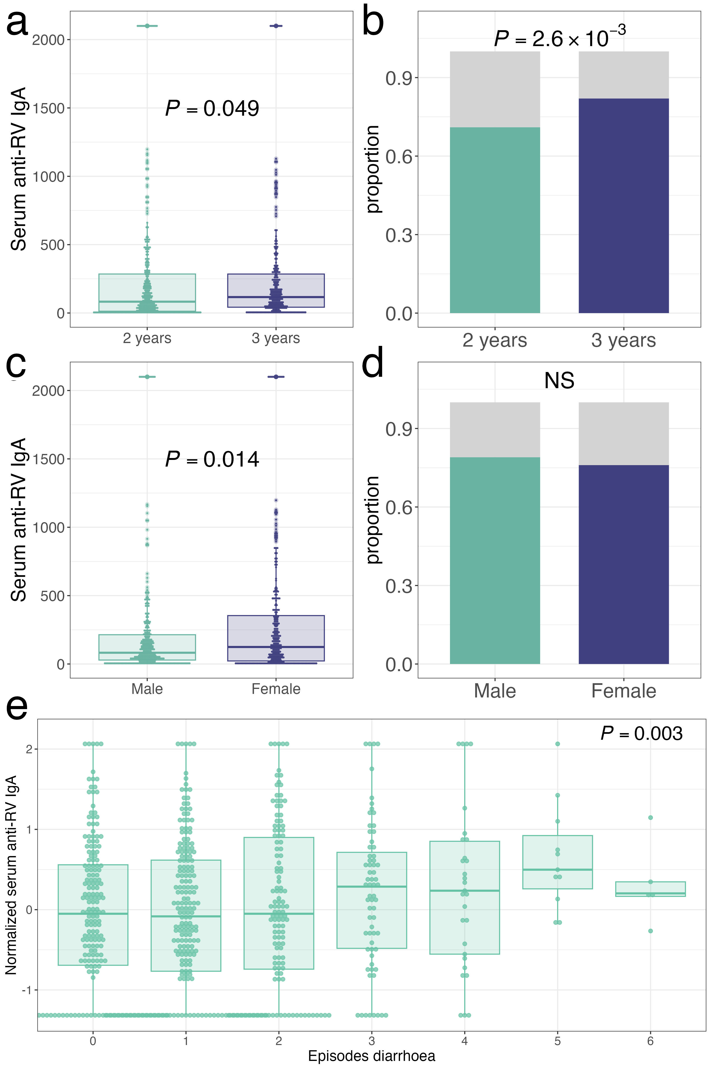
Supplementary Figure 1. Serum anti-RV IgA levels in Ugandan children a, Distribution of serum anti-RV IgA levels in Ugandan children aged 2-3 years. Children sampled at 3 years of age have higher anti-RV IgA levels (median 117 IU/ml) than do those sampled at 2 years (median 83 IU/ml). b, The proportion of children with serum anti-RV IgA seropositivity is greater at the age of 3 years (82%) than it is at 3 years (72%). C, Distribution of serum anti-RV IgA levels in Ugandan children aged 2-3 years. Female donors had higher levels of serum anti-RV IgA (median 124 IU/ml) than did male donors (median 82 IU/ml) d, The proportion of children with serum anti-RV IgA seropositivity is not modified by sex (79% male, 76% female). e, Levels of serum anti-RV IgA at 2-3 years are associated with the number of episodes of doctor-diagnosed diarrhoea in the first year of life. Throughout, Boxes depict the upper and lower quartiles of the data, and whiskers depict the range of the data excluding outliers (data-points >1.5x the interquartile range from the upper or lower quartiles).

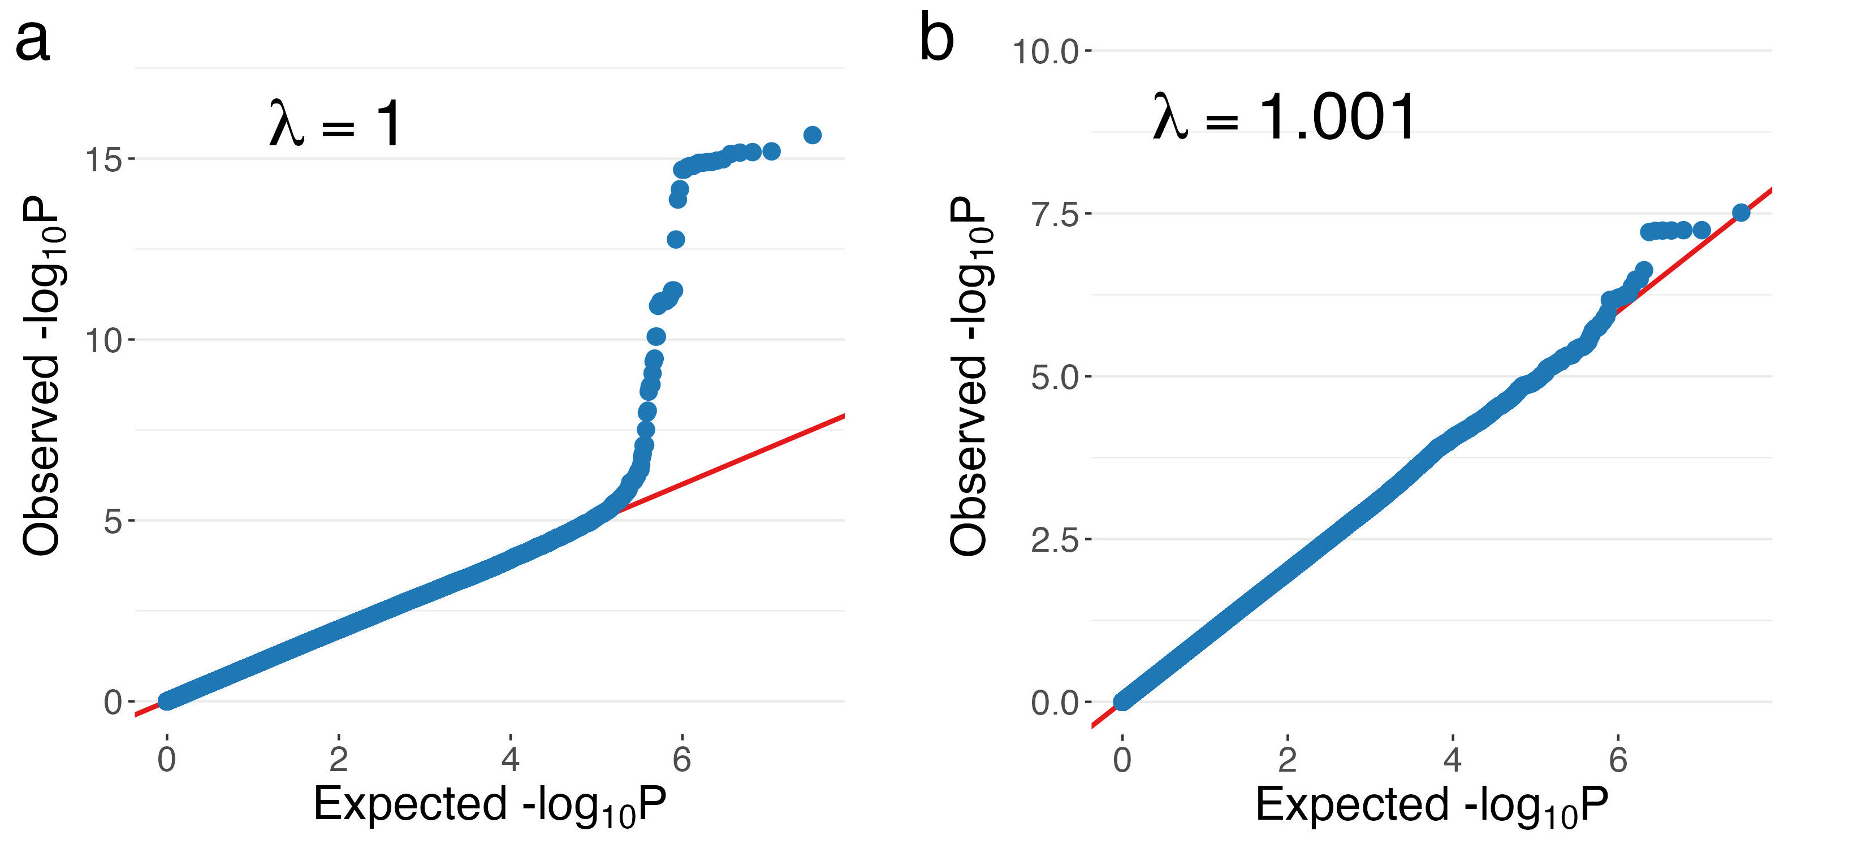
Supplementary Figure 2. Genomic inflation for RV immunity and disease genome-wide association studies. a, QQ plot of genome-wide association of serum anti-rotavirus (RV) IgA in Ugandan children aged 2 and 3 years prior to rotavirus vaccine rollout (n=611). Each point represents the observed association with anti-RV IgA against that expected under the null at each SNP passing quality control (n=16,394,501). b, QQ plot of genome-wide association of RV disease risk in Kenyan children prior to rotavirus vaccine rollout (554 cases, 1,556 controls). Each point represents the observed association with RV disease risk against that expected under the null at each SNP passing quality control (n=15,415,726).
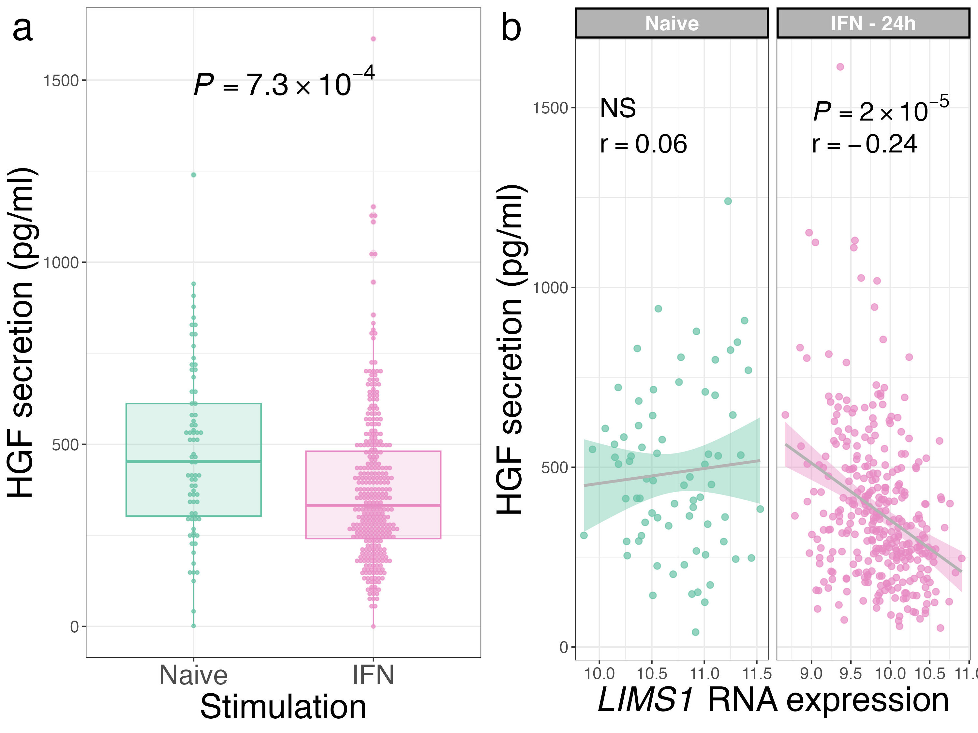
Supplementary Figure 3. Hepatocyte growth factor secretion in IFNγ-stimulated monocytes. a, Hepatocyte growth factor (HGF) secretion after 24 hours of incubation is down-regulated in the presence of IFNγ. P-values are calculated by linear regression. Boxes depict the upper and lower quartiles of the data, and whiskers depict the range of the data excluding outliers (data-points >1.5x the interquartile range from the upper or lower quartiles). b, Correlation between LIMS1 RNA expression and HGF secretion in naïve (left) and IFNγ-stimulated monocytes (right). Statistics represent Pearson’s correlations.
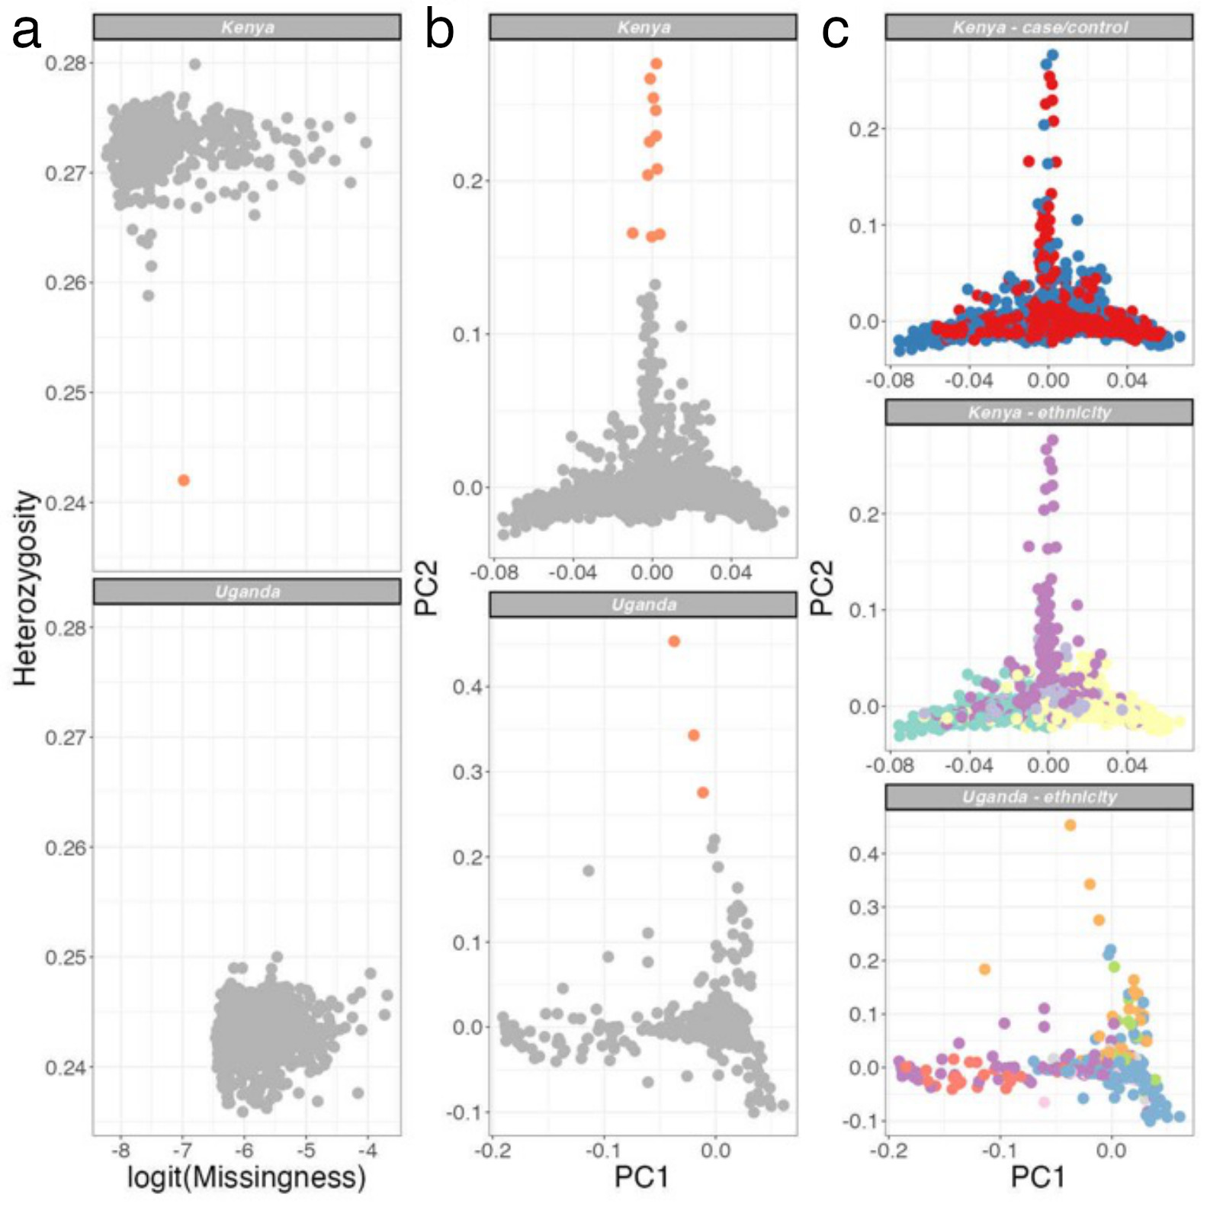
Supplementary Figure 4. Quality control of study samples. a, Plots of study sample heterozygosity and missingness in Kenyan case samples (n=596, top) and Ugandan samples (n=1,391, bottom). Excluded outlier samples (n=1 Kenyan sample) are highlighted in orange. b, Plots of the major two principal components (PC) of genotyping data in Kenyan case and control samples (n=2,207, top) and Ugandan samples (bottom). Excluded outlier samples (10 Kenyan samples, 3 Ugandan samples) are highlighted in orange. c, The major PCs of genotyping data plotted with respect to: case/control status (cases, red; controls, blue) in Kenyan samples (top), self-reported ethnicity (Chonyi, green; Giriama, yellow; Kauma, blue/grey; Other, purple) in Kenyan samples (middle), and self-reported ethnicity (Luo, red; Muganda, blue; Munyankole, orange; Munyarwanda, green; Musoga, pink; Mutoro, grey; Other, purple) in Ugandan samples (bottom).

