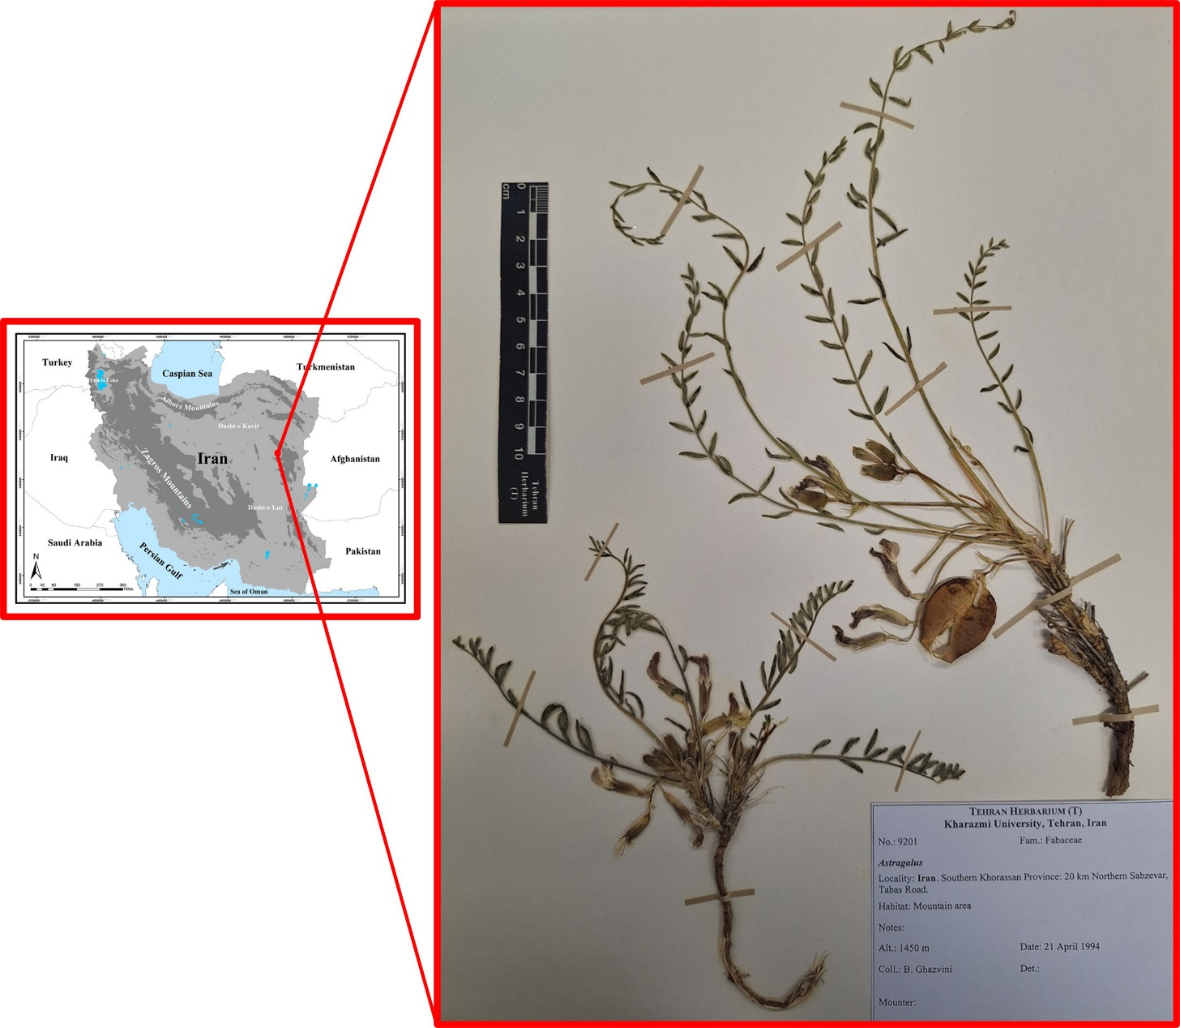
Fig. 1 Holotype and Distribution map in Iran (Southern Khorassan Province) of Astragalus kharazmii F.Ghahrem., Maassoumi & Alirezaei (B. Ghazvini 9201, T).

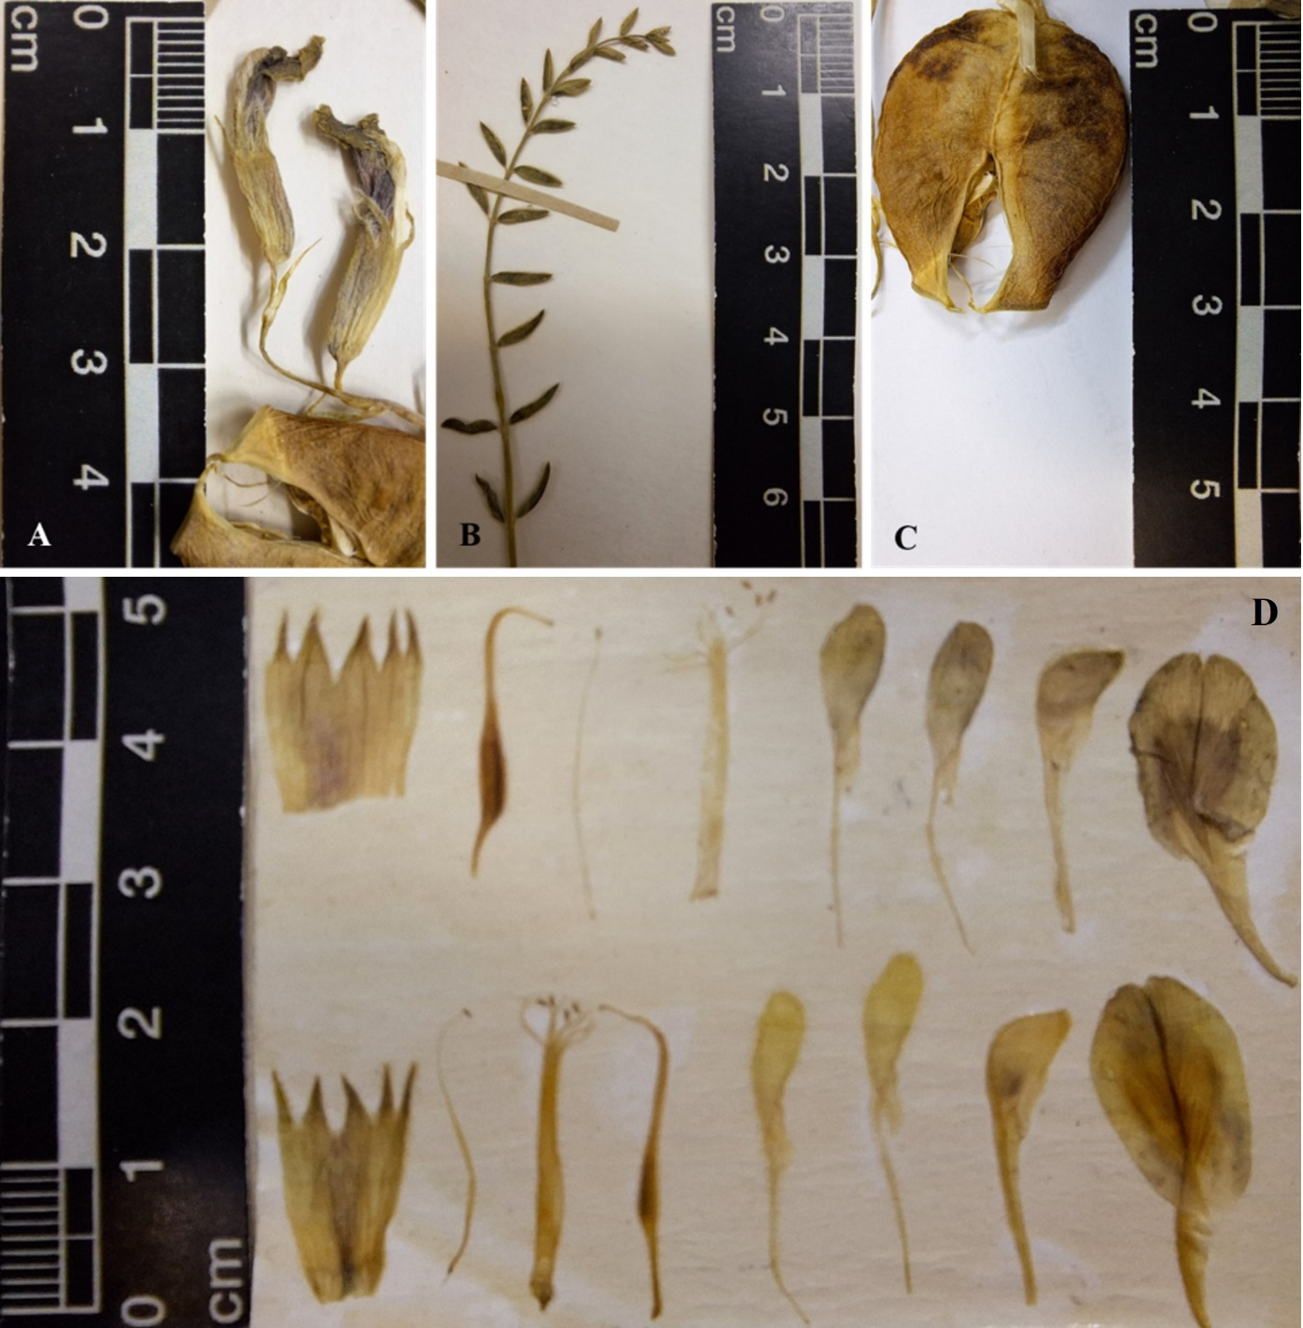
Fig. 2 Holotype of Astragalus kharazmii F.Ghahrem., Maassoumi & Alirezaei (B. Ghazvini 9201, T). A. Inflorescence, B. Leaf, C. Legume, D. Floral parts of a dissected flower include the calyx, standard, keel, wings, stamens, and pistil.

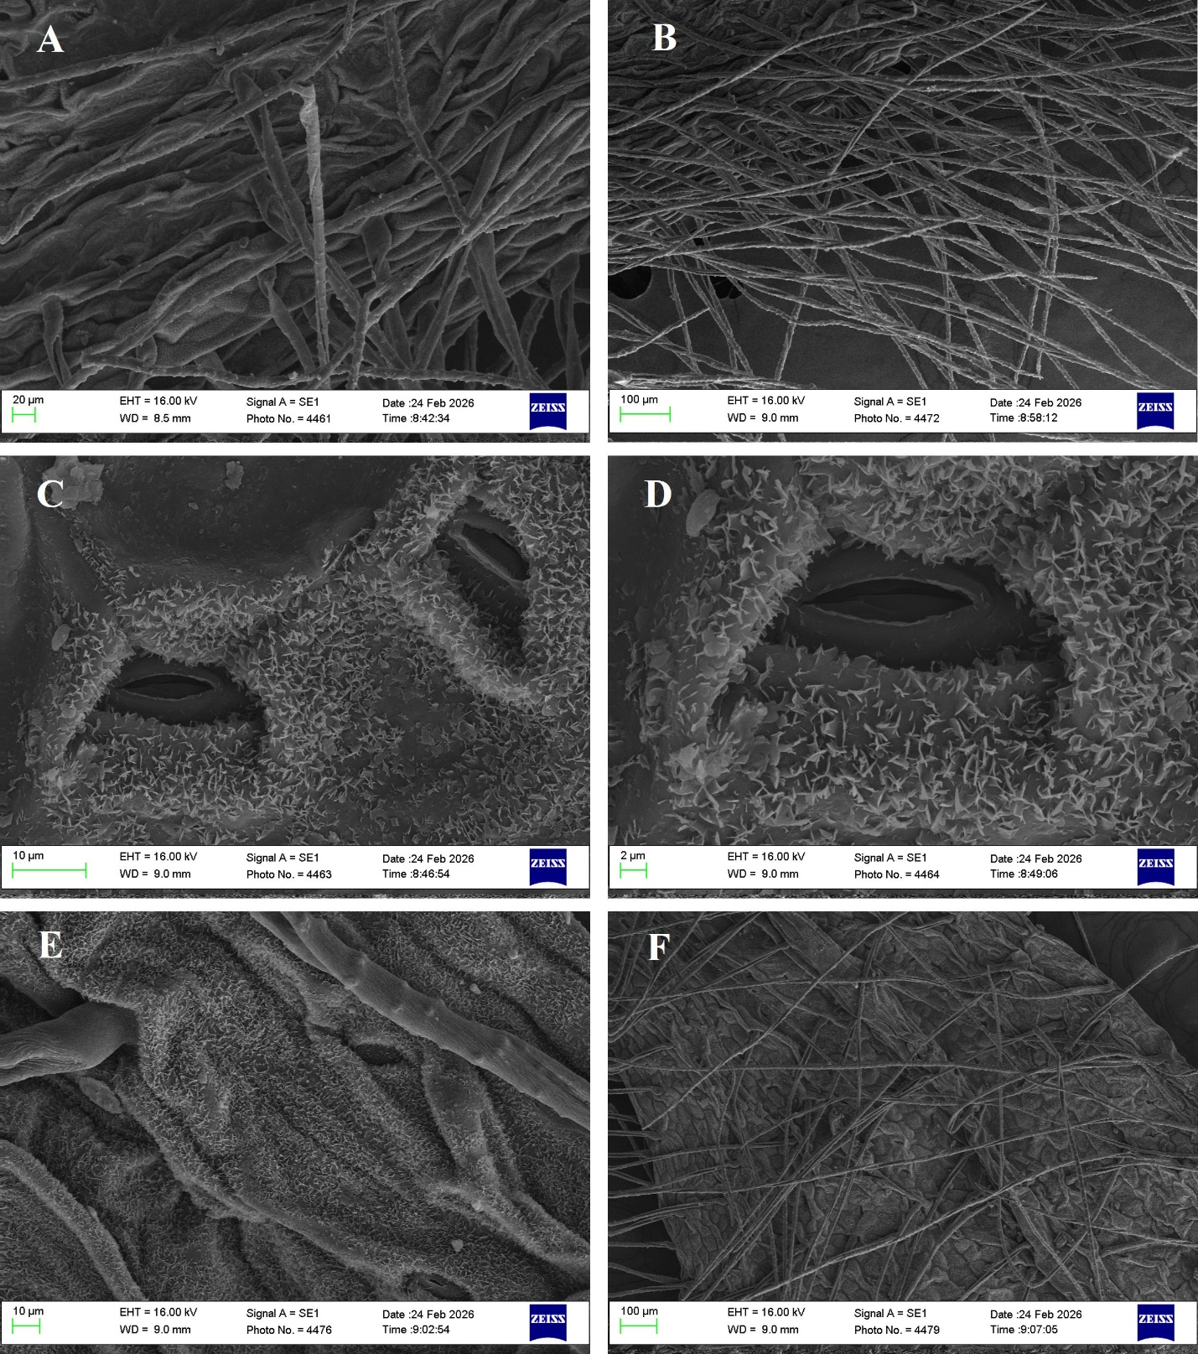
Fig. 3 Scanning electron microscopy (SEM) images of Astragalus kharazmii, A, B: leaf trichomes; C, D: stomata and leaf trichomes; E, F: calyx trichomes.

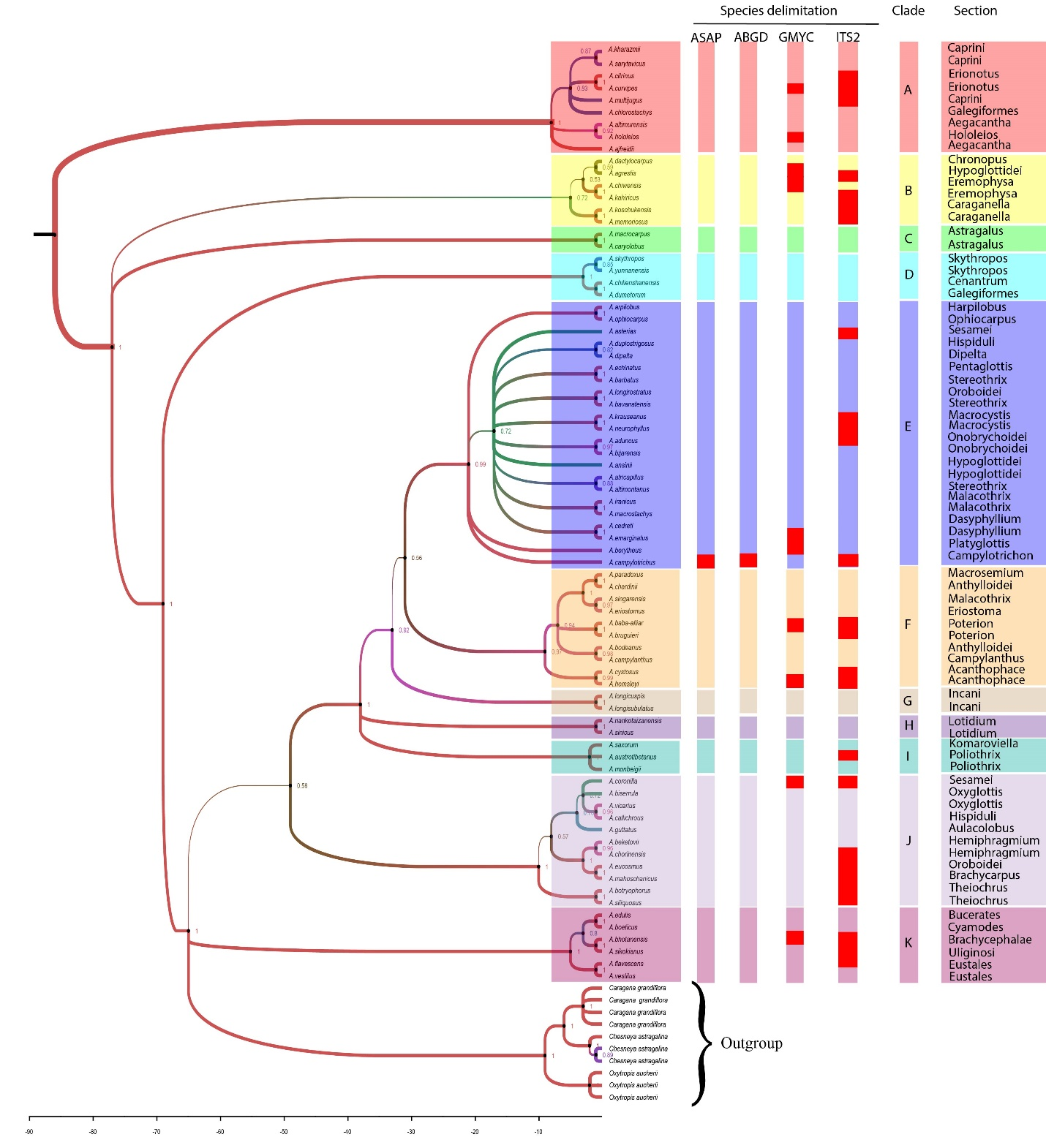
Fig. 4 Bayesian phylogenetic tree of Astragalus species based on nuclear ITS sequences. Bootstrap values are shown at branch points; values greater than 50 % were considered significant. Major clades (A–K) are indicated, and species delimitation results inferred by ASAP, ABGD, GMYC, and ITS2 analyses are summarized alongside the phylogeny.

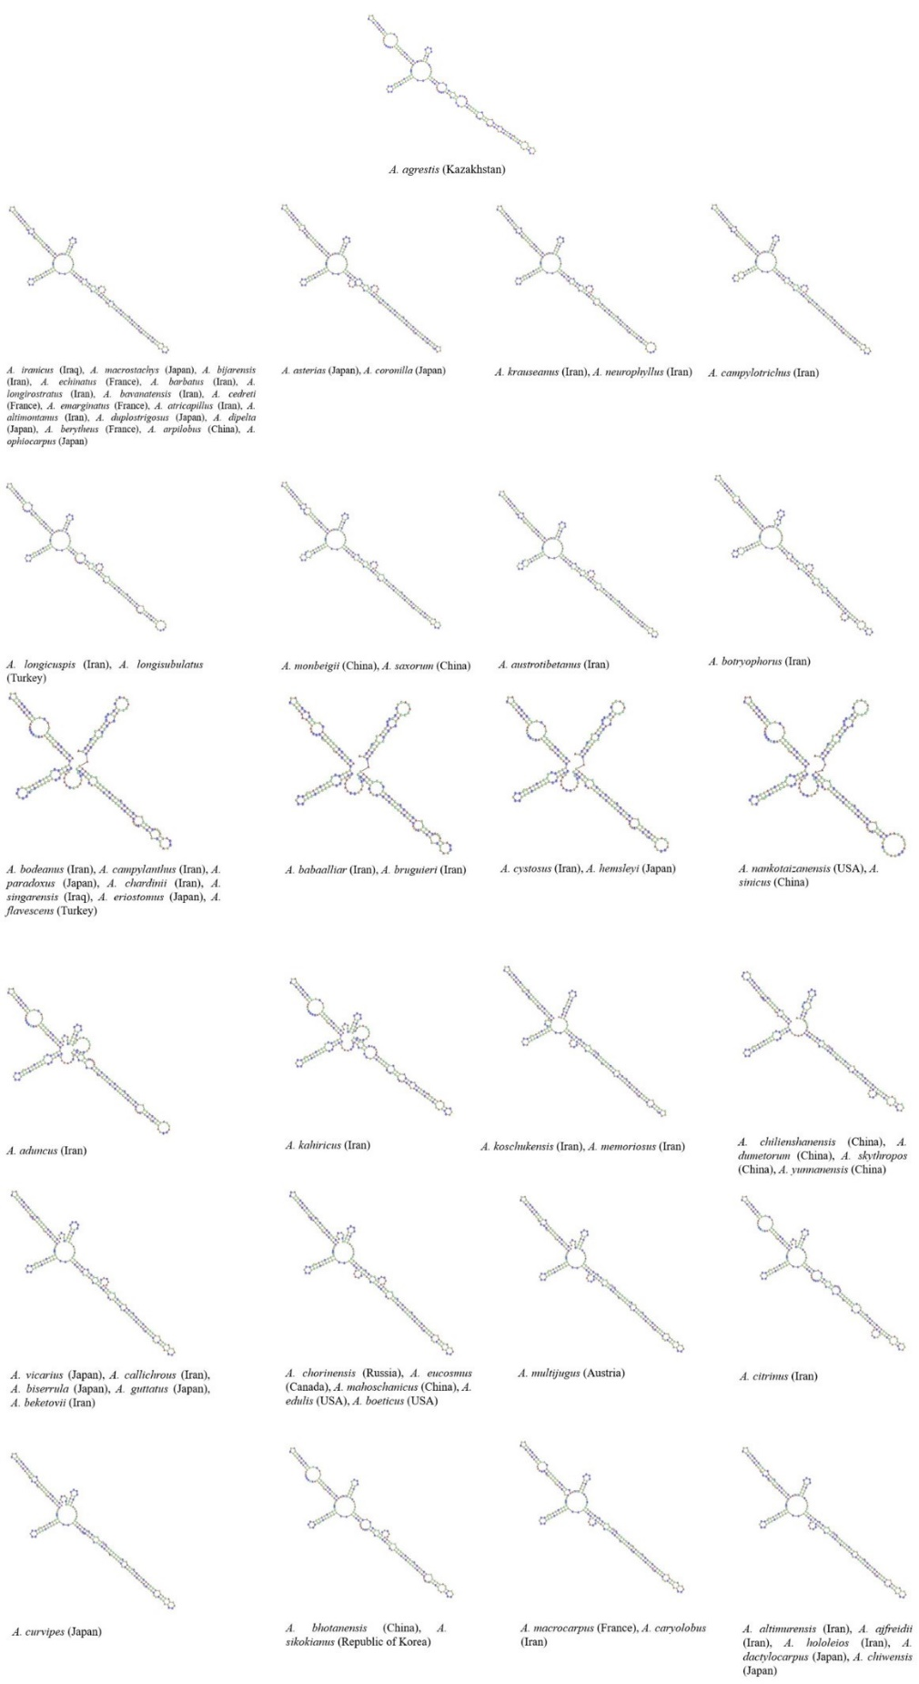
Fig. 5 Secondary structure of the ITS2 region in Astragalus species. The predicted structures show variations in helix length and unpaired bases among different taxa.
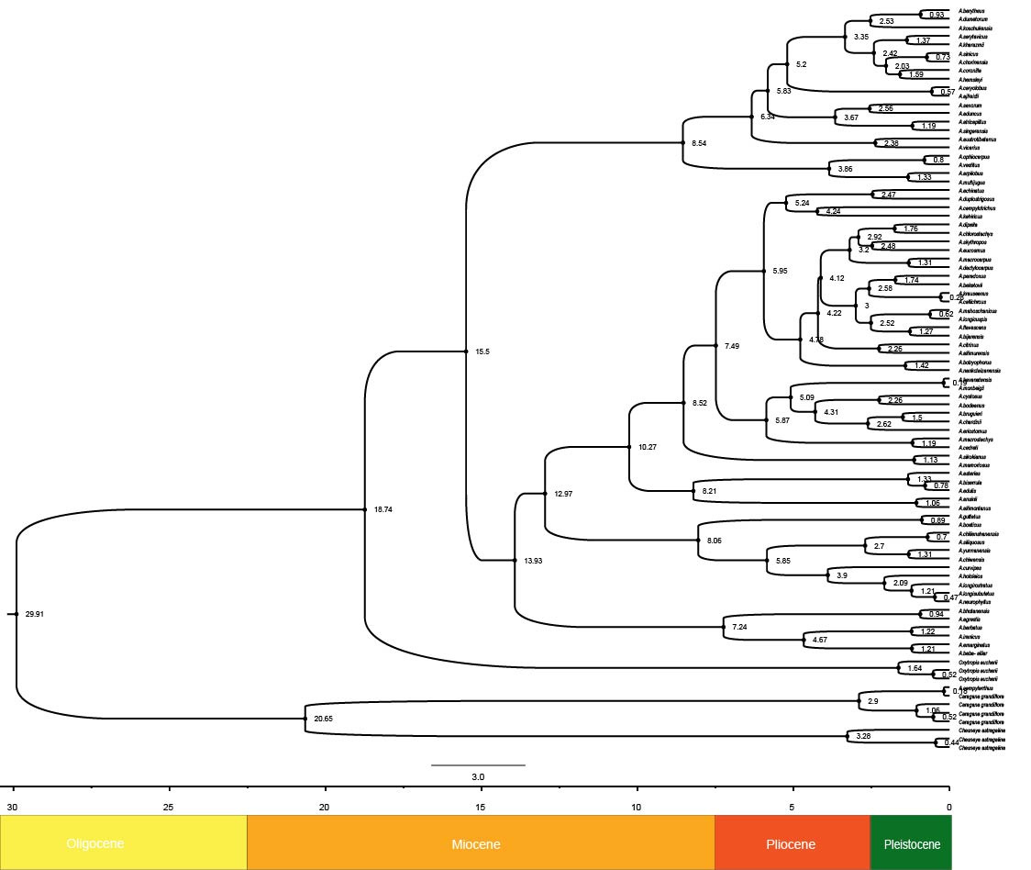
Fig. 6 Divergence time phylogenetic tree of Astragalus species inferred using a Bayesian relaxed-clock analysis. Numbers at internal nodes indicate the estimated divergence times (Ma).

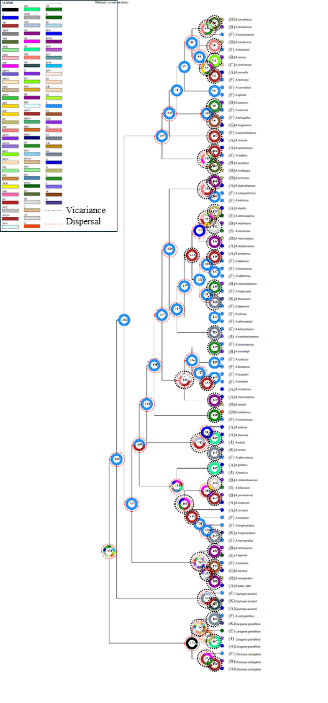
Fig. 7 Ancestral area reconstruction of Astragalus inferred using RASP. Pie charts indicate the relative probabilities of ancestral areas, whereas coloured circles represent the present-day geographic distribution of each species. Geographic regions: Japan (A), China (B), Russia (C), Korea (D), Kazakhstan (E), Iran (F), Iraq (G), Europe (H), Canada (I), the USA (J), and Turkey (K).
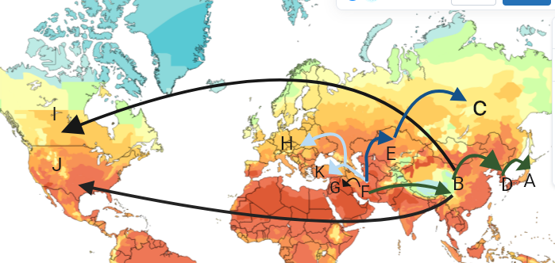
Fig. 8 Schematic representation of the hypothesized dispersal routes of the sampled Astragalus lineages inferred from ancestral area reconstruction using S-DIVA. Arrows indicate the inferred directions of lineage dispersal among the reconstructed ancestral areas.

