Supplementary Information for
Microcomb-driven parallel coherent detection and communication enabled by a power-free optical phased array
Shi Zhao^{1,†}, Jingyu Zhao^{1,†}, Wenke Jiao¹, Jingye Chen^{1,*}, Daixin Lian¹, Yongqi Ye¹, Zhe Kang^{2,*}, Jijun He², Dongmei Huang³, Daixin Dai¹, and Yaocheng Shi^{1,*}
¹State Key Laboratory for Extreme Photonics and Instrumentation, Center for Optical and Electromagnetic Research, International Research Center for Advanced Photonics, College of Optical Science and Engineering, Zhejiang University, Hangzhou 310058, China
²National Key Laboratory of Microwave Photonics, Nanjing University of Aeronautics and Astronautics, Nanjing 210016, China
³Photonics Research Institute, Department of Electrical and Electronic Engineering, The Hong Kong Polytechnic University, Kowloon, Hong Kong SAR, China
† These authors contributed equally to this work
* To whom correspondence should be addressed: jingyechen@zju.edu.cn (J. C.); zhe.kang@nuaa.edu.cn (Z. K.); yaocheng@zju.edu.cn (Y. S.)

This PDF file includes:
- Supplementary notes (Notes 1-5)
- Supplementary information figures (Figs. S1-S8)
- Supplementary references

SUPPLEMENTARY NOTE 1: Principle of two-dimensional beam steering
In the horizontal direction (θ_{x}) and vertical direction (θ_{y}), the beam angle is determined by the wavelength-dependent phase gradient and grating dispersion respectively. The equations are as follows:
(1)
where λ is the working wavelength, P is the pitch between adjacent antennas, Λ is the grating period of antenna, n_{eff}(λ) is the effective index of the guiding mode and q is an integer such that (n_{eff}(λ)·ΔL/λ+q) ∈ [-1/2,1/2].
By differentiating both sides of Eq. 1 with respect to wavelength and applying an approximation, the wavelength tuning efficiencies in two dimensions are obtained as follows:
(2)
From the above equations, it can be found that once the chip platform is selected, the wavelength tuning efficiency in the vertical direction is largely determined, while in the horizontal direction, it can be adjusted via the waveguide length difference ΔL. Generally, since ΔL is much larger than P, the wavelength tuning efficiency in the horizontal direction is faster than that in the vertical direction, which is thus referred to as the fast axis direction. Given the wavelength range of the light source, a larger ΔL results in a smaller beam scanning slope, enabling a greater number of far-field lines and addressable spots. Here the ΔL and P are selected as 78.8 μm and 4 μm to ensure spectral-spatial matching between the OPA and the microcomb.
Given that the dispersive OPA is a passive device, the beam quality cannot be optimized via external control system. Hence, it is crucial to minimize the random phase errors of the waveguide delay lines. The calculated effective index sensitivities to core width for 300 nm-thick SiN platform are shown in Fig. S1. As the waveguide width increases, the effective index grows at a decelerating rate and eventually saturates, approaching the effective index of the slab mode. Consequently, the sensitivity of the effective index to width variations decreases with wider waveguides. A width of 2 μm represents an optimal trade-off between the density of arrayed waveguides and the sensitivity of the effective index.

SUPPLEMENTARY NOTE 2: Far-field beam characterization
The light source is a tunable laser (Agilent 81640A) with wavelength range from 1510 to 1640 nm. The schematic diagram of far-field beam measurement setup is shown in Fig. S2a. The OPA chip is placed in the center of the rotating table. A polarization controller (PC) is introduced to match the polarization states of laser source and guide mode in waveguide. A charge-coupled device (CCD, Hamamatsu C14041-10U) is used to capture the far-field pattens. An infrared lens is installed on the CCD, providing a total field of view of approximately 14°, which is sufficient to cover the vertical direction. To capture the horizontal direction, the CCD is rotated in 5° intervals for separate recordings. These individual captures are then stitched together to reconstruct the entire far-field pattern of the beam. The far-field of each beam is recorded independently, and then overlapped to generate the final composite images, as shown in Figs. 2(c) and 2(d). The measured far-field distributions of 1576.8 nm in orthogonal directions are shown in Figs. S2b and S2c. The beam divergences are 0.32° and 0.15°. The measured SLSR in the horizontal direction is 10.4 dB.

SUPPLEMENTARY NOTE 3: Chirp linearity calibration
The nonlinear dependence of the VCO's output RF frequency on its drive voltage means that a triangular waveform signal from the AFG produces a nonlinear frequence sweep of laser, as shown in Fig. S3c. Therefore, linearity calibration is required to improve the ranging accuracy. The schematic of chirp linearization setup is shown in Fig. S3a. In the initial state, the AFG (SIGLENT SDG6012X-E) outputs a triangular wave. The beat signal is then acquired from the oscilloscope (Keysight DSO7032B). The instantaneous frequency f(t_{i}) at different time points within one cycle is computed using the Hilbert transform. The calculated frequency is compared against the ideal triangular waveform to generate a refined voltage sequence u(t) according following equation¹:
(3)
where B is the chirp bandwidth and T is the period of the triangular waveform. As illustrated in Fig. S3b, the root-mean-square (RMS) frequency deviation diminishes with successive iterations, attaining 1.58 MHz at the 10th iteration. The calibrated chirp frequency waveform is shown in Fig. S3d. The frequency modulation nonlinearity is calculated to be 5.997×10⁻⁶ by following equation²:
(4)
where f_{d}(t) is the desired linear chirp.

SUPPLEMENTARY NOTE 4: Microcomb and parallel beams
The schematic of microcomb generation setup is shown in Fig. S4a. The microcomb is generated based on a microring resonator (MRR) with a radius of 229 μm and corresponding to the free spectral range of 101.3 GHz, as shown in Fig. S4b. The pump seed light is amplified to 200 mW by EDFA and then coupled into the coupling waveguide of the SiN MRR via a lensed fiber. The coupling loss is 4.5 dB/facet. A BPF is introduced between EDFA and MRR to filter out the amplified spontaneous emission and improve the signal-to-noise ratio. The pump seed light is swept from the blue-detuned side to the effective red-detuned side of the cavity resonance. The measured microcomb spectra under different states are shown in Fig. S4c.
The schematic of the microcomb generator and parallel beams imaging setup is shown in Fig. S5a. After being coupled out from MRR chip, a FBG filter is used to filter out the residual pump light. The output light is then split into two paths by a 3 dB beam splitter. One path is connected to an OSA to observe the output spectrum, while the other path is injected to the dispersive OPA, and the far-field pattern is recorded by a CCD. The measured single soliton spectrum is shown in Fig. S5b. The sech² fitting curve confirm the single soliton signature of the microcomb. Figure S5c is the far-field pattern recorded by the CCD in a single exposure, containing more than 40 distinguishable beams within the monitored field of view. The step sizes between adjacent beams are both 1.1° in orthogonal directions.

SUPPLEMENTARY NOTE 5: Parallel comb teeth modulation
To characterize parallel comb teeth modulation, the output of microcomb chip is first split into two paths in a 99:1 ratio. The minor portion is directly recorded by OSA as the spectrum without modulation, while the major portion is passed through a SSB and then recorded by OSA as the spectrum after modulation. The measured results are shown in Fig. S6b. The frequency shift of all comb teeth is identical to the frequency of applied radio frequency signal, which is 11.8 GHz. The 35 comb teeth within the gray background area in Fig. S6b are selected for parallel detection demonstration.

SUPPLEMENTARY INFOTMATION FIGURES
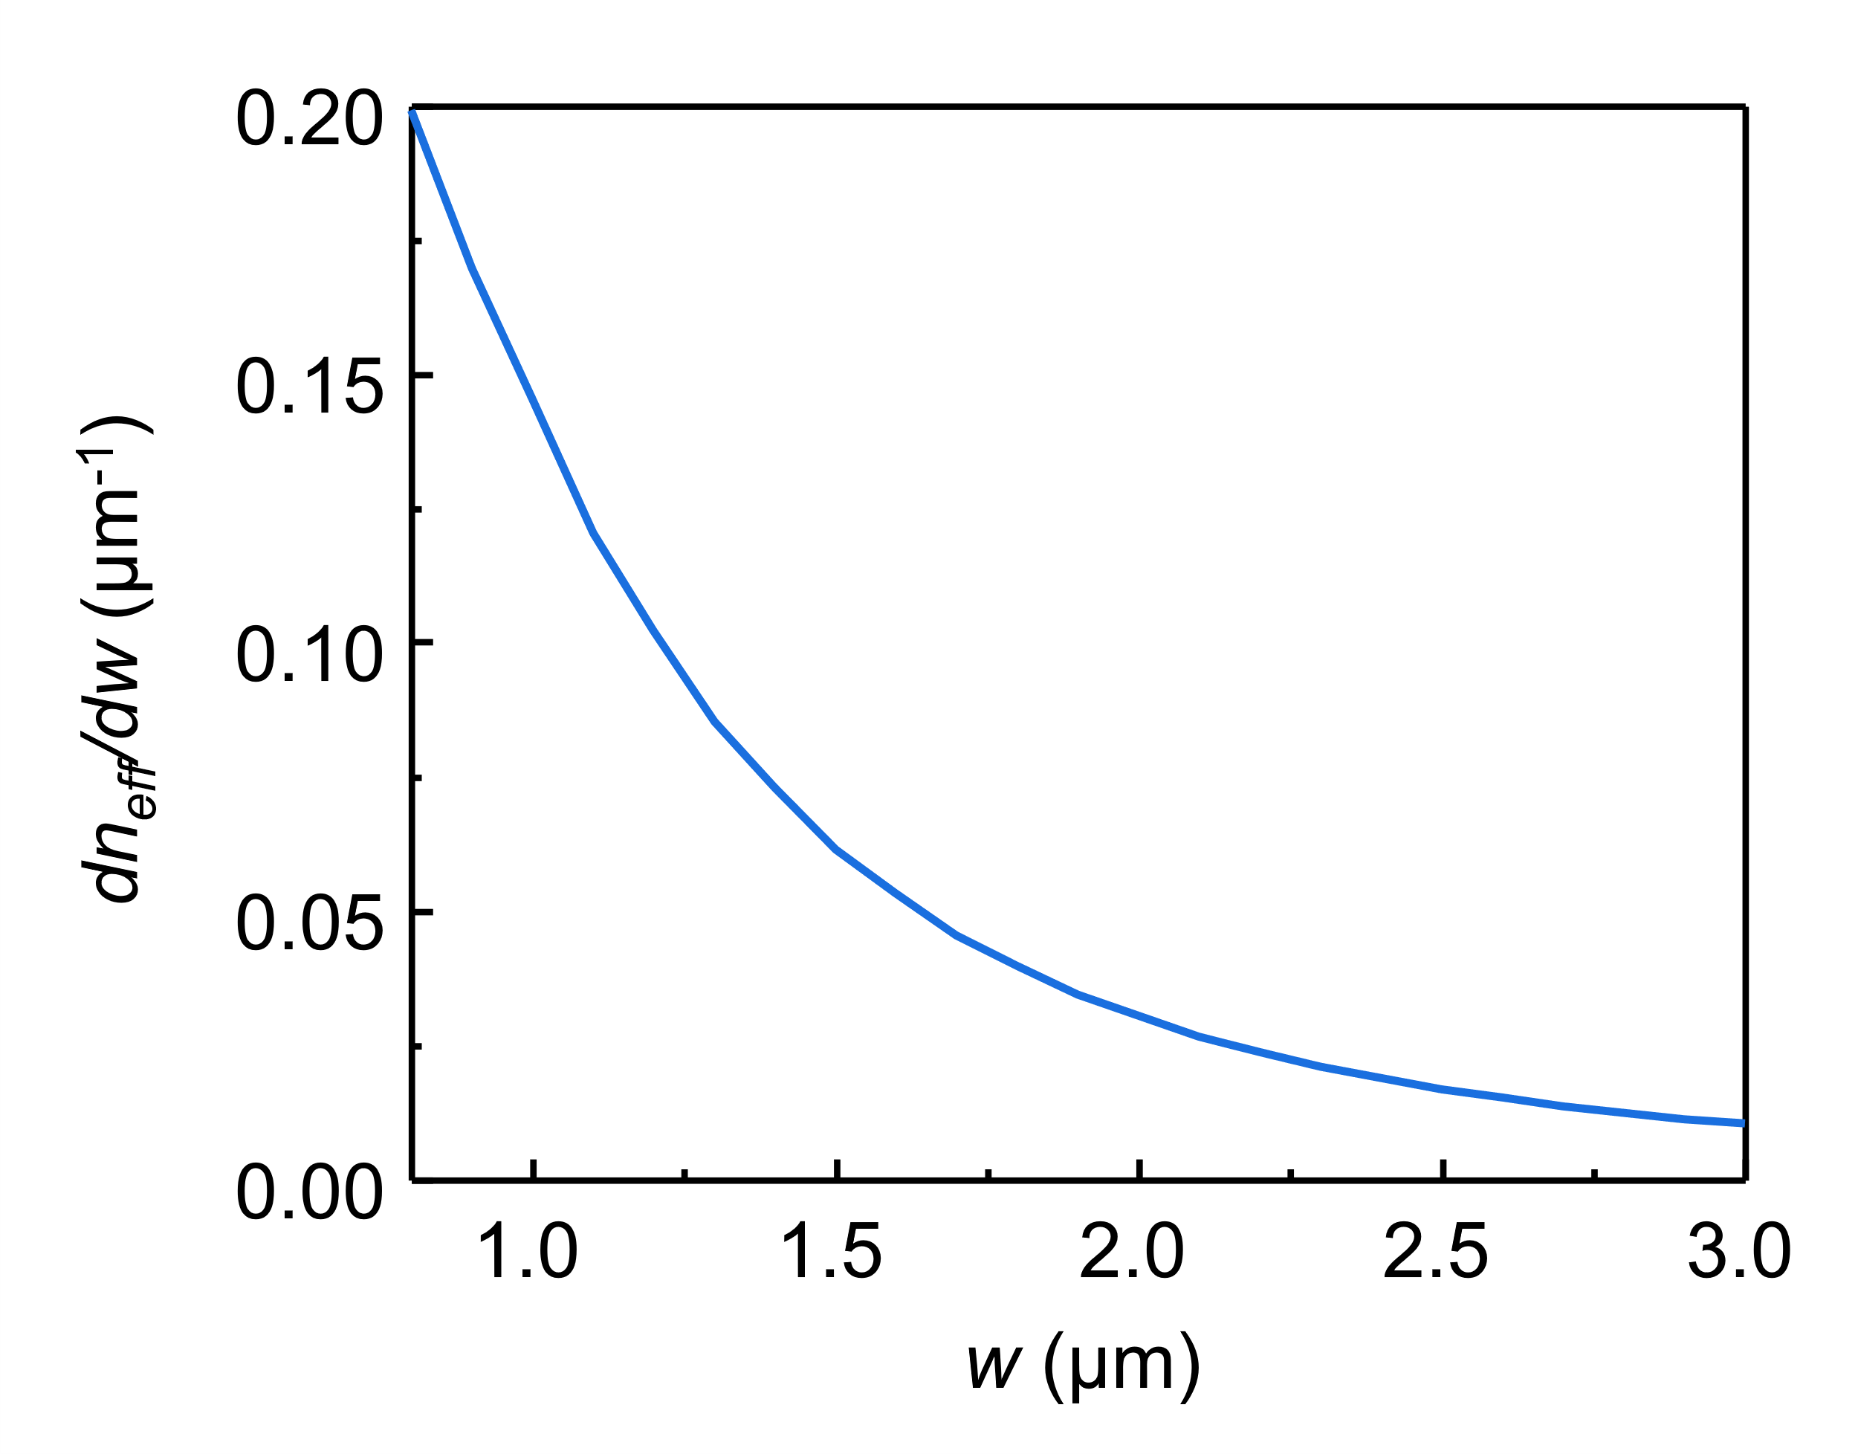
Fig. S1 Calculated effective index sensitivities to core width.

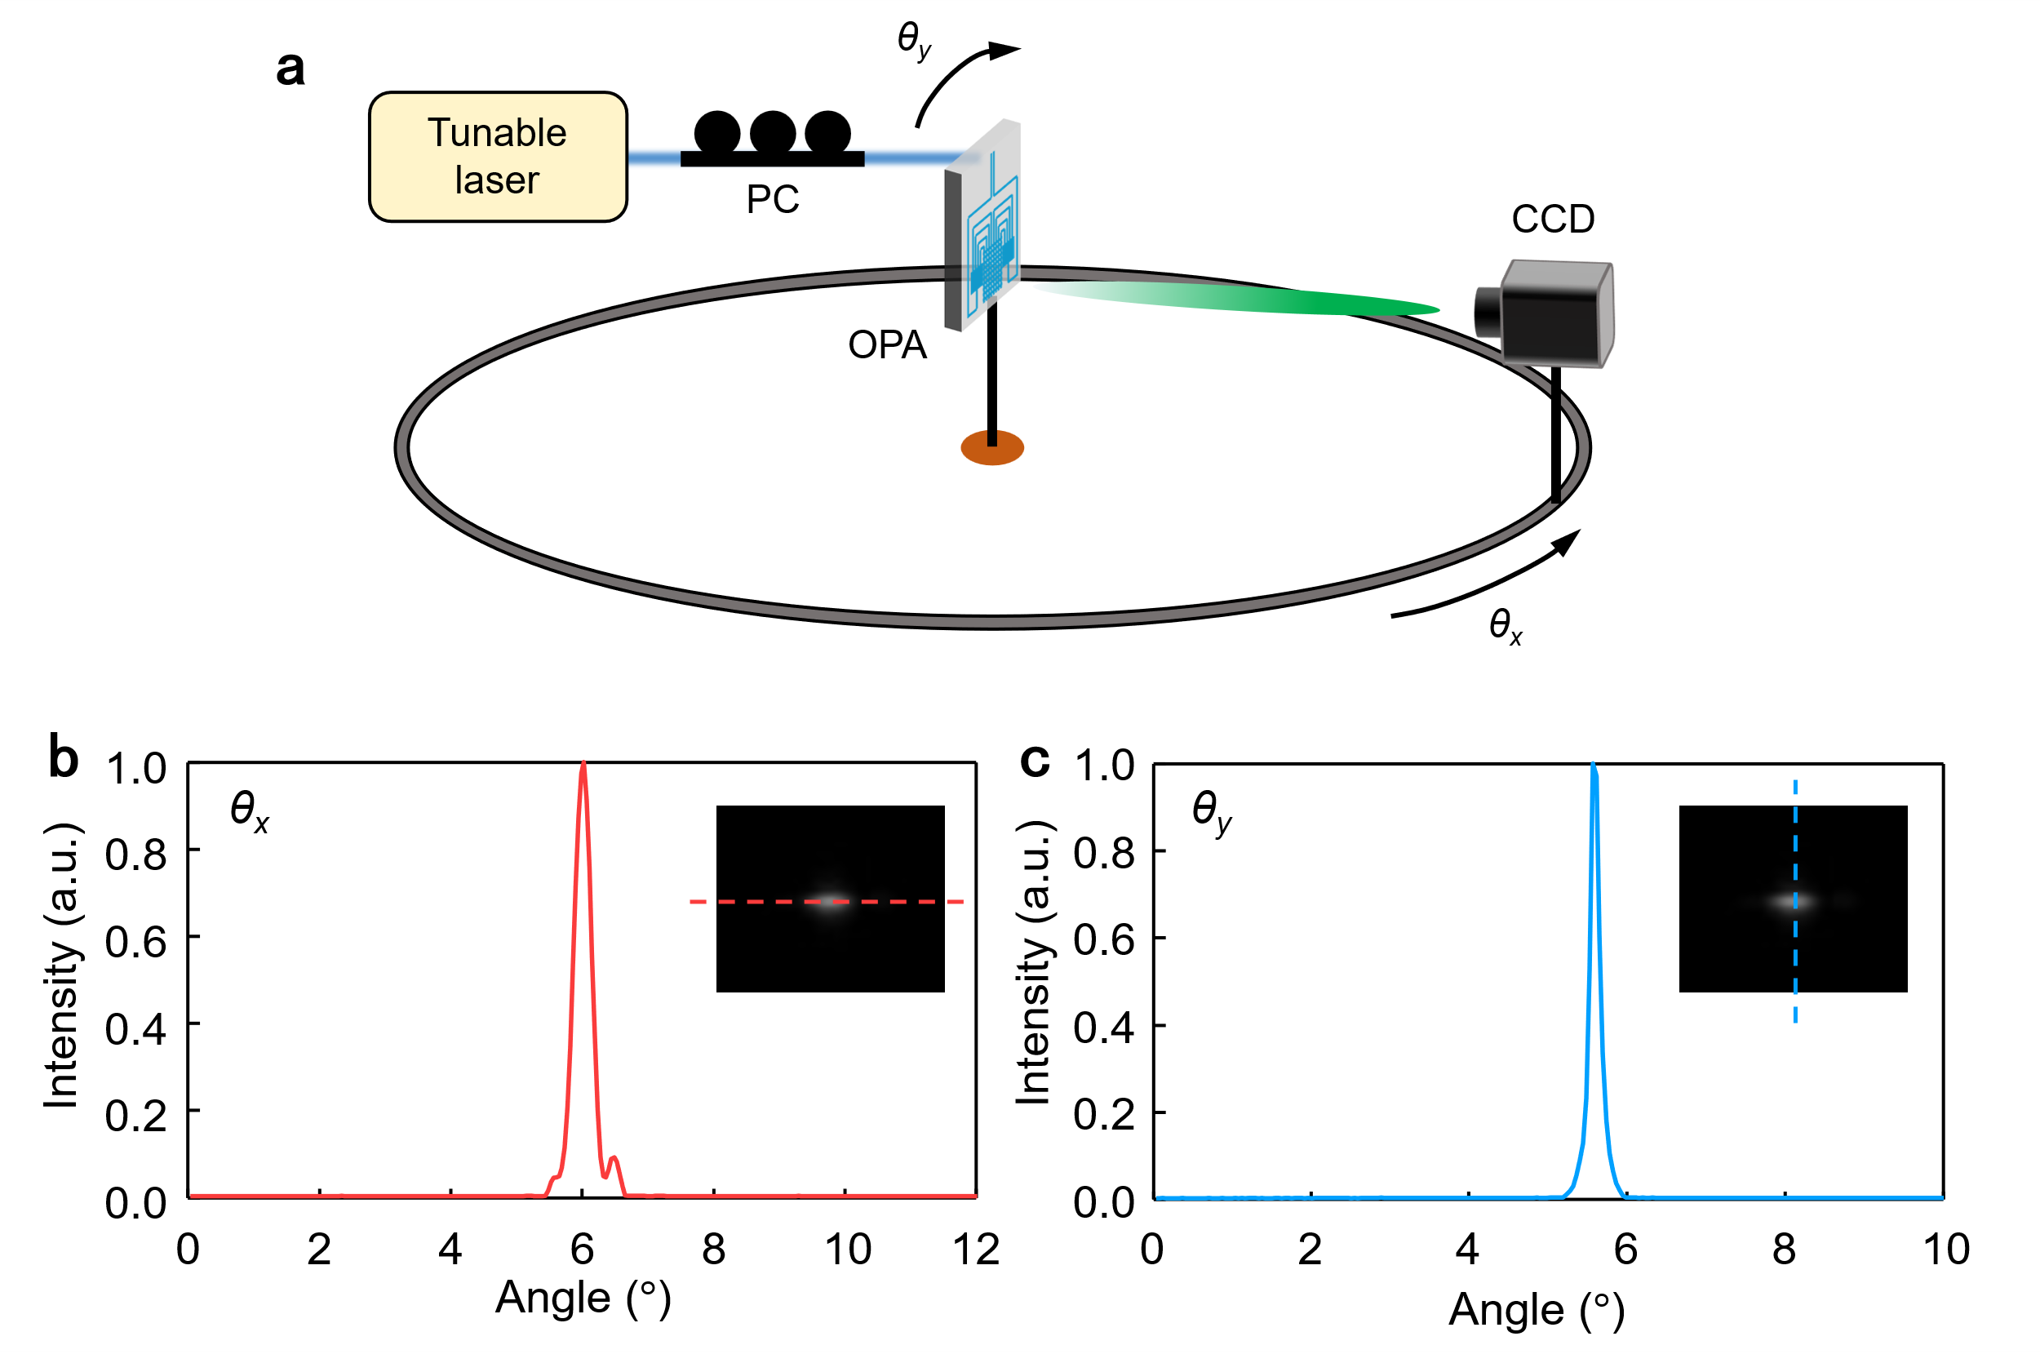
Fig. S2 Far-field beam characterization. (a) Schematic diagram of far-field beam measurement setup. The measured far-field distribution in (b) horizontal direction and (c) vertical direction with wavelength of 1576.8 nm. The inset in (b) and (c) is the corresponding far-field image.

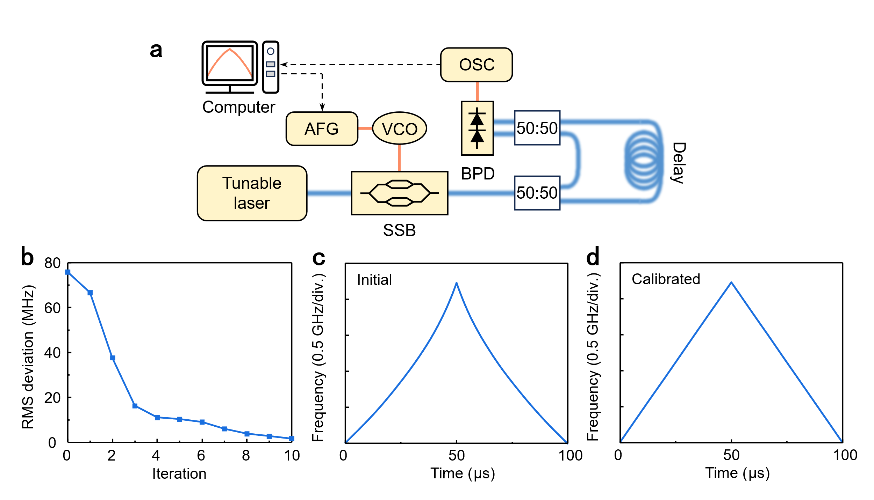
Fig. S3 Chirp linearity calibration. (a) Schematic of chirp linearization setup. (b) Evolution of the root-mean-square frequency deviation. The (c) initial and (d) calibrated chirp frequency waveforms.

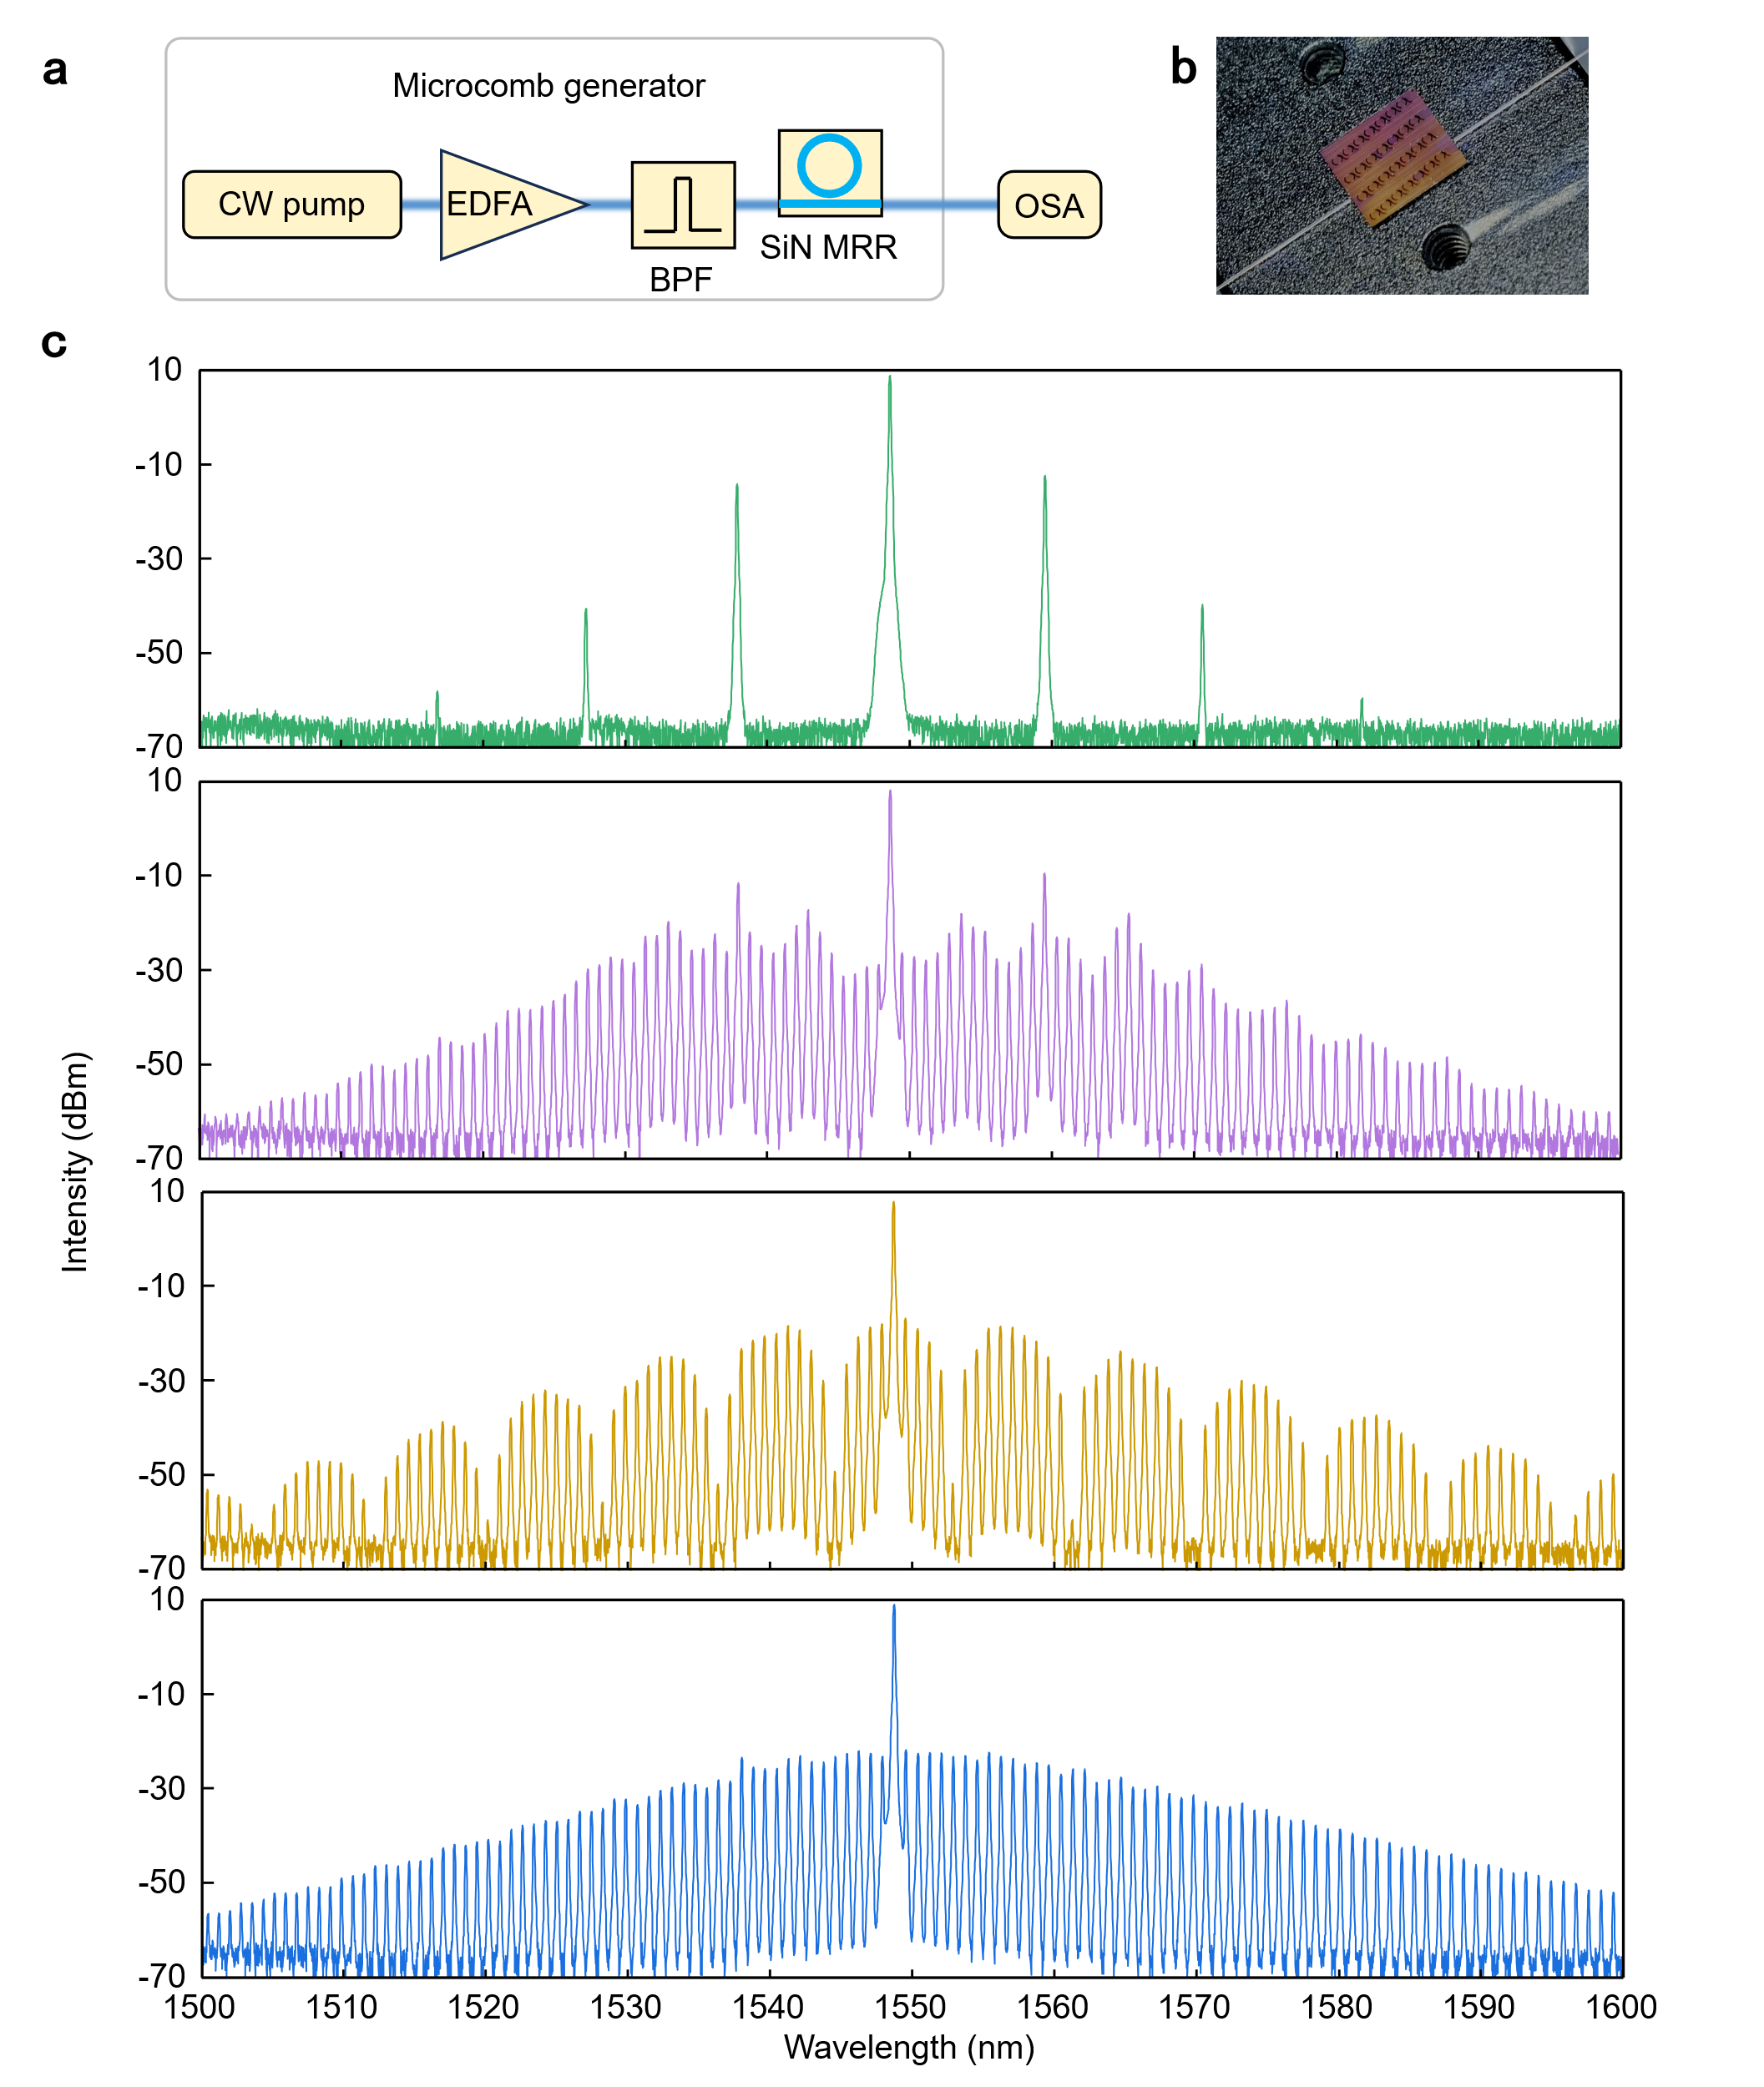
Fig. S4 Microcomb generation. (a) Schematic of microcomb generation setup. (b) The microscope image of the SiN microcomb chip under test. (c) The measured spectra of microcomb.

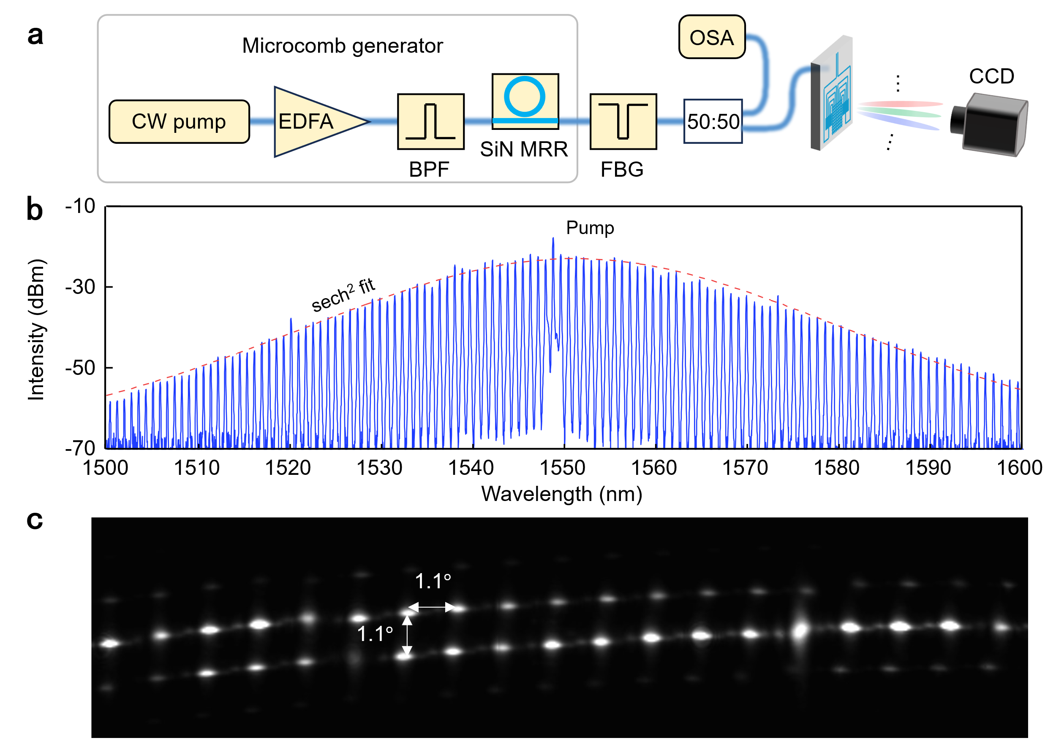
Fig. S5 Characterization of parallel optical beams. (a) Schematic of the microcomb generator and parallel beams imaging setup. (b) Measured spectrum of the single soliton microcomb. (c) Far-field image of the parallel beams.

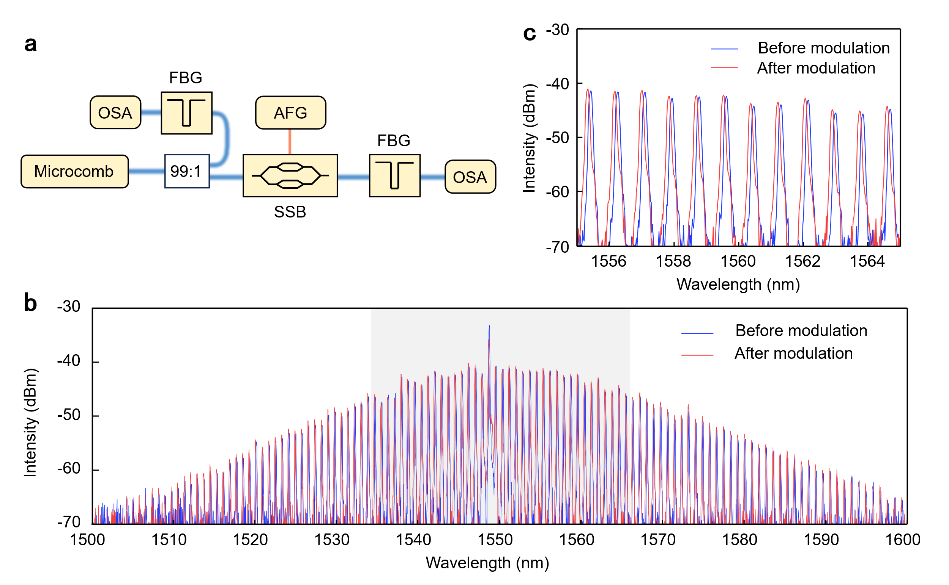
Fig. S6 Parallel comb teeth modulation. (a) Schematic of the parallel comb teeth modulation setup. (b) Measured microcomb spectra before and after modulation, comb teeth in the gray background area are used for parallel detection. (c) Measured microcomb spectra near 1560 nm.
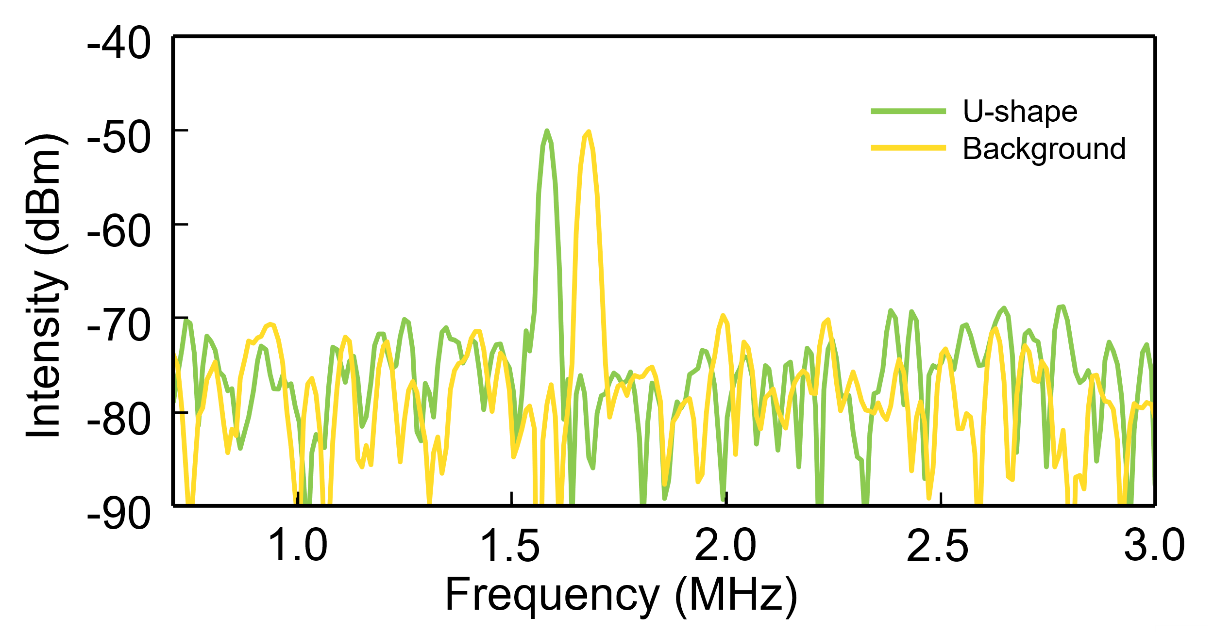
Fig. S7 Beat signal spectra with beam incident on U-shape and background respectively.

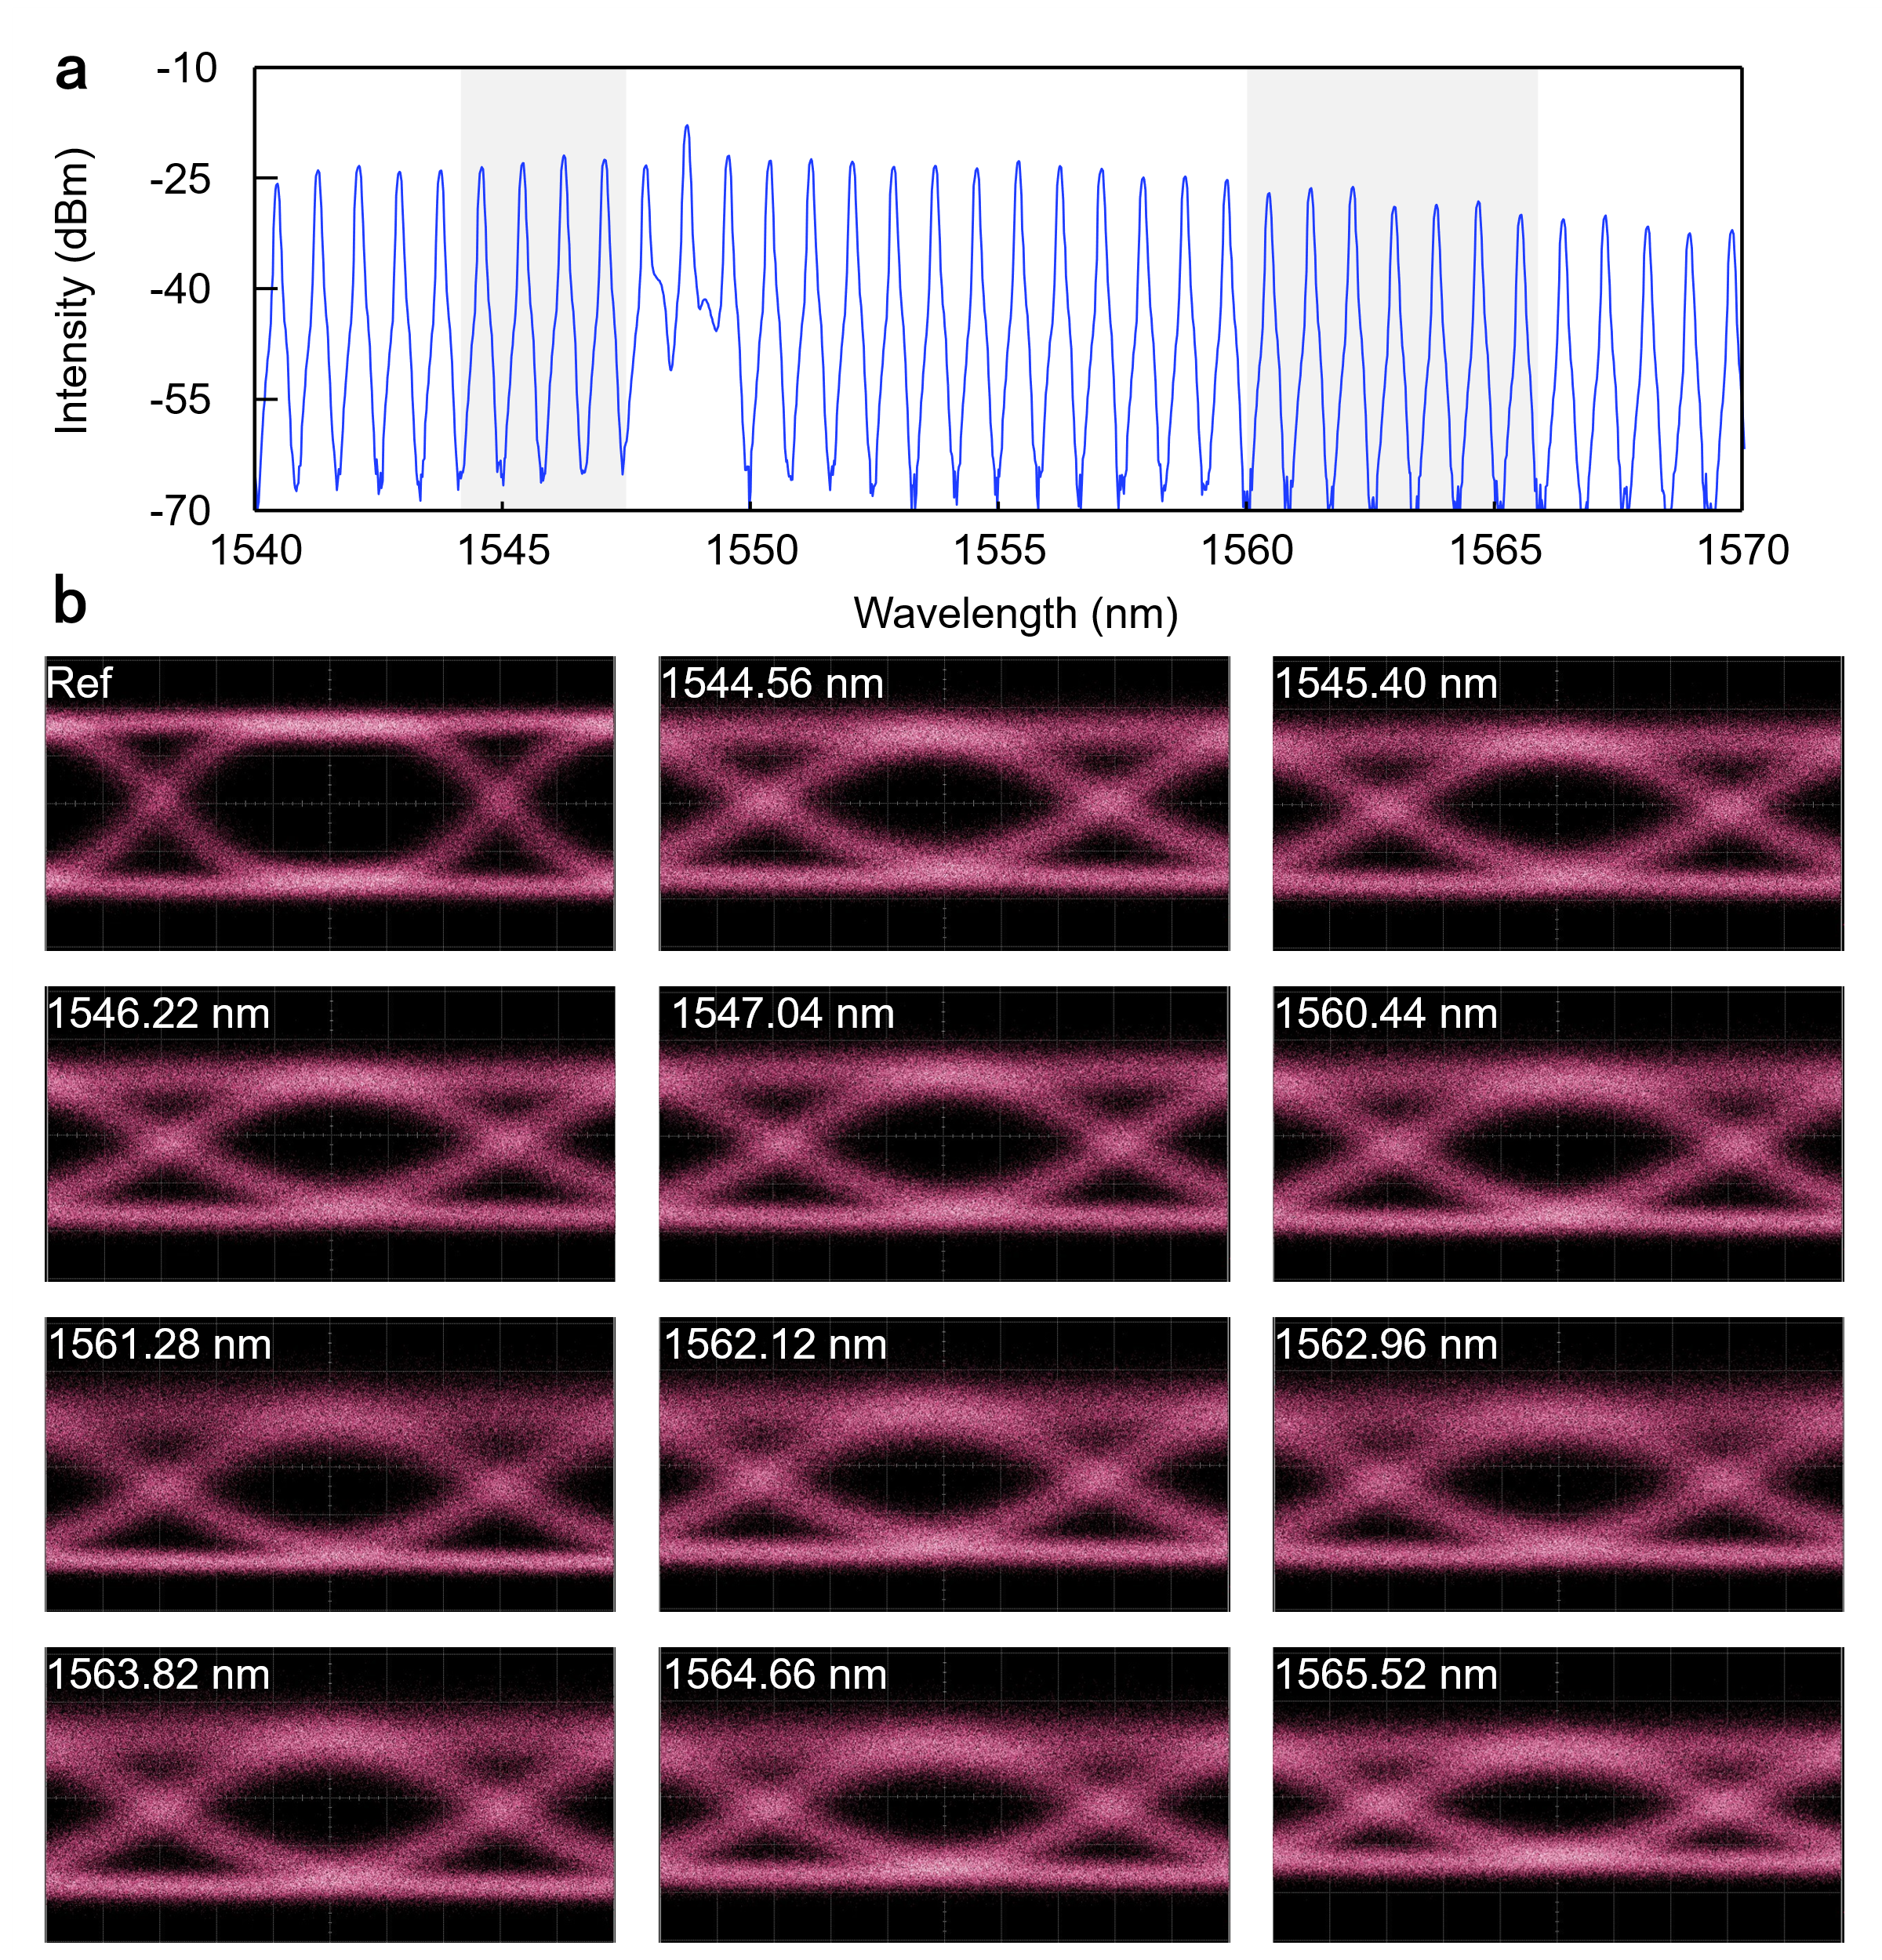
Fig. S8 Parallel free space communication. (a) Measured microcomb spectrum, comb teeth in the gray background area are used for parallel communication. (b) Measured eye diagrams of NRZ signals.

SUPPLEMENTARY REFERENCES
- Lian, D. X. et al. Grating-lobe-free optical phased array with 2-D circular sparse array aperture and high-efficiency phase calibration. Nanophotonics 13, 29-37 (2024).
- Liu, C. et al. Hybrid Integrated Frequency-Modulated Continuous-Wave Laser With Synchronous Tuning. J. Lightwave Technol. 40, 5636-5645 (2022).

