Risultati
Descriptives - Continuous clinical values
Descriptives
 | Implantation Type | Age | EF baseline | LVEDD baseline | QRSd baseline
N | LBBAP | 53 | 53 | 53 | 53
N | RVAP | 57 | 57 | 57 | 57
Mean | LBBAP | 77.5 | 58.8 | 47.5 | 134
Mean | RVAP | 82.7 | 60.1 | 47.6 | 135
Median | LBBAP | 79 | 60 | 47 | 135
Median | RVAP | 82 | 62 | 47 | 137
Standard deviation | LBBAP | 9.31 | 7.72 | 5.15 | 24.9
Standard deviation | RVAP | 7.32 | 6.97 | 4.71 | 24.4
Shapiro-Wilk W | LBBAP | 0.941 | 0.872 | 0.938 | 0.952
Shapiro-Wilk W | RVAP | 0.967 | 0.905 | 0.958 | 0.980
Shapiro-Wilk p | LBBAP | .011 | <.001 | .009 | .033
Shapiro-Wilk p | RVAP | .124 | <.001 | .045 | .482

Plots
Age
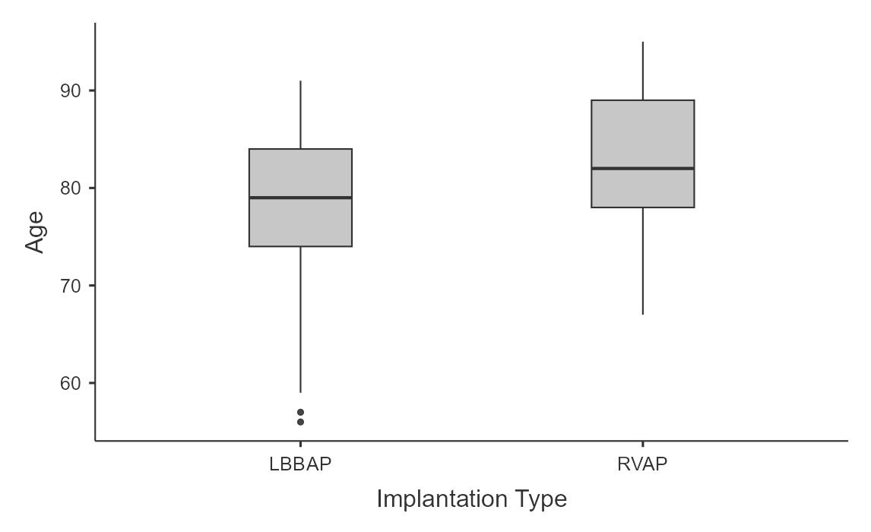
EF baseline
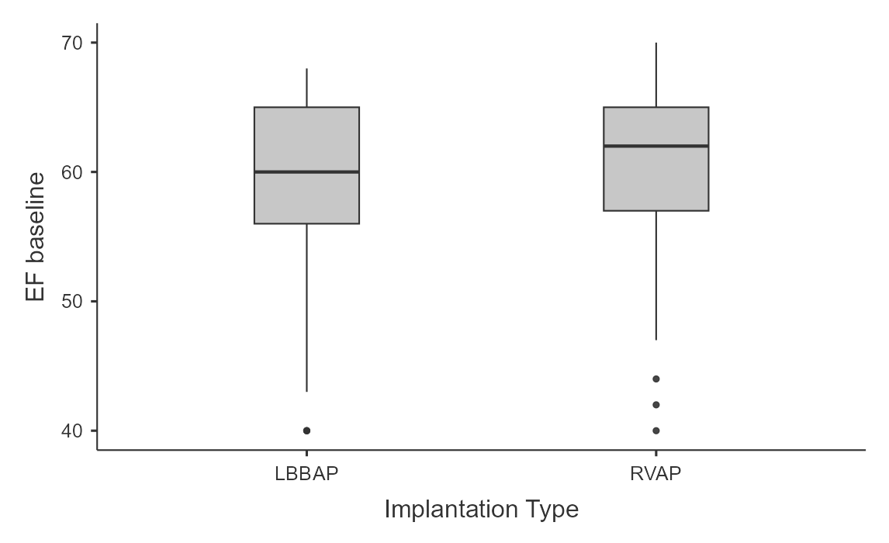
LVEDD baseline
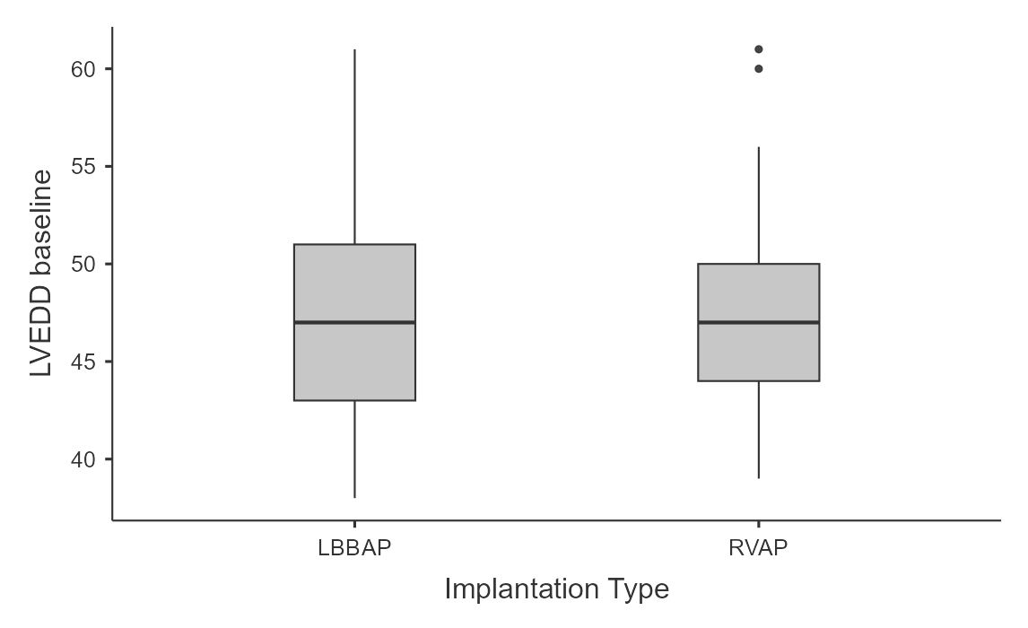
QRSd baseline
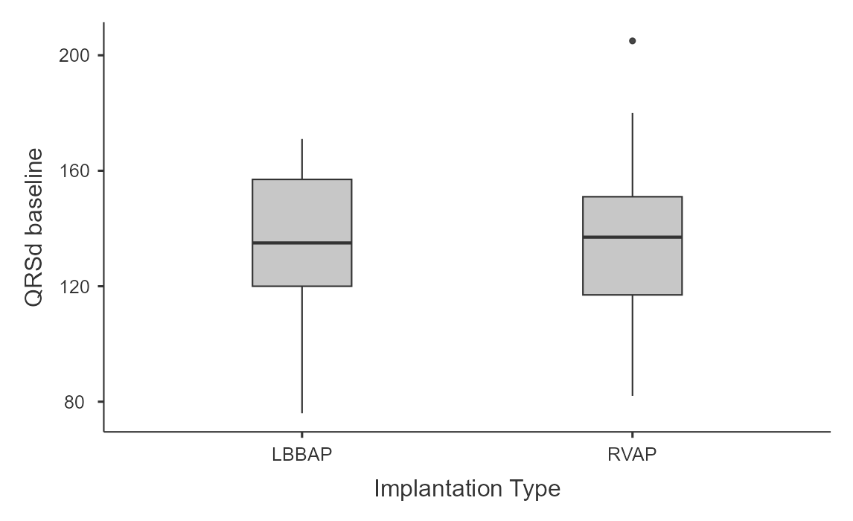
Descriptives - Nominal clinical variables
Frequencies
Frequencies of Sex
Sex | Implantation Type | Counts | % of Total | Cumulative %
F | LBBAP | 21 | 19.1% | 19.1%
F | RVAP | 25 | 22.7% | 41.8%
M | LBBAP | 32 | 29.1% | 70.9%
M | RVAP | 32 | 29.1% | 100.0%

Frequencies of Diabetes
Diabetes | Implantation Type | Counts | % of Total | Cumulative %
0 | LBBAP | 40 | 36.4% | 36.4%
0 | RVAP | 42 | 38.2% | 74.5%
1 | LBBAP | 13 | 11.8% | 86.4%
1 | RVAP | 15 | 13.6% | 100.0%

Frequencies of Hypertension
Hypertension | Implantation Type | Counts | % of Total | Cumulative %
0 | LBBAP | 9 | 8.2% | 8.2%
0 | RVAP | 15 | 13.6% | 21.8%
1 | LBBAP | 44 | 40.0% | 61.8%
1 | RVAP | 42 | 38.2% | 100.0%

Frequencies of eGFR < 45ml/min/1,73m2
eGFR < 45ml/min/1,73m2 | Implantation Type | Counts | % of Total | Cumulative %
0 | LBBAP | 51 | 46.4% | 46.4%
0 | RVAP | 47 | 42.7% | 89.1%
1 | LBBAP | 2 | 1.8% | 90.9%
1 | RVAP | 10 | 9.1% | 100.0%

Frequencies of MRA
MRA | Implantation Type | Counts | % of Total | Cumulative %
0 | LBBAP | 46 | 41.8% | 41.8%
0 | RVAP | 49 | 44.5% | 86.4%
1 | LBBAP | 7 | 6.4% | 92.7%
1 | RVAP | 8 | 7.3% | 100.0%

Frequencies of SGLT2
SGLT2 | Implantation Type | Counts | % of Total | Cumulative %
0 | LBBAP | 35 | 31.8% | 31.8%
0 | RVAP | 39 | 35.5% | 67.3%
1 | LBBAP | 18 | 16.4% | 83.6%
1 | RVAP | 18 | 16.4% | 100.0%

Frequencies of RAS inhibitors
RAS inhibitors | Implantation Type | Counts | % of Total | Cumulative %
0 | LBBAP | 14 | 12.7% | 12.7%
0 | RVAP | 21 | 19.1% | 31.8%
1 | LBBAP | 39 | 35.5% | 67.3%
1 | RVAP | 36 | 32.7% | 100.0%

Frequencies of Ischemic Heart Disease
Ischemic Heart Disease | Implantation Type | Counts | % of Total | Cumulative %
0 | LBBAP | 42 | 38.2% | 38.2%
0 | RVAP | 47 | 42.7% | 80.9%
1 | LBBAP | 11 | 10.0% | 90.9%
1 | RVAP | 10 | 9.1% | 100.0%

Frequencies of Previous AF
Previous AF | Implantation Type | Counts | % of Total | Cumulative %
0 | LBBAP | 31 | 28.2% | 28.2%
0 | RVAP | 40 | 36.4% | 64.5%
1 | LBBAP | 22 | 20.0% | 84.5%
1 | RVAP | 17 | 15.5% | 100.0%

Plots
Sex
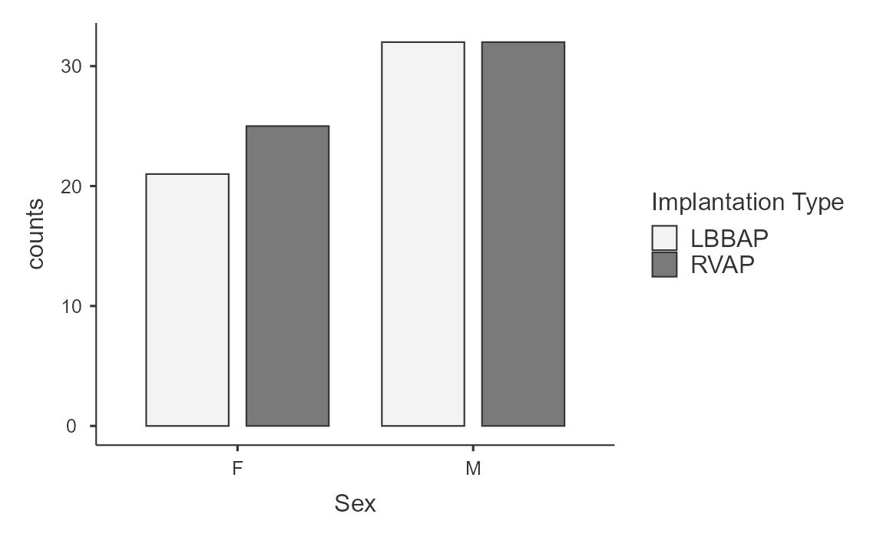
Diabetes
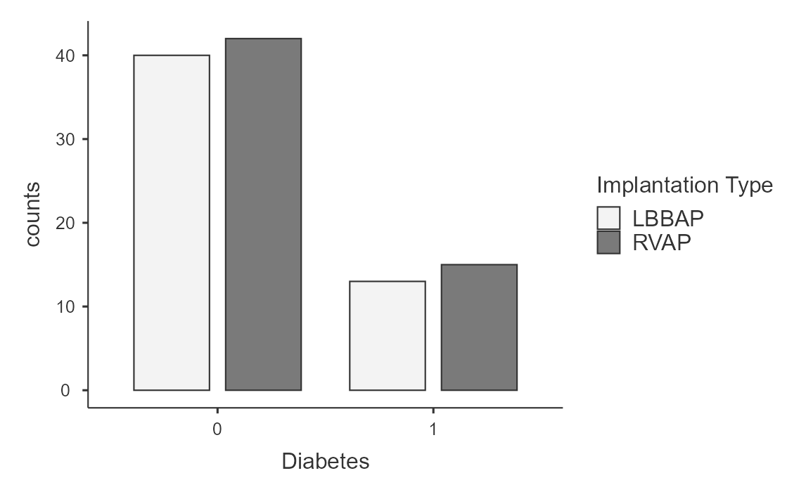
Hypertension
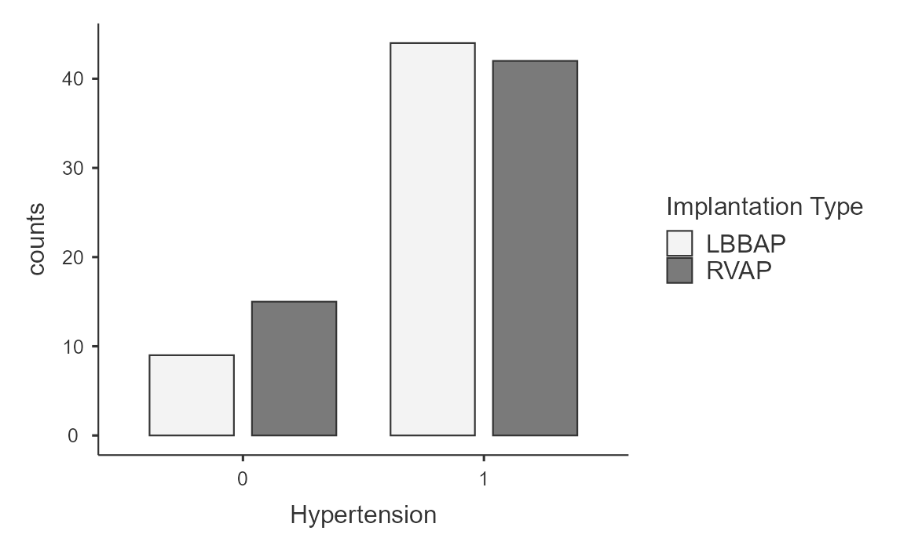
eGFR < 45ml/min/1,73m2
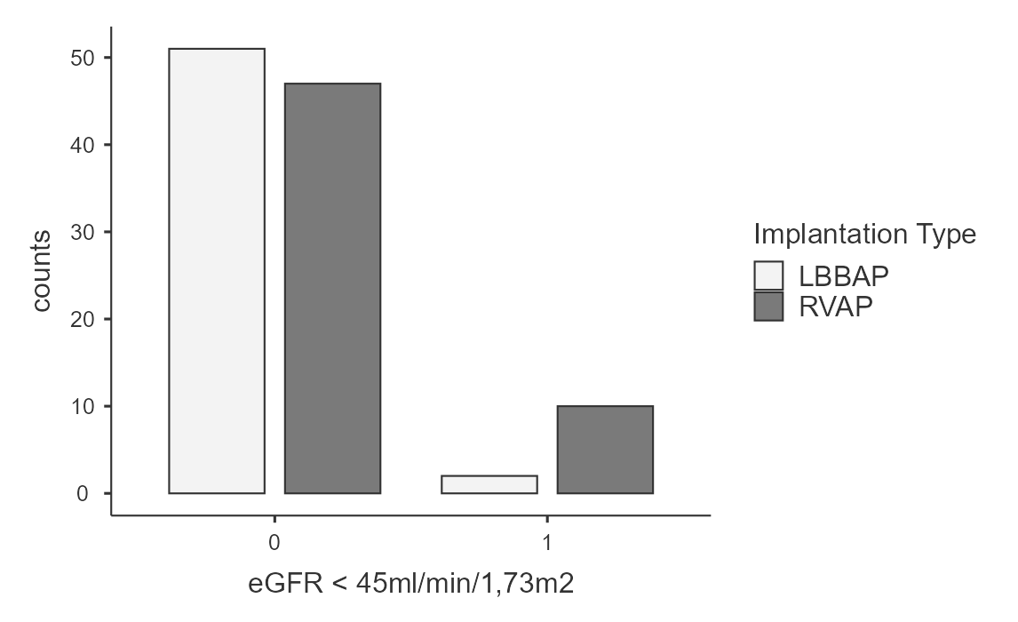
MRA
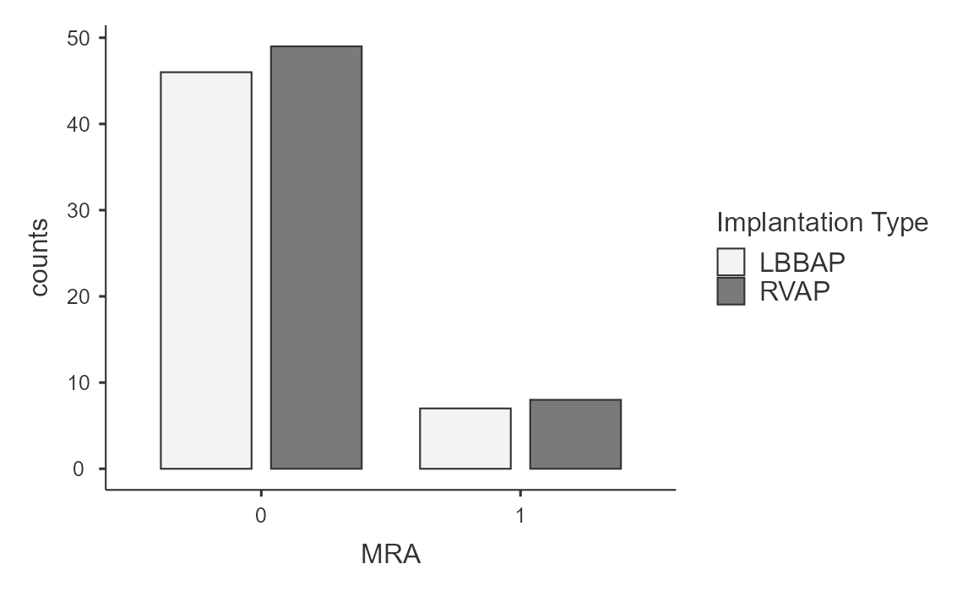
SGLT2
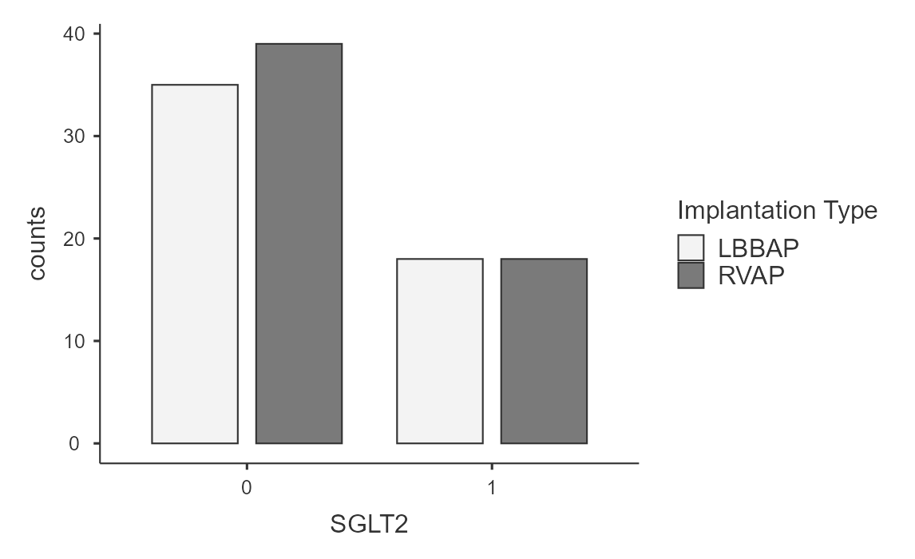
RAS inhibitors
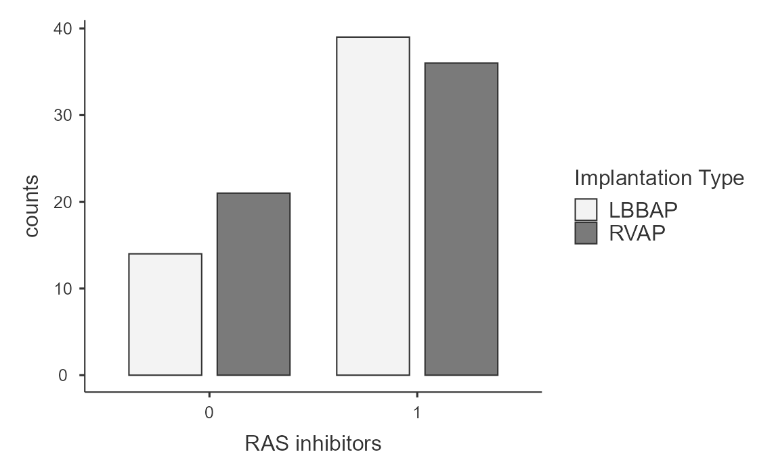
Ischemic Heart Disease
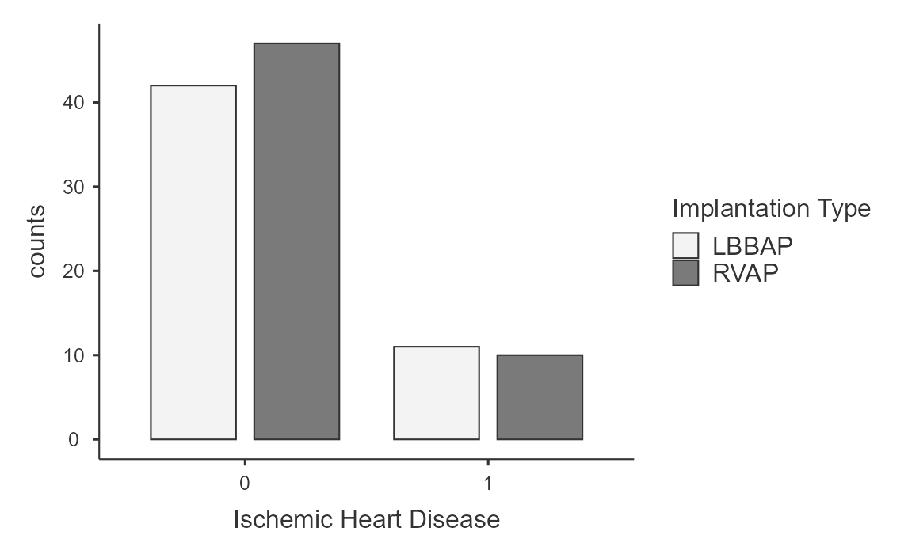

Previous AF

Descriptives - Continuous procedural variables
Descriptives
 | Implantation Type | Ventricular Pacing Burden | V6RWPT | Threshold | Fluoroscopy time (seconds)
N | LBBAP | 53 | 53 | 53 | 39
N | RVAP | 57 | 0 | 57 | 49
Mean | LBBAP | 90.4 | 78.4 | 0.984 | 430
Mean | RVAP | 91.7 | NaN | 0.745 | 371
Median | LBBAP | 100 | 78 | 1.00 | 366
Median | RVAP | 99 | NaN | 0.700 | 256
Standard deviation | LBBAP | 19.7 | 10.6 | 0.337 | 274
Standard deviation | RVAP | 15.8 | NaN | 0.315 | 314

Descriptives - Nominal procedural variables
Frequencies
Frequencies of Retractable Helix
Retractable Helix | Implantation Type | Counts | % of Total | Cumulative %
0 | LBBAP | 11 | 10.0% | 10.0%
0 | RVAP | 1 | 0.9% | 10.9%
1 | LBBAP | 42 | 38.2% | 49.1%
1 | RVAP | 56 | 50.9% | 100.0%

Frequencies of Implantation Success
Implantation Success | Implantation Type | Counts | % of Total | Cumulative %
0 | LBBAP | 5 | 4.5% | 4.5%
0 | RVAP | 0 | 0.0% | 4.5%
1 | LBBAP | 48 | 43.6% | 48.2%
1 | RVAP | 57 | 51.8% | 100.0%

Frequencies of Periprocedural complications
Periprocedural complications | Implantation Type | Counts | % of Total | Cumulative %
0 | LBBAP | 53 | 48.2% | 48.2%
0 | RVAP | 56 | 50.9% | 99.1%
1 | LBBAP | 0 | 0.0% | 99.1%
1 | RVAP | 1 | 0.9% | 100.0%

Descriptives - FU Continuous Outcomes
Descriptives
 | Implantation Type | Follow-up Months | EF FU | Delta EF | LVEDD FU | Delta LVEDD | QRSd FU | Delta QRSd
N | LBBAP | 53 | 53 | 53 | 53 | 53 | 53 | 53
N | RVAP | 57 | 57 | 57 | 57 | 57 | 57 | 57
Missing | LBBAP | 0 | 0 | 0 | 0 | 0 | 0 | 0
Missing | RVAP | 0 | 0 | 0 | 0 | 0 | 0 | 0
Mean | LBBAP | 14.8 | 58.5 | -0.377 | 45.3 | -2.19 | 129 | -4.91
Mean | RVAP | 15.3 | 53.7 | -6.44 | 47.4 | -0.281 | 156 | 21.0
Median | LBBAP | 14 | 58 | -1 | 45 | -2 | 128 | -10
Median | RVAP | 12 | 55 | -6 | 46 | 0 | 151 | 16
Standard deviation | LBBAP | 6.46 | 5.82 | 6.35 | 4.04 | 4.60 | 13.4 | 26.5
Standard deviation | RVAP | 8.06 | 8.92 | 6.73 | 6.27 | 5.65 | 21.1 | 31.6

Descriptives - FU Nominal Outcomes
Frequencies
Frequencies of PICM
PICM | Implantation Type | Counts | % of Total | Cumulative %
0 | LBBAP | 53 | 48.2% | 48.2%
0 | RVAP | 46 | 41.8% | 90.0%
1 | LBBAP | 0 | 0.0% | 90.0%
1 | RVAP | 11 | 10.0% | 100.0%

Frequencies of New onset AF
New Onset AF | Implantation Type | Counts | % of Total | Cumulative %
0 | LBBAP | 50 | 45.5% | 45.5%
0 | RVAP | 48 | 43.6% | 89.1%
1 | LBBAP | 3 | 2.7% | 91.8%
1 | RVAP | 9 | 8.2% | 100.0%

Frequencies of Admission for HF
Admission for HF | Implantation Type | Counts | % of Total | Cumulative %
0 | LBBAP | 51 | 46.4% | 46.4%
0 | RVAP | 42 | 38.2% | 84.5%
1 | LBBAP | 2 | 1.8% | 86.4%
1 | RVAP | 15 | 13.6% | 100.0%

Bar Plot
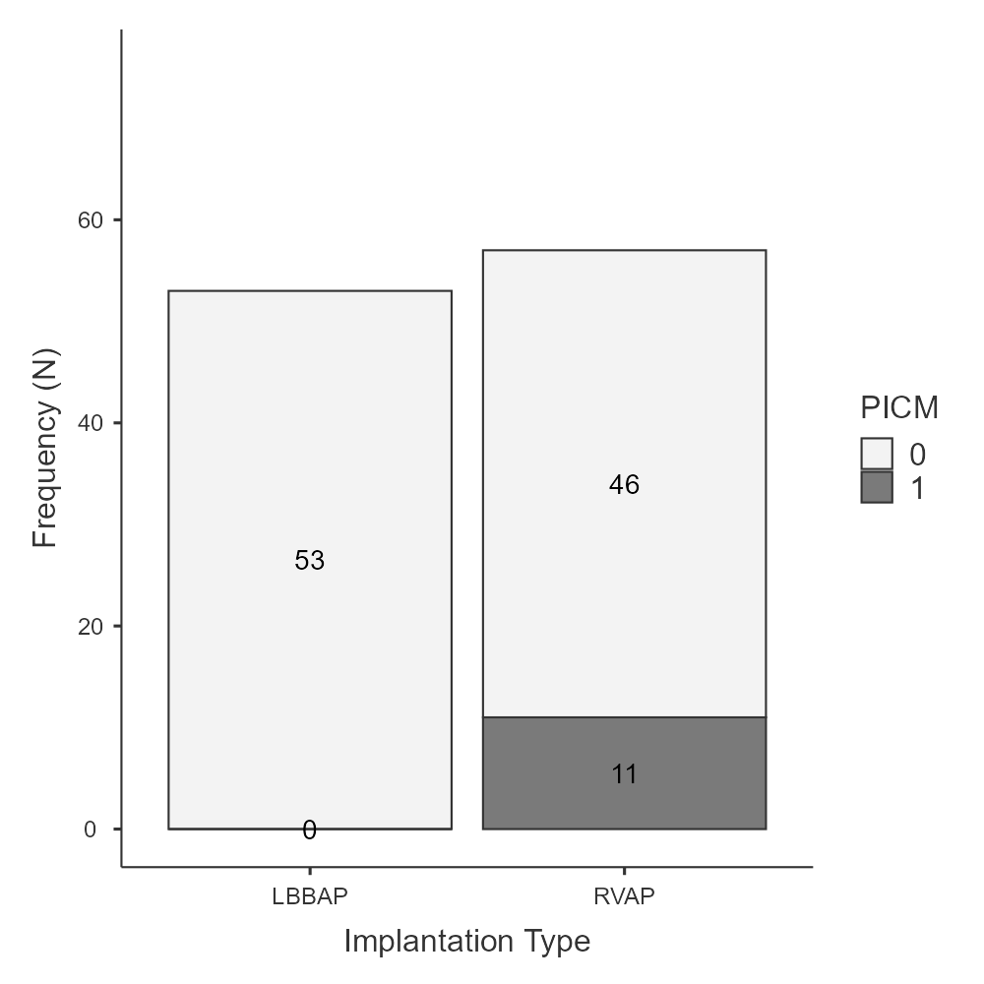
Bar Plot
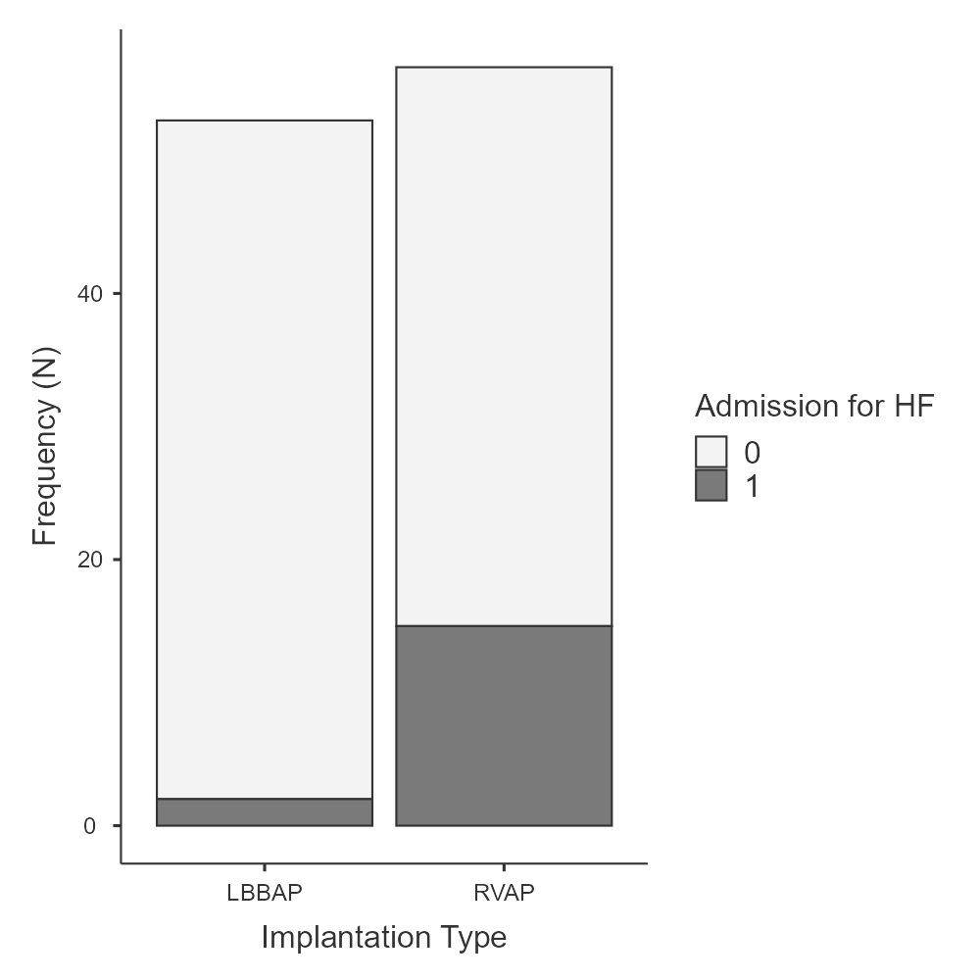
Bar Plot
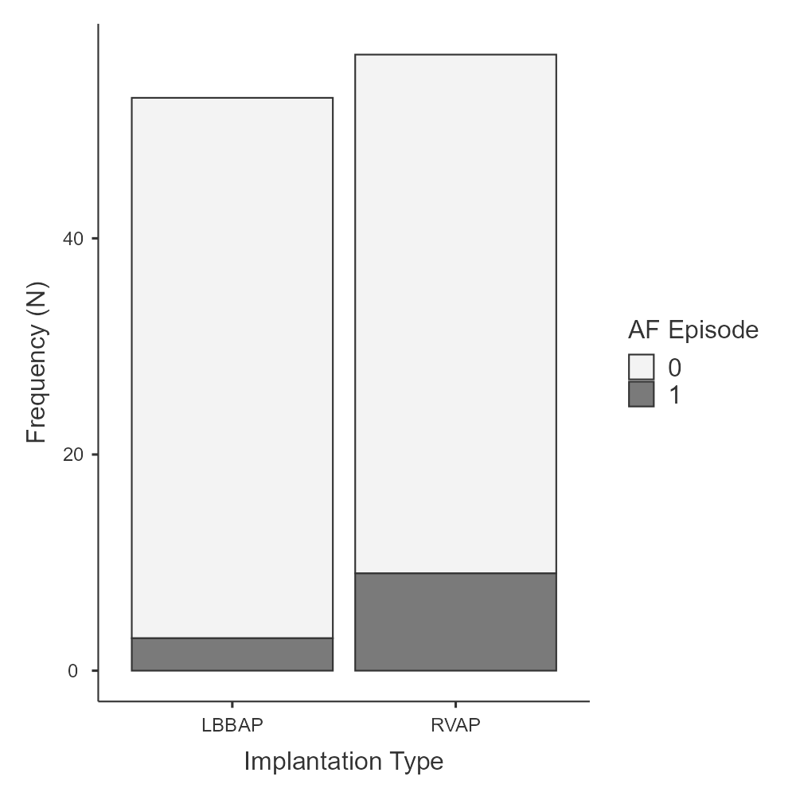
Independent Samples T-Test
Independent Samples T-Test
 |  | Statistic | p
Age | Mann-Whitney U | 1037 | .005
EF baseline | Mann-Whitney U | 1388 | .462
LVEDD baseline | Mann-Whitney U | 1435 | .651
QRSd baseline | Mann-Whitney U | 1490 | .902
Note. Hₐ μ_{LBBAP} ≠ μ_{RVAP}

Plots
Age
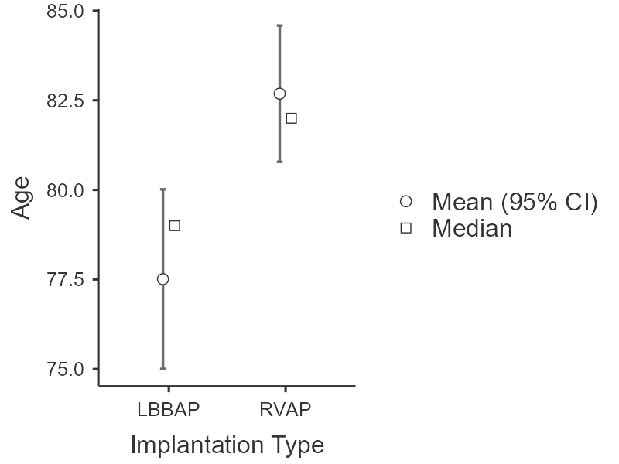
EF baseline
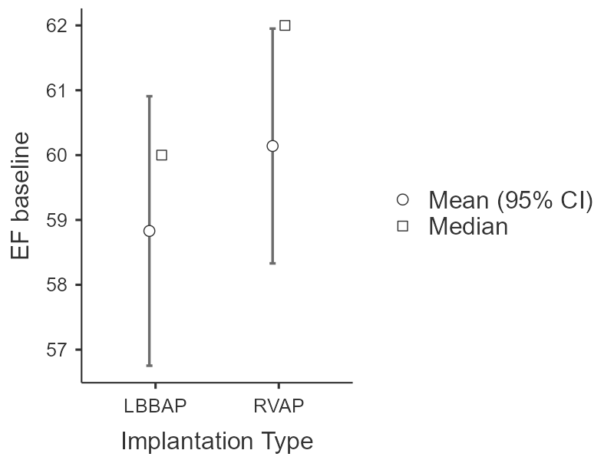
LVEDD baseline
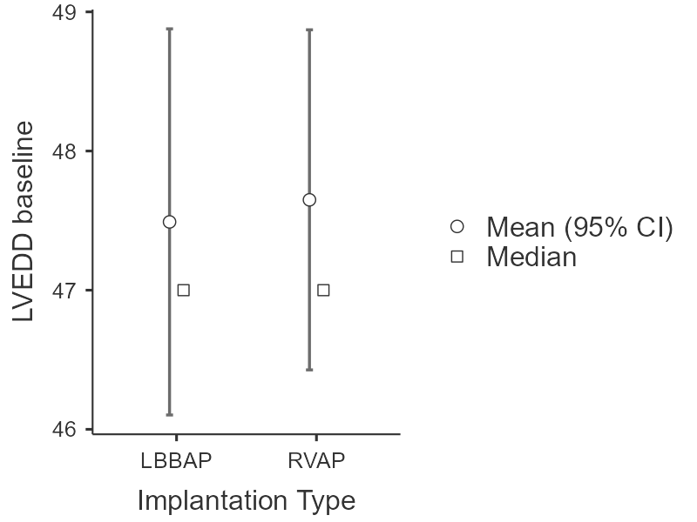
QRSd baseline
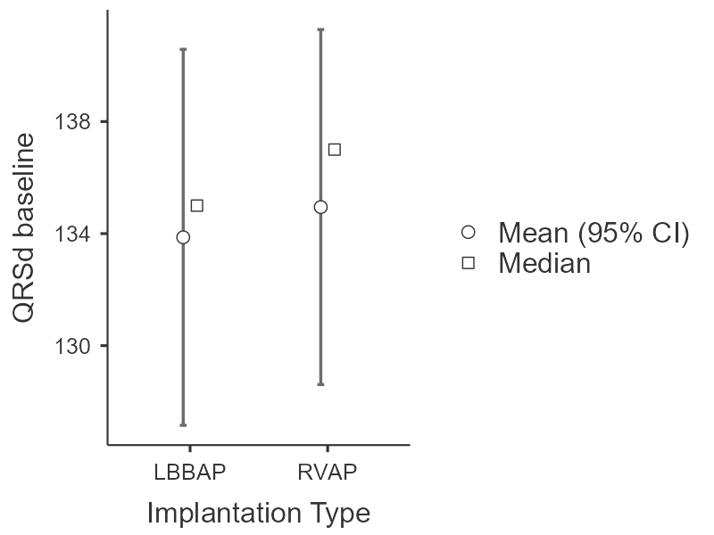
Contingency Tables
Contingency Tables
 | Implantation Type
Sex | LBBAP | RVAP | Total
F | 21 | 25 | 46
M | 32 | 32 | 64
Total | 53 | 57 | 110

χ² Tests
 | Value | df | p
χ² | 0.203 | 1 | .653
N | 110

Contingency Tables
Contingency Tables
 | Implantation Type
Diabetes | LBBAP | RVAP | Total
0 | 40 | 42 | 82
1 | 13 | 15 | 28
Total | 53 | 57 | 110

χ² Tests
 | Value | df | p
χ² | 0.0462 | 1 | .830
N | 110

Contingency Tables
Contingency Tables
 | Implantation Type
Hypertension | LBBAP | RVAP | Total
0 | 9 | 15 | 24
1 | 44 | 42 | 86
Total | 53 | 57 | 110

χ² Tests
 | Value | df | p
χ² | 1.40 | 1 | .236
N | 110

Contingency Tables
Contingency Tables
 | Implantation Type
Ischemic Heart Disease | LBBAP | RVAP | Total
0 | 42 | 47 | 89
1 | 11 | 10 | 21
Total | 53 | 57 | 110

χ² Tests
 | Value | df | p
χ² | 0.183 | 1 | .669
N | 110

Contingency Tables
Contingency Tables
 | Implantation Type
eGFR < 45ml/min/1,73m2 | LBBAP | RVAP | Total
0 | 51 | 47 | 98
1 | 2 | 10 | 12
Total | 53 | 57 | 110

χ² Tests
 | Value | p
Fisher's exact test |  | .030
N | 110

Contingency Tables
Contingency Tables
 | Implantation Type
MRA | LBBAP | RVAP | Total
0 | 46 | 49 | 95
1 | 7 | 8 | 15
Total | 53 | 57 | 110

χ² Tests
 | Value | df | p
χ² | 0.0160 | 1 | .899
N | 110

Contingency Tables
Contingency Tables
 | Implantation Type
SGLT2 | LBBAP | RVAP | Total
0 | 35 | 39 | 74
1 | 18 | 18 | 36
Total | 53 | 57 | 110

χ² Tests
 | Value | df | p
χ² | 0.0709 | 1 | .790
N | 110

Contingency Tables
Contingency Tables
 | Implantation Type
RAS inhibitors | LBBAP | RVAP | Total
0 | 14 | 21 | 35
1 | 39 | 36 | 75
Total | 53 | 57 | 110

χ² Tests
 | Value | df | p
χ² | 1.38 | 1 | .241
N | 110

Contingency Tables
Contingency Tables
 | Implantation Type
Periprocedural complications | LBBAP | RVAP | Total
0 | 53 | 56 | 109
1 | 0 | 1 | 1
Total | 53 | 57 | 110

χ² Tests
 | Value | df | p
χ² | 0.938 | 1 | .333
N | 110

Contingency Tables
Contingency Tables
 | Implantation Type
Implantation Success | LBBAP | RVAP | Total
0 | 5 | 0 | 5
1 | 48 | 57 | 105
Total | 53 | 57 | 110

χ² Tests
 | Value | df | p
χ² | 5.63 | 1 | .018
N | 110

Contingency Tables
 | Implantation Type
Previous AF | LBBAP | RVAP | Total
0 | 31 | 40 | 71
1 | 22 | 17 | 39
Total | 53 | 57 | 110

χ² Tests
 | Value | df | p
χ² | 1.64 | 1 | .210
N | 110

Contingency Tables
 | Implantation Type
Stimulation Mode | LBBAP | RVAP | Total
DDD | 31 | 34 | 65
VVI | 22 | 23 | 45
Total | 53 | 57 | 110

χ² Tests
 | Value | df | p
χ² | 0.0152 | 1 | .902
N | 110

Independent Samples T-Test
Independent Samples T-Test
 |  | Statistic | df | p
Fluoroscopy time (seconds) | Student's t | 0.929 | 86.0 | .355
Fluoroscopy time (seconds) | Mann-Whitney U | 763 |  | .106
Note. Hₐ μ_{LBBAP} ≠ μ_{RVAP}

Independent Samples T-Test
Independent Samples T-Test
 |  | Statistic | df | p
Threshold | Student's t | 3.85 | 108 | <.001
Threshold | Mann-Whitney U | 822 |  | <.001
Note. Hₐ μ_{LBBAP} ≠ μ_{RVAP}

Contingency Tables - Fisher test PICM vs eGFR < 45ml/min/1,73m2
Contingency Tables
 | PICM
eGFR < 45ml/min/1,73m2 | 0 | 1 | Total
0 | 88 | 10 | 98
1 | 11 | 1 | 12
Total | 99 | 11 | 110

χ² Tests
 | Value | df | p
χ² | 0.0416 | 1 | .838
Fisher's exact test |  |  | 1.000
N | 110

Independent Samples T-Test - PICM vs Age
Independent Samples T-Test
 |  | Statistic | df | p
Age | Student's t | -0.983 | 108 | .328
Note. Hₐ μ₀ ≠ μ₁

Binomial Logistic Regression
Model Fit Measures
Model | Deviance | AIC | R²_{McF}
1 | 81.7 | 89.7 | 0.138
Note. Models estimated using sample size of N=110

Model Coefficients - Admission for HF
 |  |  |  |  |  |  |  |  |  | 95% Confidence Interval
Predictor | Estimate | SE |  | Z |  | p |  | Odds ratio |  |  | Lower |  | Upper
Intercept | -4.2708 |  | 3.1083 |  | -1.374 |  | .169 |  | 0.0140 |  |  | 3.16e-5 |  | 6.18
Implantation Type:
RVAP – LBBAP | 2.0552 |  | 0.8025 |  | 2.561 |  | .010 |  | 7.8088 |  |  | 1.620 |  | 37.64
Age | 0.0128 |  | 0.0386 |  | 0.331 |  | .740 |  | 1.0129 |  |  | 0.939 |  | 1.09
eGFR < 45ml/min/1,73m2:
1 – 0 | 0.6352 |  | 0.7403 |  | 0.858 |  | .391 |  | 1.8873 |  |  | 0.442 |  | 8.05
Note. Estimates represent the log odds of "Admission for HF = 1" vs. "Admission for HF = 0"

Prediction
Predictive Measures
AUC
0.746
Note. The cut-off value is set to 0.5

Binomial Logistic Regression
Model Fit Measures
Model | Deviance | AIC | R²_{McF}
1 | 68.5 | 76.5 | 0.0959
1 54 62 0.0653

Note. Models estimated using sample size of N=110

Model Coefficients – New Onset AF
 |  |  |  |  |  | 95% Confidence Interval
Predictor | Estimate | SE | Z | p | Odds ratio | Lower | Upper
Intercept | 1.0838 | 3.7435 | 0.28951 | .772 | 2.956 | 0.00192 | 4541.05
Implantation Type:
RVAP – LBBAP | 0.9935 | 0.7702 | 1.28998 | .197 | 2.701 | 0.59689 | 12.22
eGFR < 45ml/min/1,73m2:
1 – 0 | -16.0211 | 1743.0319 | -0.00919 | .993 | 1.10e-7 | 0.000 | Inf
Age | -0.0437 | 0.0494 | -0.88436 | .376 | 0.957 | 0.86892 | 1.05
Note. Estimates represent the log odds of "New Onset AF = 1" vs. "New Onset AF = 0"

Prediction
Predictive Measures
AUC
0.741
Note. The cut-off value is set to 0.5

Model Fit Measures
Model | Deviance | AIC | R²_{McF}
1 | 107 | 76.5 | 0.0959
Note. Models estimated using sample size of N=110
Model Coefficients – CV admission
 |  |  |  |  |  | 95% Confidence Interval
Predictor | Estimate | SE | Z | p | Odds ratio | Lower | Upper
Intercept | -3.5392 | 2.5691 | -1.3776 | .168 | 0.029 | 1.89 |  | 4.46
Implantation Type:
RVAP – LBBAP | 1.5613 | 0.5664 | 2.7566 | .006 | 4.7651 | 1.570 |  | 14.46
eGFR < 45ml/min/1,73m2:
1 – 0 | 0.0163 | 0.0322 | 0.5069 | .612 | 1.0165 | 0.954 |  | 1.08
Age | 0.0556 | 0.7113 | 0.0782 | .938 | 1.0572 | 0.262 |  | 4.26
Note. Estimates represent the log odds of "CV Admission = 1" vs. "CV Admission = 0"

Prediction
Predictive Measures
AUC
0.688
Note. The cut-off value is set to 0.5

ANCOVA
ANCOVA - Delta EF
 | Sum of Squares | df | Mean Square | F | p | η²p
Overall model | 1564.36 | 3 | 521.45 | 16.329 | <.001
Implantation Type | 811.24 | 1 | 811.24 | 22.295 | <.001 | 0.174
Age | 5.72 | 1 | 5.72 | 0.157 | .692 | 0.001
EF baseline | 747.40 | 1 | 747.40 | 20.540 | <.001 | 0.162
Residuals | 3857.02 | 106 | 36.39

Assumption Checks
Homogeneity of Variances Test (Levene's)
F | df1 | df2 | p
3.47 | 1 | 108 | .065

Q-Q Plot
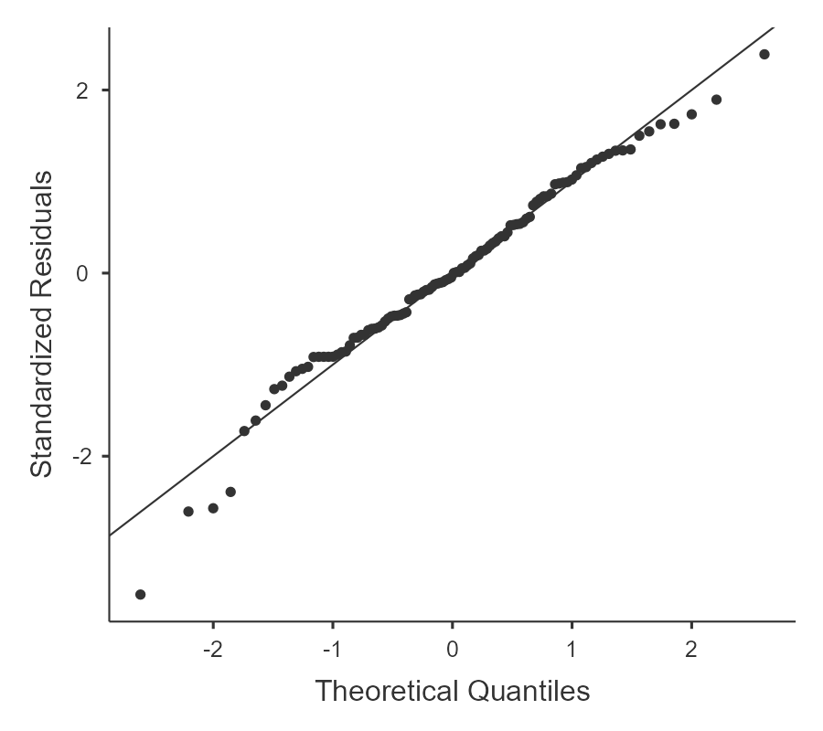
Estimated Marginal Means
Implantation Type
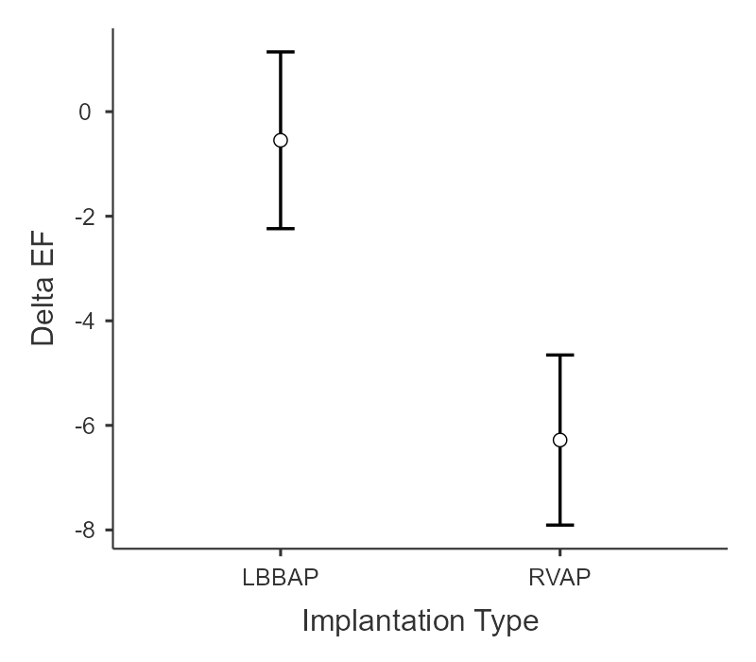
Estimated Marginal Means - Implantation Type
 |  |  | 95% Confidence Interval
Implantation Type | Mean | SE | Lower | Upper
LBBAP | -0.547 | 0.852 | -2.24 | 1.14
RVAP | -6.280 | 0.820 | -7.91 | -4.65

ANCOVA
ANCOVA - Delta LVEDD
 | Sum of Squares | df | Mean Square | F | p | η²p
Overall model | 668.698 | 3 | 222.899 | 10.36795 | <.001
Implantation Type | 95.630 | 1 | 95.630 | 4.38856 | .039 | 0.040
Age | 0.182 | 1 | 0.182 | 0.00837 | .927 | 0.000
LVEDD baseline | 572.886 | 1 | 572.886 | 26.29028 | <.001 | 0.199
Residuals | 2309.823 | 106 | 21.791

Assumption Checks
Homogeneity of Variances Test (Levene's)
F | df1 | df2 | p
12.0 | 1 | 108 | <.001

Q-Q Plot
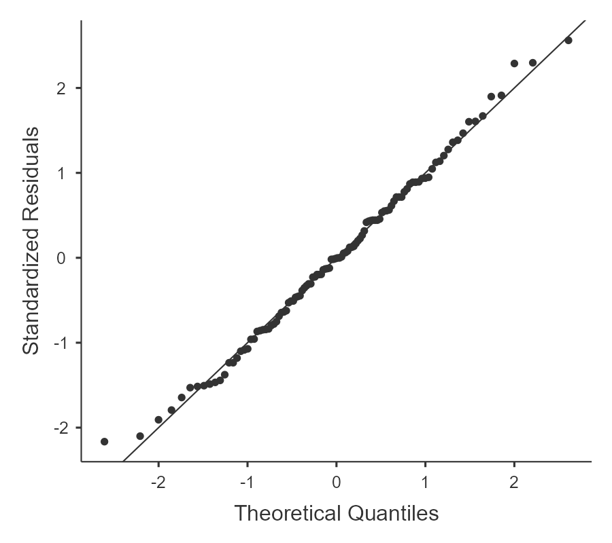
Estimated Marginal Means
Implantation Type
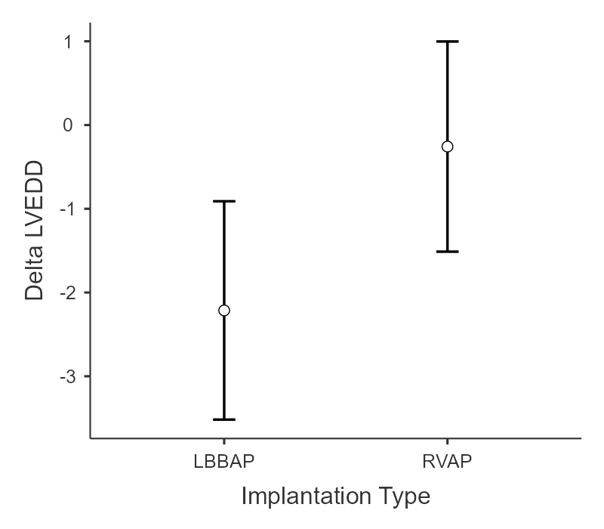
Estimated Marginal Means - Implantation Type
 |  |  | 95% Confidence Interval
Implantation Type | Mean | SE | Lower | Upper
LBBAP | -2.214 | 0.658 | -3.52 | -0.910
RVAP | -0.257 | 0.633 | -1.51 | 0.998

ANCOVA
ANCOVA - Delta QRSd
 | Sum of Squares | df | Mean Square | F | p | η²p
Overall model | 76706.9 | 3 | 25569.0 | 79.854 | <.001
Implantation Type | 18584.3 | 1 | 18584.3 | 57.867 | <.001 | 0.353
Age | 34.7 | 1 | 34.7 | 0.108 | .743 | 0.001
QRSd baseline | 58087.8 | 1 | 58087.8 | 180.871 | <.001 | 0.630
Residuals | 34042.5 | 106 | 321.2

Assumption Checks
Homogeneity of Variances Test (Levene's)
F | df1 | df2 | p
10.9 | 1 | 108 | .001

Q-Q Plot
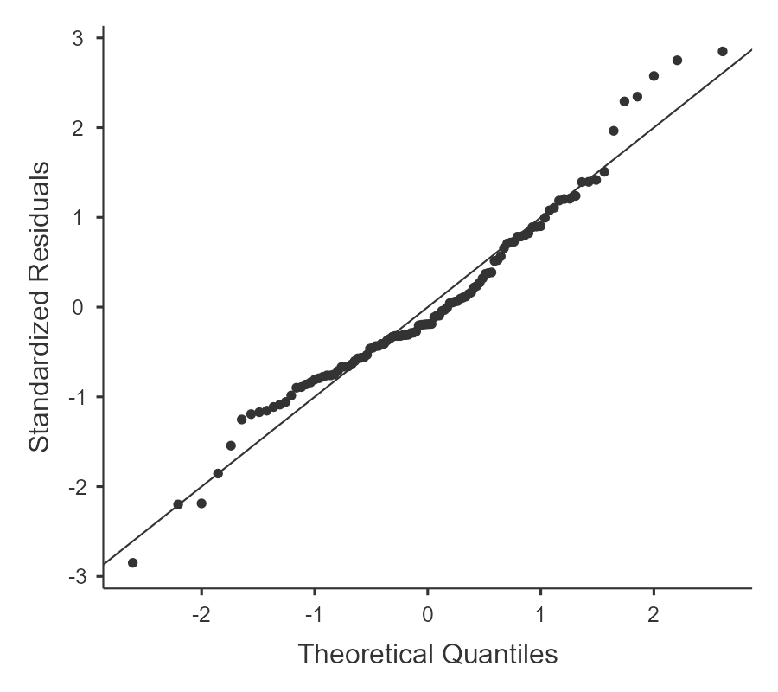
Estimated Marginal Means
Implantation Type
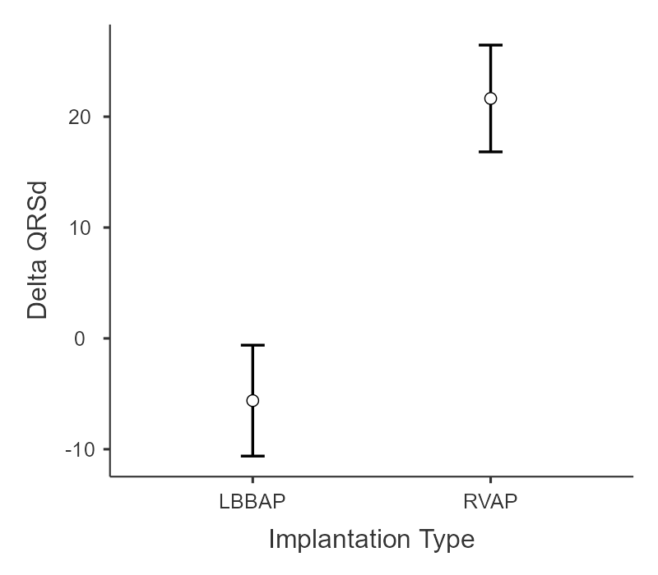
Estimated Marginal Means - Implantation Type
 |  |  | 95% Confidence Interval
Implantation Type | Mean | SE | Lower | Upper
LBBAP | -5.62 | 2.52 | -10.6 | -0.613
RVAP | 21.64 | 2.43 | 16.8 | 26.458

Supplementary Table S1. Detailed statistical output (primary analysis)
This table reports the full set of tests and model outputs derived from the primary analysis results (jamovi output).
S1-A. Normality checks for baseline continuous variables (Shapiro-Wilk)
Variable | Shapiro W (LBBAP) | Shapiro p (LBBAP) | Shapiro W (RVAP) | Shapiro p (RVAP)
Age | 0.941 | .011 | 0.967 | .124
EF baseline | 0.872 | <.001 | 0.905 | <.001
LVEDD baseline | 0.938 | .009 | 0.958 | .045
QRSd baseline | 0.952 | .033 | 0.980 | .482
S1-B. Between-group comparisons for baseline continuous variables
Variable | Test | Statistic | p | Direction (descriptive)
Age | Mann-Whitney U | 1037 | 0.005 | RVAP older
EF baseline | Mann-Whitney U | 1388 | 0.462 | No difference
LVEDD baseline | Mann-Whitney U | 1435 | 0.651 | No difference
QRSd baseline | Mann-Whitney U | 1490 | 0.902 | No difference
S1-C. Between-group comparisons for baseline categorical variables
Variable | Test | Statistic | p
Sex | Chi-square | χ2=0.203 (df=1) | 0.653
Diabetes | Chi-square | χ2=0.0462 (df=1) | 0.830
Hypertension | Chi-square | χ2=1.40 (df=1) | 0.236
Ischemic heart disease | Chi-square | χ2=0.183 (df=1) | 0.669
eGFR <45 mL/min/1.73 m2 | Fisher exact | — | 0.030
MRA | Chi-square | χ2=0.0160 (df=1) | 0.899
SGLT2 inhibitor | Chi-square | χ2=0.0709 (df=1) | 0.790
RAS inhibitor | Chi-square | χ2=1.38 (df=1) | 0.241
Previous AF | Chi-square |  | 0.210
S1-D. Between-group comparisons for procedural continuous variables
Variable | Test | Statistic | p
Fluoroscopy time (sec) | Student t | t=0.929 (df=86) | 0.355
Threshold (V) | Student t | t=3.85 (df=108) | <0.001
S1-E. Between-group comparisons for procedural categorical variables
Variable | Test | Statistic | p
Implant success | Chi-square | χ2=5.63 (df=1) | 0.018
Periprocedural comps | Chi-square | χ2=0.938 (df=1) | 0.333
S1-F. Follow-up continuous outcomes: descriptive statistics (mean ± SD)
Variable | Mean±SD (LBBAP) | Mean±SD (RVAP)
Follow-up Months | 14.8 ± 6.46 | 15.3 ± 8.06
EF FU | 58.5 ± 5.82 | 53.7 ± 8.92
Delta EF | -0.377 ± 6.35 | -6.44 ± 6.73
LVEDD FU | 45.3 ± 4.04 | 47.4 ± 6.27
Delta LVEDD | -2.19 ± 4.60 | -0.281 ± 5.65
QRSd FU | 129 ± 13.4 | 156 ± 21.1
Delta QRSd | -4.91 ± 26.5 | 21.0 ± 31.6
S1-G. ANCOVA models for Δ outcomes (adjusted for age and baseline value)
Outcome | Contrast | Statistic | p | Partial η² | Assumption check | Adjusted estimates
ΔLVEF | Implantation type effect | F=22.295 | <0.001 | 0.174 | Levene p=0.065 | EMM: LBBAP −0.547 (−2.24,1.14); RVAP −6.280 (−7.91,−4.65)
ΔLVEDD | Implantation type effect | F=4.389 | 0.039 | 0.040 | Levene p<0.001 | EMM: LBBAP −2.214 (−3.52,−0.910); RVAP −0.257 (−1.51,0.998)
ΔQRSd | Implantation type effect | F=57.867 | <0.001 | 0.353 | Levene p=0.001 | EMM: LBBAP −5.62 (−10.6,−0.613); RVAP 21.64 (16.8,26.46)
S1-H. Multivariable logistic regression models
Endpoint | Model fit | Main effect (implantation type) | Discrimination
HF admission | Deviance=81.7; AIC=89.7; McFadden R2=0.138 | RVAP vs LBBAP OR 7.81 (1.62–37.64), p=0.010 | AUC 0.746
New onset AF | Deviance=68.5; AIC=76.5; McFadden R2=0.0959 | RVAP vs LBBAP OR 4.14 (0.978–17.55), p=0.054 | AUC 0.741
S1-I. Additional exploratory analyses
Analysis | Test | Result
PICM vs eGFR<45 | Fisher exact | p=1.000
PICM vs age | Student t | t=−0.983 (df=108), p=0.328
S1-J. Unadjusted event comparisons derived from reported counts
Event | LBBAP | RVAP | OR (RVAP vs LBBAP) [approx 95% CI] | Fisher p
PICM | 0/53 (0.0%) | 11/57 (19.3%) | 26.46 (1.52–461.43) | 0.0006
HF admission | 2/53 (3.8%) | 15/57 (26.3%) | 9.11 (1.97–42.10) | 0.0012
New onset AF | 3/53 (5.7%) | 9/57 (15.8%) | 3.12 (0.80–12.24) | 0.1268
Note: Odds ratios and Wald-type 95% CIs use a 0.5 continuity correction when a cell is zero.

References
[1] The jamovi project (2025). jamovi. (Version 2.7) [Computer Software]. Retrieved from https://www.jamovi.org.
[2] R Core Team (2025). R: A Language and environment for statistical computing. (Version 4.5) [Computer software]. Retrieved from https://cran.r-project.org. (R packages retrieved from CRAN snapshot 2025-05-25).
[3] Fox, J., & Weisberg, S. (2024). car: Companion to Applied Regression. [R package]. Retrieved from https://cran.r-project.org/package=car.
[4] Lenth, R. (2025). emmeans: Estimated Marginal Means, aka Least-Squares Means. [R package]. Retrieved from https://cran.r-project.org/package=emmeans.

