Supplementary Table 1. Neuropsychological tests by cognitive domain in the Sydney Memory and Ageing Study

Cognitive domain | Neuropsychological test(s) | Reference
Attention / processing speed | Digit Symbol-Coding ^{[1]}  Trail Making Test (TMT) A ^{[2]} | 1, 2
Memory | Logical Memory Story A delayed recall ^{[3]}  Rey Auditory Verbal Learning Test (RAVLT) — total learning, immediate and delayed recall ^{[2]}  Benton Visual Retention Test recognition ^{[4]} | 2–4
Language | Boston Naming Test ^{[5]}  Semantic Fluency (Animals) ^{[2]} | 2, 5
Executive function | Controlled Oral Word Association Test ^{[2]}  Trail Making Test (TMT) B ^{[2]} | 2
Visuospatial function | Block Design ^{[6]} | 6
Note. Cognitive domains and the neuropsychological tests used to derive each domain score. References are numbered independently of the main text.
1. Wechsler D. Wechsler Adult Intelligence Scale-III. San Antonio: The Psychological Corporation; 1997a.
2. Strauss E, Sherman EMS, Spreen O. A compendium of neuropsychological tests: administration, norms, and commentary. 3rd ed. New York, NY: Oxford University Press; 2006.
3. Wechsler D. Wechsler Memory Scale. 3rd ed. manual. San Antonio: The Psychological Corporation; 1997b.
4. Manna CBG, Filangieri CM, Borod JC, Alterescu K, Allison Bender H. Benton Visual Retention Test. In: Kreutzer J, DeLuca J, Caplan B, editors. Encyclopedia of Clinical Neuropsychology. Cham: Springer International Publishing; 2017. p. 1-4.
5. Kaplan E. The Boston Naming Test. Philadelphia: Lippincott Williams & Wilkins; 2001.
6. Wechsler D. WAIS-R manual. New York: The Psychological Corporation; 1981.

Supplementary Figure 1. Density of observed and Imputed values for cognitive domain scores at year 6
Density plots confirmed that imputed distributions for wave 4 variables appropriately reflected the systematic dropout patterns identified in the attrition analysis, with imputed values shifted toward poorer performance relative to observed completers, which have been consistent with the healthy survivor bias documented in this manuscript.

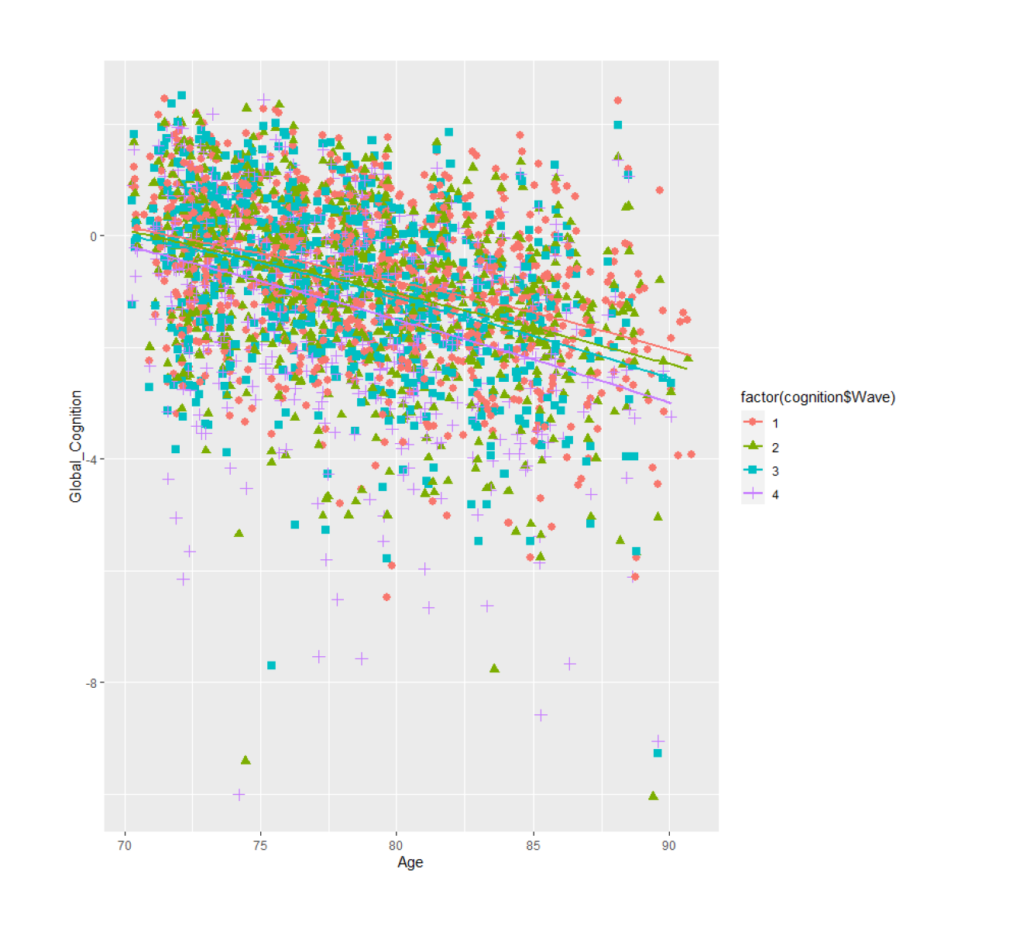
Supplementary Figure 2. Global cognitive composite scores by age at assessment across four study waves
Scatter plot of standardised global cognition composite scores against age at assessment for 847 participants, stratified by study wave: Wave 1 / baseline (pink diamonds), Wave 2 / 2-year follow-up (olive triangles), Wave 3 /4-year follow-up (teal squares), and Wave 4 / 6-year follow-up (purple crosses). Lines show wave-specific linear fits. Global cognition is expressed as a standardised composite (z-score) derived from five cognitive subdomains. Higher scores reflect better cognitive performance.

Supplementary Table 2. Attrition bias: Baseline Characteristics between participants with wave 4 cognition & without wave 4 cognition

Variable | Overall  N = 847¹ | No Wave 4 Cognition  N = 302¹ | Wave 4 Cognition  N = 545¹ | p-value²
Age, years | 78.66 (4.78) | 80.09 (5.01) | 77.88 (4.47) | <0.001
Sex |  |  |  | >0.999
Male | 368 (43%) | 131 (43%) | 237 (43%)
Female | 479 (57%) | 171 (57%) | 308 (57%)
Education, years | 11.65 (3.48) | 11.33 (3.44) | 11.82 (3.49) | 0.046
Race/ethnicity |  |  |  | 0.134
caucasian | 840 (100%) | 299 (99%) | 541 (100%)
asian | 4 (0.5%) | 3 (1.0%) | 1 (0.2%)
Olfactory function (BSIT score) | 9.27 (2.12) | 8.83 (2.36) | 9.50 (1.94) | <0.001
Memory | -0.43 (1.18) | -0.75 (1.18) | -0.26 (1.13) | <0.001
Verbal memory | -0.39 (1.16) | -0.68 (1.14) | -0.23 (1.15) | <0.001
Executive function | -0.41 (1.25) | -0.68 (1.36) | -0.26 (1.16) | <0.001
Language | -0.50 (1.36) | -0.87 (1.45) | -0.29 (1.25) | <0.001
Attention/processing speed | -0.32 (1.16) | -0.65 (1.31) | -0.14 (1.02) | <0.001
Visuospatial | -0.31 (1.08) | -0.60 (1.06) | -0.15 (1.05) | <0.001
Global cognition | -0.55 (1.29) | -1.01 (1.40) | -0.30 (1.16) | <0.001
Hypertension | 510 (60%) | 180 (60%) | 330 (61%) | 0.826
Diabetes |  |  |  | 0.505
no | 758 (90%) | 266 (89%) | 492 (91%)
yes - type 1 (juvenile-insulin dependent) | 2 (0.2%) | 1 (0.3%) | 1 (0.2%)
yes - type 2 (mature onset-non-insulin dependent) | 83 (9.8%) | 33 (11%) | 50 (9.2%)
BMI, kg/m² | 27.08 (4.61) | 26.82 (5.06) | 27.22 (4.35) | 0.254
Smoking status |  |  |  | 0.257
Never | 411 (49%) | 136 (45%) | 275 (51%)
Past | 401 (48%) | 152 (50%) | 249 (46%)
Current | 31 (3.7%) | 13 (4.3%) | 18 (3.3%)
High cholesterol | 495 (59%) | 163 (54%) | 332 (61%) | 0.058
Stroke (CVA) | 34 (4.1%) | 18 (6.0%) | 16 (3.0%) | 0.043
TIA | 59 (7.1%) | 33 (11%) | 26 (4.9%) | 0.001
APOE ε4 carrier |  |  |  | 0.721
Non-carrier | 618 (77%) | 206 (78%) | 412 (77%)
Carrier | 184 (23%) | 58 (22%) | 126 (23%)
Depression | 129 (16%) | 50 (17%) | 79 (15%) | 0.485
¹Mean (SD); n (%)
²Welch Two Sample t-test; Fisher's exact test

Supplementary Table 3. Attrition bias: Baseline Characteristics between MRI-wave 2 participants & non MRI-wave 2 participants

Variable | Overall  N = 847¹ | No MRI Wave 2  N = 500¹ | MRI Wave 2  N = 347¹ | p-value²
Age, years | 78.66 (4.78) | 79.37 (4.86) | 77.65 (4.49) | <0.001
Sex |  |  |  | 0.324
Male | 368 (43%) | 210 (42%) | 158 (46%)
Female | 479 (57%) | 290 (58%) | 189 (54%)
Education, years | 11.65 (3.48) | 11.39 (3.29) | 12.01 (3.71) | 0.013
Race/ethnicity |  |  |  | >0.999
caucasian | 840 (100%) | 496 (100%) | 344 (99%)
asian | 4 (0.5%) | 2 (0.4%) | 2 (0.6%)
Olfactory function (BSIT score) | 9.27 (2.12) | 9.16 (2.14) | 9.42 (2.09) | 0.075
Memory | -0.43 (1.18) | -0.53 (1.20) | -0.29 (1.13) | 0.003
Verbal memory | -0.39 (1.16) | -0.47 (1.17) | -0.27 (1.14) | 0.014
Executive function | -0.41 (1.25) | -0.49 (1.26) | -0.29 (1.22) | 0.022
Language | -0.50 (1.36) | -0.63 (1.38) | -0.31 (1.29) | <0.001
Attention/processing speed | -0.32 (1.16) | -0.45 (1.19) | -0.13 (1.09) | <0.001
Visuospatial | -0.31 (1.08) | -0.44 (1.06) | -0.12 (1.08) | <0.001
Global cognition | -0.55 (1.29) | -0.72 (1.33) | -0.31 (1.20) | <0.001
Hypertension |  |  |  | 0.006
No | 333 (40%) | 177 (36%) | 156 (45%)
Yes | 510 (60%) | 320 (64%) | 190 (55%)
Diabetes |  |  |  | 0.619
no | 758 (90%) | 445 (89%) | 313 (91%)
yes - type 1 (juvenile-insulin dependent) | 2 (0.2%) | 1 (0.2%) | 1 (0.3%)
yes - type 2 (mature onset-non-insulin dependent) | 83 (9.8%) | 53 (11%) | 30 (8.7%)
yes - diabetes incipidus | 0 (0%) | 0 (0%) | 0 (0%)
BMI, kg/m² | 27.08 (4.61) | 27.37 (4.97) | 26.67 (4.02) | 0.026
Smoking status |  |  |  | 0.090
Never | 411 (49%) | 228 (46%) | 183 (53%)
Past | 401 (47%) | 253 (51%) | 148 (43%)
Current | 31 (3.7%) | 17 (3.4%) | 14 (4.0%)
High cholesterol |  |  |  | 0.776
No | 348 (41%) | 203 (41%) | 145 (42%)
Yes | 495 (59%) | 294 (59%) | 201 (58%)
Stroke (CVA) |  |  |  | 0.049
No | 803 (96%) | 468 (95%) | 335 (98%)
Yes | 34 (4.1%) | 26 (5.3%) | 8 (2.3%)
TIA |  |  |  | 0.027
No | 774 (93%) | 447 (91%) | 327 (95%)
Yes | 59 (7.1%) | 43 (8.8%) | 16 (4.7%)
APOE ε4 carrier |  |  |  | 0.672
Non-carrier | 618 (77%) | 355 (78%) | 263 (76%)
Carrier | 184 (23%) | 102 (22%) | 82 (24%)
Depression |  |  |  | 0.331
No | 690 (84%) | 412 (85%) | 278 (83%)
Yes | 129 (16%) | 71 (15%) | 58 (17%)
¹Mean (SD); n (%)
²Welch Two Sample t-test (continuous); Fisher's exact test (categorical)

Supplementary Table 4. Attrition bias: Baseline Characteristics between MRI-wave 4 participants & non MRI-wave 4 participants

Variable | Overall  N = 847¹ | No MRI Wave 4  N = 625¹ | MRI Wave 4  N = 222¹ | p-value²
Age, years | 78.66 (4.78) | 79.17 (4.88) | 77.23 (4.20) | <0.001
Sex |  |  |  | 0.694
Male | 368 (43%) | 269 (43%) | 99 (45%)
Female | 479 (57%) | 356 (57%) | 123 (55%)
Education, years | 11.65 (3.48) | 11.46 (3.42) | 12.18 (3.59) | 0.010
Race/ethnicity |  |  |  | 0.578
caucasian | 840 (100%) | 619 (99%) | 221 (100%)
asian | 4 (0.5%) | 4 (0.6%) | 0 (0%)
Olfactory function (BSIT score) | 9.27 (2.12) | 9.13 (2.15) | 9.66 (1.98) | <0.001
Memory | -0.43 (1.18) | -0.53 (1.16) | -0.16 (1.18) | <0.001
Verbal memory | -0.39 (1.16) | -0.48 (1.14) | -0.15 (1.19) | <0.001
Executive function | -0.41 (1.25) | -0.50 (1.28) | -0.15 (1.12) | <0.001
Language | -0.50 (1.36) | -0.59 (1.36) | -0.22 (1.31) | <0.001
Attention/processing speed | -0.32 (1.16) | -0.40 (1.17) | -0.07 (1.10) | <0.001
Visuospatial | -0.31 (1.08) | -0.44 (1.04) | 0.05 (1.11) | <0.001
Global cognition | -0.55 (1.29) | -0.70 (1.29) | -0.14 (1.21) | <0.001
Hypertension |  |  |  | 0.749
No | 333 (40%) | 243 (39%) | 90 (41%)
Yes | 510 (60%) | 378 (61%) | 132 (59%)
Diabetes |  |  |  | 0.029
no | 758 (90%) | 552 (89%) | 206 (94%)
yes - type 1 (juvenile-insulin dependent) | 2 (0.2%) | 1 (0.2%) | 1 (0.5%)
yes - type 2 (mature onset-non-insulin dependent) | 83 (9.8%) | 70 (11%) | 13 (5.9%)
yes - diabetes incipidus | 0 (0%) | 0 (0%) | 0 (0%)
BMI, kg/m² | 27.08 (4.61) | 27.16 (4.88) | 26.86 (3.77) | 0.350
Smoking status |  |  |  | 0.786
Never | 411 (49%) | 298 (48%) | 113 (51%)
Past | 401 (47%) | 300 (48%) | 101 (45%)
Current | 31 (3.7%) | 24 (3.8%) | 7 (3.2%)
High cholesterol |  |  |  | 0.476
No | 348 (41%) | 261 (42%) | 87 (39%)
Yes | 495 (59%) | 360 (58%) | 135 (61%)
Stroke (CVA) |  |  |  | 0.016
No | 803 (96%) | 587 (95%) | 216 (99%)
Yes | 34 (4.1%) | 31 (5.0%) | 3 (1.4%)
TIA |  |  |  | <0.001
No | 774 (93%) | 560 (91%) | 214 (98%)
Yes | 59 (7.1%) | 54 (8.8%) | 5 (2.3%)
APOE ε4 carrier |  |  |  | 0.573
Non-carrier | 618 (77%) | 451 (78%) | 167 (76%)
Carrier | 184 (23%) | 130 (22%) | 54 (24%)
Depression |  |  |  | 0.828
No | 690 (84%) | 509 (84%) | 181 (84%)
Yes | 129 (16%) | 94 (16%) | 35 (16%)
¹Mean (SD); n (%)
²²Welch Two Sample t-test (continuous); Fisher's exact test (categorical)

Supplementary Table 5. Cross-sectional and longitudinal associations of baseline olfactory function with cognitive performance: Complete Case analysis

 | Cross-sectional associations |  |  | Longitudinal associations (BSIT × Year)
Cognitive Domain | β (95% CI) | SE | PFDR | β (95% CI) | SE | PFDR
Global Cognition | 0.079 (0.040, 0.118) | 0.020 | <0.001** | 0.010 (0.004, 0.016) | 0.003 | 0.002**
Memory | 0.044 (0.008, 0.081) | 0.019 | 0.017** | 0.004 (-0.002, 0.011) | 0.003 | 0.189
Executive Function | 0.040 (0.001, 0.080) | 0.020 | 0.047** | 0.014 (0.007, 0.022) | 0.004 | <0.001**
Language | 0.053 (0.013, 0.094) | 0.021 | 0.010** | 0.005 (-0.001, 0.011) | 0.003 | 0.133
Attention/Processing Speed | 0.067 (0.028, 0.106) | 0.020 | <0.001** | 0.012 (0.005, 0.019) | 0.004 | 0.001**
Visuospatial | 0.056 (0.021, 0.092) | 0.018 | 0.002** | 0.004 (-0.002, 0.010) | 0.003 | 0.178

Note: β = regression coefficient; CI = confidence interval; SE = standard error. Complete-case analysis (listwise deletion). Cross-sectional associations: BSIT main effect from linear mixed model, representing the association between baseline olfactory function and cognitive performance at baseline (year 0). Longitudinal associations: BSIT × year interaction from linear mixed model, representing the association between baseline olfactory function and the annual rate of cognitive change over 6 years (positive β = slower decline). All models adjusted for age, sex, years of education, APOE ε4 status, hypertension, diabetes, BMI, smoking, hypercholesterolaemia, stroke, TIA, depression, and nasal symptoms. *p < 0.05; **FDR-corrected p < 0.05 (Benjamini-Hochberg, across cognitive subdomains).

Supplementary Table 6. Stratified associations between olfactory function and cognitive decline by APOE ε4 carrier status

 | APOE ε4 Carriers  (n = 184 at baseline)ª |  |  | APOE ε4 Non-carriers  (n = 616 at baseline)
Cognition domain | β | 95% CI | PFDR | β | 95% CI | PFDR | PFDR  interaction
Attention/Processing Speed
BSIT | 0.0092 | (-0.0051, 0.0236) | 0.206 | 0.0078 | (-0.0005, 0.0161) | 0.065 | 0.855
Language
BSIT | 0.0024 | (-0.0093, 0.0141) | 0.686 | 0.0055 | (-0.0016, 0.0126) | 0.131 | 0.633
Executive function
BSIT | 0.0096 | (-0.0090, 0.0282) | 0.309 | 0.0141 | (0.0034, 0.0248) | 0.010* | 0.642
Visuospatial
BSIT | 0.0005 | (-0.0107, 0.0097) | 0.920 | 0.0046 | (-0.0019, 0.0111) | 0.167 | 0.387
Memory
BSIT | 0.0062 | (-0.0044, 0.0169) | 0.249 | 0.0071 | (0.0005, 0.0137) | 0.035* | 0.880
Global cognition
BSIT | 0.0068 | (-0.0052, 0.0187) | 0.266 | 0.0083 | (0.0014, 0.0153) | 0.019* | 0.797
Note: BSIT, Brief Smell Identification Test. β represents the year × BSIT interaction coefficient (slope of cognitive decline per unit BSIT per year) within each APOE ε4 stratum, pooled across m = 200 imputed datasets using Rubin’s rules. 95% CI: 95% confidence interval. P interaction: p-value for the three-way year × BSIT × APOE ε4 interaction term from the full-sample model, BH-FDR corrected across all cognitive subdomains. ª47 participants missing APOE ε4 carrier status at baseline. * PFDR<0.05 as statistically significant

Supplementary Figure 3. Association between baseline olfactory function and rate of MRI structural change over 6 years.
Note. Each point represents the standardised regression coefficient (β) for the BSIT × year interaction term from a linear mixed-effects model (LMM: MRI ~ year × BSIT + covariates + (1 + year | participant)), fitted separately for each brain region. The effect size was standardised by dividing β by the baseline standard deviation (SD) of each MRI measure, interpreted as the SD-change in regional brain structure per year, associated with per 1-point increase in BSIT score. Positive values indicate that higher olfactory function is associated with slower structural decline (or greater growth). Horizontal bars represent 95% confidence intervals derived using Rubin's rules pooled across m = 200 imputations. Multiple comparisons were controlled using the Benjamini–Hochberg false discovery rate (FDR) procedure applied across all tested regions.

Supplementary Figure 4. Two-stage product-of-coefficients mediation: indirect effect of olfactory function on rate of cognitive decline via MRI structural trajectory.
Note. BSIT, Brief Smell Identification Test; LH, left hemisphere; Inf. lat., inferior lateral; LMM, linear mixed model; FDR, false discovery rate; CI, confidence interval. Each panel shows the indirect effect (ab) of baseline olfactory identification (BSIT score) on rate of cognitive decline, mediated through the rate of structural MRI change, on each cognitive domain. Eight candidate MRI mediators are displayed on the y-axis. The shaded region (top three rows, separated by a horizontal line) indicates Tier 1 a priori olfactory-proximal mediators (hippocampus, entorhinal cortex, amygdala); unshaded rows indicate Tier 2 secondary network regions. Points represent the pooled indirect effect estimate (Rubin's rules; m = 200 imputations) and horizontal bars indicate 95% confidence intervals derived via the delta method. Point colour denotes significance: dark blue, FDR-corrected p < 0.05; light blue, uncorrected p < 0.05; grey, not significant.

Supplementary Table 7: Two-Stage Complete-Case Sensitivity Analysis
 |  | Model A: Basic adjustment |  |  | Model B: Full adjustment
Mediator | Cognitive domain | ab [95% CI] | p | PFDR | ab [95% CI] | p | PFDR
Hippocampus (bilateral) | Global cognition | 0.0009 [0.0002, 0.0015] | 0.011* | -- | 0.0008 [0.0002, 0.0015] | 0.013* | --
Hippocampus (bilateral) | Memory | 0.0013 [0.0003, 0.0023] | 0.009* | 0.106 | 0.0012 [0.0002, 0.0021] | 0.013* | 0.098
Hippocampus (bilateral) | Verbal memory | 0.0014 [0.0004, 0.0023] | 0.008* | 0.106 | 0.0012 [0.0003, 0.0022] | 0.011* | 0.098
Hippocampus (bilateral) | Executive function | 0.0012 [0.0001, 0.0023] | 0.038* | 0.150 | 0.0011 [0.0000, 0.0023] | 0.048* | 0.192
Hippocampus (bilateral) | Attention/processing speed | 0.0005 [0.0001, 0.0010] | 0.022* | 0.106 | 0.0006 [0.0001, 0.0010] | 0.019* | 0.098
Entorhinal cortex thickness (LH) | Global cognition | 0.0000 [-0.0002, 0.0003] | 0.759 | -- | 0.0000 [-0.0002, 0.0002] | 0.852 | --
Entorhinal cortex thickness (LH) | Memory | 0.0001 [-0.0006, 0.0009] | 0.742 | 0.872 | 0.0001 [-0.0006, 0.0008] | 0.842 | 0.875
Entorhinal cortex thickness (LH) | Verbal memory | 0.0001 [-0.0005, 0.0007] | 0.743 | 0.872 | 0.0001 [-0.0005, 0.0006] | 0.842 | 0.875
Entorhinal cortex thickness (LH) | Executive function | 0.0000 [-0.0002, 0.0003] | 0.697 | 0.872 | 0.0000 [-0.0002, 0.0002] | 0.767 | 0.875
Entorhinal cortex thickness (LH) | Attention/processing speed | 0.0000 [-0.0001, 0.0001] | 0.747 | 0.872 | 0.0000 [-0.0001, 0.0001] | 0.822 | 0.875
Amygdala (bilateral) | Global cognition | -0.0001 [-0.0003, 0.0002] | 0.591 | -- | -0.0001 [-0.0002, 0.0001] | 0.563 | --
Amygdala (bilateral) | Memory | -0.0001 [-0.0004, 0.0002] | 0.599 | 0.872 | -0.0000 [-0.0002, 0.0001] | 0.650 | 0.875
Amygdala (bilateral) | Verbal memory | -0.0001 [-0.0003, 0.0002] | 0.603 | 0.872 | -0.0000 [-0.0002, 0.0001] | 0.651 | 0.875
Amygdala (bilateral) | Executive function | -0.0001 [-0.0006, 0.0004] | 0.626 | 0.872 | -0.0001 [-0.0005, 0.0003] | 0.614 | 0.875
Amygdala (bilateral) | Attention/processing speed | -0.0000 [-0.0002, 0.0001] | 0.612 | 0.872 | -0.0000 [-0.0002, 0.0001] | 0.607 | 0.875
WMH volume (whole brain) | Global cognition | 0.0001 [-0.0002, 0.0005] | 0.432 | -- | 0.0001 [-0.0002, 0.0005] | 0.401 | --
WMH volume (whole brain) | Memory | 0.0000 [-0.0001, 0.0002] | 0.763 | 0.872 | 0.0000 [-0.0002, 0.0002] | 0.853 | 0.875
WMH volume (whole brain) | Verbal memory | 0.0000 [-0.0001, 0.0002] | 0.738 | 0.872 | 0.0000 [-0.0002, 0.0002] | 0.831 | 0.875
WMH volume (whole brain) | Executive function | 0.0002 [-0.0007, 0.0012] | 0.611 | 0.872 | 0.0003 [-0.0007, 0.0013] | 0.565 | 0.875
WMH volume (whole brain) | Attention/processing speed | 0.0001 [-0.0002, 0.0004] | 0.568 | 0.872 | 0.0001 [-0.0002, 0.0003] | 0.525 | 0.875
Inferior lateral ventricle (bilateral) | Global cognition | 0.0008 [0.0001, 0.0014] | 0.020* | -- | 0.0007 [0.0001, 0.0014] | 0.022* | --
Inferior lateral ventricle (bilateral) | Memory | 0.0013 [0.0003, 0.0024] | 0.013* | 0.106 | 0.0013 [0.0003, 0.0023] | 0.013* | 0.098
Inferior lateral ventricle (bilateral) | Verbal memory | 0.0011 [0.0002, 0.0021] | 0.017* | 0.106 | 0.0011 [0.0002, 0.0020] | 0.018* | 0.098
Inferior lateral ventricle (bilateral) | Executive function | 0.0015 [0.0002, 0.0028] | 0.021* | 0.106 | 0.0016 [0.0003, 0.0029] | 0.019* | 0.098
Inferior lateral ventricle (bilateral) | Attention/processing speed | 0.0006 [0.0001, 0.0010] | 0.024* | 0.106 | 0.0006 [0.0001, 0.0010] | 0.022* | 0.098
Thalamus (bilateral) | Global cognition | 0.0001 [-0.0002, 0.0005] | 0.425 | -- | 0.0002 [-0.0002, 0.0006] | 0.359 | --
Thalamus (bilateral) | Memory | 0.0001 [-0.0002, 0.0004] | 0.461 | 0.872 | 0.0001 [-0.0002, 0.0005] | 0.421 | 0.875
Thalamus (bilateral) | Verbal memory | 0.0001 [-0.0002, 0.0005] | 0.447 | 0.872 | 0.0002 [-0.0002, 0.0006] | 0.389 | 0.875
Thalamus (bilateral) | Executive function | 0.0002 [-0.0003, 0.0006] | 0.460 | 0.872 | 0.0002 [-0.0003, 0.0006] | 0.418 | 0.875
Thalamus (bilateral) | Attention/processing speed | 0.0000 [-0.0001, 0.0002] | 0.491 | 0.872 | 0.0001 [-0.0001, 0.0002] | 0.423 | 0.875
Lateral orbitofrontal thickness (LH) | Global cognition | -0.0000 [-0.0001, 0.0001] | 0.889 | -- | -0.0000 [-0.0001, 0.0001] | 0.801 | --
Lateral orbitofrontal thickness (LH) | Memory | -0.0000 [-0.0002, 0.0002] | 0.894 | 0.894 | -0.0000 [-0.0002, 0.0001] | 0.790 | 0.875
Lateral orbitofrontal thickness (LH) | Verbal memory | -0.0000 [-0.0002, 0.0002] | 0.894 | 0.894 | -0.0000 [-0.0002, 0.0002] | 0.785 | 0.875
Lateral orbitofrontal thickness (LH) | Executive function | -0.0000 [-0.0003, 0.0002] | 0.694 | 0.872 | -0.0001 [-0.0003, 0.0002] | 0.625 | 0.875
Lateral orbitofrontal thickness (LH) | Attention/processing speed | -0.0000 [-0.0002, 0.0001] | 0.818 | 0.894 | -0.0000 [-0.0002, 0.0001] | 0.699 | 0.875
Pars opercularis thickness (LH) | Global cognition | 0.0002 [-0.0001, 0.0005] | 0.270 | -- | 0.0002 [-0.0001, 0.0005] | 0.275 | --
Pars opercularis thickness (LH) | Memory | 0.0002 [-0.0002, 0.0007] | 0.260 | 0.831 | 0.0002 [-0.0002, 0.0007] | 0.259 | 0.846
Pars opercularis thickness (LH) | Verbal memory | 0.0002 [-0.0002, 0.0006] | 0.269 | 0.831 | 0.0002 [-0.0002, 0.0007] | 0.264 | 0.846
Pars opercularis thickness (LH) | Executive function | 0.0000 [-0.0004, 0.0005] | 0.853 | 0.894 | 0.0000 [-0.0004, 0.0005] | 0.895 | 0.895
Pars opercularis thickness (LH) | Attention/processing speed | 0.0001 [-0.0001, 0.0002] | 0.491 | 0.872 | 0.0000 [-0.0001, 0.0002] | 0.665 | 0.875

Note. Complete-case sensitivity analysis for the two-stage product-of-coefficients mediation (8 pre-specified mediators, 5 cognitive domains). Model A: adjusted for age, sex, education, eTIV. Model B: adjusted for age, sex, education, APOE ε4 carrier status, nasal symptom history, vascular risk score, BMI, smoking, history of stroke, depression, eTIV. Complete cases were defined as participants with non-missing BSIT, all Model B covariates, and wave-1 MRI. ab = product-of-coefficients indirect effect (BSIT → MRI trajectory slope → cognitive slope); 95% CI derived from the delta method. PFDR = Benjamini–Hochberg false discovery rate-adjusted p-value. * Nominally significant p-values (p < 0.05) are shown in green.

Supplementary Table 8. Latent growth curve mediation model (LGCMM): indirect effect (ab) of olfactory function (BSIT) on rate of cognitive decline via MRI structural trajectory.
 |  | Indirect effect (ab): β [95% CI] per cognitive domain
Tier | Mediator | Global  Cognition | Executive  Function | Memory | Attention/  Proc. Speed | Language | Visuospatial
Tier 1 | Hippocampus volume (bilateral) | 0.0089 [-0.0001, 0.0180] | 0.0046 [-0.0026, 0.0118] | 0.0058 [0.0003, 0.0113]* | 0.0062 [-0.0008, 0.0131] | 0.0080 [-0.0018, 0.0177] | 0.0040 [-0.0022, 0.0102]
Tier 1 | Entorhinal cortex thickness (LH) | 0.0007 [-0.0011, 0.0024] | 0.0012 [-0.0016, 0.0041] | 0.0013 [-0.0017, 0.0043] | 0.0002 [-0.0011, 0.0015] | -0.0013 [-0.0515, 0.0490] | -0.0001 [-0.0010, 0.0008]
Tier 1 | Amygdala volume (bilateral) | -0.0004 [-0.0032, 0.0024] | -0.0003 [-0.0031, 0.0025] | -0.0003 [-0.0021, 0.0015] | -0.0003 [-0.0030, 0.0024] | -0.0002 [-0.0022, 0.0018] | -0.0002 [-0.0012, 0.0009]
Tier 2 | Inferior lateral ventricle volume (bilateral) | 0.0079 [0.0002, 0.0156]* | 0.0062 [-0.0015, 0.0138] | 0.0064 [0.0004, 0.0124]* | 0.0089 [-0.0019, 0.0197] | 0.0103 [-0.0008, 0.0213] | 0.0030 [-0.0010, 0.0070]
Tier 2 | White matter hyperintensities | -0.0028 [-0.0078, 0.0022] | -0.0035 [-0.0091, 0.0020] | -0.0017 [-0.0047, 0.0013] | -0.0027 [-0.0078, 0.0024] | -0.0010 [-0.0029, 0.0009] | -0.0016 [-0.0042, 0.0011]
Tier 2 | Thalamus volume (bilateral) | 0.0029 [-0.0008, 0.0066] | 0.0033 [-0.0014, 0.0080] | 0.0011 [-0.0015, 0.0036] | 0.0025 [-0.0012, 0.0062] | 0.0017 [-0.0010, 0.0044] | 0.0018 [-0.0012, 0.0048]
Tier 2 | Lateral orbitofrontal thickness (LH) | 0.0005 [-0.0021, 0.0030] | 0.0002 [-0.0023, 0.0027] | 0.0016 [-0.0034, 0.0065] | -0.0001 [-0.0029, 0.0027] | 0.0005 [-0.0017, 0.0027] | 0.0274 [-0.4506, 0.5053]
Tier 2 | Pars opercularis thickness (LH) | 0.0013 [-0.0008, 0.0035] | 0.0010 [-0.0013, 0.0033] | 0.0017 [-0.0006, 0.0040] | 0.0011 [-0.0015, 0.0037] | 0.0007 [-0.0011, 0.0025] | 0.0003 [-0.0013, 0.0019]

Note. Exposure: baseline BSIT score. Mediator: latent rate of MRI structural change (slope from LGCM, waves 1–4). Outcome: latent rate of cognitive decline (slope from LGCM, years 0–6). Indirect effect (ab) pooled across m = 200 imputations using Rubin's rules. 95% CI from pooled standard errors. FDR correction (Benjamini–Hochberg) applied within each mediator across cognitive subdomains. Significance: *p < 0.05 (uncorrected). **PFDR < 0.05. Tier 1: a priori olfactory-proximal regions; Tier 2: secondary network regions. LH, left hemisphere.

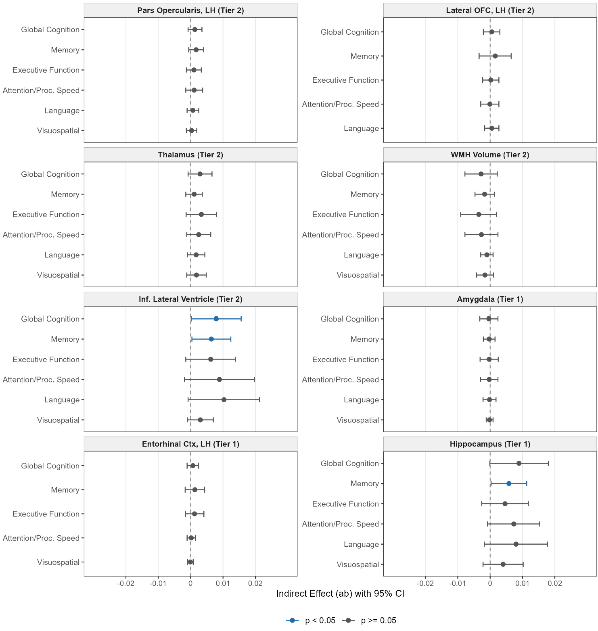
Supplementary Figure 5. Forest plot of LGCMM indirect effects of olfactory function on cognitive decline mediated via via MRI structural trajectory.
Note. Each panel shows the indirect effect (ab) of baseline olfactory identification (BSIT score) on rate of cognitive decline, mediated through the rate of structural MRI change, on each cognitive domain. Points represent the pooled indirect effect estimate (Rubin's rules; m = 200 imputations) and horizontal bars indicate 95% confidence intervals derived via the delta method. Blue filled circles indicate nominally significant indirect effects (p < 0.05, CI excludes zero); grey circles indicate non-significant effects. FDR correction (Benjamini–Hochberg) was applied within each mediator across all cognitive subdomains. Significance: p<0.05 for global cognition in tier 1 and all cognitive domains in tier 2 (exploratory). LH, left hemisphere; WMH, white matter hyperintensities; OFC, orbitofrontal cortex; BSIT, Brief Smell Identification Test.

Supplementary Table 9. VanderWeele counterfactual causal mediation: total natural indirect effect (TNIE) of olfactory function (BSIT) on rate of cognitive decline via MRI structural mediators.
 |  | TNIE (β [95% CI]) per cognitive domain
Tier | Mediator | Global  Cognition | Executive  Function | Memory | Attention/  Proc. Speed | Language | Visuospatial
Tier 1 | Hippocampus volume (bilateral) | 0.0020 [-0.0017, 0.0056] | 0.0023 [-0.0025, 0.0072] | 0.0012 [-0.0015, 0.0039] | 0.0005 [-0.0022, 0.0032] | 0.0018 [-0.0017, 0.0053] | 0.0008 [-0.0008, 0.0024]
Tier 1 | Entorhinal cortex thickness (LH) | 0.0003 [-0.0018, 0.0025] | 0.0004 [-0.0022, 0.0029] | 0.0003 [-0.0015, 0.0022] | 0.0001 [-0.0010, 0.0011] | 0.0004 [-0.0017, 0.0024] | 0.0001 [-0.0006, 0.0008]
Tier 1 | Amygdala volume (bilateral) | -0.0003 [-0.0019, 0.0014] | -0.0003 [-0.0029, 0.0022] | -0.0001 [-0.0013, 0.0011] | -0.0001 [-0.0014, 0.0011] | 0.0001 [-0.0012, 0.0013] | -0.0001 [-0.0009, 0.0006]
Tier 2 | Inferior lateral ventricle volume (bilateral) | 0.0031 [-0.0018, 0.0080] | 0.0051 [-0.0016, 0.0117] | 0.0026 [-0.0008, 0.0061] | 0.0027 [-0.0011, 0.0066] | 0.0013 [-0.0028, 0.0055] | 0.0014 [-0.0009, 0.0037]
Tier 2 | White matter hyperintensities | 0.0023 [-0.0022, 0.0068] | 0.0040 [-0.0029, 0.0108] | 0.0009 [-0.0023, 0.0042] | 0.0020 [-0.0019, 0.0060] | 0.0003 [-0.0035, 0.0041] | 0.0010 [-0.0012, 0.0032]
Tier 2 | Thalamus volume (bilateral) | 0.0015 [-0.0015, 0.0046] | 0.0027 [-0.0023, 0.0076] | -0.0000 [-0.0023, 0.0022] | 0.0006 [-0.0015, 0.0027] | 0.0007 [-0.0021, 0.0034] | 0.0009 [-0.0006, 0.0024]
Tier 2 | Lateral orbitofrontal thickness (LH) | -0.0000 [-0.0010, 0.0010] | 0.0001 [-0.0016, 0.0017] | 0.0000 [-0.0011, 0.0012] | 0.0001 [-0.0011, 0.0013] | -0.0002 [-0.0017, 0.0013] | 0.0001 [-0.0005, 0.0006]
Tier 2 | Pars opercularis thickness (LH) | -0.0001 [-0.0018, 0.0016] | -0.0004 [-0.0033, 0.0025] | -0.0010 [-0.0038, 0.0019] | 0.0001 [-0.0012, 0.0014] | -0.0001 [-0.0017, 0.0014] | 0.0003 [-0.0007, 0.0012]
Note. Mediators: wave-2 MRI measures. Outcome: z-scored rate of cognitive decline (LMM random slope, years 0–6). TNIE estimated using the CMAverse package; 95% CI via Monte Carlo simulation (m = 200 imputations). FDR correction (Benjamini–Hochberg) applied within each mediator across the six cognitive domains. *p < 0.05 (uncorrected); †PFDR < 0.05. Tier 1: a priori olfactory-proximal regions; Tier 2: secondary network regions.

Supplementary Table 10. Complete-case sensitivity analysis: VanderWeele counterfactual causal mediation
Two complete-case covariate models are presented to assess robustness of the primary multiple-imputation VanderWeele analysis.

Suppl. Table 10A: Complete-case VanderWeele counterfactual causal mediation (Covariates: age, sex, education, eTIV)

 |  | TNIE (β [95% CI]) per cognitive domain
Tier | Mediator | Global  Cognition | Executive  Function | Memory | Attention/  Proc. Speed | Language | Visuospatial
Tier 1 | Hippocampus volume (bilateral) | 0.0038 [0.0001, 0.0075]* | 0.0031 [-0.0012, 0.0075] | 0.0032 [-0.0003, 0.0067] | 0.0023 [-0.0002, 0.0048] | 0.0023 [-0.0007, 0.0054] | 0.0013 [-0.0001, 0.0027]
Tier 1 | Entorhinal cortex thickness (LH) | 0.0031 [-0.0009, 0.0071] | 0.0029 [-0.0014, 0.0072] | 0.0034 [-0.0013, 0.0080] | 0.0003 [-0.0013, 0.0020] | 0.0032 [-0.0012, 0.0075] | 0.0012 [-0.0005, 0.0029]
Tier 1 | Amygdala volume (bilateral) | 0.0010 [-0.0014, 0.0034] | 0.0008 [-0.0018, 0.0034] | 0.0012 [-0.0017, 0.0041] | 0.0006 [-0.0010, 0.0021] | 0.0002 [-0.0013, 0.0016] | 0.0005 [-0.0007, 0.0016]
Tier 2 | Inferior lateral ventricle volume (bilateral) | 0.0031 [-0.0011, 0.0072] | 0.0045 [-0.0011, 0.0101] | 0.0027 [-0.0006, 0.0060] | 0.0027 [-0.0003, 0.0057] | 0.0014 [-0.0026, 0.0053] | 0.0015 [-0.0006, 0.0036]
Tier 2 | White matter hyperintensities | 0.0021 [-0.0018, 0.0061] | 0.0033 [-0.0022, 0.0088] | 0.0008 [-0.0024, 0.0040] | 0.0018 [-0.0014, 0.0050] | 0.0005 [-0.0032, 0.0042] | 0.0011 [-0.0008, 0.0030]
Tier 2 | Thalamus volume (bilateral) | 0.0014 [-0.0014, 0.0042] | 0.0027 [-0.0018, 0.0072] | -0.0004 [-0.0025, 0.0017] | 0.0015 [-0.0007, 0.0037] | 0.0001 [-0.0025, 0.0027] | 0.0011 [-0.0002, 0.0025]
Tier 2 | Lateral orbitofrontal thickness (LH) | 0.0000 [-0.0011, 0.0012] | 0.0002 [-0.0013, 0.0016] | 0.0001 [-0.0010, 0.0011] | 0.0001 [-0.0009, 0.0012] | -0.0002 [-0.0016, 0.0012] | 0.0001 [-0.0005, 0.0007]
Tier 2 | Pars opercularis thickness (LH) | 0.0001 [-0.0011, 0.0012] | -0.0001 [-0.0021, 0.0018] | -0.0007 [-0.0030, 0.0017] | 0.0001 [-0.0009, 0.0012] | -0.0000 [-0.0013, 0.0012] | 0.0003 [-0.0006, 0.0013]

Note. Complete-case VanderWeele counterfactual causal mediation. Total natural indirect effect (TNIE) of olfactory function (BSIT score) on rate of cognitive decline via wave-2 MRI structural mediators (year 2, n =347 complete cases). Outcome: z-scored rate of cognitive decline (LMM random slope, years 0–6); slopes averaged across m = 200 imputations per participant. TNIE estimated using CMAverse (regression-based decomposition); 95% CI via normal approximation from bootstrap SE (nboot = 1000). FDR correction (Benjamini–Hochberg) applied within each mediator across six cognitive domains. *p < 0.05. Tier 1: a priori olfactory-proximal regions; Tier 2: secondary network regions.

Suppl. Table 10B: Complete-case VanderWeele counterfactual causal mediation in a fully adjusted model

 |  | TNIE (β [95% CI]) per cognitive domain
Tier | Mediator | Global  Cognition | Executive  Function | Memory | Attention/  Proc. Speed | Language | Visuospatial
Tier 1 | Hippocampus volume (bilateral) | 0.0022 [-0.0010, 0.0054] | 0.0023 [-0.0014, 0.0059] | 0.0014 [-0.0011, 0.0039] | 0.0009 [-0.0010, 0.0028] | 0.0014 [-0.0017, 0.0045] | 0.0010 [-0.0003, 0.0024]
Tier 1 | Entorhinal cortex thickness (LH) | 0.0002 [-0.0016, 0.0020] | 0.0003 [-0.0020, 0.0025] | 0.0002 [-0.0016, 0.0021] | 0.0001 [-0.0008, 0.0009] | 0.0002 [-0.0014, 0.0017] | 0.0001 [-0.0005, 0.0007]
Tier 1 | Amygdala volume (bilateral) | -0.0002 [-0.0016, 0.0012] | -0.0002 [-0.0022, 0.0018] | -0.0001 [-0.0011, 0.0010] | -0.0001 [-0.0011, 0.0009] | 0.0001 [-0.0011, 0.0013] | -0.0001 [-0.0008, 0.0006]
Tier 2 | Inferior lateral ventricle volume (bilateral) | 0.0031 [-0.0011, 0.0072] | 0.0045 [-0.0011, 0.0101] | 0.0027 [-0.0006, 0.0060] | 0.0027 [-0.0003, 0.0057] | 0.0014 [-0.0026, 0.0053] | 0.0015 [-0.0006, 0.0036]
Tier 2 | White matter hyperintensities | 0.0021 [-0.0018, 0.0061] | 0.0033 [-0.0022, 0.0088] | 0.0008 [-0.0024, 0.0040] | 0.0018 [-0.0014, 0.0050] | 0.0005 [-0.0032, 0.0042] | 0.0011 [-0.0008, 0.0030]
Tier 2 | Thalamus volume (bilateral) | 0.0016 [-0.0012, 0.0045] | 0.0026 [-0.0019, 0.0071] | -0.0000 [-0.0020, 0.0020] | 0.0006 [-0.0011, 0.0024] | 0.0009 [-0.0017, 0.0034] | 0.0011 [-0.0003, 0.0025]
Tier 2 | Lateral orbitofrontal thickness (LH) | 0.0000 [-0.0011, 0.0012] | 0.0002 [-0.0013, 0.0016] | 0.0001 [-0.0010, 0.0011] | 0.0001 [-0.0009, 0.0012] | -0.0002 [-0.0016, 0.0012] | 0.0001 [-0.0005, 0.0007]
Tier 2 | Pars opercularis thickness (LH) | 0.0001 [-0.0011, 0.0012] | -0.0001 [-0.0021, 0.0018] | -0.0007 [-0.0030, 0.0017] | 0.0001 [-0.0009, 0.0012] | -0.0000 [-0.0013, 0.0012] | 0.0003 [-0.0006, 0.0013]

Note. Complete-case VanderWeele counterfactual causal mediation (Covariates: age, sex, education, eTIV, and additionally adjusted for wave-1 value of each MRI mediator, APOE Ɛ4 carrier status, hypertension, diabetes, BMI, smoking, cholesterol, CVA,TIA, depression, nasal surgery)). Total natural indirect effect (TNIE) of olfactory function (BSIT score) on rate of cognitive decline via wave-2 MRI structural mediators (year 2, n = 347 complete cases). Outcome: z-scored rate of cognitive decline (LMM random slope, years 0–6). TNIE estimated using CMAverse (regression-based decomposition); 95% CI via normal approximation from bootstrap SE (nboot = 1000). FDR correction (Benjamini–Hochberg) applied within each mediator across six cognitive domains. *p < 0.05 (uncorrected); †FDR p < 0.05. Tier 1: a priori olfactory-proximal regions; Tier 2: secondary network regions.

