Supplemental Methods
Sample selection
Participant selection is summarized in Supplementary Fig. S1. Structural connectome data were available for 39,836 participants, and resting-state fMRI time series were available for 40,334 participants. A total of 38,853 participants had both data modalities available. Participants with excessive head motion during resting-state fMRI, defined as mean framewise displacement >0.20 mm, were excluded. Participants with any missing value required for the construction of the structural or functional connectivity profiles were also excluded. The final analytical sample comprised 34,067 participants.
MRI data acquisition and Preprocessing
All UKB brain imaging data (connectome of Glasser parcellation, ID 31022; functional time series of Glasser parcellation, ID 31016) were acquired using 3T Siemens Skyra scanners with a standard 32-channel head coil. Further details about data and preprocessing are available in the online documentation: http://biobank.ctsu.ox.ac.uk/crystal/refer.cgi?id=2367 and http://biobank.ctsu.ox.ac.uk/crystal/refer.cgi?id=1977 (Alfaro-Almagro et al., 2018; Miller et al., 2016) and related article (Mansour L, Di Biase, Smith, Zalesky, & Seguin, 2023). The T1-weighted structural brain images were acquired using a 3D MPRAGE acquisition at 1 mm isotropic resolution with a 256 mm superior-inferior field of view.
Resting-state BOLD data were acquired with a multi-band gradient echo EPI sequence, with an acquisition time of 6 min, for a total of 490 volumes, with a spatial resolution of 2.4 mm isotropic voxels (TE/TR 39/735 ms, MB 8, no in-plane acceleration, flip angle 52°, conventional fat saturation)(Dollard & Miller, 1950) (Miller et al., 2016). Preprocessing steps (Alfaro-Almagro et al., 2018) consisted of the FSL MELODIC pipeline (Jenkinson, Beckmann Cf Fau - Behrens, Behrens Te Fau - Woolrich, Woolrich Mw Fau - Smith, & Smith) (EPI susceptibility distortion correction, gradient distortion correction, motion correction with FSL MCFLIRT, grand-mean intensity normalization, and high-pass temporal filtering) followed by an ICA + FIX step to suppress remaining artifact components. In addition to UKB quality control, participants with excessive head movement (average framewise displacement > 0.2mm, ID 25741) during scans were excluded.
Diffusion-weighted MRI (dMRI) data were acquired using a multi-band spin echo EPI sequence with a 7-minute acquisition time. The data were acquired across 100 unique diffusion sensitization directions, evenly distributed over two shells (b-values: 1000, 2000 s/mm³), along with 5 b=0 volumes. The spatial resolution was 2 mm isotropic voxels (MB=3, no in-plane acceleration, TE/TR=92/3600 ms, partial Fourier=6/8, conventional fat saturation). Additionally, 3 b=0 volumes were collected with reversed phase encoding to estimate susceptibility fields. Preprocessing including corrections for eddy currents, head motion, and gradient distortions (Alfaro-Almagro et al., 2018). Whole-brain tractography was estimated using MRtrix3 (Tournier et al., 2019).
Phenotype assessment time points
In our analysis we restricted usage to phenotype available at Instance 2 (i.e., the time-point where brain imaging data were collected). Items not available at Instance 2 (for example certain PHQ modules that were only administered at baseline) were therefore excluded from our analyses. Details of each ID and its questionnaire source are listed in the Table S1. Unless otherwise specified, phenotypic measures were obtained at imaging Instance 2, corresponding to the assessment instance at which brain MRI data were acquired. Socioeconomic status variables and trauma-related variables were obtained at baseline Instance 0. These variables were retained because they were conceptualized as relatively stable socioeconomic characteristics or early-life/adversity exposures, for which the date of questionnaire completion does not represent the timing of the exposure itself. To account for age at neuroimaging assessment, age at the imaging visit was included as a covariate in all relevant association models. The assessment instance, UK Biobank field ID, coding, and analytical category for each phenotype are reported in Table SS1.
Cognitive function. Cognitive items (Category 100026) included fluid intelligence score (ID 20016), maximum digits remembered correctly (ID 4282), prospective memory result (ID 20018), mean time to correctly identify matches (ID 20023), number of word pairs correctly associated (ID 20197), number of puzzles correct (ID 21004), and number of symbol digit matches made correctly (ID 23324).
Mental health. A wide range of items pertaining to mood, feelings, satisfaction, depression/anhedonia, mania/hyper, irritability, risk‐taking, and help‐seeking were included in Category 100060. Examples include: mood swings (ID1920), miserableness (1930), irritability (1940), sensitivity/hurt feelings (1950), fed‐up feelings (1960), frequency of depressed mood in last 2 weeks (ID 2050), ever depressed for a whole week (4598), ever manic/hyper for 2 days (4642), happiness (ID 4526; reverse‐scored in main text as "Unhappiness"), work/job satisfaction (4537), health satisfaction (4548), financial situation satisfaction (4581).
Self-reported medical conditions. We included variables (Category 1003). for example, the number of self‐reported cancers (ID 134) and number of self‐reported non-cancer illnesses (ID 135). We also included the number of treatments/medications taken (ID 137). Additionally, a range of condition-specific items were included: e.g., diabetes diagnosed by doctor, cancer diagnosed by doctor, age high blood pressure diagnosed, fracture/broken bones in last 5 years, hearing difficulty, chest pain, shortness of breath walking on level ground, etc. These variables were grouped in the main text under "Self-reported medical conditions". Other relevant self-report items included overall health rating (ID 2178; renamed in main text as "Overall unhealth rating" because higher values indicate worse health), long‐standing illness, disability or infirmity, falls in the last year, weight change compared with 1 year ago, various pain items (e.g., neck/shoulder pain for 3+ months; hip pain for 3+ months; back pain for 3+ months; knee pain for 3+ months; headaches for 3+ months) and sensory/vision (e.g., wears glasses/contact lenses, age started wearing them) and hearing (e.g., tinnitus).
Lifestyle and Environmental Factors
We extracted a broad set of self-reported measures from the UK Biobank baseline and online questionnaires to characterize multiple lifestyle and environmental domains. Most variables were collected through the UK Biobank baseline touchscreen questionnaires and online follow-up Mental Health Questionnaire (MHQ), launched in 2016. The childhood adversity questions (ID 20487-20491) originated from the Childhood Trauma Screener (CTS-5) module within the MHQ (see biobank.ndph.ox.ac.uk/ukb/label.cgi?id=145), while the broader adversity and trauma items were part of the Online Mental Health dataset (see ukbiobank.ac.uk). Dietary, lifestyle, and SES variables were derived from the baseline Touchscreen Questionnaire modules described on the UK Biobank data showcase. Details of each variable are provided in the Table S1.
Social support. Measures included the number of people in household (ID 709; with "1" indicating living alone) and the frequency of friend/family visits (ID 1031).
Socioeconomic status (SES). SES was indexed by average total household income before tax (ID 738) and age completed full-time education (ID 845). In the main text, "Household" and "Education" were grouped under the SES category.
Physical activity. Variables included the number of days per week with ≥10 minutes of moderate (ID 884) or vigorous (ID 904) activity, average duration of moderate (ID 894) and vigorous (ID 914) activity, and time spent watching television (ID 1070) or using a computer (ID 1080).
Sleep. Sleep measures included sleep duration (ID 1160), with values < 6 hours classified as too short and ≥ 9 hours as too long (binary variables 1160_S and 1160_L), and sleeplessness/insomnia (ID 1200).
Diet and Healthy Diet Score Estimation. The touch-screen questionnaire, self-completed at baseline, was used to collect the frequency of consumption of the following 12 food items over the previous year with Food Frequency Questionnaire (FFQ): beef, lamb, pork, processed meat, oily fish, non-oily fish, fresh fruit, dried fruit, raw vegetables, cooked vegetables, cereal, and bread. We also created new data fields based on food items: (1) Red meat intake, (2) Total fish intake, (3) Total vegetables intake, (4) Total fruit intake, (5) Whole grains intake, and (6) Refined grains intake. We summed beef, lamb and pork intake to create red meat intake. We also summed oily fish and non-oily fish intake to generate total fish intake. To calculate total vegetables and fruit consumption respectively, we aggregated cooked vegetables and salad/raw vegetable intake as total vegetables intake, and fresh fruit and dried fruit as total fruit intake. We divided grains into whole grains and refined grains according to the type of bread and cereal mainly consumed. We defined wholemeal or wholegrain bread, bran cereal, oat cereal, and muesli as whole grains; white bread, brown bread, other bread, biscuit cereal, and other cereals as refined grains. We categorized the 12 food items into 7 food groups, including red meat, processed meat, total fish, total fruit, total vegetables, whole grains and refined grains. We also defined serving size for each baseline food items. For bread and cereal, data were provided for weekly consumption, which were converted into daily consumption. We adopted seven dietary factors and cut-offs according to previous studies (Liu, Wang, Zhu, & Jin, 2023; Lourida et al., 2019), that is, increasing fruit, vegetables, whole grains, and fish consumption, and decreasing red meat, processed meat, and refined grains intake. The healthy diet score was calculated using the seven dietary components: Total fruit ≥ 4 servings/day; Total vegetables ≥ 4 servings/day; Total fish ≥ 2 servings/week; Processed meat ≤ 1 serving/week; Red meat ≤ 1.5 servings/week; Whole grains ≥ 3 servings/day; Refined grains ≤ 1.5 servings/day. Each favorable dietary factor was given one point (Table S2). The score ranged from 0 to 7; score 0–1 are defined as low-quality diet, 2–4 as intermediate-quality diet, and 5–7 as high-quality diet, according to data distribution characteristics.
Alcohol use and smoking. Alcohol consumption was indexed by drinking frequency (ID 1558), weekly intake of specific beverage types (1568-1608), monthly intake counterparts (4407-4451), and drinker status (20117). Smoking status was assessed using ID 20116.
Early life factor. Early developmental measures included being breastfed as a baby (1677), adopted as a child (1767), multiple birth (1777), maternal smoking around birth (1787), and birth weight (20022).
Trauma. The trauma is screened using Childhood Trauma Screener (CTS-5, ID 20487-20531), including a series of items on childhood and adulthood adverse or supportive experiences, covering emotional neglect, physical abuse, and related domains. The broader set included questions on family relationships, partner violence, serious accidents, combat exposure, and other life-threatening or traumatic events.
Preprocessing of genetic data
Genotype calling was performed by Affymetrix (now part of ThermoFisher Scientific) on two closely related purpose-designed arrays. ~50,000 participants were run on the UK BiLEVE Axiom array (Resource 149600) and the remaining ~450,000 were run on the UK Biobank Axiom array (Resource 149601). The dataset combines results from both arrays (see Field 22000) and there are 805,426 markers in the released genotype data. The positions of markers in the data are in GRCh37 coordinates. It was not possible to assay genotypes for some participants (~3%) as sufficient DNA could not be extracted from their blood samples.
We restricted the sample set to participants who had undergone brain MRI scanning in our study, and analysed only autosomal variants (chromosomes 1-22). This approach ensures that the ancestry covariates included in the downstream GWAS reflect the actual sample analysed, and not the broader UKB sample whose ancestry structure may differ. Individuals with a genotype missingness rate >5% were excluded. Variants were filtered based on a minor allele frequency (MAF) threshold of 0.01, Hardy-Weinberg equilibrium (HWE) test p<1e-6, and variant missingness >5%. After QC, all 22 chromosomes were merged into a single data, allowing a maximum of two alleles per locus. To correct for population structure specific to the imaging subsample, we performed a principal component analysis (PCA) on the QCed merged dataset rather than using the population principal components provided by the UK Biobank.
Genome-wide association studies (GWAS)
GWAS analyses were conducted using PLINK 2.0, adopting an additive genetic model and a linear regression framework, in which allele dosage was modelled additively (0, 1, 2) for each SNP. The regression models included sex, age, BMI, head motion, SNR, TIV, centre, and the top 20 genetic PCs as covariates to account for potential confounding effects due to demographic or ancestry differences.
Robustness and reproducibility analyses
To assess the robustness of SFC and DSFC estimates, we performed three sets of sensitivity analyses by repeating the analyses under alternative methodological settings, including structural connectivity measures, cortical parcellation schemes, and temporal window lengths.
For each sensitivity analysis, reproducibility was evaluated at both individual and population levels using complementary approaches. At the individual level, for analyses with matched parcellations (i.e., streamline-based versus FA-based structural connectivity and different sliding window lengths), parcel-wise reproducibility was assessed by calculating Spearman rank correlation coefficients between SFC/DSFC maps across 360 brain regions for each participant. In addition, network-level reproducibility was evaluated by averaging SFC/DSFC values within the seven canonical functional networks defined by the Yeo-7 atlas and calculating Pearson correlation coefficients between corresponding network-level profiles across individuals.
At the population level, group-averaged SFC/DSFC maps derived from different methodological settings were projected to fsaverage surface and compared using spatial correlation analyses. Spearman rank correlation coefficients were used to quantify the similarity between population-level spatial patterns. Statistical significance was assessed using spin permutation tests with 10,000 spatially constrained rotations to account for spatial autocorrelation in cortical maps.
To evaluate the robustness of SFC and DSFC to structural connectivity estimation, we recalculated both metrics using an alternative structural connectivity measure based on mean fractional anisotropy (FA) between pairs of brain regions instead of the streamline-based structural connectivity used in the primary analysis. The same preprocessing procedures and analytical parameters were retained, and the resulting FA-based SFC and DSFC estimates were compared with the primary streamline-based estimates at individual parcel, individual network, and population map levels.
To evaluate the influence of cortical parcellation schemes, we repeated SFC and DSFC estimation using the Schaefer 200-area functional atlas as an alternative parcellation. The resulting SFC and DSFC patterns were compared with those obtained using the primary Glasser 360-area multimodal parcellation at individual network and population map levels. For population-level comparisons, group-averaged SFC/DSFC maps derived from different parcellation schemes were projected onto the fsaverage surface and compared using spatial correlation analyses.
To evaluate the robustness of dynamic coupling estimates to temporal parameter selection, DSFC was recalculated using alternative sliding window lengths of 40 TRs and 50 TRs, compared with the primary 30 TR window. Reproducibility of DSFC patterns across different window lengths was assessed using the same individual parcel-level, individual network-level, and population-level analyses described above.

Supplemental Figures
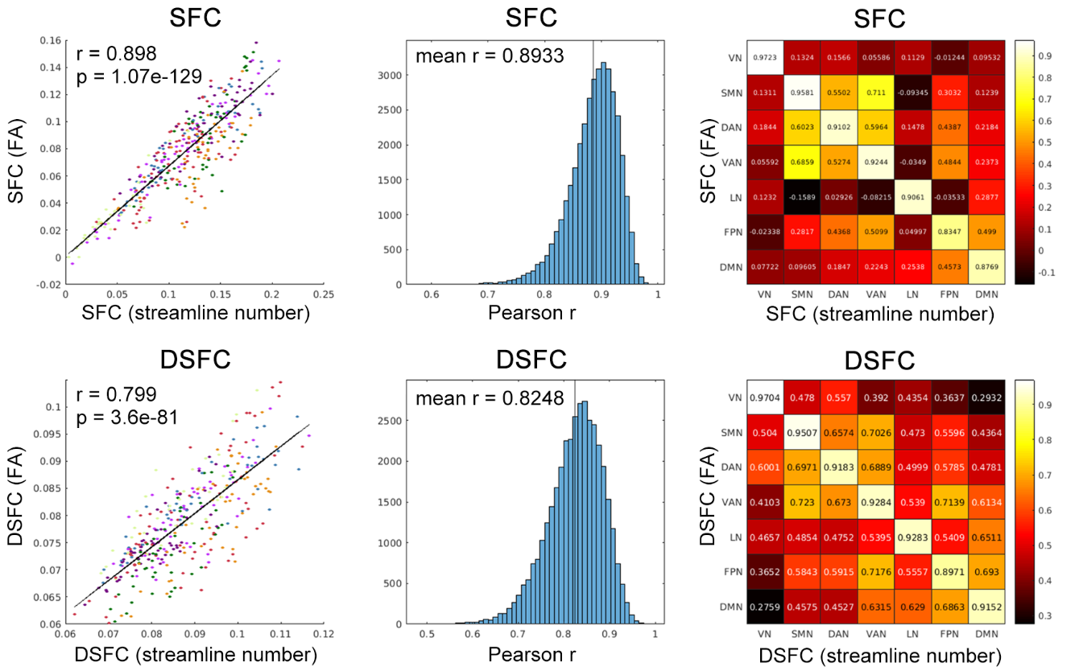
Supplementary Fig. 1. Reproducibility of SFC and DSFC (different structural connectome). We repeated the calculation of SFC and DSFC using an alternative structural connectivity measure (the mean fractional anisotropy, FA, between two brain regions) with the same dynamic parameters, and found high reproducibility of our results across different structural connectivity measures. Left panel: Correlation between group-averaged streamline-based and FA-based SFC and DSFC brain maps (measured with Pearson's correlation coefficient, r). Color indicates functional networks (consistent with the Yeo7 network used in the main text). Middle panel: Histogram of the correlation (Pearson's r) between individual-level streamline-based and FA-based SFC and DSFC maps, assessing the spatial pattern reproducibility at the individual level. Right panel: Reproducibility of network-level streamline-based and FA-based SFC and DSFC brain maps, reflecting the similarity of SFC or DSFC across networks in the population, with Pearson's r displayed in the heatmap.
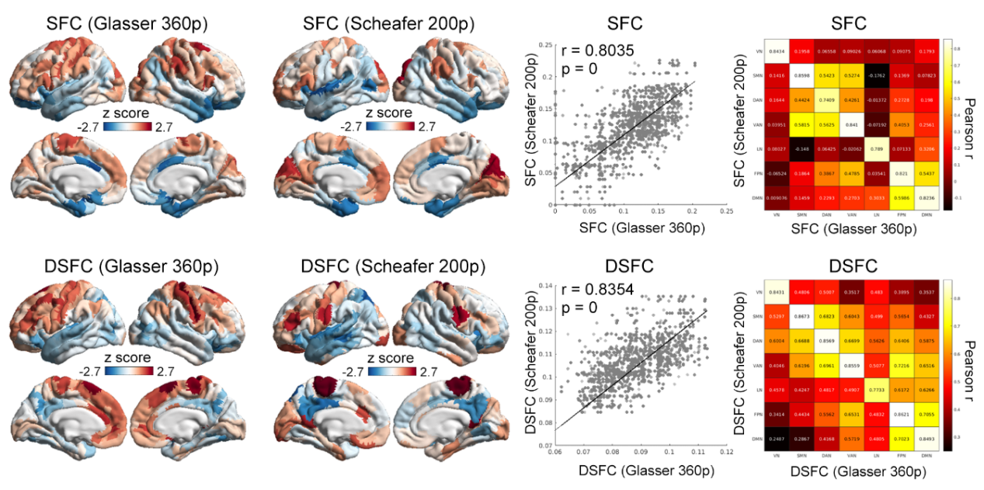
Supplementary Fig. 2. Reproducibility of SFC and DSFC (different parcellation). We repeated the calculation of SFC and DSFC using an alternative parcellation (Glasser 360 parcellation v.s. Scheafer 200 parcellation) with the same dynamic parameters. Left panel: SFC and DSFC brain maps of Glasser 360 and Scheafer 200 parcellation. Middle panel: Correlation between group-averaged SFC and DSFC brain maps of Glasser 360 and Scheafer 200 parcellation (measured with Pearson's correlation coefficient, r). Right panel: Reproducibility of network-level SFC and DSFC brain maps of Glasser 360 and Scheafer 200 parcellation, reflecting the similarity of SFC or DSFC across networks in the population, with Pearson's r displayed in the heatmap.
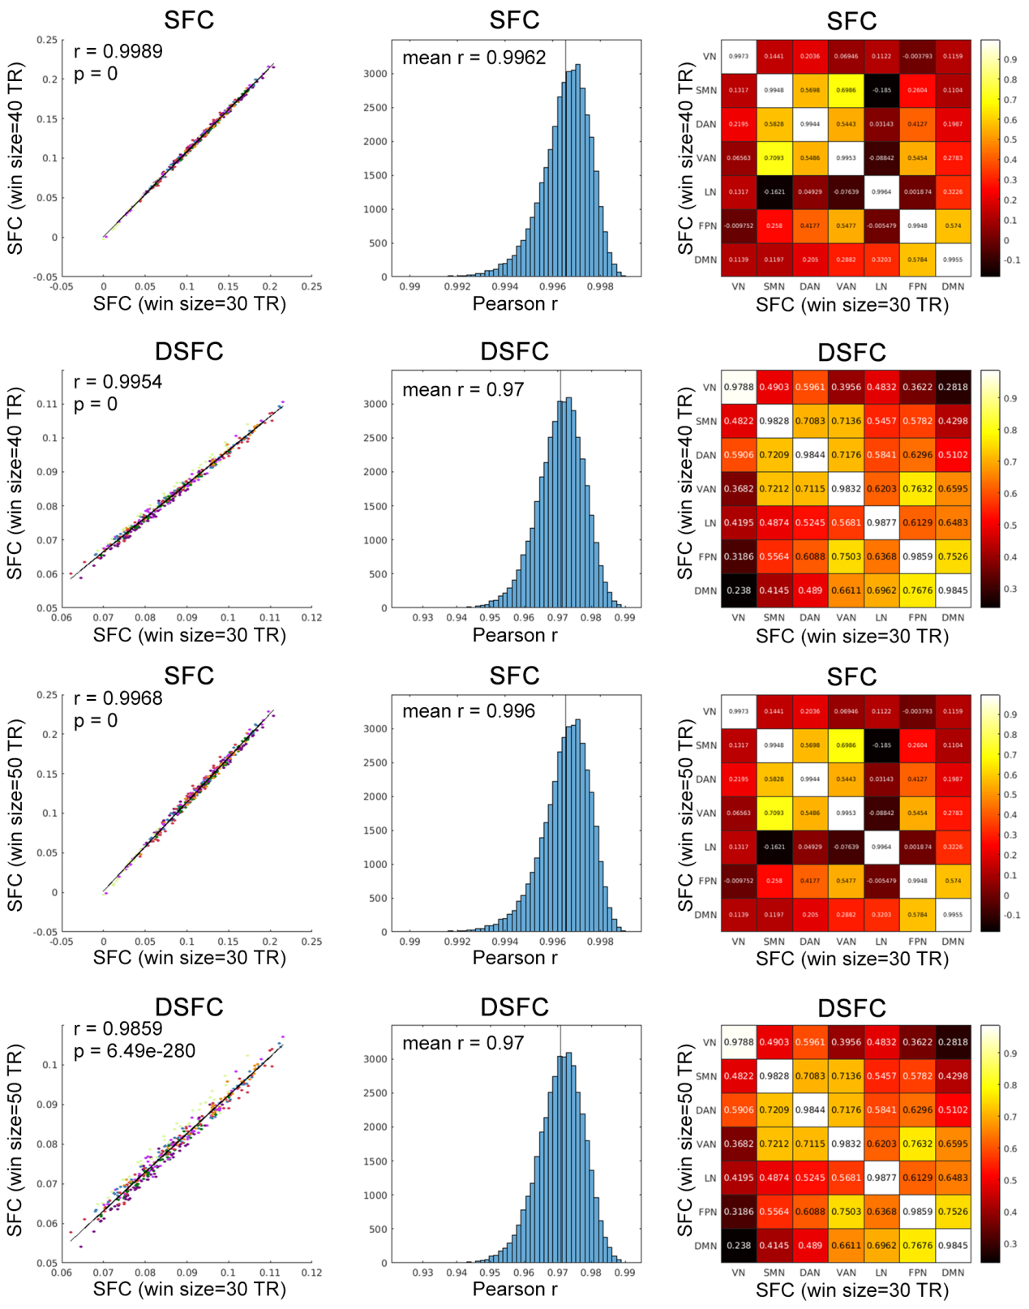
Supplementary Fig. 3. Reproducibility of SFC and DSFC (different sliding time window size). We repeated the calculation of SFC and DSFC using different sliding time window size (40 TRs/29.4s and 50 TRs/36.75s). Left panel: Correlation between group-averaged SFC and DSFC brain maps with window size=30 TR and 40/50 TR (measured with Pearson's correlation coefficient, r). Color indicates functional networks (consistent with the Yeo7 network used in the main text). Middle panel: Histogram of the correlation (Pearson's r) between individual-level SFC and DSFC maps with window size=30 TR and 40/50 TR, assessing the spatial pattern reproducibility at the individual level. Right panel: Reproducibility of network-level SFC and DSFC brain maps with window size=30 TR and 40/50 TR, reflecting the similarity of SFC or DSFC across networks in the population, with Pearson's r displayed in the heatmap.

Supplemental Tables
Table S1. Variables included in this study. Summary of all variables used in the study, including the corresponding UK Biobank category, Field ID, and variable labels used in the main text.
Table S2. Associations between demographic variables and network-level SFC/DSFC. Associations between key demographic variables, including age, age², sex, body mass index (BMI), and intracranial volume (ICV), and network-level mean static structure–function coupling (SFC) and dynamic structure–function coupling (DSFC). Linear mixed model statistics include the t-value, P value, degrees of freedom (DF), standardized beta coefficient (β) as the effect size, and 95% confidence intervals (CI; ci1: lower bound, ci2: upper bound). The same statistical metrics are reported in subsequent tables unless otherwise specified.
Table S3. Associations between demographic variables and parcel-level SFC/DSFC. Associations between demographic variables and SFC/DSFC estimated at the Glasser 360-area parcellation level.
Table S4. Associations between cognitive, mental health, and physical health phenotypes and network-level SFC/DSFC. Associations between cognitive, mental health, and physical health phenotypes and network-level mean SFC/DSFC.
Table S5. Associations between cognitive, mental health, and physical health phenotypes and parcel-level SFC/DSFC. Associations between cognitive, mental health, and physical health phenotypes and parcel-level SFC/DSFC based on the Glasser 360-area parcellation. Due to the large number of tests resulting from evaluating all phenotypes at the parcel level, only the two phenotypes showing the strongest associations (fluid intelligence score and total medication count) were further examined and reported at the parcel level.
Table S6. Interaction effects between aging trajectories and cognitive/medication status on SFC/DSFC. Interaction analyses examining whether successful, intermediate, and unsuccessful aging groups exhibited differential trajectories of SFC and DSFC across the seven canonical functional networks.
Table S7. Associations between environmental and lifestyle factors and network-level SFC/DSFC. Associations between environmental exposures, lifestyle factors, and network-level mean SFC/DSFC.
Table S8. Associations between environmental and lifestyle factors and parcel-level SFC/DSFC. Associations between environmental and lifestyle factors and parcel-level SFC/DSFC based on the Glasser 360-area parcellation. Due to the large number of tests resulting from evaluating all variables at the parcel level, only variables showing significant associations with SFC/DSFC after false discovery rate correction (P_FWE < 0.05) were further examined and reported at the parcel level.
Table S9. Mediation analysis results. Results of mediation analyses testing the association between smoking status (independent variable, X), SFC (mediator, M), and fluid intelligence score (dependent variable, Y).
Table S10. Associations between polygenic risk scores (PRS) and network-level SFC/DSFC. Associations between polygenic risk scores (PRS) for selected traits and network-level mean SFC/DSFC.
Table S11. Associations between polygenic risk scores (PRS) and parcel-level SFC/DSFC. Associations between PRS and parcel-level SFC/DSFC based on the Glasser 360-area parcellation. Due to the large number of tests resulting from evaluating all PRS variables at the parcel level, only the two most strongly associated PRS traits (Alzheimer’s disease and schizophrenia) were further examined and reported at the parcel level.
Table S12. Alzheimer’s disease-related genes identified from previous meta-analysis. List of Alzheimer’s disease-related genes derived from previous meta-analysis (Andrews et al., 2023).
Table S13. Alzheimer’s disease-related SNPs associated with SFC/DSFC. Associations between Alzheimer’s disease-related SNPs and network-level mean SFC/DSFC.
Table S14. Associations between APOE ε4 dosage and network-level SFC/DSFC.
Associations between APOE ε4 dosage and network-level mean SFC/DSFC.
Table S15. Associations between APOE ε4 dosage and parcel-level SFC/DSFC. Associations between APOE ε4 dosage and parcel-level SFC/DSFC based on the Glasser 360-area parcellation.
Table S16. Mediation analysis results linking aging, APOE ε4 dosage, SFC/DSFC, and cognitive performance. Results of mediation analyses examining whether SFC/DSFC mediates the associations between aging and APOE ε4 dosage (independent variables, X) and fluid intelligence score (dependent variable, Y). For these analyses, SFC/DSFC values were averaged across brain regions showing significant associations with both X and Y, generating one subject-level mediation variable for each participant.
Table S17. Network-level validation of SFC/DSFC reproducibility across methodological variations. Network-level reproducibility analyses comparing (i) streamline-based and FA-based SFC/DSFC estimates, (ii) Glasser 360-area and Schaefer 200-area parcellation-based SFC/DSFC estimates, and (iii) SFC/DSFC estimates derived using 30 TR and alternative 40/50 TR sliding windows. Pearson correlation coefficients between corresponding network-level profiles are reported.
Table S18. Individual- and population-level validation of SFC/DSFC reproducibility across methodological variations. Validation analyses assessing reproducibility at individual and population levels. Population-level analyses report spatial similarity between group-averaged SFC/DSFC maps and corresponding spin-test P values. Individual-level analyses report spatial similarity between individual SFC/DSFC maps across methodological settings, summarized as the mean correlation coefficient across participants.

Reference
Alfaro-Almagro, F., Jenkinson, M., Bangerter, N. K., Andersson, J. L. R., Griffanti, L., Douaud, G., . . . Smith, S. M. (2018). Image processing and Quality Control for the first 10,000 brain imaging datasets from UK Biobank. Neuroimage, 166, 400-424. doi:10.1016/j.neuroimage.2017.10.034
Dollard, J., & Miller, N. E. (1950). Personality and psychotherapy; an analysis in terms of learning, thinking, and culture.
Jenkinson, M., Beckmann Cf Fau - Behrens, T. E. J., Behrens Te Fau - Woolrich, M. W., Woolrich Mw Fau - Smith, S. M., & Smith, S. M. FSL. (1095-9572 (Electronic)).
Liu, W., Wang, T., Zhu, M., & Jin, G. (2023). Healthy diet, polygenic risk score, and upper gastrointestinal cancer risk: a prospective study from UK Biobank. Nutrients, 15(6), 1344.
Lourida, I., Hannon, E., Littlejohns, T. J., Langa, K. M., Hyppönen, E., Kuźma, E., & Llewellyn, D. J. (2019). Association of lifestyle and genetic risk with incidence of dementia. Jama, 322(5), 430-437.
Mansour L, S., Di Biase, M. A., Smith, R. E., Zalesky, A., & Seguin, C. (2023). Connectomes for 40,000 UK Biobank participants: A multi-modal, multi-scale brain network resource. Neuroimage, 283, 120407. doi:https://doi.org/10.1016/j.neuroimage.2023.120407
Miller, K. L., Alfaro-Almagro, F., Bangerter, N. K., Thomas, D. L., Yacoub, E., Xu, J., . . . Smith, S. M. (2016). Multimodal population brain imaging in the UK Biobank prospective epidemiological study. Nat Neurosci, 19(11), 1523-1536. doi:10.1038/nn.4393
Tournier, J.-D., Smith, R., Raffelt, D., Tabbara, R., Dhollander, T., Pietsch, M., . . . Connelly, A. (2019). MRtrix3: A fast, flexible and open software framework for medical image processing and visualisation. Neuroimage, 116137.

