Table S1. Outcome of principal component analysis for the effect of environmental and microbiological variables on N₂O and CH₄ emissions from soil under different land-use.
Bartlett’s test of sphericity
X² | 171.16
Degree of freedom | 66
p-value | <0.001
 | Principal Components
 | PC₁ | PC₂ | PC₃
Eigenvalue | 4.71 | 3.12 | 2.28
Percentage of variance | 39.23 | 26.02 | 19.02
Cumulative percentage of variance | 39.23 | 65.25 | 84.27
 | Correlation
Nitrous Oxide (N₂O) | -0.51 | 0.65* | -0.16
Methane (CH₄) | -0.58** | 0.71** | -0.14
Water-filled pore space (WFPS) | -0.96*** | -.003 | 0.13
Soil temperature (°C) | 0.70*** | 0.67** | -0.06
Ammonium (NH₄⁺) | 0.93*** | 0.21 | 0.01
Nitrate (NO₃⁻) | 0.44 | 0.82*** | -0.28
Ammonia-oxidizing archaea (AOA) | -0.33 | 0.34 | -0.74**
Ammonia-oxidizing bacteria (AOB) | 0.44 | 0.29 | -0.55*
Cytochrome Nitrite Reductase (nirS) | 0.46 | 0.51 | 0.62*
Copper Nitrite Reductase (nirK) | 0.35 | 0.32 | 0.76**
Nitrogenase reductase (nifH) | 0.80*** | -0.47 | -0.13
Nitrous oxide reductase (NosZ) | -0.59** | 0.49 | 0.56*
 | Contribution (%)
Nitrous Oxide (N₂O) | 5.53 | 13.72 | 1.17
Methane (CH₄) | 7.24 | 16.38 | 0.92
Water-filled pore space (WFPS) | 19.55 | 0.003 | 0.76
Soil temperature (°C) | 10.50 | 14.24 | 0.16
Ammonium (NH₄⁺) | 18.51 | 1.36 | .005
Nitrate (NO₃⁻) | 4.19 | 21.41 | 3.47
Ammonia-oxidizing archaea (AOA) | 2.26 | 3.78 | 23.88
Ammonia-oxidizing bacteria (AOB) | 4.18 | 2.67 | 13.20
Cytochrome Nitrite Reductase (nirS) | 4.50 | 8.35 | 16.94
Copper Nitrite Reductase (nirK) | 2.64 | 3.21 | 25.17
Nitrogenase reductase (nifH) | 13.50 | 6.97 | 0.78
Nitrous oxide reductase (nosZ) | 7.38 | 7.86 | 13.55
Integrated crop-livestock (ICLs) | 26.85 | 39.51 | 91.04
Monoculture pasture (MP) | 10.45 | 56.60 | 4.81
Native vegetation (NV) | 62.70 | 3.89 | 4.15
Significant code: ***p-value < 0.001, **p-value < 0.01, *p-value < 0.05.

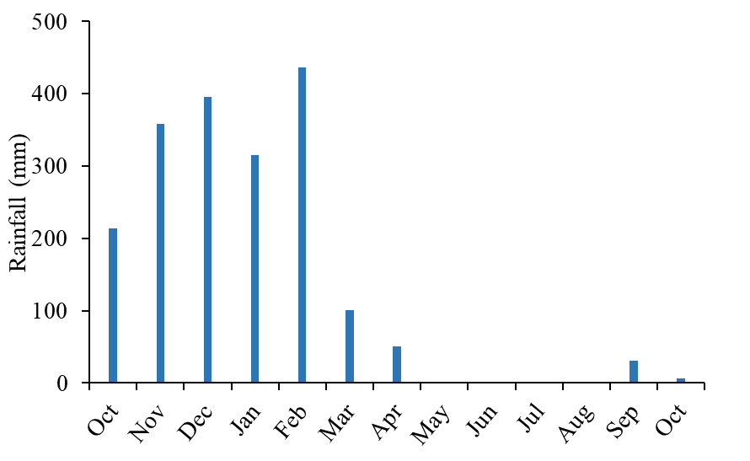
Fig. S2. Average monthly rainfall during the experimental period.

Fig. S3. Water-filled pore space (WFPS %) throughout the experimental period.

Fig. S4. Schematic representation of the experiment during two cultivation periods (Phase 1 and 2) in an integrated crop-livestock system (ICLs), monoculture pasture (MP) and native vegetation (NV) in the Tropical Savanna Biome.

Table S1. Management practices performed in the systems throughout the experimental period.

Crop management | Date | Details
Pasture desiccation | Aug. 21 | Diquat 1 L ha⁻¹
Soybean planting | Oct. 21 | EXTREMA 81I81 RSF IPRO at a raw spacing of 50 cm with 5 cm between plants
Soybean fertilization | Oct. and Nov. 21 | 90 kg de P₂O₅ at planting; K₂O in two split applications
Weed control | Dec. 21 | Potassium glyphosate, 3 L ha⁻¹
Insect control in soybean | Dec. 21 / Jan. 22 | Acephate, 1 kg ha⁻¹; Imidacloprid + Bifenthrin, 600 ml ha⁻¹; Chlorfenapyr, 700 ml ha ⁻¹.
Soybean desiccation and harvest | Feb. 22 | Diquat, 1 L ha⁻¹
Corn planting | Feb. 22 | BM3066 (Biomatrix®) at a row spacing of 50 cm with 25 cm between plants.
Corn fertilization | Feb. and Mar. 21 | 30 kg ha⁻¹ P₂O5, 30 kg ha⁻¹ K₂O (at planting and V5), and 60 kg ha⁻¹ N (at planting, V5 e V8)
Insect control in corn | Mar. 22 | Isaria fumosorosea CEPA ESALQ-1296, 800 mL ha⁻¹; Acephate, 1 kg ha⁻¹; Imidacloprid + Bifenthrin, 600 mL ha⁻¹; Chlorfenapyr, 700 mL⁻¹.
Corn harvest | May. 22 | Occurred abruptly due to wild animal invasion
Pasture planting | Feb. 22 | Manual planting at a 5 – 10cm at a 5–10 cm depth.
Pasture fertilization | Nov. 2021/ Jan. 2022/ Apr. 2022 | Urea applied in three applications (totaling 150 kg N ha⁻¹)
Pasture fertilization in integrated systems | Mar. 2021 | KCl was applied in two installments: 15 kg ha⁻¹ at planting and the second 30 days after emergence.
Weed control | Jun. 2022 | 2,4-D Dimethylamine salt, 481.93 g L⁻¹; Aminopyralid Dimethylamine salt, 60.90 g L⁻¹.

Table S2. Characterization of Pasture in MP throughout the experiment

Variables | Total forage ⁽¹⁾ | Leaf ⁽²⁾ | Stem ⁽³⁾ | Dead Material ⁽⁴⁾ | Tiller Number ⁽⁵⁾ | Grazeable Stratum ⁽⁶⁾
Mean | 6765.7 | 3012.1 | 2550.9 | 2527.7 | 7159.2 | 2282.8
SD | 1930.6 | 559.4 | 438.9 | 580.9 | 1395.7 | 468.4
SEM | 273.3 | 79.1 | 62.7 | 82.2 | 197.3 | 66.3
CV (%) | 28.5 | 18.5 | 17.2 | 23.0 | 19.5 | 20.5
*SD: Standard Deviation. SEM: Standard Error of the Mean. CV: Coefficient of Variation. * 1,2,3,4,6: t DM ha⁻¹; * 5: Number of tillers.

Table S3. Pasture for ICLs characterization throughout the experiment.

Variables | Total forage ⁽¹⁾ | Leaf ⁽²⁾ | Stem ⁽³⁾ | Dead Material ⁽⁴⁾ | Tiller Number ⁽⁵⁾ | Grazeable Stratum ⁽⁶⁾
Mean | 11828.7 | 4428.3 | 6023.7 | 102.82 | 3000 | 1261.4
SD | 3106.9 | 677.18 | 1030.7 | 82.13 | 633.3 | 287.32
SEM | 273.3 | 79.1 | 62.7 | 36.73 | 197.3 | 66.3
CV (%) | 26.27 | 15.29 | 17.11 | 79.89 | 21.11 | 22.78
*SD: Standard Deviation. SEM: Standard Error of the Mean. CV: Coefficient of Variation. * 1,2,3,4,6: t DM ha⁻¹; * 5: Number of tillers.

Table S4. Average forage bromatological composition.

Variables | ICLs ⁽⁴⁾ | MP ⁽⁵⁾
CP ⁽¹⁾ | 12.8 ± 1.25 | 7.4 ± 1.46
NDF ⁽²⁾ | 56.45 ± 2.70 | 63.06 ± 2.74
ADF ⁽³⁾ | 25.82 ± 1.52 | 29.53 ± 1.57
*±: Standard deviation. 1: Crude protein (%); 2: Neutral detergent fiber (%); 3: Acid detergent fiber (%); 4: Integrated crop-livestock system; 5: Monoculture pasture.

Table S5. N input values in the production systems.

Land use | Fertilizer ⁽³⁾ | BNF ⁽⁴⁾ | Excreta ⁽⁵⁾
ICLs ⁽¹⁾ | 135 | 83.2 | 0.17
MP ⁽²⁾ | 150 | 40 | 1.19
1: Integrated crop-livestock system; 2: Monoculture pasture; 3: kg N ha⁻¹; 4: kg N ha⁻¹ derived from the biological nitrogen fixation; 5: kg N ha⁻¹ derived from cattle excreta. N input values for items 4 (ICLs and MP) and item 5 were estimated based on Alves et al. (2003), López et al. (2024), and IPCC (2019), respectively.

Table S6. Measurement of N₂O emission factors in the production systems.

Land use | Total N input ⁽⁴⁾ | Cumulative N₂O ⁽⁵⁾ | EF ⁽⁶⁾
ICLs ⁽¹⁾ | 218 | 1.41 | -0.12
MP ⁽²⁾ | 191 | 0.77 | -0.47
NV ⁽³⁾ | - | 1.68 | -
1: Integrated crop-livestock system; 2: Monoculture pasture; 3: Native vegetation; 4: kg N ha⁻¹; 5: kg N ha⁻¹; 6: Emission factor (%). The emission factor for the systems was calculated using native vegetation as the background reference, following the 2019 IPCC Refinement.

Table S7. Primers and qPCR protocols used for the quantification of nitrogen cycle genes in soil.
Primers | Target | Sequence (5'-3')* | Thermal conditions ºC | Number of cycles
AmoA-1F  AmoA-2R | AOB/ 491 | GGG GTT TCT ACT GGT GGT  CCC CTC KGS AAA GCC TTC TTC | 95 ºC (15s) / 53 ºC (15s) / 72 ºC (40s) | 40
Arch-amoAF  Arch-amoAR | AOA/ 635 | STA ATG GTC TGG CTT AGA CG  GCG GCC ATC CAT CTG TAT GT | 95 ºC (15s) / 55 ºC (15s) / 72 ºC (40s) | 40
NirScd3aF  NirSR3cd | nirS/ 425 | GTS AAC GTS AAG GAR ACS GG  AST TCG GRT GSG TCT TGA | 95 ºC (15s) / 63 ºC (40s) / 72 ºC (40s)  95 ºC (15s) / 57 ºC (40s) / 72 ºC (40s) | 6ª  40
NirK1F  NirK5R | nirK/ 514 | GGM ATG GTK CCS TGG CA  GCC TCG ATC AGR TTR TGG | 95 ºC (15s) / 48 ºC (40s) / 72 ºC (40s)  95 ºC (15s) / 42 ºC (40s) / 72 ºC (40s) | 6ª  40
NosZ2F  NosZ2R | nosZ/ 267 | CGC RAC GGC AAS AAG GTS MSS GT  CAK RTG CAK SGC RTG GCA GAA | 95 ºC (15s) / 66 ºC (40s) / 72 ºC (40s)  95 ºC (15s) / 61 ºC (40s) / 72 ºC (40s) | 5ª  40
NifHF  NifHR | nifH/ 432 | AAA GGY GGW ATC GGY AAR TCC ACC AC TTG TTS GCS GCR TAC ATS GCC ATC AT | 94 ºC (30s)/ 53 ºC (45s) / 72 ºC (30s) | 40
S: seconds; °C: degrees Celsius. Superscript letters (ª) indicate the number of cycles for the first annealing temperature in a two-step qPCR protocol. * Primer sequences are oriented from 5' to 3' ends.

Table S8. Average amplification efficiency of the primers.
Target | Primers (F/R) | Efficiency (%) | R² | Slope
nirK | NirK876 / NirK1040 | 89.6 | > 0.99 | -3.59
nirS | nirScd3aF / nirSR3cd | 81.68 | > 0.99 | -3.85
nosZ | nosZ2F / nosZ2R | 103.00 | > 0.99 | -3.25
nifH | nifHF / nifHR | 85.77 | > 0.99 | -3.72
AOA (amoA) | Arch-amoAF / Arch-amoAR | 84.24 | > 0.99 | -3.77
AOB (amoA) | amoA1F / amoA2R | 97.31 | > 0.99 | -3.38
F: Forward primer; R: Reverse primer; R²: Coefficient of determination.

