Reefscapes of fear assess tradeoffs of risk and reward on coral reefs

Appendix S1

Margaret A. Malone^{1, 2}, Gregorio de Chevalier^{1, 3}, Christopher J. Whelan^{1,4}, and Joel S. Brown^{1,5}

¹Department of Biological Sciences, University of Illinois at Chicago
845 W. Taylor St. (M/C 066) Chicago, IL 60607

²The Field Museum of Natural History, 1400 S Lake Shore Dr. Chicago, IL 60605

³Universiteit van Amsterdam, Institute for Biodiversity and Ecosystem Dynamics (IBED), P.O. Box 94240, 1090 GE Amsterdam, The Netherlands

⁴Cancer Physiology and Cancer Biology and Evolution, Moffitt Cancer Center and Research Institute, SRB-4, 12902 USF Magnolia Drive Tampa, FL 33612

⁵Integrated Mathematical Oncology and Cancer Biology and Evolution, Moffitt Cancer Center and Research Institute, SRB-4, 12902 USF Magnolia Drive Tampa, FL 33612

Corresponding Author:
Margaret A. Malone
Department of Biological Sciences
University of Illinois at Chicago
845 W. Taylor St. (M/C 066) Chicago, IL 60607
mmalon29@uic.edu

I. Benthic Community

Table S1. Table of 18 benthic variables observed from images (n=15) taken for benthic community analysis of 5 study reefs in Kāne‘ohe Bay, O‘ahu, Hawai‘i.

Benthic Variable/Taxonomy | Code
Animal | A
Coral Rubble | CR
Dead Coral | DC
Rock/ Sand | RS
Kappaphycus/ Euchema | KE
Equipment | E
Montipora capitata | MC
Montipora dilatata | MD
Montipora incrassata | MI
Pocillopora damicornis | PPD
Pocillopora ligulata | PPL
Pocillopora meandrina | PPMe
Porites annae | PRA
Porites compressa | PRC
Porites duerdeni | PRD
Porites lichen | PRLi
Porites monticulosa | PRM
Porites rus | PRR

Table S2. Eigenvalues and percent eigenvalues for the first 4 principle component axes obtained from the principle component analysis (PCA) performed on Hellinger transformed abundance benthic data from the 15 stations on 5 reefs in Kāne‘ohe Bay, O‘ahu, Hawai‘i.

 | Eigenvalue | Percent Eigenvalue
PC1 | 0.16718 | 41.05
PC2 | 0.08581 | 21.07
PC3 | 0.06879 | 16.89
PC4 | 0.01914 | 4.70

Table S3. Permutational multivariate analysis of variance (PERMANOVA) to test for differences in benthic communities between patch reefs by partitioning Euclidean distance matrix by species (model: adonis(master2.h ~ reef, data = master2, method='eu'); 999 permutations). Significance indicated by bolded text.

 | Df | SS | MS | F | R2 | P (>F)
Reef | 4 | 12.19 | 3.05 | 12.21 | 0.42 | 0.001
Residuals | 67 | 16.72 | 0.25 | 0.58
Total | 71 | 28.92 |  |  | 1

Table S4. Permutation test for homogeneity of multivariate dispersions with 999 permutations.
 | Df | SS | MS | F | N Perm | P (>F)
Reef | 4 | 0.28 | 0.07 | 2.63 | 999 | 0.04
Residuals | 67 | 1.79 | 0.03

Table S5. Summary table for ANOVA testing for differences in coral cover between reefs. (Model: Reef<-glm(cc~reef, data = coral)). Significance indicated by bolded text.

Coefficients:
 | Estimate | Std. Error | T value | P (>|t|)
Reef 12 | 0.68 | 0.05 | 12.94 | < 2E-16
Reef 13N | -0.08 | 0.08 | -1.04 | 0.30
Reef 13S | 0.10 | 0.08 | 1.31 | 0.20
Reef 14 | -0.38 | 0.07 | -5.10 | 3.05E-06
Reef 16 | 0.18 | 0.07 | -2.42 | 0.02

Figure S1. Residual and Q-Q plots used to test for normality for above ANOVA analysis, comparing coral cover between 5 study reefs in Kāne‘ohe Bay, O‘ahu, Hawai‘i.
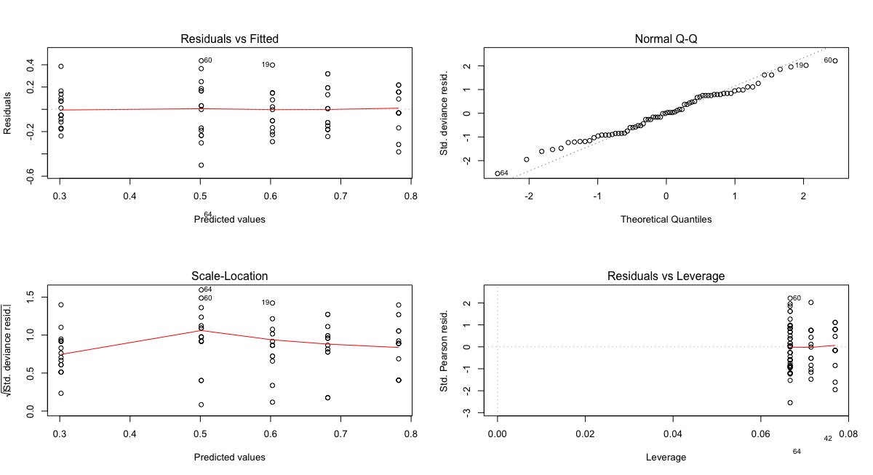

Table S6. ANOVA comparing null model of no difference in coral cover among reefs to S5 GLM model. (Null<- glm(coral cover ~1); anova(Reef, Null, test = “F”). Significance indicated by bolded text.

 | Df | Deviance | Resid. | Df Resid. | F | P (>F)
NULL |  |  | 71 | 4.72
Reef | 4 | 1.93 | 67 | 2.79 | 11.63 | 3.14E-07

Table S7. We conducted a multivariate analysis of variance (MANOVA) to test for a relationship between coral cover and benthic diversity at each station between reefs. (model: manova(cbind(dat$Coral_Cover, Bdiversity$Simpson) ~ dat$Reef)). Significance indicated by bolded text.

 | Df | Pillai | approx F | num Df | den F | Pr(>F)
Reef | 4 | 0.78 | 11.3 | 8 | 140 | 2.86E-12
Residuals | 70

Table S8. Coral cover is highly significantly different among reefs. Significance indicated by bolded text.

 | Df | SS | MS | F | Pr(>F)
Reef | 4 | 1.76 | 0.44 | 10.19 | 1.47E-06
Residuals | 70 | 3.02 | 0.04

Table S9. Benthic Simpson’s diversity index is also highly significantly different among reefs. Significance indicated by bolded text.

 | Df | SS | MS | F | Pr(>F)
Reef | 4 | 27.95 | 6.99 | 12.10 | 1.57E-07
Residuals | 70 | 40.43 | 0.58

Figure S2. Relationship between coral cover and benthic Simpson’s diversity index on the 5 study patch reefs. Shading represents the 95% CI.
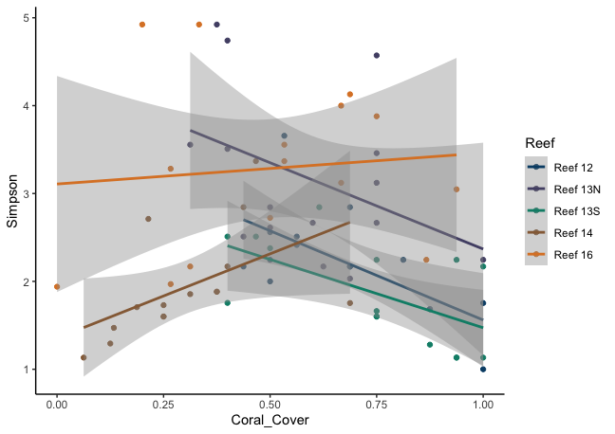

II. Fish community and T. duperrey population

Table S10. Table of 34 fish species observed in transects (n=4) across 5 study reefs in Kāne‘ohe Bay, O‘ahu, Hawai‘i.

Family | Taxonomy | Code
Acanthuridae | Acanthurus blochii | ACBL
Acanthuridae | Acanthurus leucopareius | ACLU
Acanthuridae | Acanthurus nigrofuscus | ACNF
Acanthuridae | Acanthurus tristegus | ACTR
Acanthuridae | Ctenochaetus strigosus | CTST
Acanthuridae | Naso brevirostris | NABR
Acanthuridae | Zebrasoma flavescens | ZEFL
Acanthuridae | Zebrasoma veliferum | ZEVE
Carangidae | Caranx melampygus | CAME
Chaetodontidae | Chaetodon auriga | CHAU
Chaetodontidae | Chaetodon lunulatus | CHLN
Chaetodontidae | Chaetodon lunula | CHLU
Chaetodontidae | Chaetodon miliaris | CHMI
Chaetodontidae | Chaetodon orntissimus | CHOR
Chaetodontidae | Chaetodon unimaculatus | CHUN
Fistulariidae | Fistularia commersonii | FICO
Labridae | Gomphosus varius | GOVA
Labridae | Stethojulis balteata | STBA
Labridae | Thalassoma duperrey | THDU
Lutjanidae | Lutjanus fulvus | LUFU
Mulloidae | Mulloidichthys vanecolensis | MUVA
Mulloidae | Parupeneus multifasciatus | PAMU
Muraenidae | Gymnothorax eurostus | GYEU
Pomacentridae | Abudefduf abdominalis | ABAB
Pomacentridae | Chromis hanui | CHHA
Pomacentridae | Dascyllus albisella | DAAL
Pomacentridae | Plyctroglyphidodon johnstonianus | PLJO
Pomacentridae | Stegastes marginatus | STMA
Scaridae | Chlorurus spilurus | CHSP
Scaridae | Scarus psittacus | SCPS
Scaridae | Scarus sp. | SCSP
Scropaenidae | Scorpaenopsis diabolus | SCDI
Tetradontidae | Cathignster jacator | CAJA
Zanclidae | Zanclus cornutus | ZACO

Figure S3. Species diversity (A) and richness (B) of fishes at 5 study reefs in Kāne‘ohe Bay, O‘ahu, Hawai‘i.

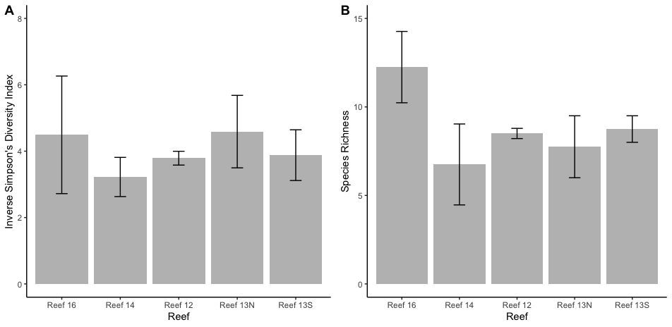

Table S11. ANOVA comparing null model of no difference in fish diversity among reefs. (model: glm(Inverse Simpson’s ~ Reef))

 | Df | Deviance | Resid. | Df Res. Dev | F | Pr(>F)
NULL |  |  | 19 | 68.69
Reef | 4 | 5.01 | 15 | 63.69 | 0.029 | 0.88

Table S12. ANOVA comparing null model of no difference in fish species richness among reefs. (model: glm(Richness ~ Reef))

 | Df | Deviance | Resid. | Df Resid. Dev | F | Pr(>F)
NULL |  |  | 19 | 225.2
Reef | 4 | 69.2 | 15 | 156 | 1.66 | 0.21

Figure S4. Histogram bar graph of fish species occurrences (A) and relative frequencies (B) in Kāne‘ohe Bay, O‘ahu, Hawai‘i.
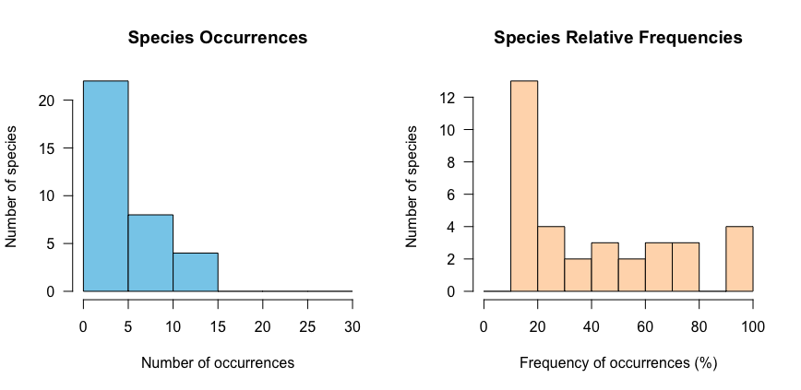

Figure S5. An investigation of various standardization approaches for T. duperrey abundance data reveals that transformations are unnecessary and raw data of species density (number of individuals/100m²) are appropriate for comparisons. Fish communities, however, should be standardized using the common Hellinger transformation, which reduces the impact of rare species in community datasets.

Table S13. Eigenvalues and percent eigenvalues for the first 4 principal component axes obtained from the principal component analysis (PCA) performed on Hellinger transformed fish abundance data from 5 study reefs in Kāne‘ohe Bay, O‘ahu, Hawai‘i.

 | Eigenvalue | Percent Eigenvalue
PC1 | 0.09635 | 31.53
PC2 | 0.04747 | 15.54
PC3 | 0.03421 | 11.19
PC4 | 0.02781 | 9.10

Table S14. We ran a permutational multivariate analysis of variance (PERMANOVA) to test for differences in fish communities between patch reefs by partitioning Euclidean distance matrix by species (model: adonis(spe.h ~ reef, data = master2, method='eu')). Significance indicated by bolded text.

 | Df | SS | MS | F | R2 | Pr(>F)
Reef | 4 | 1.9881 | 0.49703 | 1.953 | 0.34245 | 0.003
Residuals | 15 | 3.8175 | 0.25450 |  | 0.65755
Total | 19 | 5.8056 |  |  | 1

Table S15. Permutation test for homogeneity of multivariate dispersions with 999 permutations reveals no dispersion effect.

 | Df | SS | MS | F | N Perm | Pr(>F)
Reef | 4 | 0.14 | 0.04 | 0.98 | 999 | 0.439
Residuals | 15 | 0.55 | 0.04

Figure S6. We assessed herbivore diversity (A), richness (B), and total herbivore density (C) on patch reefs to investigate the possibility of a trophic cascade that may have occurred due to differences of predation risk on reefs. If herbivores perceive risk similarly to saddle wrasse, we expect lower herbivore diversity, richness and density on risky reefs.
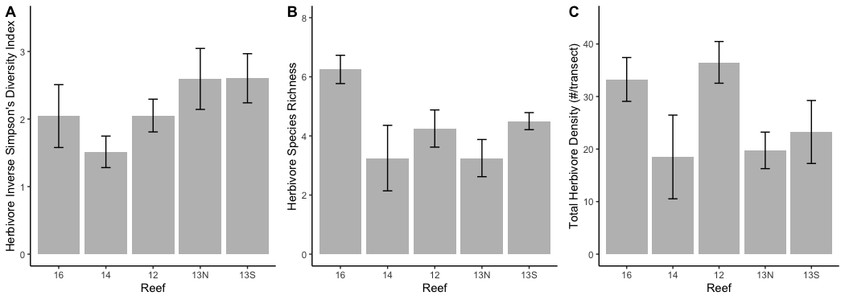

Table S16. ANOVA comparing herbivore diversity between reefs (model: glm(Herb. Inverse Simp ~ Reef)).

 | Df | Deviance | Resid. | Df Res. Dev | F | Pr(>F)
NULL |  |  | 19 | 11.3
Reef | 4 | 3.31 | 15 | 7.99 | 1.55 | 0.23

Table S17. ANOVA comparing herbivore richness between reefs (model: glm(Herb. Richness ~ Reef)). Significance indicated by bolded text.

 | Df | Deviance | Resid. | Df Res. Dev | F | Pr(>F)
NULL |  |  | 19 | 52.2
Reef | 4 | 24.2 | 15 | 28 | 3.24 | 0.04

Table S18. ANOVA comparing total herbivore density between reefs (model: glm(Herb. Density ~ Reef)).

 | Df | Deviance | Resid. | Df Res. Dev | F | Pr(>F)
NULL |  |  | 19 | 2795.8
Reef | 4 | 1061.5 | 15 | 1734.2 | 2.29 | 0.11

III. Giving-up Densities

Table S19. Summary results from the linear mixed effects model (model: lmer(GUD ~ Reef + s + (1|Exp_Day), data = MEGA)). Significance indicated by bolded text.

 | SS | MS | Num DF | Den DF | F value | Pr(>F)
Reef | 21.594 | 5.3985 | 4 | 696.7 | 5.5902 | 1.97E-04
Reef:Station | 87.331 | 1.2476 | 70 | 694.45 | 1.2919 | 0.06

Table S20. Summary results from the analysis of covariance to test for effects of reef, coral cover, and Simpson’s diversity at each station and their interaction on the average station GUD (model: aov(Avg_GUD ~ Reef*Coral_Cover*Simpson, data = dat)). Significance indicated by bolded text.

 | Df | SS | MS | F value | P (>F)
Reef | 4 | 5.707 | 1.42 | 9.78 | 4.78E-06
Coral Cover | 1 | 0 | 0.0003 | 0.002 | 0.97
Simpson | 1 | 0.03 | 0.03 | 0.2 | 0.66
Reef:Coral Cover | 4 | 0.73 | 0.18 | 1.26 | 0.3
Reef:Simpson | 4 | 0.11 | 0.03 | 0.18 | 0.95
Coral Cover:Simpson | 1 | 0.03 | 0.03 | 0.18 | 0.67
Reef:CoralCover:Simpson | 4 | 0.49 | 0.12 | 0.84 | 0.5
Residuals | 55 | 8 | 0.14

Figure S7. The relationship between inverse Simpson’s diversity index and average station GUD for the 5 study reefs. Shading represents the 95% CI.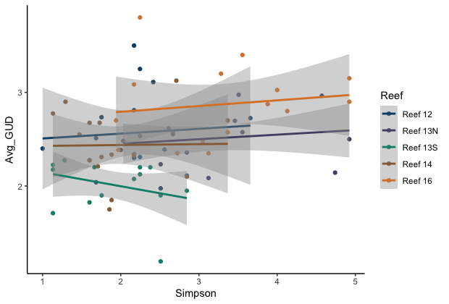
Figure S8. The relationship between coral cover and average station GUD for the 5 study reefs. Shading represents the 95% CI.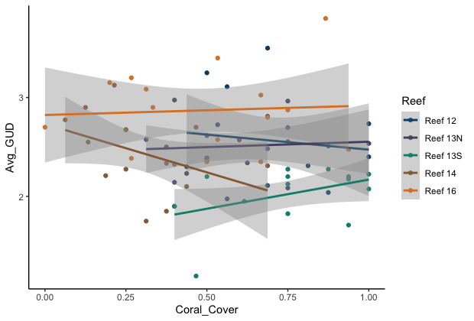
IV. R Statistical Package References:

Bates D, Mächler M, Bolker B, Walker S (2015). Fitting Linear Mixed-Effects Models Using lme4. Journal of Statistical Software, 67(1), 1–48. doi: 10.18637/jss.v067.i01.
Beck, M.W. (2017). ggord: Ordination Plots with ggplot2. R package version 1.0.0. https://zenodo.org/badge/latestdoi/35334615
Kahle, D. and H. Wickham. ggmap: Spatial Visualization with ggplot2. The R Journal, 5(1), 144-161. URL http://journal.r-project.org/archive/2013-1/kahle-wickham.pdf
Kassambara, A. (2019). Ggpubr: R package version 0.3.0 https://rpkgs.datanovia.com/ggpubr/
Sievert, C. (2020). Interactive Web-Based Data Visualization with R, plotly, and shiny. CRC Press, Boca Raton, FL.
Wickham, H., Averick, M., Bryan, J., Chang, W., McGowan, L. D. A., François, R., Kuhn, M., et al. (2019). Welcome to the Tidyverse. Journal of Open Source Software, 4(43), 1686.

