Electronic Supporting Information

New periodic mesoporous organosilica containing p-phenylenediamine bridges for efficient CO₂ capture under mild conditions

Maryam Mahnampour, Mohammad G. Dekamin*
Department of Chemistry, Iran University of Science and Technology, Tehran 16846-13114, Iran.
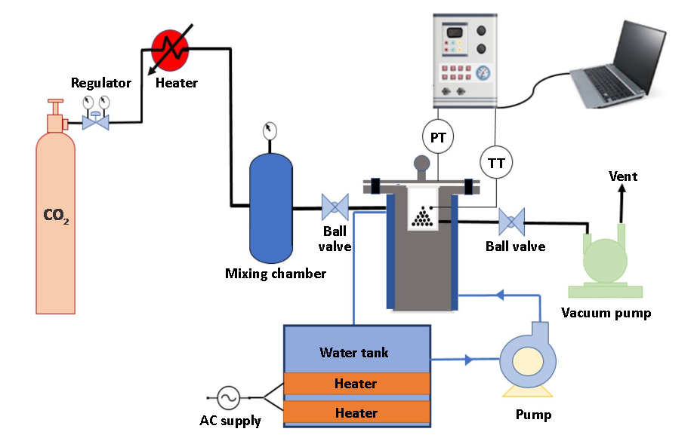
* Correspondence: mdekamin@iust.ac.ir

Fig. S1 Experimental CO₂ adsorption setup.

Fig. S2. The EDX spectrum of PPDA-PMO adsorbent.

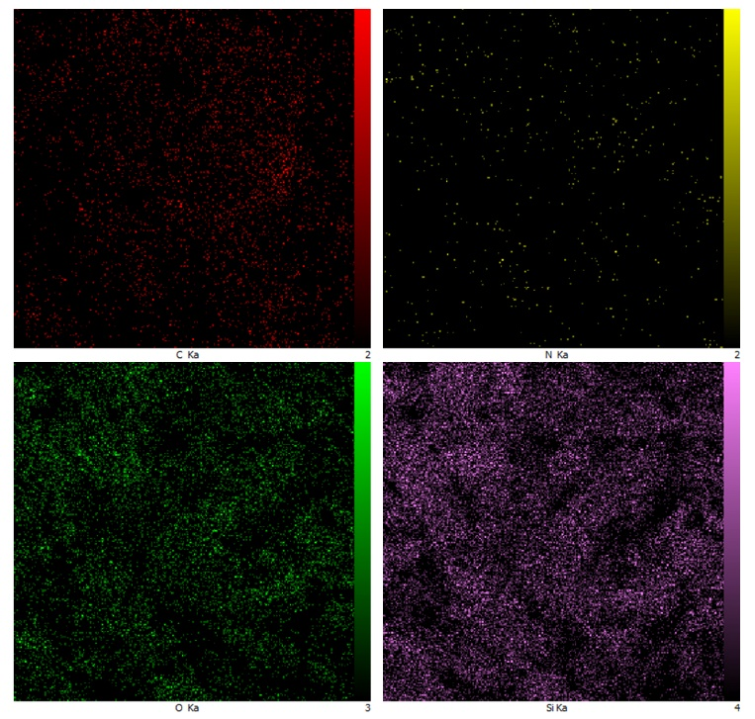
Fig. S3 elemental mapping of PPDA-PMO adsorbent.

