Supporting Information

Color-Purity narrow-band near-infrared (NIR) phosphors of [Ir(C^N)₂(N^N)]-bis-heteroleptic and [Ir(C^N)(C’^N’)(N^N)]-tris-heteroleptic Ir(III)-complexes forward to high-performance (all)-solution-processed NIR-PLEDs

Baowen Wang^{1,2,#} • Youquan Chen^{2,#} • Zhiming Zhang^{2,#} • Yu Chen² • Xiaohui Yang² • Sicheng Yao² • Guorui Fu^{2,}* • Xingqiang Lü^{2,}* • Wai-Yeung Wong^{3,}*

¹Rocket Force University of Engineering, Xi’an, Shaanxi, P. R. China
²School of Chemical Engineering, Northwest University, Xi’an, Shaanxi, P. R. China
³Department of Applied Biology and Chemical Technology and Research Institute for Smart Energy, The Hong Kong Polytechnic University, Hung Hom, Hong Kong, P. R. China

Corresponding Emails: lvxq@nwu.edu.cn (Xingqiang Lü); fuguorui@nwu.edu.cn (Guorui Fu); wai-yeung.wong@polyu.edu.hk (Wai-Yeung Wong)

General Experimental Details
Materials and methods. All the starting materials were purchased from Sigma Aldrich and used without further purification. All the solvents unless otherwise stated, were degassed and stored over 3 Å activated molecular sieves prior to use. Experiments of air and/or water sensitive compounds were carried out under dry N₂ using the standard Schlenk line techniques. The polymeric ETL (Poly(vinyl-PBD); M_{n} = 2136 g/mol and PDI = 1.29) was obtained from our group as reported by the literature [1].
Elemental analysis (EA) was performed on a Perkin-Elmer 240C elemental analyzer. Fourier Transform Infrared (FT-IR) spectra were recorded on a Nicolet Nagna-IR 550 spectrophotometer in the region of 4000-400 cm⁻¹ using KBr pellets. ¹H NMR spectra were performed on a JEOL EX 400 spectrometer with SiMe₄ as internal standard in CDCl₃ or DMSO-d₆ at room temperature. Electro-spray ionization mass spectrometry (ESI-MS) was recorded on a Finnigan LCQ^{DECA} XP HPLC-MS_{n} mass spectrometer with a mass to charge (m/z) range of 4000 using a standard electro-spray ion source and dichloromethane (CH₂Cl₂) as the solvent. Electronic absorption spectra in the UV-visible-NIR region were recorded on a Cary 300 UV spectrophotometer. Visible or NIR emission and excitation spectra were collected by a combined fluorescence lifetime and steady-state spectrometer (FLS-980, Edinburgh) with a 450 W Xe lamp. Excited-state decay times were obtained by the same spectrometer but with a μF900 Xe lamp. The luminescent quantum yield (Φ_{PL}) in solution was measured with free-base tetraphenylporphyin (Φ_{r} = 0.13 in toluene solution at 298 K) as the standard [2]. The solution was degassed by three freeze-pump-thaw circles. The following equation was used to calculate the quantum yields:
Φ_{s} = Φ_{r} ⋅[(n_{s}² ⋅ A_{r} ⋅ I_{s})/(n_{r}² ⋅ A_{s} ⋅ I_{r})]
where Φ_{s} is the quantum yield of the sample, Φ_{r} is the quantum yield of the reference, n_{s} is the refractive index of the sample, n_{r} is the refractive index of the reference, A_{s} and A_{r} are the absorbance of the sample and the reference at the wavelength of excitation (500 nm), respectively, and the I_{s} and I_{r} are the integrated areas of emission bands of the sample and the reference from 600 to 900 nm, which were recorded by a red photomultiplier tube (PMT) detector. Thermal properties were characterized using thermogravimetric (TG) analyses on a NETZSCH TG 209 instrument under a flow of nitrogen at a heating rate of 10 °C/min.

Synthesis and Characterizations
Synthesis of the HC^N ligand Hdpbq (Hdpbq = 2,3-diphenylbenzo[g]quinoxaline). The C^N ligand Hdpbq was synthesized from the well-established procedure from the literature [3]. A mixture of 2,3-naphthalenediamine (1.000 g, 6.33 mmol), oxalic acid (0.018 g, 0.2 mmol) and DMSO (20 mL) in a 50 mL round-bottomed flask was add benzil (1.340 g, 6.33 mmol) and the resulting mixture was stirred at room temperature for 3 h. Then, H₂O (20 mL) was added to the reaction mixture, and allowed to stand at room temperature for 1 hour. During this time, the yellow powder formed which were collected by filtration and dried. Then, the powder was recrystallized by absolute ethanol to afford the yellow needle-like polycrystalline solid product. Yield: 1.800 g (86%). Anal. Calcd for C₂₄H₁₆N₂: C, 86.72; H, 4.85; N, 8.43. Found: C, 86.75; H, 4.86; N, 8.39. ¹H NMR (CDCl₃, 400 MHz): δ (ppm) 8.75 (s, 2H, -Ph), 8.13 (q, 2H, -Ph), 7.58 (m, 6H, -Ph), 7.38 (m, 6H, -Ph).

Synthesis of the HC’^N’ ligand Hiqbt (Hiqbt = 1-(benzo[b]-thiophen-2-yl)-isoquinoline). The HC’^N’ ligand Hiqbt was synthesized from the improved Suzuki coupling reaction of 2-chloro-isoquinoline [4] (instead of 2-bromo-isoquinoline [5]) with benzo[b]thien-2-yl boronic acid. A mixture of 2-Cl-isoquinoline (0.653 g, 4.0 mmol), benzo[b]thien-2-y boronic acid (0.713 g, 4.0 mmol) was dissolved into absolute mixed solvents of toluene-EtOH (60 mL; V/V = 2:1) under an N₂ atmosphere. Then an aqueous solution (20 mL) of Na₂CO₃ (2 M) was added, and the mixture was degassed by an N₂ flow. Anhydrous Pd(PPh₃)₄ (190 mg, 0.2 mmol; 5 mol%) was added to the reaction mixture and then heated at 85 °C for 48 h. The complete consumption of reagents was monitored by TLC (Hexane/AcOEt, V/V = 9:1; R_{f} = 0.25). After cooling to room temperature, the organic phase was washed with brine and extracted with absolute CH₂Cl₂ (3×20 mL) three times. The combined organic phase was dried over anhydrous Na₂SO₄ and further purified with flash-column chromatography on silica gel (Hexane/AcOEt, v/v = 9:1), affording to an off-white solid. Yield: 0.762 g (73%). Anal. Calcd for C₁₇H₁₁NS: C, 78.13; H, 4.24; N, 5.36%. Found: C, 78.05; H, 4.36; N, 5.29%. ¹H NMR (DMSO-d₆, 400 MHz): δ (ppm) 8.70 (d, 1H, -CH=N of Py), 8.61 (d, 1H, -Ph), 8.19 (s, 1H, -Th), 8.11 (d, 1H, -Py), 8.06 (m, 1H, -Ph), 8.02 (m, 1H, -Ph), 7.89 (m, 2H, -Ph), 7.82 (t, 1H, -Ph), 7.46 (q, 2H, -Ph).

Synthesis of the HN’’^N’’’ ligand Hftrpz (Hftrpz = 2-(3-(trifluoromethyl)-1H-1,2,4-triazol-5-yl)pyrazine). The HN’’^N’’’-ancillary ligand Hftrpz was synthesized by an improved synthetic procedure as the literature [6] except that pyrazine-2-carbonitrile instead of picolinonitrile was used. Pyrazine-2-carbonitrile (1.05 g, 10 mmol) and sodium methoxide (60 mg, 1 mmol) in anhydrous ethanol (30 mL) were stirred at room temperature for 12 h, then NH₄Cl (0.64 g) was added and the mixture was refluxed for another 5 h. After cooling to room temperature, the resultant mixture was filtered, and the filtrate was evaporated under reduced pressure, giving rise to a residue of pyrazine-2-carboximidamide hydrochloride (1.5 g). The residue upon vacuum dryness, was used further without purification. The solution of ethyl trifluoroacetate (1.42 g, 10 mmol) and hydrazine hydrate (0.75 g, 80%, 12.0 mmol) in anhydrous THF (15 mL) were refluxed for 1.5 h. After cooling to room temperature, the pyrazine-2-carboximidamide hydrochloride (1.5 g) and NaOH (0.4 g, 10 mmol) were added, then refluxed for 8 h. After cooling to room temperature, the solvent was removed under vacuum to give the crude product, which was purified with flash-column chromatography on silica gel (ethyl acetate/hexane, v/v = 1:5) to afford the desirable product as a white solid. Yield: 1.51 g, 70%. Calc. for C₇H₄F₃N₅: C, 39.08; H, 1.87; N, 32.55%. Found: C, 39.02; H, 1.96; N, 32.50%. ¹H NMR (CDCl₃, 400 MHz): δ (ppm) 13.15 (s, 1H, -NH), 9.57 (s, 1H, -pyrazine), 8.83 (d, 1H, -pyrazine), 8.74 (s, 1H, -pyrazine).

Synthesis of the dimer intermediates including [Ir(dpbq)(iqbt)(μ-Cl)]₂. The μ-chloro-bridged dimer intermediates including [Ir(dpbq)(iqbt)(μ-Cl)]₂, were prepared from an improved Nonoyama procedure [7], where to a 3:1 (v/v) mixture of ethoxyethanol and D. I. water, IrCl₃⋅3H₂O (1 equiv), 1.25 equiv of the HC^N ligand Hdpbq, and 1.25 equiv of the HC’^N’ ligand Hiqbt, were added, and the resulting mixture was heated overnight at 120 °C under an Ar atmosphere. After cooling to room temperature (RT), a saturated aqueous solution of NaCl (50 mL) was added and the suspension was filtered. After washing with D. I. water and diethyl ether and dryness under high vacuum, the obtained brown solid in 78% yield was used in the next steps without further purification.

X-ray crystallography. Single crystals for the Ir(III)-complexes [Ir(dpbq)₂(ftrpz)] (Ir-1) and [Ir(dpbq)(iqbt)(ftrpz)] (Ir-2) of suitable dimensions were mounted onto thin glass fibers. All the intensity data were collected on a Bruker APLEX-II CCD diffractometer (Ga-Kα radiation and λ = 1.34139 Å) in Φ and ω scan modes. Structures were solved by Direct methods followed by difference Fourier syntheses, then refined by full-matrix least-squares techniques against F² using SHELXTL [8]. All other non-hydrogen atoms were refined with anisotropic thermal parameters. Absorption corrections were applied using SADABS [9]. All hydrogen atoms were placed in calculated positions and refined isotropically using a riding model. Crystallographic data, relevant atomic distances and bond angles for the Ir(III)-complexes [Ir(dpbq)₂(ftrpz)] (Ir-1) and [Ir(dpbq)(iqbt)(ftrpz)] (Ir-2) are presented in Tables S1-2 with the CCDC numbers 2389456-2389457, respectively.

Electronic structure calculations. To gain further insight into the photophysical and electrochemical characteristics of the Ir(III)-complexes Ir-1 and Ir-2, theoretical studies on their electronic structures were carried out by using density functional theory (DFT) and time-dependent DFT (TD-DFT) methods. Each of their molecular structures was optimized at the ground state (S₀) in the gas phase. TD-DFT calculations using the B3LYP functional were then performed on the basis of the structural optimized geometries [10]. The 6-31G (d,p) basis set was applied for C, H, N atoms, while effective core potentials employed for Ir atom were based on a LanL2DZ basis set [11-12]. The energies of the excited states of the Ir(III)-complex were computed by TD-DFT based on all the ground-state (S₀) geometries. Calculations of the permanent dipole moments (μ) of the different emitters were performed by DFT single point energy calculations using the hybrid functional B3LYP with the def2tzvp basis set based on the corresponding optimized S₀ and T₁ states. The inter fragment charge transfer (IFCT) [13] in the electronic excitation process were analyzed by the Ros and Schuit method [14] (C-squared population analysis method, SCPA) in the Multiwfn 3.8 program [15]. All calculations were carried out with Gaussian 09, Revision D.01 software package [16]. The electron density diagrams of the molecular orbitals were obtained with the crystal structure.

Cyclic voltammetry (CV) measurement. Electro-chemical measurements were made using a Princeton Applied Research model 2273A potentiostat at a scan rate of 100 mV s⁻¹. A conventional three-electrode configuration consisting of a glassy carbon working electrode, a Pt-sheet counter electrode, and a Pt wire reference electrode was used. The supporting electrolyte was 0.1 M tetrabutylammonium tetrafluoroborate ([Bu₄N]BF₄) in MeCN. Ferrocene was added as a calibrant after each set of measurements, and all potentials reported are quoted with reference to the ferrocene–ferrocenium (Fc/Fc⁺) couple. The HOMO and the LUMO energy levels of each complex are calculated according to the following equations [17], E_{HOMO} = -(E_{OX}^{on}– E^{1/2}_{ferrocene}+ 4.8) eV, E_{LUMO} = E_{HOMO} + E_{g}^{OPT} eV, where E_{OX}^{on} is the recorded onset oxidation potential and E^{1/2}_{ferrocene} is internal standard ferrocene Oxidation half potential. Eg^{OPT} is the energy band gap estimated from the low-energy edge of the absorption spectra from the samples.

Fabrication and testing of the solution-processed and polymer-matrixed NIR-PLEDs-1A/2A and NIR-PLED-2B. Each of the NIR-PLEDs were fabricated on ITO (Indium tin oxide) coated glass substrates with a sheet resistance of 20 Ω/m². Patterned ITO coated glass substrates were washed with acetone, detergent, D. I. water and isopropanol in an ultrasonic bath. After being exposed under oxygen plasma for 20 min, PEDOT:PSS from water solution was spin-coated (at 4800 rpm) on the substrate followed by drying in a vacuum oven at 130 °C for 30 min, giving a film of 50 nm in thickness. The DCM solution (10 mg/mL) of the mixture of PVK, OXD7 and one of the bis/tris-heteroleptic Ir(III)- complexes Ir-1/Ir-2 as the emitting layer was prepared under an N₂ atmosphere and spin-coated (at 2100 rpm) on the PEDOT:PSS layer with a thickness of 60 nm. For the A series of NIR-PLEDs-1A/2A (ITO/PEDOT:PSS (50 nm)/PVK:OXD7:Ir-1/Ir-2 (60 nm)/TmPyPB (45 nm)/LiF (1 nm)/Al (100 nm)), the TmPyPB layer (45 nm) was thermally deposited onto the emitting layer. Finally, a thin layer (1 nm) of LiF followed by Al capping layer (100 nm) was deposited onto the substrate under vacuum (5 × 10⁻⁶ Pa). As to the all-solution-processed NIR-PLED-2B doped with Ir-2, its structure difference between the NIR-PLED-2B and NIR-PLED-2A lies in the usage of self-made polymeric Poly(vinyl-PBD) (30 nm) [1] for the NIR-PLED-2B (ITO/PEDOT:PSS (50 nm)/PVK:OXD7:Ir-2 (60 nm)/Poly(vinyl-PBD) (30 nm)/LiF (1 nm)/Al (100 nm)) instead of TmPyPB (45 nm) as the ETL,
Current density-voltage (J-V) characteristics were collected using a Keithley 2400 source meter equipped with a calibrated silicon photodiode. The NIR EL irradiance (R) was measured through a PR735 Spectra Scan spectrometer. The external quantum efficiency (η_{EQE}) of the NIR emission was obtained by measuring the irradiance in the forward direction and assuming the external emission profile to Lambertian.

References
- W. Li, Y. He, T. Miao, X. Lü, G. Fu, W.-Y. Wong, H. He, All-solution-processed multilayered white polymer light-emitting diodes (WPLEDs) based on cross-linked [Ir(4-vb-PBI)₂(acac)]. Acs. Appl. Mater. Inter. 13, 11096-11107 (2022).
- P. Joshua, D. Alec, G. Zeev, W. Jay, G. Harry, Near-IR phosphorescence of iridium(III) corroles at ambient temperature. J. Am. Chem. Soc. 132, 9230-9231 (2010).
- J. Guo, J. Zhou, G. Fu, Y. He, W. Li, X. Lü, Two efficient near-infrared (NIR) luminescent [Ir(CN)₂(NO)]-characteristic complexes with 8-hydroxyquinoline (8-Hq) as the ancillary ligand. Inorg. Chem. Commun. 101, 69-73 (2019).
- G. Fu, H. Zheng, Y. He, W. Li, X. L, H. He, Efficient near-infrared (NIR) polymer light-emitting diodes (PLEDs) based on heteroleptic iridium(III) complexes with post-modification effects of intramolecular hydrogen bonding or BF₂-chelation. J. Mater. Chem. C. 6, 10589-10596 (2018).
- S. Kesarkar, W. Mróz, M. Penconi, M. Pasini, S. Destri, M. Cazzaniga, D. Ceresoli, P. Mussini, C. Baldoli, U. Giovanella, A. Bossi, Near-IR emitting iridium(III) complexes with heteroaromatic β-diketonate ancillary ligands for efficient solution-processed OLEDs: structure-property correlations. Angew. Chem. Int. Ed. 55, 2714-2718 (2016).
- Y. Feng, X. Zhuang, D. Zhu, Y. Liu, Y. Wang, M. Bryce, Rational design and characterization of heteroleptic phosphorescent iridium(iii) complexes for highly efficient deep-blue OLEDs. J. Mater. Chem. C. 4, 10246-10252 (2016).
- M. Nonoyama, Synthesis of a few derivatives of cycloiridated 2-(2-thienyl)pyridine. Bull. Chem. Soc. Jpn. 52, 3749-3750 (1979).
- G. Sheldrick, SHELXL-97: Program for crystal structure refinement. 1997;University of Göttingen, Germany.
- G. Sheldrick, SADABS.1997;University of Göttingen, Germany.
- (a) A. Becke, Density‐functional thermochemistry. III. The role of exact exchange. J. Chem. Phys. 98, 5648-5652 (1993); (b) C. Lee, W. Yang, R. Parr, Development of the Colle-Salvetti correlation-energy formula into a functional of the electron density. Phys. Rev. B. 37, 785-789 (1988).
- W. Wadt, P. Hay, Ab initio effective core potentials for molecular calculations. Potentials for main group elements Na to Bi. J. Chem. Phys. 82, 284-298 (1985).
- P. Hay, W. Wadt, Ab initio effective core potentials for molecular calculations. Potentials for K to Au including the outermost core orbitale. J. Chem. Phys. 82, 299-310 (1985).
- T. Lu, Multiwfn Manual, version 3.6 (dev), Section 3.21.1 and 3.21.8, available at http://sobereva.com/multiwfn.
- P. Ros, G. Schuit, Molecular orbital calculations on copper chloride complexes. Theor. Chim. Acta. 4, 1-12 (1966).
- T. Lu, F. Chen, Multiwfn: A multifunctional wavefunction analyzer. J. Comput. Chem. 33, 580-592 (2012).
- M. Frisch, G. Trucks, H. Schlegel, G. Scuseria, M. Robb, J. Cheesema, et al., Gaussian 16, Revision C.01, Gaussian, Inc., Wallingford, CT, 201.
- H. Chen, C. Chen, Synthesis and characterization of a new series of blue fluorescent 2,6-linked 9,10-diphenylanthrylenephenylene copolymers and their application for polymer light-emitting diodes. Macromolecules 43, 3613-3623 (2010).
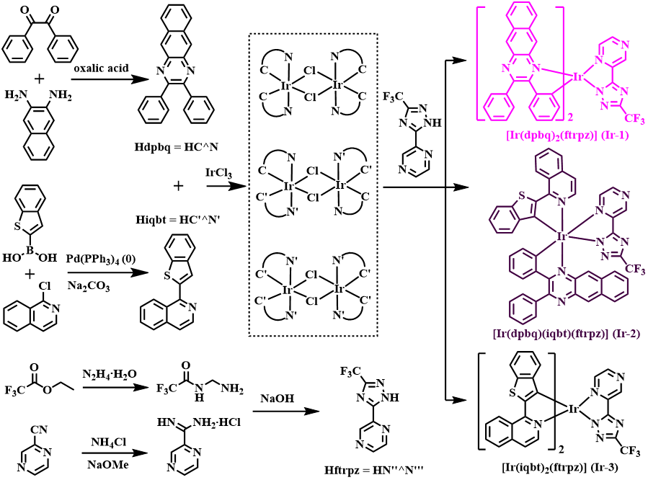
Scheme S1. Synthetic scheme of the Hdpbq-HC^N, Hiqbt-HC’^N’, Hftrpz-HN’’^N’’’ ligands and their [Ir(dpbq)₂(ftrpz)] (Ir-1)/[Ir(iqbt)₂(ftrpz)] (Ir-3) and [Ir(dpbq)(iqbt)(ftrpz)] (Ir-2), respectively.

Table S1. Crystal data and structure refinement for [Ir(dpbq)₂(ftrpz)] (Ir-1) and [Ir(dpbq)(iqbt)(ftrpz)] (Ir-2).
 | Ir-1 | Ir-2
empirical formula | C₅₅H₃₃F₃IrN₉ | C₄₈H₂₈F₃IrN₈S
formula weight | 1080.18 | 998.04
Cryst. syst. | triclinic | monoclinic
space group | Pī | P2₁/n
a, Å | 11.123(8) | 12.013(2)
b, Å | 11.929(12) | 19.844(4)
c, Å | 17.564(14) | 17.318(4)
α, deg | 73.43(4) | 90
β, deg | 73.43(4) | 97.067(7)
γ, deg | 82.99(7) | 90
V, Å³ | 2139(3) | 4097.0(14)
Z | 2 | 4
ρ, g⋅cm⁻³ | 1.660 | 1.618
size, mm | 0.27×0.21×0.18 | 0.24×0.22×0.22
μ(Mo-Kα), mm⁻¹ | 4.353 | 4.817
data/restraints/parameters | 7661/1/613 | 7809/369/644
quality-of-fit indicator | 1.032 | 1.113
No. observed reflections | 19427 | 56559
final R indices [I> 2σ(I)] | R₁ = 0.0791 | R₁ = 0.0389
 | wR₂ = 0.2235 | wR₂ = 0.1007
final R indices (all data) | R₁ = 0.1186 | R₁ = 0.0456
 | wR₂ = 0.2608 | wR₂ = 0.1039
CCDC Number | 2389456 | 2389457

Table S2. Relevant atomic distances (Å) and bond angles (°) of the [Ir(dpbq)₂(ftrpz)] (Ir-1) and [Ir(dpbq)(iqbt)(ftrpz)] (Ir-2).

Ir-1 |  | Ir-2
Ir(1)-C(1) | 2.000(12) | Ir(1)-C(1) | 1.986(6)
Ir(1)-C(25) | 1.979(11) | Ir(1)-C(25) | 2.014(6)
Ir(1)-N(1) | 2.073(9) | Ir(1)-N(1) | 2.081(4)
Ir(1)-N(3) | 2.101(9) | Ir(1)-N(3) | 2.043(4)
Ir(1)-N(5) | 2.239(9) | Ir(1)-N(4) | 2.000(6)
Ir(1)-N(6) | 2.145(10) | Ir(1)-N(9) | 2.207(9)
C(1)-Ir(1)-N(1) | 78.2(4) | C(1)-Ir(1)-N(1) | 79.5(2)
C(1)-Ir(1)-N(3) | 100.7(4) | C(1)-Ir(1)-N(3) | 93.1(2)
C(1)-Ir(1)-N(5) | 94.5(4) | C(1)-Ir(1)-N(4) | 96.4(3)
C(1)-Ir(1)-N(6) | 169.3(4) | C(1)-Ir(1)-N(9) | 168.2(8)
C(1)-Ir(1)-C(25) | 93.4(4) | C(1)-Ir(1)-C(25) | 92.9(2)

Table S3. Frontier orbital energy and electron density distribution for [Ir(dpbq)₂(ftrpz)] (Ir-1) and [Ir(dpbq)(iqbt)(ftrpz)] (Ir-2) on the basis of their optimized S₀ geometries, respectively.

complex | MO | Contribution of metal d_{π} orbitals and π orbitals of ligand to MOs (%)
complex | MO | Ir | dpbq-1 | dpbq-2 | ftrpz
Ir-1 | LUMO+2 | 3.53 | 0.53 | 2.83 | 93.11
Ir-1 | LUMO+1 | 2.55 | 21.54 | 73.08 | 2.83
Ir-1 | LUMO | 3.02 | 74.16 | 21.49 | 1.33
Ir-1 | HOMO | 30.50 | 29.26 | 38.76 | 1.48
Ir-1 | HOMO-1 | 6.34 | 71.08 | 20.22 | 2.36
Ir-1 | HOMO-2 | 6.41 | 18.76 | 74.19 | 0.64
Ir-2 |  | Ir | dpbq | iqbt | ftrpz
Ir-2 | LUMO+2 | 3.55 | 2.55 | 0.70 | 93.20
Ir-2 | LUMO+1 | 4.88 | 0.84 | 91.64 | 2.64
Ir-2 | LUMO | 2.42 | 94.01 | 0.97 | 2.60
Ir-2 | HOMO | 22.66 | 16.14 | 60.00 | 1.20
Ir-2 | HOMO-1 | 5.58 | 84.73 | 8.89 | 0.79
Ir-2 | HOMO-2 | 4.12 | 73.87 | 21.11 | 0.90

Table S4. Frontier orbital energy and electron density distribution for [Ir(dpbq)₂(ftrpz)] (Ir-1) and [Ir(dpbq)(iqbt)(ftrpz)] (Ir-2) on the basis of their optimized T₁ geometries, respectively.

complex | MO | Contribution of metal d_{π} orbitals and π orbitals of ligand to MOs (%)
complex | MO | Ir | dpbq-1 | dpbq-2 | ftrpz
Ir-1 | LUMO+2 | 3.16 | 0.58 | 2.06 | 94.20
Ir-1 | LUMO+1 | 3.39 | 26.03 | 68.42 | 2.16
Ir-1 | LUMO | 3.15 | 69.05 | 26.40 | 1.40
Ir-1 | HOMO | 28.46 | 27.80 | 42.33 | 1.41
Ir-1 | HOMO-1 | 6.51 | 67.57 | 23.79 | 2.13
Ir-1 | HOMO-2 | 7.05 | 23.09 | 68.98 | 0.88
Ir-2 |  | Ir | dpbq | iqbt | ftrpz
Ir-2 | LUMO+2 | 3.95 | 3.67 | 2.21 | 90.17
Ir-2 | LUMO+1 | 4.98 | 0.69 | 90.19 | 4.14
Ir-2 | LUMO | 4.42 | 90.87 | 1.09 | 3.62
Ir-2 | HOMO | 25.61 | 7.27 | 65.47 | 1.65
Ir-2 | HOMO-1 | 5.98 | 86.93 | 6.18 | 0.91
Ir-2 | HOMO-2 | 4.78 | 72.89 | 21.10 | 1.23

Table S5. The calculated orbital transition analyses for [Ir(dpbq)₂(ftrpz)] (Ir-1) and [Ir(dpbq)(iqbt)(ftrpz)] (Ir-2) by TD-DFT calculations with the IFCT analyses at the B3LYP level, respectively.

Comp | State | λ (nm) | E (eV) | Oscillator (f) | transition (contrib.) | Assignment (%)
Ir-1 | S₀ → S₁ | 584 | 2.12 | 0.0063 | H-1→L (51.28%)  H-1→L+1 (12.35%)  H→L (17.91%) | ¹LLCT (37.36%)/¹ILCT (37.36%)/¹MLCT (37.36%)
Ir-1 | S₀ → T₁ | 783 | 1.58 | 0.0000 | H-1→L (51.28%)  H-1→L+1 (12.35%)  H→L (17.91%) | ³ILCT (82.70%)/³LLCT (8.10%)/³MLCT (5.95%)
Ir-1 | T₁ → S₀ | 881 | 1.41 | 0.0000 | H-1→L (45.89%)  H-1→L+1 (14.84%)  H→L (20.76%) | ³ILCT (78.74%)//³LLCT (10.76%)/³MLCT (5.80%)
Ir-2 | S₀ → S₁ | 579 | 2.14 | 0.0212 | H→L (97.75%) | ¹LLCT (59.68%)/¹ILCT (22.11%)/¹MLCT (15.78%)
Ir-2 | S₀ → T₁ | 732 | 1.69 | 0.0000 | H-1→L (81.08%) | ³ILCT (85.84%)/³MLCT (6.75%)/³LLCT (4.98%)
Ir-2 | T₁ → S₀ | 1146 | 1.08 | 0.0000 | H-1→L (90.67%) | ³ILCT (87.24%)/³MLCT (6.89%)/³LLCT (3.96%)

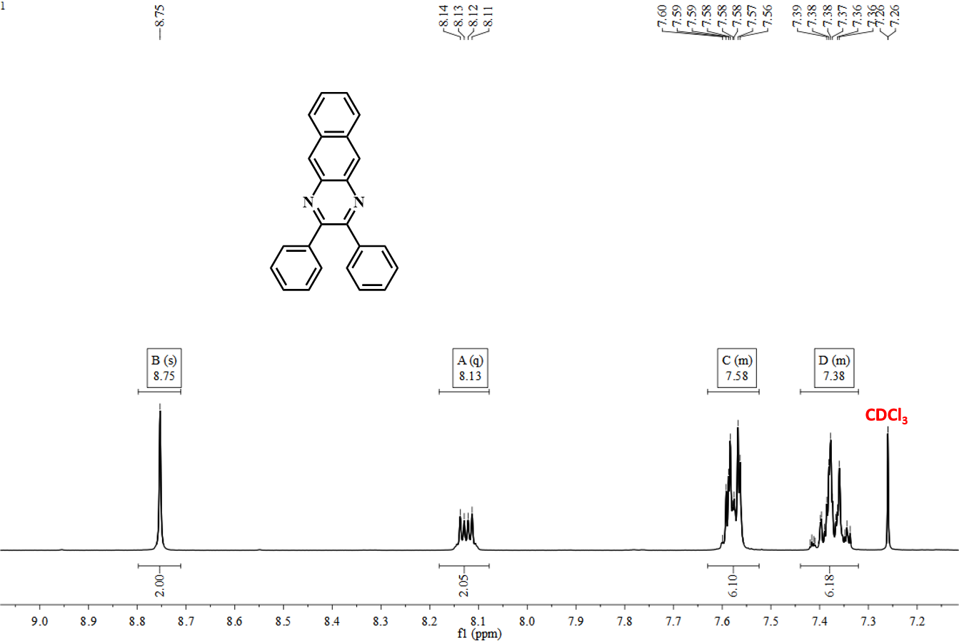
Figure S1. The ¹H NMR spectrum of the HC^N ligand Hdpbq in CDCl₃ at room temperature.

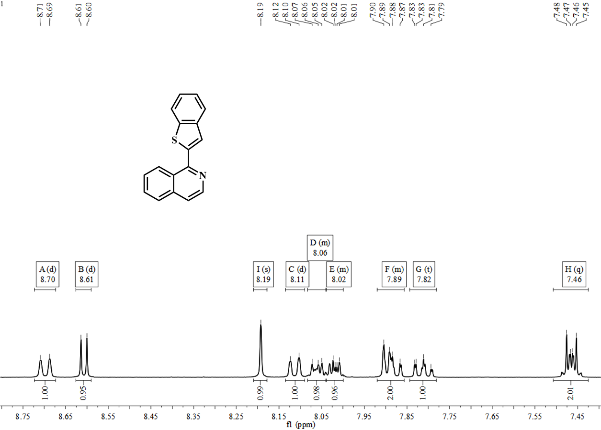
Figure S2. The ¹H NMR spectrum of the HC’^N’ ligand Hiqbt in DMSO-d₆ at room temperature.

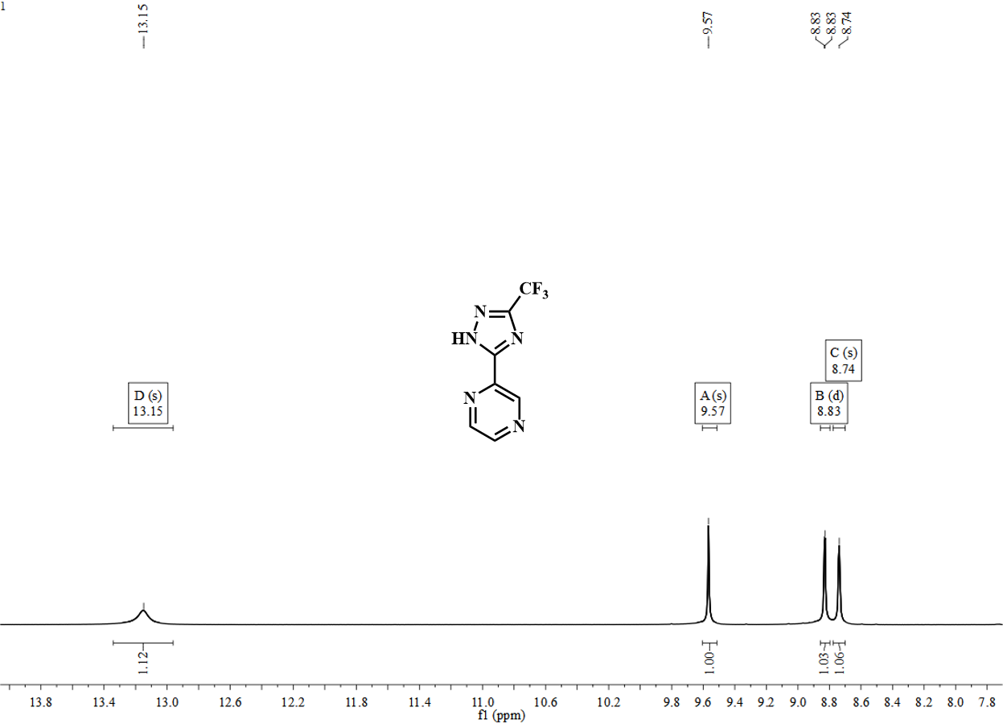
Figure S3. The ¹H NMR spectrum of the HN’’^N’’’ ligand Hftrpz in DMSO-d₆ at room temperature.

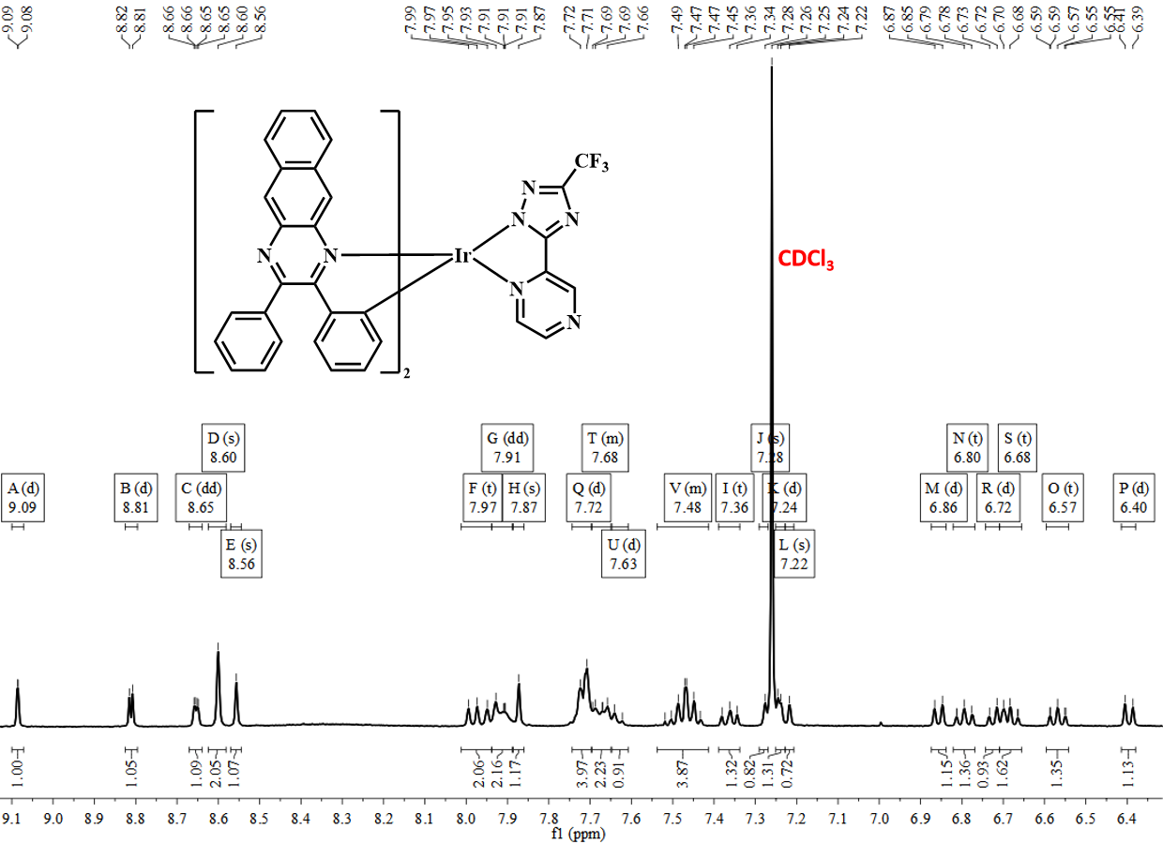
Figure S4. The ¹H NMR spectrum of the [Ir(dpbq)₂(ftrpz)] (Ir-1) in CDCl₃ at room temperature.

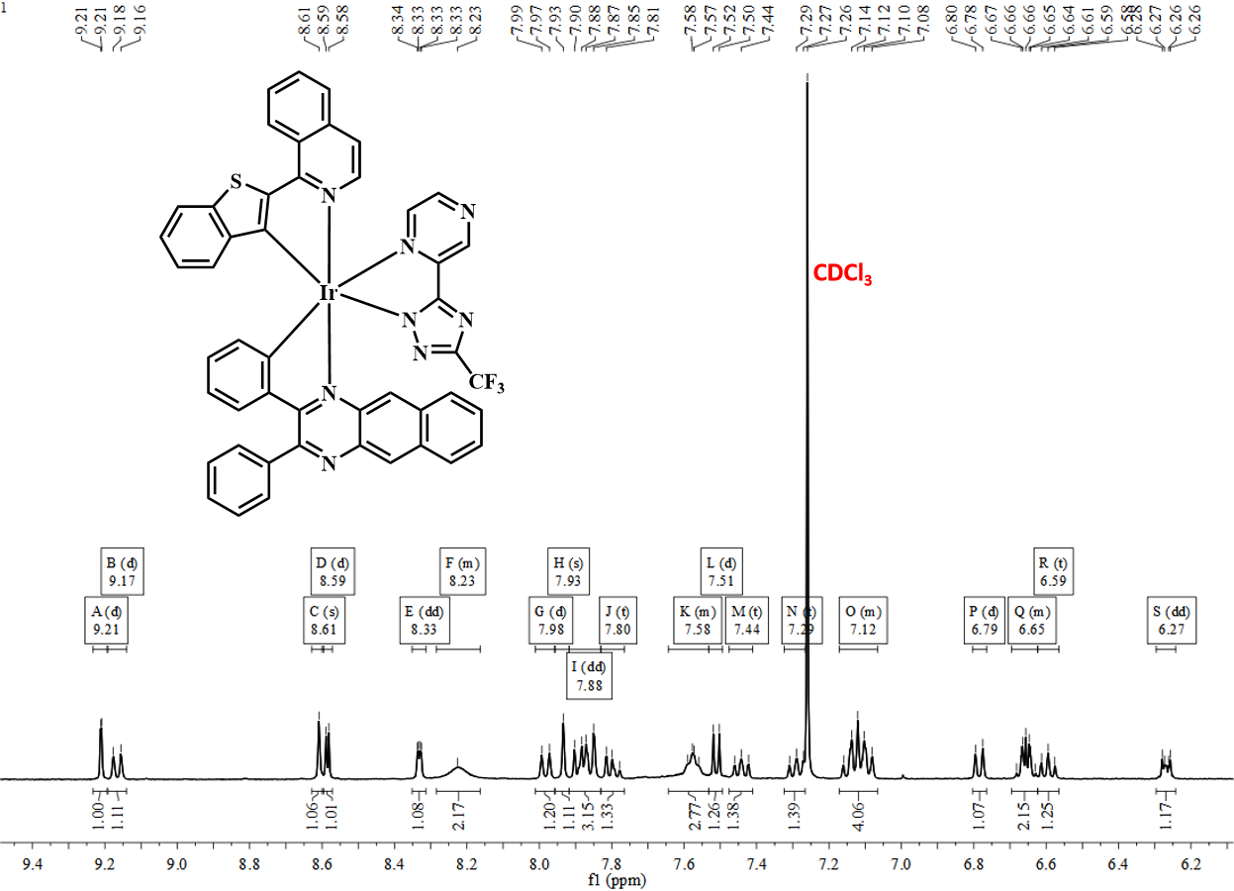
Figure S5. The ¹H NMR spectrum of the [Ir(dpbq)(iqbt)(ftrpz)] (Ir-2) in CDCl₃ at room temperature.

Figure S6. The thermogravimetric analysis (TGA) curves for [Ir(dpbq)₂(ftrpz)] (Ir-1) and [Ir(dpbq)(iqbt)(ftrpz)] (Ir-2), respectively.

Figure S7. The normalized UV-visible absorption spectra of the Hdpbq-HC^N, Hiqbt-HC’^N’, and Hftrpz-HN’’^N’’’ ligands in degassed CH₂Cl₂ solutions at room temperature, respectively.

Figure S8. The normalized emission spectra of the Hdpbq-HC^N, Hiqbt-HC’^N’, and Htrpz-HN’’^N’’’ ligands in degassed CH₂Cl₂ solutions at room temperature, respectively.

Figure S9. The cyclic voltammogram (CV) results of [Ir(dpbq)₂(ftrpz)] (Ir-1) and [Ir(dpbq)(iqbt)(ftrpz)] (Ir-2) recorded versus Fc⁺/Fc in degassed MeCN solution at room temperature under a N₂ atmosphere (scan rate = 100 mV/s), respectively.

