Supplementary informations

SI Appendix, Fig. S1
Crop dynamics time frame: To estimate the timeframe of reported crop dynamics, we calculate the years when informants likely began engaging in agricultural activities, assuming an average starting age at 15 years old. We then narrowed this timeframe to span from 1977, the first quartile of the estimated starting years (capturing the most recent 75% of cases), up to the survey data collection period (2019–2021). To contextualize the observed dynamics of crop changes with climate variability, we identified years of local extreme climatic events using background data collected via the main protocol (Reyes-García et al., 2023) to build a comprehensive timeline of extreme events across the study sites.
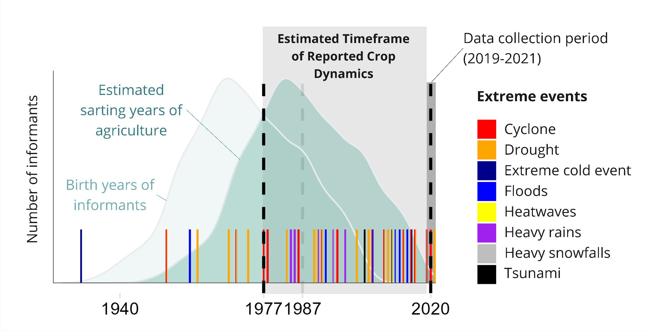
Fig. S1. Estimated timeframe of reported crop dynamics. Density chart of birth years of informants (light green) and respective estimated starting years of agriculture (dark green) with local extreme events timeline overlaid. The first quartile (1977) and the median year (1987) of estimated agricultural start years are indicated, respectively by a black and dashed gray line.

SI Appendix, Fig. S2A

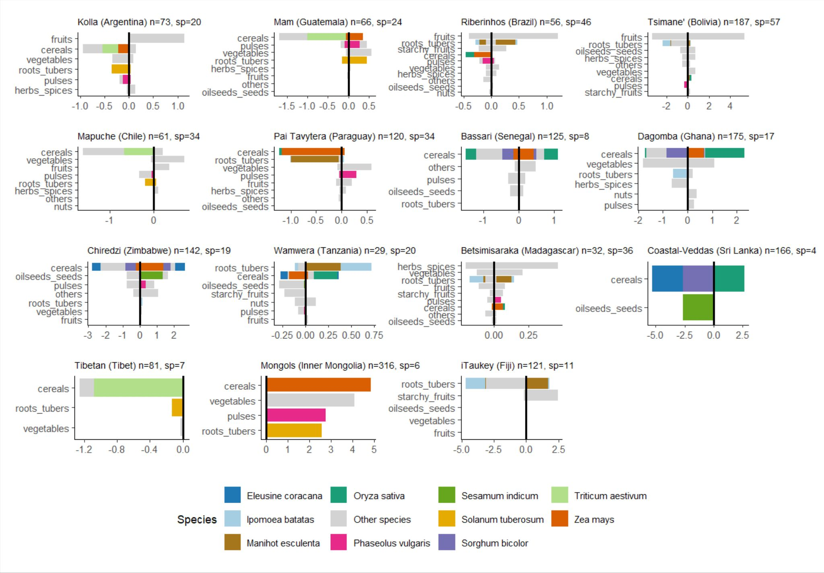
Fig. S2A. Total proportion of abandoned and adopted crops by functional groups. ‘n’ indicates the number of informants and ‘sp’ the number of species reported in each site. The species cited by over 10% of all informants are displayed in colors and the remaining species are grouped as “other species”.

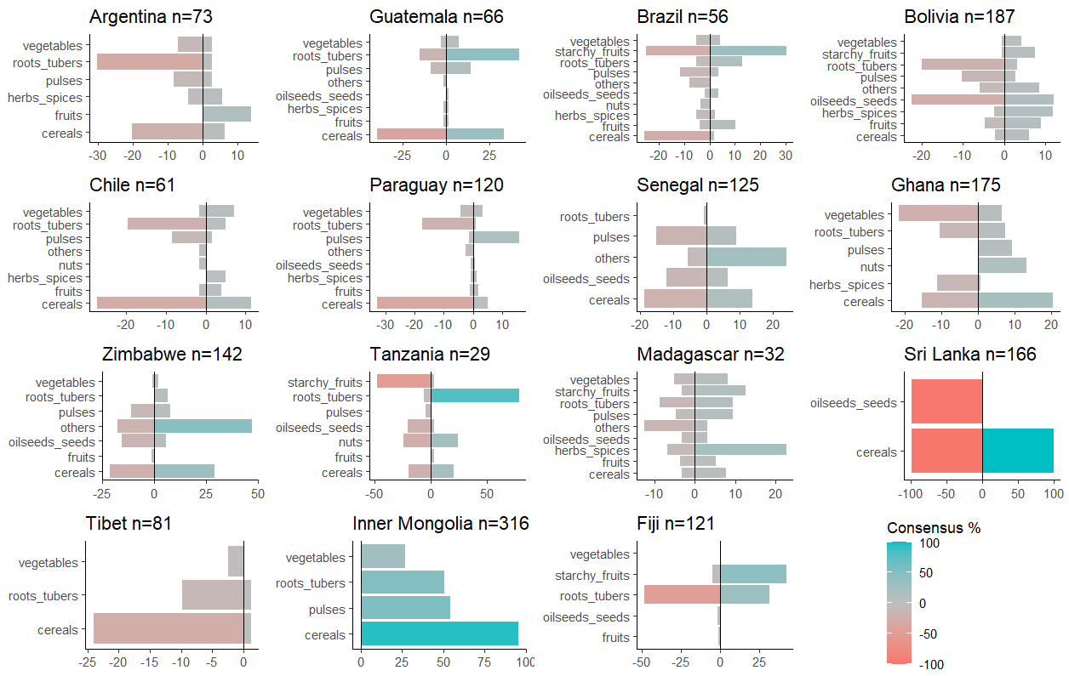
Fig. S2B. Site-level agreement (consensus on the figure) in abandonment (red) and adoption (blue) events of crop species aggregated by functional groups. ‘n’ indicates the number of informants by site.

SI Appendix, Fig. S4
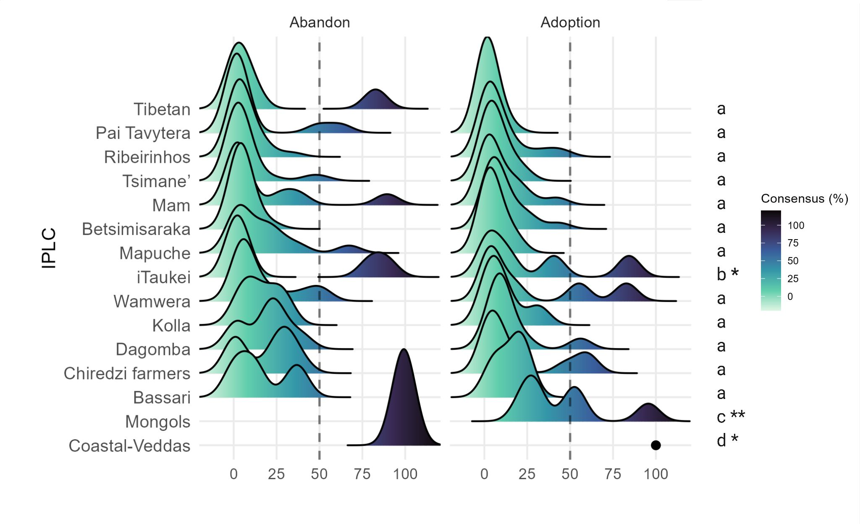
Fig. S4. (A) Distribution of the crop species reported as abandoned and adopted according to their site-level consensus for each site. We indicate with a black dot adoption events for individual species that cannot be visualized in the density plot (i.e., Oryza sativa adopted by the Coastal-Veddas with 100% consensus). Significant differences in mean Wasserstein distances (between each pair of sites) are indicated by different letters (Wilcoxon test; p-value<0.05* and p-value<0.01**).
SI Appendix, Fig. S5
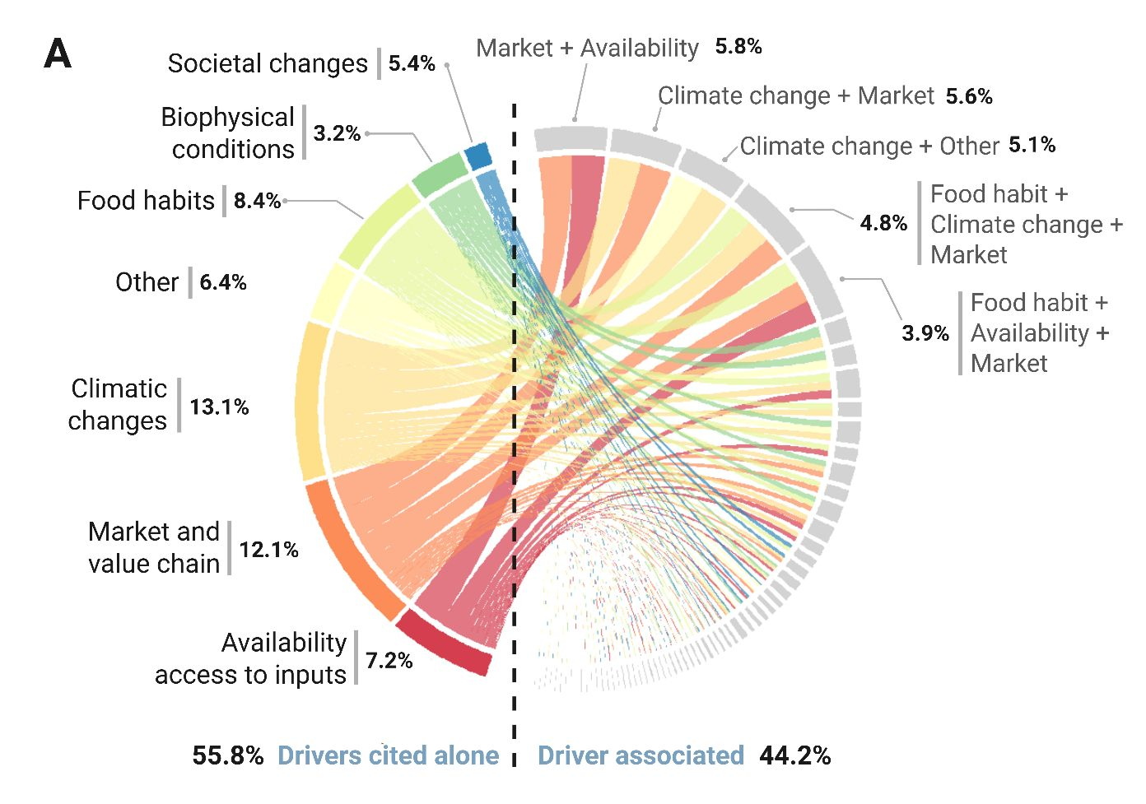

Fig. S5. Chord diagram of driver cooccurrence in farmers’ answers. Numbers indicate the total proportion of drivers reported alone (left) and associated with other drivers (right), while segment size displays the relative contribution of each driver to the association. The larger the segment, the more the driver is associated with others in the responses.

SI Appendix, Table. 1
Table 1. Selection of verbatim quotes illustrating the variety of drivers influencing farmers’ crop abandonment or adoption decisions.
Site | Theme | Verbatim
Western highland Guatemala, Mam community (Guatemala) | Shift in production from wheat to vegetable due to societal changes | Interviewer: Are there any crops that you all have lost here?  Grower: Yes, we’ve lost the cultivation of wheat. Before, we used to plant a lot of wheat. Now, we don’t plant wheat anymore, very little.  Interviewer: Why?  Grower: There were some years that the wheat didn’t want to produce much, maybe because of the weather. And that is where (growers) gave up planting wheat. As we are now more focused on growing vegetables, we don’t have time to go plow for wheat. Because wheat requires some work. Now, vegetable (production) has stuck with us.
Ba, iTaukai community (Fiji) | Choosing more flood resilient crops | "We are now focusing on sweet potato and not cassava because sweet potatoes can be harvested quickly."  "We have started to plant more fruit-bearing trees like papaya and breadfruit because they are available during floods."
Ba, iTaukai community (Fiji) | Soil fertility decreasing | "The soil is not what it used to be like 20 years ago; we have stopped growing some root crops because they don't produce that much yield now."
Kumbungu, Dagomba-Gur (Ghana) | Climate change and market together as main drivers for crop shift | "The rainfall patterns have changed, and it makes it harder to grow some of our traditional crops, and with the high cost of farm inputs, many of us farmers are switching to crops that can survive the unpredictable weather. But even then, we are forced to grow what people need based on their taste, not just what we are used to. If there is no buyer, we cannot afford to keep cultivating it."
Eastern Sri Lanka, Coastal-Veddas community (Sri Lanka) | Economic crisis influencing farming production techniques and labor | “But I feel old techniques were user-friendly given the economic issues we faced recent past, we used cows back then but we could not operate tractors and other equipment due to the fuel crisis”  “We have an issue with manure, and due to the sudden economic crises, we couldn't tolerate the prices."
Bassari country, Bassari people (Senegal) | Choosing crops more adapted to new weather conditions | “Now we grow short-cycle crops. The old varieties do not reach maturity anymore, because the rainy season stops very early.”
Bassari country, Bassari people (Senegal) | Choosing vegetable as cash crops, while knowing the irrigation implications | “Vegetables help us get some money, but you need to water them. If you don’t go to the well very early in the morning, you won’t find water and need to go further.”

SI Appendix, Fig. S6
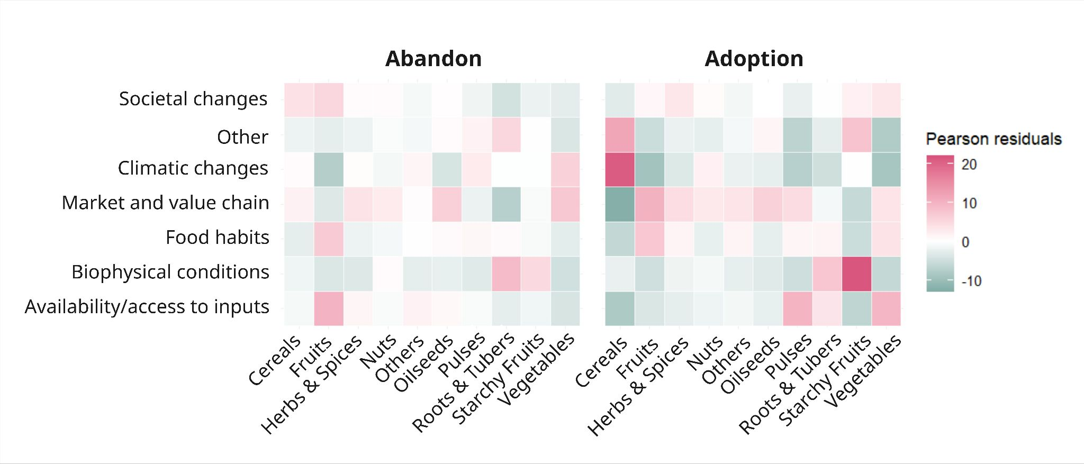Fig. S6. Pearson’s residuals from a chi-square test on drivers of abandon (X-squared = 810.87, df = 54, p-value < 2.2e-16) and adoption (X-squared = 1410.2, df = 54, p-value < 2.2e-16) of functional groups.

SI Appendix, Fig. S7
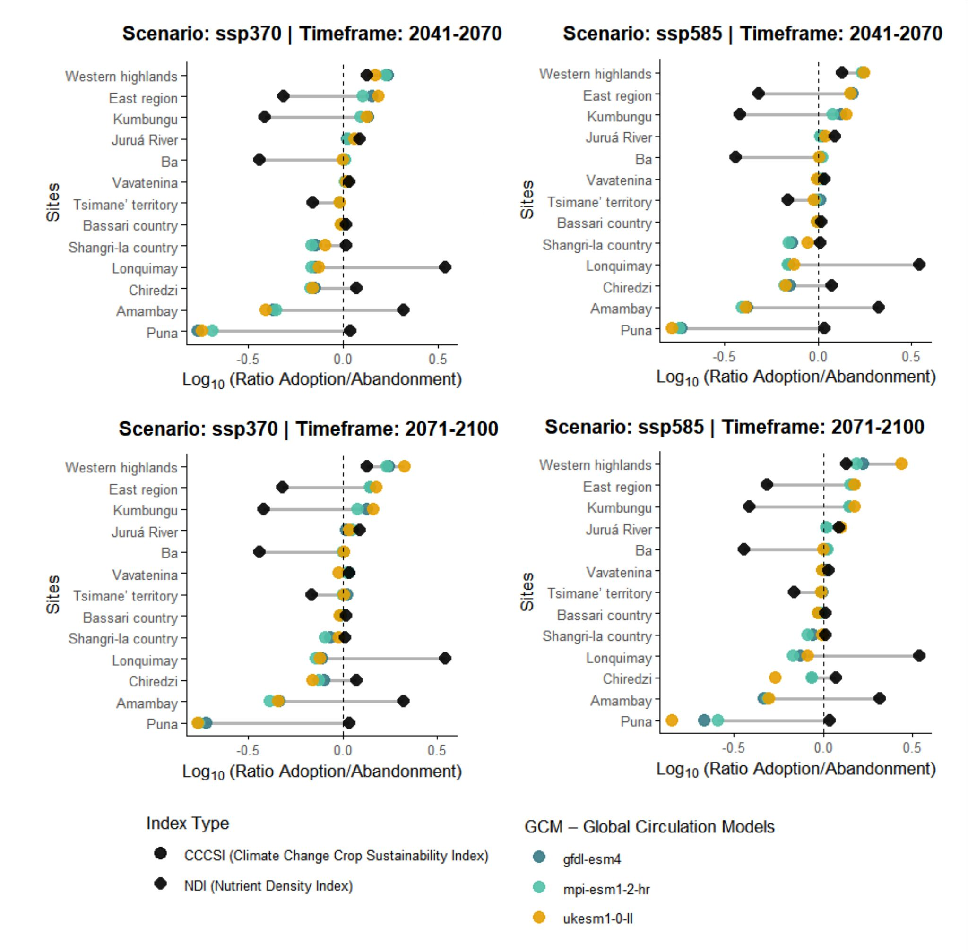Fig. S7. Trend and trade-off in crop composition shift suitability to climate change and nutritional quality per study site. Colored round dots represent the ratio of median Crop Suitability Index values for adopted crops relative to those for abandoned ones, under the SSP3–7.0 and SSP5–8.5 scenarios for the period 2041–2070 and 2071-2100 computed with three different Global Circulation Models (UKESM1-0-LL from the UK Met Office, GFDL-ESM4 from the Geophysical Fluid Dynamics Laboratory and the MPI-ESM1-2-HR from the Max Planck Institute for Meteorology). Black rhomboid dots represent the ratio of median Nutrient Density Index values for adopted crops relative to those for abandoned ones (calculated for 19 nutrients). Ratios values are expressed as the logarithm of the ratio between adoption and abandonment. Positive values indicate higher index values among adopted crops relative to abandoned ones (toward a crop composition more suitable to climatic scenarios or of a higher nutritional quality), while negative values indicate the opposite.

SI Appendix, method
Environmental predictors for modelling:
We used the following set of variables to fit our models. Climate: 19 Bioclimatic layers and 42 other layers describing associated patterns. Baseline data is from 1981–2010. https://chelsa-climate.org/bioclim/ . Included 12 other future climate scenarios as well: Soil: 11 variables for soil properties, https://www.isric.org/explore/soilgrids. 5–15cm depth. Topography (mean elevation, mean slope): https://pubs.usgs.gov/publication/ofr20111073
All spatial layers were resampled at 10 arc minutes. From our compiled dataset of 72 variables, we reduced them before using them in our models. We first grouped variables that were highly correlated (r ≥ 0.7).at a global scale Within each group of highly correlated variables, we then prioritised layers to use, based on the following set of criteria: we prioritised layers that did not have large extents of missing data. Layers with future projections (environmental and climate layers) were prioritised over layers assumed constant over time (i.e., topography and soil data). Finally, we prioritised yearly and quarterly averages over monthly averages. This process reduced our number of predictor variables to nine: mean annual air temperature, mean diurnal air temperature range, mean daily mean air temperatures of the wettest quarter, annual precipitation, precipitation seasonality, net primary productivity, mean slope, volumetric fraction of coarse fragments and percentage of sand.
Species Occurrence Data: Occurrence data per species obtained from 2 sources: GBIF (Chamberlain et al., 2025) and Genesys https://www.genesys-pgr.org/. We cleaned the records, and thinned them based on 10 arcmin resolution to avoid potential bias related to sampling effort.
Chamberlain S, Barve V, Mcglinn D, Oldoni D, Desmet P, Geffert L, Ram K (2025). rgbif: Interface to the Global Biodiversity Information Facility API. R package version 3.8.4, https://CRAN.R-project.org/package=rgbif.
Modelling: For species for which we had more than 10 records after cleaning and thinning data points, we fitted species distribution models to each species via an ensemble modelling approach. Our ensemble model was constructed based on a weighted-average model across multiple runs of three different model types: Generalised Additive Models (GAMs), Maximum Entropy, and Random Forest. We sampled three sets of pseudoabsences: because we were projecting suitability globally, we sampled a high amount of pseudo-absences (10,000) evenly across all terrestrial areas. From each set of species occurrences and pseudo-absences, we calculated the variance inflation factor (VIF) and removed the explanatory variables with high VIF values prior to fitting our models. We ran three runs of each set, giving us a total of 9 repeats for each model type and 27 across all models. We then built ensemble models using a weighted average: individual models were weighted based on their true skill statistic (TSS) scores. Across the list of species, models performed fairly well (TSS scores 0.703 to 0.9880). If a species did not have sufficient points of occurrences after cleaning and thinning the data (<10 unique occurrence points: Pandanus amaryllifolius with 9 occurrence points), we used a surface range envelope (SRE) approach to capture the range of environments across the nine variables in which this species might occur. We used these models to project environmental suitability of each species globally, and under future climate projections (model that you chose). When projecting future climate suitability, predictors associated with topography and edaphic characteristics were assumed constant.
Extracting data: Based on the list of species reported and study sites coordinates (coordinate reference system of EPSG:4326), we extracted the suitability index per each species (0–1, 1 being most suitable) for which we had environmental suitability models. We used a bilinear approach when extracting data, i.e., values are interpolated with immediate neighbour cells. Only the site of Mafia Island (Tanzania) is missing from our analysis due to the lack of climatic data, therefore we didn’t analyze it for this site.

