Additional file 1
Islet autoantibody strength and multiplicity reveal a high-HDL, low-triglyceride phenotype across routine adult diabetes labels
Supplementary methods, Tables S1–S6, and Figures S1–S8

Supplementary methods

Source reconciliation and privacy
Forty-two frozen workbooks were read in two identity passes. Repeated deliveries were reconciled by patient, specimen, audit time, and analyte. Direct identifiers were transformed into irreversible in-memory tokens. No patient-level record, match set, propensity, or row weight was exported.

Time windows and standardization
The index specimen was preferred. Otherwise, the nearest result within ±7 days was selected, with earlier results preferred for ties. Values were rank-normalized against E0 within year×method×setting, with prespecified fallback for sparse reference strata. Domain scores required every component and were rescaled to the E0 standard deviation.

Matching and alternative estimators
Matching was exact on year, care setting, and clinician-assigned diagnosis. Distance variables were age, sex, department, prior laboratory burden, observable days, and linkage quality. Controls were not reused. Robust regression and coarsened-exact estimation reconstructed the cohort independently.

Observation-process analysis
Outcome observation was modeled in the full E0/H set using demographic, clinical-setting, and observation-history variables. Stabilized inverse probabilities were truncated at 0.05–0.95 and 0.02–0.98. This sensitivity analysis assumes conditional missing at random.

Local covariate preflight
An existing VCTE–LIS resource used a shared patient_hash, but the antibody workbooks lacked a compatible hash and the historical key was unavailable. A governed fingerprint bridge yielded no H links. Prespecified BMI, HbA1c, and interpretable C-peptide gates therefore failed.

Public-data boundary
TN09 whole-blood RNA sequencing tested a continuous four-antibody burden against prespecified neutrophil/lactotransferrin and cytotoxic modules. HPAP donor-level flow cytometry compared antibody-positive and antibody-negative nondiabetic donors. These analyses provided orthogonal context and were not lipid replication.

Supplementary results

Independent reconstruction
The validation program rebuilt 18845 unique adults; reproduced E0/E1/E2/E3 counts of 18137/513/96/99; confirmed that H5 equaled the original H definition for every participant; and verified nested H3/H5/H10 sets of 238/195/158. Three key matched point estimates reproduced with zero numerical difference.

Same-specimen verification
Among 7728 participants with selected HDL-C and triglyceride records, 99.97% were from the same specimen and audit date. The rate was 100% in H and 99.97% in E0.

Observation diagnostics
Outcome availability was higher in H and remained strongly predictable from measured care-process variables. Weighted estimates retained direction; lower effective sample sizes and extreme probabilities limited precision and causal interpretation.

Supplementary tables
Table S1. Source reconciliation and cohort flow
Stage | n
Physical source rows | 642731
Logical results after reconciliation | 584142
Patients with any antibody record | 24683
No eligible 365-day-washout candidate | 5555
Identity conflict | 160
Age exclusion | 122
No same-event GADA–ICA pair | 1
Adult index cohort | 18845
Table S2. Antibody evidence patterns and lipid availability
Pattern | n | HDL–LDL complete | HDL–TG complete
E0_both_negative | 18137 | 8041 | 7321
dual_high_any_ge5x | 91 | 60 | 52
dual_low_both_lt5x | 8 | 2 | 2
isolated_GADA_ge5x | 77 | 52 | 47
isolated_GADA_lt5x | 394 | 205 | 190
isolated_ICA_ge5x | 19 | 7 | 7
isolated_ICA_lt5x | 119 | 41 | 39
H3_isolated_ge3x_or_dual | 238 | 147 | 132
H5_isolated_ge5x_or_dual | 195 | 121 | 108
H10_isolated_ge10x_or_dual | 158 | 98 | 87
Table S3. Antibody-threshold and pattern-specific matched effects
Analysis | Exposed | E0 | Effect | 95% CI | Maximum SMD
threshold_3x_HDL_TG | 124 | 372 | -0.558 | -0.765 to -0.345 | 0.147
threshold_5x_HDL_TG | 101 | 303 | -0.634 | -0.852 to -0.407 | 0.141
threshold_10x_HDL_TG | 84 | 252 | -0.701 | -0.957 to -0.450 | 0.155
pattern_isolated_GADA_ge5x_HDL_TG | 44 | 132 | -0.614 | -0.931 to -0.284 | 0.132
pattern_dual_high_HDL_TG | 51 | 153 | -0.646 | -0.978 to -0.306 | 0.200
Table S4. Observation-process sensitivity analyses
Method | Outcome | Truncation | H | Effect | 95% CI | Weighted ESS
stabilized_inverse_observation_weighted_regression | lipid_pm7_score | 0.05-0.95 | 121 | -0.439 | -0.621 to -0.256 | 2927
stabilized_inverse_observation_weighted_regression | lipid_pm7_score | 0.02-0.98 | 121 | -0.481 | -0.664 to -0.298 | 1063
covariate_adjusted_complete_case_regression | lipid_pm7_score | none | 121 | -0.416 | -0.614 to -0.218 | 8162
stabilized_inverse_observation_weighted_regression | hdl_tg_pm7_score | 0.05-0.95 | 108 | -0.861 | -1.157 to -0.566 | 2849
stabilized_inverse_observation_weighted_regression | hdl_tg_pm7_score | 0.02-0.98 | 108 | -1.009 | -1.406 to -0.612 | 1168
covariate_adjusted_complete_case_regression | hdl_tg_pm7_score | none | 108 | -0.729 | -0.955 to -0.504 | 7429
Table S5. Frozen robustness analyses
Analysis | H/E0 | Effect | 95% CI
Pre-index 7 days | 113/339 | −0.340 | −0.554 to −0.124
E2 vs E0 | 56/168 | −0.446 | −0.710 to −0.180
E3 vs E0 | 61/183 | −0.369 | −0.690 to −0.052
Inpatient | 67/201 | −0.420 | −0.713 to −0.124
Outpatient | 46/138 | −0.373 | −0.692 to −0.050
T2D | 84/252 | −0.337 | −0.587 to −0.082
Exclude T1D/LADA/DKA | 102/306 | −0.372 | −0.609 to −0.144
Robust regression HC3 | 121/8041 | −0.380 | −0.577 to −0.183
Coarsened-exact ATT | 104 H in support | −0.419 | −0.623 to −0.207
Table S6. Local-data and public-data boundary analyses
Assessment | Result | Interpretation
Project23 H with linked BMI | 0 | Prespecified enrichment gate failed
Project23 H with linked HbA1c | 0 | Prespecified enrichment gate failed
Project23 H with C-peptide ±7 days | 12 | No synchronous glucose
TN09 neutrophil module | 0.014 SD | 95% CI −0.198 to 0.222
TN09 cytotoxic module | −0.083 SD | 95% CI −0.282 to 0.134
HPAP antibody-positive donors | 5 | Orthogonal context; not lipid replication

Supplementary figures
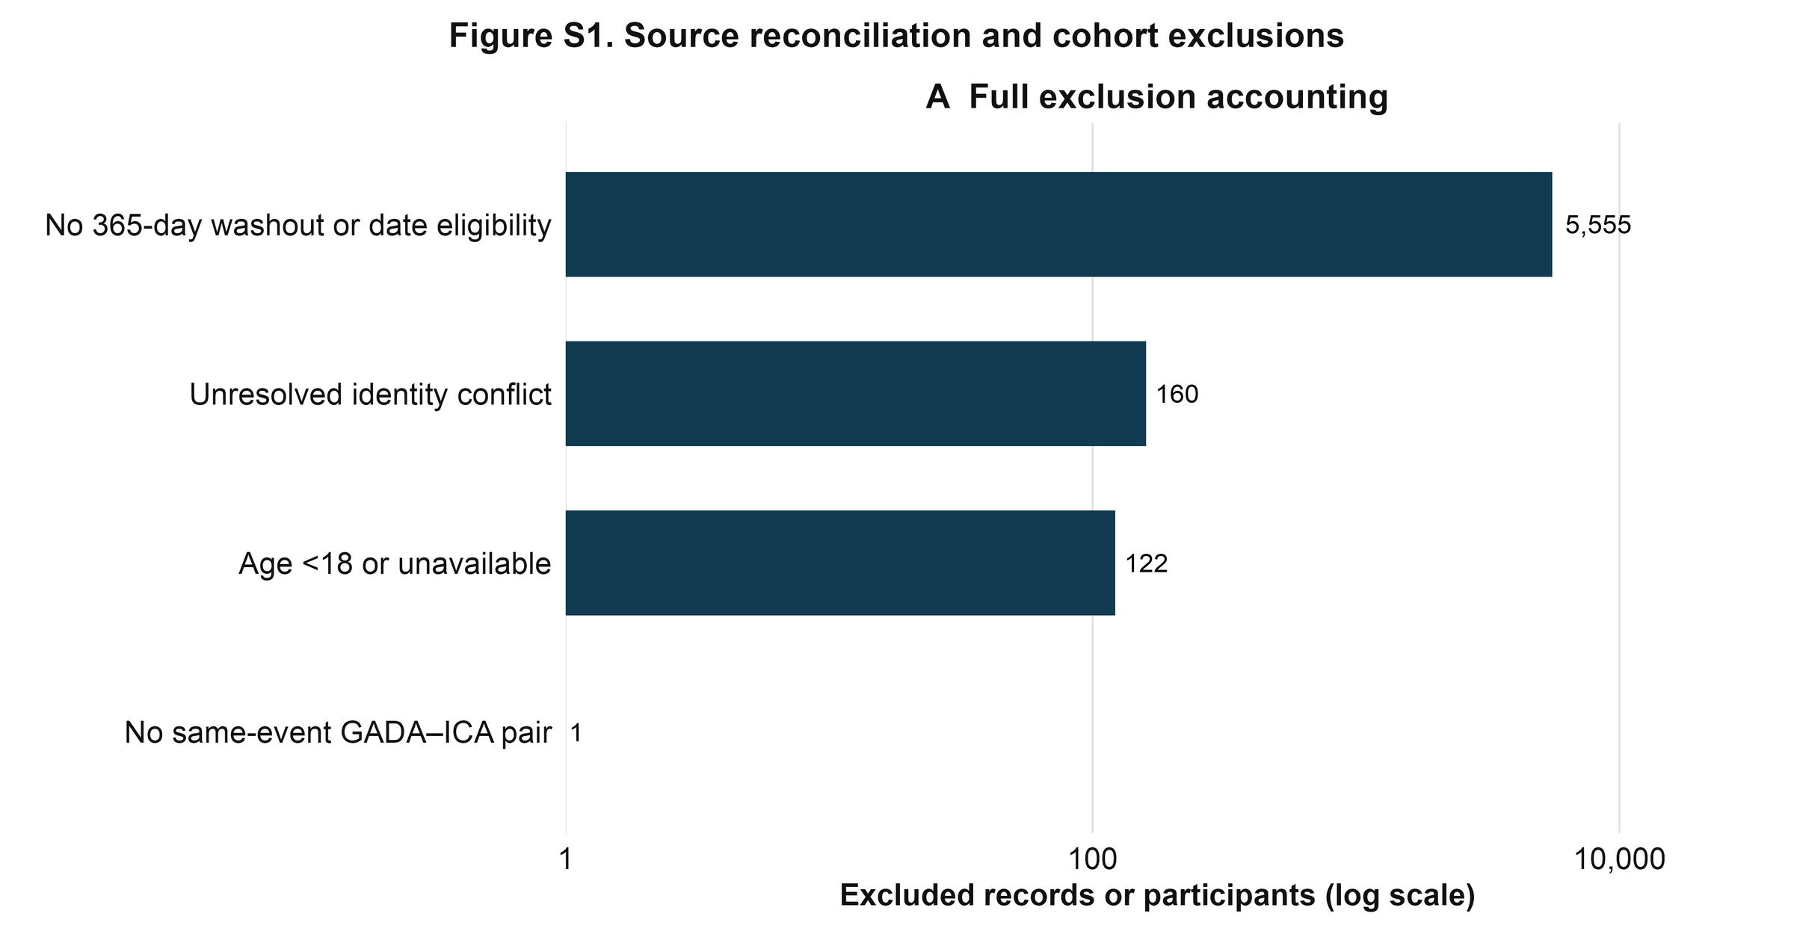
Figure S1. Source reconciliation and all cohort exclusions are shown on a logarithmic count scale.
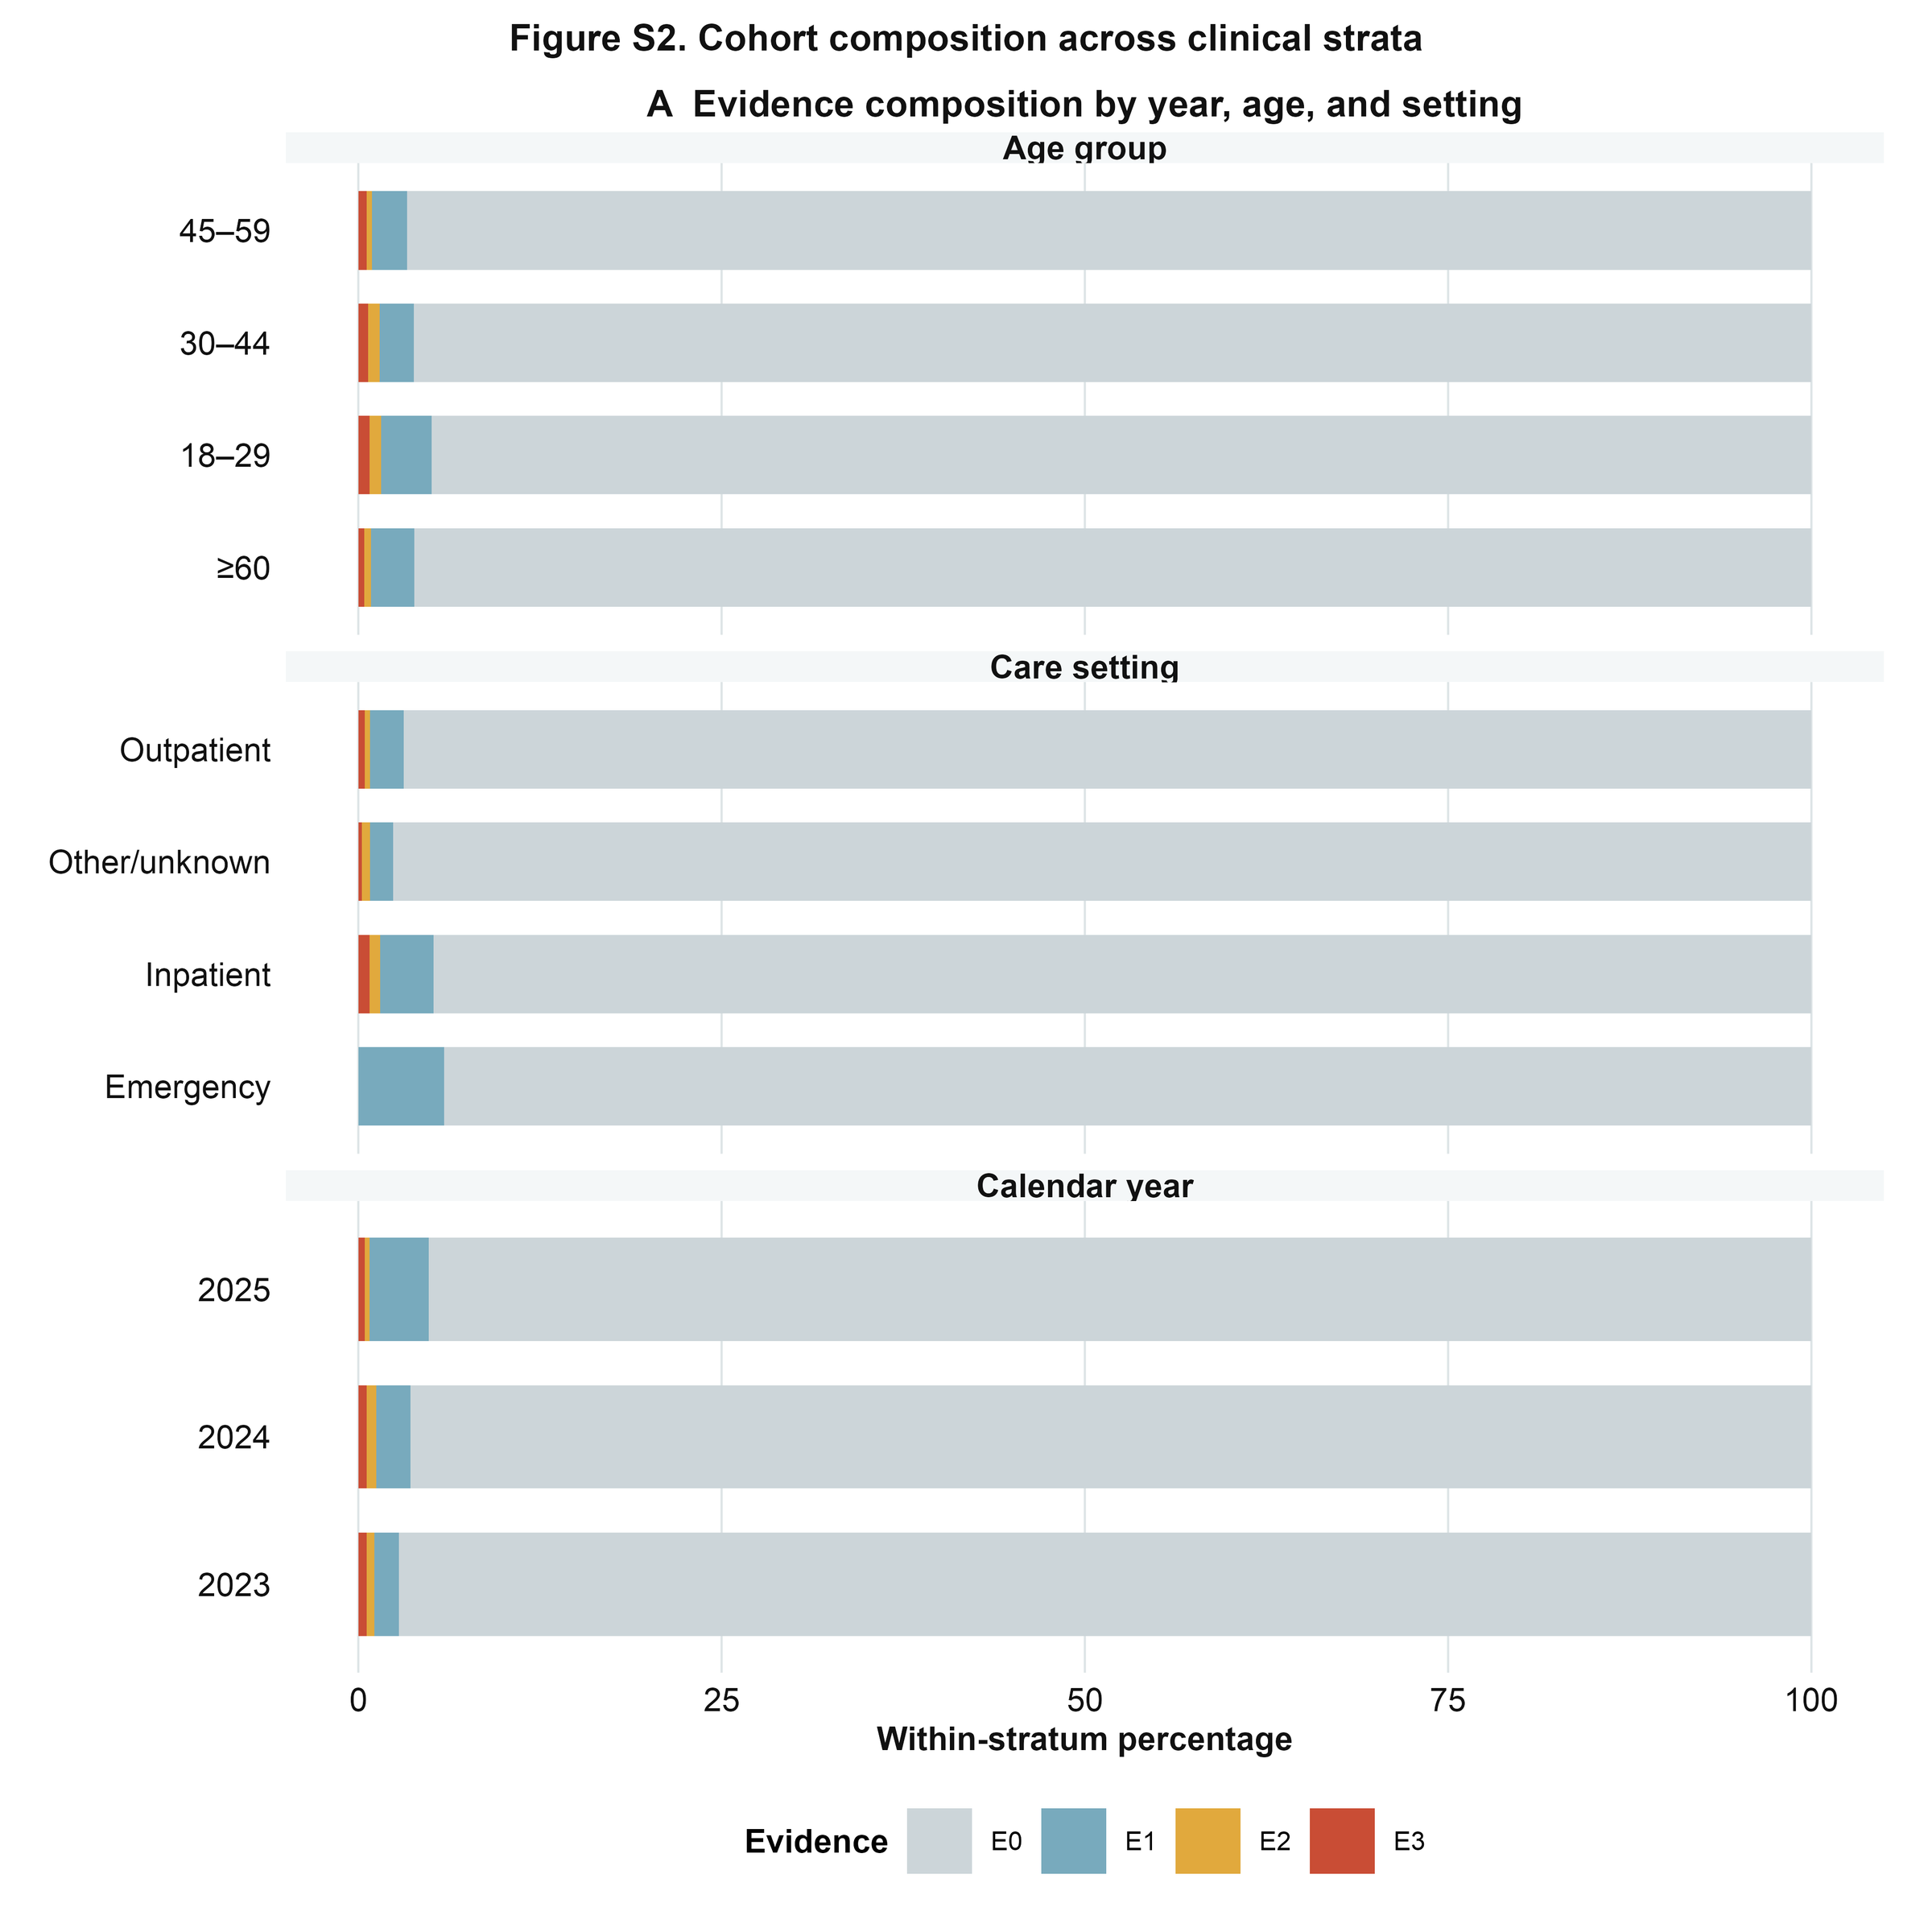
Figure S2. E0–E3 composition is shown by age, care setting, and calendar year. Percentages are within each clinical stratum.
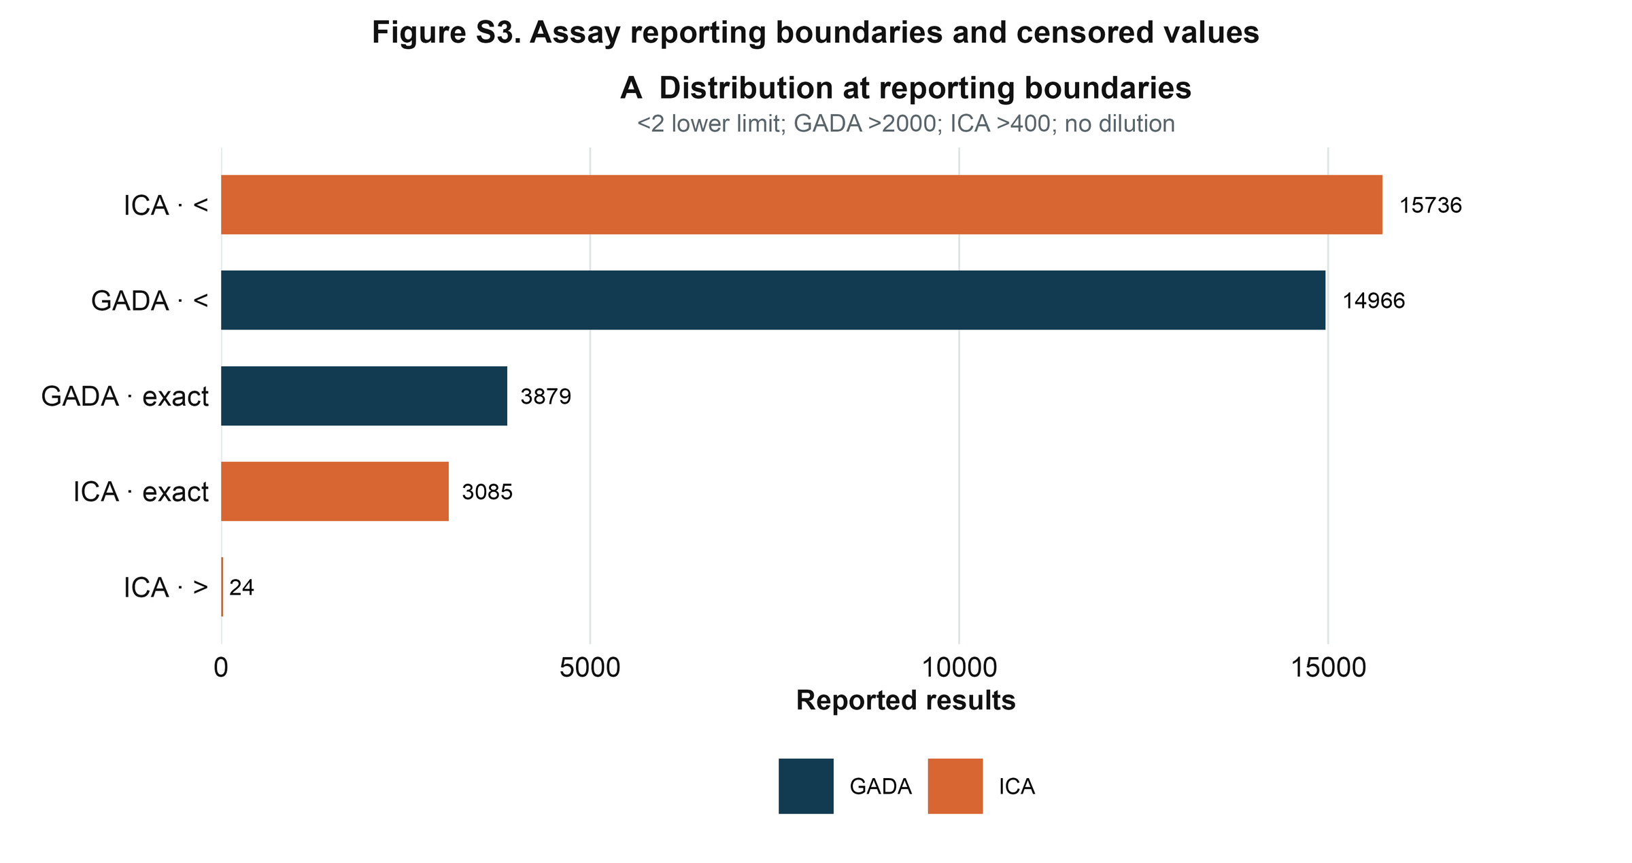
Figure S3. Reported GADA and ICA results are summarized at exact and censored reporting categories. The common lower reporting boundary was <2 AU/mL; above-range reports were GADA >2000 AU/mL and ICA >400 AU/mL without dilution.
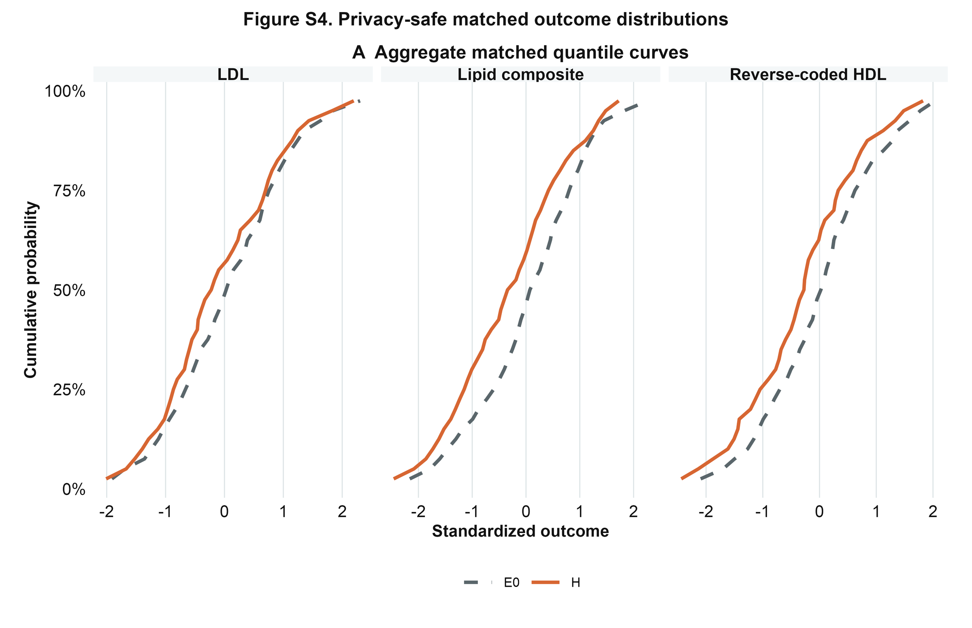
Figure S4. Aggregate quantile curves compare privacy-safe matched outcome distributions for E0 and H. No patient-level marks are displayed.
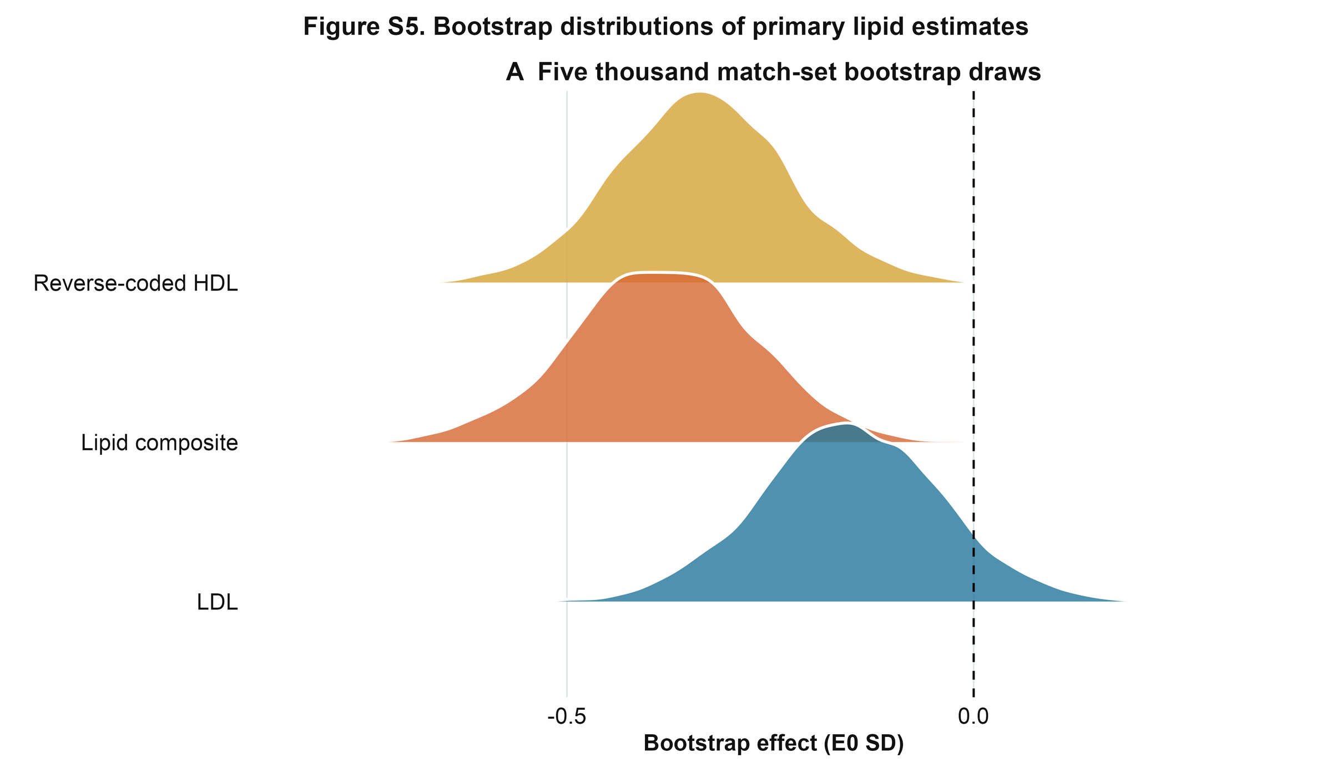
Figure S5. Five thousand match-set bootstrap draws are shown for the prespecified lipid composite, reverse-coded HDL-C, and LDL-C.
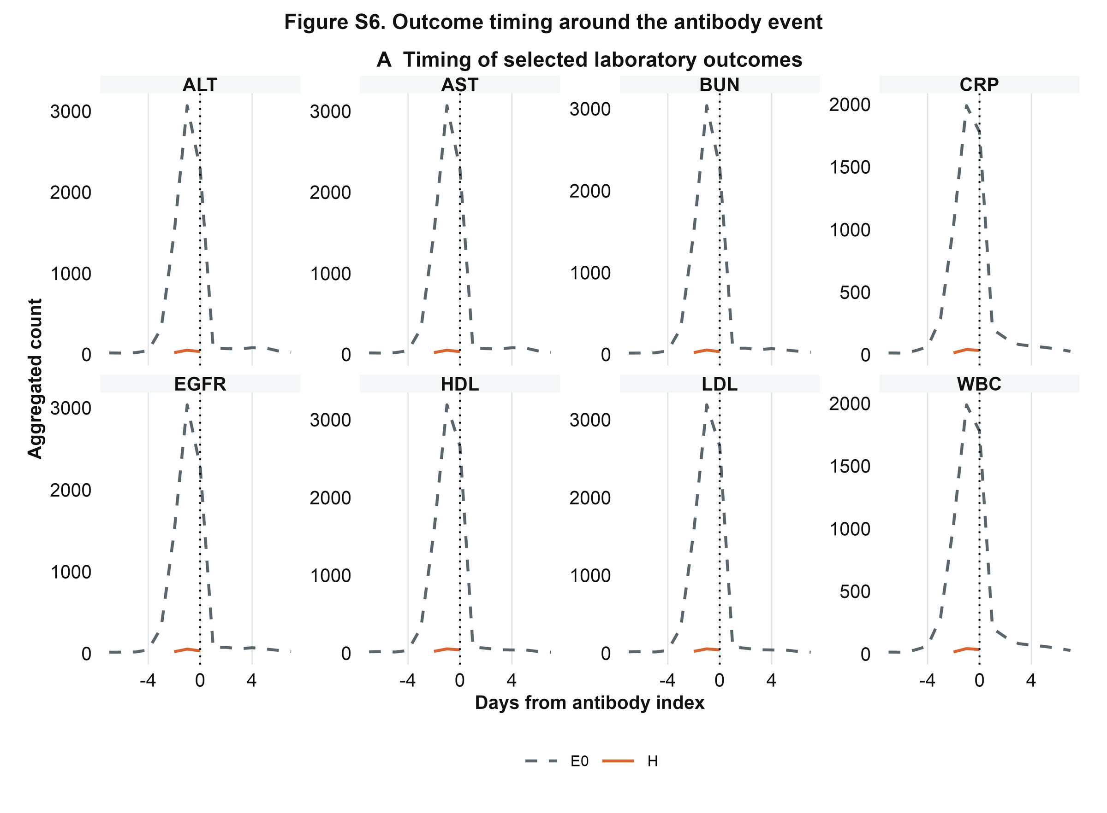
Figure S6. Aggregated timing distributions show selected laboratory outcomes relative to the antibody index event.
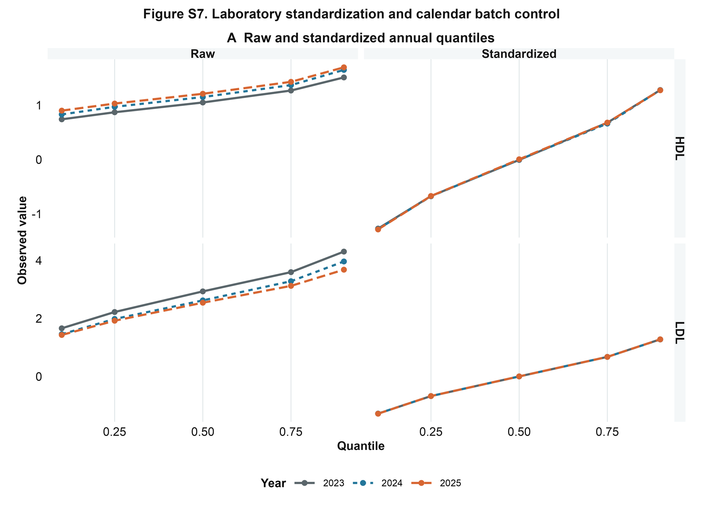
Figure S7. Raw and standardized annual quantiles illustrate calendar and laboratory standardization behavior for HDL-C and LDL-C.
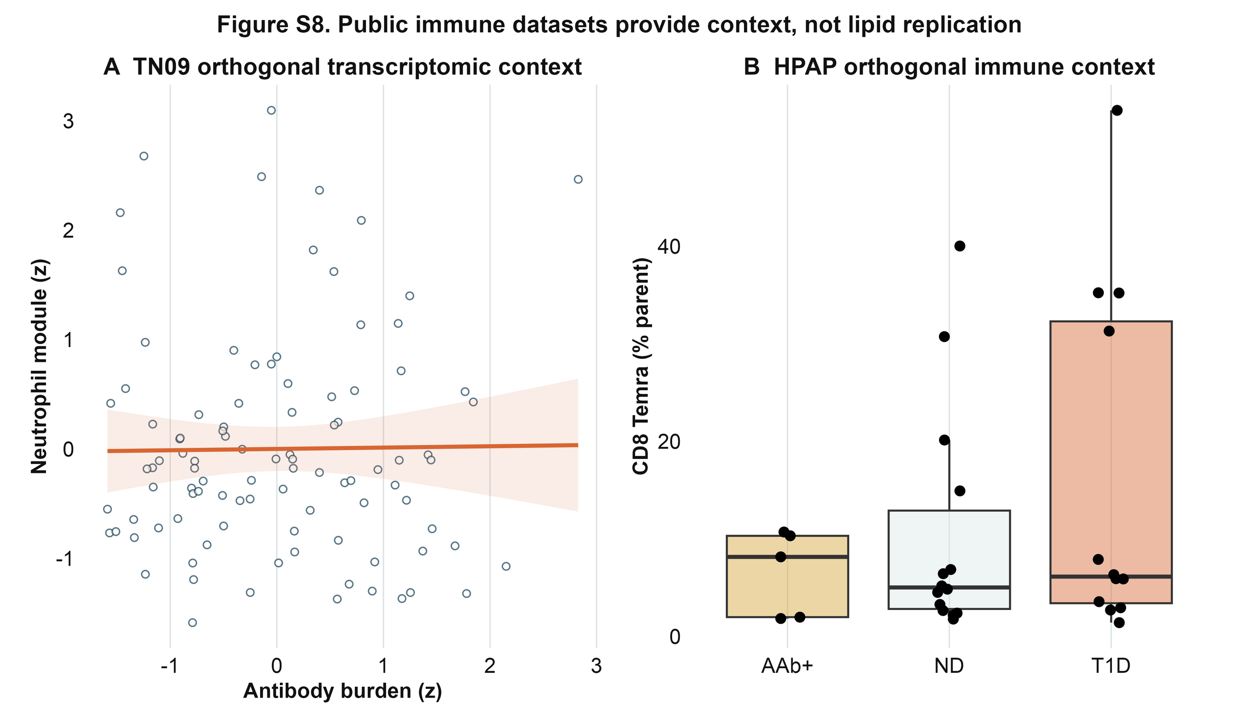
Figure S8. TN09 and HPAP provide orthogonal public immune context. These analyses are not external replication of the hospital lipid phenotype.

